SUPPLEMENTARY MATERIAL
for
Novel (−)-goniofufurone mimics: synthesis, antiproliferative activity and SAR analysis

BOJANA SREĆO ZELENOVIĆ¹, SLAĐANA KEKEZOVIĆ¹, MIRJANA POPSAVIN¹, VESNA KOJIĆ², GORAN BENEDEKOVIĆ¹ and VELIMIR POPSAVIN^{1,3}*
¹Department of Chemistry, Biochemistry and Environmental Protection, Faculty of Sciences, University of Novi Sad, Trg Dositeja Obradovića 3, 21000 Novi Sad, Serbia
²Oncology Institute of Vojvodina, Put dr Goldmana 4, 21204 Sremska Kamenica, Serbia
³Serbian Academy of Sciences and Arts, Knez Mihajlova 35, 11000 Belgrade, Serbia

TABLE OF CONTENTS

PHYSICAL AND SPECTRAL DATA OF SYNTHESIZED COMPOUNDS 2
NMR SPECTRA OF FINAL PRODUCTS 7
SAR ANALYSIS 24

PHYSICAL AND SPECTRAL DATA OF SYNTHESIZED COMPOUNDS

3,6-Anhydro-5-O-benzyl-7-O-hexyl-2-deoxy-l-ido-heptono-1,4-lactone (12). Colourless oil, [α]_{D} = –17.4 (c 0.5, CHCl₃); R_{f} = 0.14 (3:2 light petroleum/Et₂O). IR (CHCl₃): ν_{max} 1790 (C=O). ¹H NMR (400 MHz, CDCl₃): δ 0.89 (t, 3H, J=6.8 Hz, CH₃), 1.20–1.39 (m, 6H, 3×CH₂ from side chain), 1.51–1.65 (m, 2H, OCH₂CH₂(CH₂)₃CH₃), 2.69 (dd, 1H, J_{2a,3}=2.7, J_{2a,2b}=18.8 Hz, H-2a), 2.75 (dd, 1H, J_{2b,3}=4.7, J_{2a,2b}=18.8 Hz, H-2b), 3.46 (m, 2H, OCH₂(CH₂)₄CH₃), 3.75 (d, 2H, J_{6,7}=5.5 Hz, H-7), 4.21 (d, 1H, J_{5,6}=4.1 Hz, H-5), 4.26 (td, 1H, J_{5,6}=4.1, J_{6,7}=5.5 Hz H-6), 4.60 and 4.70 (2×d, 2H, J_{gem}=11.9 Hz, CH₂Ph), 4.92 (d, 1H, J_{3,4}=4.7 Hz, H-4), 4.98 (td, 1H, J_{3,4}=4.7, J_{2a,3}=2.9, J_{2b,3}=4.6 Hz, H-3), 7.30–7.45 (m, 5H, Ph). ¹³C NMR (100 MHz, CDCl₃): δ 14.06 (CH₃), 22.61, 25.80, 29.62, 31.67 (4×CH₂ from side chain), 36.03 (C-2), 68.57 (C-7), 71.86 (OCH₂(CH₂)₄CH₃), 72.76 (CH₂Ph), 76.83 (C-3), 79.65 (C-6), 81.51 (C-5), 85.52 (C-4), 127.75, 128.17, 128.60, 137.17 (Ph), 175.35 (C=O). HRMS-Heated ESI-Orbitrap: m/z 371.18272 (M⁺+Na), calcd. for C₂₀H₂₈NaO₅: 371.18344.
3,6-Anhydro-5-O-benzyl-7-O-heptyl-2-deoxy-l-ido-heptono-1,4-lactone (13). Colourless oil; [α]_{D} = – 16.0 (c 0.5, CHCl₃); R_{f} = 0.28 (1:1 light petroleum/Et₂O). IR (CHCl₃): ν_{max} 1789 (C=O). ¹H NMR (400 MHz, CDCl₃): δ 0.89 (t, 3H, J=6.8 Hz, CH₃), 1.19–1.41 (m, 8H, 4×CH₂ from side chain), 1.58 (m, 2H, OCH₂CH₂(CH₂)₄CH₃), 2.69 (dd, 1H, J_{2a,2b}=18.9, J_{2a,3}=2.6 Hz, H-2a), 2.74 (dd, 1H, J_{2a,2b}=18.9, J_{2b,3}=4.7 Hz, H-2b), 3.38–3.54 (m, 2H, OCH₂(CH₂)₅CH₃), 3.65 (d, 2H, J_{6,7}=5.5 Hz, H-7), 4.21 (d, 1H, J_{5,6}=4.0 Hz, H-5), 4.27 (dd, 1H, J_{5,6}=4.1, J_{6,7}=5.5 Hz, H-6), 4.60 and 4.70 (2×d, 2H, J_{gem}=11.9 Hz, CH₂Ph), 4.92 (d, 1H, J_{3,4}=4.7 Hz, H-4), 4.98 (td, 1H, J_{3,4}=4.6, J_{2a,3}=2.9, J_{2b,3}=4.6 Hz, H-3), 7.29–7.40 (m, 5H, Ph). ¹³C NMR (100 MHz, CDCl₃): δ 14.10 (CH₃), 22.62, 26.08, 29.14, 29.66, 31.81 (5×CH₂ from side chain), 36.03 (C-2), 68.57 (C-7), 71.86 (OCH₂(CH₂)₅CH₃), 72.76 (CH₂Ph), 76.83 (C-3), 79.65 (C-6), 81.51 (C-5), 85.53 (C-4), 127.75, 128.17, 128.60, 137.17 (Ph), 175.35 (C=O). HRMS-Heated ESI-Orbitrap: m/z 385.19874 (M⁺+Na), calcd. for C₂₁H₃₀NaO₅: 385.19909.
3,6-Anhydro-5-O-benzyl-7-O-octyl-2-deoxy-l-ido-heptono-1,4-lactone (14). Colourless oil, [α]_{D} = –14,8 (c 0.5, CHCl₃); R_{f} = 0.25 (1:1 light petroleum/Et₂O). IR (CHCl₃): ν_{max} 1790 (C=O). ¹H NMR (400 MHz, CDCl₃): δ 0.89 (t, 3H, J=6.9 Hz, CH₃), 1.22–1.38 (m, 10H, 5×CH₂ from side chain), 1.58 (m, 2H, OCH₂CH₂(CH₂)₅CH₃), 2.68 (dd, 1H, J_{2a,2b}=18.7, J_{2a,3}=2.5 Hz, H-2a), 2.71 (dd, 1H, J_{2a,2b}=18.7, J_{2b,3}=4.8 Hz, H-2b), 3.37–3.54 (m, 2H, OCH₂(CH₂)₆CH₃), 3.65 (d, 2H, J_{6,7}=5.5 Hz, H-7), 4.20 (d, 1H, J_{5,6}=4.0 Hz, H-5), 4.25 (td, 1H, J_{5,6}=4.1, J_{6,7}=5.5 Hz, H-6), 4.60 and 4.69 (2×d, 2H, J_{gem}=11.9 Hz, CH₂Ph), 4.92 (d, 1H, J_{3,4}=4.7 Hz, H-4), 4.97 (td, 1H, J_{3,4}=4.8, J_{2a,3}=2.5, J_{2b,3}=4.8 Hz, H-3), 7.29–7.43 (m, 5H, Ph). ¹³C NMR (100 MHz, CDCl₃): δ 14.01 (CH₃), 22.56, 26.02, 29.16, 29.33, 29.56, 31.73 (6×CH₂ from side chain), 35.92 (C-2), 68.47 (C-7), 71.75 (OCH₂(CH₂)₆CH₃), 72.63 (CH₂Ph), 76.73 (C-3), 79.54 (C-6), 81.40 (C-5), 85.40 (C-4), 127.64, 128.05, 128.49. 137.10 (Ph), 175.26 (C=O). HRMS-Heated ESI-Orbitrap: m/z 399.21400 (M⁺+Na), calcd. for C₂₂H₃₂NaO₅: 399.21474; m/z 415.18765 (M⁺+K), calcd. for C₂₂H₃₂KO₅: 415.18868.
3,6-Anhydro-5-O-benzyl-7-O-nonyl-2-deoxy-l-ido-heptono-1,4-lactone (15). Colourless crystals, mp 34 °C (CH₂Cl₂/hexane), [α]_{D} = –10.8 (c 0.75, CHCl₃), R_{f}=0.33 (1:1 Et₂O/light petroleum). IR (film): ν_{max} 1773 (C=O). ¹H NMR (250 MHz, CDCl₃): δ 0.89 (t, 3H, J=6.9 Hz, CH₃), 1.18–1.39 (m, 12H, 6×CH₂ from side chain), 1.57 (m, 2H, OCH₂CH₂(CH₂)₆CH₃), 2.66–2.76 (pseudo d, 2H, 2×H-2), 3.45 (m, 2H, OCH₂(CH₂)₇CH₃), 3.65 (d, 2H, J_{6,7}=5.4 Hz, H-7), 4.20 (d, 1H, J_{5,6}=4.3 Hz, H-5), 4.26 (m, 1H, J_{5,6}=4.3, J_{6,7}=5.4 Hz, H-6), 4.59 and 4.69 (2×d, 2H, J_{gem}=11.9 Hz, CH₂Ph), 4.92 (d, 1H, J_{3,4}=4.1 Hz, H-4), 4.98 (m, 1H, J_{3,2a}=2.8, J_{3,2b}=3.1, J_{3,4}=4.1 Hz, H-3), 7.29–7.43 (m, 5H, Ph). ¹³C NMR (62.9 MHz, CDCl₃): δ 14.05 (Me), 22.60, 26.04, 29.20, 29.40, 29.48, 29.58 and 31.81 (7×CH₂) 35.94 (C-2), 68.49 (C-7), 71.78 (OCH₂(CH₂)₇CH₃), 72.66 (CH₂Ph), 76.75 (C-3), 79.57 (C-6), 81.42 (C-5), 85.44 (C-4), 127.67, 128.08, 128.51 and 137.10 (Ph), 175.29 (C-1). LRMS (ESI⁺): m/z 429 (M⁺+K), 413 (M⁺+Na), 391 (M⁺+H). HRMS (ESI⁺): m/z 391.2482 (M⁺+H), calcd. for C₂₃H₃₅O₅: 391.2479; m/z 408.2745 (M⁺+NH₄), calcd. for C₂₃H₃₈NO₅: 408.2744; m/z 413.2290 (M⁺+Na), calcd. for C₂₃H₃₄NaO₅: 413.2298; m/z 429.2034 (M⁺+K), calcd. for C₂₃H₃₄KO₅ 429.2038.
3,6-Anhydro-5-O-benzyl-7-O-decyl-2-deoxy-l-ido-heptono-1,4-lactone (16). Colourless oil, [α]_{D} = −11.1 (c 0.63, CHCl₃); R_{f}=0.44 (1:1 light petroleum/Et₂O). IR (film): ν_{max} 1788 (C=O). ¹H NMR (250 MHz, CDCl₃): δ 0.89 (t, 3H, J=7.0 Hz, CH₃), 1.21–1.41 (m, 14H, 7×CH₂ from side chain), 1.49–1.64 (m, 2H, OCH₂CH₂(CH₂)₇CH₃), 2.72 (pseudo d, 2H, 2×H-2), 3.46 (m, 2H, OCH₂ from side chain), 3.65 (d, 2H, J_{6,7}=5.3 Hz, 2×H-7), 4.21 (d, 1H, J_{5,6}=4.1 Hz, H-5), 4.26 (m, 1H, J_{5,6}=4.1, J_{6,7}=5.3 Hz, H-6), 4.60 and 4.70 (2×d, 2H, J_{gem}=11.9 Hz, CH₂Ph), 4.92 (d, 1H, J_{3,4}=4.7 Hz, H-4), 4.99 (m, 1H, J_{3,4}=4.7 Hz, H-3), 7.30–7.42 (m, 5H, Ph). ¹³C NMR (62.9 MHz, CDCl₃): δ 14.08 (Me), 22.66, 26.10, 29.30, 29.45, 29.55, 29.57, 29.63 and 31.87 (8×CH₂ from side chain), 36.00 (C-2), 68.53 (C-7), 71.84 (C-9), 72.74 (CH₂Ph), 76.79 (C-3), 79.62 (C-6), 81.50 (C-5), 85.51 (C-4), 127.71, 128.14, 128.56 and 137.15 (Ph), 175.29 (C-1). LRMS (CI): m/z 405 (M⁺+H). Anal. Found: C, 71.60; H, 9.29. Calculated for C₂₄H₃₆O₅: C, 71.26; H, 8.97.
3,6-Anhydro-5-O-benzyl-7-O-undecyl-2-deoxy-l-ido-heptono-1,4-lactone (17). White crystals, mp 30–32 °C (CH₂Cl₂/hexane); [α]_{D} –12.8 (c 0.5, CHCl₃); R_{f} = 0.38 (3:2 light petroleum/Et₂O). IR (CHCl₃): ν_{max} 1788 (C=O). ¹H NMR (400 MHz, CDCl₃): δ 0.90 (t, 3H, J=7.0 Hz, CH₃), 1.22–1.38 (m, 16H, 8×CH₂ from side chain), 1.57 (m, 2H, OCH₂CH₂(CH₂)₈CH₃), 2.69 (dd, 1H, J_{2a,2b}=18.8, J_{2a,3}=2.7 Hz, H-2a), 2.75 (dd, 1H, J_{2a,2b}=18.8, J_{2b,3}=4.7 Hz, H-2b), 3.39–3.53 (m, 2H, OCH₂(CH₂)₉CH₃), 3.66 (d, 2H, J_{6,7}=5.5 Hz, H-7), 4.21 (br. d, 1H, J_{5,6}=4.0 Hz, H-5), 4.26 (td, 1H, J_{5,6}=4.0, J_{6,7}=5.5 Hz, H-6), 4.62 and 4.71 (2×d, 2H, J_{gem}=11.9 Hz, CH₂Ph), 4.93 (dd, 1H, J_{3,4}=4.7, J_{4,5}=0.9 Hz, H-4), 4.98 (td, 1H, J_{3,4}=4.7, J_{2a,3}=2.8, J_{2b,3}=4.7 Hz, H-3), 7.29–7.40 (m, 5H, Ph). ¹³C NMR (100 MHz, CDCl₃): δ 14.08 (CH₃), 22.64, 26.07, 29.29, 29.43, 29.55, 29.57, 29.60, 29.65 and 31.86 (9×CH₂ from side chain), 35.97 (C-2), 68.51 (C-7), 71.81 (OCH₂(CH₂)₉CH₃), 72.70 (CH₂Ph), 76.77 (C-3), 79.59 (C-6), 81.45 (C-5), 85.47 (C-4), 127.69, 128.11, 128.54 and 137.12 (Ph), 175.29 (C=O). HRMS-Heated ESI-Orbitrap: m/z 441.26129 (M⁺+Na), calcd. for C₂₅H₃₈NaO₅: 441.26169; m/z 457.23465 (M⁺+K), calcd. for C₂₅H₃₈KO: 457.23563.
3,6-Anhydro-5-O-benzyl-7-O-dodecyl-2-deoxy-l-ido-heptono-1,4-lactone (18). White needles, mp 45–46 °C (CH₂Cl₂/hexane); [α]_{D} = –13.0 (c 0.5, CHCl₃); R_{f} = 0.25 (3:2 light petroleum/Et₂O). IR (CHCl₃): ν_{max} 1788 (C=O). ¹H NMR (400 MHz, CDCl₃): δ 0.89 (t, 3H, J=6.7 Hz, CH₃), 1.19–1.37 (m, 18H, 9×CH₂ from side chain), 1.57 (m, 2H, OCH₂CH₂(CH₂)₉CH₃), 2.68 (dd, 1H, J_{2a,2b}=18.8, J_{2a,3}=2.7 Hz, H-2a), 2.74 (dd, 1H, J_{2a,2b}=18.8, J_{2b,3}=4.8 Hz, H-2b), 3.40–3.52 (m, 2H, OCH₂(CH₂)₁₀CH₃), 3.64 (d, 2H, J_{6,7}=5.5 Hz, H-7), 4.21 (d, 1H, J_{5,6}=4.1 Hz, H-5), 4.27 (td, 1H, J_{5,6}=4.1, J_{6,7}=5.5 Hz, H-6), 4.60 and 4.70 (2×d, 2H, J_{gem}=11.9 Hz, CH₂Ph), 4.92 (dd, 1H, J_{3,4}=4.7, J_{4,5}=0.8 Hz, H-4), 4.97 (td, 1H, J_{3,4}=4.7, J_{2a,3}=2.8, J_{2b,3}=4.7 Hz, H-3), 7.29–7.40 (m, 5H, Ph). ¹³C NMR (100 MHz, CDCl₃): δ 14.07 (CH₃), 22.63, 26.06, 29.29, 29.42, 29.55, 29.56, 29.58, 29.60, 29.61, 31.86 (10×CH₂ from side chain), 35.96 (C-2), 68.50 (C-7), 71.79 (OCH₂(CH₂)₁₀CH₃), 72.68 (CH₂Ph), 76.76 (C-3), 79.58 (C-6), 81.44 (C-5), 85.45 (C-4), 127.68, 128.09, 128.53, 137.12 (Ph), 175.28 (C=O). HRMS-Heated ESI-Orbitrap: m/z 455.27712 (M⁺+Na), calcd. for C₂₆H₄₀NaO₅: 455.27734; m/z 471.25088 (M⁺+K), calcd. for C₂₆H₄₀KO₅: 471.25128.
3,6-Anhydro-5-O-benzyl-7-O-tridecyl-2-deoxy-l-ido-heptono-1,4-lactone (19). White needles, mp 44–46 °C (CH₂Cl₂/hexane), [α]_{D} = –13.0 (c 0.5, CHCl₃); R_{f} = 0.13 (7:3 light petroleum/Et₂O). IR (KBr): ν_{max} 1791 (C=O). ¹H NMR (400 MHz, CDCl₃): δ 0.89 (t, 3H, J=6.8 Hz, CH₃), 1.20–1.37 (m, 20H, 10×CH₂ from side chain), 1.58 (m, 2H, OCH₂CH₂(CH₂)₁₀CH₃), 2.69 (dd, 1H, J_{2a,2b}=18.9, J_{2a,3}=2.9 Hz, H-2a), 2.74 (dd, 1H, J_{2a,2b}=18.9, J_{2b,3}=4.7 Hz, H-2b), 3.37–3.53 (m, 2H, OCH₂(CH₂)₁₁CH₃), 3.65 (d, 2H, J_{6,7}=5.5 Hz, H-7), 4.21 (d, 1H, J_{5,6}=4.0 Hz, H-5), 4.26 (td, 1H, J_{5,6}=4.1, J_{6,7}=5.5 Hz, H-6), 4.61 and 4.70 (2×d, 2H, J_{gem}=11.9 Hz, CH₂Ph), 4.93 (d, 1H, J_{3,4}=4.7 Hz, H-4), 4.97 (ddd, 1H, J_{3,4}=4.7, J_{2a,3}=2.9, J_{2b,3}=4.6 Hz, H-3), 7.30–7.41 (m, 5H, Ph). ¹³C NMR (100 MHz, CDCl₃): δ 14.13 (CH₃), 22.70, 26.13, 29.37, 29.41, 29.49, 29.56, 29.62, 29.63, 29.66, 29.68, 31.93 (11×CH₂ from side chain), 36.03 (C-2), 68.57 (C-7), 71.87 (OCH₂(CH₂)₁₁CH₃), 72.76 (CH₂Ph), 76.72 (C-3), 79.65 (C-6), 81.51 (C-5), 85.53 (C-4), 127.75, 128.17, 128.60, 137.17 (Ph), 175.34 (C=O). HRMS-Heated ESI-Orbitrap: m/z 469.29308 (M⁺+Na); calcd. for C₂₇H₄₂NaO₅: 469.29299; m/z 485.26669 (M⁺+K), calcd. for C₂₇H₄₂KO₅: 485.26693.
3,6-Anhydro-2-deoxy-l-ido-heptono-1,4-lactone (2). White crystals, mp 73–75 °C (EtOAc/ pentane), lit. mp 72–74 °C (EtOAc/pentane); [α]_{D} = –25.0 (c 0.44, H₂O), lit.¹ [α]_{D}²⁰ = –32.0 (c 0.6, H₂O); R_{f} = 0.16 (3:2 EtOAc/CH₂Cl₂). IR (CHCl₃): ν_{max} 3378 (OH), 1780 (C=O). ¹H NMR (400 MHz, acetone-d₆): δ 2.46 (d, 1H, J_{2a,2b}=18.4 Hz, H-2a), 2.85 (dd, 1H, J_{2a,2b}=18.4, J_{2b,3}=6.2 Hz, H-2b), 2.89 (br. s, 2H, 2×OH), 3.77 (dd, 1H, J_{6,7a}=5.5, J_{7a,7b}=11.0 Hz, H-7a), 3.83 (dd, 1H, J_{6,7b}=5.3 Hz, J_{7a,7b}=11.0 Hz, H-7b), 4.00 (td, 1H, J_{5,6}=3.5, J_{6,7}=5.0 Hz, H-6), 4.41 (t, 1H, J_{5,6}=4.0 Hz, H-5), 4.88 (d, 1H, J_{3,4}=4.3 Hz, H-4), 4.95 (dd, 1H, J_{3,4}=4.4, J_{2b,3}=6.1 Hz, H-3); ¹³C NMR (100 MHz, acetone-d₆): δ 36.55 (C-2), 60.96 (C-7), 75.24 (C-5), 77.57 (C-3), 82.21 (C-6), 89.14 (C-4), 176.13 (C=O). HRMS (ESI⁺): m/z 175.06038 (M⁺+H), calculated for C₇H₁₁O₅: 175.06010.
3,6-Anhydro-7-O-hexyl-2-deoxy-l-ido-heptono-1,4-lactone (3). White crystals, mp 47–49 °C (CH₂Cl₂/hexane); [α]_{D} = –26.3 (c 0.3, CHCl₃); R_{f} = 0.15 (7:3 Et₂O/light petroleum). IR (KBr): ν_{max} 3290 (OH), 1775 (C=O). ¹H NMR (400 MHz, CDCl₃): δ 0.89 (t, 3H, J=6.8 Hz, CH₃), 1.22–1.38 (m, 6H, 3×CH₂ from side chain), 1.59 (m, 2H, OCH₂CH₂(CH₂)₃CH₃), 2.67 (d, 1H, J_{2a,2b}=18.7 Hz, H-2a), 2.75 (dd, 1H, J_{2a,2b}=18.7, J_{2b,3}=5.7 Hz, H-2b), 3.52 (m, 2H, OCH₂(CH₂)₄CH₃), 3.88 (dd, 1H, J_{6,7a}=3.0, J_{7a,7b}=11.2 Hz, H-7a), 3.91 (dd, 1H, J_{6,7b}=3.4, J_{7a,7b}=11.2 Hz, H-7b), 4.12 (m, 1H, H-6), 4.23 (d, 1H, J_{5,OH}=3.6 Hz, OH), 4.54 (t, 1H, H-5), 4.87 (d, 1H, J_{3,4}=4.2 Hz, H-4), 5.01 (t, 1H, J_{3,4}=4.7 Hz, H-3). ¹³C NMR (100 MHz, CDCl₃): δ 14.00 (CH₃), 22.53, 25.63, 29.37, 31.53 (4×CH₂ from side chain), 36.10 (C-2), 69.58 (C-7), 72.66 (OCH₂(CH₂)₄CH₃), 76.16 (C-5), 76.91 (C-3), 78.59 (C-6), 88.27 (C-4), 175.40 (C=O). HRMS-Heated ESI-Orbitrap: m/z 281.13567 (M⁺+Na), calcd. for C₁₃H₂₂NaO₅: 281.13649.
3,6-Anhydro-7-O-heptyl-2-deoxy-l-ido-heptono-1,4-lactone (4). White crystals, mp 41–42 °C (CH₂Cl₂/hexane); [α]_{D} = –33.2 (c 0.5, CHCl₃); R_{f} = 0.15 (7:3 Et₂O/light petroleum). IR (KBr): ν_{max} 3434 (OH), 1784 (C=O). ¹H NMR (400 MHz, CDCl₃): δ 0.88 (t, 3H, J=6.9 Hz, CH₃), 1.20–1.36 (m, 8H, 4×CH₂ from side chain), 1.59 (m, 2H, OCH₂CH₂(CH₂)₄CH₃), 2.67 (d, 1H, J_{2a,2b}=18.7 Hz, H-2a), 2.75 (dd, 1H, J_{2a,2b}=18.7, J_{2b,3}=5.7 Hz, H-2b), 3.52 (m, 2H, OCH₂(CH₂)₅CH₃), 3.88 (dd, 1H, J_{6,7a}=3.1, J_{7a,7b}=11.1 Hz, H-7a), 3.91 (dd, 1H, J_{6,7b}=3.4, J_{7a,7b}=11.1 Hz, H-7b), 4.12 (m, 1H, H-6), 4.23 (d, 1H, J_{5,OH}=3.7 Hz, OH), 4.54 (t, 1H, J_{5,6}=3.1 Hz, H-5), 4.87 (d, 1H, J_{3,4}=4.2 Hz, H-4), 5.01 (m, 1H, H-3). ¹³C NMR (100 MHz, CDCl₃): δ 14.06 (CH₃), 22.58, 25.93, 29.02, 29.42, 31.71 (5×CH₂ from side chain), 36.10 (C-2), 69.59 (C-7), 72.66 (OCH₂(CH₂)₅CH₃), 76.17 (C-5), 76.91 (C-3), 78.59 (C-6), 88.27 (C-4), 175.39 (C=O). HRMS-Heated ESI-Orbitrap: m/z 295.15146 (M⁺+Na), calcd. for C₁₄H₂₄NaO₅: 295.15214.
3,6-Anhydro-7-O-octyl-2-deoxy-l-ido-heptono-1,4-lactone (5). White crystals, mp 51–53 °C (CH₂Cl₂/hexane); [α]_{D} –26.2 (c 0.5, CHCl₃); R_{f} = 0.19 (4:1 Et₂O/light petroleum). IR (KBr): ν_{max} 3430 (OH), 1777 (C=O). ¹H NMR (400 MHz, CDCl₃): δ 0.88 (t, 3H, J=6.9 Hz, CH₃), 1.20–1.37 (m, 10H, 5×CH₂ from side chain), 1.60 (m, 2H, OCH₂CH₂(CH₂)₅CH₃), 2.68 (d, 1H, J_{2a,2b}=18.6 Hz, H-2a), 2.76 (dd, 1H, J_{2a,2b}=18.6, J_{2b,3}=5.7 Hz, H-2b), 3.52 (m, 2H, OCH₂(CH₂)₆CH₃), 3.88 (dd, 1H, J_{6,7a}=3.0, J_{7a,7b}=11.1 Hz, H-7a), 3.90 (dd, 1H, J_{6,7b}=3.4, J_{7a,7b}=11.1 Hz, H-7b), 4.12 (m, 1H, H-6), 4.25 (br. s, 1H, OH), 4.55 (d, 1H, J_{5,6}=3.2 Hz, H-5), 4.88 (d, 1H, J_{3,4}=4.2 Hz, H-4), 5.01 (m, 1H, H-3). ¹³C NMR (100 MHz, CDCl₃): δ 14.05 (CH₃), 22.60, 25.94, 29.14, 29.28, 29.38, 31.75 (6×CH₂ from side chain), 36.07 (C-2), 69.56 (C-7), 72.65 (OCH₂(CH₂)₆CH₃), 76.15 (C-5), 76.88 (C-3), 78.54 (C-6), 88.23 (C-4), 175.34 (C=O). HRMS-Heated ESI-Orbitrap: m/z 309.16760 (M⁺+Na), calcd. for C₁₅H₂₆NaO₅: 309.16779.
3,6-Anhydro-7-O-nonyl-2-deoxy-l-ido-heptono-1,4-lactone (6). Colourless crystals, mp 53 °C (CH₂Cl₂/hexane), [α]_{D} = −35.0 (c 0.5, CHCl₃), R_{f}=0.32 (Et₂O). IR (film): ν_{max} 3277 (OH), 1774 (C=O). For ¹H and ¹³C NMR spectra see, ref. . HRMS: m/z 301.2000 (M⁺+H), calcd. for C₁₆H₂₉O₅: 301.2010; m/z 318.2266 (M⁺+NH₄), calcd. for C₁₆H₃₂NO₅: 318.2275.
3,6-Anhydro-7-O-decyl-2-deoxy-l-ido-heptono-1,4-lactone (7). White crystals, mp 59–60 °C (CH₂Cl₂/hexane), [α]_{D} = −29.1 (c 1.0, CHCl₃), R_{f}=0.25 (9:1 CH₂Cl₂/EtOAc). IR (film): ν_{max} 3481 (OH), 1773 (C=O). For NMR (¹H and ¹³C) and LRMS spectra see, ref. 2. Anal. Found: C, 65.12; H, 9.56. Calculated for C₂₄H₃₆O₅: C, 64.94; H, 9.62.
3,6-Anhydro-7-O-undecyl-2-deoxy-l-ido-heptono-1,4-lactone (8). White crystals, mp 57 °C (CH₂Cl₂/hexane); [α]_{D} –26.6 (c 0.5, CHCl₃); R_{f} = 0.15 (7:3 Et₂O/light petroleum). IR (KBr): ν_{max} 3444 (OH), 1775 (C=O). ¹H NMR (400 MHz, CDCl₃): δ 0.88 (t, 3H, J=7.1 Hz, CH₃), 1.21–1.34 (m, 16H, 8×CH₂ from side chain), 1.59 (m, 2H, OCH₂CH₂(CH₂)₈CH₃), 2.67 (d, 1H, J_{2a,2b}=18.7 Hz, H-2a), 2.75 (dd, 1H, J_{2a,2b}=18.7, J_{2b,3}=5.7 Hz, H-2b), 3.52 (m, 2H, OCH₂(CH₂)₉CH₃), 3.87 (dd, 1H, J_{6,7a}=3.1, J_{7a,7b}=11.1 Hz, H-7a), 3.90 (dd, 1H, J_{6,7b}=3.4, J_{7a,7b}=11.1 Hz, H-7b), 4.11 (m, 1H, H-6), 4.53 (d, 1H, J_{5,6}=3.3 Hz, H-5), 4.87 (d, 1H, J_{3,4}=4.3 Hz, H-4), 5.03 (m, 1H, H-3). ¹³C NMR (100 MHz, CDCl₃): δ 14.07 (CH₃), 22.63, 25.92, 29.27, 29.32, 29.37, 29.47, 29.53, 29.54, 31.85, (9×CH₂ from side chain), 36.05 (C-2), 69.52 (C-7), 72.61 (OCH₂(CH₂)₉CH₃), 76.09 (C-5), 76.86 (C-3), 78.56 (C-6), 88.23 (C-4), 175.37 (C=O). HRMS-Heated ESI-Orbitrap: m/z 351.21415 (M⁺+Na), calcd. for C₁₈H₃₂NaO₅: 351.21474.
3,6-Anhydro-7-O-dodecyl-2-deoxy-l-ido-heptono-1,4-lactone (9). White needles, mp 69–70 °C (CH₂Cl₂/hexane); [α]_{D} = –25.0 (c 0.5, CHCl₃); R_{f} = 0.15 (3:2 Et₂O/light petroleum). IR (KBr): ν_{max} 3447 (OH), 1775 (C=O). ¹H NMR (400 MHz, CDCl₃): δ 0.88 (t, 3H, J=6.8 Hz, CH₃), 1.20–1.36 (m, 18H, 9×CH₂ from side chain), 1.59 (m, 2H, OCH₂CH₂(CH₂)₉CH₃), 2.66 (d, 1H, J_{2a,2b}=18.6 Hz, H-2a), 2.75 (dd, 1H, J_{2a,2b}=18.6, J_{2b,3}=5.7 Hz, H-2b), 3.52 (m, 2H, OCH₂(CH₂)₁₀CH₃), 3.86 (dd, 1H, J_{6,7a}=3.1, J_{7a,7b}=11.0 Hz, H-7a), 3.91 (dd, 1H, J_{6,7b}=3.4, J_{7a,7b}=11.1 Hz, H-7b), 4.11 (m, 1H, H-6), 4.22 (d, 1H, J_{5,OH}=3.7 Hz, OH), 4.53 (t, 1H, J_{5,6}=3.3 Hz, H-5), 4.86 (d, 1H, J_{3,4}=4.1 Hz, H-4), 5.01 (m, 1H, H-3). ¹³C NMR (100 MHz, CDCl₃): δ 14.08 (CH₃), 22.64, 25.93, 29.30, 29.33, 29.38, 29.48, 29.54, 29.58, 29.60, 31.87 (10×CH₂ from side chain), 36.06 (C-2), 69.54 (C-7), 72.62 (OCH₂(CH₂)₁₀CH₃), 76.11 (C-5), 76.86 (C-3), 78.56 (C-6), 88.23 (C-4), 175.35 (C=O). HRMS-Heated ESI-Orbitrap: m/z 365.23022 (M⁺+Na), calcd. for C₁₉H₃₄NaO₅: 365.23039.
3,6-Anhydro-7-O-tridecyl-2-deoxy-l-ido-heptono-1,4-lactone (10). White needles, mp 63–65 °C (CH₂Cl₂/hexane); [α]_{D} = –19.3 (c 0.5, CHCl₃); R_{f} = 0.17 (7:3 Et₂O/light petroleum). IR (KBr): ν_{max} 3450 (OH), 1785 (C=O). ¹H NMR (400 MHz, CDCl₃): δ 0.89 (t, 3H, J=6.8 Hz, CH₃), 1.21–1.34 (m, 20H, 10×CH₂ from side chain), 1.59 (m, 2H, OCH₂CH₂(CH₂)₁₀CH₃), 2.68 (d, 1H, J_{2a,2b}=18.6 Hz, H-2a), 2.76 (dd, 1H, J_{2a,2b}=18.6, J_{2b,3}=5.6 Hz, H-2b), 3.52 (m, 2H, OCH₂(CH₂)₁₁CH₃), 3.88 (dd, 1H, J_{6,7a}=3.0, J_{7a,7b}=11.1 Hz, H-7a), 3.92 (dd, 1H, J_{6,7b}=3.4, J_{7a,7b}=11.1 Hz, H-7b), 4.12 (m, 1H, H-6), 4.24 (d, 1H, J_{5,OH}=3.7 Hz, OH), 4.55 (t, 1H, J_{5,6}=3.0 Hz, H-5), 4.88 (d, 1H, J_{3,4}=4.1 Hz, H-4), 5.04 (m, 1H, H-3). ¹³C NMR (100 MHz, CDCl₃): δ 14.12 (CH₃), 22.70, 25.97, 29.36, 29.37, 29.42, 29.53, 29.59, 29.65, 29.67, 29.71, 31.92 (11×CH₂ from side chain), 36.11 (C-2), 69.61 (C-7), 72.69 (OCH₂(CH₂)₁₁CH₃), 76.21 (C-5), 76.92 (C-3), 78.57 (C-6), 88.27 (C-4), 175.37 (C=O). HRMS-Heated ESI-Orbitrap: m/z 379.24528 (M⁺+Na), calcd. for C₂₀H₃₆NaO₅: 379.24604.

NMR SPECTRA OF FINAL PRODUCTS
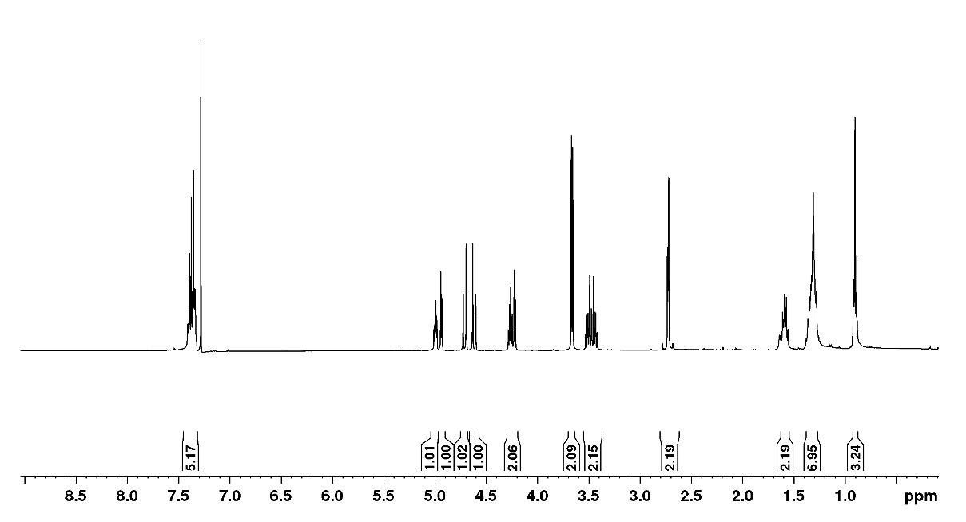
Fig. S-1. ¹H-NMR spectrum of 12 (400 MHz, CDCl₃).

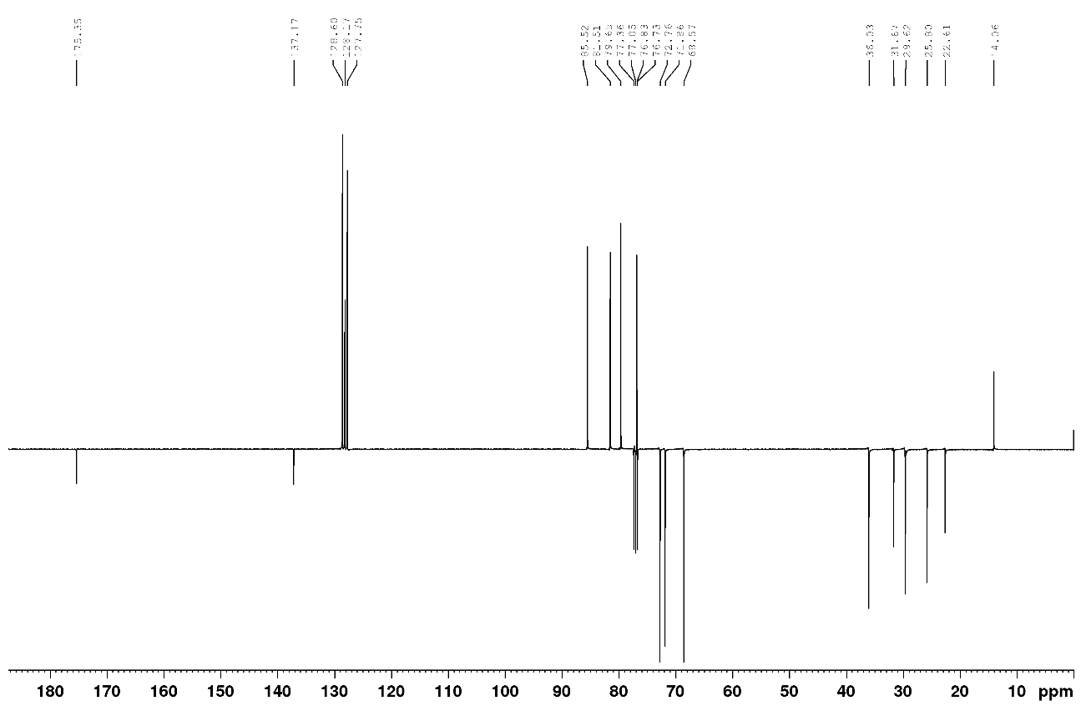
Fig. S-2. ¹³C-NMR spectrum of 12 (100 MHz, CDCl₃).

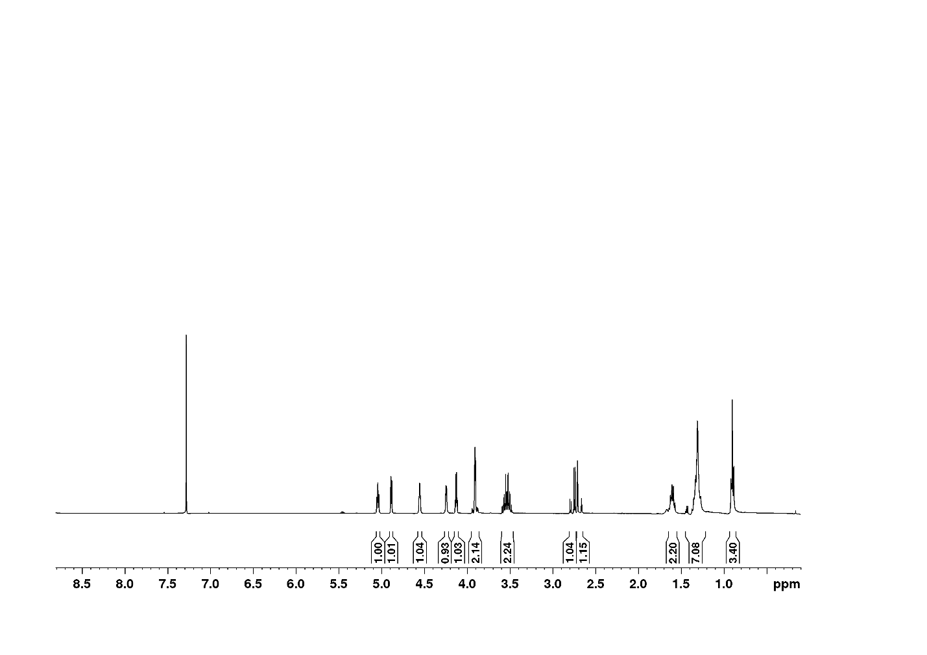
Fig. S-3. ¹H-NMR spectrum of 3 (400 MHz, CDCl₃).

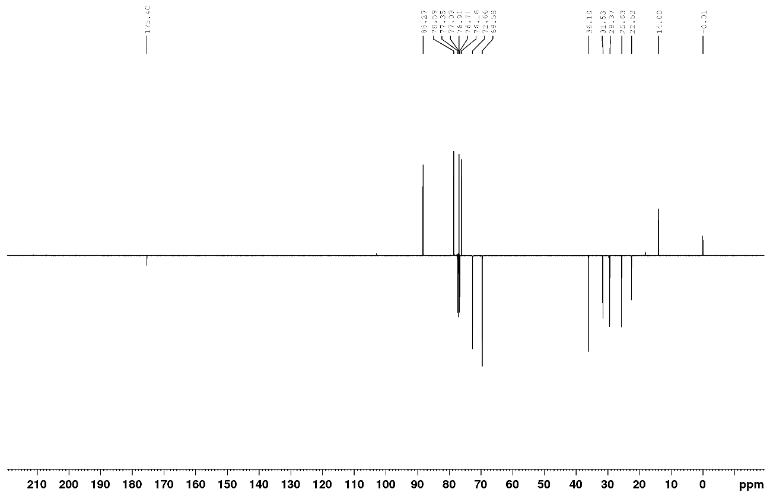
Fig. S-4. ¹³C-NMR spectrum of 3 (100 MHz, CDCl₃).
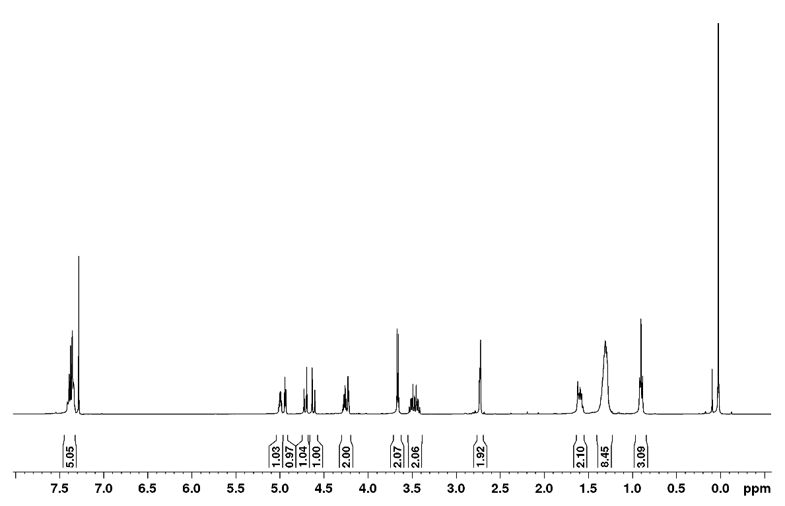
Fig. S-5. ¹H-NMR spectrum of 13 (400 MHz, CDCl₃).

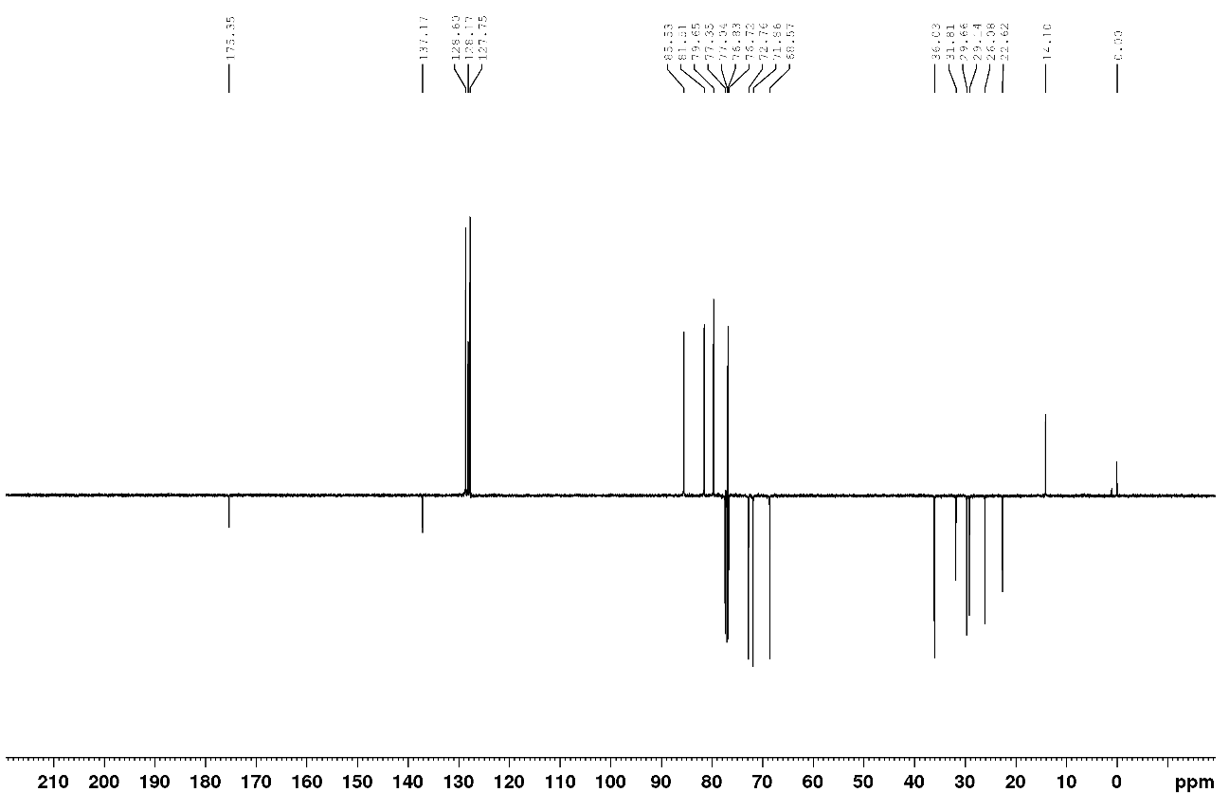
Fig. S-6. ¹³C-NMR spectrum of 13 (100 MHz, CDCl₃).

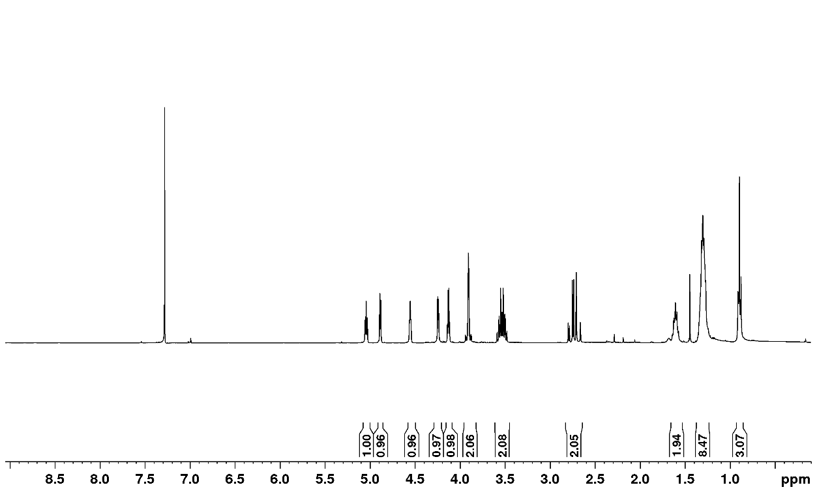
Fig. S-7. ¹H-NMR spectrum of 4 (400 MHz, CDCl₃).

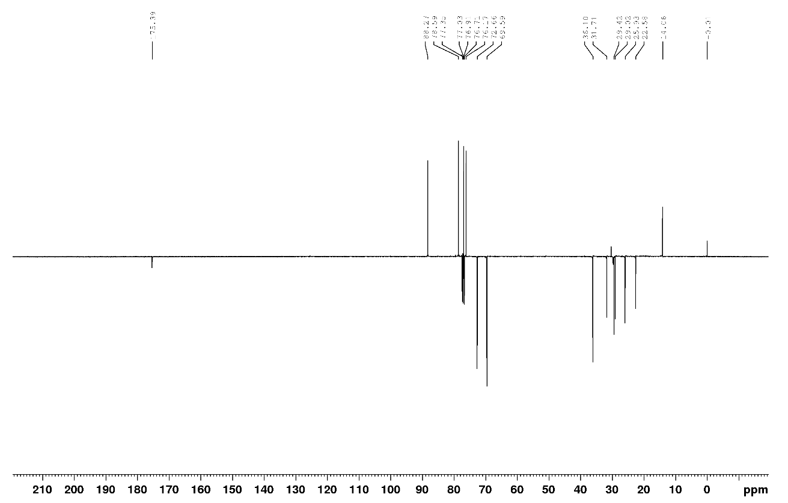
Fig. S-8. ¹³C-NMR spectrum of 4 (100 MHz, CDCl₃).
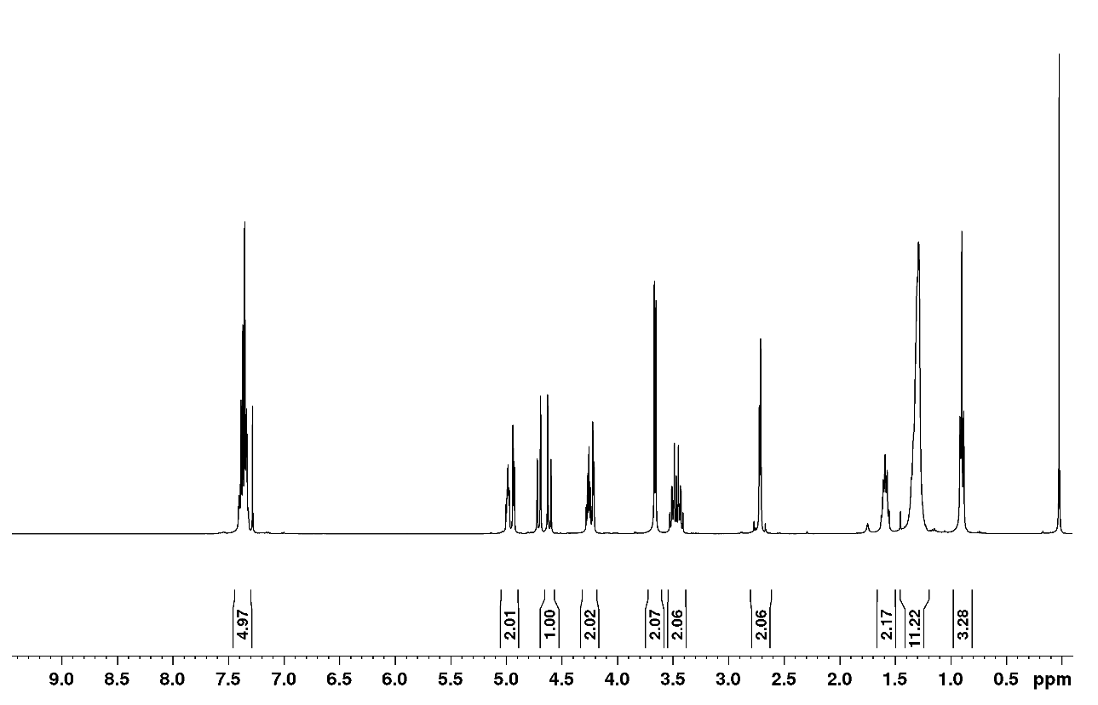
Fig. S-9. ¹H-NMR spectrum of 14 (400 MHz, CDCl₃).

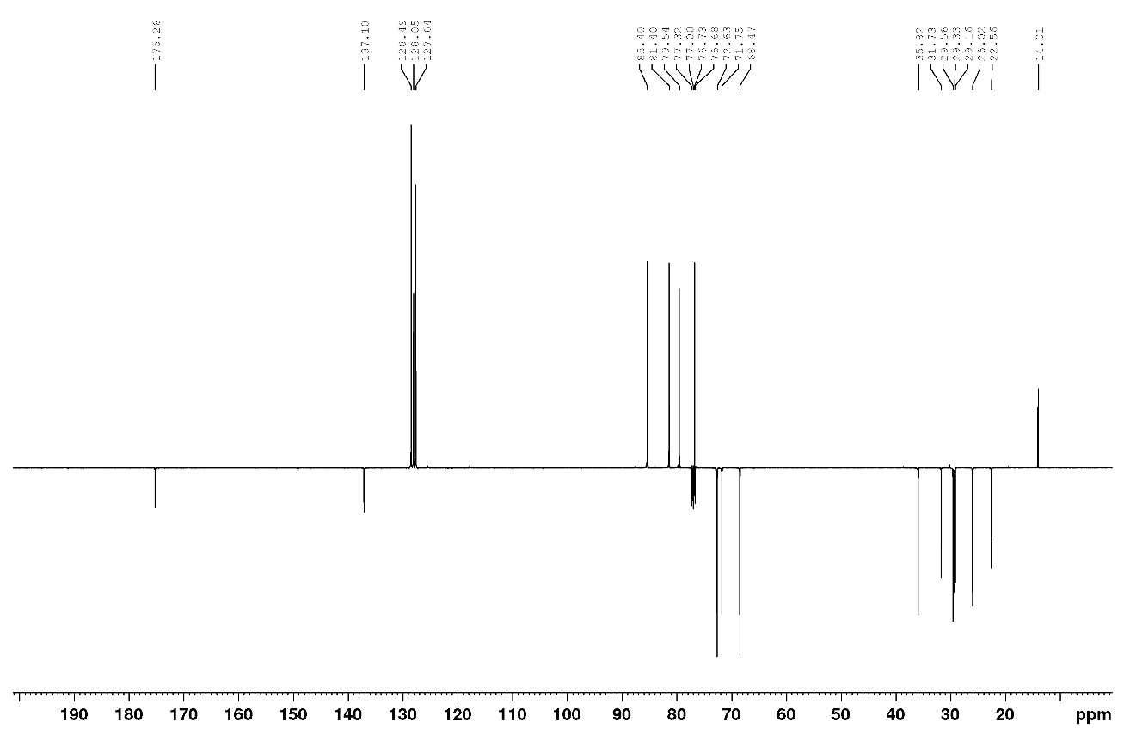
Fig. S-10. ¹³C-NMR spectrum of 14 (100 MHz, CDCl₃).
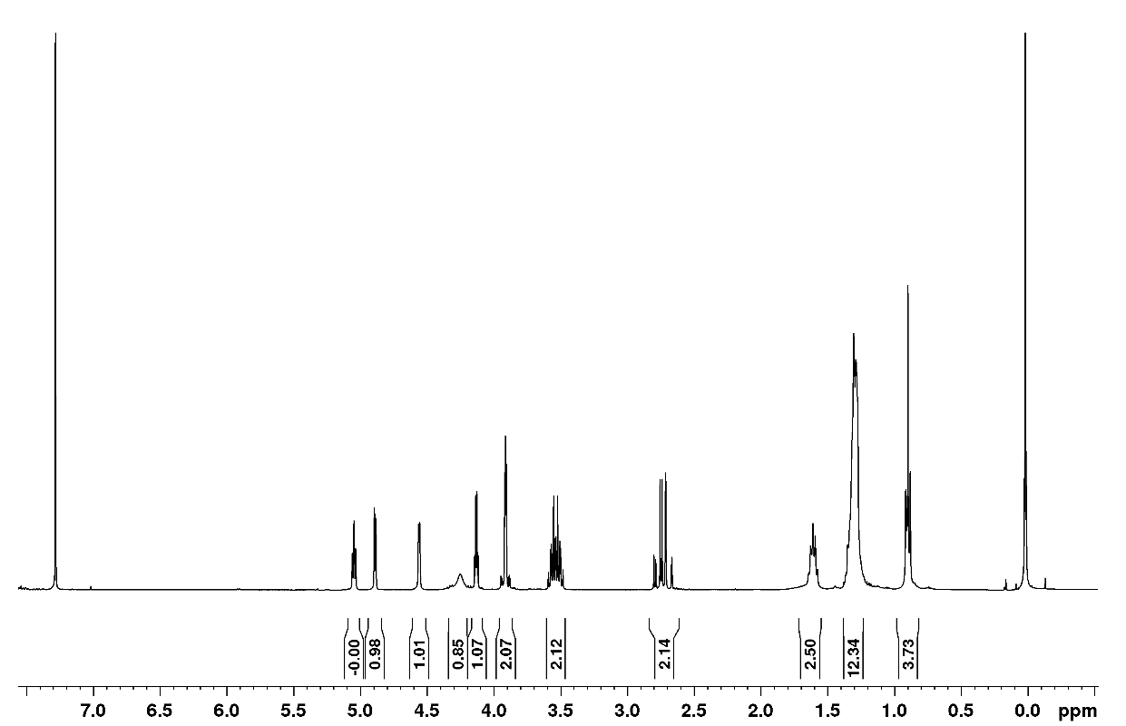
Fig. S-11. ¹H-NMR spectrum of 5 (400 MHz, CDCl₃).

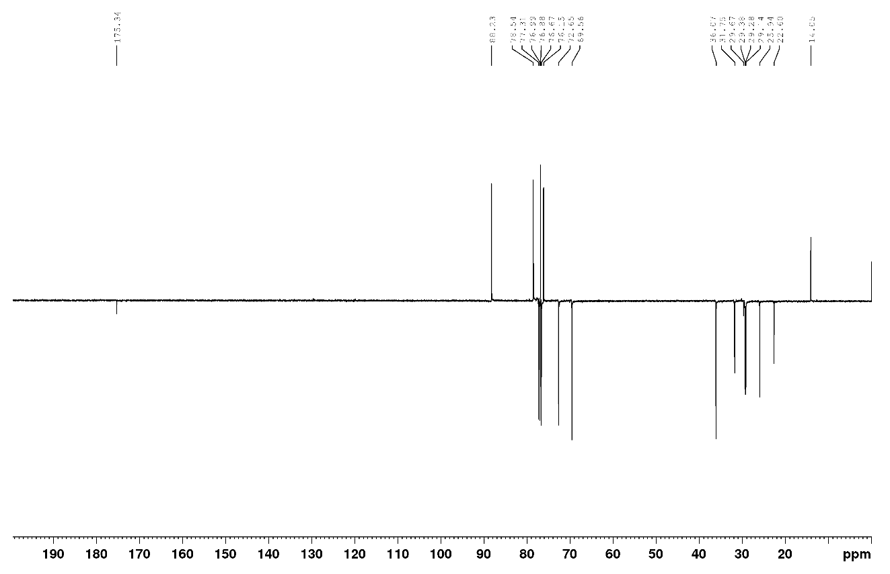
Fig. S-12. ¹³C-NMR spectrum of 5 (100 MHz, CDCl₃).

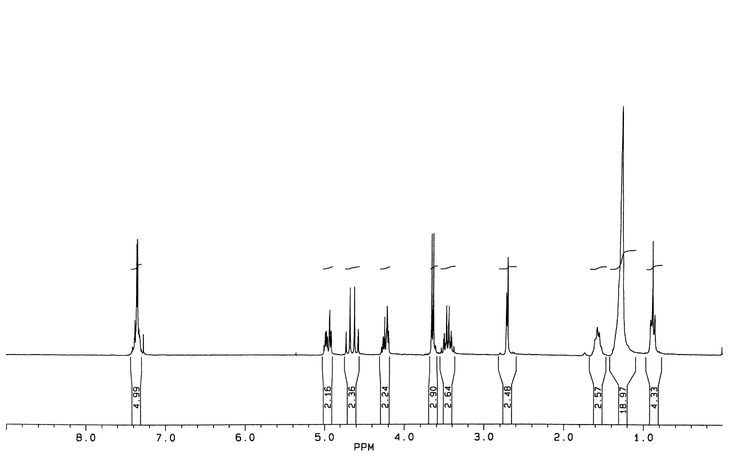
Fig. S-13. ¹H-NMR spectrum of 15 (250 MHz, CDCl₃).

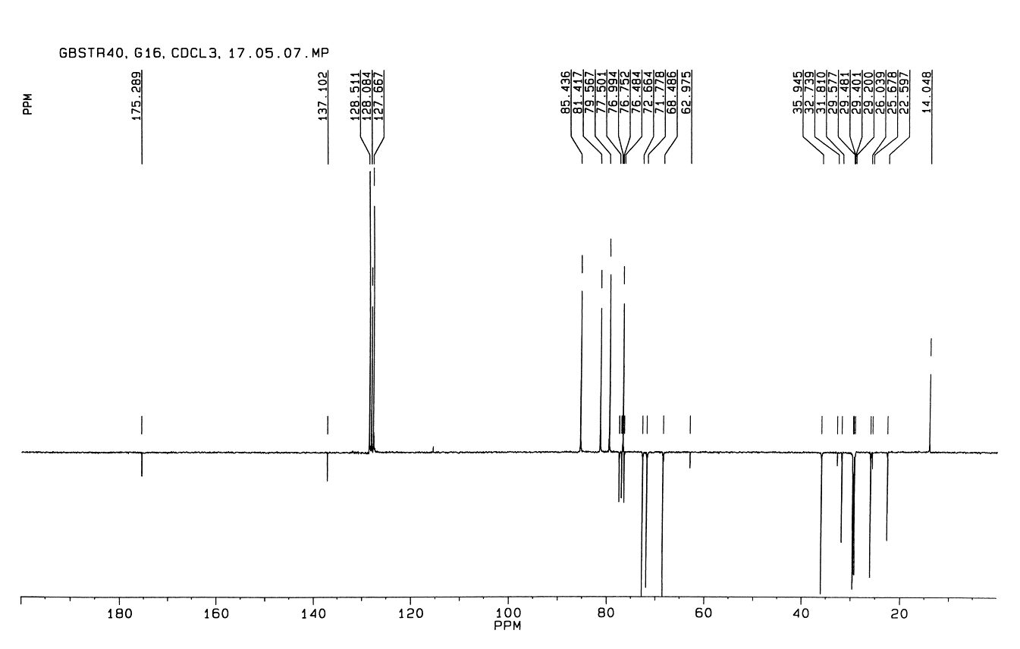
Fig. S-14. ¹³C-NMR spectrum of 15 (63.9 MHz, CDCl₃).

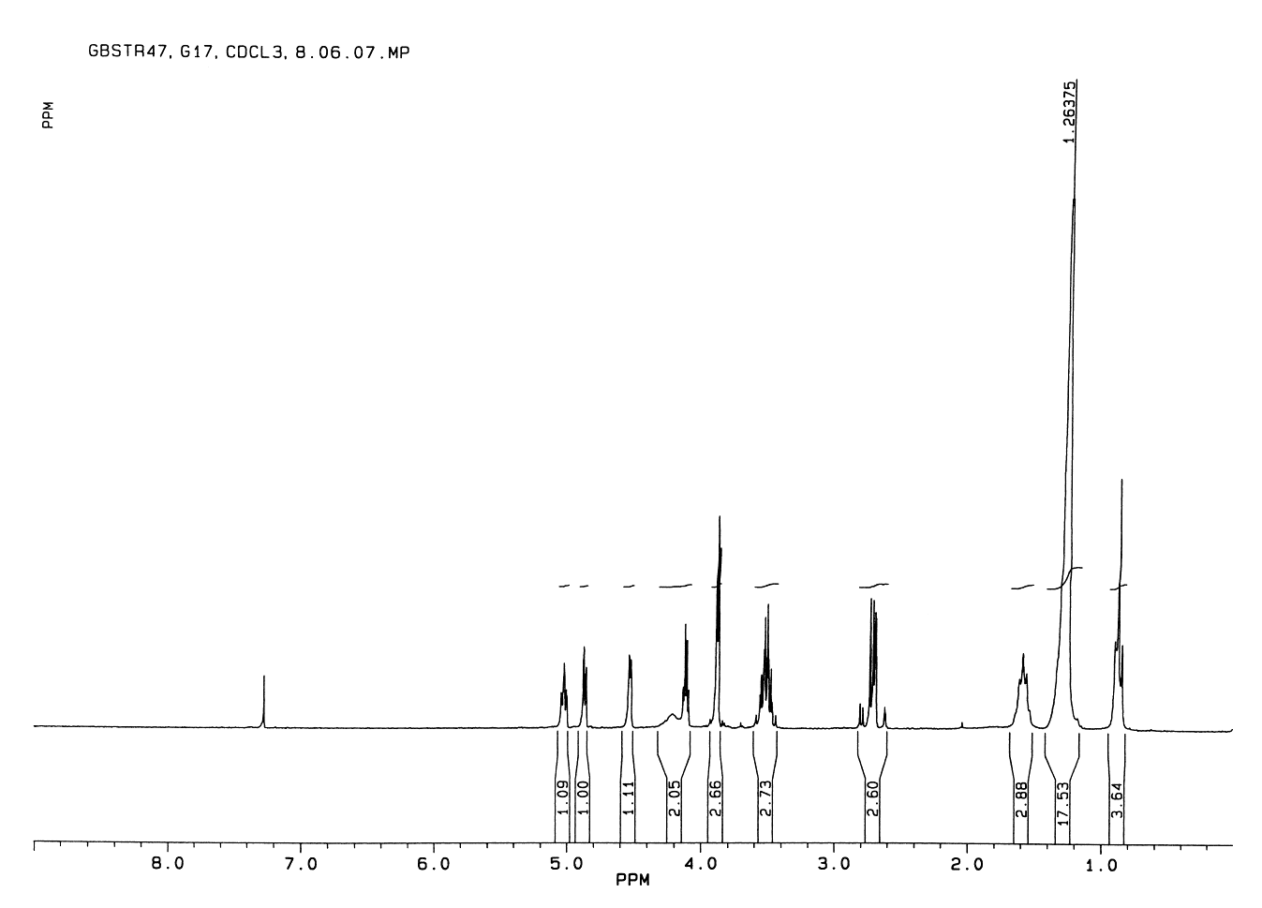
Fig. S-15. ¹H-NMR spectrum of 6 (250 MHz, CDCl₃).

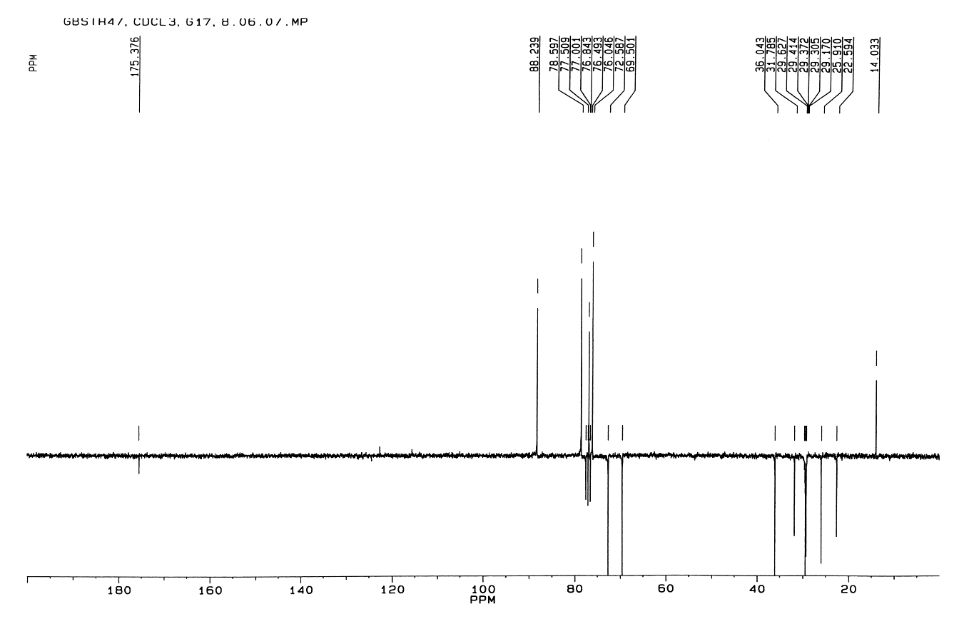
Fig. S-16. ¹³C-NMR spectrum of 6 (63.9 MHz, CDCl₃).
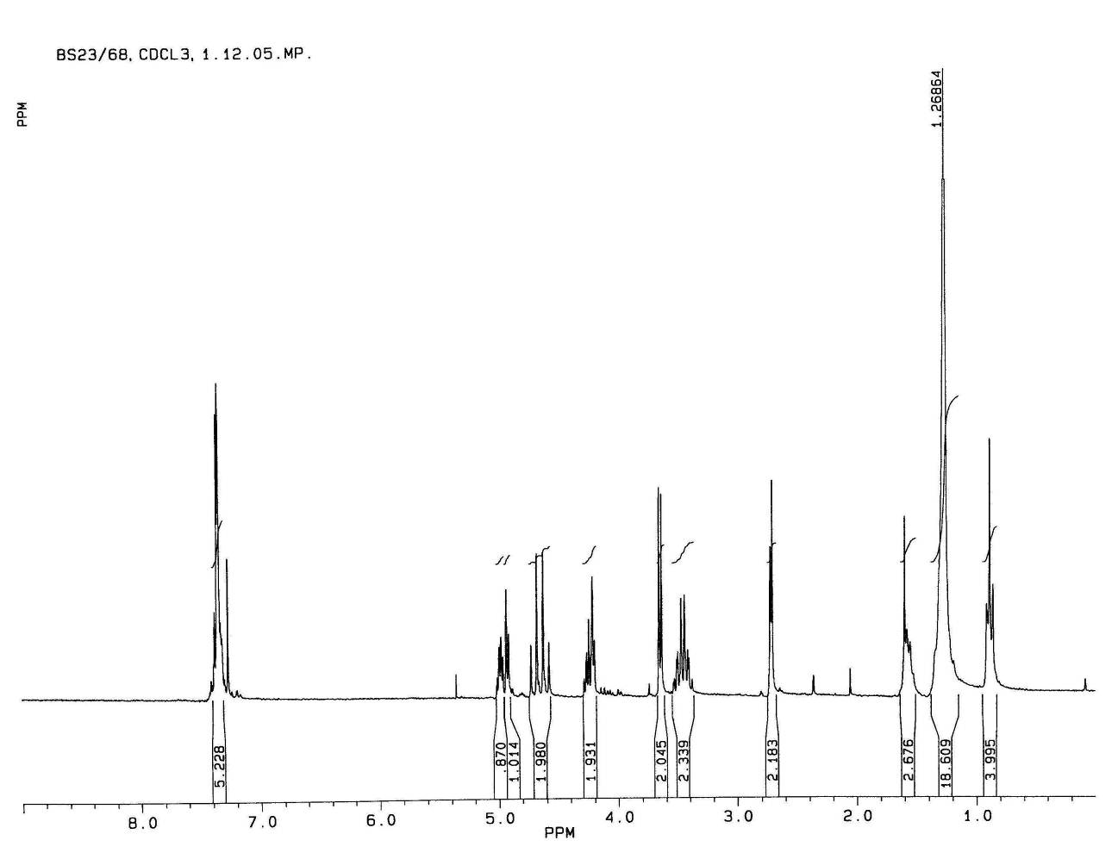Fig. S-17. ¹H-NMR spectrum of 16 (250 MHz, CDCl₃).

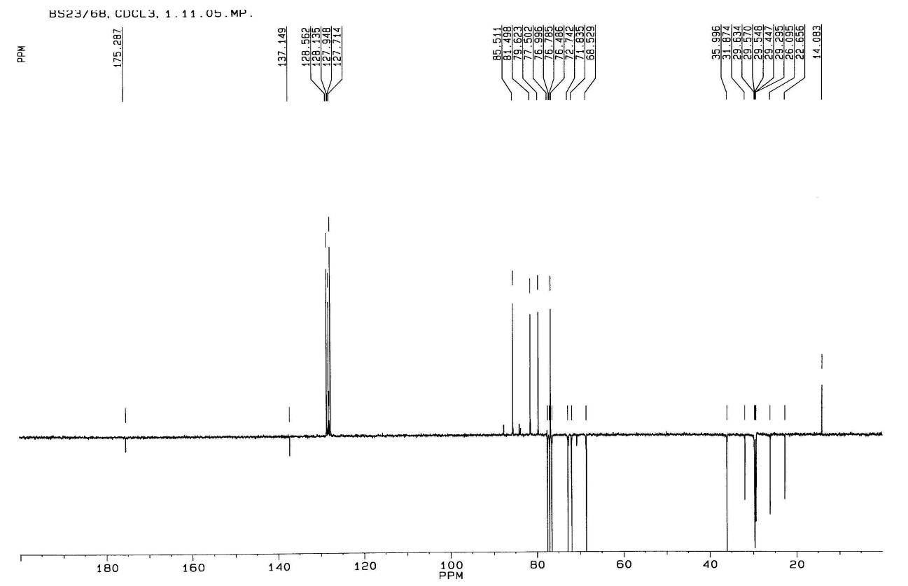
Fig. S-18. ¹³C-NMR spectrum of 16 (63.9 MHz, CDCl₃).

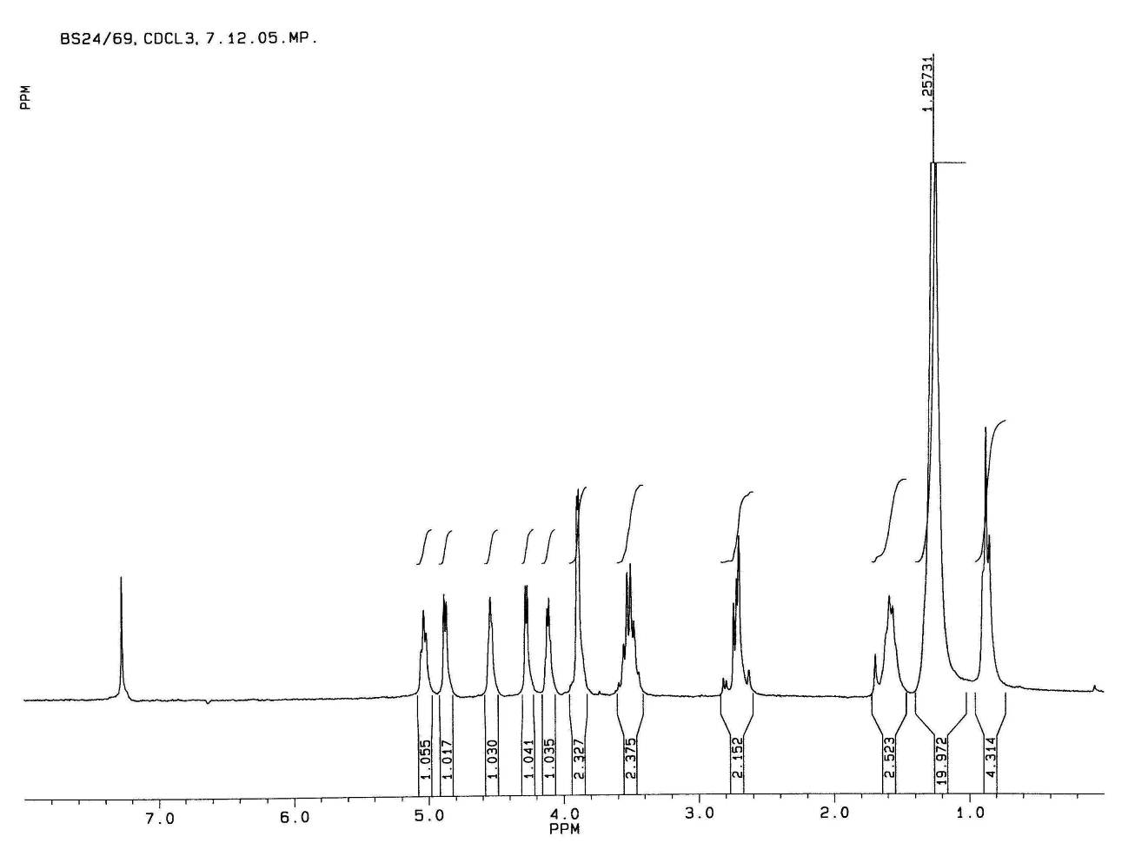
Fig. S-19. ¹H-NMR spectrum of 7 (250 MHz, CDCl₃).

Fig. S-20. ¹³C-NMR spectrum of 7 (63.9 MHz, CDCl₃).

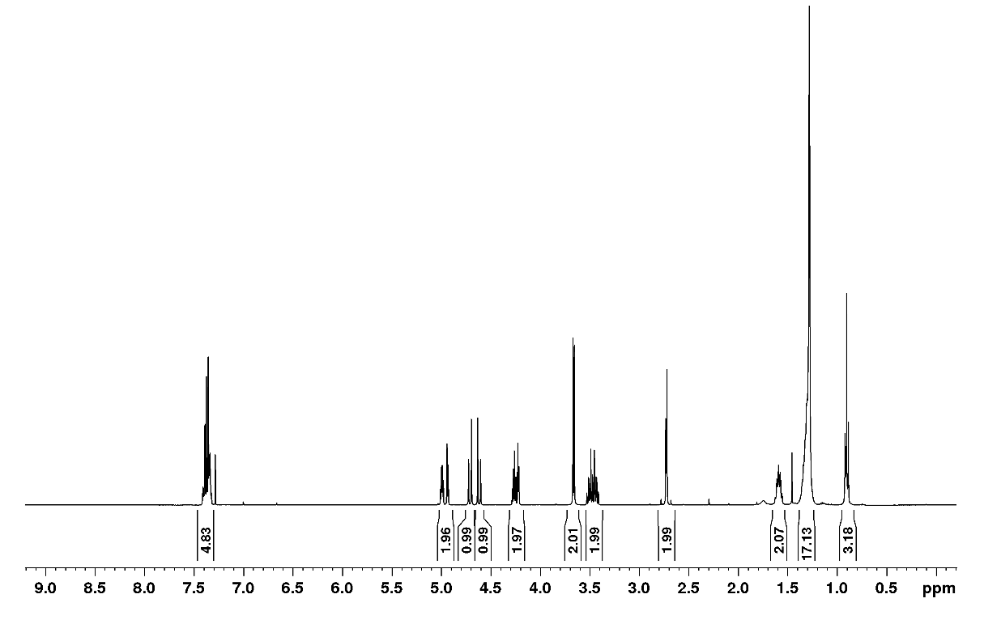
Fig. S-21. ¹H-NMR spectrum of 17 (400 MHz, CDCl₃).

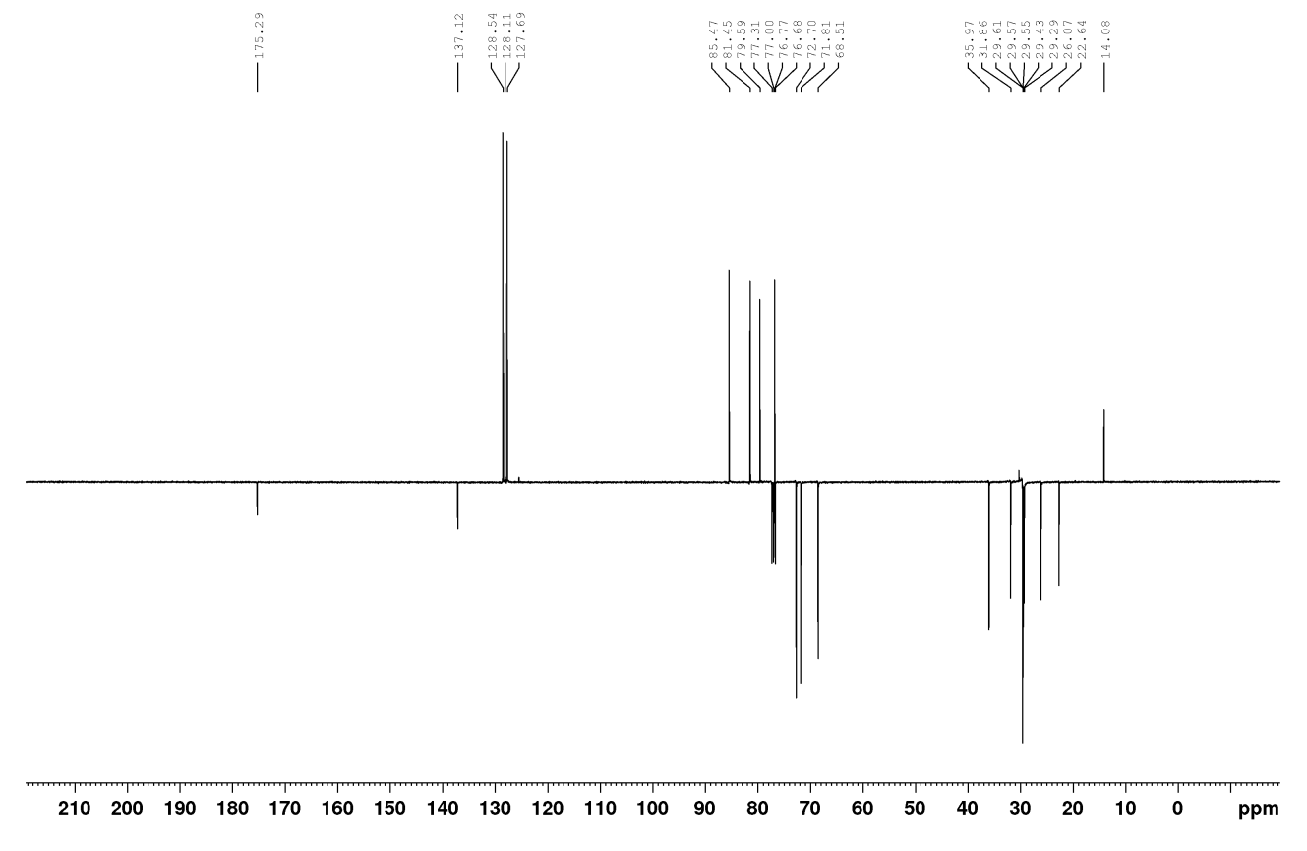
Fig. S-22. ¹³C-NMR spectrum of 17 (100 MHz, CDCl₃).

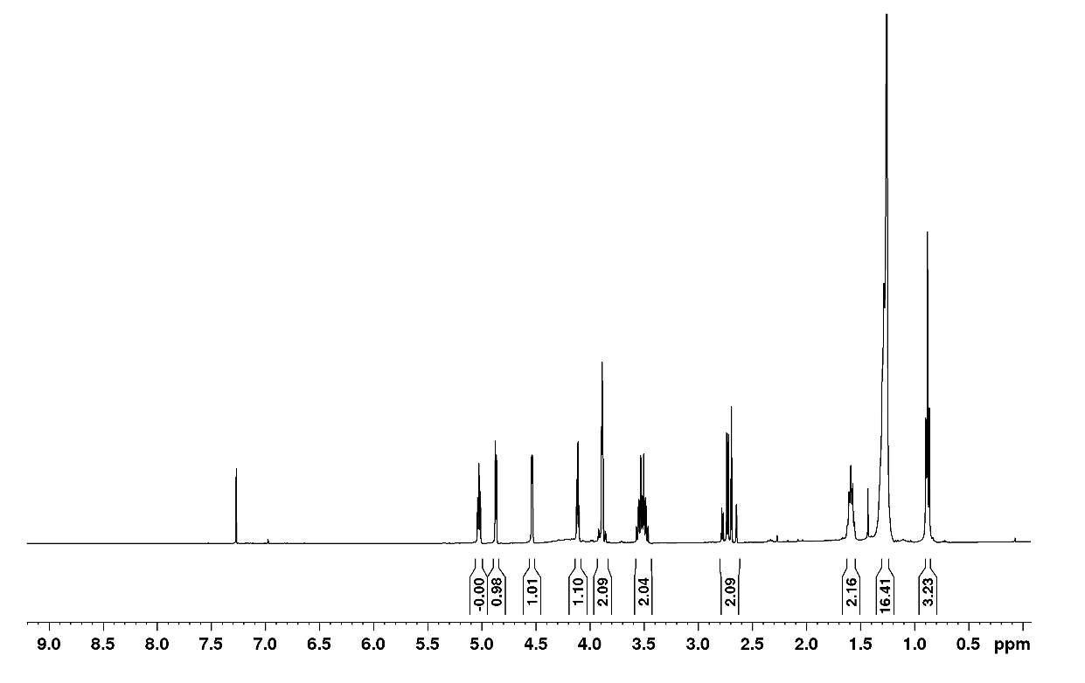
Fig. S-23. ¹H-NMR spectrum of 8 (400 MHz, CDCl₃).

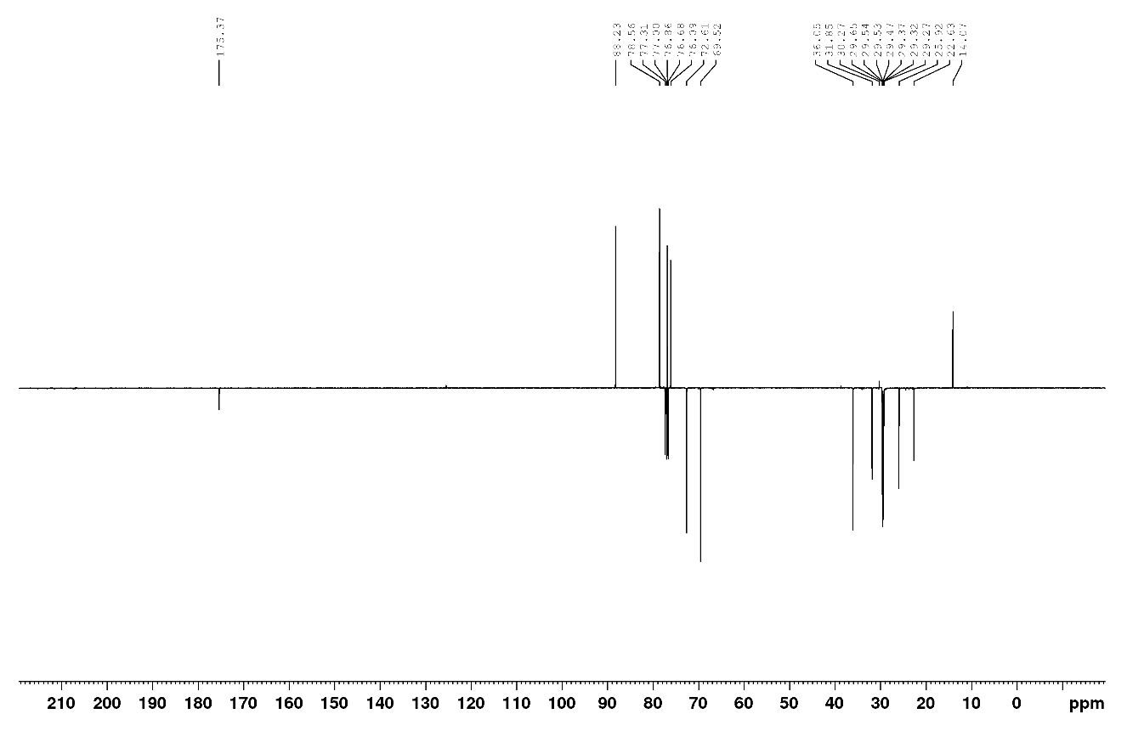
Fig. S-24. ¹³C-NMR spectrum of 8 (100 MHz, CDCl₃).
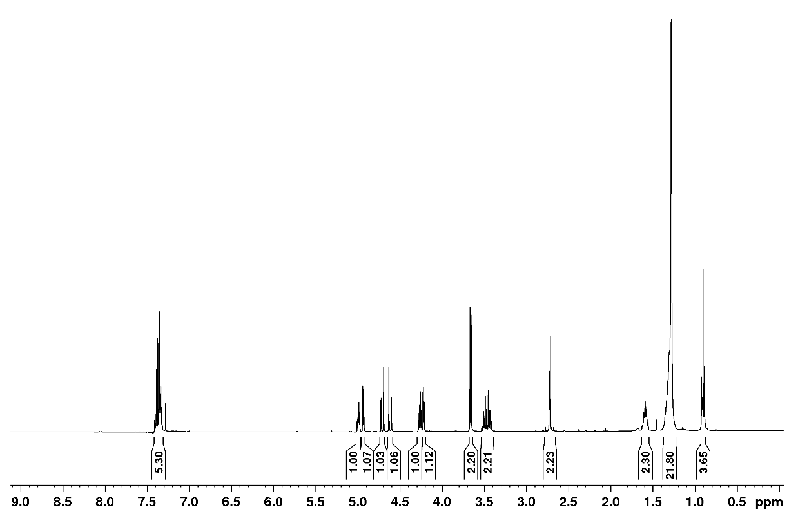
Fig. S-25. ¹H-NMR spectrum of 18 (400 MHz, CDCl₃).

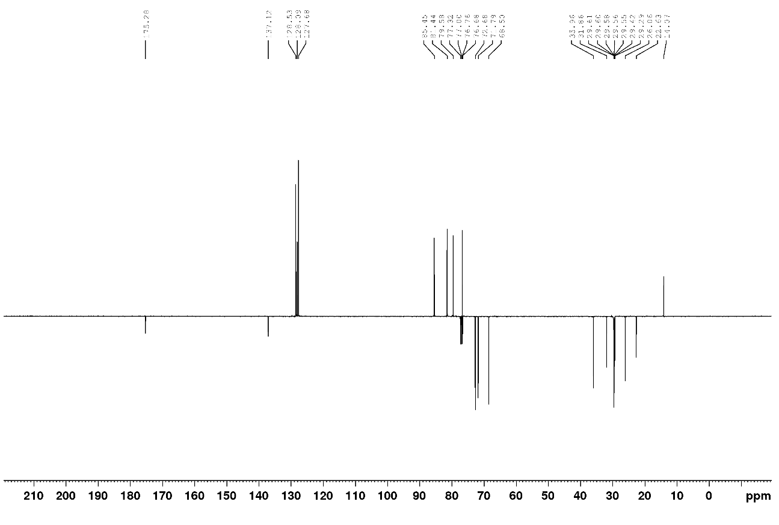
Fig. S-26. ¹³C-NMR spectrum of 18 (100 MHz, CDCl₃).
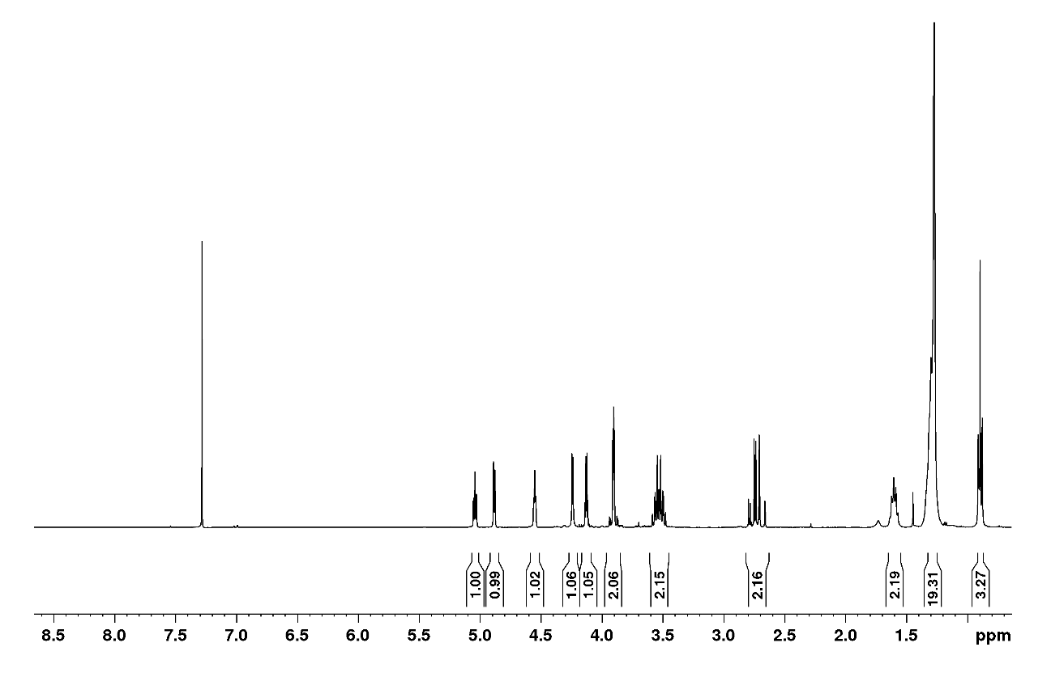
Fig. S-27. ¹H-NMR spectrum of 9 (400 MHz, CDCl₃).

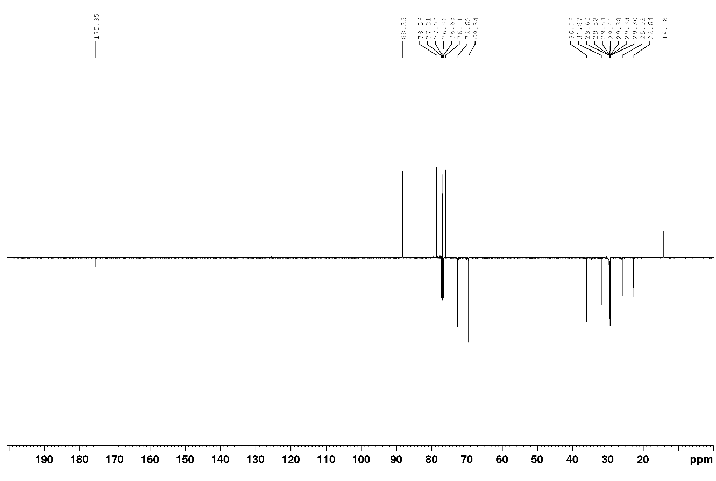
Fig. S-28. ¹³C-NMR spectrum of 9 (100 MHz, CDCl₃).
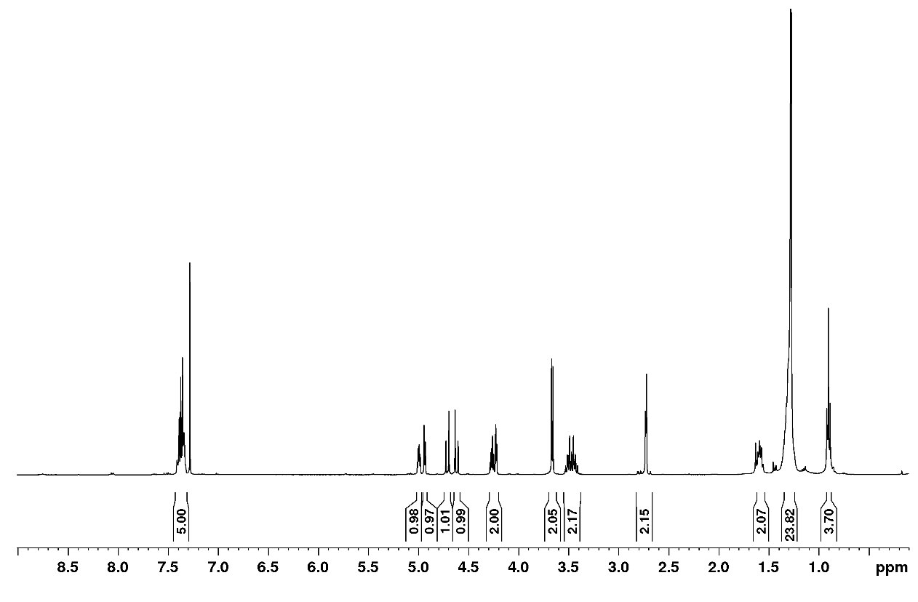
Fig. S-29. ¹H-NMR spectrum of 19 (400 MHz, CDCl₃).

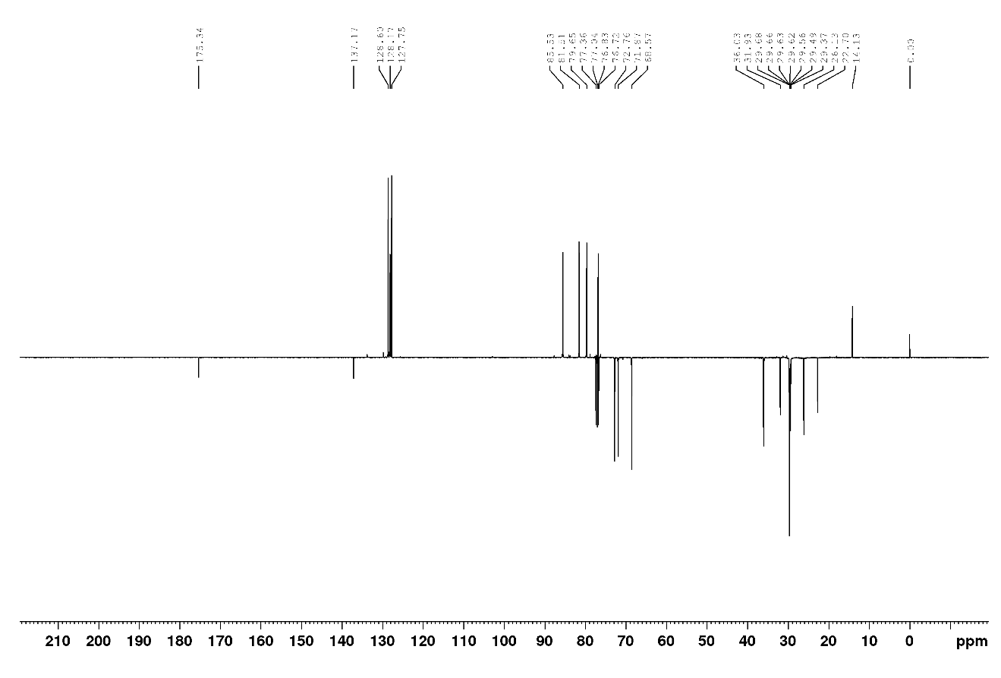
Fig. S-30. ¹³C-NMR spectrum of 19 (100 MHz, CDCl₃).
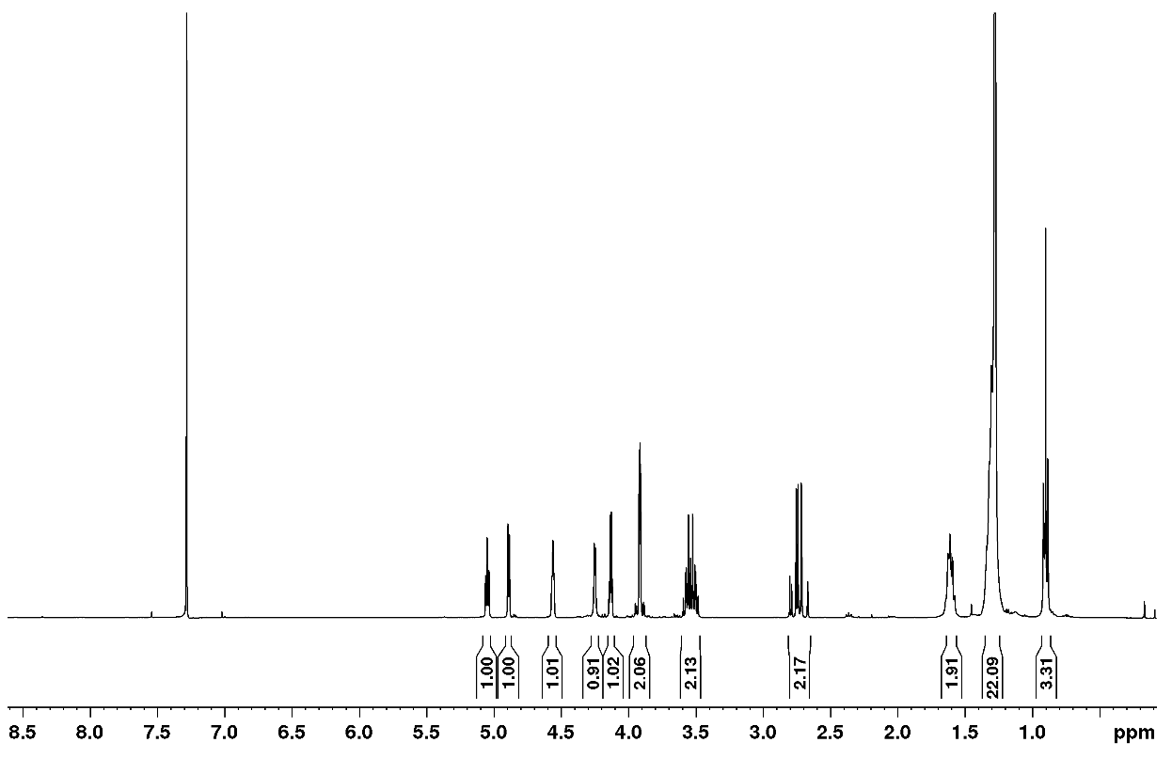
Fig. S-31. ¹H-NMR spectrum of 10 (400 MHz, CDCl₃).

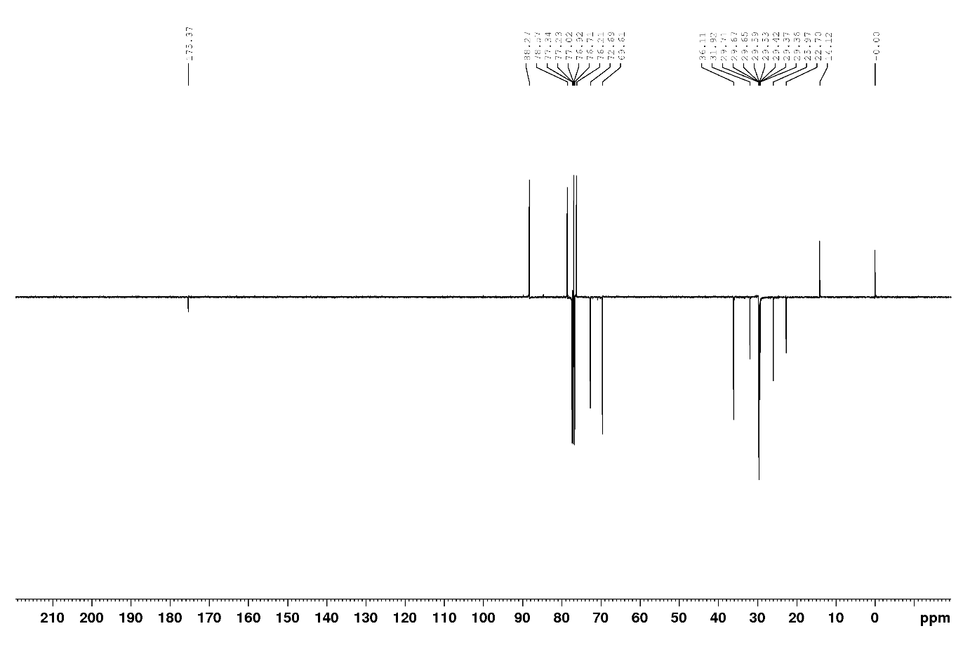
Fig. S-32. ¹³C-NMR spectrum of 10 (100 MHz, CDCl₃).
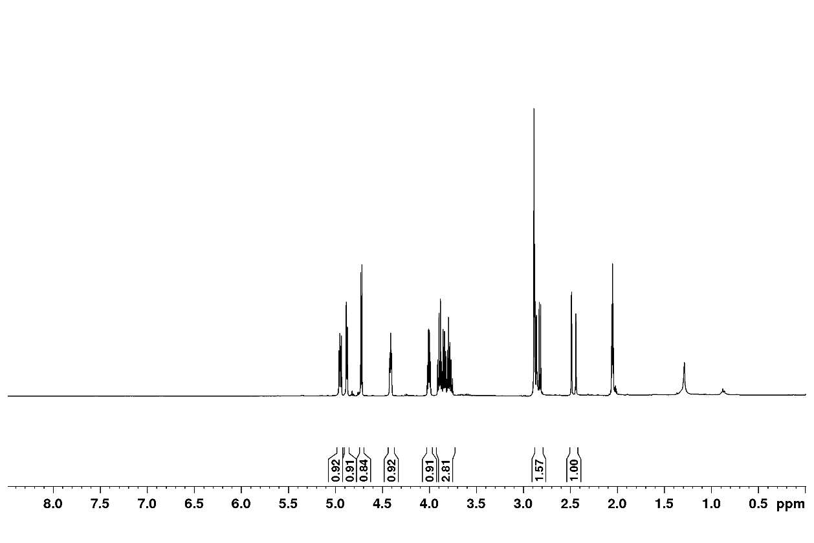
Fig. S-33. ¹H-NMR spectrum of 2 (400 MHz, acetone-d₆).

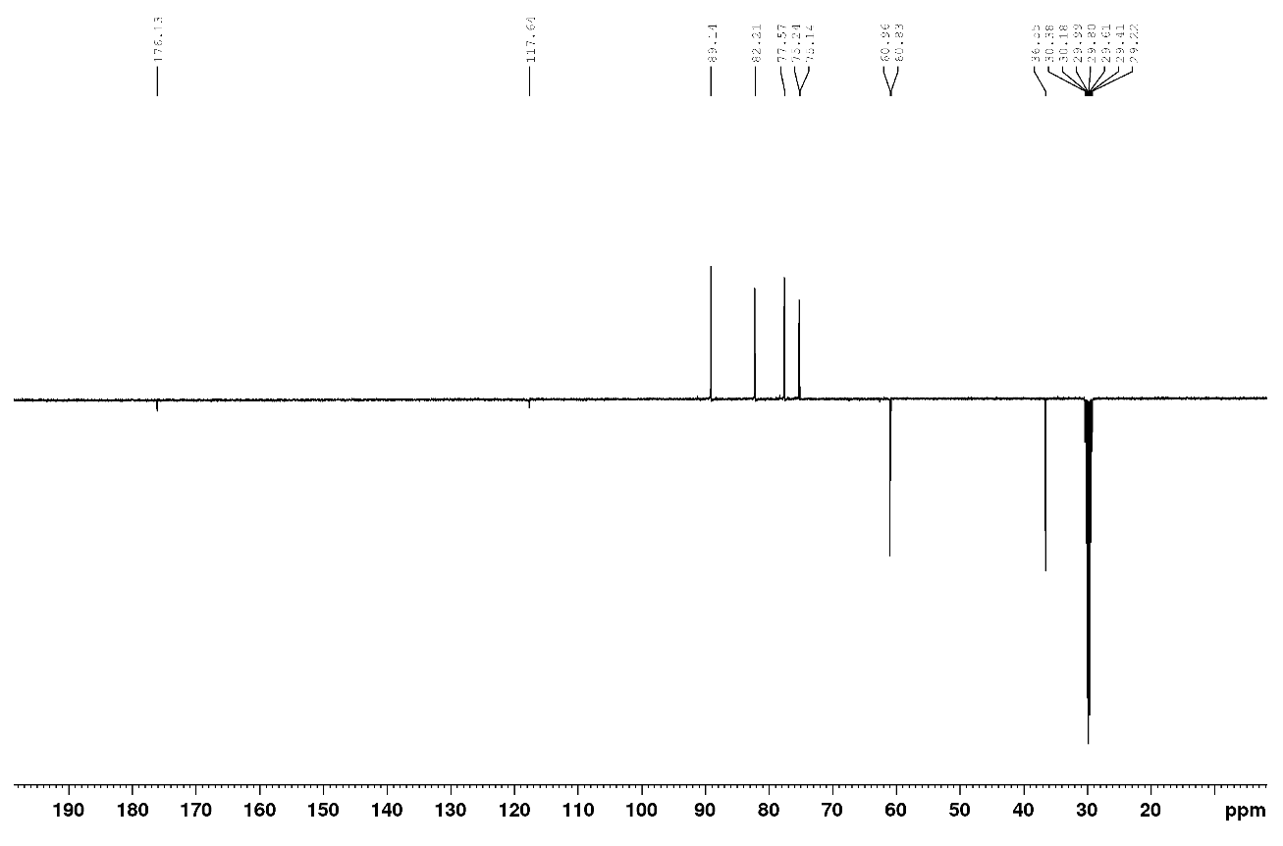
Fig. S-34. ¹³C-NMR spectrum of 2 (100 MHz, acetone-d₆).

SAR ANALYSIS
TABLE S-1. Cytotoxicity data for SAR analysis.
Compounds | IC₅₀ (µM) ª, 72 h
Compounds | K562 | HL-60 | Jurkat | Raji | MCF-7 | MDA-MB 231 | HeLa | A549
1 | 2.96 | 224.61 | 2.49 | 23.42 | 51.27 | 598.66 | 785.31 | 2.36
2 | 2.69 | 9.97 | 9.51 | 7.40 | 9.64 | 0.24 | 5.22 | 31.45
3 | 0.70 | 4.91 | 8.87 | 1.11 | 12.34 | 15.62 | 3.54 | 2.43
4 | 1.02 | 1.10 | 11.53 | 5.98 | 2.38 | 9.76 | 0.56 | 4.43
5 | 0.74 | 0.68 | 19.78 | 4.25 | 0.34 | 28.70 | 3.41 | 4.19
6 | 8.61^{b} | 1.53^{b} | 6.64^{b} | 7.25 | 102.36 | 296.78 | 9.59^{b} | 0.92
7 | 1.25^{b} | 0.14^{b} | 103.27^{b} | 76.36 | 89.36 | 112.36 | 0.30^{b} | 29.05
8 | 0.18 | 1.83 | 16.26 | 2.79 | 2.28 | 26.57 | 4.11 | 7.72
9 | 3.46 | 8.25 | 8.02 | 3.52 | 5.31 | 7.63 | 2.25 | 3.96
10 | 4.87 | 3.96 | 4.29 | 4.88 | 15.36 | 36.47 | 10.32 | 0.025
ª IC₅₀ is the concentration of compound required to inhibit the cell growth by 50% compared to an untreated control. Values are means of three independent experiments. Coefficients of variation were less than 10%.
^{b} Taken from reference 22.
The structure-activity relationships were accessed as follows: the IC₅₀ values of two compounds were compared, and the ∆ log IC₅₀ was calculated (∆ log IC₅₀ is a difference between the log IC₅₀ values of an analogue and the corresponding control compound). Positive ∆ log IC₅₀ values show a decrease of antiproliferative activity, whereas negative values indicate an increase in the activity upon the structural modification being considered. The results are presented in Figure S-35.
Fig. S-35. SAR Analysis. Influence of: (A) replacement of the hydroxybenzyl group in 1 with an alkoxymethyl chain; (B) introduction of an alkyl chain at the 7-OH position in molecule 2; (C) increasing the number of carbon atoms in the side chain of analogues 3–10.

K. Bock, I. Lundt, C. Pedersen, Carbohydr. Res. 179 (1988) 87.
V. Popsavin, B. Srećo, G. Benedeković, M. Popsavin, J. Francuz, V. Kojić, G. Bogdanović, Bioorg. Med. Chem. Lett. 18 (2008) 5182.

