Synthesis, Structural Characterization and Myorelaxant Activity of 4-Naphthyl-Hexahydroquinoline Derivatives Containing Different Ester Groups

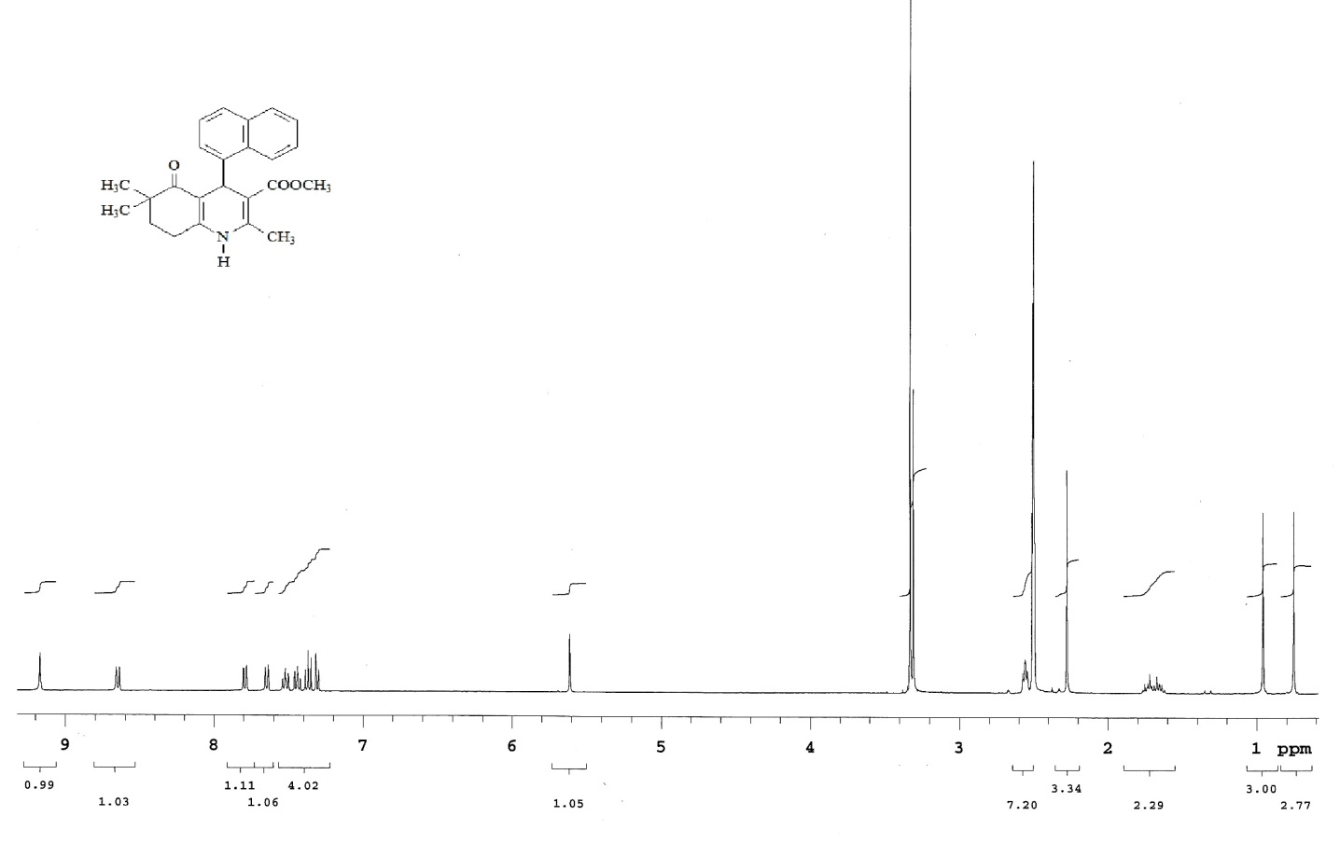
¹H-NMR spectrum of compound 1

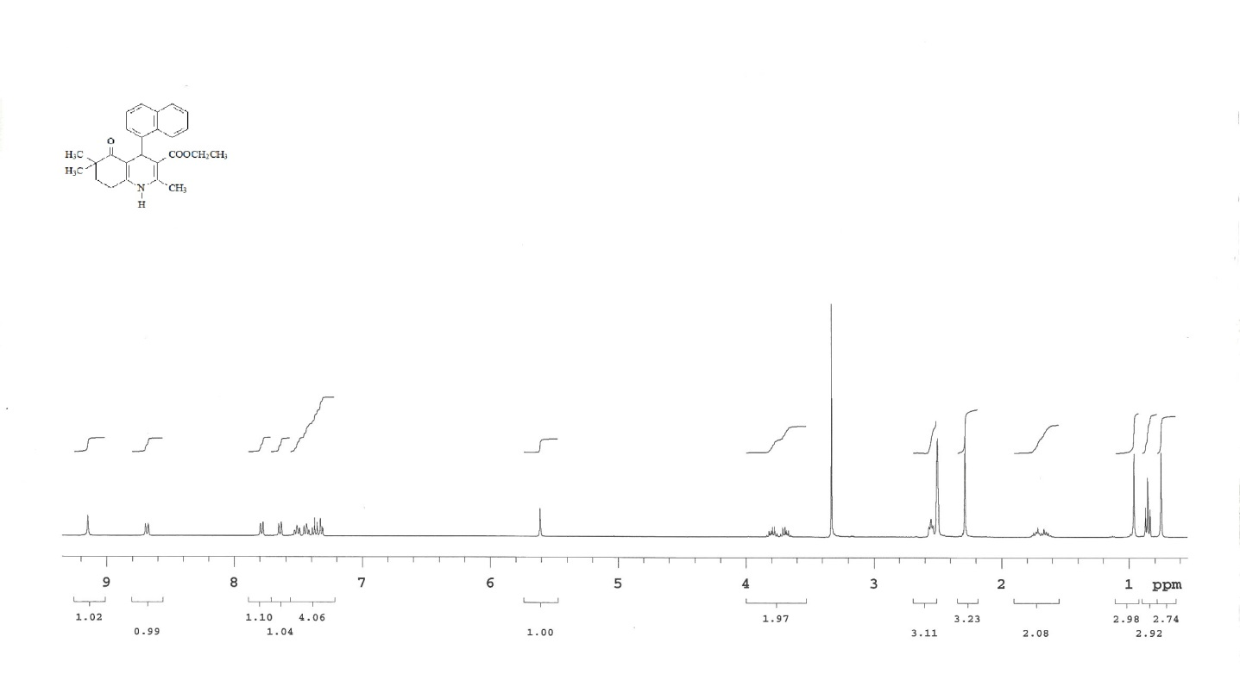
¹H-NMR spectrum of compound 2

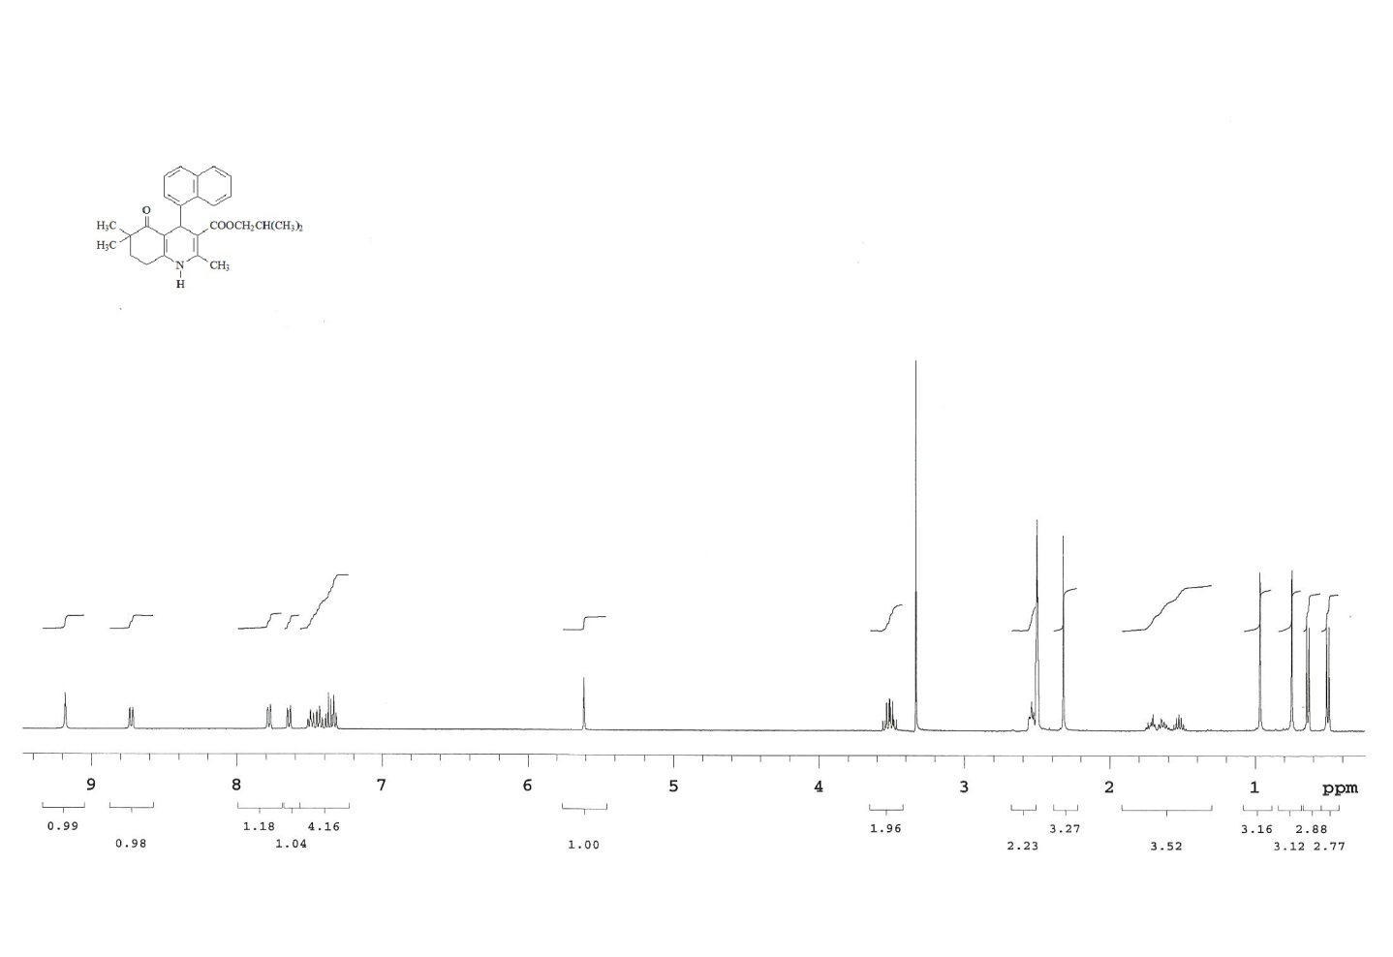
¹H-NMR spectrum of compound 4

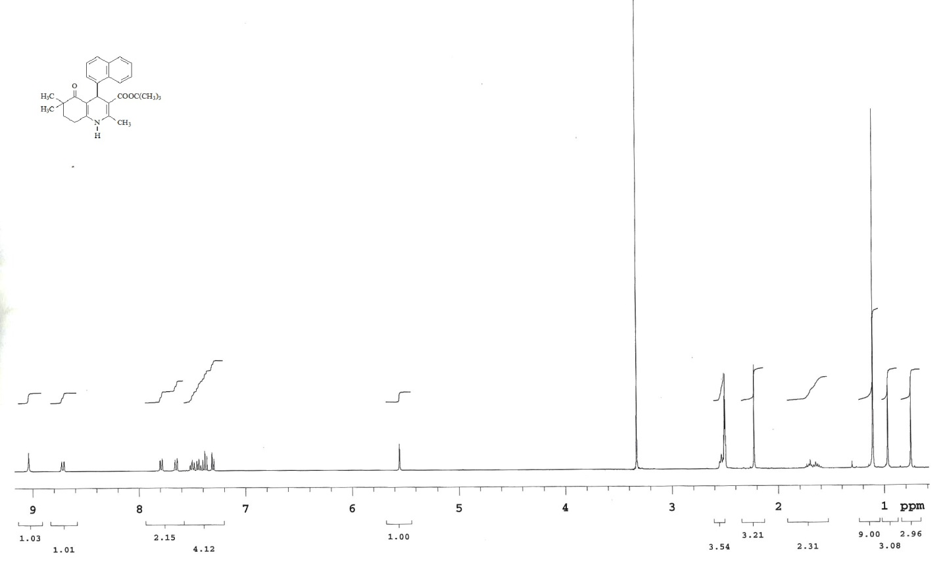
¹H-NMR spectrum of compound 5

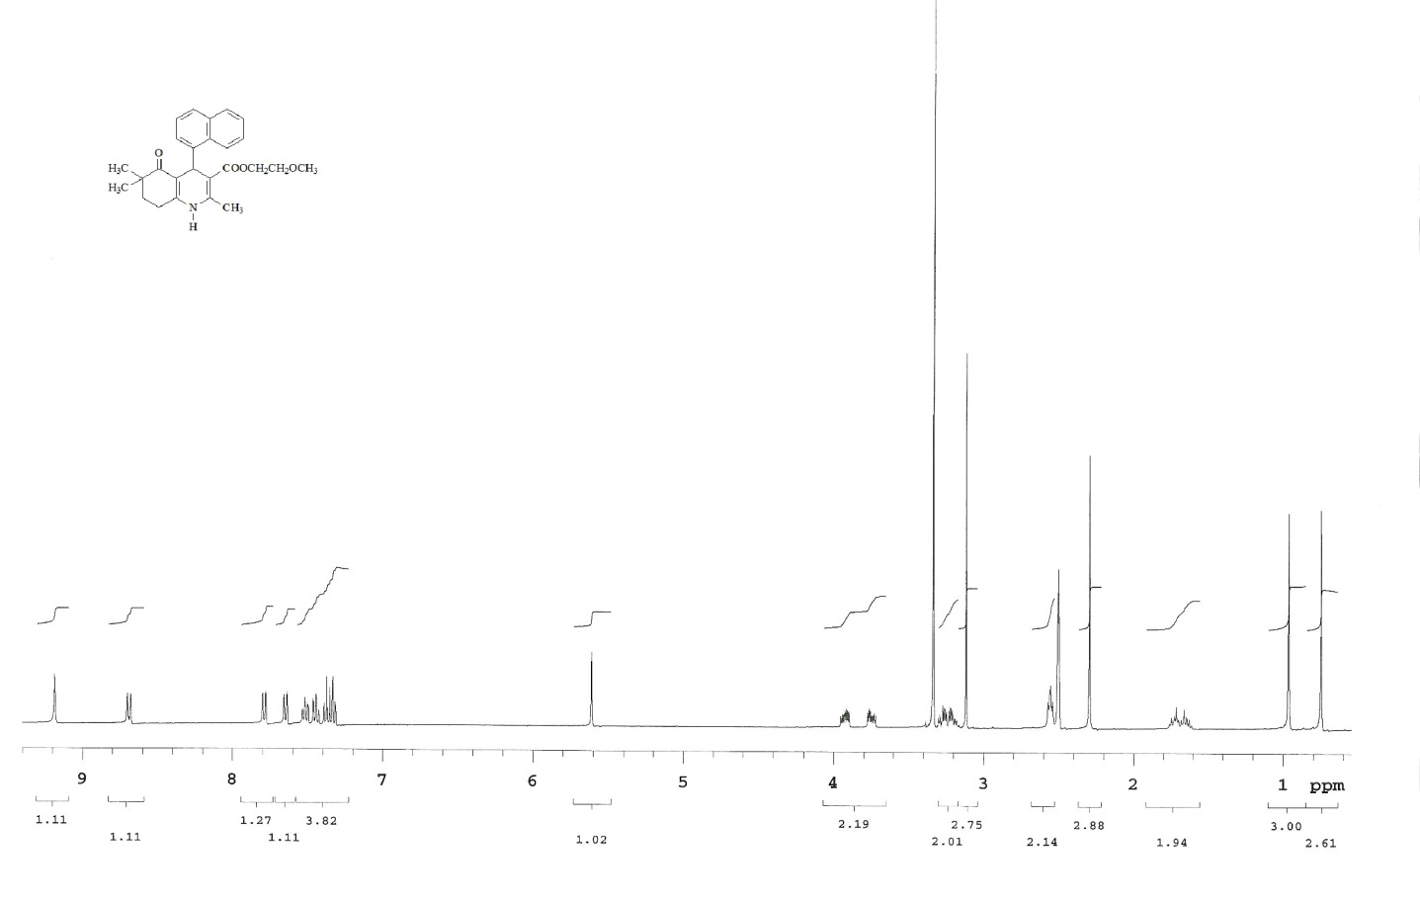
¹H-NMR spectrum of compound 6
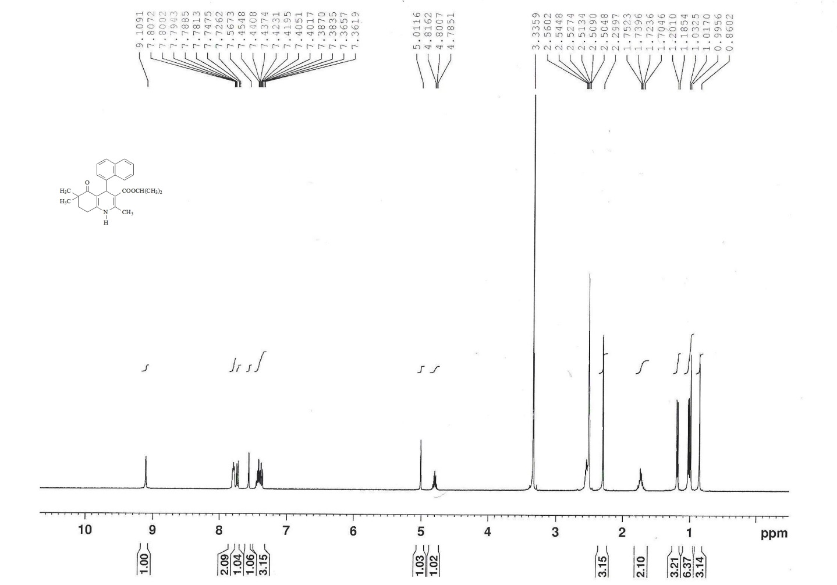
¹H-NMR spectrum of compound 11

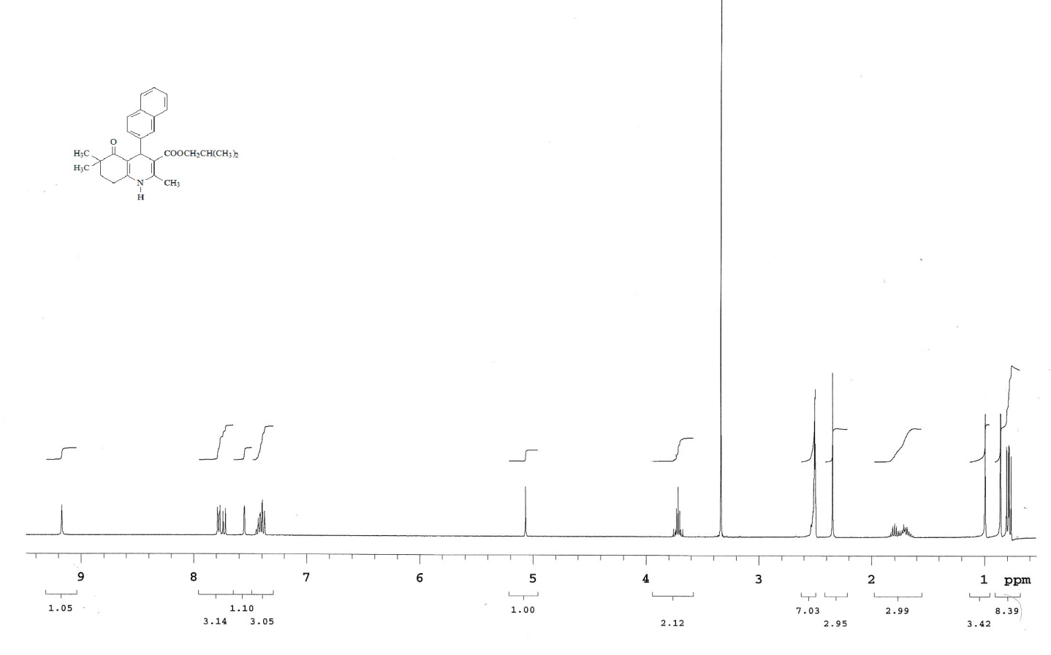
¹H-NMR spectrum of compound 12

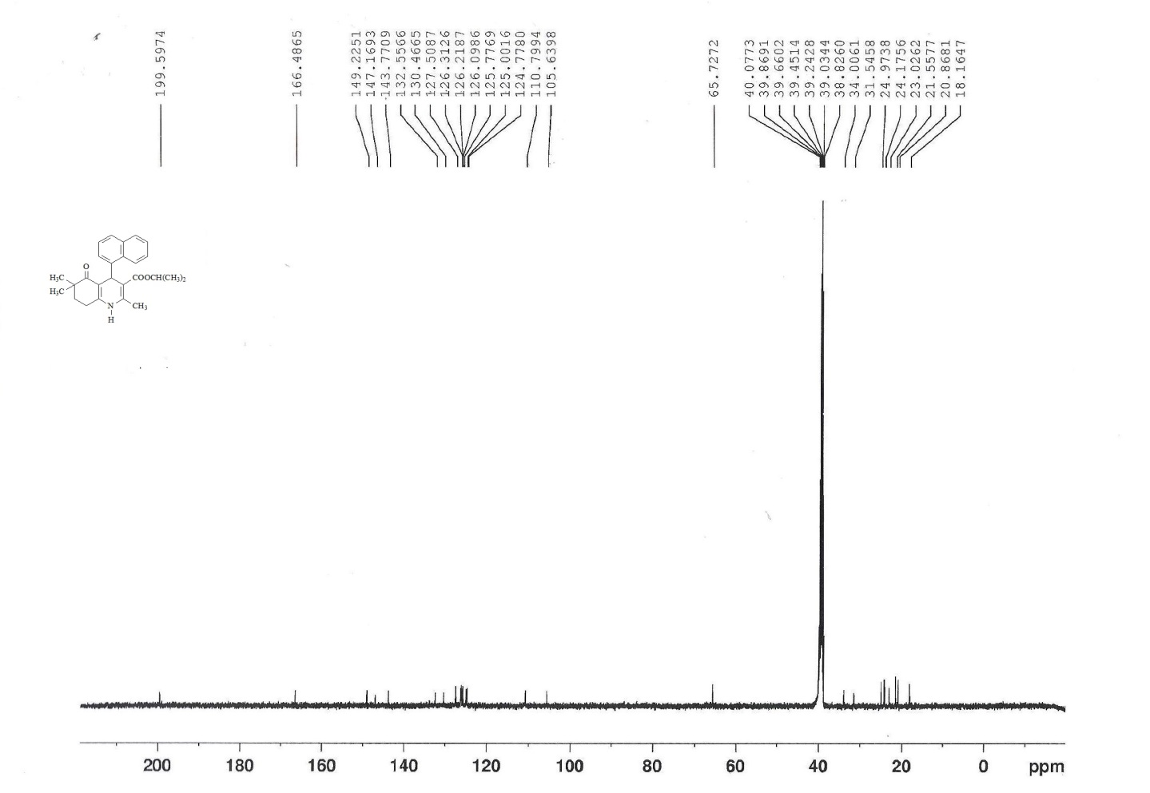
¹³C-NMR spectrum of compound 3

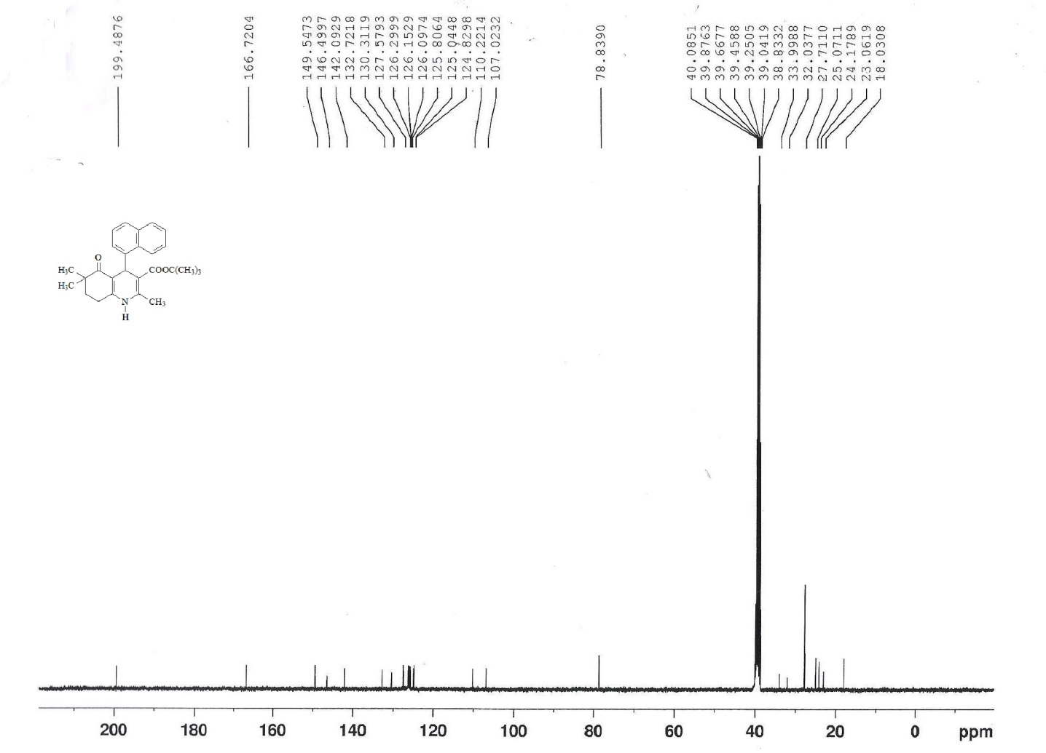
¹³C-NMR spectrum of compound 5

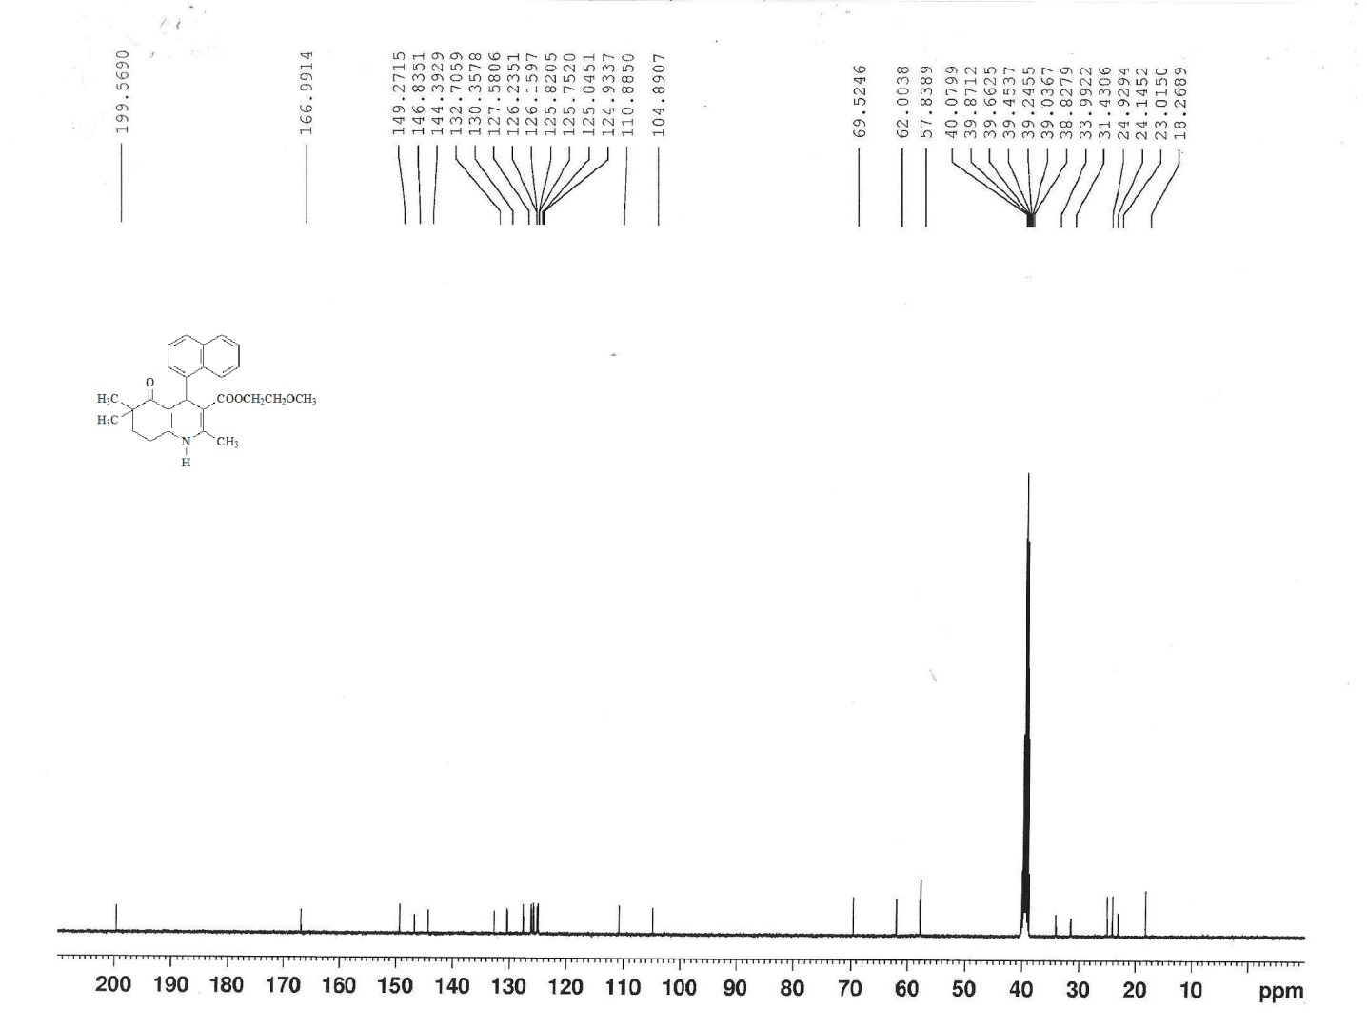
¹³C-NMR spectrum of compound 6

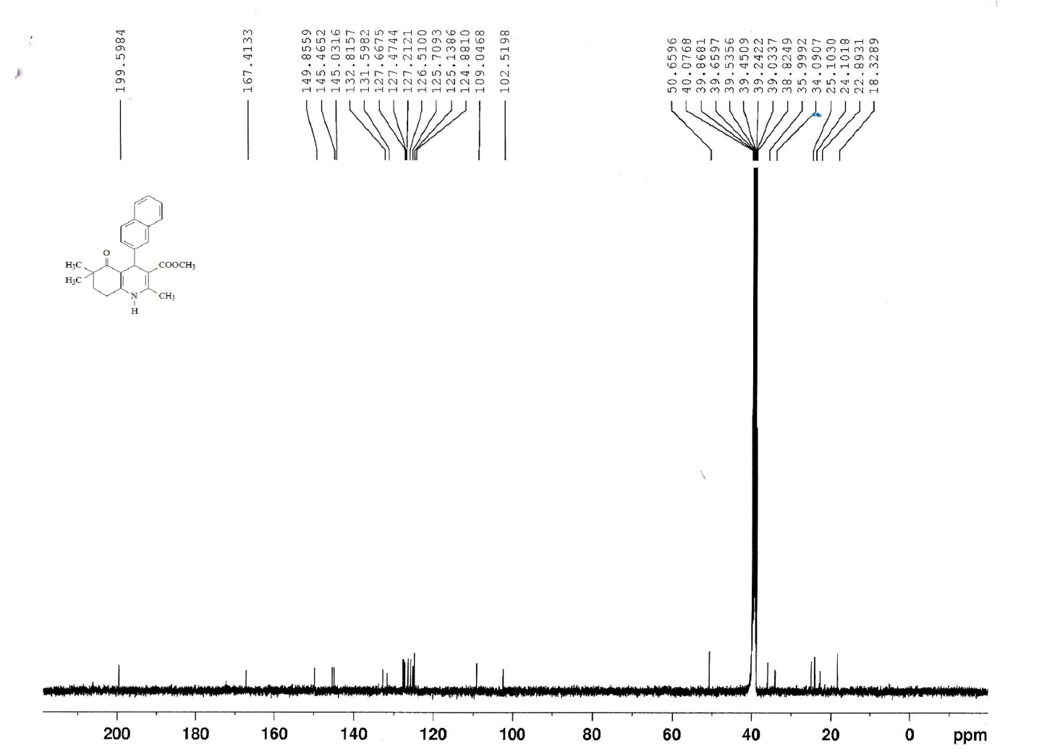
¹³C-NMR spectrum of compound 9

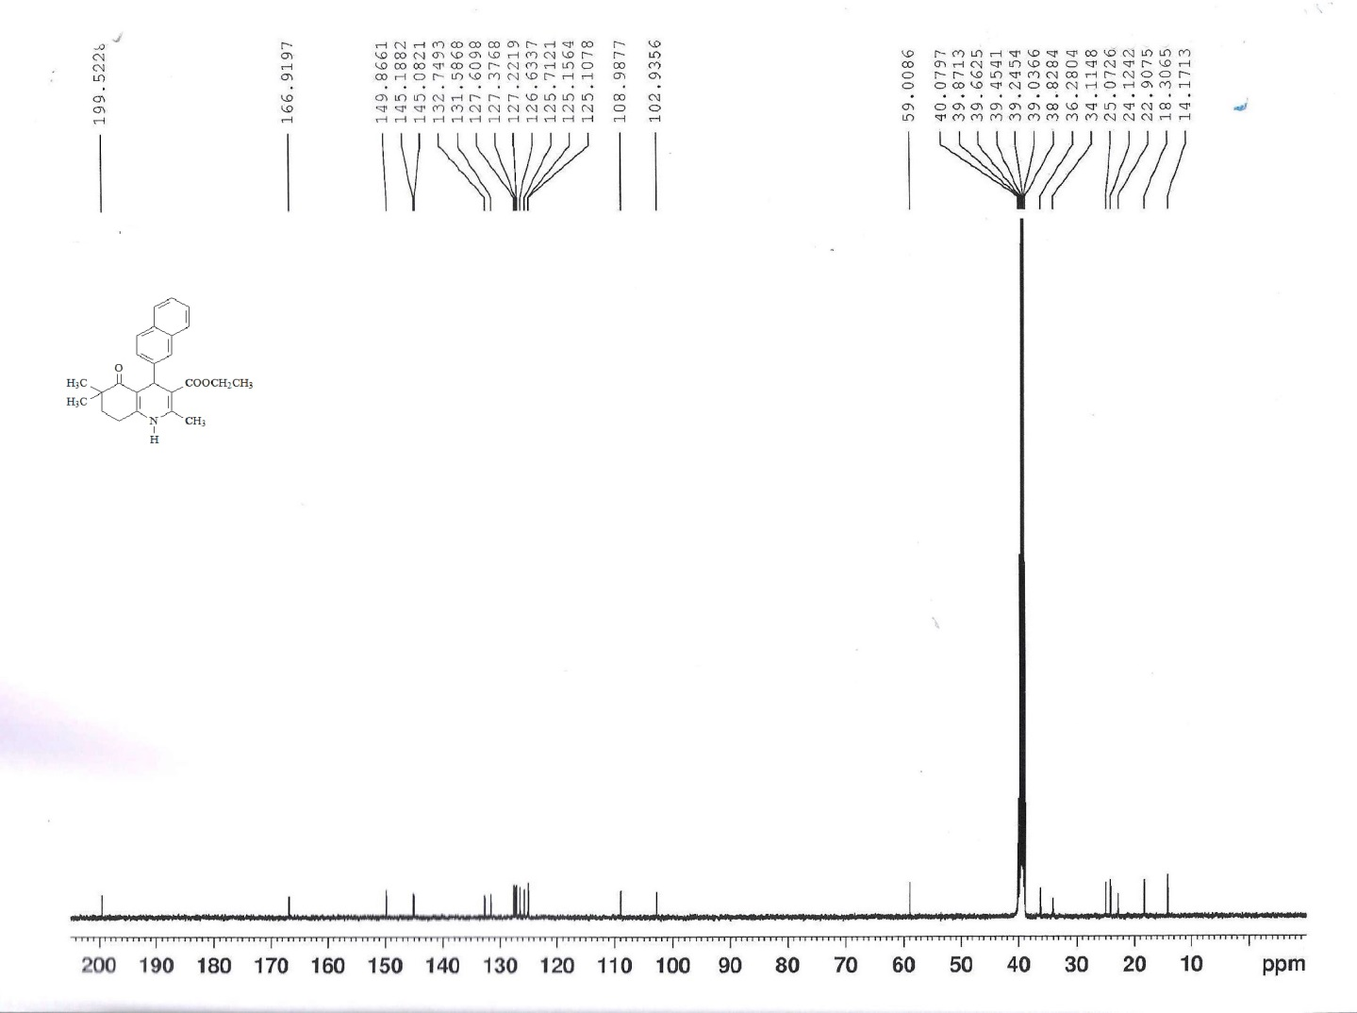
¹³C-NMR spectrum of compound 10

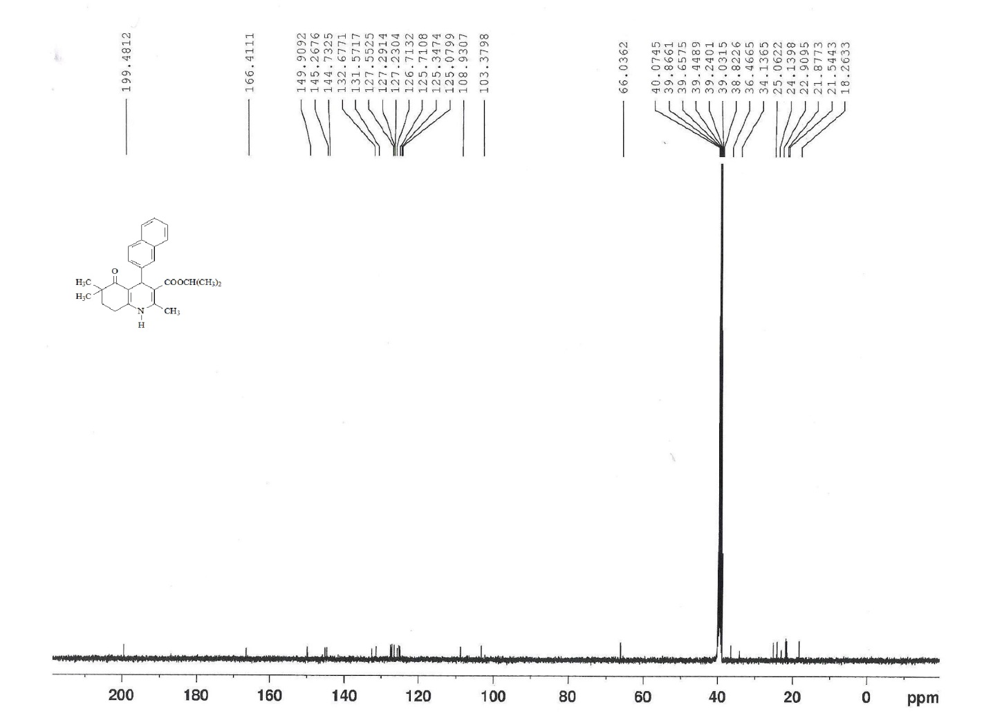
¹³C-NMR spectrum of compound 11

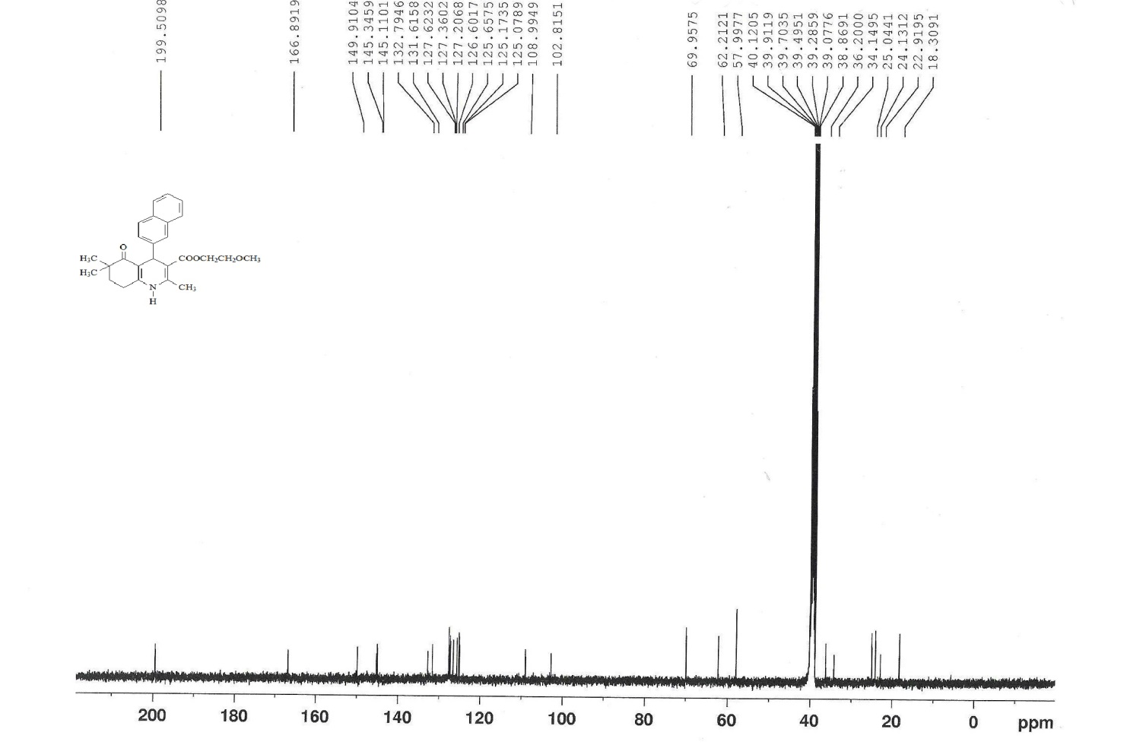
¹³C-NMR spectrum of compound 14

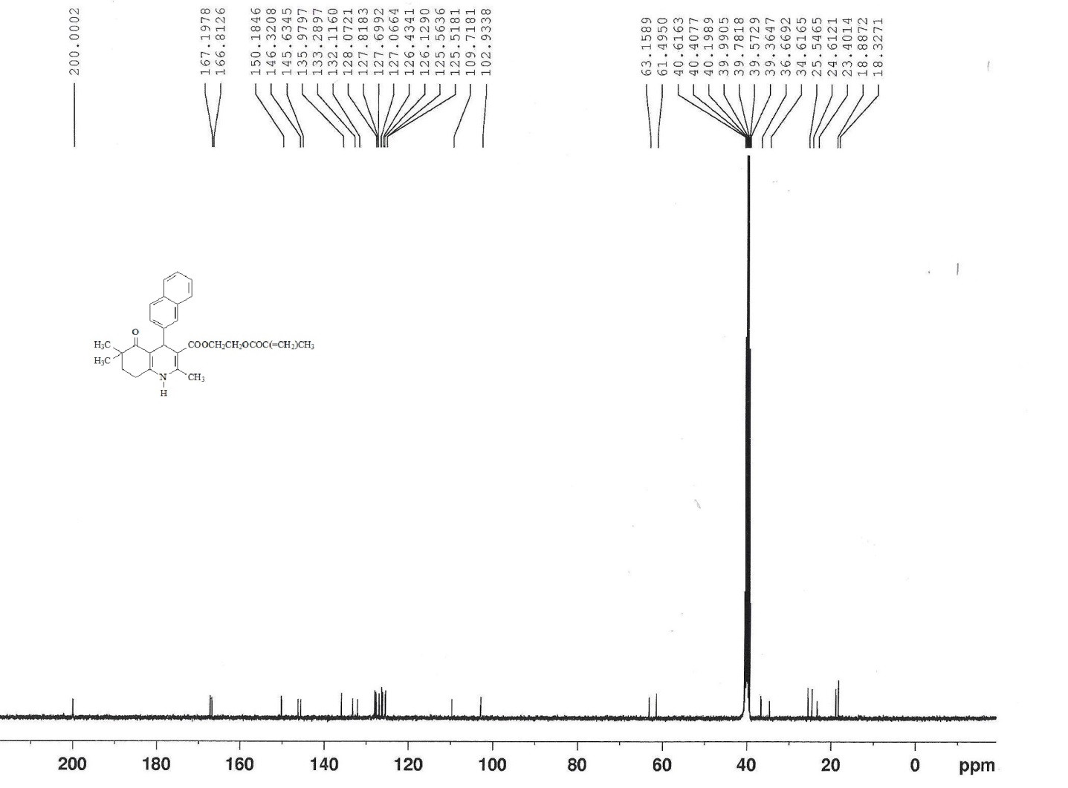
¹³C-NMR spectrum of compound 15

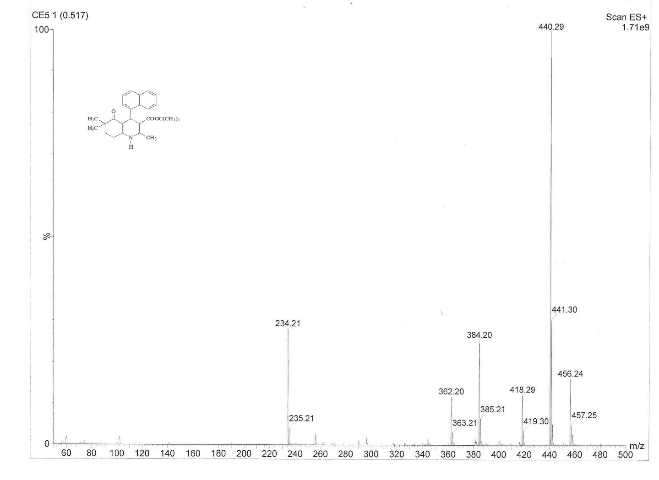
Mass spectrum of compound 5

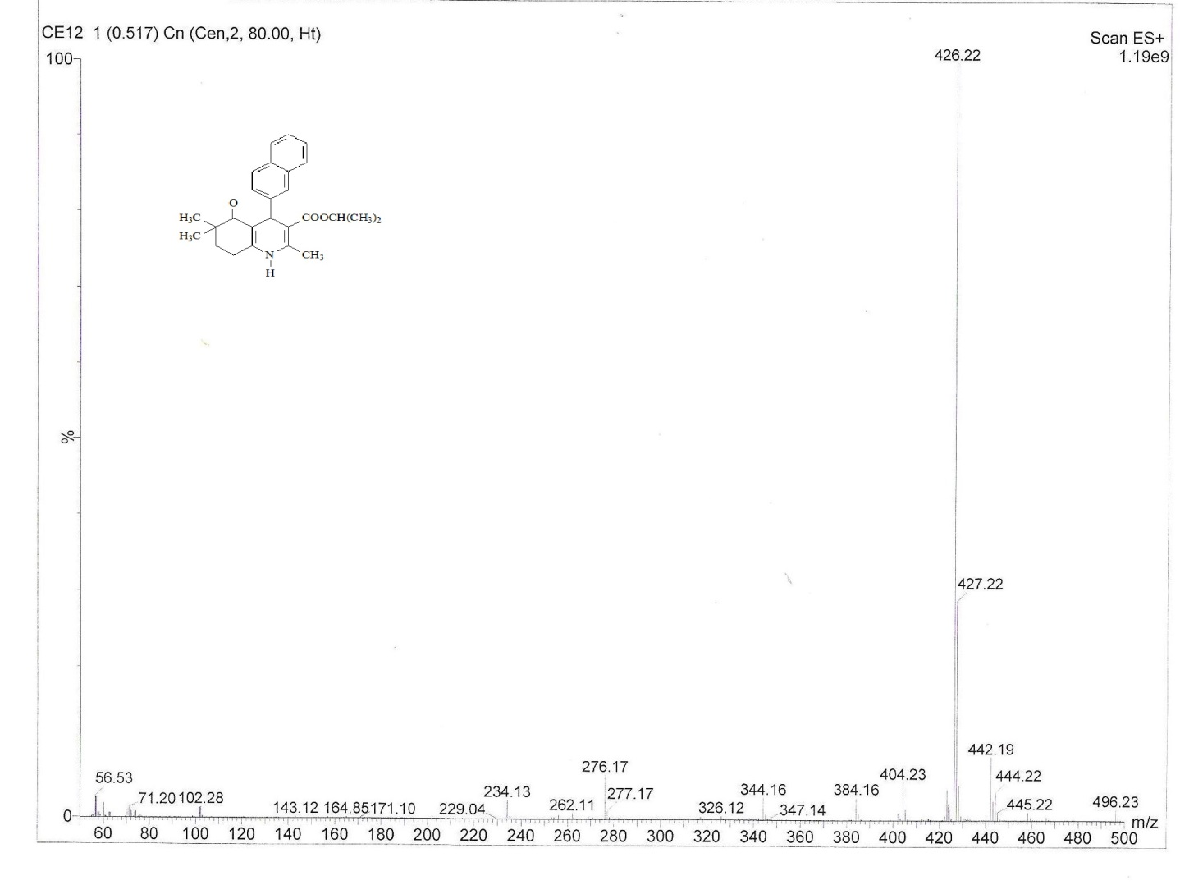
Mass spectrum of compound 11

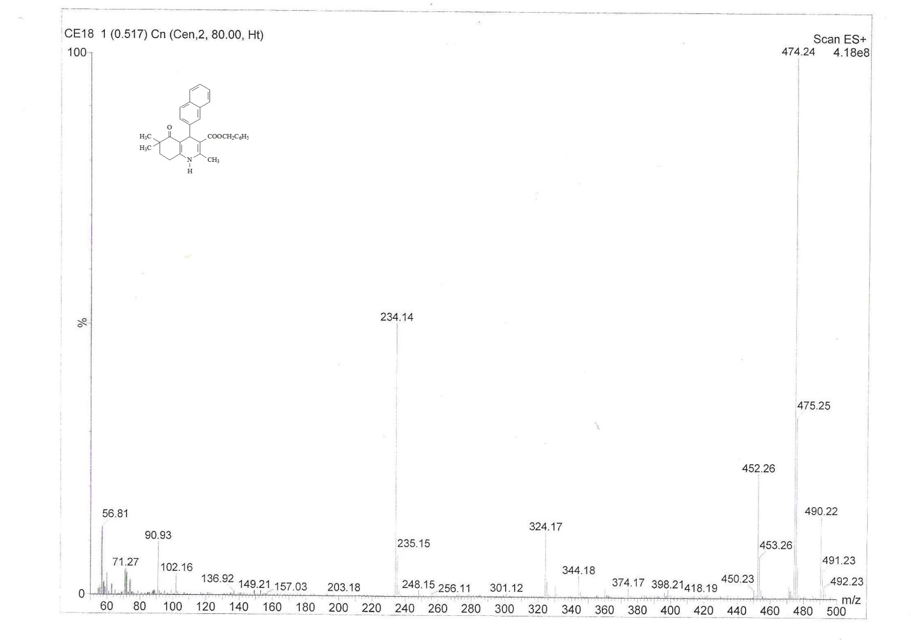
Mass spectrum of compound 16

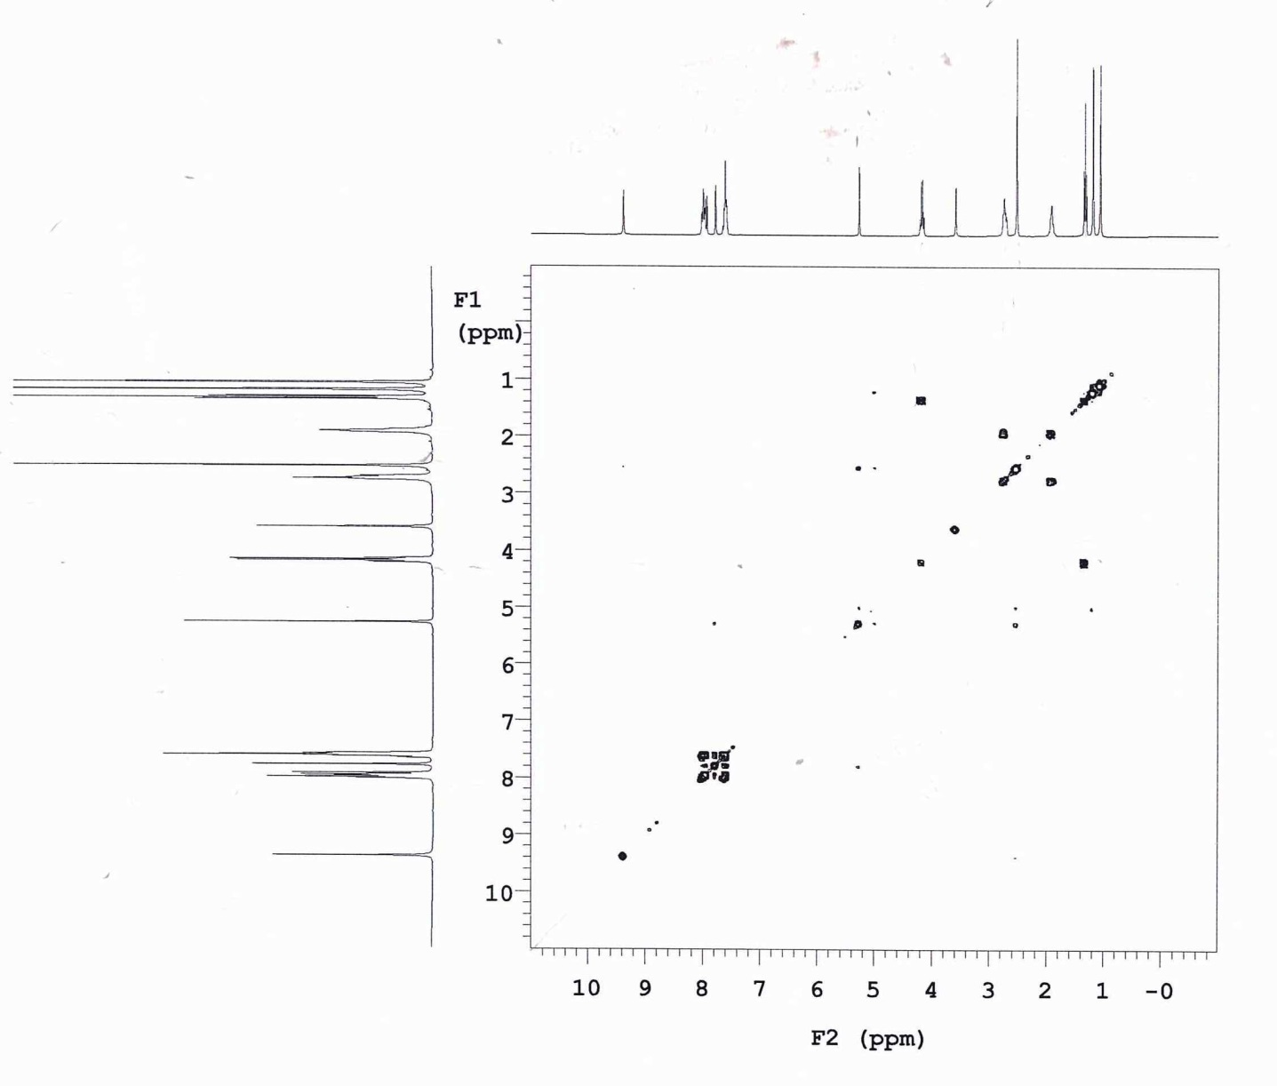
COSY spectrum of compound 2

