SUPPLEMENTARY MATERIAL TO
Copper and copper oxide nanoparticles prepared from copper (II) acetate bipyridine complex
Tatiana Lastovina,^{1*} Andriy Budnyk,¹ Gevorg Khaishbashev,¹ Egor Kudryavtsev² and Alexander Soldatov¹
¹International Research Center "Smart materials", Southern Federal University, 344090, 5, Zorge St., Rostov-on-Don, Russia
² Joint Research Center "Diagnostics of structure and properties of nanomaterials", Belgorod National Research University, 308015, 85, Pobedy St., Belgorod, Russia
* Corresponding author. E-mail: lastovina@sfedu.ru

Content:
1. Selection of copper-precursor
2. Formation of copper (II) acetate bipyridine complex
3. Characterization of copper and copper oxide nanoparticles

1. Selection of copper-precursor

Table S1. Examples of Cu(II) precursors used for synthesis of Cu, CuO or Cu₂O NPs.
Compound | Reagents / Method | Particles | Ref
CuCl₂ | Chemical reduction by NaBH₄ in methanol in Ar atmosphere | Cu NPs, 5-15 nm, spherical | ¹
CuCl₂·2H₂O | Chemical reduction by L-ascorbic acid at 80 °C until change of colour | Cu NPs, 2 nm, spherical | ²
Cu-  (N₂H₃COO)₂·2H₂O from CuCl₂ | Thermal Process: 80 °C for 3 h in Ar atmosphere.  Sonochemical Process: 100 Wcm⁻² ultrasound radiation for 3 h in water | Cu NPs, 200-300 nm, irregular  Cu NPs, 50 nm, porous & irregular | ³
CuSO₄ | Chemical reduction by NaBH₄ in water and stabilization in C₆H₅O₇Na₃ | CuNPs, 70 nm, irregular | ⁴
Cu(NO₃)₂ | Chemical reduction by NaBH₄ in methanol and stabilization in a PEG | Cu NPs, 2 nm, round-like | ⁵
Cu(NO₃)₂·H₂O | Precipitation-pyrolysis by (1) sol-gel in ethanol/propanol, (2) calcination at 200-500 °C for 1h | CuO NPs, 30 nm (XRD) | ⁶
CuSO₄·5H₂O | Precipitation-pyrolysis by (1) addition of NaOH in C₆H₅O₇Na₃,(2) calcination at 500 °C for 3h | CuO NPs, 19 nm (XRD), 20-50 nm (TEM) irregular | ⁷
A. CuCO₃·Cu(OH)₂ from Cu(OAc)₂  B. Cu(OH)₂& CuSO₄ | Precipitation-pyrolysis by (1) addition aqueous (NH₄)₂CO_{3,} (2) calcination at 200-500 °C for 3h | CuO NPs 8-26 nm (XRD), CuOnanorods 30x100 nm | ⁸
CuSO₄·5H₂O | Hydrothermal microwave-assistant in C₆H₁₂O₆·H₂O, C₄H₄O₆KNa·4H₂O & PEG mixture at pH=12 (NaOH), 700W stove at 95 °C for 1 h. | Cu₂O NPs 400-680 nm, different shapes | ⁹
CuSO₄·5H₂O | Solution-phase in PVP, NaH₂C₆H₅O₇, Na₂CO₃&glucose mixture at 80 °C for 2 h | Cu₂O NPs 300-500 nm, different shapes | ¹⁰

2. Formation of copper (II) acetate bipyridine complex

The Cu(II) acetate bipyridine complex has been synthesized fromparent Cu(II) acetate (Alfa Aesar) according to recipe proposed by Bon Kweon Koo¹¹. FTIR spectra of these two compounds are presented in Fig.S1. The spectra were measured in transmittance on FSM-1202 FTIR spectrometer (produced by InfraSpec) in air. The sample powder was mixed with KBr powder in weight ratio 1:200 and pressed in a disc of 1 mm thickness. The spectrum of a reference KBr disc has been subtracted from the spectra.
The main spectroscopic features originate from vibrations of acetate group with participation from adsorbed water. The spectrum of Cu(II) acetate bipyridine contains characteristic bands, mentioned by Koo in his work ¹¹: 2923, 1580, 1400, 1375, 1317, 1248, 1027, 923, 771 and 676 cm⁻¹. They are highlighted in Fig.S1 by asterisks. In the region of 600-500 cm⁻¹ there are some bands related to Cu–O bond stretching vibrations (clearly visible for Cu(II) acetate and less pronounced for Cu(II) acetate bipyridine).
Figure S1. FTIR spectra of Cu(II) acetate bipyridine (black) and Cu(II) acetate (grey). Asterisks mark the positions of vibrations for Cu(II) acetate bipyridine¹¹.

Optical spectra of precursors were collected in Diffuse Reflectance mode on Shimadzu UV2600 spectrophotometer equipped with integrating sphere. For the measurements the compounds were mixed with BaSO₄ and filled in a standard UV cuvette. Fig.S2 reports the spectrum of Cu(II) acetate bipyridine (black) obtained in this work, and both precursors Cu(II) acetate (grey) and 2,2'-bipyridine (light grey) presented in % of Reflectance values. Difference in total intensity of reflectance relates to different quantities of samples exposed to light.

Figure S2. DRUV-Vis-NIR spectra of Cu(II) acetate bipyridine (black), Cu(II) acetate (grey) and 2,2'-bipyridine (light grey). Asterisks mark the band positions for Cu(II) acetate bipyridine¹¹.

In his work Koo¹¹ reports about two UV/VIS bands at 310 and 691 nm, which were measured in DMSO-d₆ solution. Both bands are well comply with spectral profile of Cu(II) acetate bipyridine in Fig. S2. In this regard some comparative comments can be written as well.
Looking at spectrum of Cu(II) acetate precursor, the wide band stretching from red to NIR can be undoubtedly assigned to d-d transition occurring in Cu, while a high energy band below 400 nm is attributed to acetate-to-copper LCMT transitions comparing to the free ligand bands¹². As far as the spectrum of 2,2'-bipyridine is concerned, two clearly distinguished peaks at 237 and 283 nm originates from π-transitions and can be evident for prevalence of trans-form in dry precursor¹³. It was also shown¹⁴ that in metal chelate compounds the splitting of higher wavelength π-band (called π₁-band) may occur due to the vibrational fine structures.

3. Characterization of copper and copper oxide nanoparticles

Fig. S3 presents powder XRD patterns for Сu/Cu₂O NPs prepared by microwave-assisted polyol synthesis at 185 and 200 °C. If patterns are matched (subtracting baseline) it becomes clear that synthesis at higher temperature results in almost double decrease in intensity for reflexes from Cu NPs, while does not affect appreciably the characteristic reflex (111) from Cu₂O NPs. Observed difference can be attributed to improved crystallinity of metal particles, obtained at higher temperature.
Figure S3. XRD pattern of Сu/Cu₂O NPs prepared by microwave-assisted polyol synthesis at 185 °C (grey) and 200 °C (black). The inset shows the same patterns matched for comparison of reflex intensities. Asterisk marks the reflex attributed to Cu₂O phase.

TEM images for CuO and Cu/Cu₂O (185 °C) NPs are presented here in Fig. S4 and S5 in better magnification than in the main text with the scope to make details more appreciable. Instead, Fig. S6 adds the same set of analysis made for Cu₂O sample obtained at 200 °C. The last shows formation of particles with round-like shape having the average size of 95.3 nm. These particles appear to have higher extent of agglomeration in respect to what was observed for the sample prepared at 185 °C.
The lattice parameter a and interplanar spacings d, calculated from the XRD and SAED data are summarized in Table S2. By comparing the structural quality of NPs coming from two different synthesis one must admit that cubic CuO NPs do not posses significant structural defects. It is not a case for Cu/Cu₂O particles, where different types of defects like dislocations, twins and stacking faults were found.
The calculated characteristic values (Table S2) are in good agreement with each other and comply well with structural data known from the literature for copper-based NPs.

Table S2. Lattice parameter a and interplanar spacing d for the prepared copper-based NPs.
Sample | a,Å (XRD) | d value/ d_{theor.}*  (XRD) | Phase | d value/ d_{theor.}  (XRD) | Phase | d value/ d_{theor.}  (XRD) | Phase
CuO NPs (solvothermal synthesis) | CuO  a=4.695  b=3.4305  c=5.1403 | 2.5612/  2.5324 | CuO  <002> | 2.3241/  2.3243 | CuO  <111> | 1.8731/  1.8676 | CuO  <20-2>
Сu/Cu₂O NPs (MW-assisted polyol synthesis at 185 °C) | Cu  3.6153  Cu₂O 4.2736 | 2.0917/  2.0880 | Cu  <111> | 2.1450/  2.1260 | Cu₂O  <002> | 1.7928/  1.8080 | Cu  <200>
Сu/Cu₂O NPs (MW-assisted polyol synthesis at 200 °C) | Cu  3.6157  Cu₂O 4.2529 | 2.0917/  2.0880 | Cu  <111> | 2.1270/  2.1260 | Cu₂O  <002> | 1.8120/  1.8080 | Cu  <200>
CuO/Cu₂O (borohydride synthesis) | Cu₂O  4.2787  CuO  a=4.7058  b=3.4407  c=5.1527 | 3.0609/  3.0123 | Cu₂O <011> | 2.4607/  2.4595 | Cu₂O  <111> | 2.1270/  2.1300 | Cu₂O  <002>
 |  | 1.5120/  1.5060 | CuO  <11-3> | 1.2938/1.2959 | CuO  <221> | - | -
* the value is taken from XRD database (ICSD)
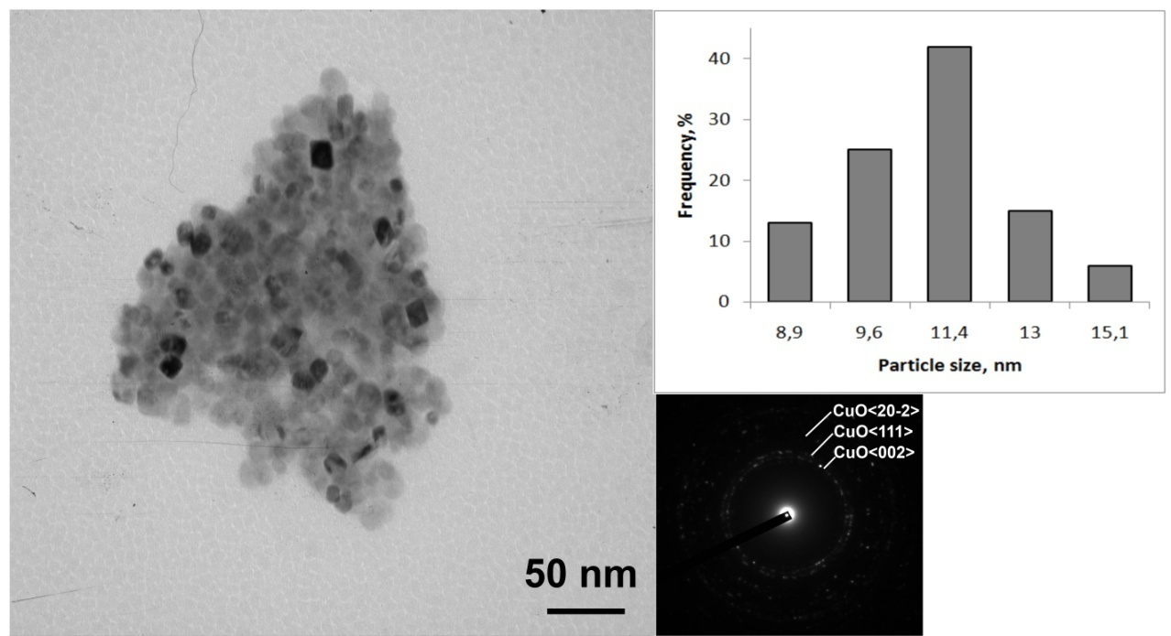
Figure S4. TEM image, SAED image and histogram of the size distribution of CuO NPs prepared by solvothermal synthesis. See text for details.

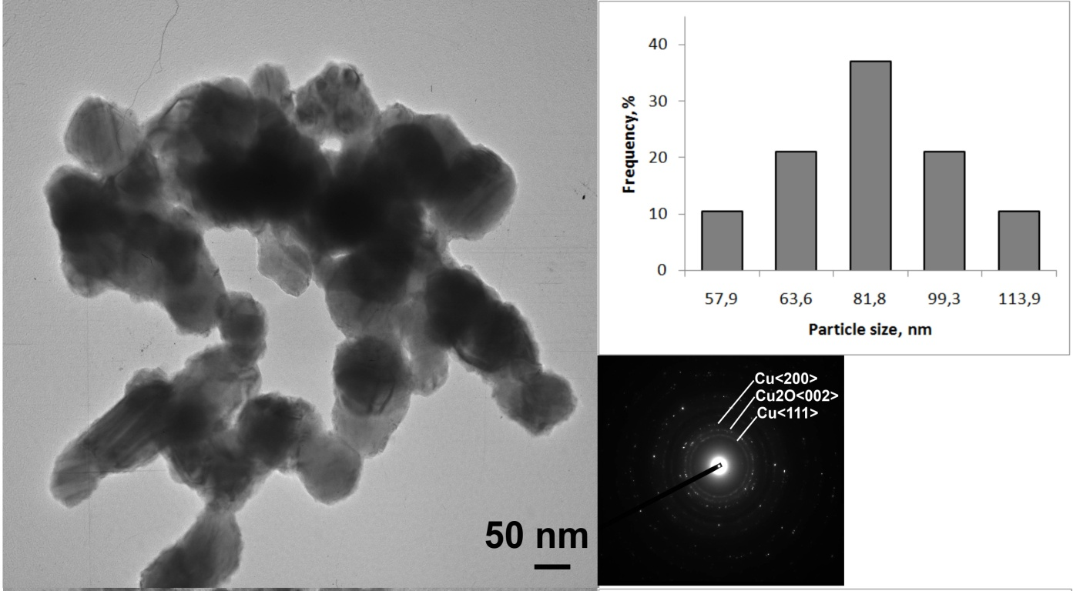
Figure S5. TEM image, SAED image and histogram of the size distribution of Cu/Cu₂O NPs prepared by MW-assisted polyol synthesis at 185 °C. See text for details.

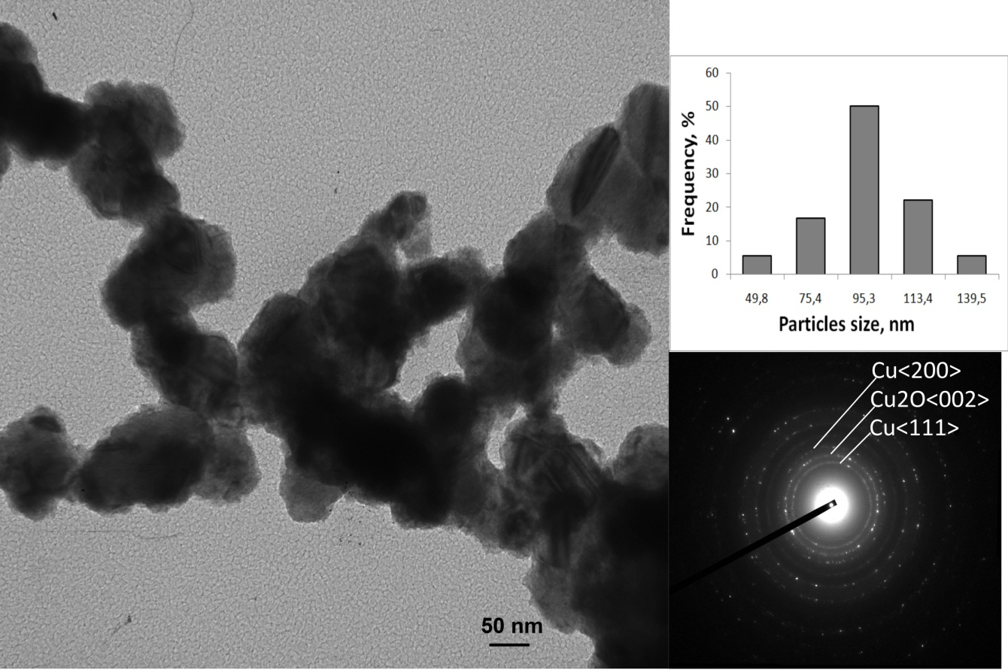
Figure S6. TEM image, SAED image and histogram of the size distribution of Cu/Cu₂O NPs prepared by MW-assisted polyol synthesis at 200 °C. See text for details.

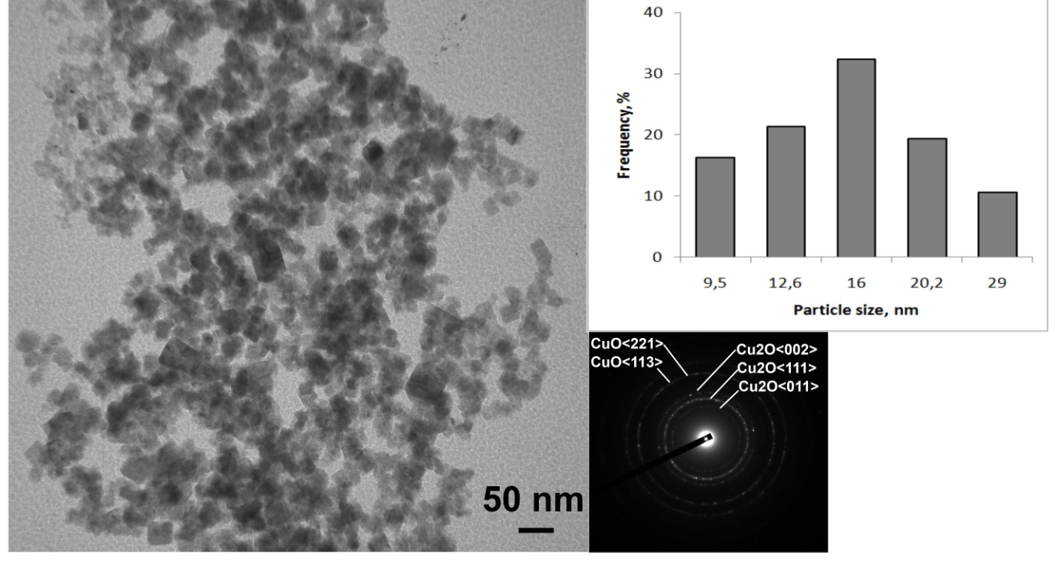
Figure S7. TEM image, SAED image and histogram of the size distribution of Cu₂O/CuO NPs prepared by borohydride synthesis. See text for details.

Optical properties of obtained samples were measured on Shimadzu UV-2600 UV-VIS spectrophotometer in Diffuse Reflectance mode by using integration sphere accessory. Some small amounts of samples were mixed homogeneously with BaSO₄ powder and filled in a standard optical cuvette. Optical cuvette filled with pure BaSO₄ was used as a reference. Care has been taken to ensure a snug fit of cuvette and window of integrating sphere to avoid light loss.
The measured optical spectra in % of Reflectance values are reported in Fig. S8a. The difference in level of reflectance throughout the spectrum originates from different amount of samples available for the measurements. The same spectra were also converted in Kubelka-Munk values and presented in Fig. S8b as a function of wave numbers.

Figure S8. (a) DRUV-Vis spectra of CuO (black), Cu/Cu₂O (185 °C, grey), Cu/Cu₂O (200 °C, dark grey) and Cu₂O/CuO NPs; (b) the same spectra converted in Kubelka-Munk function values and plotted versus cm⁻¹.

References:
- K.C. Anyaogu, A.V. Fedorov, and D.C. Neckers, Langmuir 24 (2008) 4340
- J. Xiong, Y. Wang, Q.Xue and X. Wu, Green Chem. 13 (2011) 900
- N. Arul Dhas, C. Paul Raj, and A. Gedanken, Chem. Mater., 10 (1998) 1446
- D.P. Chattopadhyay and B.H. Patel, Int. J. Pure Appl. Sci. Technol. 9 (2012) 1
- P. Christian and M. Bromfield, J. Mater. Chem. 20 (2010) 1135
- P. Mallick, S. Sahu, Nanoscience and Nanotechnology, 2 (2012) 71
- A.A. Radhakrishnan, B.B.Beena, Indian Journal of Advances in Chemical Science, 2 (2014) 158
- H. Fan, L. Yang, W. Hua, X. Wu, Z. Wu, S.Xie and B. Zou, Nanotechnology 15 (2004) 37
- Z. Wu, M. Shao, W. Zhang, Y. Ni, Journal of Crystal Growth 260 (2004) 490
- Y. Sui, W.Fu, H. Yang, Y. Zeng, Y. Zhang, Q. Zhao, Y. Li, X. Zhou, Y. Leng, M. Li, and G. Zou, Crystal Growth & Design 10 (2010) 99
- B.K. Koo, Bull. Korean Chem. Soc. 22 (2001) 113
- A.B. Lever, Inorganic Electronic Spectroscopy, 2nd Ed.; Elsevier: Amsterdam, 1984, (pp 553-572, 636-638)
- K. Nakamoto, J. Phys. Chem., 64 (1960) 1420
- K. Sone, P. Krumholz and H. Stammereich, J. Am. Chem. Soc. 77 (1955) 777

