The research of the relationship between dialkylphosphate ester chain length and the oil based fracturing fluid viscosity
LENG Jun¹, Pan Yi* ¹, YANG Shuangchun¹, WANG Shidong¹ and ADEWALE Adebayo²
¹Petroluem Institute, Liaoning Shihua University, No 1, Dandong Road, FuShun, LiaoNing, China ²Kazan National Research Technological University，ul. Karl Marx 68, Kazan, Tatarstan, Russia
*Corresponding author: panyi_bj@126.com
Abstract: For the usage of dialkylphosphate as a gelatinizer in oil based fracturing fluid, there are two methods of preparation involved: 1.The improved ethylphosphate method is used to control one of the ester chains by using single alcohol substitute for mixed alcohols; 2.The new method of polyphosphate is used to control both of ester chains. Different kinds of alcohols are used as the raw materials in 3×3 orthogonal experiment (ratio of reactants, reaction temperature and reaction time) to obtain the optimum reaction conditions. Furthermore, 14 kinds of gelatinizers are produced by these experiments. The viscosity of the products is used as an evaluation index. The results based on these two methods show that there is a positive correlation between the length of dialkyl phosphate ester chain and the viscosity of the fracturing fluid in a certain number of carbon atoms. In other words, the viscosity of fracturing fluid increased with an increasing length of the ester chain length, and reached the maximum at C₁₃. Then the growth slowed down. The viscosity of the products which were produced by the polyphosphate method has been obviously improved by 7.72%-45.35% at the level of the other.
Key words: Gelatinizer; Ethylphosphate; Phosphorus-pentoxide; Monoethylphosphate; Polyphosphate
RUNNING TITLE: RELATIONSHIP BETWEEN CHAIN LENGTH-VISCOSITY

1 INTRODUCTION
In recent years, the yield of conventional oil and gas shows a downward trend, so countries all over the world shift their focus on tight sandstone gas, shale gas and other unconventional oil and gas resources to increase oil and gas yield. Those reserves are about 1.910¹⁴ m³ ¹ in China and doubled the number of conventional reserves. Hydraulic fracturing is a necessary method to develop these reservoirs. The hydroxypropyl guar gum system is a common system of water based fracturing fluid which has a good fracturing outcome because of its high viscosity. Due to the large quantity of residues after gel breaking, this fracturing fluid system has a poor effect under low porosity and low permeability conditions. The oil based fracturing fluid overcomes the above shortcomings admirably with no residue after gel breaking. Meanwhile the characteristics of no water sensitive and no acid sensitive make it have obvious advantages during the development of unconventional oil and gas reserves ^{2,3}. In the study of oil based fracturing fluid, some researchers ^{4,5} focus on the study of cross-linking agent, gelatinizer and solubilizer. Such as the usage of new Fe³⁺ cross-linking agent to improve the rate of Al³⁺ cross-linking, the usage of different alcohols mix with benzene and toluene to prepare a gelatinizer which has higher viscosity ⁶ and the usage of Fe³⁺ complexing cross-linking agent to keep improving the cross-linking rate by increasing the dispersion of Fe³⁺ ⁷. Gelatinizers play an important role in oil based fracturing fluids, when gelatinizer bonds with cross-linking agent, basing oil will be thickened and the viscosity will be increased. It can also play a role like a drag reducer in the process of injection and backflow ^{6,7,8,9}. This paper is focused on dialkyl phosphate. Using two methods, the ester chain type of the gelatinizer can be controlled, and the length of the ester chain can be determined, so the relationship between the ester chain length and the viscosity of the oil based fracturing fluid can be found. The ethylphosphate method is the current method which was first proposed by Huddleston¹⁰ used by Y. Kong ⁶, X.Q. Hou ⁷, K.W. Smith ⁸, Z.Z. Chu ¹¹, M.X. Wang ¹² and B. Wang ¹³ to prepare dialkyl phosphate in their study of oil based fracturing fluid. However, the use of mixed alcohols in this reaction has two limitations: firstly, the reaction temperature cannot be optimal reaction temperature for all of the alcohols, so it leads to incomplete reaction. Secondly, the product variety and the concentration of all kinds of products cannot be determined. So the kinds of products that play a critical role in the final performance of fracturing fluid cannot be known either. Due to the above mentioned limitations, the current method—the improved ethylphosphate method has been remodified in this paper by controlling one of the dialkyl phosphate ester chains to determine the type of products. The polyphosphate method can control both of dialkyl phosphate ester chains to make up for the shortcomings of the improved ethylphosphate method.

2 EXPERIMENTAL

2.1 IMPROVED ETHYLPHOSPHATE METHOD
Through the reaction between ethylphosphate and phosphorus pentoxide, an intermediate monoethylphosphate is produced. Through another reaction between this intermediate and alcohol, dialkylphosphate has been synthesized. One ester chain of this dialkylphosphate is ethyl, and another ester chain is target ester chain. In another words, this method can only determine one of the dialkylphosphate ester chains.
Reaction molecular formula is as follows (Fig. 1):
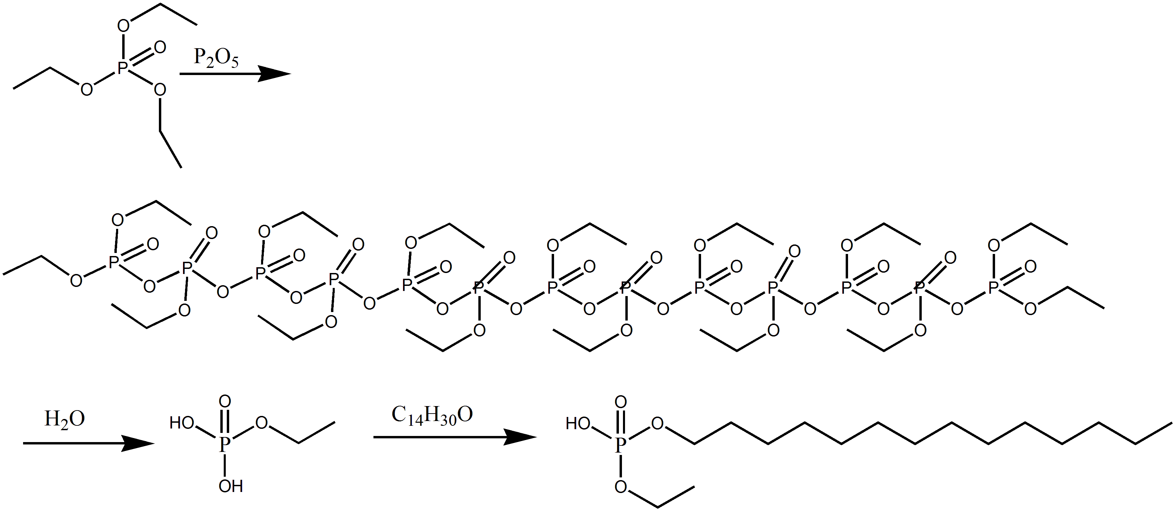
Fig. 1. Improved Ethylphosphate Method (taking tetradecyl alcohol as an example).

2.1.1 Preparation and purification of monoethylphosphate
Monoethylphosphate is an intermediate for synthesizing dialkylphosphate. The 3×3 orthogonal test combines reaction rate, reaction temperature and reaction time are used to find out the optimum conditions. Then a purification process is used to improve product quality. Viscosity is an important parameter for the performance evaluation of fracturing fluid, and when other conditions are constant, the greater the viscosity, the greater the crack ¹⁴. Therefore, this paper chooses the viscosity to evaluate the experimental product.
(1) Preparation of Monoethyl Phosphate
The reaction between (CH₃CH₂O₃)PO and P₂O₅ to generate the polyphosphate which can be hydrolyzed to a monoester. The conversion rate of polyphosphate will directly affect the quality of the subsequent reactions. After obtaining the optimum reaction conditions by 3×3 orthogonal test, the Mixed Titration Method is used to determine the percentages of the monoester and the diester.
(2)Purification of MonoethylPhosphate
The product of the monoethyl-phosphate contains monoethylphosphate, dialkylphosphate, ethylphosphate and alcohol, among them the ethylphosphate and alcohol are impurities¹⁵. Due to the property of monosodium phosphate—insolubility in water and in organic solvents, so ethylphosphate and alcohol can be removed by solid-liquid separation procedure after using sodium hydroxide to neutralize one of hydroxyls from monoethylphosphate. Then by acidizing the solid obtained from the last solid-liquid separation procedure, the phosphate ester is regained. n-Hexane was used to extract the phosphate ester. Through the process of distillation, the purified phosphate ester can be obtained. The operation steps: firstly, take some products which were produced under the optimum reaction conditions in the flask and add sufficient n-hexane in flask under stirring condition fully dissolved, the original solution is gotten. The treatment solution is obtained by adding some amount of ethanol in 50% NaOH and stirring them. Secondly, pour the treatment solution into the flask which have stirring original solution in slowly and keep stirring them until no more white precipitation emerging. Sediment was obtained by suction filtration. Thirdly, add excess dilute hydrochloric acid to the precipitate and stir them 2~3 h under a temperature of 50 °C. Enough hexane and a small amount of the broken emulsion isopropyl alcohol were used to extract the phosphate ester and the distillation was used to remove the hexane and the isopropyl alcohol to get purified product.

2.1.2 Synthesis of gelatinizer
Choosing reactant ratio, reaction temperature and reaction time from the reaction between alcohol (1-butanol, 1-hexanol, 1-octanol, 1-nonanol, 1-tridecanol, 1-tetradecanol, 1-octadecanol) and phosphorus pentoxide as the orthogonal factors, start an orthogonal experiment. The index of this experiment is dialkyl phosphate conversion rate (choose one kind of oil as the base fluid (in this passage mineral oil was used) and the ratio of cross-linked base fluid viscosity to the mineral oil viscosity is used to measure conversion rate).This oil based fracturing fluid is prepared by using mineral oil as the base fluid, dialkyl phosphate (self-made) as gelatinizer, Al₂(SO₄)₃ as cross-linking agent, NaAc as pH regulator, diethanolamine as co-cross-linking agent (500 ml mineral oil + 2% dialkyl phosphate+ 0.6% Al₂(SO₄)₃+1% diethanolamine + 1% NaAc).

2.2 POLYPHOSPHATE METHOD
Phosphoric acid and phosphoric anhydride are used as raw materials, heating and stirring them to synthesize polyphosphate intermediates in the anhydrous state. Then dialkyl phosphate was synthetized through a reaction between the intermediates and alcohols. In comparison with dialkyl phosphate prepared by the improved ehylphosphate method, the dialkyl phosphate made by the polyphosphate method is different because both ester chains of this dialkyl phosphate can be controlled.

2.2.1 Preparation of polyphosphate
Add a certain amount of phosphorus pentoxide in a 250 ml round-bottom flask with a stirrer and a condenser pipe on it. Put the flask into a 40 °C constant temperature water bath. Add proper amount of phosphoric acid into the flask and turn on the stirrer to avoid phosphorus pentoxide becoming pyrophosphate precipitate. Maintain the temperature of 40 °C for 0.5 h. Then increase the temperature to 90 °C, polyphosphate is obtained after 1 h of the constant temperature reaction.
Reaction molecular formula is as follows (Fig. 2):
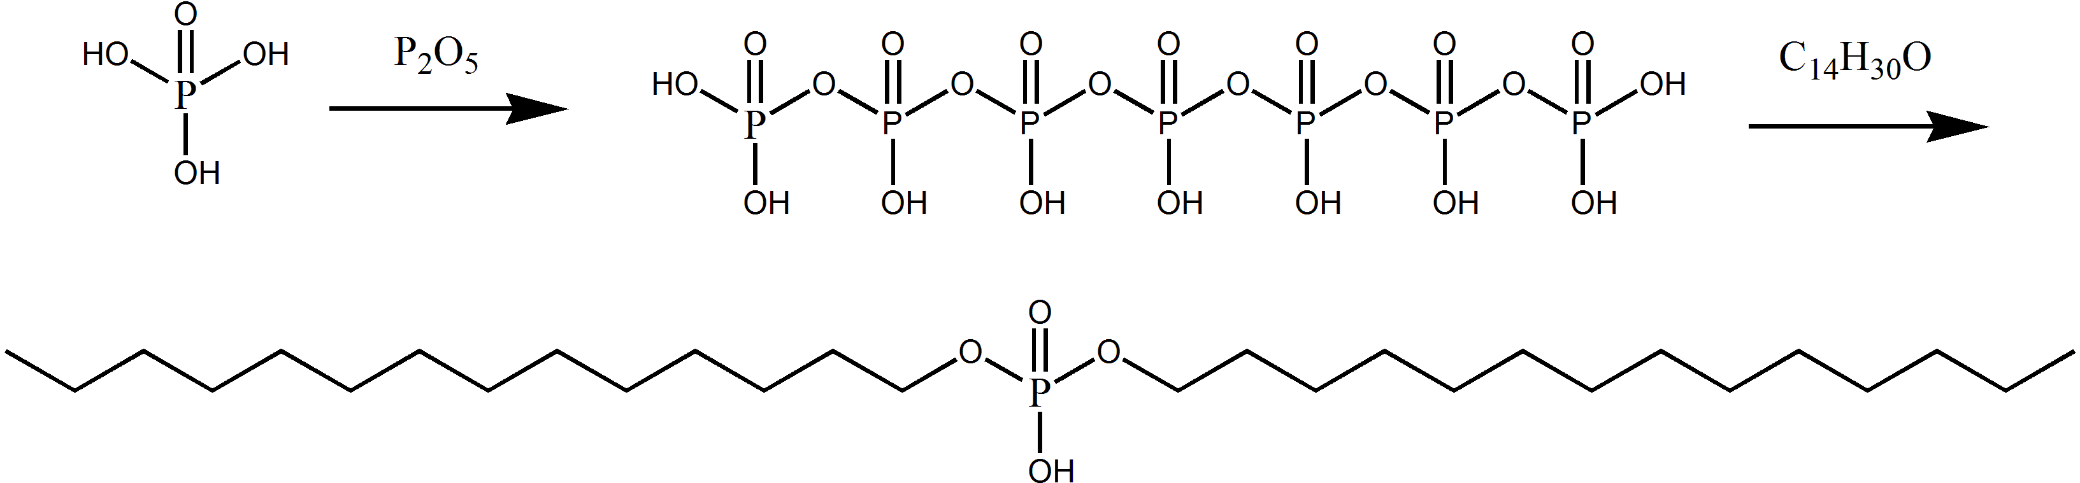
Fig. 2. Polyphosphate Method (taking tetradecyl alcohol as an example).

2.2.2 Synthesis of dialkylphosphate
Choosing reactant ratio, reaction temperature and reaction time from the reaction between alcohol (1-butanol, 1-hexanol, 1-octanol, 1-nonanol, 1-tridecanol, 1-tetradecanol, 1-octadecanol) and polyphosphate as the orthogonal factors, an orthogonal experiment is started. Specific steps: add a certain amount of alcohol in a 250 ml round-bottom flask with a stirrer in it and turn on the stirrer. Add polyphosphate into the flask slowly at several intervals and maintain the temperature of 40 °C. After polyphosphate is completely added, install a condensing pipe and increase the temperature to the target temperature ¹⁸ and after several hours product would be gotten. Use the same experimental steps to obtain the optimal reaction conditions for above mentined alcohols. Following the same purification process as for monoethyl-phosphate, the products of different alcohols under the optimum reaction conditions were purified. The purified product is then used as a gelatinizer to prepare a fracturing fluid, and the relationship between the ester chain length and the viscosity of the oil based fracturing fluid is studied.

3 RESULT AND DISCUSSION

3.1. The formation of the monoethylphosphate
Table 1 shows orthogonal experimental factors of preparation of monoethyl phosphate. Table 2 shows the orthogonal experiment result (1. - the reactant ratio in this table is the ratio of ethylphosphate to phosphorus pentoxide; 2. - the levels and factors are from Table 1; 3 - the first number in K1 means sum of conversion rate under factor A level 1, so as the later two numbers and K2, K3 as K1; 4 - the first number in R means the difference between the largest number and smallest number from K1, K2 and K3 under factor A, so as the later two numbers).
Table 1. Orthogonal experimental factors of preparation of monoethylphosphate
Factors  Levels | A  Reactant Ratio | B  t /°C | C  τ /h
1 | 1:1 | 70 | 4
2 | 1.25:1 | 80 | 5
3 | 1.5:1 | 90 | 6
Table 2. The orthogonal experiment result
Factors  Experiment No. | A | B | C | Conversion rate
1 | 1 | 1 | 3 | 7.5918%
2 | 2 | 1 | 1 | 5.9843%
3 | 3 | 1 | 2 | 3.568%
4 | 1 | 2 | 2 | 4.7722%
5 | 2 | 2 | 3 | 42.4312%
6 | 3 | 2 | 1 | 3.8066%
7 | 1 | 3 | 1 | 55.9953%
8 | 2 | 3 | 2 | 16.8641%
9 | 3 | 3 | 3 | 11.2001%
K1 | 68.3593% | 17.1441% | 65.7862% | -
K2 | 65.2796% | 51.01% | 25.2043% | -
K3 | 18.5747% | 84.0595% | 61.2231% | -
R | 49.7846% | 66.9154% | 40.5819%
The results show that the main factor affecting this reaction is the reaction temperature (reaction temperature > reactant ratio> reaction time; Tables 1 and 2). The optimum reaction condition is A₁B₃C₁, namely, the mole ratio of (CH₃CH₂O)₃PO to P₂O₅ is A (1:1), reaction temperature B is (90 °C) and reaction time is C(4 h).

3.2. Synthesis of dialkylphosphate with 1-butanol
Table 3 shows orthogonal experimental factors of preparation of dialkyl phosphate with 1-butanol (the reactant ratio in this table is the ratio of 1-butanol to phosphorus pentoxide). Table 4 shows the conversion rate and dialkylphosphate ratio (1 - the levels and factors are from Table 3; 2 - the first number in K1 means sum of conversion rate under factor A level 1, so as the later two numbers and K2, K3 as K1; 3 - the first number in R means the difference between the largest number and smallest number from K1, K2 and K3 under factor A, so as the later two numbers).
Table 3. Orthogonal experimental factors of preparation of dialkylphosphate with 1-butanol
Factor  Level | A  Reactant Ratio | B  t /°C | C  τ /h
1 | 2:1 | 70 | 5
2 | 3:1 | 80 | 6
3 | 4:1 | 90 | 7
Table 4. The conversion rate and dialkylphosphate ratio
Factor  Experiment No. | A | B | C | Conversion rate | Dialkyl phosphate ratio
1 | 1 | 1 | 3 | 147.1% | 77.12%
2 | 2 | 1 | 1 | 133.9% | 65.15%
3 | 3 | 1 | 2 | 136.6% | 65.83%
4 | 1 | 2 | 2 | 115.2% | 55.95%
5 | 2 | 2 | 3 | 145.2% | 75.54%
6 | 3 | 2 | 1 | 102.7% | 25.34%
7 | 1 | 3 | 1 | 131.8% | 61.55%
8 | 2 | 3 | 2 | 146.4% | 75.56%
9 | 3 | 3 | 3 | 149.0% | 77.73%
K1 | 394.1% | 417.6% | 368.4%
K2 | 425.5% | 363.1% | 398.2%
K3 | 388.3% | 427.2% | 441.3%
R | 37.2% | 64.1% | 72.9%
The results from tables 3 and 4, show that the main factor affecting this reaction is the reaction time (reaction time>reaction temperature > reactant ratio). The optimum reaction condition is A₂B₃C₃, namely, the mole ratio of 1-butanol to P₂O₅ is A (3:1), reaction temperature is B (90 °C) and reaction time is C (7 h).

3.3. Experiment results of synthesis dialkylphosphate with different alcohols
According to the synthesis of dialkyl phosphate with 1-butanol, the same experimental procedure can be used to obtain the optimum reaction conditions of 1-hexanol, 1-octanol, 1-nonanol, 1-tridecanol, 1-tetradecanol and 1-octadecanol (shown in table 5) and products produced under the optimum reaction conditions are used to prepare fracturing fluid. Relationship between the length of the ester chain and the viscosity of the oil based fracturing fluid is shown in table 6.
Table 5. Optimal reaction conditions for the synthesis of dialkylphosphate with different alcohols
 | 1-Butanol | 1-Hexanol | 1-Octanol | 1-Nonanol | 1-Tridecanol | 1-Tetradecanol | 1-Octadecanol
A | 3:1 | 2:1 | 4:1 | 4:1 | 4:1 | 3:1 | 3:1
B | 90 | 90 | 90 | 90 | 90 | 90 | 90
C7676777Table 6. The viscosity of the oil based fracturing fluid
Name  Factor | 1-Butanol | 1-Hexanol | 1-Octanol | 1-Nonanol | 1-Tridecanol | 1-Tetradecanol | 1-Octadecanol
μ, mPa·s
33.741.265.772.1134.4147.9150.7The optimum synthesis conditions of monoethylphosphate (shown in table 2) are the mole ratio of triethyl phosphate to phosphorus pentoxide 1:1, reaction temperature of 90 °C and reaction time of 4 hours. Under these conditions monoethylphosphate yield is 56.00%. Dialkylphosphate is synthetized through this monoethylphosphate. The optimum reaction conditions (shown in table 4) are the mole ratio of 1-butanol to phosphorus pentoxide 3:1, reaction temperature of 90 °C and reaction time of 7 h. The yield of dialkylphosphate reaches 83.25%. After preparing these fracturing fluids, the viscosity could be measured and the results shown in table 6 indicate that the viscosity of fracturing fluid increased with increasing length of dialkylphosphate ester chain, reaching the maximum at C₁₃. The addition of dialkyl phosphate increases the viscosity of fracturing fluid because the basing fluid is coated by combination of the dehydrogenating dialkylphosphate with Al³⁺ and then the three-dimensional network structure of gel has been formed. With the increase of the ester chain length, the viscosity increase maybe because the long ester chain can be wrapped with the coated base fluid molecules and make the coat more solid. The obtained result is in accordance with the results of Funkhouser's research¹⁶. It may also be because long ester chain is conducive for the formation of an overlap with another long ester chain from coating molecule. It makes the gel group larger, having higher viscosity ¹⁷.

3.4. Synthesis of dialkylphosphate with 1-butanol
Table 7 shows orthogonal experimental factors of preparation of dialkyl phosphate with 1-butanol and polyphosphate. Table 8 shows the result of the orthogonal experiment (the reactant ratio in this table is the mole ratio of 1-butanol to polyphosphate).
Table 7. Orthogonal experimental factors of preparation of dialkylphosphate with 1-butanol and polyphosphate
Factor  Level | A  Reactant ratio | B  t /°C | C  τ /h
1 | 2:1 | 85 | 6
2 | 3:1 | 90 | 7
3 | 4:1 | 95 | 8
Table 8. The result of the orthogonal experiment
Factor  Experiment No. | A | B | C | Conversion
1 | 1 | 1 | 3 | 11.36%
2 | 2 | 1 | 1 | 25.05%
3 | 3 | 1 | 2 | 36.89%
4 | 1 | 2 | 2 | 38.62%
5 | 2 | 2 | 3 | 45.10%
6 | 3 | 2 | 1 | 52.77%
7 | 1 | 3 | 1 | 17.25%
8 | 2 | 3 | 2 | 34.44%
9 | 3 | 3 | 3 | 43.13%
K1 | 67.23% | 73.30% | 95.07%
K2 | 104.59% | 136.49% | 109.95%
K3 | 132.79% | 94.82% | 99.59%
R | 65.56% | 63.19% | 14.88%
The results from tables 7 and 8, show that the main factor affecting this reaction is the reaction ratio (reactant ratio >reaction temperature > reaction time). The optimum reaction condition is A₃B₂C₂—the mole ratio of 1-butanol to P₂O₅ is A (4:1), reaction temperature is B (90 °C) and reaction time is C (7 h).

3.5. Experimental results of synthesis dialkylphosphate with different alcohols
According to the synthesis of dialkylphosphate with 1-butanol, the same experiment procedure can be used to obtain the optimum reaction conditions of 1-hexanol, 1-octanol, 1-nonanol, 1-tridecanol, 1-tetradecanol and 1-octadecanol (shown in table 9), and purified products are used to prepare fracturing fluid. Relationship between the length of the ester chain and the viscosity of the oil based fracturing fluid is shown in table 10.
Table 9. Optimal reaction conditions for the synthesis of dialkylphosphate with different alcohols
 | 1-Butanol | 1-Hexanol | 1-Octanol | 1-nonanol | 1-Tridecanol | 1-Tetradecanol | 1-Octadecanol
A | 4:1 | 4:1 | 4:1 | 4:1 | 4:1 | 4:1 | 4:1
B | 90 | 85 | 85 | 85 | 90 | 85 | 90
C | 7 | 8 | 8 | 8 | 7 | 7 | 8
Table 10. The viscosity of the oil based fracturing fluids
Name  Factor | 1-Butanol | 1-Hexanol | 1-Octanol | 1-nonanol | 1-Tridecanol | 1-Tetradecanol | 1-Octadecanol
μ, mPa·s | 36.3 | 52.2 | 87.4 | 104.8 | 181.48 | 194.08 | 200.03
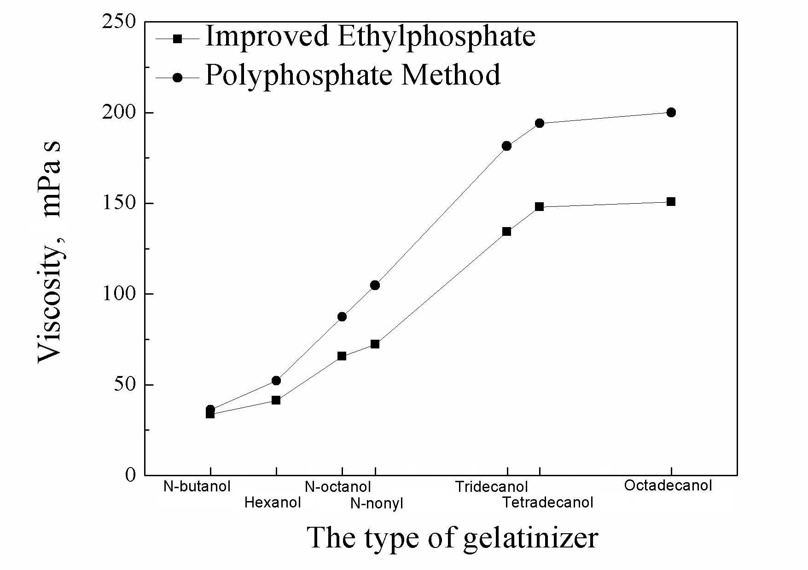
Fig. 3. The products viscosity of two synthetic methods.
As is shown in table 8, the optimum synthesis condition of dibutylphosphate is the mole ratio of 1-butanol to phosphorus pentoxide 4:1, reaction temperature of 90 °C and reaction time of 7 hours. Under mentioned conditions, the yield of dibutylphosphate reaches 55.32%. In addition, the viscosity of fracturing fluid increased with the increasing length of dialkyl phosphate ester chain. And the tendency of the polyphosphate methods was similar to that of the improved ethylphosphate method, and the viscosity of the product was improved by 7.72%-45.35% at the level of improved ethylphosphate method (Fig. 3).This may be due to the increase of ester chain number that can not only enhance the wrap with the coated base fluid molecules but also form another overlap with other molecules.

3.6. Infrared spectroscopy (IR) analysis
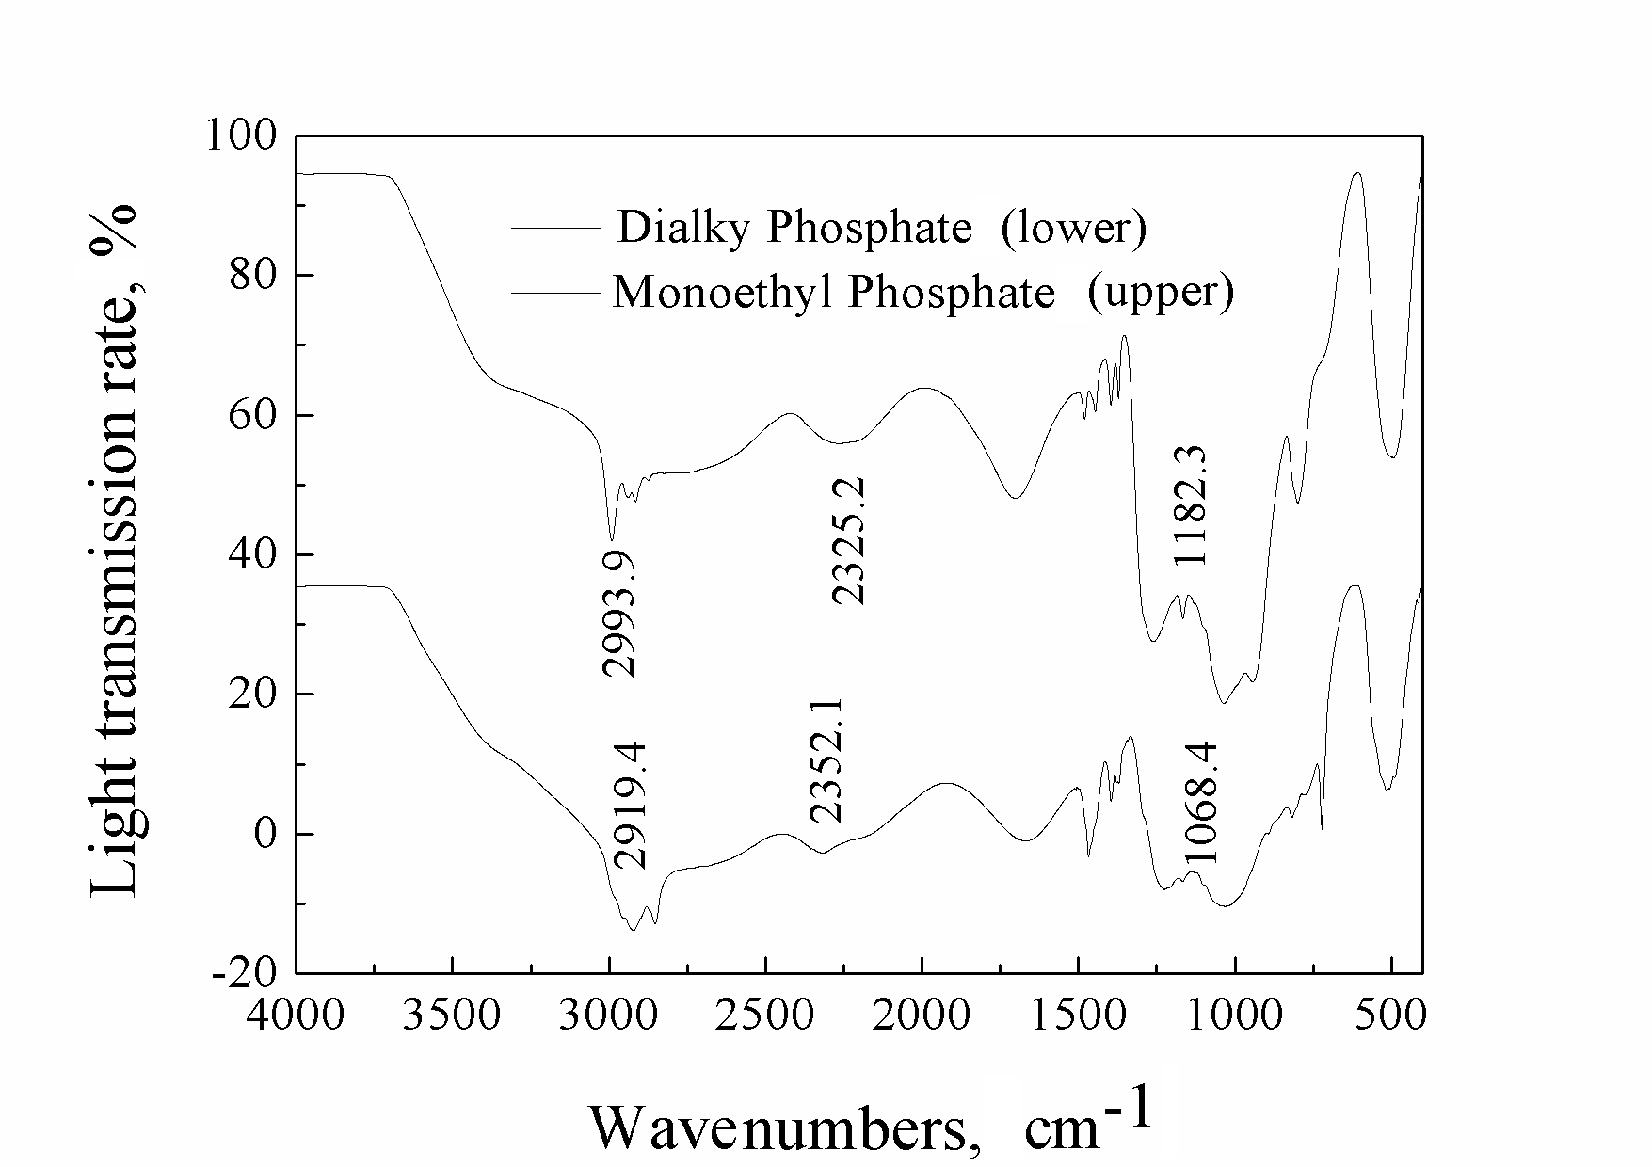
Fig. 4. IR spectra.
Diagram in figure 4 shows the curve of monoethyl-phosphate. The peak at 2993.9 cm⁻¹ is a typical of carbon chain, 2325.2 cm⁻¹ is O=P-OH, 1182.3, and 1103.7 cm⁻¹ are asymmetric stretching vibration and symmetric stretching vibration of P-O-C group, and 789.9 cm⁻¹ is the characteristic peak of carbon chain of -(CH₂)_{n}-.¹⁹ We can also see from the curve of dialkyl phosphate (C₁₄ dialkyl phosphate used as an example in the diagram, Fig. 4) that 2919.4 and 2986.9 cm⁻¹ are characteristic peaks of carbon chain; 2352.1 cm⁻¹ is O=P-OH, 1210.1 and 1068.4 cm⁻¹ are asymmetric stretching vibration and symmetric stretching vibration of P-O-C group, and 725.1 cm⁻¹ is the characteristic peak of carbon chain of -(CH₂)_{n}-. From this IR, the different positions of the -(CH₂)_{n}- appearing means the different length of -(CH₂)_{n}-. A conclusion can be drawn that the former is -CH₂- and the latter is -(CH₂)n- (n>4). It is obvious that the conversion of the monoethyl-phosphate to the dialkyl-phosphate has occurred.

4 CONCLUSION
The yield of dialkylphosphate which was produced by the improved ethylphosphate method reached 80.75%. As shown in tables 5 and 9, the optimum temperature of dialkyl phosphate synthesis is 85 °C-90 °C. Compared with the improved ethylphosphate method, more alcohol and longer reaction time are needed for the polyphosphate method because of generating equivalent amount of substance, another ester chain needed to be produced to the latter method.
The same quantity of two different kinds of dialkylphosphates which were produced by the improved ethylphosphate method and the polyphosphate method were used to prepare two kinds of fracturing fluid in this paper. Their viscosities are different and that of the latter one is higher. The yield can be improved by 45.35%. It can be concluded that the performance of fracturing fluid can be significantly improved through the polyphosphate method instead of the improved ethylphosphate method.
Mineral oil is used as the base fluid whose principal component is long carbon chain alkanes. Results from tables 6 and 10, show that the viscosity of fracturing fluid increased with an increasing length of dialkylphosphate ester chain, reaching the maximum at the ester chain length of C₁₃. Then it gets stable. In other word, the wrap generated by the coated base fluid molecules with dialkylphosphate ester chains and the overlap created by ester chain with another ester chain reach saturation point at C₁₃.

Acknowledgements
The authors are thankful to LJQ (2015063), China, Liaoning Provence Provincial Education Department for financial support of “Supported by Program for Liaoning Outstanding Young Scholar in University”. The authors are also thankful to Prof. Jinhui Zhang, Prof. Dr. Guiyang Ma, Central Laboratory, College of Petroleum Engineering, Liaoning Shihua University, for providing laboratory facilities support. The authors are also thankful to Ali Uzair and Asset Ongarbayev Orazovich, students of Liaoning Shihua University for their experimental work.

REFERENCES
1. W.J. Zhao, H.L. Li, W.Y. Yang, J. LanZhou, Research Institute of Petroleum Exploration & Development Northwest 17 (2012) 36 (in Chinese)
2. S.H. Robert, L.H. Trevor, J.T. Gary, US patent 20070213232 A1 (2007)
3. W. Liu, J.Q. Liu, J. Beijing, Drilling Fluid & Completion Fluid 21 (2004) 16 (in Chinese)
4. M.X. Wang, M.T. Chen, X.L. Guo, J. Xi’an, Oilfield Chemistry 17 (2000) 218 (in Chinese)
5. M.X. Wang, J. He, W.S. Zhang, J. Xi’an, Univ. Science & Technology Edition 1 (2013) 150 (in Chinese)
6. Y. Kong, J.Z. Jing, H. Feng, J. Jingzhou, Univ. Petrochemical Industry Application 31 (2012) 81 (in Chinese)
7. X.Q. Hou, Y.J. Lu, B. Fang, J. Shanghai, Univ. Petroleum Exploration and Development, 40 (2013) 601 (in Chinese)
8. K.W. Smith, L.J. Persinski, US patent 5571315 (1996)
9. Y.J. Lu, H.L. Zhou, Modern fracturing enhancing natural gas production, Petroleum industry press, Beijing, 2012, p. 116-125 (in Chinese)
10. Huddleston, A. David, US patent 4877894 (1989)
11. Z.Z. Chu, Z.P. Lu, Z.J. Xiong, J. Dongying, Journal of Shengli Oil Field Staff University 23 (2009) 38 (in Chinese)
12. M.X. Wang, A.M. Wu, M.T. Chen, J. Xi’an, Drilling Fluid & Completion Fluid 16 (1999) 8 (in Chinese)
13. B. Wang, W. Liu, J. Xi’an, Univ. Chemical Industry and Engineering 16 (1999) 99 (in Chinese)
14. Z.Q. Qu, F. Fan, G.Q. Hu. J. Dongying, Univ. Special Oil & Gas Reservoirs 17 (2010) 104 (in Chinese)
15. K. Tang, J. Yan, J. Zigong, Univ. China Surfactant Detergent & Cosmetics 37 (2007) 410 (in Chinese)
16. Funkhouser. US patent 7066262 B2 (2006)
17. J. James, D. Harynuk Aleisha, G. Rossé, M. Bryce, J. Anal Bioanal Chem. 8 (2011) 2415
18. M.Q. Fu, Q. Li, J. Yang, J. Tianjing, Institute Surfactant Industry 4 (1998) 12 (in Chinese)
19. S. Bourbigot, M. Le Bras, R. Delobel, Carbon 31 (1993) 1219.

