Supplementary material
Solvatochromism of isatin based compounds: LSER and LFER study of 3-aryliminoindolin-2-one derivatives

DOMINIK R. BRKIĆ,¹ ALEKSANDRA R. BOŽIĆ,¹ VESNA D. NIKOLIĆ,² ALEKSANDAR D. MARINKOVIĆ,#³ HANA ELSHAFLU,³ JASMINA B. NIKOLIĆ,#*³ SAŠA Ž. DRMANIĆ^{#3}

¹Belgrade Polytechnic, Brankova 17, 11000 Belgrade, Serbia, ²Faculty of Chemistry, University of Belgrade, Studentski trg 12–16, 11000 Belgrade, Serbia, ³Department of Organic Chemistry, Faculty of Technology and Metallurgy, University of Belgrade, Karnegijeva 4, 11120 Belgrade, Serbia

General method for preparation of isatin derivatives
Isatin derivatives was synthesized according to literature method.¹ Isatin (5 mmol) was dissolved in methanol (40 mL), and corresponding reactants (substituted anilines or aryl amines (5 mmol) and glacial acetic acid (10 mL) were added. Reaction mixture was refluxed at 70 °C for 6 h by using magnetic stirrer. Subsequently, the mixture was left overnight without stirring at room temperature. The obtained crystals were filtered off, dried and recrystallized from methanol or appropriate solvent mixture (Table SII). The average yield was about 70–79 %.

Materials and methods
All commercially available chemicals were purchased from Sigma-Aldrich (St. Louis, MO, USA). All NMR spectral measurements were performed on a Varian 2000 (200 MHz for ¹H and 50 MHz for ¹³C NMR spectra). The spectra were recorded at room temperature in deuterated dimethyl sulfoxide (DMSO-d₆). The chemical shifts were expressed in ppm values referenced to δ_{H} = 2.5 and δ_{C} = 39.5 ppm in ¹H and ¹³C NMR spectra, respectively. Numeration of the atom of interest for characterization is given in Table SII. UV data were obtained using Shimadzu 1700 UV-vis spectrophotometer in ethanol as solvent at 5x10^{–5} mol dm^{–3}. Fourier-transform infrared (FTIR) spectra were obtained using FTIR BOMEM MB 100 in the form of KBr pellets. FTIR spectra were recorded in the transmission mode between 400 i 4000 cm⁻¹ with a resolution of 4 cm⁻¹.

Table SI. Solvent parameters used in Kamlet–Taft equation²
Solvent | π* | β | α
Ethanol | 0.54 | 0.77 | 0.83
Methanol | 0.6 | 0.62 | 0.93
2-Propanol | 0.48 | 0.95 | 0.76
2-Butanol | 0.4 | 0.8 | 0.69
Cyclohexanol | 0.45 | 0.84 | 0.66
Benzyl alcohol (BzOH) | 0.98 | 0.52 | 0.6
2-Methoxyethanol | 0.71 | 0 | 0
2-Chloroethanol | 0.46 | 0.53 | 1.28
1,2-dimethoxyethane (DME) | 0.53 | 0.41 | 0
Toluene | 0.54 | 0.11 | 0
Dichloromethane (DCM) | 0.82 | 0.1 | 0.13
Tetrahydrofuran (THF) | 0.58 | 0.55 | 0
Acetonitrile (AcN) | 0.75 | 0.31 | 0.19
Formamide (F) | 0.97 | 0.48 | 0.71
Dimethylacetamide (DMAc) | 0.88 | 0.76 | 0
Dimethylformamide (DMF) | 0.88 | 0.69 | 0
1-Methyl-2-pyrrolidinone (NMP) (((NMP)(NMP) | 0.92 | 0.77 | 0
Ethyl acetate (EtAc) | 0.55 | 0.45 | 0
2-Pyrrolidone | 0.85 | 0.77 | 0.36
Dimethylsulfoxide (DMSO) | 1 | 0.76 | 0
Acetone | 0.71 | 0.48 | 0.08
Cyclohexanone (ChO) | 0.76 | 0.53 | 0

¹H and ¹³C NMR, FTIR spectra and elemental analysis of studied compounds are given in Table SII, and general formula with labeling of atom is given on Fig S1:

Fig. S1 General formula of 1,3-dihydro-3-(arylimino)-2H-indol-2-one with labeling of the atom
Table SII Yield, melting point, FTIR, ¹H and ¹³C NMR data of synthesized compounds
No | R | Yield and m.p. | Elemental analysis | IR (cm⁻¹) | ¹H NMR  (200 MHz, DMSO-d₆)(ppm) | ¹³C NMR  (50 MHz, DMSO-d₆)(ppm)
1 |  | Yield: 76%; Exp: 221-222 °C (methanol)  Lit: 209.7-211.4 °C³ | Theory (%)  C: 75.66 H: 4.54 N: 12.60  Found (%)  C: 75.42 H: 4.65 N: 12.38 | 3344, 1741, 1661, 1254. | 6,65 (d, 1H, 4), 6,74 (t, 1H, 5), 6.95 (d, 1H, 4´), 7,04 (d, 2H, 2´6´), 7,26 (t, 1H, 6 ), 7,30 (t, 1H, 7 ), 7,44 (t, 2 H, 3´,5) 10.76 (s, 1H, 8). | 112.1 (C-7), 116.4 (C-3a), 118.1  (C-2´6’), 123.0 (C-5), 125.70 (C-4), 126.6 ( C-4’), 129.7 ( C-3´5’), 134.6 (C-6), 146.0 (C-7a), 151.88 (C-1’), 156.20 (C-3), 164.21 (C-2).
2 |  | Yield: 69%;  Exp: 223-224 ºC (methanol)  Lit: 219.8-220.6 ºC³ | Theory (%)  C: 55.84 H: 3.01 N: 9.30  Found (%)  C: 56.01 H: 2,94 N: 9,28 | 3342, 1746, 1659, 1252. | 6,41 (d, 1H, 4), 6,38 (td, 1H, 5), 6.78 (d, 1H, 6´), 6,94 (d, 1H, 6), 7.34 (d, 1H, 4´), 7,36-7.43 (m, 2H, 7, 5´ ), 7,62 (d, 1H, 3´), 10.66 (s, 1H, 8). | 89.1 (C-2’), 111.6 (C-7), 116.74 (C-3a), 119.58 (C-6’), 122.21 (C-5), 123.4 C-4’), 125.82 (C-4), 127.13 (C-5’); 133.02 (C-3’), 135.11 (C-6), 147.62 (C-1’), 148.04 (C-7a), 152.1 (C-3), 164.1 (C-2).
3 |  | Yield: 66%;  Exp: 235-236 ºC (methanol)  Lit: 219.1-220.2 ºC³ | Theory (%)  C: 55.84 H: 3.01 N: 9.30  Found (%)  C: 56.04 H: 2,92 N: 9,34 | 3340, 1744, 1658, 1250. | 6,38 (d, 1H, 4), 6,39 (td, 1H, 5), 6.88 (d, 1H, 6´), 6,91 (d, 1H, 6), 7.28 (d, 1H, 5´), 7,37 (dd, 1H, 7 ), 7,54-7,68 (m, 2H, 2´, 4´), 10.84 (s, 1H, 8). | 88.56 (C-3’), 111.8 (C-7), 116.70 (C-3a), 119.69 (C-6’), 122.24 (C-5), 123.4 C-2’), 125.77 (C-4), 126.23 (C-4’); 135.06 (C-6), 136.02 (C-5’), 147.61 (C-1’), 148.2 (C-7a), 152.03 (C-3), 164.03 (C-2).
4 |  | Yield: 80%;  Exp: 244-241 ºC (methanol)  Lit: 220,9-223 ºC³ | Theory (%)  C: 55.84 H: 3.01 N: 9.30  Found (%)  C: 55.98 H: 2,96 N: 9,31 | 3342, 1745, 1648, 1251 | 6,40 (d, 1H, 4), 6,71 (td, 1H, 5), 6.83 (d, 2H, 2´,6´), 6,91 (d, 1H, 6), 7,35 (dd, 1H, 7 ), 7,76 (td, 2H, 3´, 5´), 10.81 (s, 1H, 8). | 89.55 (C-4’), 111.91 (C-7), 115.87 (C-3a), 119.69 (C-2’, C-6’), 122.18 (C-5), 125.72 (C-4), 135.0 (C-6), 138.58 (C-3’,C-5’), 147.39 (C-7a), 147.63 (C-1’), 152.09 (C-3), 164.11 (C-2).
5 |  | Yield: 64%;  Exp:239-240 ºC (DMF/methanol) | Theory (%)  C: 76.25 H: 5.12 N: 11.86  Found (%)  C: 76.41 H: 5,06 N: 11,74 | 3445, 3191, 1751, 1729, 1625, 1251. | 2.31 (s, 3H, CH₃), 6,41 (d, 1H, 4), 6,72 (td, 1H, 5), 6,96 (d, 1H, 6), 7.06 (d, 1H, 4´), 7,38 (dd, 1H, 7 ), 7,66 (dd, 1 H, 5´),8,36 (dd, 1 H, 3´), 11.05 (s, 1H, 8). | 19,7 (CH₃); 111.88 (C-7), 115.98 (C-3a), 118.73 ( C-4’), 122.19 (C-5), 125.82 (C-4), 131.24 ( C-3’), 135.12 (C-6), 138.22 (C-5’), 147.44 (C-7a), 151.64 ( C-3’), 152.16 (C-3), 158.3 (C-1’), 163.4 (C-2).
6 |  | Yield: 72%;  Exp: 204-205 ºC (DMF/methanol)  Lit: 204-206 ºC¹ | Theory (%)  C: 76.25 H: 5.12 N: 11.86  Found (%)  C: 76.36 H: 5,20 N: 11,88 | 3444, 3191, 1752, 1731, 1627, 1254. | 2.34 (s, 3H, CH₃), 6,41 (d, 1H, 4), 6,68 (td, 1H, 5), 6,93 (d, 1H, 6), 7.11 (d, 1H, 6´), 7,38 (dd, 1H, 7 ), 7,45 (dd, 1 H, 4´),8,42 (dd, 1 H, 3´), 11.04 (s, 1H, 8). | 19,8 (CH₃); 111.91 (C-7), 115.99 (C-3a), 117.90 ( C-6’), 122.19 (C-5), 125.68 (C-4), 127.3 ( C-4’), 135.13 (C-6), 147.38 (C-7a), 148.58 (C-5’), 151.44 ( C-3’), 152.32 (C-3), 155.32 (C-1’), 163.4 (C-2);
7 |  | Yield: 60%;  Exp: 203-204 ºC (DMF/methanol) | Theory (%)  C: 76.25 H: 5.12 N: 11.86  Found (%)  C: 76.33 H: 5,14 N: 11,73 | 3447, 3193, 1753, 1733, 1626, 1253. | 2.33 (s, 3H, CH₃), 6,43 (d, 1H, 4), 6,72 (td, 1H, 5), 6.88 (d, 1H, 6´), 6,95 (d, 1H, 6), 7,37 (dd, 1H, 7 ), 7,63 (dd, 1 H, 5´),8,33 (dd, 1 H, 3´), 11.07 (s, 1H, 8). | 19,5 (CH₃); 111.88 (C-7), 116.01 (C-3a), 117.73 ( C-6’), 122.22 (C-5), 125.74 (C-4), 132.3 ( C-4’), 135.1 (C-6), 138.58 (C-5’), 147.41 (C-7a), 151.74 ( C-3’), 152.2 (C-3), 154.4 (C-1’), 163.6 (C-2);
8 |  | Yield: 71%;  Exp: 185-187 ºC (DMF/methanol) | Theory (%)  C: 76.25 H: 5.12 N: 11.86  Found (%)  C: 76.22 H: 5,14 N: 11,92 | 3447, 3191, 1753, 1731, 1626, 1253. | 2.30 (s, 3H, CH₃), 6,43 (d, 1H, 4), 6,74 (td, 1H, 5), 6,88 (d, 1H, 6), 6.94 (d, 1H, 6´), 7,40 (dd, 1H, 7 ), 7,68 (dd, 1 H, 5´),7,72 (dd, 1 H, 4´), 11.03 (s, 1H, 8). | 19,4 (CH₃); 111.92 (C-7), 116.01 (C-3a), 114.73 ( C-6’), 122.26 (C-5), 123.42 (C-4’), 125.91 (C-4), 135.22 (C-6), 137.50 ( C-5’), 147.51 (C-7a), 151.62 ( C-3’), 152.18 (C-3), 156.42 (C-1’), 163.5 (C-2
9 |  | Yield: 59%;  Exp: 300-301 ºC (DMF/methanol)  Lit: 303-304 ºC⁴ | Theory (%)  C: 74.71 H: 4.06 N: 15.38  Found (%)  C: 75.01 H: 3,99 N: 15,24 | 3048,  1742,  1614, 1311, 1254. | 6,33 (d, 1H, 4), 6,69 (td, 1H, 5), 6,92 (d, 1H, 6), 7,11 (t, 1H, 6´ ), 7,35 (dd, 1H, 7 ), 7,44-7,82 (dtdd, 2H, 4´, 5´), 7,87 – 8,15 (m, 2H, 7´, 8´ ), 8.68 (dd, 1H, 2´),11.03 (s, 1H, 8). | 111.34 (C-7), 116.20 (C-3a), 122.33 (C-5), 125.52 (C-4), 127,79 (C-6’), 128,11 (C-4’), 128,30 (C-5’), 128,50 (C-8’), 129,20 (C-7’a), 135,11 (C-7’),135.34 (C-6), 143,11 (C-2’), 144,51 (C-1’) , 146,53 (C-3’a), 147.70 (C-7a), 154.25 (C-3), 163.52 (C-2).
10 |  | Yield: 64%;  Exp: 290-291 ºC (DMF/methanol) | Theory (%)  C: 74.71 H: 4.06 N: 15.38  Found (%)  C: 74.98 H: 3,94 N: 15,27 | 3061,  742,  1618, 1302, 1254. | 6,35 (d, 1H, 4), 6,72 (td, 1H, 5), 6,94 (d, 1H, 6), 7,30 (t, 1H, 7´ ), 7,37 (dd, 1H, 7 ), 7,52 -7,85 (m, 2H, 4´, 8´), 8,09 – 8,40 (m, 2H, 2´, 3´ ), 8.79 (dd, 1H, 5´),11.06 (s, 1H, 8). | 111.28 (C-7), 115.9 (C-3a), 122.29 (C-5), 125.47 (C-4), 126,76 (C-2’), 127,66 (C-4’), 128,10 (C-8’), 129,80 (C-2’a), 133,10 (C-7’), 135,11 (C-3’),136.56 (C-6), 146,98 (C-6’ a), 147.54 (C-7a), 149,11 (C-5’), 151,11 (C-1’) , 154.31 (C-3), 163.8 (C-2).
11 |  | Yield: 70%;  Exp: 283-285 ºC (DMSO/methanol) | Theory (%)  C: 70.58 H: 3.83 N: 14.53  Found (%)  C: 70.66 H: 3,95 N: 14,67 | 3451, 3056, 1740,  1626, 1302. | 6,33 (d, 1H, 4), 6,67 (t, 1H, 5), 6,92 (d, 1H, 6), 7,35 (t, 1H, 5´), 7,45 – 7,61 (m, 3H, 7,4´,6´ ), 8,14 (d, 1H, 3´), 8,35 (d, 1H, 2´), 9,80 (d, 1H, 8´), 11,06 (s, 1H, 8). | 111.24 (C-7), 112,00 (C6´); 116.13 (C-3a), 117,71 (C4´); 118,65 (C2´); 122.41 (C-5), 125.58 (C-4), 127,97 (C5´); 128,71 (C3a´); 135.41 (C-6), 136,03 (C3´); 138,10 (C7a´); 147.70 (C-7a), 153,36 (C1´); 159.25 (C-3), 163.52 (C-2); 175,72 (C7´).

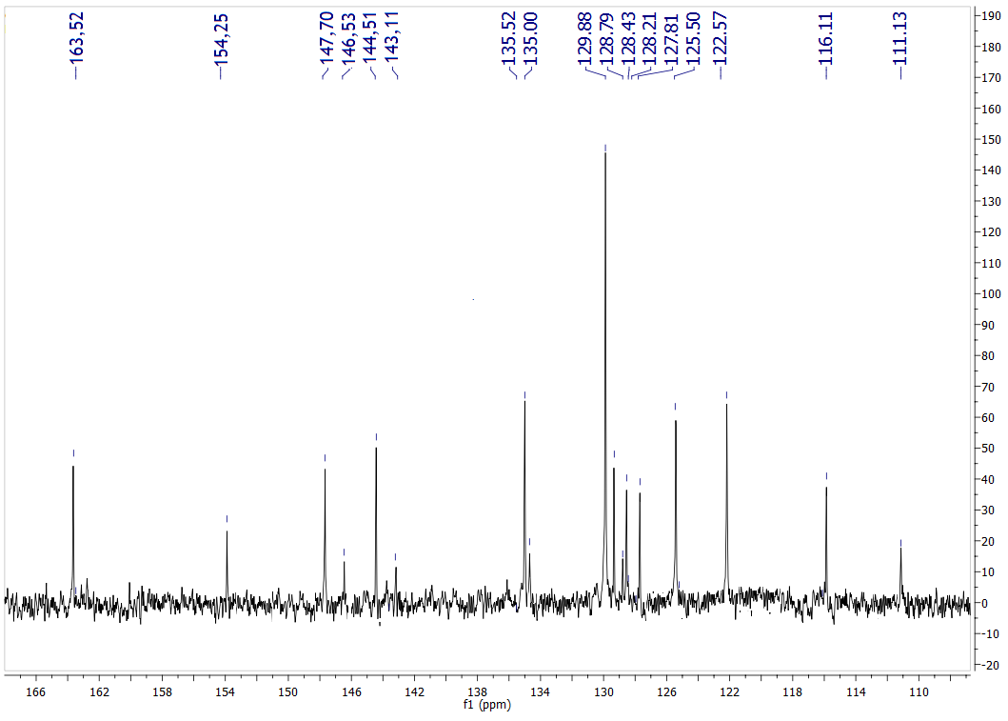
Figure S2. ¹H NMR spectrum of compound 9

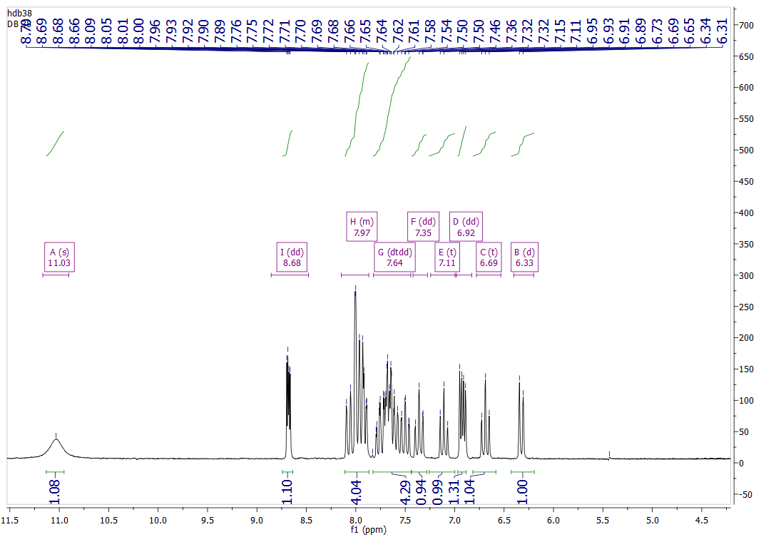
Figure S3. ¹³C NMR spectrum of compound 9

Table SIII. Absorption frequencies of isatin compounds in selected solvents (lower wavelength peak)
Solvent/  Compound | ν_{max}×10^{–3} (cm^{–1})
Solvent/  Compound | 1 | 2 | 3 | 4 | 5 | 6 | 7 | 8 | 9 | 10 | 11
Methanol | 34,31 | 33,39 | 33,5 | 33,44 | 33,39 | 33,73 | 33,61 | 33,73 | 32,63 | 33,9 | 34,01
Ethanol | 33,17 | 33,28 | 33,44 | 33,17 | 33,22 | 33,39 | 33,33 | 33,39 | 31,5 | 34,07 | 33,22
2-Propanol | 33,50 | 33,67 | 33,67 | 33,61 | 33,28 | 33,61 | 33,61 | 33,67 | 33,11 | / | 33,96
2-Butanol | / | / | / | / | / | / | / | / | 31,35 | /
Benzyl alcohol (BzOH) | / | / | / | / | 31,7 | / | / | / | / | 31,06
2-Methoxyethanol (2-ME) | / | 33,44 | 33,44 | 33,5 | 33,5 | 33,06 | 33,56 | 33,78 | 32,79 | 34,01 | 33,78
2-Chloroethanol (2-CE) | / | 33,11 | 33,06 | 33,28 | 32,89 | 33,06 | 33,06 | 33,28 | 32,73 | / | 32,73
DME | / | 34,01 | 33,78 | 33,96 | 34,19 | 34,25 | 34,07 | 34,07 | 31,3 | 34,19 | 34,36
Toluene | / | 33,73 | 33,61 | 33,78 | / | / | / | / | 31,15 | 31,4 | 33,33
DCM | / | 33,67 | 33,73 | 33,61 | / | 33,73 | 33,61 | 33,78 | 32,95 | 34,19 | 33,9
EtAc | 35,03 | 34,01 | 33,9 | 34,07 | / | 34,13 | 34,13 | 34,19 | 31,4 | 34,42 | 34,48
Fe | / | 33,22 | 33,17 | 33,11 | 33,17 | 33,22 | 33,22 | 33,22 | 32,36 | 33,84 | 33,84
DMF | / | 33,56 | 33,44 | 33,56 | 34,13 | 33,67 | 33,73 | 33,73 | 31,4 | 34,19 | 34,25
DMAc | 36,30 | 33,67 | 33,67 | 33,67 | 33,73 | 33,73 | 33,61 | 33,78 | 31,3 | 34,25 | 34,25
NMP | / | 33,61 | 33,39 | 33,56 | / | 33,78 | 33,56 | 33,61 | 31,2 | 34,19 | 34,07
AcN | 35,97 | 33,84 | 33,96 | 34,01 | / | 33,9 | 33,9 | 33,90 | 32,84 | 34,54 | 34,36
DMSO | / | 33,5 | 33,56 | 33,73 | 33,73 | 33,61 | 33,61 | 33,67 | 31,25 | 34,13 | 34,01
THF | 36,83 | 33,84 | 33,73 | 33,67 | 34,25 | 34,13 | 34,07 | 34,13 | 31,3 | 34,25 | 34,25
2-Pyrrolidone | / | 33,67 | 33,67 | 33,67 | 33,5 | 33,73 | 33,61 | 33,61 | 31,45 | 34,42 | 34,01

Table SIV. The results of the correlation analysis for the isatin derivatives (lower wavelength peak) according to Kamlet–Taft equation
Comp.* | ν₀×10^{–3}  (cm^{–1}) | s×10^{–3}  (cm^{–1}) | b×10^{–3}  (cm^{–1}) | a×10^{–3}  (cm^{–1}) | Rª | Sd^{b} | F^{c} | P_{π}^{d} | P_{β} | P_{α} | Solvent excluded from correlation
2 | 34.50  ±0.16 | -0.86  ±0.18 | -0.13  ±0.15 | -0.62  ±0.08 | 0.94 | 0.11 | 24.99 | 53.42 | 8.07 | 38.51 | 2-Butanol, Cyclohexanol, BzOH, Acetone, ChO, 2-Methoxyethanol, Toluene, 2-Pyrrolidone
3 | 33.89  ±0.11 | -0.66  ±0.15 | 0.55  ±0.12 | -0.57  ±0.07 | 0.95 | 0.09 | 23.96 | 37.08 | 30.90 | 32.02 | 2-Butanol, Cyclohexanol, BzOH, Acetone, ChO, AcN, DCM, NMP, DMF, Methanol
4 | 34.37  ±0.13 | -0.93  ±0.17 | 0.18  ±0.14 | -0.57  ±0.08 | 0.94 | 0.10 | 21.35 | 55.36 | 10.71 | 33.93 | 2-Butanol, Cyclohexanol, BzOH, Acetone, ChO, AcN, Ethanol, THF, 2-Methoxyethanol, 2-Pyrrolidone
5 | 35.04  ±0.16 | -1.21  ±0.20 | -0.33  ±0.16 | -0.31  ±0.11 | 0.94 | 0.10 | 18.86 | 65.41 | 17.84 | 17.76 | 2-Butanol, Cyclohexanol, BzOH, Toluene, Acetone, ChO, F, 2-Methoxyethanol, 2-ClEthanol, Ethanol
6 | 34.72  ±0.15 | -0.99  ±0.17 | -0.05  ±0.14 | -0.83  ±0.08 | 0.96 | 0.11 | 40.38 | 52.94 | 2.67 | 44.39 | 2-Butanol, Cyclohexanol, BzOH, Toluene, Acetone, ChO, 2-Methoxyethanol, Methanol
7 | 34.63  ±0.16 | -0.97  ±0.18 | -0.06  ±0.16 | -0.77  ±0.08 | 0.95 | 0.11 | 30.14 | 53.89 | 3.33 | 42.78 | 2-Butanol, Cyclohexanol, BzOH, Toluene, Acetone, ChO, Methanol, 2-Methoxyethanol
8 | 34.63  ±0.12 | -1.00  ±0.15 | 0.02  ±0.10 | -0.71  ±0.07 | 0.96 | 0.09 | 39.98 | 57.80 | 1.16 | 41.04 | 2-Butanol, Cyclohexanol, BzOH, Toluene, Acetone, ChO, Methanol
9 | 31.66  ±0.21 | 1.57  ±0.28 | -2.45  ±0.18 | 1.42  ±0.13 | 0.98 | 0.15 | 80.32 | 28.86 | 45.04 | 26.10 | Cyclohexanol, BzOH, Acetone, ChO, 2-Propanol,  AcN, F, Ethanol, Toluene
10 | / | / | / | / | / | / | / | / | / | / | /
11 | 34.62  ±0.27 | -1.00  ±0.36 | 0.67  ±0.22 | -1.32  ±0.16 | 0.94 | 0.18 | 24.79 | 33.44 | 22.41 | 44.15 | 2-Butanol, Cyclohexanol, BzOH, Acetone, ChO, Methanol, Toluene, F, AcN
* No statistically valuable correlations were obtained for comps. 1 and 10; ª Correlation coefficient; ^{b} Standard deviation; ^{c} Fisher test of significance; ^{d} The percentage contribution of solvatochromic parameters obtianed by the use of Kamlet-Taft equation (%);

Table SIV. Substituent constants⁵
No. | X | σ
1 | H | 0
2 | 2-Br | 0.58
3 | 3-Br | 0.39
4 | 4-Br | 0.23
5 | 3-Me-2-Pyridyl | 0.63*
6 | 4-Me-2-Pyridyl | 0.68*
7 | 5-Me-2-Pyridyl | 0.58*
8 | 6-Me-2-Pyridyl | 0.68*
9 | Compound 38 (3-quinolinyl) | 0.5
10 | Compound 13 (6-quinolinyl) | 0.6
11 | Compound 12 (8-OH-2-quinolinyl) | 0.47*
* σ constant was calculated as additive value; 4-NO₂ (0.78) and 4-CN (0.66) were taken from literature¹

TD-DFT calculations

In order to confirm validity of implemented theoretical consideration, theoretical absorption spectra of compound 1 were calculated in acetone, acetonitrile, ethanol, tetrahydrofuran, dimethylsulfoxide, foramide and toluene. The calculated value for the higher wavelength peak are presented in Table SV and are in good agreement with experimental values.

Table SV. Calculated and experimental absorption frequencies of compound 1 in selected solvents (higher wavelength peak)
Solvent | ν_{max}×10^{–3} / cm^{–1}
Solvent | Calculated (TD-DFT) | Experimetal
Acetone | 24.10 | 24.66
Acetonitrile | 24.13 | 25.41
Ethanol | 24.11 | 24.48
THF | 23.97 | 23.95
DMSO | 24.12 | 24.39
Formamide | 24.13 | 24.84
Toluene | 23.66 | 24.04

REFERENCES
- G. M. Šekularac, J. B. Nikolić, P. Petrović, B. Bugarski, B. Đurović, S. Ž. Drmanić, J. Serb. Chem. Soc. 79 (11) (2014) 1347
- M. J. Kamlet, J. L. M. Abboud, M. H. Abraham, R. W. Taft, J Org Chem 48 (1983) 2877
- J.-Y. Ma, Y.-C Quan, H.-G. Jin, X.-H. Zhen, X.-W. Zhang, L.-P. Guan, Chemical Biology & Drug Design (2015) doi: 10.1111/cbdd.12668.
- F. D. Popp, Journal of Heterocyclic Chemistry 21(6) (1984) 1641
- C. Hansch, A. Leo, D. Hoekman, in Exploring QSAR: Hydrophobic, Electronic and Steric Constants; American Chemical Society ACS Professional Reference Book, American Chemical Society, Washington DC, 1995.

# Serbian Chemical Society member
*corresponding author, e-mail: jasmina@tmf.bg.ac.rs

