Accepted Manuscript

This is an early electronic version of an as-received manuscript that has been accepted for publication in the Journal of the Serbian Chemical Society but has not yet been subjected to the editing process and publishing procedure applied by the JSCS Editorial Office.

Please cite this article as: S. M. Miulović, V. M. Nikolić, P. Z. Laušević, D. D. Aćimović, G. S. Tasić, M. P. Marčeta Kaninski, J. Serb. Chem. Soc. (2015), doi:

This “raw” version of the manuscript is being provided to the authors and readers for their technical service. It must be stressed that the manuscript still has to be subjected to copyediting, typesetting, English grammar and syntax corrections, professional editing and authors’ review of the galley proof before it is published in its final form. Please note that during these publishing processes, many errors may emerge which could affect the final content of the manuscript and all legal disclaimers applied according to the policies of the Journal.

Electrochemistry of cobalt ethylenediamine complexes
at high pH
SNEŽANA M. MIULOVIĆ*, VLADIMIR M. NIKOLIĆ, PETAR Z. LAUŠEVIĆ, DANKA D. AĆIMOVIĆ, GVOZDEN S. TASIĆ and MILICA P. MARČETA KANINSKI
Institute of Nuclear Sciences – Vinča, Laboratory of Physical Chemistry, University of Belgrade, 11000 Belgrade, Mike Alasa 12-14, Serbia
(Received 27 March, revised 23 June, accepted 30 june 2015)
Abstract: In this work the electrochemical behavior of cobalt ethylendiamine complexes (Co(en)), at pH 12 has been investigated by cyclic voltammetry (CV), potentiostatic pulse technique and polarization curve measurements at stationary and rotating glassy carbon (GC) electrode. It was shown that sixteen different species can be formed in the solution containing Co(en)₃ ligand, with the most stable one at all pH values being [Co(en)₃]³⁺. The reduction of [Co(en)₃]³⁺ into [Co(en)₃]²⁺ was shown to be totally irreversible, one-electron exchange reaction. Further reduction of [Co(en)₃]²⁺ was found to be complex process leading to a cobalt deposition at the potentials more negative than -1.45 V vs. SCE. The process of [Co(en)₃]²⁺ oxidation was also complex and most probably coupled with the chemical reaction.
Keywords: Distribution of Co(en)₃ complexes; irreversible reduction of [Co(en)₃]³⁺/[Co(en)₃]²⁺; reduction of [Co(en)₃]²⁺ to Co.
INTRODUCTION
The Co(en)₃Cl₃ was first described and isolated as yellow-gold needle-like crystals by Werner.¹ It was important in the history of coordination chemistry due to its stability and stereochemistry. The cation [Co(en)₃]³⁺ possess octahedral structure with Co-N distance in the range 0.1947 – 0.1981 nm, with the N-Co-N angles of 85° within the chelate rings and 90° between N atoms on adjacent rings.² The acid-base, cis-trans, and complex equilibria in the cobalt(III)(en) system has been investigated by Bjerrum and Rasmunssen.³ It was shown that in the inert cobalt(III)(en) system the first hydrolysis constant of the tris(en) ion could be estimated by analytical methods. In the system of diaquobis(en) cobalt(III) ions the cis-trans equilibria establish spontaneously. All acidic dissociation and cis-trans equilibrium constants were determined. It was also shown that the partial formation constants could be estimated by glass electrode and spectro-photometric measurements.³
It was shown that [Co(en)₃]³⁺ became reversibly reduced to the divalent state at the dropping mercury electrode in the excess of (en), while irreversible behavior has been detected in the absence of complexing agent.^{4,5} Formal potential for the reduction of [Co(en)₃]³⁺ into [Co(en)₃]²⁺ in the aqueous solution of 0.1 mol dm⁻³ LiClO₄ was found to be about -0.46 V vs. SCE using cyclic voltammetry (CV) technique.⁶ It was stated by the same authors that, although the [Co(en)₃]²⁺ is labile, small excess (0.002 – 0.01 mol dm⁻³) of (en) were required in order to prevent dissociation of [Co(en)₃]²⁺.⁷ At the same time the authors claimed that equal cathodic and anodic peak currents were obtained at the CV, with the peak potential separation varying between 60 mV and 90 mV in the investigated solution.⁷ In many electrochemical investigations the redox reaction [Co(en)₃]³⁺/[Co(en)₃]²⁺ has been examined in order to determine the influence of the outer-sphere effects on the reduction process.^{8,9}
One of the important applications of Co(en)₃Cl₃ was its use as ionic activator for in situ activation of the hydrogen evolution reaction (HER) in combination with molybdate ions.¹⁰⁻¹² Addition of small concentrations (0.001 – 0.01 mol dm⁻³) of ionic activators reduced the overvoltage for HER and energy needs per mass unit of hydrogen produced.¹³ A possible mechanism for in situ activation of the HER is not yet offered. It is supposed that both metals deposit on the cathode surface producing large surface area of active centers.¹⁴⁻¹⁷ At the same time the catalytic activity of (en), which is present in the electrolyte after decomposition of cobalt complex, has been discussed in the light of Rowland's effect.^{18,19} It is assumed that (en) cleans the cathode surface by removing the oxide film and preparing it for deposition of Co and Mo. Since it is found that both metals are present in a very rough deposit formed during the process of in situ activation,^{14,15} the question arises what is the current efficiency for deposition of such coating and how often these chemicals should be added to the electrolyte in order to keep the same catalytic activity for the HER.
In this work an attempt was made to better understand the process of [Co(en)₃]³⁺ reduction to a metallic cobalt in the presence of excess of (en) at high pH.
EXPERIMENTAL
All experiments were carried out with extra pure UV water (Smart2PureUV, TKA) and p.a. chemicals in a standard electrochemical cell (EuroCell, Gamry Instruments). The working electrode was glassy carbon (GC) rotating disc electrode (RDE) (Gamry Instruments). Saturated calomel electrode (SCE), connected to the working electrode by means of a Luggin capillary, was used as a reference electrode, while Pt wire was a counter electrode. Rotating experiments were performed with rotating system RDE710 (Gamry Instruments). Before the experiments GC electrode was polished on polishing cloths impregnated with polishing alumina (0.05 μm), kept in an ultrasonic bath for 10 min and rinsed with the UV water. CV, pulse experiments and polarization measurements were performed with the potentiostat Reference 600 using PHE 200 software (Gamry Instruments).
The distribution of the Co³⁺ and Co²⁺ complexes in the investigated solutions was obtained with the commercial software HySS2009 (Protonic Software).
RESULTS AND DISCUSSION
Distribution of different cobalt complexes
In the solution containing excess of ethylenediamine (en) of 0.2 mol dm⁻³ and 0.01 mol dm⁻³ Co²⁺ (as CoCl₂) following species with could be formed:²⁰ (en), (en)H, (en)H₂, Co²⁺, [Co(OH)]⁺, [Co(OH)₂], [Co(OH)₃]⁻, [Co₄(OH)₄]⁴⁺, [Co(en)]²⁺, [Co(en)₂]²⁺, [Co(en)₃]²⁺. In the same solution of ethylenediamine and 0.01 mol dm⁻³ Co³⁺ (as Co(en)₃Cl₃), among (en), (en)H, (en)H₂, additional species, Co³⁺, [Co(OH)]²⁺, [Co(en)]³⁺, [Co(en)₂]³⁺, [Co(en)₃]³⁺ can be formed. Hence, if both Co²⁺ and Co³⁺ are present in 0.2 mol dm⁻³ (en) sixteen different species can be formed. Taking into account stability constants for all above mentioned species it is possible to obtain distribution of all species as a function of pH (by using HySS 2009 software).²⁰ The results of such analysis are presented in Fig. 1: (a) only Co²⁺ is present in the solution, (b) only Co³⁺ is present in the solution and (c) both, Co²⁺ and Co³⁺ are present in the solution. As can be seen in Fig. 1a, at the pH values higher than 10 only [Co(en)₃]²⁺ complex is present in the solution. Fig. 1b shows that [Co(en)₃]³⁺ complex is dominant at all values of pH with its concentration being 0.01 mol dm⁻³ (concentration of (en) is also independent of pH), while Fig.1c confirms that at the pH > 10 [Co(en)₃]²⁺ and [Co(en)₃]³⁺ complexes dominate in 0.2 mol dm⁻³ (en). Hence, in the excess of (en) and pH 12 (Fig. 1c) it should be possible to investigate oxidation of [Co(en)₃]²⁺ into [Co(en)₃]³⁺, as well as reduction of [Co(en)₃]³⁺ into [Co(en)₃]²⁺.
Electrochemical behavior of Co³⁺ in 0.2 mol dm⁻³ ethylenediamine
In Fig. 2 are shown CV's recorded onto GC electrode at the sweep rate of 100 mV s⁻¹ in the solution containing 0.01 mol dm⁻³ Co(en)₃Cl₃ + 0.2 mol dm⁻³ (en) (a) and 0.001 mol dm⁻³ Co(en)₃Cl₃ + 0.2 mol dm⁻³ (en) (b). The CV's are recorded at stationary (0 RPM) and rotating electrodes (1000 RPM and 2000 RPM). Identical behavior is observed in both solutions, except that the current densities were for one order of magnitude lower in the solution containing lower concentration of cobalt ions (Fig. 2b). Starting potential is set at -0.4 V and electrode is cycled first towards anodic potentials (up to 0.5 V). As expected, no oxidation peak has been recorded during the first sweep, since only [Co(en)₃]³⁺ complex is present in the solution. During the reverse sweep down to -1.0 V well-defined reduction peaks at about -0.7 V (a) and -0.6 V (b) respectively, are obtained at stationary electrode. In both cases reduction of [Co(en)₃]³⁺ into [Co(en)₃]²⁺ commences at about -0.45 V, being defined with the cathodic peaks
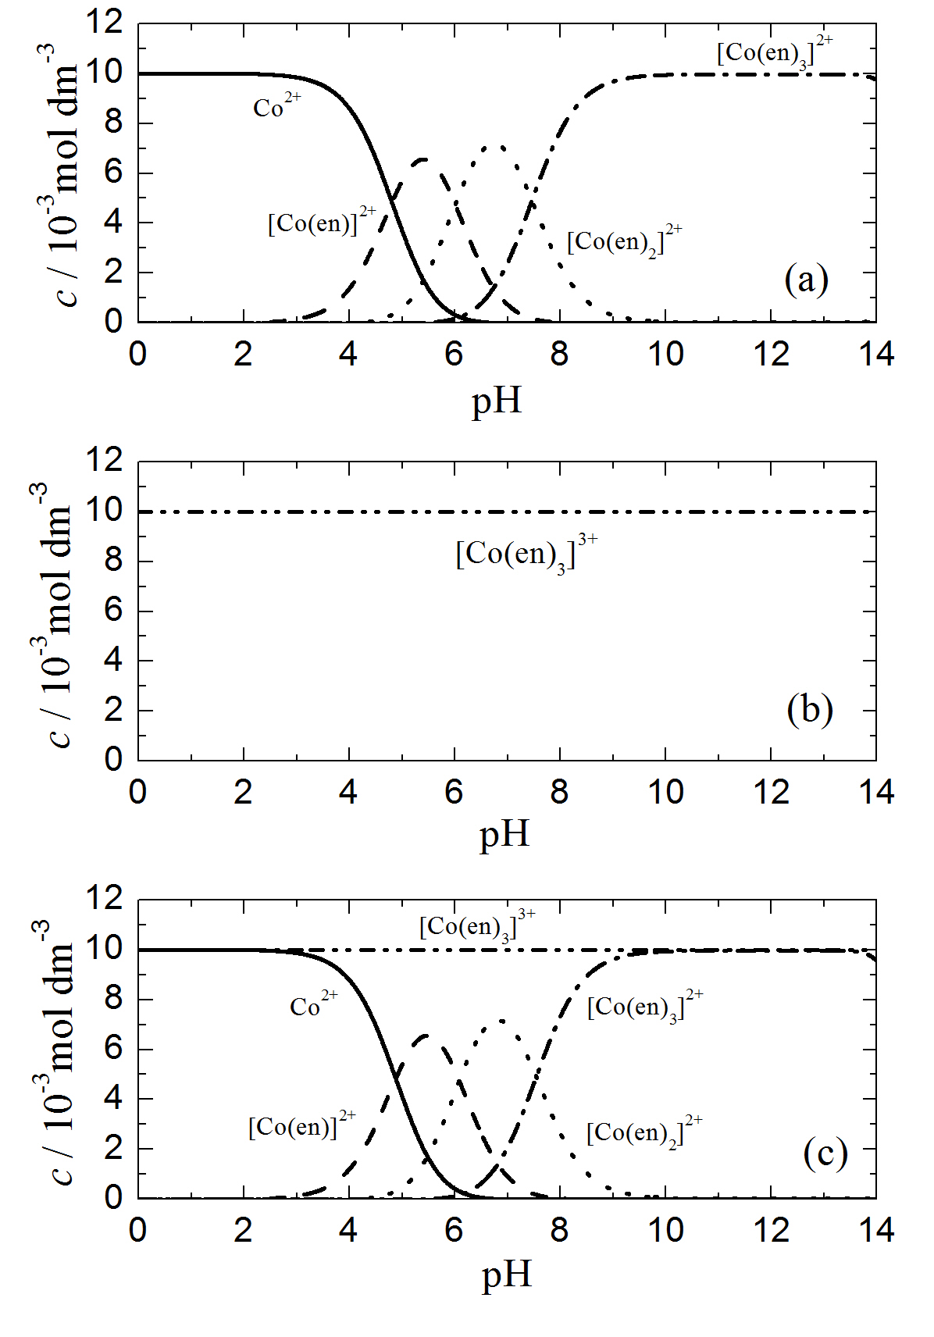
Fig. 1. Distribution of different cobalt complexes in the solution 0.2 mol dm⁻³ ethylenediamine, pH 12: (a) 0.01 mol dm⁻³ Co²⁺; (b) 0.01 mol dm⁻³ Co³⁺; (c) 0.01 mol dm⁻³ Co²⁺ + 0.01 mol dm⁻³ Co³⁺.
at stationary electrode (0 RPM) and current density plateaus at rotating electrode (RPM's 1000 and 2000). The oxidation of [Co(en)₃]²⁺ into [Co(en)₃]³⁺ is seen to take place only at stationary electrode after the formation of [Co(en)₃]²⁺ complex during the first sweep which remained in the vicinity of the electrode surface, being characterized with a broad anodic peak for all subsequent sweeps (2nd – n^{th}). At the rotating electrode this reaction does not take place, since all [Co(en)₃]²⁺ complexes formed during the reduction of [Co(en)₃]³⁺ are transferred from the electrode surface in the bulk of electrolyte by electrode rotation. Hence, it could be concluded that only certain amount of [Co(en)₃]²⁺, which remained in the vicinity of the electrode surface at stationary electrode after reduction of [Co(en)₃]³⁺ into [Co(en)₃]²⁺, could be oxidized into [Co(en)₃]³⁺ during the anodic sweep. Taking into account that the whole amount of cobalt in both solutions is in the form of [Co(en)₃]³⁺ complex (Fig. 1b), such behavior could be expected. This finding is in accordance with certain literature data,⁵ while some authors claimed that reduction/oxidation process is reversible with the peaks potential difference varying from 60 mV to 90 mV.⁷
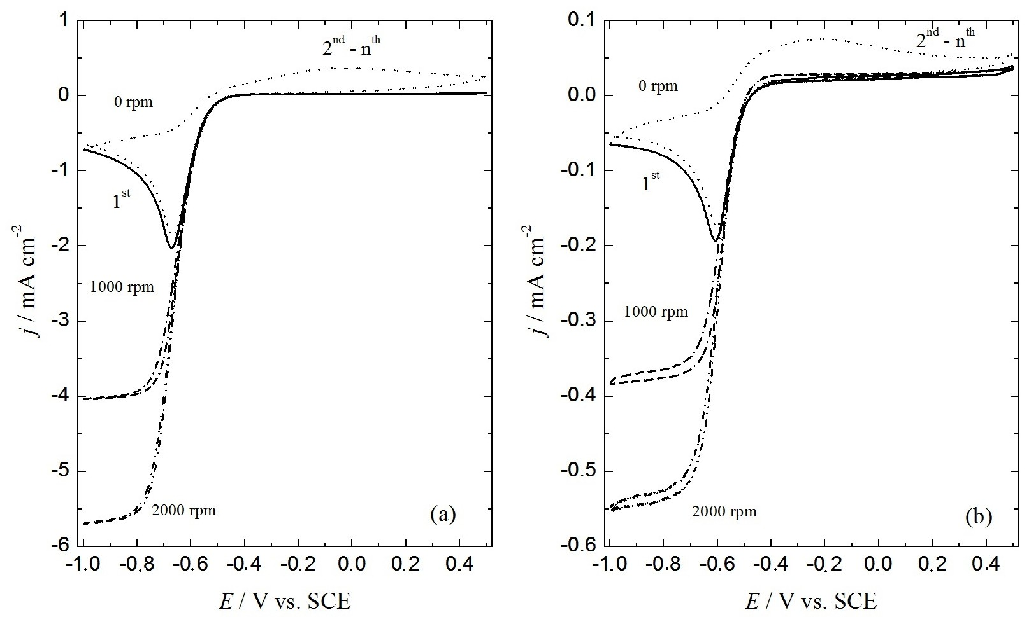
Fig. 2. CV's recorded with v = 100 mV s⁻¹ at different rotation speeds (marked in the figure) in the solutions containing 0.01 mol dm⁻³ Co(en)₃Cl₃ + 0.2 mol dm⁻³ (en) (a) and 0.001 mol dm⁻³ Co(en)₃Cl₃ + 0.2 mol dm⁻³ (en) (b).
Polarization curves for reduction of [Co(en)₃]³⁺ into [Co(en)₃]²⁺, recorded with the sweep rate of 5 mV s⁻¹ at different rotation speeds (marked in the figure) are presented in Fig. 3a. As can be seen well-defined diffusion limiting current density plateaus are obtained at potentials more negative than -0.7 V with the shape of the j - E curves being typical for the totally irreversible reaction. Corresponding diffusion coefficient (D) of the [Co(en)₃]³⁺ complex is calculated by using Levich's equation from the slope of this dependence (assuming one electron exchange) and the value of 1.64 x10⁻⁵ cm² s⁻¹ is obtained.²¹ The j⁻¹ vs. ω^{-1/2} dependences, obtained by the analysis of the polarization curves presented in Fig. 2a, are plotted in Fig. 3b for different potentials (marked in the figure) and the j⁻¹ vs. ω^{-1/2} dependence recorded for E = -0.80 V is linear one passing through zero. The diffusion coefficient calculated from the slope of this dependence (using Koutecky-Levich's equation for one electron exchange)²¹ amounts to 1.60 x 10⁻⁵ cm² s⁻¹, indicating very good agreement between the values of D obtained by the analysis of these two dependences. As expected, in the region of mixed activation-diffusion control of the reduction process (potential range -0.45 V to -0.65 V), the values of intercepts on the j⁻¹ axes increase with decreasing cathodic potential, producing higher values of the kinetic current density (j_{k}) and accordingly higher values of the rate constants (k_{f}(E)) at a given potential, since:²¹
(1)
(c₀ is bulk concentration of the [Co(en)₃]³⁺ complex). Corresponding values of the rate constants are: E = -0.60 V, k_{f}(E) = 0.0497 cm s⁻¹; E = -0.55 V, k_{f}(E) = 0.0122 cm s⁻¹; E = -0.50 V, k_{f}(E) = 0.0022 cm s⁻¹.
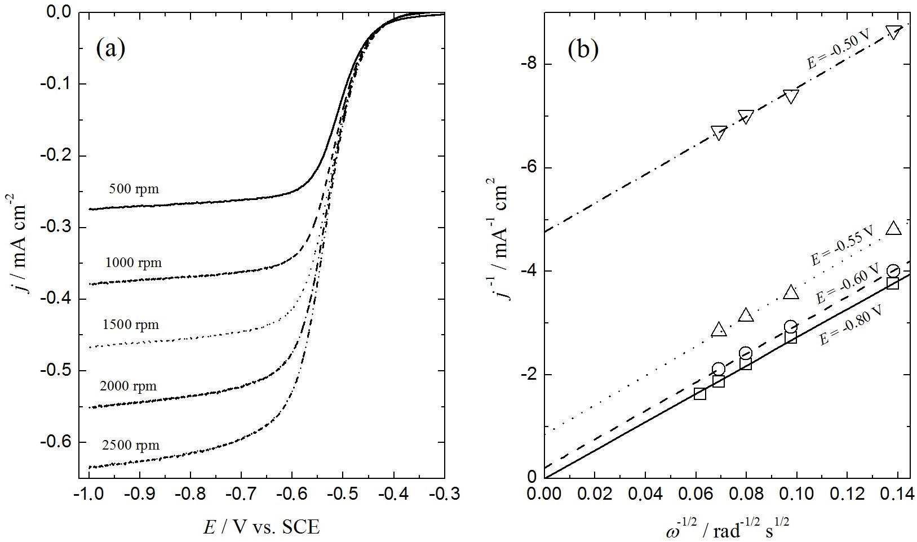
Fig. 3. a) Polarization curves for the reduction of [Co(en)₃]³⁺ into [Co(en)₃]²⁺, recorded with v = 5 mV s⁻¹ at different rotation speeds (marked in the figure) in the solution: 0.001 mol dm⁻³ Co(en)₃Cl₃ + 0.2 mol dm⁻³ (en). b) The j⁻¹ vs. ω^{-1/2} dependences obtained by the analysis of polarization curves presented in (a) for different potentials (marked in the figure).
Similar results are obtained for 0.01 mol dm⁻³ Co(en)₃Cl₃ + 0.2 mol dm⁻³ (en) solution at pH 12. In order to find out what is the next step in the process of [Co(en)₃]³⁺ reduction, cathodic potential limit is adjusted at -1.5 V and the CV with v = 20 mV s⁻¹ is recorded (Fig. 4a). As can be seen at potentials more negative than -1.0 V stable cathodic current density is detected, while its sudden increase is observed at about -1.47 V. This current density increase reflects simultaneous hydrogen evolution and deposition of cobalt. During the reverse sweep three anodic peaks appeared on the CV at about -0.85 V (I_{a}), -0.70 V (II_{a}) and -0.45 V (III_{a}) respectively. The first two peaks (I_{a} and II_{a}) correspond most likely to the dissolution of deposited Co and formation of [Co(en)₃]²⁺ complex, while the third one (III_{a}) could be ascribed to a further oxidation of [Co(en)₃]²⁺ into [Co(en)₃]³⁺. Hence, before the deposition of cobalt from this solution, the reduction of [Co(en)₃]³⁺ into [Co(en)₃]²⁺ takes place (I_{c}) at potentials for about 1.00 V more positive, indicating that the current efficiency for the deposition process (which occurs with simultaneous hydrogen evolution) is very low. At higher concentration of Co(en)₃Cl₃ of 0.1 mol dm⁻³ two more peaks could be detected on the CV recorded at the sweep rate of 2 mV s⁻¹ (Fig. 4b). The peak (wave) II_{c} indicates the commencement of cobalt deposition at about -1.25 V, while the peak IV_{a} corresponds to the oxidation of deposited cobalt which could not be quantitatively dissolved from the GC surface and its presence can be detected on the GC surface after the experiment.²²
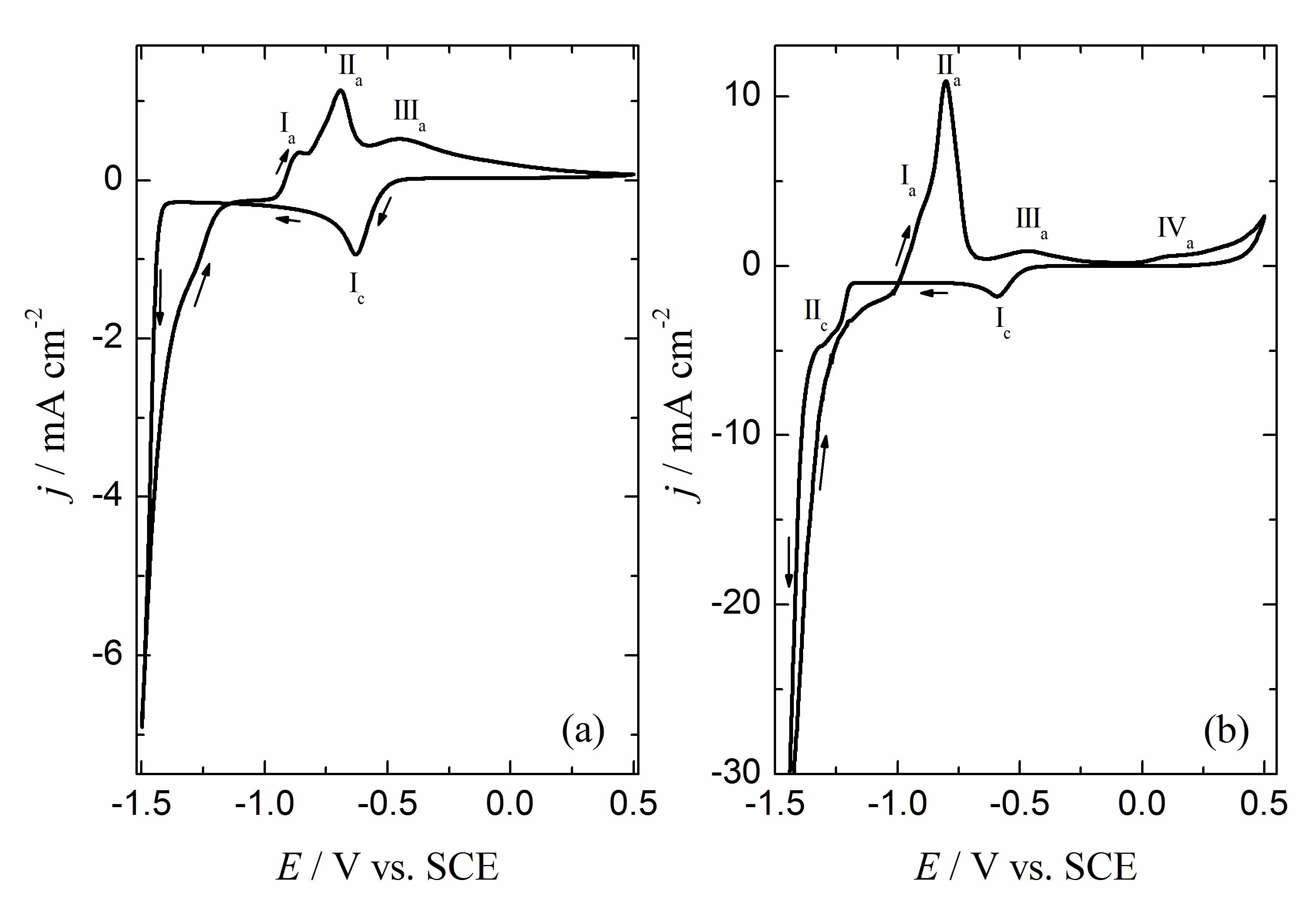
Fig. 4. a) CV with v = 20 mV s⁻¹ recorded in the solution 0.01 mol dm⁻³ Co(en)₃Cl₃ + 0.2 mol dm⁻³ (en). b) CV with v = 2 mV s⁻¹ recorded in the solution 0.1 mol dm⁻³ Co(en)₃Cl₃ + 0.2 mol dm⁻³ (en), both obtained at stationary electrode at pH 12.
Electrochemical behavior of Co²⁺ in 0.2 mol dm⁻³ ethylenediamine
The CV's recorded onto GC electrode at the sweep rate of 100 mV s⁻¹ onto stationary (0 RPM) and rotating electrodes (1000 RPM and 2000 RPM) in the solution containing 0.001 mol dm⁻³ CoCl₂ + 0.2 mol dm⁻³ (en) are shown in Fig. 5a. Potential is swept to anodic direction from starting potential marked with the arrow. Considering the CV obtained at stationary electrode (0 RPM) it appears that the oxidation of [Co(en)₃]²⁺ (dominant complex at pH 12, Fig. 1a) into [Co(en)₃]³⁺ does not occur during the first cycle (solid line) and that its reduction takes place at potentials more negative than -0.70 V through a current density wave characterized with the plateau. During the reverse sweep, the oxidation of [Co(en)₃]²⁺ into [Co(en)₃]³⁺ does occur through a broad anodic peak, while the reduction of [Co(en)₃]³⁺ (which is formed during the oxidation process) into
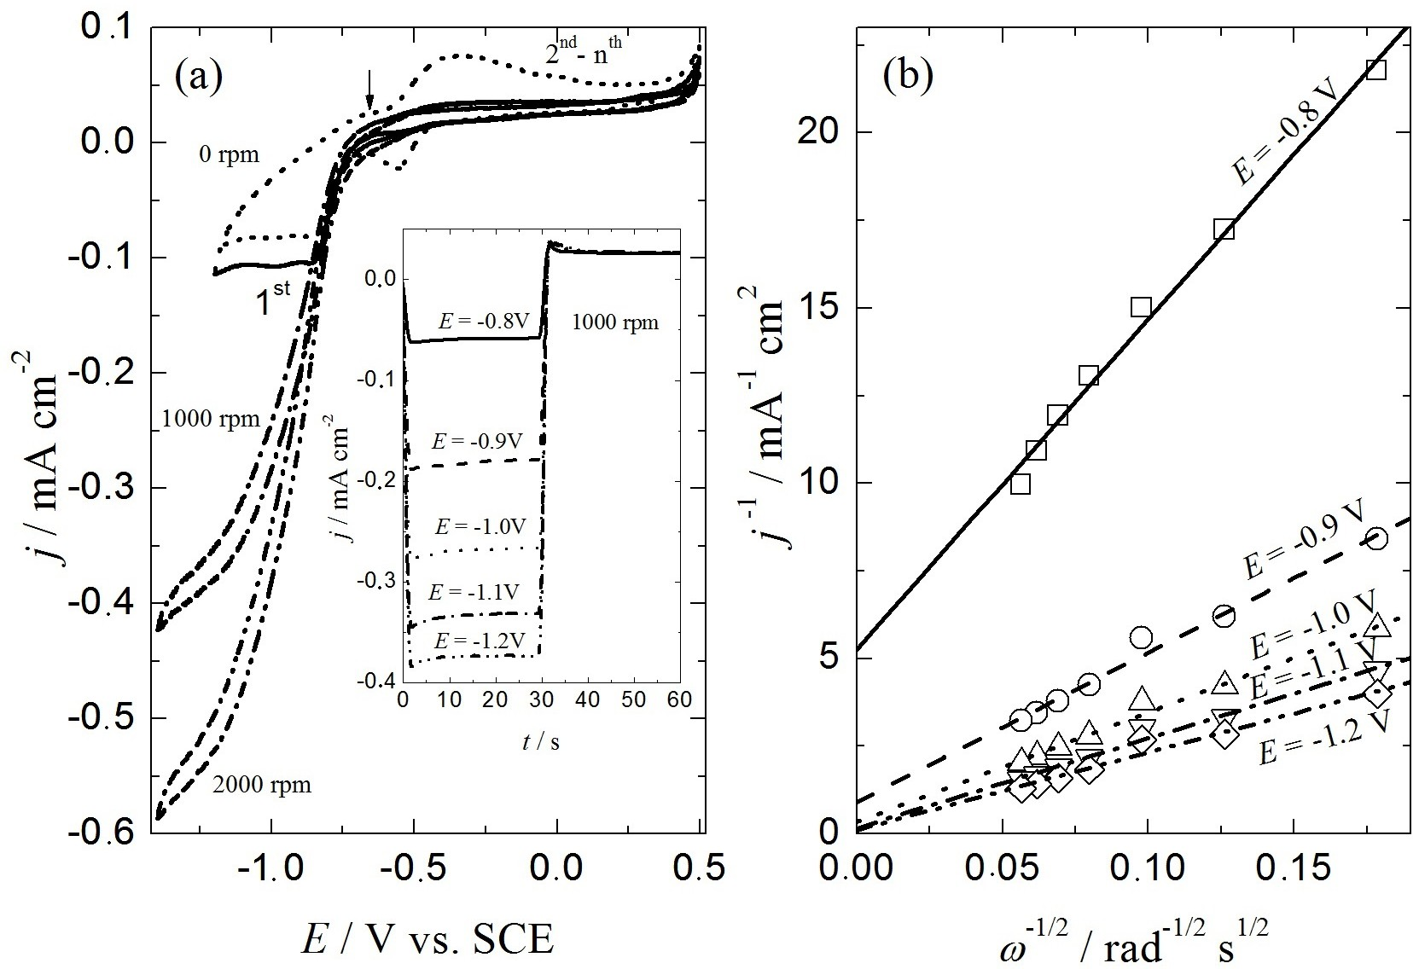
Fig. 5. a) CV's recorded with v = 100 mV s⁻¹ at different rotation speeds (marked in the figure) in the solutions containing 0.001 mol dm⁻³ CoCl₂ + 0.2 mol dm⁻³ (en). Inset: potentiostatic j vs. t transients recorded at different cathodic potentials (marked in the figure) and constant anodic potential E = -0.2 V at 1000 rpm. b) The j⁻¹ vs. ω^{-1/2} dependences obtained from the potentiostatic j vs. t transients recorded at different potentials (marked in the figure).
takes place through a sharper cathodic peak positioned between about -0.45 V and -0.65 V during the 2nd and subsequent cycles. In the conditions of convective diffusion oxidation of [Co(en)₃]²⁺ into [Co(en)₃]³⁺ cannot be detected on the CV's in this solution. The process of reduction of [Co(en)₃]²⁺ is seen to commence at about -0.75 V, being expressed by sudden increase of the cathodic current density without indication of the diffusion limiting current density plateau. The j vs. t transients recorded at RPM=1000 (1000 RPM) and presented in the inset of Fig. 5a, are characterized with the constant current density response at all applied potentials. As can be seen the values of the cathodic current density increase with increasing cathodic potential, while the values of anodic current density recorded during the anodic pulse at E = -0.2 V (as well as the amount of anodic charge for the oxidation reaction) is independent on cathodic potential, i.e. on the amount of reduced [Co(en)₃]²⁺. Taking into account that all reduced species during the cathodic process are removed to the bulk of solution by the electrode rotation, it is reasonable to expect that only limited amount could be oxidized during the anodic pulse. It should be stated here that even in the case of stationary electrode (0 RPM) only small amount (about 10 %) of reduced species can be oxidized, although certain amount of them remain in the vicinity of the electrode surface after the cathodic current density pulse. Hence, it could be concluded that, as in the solution containing only [Co(en)₃]³⁺ complex, the oxidation process of [Co(en)₃]²⁺ into [Co(en)₃]³⁺ is complex. Considering results presented in Fig. 5b it is obvious that the reduction process is complex, since the slopes of the j⁻¹ vs. ω^{-1/2} dependences change with the potential, indicating that most likely different species undergo to reduction process in the investigated potential range.²¹ It is also possible that some chemical reactions occur, but it is not possible to predict what is really happening in the system from the presented results.²¹
If the concentration of CoCl₂ is increased to 0.01 mol dm⁻³ slightly different results are obtained. As can be seen in Fig. 6a, at the stationary electrode (0 RPM) first and subsequent sweeps are identical, indicating oxidation of [Co(en)₃]²⁺ into [Co(en)₃]³⁺ immediately at the beginning of cycling (starting potential is marked with the arrow). It appears that in order to be able to detect this process by CV at 100 mV s⁻¹, it is necessary to increase the concentration of CoCl₂. During the reverse (cathodic) sweep, sharp peak of the reduction of [Co(en)₃]³⁺ (formed during the oxidation reaction) into [Co(en)₃]²⁺ appears at about -0.6 V, while further reduction of [Co(en)₃]²⁺ species is characterized by the presence of additional, smaller, peak at about -0.8 V. As in previous cases, the increase of the anodic current density at the oxidation peak on all the CV's recorded at 100 mV s⁻¹ is positioned at more negative potentials than expected for the totally irreversible oxidation/reduction mechanism. This could be the consequence of the occurrence of some other reaction, most probably coupled chemical reaction, during the oxidation process, since the shape of the CV's is similar to those theoretically predicted for such reactions.²¹ In the case of electrode rotation anodic peak becomes more pronounced, but practically independent of the rotation speed. During the reverse sweep (from 0.5 V to -1.2 V) a first current density plateau appears between 0.0 V and -0.3 V indicating diffusion controlled oxidation reaction taking place at a current density of about 0.4 mA cm⁻². Additional, much shorter current density plateau, between -0.50 V and -0.75 V, at zero current density indicates that no reduction of [Co(en)₃]³⁺ into [Co(en)₃]²⁺ occurs in the conditions of convective diffusion. The increase of cathodic current density at potentials more negative than -0.75 V corresponds to further reduction of the [Co(en)₃]²⁺ complex. In order to better understand these processes potentiostatic pulse experiments presented in (b) and (c) are performed. Fig. 6b shows that the species formed during the anodic potential step (E = 0.1 V) start reducing at -0.70 V. The amount of species being reduced during the cathodic potential steps increases with the increase of cathodic potential reaching maximum of about 12 % at E = -1.1 V. Results presented in Fig. 6c show that about 28 % of species formed at E = -0.2 V on the stationary electrode become reduced at E = -0.6 V (peak potential, Fig. 6a), while no reduction could be detected at the conditions of convective diffusion. At the same time it could be seen that the oxidation process is practically insensitive on the rotation speed. It should be noted here that similar j⁻¹ vs. ω^{-1/2} dependences (changing slopes and intercepts as a function of the cathodic potential) compared to those recorded for 0.001 mol dm⁻³ CoCl₂ are obtained.
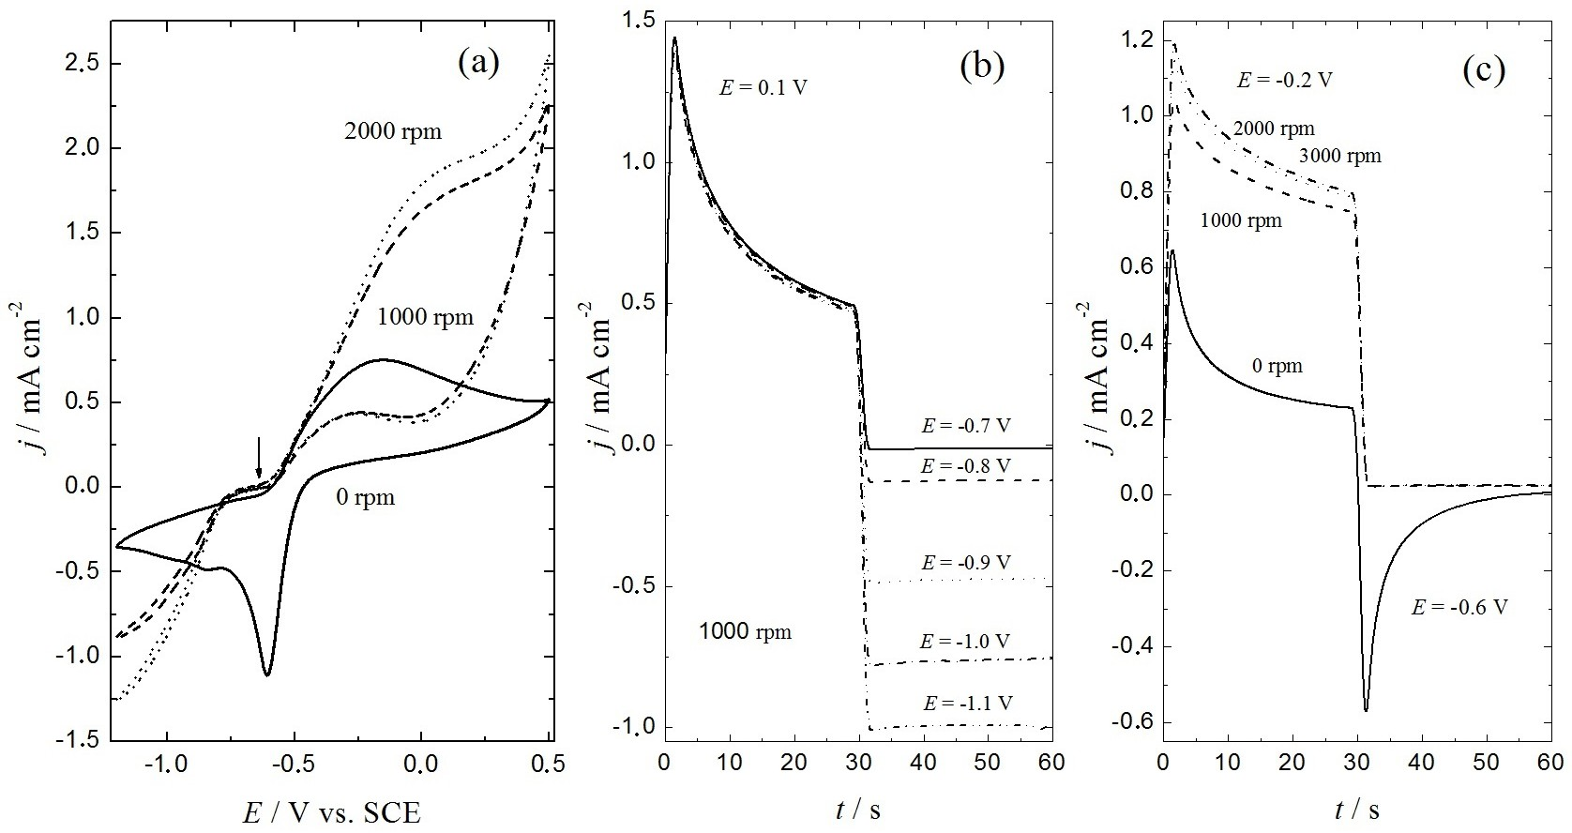
Fig. 6. a) CV's recorded with v = 100 mV s⁻¹ at different rotation speeds (marked in the figure) in the solutions containing 0.01 mol dm⁻³ CoCl₂ + 0.2 mol dm⁻³ (en). b) Potentiostatic j vs. t transients recorded at different cathodic potentials (marked in the figure) and constant anodic potential E = 0.1 V at 1000 rpm. (c) Potentiostatic j vs. t transients at constant anodic and cathodic potentials (marked in the figure) recorded at different rotation speeds
(marked in the figure).
Electrochemical behavior of Co²⁺ + Co³⁺ in 0.2 mol dm⁻³ ethylenediamine
The CV's recorded onto GC electrode at the sweep rate of 100 mV s⁻¹ onto stationary (0 RPM) and rotating electrode (1000 RPM) in the solution containing 0.001 mol dm⁻³ CoCl₂ + 0.001 mol dm⁻³ Co(en)₃Cl₃ + 0.2 mol dm⁻³ (en) are shown in Fig. 7a. Potential is swept to anodic direction from starting potential marked with the arrow. In comparison with the results obtained in the solution containing only 0.001 mol dm⁻³ CoCl₂ (Fig. 5a) a small anodic peak for the 1st sweep could be detected at the stationary electrode, while for the subsequent sweeps this peak is identical to that obtained in pure 0.001 mol dm⁻³ CoCl₂ solution. At the same time cathodic peak corresponding to the reduction of [Co(en)₃]³⁺ into [Co(en)₃]²⁺ is much better defined since the [Co(en)₃]³⁺ complex is present in the solution at the concentration slightly higher than 0.001 mol dm⁻³ (taking into account that certain amount of the [Co(en)₃]³⁺ complex is formed by the oxidation of [Co(en)₃]²⁺). In the conditions of convective diffusion the increase of anodic current density without plateau confirms that the oxidation process is not diffusion controlled, while the shape of cathodic current density wave indicates the occurrence of two processes, the first one corresponding to reduction of [Co(en)₃]³⁺ into [Co(en)₃]²⁺ (potential range between -0.7 V and -0.8V) and the second one at more negative potentials, which is less pronounced and corresponds to further reduction of [Co(en)₃]²⁺. The potentistatic pulse responses presented in the inset of Fig. 7a clearly show that only certain amount of species formed during the reduction process can be oxidized during the anodic pulse (E = -0.2 V) and that oxidation is independent of the rotation speed. The j⁻¹ vs. ω^{-1/2} dependences presented in Fig. 7b also confirm, as in the case of 0.001 mol dm⁻³ CoCl₂ solution, that the reduction process is complex in the presence of Co²⁺ ions.
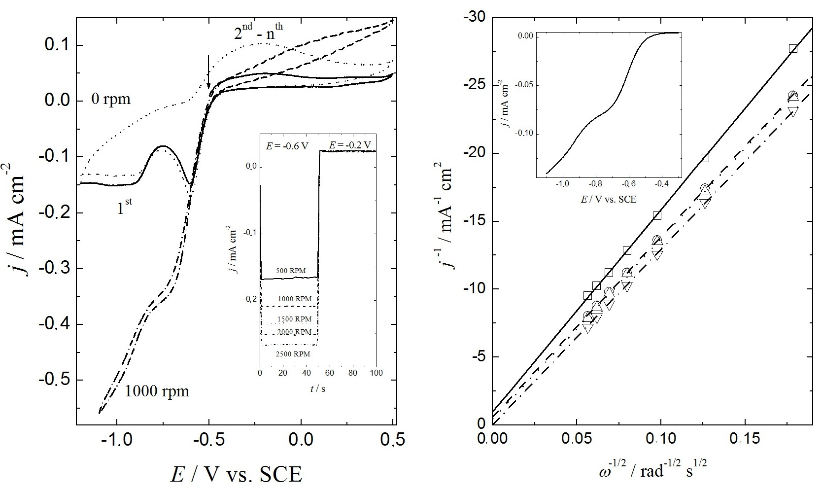
Fig. 7. a) CV's recorded with v = 100 mV s⁻¹ at different rotation speeds (marked in the figure) in the solution containing 0.001 mol dm⁻³ CoCl₂ + 0.001 mol dm⁻³ Co(en)₃Cl₃ + 0.2 mol dm⁻³ (en). Inset: potentiostatic j vs. t transients recorded at different cathodic potentials (marked in the figure) and constant anodic potential E = -0.2 V at 1000 RPM. (b) The j⁻¹ vs. ω^{-1/2} dependences obtained from the potentiostatic j vs. t transients. Inset: Polarization curve for the reduction process recorded at the sweep rate of 1 mV s⁻¹.
CONCLUSIONS
From the results presented in this work it could be concluded that different cobalt complexes are present in the solution containing 0.2 mol dm⁻³ ethylenediamine, with the [Co(en)₃]³⁺ complex being the most stable one at all pH values. Its reduction into [Co(en)₃]²⁺ complex represents totally irreversible one electron exchange reaction, while further reduction of [Co(en)₃]²⁺ is complex process leading to a cobalt deposition at the potentials more negative than -1.45 V. The process of [Co(en)₃]²⁺ oxidation is also complex and most probably coupled with the chemical reaction.
Acknowledgement. The authors would like to thank the Ministry of the Science of the Republic of Serbia for the financial support through Project No. 172045.
извод
ЕЛЕКТРОХЕМИЈА КОБАЛТ-ЕТИЛЕНДИАМИН КОМПЛЕКСА ПРИ ВИСОКИМ
pH ВРЕДНОСТИМА
СНЕЖАНА М. МИУЛОВИЋ, ВЛАДИМИР М. НИКОЛИЋ, ПЕТАР З. ЛАУШЕВИЋ, ДАНКА Д. АЋИМОВИЋ, ГВОЗДЕН С. ТАСИЋ и МИЛИЦА П. МАРЧЕТА КАНИНСКИ
Институт за нуклеарне науке „Винча“, Лабораторија за физичку хемију, Универзитет у Београду, Мике Аласа 12–14, 11000 Београд
У овом раду је испитивано електрохемијско понашање кобалта у присуству етилендиамина у великом вишку при pH 12. Испитивања су извршена методама цикличне волтаметрије, потенциостатског пулса и мерењем поларизационих кривих на стационарној и ротирајућој електроди од стакластог угљеника. Показано је да се у раствору формира шеснаест различитих врста које садрже Co(en)₃ и да је најстабилнији [Co(en)₃]³⁺ при свим pH вредностима. Показано је да је редукција [Co(en)₃]³⁺ до [Co(en)₃]²⁺ потпуно иреверзибилна једноелектронска реакција. Утврђено је да је даља редукција [Co(en)₃]²⁺ сложен процес који води ка таложењу кобалта на потенцијалима негативнијим од –1,45 V у односу на засићену каломелову електроду. Процес оксидације [Co(en)₃]²⁺ такође је комплексан и највероватније спрегнут са хемијском реакцијом.
(Примљено 27. марта, ревидирано 23. јуна, прихваћено 30. јуна 2015)
REFERENCES
- A. Werner, Ber. Dtsch. Chem. Ges.45 (1912) 121
- D. Witiak, J. C. Clardy, D. S. Martin, Acta Crystallogr., Sect. B: Struct. Sci 28 (1972) 2694
- J. Bjerrum, S. E. Rasmussen, Acta Chem. Scand. 6 (1952) 1265
- H. A. Laitinen, M. W. Grieb, J. Am. Chem. Soc. 77 (1955) 5201
- P. Kivalo, J. Am. Chem. Soc. 77 (1955) 2678
- S. Sahami, M. J. Weaver, J. Electroanal. Chem. 122 (1981) 171
- S. Sahami, M. J. Weaver, J. Electroanal. Chem. 122 (1981) 155
- S. Sahami, M. J. Weaver, J. Electroanal. Chem. 124 (1981) 35
- U. Mayer, A. Kotocova, V. Gutmann, W. Gerger, J. Electroanal. Chem. 100 (1979) 875
- M. M. Jakšić, Č. M. Lačnjevac, Chem. Tech. 37 (1985) 257
- M. M. Jakšić, Int. J. Hydrogen Energy 11 (1986) 519
- M. M. Jakšić, Mater. Chem. Phys. 22 (1987) 1
- M. P. Marceta Kaninski, D. Lj.Stojic, Dj. P. Saponjic, N. I. Potkonjak, S. S. Miljanic, J. Power Sources 157 (2006) 758
- S. Lj. Maslovara, S. M. Miulovic, M. P. Marceta Kaninski, G. S. Tasic, V. M. Nikolic, Appl. Catal., A 451 (2013) 216
- S. M. Miulovic, S. Lj. Maslovara, I. M. Perovic, V. M. Nikolic, M. P. Marceta Kaninski, Appl. Catal., A 451 (2013) 220
- M. P. Marceta Kaninski, V. M. Nikolic, G. S. Tasic, Z. Lj. Rakocevic, Int. J. Hydrogen Energy 34 (2009) 703
- M. P. Marceta Kaninski, A. D. Maksic, D. Lj. Stojic, S. S. Miljanić, J. Power Sources 131 (2004) 107
- P. R. Rowland, Nature 218 (1968) 945
- P. R. Rowland, J. Electroanal. Chem. 32 (1971) 109
- A. E. Martell, R. M. Smith, NIST critically selected stability constants of metal complexes: version 8.0, NIST standard reference database 46, 2004
- A. J. Bard, L. R. Faulkner, Electrochemical methods, fundamentals and applications, John Wiley & Sons, Inc., New York, 2001, pp. 339-343, 471-517
- H. Gomez Meier, J. R. Vilche, A. J. Arvia, J. Electroanal. Chem. 138 (1982) 367.

* Corresponding author. E-mail: snezana.miulovic@vinca.rs doi:

