SUPPLEMENTARY MATERIAL TO
Microwave Assisted Synthesis of Substituted 4-Chloro-8-methyl-2-(1,3-diphenyl-1H-pyrazol-4-yl)-1,5-dioxa-2H-phenanthren-6-ones and Their Antimicrobial Activity
DONGAMANTI ASHOK^{1*}, BACHI REDDY VANAJA¹, MDDERLA SARASIJA² and B. VIJAYA LAKSHMI¹
¹Green and Medicinal Chemistry Laboratory, Department of Chemistry, Osmania University, Hyderabad, India, 500007, ²Department of Chemistry, Satavahana University, Karimnagar, Telangana, India, 505001
However, Vilsmeier reagent (DMF/POCl₃) serves for formylation of electron-rich aromatic ring, it is highly efficient for intramolecular cyclization of 2'-hydroxychalcones to 4-chloro-2H-chromenes. The mechanism of reaction is shown below
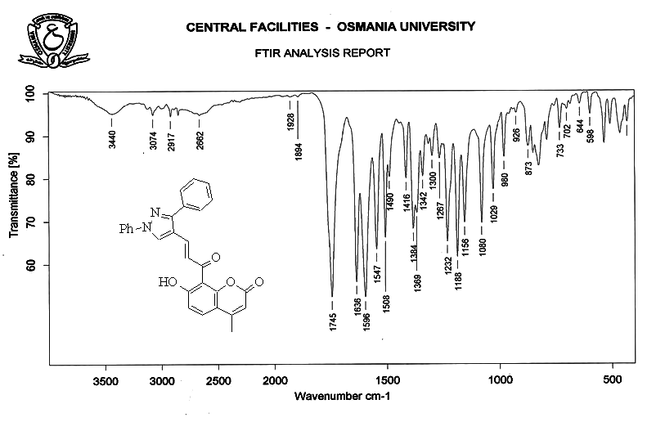
IR spectrum of (E)-1-(7-Hydroxy-4-methyl-8-coumarinyl)-3-(3-aryl-1-phenyl-1H-pyrazol-4-yl)-2-propen-1-one (3a):
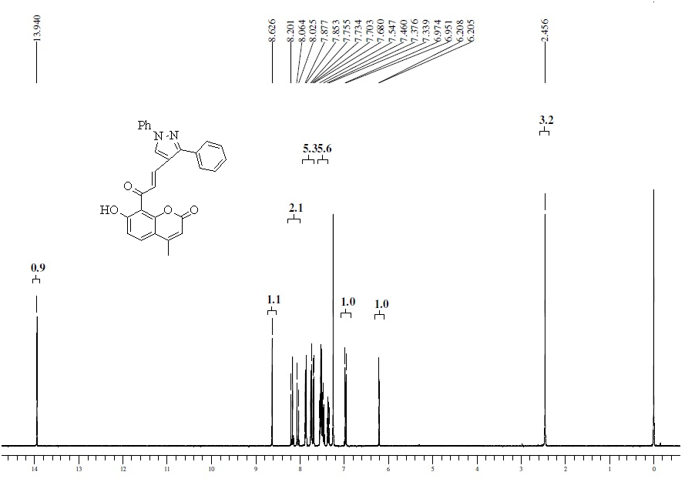
¹H NMR (400 MHz, CDCl₃) spectrum of (E)-1-(7-Hydroxy-4-methyl-8-coumarinyl)-3-(3-aryl-1-phenyl-1H-pyrazol-4-yl)-2-propen-1-one (3a)

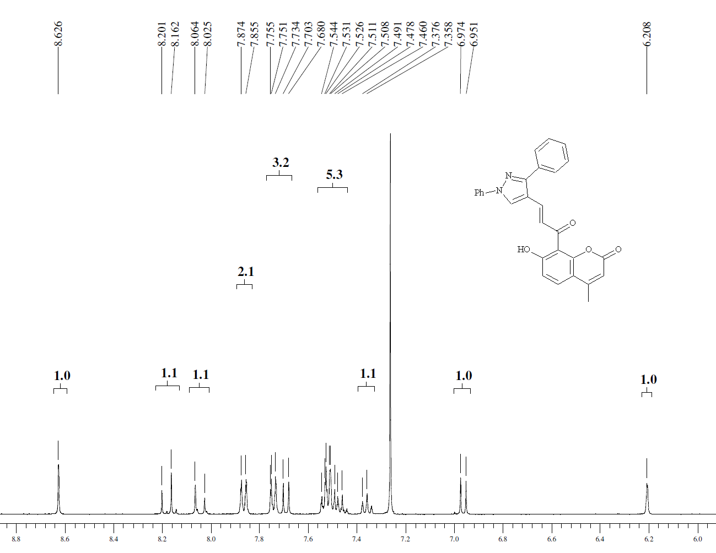
¹H NMR (400 MHz, CDCl₃) (expansion) spectrum of (E)-1-(7-Hydroxy-4-methyl-8-coumarinyl)-3-(3-aryl-1-phenyl-1H-pyrazol-4-yl)-2-propen-1-one (3a)

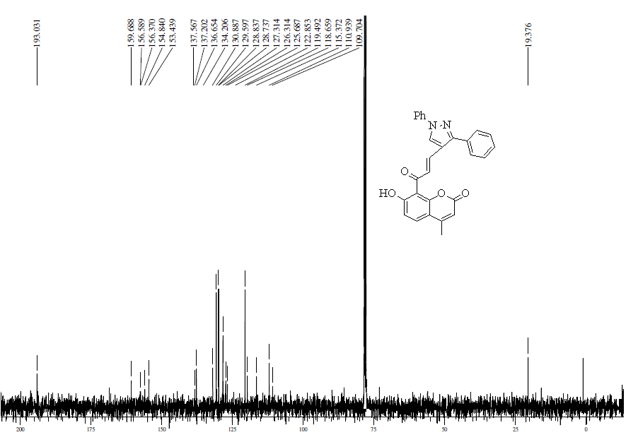
¹³C NMR (100 MHz, CDCl₃) spectrum of (E)-1-(7-Hydroxy-4-methyl-8-coumarinyl)-3-(3-aryl-1-phenyl-1H-pyrazol-4-yl)-2-propen-1-one (3a)
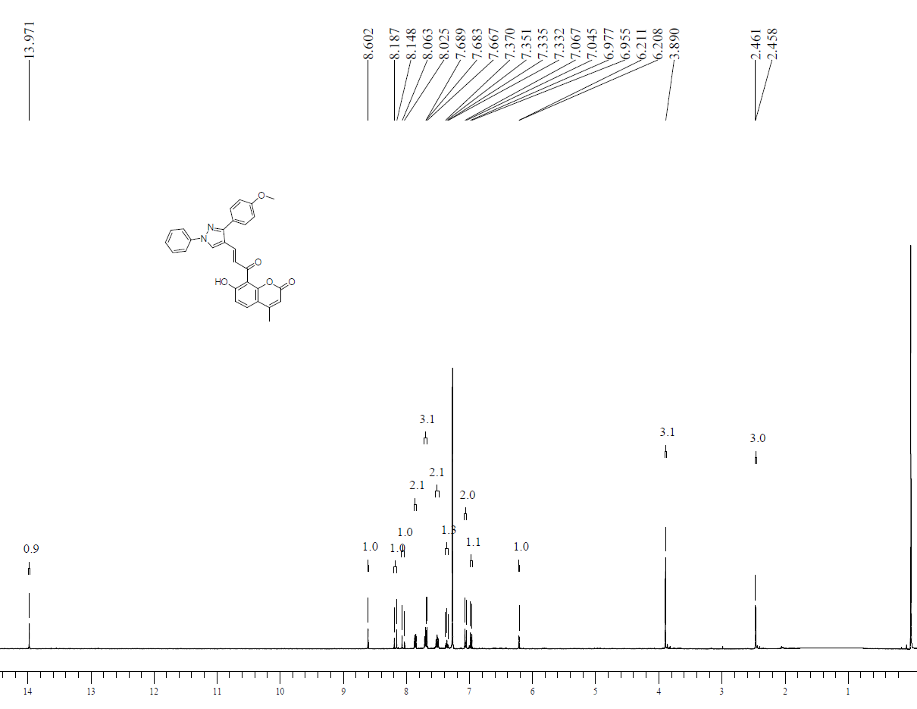
¹H NMR (400 MHz, CDCl₃) spectrum of (E)-3-[3-(4-Methoxyphenyl)-1-phenyl-1H-pyrazol-4-yl]-1-(7-hydroxy-4-methyl-8-coumarinyl)-2-propen-1-one (3b)
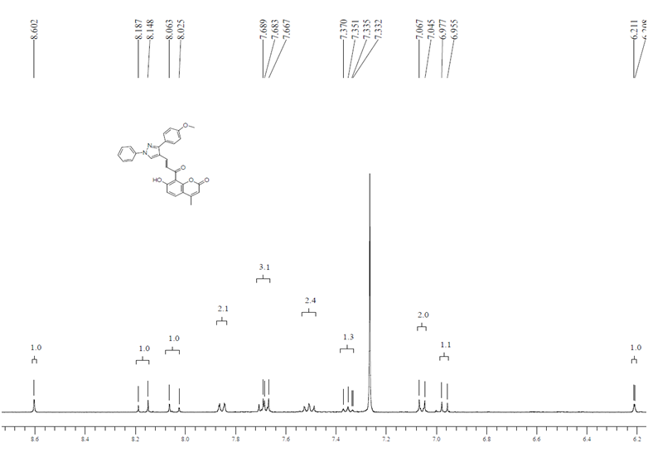
¹H NMR (400 MHz, CDCl₃) spectrum (expansion) of (E)-3-[3-(4-Methoxyphenyl)-1-phenyl-1H-pyrazol-4-yl]-1-(7-hydroxy-4-methyl-8-coumarinyl)-2-propen-1-one (3b)

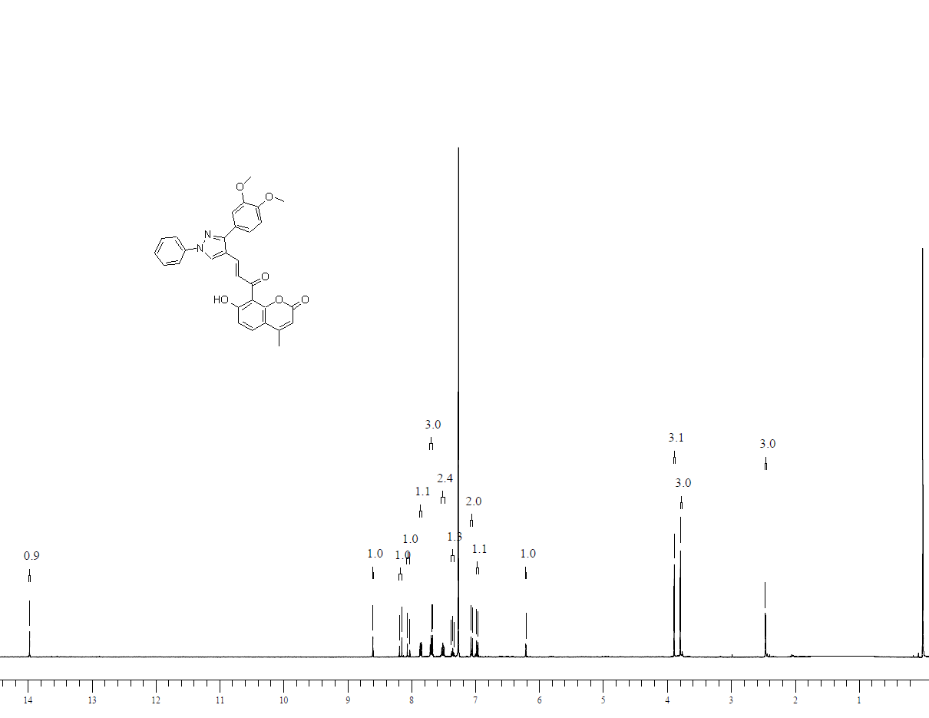
¹H NMR (400 MHz, CDCl₃) spectrum of (E)-3-[3-(4-Dimethoxyphenyl)-1-phenyl-1H-pyrazol-4-yl]-1-(7-hydroxy-4-methyl-8-coumarinyl)-2-propen-1-one (3b)

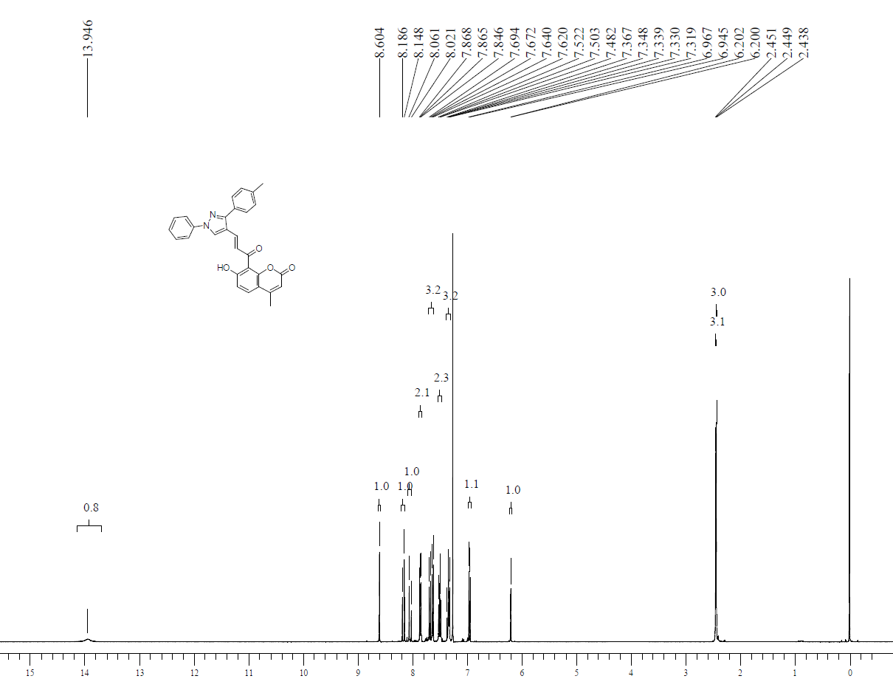
¹H NMR (400 MHz, CDCl₃) spectrum of (E)-7-hydroxy-4-methyl-8-(3-(1-phenyl-3-(p-tolyl)-1H-pyrazol-4-yl)acryloyl)-2H-chromen-2-one (3d)
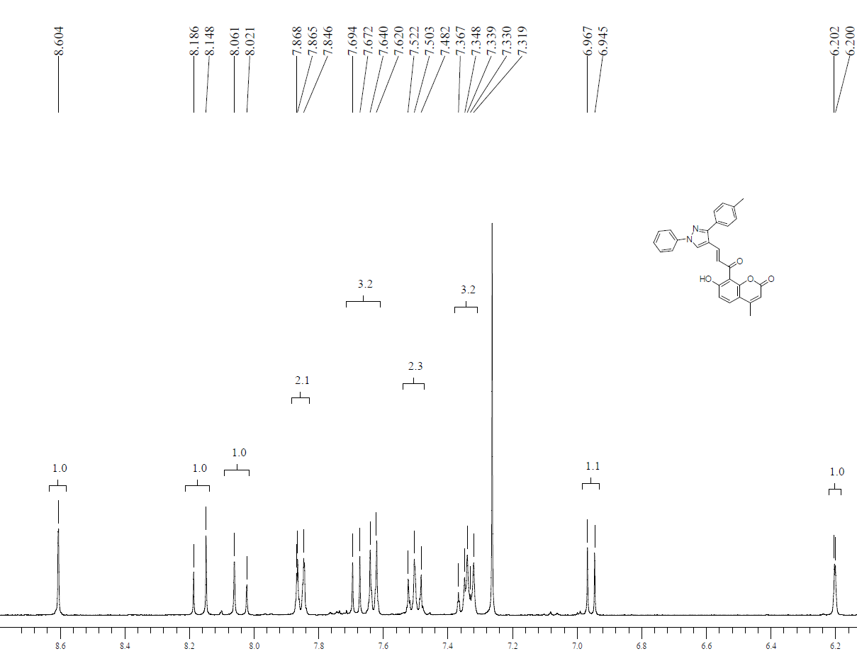

¹H NMR (400 MHz, CDCl₃) spectrum (expansion) of (E)-7-hydroxy-4-methyl-8-(3-(1-phenyl-3-(p-tolyl)-1H-pyrazol-4-yl)acryloyl)-2H-chromen-2-one (3d)
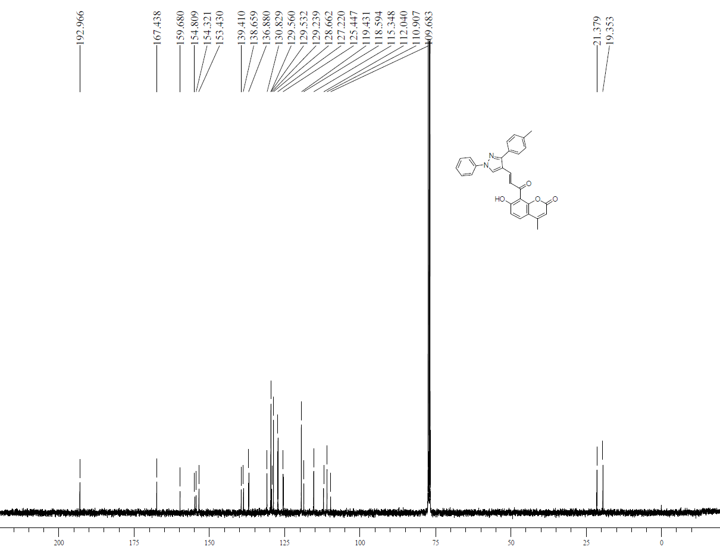
¹³C NMR (100 MHz, CDCl₃) spectrum of (E)-7-hydroxy-4-methyl-8-(3-(1-phenyl-3-(p-tolyl)-1H-pyrazol-4-yl)acryloyl)-2H-chromen-2-one (3d)
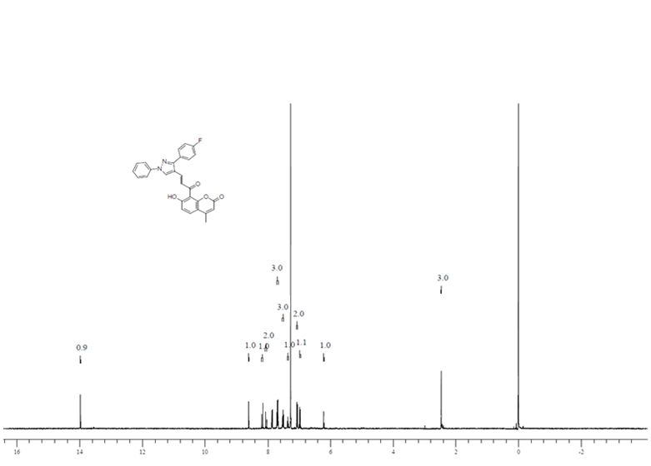
¹H NMR (400 MHz, CDCl₃) spectrum of (E)-8-(3-(3-(4-fluorophenyl)-1-phenyl-1H-pyrazol-4-yl)acryloyl)-7-hydroxy-4-methyl-2H-chromen-2-one (3e)
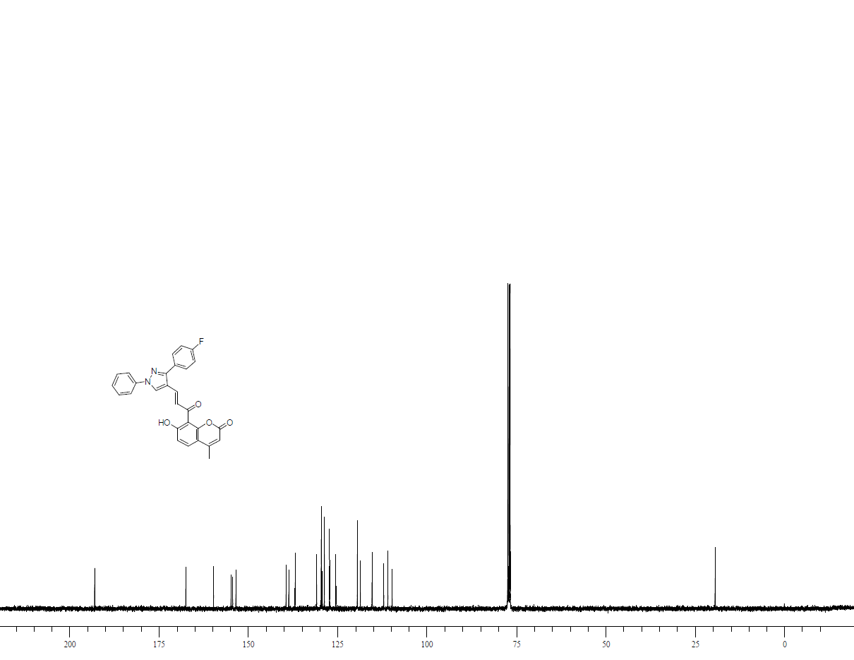
¹H NMR (400 MHz, CDCl₃) spectrum of (E)-8-(3-(3-(4-fluorophenyl)-1-phenyl-1H-pyrazol-4-yl)acryloyl)-7-hydroxy-4-methyl-2H-chromen-2-one (3e)
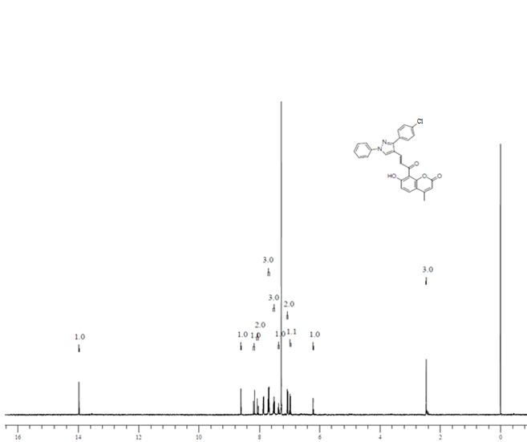
¹H NMR (400 MHz, CDCl₃) spectrum of (E)-3-[3-(4-Chlorophenyl)-1-phenyl-1H-pyrazol-4-yl]-1-(7-hydroxy-4-methyl-8-coumarinyl)-2-propen-1-one (3f):
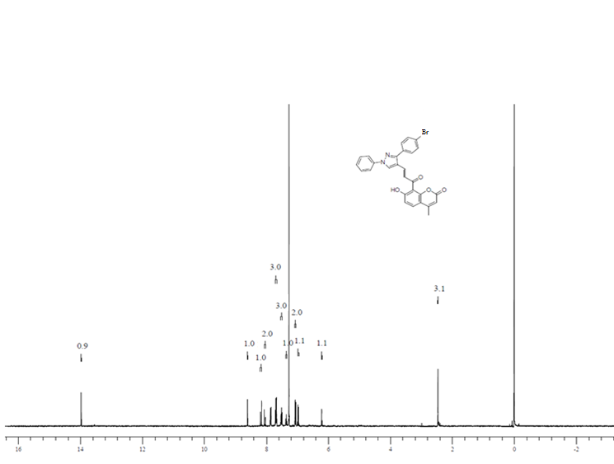
¹H NMR (400 MHz, CDCl₃) spectrum of (E)-3-[3-(4-Bromophenyl)-1-phenyl-1H-pyrazol-4-yl]-1-(7-hydroxy-4-methyl-8-coumarinyl)-2-propen-1-one (3g):

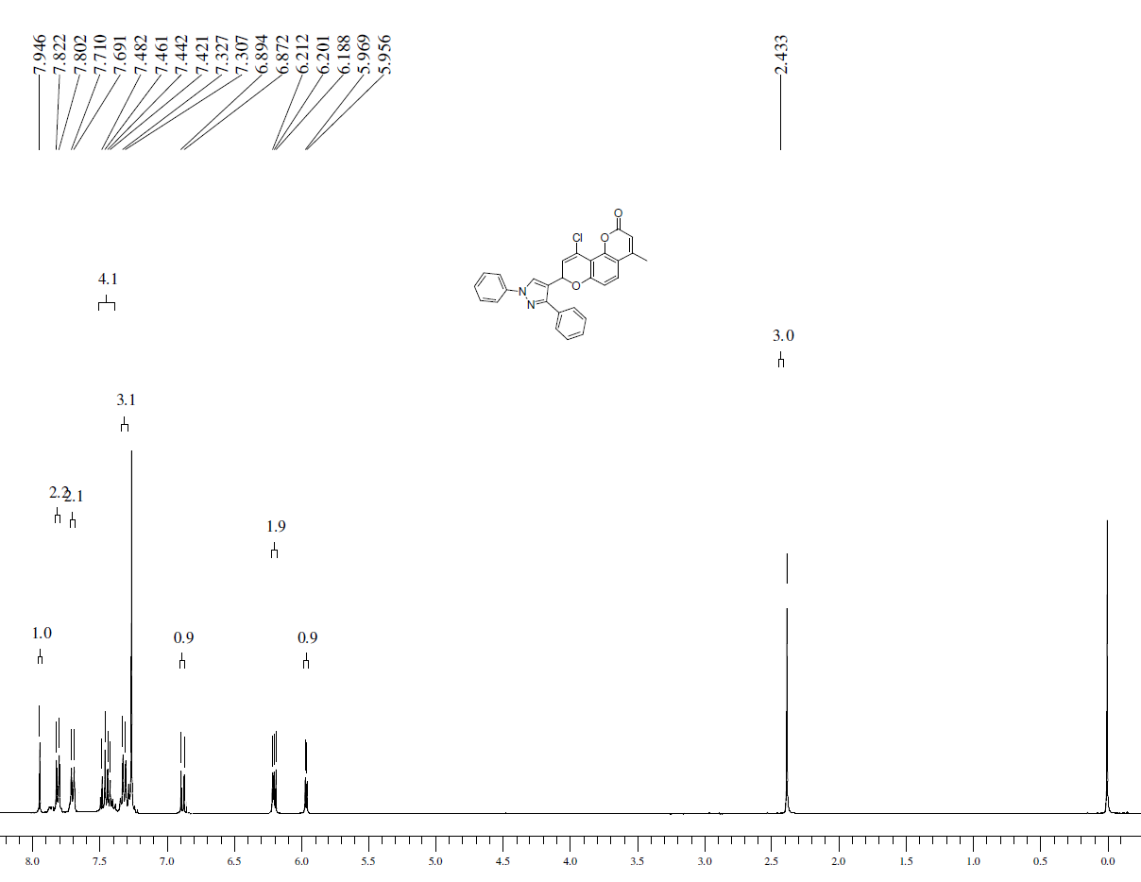
¹H NMR (400 MHz, CDCl₃) spectrum of 4-Chloro-8-methyl-2-(1,3-diphenyl-1H-pyrazol-4-yl)-1,5-dioxa-2H-phenanthren-6-one (4a)
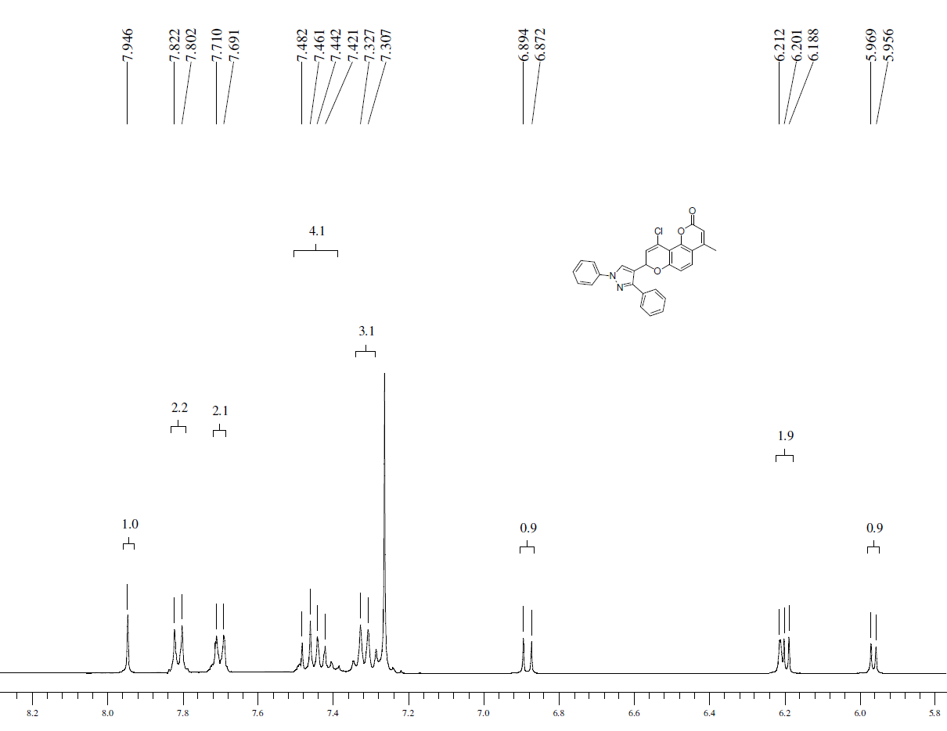
¹H NMR (400 MHz, CDCl₃) spectrum (expansion) of 4-Chloro-8-methyl-2-(1,3-diphenyl-1H-pyrazol-4-yl)-1,5-dioxa-2H-phenanthren-6-one (4a)

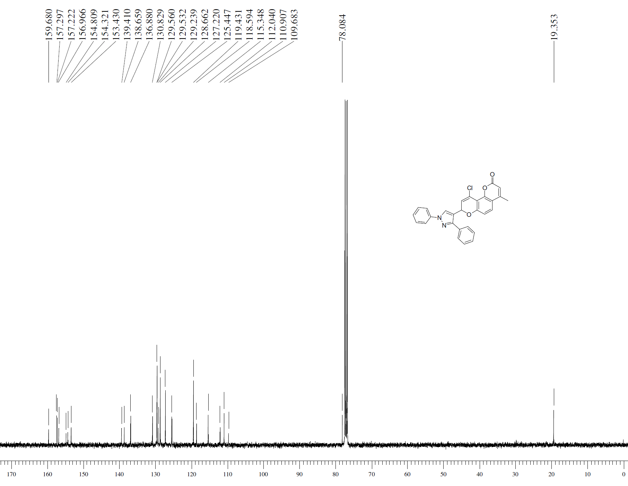
¹³C NMR (100 MHz, CDCl₃) spectrum of 4-Chloro-8-methyl-2-(1,3-diphenyl-1H-pyrazol-4-yl)-1,5-dioxa-2H-phenanthren-6-one (4a)

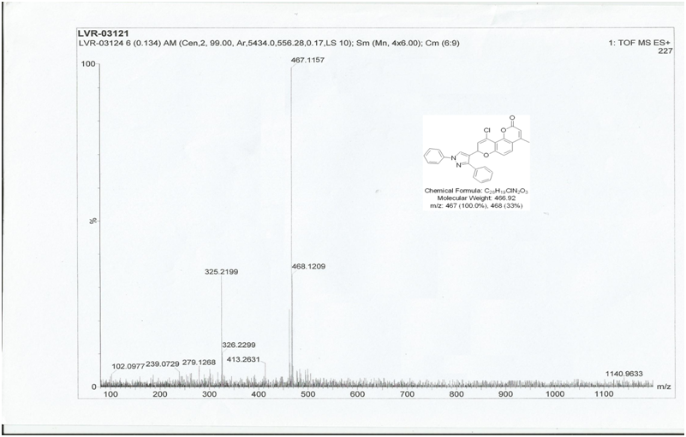
Mass spectrum of 4-Chloro-8-methyl-2-(1,3-diphenyl-1H-pyrazol-4-yl)-1,5-dioxa-2H-phenanthren-6-one (4a)

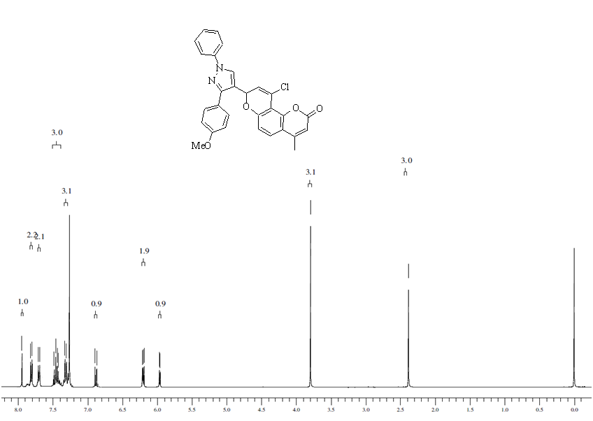
¹H NMR (400 MHz, CDCl₃) spectrum 4-Chloro-2-[3-(p-methoxyphenyl)-1-phenyl-1H-pyrazol-4-yl]-8-methyl-1,5-dioxa-2H-phenanthren-6-one (4b)
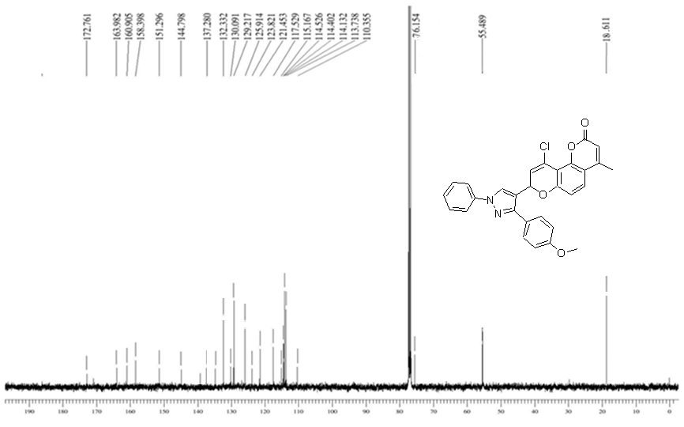
¹³C NMR (100 MHz, CDCl₃) spectrum of 4-Chloro-2-[3-(p-methoxyphenyl)-1-phenyl-1H-pyrazol-4-yl]-8-methyl-1,5-dioxa-2H-phenanthren-6-one (4b)

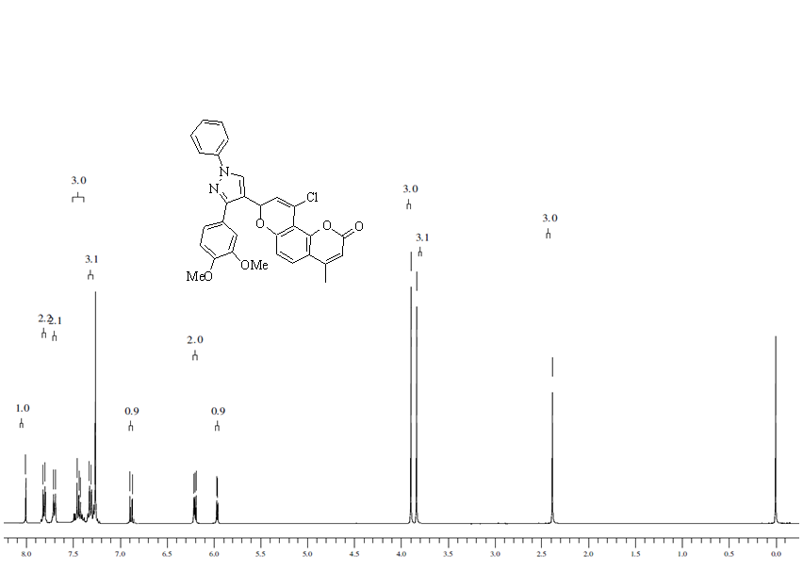
¹H NMR (400 MHz, CDCl₃) spectrum of 4-Chloro-2-[3-(3,4-dimethoxyphenyl)-1-phenyl-1H-pyrazol-4-yl]-8-methyl-1,5-dioxa-2H-phenanthren-6-one (4c)
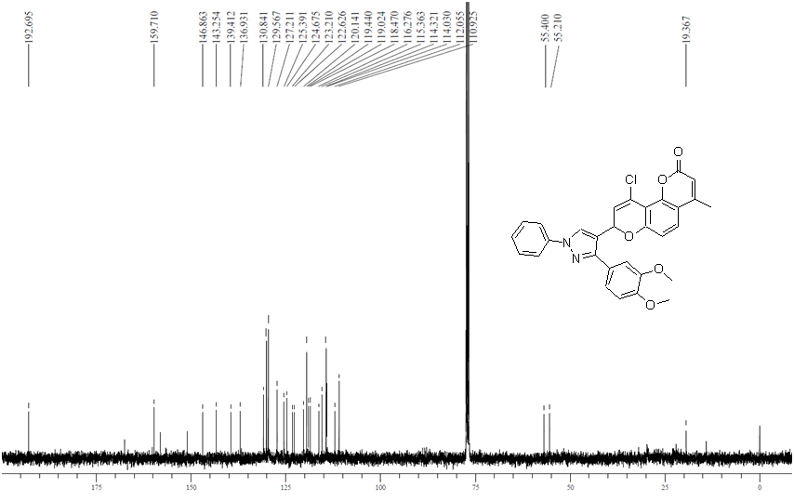
¹H NMR (400 MHz, CDCl₃) spectrum of 4-Chloro-2-[3-(3,4-dimethoxyphenyl)-1-phenyl-1H-pyrazol-4-yl]-8-methyl-1,5-dioxa-2H-phenanthren-6-one (4c)

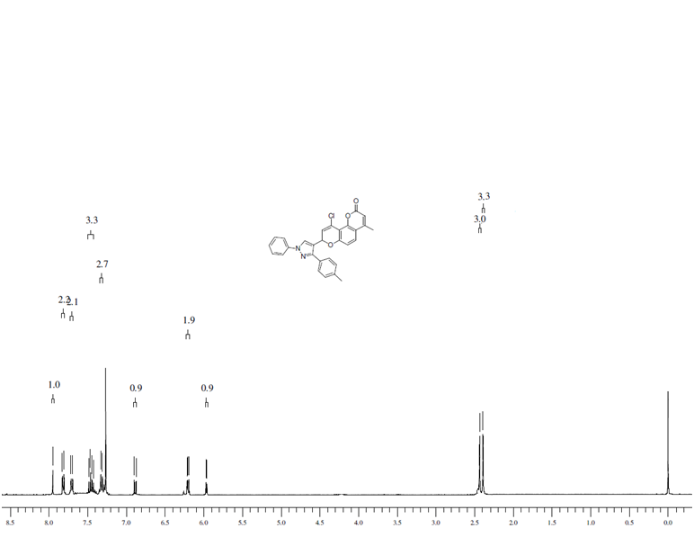
¹H NMR (400 MHz, CDCl₃) spectrum of 4-Chloro-8-methyl-2-[3-(p-tolyl)-1-phenyl-1H-pyrazol-4-yl]-1,5-dioxa-2H-phenanthren-6-one (4d)
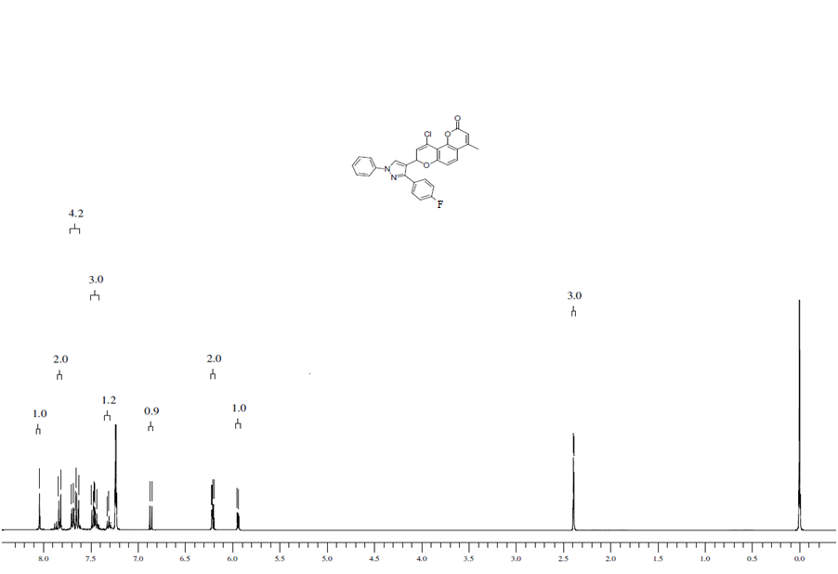
¹H NMR (400 MHz, CDCl₃) spectrum of 4-Chloro-2-[3-(p-fluorophenyl)-1-phenyl-1H-pyrazol-4-yl]-8-methyl-1,5-dioxa-2H-phenanthren-6-one (4e)
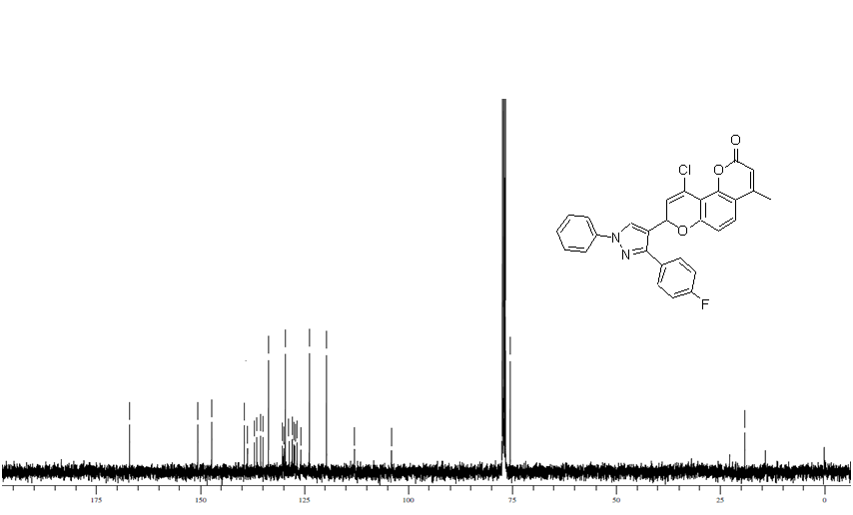
¹³C NMR (100 MHz, CDCl₃) of 4-Chloro-2-[3-(p-fluorophenyl)-1-phenyl-1H-pyrazol-4-yl]-8-methyl-1,5-dioxa-2H-phenanthren-6-one (4e)
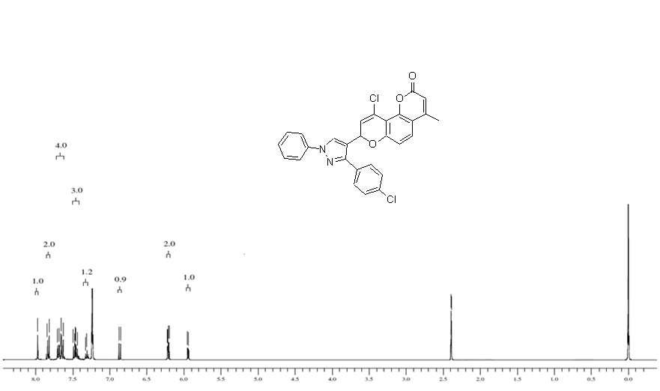
¹H NMR (400 MHz, CDCl₃) spectrum of 4-Chloro-2-[3-(p-chlorophenyl)-1-phenyl-1H-pyrazol-4-yl]-8-methyl-1,5-dioxa-2H-phenanthren-6-one (4f)

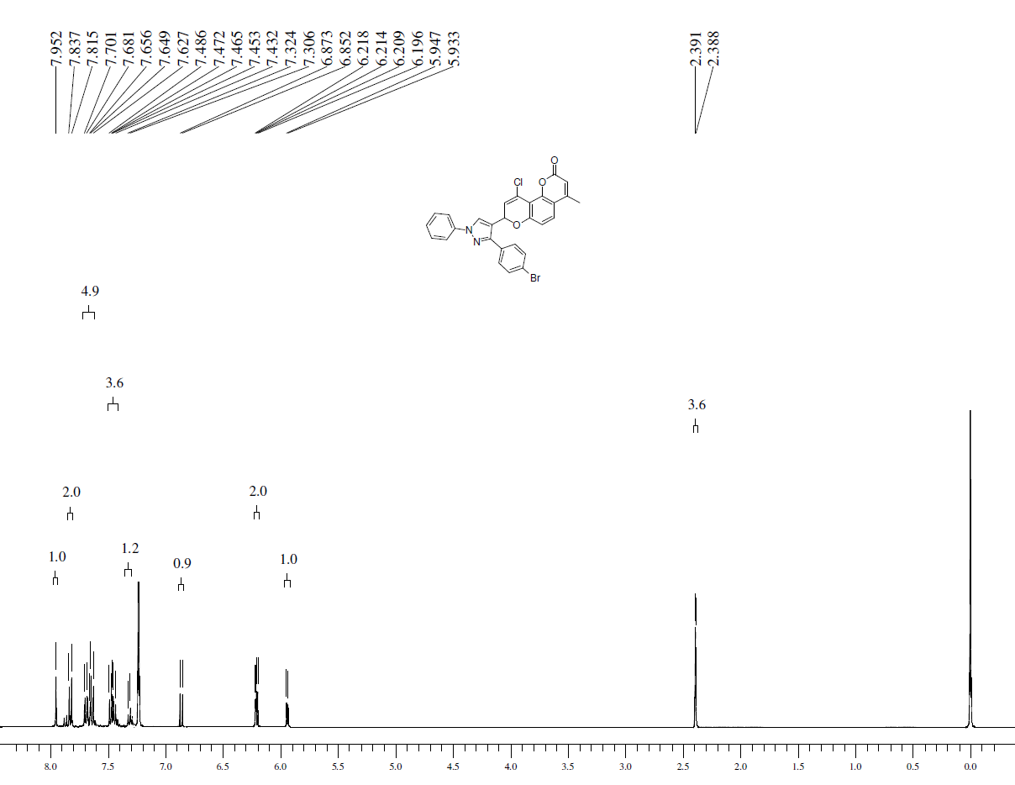
¹H NMR (400 MHz, CDCl₃) spectrum of 4-Chloro-2-[3-(p-bromophenyl)-1-phenyl-1H-pyrazol-4-yl]-8-methyl-1,5-dioxa-2H-phenanthren-6-one (4g)
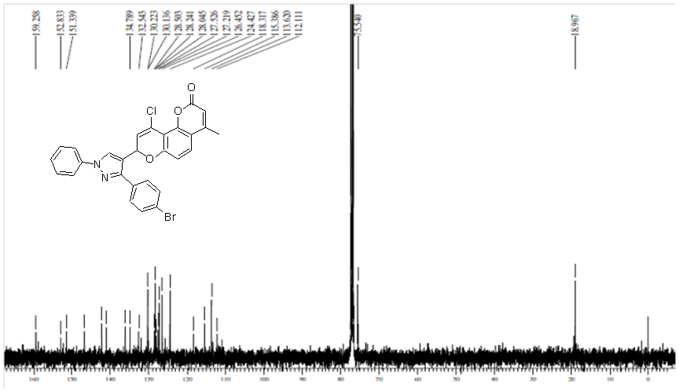
¹³C NMR (100 MHz, CDCl₃) of 4-Chloro-2-[3-(p-bromophenyl)-1-phenyl-1H-pyrazol-4-yl]-8-methyl-1,5-dioxa-2H-phenanthren-6-one (4g)

