SUPPLEMENTARY MATERIAL TO

**Synthesis, spectral studies and in vitro antimicrobial activity of some new Di/Triorganotin(IV) complexes of Schiff bases derived from 2-benzoyl pyridine**

PRIYANKA KHATKAR1, SONIKA ASIJA1*, and NAMITA SINGH2

*1Department of Chemistry, Guru Jambheshwar University of Science & Technology, Hisar-125001, Haryana, India.*

*2Department of Bio & Nano Technology, Guru Jambheshwar University of Science & Technology, Hisar-125001, Haryana, India.*

*\*Corresponding Author*

*E-mail- sc_ic2001@yahoo.co.in*

SPECTRAL DATA OF SYNTHESIZED LIGANDS AND ORGANOTIN COMPLEXES,

AND NMR, MASS SPECTRA OF COMPLEXES (Bu2SnClL2 & Bu3SnClL4)

**(E)-2-nitro-N'-(phenyl(pyridin-2-yl)methylene)benzohydrazide** **(H1L1):**

C19H14N4O3, M.pt: 125 °C, Light brown color, Yield: 79 %. IR (KBr) ν: 1605 (C=N), 3310 (N-H), 1671 (C=O), cm-1. 1H NMR (CDCl3, 400 MHz, *δ*): 13.75 (*s*, 1H, NH, H-8), 8.82(*d*, 1H, J = 8Hz, H-1pyd.ring), 8.16 (*d*, 1H, *J* = 4), 8.02 (*d*, 1H *J* = 4), 7.82-7.71 (*m*, 2H), 7.65-7.57 (*m*, 2H), 7.46-7.22 (*m*, 7H, Ar-H). 13C NMR (CDCl3, 100 MHz, *δ*): 163.98 (C=O), 158.66 (C=N), 152.13, 147.53, 149.31, 146.69, 143.84, 141.50, 138.74, 137.23, 134.73, 133.21, 130.08, 129.81, 129.74 128.80, 123.76 (Ar-C), ESI-MS (*m/z*): Calculated for [C19H14N4O3 + H]+ 346.11, observed 346.08. Combustion analysis for C19H14N4O3: Calculated. C 65.89, H 4.07, N 16.18, O 13.86; found C 65.60, H 3.98, N 16.08, O 13.62.

**(E)-4-nitro-N'-(phenyl(pyridin-2-yl)methylene) benzohydrazide (H1L2):**

C19H14N4O3, M.pt: 152 °C, White color, Yield: 82 %. IR (KBr) ν: 1611 (C=N), 3190 (N-H), 1682 (C=O), cm-1. 1H NMR (DMSO-*d6*, 400 MHz, *δ*): 14.83 (*s*, 1H, NH, H-8), 9.00 (*d*, 1H, *J* = 4, H-1pyd.ring), 8.41 (*d*, 2H, *J* = 4), 8.13-8.04 (*m*, 3H), 7.55-7.41 (*m*, 7H) , 7.66-7.63(*m*, 2H, Ar-H), 7.41-7.32. 13C NMR (DMSO-d6, 100 MHz, *δ*): 162.16 (C=O), 153.49 (C=N), 150.10, 149.87, 149.62, 139.30, 138.34, 137.46, 131.24, 129.76, 127.33, 125.15, 124.19, 122.11, 120.57(Ar-C). ESI-MS (*m/z*): Calculated for [C19H14N4O3 + H]+ 346.11, observed 346.07. Combustion analysis for C19H14N4O3: Calculated. C 65.89, H 4.07, N 16.18, O 13.86 ; found C 65.78, H 3.98, N 16.09, O 13.66.

**(E)-4-methyl-N'-(phenyl(pyridin-2-yl)methylene)benzohydrazide (H1L3):**

C20H17N3O, M.pt: 296 °C, white color, Yield: 78%. IR (KBr) ν: 1608 (C=N), 3292 (N-H), 1675 (C=O) cm-1. 1H NMR (CDCl3, 400 MHz, *δ*): 13.78 (*s*, 1H, NH, H-8), 8.71(*d*, 1H, *J* = 4, H-1pyd.ring), 8.23 (*d*, 1H, *J* = 8), 7.68-7.65 (*m*, 2H, Ar-H), 7.63 (*d*, 2H, *J* = 8), 7.52-7.41- (*m*, 5H, Ar-H), 7.23 (*d*, 2H, *J* = 8), 2.15 (*s*, 3H). 13C NMR (CDCl3, 100 MHz, *δ*): 163.19 (C=O), 152.46 (C=N), 150.13, 149.84, 148.50, 147.34, 139.58, 137.23, 129.7, 139.24, 137.23, 129.76, 125.72, 124.26, 120.56 (Ar-C), 23.67 (CH3). ESI-MS (*m/z*): Calculated for [C20H17N3O + H] + 315.37, observed 315.14. Combustion analysis for C20H17N3O: Calculated. C 76.17, H 5.43, N 13.32, O 5.07; found C 76.05, H 5.21, N 13.09, O 4.99.

**(E)-4-chloro-N'-(phenyl(pyridin-2-yl)methylene)benzohydrazide (H1L4):**

C19H14ClN3O, M.pt: 170 °C,White color, Yield: 78%.. IR (KBr) ν: 1603 (C=N), 3305 (N-H), 1686 (C=O) cm-1. 1H NMR (CDCl3, 400 MHz, δ): 15.20 (*s*, 1H, NH, H-8), 8.82 (*d*, 1H, *J* = 4, H-1pyd.ring), 7.95 (*d*, 2H, *J* = 8), 7.88-7.84 (*m*, 1H, Ar-H), 7.52-7.28 (*m*, 9H, Ar-H). 13C NMR (CDCl3, 100 MHz, δ): 163.38 (C=O), 153.11 (C=N), 148.30, 147.83, 138.19, 137.72, 137.63, 132.27, 129.48, 129.20, 129.04, 128.99, 128.43, 126.98, 124.40 (Ar-C). ESI-MS (*m/z*): Calculated for [C19H14ClN3O + H]+ 335.79, observed 335.08. Combustion analysis for C19H14ClN3O: Calculated. C 67.96, H 4.20, Cl 10.56, N 12.51, O 4.76 ; found C 67.82, H 4.09, Cl 10.31, N 12.45, O 4.56.

**(1E,N'Z)-chlorodiphenylstannyl-2-nitro-N'-(phenyl(pyridin-2-yl)methylene)benzohydrazonate (Ph2SnL1Cl):**

C31H23ClN4O3Sn M.pt: 213 °C, yellow color, Yield: 78%. IR (KBr) ν: 1591 (C=N), 447 (Sn-N) , 552 (Sn-O), 731 (Sn-C), cm-1. 1H NMR (CDCl3, 400 MHz, *δ*): 9.23 (*d*, 1H, *J* = 4, H-1pyd.ring), 8.89-8.23 (*m*, 4H, Ar-H), 7.95-7.23 (*m*, 18H, Ar-H). 13C (CDCl3, 100 MHz, *δ*): 163.75 (C=O), 148.75 (C=N), 148.92, 145.74, 143.52, 131.42, 137.94, 137.35, 137.16, 131.22, 129.77, 129.58, 129.17, 128.98, 128.42, 127.79, 126.83, 125.89, 123.29, (Ar-C). 119Sn NMR (CDCl3, 149 MHz, *δ*): ‒343.76. ESI-MS (*m/z*): Calculated for [C31H23ClN4O3Sn + H]+ 653.70, observed 654.61. Combustion analysis for C31H23ClN4O3Sn: Calculated. C 56.96, H 3.55,Cl 5.42, N 8.57, O 7.34, Sn 18.16; found C 56.67, H 3.23,Cl 5.31, N 8.34, O 7.22, Sn, 18.04.

**(1E,N'Z)-dibutylchlorostannyl-2-nitro-N'-(phenyl(pyridin-2-yl)methylene)benzohydrazonate (Bu2SnL1Cl):**

C27H31ClN4O3Sn, M.pt: 203 °C, Light brown, Yield: 73%. IR (KBr) ν: 1582 (C=N), 432 (Sn-N), 557 (Sn-O), 689 (Sn-C), cm-1. 1H NMR (CDCl3, 400 MHz, *δ*): 9.12 (*d*, 1H, *J* = 4, H-1pyd.ring), 8.93- 8.61 (*m*, 3H), 8.34 (*d*, 1H), 7.92-7.67 (*m*, 3H), 7.61-7.54 (*m*, 5H), 1.73-1.67 (*m*, 4H, 4CH2, Bu), 1.48-1.41 (*m*, 4H, CH2, Bu), 1.38-1.32 (*m*, 4H, CH2, Bu), 0.70 (*t*, *J* = 8, 6H, CH3, Bu). 13C NMR (CDCl3, 100 MHz, δ): 164.01 (C=O), 149.15 (C=N), 148.24, 141.25, 137.56, 133.43, 134.87, 134.27, 133.47, 131.71, 129.63, 129.52, 129.03, 129.00, 128.57, 126.32, 123.29 (Ar-C), 34.32, 28.81, 25.82, 13.57 (Aliphatic proton). 119Sn NMR (CDCl3, 149 MHz, *δ*): ‒297.11. ESI-MS (*m/z*): Calculated for [C31H23ClN4O3Sn + H]+ 613.72, observed (614.72). Combustion analysis for C27H31ClN4O3Sn: Calculated. C 52.84, H 5.09, Cl 5.78, N 9.13, O 7.82, Sn 19.34; found C 52.91, H 4.98, Cl 5.49, N 8.95, O 7.67, Sn 19.01.

**(1E,N'Z)-chlorodimethylstannyl-2-nitro-N'-(phenyl(pyridin-2-yl)methylene)benzohydrazonate (Me2SnL1Cl):**

C21H19ClN4O3Sn, M.pt: 219°C, Yellow, Yield: 71%. IR (KBr) ν: 1576 (C=N), 435 (Sn-N), 553 (Sn-O), 692 (Sn-C), cm-1. 1H NMR (CDCl3, 400 MHz, *δ*): 8.92 (*d*, 1H, *J* = 4, H-1pyd.ring), 8.51 (*d*, 1H), 8.31-8.28 (*m*, 3H, Ar-H), 7.68-7.31 (*m*, 8H, Ar-H), 1.32 (*s*, 6H, CH3). 13C NMR (CDCl3, 100 MHz, *δ*): 161.34 (C=O), 149.28 (C=N), 153.94, 149.13, 137.96, 132.76, 130.51, 129.63, 129.19, 128.84, 128.61, 128.58, 127.87, 126.75, 124.81, 124.25, 122.34, (Ar-C), 21.1(CH3-C). 119Sn NMR (CDCl3, 149 MHz, *δ*): ‒219.89. ESI-MS (*m/z*): Calculated for [C21H19ClN4O3Sn + H]+ 529.50, observed 530.71. Combustion analysis for C21H19ClN4O3Sn: Calculated. C 47.63, H 3.62, Cl 6.69, N 10.58, O 9.06, Sn 22.42; found C 47.48, H 3.43, Cl 6.43, N 10.21, O 8.87, Sn 22.76.

**(1E,N'Z)-triphenylstannyl-2-nitro-N'-(phenyl(pyridin-2-yl)methylene)benzohydrazonate (Ph3SnL1):**

C37H28N4O3Sn, M.pt: 234 °C, Yellow, Yield: 62%. IR (KBr) ν: 1579 (C=N), 437 (Sn-N), 557 (Sn-O), 703 (Sn-C), cm-1. 1H NMR (CDCl3, 400 MHz, *δ*): 9.03 (*d*, 1H, *J* = 4, H-1pyd.ring), 8.82-8.63 (*m*, 4H, *J* = 8), 7.68-7.33 (*m*, 23 H, Ar-H). 13C NMR (CDCl3, 100 MHz, *δ*): 162.48 (C=O), 149.87 (C=N), 152.76, 137.65, 137.14, 137.00, 136.78, 135.34, 134.91, 134.83, 131.72, 130.54, 130.12, 129.40, 129.37, 128.53, 128.34 (Ar-C). 119Sn NMR (CDCl3, 149 MHz, *δ*): -437.89. ESI-MS (*m/z*): Calculated for [C37H28N4O3Sn + H]+ 695.35, observed 696.84. Combustion analysis for C37H28N4O3Sn: Calculated. C 63.89, H 4.01, N 8.03, O 6.88, Sn 17.05, found C 63.91, H 4.06, N 8.06, O 6.90, Sn 17.07.

**(1E,N'Z)-tributylstannyl-2-nitro-N'-(phenyl(pyridin-2-yl)methylene)benzohydrazonate(Bu3SnL1):**

C31H40N4O3Sn, M.pt: 204 °C, Dark brown, Yield: 75%. IR (KBr) ν: 1582 (C=N), 453 (Sn-N), 554 (Sn-O), 617 (Sn-C), cm-1. 1H NMR (CDCl3, 400 MHz, *δ*): 9.18 (*d*, 1H, *J* = 4, H-1pyd.ring), 8.28 (*d*, 1H, *J* = 8 Hz), 7.94-7.91 (*m*, 2H), 7.87 (*t*, 1H, *J* = 8), 7.60-7.56 (*m*, 3H) 7.38-7.32 (*m*, 5H, Ar-H), 1.49 (*t*, 6H,-CH2, Bu), 1.41-1.21 (*m*, 12H -CH2, Bu), δ = 0.94 (*t*, 9H, CH3, J=8 Hz, Bu). 13C NMR (CDCl3, 100 MHz, *δ*): 163.81 (C=O), 148.41 (C=N), 148.20, 145.21, 131.98, 131.73, 130.72, 130.24, 129.89, 129.58, 128.81, 128.73, 124.77, 124.63, 124.41, 125.32, 123.70, (Ar-C), 12.54, 22.17, 27.88, 42.67 (Aliphatic C). 119Sn NMR (CDCl3, 149 MHz, *δ*): -290.72. ESI-MS (*m/z*): Calculated for [C31H40N4O3Sn + H]+ 635.38, observed 636.84. Combustion analysis for C31H40N4O3Sn: Calculated. C 58.60, H 6.35, N 8.82, O 7.55, Sn 18.68; found C 58.71, H 6.18, N 8.54, O 7.34, Sn 18.42.

**(1E,N'Z)-trimethylstannyl-2-nitro-N'-(phenyl(pyridin-2-yl)methylene)benzohydrazonate (Me3SnL1):**

C22H22N4O3Sn, M.pt: 198°C, Yellow, Yield: 69%. IR (KBr) ν: 1581 (C=N), (N-H), (C=O) disappeared, 457 (Sn-N), 564 (Sn-O), 696 (Sn-C), cm-1. 1H NMR (CDCl3, 400 MHz, *δ*): 8.96 (*d*, 1H, *J* = 4, H-1pyd.ring), 8.57-8.32 (*m*, 4H, Ar-H), 7.84-7.35 (*m*, 8H, Ar-H), 1.03 (*s*, 9H, CH3). 13C NMR (CDCl3, 100 MHz, *δ*): 167.62 (C=O), 149.78 (C=N), 151.72, 141.34, 133.18, 130.65, 129.96, 129.74, 129.86, 129.80, 129.78, 129.64, 129.59, 129.47, 128.48, 128.39, 125.29, (Ar-C), 14.54, (Aliphatic C). 119Sn NMR (CDCl3, 149 MHz, *δ*): -236.84. ESI-MS (*m/z*): Calculated for [C22H22N4O3Sn + H]+ 509.15, observed 510.56. Combustion analysis for C22H22N4O3Sn: Calculated. C 51.88, H 4.03, N 10.97, O 9.41, Sn 23.30; found C 51.90, H 4.36, N 11.00, O 9.43, Sn 23.32.

**(1E,N'Z)-chlorodiphenylstannyl-4-nitro-N'-(phenyl(pyridin-2-yl)methylene)benzohydrazonate (Ph2SnClL2):**

C31H23ClN4O3Sn, M.pt: 211°C, Yellow, Yield: 71%. IR (KBr) ν: 1592 (C=N), 449 (Sn-N), 561 (Sn-O), 668 (Sn-C), cm-1. 1H NMR (CDCl3, 400 MHz, *δ*): 9.25 (*d*, 1H, *J* = 4, H-1pyd.ring), 8.92-8.15 (*m*, 5H, Ar-H), 7.91-7.89 (*d*, 2H, *J* = 8), 7.34-7.17 (*m*, 15 H, Ar-H). 13C NMR (CDCl3, 100 MHz, δ): 167.40 (C=O), 149.37 (C=N), 148.27, 142.78, 137.91, 131.74, 130.78, 129.73, 129.36, 129.13, 129.07, 128.29, 128.37, 127.57, 127.02 (Ar-C). 119Sn NMR (CDCl3, 149 MHz, *δ*): -331.45. ESI-MS (*m/z*): Calculated for [C31H23ClN4O3Sn + H]+ 653.70, observed 654.78. Combustion analysis for C31H23ClN4O3Sn: Calculated. C 56.96, H 3.55,Cl 5.42, N 8.57, O 7.34, Sn 18.16; found C 56.73, H 3.27, Cl 5.34, N 8.13, O 7.09, Sn 18.03.

**(1E,N'Z)-dibutylchlorostannyl-4-nitro-N'-(phenyl(pyridin-2-yl)methylene)benzohydrazonate (Bu2SnClL2):**

C27H31ClN4O3Sn, M.pt: 215 °C, Yellow, Yield: 68%.IR (KBr) ν: 1588 (C=N), 433 (Sn-N), 566 (Sn-O), 675 (Sn-C), cm-1. 1H NMR (CDCl3, 400 MHz, *δ*): 9.54 (*d*, 1H, *J* = 4 H-1pyd.ring), 8.26-8.18 (*m*, 5H, Ar-H), 7.70-7.53 (*m*, 7H, Ar-H), 1.75-1.68 (*m*, 4H, -CH2 Bu), 1.46-1.38 (*m*, 4H -CH2 Bu), 1.24-1.15 (m, 4H, -CH2,Bu), 0.73 (*t*, 6H, *J* = 8, CH3, Bu). 13C NMR (CDCl3, 100 MHz, *δ*): 162.74 (C=O), 149.57 (C=N), 140.48, 139.75, 130.48, 129.82, 129.51, 129.47, 128.68, 128.49, 126.66, 126.25, 124.79, 123.99, 123.19, (Ar-C), 45.84, 27.65, 26.01, 25.37, (Aliphatic C). 119Sn NMR (CDCl3, 149MHz, *δ*): -274.11. ESI-MS (*m/z*): Calculated for [C27H31ClN4O3Sn + H]+ 613.72, observed 614.59. Combustion analysis for C27H31ClN4O3Sn: Calculated. C 52.84, H 5.09,Cl 5.78, N 9.13, O 7.82, Sn 19.34; found C 52.58, H 4.85,Cl 5.43, N 9.01, O 7.65, Sn 19.08.

**(1E,N'Z)-chlorodimethylstannyl-4-nitro-N'-(phenyl(pyridin-2-yl)methylene)benzohydrazonate (Me2SnClL2):**

C21H19ClN4O3Sn, M.pt: 238 °C, Yellow, Yield: 61%. IR (KBr) ν: 1590 (C=N), 451 (Sn-N), 553 (Sn-O), 621 (Sn-C), cm-1. 1H NMR (CDCl3, 400MHz, *δ*): 8.86 (*d*, 1H, *J* = 4, H-1pyd.ring), 8.40 (*d*, 2H, *J* = 8), 8.17 (*d*, 2H *J* = 8), 7.89 (*t*, 1H, *J* = 8), 7.66-7.64 (*m*, 2H, Ar-H), 7.52-7.38 (*m*, 5H, Ar-H), 1.67 (*s*, 6H, CH3). 13C NMR (CDCl3, 100 MHz, *δ*): 162.34 (C=O), 149.83 (C=N), 153.04, 149.83, 149.26, 147.80, 137.90, 129.49, 129.43, 128.71, 128.51, 127.27, 124.65, 124.01, 122.50, (Ar-C), 10.49 (CH3). 119Sn NMR (CDCl3, 149M Hz, *δ*): -213.67. ESI-MS (*m/z*): Calculated for [C21H19ClN4O3Sn + H]+ 529.56, observed 530.56. Combustion analysis for C21H19ClN4O3Sn: Calculated. C 47.63, H 3.62,Cl 6.69, N 10.58, O 9.06, Sn 22.42; found C 47.34, H 3.37, Cl 6.38, N 10.29, O 8.89, Sn 22.13.

**1E,N'Z)-triphenylstannyl-4-nitro-N'-(phenyl(pyridin-2-yl)methylene)benzohydrazonate((Ph3SnL2):**

C37H28N4O3Sn, M.pt: 243 °C, Yellow, Yield: 72%. IR (KBr) ν: 1578 (C=N), 456 (Sn-N), 561 (Sn-O), 708 (Sn-C), cm-1. 1H NMR (CDCl3, 400 MHz, *δ*): 8.85 (*d*, 1H, *J* = 4, H-1pyd.ring), 8.40 (*d*, 2H, *J* = 8), 8.17 (*d*, 2H, *J* = 8), 7.89(*t*, 1H, *J* = 8), 7.38-7.82 (*m*, 22H, Ar-H). 13C NMR (CDCl3, 100 MHz, *δ*): 160.81 (C=O), 149.93 (C=N), 152.47, 137.69, 137.34, 137.10, 136.48, 135.89, 134.73, 134.51, 131.47, 130.58, 130.23, 129.41, 129.38, 129.27, 128.86 (Ar-C). 119Sn NMR (CDCl3, 400 Hz, *δ*): -453.62. ESI-MS (*m/z*): Calculated for [C37H28N4O3Sn + H]+ 695.35, observed 696.78. Combustion analysis for C37H28N4O3Sn: Calculated. C 63.91, H 4.06, N 8.08, O 6.90, Sn 17.07; found C 63.71, H 3.97, N 7.99, O 6.71, Sn 17.05.

**(1E,N'Z)-tributylstannyl-4-nitro-N'-(phenyl(pyridin-2-yl)methylene)benzohydrazonate (Bu3SnL2):**

C31H40N4O3Sn, M.pt: 211°C, Light yellow, Yield- 73%. IR (KBr) ν: 1589 (C=N), 439 (Sn-N), 558 (Sn-O), 643 (Sn-C), cm-1.  1H NMR (CDCl3, 400 MHz, *δ*): 9.13 (*d*, 1H, *J* = 4, H-1pyd.ring), 8.74 (*d*, 2H, *J* = 8), 8.37 (*d*, 2H, *J* = 8), 7.93 (*t*, 1H, *J* = 8 ), 7.65(*m*, 2H, Ar-H), 7.52-7.38(*m*, 5H, Ar-H), 1.51-1.26 (*m*, 18H,-CH2, Bu), 0.91(*t*, 9H, CH3 Bu, *J*=8 Hz). 13C NMR (CDCl3, 100 MHz, *δ*): 163.04 (C=O), 149.50 (C=N), 149.26, 147.80, 139.4, 137.29, 131.53, 130.71, 130.64, 129.43, 128.71, 128.51, 127.31, 124.65, 124.01, (Ar-C), 16.96, 21.15, 26.28, 43.67(Aliphatic C). 119Sn NMR (CDCl3, 149 MHz, *δ*): -272.48. ESI-MS (*m/z*): Calculated for [C31H40N4O3Sn + H]+ 635.38, observed 636.71. Combustion analysis for C31H40N4O3Sn: Calculated. C 58.60, H 6.35, N 8.82, O 7.55, Sn 18.68; found C 58.27, H 6.19, N 8.57, O 7.24, Sn 18.43.

**(1E,N'Z)-trimethylstannyl-4-nitro-N'-(phenyl(pyridin-2-yl)methylene)benzohydrazonate (Me3SnL2):**

C22H22N4O3Sn, M.pt: 189 °C Yellow, Yield: 79%. IR (KBr) ν: 1591 (C=N), 438 (Sn-N), 567 (Sn-O), 683 (Sn-C), cm-1. 1H NMR (CDCl3, 400 MHz, *δ*): 9.12 (*d*, 1H, *J* = 4, H-1pyd.ring), 8.89-8.83 (*m*, 3H, Ar-H), 8.62 (*d*, 2H, *J* = 8), 7.95 (*d*, 2H, *J* = *8*), 7.45-7.32 (*m*, 5H, Ar-H), 0.97 (s, 9H, CH3). 13C NMR (CDCl3, 100 MHz, *δ*): 166.97 (C=O), 149.81 (C=N), 150.72, 141.47, 134.27, 130.74, 130.61, 129.84, 129.67, 129.53, 129.46, 128.40, 128.41, 127.75, 125.39, (Ar-C), 15.39(CH3). 119Sn NMR (CDCl3, 149 MHz, *δ*): -203.35. ESI-MS (*m/z*): Calculated for [C22H22N4O3Sn + H]+ 509.15, observed 510.25. Combustion analysis for C22H22N4O3Sn: Calculated. C 51.90, H 4.36, N 11.00, O 9.43, Sn 23.32; found C 51.76, H 4.03, N 10.82, O 9.32, Sn 23.08.

**(1E,N'Z)-chlorodiphenylstannyl-4-methyl-N'-(phenyl(pyridin-2-yl)methylene)benzohydrazonate (Ph2SnClL3):**

C32H26 ClN3OSn, M.pt: 133°C, Dark Yellow, Yield: 71%. IR (KBr) ν: 1575 (C=N), 445 (Sn-N), 549 (Sn-O), 701 (Sn-C), cm-1. 1H NMR (CDCl3, 400 MHz, *δ*): 9.05 (*d*, 1H, *J* = 4, H-1pyd.ring) , 8.62-8.35 (*m*, 3H, Pyrd ring), 7.57 (*d*, 2H, *J* = 8), 7.38-7.23 (*m*, 15 H, Ar-H), 6.94 (*d*, 2H, *J* = 8), 2.15 (*s*, 3H, CH3). 13C NMR (CDCl3, 100 MHz, *δ*): 168.79 (C=O), 149.29 (C=N), 143.78, 140.24, 139.92, 130.29, 130.77, 130.34, 129.08, 129.31, 129.45, 129.27, 128.37, 128.29, 125.97, 125.12, 124.06, (Ar-C), 21.57(CH3). 119Sn NMR (CDCl3, 149 MHz, *δ*): -367.41. ESI-MS (*m/z*): Calculated for [C32H26 ClN3OSn + H] + 622.73, observed 622.73. Combustion analysis for C32H26 ClN3OSn: Calculated. C 61.72, H 4.21, Cl 5.69, N 6.75, O 2.57, Sn 19.06; found C 61.54, H 3.98, Cl 5.69, N 6.54, O 2.39, Sn 18.84.

**(1E,N'Z)-dibutylchlorostannyl-4-methyl-N'-(phenyl(pyridin-2-yl)methylene)benzohydrazonate** (**Bu2SnClL3):**

C28H34 ClN3OSn, M.pt: 142°C, Dark Yellow, Yield: 74%. IR (KBr) ν: 1578 (C=N), 436 (Sn-N), 547 (Sn-O), 612 (Sn-C), cm-1. 1H NMR (CDCl3, 400 MHz, *δ*): 9.48 (*d*, 1H, *J* = 4, H-1pyd.ring), 8.02-7.98 (*m*, 3H, Pyrd ring), 7.66-7.55 (*m*, 7H, Ar-H), 7.18 (*d*, 2H, *J* = 8), 2.39 (*s*, 3H, CH3), 1.73-1.66 (*m*, 4H,-CH2, Bu), 1.48-1.35 (*m*, 4H -CH2, Bu), 1.22-1.17 (*m*, 4H,-CH2, Bu), 0.73 (*t*, 6H, CH3, Bu, *J* = 8). 13C NMR (CDCl3, 100MHz, *δ*): 173.91 (C=O), 149.24 (C=N), 149.42, 142.37, 140.22, 131.19, 130.77, 130.10, 129.77, 129.61, 129.54, 129.07, 128.79, 128.57, 125.97, (Ar-C), 34.81, 27.24, 25.95 21.86, 20.89(Aliphatic C). 119Sn NMR (CDCl3, 149 MHz, *δ*): -270.75. ESI-MS (*m/z*): Calculated for [C28H34 ClN3OSn + H]+ 582.75, observed 583.95. Combustion analysis for C28H34 ClN3OSn: Calculated. C 57.71, H 5.88, Cl 6.08, N 7.21, O 2.75, Sn 20.37; found C 57.59, H 5.65, Cl 5.81, N 6.94, O 2.49, Sn 20.03.

**(1E,N'Z)-chlorodimethylstannyl-4-methyl-N'-(phenyl(pyridin-2-yl)methylene)benzohydrazonate** (**Me2SnClL3):**

C22H22 ClN3OSn, M.pt: 120°C, Yellow, Yield: 68%. IR (KBr) ν: 1573 (C=N), 434 (Sn-N), 523 (Sn-O), 623 (Sn-C) cm-1. 1H NMR (CDCl3, 400 MHz, *δ*): 9.28 (*d*, 1H, *J* = 4, H-1pyd.ring), 7.63 (*d*, 2H, *J* = 4), 7.41-7.37 (*m*, 8H, Ar-H), 7.13 (*d*, 2H, *J* = 8), 2.03 (*s*, 3H, CH3), 1.07 (*s*, 6H, CH3). 13C NMR (CDCl3, 100 MHz, *δ*): 162.23 (C=O), 148.79 (C=N), 141.37, 140.42, 138.83, 131.97, 131.62, 130.83, 130.05, 129.38, 129.29, 128.36, 128.17, 128.07, 127.67(Ar-C), 31.81, 20.09(Aliphatic C). 119Sn NMR (CDCl3, 149 MHz, *δ*): -228.23. ESI-MS (*m/z*): Calculated for [C22H22 ClN3OSn + H] + 498.95, observed 499.76. Combustion analysis for C22H22ClN3OSn: Calculated. C 53.00, H 4.45, Cl 7.11, N 8.43, O 3.21, Sn 23.81; found C 52.73, H 4.18; Cl 6.89, N 8.01, O 3.08, Sn 23.66.

**(1E,N'Z)-triphenylstannyl-4-methyl-N'-(phenyl(pyridin-2-yl)methylene)benzohydrazonate** (**Ph3SnL3):**

C38H31N3OSn, M.pt: 198 °C, Yellow, Yield: 62%. IR (KBr) ν: 1585 (C=N), 451 (Sn-N), 556 (Sn-O), 678 (Sn-C), cm-1. 1H NMR (CDCl3, 400 MHz, *δ*): 8.96 (*d*, 1H, *J* = 4, H-1pyd.ring), 8.47-8.21 (*m*, 3H), 7.89-7.37 (*m*, 24H, Ar-H), 1.96 (s, 3H CH3). 13C NMR (CDCl3, 100 MHz, *δ*): 161.92 (C=O), 149.36 (C=N), 152.78, 137.79, 137.48, 137.67, 136.28, 135.56, 134.72, 134.53, 131.49, 130.11, 130.07, 129.67, 129.58, 129.11, 128.75, (Ar-C). 119Sn NMR (CDCl3, 149 MHz, *δ*): -452.38. ESI-MS (*m/z*): Calculated for [C38H31N3OSn + H]+ 664.38, observed 665.21. Combustion analysis for C38H31N3OSn: Calculated. C 68.70, H 4.70, N 6.32, O 2.41, Sn 17.87; found C 68.67, H 4.66; N 6.29, O 2.39, Sn 17.85.

**(1E,N'Z)-tributylstannyl-4-methyl-N'-(phenyl(pyridin-2-yl)methylene)benzohydrazonate (Bu3SnL3):**

C32H43 N3OSn, M.pt: 178 °C, Pale Yellow, Yield: 68%. IR (KBr) ν: 1572 (C=N), 457 (Sn-N), 543 (Sn-O), 679 (Sn-C), cm-1. 1H NMR (CDCl3, 400 MHz, *δ*): 8.85 (*d*, 1H, *J* = 4, H-1pyd.ring), 7.91 (*d*, 2H, *J* = 8), 7.87 (*t*, 1H, *J* = 8), 7.69-7.60 (*m*, 5H, Ar-H), 7.33 (*d*, 2H, *J* = 8), 2.45 (*s*, 3H, CH3), 1.57-1.41 (*m*, 12H-CH2), 1.34 -1.28 (*m*, 6H, -CH2), 0.92 (*t*, 9H, CH3, *J* = 8). 13C NMR (CDCl3, 100 MHz, *δ*): 168.77 (C=O), 149.78 (C=N), 149.75 141.62, 140.59, 131.83, 130.51, 130.10, 129.61, 129.37, 129.31, 129.12, 128.59, 128.27, 125.92, (Ar-C), 45.67, 25.17, 20.35, 21.78, 14.69, (Aliphatic C). 119Sn NMR (CDCl3, 149 MHz, *δ*): -273.29. ESI-MS (*m/z*): Calculated for [C32H43 N3OSn + H]+ 604.41, observed 605.47. Combustion analysis for C32H43 N3OSn: Calculated. C 63.59, H 7.17, N 6.95, O 2.65, Sn 19.64; found C 63.37, H 6.98; N 6.87, O 2.32, Sn 19.23.

**(1E,N'Z)-trimethylstannyl 4-methyl-N'-(phenyl(pyridin-2-yl)methylene)benzohydrazonate (Me3SnL3):**

C23H25N3OSn, M.pt: 168 °C, Yellow, Yield: 69%. IR (KBr) ν: 1578 (C=N), 451 (Sn-N), 547 (Sn-O), 682 (Sn-C) cm-1. 1H NMR (CDCl3, 400 MHz, *δ*): 8.97 (*d*, 1H, *J* = 4, H-1pyd.ring), 8.89-8.83 (*m*, 3H), 8.62 (*d*, 2H, *J* = 8), 7.95 (*d*, 2H, *J* = 8), 7.45-7.32 (*m*, 5H, Ar-H), 0.97 (*s*, 9H, CH3). 13C NMR (CDCl3, 100 MHz, *δ*): 170.93 (C=O), 149.78 (C=N), 150.68, 140.87, 135.87, 131.74, 130.72, 129.84, 129.68, 129.51, 129.46, 128.39, 128.16, 127.87, 125.49, (Ar-C), 41.62, 15.23, (Aliphatic C). 119Sn NMR (CDCl3, 149 MHz, *δ*): -210.83. ESI-MS (*m/z*): Calculated for [C23H25N3OSn + H]+ 478.17, observed 479.39. Combustion analysis for C23H25N3OSn: Calculated. C 57.77, H 5.27, N 8.79, O 3.35, Sn 24.83; found C 57.75, H 5.24, N 8.76, O 3.32, Sn 24.79.

**(1E,N'Z)-chlorodiphenylstannyl-4-chloro-N'-(phenyl(pyridin-2-yl)methylene)benzohydrazonate (Ph2SnClL4):**

C31H23Cl2N3OSn, M.pt: 122°C, Yellow, Yield: 73%. IR (KBr) ν: 1592 (C=N), 459 (Sn-N), 561 (Sn-O), 701 (Sn-C), cm-1. 1H NMR (CDCl3, 400 MHz, *δ*): 9.28 (*d*, 1H, *J* = 4, H-1pyd.ring), 8.57-8.28 (*m*, 3H, Pyrd ring), 7.63 (*d*, 2H, *J* = 8), 7.57 (*d*, 2H, *J* = 8), 7.36-7.21 (*m*, 15H, Ar-H). 13C NMR (CDCl3, 100 MHz, *δ*): 167.89 (C=O), 148.70 (C=N), 142.58, 140.24, 138.36, 131.83, 130.92, 130.45, 129.31, 129.03, 129.56, 129.27, 128.89, 127.76, 125.97, (Ar-C). 119Sn NMR (CDCl3, 149 MHz, *δ*): -376.12. ESI-MS (*m/z*): Calculated for [C31H23Cl2N3OSn + H] + 643.15, observed 644.95. Combustion analysis for C31H23Cl2N3OSn: Calculated. C 57.89, H 3.60, N 6.53, O 2.49,Cl 11.02, Sn 18.46; found C 57.64, H 3.53, N 6.27, O 2.15,Cl 10.87, Sn 18.12.

**(1E,N'Z)-dibutylchlorostannyl-4-chloro-N'-(phenyl(pyridin-2-yl)methylene)benzohydrazonate (Bu2SnClL4) :**

C27H31Cl2N3OSn, M.pt: 169°C, Yellow, Yield: 72%, IR (KBr) ν: 1579 (C=N), 433 (Sn-N), 556 (Sn-O), 693(Sn-C), cm-1. 1H NMR (CDCl3, 400 MHz, *δ*): 9.51 (*d*, 1H, *J* = 4, H-1pyd.ring), 8.23-8.16 (*m*, 5H, Ar-H), 7.71-7.54 (*m*, 5H, Ar-H), 7.50 (*d*, 2H, *J* = 8), 1.53-1.48 (*m*, 4H,-CH2), 1.38-1.33 (*m*, 4H-CH2), 1.21-1.13 (*m*, 4H, -CH2), 0.72 (*t*, 6H, CH3, *J* = 8). 13C NMR (CDCl3, 100 MHz, *δ*): 170.91 (C=O), 149.30 (C=N), 141.37, 140.12, 130.35, 131.91, 130.11, 129.64, 129.41, 128.80, 128.33, 127.85, 127.08, 126.15, 125.76, (Ar-C), 13.51, 25.54, 25.98, 35.43, (Aliphatic C). 119Sn NMR (CDCl3, 149 MHz, *δ*): -289.17. ESI-MS (*m/z*): Calculated for [C27H31Cl2N3OSn + H]+ 603.17, observed 604.78. Combustion analysis for C27H31Cl2N3OSn: Calculated. C 53.76, H 5.18, N 6.97, O 2.65,Cl 11.76, Sn 19.68; found C 53.59, H 4.97, N 6.73, O 2.47,Cl 11.64, Sn 19.56.

**(1E,N'Z)-chlorodimethylstannyl-4-chloro-N'-(phenyl(pyridin-2-yl)methylene)benzohydrazonate ((Me2SnClL4):**

C21H19Cl2N3OSn, M.pt: 137°C, Yellow, Yield: 69%. IR (KBr) ν: 1593 (C=N), 431(Sn-N), 534(Sn-O), 632(Sn-C), cm-1. 1H NMR (CDCl3, 400 MHz, *δ*): 9.33 (*d*, 1H, *J* = 4, H-1pyd.ring), 8.03 (*d*, 2H, *J* = 8), 7.54-7.41 (*m*, 8H, Ar-H), 7.33 (*d*, 2H, *J* = 8), 1.12 (*s*, 6H). 13C NMR (CDCl3, 100 MHz, *δ*): 168.56 (C=O), 148.63 (C=N), 148.57, 139.80, 137.81, 131.80, 130.19, 129.59, 129.43, 129.07, 128.41, 128.22, 126.42, 125.81, (Ar-C), 26.08 (CH3). 119Sn NMR (CDCl3, 149MHz, *δ*): -208.18. ESI-MS (*m/z*): Calculated for [C21H19Cl2N3OSn + H]+ 519.01, observed 520.71. Combustion analysis for C21H19Cl2N3OSn: Calculated. C 48.60, H 3.69, N 8.10, O 3.08, Cl 13.66, Sn 22.87; found C 48.37, H 3.47, N 7.97, O 2.95, Cl 13.34, Sn 22.53.

**(1E,N'Z)-triphenylstannyl 4-chloro-N'-(phenyl(pyridin-2-yl)methylene)benzohydrazonate (Ph3SnL4):**

C37H28ClN3OSn, M.pt: 207°C, Yellow, Yield: 67%, IR (KBr) ν: 1603 (C=N), 446 (Sn-N), 548 (Sn-O), 673 (Sn-C), cm-1. 1H NMR (CDCl3, 400 MHz, *δ*): 9.01 (*d*, 1H, *J* = 4, H-1pyd.ring), 8.54-8.37 (*m*, 3H), 7.92-7.48 (*m*, 24H). 13C NMR (CDCl3, 100 MHz, *δ*): 167.91 (C=O), 149.78 (C=N), 152.91, 137.59, 137.42, 137.69, 136.33, 135.76, 134.65, 134.52, 131.53, 130.15, 130.08, 129.48, 129.32, 129.03, (Ar-C). 119Sn NMR (CDCl3, 149MHz, *δ*): -468.18. ESI-MS (m/z): Calculated for [C37H28ClN3OSn + H]+ 684.80, observed 685.87. Combustion analysis for C37H28ClN3OSn: Calculated. C 64.89, H 4.12, N 6.14, O 2.34, Cl 5.18, Sn 17.33; found C 64.69, H 4.01, N 5.97, O 2.10, Cl 5.02, Sn 17.01.

**(1E,N'Z)-tributylstanny-4-chloro-N'-(phenyl(pyridin-2-yl)methylene)benzohydrazonate(Bu3SnL4):**

C31H40ClN3OSn, M.pt: 191°C, Yellow, Yield: 71%. IR (KBr) ν: 1592 (C=N), 447 (Sn-N), 551 (Sn-O), 631 (Sn-C), cm-1. 1H NMR (CDCl3, 400 MHz, *δ*): 9.41(*d*, 1H, *J* = 4, H-1pyd.ring), 8.26-8.19 (*m*, 4H, Ar-H), 8.03 (*t*, 1H, *J* = 8), 7.69-7.52 (*m*, 7H, Ar-H), 1.81-1.05 (*m*, 18H,-CH2), 0.73(*t*, 9H, CH3, *J* = 8). 13C NMR (CDCl3, 100 MHz, *δ*): 164.04(C=O), 149.66(C=N), 148.90, 148.49, 140.19, 139.15, 130.79, 130.58, 129.83, 129.61, 128.65, 128.53, 127.00, 126.45, 123.22, (Ar-C), 50.87, 31.26, 25.96, 16.65, (Aliphatic-C). 119Sn NMR (CDCl3, 149MHz, *δ*): -252.95. ESI-MS (*m/z*): Calculated for [C31H40 ClN3OSn + H]+ 624.83, observed 625.97. Combustion analysis for C31H40 ClN3OSn: Calculated. C 59.59, H 6.45, N 6.73, O 2.56, Cl 5.67, Sn 19.00; found C 59.32, H 6.21, N 6.58, O 2.38, Cl 5.43, Sn 18.86.

**(1E,N'Z)-trimethylstannyl-4-chloro-N'-(phenyl(pyridin-2-yl)methylene)benzohydrazonate(Me3SnL4):**

C22H22ClN3OSn, M.pt: 181°C, Yellow, Yield: 74%. IR (KBr) ν: 1597 (C=N), 452 (Sn-N), 559 (Sn-O), 656 (Sn-C), cm-1. 1H NMR (CDCl3, 400 MHz, *δ*): 8.98 (*d*, 1H, *J* = 4, H-1pyd.ring), 8.83-8.74(*m*, 3H), 8.68 (*d*, 2H, *J* = 8), 7.93 (*d*, 2H, *J* = 8), 7.57-7.39 (*m*, 5H, Ar-H), 1.32 (*s*, 9H, CH3). 13C NMR (CDCl3, 100 MHz, *δ*): 170.92 (C=O), 149.56 (C=N), 150.06, 140.57, 135.86, 131.72, 130.46, 129.78, 129.62, 129.50, 129.41, 128.98, 128.26, 127.94, 125.45, (Ar-C), 16.38 (CH3). 119Sn NMR (CDCl3, 149MHz, *δ*): -215.766. ESI-MS (*m/z*): Calculated for [C22H22ClN3OSn + H]+ 498.59, observed 499.87. Combustion analysis for C22H22ClN3OSn: Calculated. C 53.00, H 4.45, N 8.43, O 3.21, Cl 7.11, Sn 23.81; found . C 52.98, H 4.43, N 8.39, O 3.19, Cl 7.08, Sn 23.77.

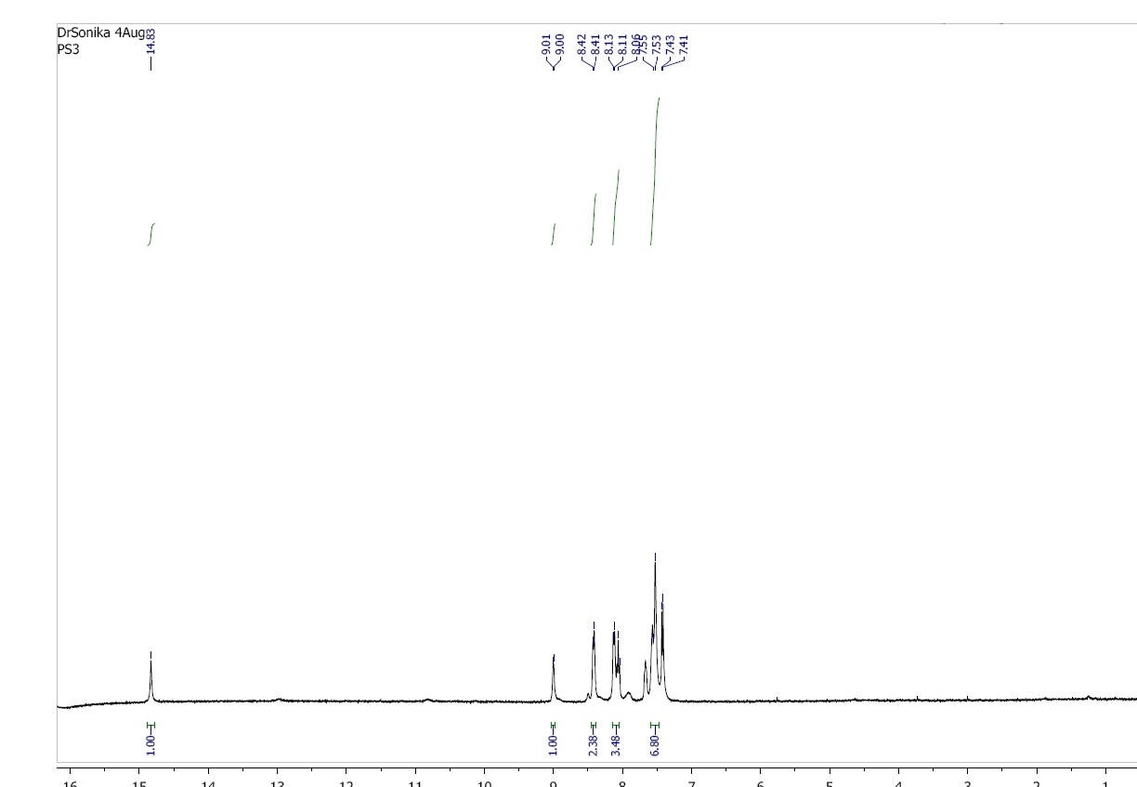

Fig S1 1H NMR of H1L2

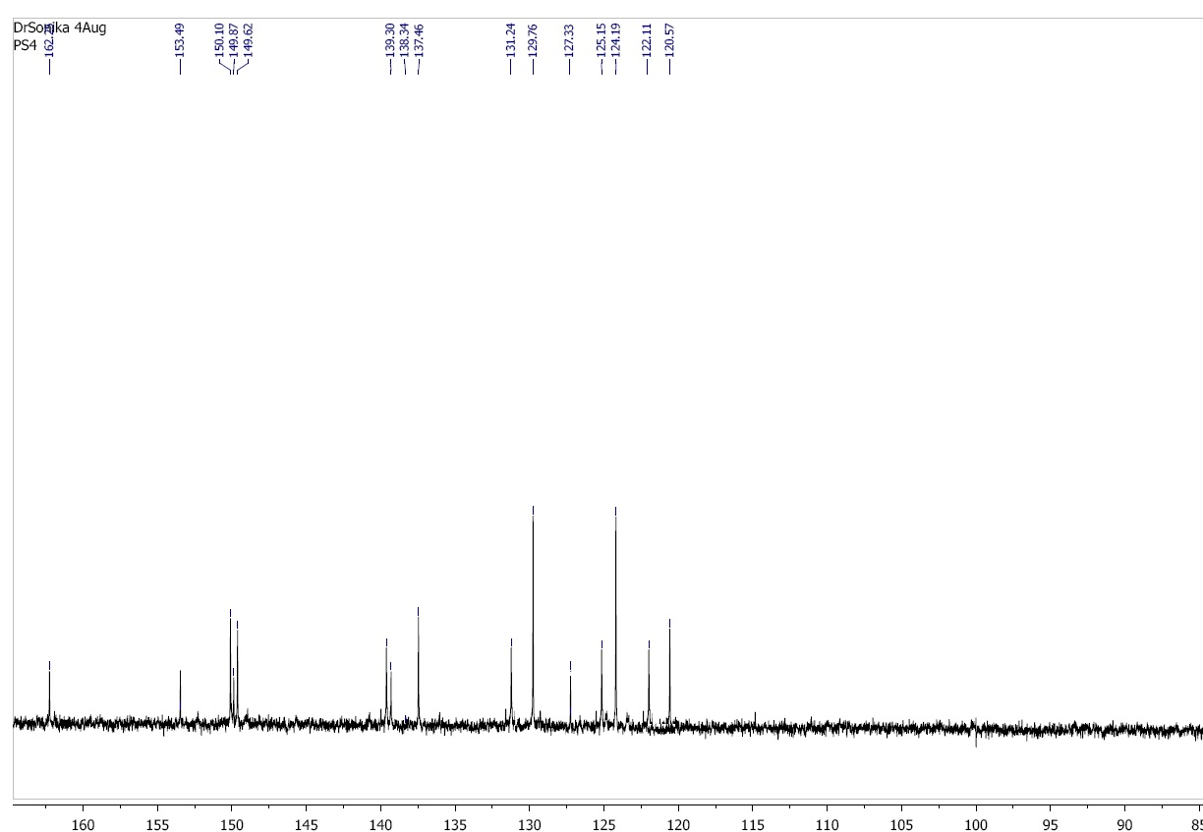

Fig S2 13C NMR of H1L2

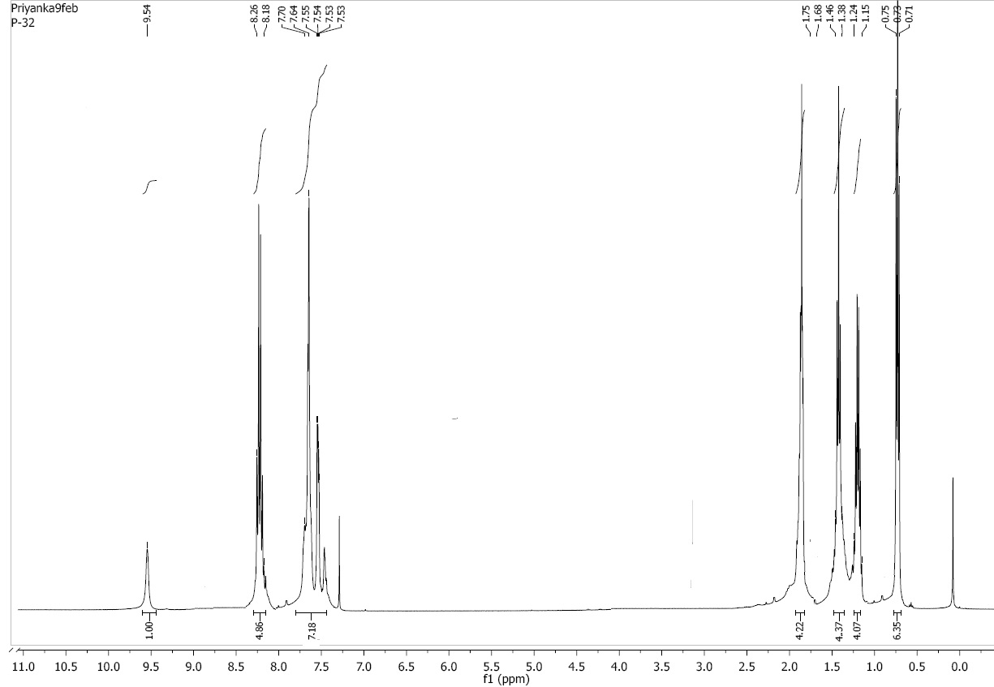

Fig S3 1H NMR of Bu2SnClL2

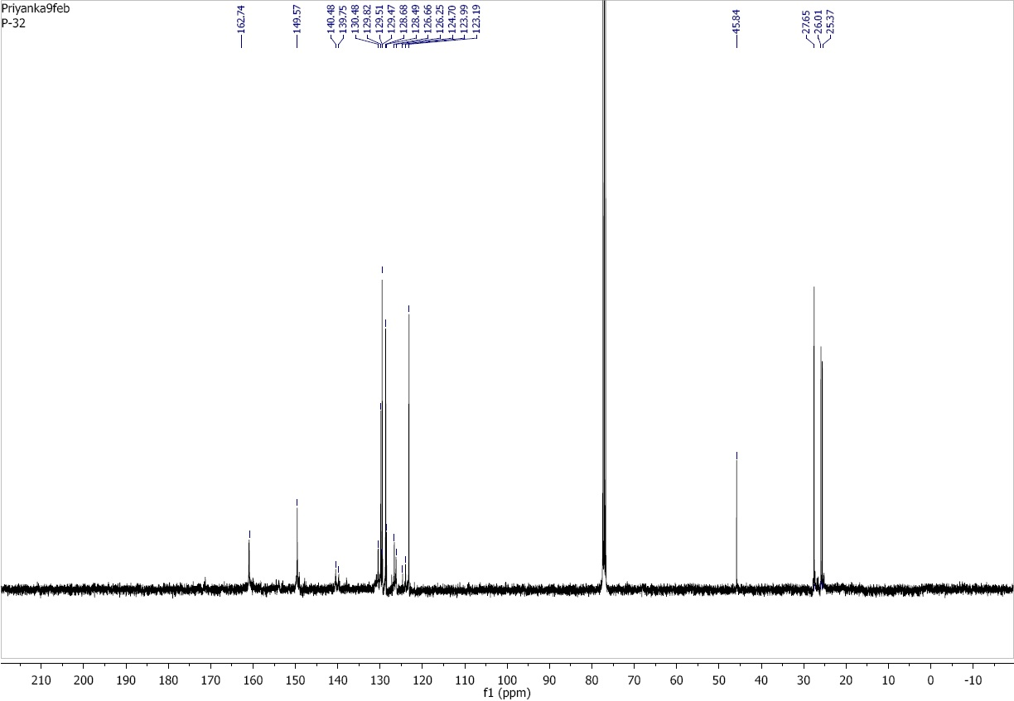

Fig S4 13C NMR of Bu2SnClL2



Fig S5 119Sn NMR of Bu2SnClL2

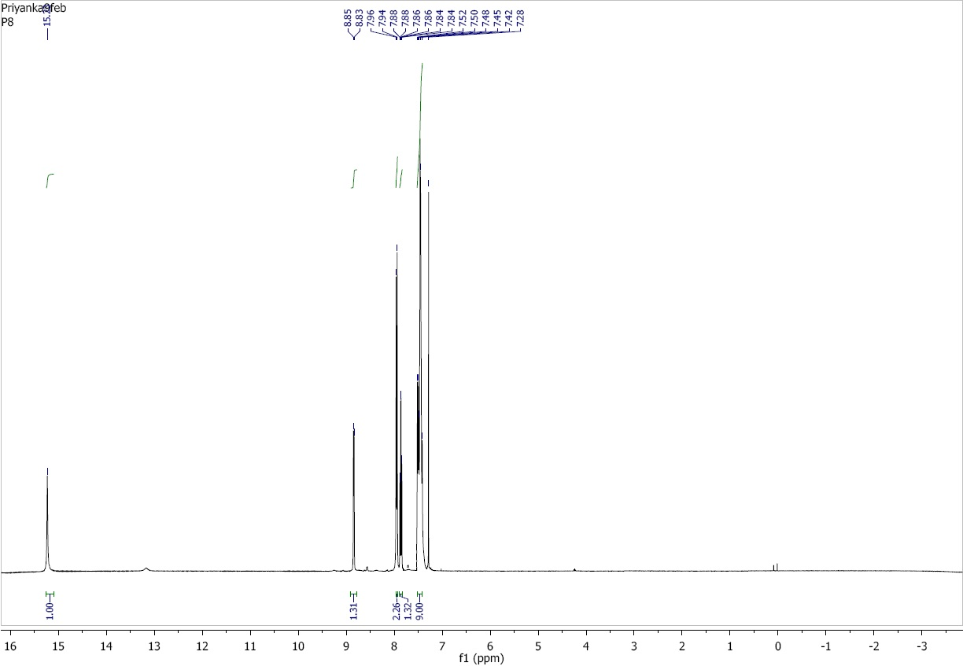

Fig S6 1HNMR of H1L4

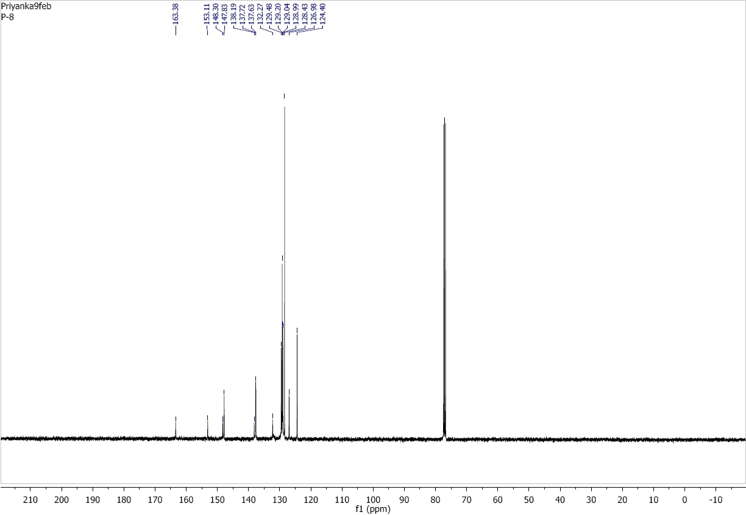

Fig S7 13CNMR of H1L4

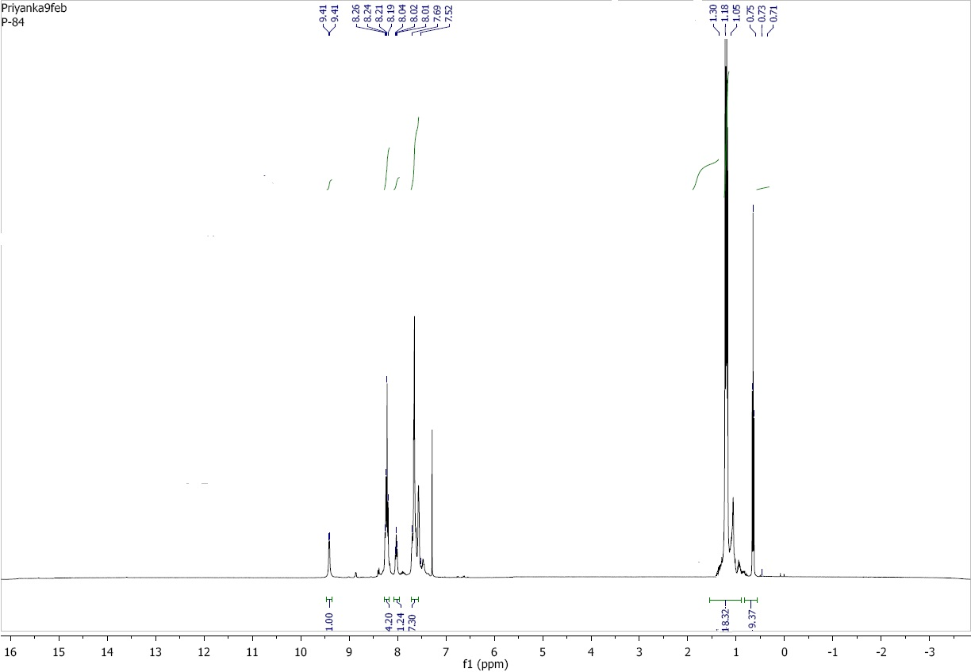

Fig S8 1HNMR of Bu3SnL4

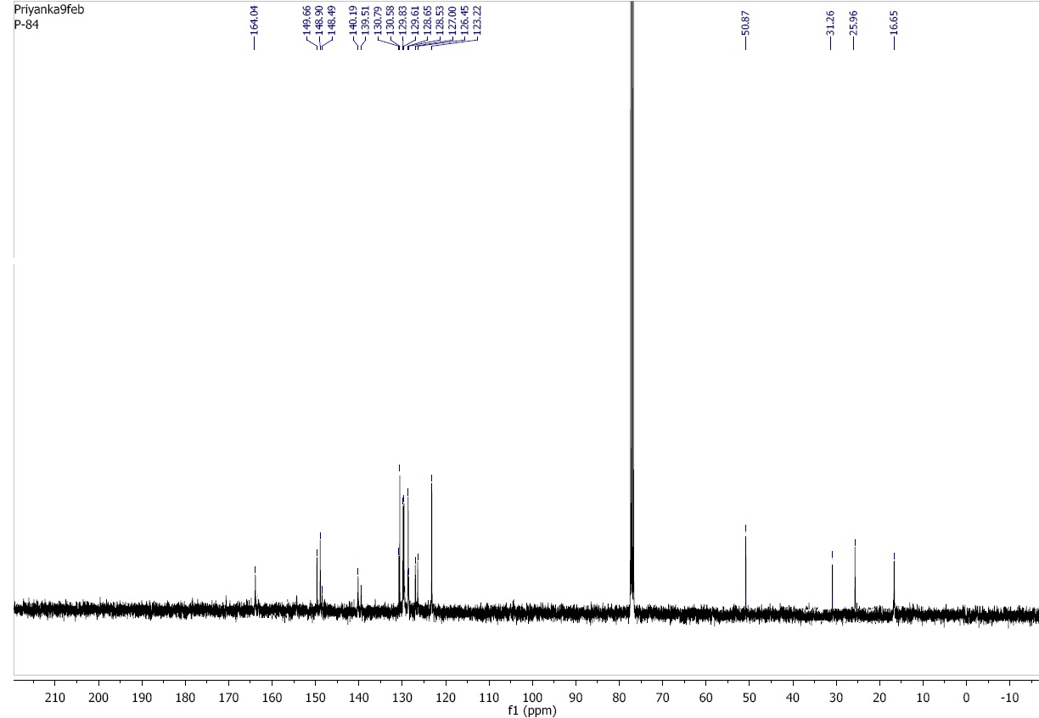

Fig S9 13C NMR of Bu3SnL4



Fig S10 119Sn NMR of Bu3SnL4

Fig S11 Mass spectra of H1L1



Fig S12 Mass spectra of Bu2SnClL2