SUPPLEMENTARY MATERIAL TO
Synthesis, Characterization and Antimicrobial Activity of Benzofuran and Thiophene Substituted Novel Diketoxime Derivatives

DEMET COSKUN^{1*}, SEHER GUR², MEHMET FATİH COSKUN¹
¹ University of Fırat, Faculty of Science, Department of Chemistry , 23119 Elazığ-Turkey.
² University of Fırat, Faculty of Science, Department of Biology , 23119 Elazığ-Turkey.

(a)
(b)
Figure S1: (a) ¹H-NMR and (b) ¹³C-NMR spectra of compound 1

(a)
(b)
Figure S2: (a) ¹H-NMR and (b) ¹³C-NMR spectra of compound 2
(a)
(b)
Figure S3: (a) ¹H-NMR and (b) ¹³C-NMR spectra of compound 3

(a)
(b)
Figure S4: (a) ¹H-NMR and (b) ¹³C-NMR spectra of compound 4a
(a)
(b)

Figure S5: (a) ¹H-NMR and (b) ¹³C-NMR spectra of compound 4b
(a)
(b)
Figure S6: (a) ¹H-NMR and (b) ¹³C-NMR spectra of compound 4c
(a)
(b)
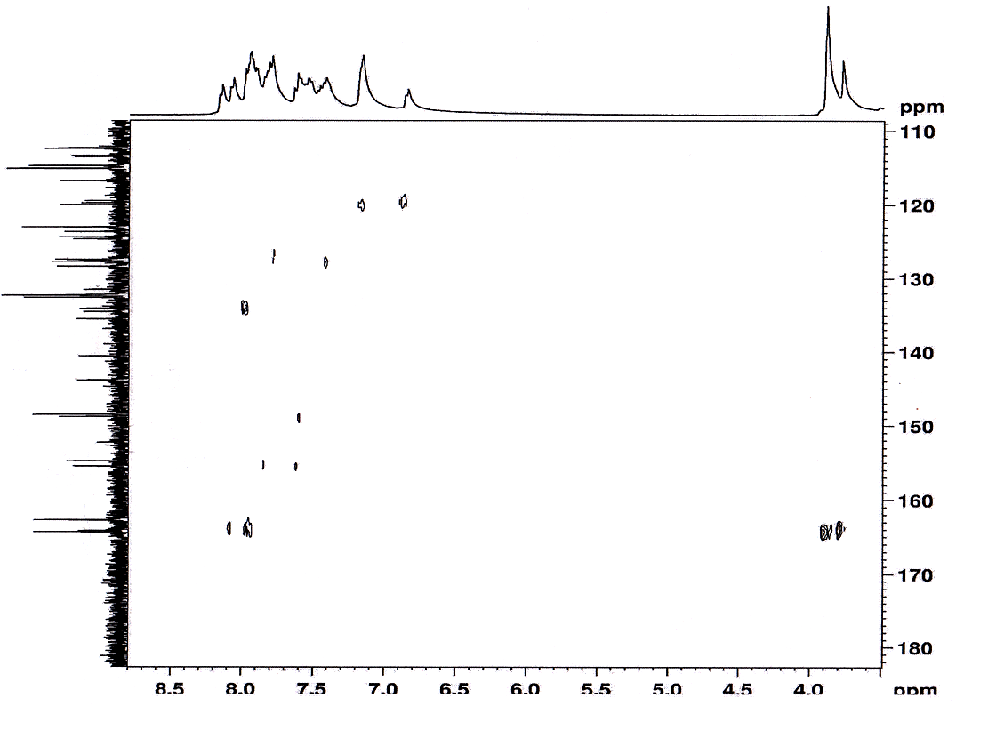
(c)
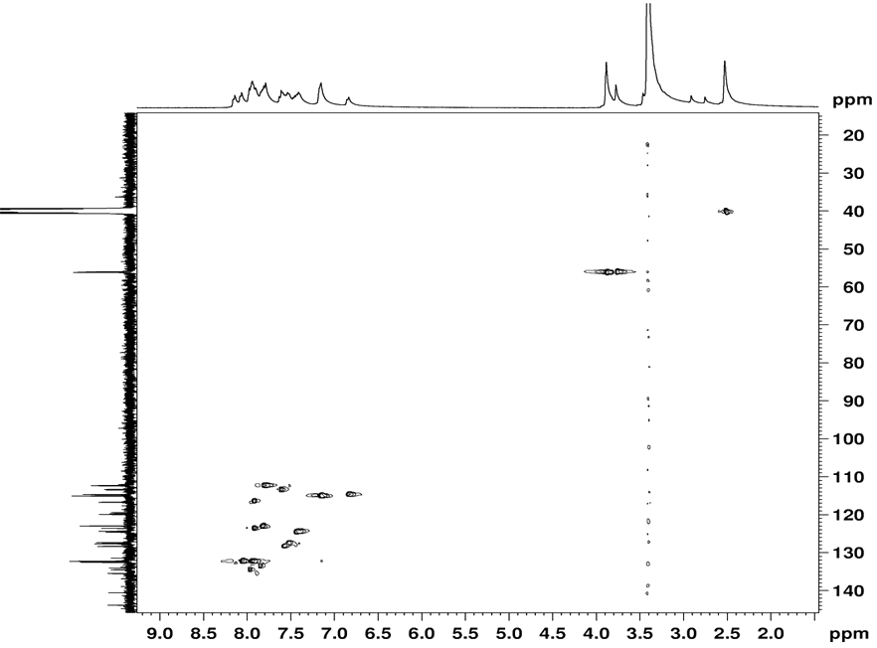
(d)
Figure S7: (a) ¹H-NMR, (b) ¹³C-NMR, (c) HMBC and (d) HSQC spectra of compound 4d
(a)

(b)
Figure S8: (a) ¹H-NMR and (b) ¹³C-NMR spectra of compound 4e

