**Efficient pollutants removal by amino modified nanocellulose impregnated with iron oxide**

KHALED A. TALEB1, JELENA D. RUSMIROVIĆ2, MILICA P. RANČIĆ3,#, JASMINA B. NIKOLIĆ1,#,[1], SAŠA Ž. DRMANIĆ1,#, ZLATE S. VELIČKOVIĆ4, ALEKSANDAR D. MARINKOVIĆ1,#

*1Department of Organic Chemistry, Faculty of Technology and Metallurgy, University of Belgrade, Karnegijeva 4, 11120 Belgrade, Serbia*

*2Innovation center, Faculty of Technology and Metallurgy, University of Belgrade, 11120 Belgrade, Serbia*

*3Faculty of Forestry, University of Belgrade, Kneza Višeslava 1, 11030 Belgrade, Serbia*

*4Military Academy, University of Defence, 33 General Pavle Jurišić – Šturm Street, Belgrade, Serbia*

# *Materials*

All the chemicals used in this study were of analytical grade or p.a. chemicals. PEG-6-arm amino polyethylene glycol (PEG-NH2, Mr≈15000 g mol-1) (Sunbio, South Korea) was used. The following chemicals, p.a. quality, were supplied from Sigma Aldrich: sulfuric acid, glacial acetic acid, toluene, perchloric acid, maleic anhydride (**MA**), tetrahydrofurane (THF), *N,N*-dimethylformamide (DMF), coupling agent *N,N'*-diisopropylcarbodiimide, sodium hydrogencarbonate (NaHCO3) and iron(II) sulfate heptahydrate (FeSO4•7H20). Deionised water (DW) with 18 MΩ cm resistivity was used. The As(V), As(III), nickel and cadmium standard solutions (Sigma Aldrich), 1000 mg L–1, were further diluted with deionised (DW) to the required concentration. Adjustment of pH was accomplished with 0.1 M NaOH and 0.1 M HNO3 (Sigma Aldrich).

*Adsorbents preparation*

*Nanocellulose (****NC****) isolation*

The **NC** was isolated from cotton microfiber (20 g) by treating with sulfuric acid (200 cm3, 64 wt.%) at temperature <40 °C for 24 h.1 Product was diluted with 800 cm3 of deionised water (DW), neutralized to pH 6, and three cycles of centrifugation/DW water washing were applied. After dialyzing for 48 h, nanocellulose was filtered by using polytetrafluoroethylene (200 nm) filter membrane, and named **NC**.

*The* ***NC*** *modification with maleic acid anhydride (****NC-MA)***

**NC** (10 g) was dispersed in the mixture of glacial acetic acid (100 cm3), toluene (130 cm3) and perchloric acid (0.5 cm3) by the use of ultrasound. Solution of MA (5 g) in 45 cm3 of toluene was added drop-wise into reaction mixture for 15 minutes under sonication, and reaction was continued on magnetic stirrer for 1 h at room temperature. Raw product was washed thoroughly with toluene and ethanol, and dried.2

***NC-MA*** *modification with PEG-NH2*

Dispersion of **NC-MA** (10 g) in the 50 mL dry DMF was added slowly into solution of 1 g of PEG-NH2 in 50 ml dry DMF. After addition of 2 g of *N,N'*-diisopropylcarbodiimide in 20 mL DMF reaction was carried out by ultrasonic treatment for 30 min (5 min/5 min sonication/mixing cycles), and continued with magnetic stirring at 20-25 oC for 3 h. The product was then diluted with 300 ml of methanol, vacuum-filtered with 0.05 μm pore size PTFE filter membrane, and washed extensively with excess methanol. The PEG-NH2 functionalized **NC** (**NC-PEG**) was freeze/dried by keeping freshly obtained material at –30 °C for 24 h, followed by freeze drying at –50 °C maintaining 0.05 mbar for 24 h, and process was finished at –70 °C and 0.01 mbar for 1 h material treatment. In that way obtained porous **NC-PEG** substrate was used for subsequent precipitation of iron oxide.

*Optimization of adsorbent preparation*

The coded and operational values of the selected variables are shown in Table SI, together with the experimental plan, which comprised 16 experimental runs plus six replicates on the central point.

TABLE SI. Experimental plan for RSM and experiment results for adsorbent NC-PEG/FO (*m/V* = 100 mg dm-3, *C*i[As(V)] = 0.5 mg g-1, *T* = 25 °C, pH = 6).

|  |  |  |  |
| --- | --- | --- | --- |
| No. | *C*[FeSO4], X1,  mol dm-3 | *C*[NaHCO3], X2,  mol dm-3 | Obtained capacity As(V), mg g-1  mg g-1 |
| 1. | 0.35 | 0.32 | 2.039 |
| 2. | 0.21 | 0.22 | 3.142 |
| 3. | 0.21 | 0.22 | 3.142 |
| 4. | 0.09 | 0.17 | 1.605 |
| 5. | 0.35 | 0.05 | 2.440 |
| 6. | 0.12 | 0.50 | 2.273 |
| 7. | 0.12 | 0.50 | 2.273 |
| 8. | 0.23 | 0.17 | 2.975 |
| 9. | 0.21 | 0.22 | 3.209 |
| 10. | 0.04 | 0.32 | 1.805 |
| 11. | 0.35 | 0.05 | 1.471 |
| 12. | 0.29 | 0.15 | 3.311 |
| 13. | 0.35 | 0.50 | 2.106 |
| 14. | 0.04 | 0.32 | 1.905 |
| 15. | 0.18 | 0.05 | 2.340 |
| 16. | 0.04 | 0.05 | 1.471 |

*Characterization of the adsorbents*

Analysis of textural properties of obtained materials was performed by using **B**runauer-**E**mmett-**T**eller (BET) method for the determination of the specific surface area, the **B**arrett-**J**oyner-**H**alenda (BJH) method for the determination of the mesoporosity parameters. The X-ray diffraction (XRD) (BRUKER D8 ADVANCE) was used for phase and structural analysis of adsorbents. The morphology of the obtained powders and sintered samples was characterized by scanning electron microscopy (JEOL JSM-6390 LV). The powders were crushed and covered with gold in order to perform recording of SEM images. Fourier-transform infrared spectra (FTIR) were collected on BOMEM (Hartmann & Braun) spectrometer and were employed to determine the surface groups and its interactions with arsenate. The pH values at the point of zero charge (pHPZC) of the samples, *i.e*. the pH above which the total surface of the samples is negatively charged, were measured using the pH drift method.3 Quantification of the available amino group was determined by applying Kaiser test (*DA*Kaiser – degree of amination obtained by Kaiser test,4 and by volumetric method.5 The acid value (*AV*) was determined according to ASTM D664 standard, and presented as mg KOH g-1 of the specimen. The arsenic concentrations in the solutions after the adsorption and kinetic experiments were analyzed by inductively coupled plasma mass spectrometry (ICP-MS), using an Agilent 7500ce ICP-MS system (Waldbronn, Germany).

*Adsorption and kinetic experiments in a batch system*

Batch experiments were conducted in 10 cm3 polyethylene bottles in 100 mg dm-3 suspension with 10 cm3 of arsenic solution of certain concentration, time period, temperature and pH value. Time dependent batch experiments were determined in 1 mg dm-3 solution for cations and 0.5 mg dm-3 for As(V) solution during 5, 10, 15, 30, 45, 60 and 120 min. This study revealed that 60 minutes was sufficient for quantitative removal of pollutants. The effect of pH value on As(V) removal was studied with an initial As(V) concentration of 0.5 mg dm-3 varying the pH in the range 2-12. Adsorption isotherm and thermodynamic parameters were evaluated by varying initial concentration (*C*i) of cation (1, 2, 3, 4, 5, 6 and 7 mg dm-3) and oxyanions concentration (0.1, 0.2, 0.5, 1, 2, 5 and 10 mg dm-3) and temperature (25, 35, 45 °C). Batch experiments were performed under classical mixing using magnetic stirrer Heidolph MR 3001. After adsorption experiments, adsorbent was removed by filtration with 0.22 µm PTFE membrane and filtrate was analyzed on pollutant content. The adsorbent capacity was calculated according to the eq. (S1):

 (S1)

where *q* is adsorption capacity in mg g–1, *C*i and *C*e are initial and final ion concentrations in mg dm-3 (μg dm-3), respectively, *V* is volume of the solution in dm3, and *m* is mass of adsorbent in g. The results of ions adsorption on glass tube wall and filters showed negligible effect on the reliability of results.

To evaluate the regeneration capabilities, after adsorption experiments and washing with DW, wet adsorbents (*m/V* = 100 mg dm-3) were re-dispersed in 20 cm3 of regenerator. Different solutions: NaOH (0.2 or 0.5 mol dm-3), NaCl (0.2 or 0.5 mol dm-3) or their combination was used for cation and arsenic elution. The amount of desorbed cations and As(V) was measured after magnetic mixing for 3 h in a batch system. Five consecutive adsorption/desorption cycles were performed in triplicate by using both **NC-PEG** and **NC-PEG/FO** adsorbents.

*Adsorption data modeling and statistical analysis*

Calculations of kinetic and thermodynamic parameters were obtained by using OriginPro 9.1® software. Unknown parameters of the isotherm models were determined using Levenberg-Marquardt (LM) algorithm and Orthogonal Distance Regression (ODR) algorithm. Levenberg-Marquardt (LM) algorithm minimizes the residual sum of squares by adjusting fitting parameters in the iterative process. The residual in LM is the difference between the observed value and the predicted value of the dependent variable. And the algorithm combines the Gauss-Newton method and the steepest descent method. Orthogonal distance regression (ODR) algorithm minimizes the residual sum of squares by adjusting both fitting parameters and values of the independent variable in the iterative process. The residual in ODR is not the difference between the observed value and the predicted value for the dependent variable, but the orthogonal distance from the data to the fitted curve.6 Considering that values of both axes are affected by measurement error in the process of experimental data by adsorption isotherm models fitting, the use of ODR modeling procedure is statistically correct, and can be presented by following eq. (S2):

 (S2)

where *n*, , , *C*fi and denote the number of data points, the experimental and the estimated values of adsorption capacity and equilibrium adsorbate concentration, respectively, is suitable for fitting adsorption isotherms when the measurements of initial and final adsorbate concentrations are affected by heteroscedastic error and no replicates were done. In eq. (S2) weighting is performed by 1/*q*i and 1/*C*fi for the *y* and *x* axes, respectively, and thus at the same time heteroscedasticity is taken into account and the scaling is performed so that dimensionless values, independent of units, can be added together to form the sum of error function.

RESULTS AND DISCUSSION

*The XRD analysis*

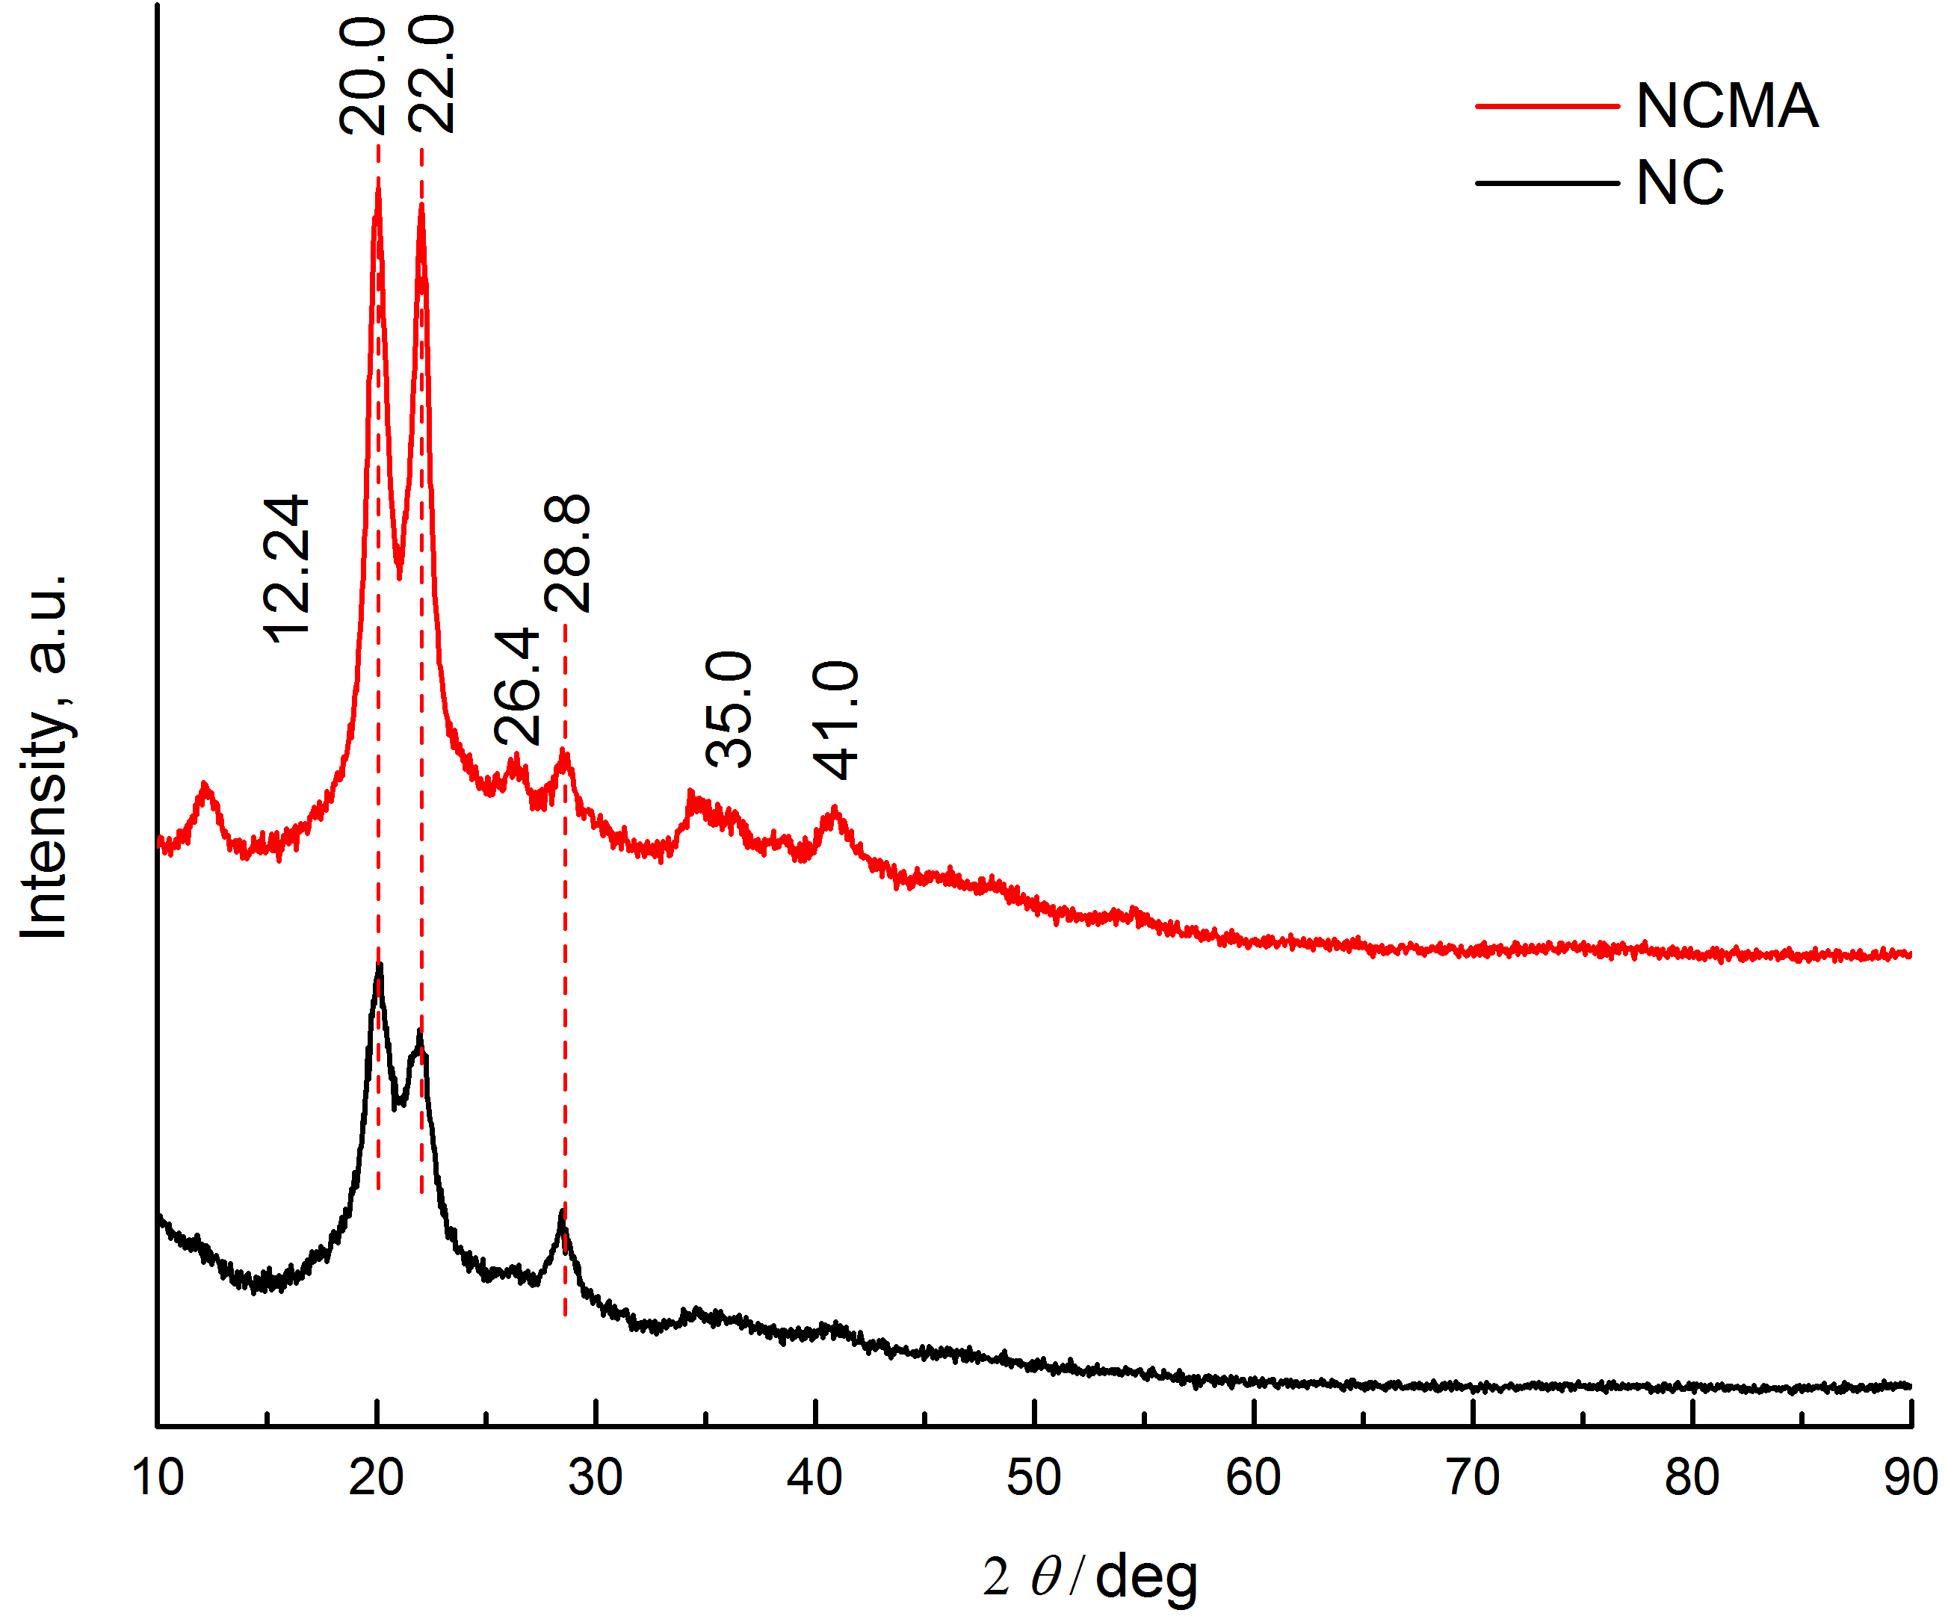

Fig. S1. XRD diffractograms of NC and NCMA2

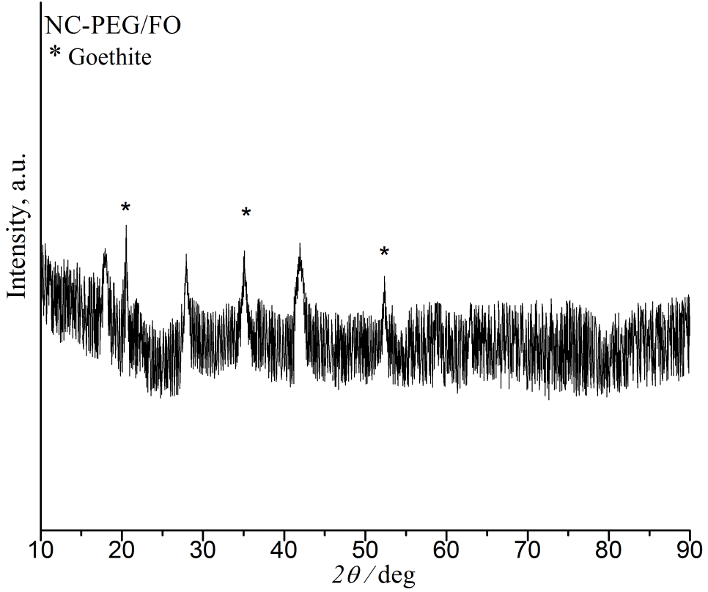

Fig. S2.XRD pattern of **NC-PEG/FO**.

The maximum adsorption capacities for As(V) and As(III) by using **NC-PEG/FO,** as well asCd2+ and Ni2+ by using NC-PEG are given in Table

Table SII. The maximum adsorption capacities for As(V), As(III), Cd2+ and Ni2+, obtained by using Langmuir model

|  |  |  |  |  |
| --- | --- | --- | --- | --- |
|  | | *q*e / mg g-1 | | |
| Adsorbent |  | 25 °C | 35 °C | 45 °C |
| **NC-PEG/FO** | As(V) | 26.0 | 27.4 | 28.6 |
| As(III) | 23.6 | 24.3 | 25.5 |
| **NC-PEG** | Cd2+ | 37.9 | 40.9 | 43.9 |
| Ni2+ | 32.4 | 33.7 | 35.0 |

REFERENCES

1. P. Lu, Y-L. Hsieh, *Carbohyd. Polym.* 82 (2010) 329

2. N. Ðorđević, A. D. Marinković, J. B. Nikolić, S. Ž. Drmanić, M. Rančić, D. V. Brković, P. S. Uskoković, *J. Serb. Chem. Soc*. (2016), doi: 10.2298/JSC151217019D

3. G. D. Vuković, A. D. Marinković, S. D. Škapin, M. T. Ristić, R. Aleksić, A. Perić-Grujić, P. S. Uskoković, *Chem. Eng. J.*  **173** (2011) 855

4. Y. Tian, M. Wu, R. Liu, D. Wang, X. Lin, W. Liu, Y. Huang, *J. Hazard. Mater.* **185** (2011) 93

5. J.S. Markovski, D. D. Marković, V. R. Dokić, M. Mitrić, M. D. Ristić, A. E. Onjia, A.D. Marinković, *Chem. Eng. J.*  **237** (2014) 430

6. D.D. Marković, B.M. Lekić, V.N. Rajaković-Ognjanović, A.E. Onjia, L.V. Rajaković, *Sci. World J.* **2014**(2014) 1, http://dx.doi.org/10.1155/2014/930879

1. Corresponding author. E-mail: jasmina@tmf.bg.ac.rs

   # Serbian Chemical Society member.