Reviewer B
Comment;
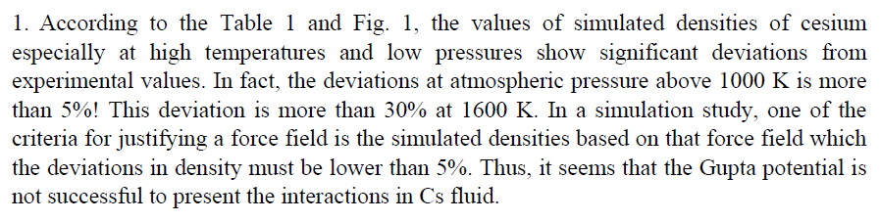

Response:
In this work, we have studied thermodynamic state where the metal-nonmetal transition tends to initiate and discussed coordination number and diffusion coefficient around the maximum region of the P_{i}-V_{m} curve (Fig. 3 in the revised manuscript). It is worth mentioning that the maximums of P_{i}-V_{m} curves are at (1100 K and 400 bar) and (1200 and 500 bar) where the density deviation are less than 3% . For temperatures from 900 up to 1200 K and pressures from 400 up to 600 bar, deviation of density are less than 3% . Also, it is less than 5% for 800 K up to 1300 K in 300 – 800 bar. In fact, the large deviation of density at 1500 K and 1600 k cannot impress the results of this work.

Comment;
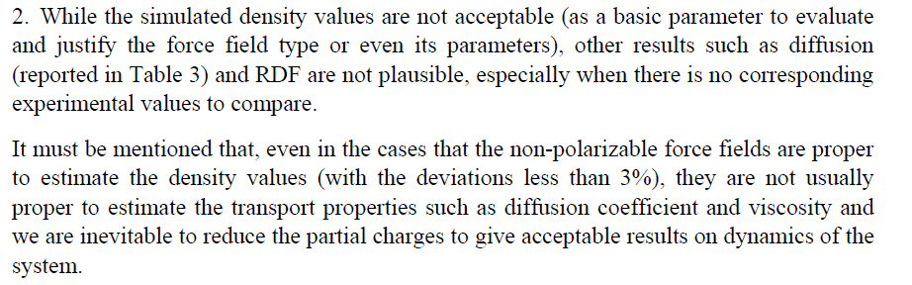

Response:
Gupta potential is a n-body potential designed for simulating the metallic clusters. Including the polarizability effects or reducing the atomic partial charges usually applied for site-site potential interactions used for simulating molecular systems like ionic liquids.
The calculated coordination numbers and positions of RDF_{s} are in good agreement with x-ray diffraction and small-angel x-ray scattering measurements in ref. 6 and 30 of the revised manuscript.

Comment;
Respons;
The goal of our study is to investigate the deviation of metallic characteristic for Cs using internal pressure and we find that it occurs around 1100 and 1200 K. The internal pressure for Cs expanded fluid has been studied in ref. 5 at 600-1600 K, so we chose a similar ranges of temperature changes to compare with that data.

Comment;

Respons;

The calculated internal energy from Eq. (4) and the simulated one, have been illustrated in fig 2 in revised manuscript.
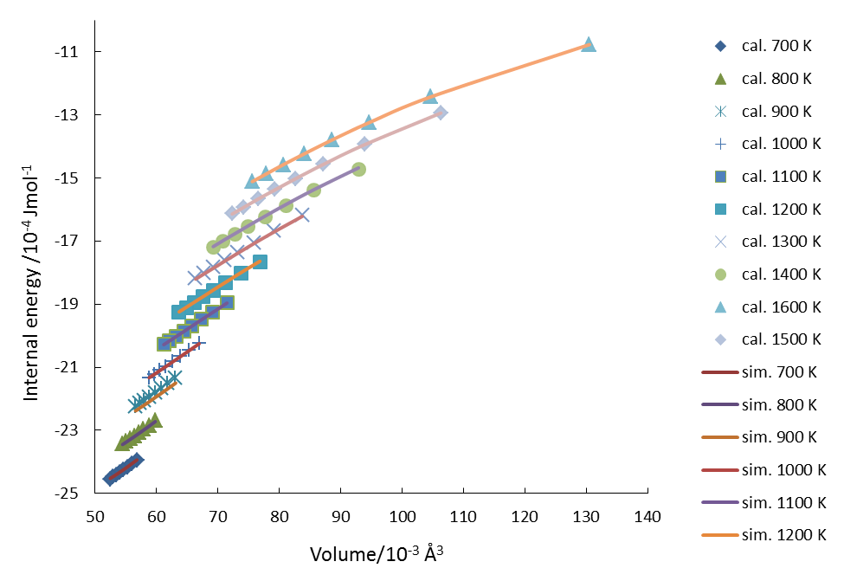
Fig. 2 Calculated and simulated internal energies for Cs at temperature range 700 – 1600 K.

Comment;

Respons;

Comparing snapshots of the simulated ensemble at thermodynamic conditions which has the lowest and highest densities can be used for clarification of formation of Cs clusters. (1600 k was not used because of it’s large deviation in calculated density).

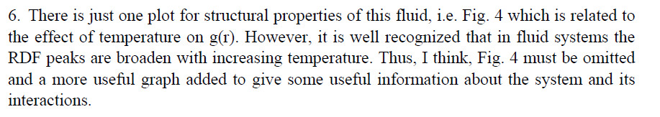

Respons;
We calculated RDFs for expanded Cs in whole studied temperature and pressure ranges but showing just one graph for illustration. This graph is useful for showing the extent of the effect of the temperature on the height and location of the first peak of g(r).

Comment;

Respons;
Yes, it is expected, but we try to show the amount of changes. The results are in good agreement with ref. 6 and 7 and similar study in ref. 48 (in new manuscript )for Rb.

Comment;

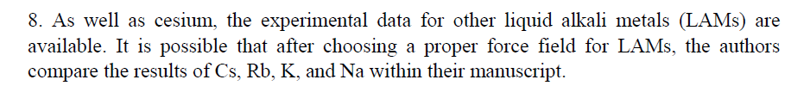

Respons;

This manuscript is the first project on LAMs in our lab. Investigation on other LAMs is ongoing.

Comment;

Respons;
Some new references was added to the manuscript (ref. 19, 20 and 21 in the revised manuscript).

Reviewer C
Comment;
•The Authors should consult a native English speaker since there are grammatical problems in the paper.

Response:
The manuscript was proofread by an expert and we did our best to make the manuscript clear, concise and error-free

Comment;
• ’’Sticky notes’’ with some comments are added in the paper (pdf format).
Response:
Thanks for useful comments and corrections. All comments in sticky notes were taken into the consideration.

Comment;
• Terms and acronyms should be uniform through the whole paper.

Response:
All terms and abbreviations have been checked and made uniform.

Comment:
• The Authors should decide which term is used in the whole Manuscript (Cesium, cesium or Cs).

Response:
Cs was used through the manuscript.

Comment:
• Tables should be shown as more descriptive and in accordance with the text.
Response:
All Tables and related texts were checked.

Reviewer D

Comment;
I have a question regarding the temperature dependence of the fitting parameters a, b, and c from Eq. (4), which are given in Table 2. This temperature dependence is quite strong and should be commented on by the authors. Are there previous theoretical results on this?

Response:

After the seminal work of Parsafar (31.34. G. Parsafar, E. A. Mason, Phys. Rev. B 49 (1994) 3049 , Ref. 34 of the manuscript) many researcher used the equation U=U(V) for obtaining the equation of state and some Linear Regalities (LIR). Up to our knowledge, we obtained for the first time the coefficients of U=U(V) by fitting the calculated internal energies to volume.
The obtained coefficients are strongly depended to temperature and a similar discussion to this text was added to the manuscript.

