Supplementary Information

Facile and rapid synthesis of divers xanthene derivatives using Lanthanum(III) chloride/chloroacetic acid as an efficient and reusable catalytic system under solvent-free conditions
Behjat Pouramiriª, Maryam Shirvaniª and Esmat Tavakolinejad Kermani^{a*}
ªFaculty of Science, Depatrtment of Chemistry, Shahid Bahonar University of Kerman, Kerman, 76169, Iran.

9,10-dihydro-9,9-dimethyl-12-phenyl-8H-benzo[a]xanthene-11(12H)-one (5a): IR (KBr): ν= 3072, 2960, 1664 (C=O), 1624, 1424, 1359cm⁻¹. ¹H NMR (400 MHz, CDCl₃) δ= 0.98 (3H, s, CH₃), 1.14 (3H, s, CH₃), 2.21-2.36 (2H, m, CH₂), 2.59 (2H,s, CH₂), 5.73 (1H, s, CH), 7.05-7.21 (3H, m, arom), 7.34-7.47 (5H, m, arom), 7.75-8.03 (3H, m, arom)., ¹³C NMR (CDCl₃, 100 MHz): δ= 27.18, 29.30, 34.71, 41.42, 50.89, 109.46, 114.27, 117.05, 117.70, 123.69, 124.91, 126.25, 127.01, 128.07, 128.24, 128.43, 128.84, 129.77, 131.40, 131.49, 144.74, 147.73, 197.02.
9,10-dihydro-12-(4-hydroxyphenyl)-9,9-dimethyl-8H-benzo[a]xanthene-11(12H)-one (5b): IR (KBr): ν= 3354 (OH), 3059, 3022, 2954, 2869, 1651(C=O), 1594, 1466, 1373 cm⁻¹. ¹H NMR (400 MHz, CDCl₃) δ= 0.99 (3H, s, CH₃), 1.13 (3H, s, CH₃), 2.22-2.36 (2H, m, CH₂), 2.59 (2H, s, CH₂ ), 4.83 (1H, s, OH), 5.66 (1H, s, CH), 6.61-6.67 (2H, m, arom), 7.14-7.21 (2H, m, arom), 7.32-7.47 (3H, m, arom), 7.69-8.00 (3H, m, arom). ¹³C NMR (CDCl₃, 100 MHz): δ= 27.17, 29.26, 33.87, 41.41, 50.90, 109.47, 114.43, 115.19, 117.02, 117.62, 123.73, 124.91, 126.98, 128.39, 128.77, 129.57, 131.51, 137.00, 147.62, 154.01, 162.32, 197.67.
12-phenyl-9,10-dihydro-8H-benzo[a]xanthen-11(12H)-one (5c): IR (KBr): ν= 3063, 2967, 2895, 1652(C=O), 1595, 1369 cm⁻¹. ¹H NMR (400 MHz, CDCl₃) δ= 1.98-2.10 (2H, m, CH₂), 2.30-2.52 (2H, m, CH₂), 2.64 -2.80 (2H, m, CH₂), 5.76 (1H, s, CH), 7.09 (1H, t, J=7 Hz, arom), 7.18 (2H, t, J=8Hz, arom), 7.35-7.42 (3H, m, arom), 7.43-7.46 (2H, m, arom), 7.78-7.81 (2H, m, arom), 7.99 (1H, d, J=8 Hz, arom). ¹³C NMR (CDCl₃, 100 MHz): δ= 27.28, 27.75, 34.64, 37.06, 115.56, 116.98, 117.71, 123.71, 124.89, 126.56, 127.00, 128.28, 128.38, 128.50, 128.64, 131.39, 131.49, 150.09, 145.04, 147.78, 147.78, 165.63, 197.11.
9,10 -dihydro-12-(3-nitro phenyl)-8H-benzo[a]xanthene-11 (12H)-one (5d): IR (KBr): ν= 3064, 2954, 2891, 1647(C=O), 1595, 1375 cm⁻¹. ¹H NMR (400 MHz, CDCl₃) δ= 1.95-2.13 (2H, m, CH₂), 2.35-2.47 (2H, m, CH₂), 2.69 -2.85 (2H, m, CH₂), 5.86 (1H, s, CH), 7.37-7.48 (4H, m, arom), 7.81-7.86 (4H, m, arom), 7.95-8.11 (2H, m, arom). ¹³C NMR (CDCl₃, 100 MHz): δ= 20.25, 27.75, 34.72, 36.91, 114.40, 116.01, 117.16, 121.61, 122.52, 123.16, 123.33, 125.20, 127.36, 128.69, 129.08, 131.61, 134.95, 135.99, 146.99, 147.83, 197.10.
9,10 -dihydro-12-(4-nitro phenyl)-8H-benzo[a]xanthene-11 (12H)-one (5e): IR (KBr): ν= 3106, 3068, 2946, 2887, 1651 (C=O), 1593, 1455 cm⁻¹. ¹H NMR (400 MHz, CDCl₃) δ= 1.93-2.15 (2H, m, CH₂), 2.35-2.52 (2H, m, CH₂), 2.68-2.83 (2H, m, CH₂), 5.86 (1H, s, CH), 7.38-7.54 (5H, m, arom), 7.82-7.85 (3H, m, arom), 8.05-8.12 (2H, m, arom). ¹³C NMR (CDCl₃, 100 MHz): δ= 20.23, 27.78, 34.83, 36.95, 114.25, 116.05, 117.04, 123.15, 123.46, 123.68, 125.25, 127.40, 128.67, 129.44, 129.65, 131.01, 131.57, 143.35, 147.77, 152.13, 196.99.
3,4,7-tetrahydro-9-phenyl-2H-xanthene-1,8(5H,9H)-dione (6a): IR (KBr): ν= 3050, 2953, 2885, 1673 (C=O), 1621, 1429 cm⁻¹. ¹H NMR (400 MHz, CDCl₃) δ= 1.96-2.05 (4H, m, CH₂), 2.29-2.41 (4H, m, CH₂), 2.54-2.70 (4H, m, CH₂), 4.83 (1H, s, CH), 7.12-7.33 (5H, m, arom). ¹³C NMR (CDCl₃, 100 MHz): δ= 20.30, 27.16, 31.62, 36.96, 116.91, 126.42, 128.38, 144.37, 163.91, 196.55.
9-(4-chiorophenyl)-3,4,6,7-tetrahydro-2H-xanthene-1,8(5H,9H)-dione (6b): IR (KBr): ν= 3086, 3052, 2958, 2893, 1667(C=O), 1616, 1459 cm⁻¹. ¹H NMR (400 MHz, CDCl₃) δ= 1.92-2.10 (4H, m, CH₂), 2.29-2.42 (4H, m, CH₂), 2.54-2.70 (4H, m, CH₂), 4.78 (1H, s, CH), 7.18-7.28 (4H, m, arom) ¹³C NMR (CDCl₃, 100 MHz): δ= 20.28, 27.13, 31.29, 36.91, 116.49, 128.24, 129.81, 132.09, 142.94, 164.10, 196.56.
3,4,7-tetrahydro-9-(4-hydroxyphenyl)-2H-xanthene-1,8(5H,9H)-dione (6c): IR (KBr): ν= 3378 (OH), 3022, 2949, 2920, 2867, 1661 (C=O), 1609, 1446 cm⁻¹. ¹H NMR (400 MHz, CDCl₃) δ= 1.98-2.08 (4H, m, CH₂), 2.29 -2.44 (4H, m, CH₂), 2.53-2.70 (4H, m, CH₂), 4.26(1H, s, -OH), 4.76 (1H, s, CH), 6.66 (2H, d, J=8.4 Hz, arom), 7.16 (2H, d, J=8.4 Hz, arom). ¹³C NMR (CDCl₃, 100 MHz): δ= 20.31, 27.14, 30.79, 36.98, 115.08, 117.07, 129.52, 136.58, 154.23, 163.86, 196.94.
9-(p-tolyl)-3,4,5,6,7,9-hexahydro-1H-xanthene-1,8(2H)-dione (6d): IR (KBr): ν= 3012, 2949, 2919, 2867, 1661 (C=O), 1609, 1446 cm⁻¹. ¹H NMR (400 MHz, CDCl₃) δ= 1.44-1.47 (4H, m, CH₂), 2.11(3H, s, CH₃), 2.14-2.22 (4H, m, CH₂), 2.63-2. 80 (4H, m, CH₂), 4.88 (1H, s, CH), 7.42(2H, d, J=7 Hz, arom), 7.49 (2H, d, J=7 Hz, arom). ¹³C NMR (CDCl₃, 100 MHz): δ= 20.61, 26.40, 27.62, 30.92, 36.14, 118.71, 129.35, 129.65, 129.98, 130.32, 130.78, 130.88, 130.98, 197.04.
3,4,6,7-tetrahydro-9-(4-nitrophenyl)-2H-xanthene-1,8(5H,9H)-dione (6e): IR (KBr): ν= 3022, 2949, 2920, 2867, 1661 (C=O), 1609, 1446 cm⁻¹. ¹H NMR (400 MHz, CDCl₃) δ= 1.98-2.10 (4H, m, CH₂), 2.35 -2.52 (4H, m, CH₂), 2.64-2.80 (4H, m, CH₂), 4.76 (1H, s, CH), 7.42 (2H, d, J=8 Hz, arom), 7.48-7.70 (2H, m, arom). ¹³C NMR (CDCl₃, 100 MHz): δ= 20.62, 27.62, 30.63, 36.17, 116.16, 127.96, 129.22, 129.98, 130.98, 145.69, 157.76, 195.41.
9-(3-nitrophenyl)-3,4,5,6,7,9-hexahydro-1H-xanthene-1,8(2H)-dione (6f): IR (KBr): ν= 3031, 2922, 1664 (CO), 1595. ¹H NMR (400 MHz, DMSO, d₆) δ= 1.61-1.78 (4H, m, CH₂), 2.06-2.19 (m, 4H, 2CH₂), 4.72 (s, 1H, CH), 7.55 (1H, t, J= 7 Hz, 1H, arom), 7.72-7.75 (m, 1H, arom), 7.97-8.16 (2H, m, arom). ¹³C NMR (DMSO, d₆, 100 MHz): δ= 21.10, 26.18, 32.36, 36.54, 113.54, 121.47, 129.35, 148.02, 153.32, 167.37, 196.04.
3,3,6,6-tetramethyl-9-phenyl-3,4,5,6,7,9-hexahydro-1H-xanthene-1,8(2H)-dione (6g): IR (KBr): ν= 3029, 2988, 1669 (CO), 1596. ¹H NMR (400 MHz, DMSO, d₆) δ= 0.68 (6H, s, CH3), 0.85 (6H, s, CH₃), 1.73 (2H, d, J = 17.4 Hz), 1.97 (2H, d, J = 16.0 Hz), 2.15 (4H, dd, J1 = 15.9 Hz, J2 = 3.6 Hz ), 5.01 (1H,s), 7.20-7.30 (4H, m, arom), 7.47 (1H, d, J = 6.9 Hz, arom). ¹³C NMR (DMSO, d₆, 100 MHz): δ= 26.40, 29.63, 32.47, 41.37, 50.00, 113.55, 126.26, 128.00, 128.42, 135.33, 141.31, 146.68, 150.5, 167.41, 195.6.
9-(4-chlorophenyl)-3,3,6,6-tetramethyl-3,4,5,6,7,9-hexahydro-1H-xanthene-1,8(2H)-dione (6h): IR (KBr): ν= 3031, 2989, 1670 (CO), 1596. ¹H NMR (400 MHz, DMSO, d₆) δ= 0.67 (6H, s, CH3), 0.85 (6H, s, CH₃), 1.76 (2H, d, J = 17.4 Hz), 1.99 (2H, d, J = 16.0 Hz), 2.17 (4H, dd, J1 = 15.9 Hz, J2 = 3.6 Hz ), 5.11 (1H,s), 7.54-7.56 (2H, d, J=7 Hz, arom), 8.05-8.07 (2H, d, J = 6.9 Hz, arom). ¹³C NMR (DMSO, d₆, 100 MHz): δ= 26.45, 29.59, 32.55, 41.34, 49.80, 112.66, 122.57, 130.26, 134.77, 136.51, 147.86, 148.61, 151.30, 167.34, 195.59.
11-phenyl-10H-diindeno[1,2-b:2',1'-e]pyran-10,12(11H)-dione (7a): IR (KBr): ν= 3066, 2945, 2841, 1699 (C=O), 1608cm⁻¹. ¹H NMR (400 MHz, CDCl₃) δ= 4.66 (1H, s, CH), 7.03-7.05 (1H, m, arom), 7.10-7.18 (2H, m, arom), 7.47-7.60 (3H, m, arom), 7.84-7.94 (3H, m, arom), 8.03-8.07 (2H, m, arom), 8.49 (2H, d, J=6.8 Hz, arom). ¹³C NMR (CDCl₃, 100 MHz): δ= 47.01, 122.08, 123.37, 124.30, 125.68, 128.82, 130.93, 133.23, 134.18, 135.26, 136.65, 147.04, 196.78. Anal. Calcd. for. C₂₅H₁₄O₃: C: 82.86, H: 3.89 %. Found: C: 82.36; H: 3.47. %.
11-(4-chlorophenyl)-10H-diindeno[1,2-b:2',1'-e]pyran-10,12(11H)-dione (7b): IR (KBr): ν= 3062, 2950, 29021, 1689 (C=O), 1608cm⁻¹. ¹H NMR (400 MHz, DMSO-d₆) δ=5.13 (1H, s, CH), 6.79 (4H, t, J = 8.0 Hz, arom), 6.96 (1H, d, J= 8 Hz, arom), 7.15 (1H, d, J = 6.8 Hz, arom), 7.59 (2H, t, J = 7.6 Hz, arom), 7.75 (1H, d, J = 8.0 Hz, arom), 8.08 (2H, d, J = 8 Hz, arom), 8.11 (1H, d, J = 2.5 Hz, arom). ¹³C NMR (DMSO-d₆, 100 MHz): δ= 40.8, 111.9, 116.1, 120.9, 121.9, 129.1, 129.6, 131.0, 134.2, 147.3, 148.3, 151.8, 157.8, 195.1. Anal. Calcd. for. C₂₅H₁₃ClO₃: C: 75.67, H: 3.30 %. Found: C: 75.48, H: 3.32 %.

Spectra
¹H NMR and ¹³C NMR of 9,9-dimethyl-12-phenyl-9,10-dihydro-8H-benzo[a]xanthen-11(12H)-one (5a):
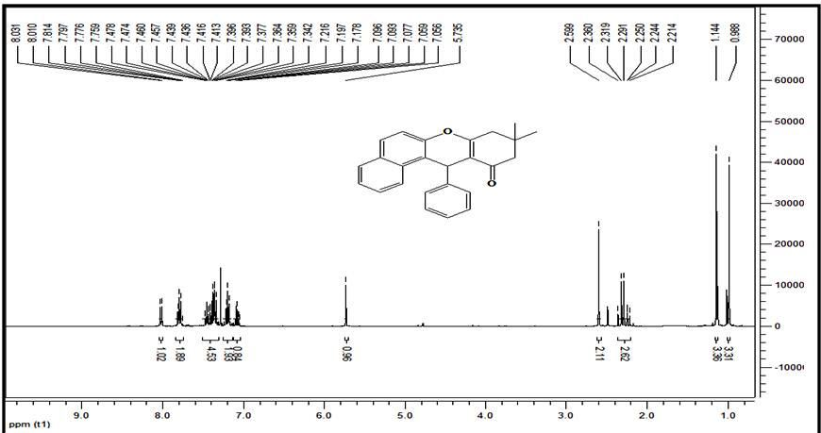

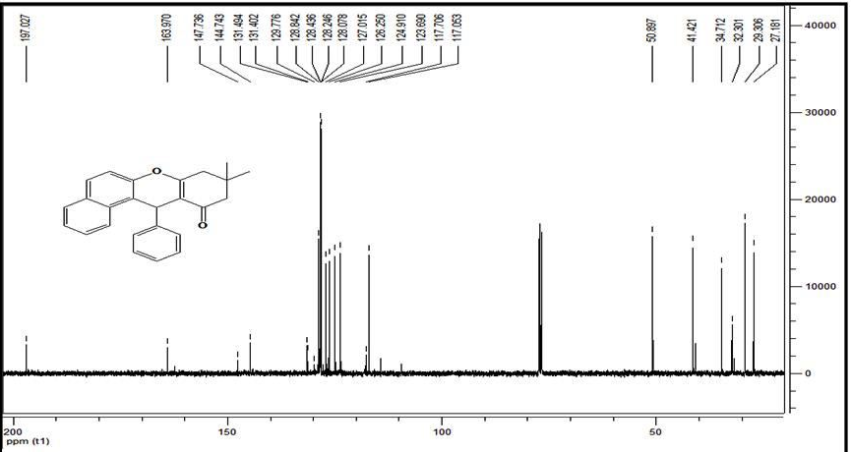

¹H NMR and ¹³C NMR of 12-(4-hydroxyphenyl)-9,9-dimethyl-9,10-dihydro-8H-benzo[a]xanthen-11(12H)-one (5b):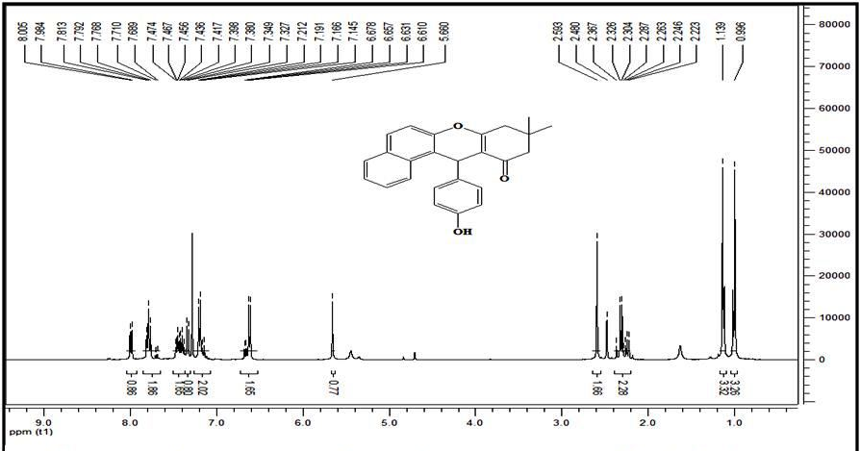

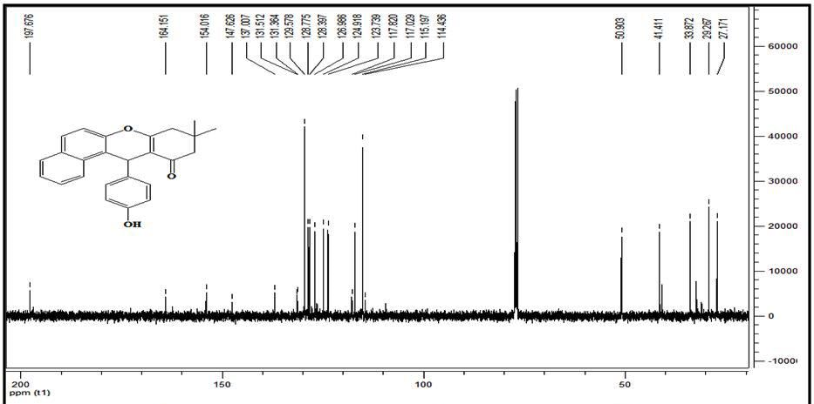

¹H NMR and ¹³C NMR of 12-phenyl-9,10-dihydro-8H-benzo[a]xanthen-11(12H)-one (5c):
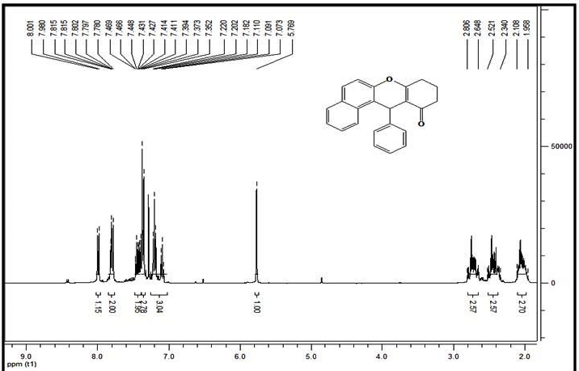
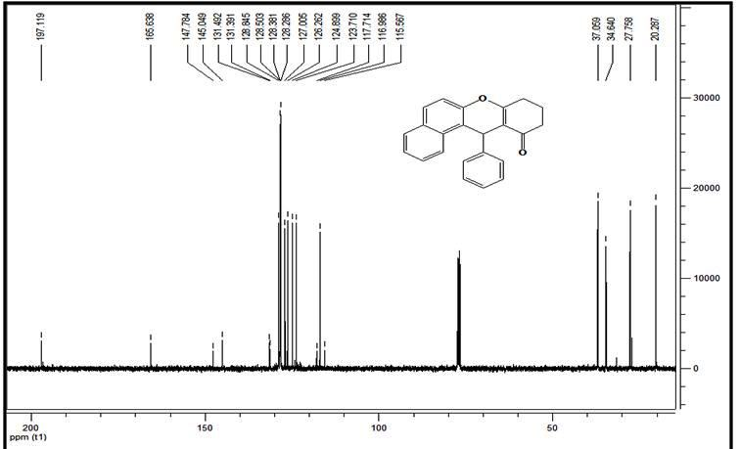

¹H NMR of 12-(3-nitrophenyl)-9,10-dihydro-8H-benzo[a]xanthen-11(12H)-one (5d)
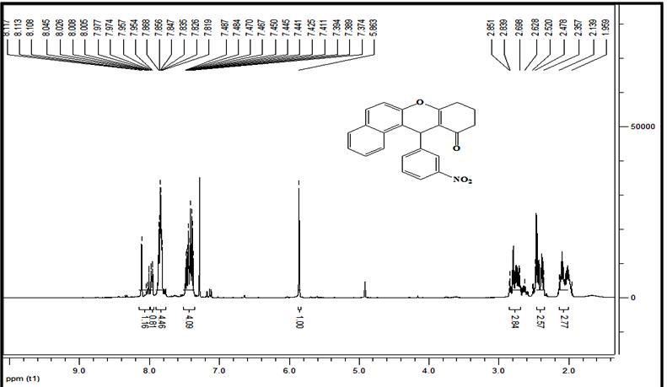

¹H NMR and ¹³C NMR of 12-(4-nitrophenyl)-9,10-dihydro-8H-benzo[a]xanthen-11(12H)-one (5e):
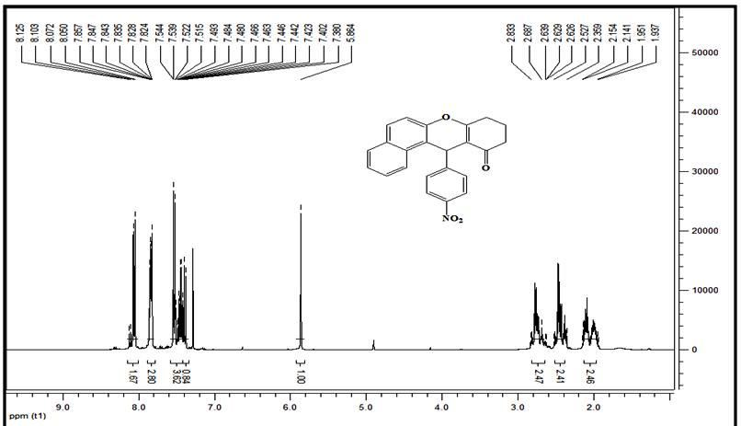

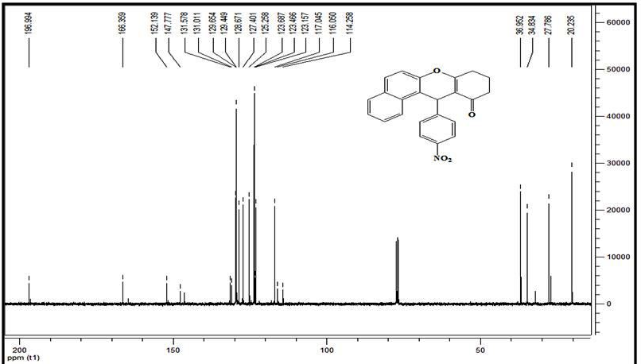

¹H NMR and ¹³C NMR of 9,10 -dihydro-12-(4-hydroxyphenyl)-8H-benzo[a]xanthene-11(12H)-one (5f):
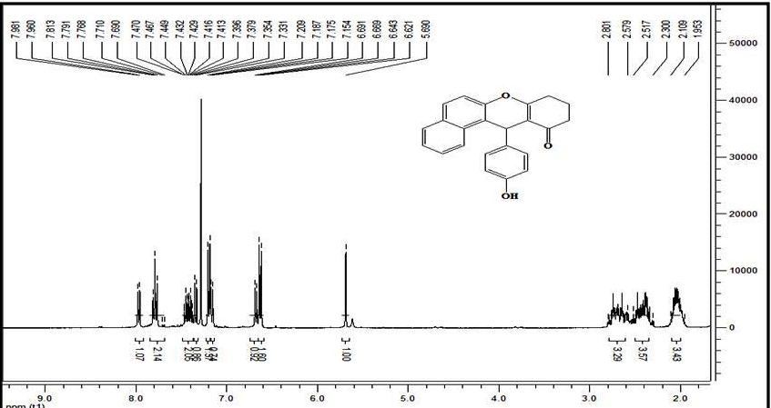

¹H NMR and ¹³C NMR of 3,4,7-tetrahydro-9-phenyl-2H-xanthene-1,8(5H,9H)-dione (6a) :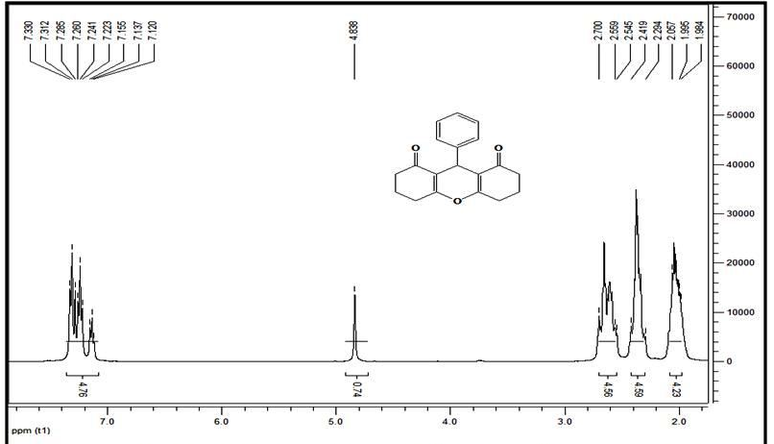

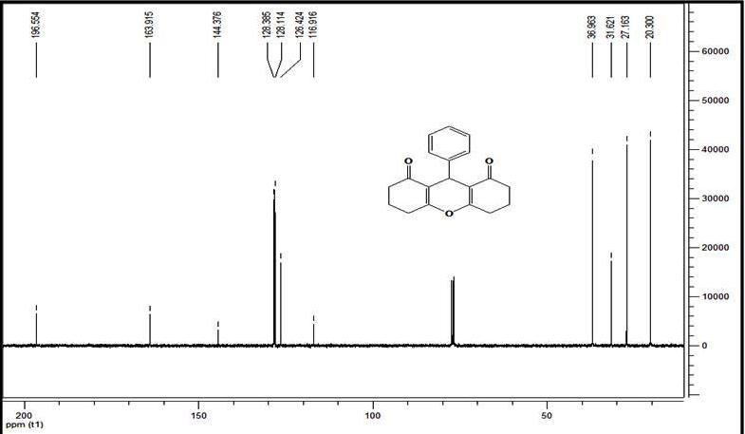

¹H NMR and ¹³C NMR of 9-(4-chiorophenyl)-3,4,6,7-tetrahydro-2H-xanthene-1,8(5H,9H)-dione (6b) :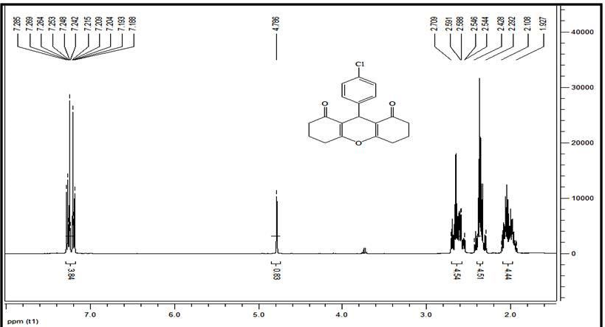

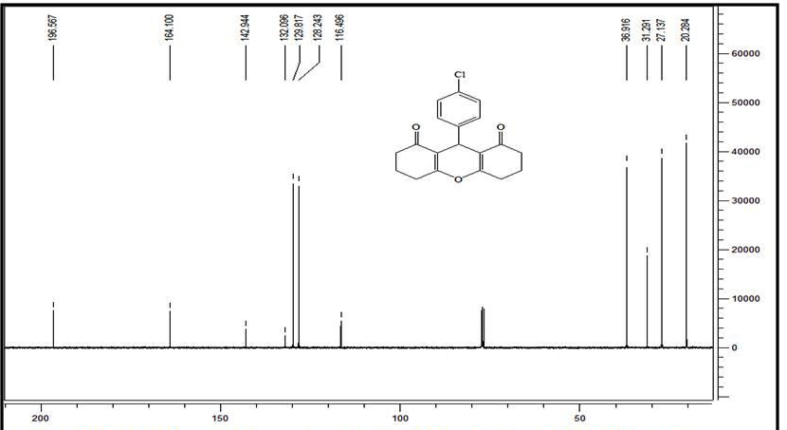

¹H NMR and ¹³C NMR of 3,4,7-tetrahydro-9-(4-hydroxyphenyl)-2H-xanthene-1,8(5H,9H)-dione (6c):
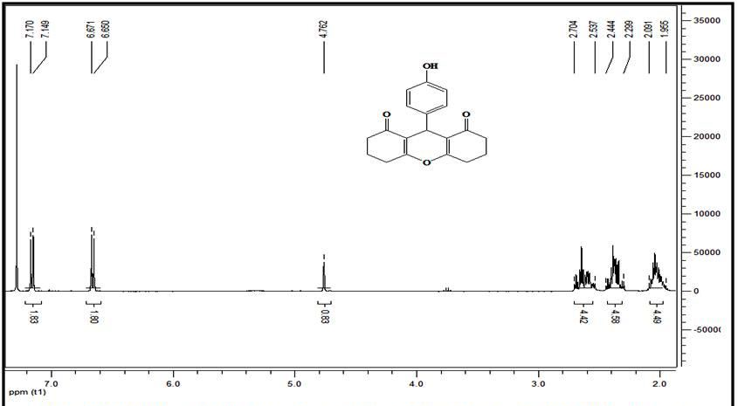

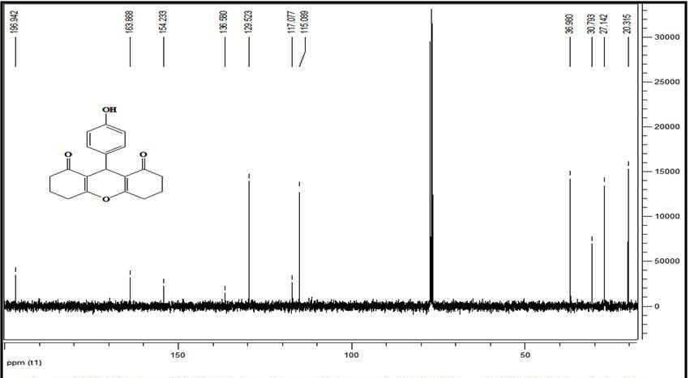

1H NMR and 13C NMR of 9-(p-tolyl)-3,4,5,6,7,9-hexahydro-1H-xanthene-1,8(2H)-dione (6d):
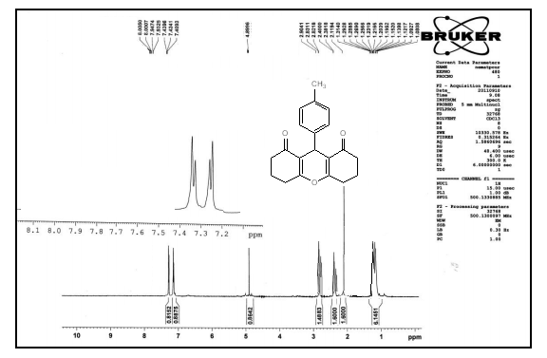

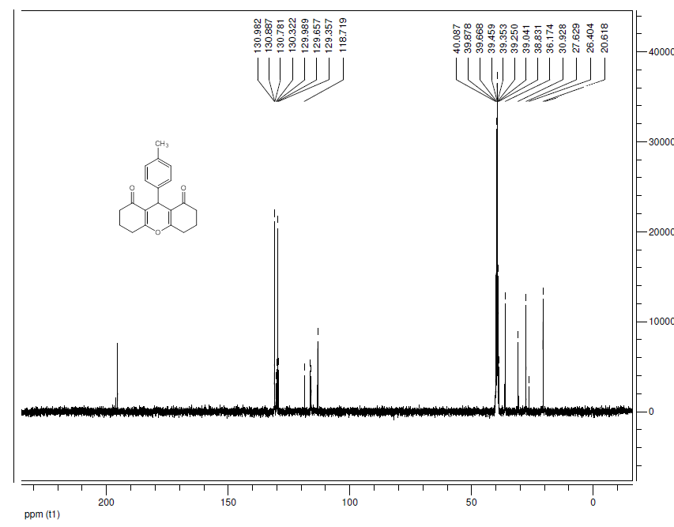
¹H NMR and ¹³C NMR of 3,4,6,7-tetrahydro-9-(4-nitrophenyl)-2H-xanthene-1,8(5H,9H)-dione (6e):
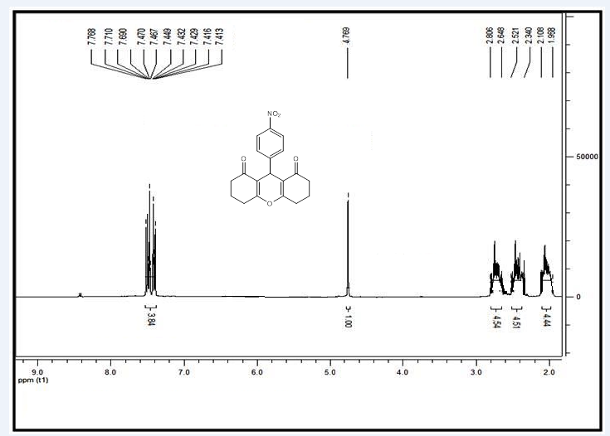

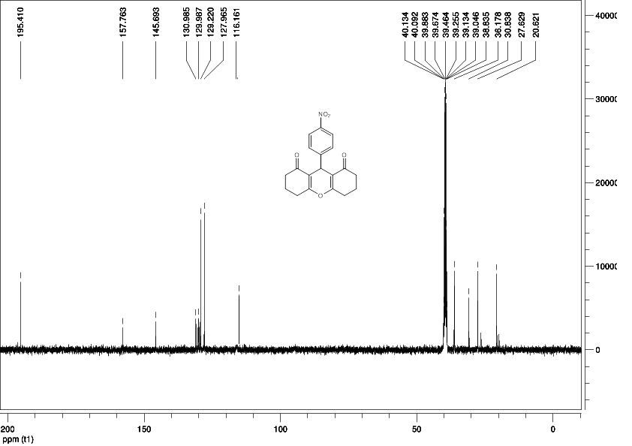

¹H NMR and ¹³C NMR of 9-(3-nitrophenyl)-3,4,5,6,7,9-hexahydro-1H-xanthene-1,8(2H)-dione (6f ):
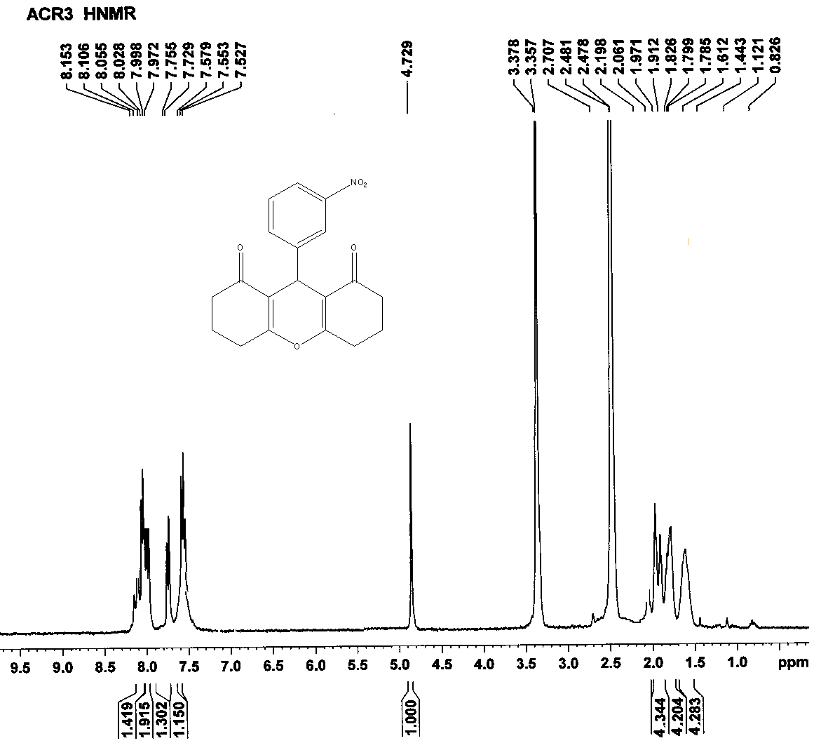

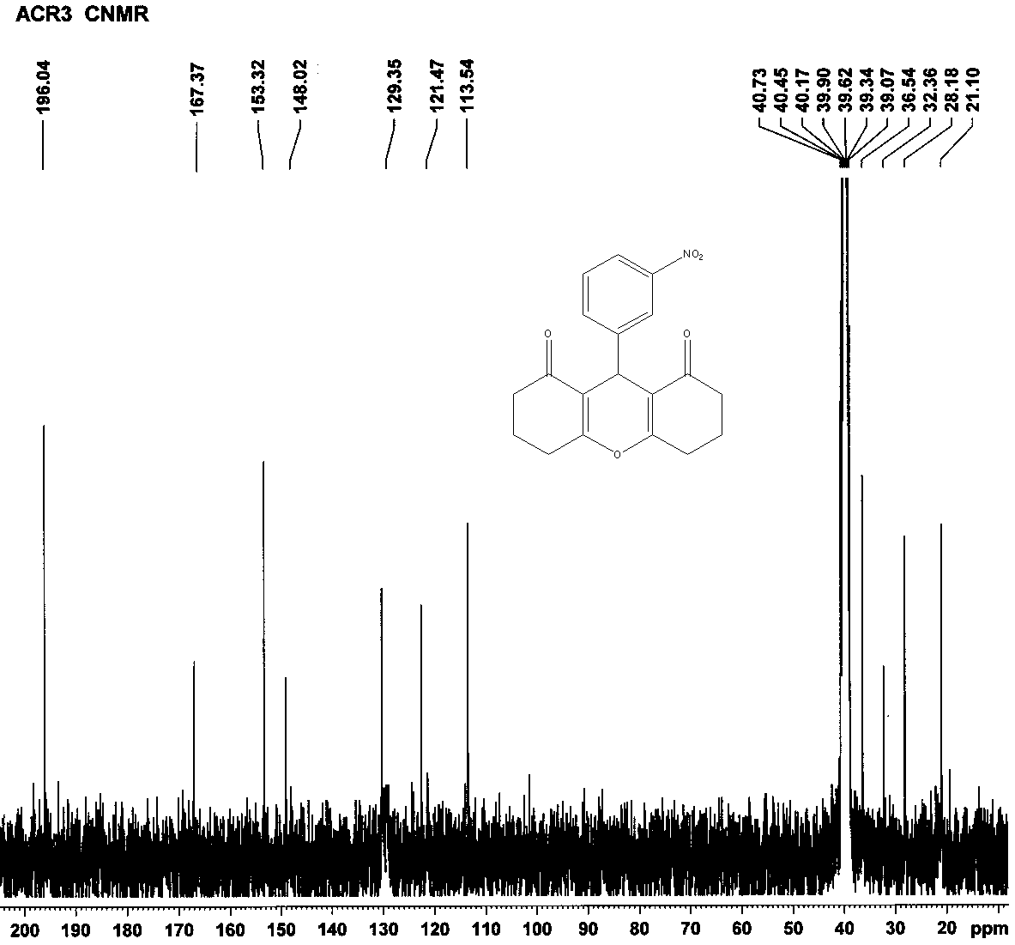

1H NMR and 13C NMR of 3,3,6,6-tetramethyl-9-phenyl-3,4,5,6,7,9-hexahydro-1H-xanthene-1,8(2H)-dione (6g):
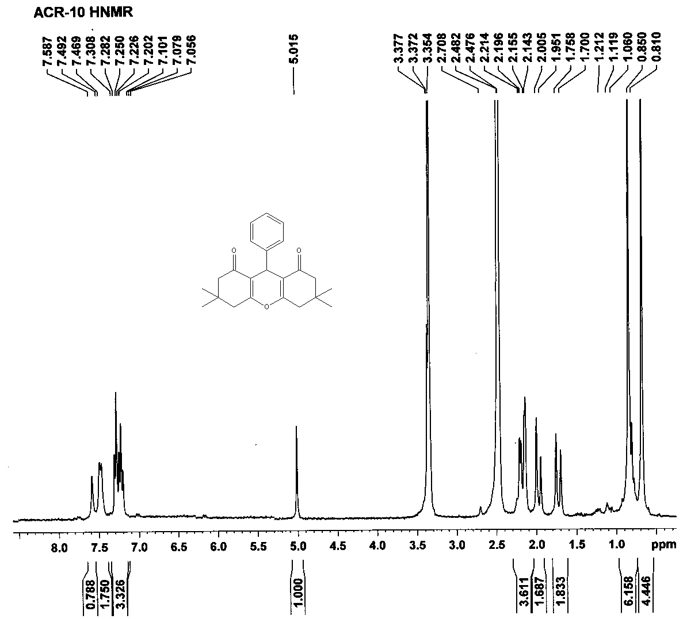
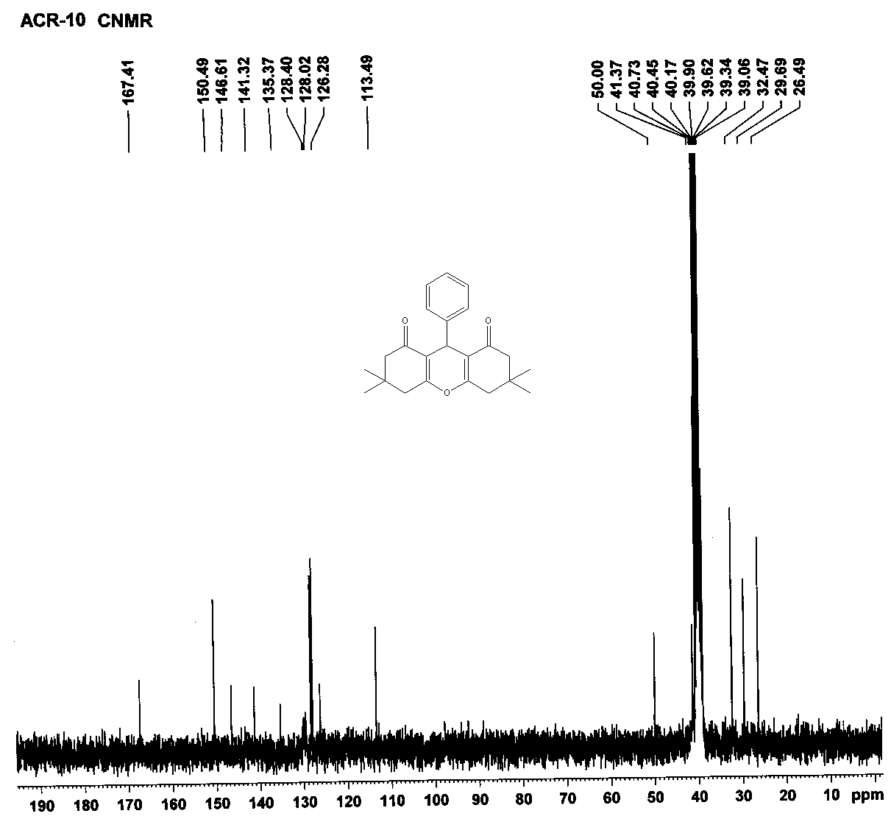

1H NMR and 13C NMR of 9-(4-chlorophenyl)-3,3,6,6-tetramethyl-3,4,5,6,7,9-hexahydro-1H-xanthene-1,8(2H)-dione (6h):
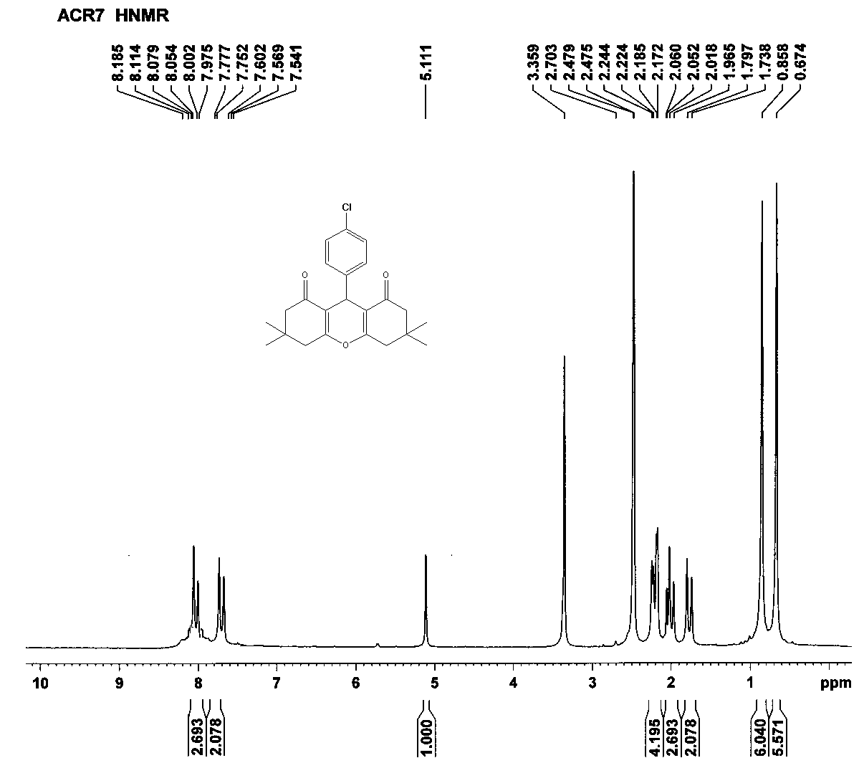
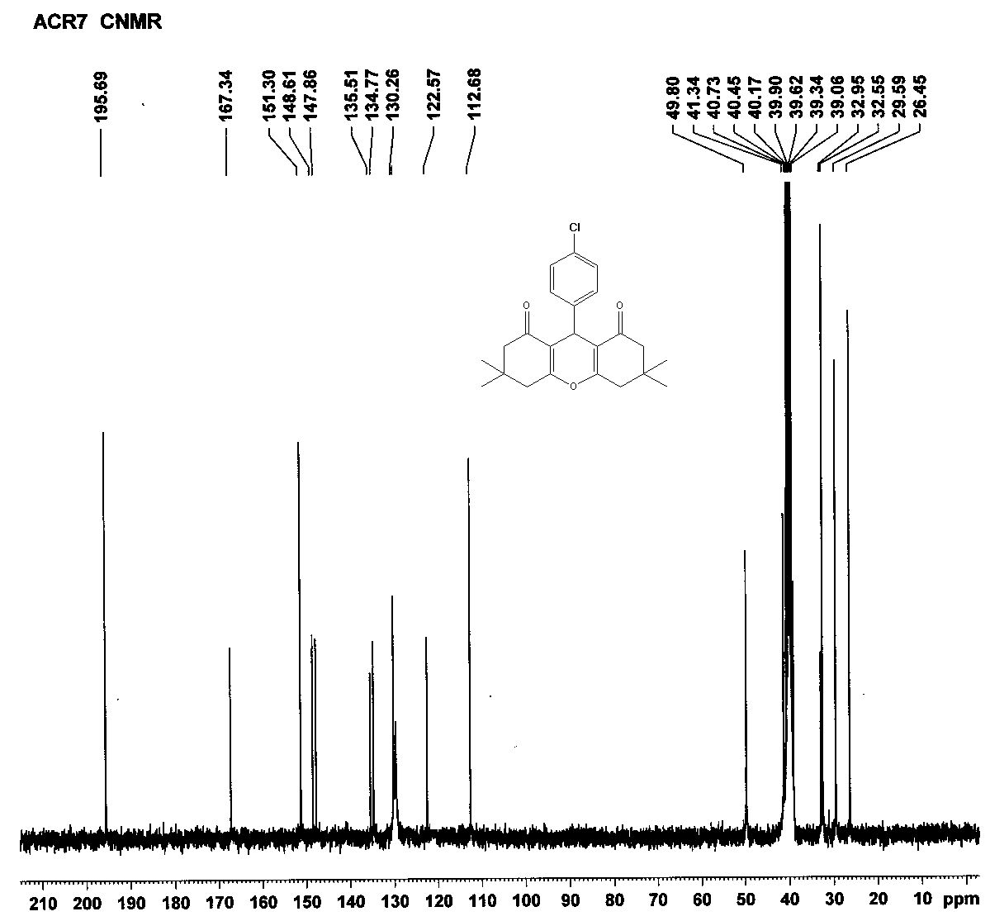
¹H NMR and ¹³C NMR of 11-phenyl-10H-diindeno[1,2-b:2',1'-e]pyran-10,12(11H)-dione (7a):
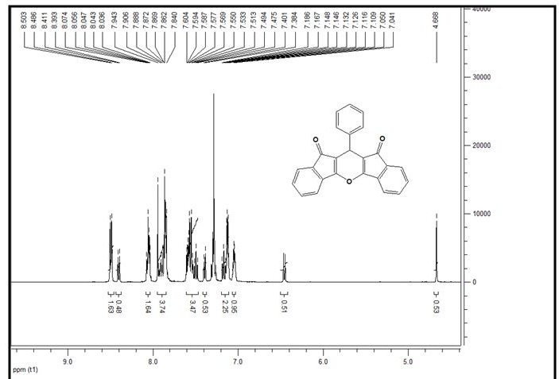

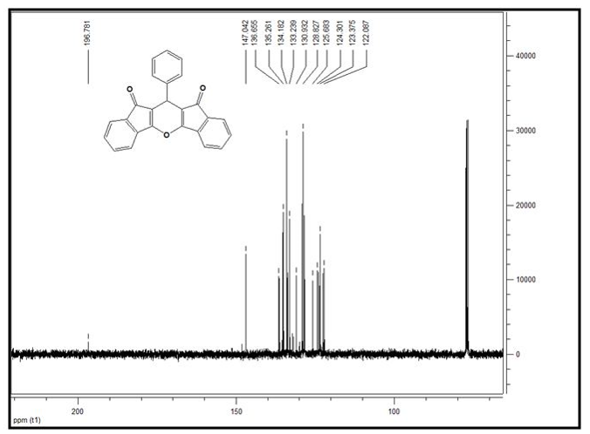

¹H NMR and ¹³C NMR of 11-(4-chlorophenyl)-10H-diindeno[1,2-b:2',1'-e]pyran-10,12(11H)-dione (7b):
