Some selected spectra
¹H NMR and ¹³C NMR of 9,9-dimethyl-12-phenyl-9,10-dihydro-8H-benzo[a]xanthen-11(12H)-one
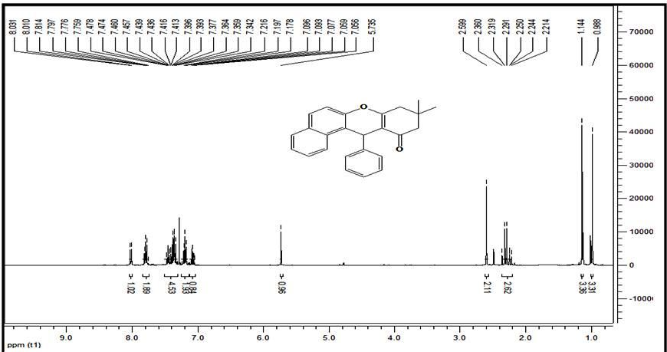

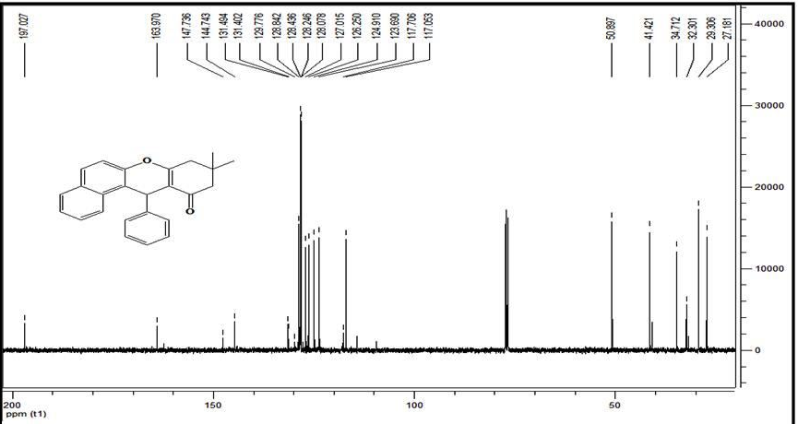

¹H NMR and ¹³C NMR of 12-(4-hydroxyphenyl)-9,9-dimethyl-9,10-dihydro-8H-benzo[a]xanthen-11(12H)-one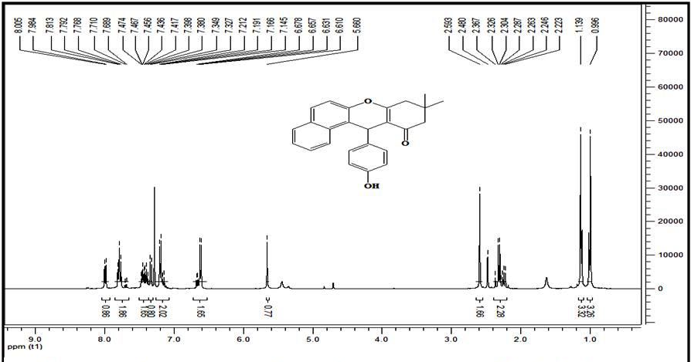

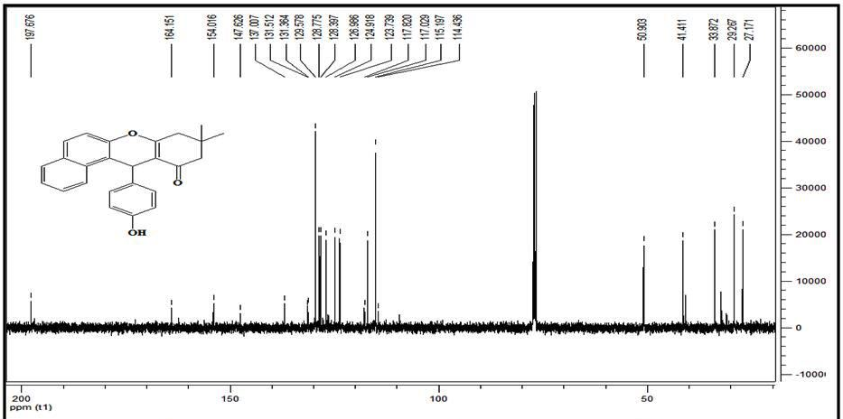

¹H NMR and ¹³C NMR of 12-(4-hydroxyphenyl)-9,10-dihydro-8H-benzo[a]xanthen-11(12H)-one
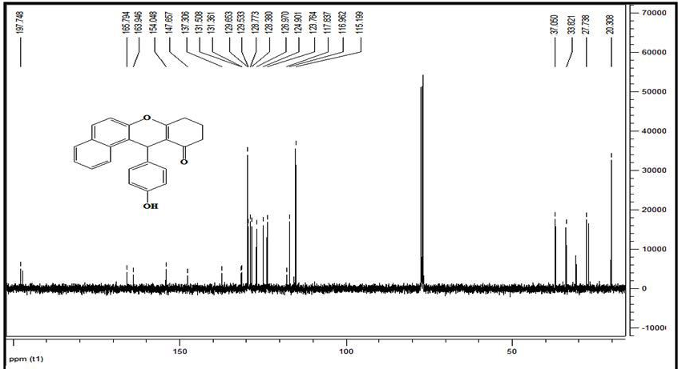

¹H NMR and ¹³C NMR of 12-phenyl-9,10-dihydro-8H-benzo[a]xanthen-11(12H)-one
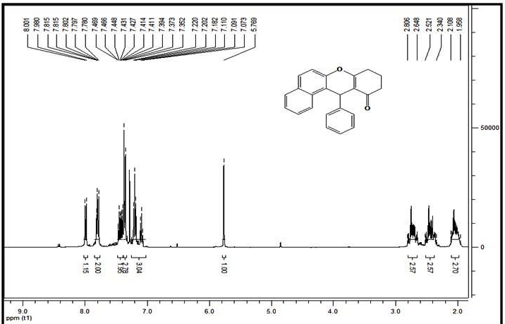
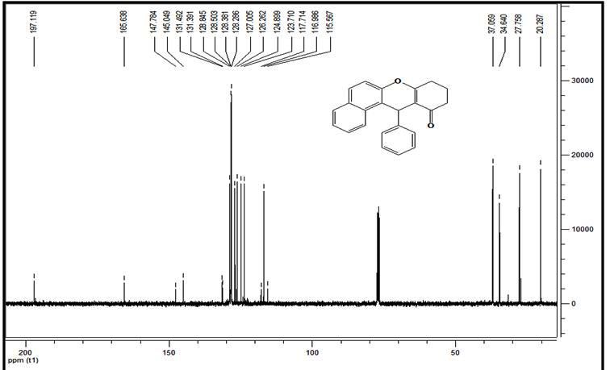

¹H NMR of 12-(3-nitrophenyl)-9,10-dihydro-8H-benzo[a]xanthen-11(12H)-one
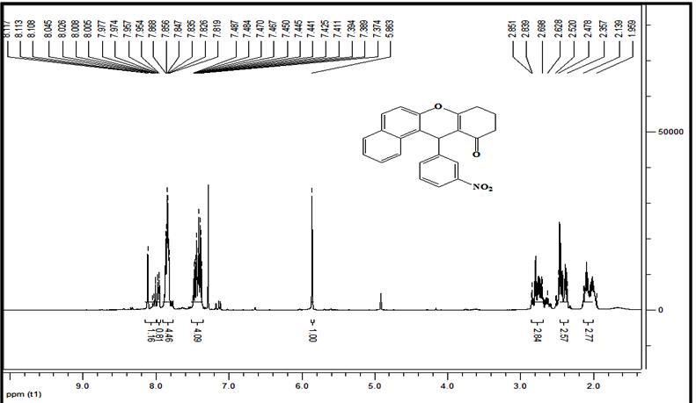

¹H NMR and ¹³C NMR of 12-(4-nitrophenyl)-9,10-dihydro-8H-benzo[a]xanthen-11(12H)-one
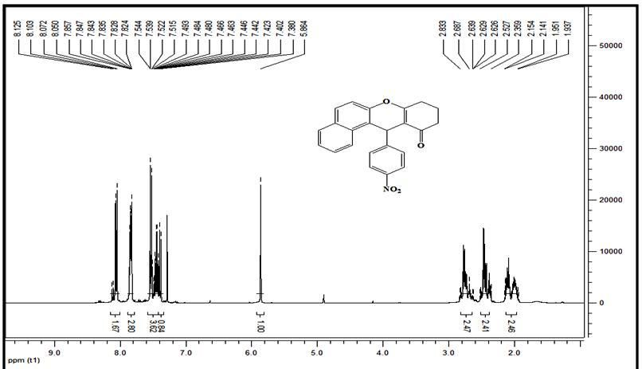

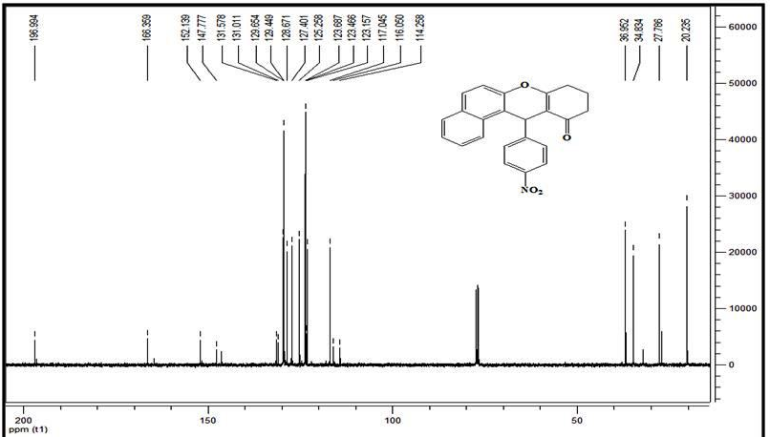

¹H NMR and ¹³C NMR of 9-(4-chlorophenyl)-3,4,5,6,7,9-hexahydro-1H-xanthene-1,8(2H)-dione
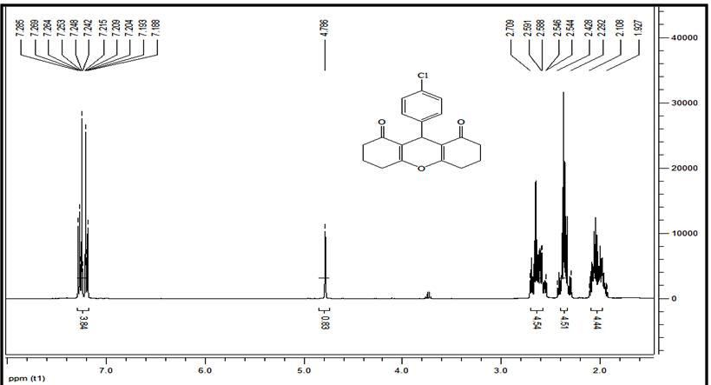

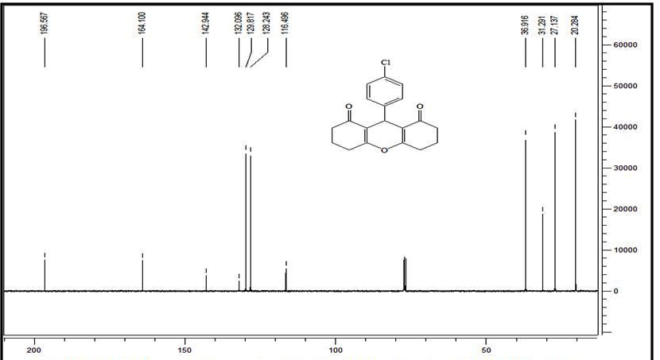

¹H NMR and ¹³C NMR of 9-phenyl-3,4,5,6,7,9-hexahydro-1H-xanthene-1,8(2H)-dione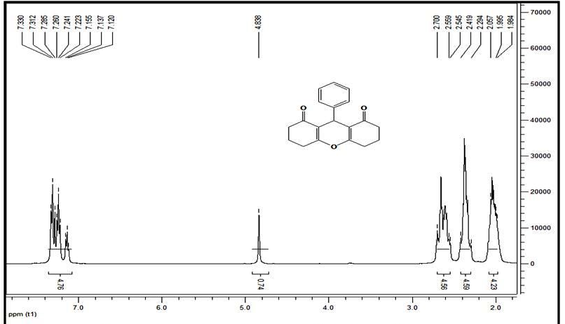

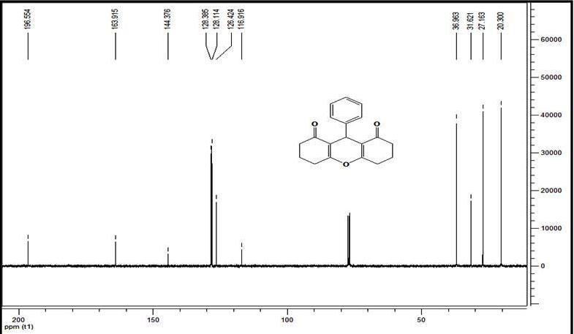

¹H NMR of 12-(4-hydroxyphenyl)-9,10-dihydro-8H-benzo[a]xanthen-11(12H)-one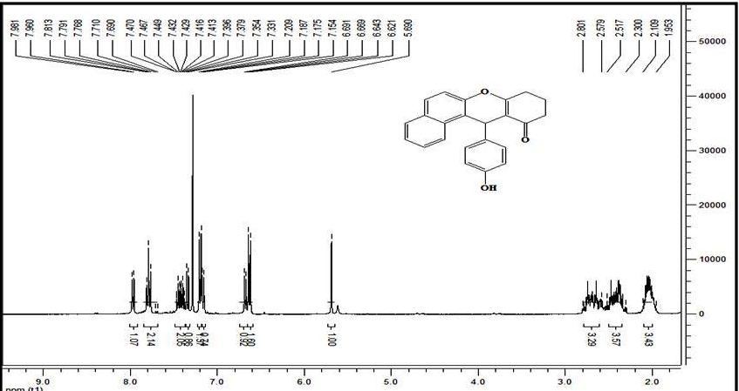

¹H NMR and ¹³C NMR of 9-(4-hydroxyphenyl)-3,4,5,6,7,9-hexahydro-1H-xanthene-1,8(2H)-dione
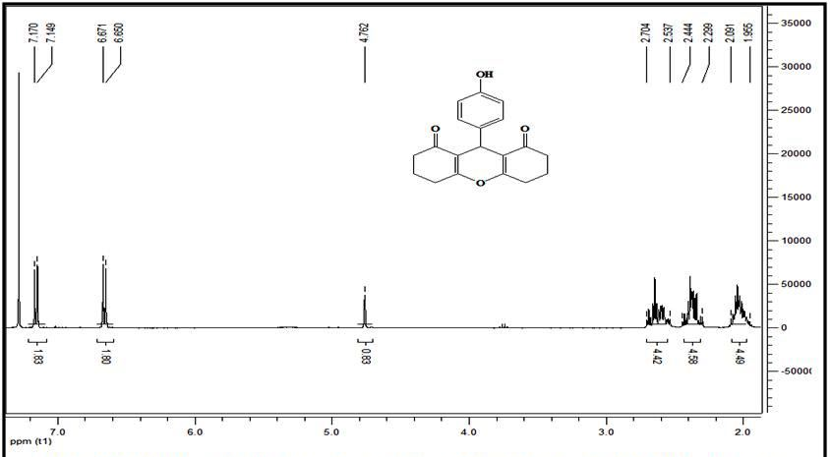

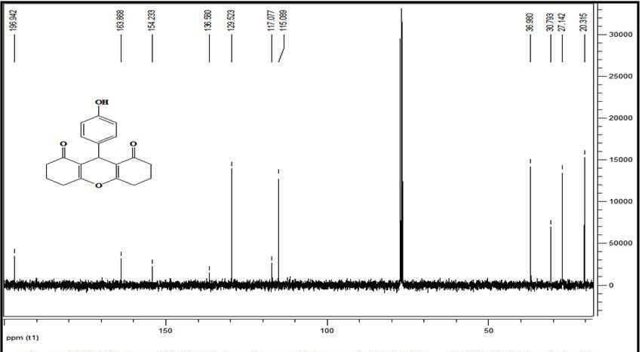
¹H NMR and ¹³C NMR of 11-phenyl-10H-diindeno[1,2-b:2',1'-e]pyran-10,12(11H)-dione
