Dear B. Nikolić,
Editor-in-Chief
Journal of the Serbian Chemical Society
Thanks very much for your e-mail on 3 October 2016 regarding our research work with ID. No.: 3533 entitled “Facile and rapid synthesis of divers xanthene derivatives using Lanthanum(III) chloride/chloroacetic acid as an efficient and reusable catalytic system under solvent-free conditions”.
I am herewith enclosing the revised manuscript. All changes and corrected were marked in red.
In response to reviewer comments:
1. The structure of recovered catalytic system was determined by FT-IR adsorption spectroscopy (Figure 1. )
In IR spectrum, stretching frequencies of hydroxy and carbononyl groups were appeared at 3387 to 2957 cm⁻¹(as a broad peak) and 1730 cm⁻¹ respectively. These results confirm that there is not any chemical interaction between LaCl₃ and ClCH₂CO₂H. So this catalytic system is a simple mixture of LaCl₃ and ClCH₂CO₂H.
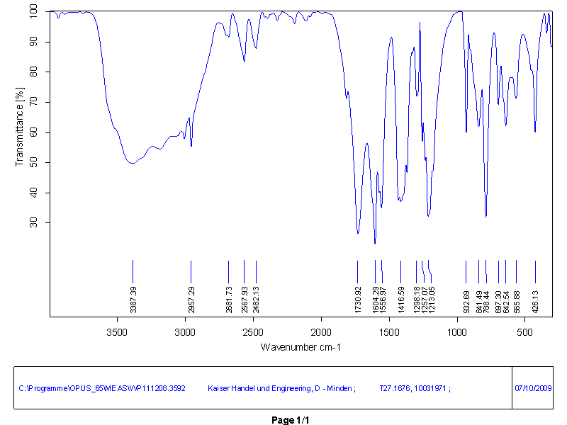
Figure 1.
2- Labels of obtained compounds were synchronized between Experimental section, Tables and main text.
3- Copies of NMR spectra for all synthetized compounds were provided in supporting information section.
4- Table IIII provides important advantages of used catalyst in comparison to other reported catalyst.
I hope the revised manuscript will be suitable for publication in the Journal of the Serbian Chemical Society.

With best regards,
Sincerely Yours,
E. Tvakolinejad

