SUPPLEMENTARY MATERIAL
Regioselective synthesis, characterization and antimicrobial evaluation of amide-ether linked 1,4-disubstituted 1,2,3-triazoles

CHANDER PRAKASH KAUSHIK¹ *, KRISHAN KUMAR¹, DEVINDER KUMAR¹, SATBIR MOR¹, ASHWANI KUMAR² and DEEPAK KUMAR JINDAL²

¹Department of Chemistry, Guru Jambheshwar University of Science & Technology, Hisar, Haryana, India
²Department of Pharmaceutical Sciences, Guru Jambheshwar University of Science & Technology, Hisar, Haryana, India

* Corresponding Author: E-mail: kaushikcp@gmail.com

PHYSICAL & SPECTRAL DATA OF THE SYNTHESIZED COMPOUNDS

2-(4-((naphthalen-1-yloxy)methyl)-1H-1,2,3-triazol-1-yl)-N-phenylacetamide (7a):
White solid; Yield: 68%; m.p. 242-244 ºC; FTIR (KBr): 3296 (N-H str., amide), 3138 (C-H str., triazole ring), 3055 (C-H str., aromatic ring), 2929, 1664 (C=O str., amide), 1583, 1508, 1465 (C=C str., aromatic ring), 1267 (C-O asym. str., ether), 1101 (C-O sym. str., ether) cm⁻¹; ¹H NMR (400 MHz, DMSO-d₆, δ / ppm): 5.42 (s, 2H, OCH₂), 5.58 (s, 2H, NCH₂), 7.05-7.11 (m, 1H, Ar-H), 7.22-7.55 (m, 7H, Ar-H), 7.58-7.89 (m, 3H, Ar-H), 8.14 (d, 1H, J = 8.0 Hz, Ar-H), 8.43 (s, 1H, C-H triazole), 11.14 (s, 1H, N-H amide); ¹³C NMR (100 MHz, DMSO-d₆, δ / ppm): 52.7, 62.1, 106.2, 119.7, 120.8, 122.0, 124.3, 125.4, 125.8, 126.6, 126.7 (C-5 triazole), 126.9, 128.0, 134.5, 138.9, 143.2 (C-4 triazole), 145.0, 154.0, 165.7 (C=O amide); ESI-HRMS (m/z) calculated for [C₂₁H₁₈N₄O₂+H]⁺: 359.1430 Observed: 359.2213.

N-(4-methoxyphenyl)-2-(4-((naphthalen-1-yloxy)methyl)-1H-1,2,3-triazol-1-yl)acetamide (7b):
Dark brown solid; Yield: 75%; m.p. 210-212 ºC; FTIR (KBr): 3269 (N-H str., amide), 3143 (C-H str., triazole ring), 3093 (C-H str., aromatic ring), 2945, 1662 (C=O str., amide), 1606, 1558, 1474 (C=C str., aromatic ring), 1242 (C-O asym. str., ether), 1103 (C-O sym. str., ether) cm⁻¹; ¹H NMR (400 MHz, DMSO-d₆, δ / ppm): 3.73 (s, 3H, OCH₃), 5.35 (s, 2H, OCH₂), 5.39 (s, 2H, NCH₂), 6.91 (d, 2H, J = 8.0 Hz, Ar-H), 7.22 (d, 1H, J = 8.0 Hz, Ar-H), 7.44-7.55 (m, 6H, Ar-H), 7.88 (d, 1H, J = 8.0 Hz, Ar-H), 8.13 (d, 1H, J = 8.0 Hz, Ar-H), 8.38 (s, 1H, C-H triazole), 10.38 (s, 1H, N-H amide); ¹³C NMR (100 MHz, DMSO-d₆, δ / ppm): 52.6, 55.6, 62.1, 106.2, 114.5, 120.8, 122.0, 125.4, 125.6, 125.8, 126.6, 126.8 (C-5 triazole), 126.9, 128.0, 132.0, 134.5, 143.2 (C-4 triazole), 154.0, 156.0, 165.8 (C=O amide); ESI-HRMS (m/z) calculated for [C₂₂H₂₀N₄O₃+H]⁺: 389.1535 Observed: 389.0061.

N-(4-bromophenyl)-2-(4-((naphthalen-1-yloxy)methyl)-1H-1,2,3-triazol-1-yl) acetamide (7c):
Dark brown solid; Yield: 65%; m.p. 186-188 ºC; FTIR (KBr): 3261 (N-H str., amide), 3126 (C-H str., triazole ring), 3059 (C-H str., aromatic ring), 2943, 1668 (C=O str., amide), 1585, 1550, 1489 (C=C str., aromatic ring), 1269 (C-O asym. str., ether), 1101 (C-O sym. str., ether) cm⁻¹; ¹H NMR (400 MHz, DMSO-d₆, δ / ppm): 5.39 (s, 2H, OCH₂), 5.39 (s, 2H, NCH₂), 7.23 (d, 1H, J = 8.0 Hz, Ar-H), 7.44-7.55 (m, 8H, Ar-H), 7.87 (d, 1H, J = 8.0 Hz, Ar-H), 8.13 (d, 1H, J = 8.0 Hz, Ar-H), 8.38 (s, 1H, C-H triazole), 10.65 (s, 1H, N-H amide); ¹³C NMR (100 MHz, DMSO-d₆, δ / ppm): 52.7, 62.1, 106.2, 115.9, 120.8, 122.0, 125.4, 125.8, 126.6, 126.7 (C-5 triazole), 126.9, 128.0, 132.2, 134.5, 143.2 (C-4 triazole), 154.0, 165.8 (C=O amide); ESI-HRMS (m/z) calculated for [C₂₁H₁₇BrN₄O₂+H]⁺: 437.0535 Observed: 436.8784.

2-(4-((naphthalen-1-yloxy)methyl)-1H-1,2,3-triazol-1-yl)-N-(4-nitrophenyl) acetamide (7d):
Light brown solid; Yield: 95%; m.p. 204-206 ºC; FTIR (KBr): 3251 (N-H str., amide), 3157 (C-H str., triazole ring), 3055 (C-H str., aromatic ring), 2949, 1670 (C=O str., amide), 1616, 1564, 1496 (C=C str., aromatic ring), 1502 (N-O str., asym., NO₂), 1344 (N-O str., sym., NO₂), 1263 (C-O asym. str., ether), 1103 (C-O sym. str., ether) cm⁻¹; ¹H NMR (400 MHz, DMSO-d₆, δ / ppm): 5.41 (s, 2H, OCH₂), 5.49 (s, 2H, NCH₂), 7.22 (d, 1H, J = 8.0 Hz, Ar-H), 7.44-7.55 (m, 4H, Ar-H), 7.85 (d, 2H, J = 8.0 Hz, Ar-H), 7.88 (d, 1H, J = 8.0 Hz, Ar-H), 8.14 (d, 1H, J = 8.0 Hz, Ar-H), 8.26 (d, 2H, J = 8.0 Hz, Ar-H), 8.41 (s, 1H, C-H triazole), 11.14 (s, 1H, N-H amide); ¹³C NMR (100 MHz, DMSO-d₆, δ / ppm): 52.8, 62.1, 106.2, 119.5, 120.8, 122.0, 125.4, 125.6, 125.8, 126.6, 126.7 (C-5 triazole), 126.9, 128.0, 134.5, 143.1, 143.2 (C-4 triazole), 145.0, 154.0, 165.9 (C=O amide); ESI-HRMS (m/z) calculated for [C₂₁H₁₇N₅O₄+H]⁺: 404.1281 Observed: 403.9596.

N-(naphthalen-1-yl)-2-(4-((naphthalen-1-yloxy)methyl)-1H-1,2,3-triazol-1-yl)acetamide (7e):
Light yellow solid; Yield: 91%; m.p. 182-184 ºC; FTIR (KBr): 3255 (N-H str., amide), 3152 (C-H str., triazole ring), 3055 (C-H str., aromatic ring), 2985, 1672 (C=O str., amide), 1610, 1550, 1508 (C=C str., aromatic ring), 1267 (C-O asym. str., ether), 1101 (C-O sym. str., ether) cm⁻¹; ¹H NMR (400 MHz, DMSO-d₆, δ / ppm): 5.40 (s, 2H, OCH₂), 5.60 (s, 2H, NCH₂), 7.23 (d, 1H, J = 8.0 Hz, Ar-H), 7.46-7.54 (m, 7H, Ar-H), 7.59 (d, 1H, J = 8.0 H, Ar-Hz), 7.74 (d, 1H, J = 8.0 Hz, Ar-H), 7.80 (d, 1H, J = 8.0 Hz, Ar-H), 7.88 (d, 1H, J = 8.0 Hz, Ar-H), 8.14 (d, 2H, J = 8.0 Hz, Ar-H), 8.44 (s, 1H, C-H triazole), 10.47 (s, 1H, N-H amide); ¹³C NMR (100 MHz, DMSO-d₆, δ / ppm): 52.6, 62.1, 106.2, 120.8, 122.0, 123.1, 125.4, 125.8, 126.2, 126.5, 126.8 (C-5 triazole), 126.9, 128.0, 128.7, 133.2, 134.2, 134.5, 143.2 (C-4 triazole), 154.0, 165.6 (C=O amide); ESI-HRMS (m/z) calculated for [C₂₅H₂₀N₄O₂+H]⁺: 409.1586 Observed: 408.9689.

2-(4-((naphthalen-2-yloxy)methyl)-1H-1,2,3-triazol-1-yl)-N-phenylacetamide (10a):
White solid; Yield: 67%; m.p. 202-204 ºC; FTIR (KBr): 3267 (N-H str., amide), 3136 (C-H str., triazole ring), 3084 (C-H str., aromatic ring), 2927, 1668 (C=O str., amide), 1608, 1554, 1504 (C=C str., aromatic ring), 1261 (C-O asym. str., ether), 1178 (C-O sym. str., ether) cm⁻¹; ¹H NMR (400 MHz, DMSO-d₆, δ / ppm): 5.31 (s, 2H, OCH₂), 5.38 (s, 2H, NCH₂), 7.10 (t, 1H, J = 8.0 Hz, Ar-H), 7.22 (d, 1H, J = 8.0 Hz, Ar-H), 7.33-7.39 (m, 3H, Ar-H), 7.55-7.59 (m, 2H, Ar-H), 7.60 (d, 2H, J = 8.0 Hz, Ar-H), 7.85 (d, 3H, J = 8.0 Hz, Ar-H), 8.34 (s, 1H, C-H triazole), 10.51 (s, 1H, N-H amide); ¹³C NMR (100 MHz, DMSO-d₆, δ / ppm): 52.7, 61.5, 107.6, 119.2, 119.7, 124.2, 124.3, 126.9 (C-5 triazole), 127.2, 128.0, 129.1, 129.4, 129.8, 134.7, 138.9, 142.9 (C-4 triazole), 156.4, 164.7 (C=O amide); ESI-HRMS (m/z) calculated for [C₂₁H₁₈N₄O₂+H]⁺: 359.1430 Observed: 358.9767.

N-(4-methoxyphenyl)-2-(4-((naphthalen-2-yloxy)methyl)-1H-1,2,3-triazol-1-yl)acetamide (10b):
White solid; Yield: 62%; m.p. 198-200 ºC; FTIR (KBr): 3282 (N-H str., amide), 3138 (C-H str., triazole ring), 3059 (C-H str., aromatic ring), 2947, 1678 (C=O str., amide), 1600, 1546, 1514 (C=C str., aromatic ring), 1240 (C-O asym. str., ether), 1178 (C-O sym. str., ether) cm⁻¹; ¹H NMR (400 MHz, DMSO-d₆, δ / ppm): 3.73 (s, 3H, OCH₃), 5.30 (s, 2H, OCH₂), 5.33 (s, 2H, NCH₂), 6.91 (d, 2H, J = 12.0 Hz, Ar-H), 7.22 (d, 1H, J = 8.0 Hz, Ar-H), 7.37 (d, 1H, J = 8.0 Hz, Ar-H), 7.48-7.55 (m, 4H, Ar-H), 7.85 (d, 3H, J = 8.0 Hz, Ar-H), 8.32 (s, 1H, C-H triazole), 10.36 (s, 1H, N-H amide); ¹³C NMR (100 MHz, DMSO-d₆, δ / ppm): 52.6, 55.6, 61.5, 107.6, 114.5, 119.2, 121.2, 124.2, 126.9 (C-5 triazole), 127.2, 128.0, 129.1, 129.8, 132.0, 134.7, 142.8 (C-4 triazole), 156.4, 164.1 (C=O amide); ESI-HRMS (m/z) calculated for [C₂₂H₂₀N₄O₃+H]⁺: 389.1535 Observed: 388.9711.
N-(4-bromophenyl)-2-(4-((naphthalen-2-yloxy)methyl)-1H-1,2,3-triazol-1-yl)acetamide (10c):
Light brown solid; Yield: 87%; m.p. 226-228 ºC; FTIR (KBr): 3258 (N-H str., amide), 3126 (C-H str., triazole ring), 3045 (C-H str., aromatic ring), 2918, 1664 (C=O str., amide), 1595, 1550, 1475 (C=C str., aromatic ring), 1267 (C-O asym. str., ether), 1182 (C-O sym. str., ether) cm⁻¹; ¹H NMR (400 MHz, DMSO-d₆, δ / ppm): 5.31 (s, 2H, OCH₂), 5.38 (s, 2H, NCH₂), 7.21 (d, 1H, J = 8.0 Hz, Ar-H), 7.38 (d, 1H, J = 8.0 Hz, Ar-H), 7.46-7.58 (m, 6H, Ar-H), 7.84 (d, 3H, J = 8.0 Hz, Ar-H), 8.33 (s, 1H, C-H triazole), 10.66 (s, 1H, N-H amide); ¹³C NMR (100 MHz, DMSO-d₆, δ / ppm): 52.7, 61.5, 107.6, 115.9, 119.2, 121.6, 124.2, 126.9 (C-5 triazole), 127.2, 128.0, 129.1, 129.8, 132.2, 134.7, 138.3, 142.9 (C-4 triazole), 156.4, 164.9 (C=O amide); ESI-HRMS (m/z) calculated for [C₂₁H₁₇BrN₄O₂+H]⁺: 437.0535 Observed: 436.9047.

2-(4-((naphthalen-2-yloxy)methyl)-1H-1,2,3-triazol-1-yl)-N-(4-nitrophenyl) acetamide (10d):
Brown solid; Yield: 78%; m.p. 218-220 ºC; FTIR (KBr): 3317 (N-H str., amide), 3153 (C-H str., triazole ring), 3061 (C-H str., aromatic ring), 2945, 1699 (C=O str., amide), 1610, 1583, 1478 (C=C str., aromatic ring), 1504 (N-O str., asym., NO₂), 1340 (N-O str., sym., NO₂), 1257 (C-O asym. str., ether), 1180 (C-O sym. str., ether) cm⁻¹; ¹H NMR (400 MHz, DMSO-d₆, δ / ppm): 5.32 (s, 2H, OCH₂), 5.48 (s, 2H, NCH₂), 7.22 (d, 1H, J = 8.0 Hz, Ar-H), 7.37 (d, 1H, J = 8.0 Hz, Ar-H), 7.48-7.54 (m, 2H, Ar-H), 7.84-7.85 (m, 5H, Ar-H), 8.26 (d, 2H, J = 8.0 Hz, Ar-H), 8.35 (s, 1H, C-H triazole), 11.14 (s, 1H, N-H amide); ¹³C NMR (100 MHz, DMSO-d₆, δ / ppm): 52.8, 61.5, 107.6, 119.2, 119.5, 124.2, 125.6, 126.9 (C-5 triazole), 127.2, 128.0, 129.1, 129.9, 134.7, 143.0 (C-4 triazole), 143.1, 145.0, 156.4, 165.8 (C=O amide); ESI-HRMS (m/z) calculated for [C₂₁H₁₇N₅O₄+H]⁺: 404.1281 Observed: 403.8690.

N-(naphthalen-1-yl)-2-(4-((naphthalen-2-yloxy)methyl)-1H-1,2,3-triazol-1-yl)acetamide (10e):
White solid; Yield: 92%; m.p. 220-222 ºC; FTIR (KBr): 3259 (N-H str., amide), 3165 (C-H str., triazole ring), 3055 (C-H str., aromatic ring), 2916, 1678 (C=O str., amide), 1601, 1544, 1462 (C=C str., aromatic ring), 1263 (C-O asym. str., ether), 1178 (C-O sym. str., ether) cm⁻¹; ¹H NMR (400 MHz, DMSO-d₆, δ / ppm): 5.38 (s, 2H, OCH₂), 5.59 (s, 2H, NCH₂), 7.22 (d, 1H, J = 8.0 Hz, Ar-H), 7.37 (d, 1H, J = 8.0 Hz, Ar-H), 7.48-7.59 (m, 5H, Ar-H), 7.73-7.98 (m, 6H, Ar-H), 8.18 (d, 1H, J = 8.0 Hz, Ar-H), 8.39 (s, 1H, C-H triazole), 10.47 (s, 1H, N-H amide); ¹³C NMR (100 MHz, DMSO-d₆, δ / ppm): 52.5, 61.6, 107.6, 119.2, 122.0, 123.1, 124.2, 126.1, 126.2, 126.5, 126.7, 126.9 (C-5 triazole), 127.2, 128.0, 128.7, 129.1, 129.8, 133.2, 134.2, 134.7, 143.0 (C-4 triazole), 156.4, 165.6 (C=O amide); ESI-HRMS (m/z) calculated for [C₂₅H₂₀N₄O₂+H]⁺: 409.1586 Observed: 408.9673.

2,2'-(4,4'-(1,4-phenylenebis(oxy))bis(methylene)bis(1H-1,2,3-triazole-4,1-diyl))bis(N-phenylacetamide) (13a):
Dark brown solid; Yield: 83%; m.p. >250 ºC; FTIR (KBr): 3278 (N-H str., amide), 3142 (C-H str., triazole ring), 3095 (C-H str., aromatic ring), 2947, 1680 (C=O str., amide), 1604, 1556, 1508 (C=C str., aromatic ring), 1236 (C-O str., asym., ether), 1056 (C-O str., sym., ether) cm⁻¹; ¹H NMR (400 MHz, DMSO-d₆, δ / ppm): 5.08 (s, 4H, OCH₂), 5.36 (s, 4H, NCH₂), 7.01 (s, 4H, Ar-H), 7.09 (t, 2H, J = 8.0 Hz, Ar-H), 7.34 (t, 2H, J = 8.0 Hz, Ar-H), 7.59 (d, 4H, J = 8.0 Hz, Ar-H), 8.24 (s, 2H, C-H triazole), 10.49 (s, 2H, N-H amide); ¹³C NMR (100 MHz, DMSO-d₆, δ / ppm): 52.7, 62.1, 116.0, 119.7, 124.2, 126.6 (C-5 triazole), 129.4, 138.9, 143.2 (C-4 triazole), 152.8, 164.7 (C=O amide); ESI-HRMS (m/z) calculated for [C₂₈H₂₆N₈O₄+H]⁺: 539.2077 Observed: 539.2239.
2,2'-(4,4'-(1,4-phenylenebis(oxy))bis(methylene)bis(1H-1,2,3-triazole-4,1-diyl))bis (N-(4-methoxyphenyl)acetamide) (13b):
Dark brown solid; Yield: 88%; m.p. >250 ºC; FTIR (KBr): 3275 (N-H str., amide), 3140 (C-H str., triazole ring), 3089 (C-H str., aromatic ring), 2951, 1674 (C=O str., amide), 1606, 1552, 1510 (C=C str., aromatic ring), 1238 (C-O str., asym., ether), 1053 (C-O str., sym., ether) cm⁻¹; ¹H NMR (400 MHz, DMSO-d₆, δ / ppm): 3.72 (s, 6H, OCH₃), 5.11 (s, 4H, OCH₂), 5.31 (s, 4H, NCH₂), 6.92 (s, 4H, Ar-H), 7.00 (d, 4H, J = 8.0 Hz, Ar-H), 7.49 (d, 4H, J = 8.0 Hz, Ar-H), 8.24 (s, 2H, C-H triazole), 10.36 (s, 2H, N-H amide); ¹³C NMR (100 MHz, DMSO-d₆, δ / ppm): 52.6, 55.6, 61.9, 114.5, 116.2, 121.2, 126.6 (C-5 triazole), 132.0, 143.2 (C-4 triazole), 152.8, 156.0, 164.1 (C=O amide); ESI-HRMS (m/z) calculated for [C₃₀H₃₀N₈O₆+H]⁺: 599.2425 Observed: 599.2288.

2,2'-(4,4'-(1,4-phenylenebis(oxy))bis(methylene)bis(1H-1,2,3-triazole-4,1-diyl))bis (N-(4-bromophenyl)acetamide) (13c):
Dark brown solid; Yield: 86%; m.p. >250 ºC; FTIR (KBr): 3273 (N-H str., amide), 3124 (C-H str., triazole ring), 3070 (C-H str., aromatic ring), 2947, 1680 (C=O str., amide), 1604, 1544, 1508 (C=C str., aromatic ring), 1236 (C-O str., asym., ether), 1074, 1055 (C-O str., sym., ether) cm⁻¹; ¹H NMR (400 MHz, DMSO-d₆, δ / ppm): 5.12 (s, 4H, OCH₂), 5.36 (s, 4H, NCH₂), 6.99 (s, 4H, Ar-H), 7.52 (d, 4H, J = 12.0 Hz, Ar-H), 7.56 (d, 4H, J = 12.0 Hz, Ar-H), 8.24 (s, 2H, C-H triazole), 10.64 (s, 2H, N-H amide); ¹³C NMR (100 MHz, DMSO-d₆, δ / ppm): 52.7, 61.9, 115.9, 116.0, 121.6, 126.6 (C-5 triazole), 132.2, 138.3, 143.2 (C-4 triazole), 152.8, 164.9 (C=O amide); ESI-HRMS (m/z) calculated for [C₂₈H₂₄Br₂N₈O₄+H]⁺: 697.3494 Observed: 697.3443 and (m/z) calculated for [C₂₈H₂₄Br₂N₈O₄+2] ⁺: 698.3494 Observed: 698.3538.
2,2'-(4,4'-(1,4-phenylenebis(oxy))bis(methylene)bis(1H-1,2,3-triazole-4,1-diyl))bis(N-(4-nitrophenyl)acetamide) (13d):
Dark brown solid; Yield: 82%; m.p. >250 ºC; FTIR (KBr): 3253 (N-H str., amide), 3155 (C-H str., triazole ring), 3089 (C-H str., aromatic ring), 2954, 1705 (C=O str., amide), 1597, 1552, 1510 (C=C str., aromatic ring), 1506 (N-O str., asym., NO₂), 1342 (N-O str., sym., NO₂), 1261 (C-O str., asym., ether), 1060 (C-O str., sym., ether) cm⁻¹; ¹H NMR (400 MHz, DMSO-d₆, δ / ppm): 5.13 (s, 4H, OCH₂), 5.45 (s, 4H, NCH₂), 7.00 (s, 4H, Ar-H), 7.84 (d, 4H, J = 8.0 Hz, Ar-H), 8.25 (s, 2H, C-H triazole), 8.26 (d, 4H, J = 8.0 Hz, Ar-H), 11.12 (s, 2H, N-H amide); ¹³C NMR (100 MHz, DMSO-d₆, δ / ppm): 52.7, 61.9, 116.1, 119.5, 125.6, 126.6 (C-5 triazole), 143.2 (C-4 triazole), 145.0, 152.8, 164.8 (C=O amide); ESI-HRMS (m/z) calculated for [C₂₈H₂₄N₁₀O₈+H]⁺: 629.1779 Observed: 629.4429.

2,2'-(4,4'-(1,4-phenylenebis(oxy))bis(methylene)bis(1H-1,2,3-triazole-4,1-diyl))bis(N-(naphthalen-1-yl)acetamide) (13e):
Dark brown solid; Yield: 85%; m.p. >250 ºC; FTIR (KBr): 3261 (N-H str., amide), 3138 (C-H str., triazole ring), 3088 (C-H str., aromatic ring), 2947, 1678 (C=O str., amide), 1597, 1543, 1508 (C=C str., aromatic ring), 1236 (C-O str., asym., ether), 1055 (C-O str., sym., ether) cm⁻¹; ¹H NMR (400 MHz, DMSO-d₆, δ / ppm): 5.13 (s, 4H, OCH₂), 5.56 (s, 4H, NCH₂), 7.00 (s, 4H, Ar-H), 7.49-7.82 (m, 10H, Ar-H), 7.97 (d, 2H, J = 8.0 Hz, Ar-H), 8.17 (d, 2H, J = 8.0 Hz, Ar-H), 8.27 (s, 2H, C-H triazole), 10.46 (s, 2H, N-H amide); ¹³C NMR (100 MHz, DMSO-d₆, δ / ppm): 52.7, 62.1, 116.0, 122.0, 123.1, 126.1, 126.2, 126.5, 126.6 (C-5 triazole), 126.8, 128.0, 128.7, 133.2, 134.2, 143.2 (C-4 triazole), 152.8, 164.7 (C=O amide); ESI-HRMS (m/z) calculated for [C₃₆H₃₀N₈O₄+H]⁺: 639.2390 Observed: 639.2136.
¹H NMR, ¹³C NMR and HRMS of Compounds

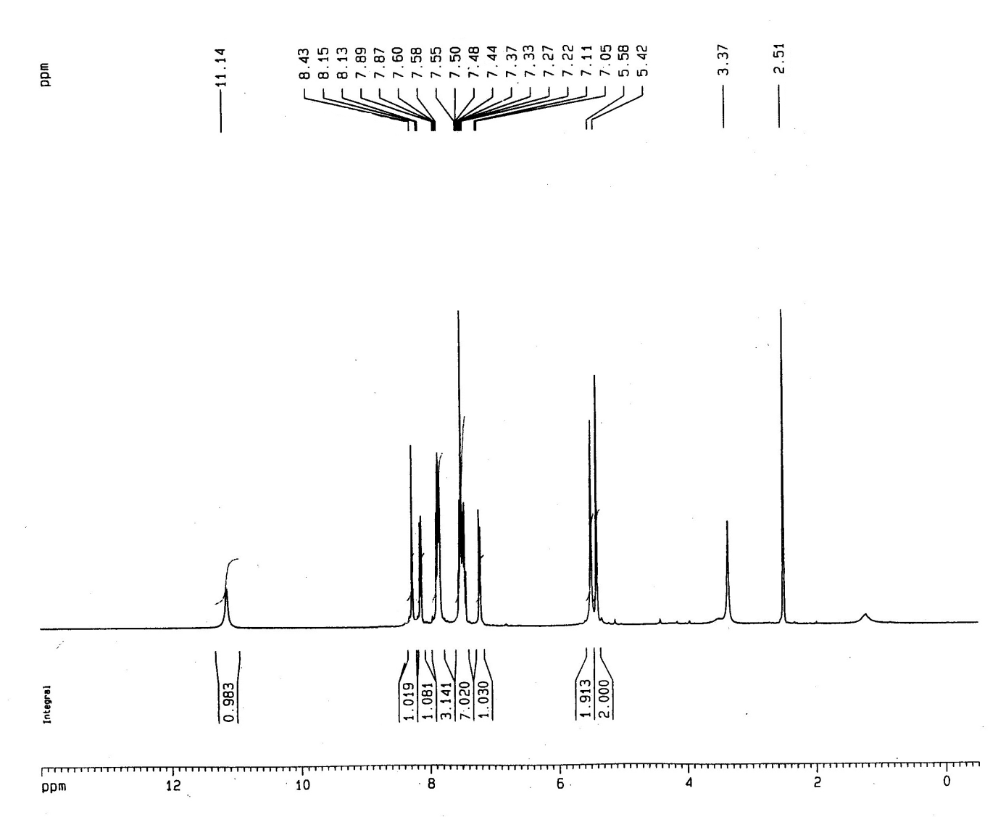
Figure S1. ¹H NMR spectrum (DMSO-d₆, 400 MHz) of compound 7a

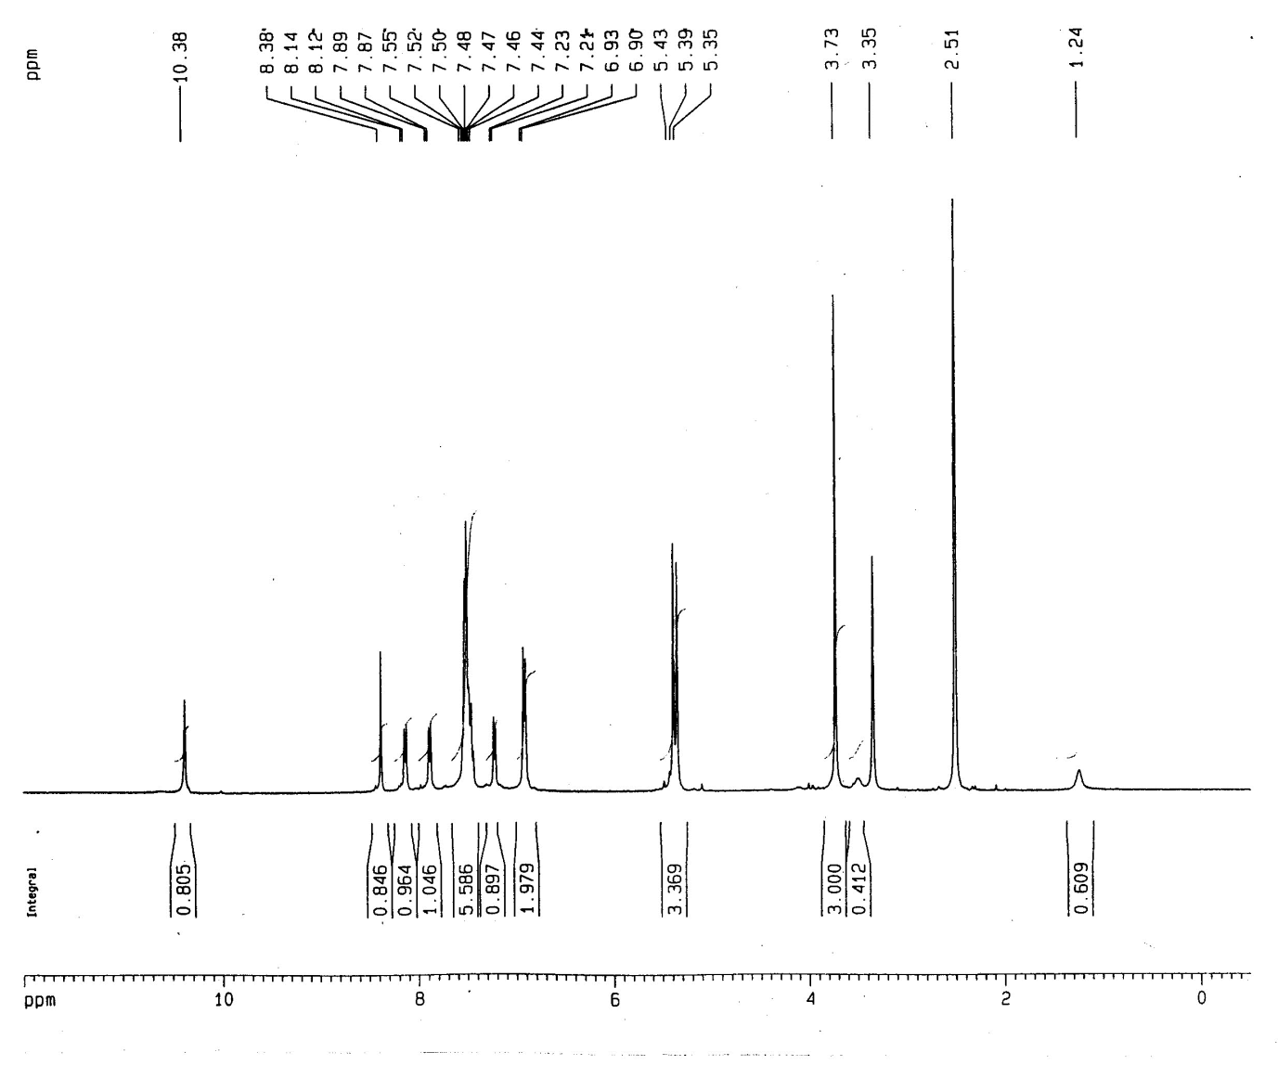
Figure S2. ¹H NMR spectrum (DMSO-d₆, 400 MHz) of compound 7b
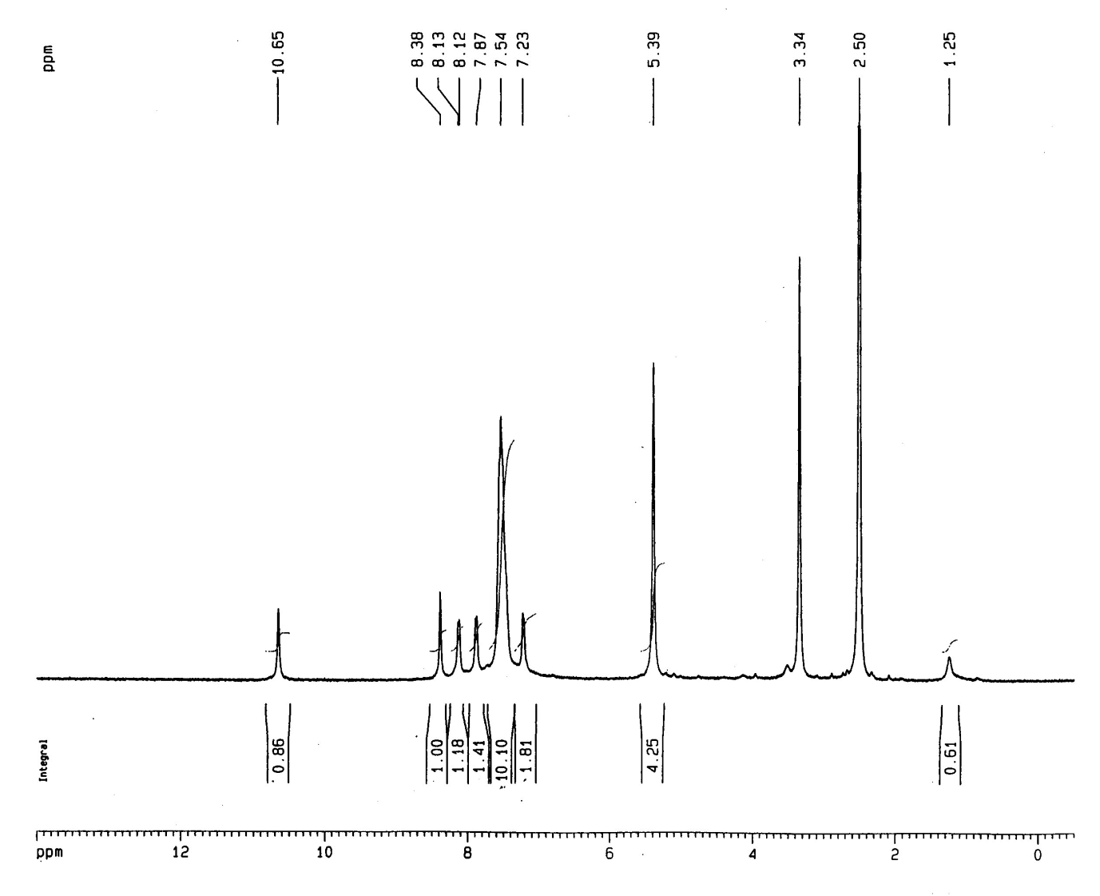
Figure S3. ¹H NMR spectrum (DMSO-d₆, 400 MHz) of compound 7c

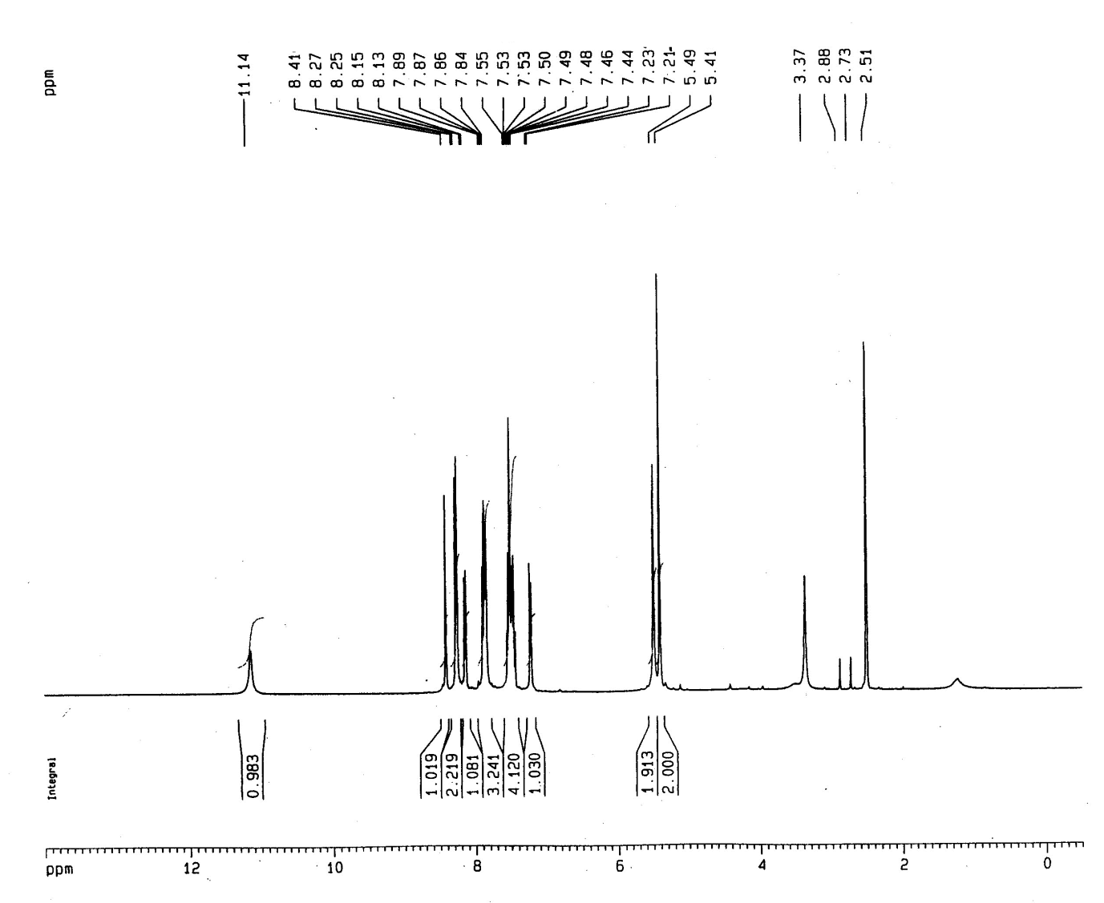
Figure S4. ¹H NMR spectrum (DMSO-d₆, 400 MHz) of compound 7d
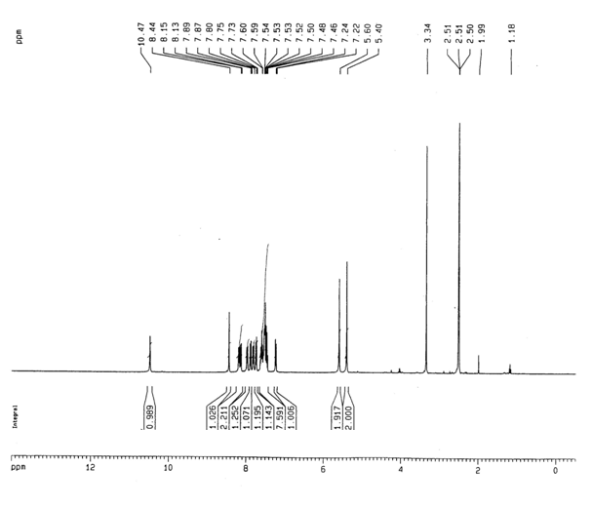
Figure S5. ¹H NMR spectrum (DMSO-d₆, 400 MHz) of compound 7e
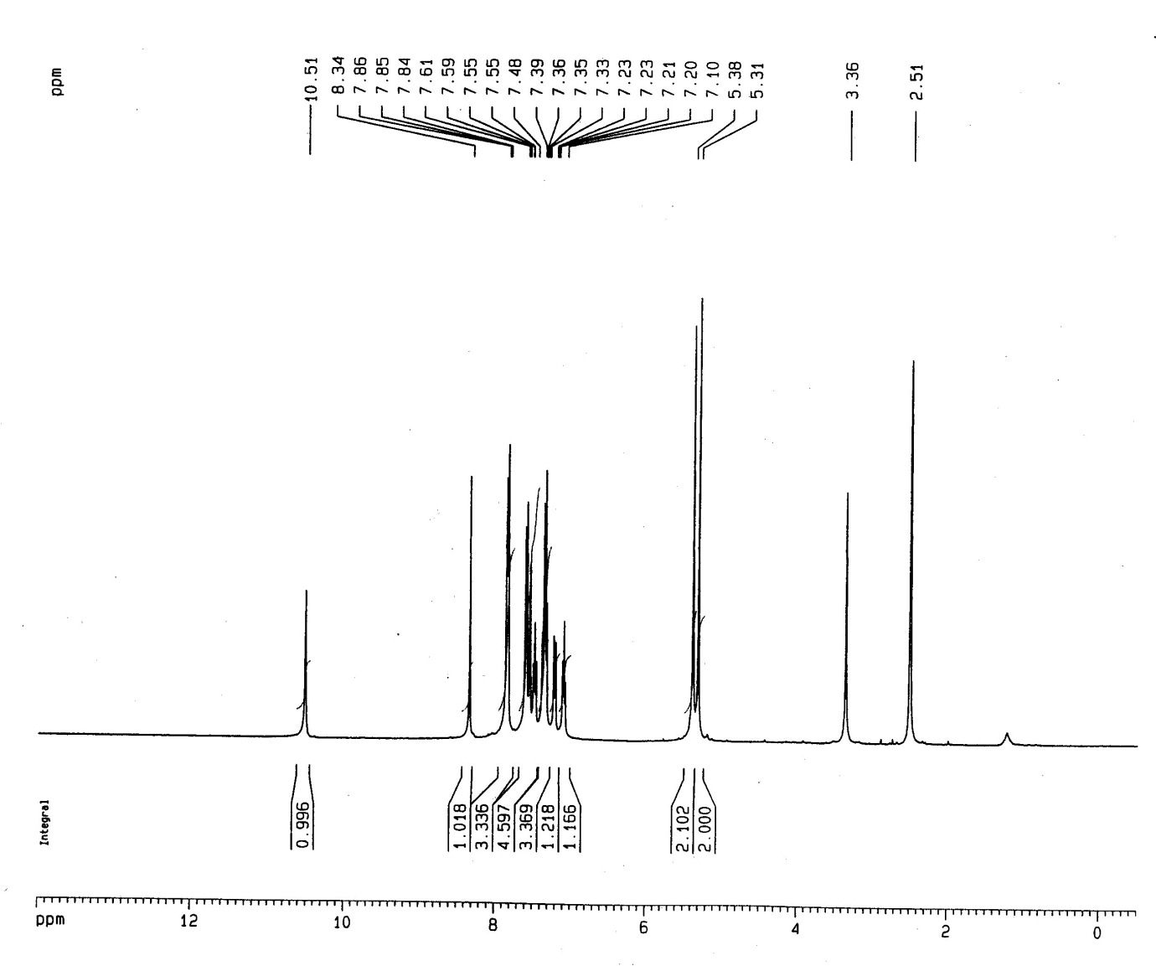
Figure S6. ¹H NMR spectrum (DMSO-d₆, 400 MHz) of compound 10a
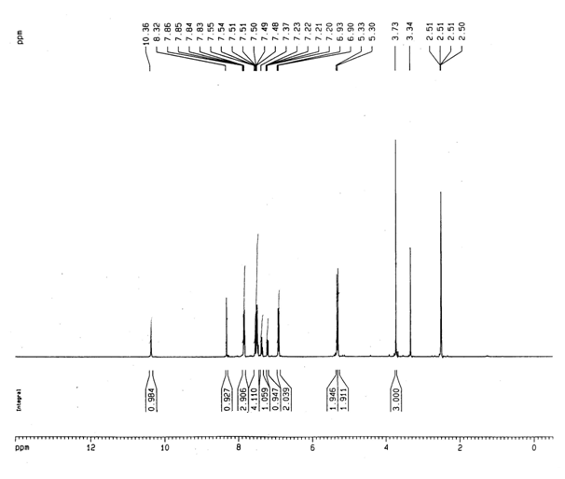
Figure S7. ¹H NMR spectrum (DMSO-d₆, 400 MHz) of compound 10b
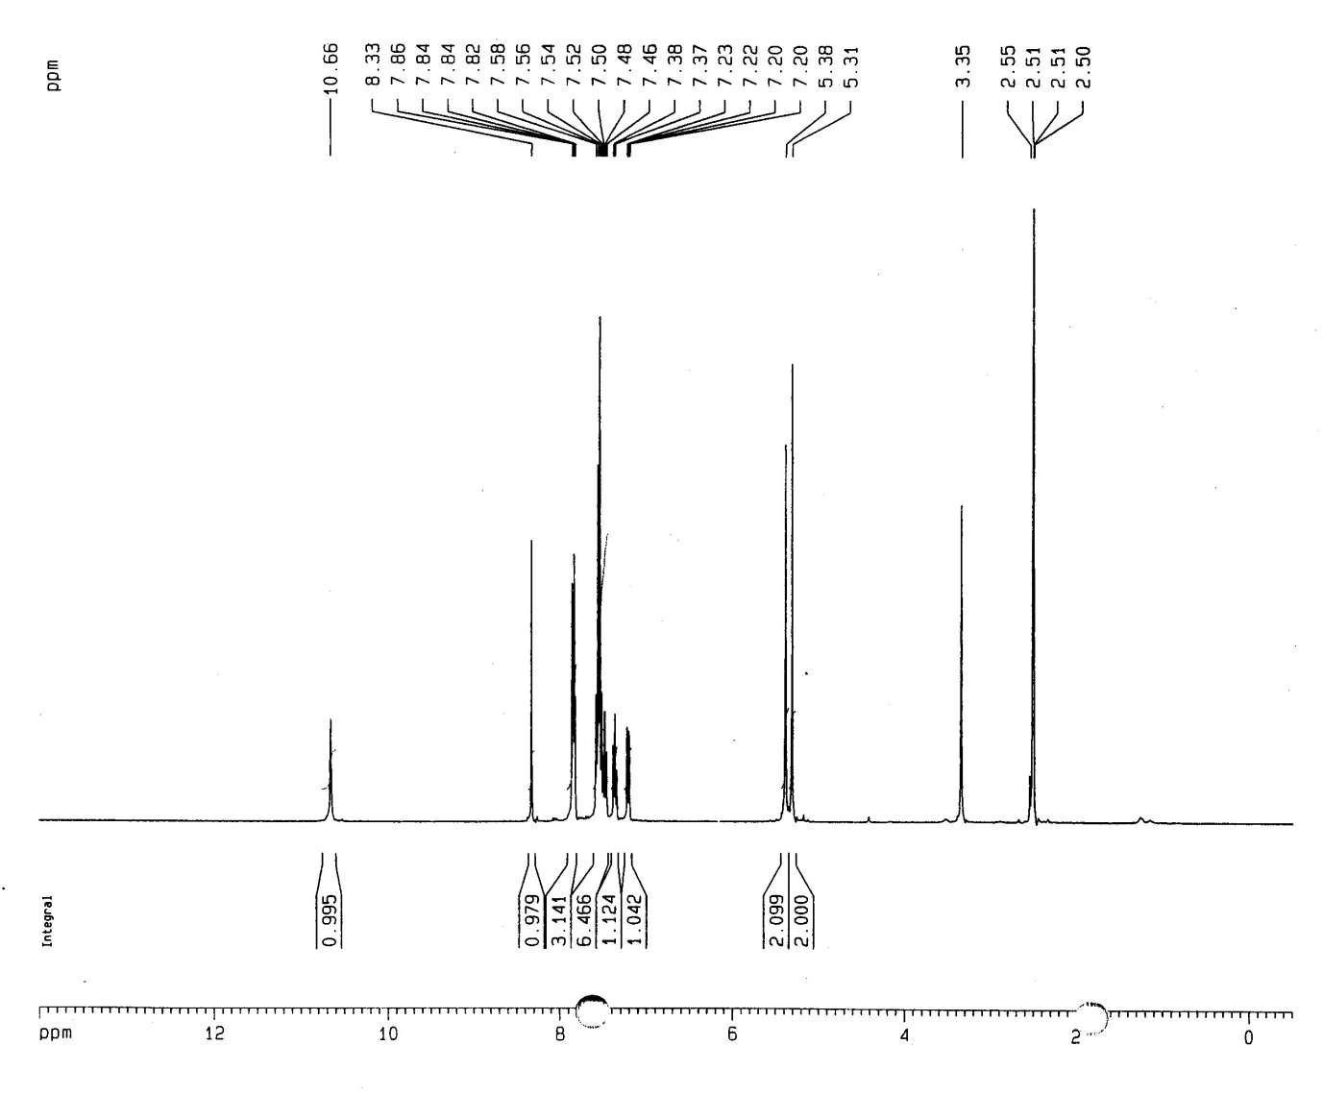
Figure S8. ¹H NMR spectrum (DMSO-d₆, 400 MHz) of compound 10c
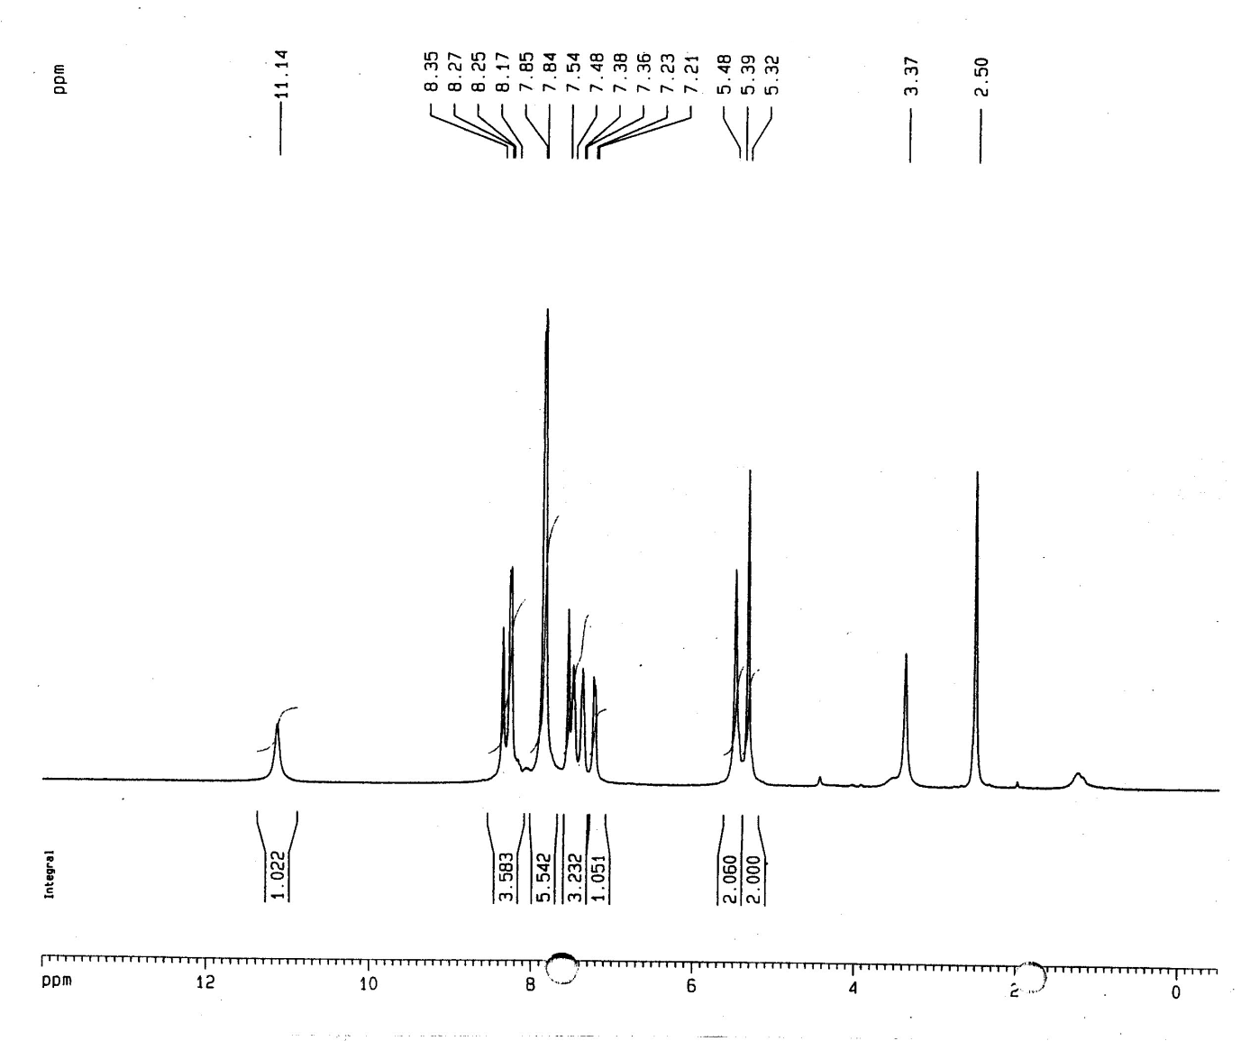
Figure S9. ¹H NMR spectrum (DMSO-d₆, 400 MHz) of compound 10d
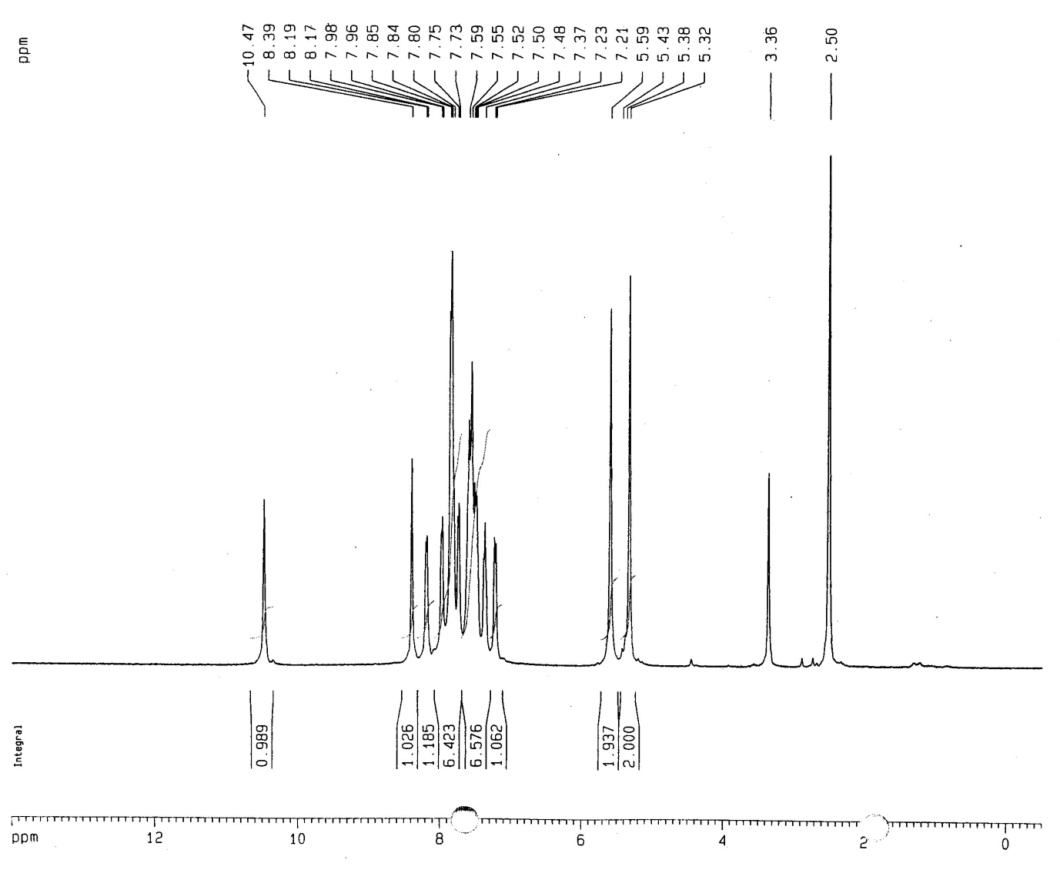
Figure S10. ¹H NMR spectrum (DMSO-d₆, 400 MHz) of compound 10e
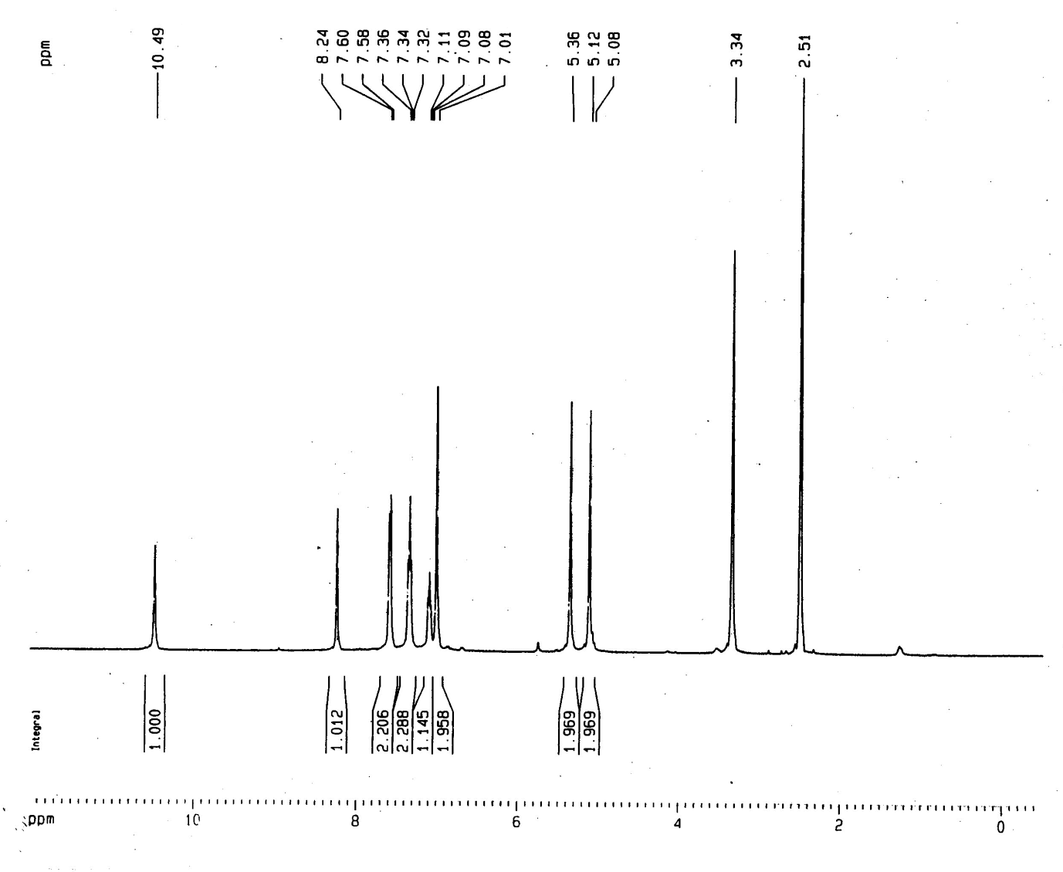
Figure S11. ¹H NMR spectrum (DMSO-d₆, 400 MHz) of compound 13a

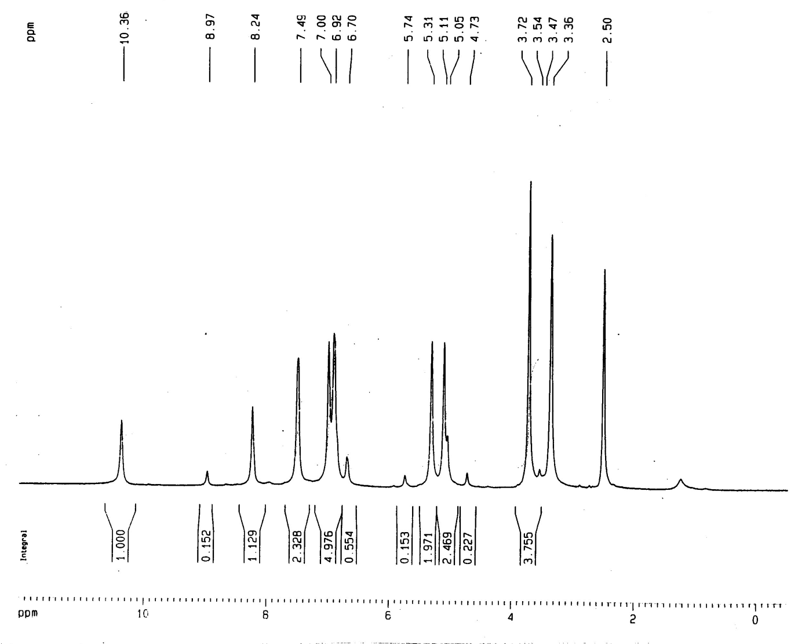
Figure S12. ¹H NMR spectrum (DMSO-d₆, 400 MHz) of compound 13b
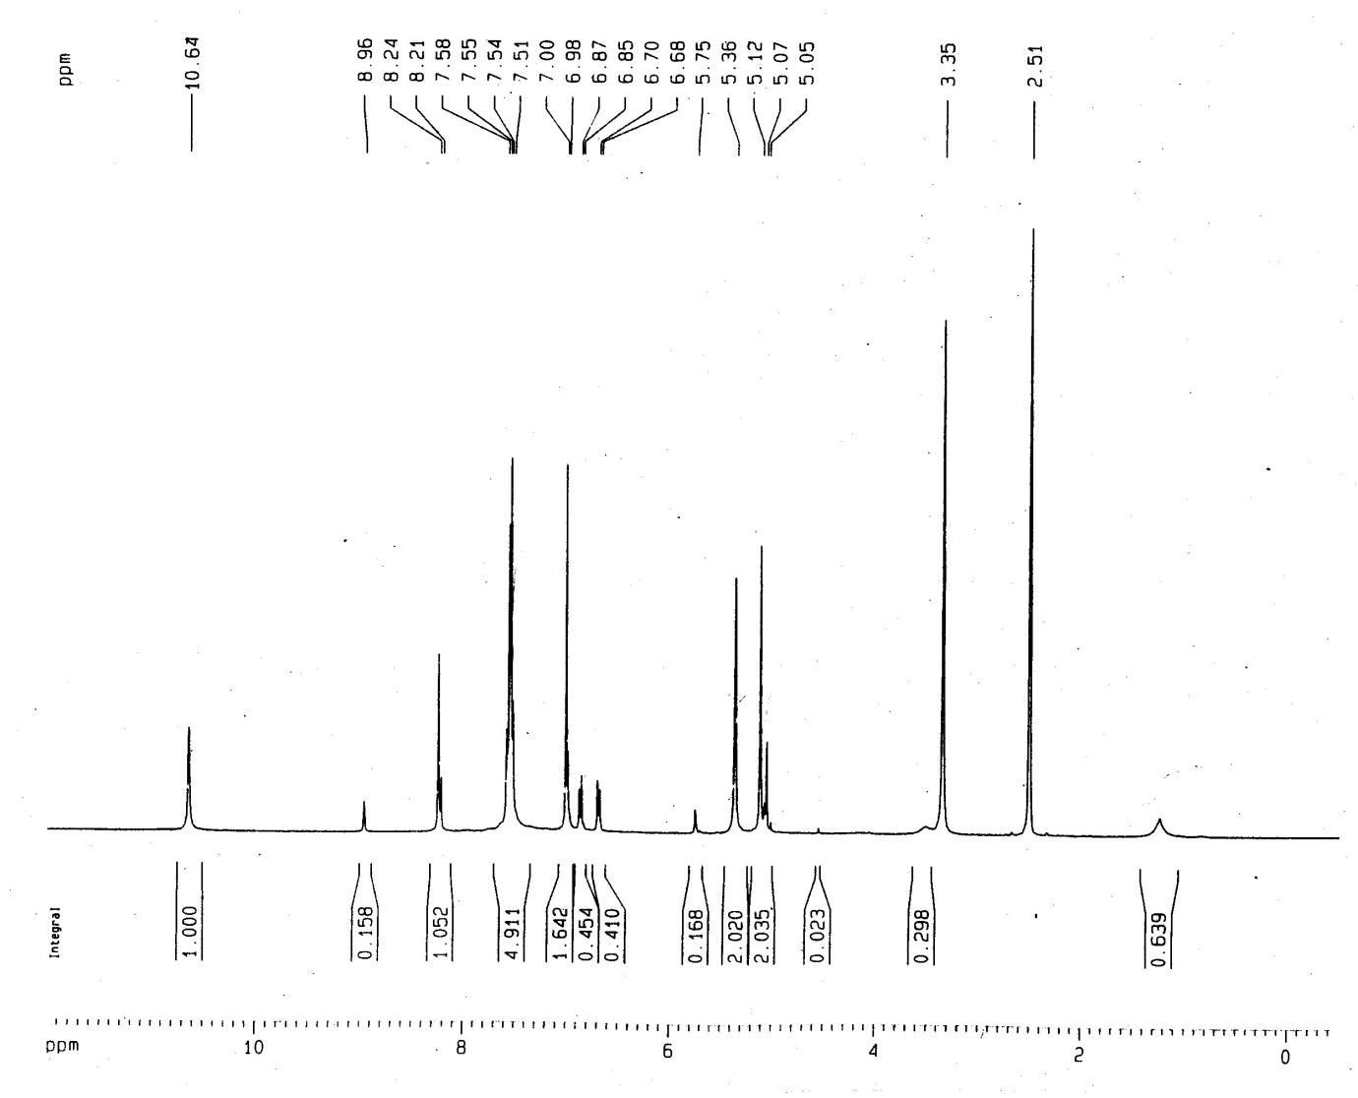
Figure S13. ¹H NMR spectrum (DMSO-d₆, 400 MHz) of compound 13c
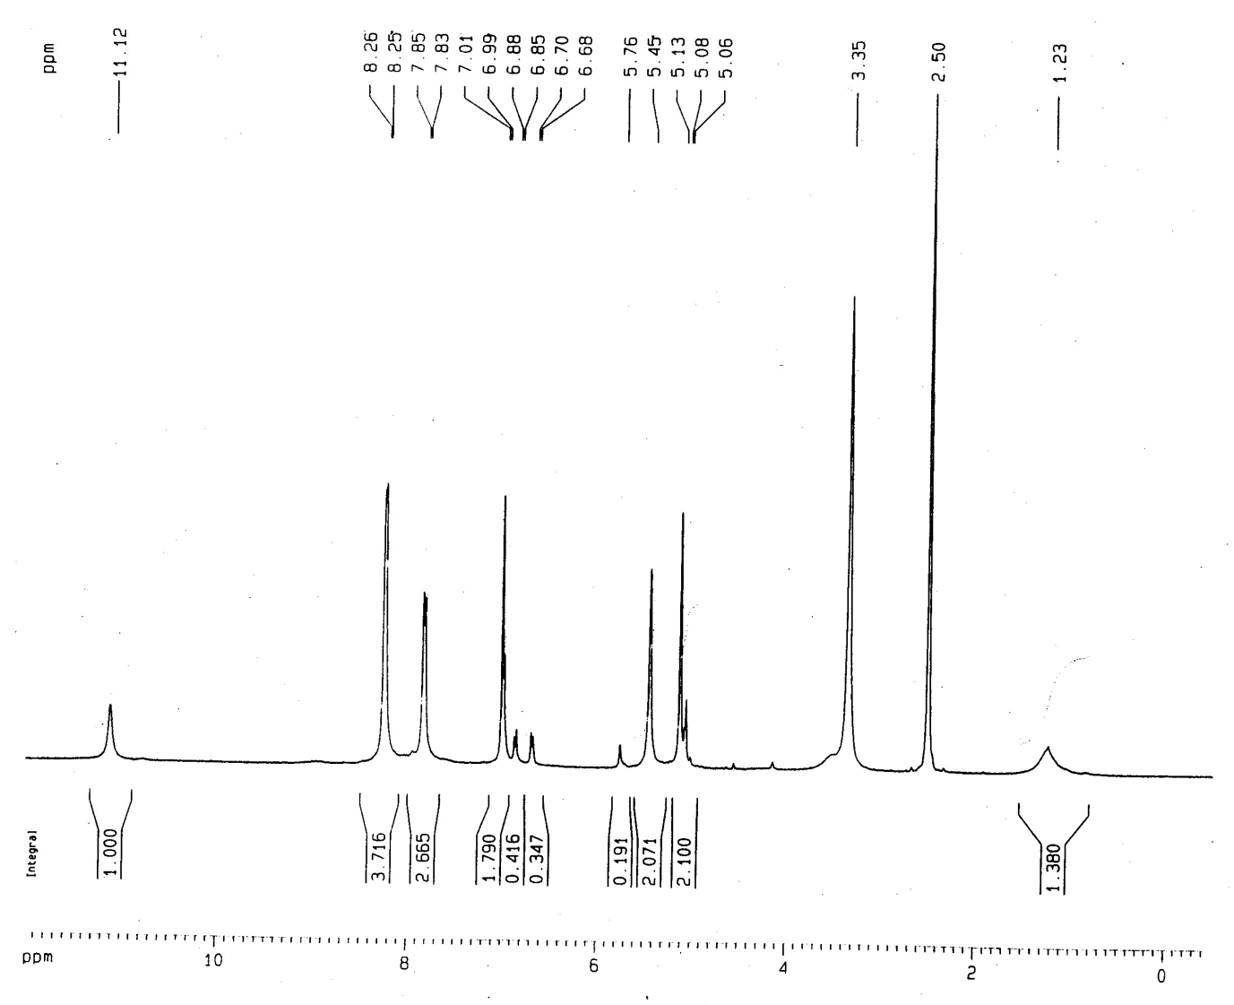
Figure S14. ¹H NMR spectrum (DMSO-d₆, 400 MHz) of compound 13d
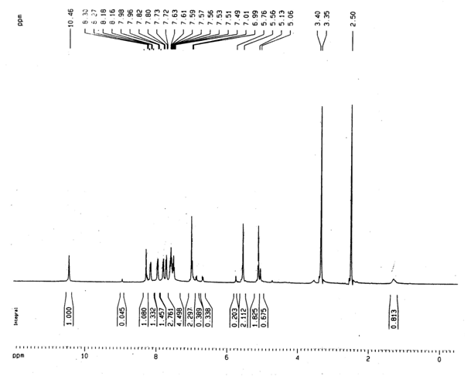
Figure S15. ¹H NMR spectrum (DMSO-d₆, 400 MHz) of compound 13e
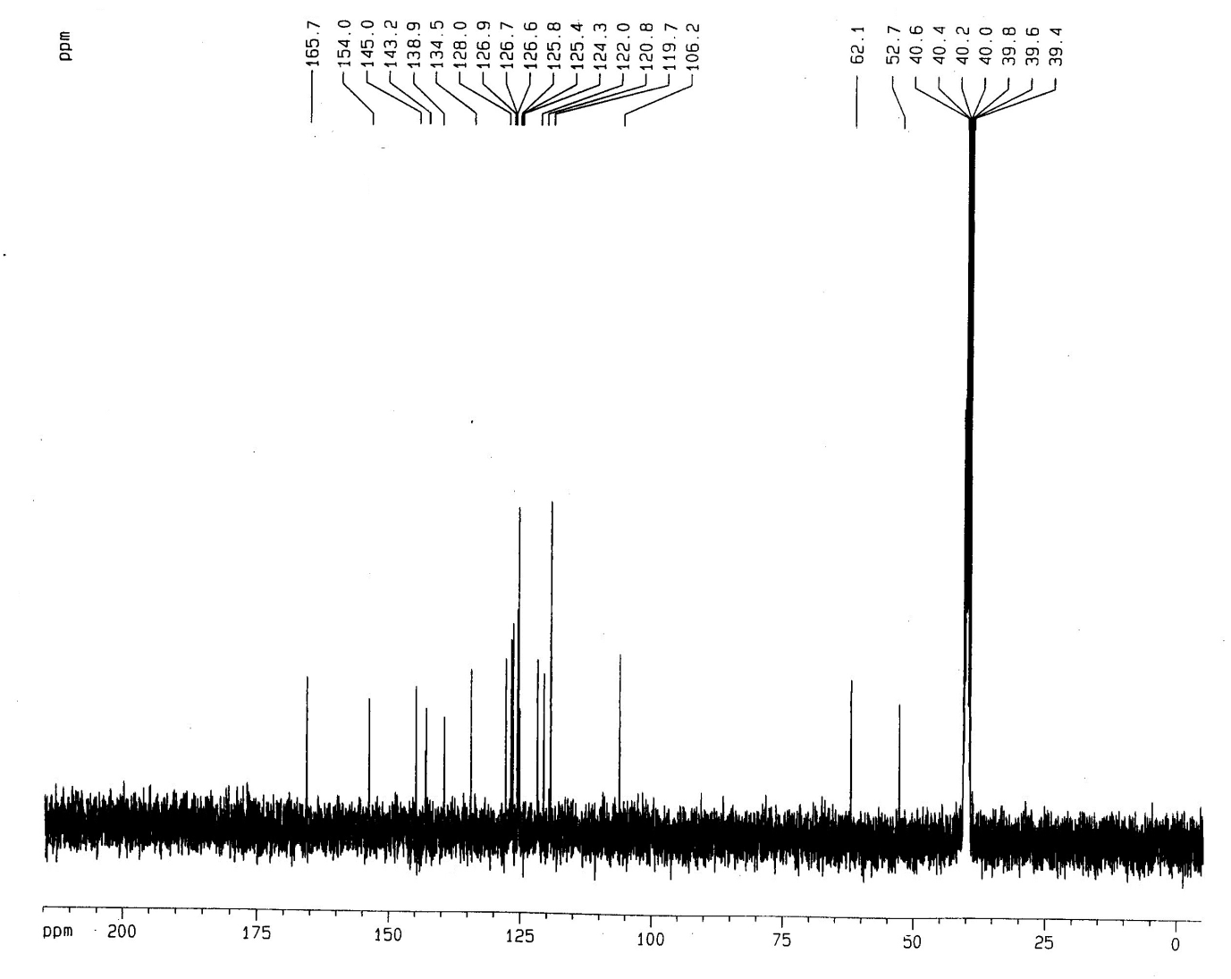
Figure S16. ¹³C NMR spectrum (DMSO-d₆, 100 MHz) of compound 7a
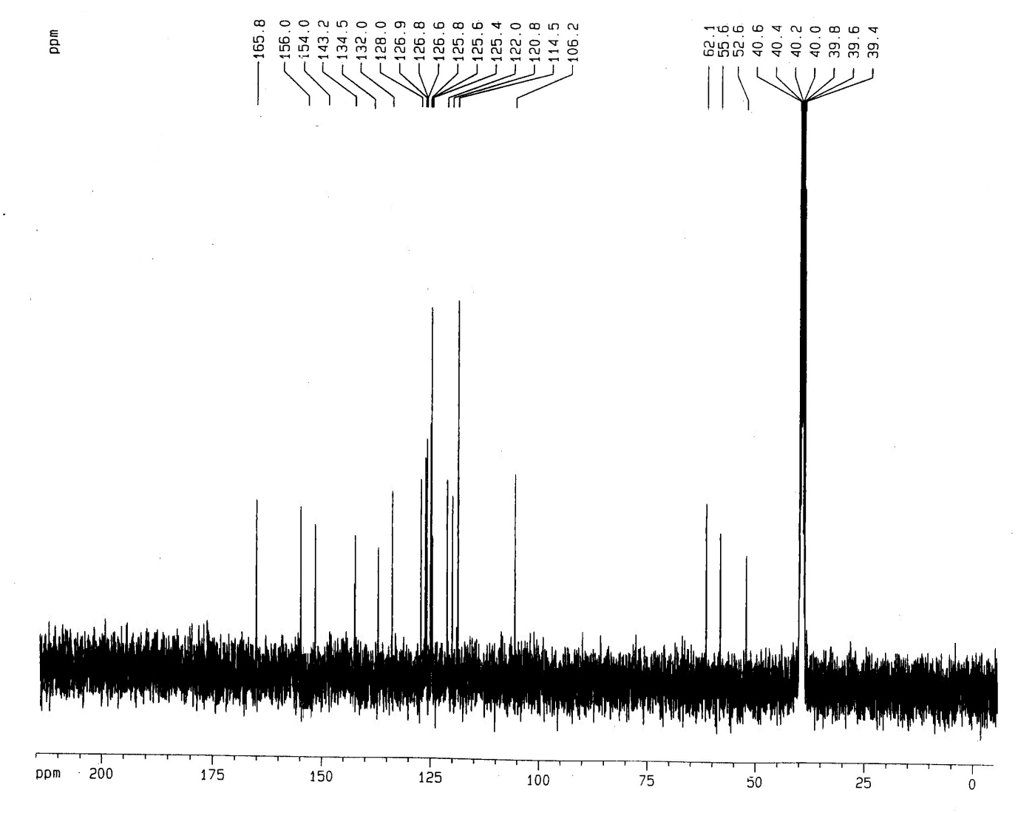
Figure S17. ¹³C NMR spectrum (DMSO-d₆, 100 MHz) of compound 7b
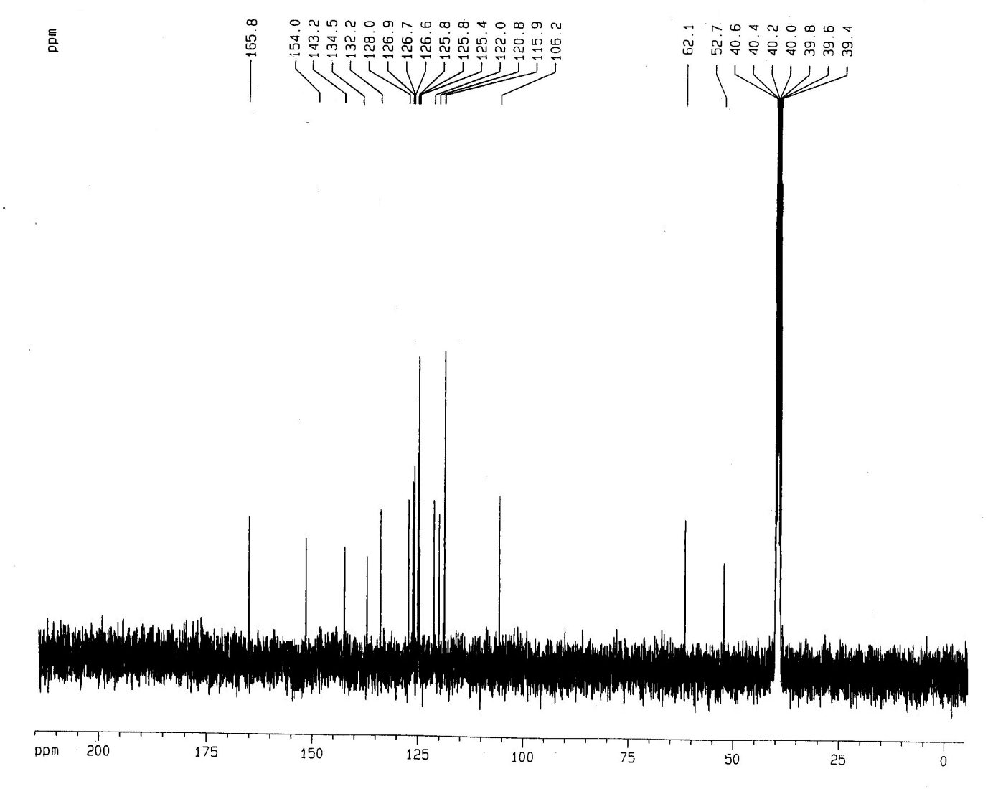
Figure S18. ¹³C NMR spectrum (DMSO-d₆, 100 MHz) of compound 7c

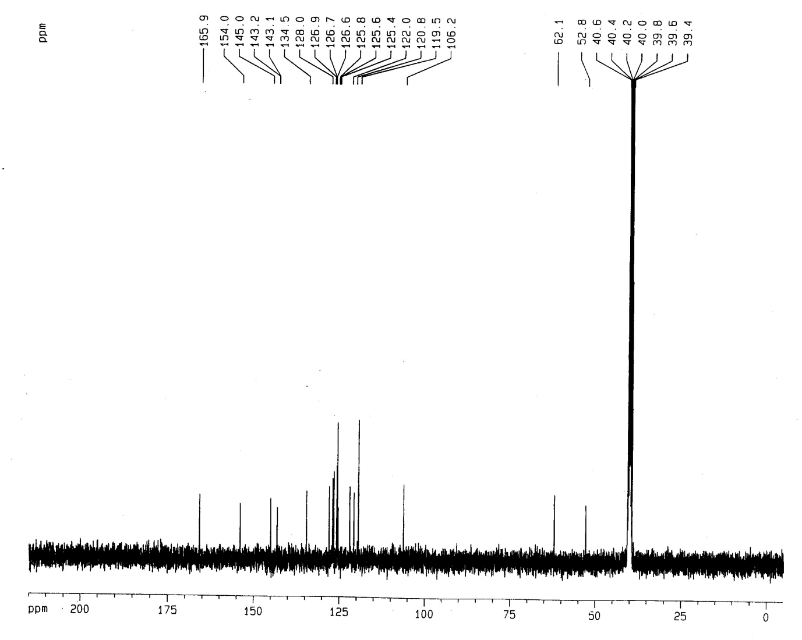
Figure S19. ¹³C NMR spectrum (DMSO-d₆, 100 MHz) of compound 7d
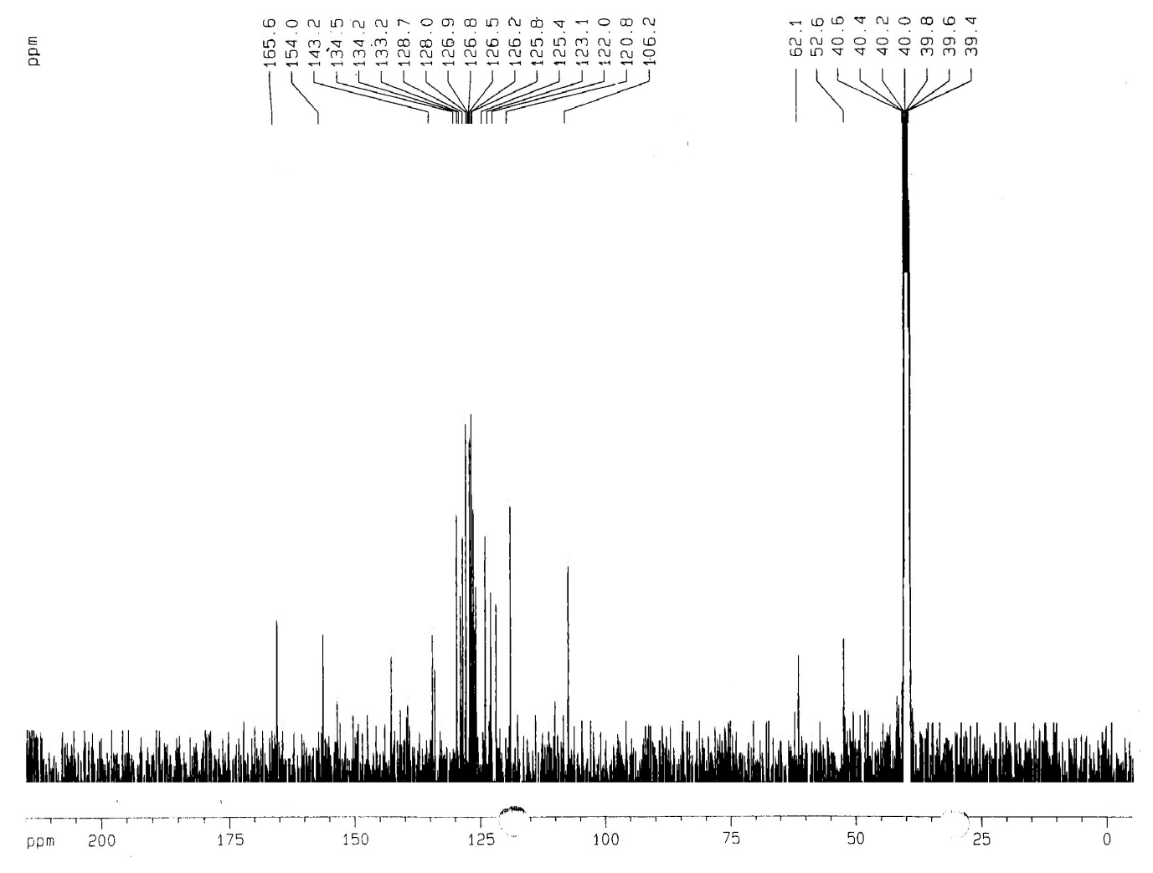
Figure S20. ¹³C NMR spectrum (DMSO-d₆, 100 MHz) of compound 7e

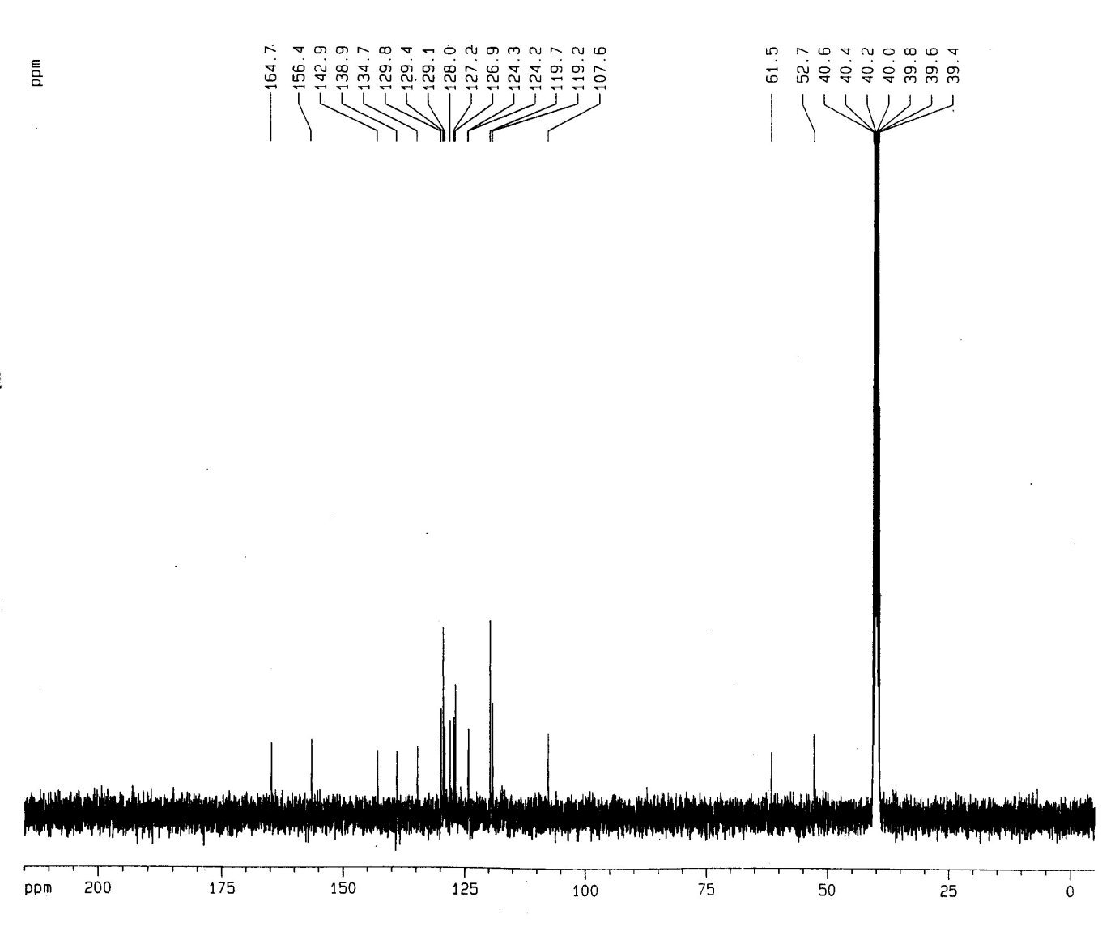
Figure S21. ¹³C NMR spectrum (DMSO-d₆, 100 MHz) of compound 10a
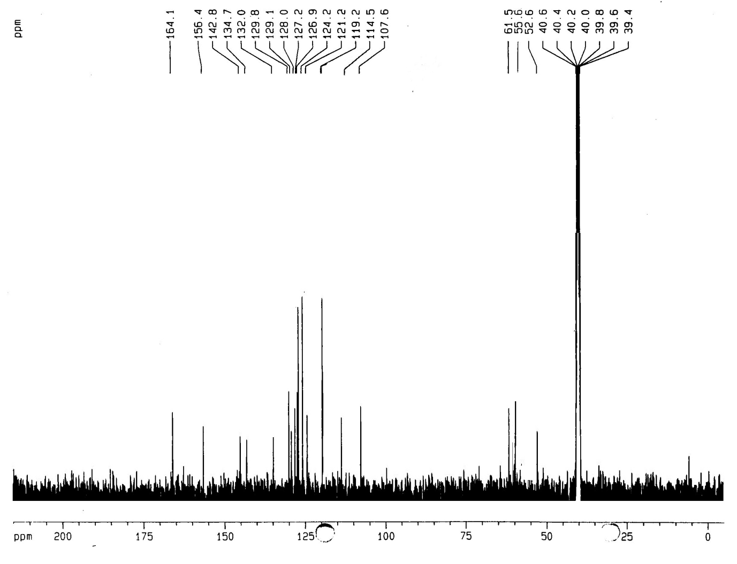
Figure S22. ¹³C NMR spectrum (DMSO-d₆, 100 MHz) of compound 10b

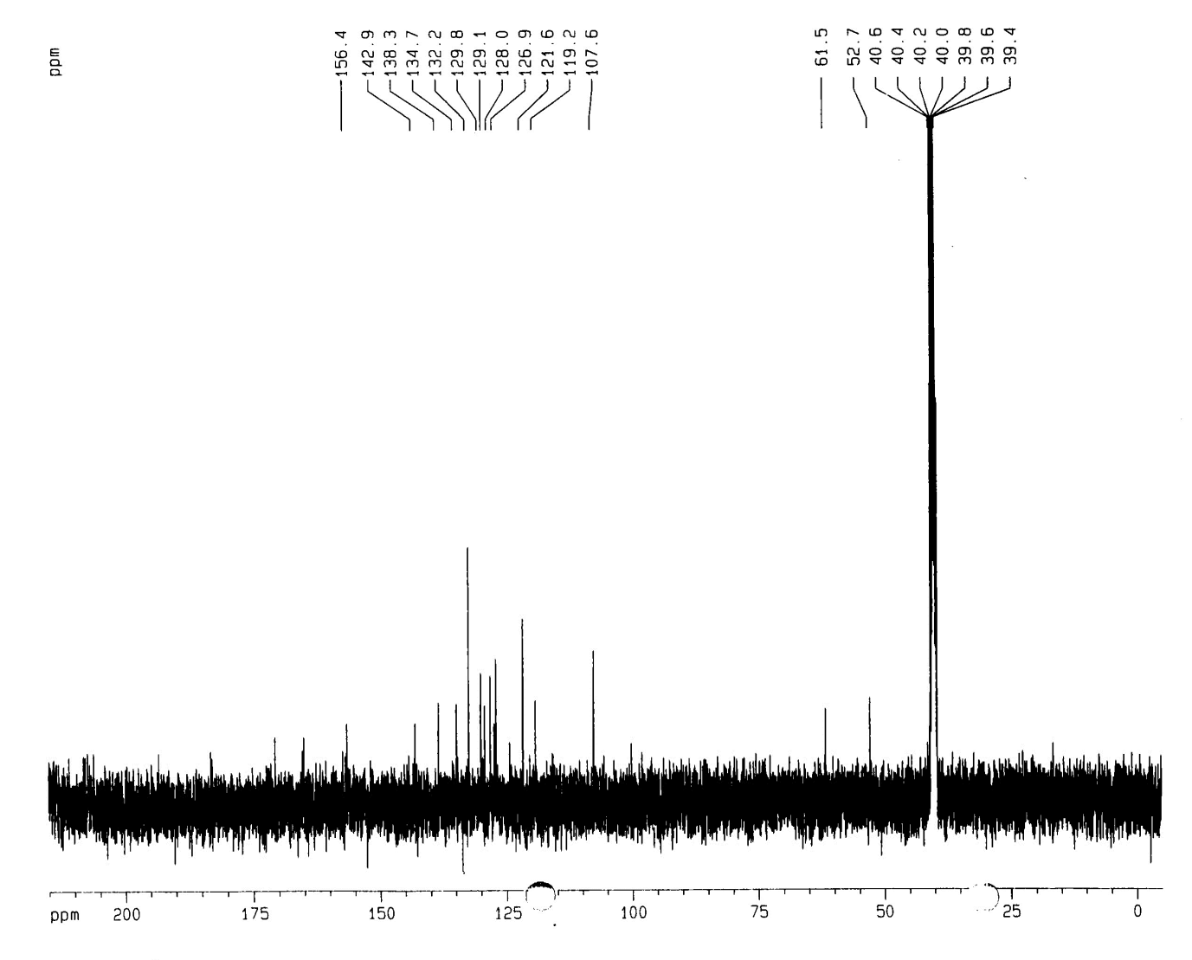
Figure S23. ¹³C NMR spectrum (DMSO-d₆, 100 MHz) of compound 10c
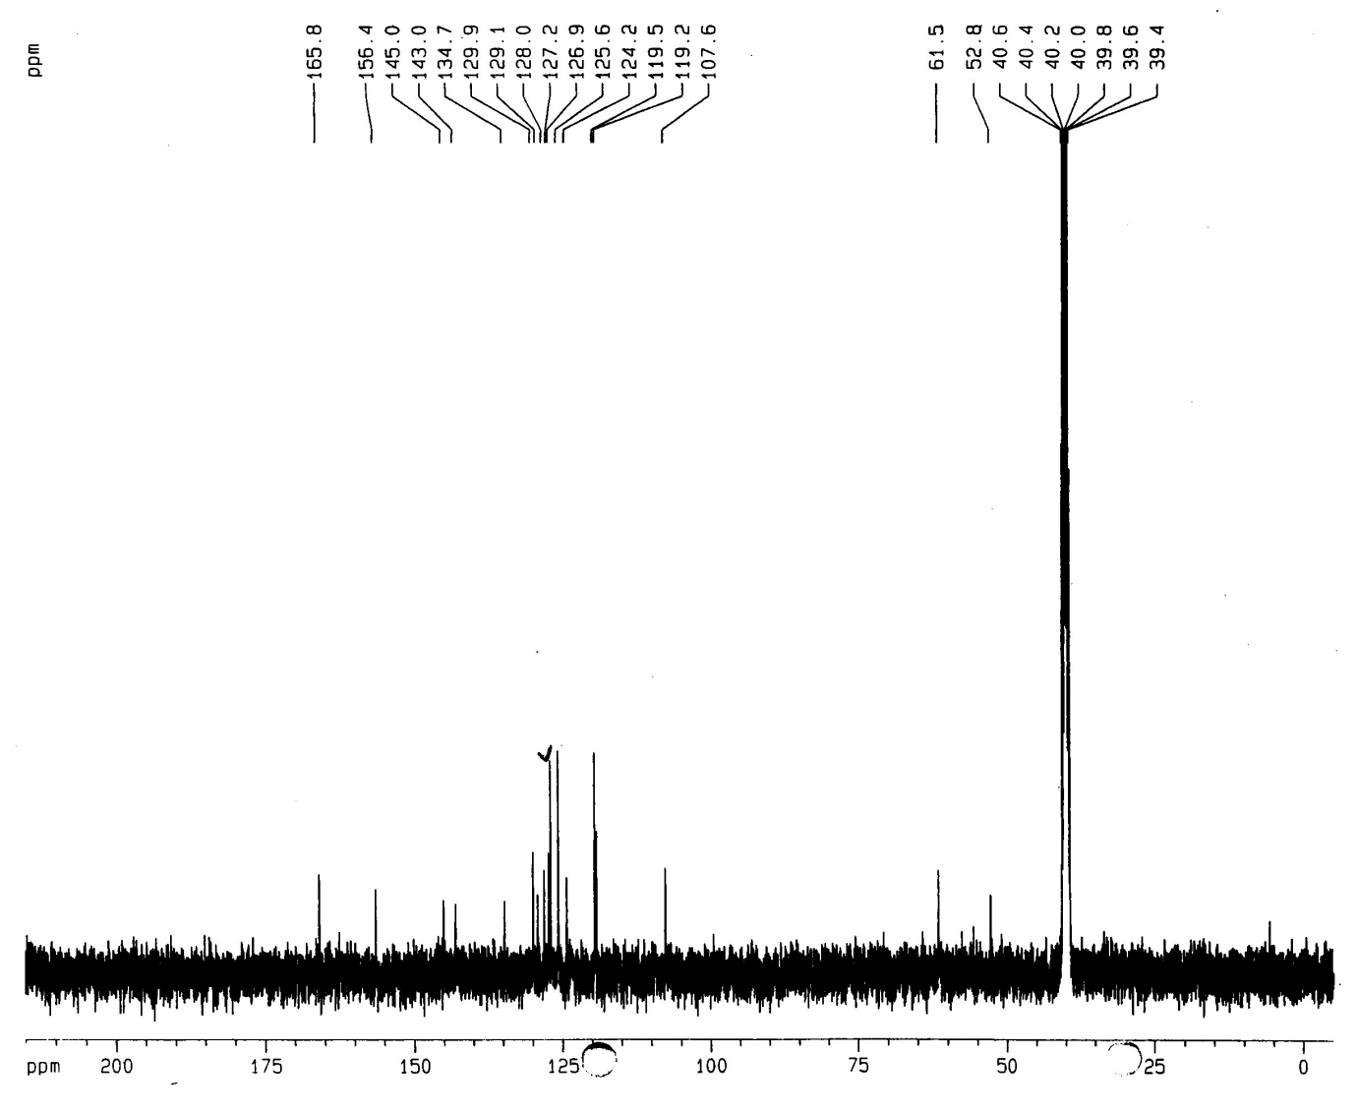
Figure S24. ¹³C NMR spectrum (DMSO-d₆, 100 MHz) of compound 10d
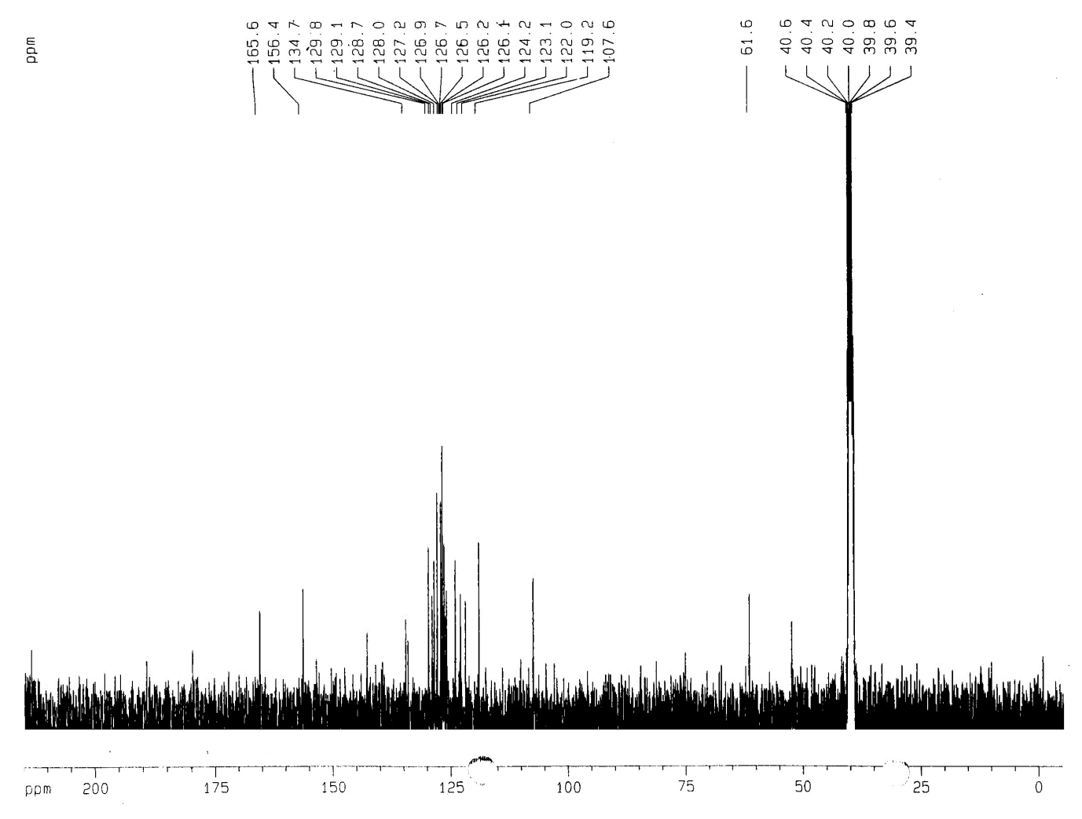
Figure S25. ¹³C NMR spectrum (DMSO-d₆, 100 MHz) of compound 10e
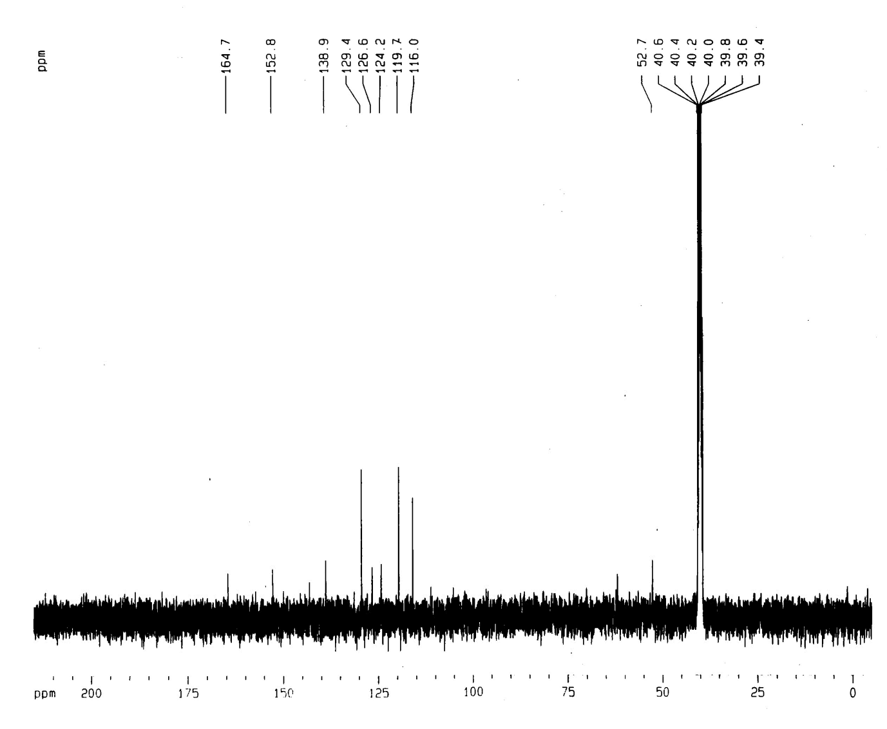
Figure S26. ¹³C NMR spectrum (DMSO-d₆, 100 MHz) of compound 13a
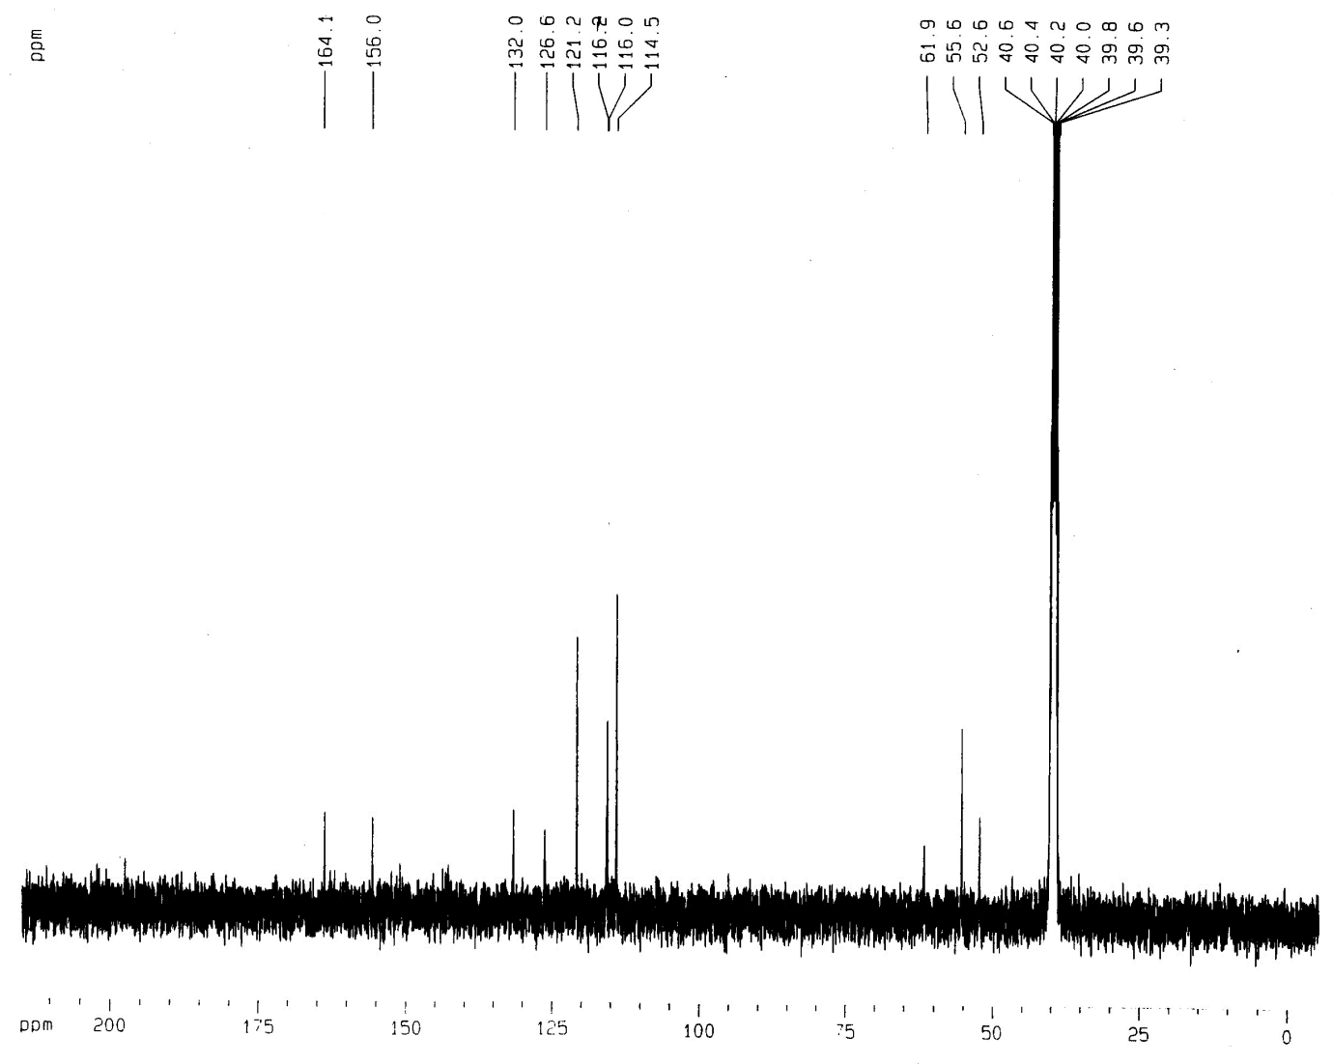
Figure S27. ¹³C NMR spectrum (DMSO-d₆, 100 MHz) of compound 13b
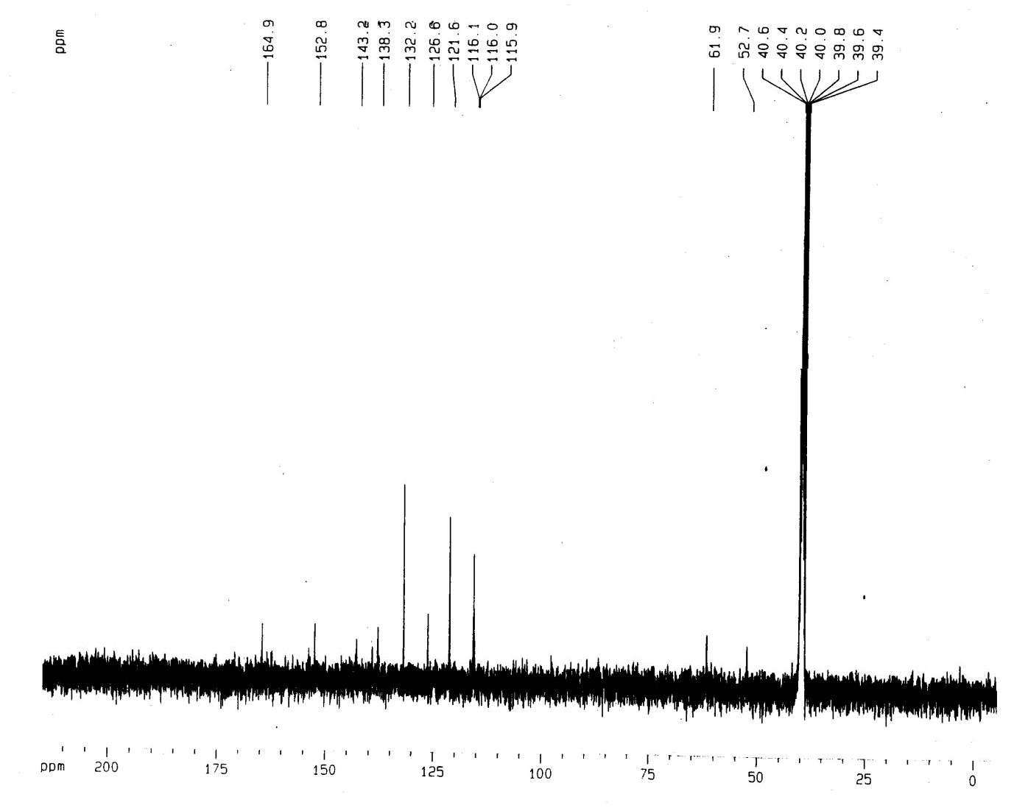
Figure S28. ¹³C NMR spectrum (DMSO-d₆, 100 MHz) of compound 13c
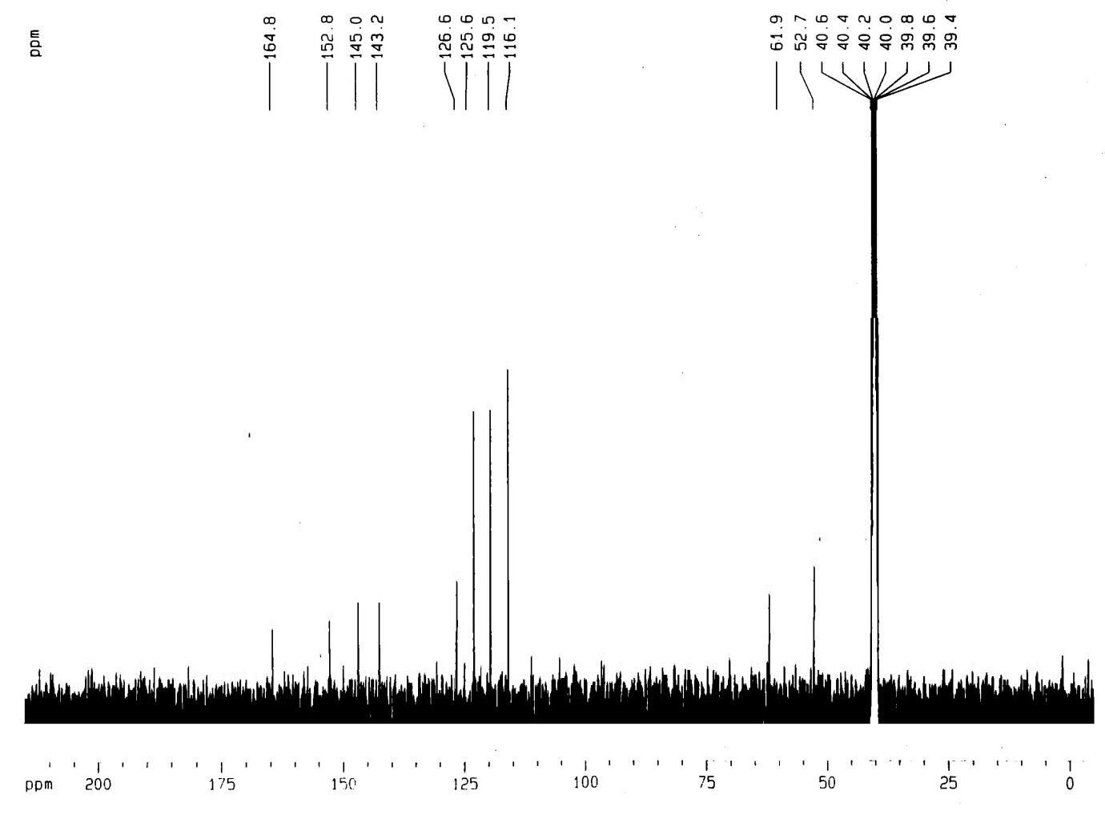
Figure S29. ¹³C NMR spectrum (DMSO-d₆, 100 MHz) of compound 13d
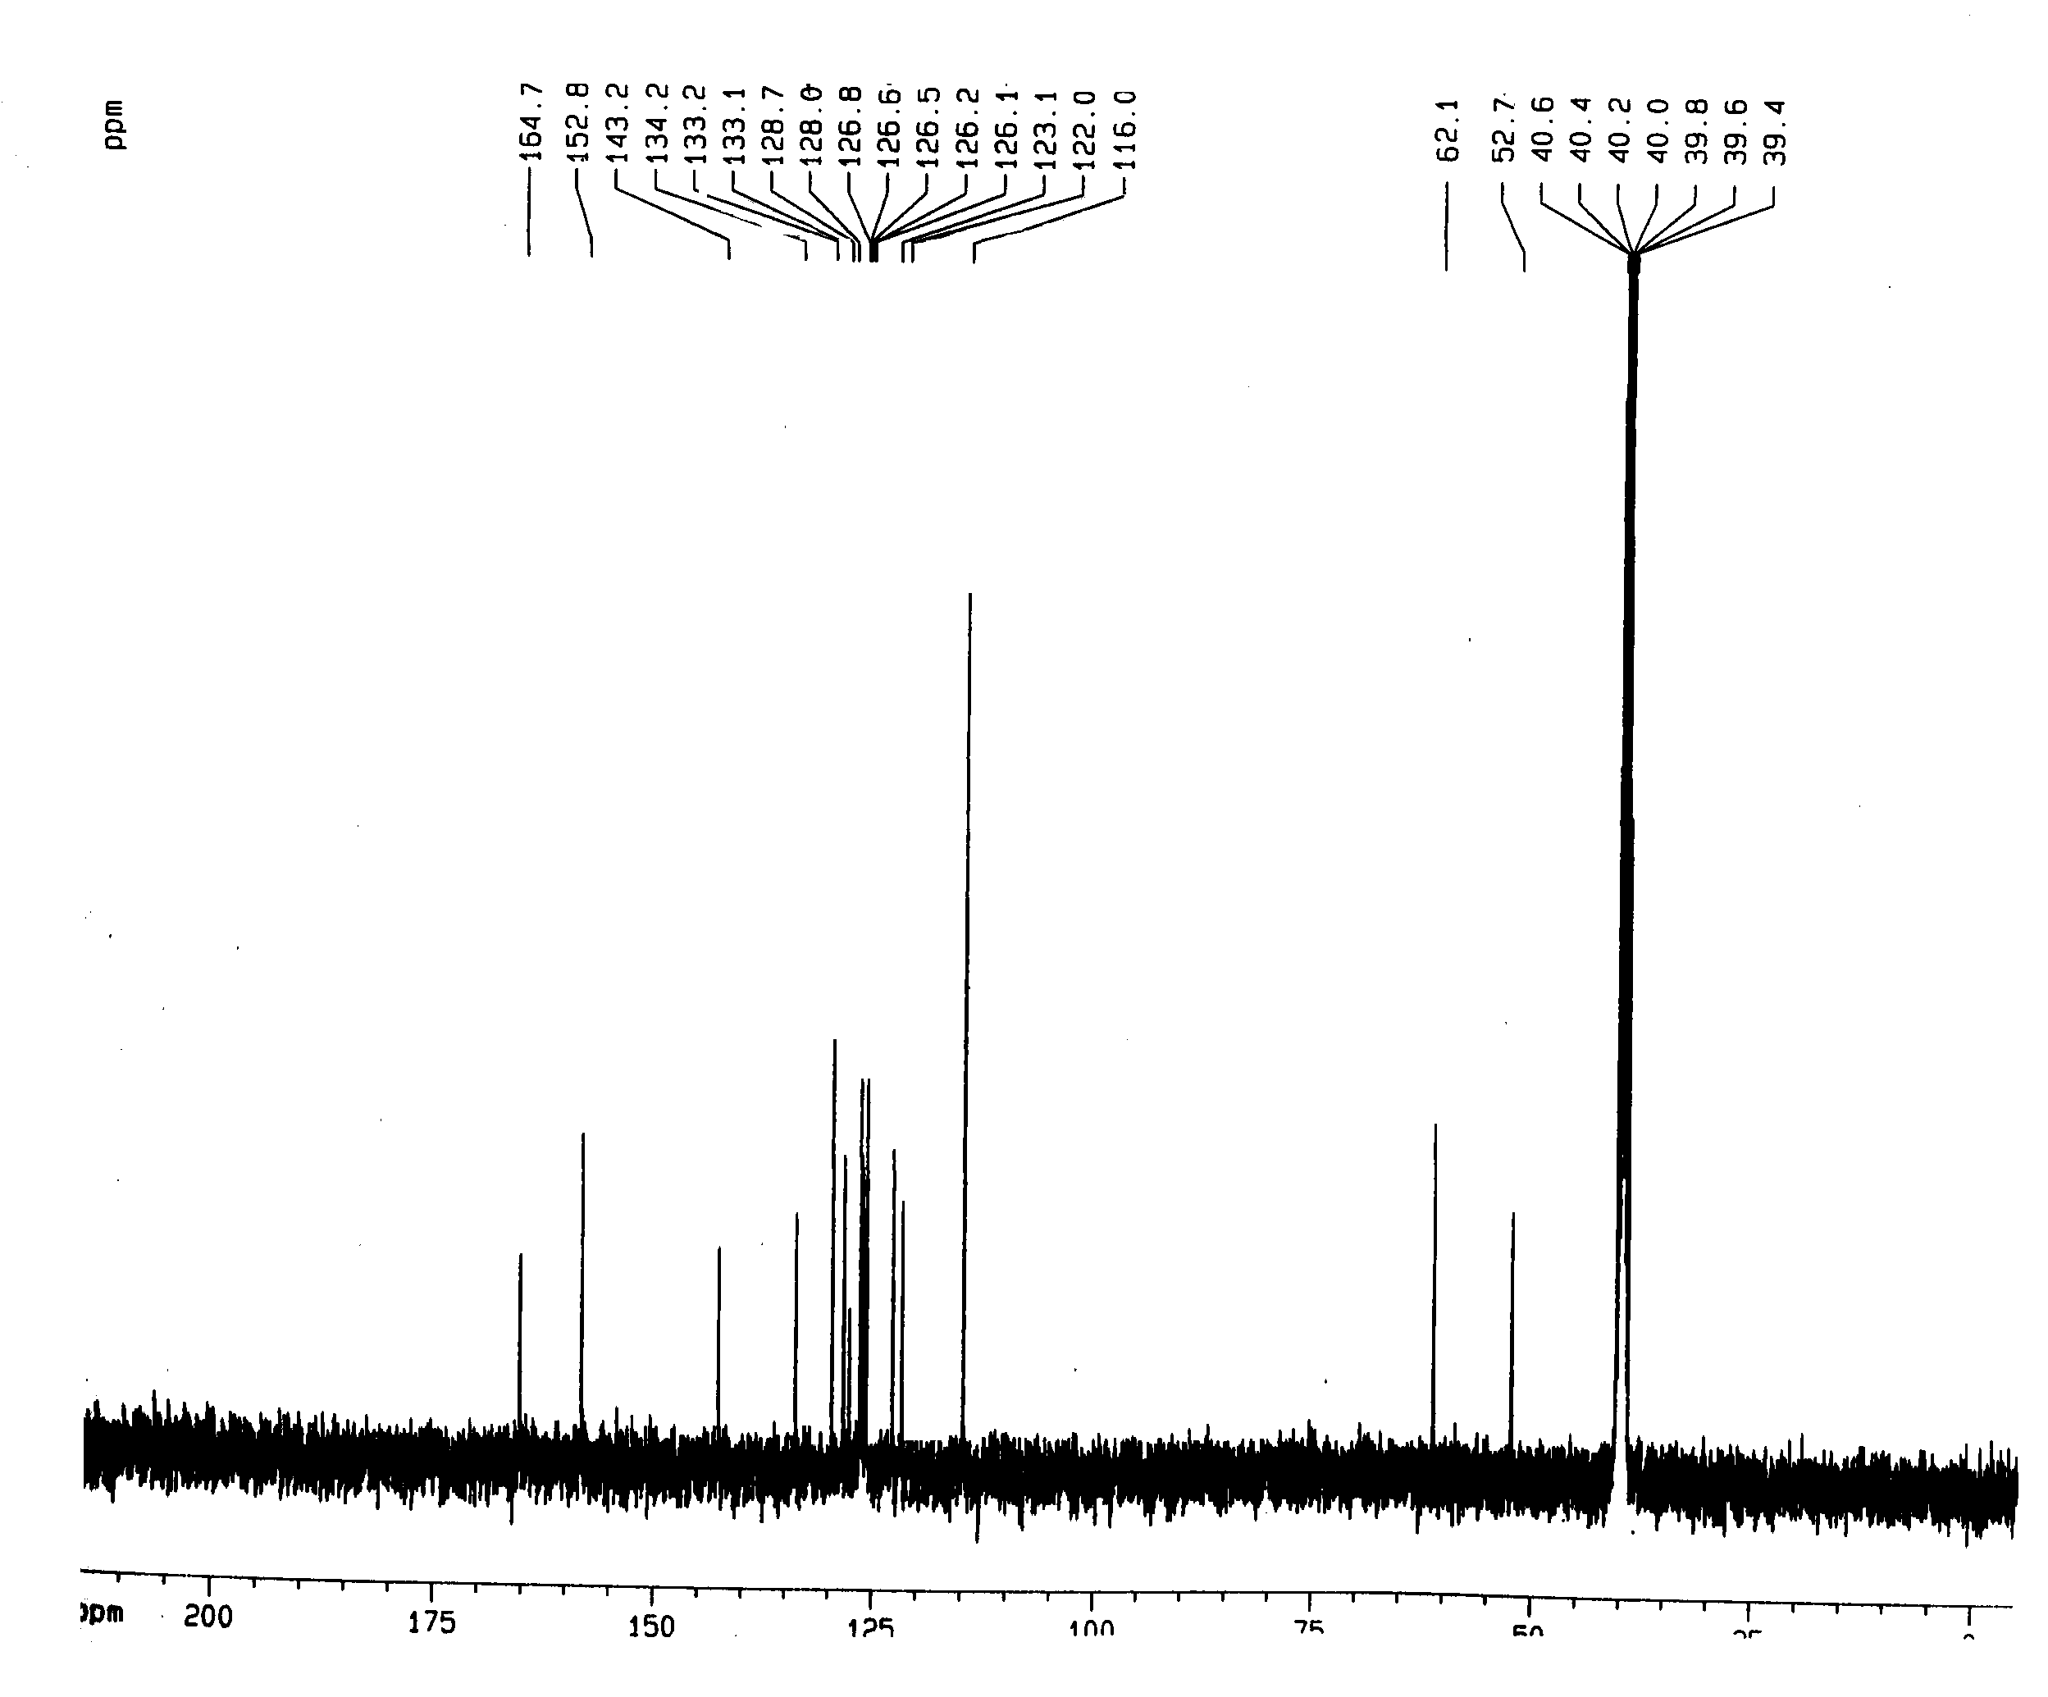
Figure S30. ¹³C NMR spectrum (DMSO-d₆, 100 MHz) of compound 13e

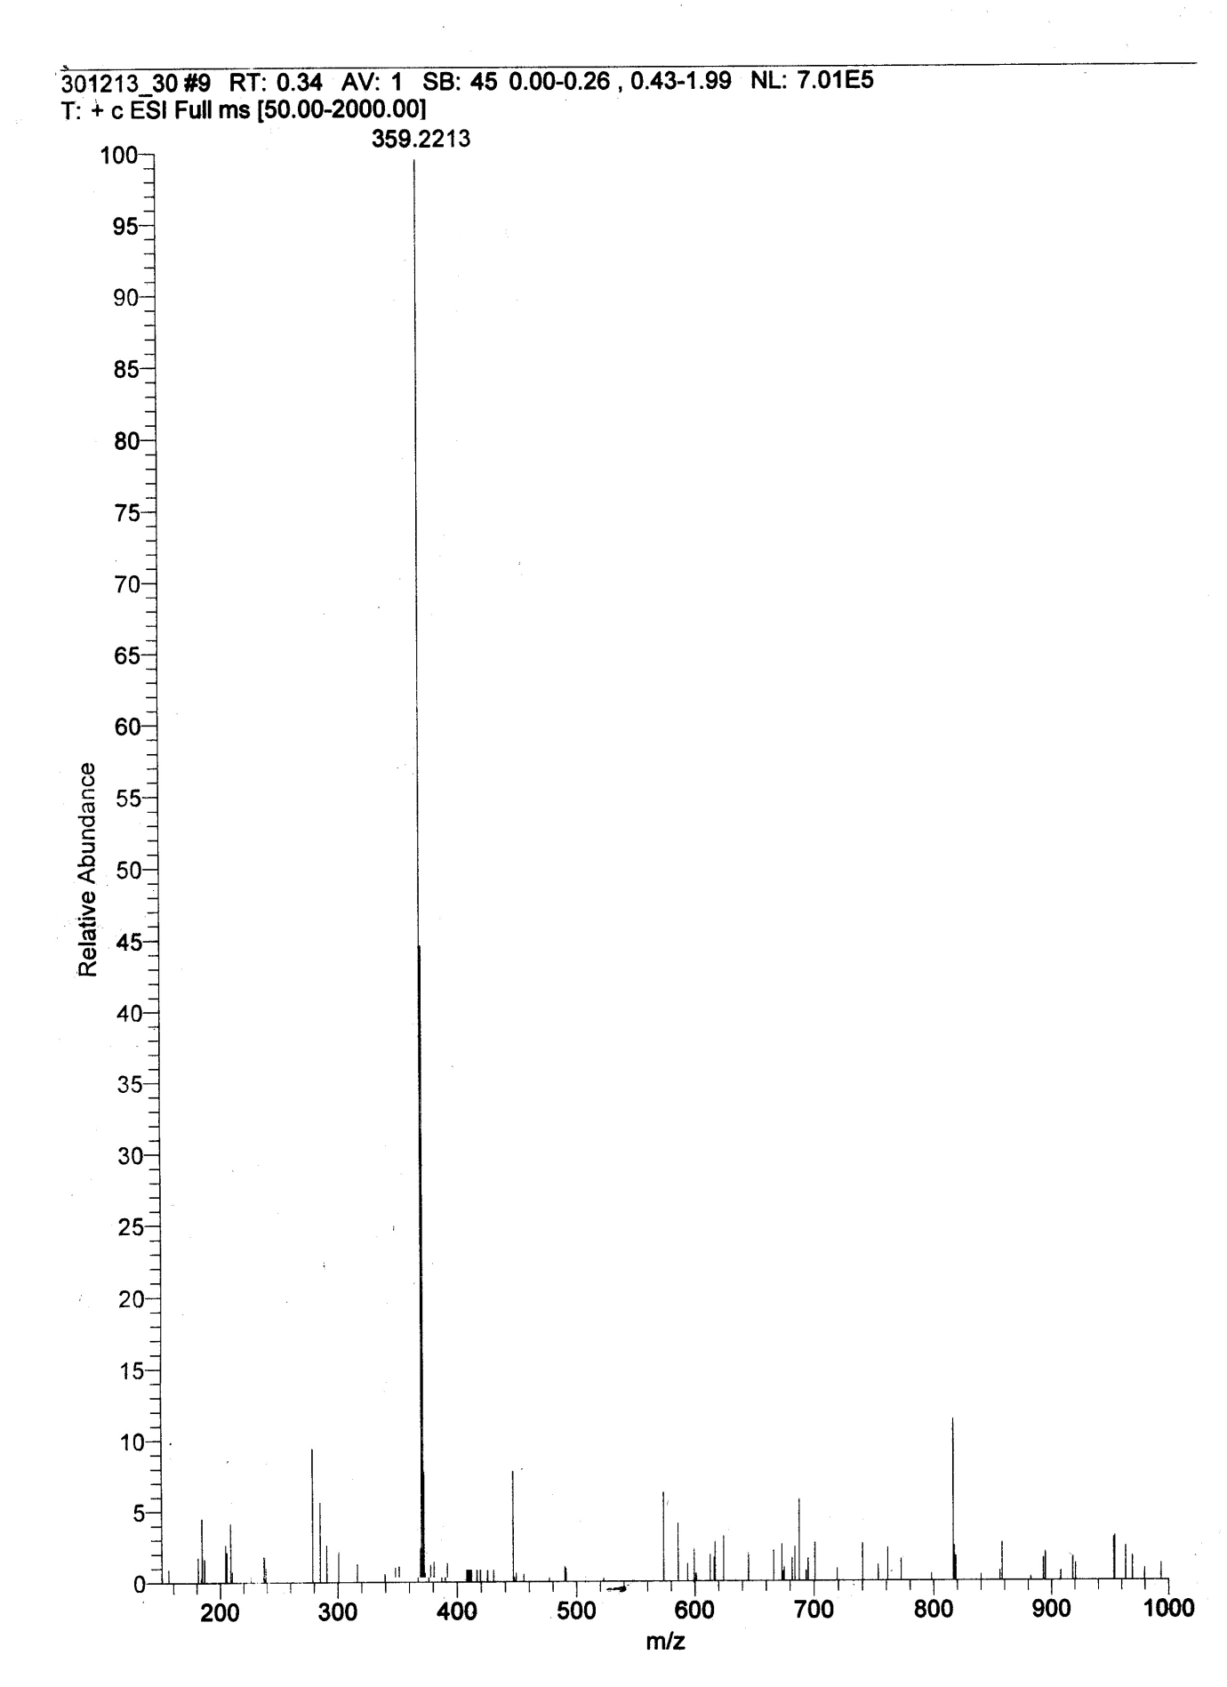
Figure S31. HRMS of compound 7a

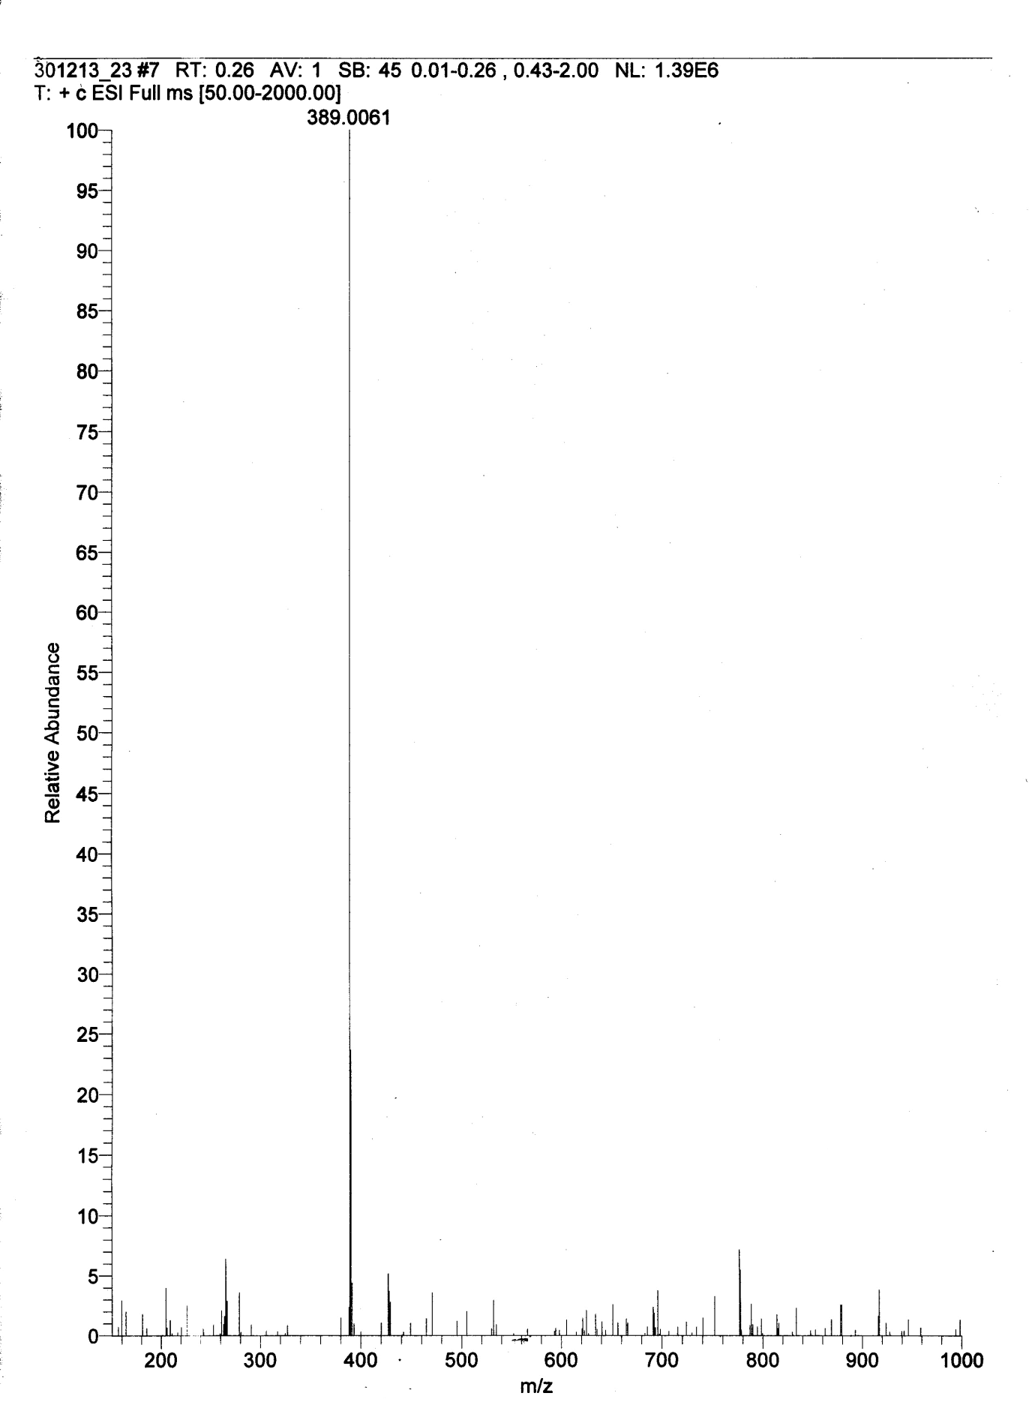
Figure S32. HRMS of compound 7b
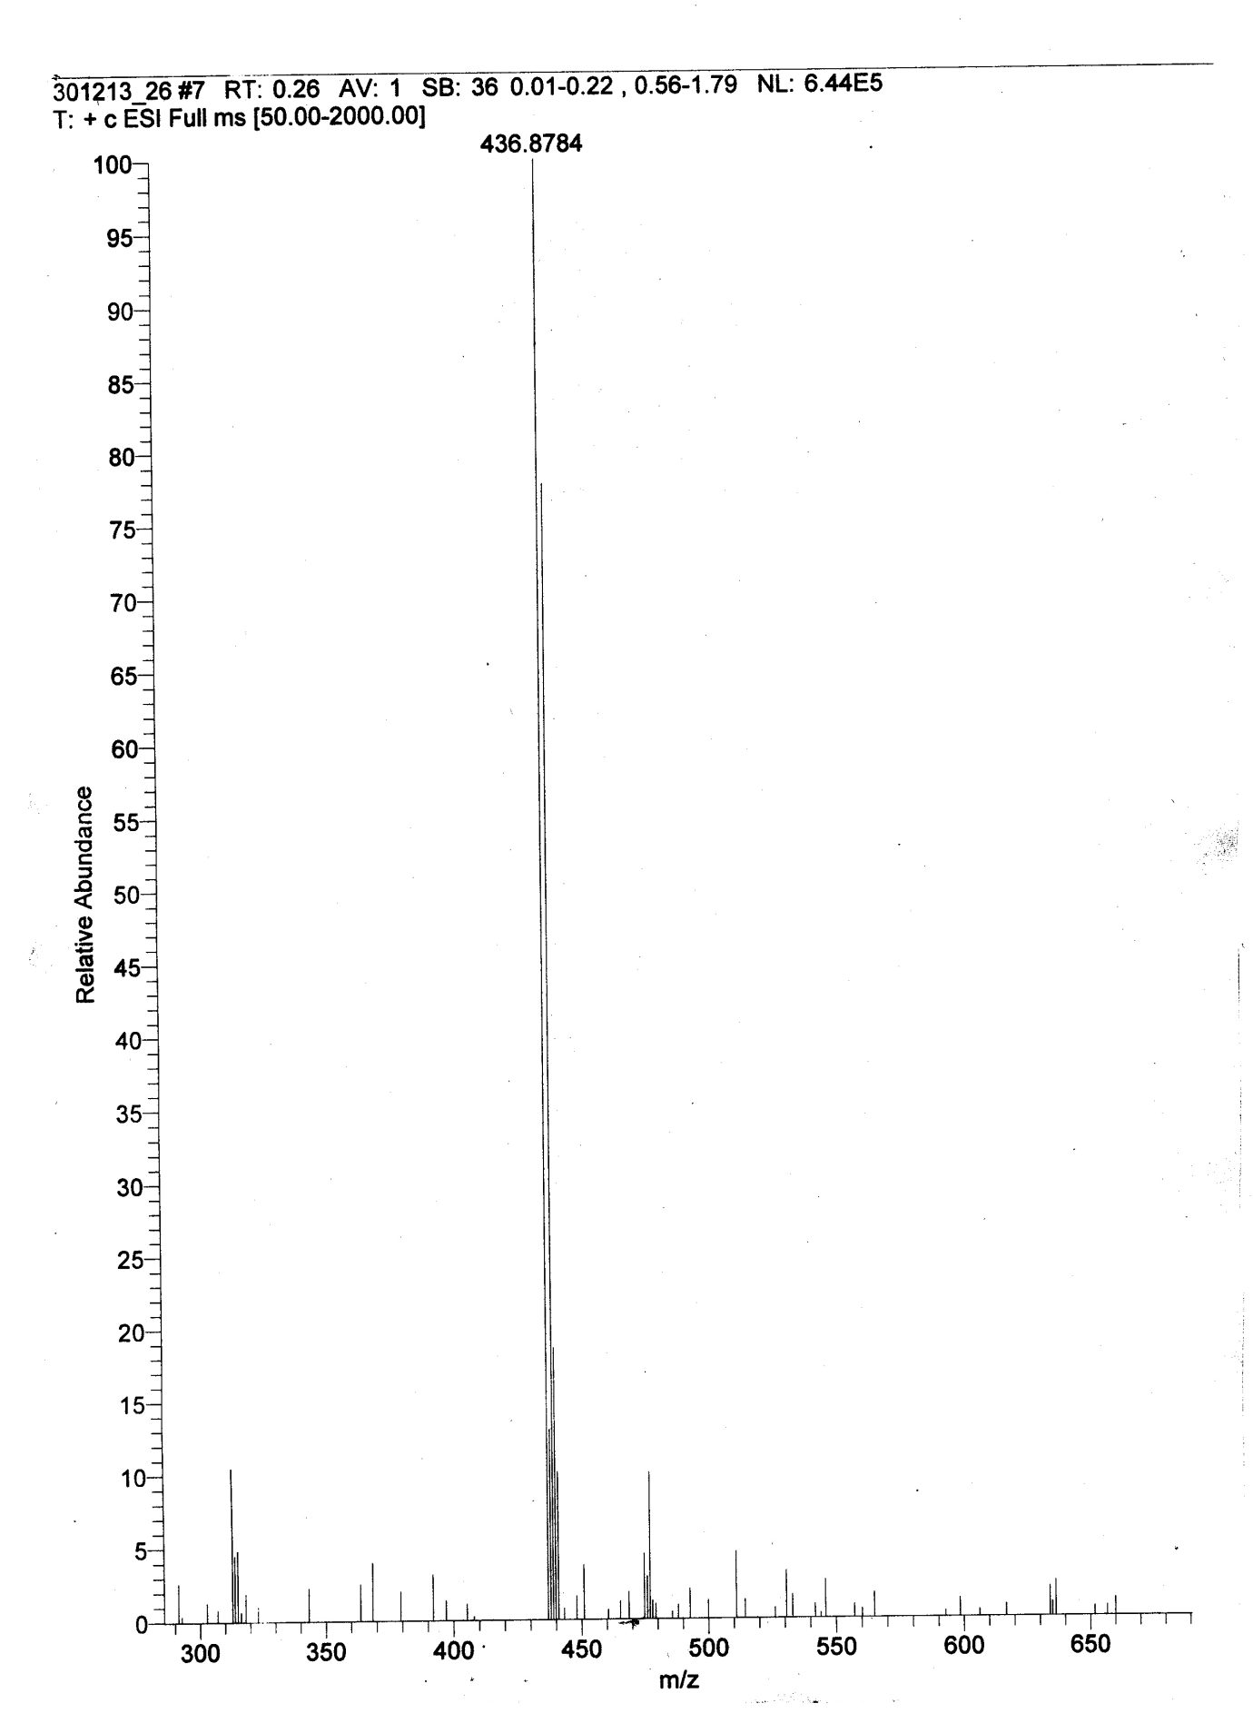
Figure S33. HRMS of compound 7c
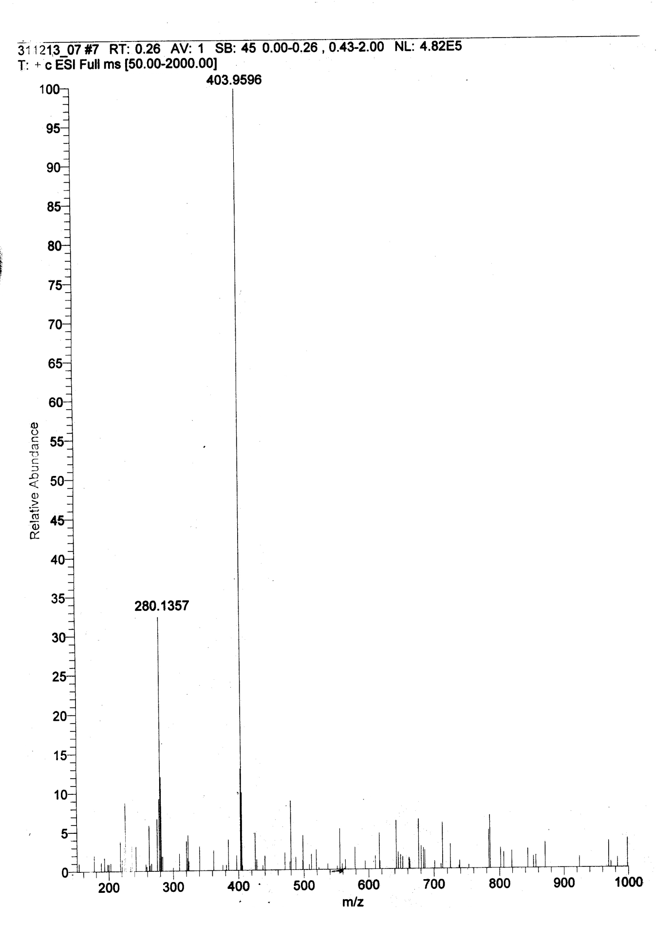
Figure S34. HRMS of compound 7d
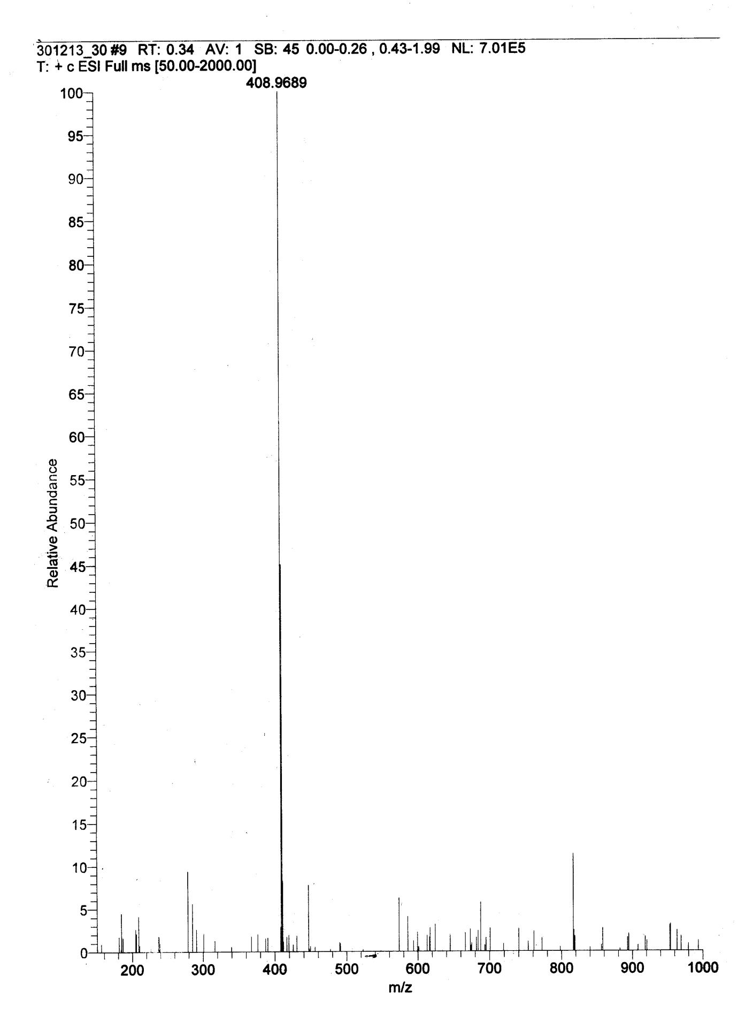
Figure S35. HRMS of compound 7e
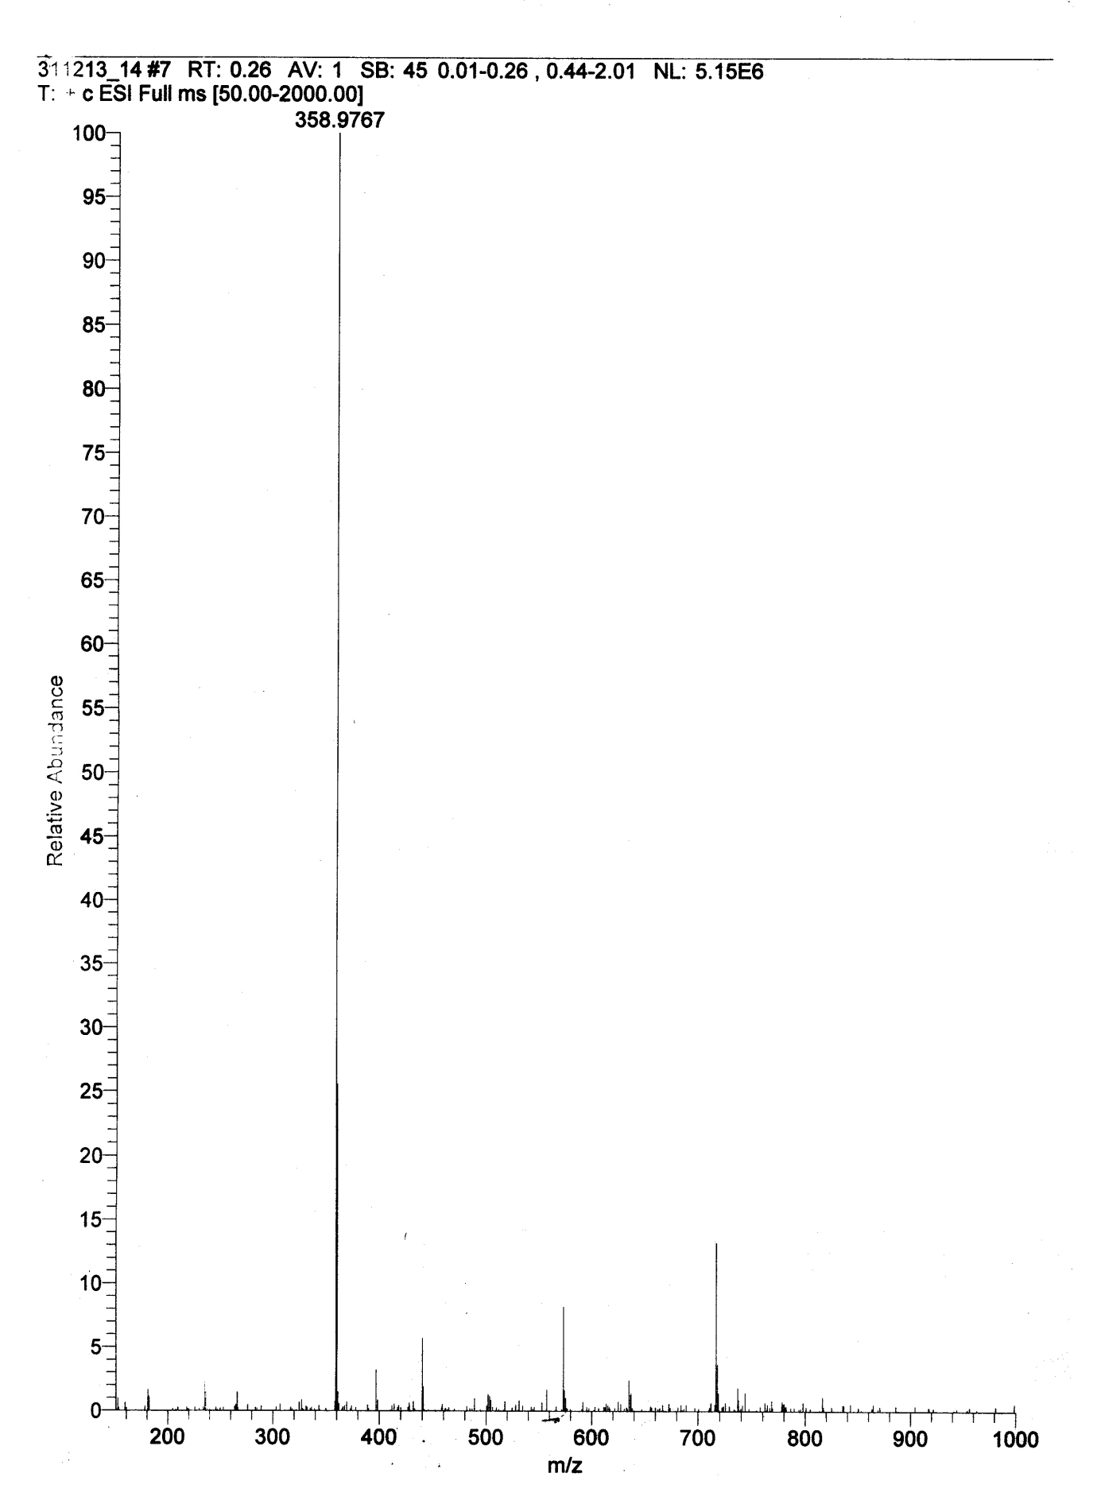
Figure S36. HRMS of compound 10a
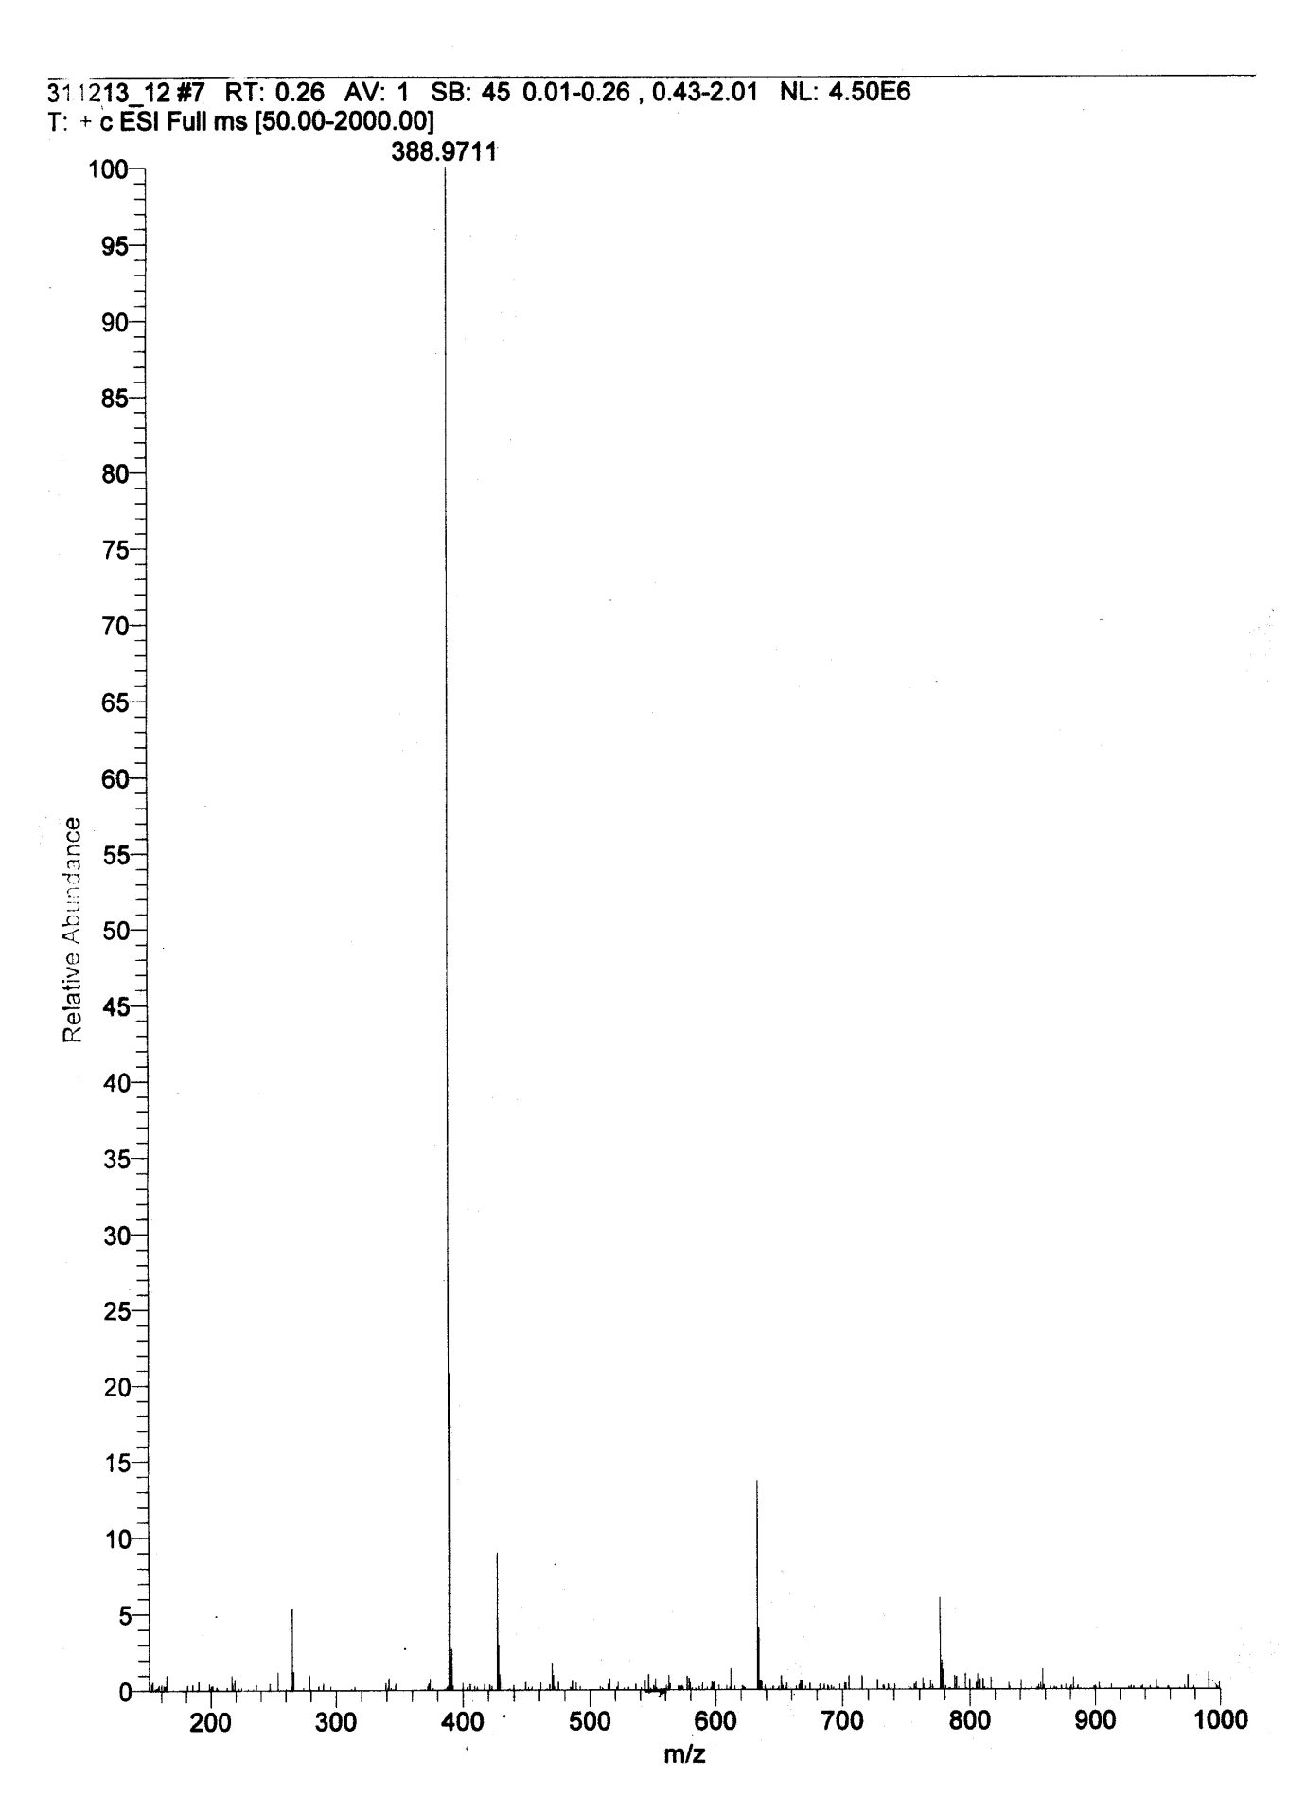
Figure S37. HRMS of compound 10b
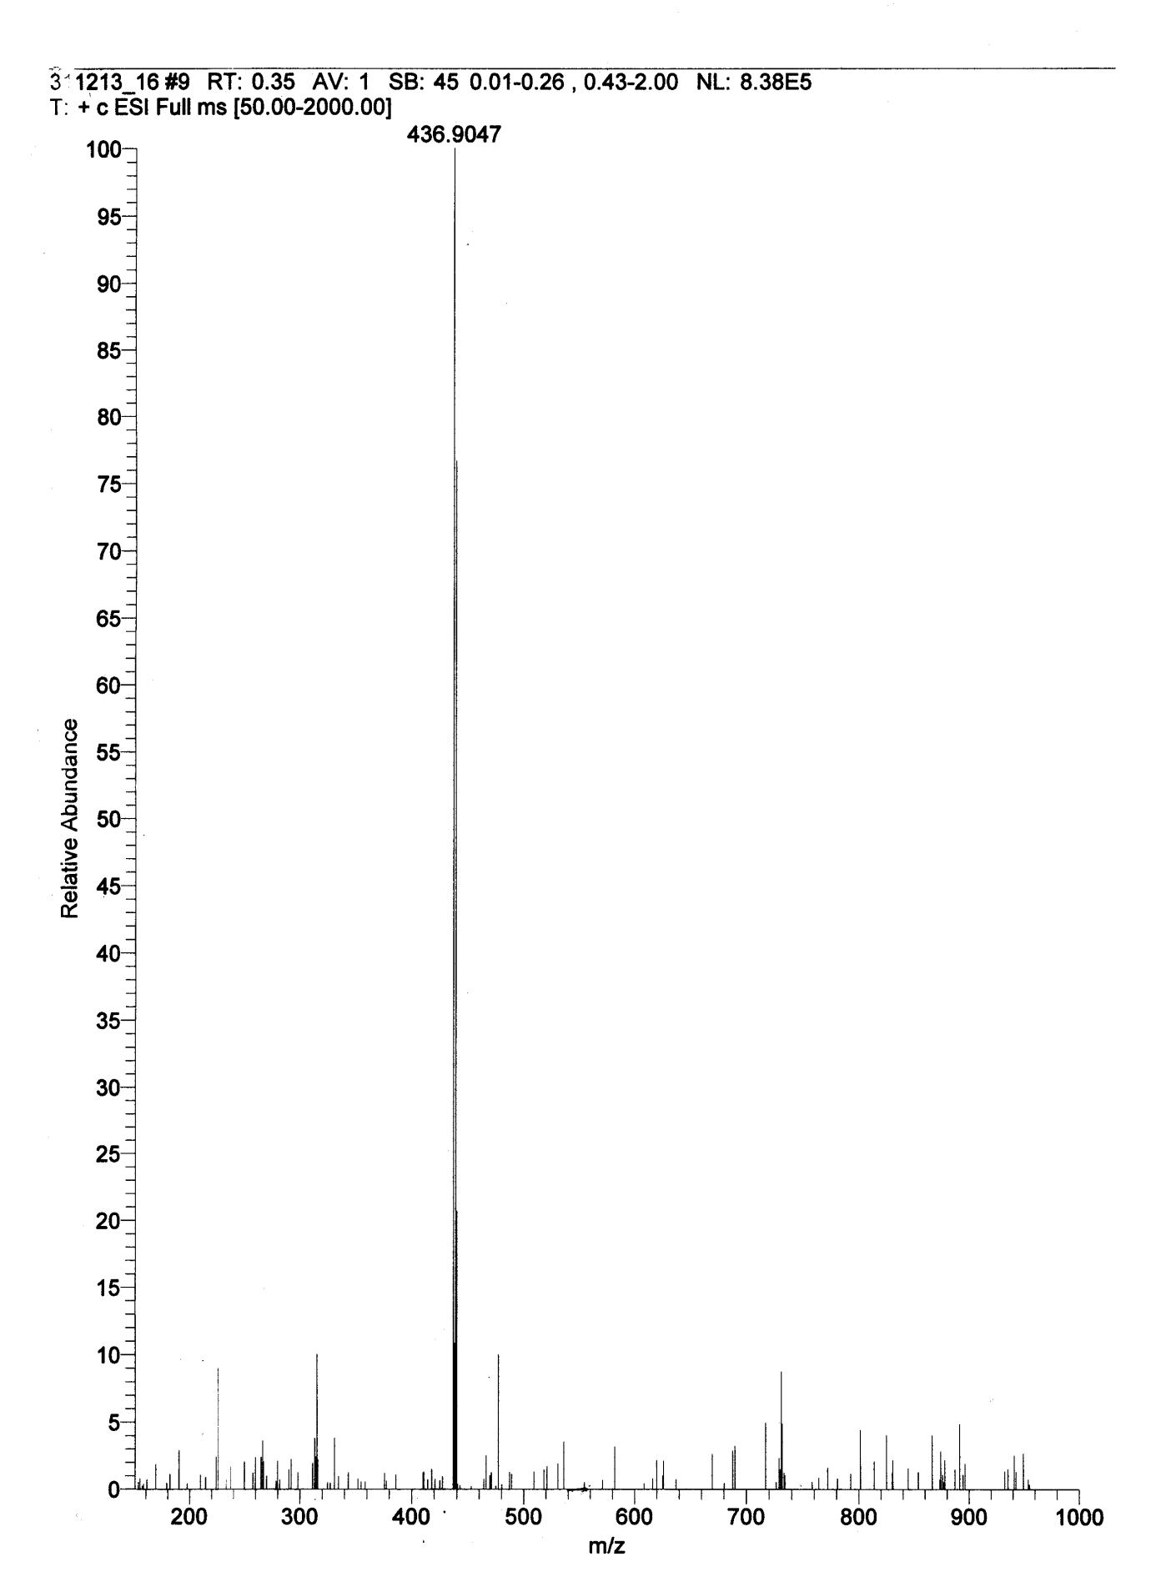
Figure S38. HRMS of compound 10c
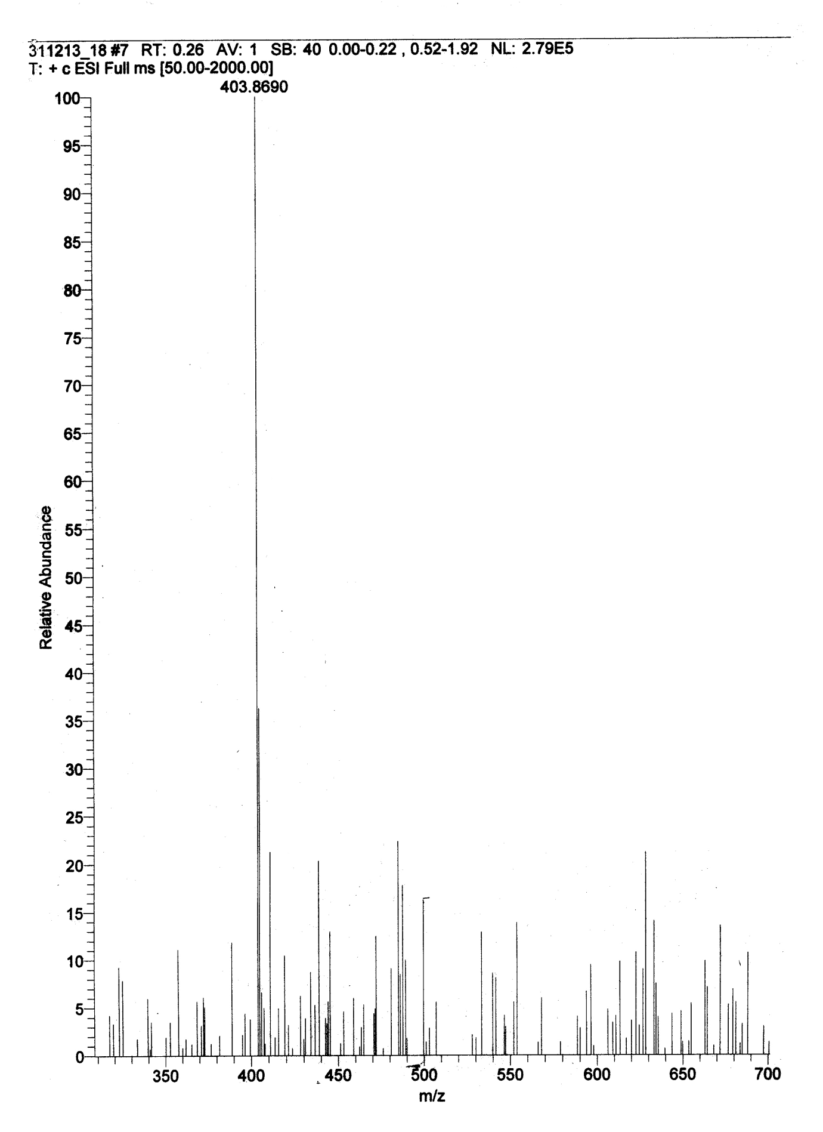
Figure S39. HRMS of compound 10d
Figure S40. HRMS of compound 10e
Figure S41. HRMS of compound 13a
Figure S42. HRMS of compound 13b
Figure S43. HRMS of compound 13c
Figure S44. HRMS of compound 13d
Figure S45. HRMS of compound 13e

