TABLE CAPTIONS
Table S1- The calculated activation energies (ΔE# / kJ mol⁻¹), activation free energies (∆G# / kJ mol⁻¹) and reaction energies (∆E_{r} / kJ mol⁻¹), of I-DA reaction between phenyl (pyridin-2-yl methylene) oxonium 1 and styrene derivatives 2a-c for the meta pathways of concerted mechanism at the B3LYP/cc-pVDZ level of theory

Table S2- The calculated activation energies (ΔE# / kJ mol⁻¹), activation free energies (∆G# / kJ mol⁻¹) and reaction energies (∆E_{r} / kJ mol⁻¹), of I-DA reaction between phenyl (pyridin-2-yl methylene) oxonium 1 and styrene 2a for the meta pathway of stepwise mechanism at the B3LYP/cc-pVDZ level of theory

Table S3- The selected geometrical parameters, bond lengths (r / Ǻ) and dihedral angles (φ / °) for stationary points of I-DA reactions between phenyl (pyridin-2-yl methylene) oxonium 1 and styrene derivatives (2b-c) for the ortho pathway of stepwise mechanism at the B3LYP/cc-pVDZ level of theoryª

Table S1
Entry |  | Species | TS | ∆E# | ∆G# | ∆Er
1 | 1+2a→5a |  | TS5a | 42.10 | 101.98 | -89.21
2 | 5a →9a |  | TS6a | -61.92 | 2.16 | -254.62
3 | 1+2a→6a |  | TS7a | 59.85 | 117.45 | -84.87
4 | 6a →10a |  | TS8a | -43.85 | 21.62 | -241.98
5 | 1+2b→5b |  | TS5b | 50.98 | 111 | -80.93
6 | 5b →9b |  | TS6b | -62.38 | 2.31 | -256.04
7 | 1+2b→6d |  | TS7b | 68.55 | 126.43 | -75.79
8 | 6b →10b |  | TS8b | -44.90 | 20.65 | -242.68
9 | 1+2c→5c |  | TS5c | 37.97 | 96.41 | -92.27
10 | 5c →9c |  | TS6c | -48.40 | 2.39 | -254.35
11 | 1+2c→6c |  | TS7c | 54.88 | 111.55 | -88.39
12 | 6c →10c |  | TS8c | -43.47 | 22.10 | -241.43

Table S2
Entry |  | Species | TS | ∆E# | ∆G# | ∆Er
1 | 1+2a→17a |  | TS9a | 66.77 | 121.98 | 57.28
2 | 17a →18a |  | TS10a | 81.02 | 148.80 | 31.15
3 | 18a →19a |  | TS11a | 127.76 | 183.13 | 79.58
4 | 19a →5a |  | TS12a | 88.24 | 152.18 | -89.21
5 | 1+2a→20a |  | TS13a | 39.94 | 93.37 | 40.62
6 | 20a →21a |  | TS14a | 103.17 | 164.94 | 22.46
7 | 21a →22a |  | TS15a | 105.64 | 167.21 | 39.57
8 | 22a →6a |  | TS16a | 50.77 | 116.45 | -84.87

Table S3
Species | φ_{OC1C5C6} | r_{C1O} | r_{C3C4} | r_{C4C6} | r_{C5C6}
TS9b | 67.44 | 1.31 | 1.39 | 4.90 | 1.37
11b | 53.36 | 1.41 | 1.39 | 5.09 | 1.47
TS10b | 116.22 | 1.43 | 1.39 | 5.74 | 1.48
12b | 172.18 | 1.41 | 1.40 | 5.22 | 1.46
TS11b | 115.02 | 1.44 | 1.39 | 4.92 | 1.46
13b | 43.60 | 1.41 | 1.39 | 4.79 | 1.47
TS12b | 65.23 | 1.45 | 1.44 | 2.51 | 1.48
3b | 28.65 | 1.48 | 1.47 | 1.58 | 1.55
TS2b | 52.82 | 1.46 | 1.45 | 1.55 | 1.53
7b | 62.10 | 1.43 | 1.40 | 1.52 | 1.54
TS13b | 65.09 | 1.30 | 1.39 | 4.53 | 1.37
14b | 60.55 | 1.41 | 1.39 | 5.14 | 1.47
TS14b | 120.21 | 1.42 | 1.39 | 5.52 | 1.47
15b | 177.45 | 1.40 | 1.40 | 4.43 | 1.46
TS15b | 119.65 | 1.40 | 1.40 | 4.76 | 1.46
16b | 43.12 | 1.41 | 1.39 | 4.78 | 1.47
TS16b | 43.55 | 1.45 | 1.44 | 2.49 | 1.49
4b | 53.23 | 1.47 | 1.49 | 1.55 | 1.54
TS4b | 51.02 | 1.45 | 1.49 | 1.55 | 1.53
8b | 53.23 | 1.43 | 1.40 | 1.52 | 1.54
TS9c | 67.52 | 1.30 | 1.39 | 4.94 | 1.37
11c | 54.23 | 1.41 | 1.39 | 5.08 | 1.47
TS10c | 116.64 | 1.43 | 1.39 | 5.73 | 1.48
12c | 172.95 | 1.41 | 1.40 | 5.21 | 1.46
TS11c | 115.54 | 1.44 | 1.39 | 4.90 | 1.46
13c | 47.52 | 1.42 | 1.40 | 4.65 | 1.47
TS12c | 64.26 | 1.45 | 1.44 | 2.51 | 1.48
3c | 26.75 | 1.48 | 1.47 | 1.58 | 1.55
TS2c | 47.01 | 1.46 | 1.48 | 1.58 | 1.55
7c | 62.58 | 1.43 | 1.40 | 1.52 | 1.54
TS13c | 67.44 | 1.29 | 1.39 | 4.55 | 1.37
14c | 60.21 | 1.41 | 1.39 | 5.15 | 1.47
TS14c | 120.01 | 1.42 | 1.39 | 5.52 | 1.47
15c | 176.06 | 1.41 | 1.39 | 4.90 | 1.46
TS15c | 119.20 | 1.40 | 1.40 | 4.76 | 1.46
16c | 46.09 | 1.43 | 1.40 | 4.59 | 1.46
TS16c | 44.52 | 1.45 | 1.44 | 2.35 | 1.49
4c | 53.23 | 1.47 | 1.49 | 1.55 | 1.54
TS4c | 51.86 | 1.45 | 1.49 | 1.56 | 1.53
8c | 53.25 | 1.43 | 1.40 | 1.52 | 1.54
ªFor numbering of atoms, see Scheme 2.

FIGURE CAPTION
Figure S1- The geometrical optimized of transition states and intermediates for meta pathways of the I-DA reactions between phenyl (pyridin-2-yl methylene) oxonium (1) and styrene derivatives (2a-c) via concerted mechanism at the B3LYP/6-31G level of theory. Bond distances are given in Å, wiberg bond indices are given in parenthesis and the natural charges (CT) of TSs are also given

 |  | 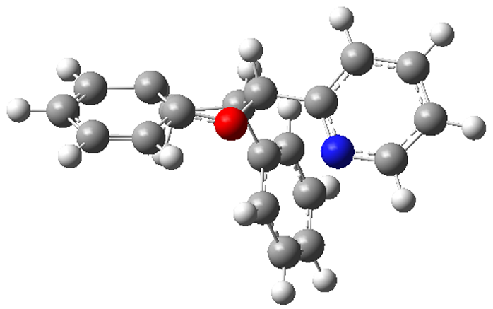
TS7a, (CT=0.206) | TS6a | 5a | TS5a, (CT=0.198)
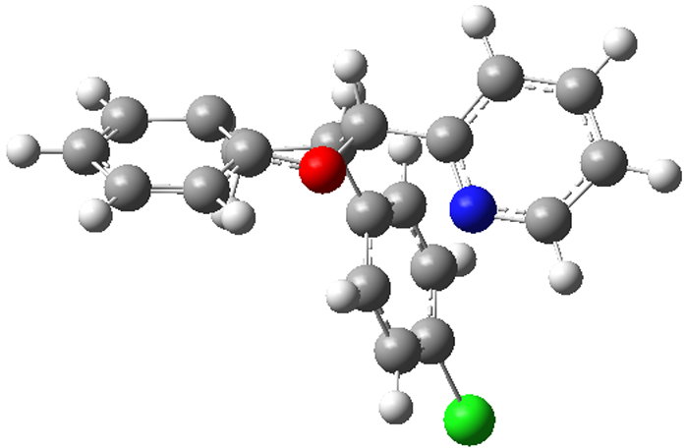 |  |  | 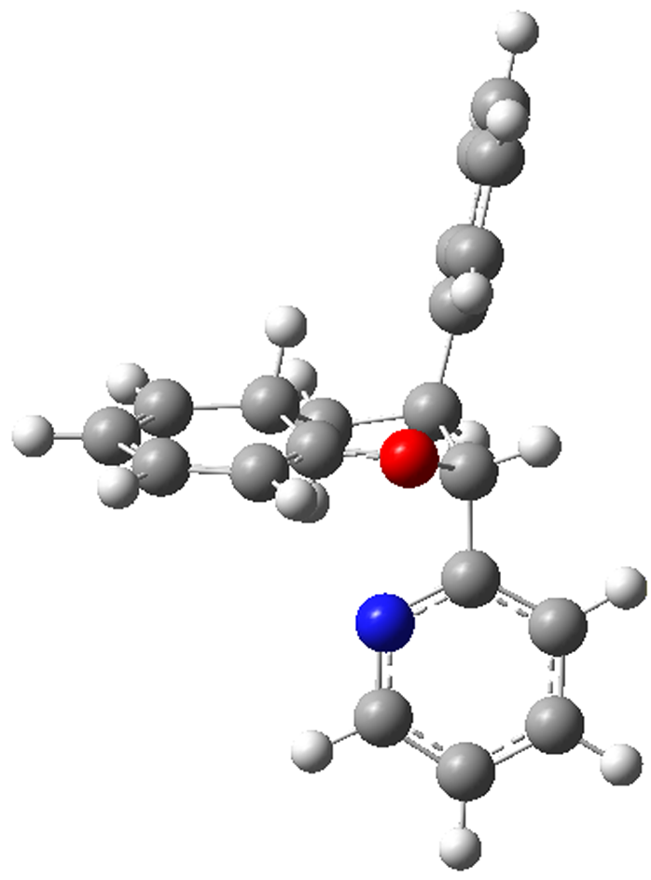
5b | TS5b, (CT=0.195) | TS8a | 6a
 | 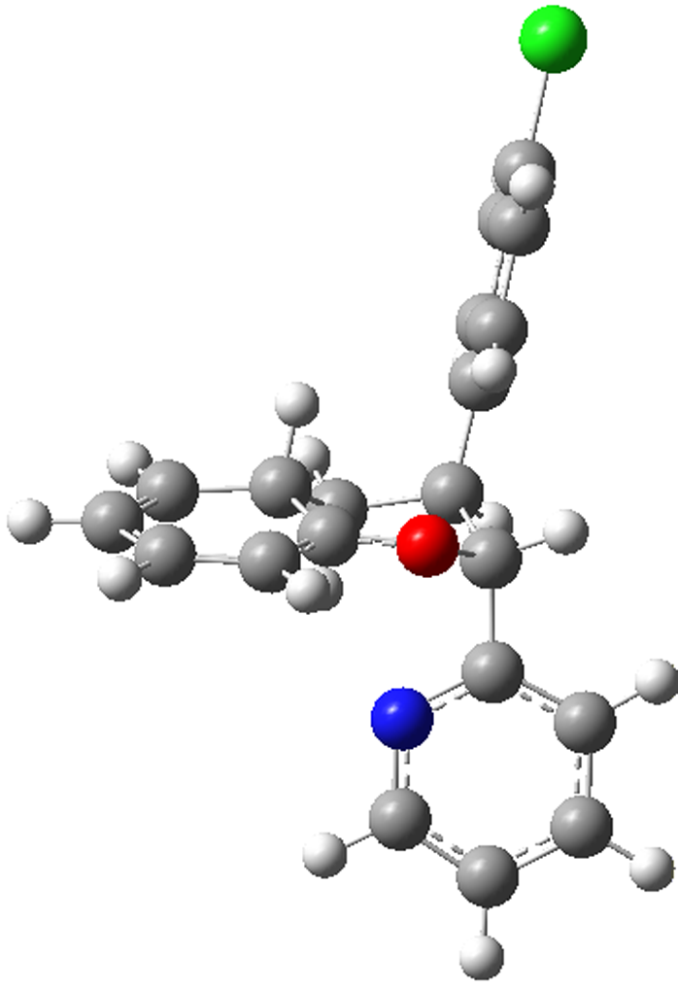
TS8b | 6b | TS7b, (CT=0.205) | TS6b
 |  | 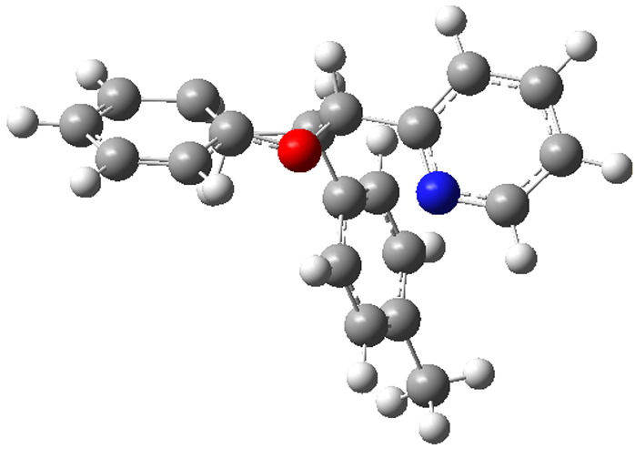
TS7c, (CT=0.214) | TS6c | 5c | TS5c, (CT=0.202)
 |  | 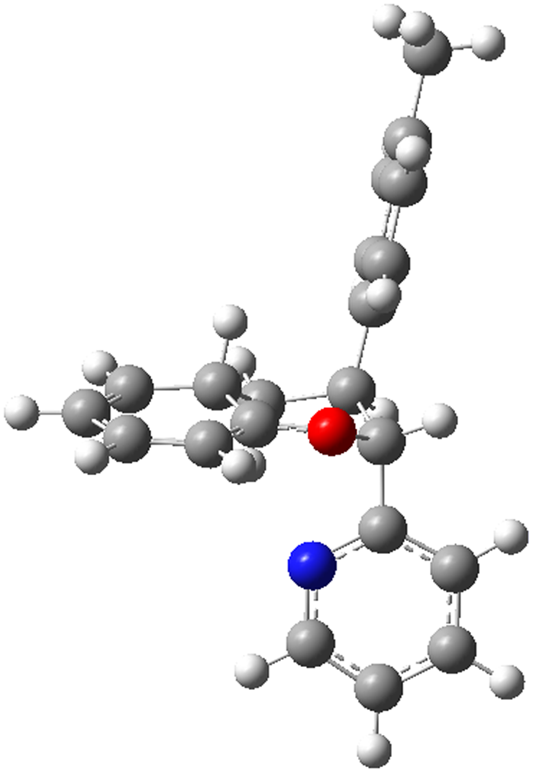
 | TS8c | 6c  Figure S1

