SUPPLEMENTARY MATERIAL TO
Hindered phenolic aminothiazoles – Synthesis, α-glucosidase, α-amylase inhibitory and antioxidant activities
Vyjayanthy Satheesh Sandhya, Vijayan Radha Akhila, Krishnan Nair Girija Krishnapriya, Kallikat Narayanan Rajasekharan, Maheswari Priya Rani*
Department of Chemistry, University of Kerala, Kariavattom Campus, Trivandrum, Kerala, 695581, India

Analytical and Spectral data of the synthesised compounds
4-Amino-5-(3,5-di-t-butyl-4-hydroxybenzoyl)-2-phenylaminothiazole (5a). Method A: Yield 360 mg (85 %); Method B: Yield 390 mg (93 %). yellow crystals m.p.: 135-136 $°$C. IR (KBr, cm⁻¹): 3739m, 3617m, 3433m, 2958m, 1700s, 1532s, 1428s, 1308m, 1238s, 1109m, 759w, 683w. ¹H NMR (400 MHz, CDCl₃, δ): 8.78 (s, 1H, NH), 7.66 (s, 2H, ArH), 7.36 (d, 4H, J = 5.6 Hz, ArH), 7.13-7.16 (m, 1H, ArH), 5.51 (s, 1H, ArOH), 1.43 (s, 18H, Me). ¹³C NMR (100 MHz, CDCl₃, δ): 185.5 (C=O), 168.9 (thiazole C), 164.1 (thiazole C), 156.4 (C-OH), 138.7 (Ar-C), 135.6 (Ar-C), 132.5 (Ar-C), 129.6 (Ar-C), 125.0 (Ar-C), 124.9 (Ar-C), 120.1 (Ar-C), 34.5 (t-Bu), 30.2 (t-Bu). (+)ESI-HRMS (m/z): calculated for [C₂₄H₂₉N₃O₂S + H]⁺ 424.20587, observed 424.20619. Combustion analysis for C₂₄H₂₉N₃O₂S: Calculated. C 68.05, H 6.90, N 9.02; found C 68.21, H 6.65, N 9.19.
4-Amino-5-(3,5-di-t-butyl-4-hydroxybenzoyl)-2-(4-methoxyphenylamino)thiazole (5b). Method A: Yield 281 mg (62 %); Method B: Yield 326 mg (72 %). orange crystals m.p.: 130-132 $°$C. IR (KBr, cm⁻¹): 3738m, 3615m, 3432w, 2924m, 1743m, 1520s, 1463s, 1304m, 1242s, 1110m, 1026m, 832w, 763w. ¹H NMR (400 MHz, CDCl₃, δ): 7.62 (s, 2H, ArH), 7.30 (d, 2H, J = 8.8 Hz, ArH), 6.89 (d, 2H, J = 8.8 Hz, ArH), 5.49 (s, 1H, ArOH), 3.81 (s, 3H, -OMe), 1.45 (s, 18H, Me). ¹³C NMR (100 MHz, CDCl₃, δ): 185.3 (C=O), 170.6 (thiazole C), 164.4 (thiazole C), 157.5 (C-OH), 156.3 (C-OCH₃), 135.5 (Ar-C), 132.6 (Ar-C), 131.5 (Ar-C), 124.9 (Ar-C), 123.4 (Ar-C), 114.8 (Ar-C), 55.6 (CH₃), 34.5 (t-Bu), 30.2 (t-Bu). FABMS (Thioglycerol matrix) (m/z): calculated for [C₂₅H₃₁N₃O₃S]⁺ 453.20, observed 453.74. Combustion analysis for C₂₅H₃₁N₃O₃S: Calculated. C 66.20, H 6.89, N 9.26; found C 66.32, H 7.04, N 9.18.
4-Amino-5-(3,5-di-t-butyl-4-hydroxybenzoyl)-2-(4-chlorophenylamino)thiazole (5c). Method A: Yield 288 mg (59 %); Method B: Yield 366 mg (80 %). yellowish orange crystals m.p.: 131-133$°$C. IR (KBr, cm⁻¹): 3611w, 3345w, 2925m, 1741m, 1542s, 1488s, 1211s, 1099m, 1019m, 825w. ¹H NMR (400 MHz, CDCl₃, δ): 8.72 (s, 1H, NH), 7.65 (s, 2H, ArH), 7.35 (d, 2H, J = 8.8 Hz, ArH), 7.27 (d, 2H, J = 4.8 Hz, ArH), 5.52 (s, 1H, ArOH), 3.72 (q, 2H, J = 8.75 Hz, -CH₂, solvent of crystallisation), 1.42 (s, 18H, Me), 1.24 (t, 3H, J = 8.75, -CH₃, solvent of crystallisation). ¹³C NMR spectrum (100 MHz, CDCl₃, δ): 185.6 (C=O), 168.2 (thiazole C), 164.2 (thiazole C), 156.5 (C-OH), 137.4 (Ar-C), 135.7 (Ar-C), 132.4 (Ar-C), 129.5 (Ar-C), 129.4 (Ar-C), 125.0 (Ar-C), 121.0 (Ar-C), 58.5 (-CH₂, solvent of crystallisation), 34.5 (t-Bu), 30.2 (t-Bu), 18.4 (-CH₃, solvent of crystallisation). FABMS (Thioglycerol matrix) (m/z): calculated for [C₂₄H₂₈ClN₃O₂S]⁺ 457.16, observed 457.16. Combustion analysis for C₂₄H₂₈ClN₃O₂S: Calculated. C 62.94, H 6.16, N 9.17; found C 62.71, H 5.92, N 9.03.
4-Amino-5-(3,5-di-t-butyl-4-hydroxybenzoyl)-2-(4-methylphenylamino)thiazole (5d). Method A: Yield 232 mg (53 %); Method B: Yield 263 mg (60 %). yellow crystals m.p.: 123-125$°$C. IR (KBr, cm⁻¹): 3619m, 3288m, 2959s, 2871s, 1745m, 1562s, 1514s, 1433s, 1363s, 1237s, 1202s, 1159s, 1117s, 930w, 888m, 814m, 774m, 616w. ¹H NMR (400 MHz, CDCl₃, δ): 7.66 (s, 2H, ArH), 7.25 (d, 2H, J = 8.8 Hz, ArH), 7.17 (d, 2H, J = 8.4 Hz, ArH), 5.50 (s, 1H, ArOH), 3.72 (q, 2H, J = 9.5 Hz, -CH₂, solvent of crystallisation), 2.34 (s, 3H, Me), 1.45 (s, 18H, Me), 1.24 (t, 3H, J = 9.5 Hz, -CH₃, solvent of crystallisation). ¹³C NMR (100 MHz, CDCl₃, δ): 185.4 (C=O), 169.3 (thiazole C), 164.1 (thiazole C), 156.4 (C-OH), 135.9 (Ar-C), 135.6 (Ar-C), 135.0 (Ar-C), 132.6 (Ar-C), 130.1 (Ar-C), 124.9 (Ar-C), 120.5 (Ar-C), 58.5 (-CH₂, solvent of crystallisation), 34.5 (t-Bu), 30.2 (t-Bu), 20.9 (-CH₃), 18.4 (-CH₃, solvent of crystallisation). (+)ESI-HRMS (m/z): calculated for [C₂₅H₃₁N₃O₂S + H]⁺ 438.22152, observed 438.22227. Combustion analysis for C₂₅H₃₁N₃O₂S: Calculated. C 68.62, H 7.14, N 9.60; found C 68.70, H 6.99, N 9.46.
4-Amino-5-(3,5-di-t-butyl-4-hydroxybenzoyl)-2-(4-ethoxyphenylamino)thiazole (5e). Method A: Yield 248 mg (53 %); Method B: Yield 304 mg (65 %). yellow crystals m.p.: 123-125$°$C. IR (KBr, cm⁻¹): 3619m, 3282w, 2959m, 1730m, 1514s, 1305m, 1239s, 1168m, 1111m, 1064m, 892w, 830w, 768w. ¹HNMR (500 MHz, CDCl₃, δ): 8.11 (s, 1H, NH), 7.63 (s, 2H, ArH), 7.28-7.26 (m, 2H, ArH), 6.90-6.88 (m, 2H, ArH), 5.49 (s, 1H, ArOH), 4.03 (q, 2H, J = 7 Hz, -OCH₂), 1.66 (s, 18H, Me), 1.42 (t, 3H, J₁ = 7.5 Hz, Me). ¹³C NMR (125 MHz, CDCl₃, δ): 185.3 (C=O), 170.7 (thiazole C), 164.4 (thiazole C), 156.9 (C-OH), 156.3 (C-OC₂H₅), 135.5 (Ar-C), 132.6 (Ar-C), 131.2 (Ar-C), 124.9 (Ar-C), 123.5 (Ar-C), 115.3 (Ar-C), 63.8 (-OCH₂), 34.5 (t-Bu), 30.2 (t-Bu), 14.8 (-CH₃). FABMS (Thioglycerol matrix) (m/z): calculated for [C₂₆H₃₃N₃O₃S + H]⁺ 468.23, observed 469.00. Combustion analysis for C₂₆H₃₃N₃O₃S: Calculated. C 66.78, H 7.11, N 8.99; found C 66.63, H 6.89, N 8.91.

Spectra of compounds 5a-e

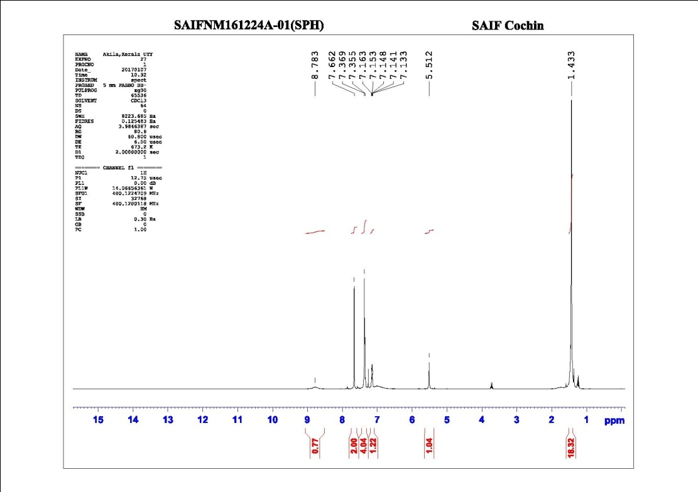
Figure I: ¹H NMR spectrum (400 MHz, CDCl₃) of 4-Amino-5-(3,5-di-t-butyl-4-hydroxybenzoyl)-2-phenylaminothiazole (5a)
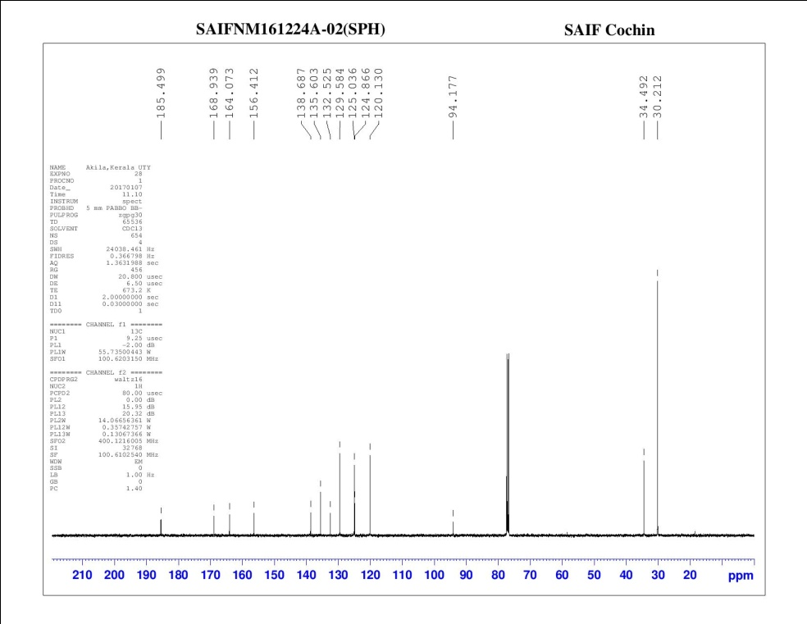
Figure II: ¹³C NMR spectrum (100 MHz, CDCl₃) of 4-Amino-5-(3,5-di-t-butyl-4-hydroxybenzoyl)-2-phenylaminothiazole (5a)
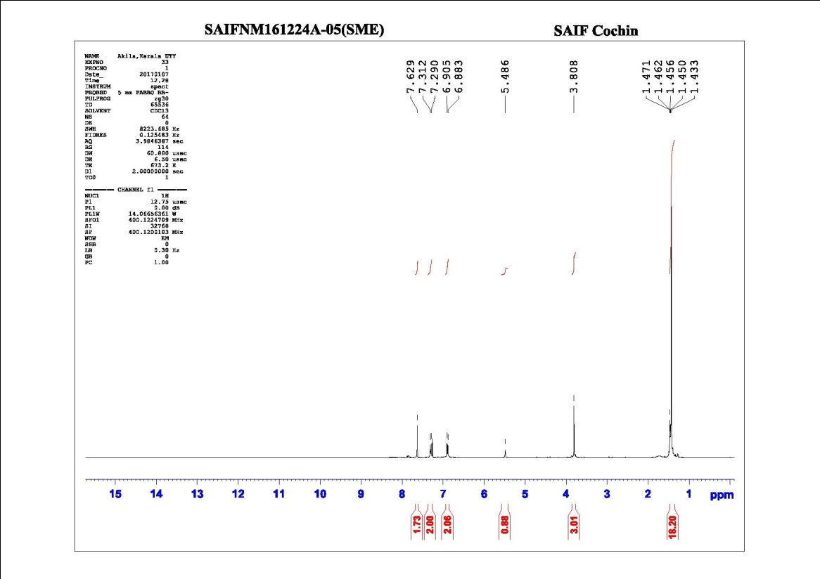
Figure III: ¹H NMR spectrum (400 MHz, CDCl₃) of 4-Amino-5-(3,5-di-t-butyl-4-hydroxybenzoyl)-2-(4-methoxyphenylamino)thiazole (5b)
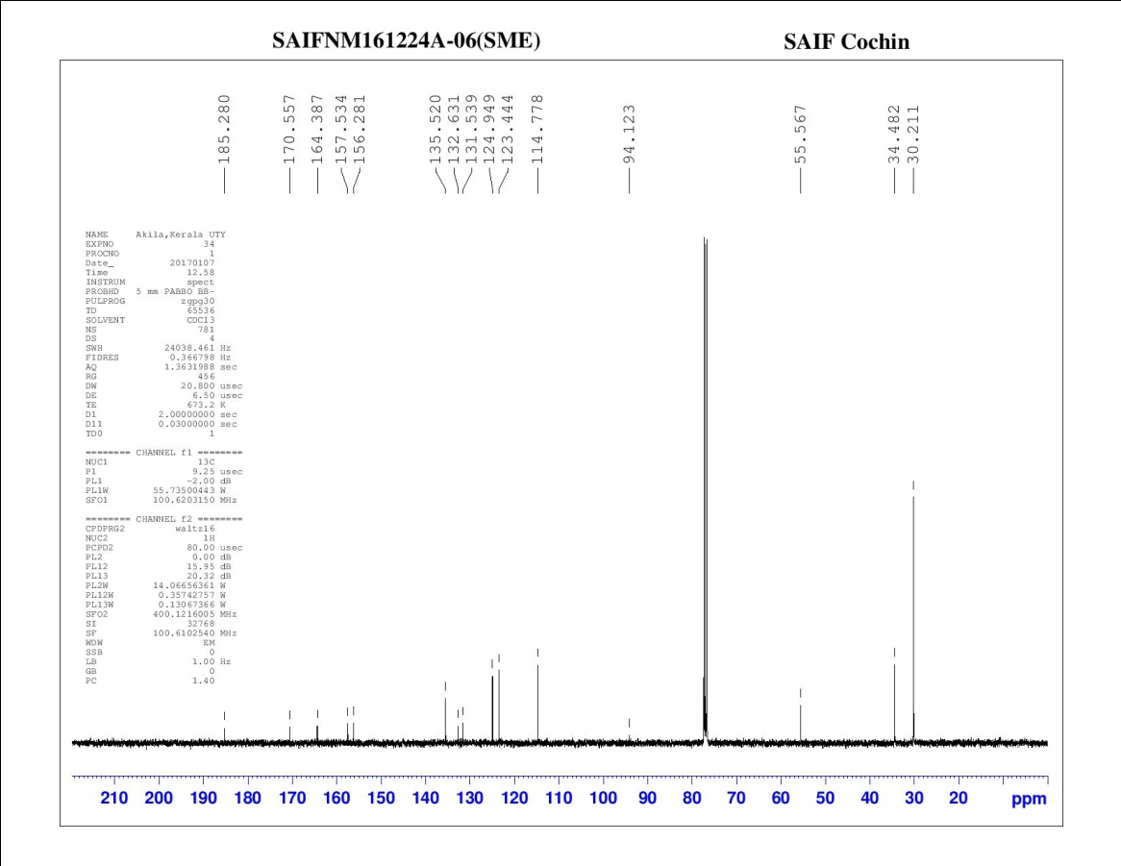
Figure IV: ¹³C NMR spectrum (100 MHz, CDCl₃) of 4-Amino-5-(3,5-di-t-butyl-4-hydroxybenzoyl)-2-(4-methoxyphenylamino)thiazole (5b)

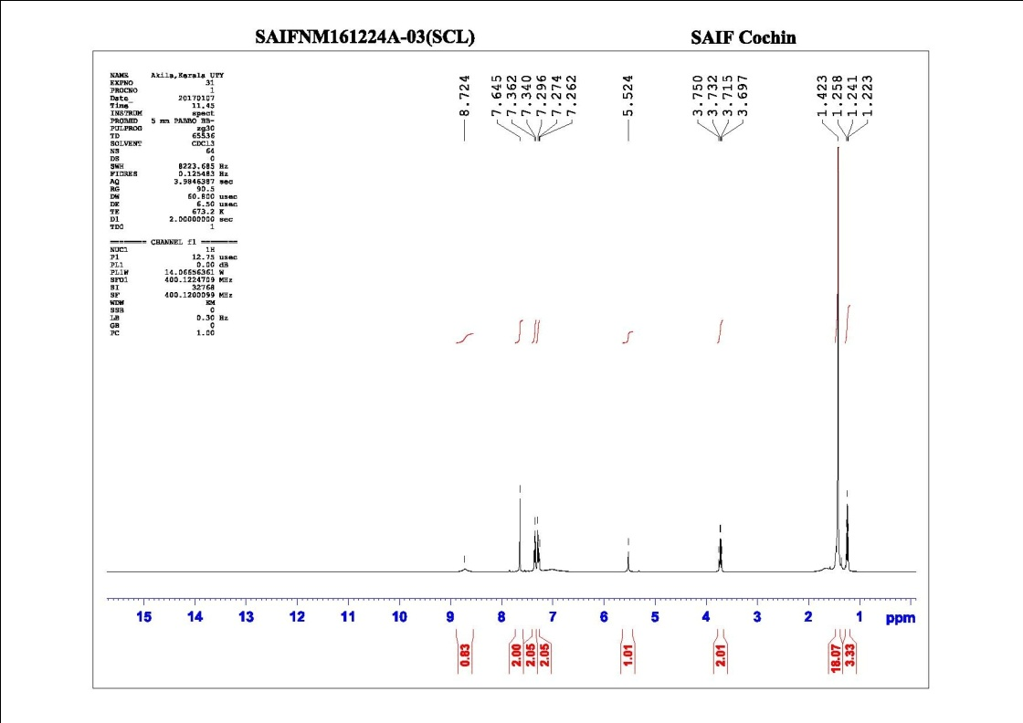
Figure V: ¹H NMR spectrum (400 MHz, CDCl₃) of 4-Amino-5-(3,5-di-t-butyl-4-hydroxybenzoyl)-2-(4-chlorophenylamino)thiazole (5c)
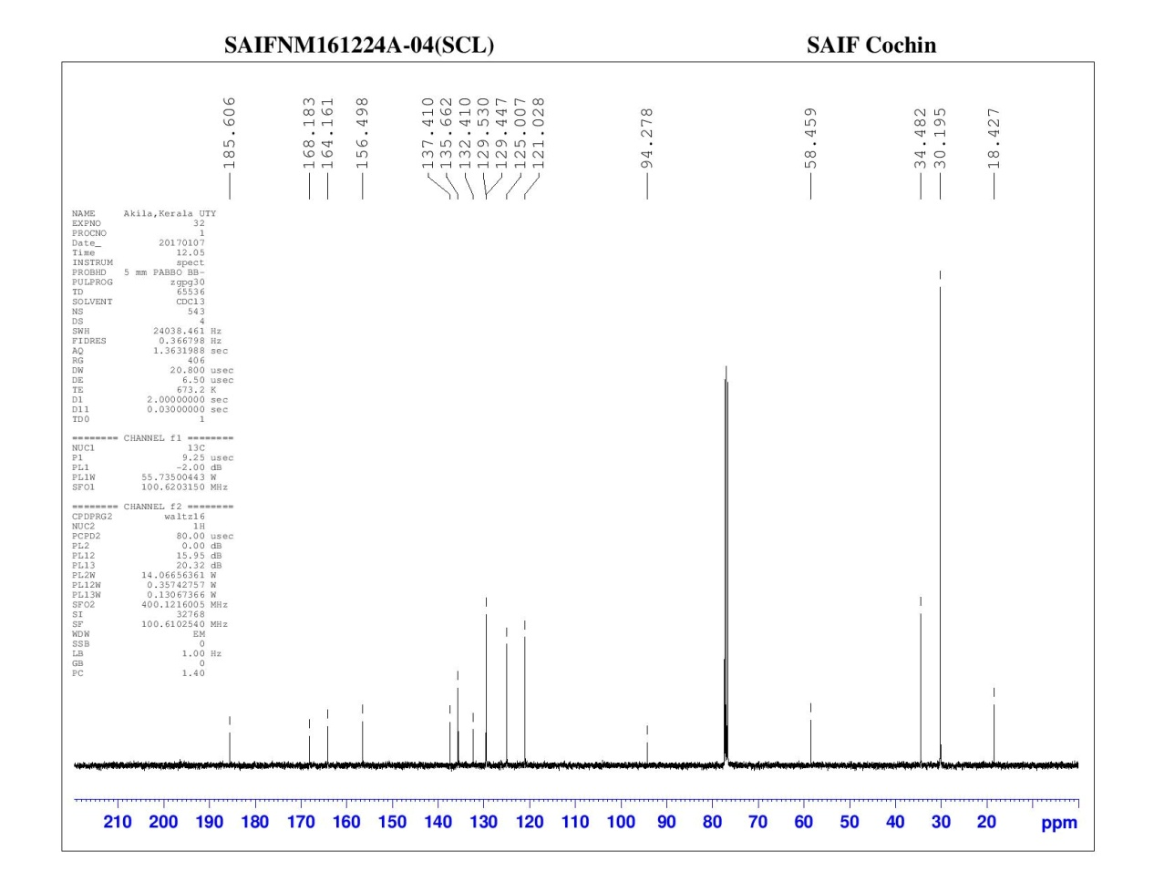
Figure VI: ¹³C NMR spectrum (100 MHz, CDCl₃) of 4-Amino-5-(3,5-di-t-butyl-4-hydroxybenzoyl)-2-(4-chlorophenylamino)thiazole (5c)
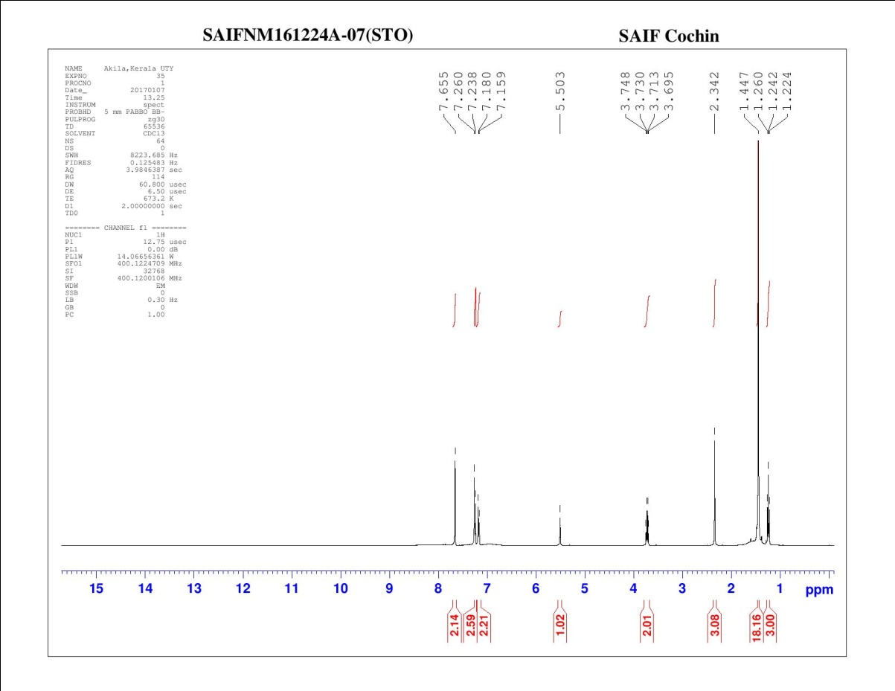
Figure VII: ¹H NMR spectrum (400 MHz, CDCl₃) of 4-Amino-5-(3,5-di-t-butyl-4-hydroxybenzoyl)-2-(4-methylphenylamino)thiazole (5d)
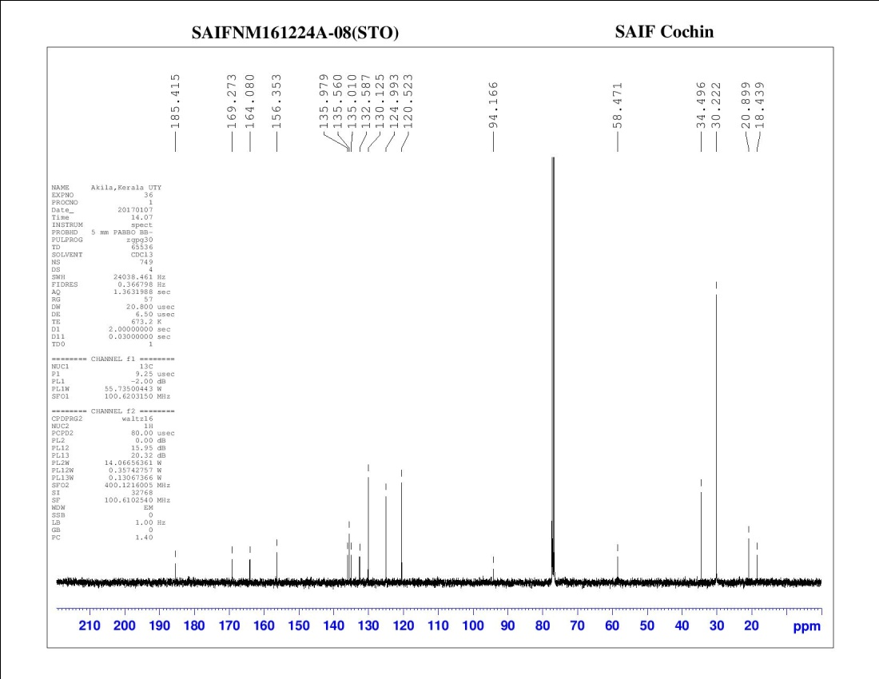
Figure VIII: ¹³C NMR spectrum (100 MHz, CDCl₃) of 4-Amino-5-(3,5-di-t-butyl-4-hydroxybenzoyl)-2-(4-methylphenylamino)thiazole (5d)
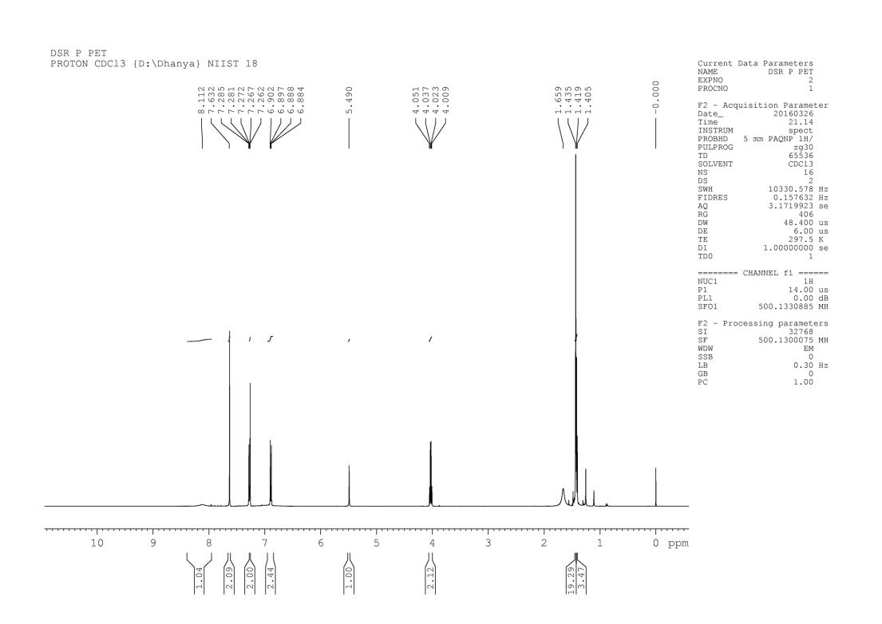
Figure IX: ¹H NMR spectrum (500 MHz, CDCl₃) of 4-Amino-5-(3,5-di-t-butyl-4-hydroxybenzoyl)-2-(4-ethoxyphenylamino)thiazole (5e)

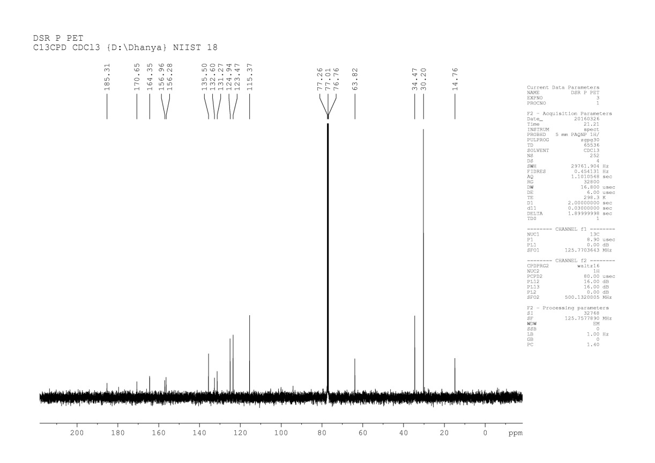

Figure X: ¹³C NMR spectrum (125 MHz, CDCl₃) of 4-Amino-5-(3,5-di-t-butyl-4-hydroxybenzoyl)-2-(4-ethoxyphenylamino)thiazole (5e)

