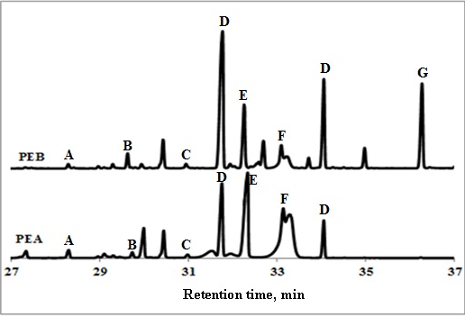

Fig.1. Monosaccharide chromatogram of polysaccharidic extracts of Isochrysis galbana (PEA) and Nannochloropsis oculata (PEB) determined by trimethylsilylation method. A: xylose; B: mannose; C: galactose; D: glucose; E: sorbitol; F: mannitol; G: inositol.

