Dr. Branislav Ž. Nikolić, Dr. Bojan RADAK
Editor in Chief Environmental Chemistry Sub-Editor
Serbian Chemical Society – JSCS Serbian Chemical Society – JSCS
4, Karnegijeva Street Department of Physical Chemistry
11120 Belgrade Vinča Institute of Nuclear Sciences
Serbia 11120 Belgrade
E-mail: JSCS-ed@shd.org.rs Serbia
E-mail: JSCS-EC@shd.org.rs

Belgrade, February 17, 2017

Dear Dr. Nikolić, dear Dr. Radak,

Enclosed please find the revised manuscript entitled “Characterisation of lignite lithotypes from the “Kovin” deposit (Serbia) – implications from petrographic, biomarker and isotopic analysis” by D. Mitrović, N. Đoković, D. Životić, A. Bechtel, O. Cvetković and K. Stojanović (Ref. No. 4198-GH).
Changes which have been made in the revised manuscript are indicated in red colour (new text added by the authors) and blue colour (the reviewers’ corrections). According to suggestion of Reviewer A, coloured markers in Figures 2, 3 and 6 are changed to be more appropriate for black/white printing.
On behalf of all authors I want to thank you very much. We are also grateful to the reviewers for comments and suggestions, which greatly improved this paper. We considered them carefully. All remarks were accepted and the manuscript was revised accordingly.
Restatements of issues raised by the reviewers, together with authors′ specific responses to the issues, are appended below.

Reviewer A

REPORT: Cilj rada bi trebalo jasnije naglasiti, kao i zbog cega su koje metode bile primenjene (koja problematika se zelela da resi). Ukoliko je razmatrana mogucnost (neresene ?) primene uglja iz Kovina, to je takodje trebalo potencirati, delom i u samom naslovu. S druge strane, neke od primenjenih metoda nemaju veze sa resavanjem problematike primene.....Videti primedbe u samom pdf-u. Prilaze se predlog korekcija u samom pdf-u. Na slikama 2, 3 i 6 bi trebalo napraviti jasniju razliku oznaka - ukoliko se ne stampaju u boji.

In my opinion, this manuscript should:
be published after minor revision without additional review

If manuscript is suitable for publishing, referees recommendation:
Original scientific paper

Comments of the Reviewer A marked in the attached annotated manuscript (pdf file)

Authors: All suggested changes and corrections in the attached manuscript file are accepted. In the revised manuscript these changes are indicated in blue colour. New text added by the authors is indicated in red colour.
Note: Pages and lines in responses correspond to your marked attached pdf. file of the previous submission of the manuscript.

Reviewer A (1): Page 1, Abstract: Nije jasno zasto se ovo komentarise ? Apstrakt bi trebalo jasnije napisati u smislu sta je bio cilj rada, koja je osnovna ideja i kako je to analizirano. Iz ovoga sledi da je cilj bio da se sagleda namena uglja ... Odmah zatim se prelazi na toplotnu vrednost.....sto opet nije jasno
Authors: The abstract was rewritten. The paper was aimed to determine the main maceral, biomarker and isotopic (δ¹³C) characteristics of four lignite lithotypes (matrix coal, xylite-rich coal, mixture of matrix and mineral-rich coal and mixture of matrix and xylite-rich coal) and to reconstruct their origin and depositional environment. Therefore, the title of the paper was not changed. The focus of the study was not addressed to investigate the practical applicability of Kovin lignites only; however maceral data from this sample set were used to access the most convenient utilization of each lithotype. Moreover, results of isotopic analysis were used for investigation of the influence of diagenetic alteration on δ¹³C signatures of biomarkers. Objectives of the manuscript are explained in more detail at the end of the Introduction Section: “The paper was aimed to determine the main maceral, biomarker and isotopic (δ¹³C) characteristics of four lignite lithotypes (matrix coal, xylite-rich coal, mixture of matrix and mineral-rich coal and mixture of matrix and xylite-rich coal). Lignite originating from the Kovin deposit was used as a substrate. Based on a comprehensive study, the sources of OM and depositional environment of 4 lignite lithotypes have been reconstructed. Alongside, data from maceral analysis were served for assessment of the most convenient utilization of each lithotype, whereas results of isotopic analysis were used for investigation of the influence of diagenetic alteration on δ¹³C signatures of biomarkers.”

Reviewer A (2): Page 2, Lines 56-63: Ovaj pasus bi po mom misljenju trebalo prebaciti na pocetak tj. da bude DRUGI pasus u Introduction-u.
Authors: This remark was accepted and text from the third paragraph was combined with the text from second paragraph.

Reviewer A (3): Page 2, Lines 71-76: Ovo bi po mom misljenju trebalo prebaciti da bude prvi pasus Introduction-a.
Authors: This remark could not be accepted, since according to author experience, the aims of the paper are usually clearly outlined at the end of Introduction Section.

Reviewer A (4): Page 3, Line 76: Zbog cega je razmatrana razlicita mogucnost primene uglja ? Pojasniti "racionalno koriscenje".
Authors: Applying literature data to results obtained from maceral analysis possible utilization of studied lithotypes was estimated. The term “rational utilization” represents the most convenient utilization.

Reviewer A (5): Page 3, Lines 80 and 86: Napisati ukratko kakva je reprezentativnost uzoraka tj. sta su oni obuhvatili u geoloskom smislu.....koliko i cega reprezentuju....koji deo lezista i sl. Mislim da je lepse napisati jednu slikovitu recenicu o geoloskoj gradji, a autocitate davati na standardni nacin (samo indeksom) ? Bez potenciranja "our", pogotovo sto nije ista grupa autora.
Authors: Samples of four lignite lithotypes: matrix coal (MC), xylite-rich coal (XC), mixture of matrix and mineral-rich coal (MMiC) and mixture of matrix and xylite-rich coal (MXC) were taken from four boreholes, GD-601 and GD-603 (the “A” field), and KB-79 and KB-91 (the “B” field), representative for all three coal seams (I, II and III), hosted in the Kovin deposit (Fig. 1; Table I). The area of the Kovin deposit consists of Palaeozoic schist, Tertiary, and Quaternary sediments. The basement of the Kovin deposit is formed of Devonian low grade schist overlain by Neogene sediments. Neogene of the Kovin deposit consists of the following units: Sarmatian (Middle Miocene), Pannonian (Late Miocene), Pontian (Late Miocene), Lower Pliocene and Quaternary. Three lignite seams: oldest III seam, middle II, and the youngest I seam, having maximal thickness of 48.7 m, 7.6 m, and 15.2 m, respectively are hosted in Pontian series. Detailed geological description of the Kovin deposit is given in the previous article.²⁰
Term “our” is replaced by “the”.

Reviewer A (6): Page 3, Line 93; Page 4, Line 103: Bez potenciranja "our", pogotovo sto nije ista grupa autora.
Authors: Term “our” is replaced by “the”.

Reviewer A (7): Page 7, Lines 148-149: Trebalo bi poceti s ovim i reci zasto je to bitno?
Authors: The sentence is rewritten “An important conclusion, which avoid non-rational utilization and consequent cost is that all studied lithotypes from the Kovin deposit are unsuitable for coal briquetting according to Gelification of coal, ΣG higher than 20 vol. % (Tables III, S-II)¹⁰“.

Reviewer A (7): Page 7, Lines 166-167: razlika u cemu ?
Authors: The sentence is rewritten “The composition of liptinite macerals was similar in all lithotypes, characterising by prevalence of sporinite and liptodetrinite (Tables II, S-I) “.

Reviewer A (8): Page 7, Lines 170-171: Ukoliko je cilj rada bio da se resi (neresena ?) upotreba uglja - onda je to trebalo staviti i u naslov ?
Authors: The response has already been explained in the point (1).

Reviewer A (9): Page 7, Lines 175-177: Ovde se citira autor vrste dijagrama.... Ako se rad stampa crno-belo, oznake nece biti dovoljno razlicite.
Authors: The name of the author of the diagram shown in Figure 2 is added. Coloured markers in Figures 2, 3 and 6 are changed to be more appropriate for black/white printing.

Reviewer A (10): Page 21, Lines 486, 494, 502: Ovo se tice moguce primene (da li je ona uopste sporna / neresena ??). Sledeci pasusi zakljucka se odnose na drugu problematiku. Ovo se tice porekla organske supstance (nije primena), trebalo bi dovesti u vezu sa ostalim. Ovo se tice uticaja na promene organske supstance, trebalo bi dovesti u vezu sa ostalim......
Authors: The Conclusion is rewritten. Since article had three objectives, the first part of the conclusions is related to maceral, biomarker and isotopic characteristics from which origin and depositional environment were assessed. The second part is addressed to the most convenient utilization for each studied lithotype, and the third considered influence of diagenetic alteration on isotopic signatures of biomarkers. Moreover, origin and depositional environment of studied lithotypes was related to their calorific value.

Reviewer A (11): Page 23, Line 545: Trebalo bi pojasniti sta je i zasto radjeno, koji je bio cilj, logicki sled, ali i zasto su bas te metode primenjene
Authors: Abstract in Serbian language is modified in accordance to the revised Abstract in English.

Reviewer B

REPORT: The paper deals with a very detailed description of coaly material of different composition. It is a very comprehensive study using different analytical approaches in a complementary way. The results are thoroughly discussed and interpreted. Beside some minor points that need to be corrected as I have annotated in attached pdf-file, there are two major analytical drawbacks, which need to be clarified prior to publication:

General comments of Reviewer B

Reviewer B (1): Quantitative data are presented without description how they have been determined. Information about calibration (internal, external ....), chromatograms used (ion chromatograms, TIC, ....), recovery rates, test of reproducibility and many further quality parameter need to be addressed clearly.
Authors: Quantitative data are explained in the Experimental Section. “Vials of the aliphatic and aromatic fractions of the Kovin lignite samples after MPLC separation were weighted. Two internal standards, deuterated n-tetracosane for the aliphatic fraction and 1,1’ binaphthyl for the aromatic fraction were used. Standards diluted in n-hexane in concentrations of 10 mg/cm³ or 1 mg/cm³, depending on the weight of the respective fractions, were added to obtain a sample/standard mass ratio of 100:1. Final concentration of the fractions in the vials prior to gas chromatography-mass spectrometry (GC-MS) analysis was set to 1 mg/cm³, by dilution with n-hexane. Saturated and aromatic fractions were analysed by GC-MS. A gas chromatograph Agilent 7890A GC (HP5-MS capillary column, 30 m x 0.25 mm, 0.25 μm film thickness, He carrier gas 1.5 cm³/min) coupled to a Agilent 5975C mass selective detector (70 eV) was used. The column was heated from 80 to 310 °C, at a rate of 2 °C/min, and the final temperature of 310 °C was maintained for an additional 25 min. Individual compounds were identified from the total ion current (TIC) by comparison of mass spectra and retention times with literature data. Absolute concentrations of individual biomarkers were calculated using peak areas (software GCMS Data Analysis) from the TICs of aliphatic and aromatic fractions in relation to that of internal standards. The concentrations were normalized to the total organic carbon (TOC) content. The same quantification method was used in numerous investigations.²⁶⁻²⁸.”

Reviewer B (2): Also compound specific stable carbon isotope data have been presented. A very important precondition for unambiguous determination of correct isotope data is a gas chromatographic baseline separation of the analytes. The chromatograms illustrated in the paper show a superimposition for compounds also measured for isotope composition. Examples are marked in the pdf-file. These chromatograms indicate no sufficient GC separation in particular with a 30 m column as described in the material and method part. Without a clear demonstration that the mentioned precondition is valid for the measurements of this study, many isotope data are not reliable and cannot be used !
Authors: Carbon isotope determination of individual biomarkers in selected samples, representing all lithotypes was performed using a Trace GC instrument attached to a ThermoFisher DELTA-V isotope ratio mass spectrometer via a combustion interface (GC Isolink, ThermoFisher). Since n-alkanes were not separated from polycyclic biomarkers by molecular sieves, due to the possible superimposition of n-alkanes and hopanoids³⁰ which show notably different δ¹³C values, prior to isotopic analysis, abundances and mass spectra of these biomarkers, as well as of all individual compounds, whose δ¹³C were determined, were carefully checked. Based on these results, δ¹³C was not measured for all individual biomarkers interpreted by isotopic signatures here, in all selected representative lithotypes. Namely, the δ¹³C was measured only for those biomarkers present in certain selected sample (please see the supplementary material) in adequate amount, which showed at the same time sufficiently pure mass spectra. Moreover the used instrument allows manual integration of the peaks, and therefore even peaks which have close retention times could be separated and measured. Accordance between measured δ¹³C values of individual biomarkers and those reported in literature,^{16,18,31-35} indicated that selection of samples based on above mentioned characteristics was correct and that manual peak integration was done accurately. However despite of purity of mass spectra of hopanoids (for example mass spectra of C₂₉17β(H)21β(H)-hopane and C₂₈ 28,30-bisnorneohop13(18)-ene are given bellow), the interpretation should be taken with certain caution due to the generally low concentration of free hopanoids, since the part of these biomarkers, particularly in immature lignite OM, is still bounded into macromolecular matrix and occurred as functionalized compounds (e.g. hopanoic acids, alcohols…)^{36,37}.

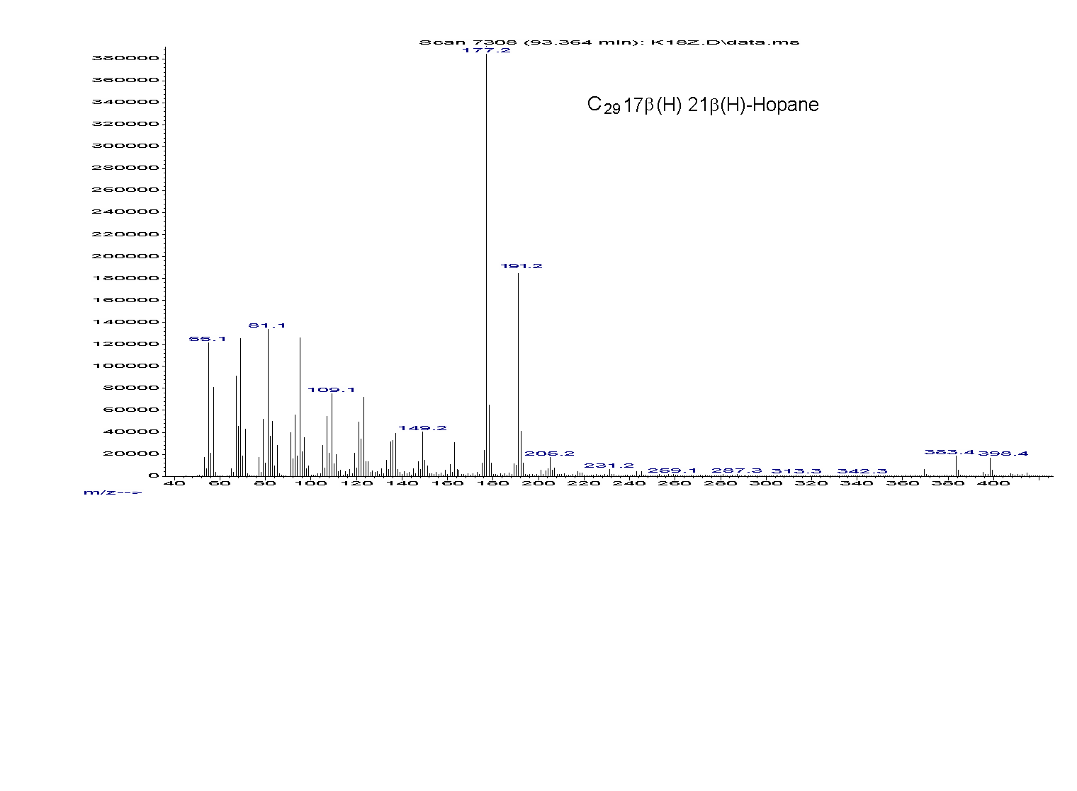

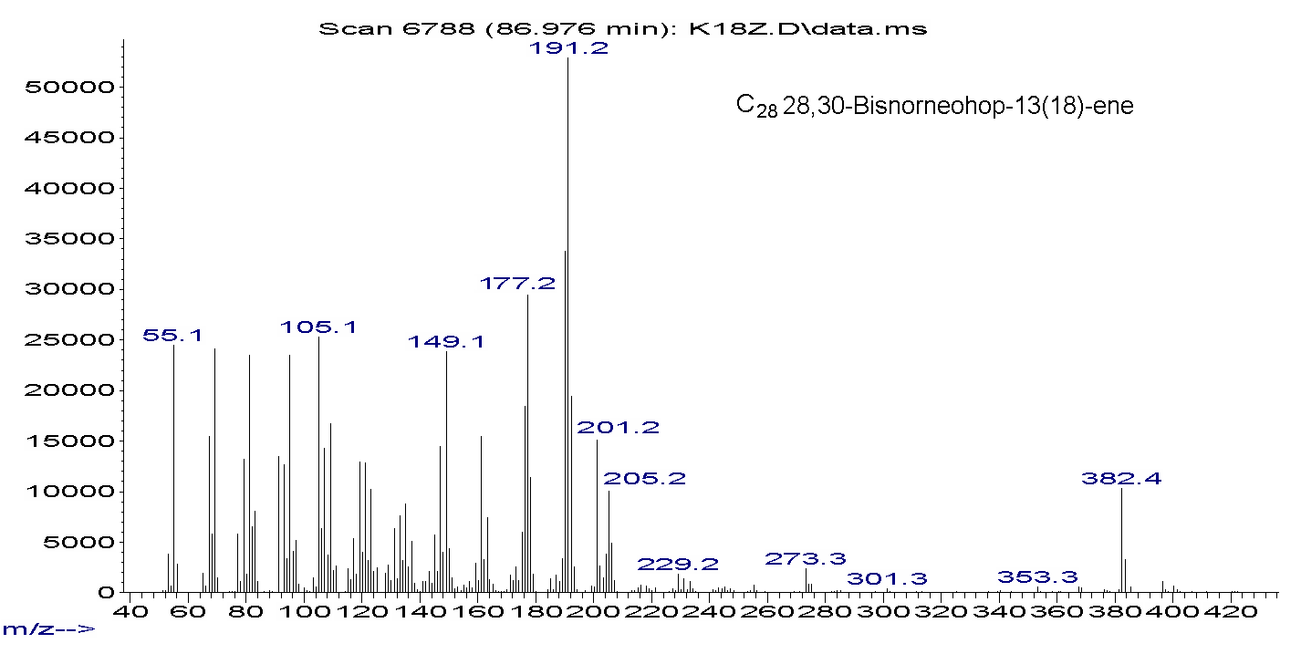
Mass spectra of C₂₉17β(H)21β(H)-hopane and C₂₈ 28,30-bisnorneohop13(18)-ene.

In my opinion, this manuscript should:
be published after major revision and additional review

If manuscript is suitable for publishing, referees recommendation:
Original scientific paper

______________________________________________________________

Comments of the Reviewer B marked in the attached annotated manuscript (pdf file)

Authors: All suggested changes and corrections in the attached manuscript file are accepted. In the revised manuscript these changes are indicated in blue colour. New text added by the authors is indicated in red colour.
Note: Pages and lines in responses correspond to your marked attached pdf. file of the previous submission of the manuscript.

Reviewer B (1) Page 2, Line 24:
Authors: “digenetic” is replaced by “diagenetic”.

Reviewer B (2) Page 2, Line 56: Introduce chemical approach (vs macroscopic) here in more detail
Authors: Chemical (biomarker) and petrographic approach were compared and explained in more detail.

Reviewer B (3) Page 3, Line 75: What's the mean hypothesis? What's the general motivation of the study
Authors: Objectives of the manuscript are explained in more detail at the end of the Introduction Section: “The paper was aimed to determine the main maceral, biomarker and isotopic (δ¹³C) characteristics of four lignite lithotypes (matrix coal, xylite-rich coal, mixture of matrix and mineral-rich coal and mixture of matrix and xylite-rich coal). Lignite originating from the Kovin deposit was used as a substrate. Based on a comprehensive study, the sources of OM and depositional environment of 4 lignite lithotypes have been reconstructed. Alongside, data from maceral analysis were served for assessment of the most convenient utilization of each lithotype, whereas results of isotopic analysis were used for investigation of the influence of diagenetic alteration on δ¹³C signatures of biomarkers.”

Reviewer B (4) Page 5, Line 93: Avoid one-sentence-paragraphs.
Authors: The sentence is replaced into the previous paragraph to avoid one-sentence paragraph.

Reviewer B (5) Page 4, Line 110: How did you garantuee a complete separation of the compounds (basic precondition for isotope analyses) by using only a 30m column?
Authors: This was explained in the response to point 2 of your General comments.

Reviewer B (6) Page 5, Line 120: What is the systematic here
Authors: Sample ID corresponds to abbreviations of the samples in our Laboratory. Number after slash represents borehole ID. The first number (before slash) represents number of the sample. Numbers have increasing trend with depth. Numbers which are missing correspond to clayey / sandy samples without coal.

Reviewer B (7) Page 10, Line 227: In M&M part information about quantification is missing. Internal standard method? Area integration of ion traces? .....Here a clear and thorough description is needed (not just reference to former publications)
Authors: This was explained in the response to point 1 of your General comments.

Reviewer B (8) Page 13, Line 274: Retene δ¹³C
Authors: δ¹³C of retene was not measured in samples 46/601, 4/79, 19/79 and 18/79, whose TICs of aromatic fraction are given in Figure 5, representing the biomarker distributions in different lignite lithotypes. As you can see from Supplementary material (Table S-IV), δ¹³C of retene was measured only on 13 samples in which retene was present in adequate amount showing the pure mass spectra. Example of TIC of aromatic fraction of the sample in which δ¹³C of retene was measured is given bellow along with corresponding mass spectra of retene from the sample and from the NIST05 library (accordance between these two mass spectra was 99 %).
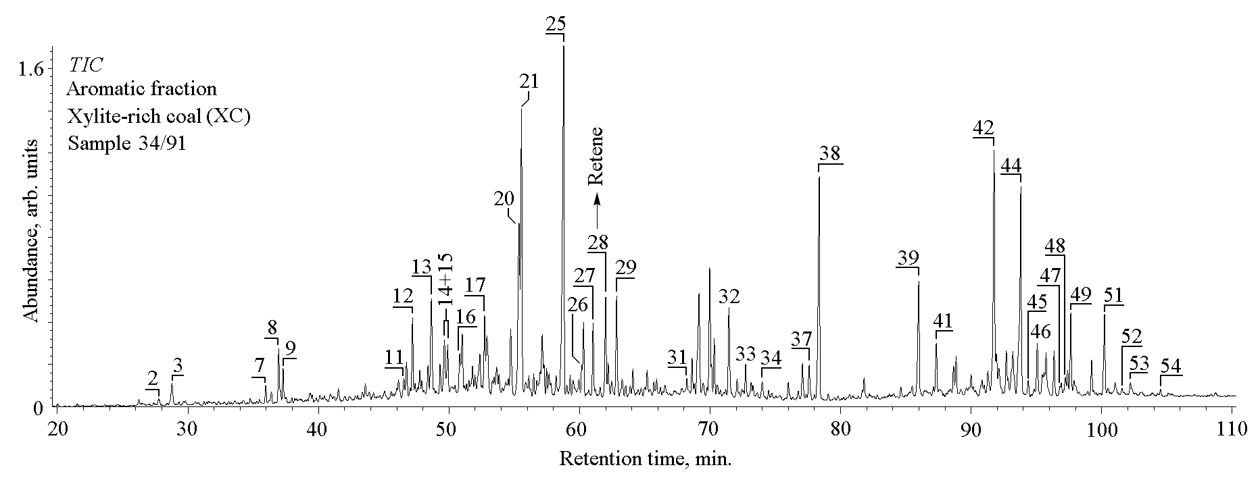
TIC of aromatic fraction of sample 34/91 (For peak identification, please see legend of Figure 5).

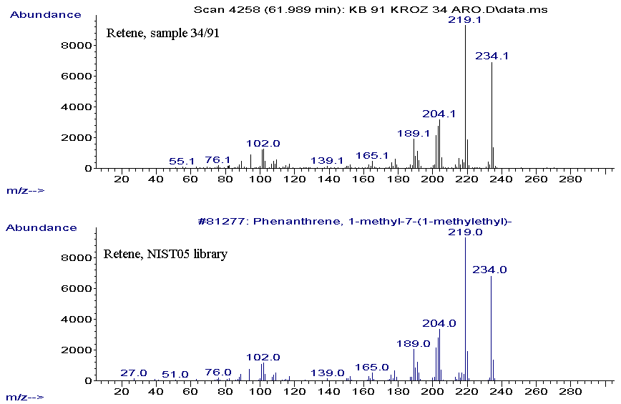
Mass spectra of retene from the sample and from the NIST05 library.

Reviewer B (9): Page 17, Line 381: Once again, how did separate fully n-alkanes from e.g hopanes? Isotope values determined based on the chromatograms above do not provide reliable data due to superimposition of compounds and their isotope properties
Authors: This was explained in the response to point 2 of your General comments.

Kind regards,
Sincerely,

Dr. Ksenija Stojanović,
Associate Professor
Faculty of Chemistry,
University of Belgrade
Studentski trg 12-16
11000 Belgrade
SERBIA
Phone: + 381 11 3336 776; fax: + 381 11 2636 061
E-mail: ksenija@chem.bg.ac.rs
xenasyu@yahoo.com

