Supplementary data for

Redox properties of alkyl-substituted 4-aryl-2,4-dioxobutanoic acids
Ilija N. Cvijetić,¹ Tatjana Ž. Verbić,^{2*} Branko J. Drakulić,^{3&} Dalibor M. Stanković,^{1,4} Ivan O. Juranić,³ Dragan D. Manojlović² and Mire Zloh⁵

¹Innovation Center of the Faculty of Chemistry, University of Belgrade, Studentski Trg 16, 11000 Belgrade, Serbia
²Faculty of Chemistry, University of Belgrade, Studentski Trg 16, 11000 Belgrade, Serbia
³Department of Chemistry-IChTM, University of Belgrade, Njegoševa 12, 11000 Belgrade, Serbia
⁴The Vinča Institute of Nuclear Sciences, University of Belgrade, POB 522, 11001 Belgrade, Serbia
⁵Department of Pharmacy, University of Hertfordshire, Hatfield, Hertfordshire AL10 9AB, United Kingdom

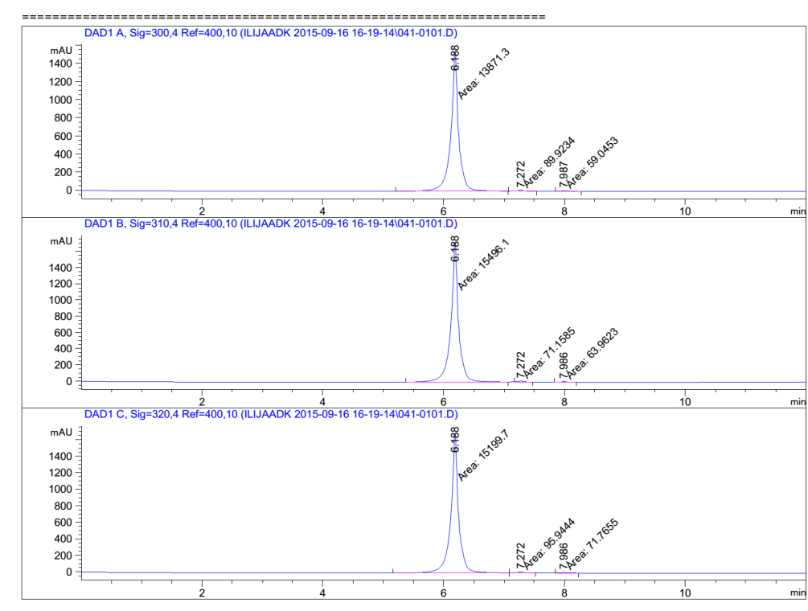 | 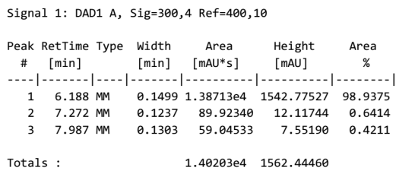
 | 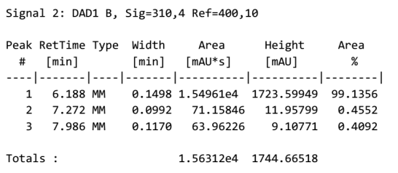
 | 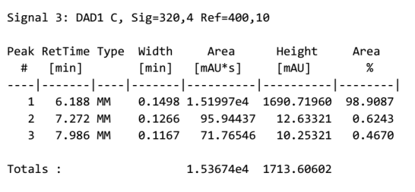
Fig. S1. Chromatogram for the assessment of compound 1 purity, with the tables showing the detector response at three wavelengths

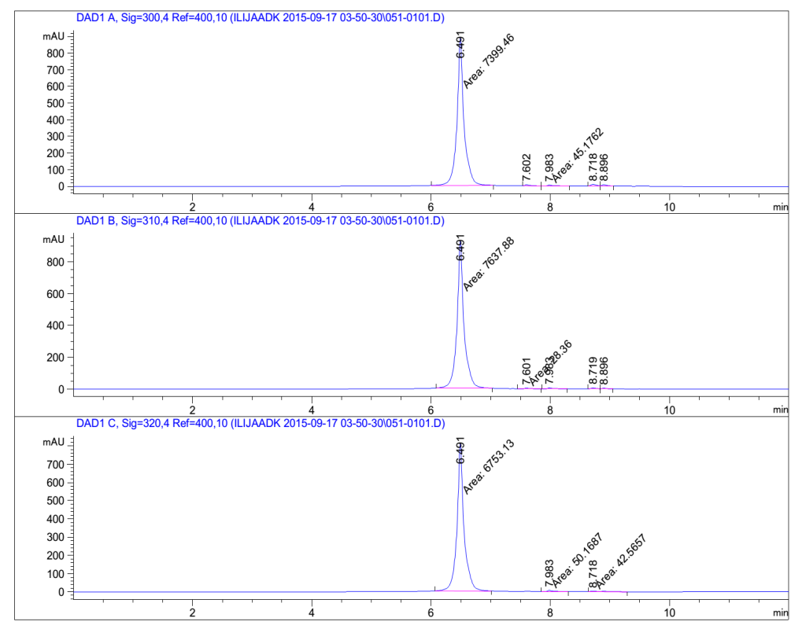 | 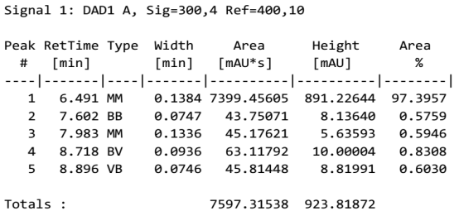
 | 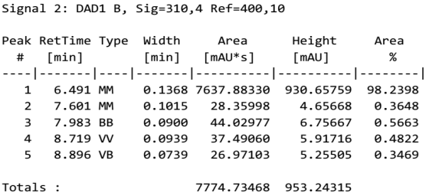
Fig. S2. Chromatogram for the assessment of compound 2 purity, with the tables showing the detector response at three wavelengths.

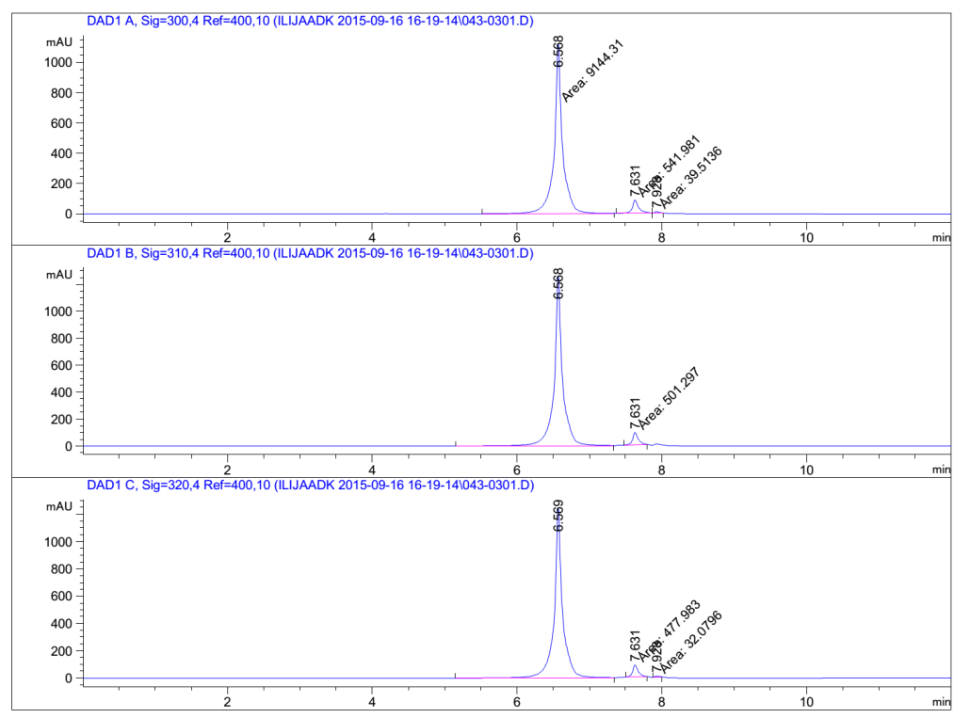 | 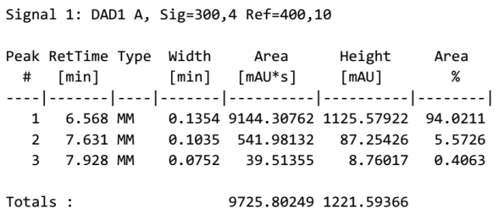
 | 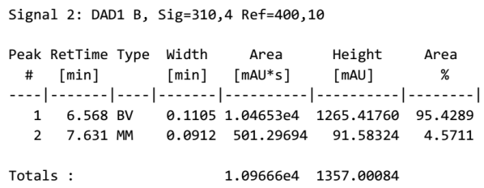
 | 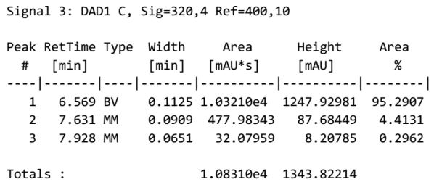
Fig. S3. Chromatogram for the assessment of compound 3 purity, with the tables showing the detector response at three wavelengths.

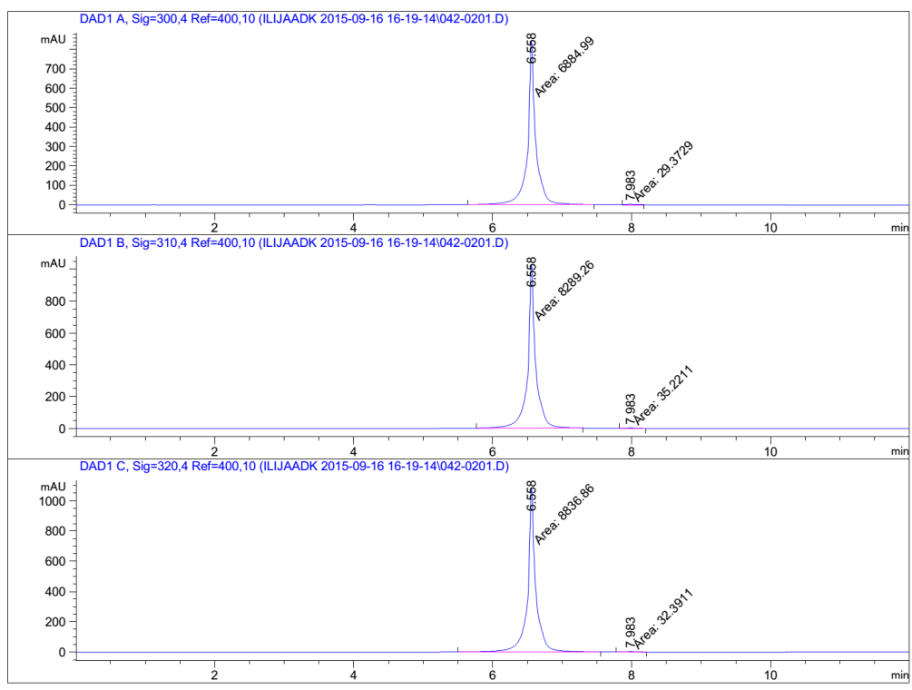 | 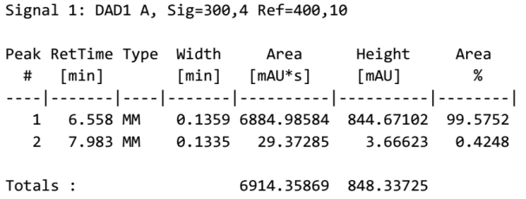
 | 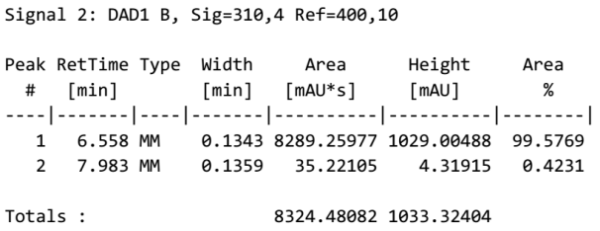
 | 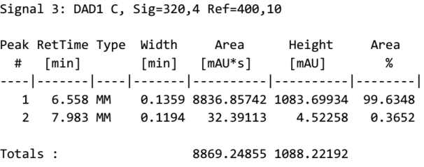
Fig. S4. Chromatogram for the assessment of compound 4 purity, with the tables showing the detector response at three wavelengths.

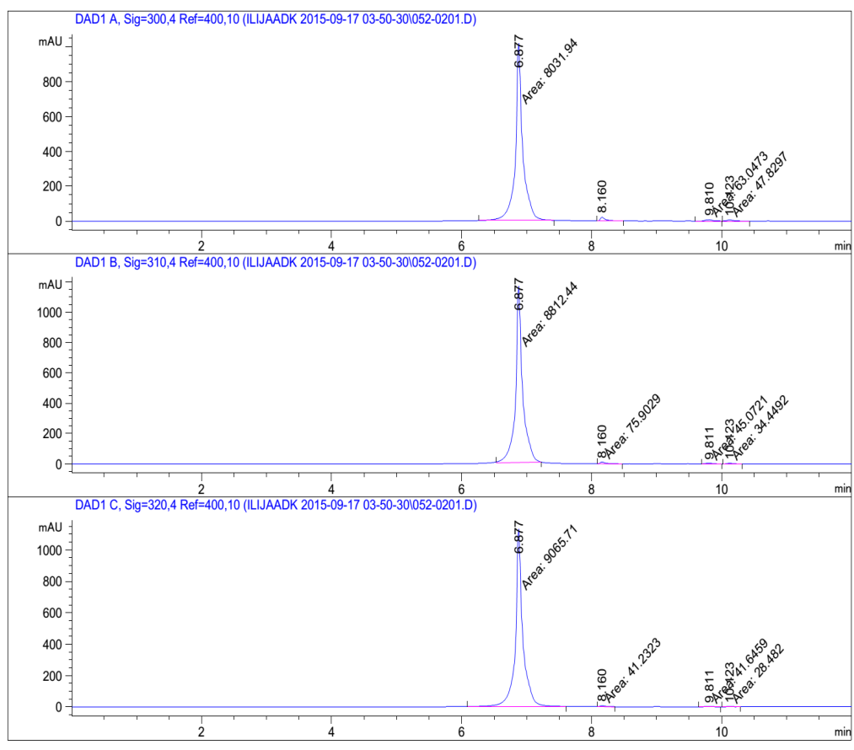 | 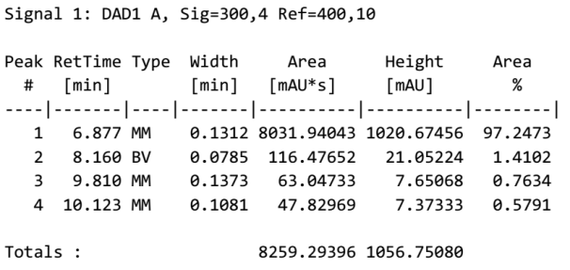
 | 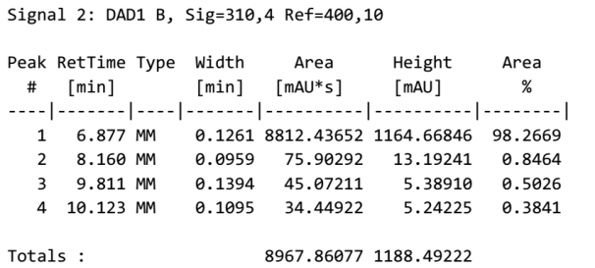
 | 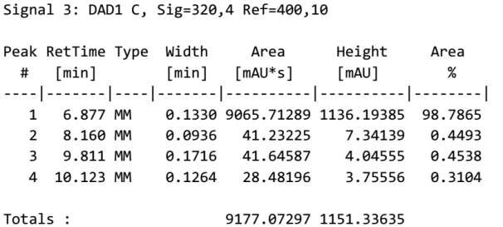
Fig. S5. Chromatogram for the assessment of compound 5 purity, with the tables showing the detector response at three wavelengths.

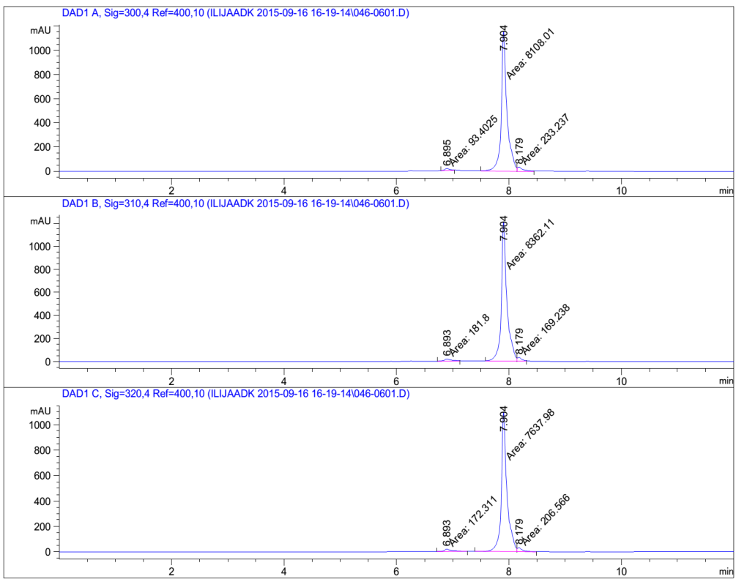 | 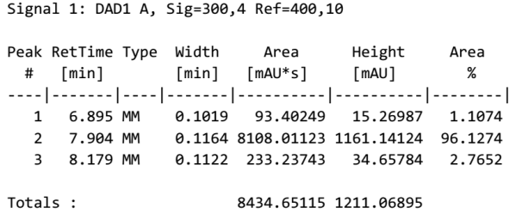
 | 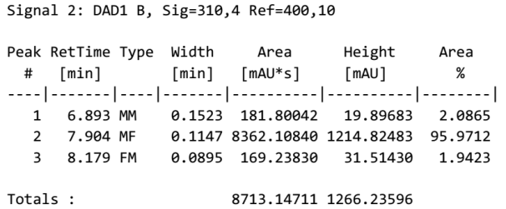
 | 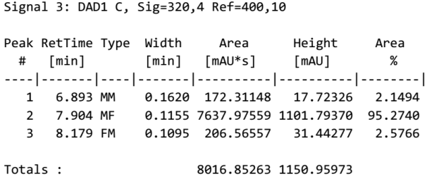
Fig. S6. Chromatogram for the assessment of compound 6 purity, with the tables showing the detector response at three wavelengths.

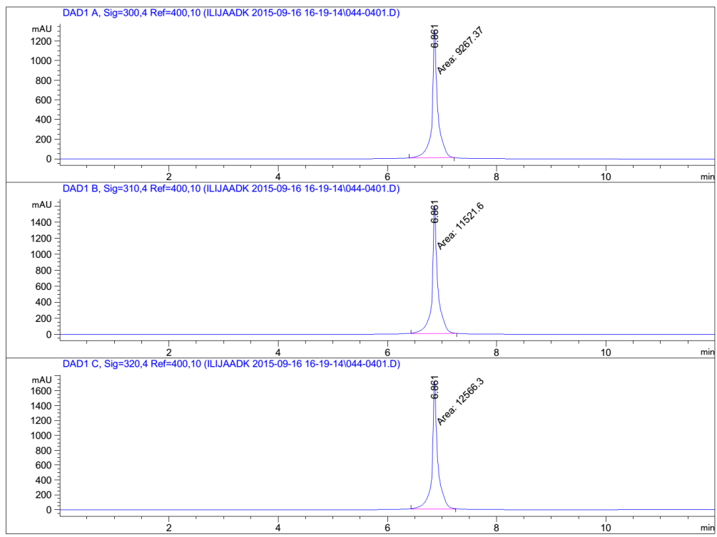 | 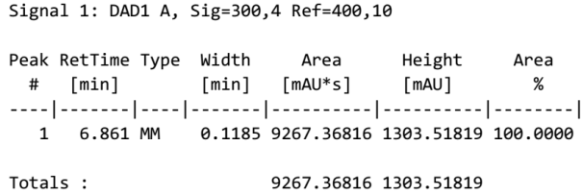
 | 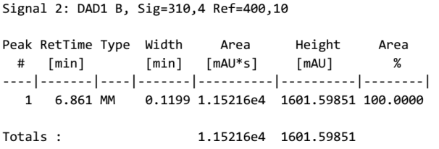
 | 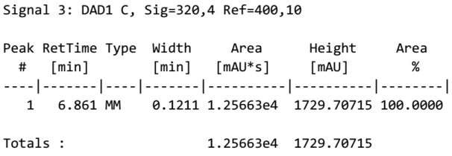
Fig. S7. Chromatogram for the assessment of compound 7 purity, with the tables showing the detector response at three wavelengths.

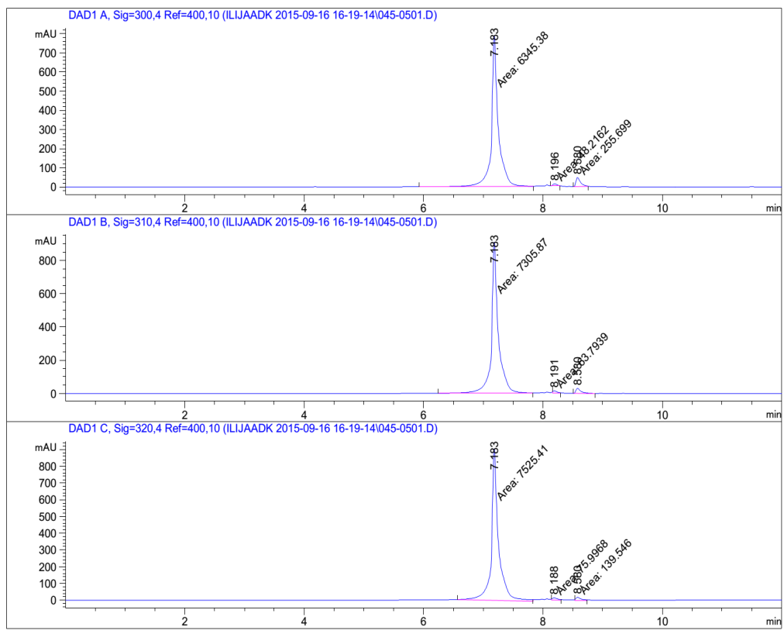 | 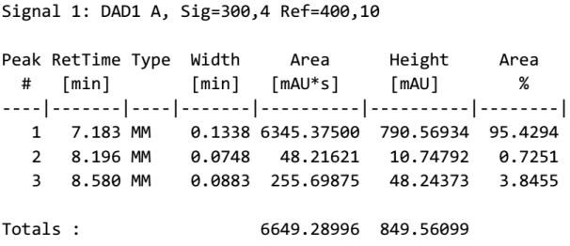
 | 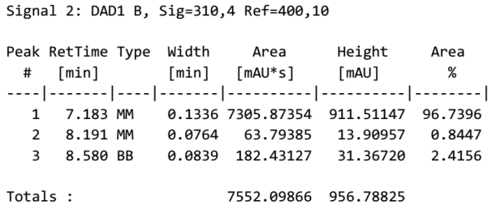
 | 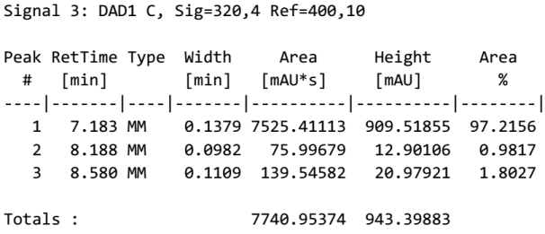
Fig. S8. Chromatogram for the assessment of compound 8 purity, with the tables showing the detector response at three wavelengths.

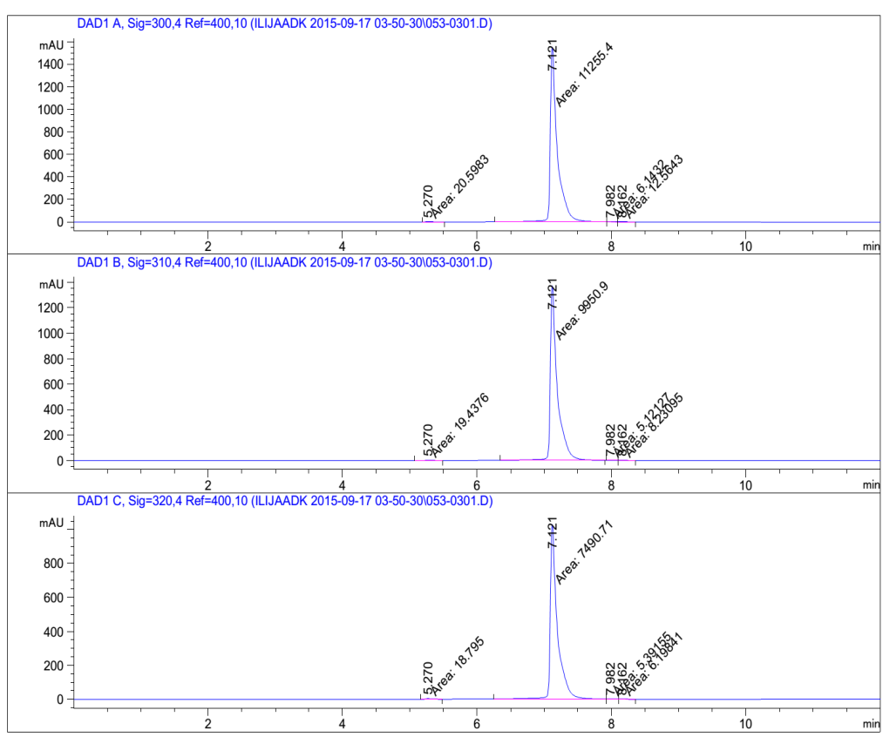 | 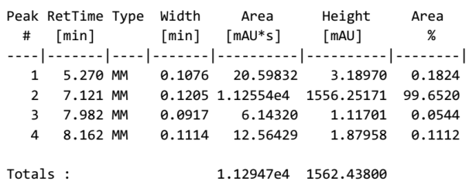
 | 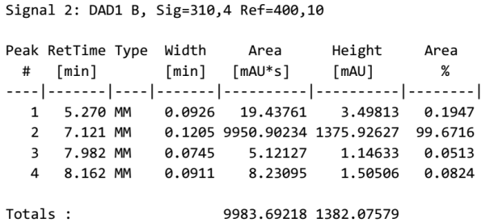
 | 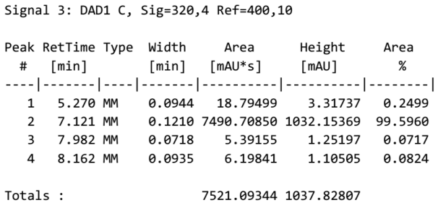
Fig. S9. Chromatogram for the assessment of compound 9 purity, with the tables showing the detector response at three wavelengths.

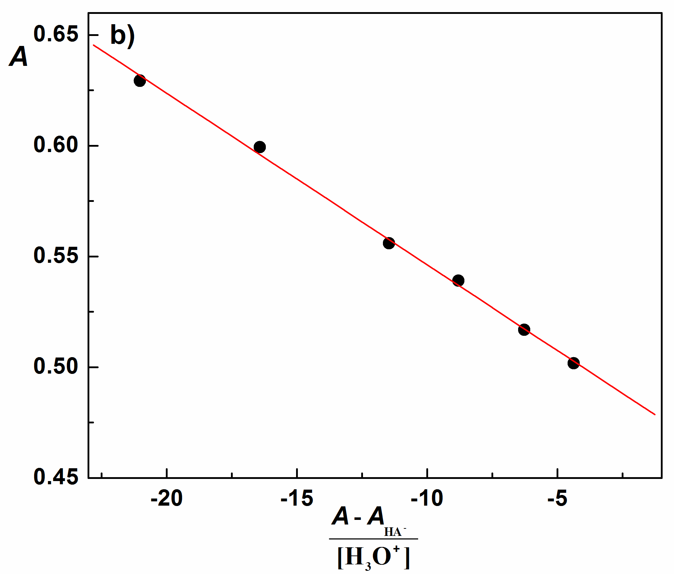
Fig. S10. Absorption spectra of compound 2 used for K_{a1} determination in solutions of different acidity, pH values are indicated; b) Spectrophotometric determination of K_{a1} according to Equation 1; c₂=5.023×10⁻⁵ M; λ=302.9 nm; t = 25 °C, I = 0.1 M (NaCl); scan speed 500 nm/min.

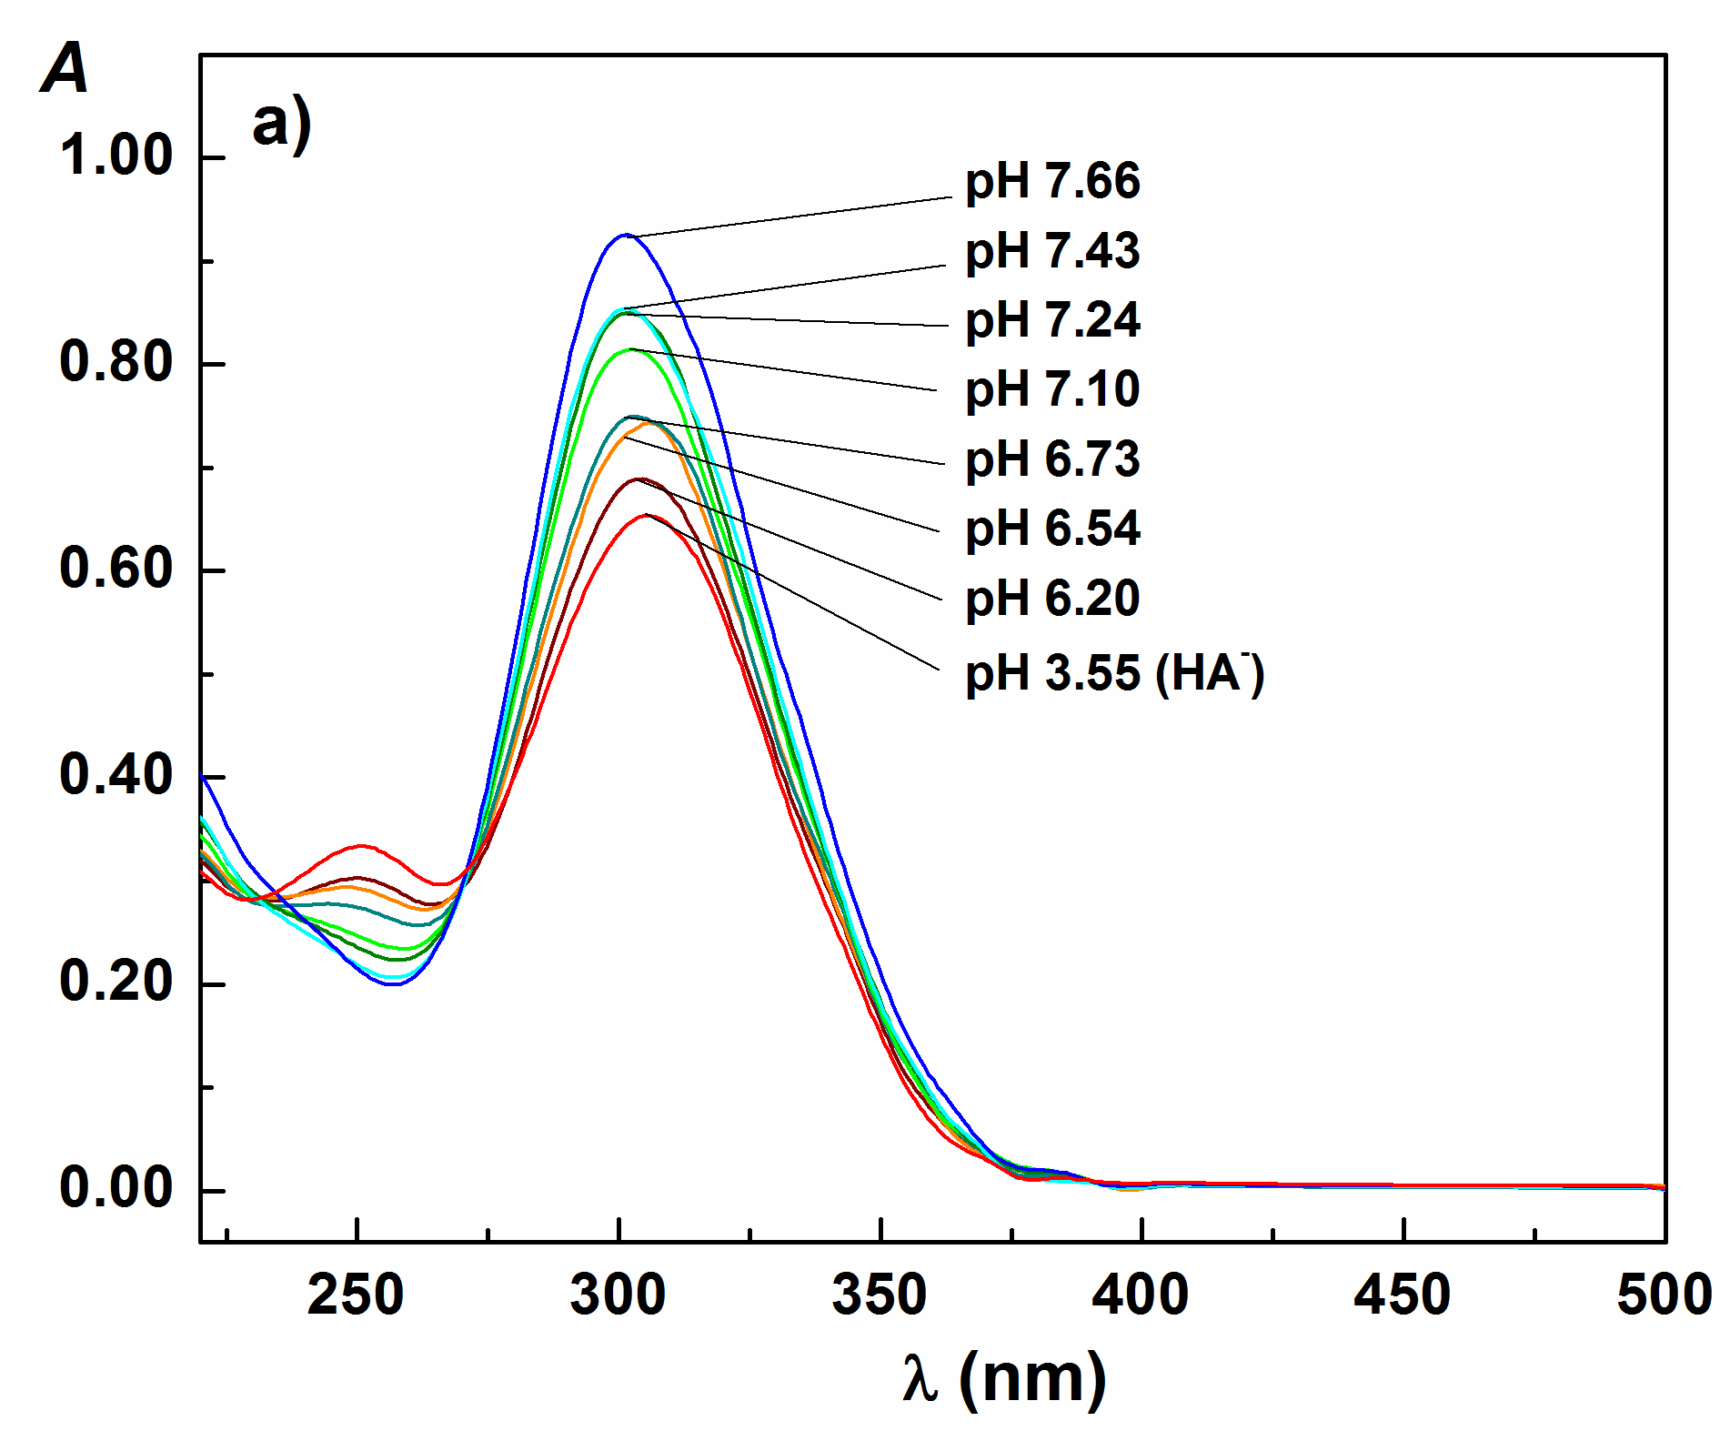 | 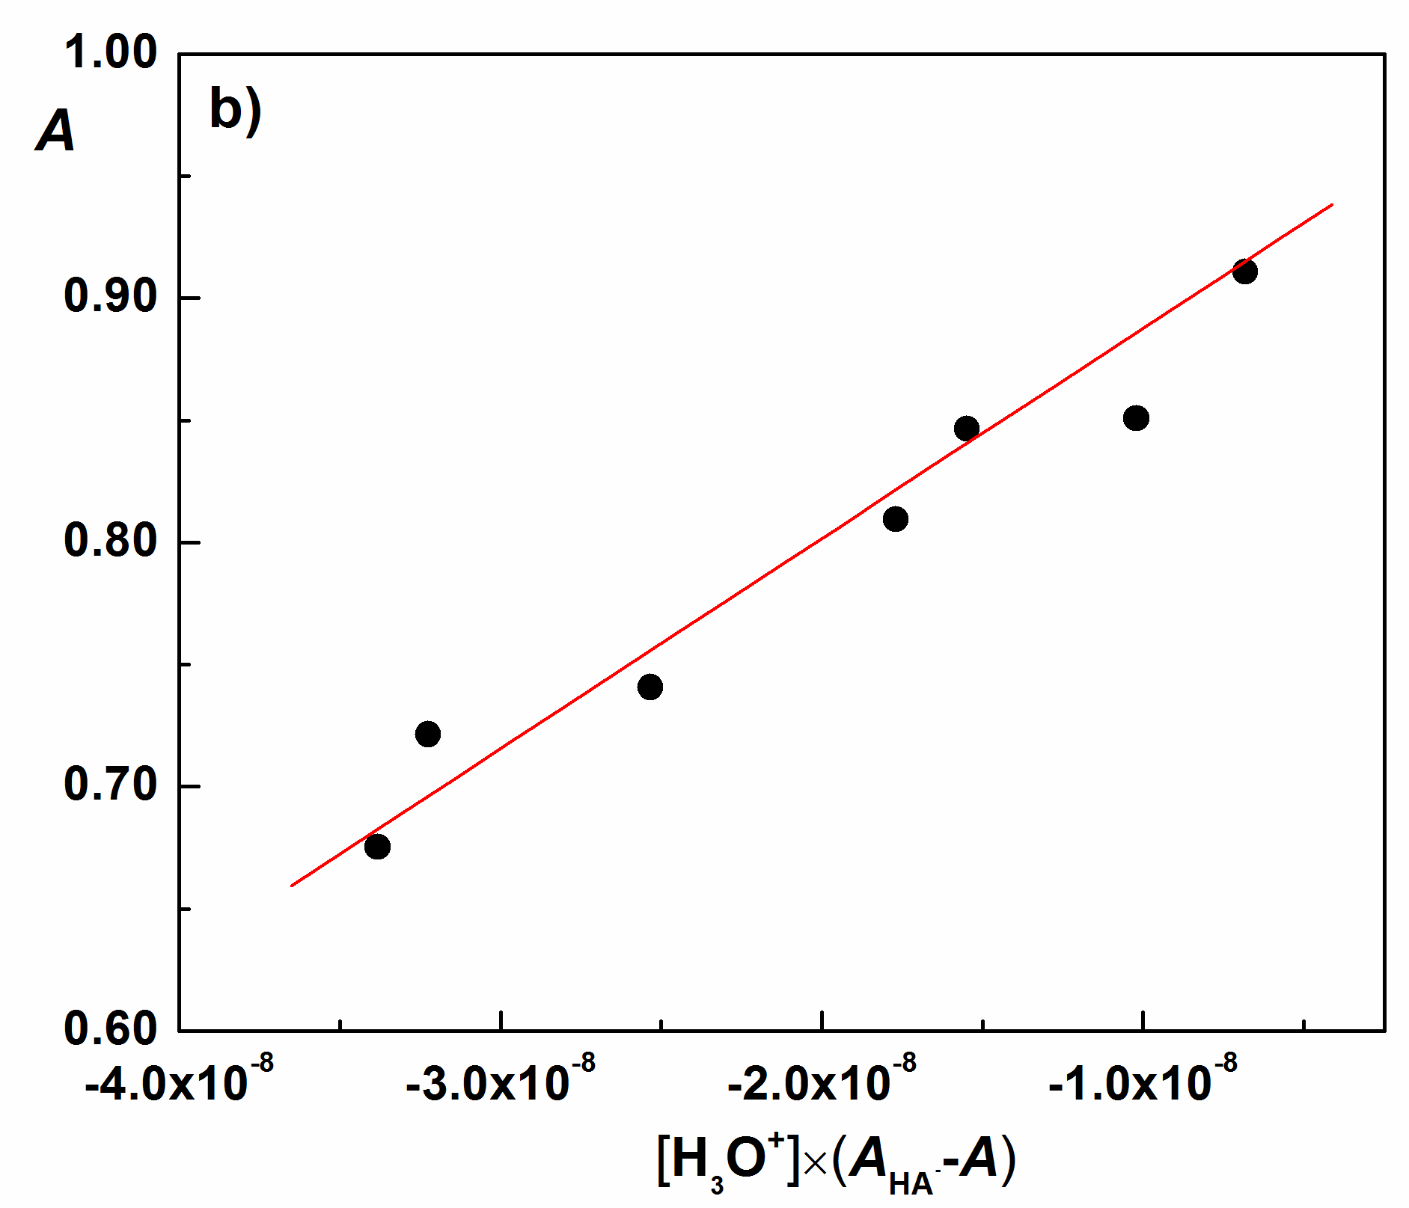
Fig. S11.Absorption spectra of compound 2 used for K_{a2} determination in solutions of different acidity, pH values are indicated; b) Spectrophotometric determination of K_{a2} according to Equation 2; c₂=5.023×10⁻⁵ M; λ=299.5 nm; t = 25 °C, I = 0.1 M (NaCl); scan speed 500 nm/min.

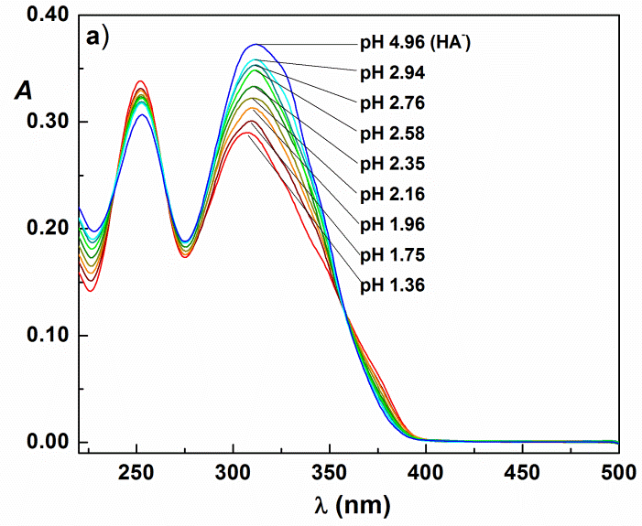 | 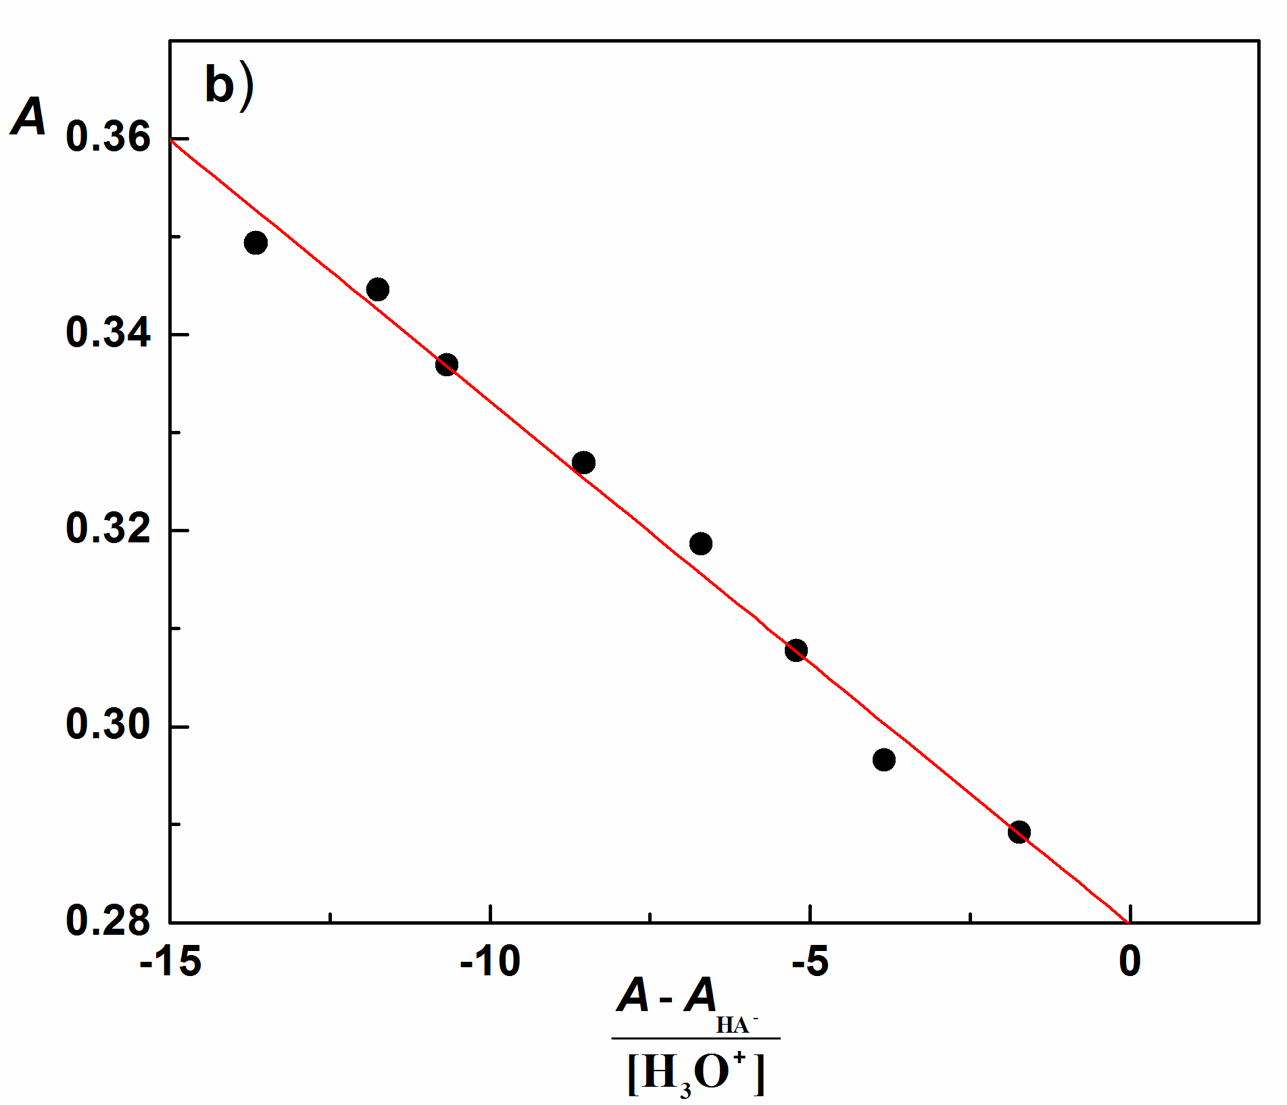
Fig. S12. Absorption spectra of compound 3 used for K_{a1} determination in solutions of different acidity, pH values are indicated; b) Spectrophotometric determination of K_{a1} according to Equation 1; c₃=4.908×10⁻⁵ M; λ=305.4 nm; t = 25 °C, I = 0.1 M (NaCl); scan speed 500 nm/min.

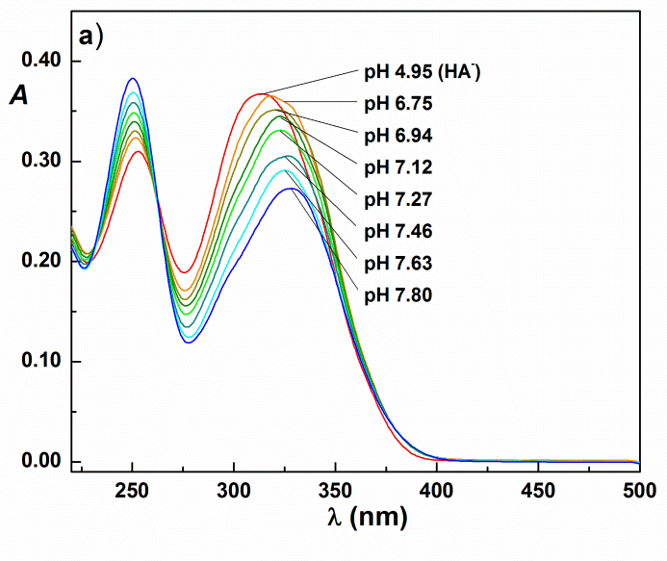 | 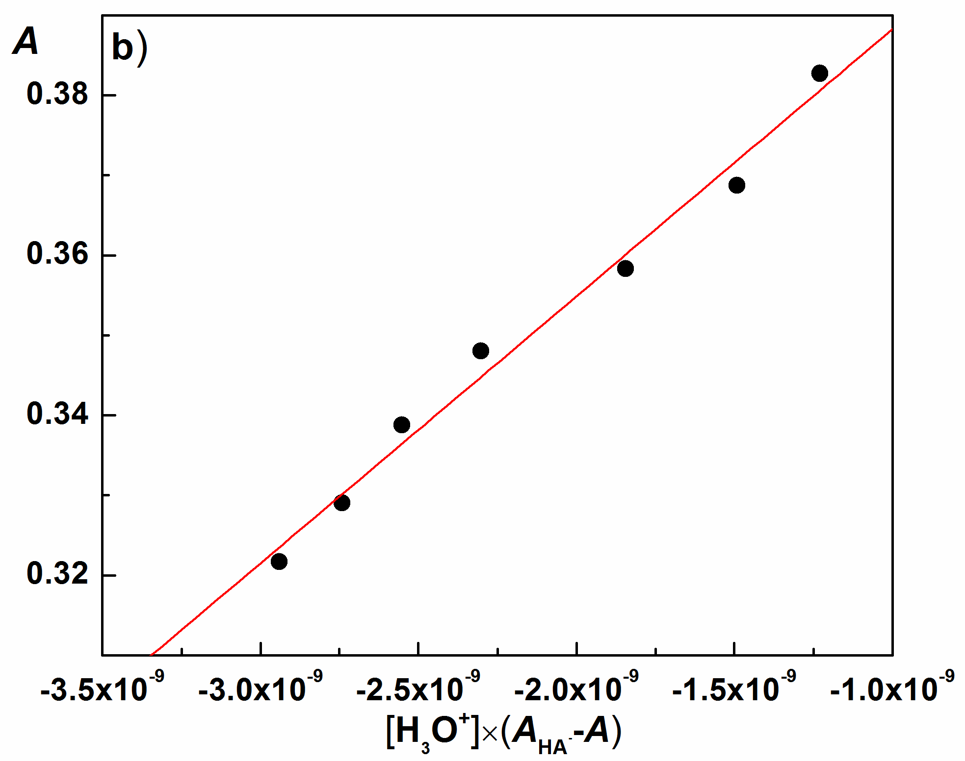
Fig. S13. Absorption spectra of compound 3 used for K_{a2} determination in solutions of different acidity, pH values are indicated; b) Spectrophotometric determination of K_{a2} according to Equation 2; c₃=4.908×10⁻⁵ M; λ=250.0 nm; t = 25 °C, I = 0.1 M (NaCl); scan speed 500 nm/min.

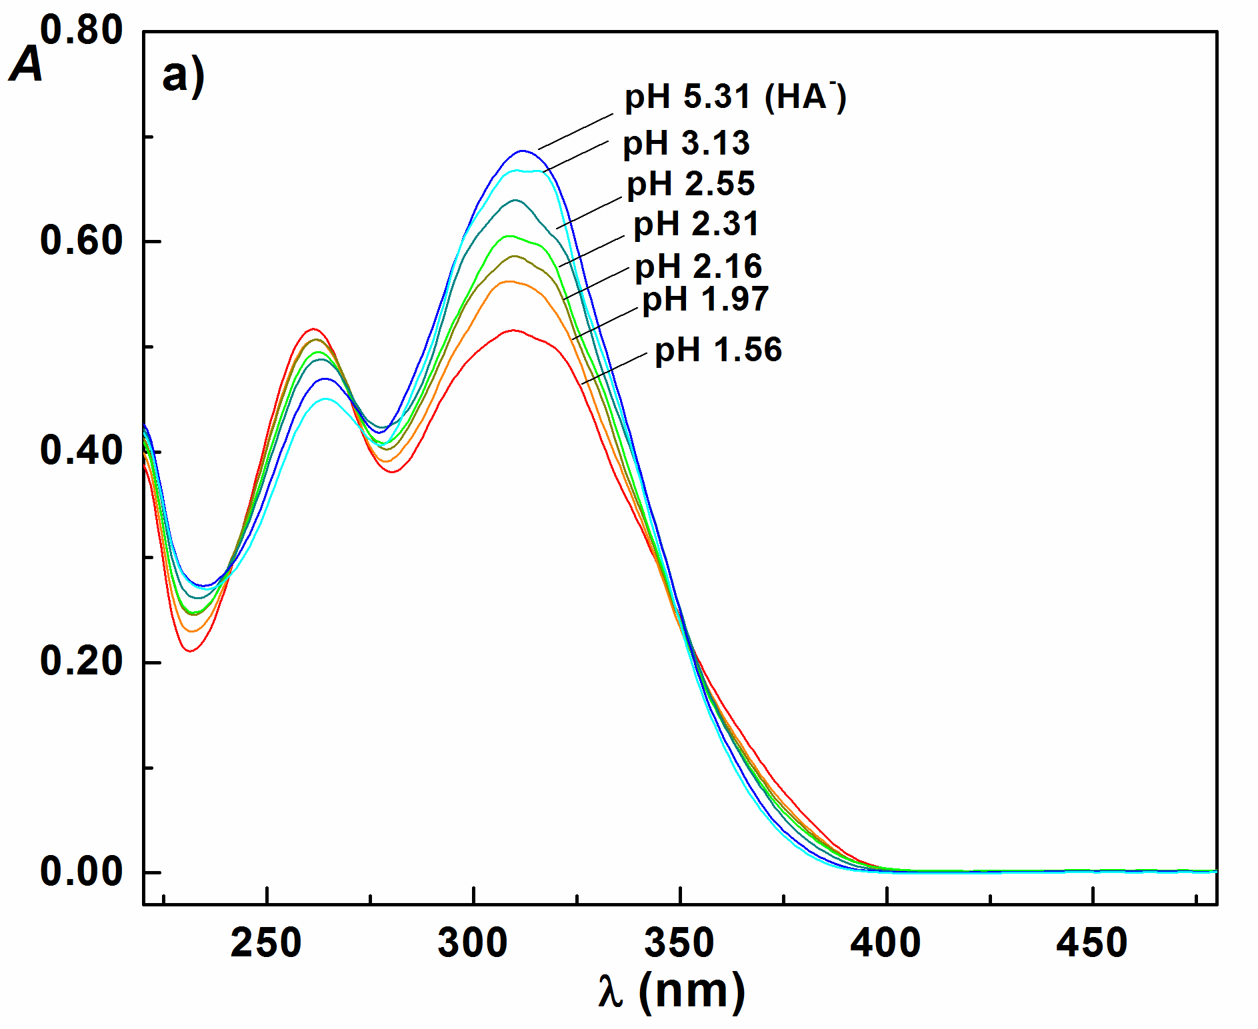 | 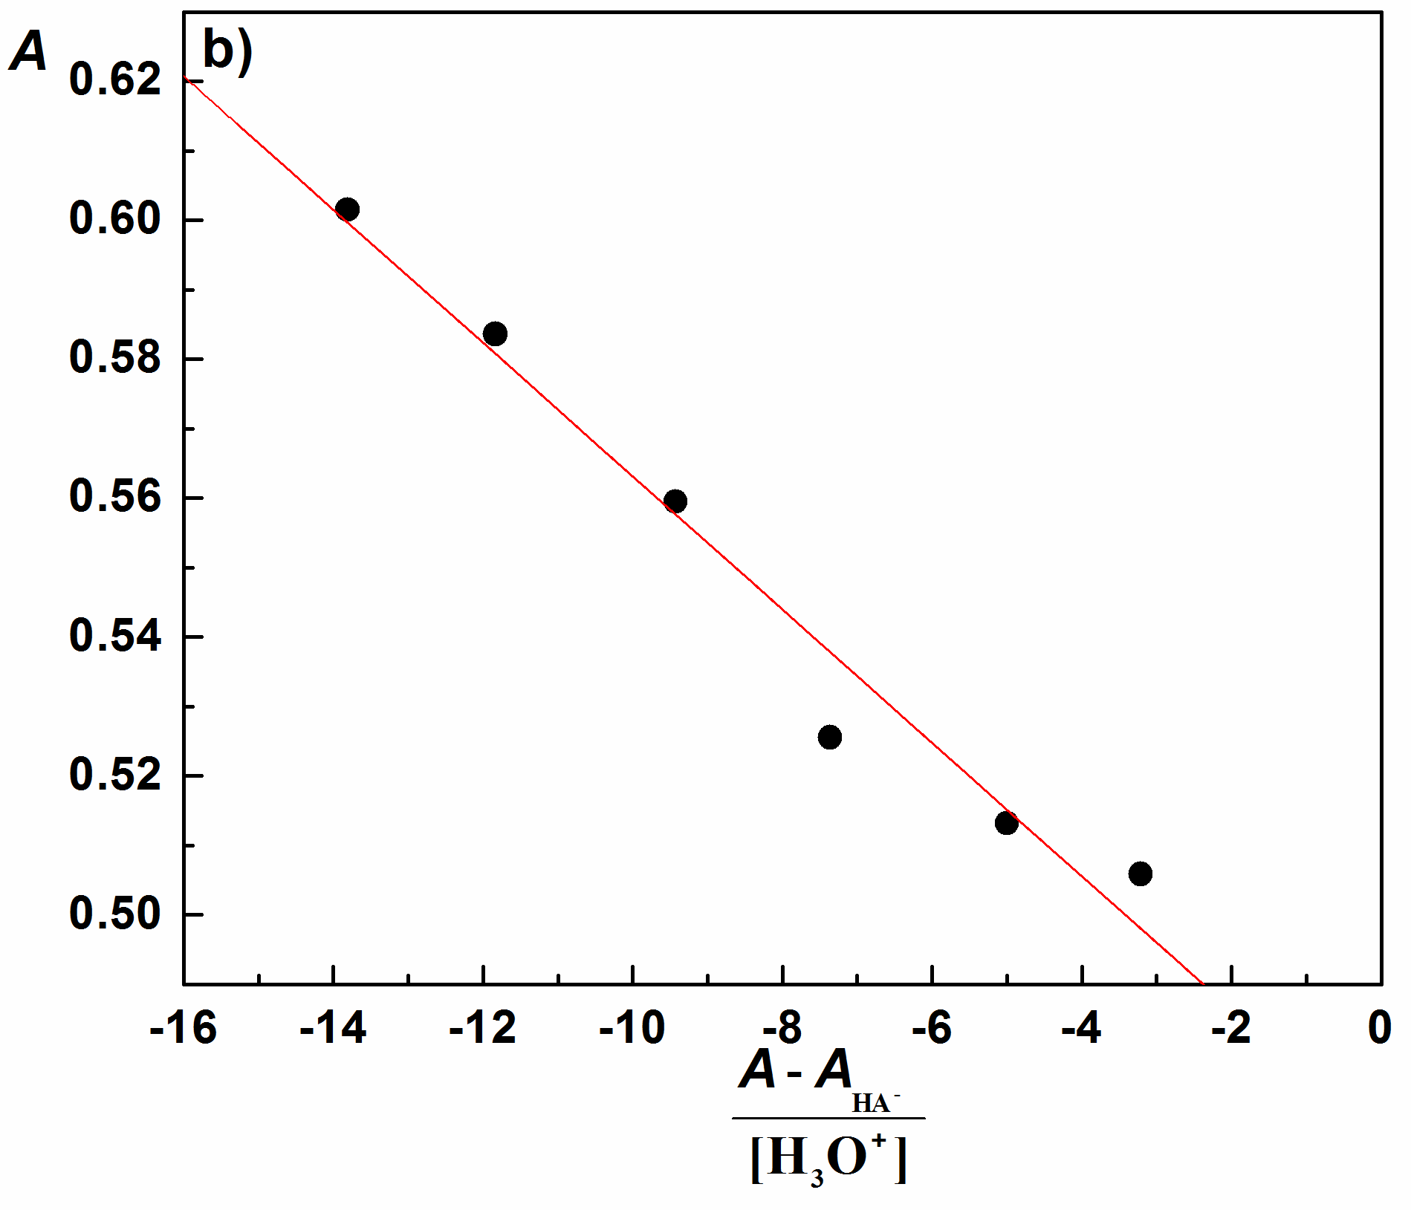
Fig. S14. Absorption spectra of compound 5 used for K_{a1} determination in solutions of different acidity, pH values are indicated; b) Spectrophotometric determination of K_{a1} according to Equation 1; c₅=6.021×10⁻⁵ M; λ=312.3 nm; t = 25 °C, I = 0.1 M (NaCl); scan speed 500 nm/min.

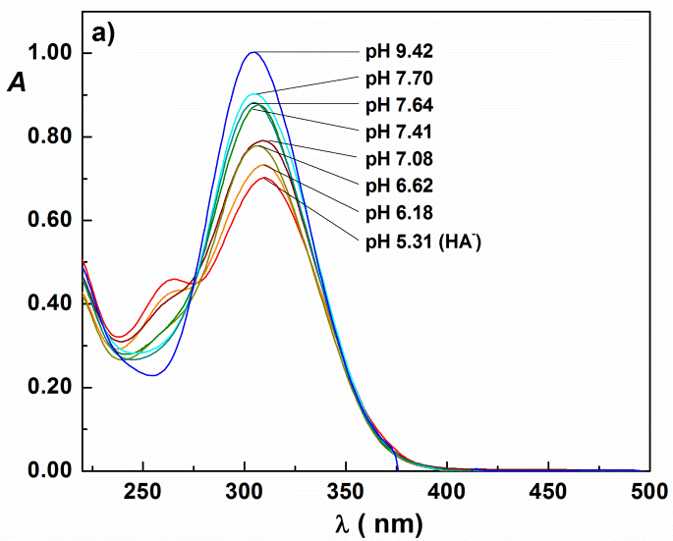 | 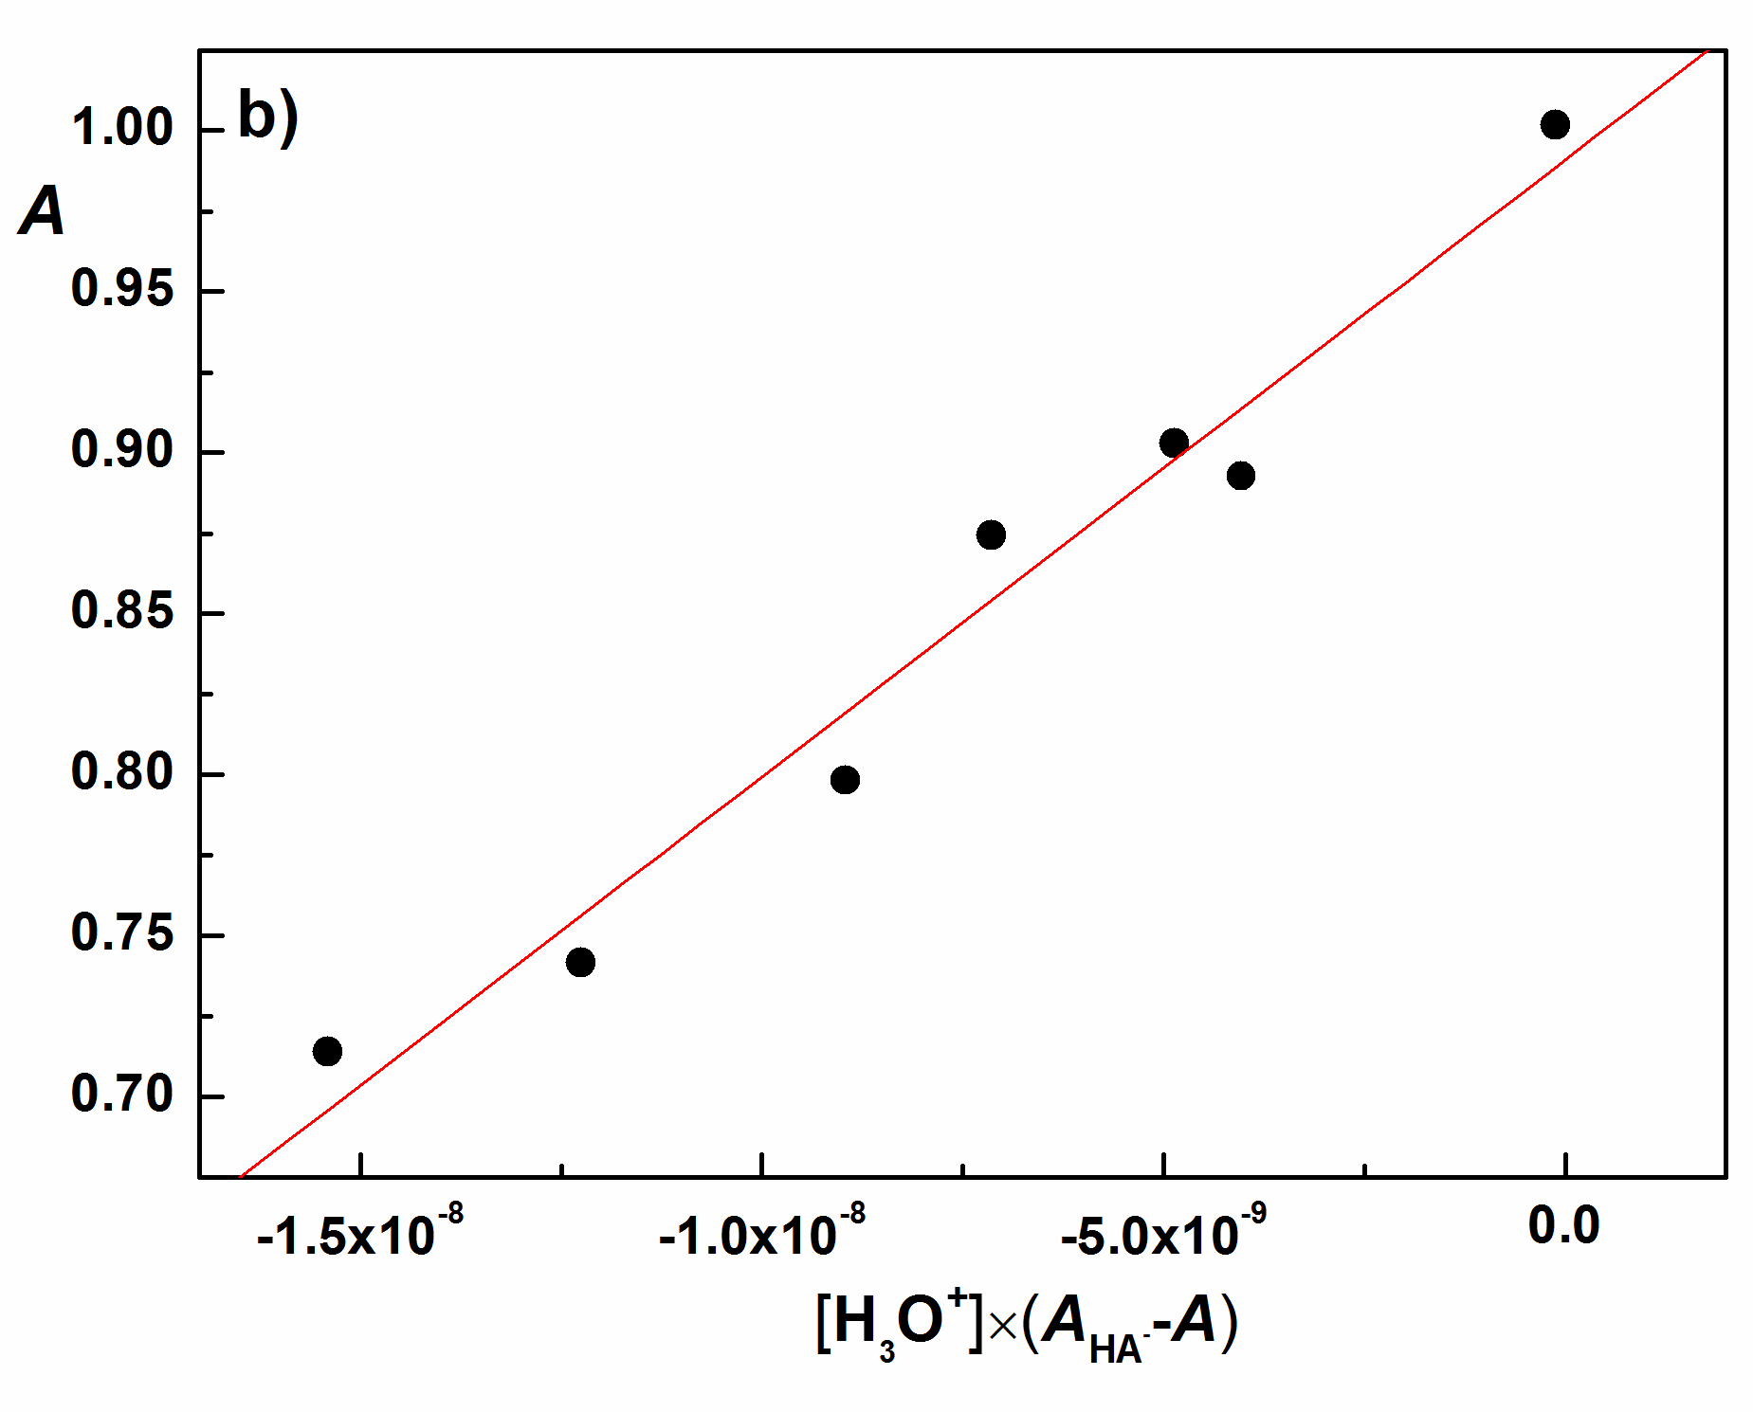
Fig. S15. Absorption spectra of compound 5 used for K_{a2} determination in solutions of different acidity, pH values are indicated; b) Spectrophotometric determination of K_{a2} according to Equation 2; c₅=6.021×10⁻⁵ M; λ=305.9 nm; t = 25 °C, I = 0.1 M (NaCl); scan speed 500 nm/min.

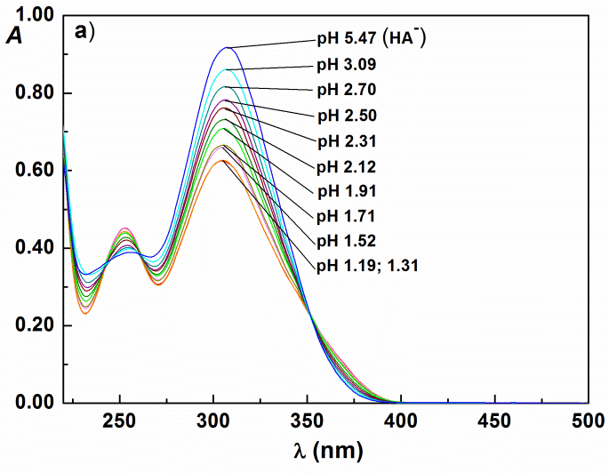 | 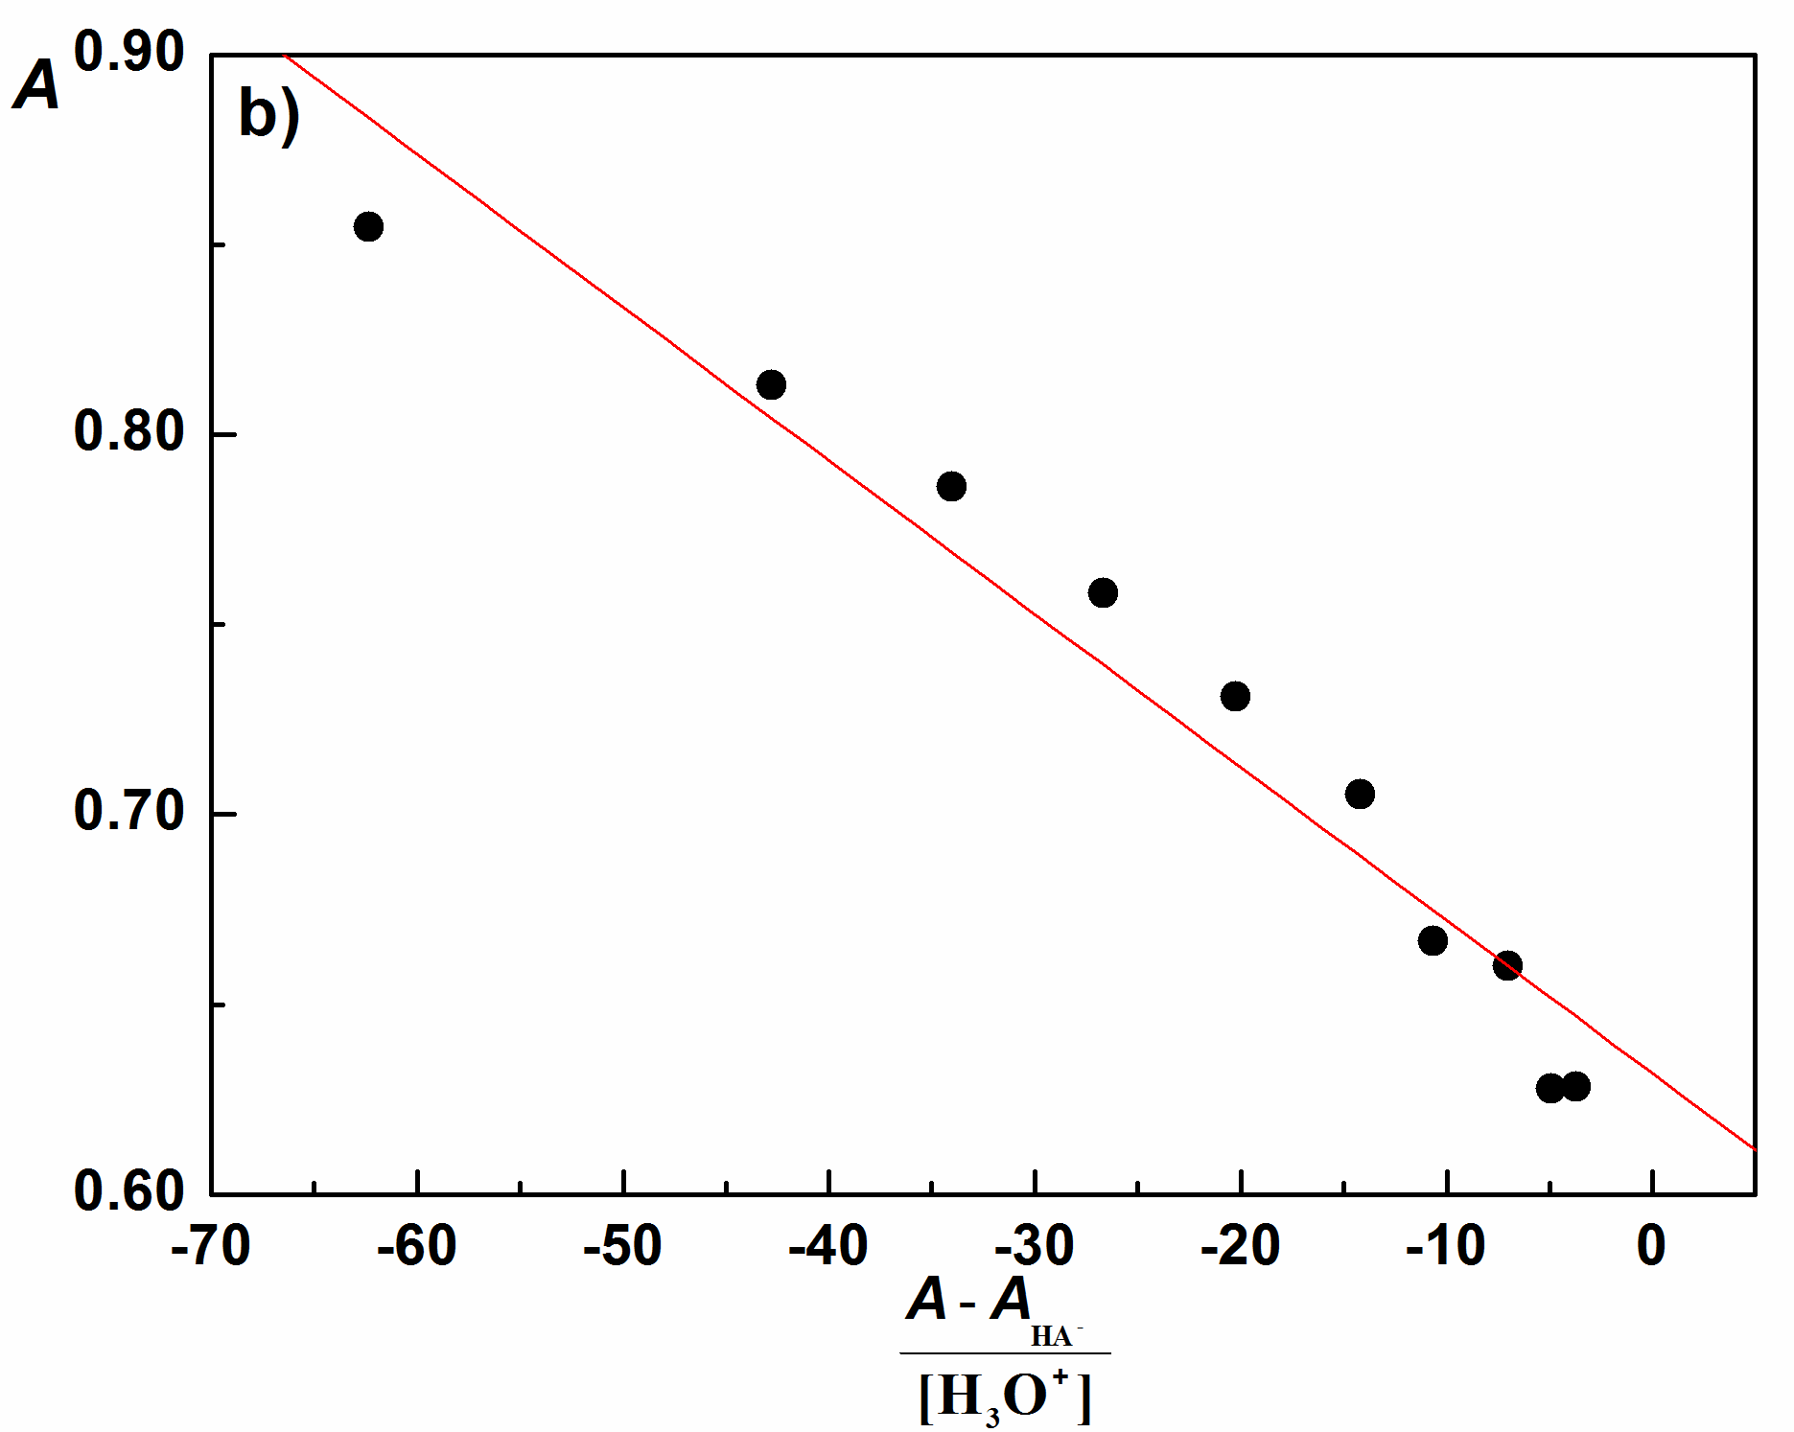
Fig. S16. Absorption spectra of compound 6 used for K_{a1} determination in solutions of different acidity, pH values are indicated; b) Spectrophotometric determination of K_{a1} according to Equation 1; c₆=9.014×10⁻⁵ M; λ=306.3 nm; t = 25 °C, I = 0.1 M (NaCl); scan speed 500 nm/min.

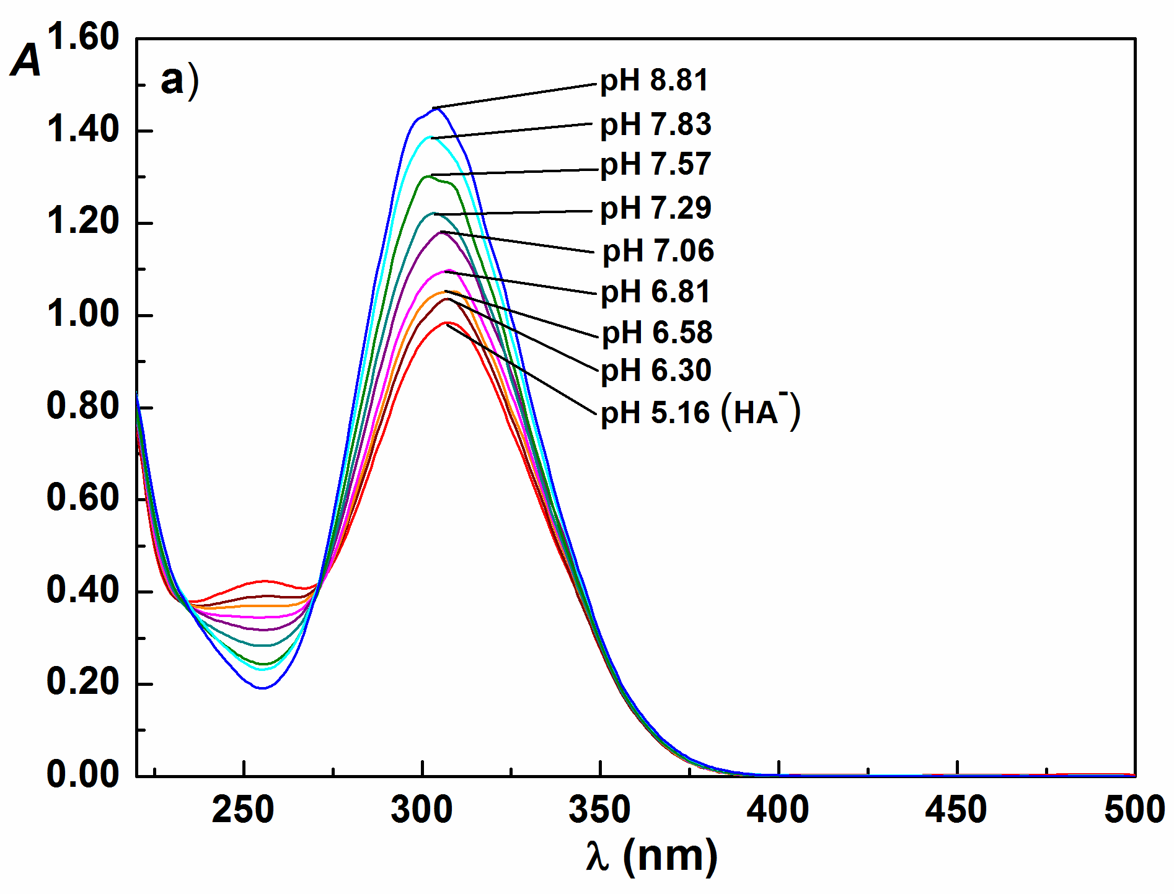 | 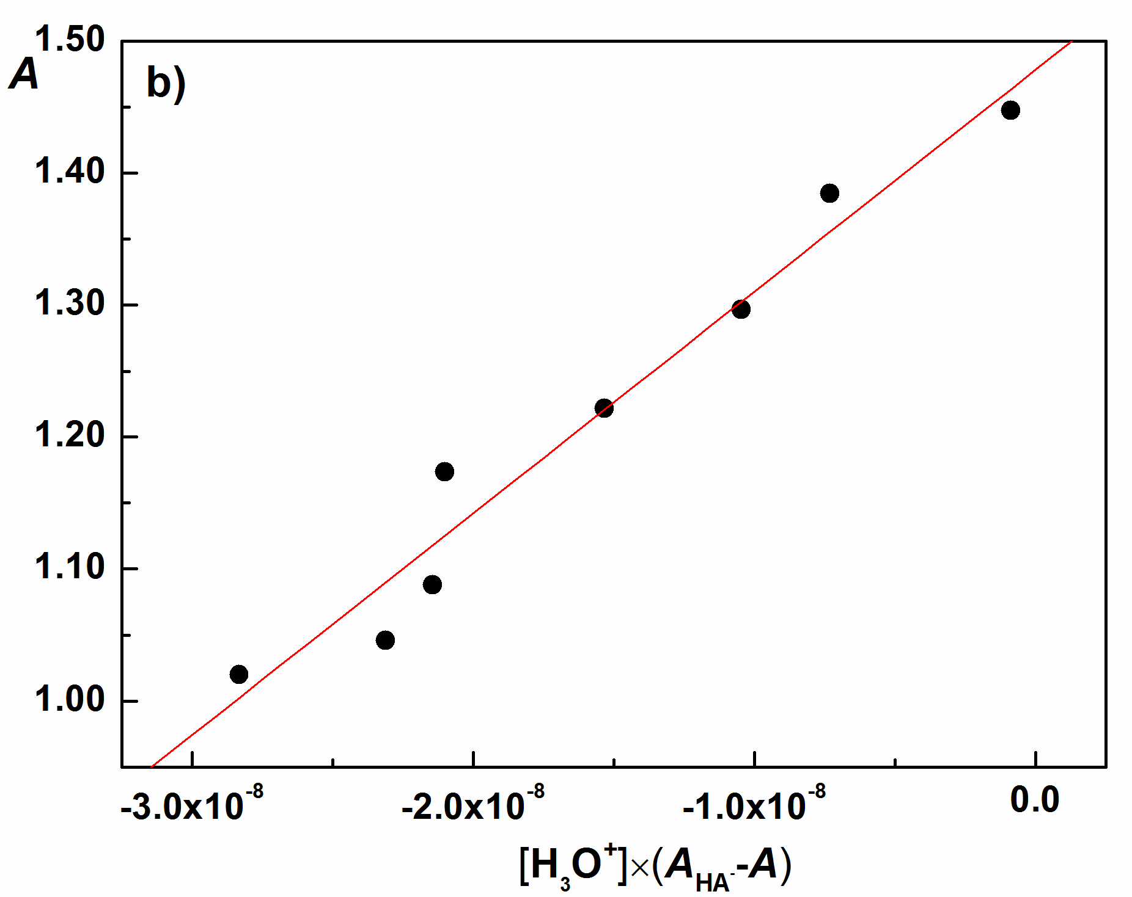
Fig. S17. Absorption spectra of compound 6 used for K_{a2} determination in solutions of different acidity, pH values are indicated; b) Spectrophotometric determination of K_{a2} according to Equation 2; c₆=9.014×10⁻⁵ M; λ=303.7 nm; t = 25 °C, I = 0.1 M (NaCl); scan speed 500 nm/min.

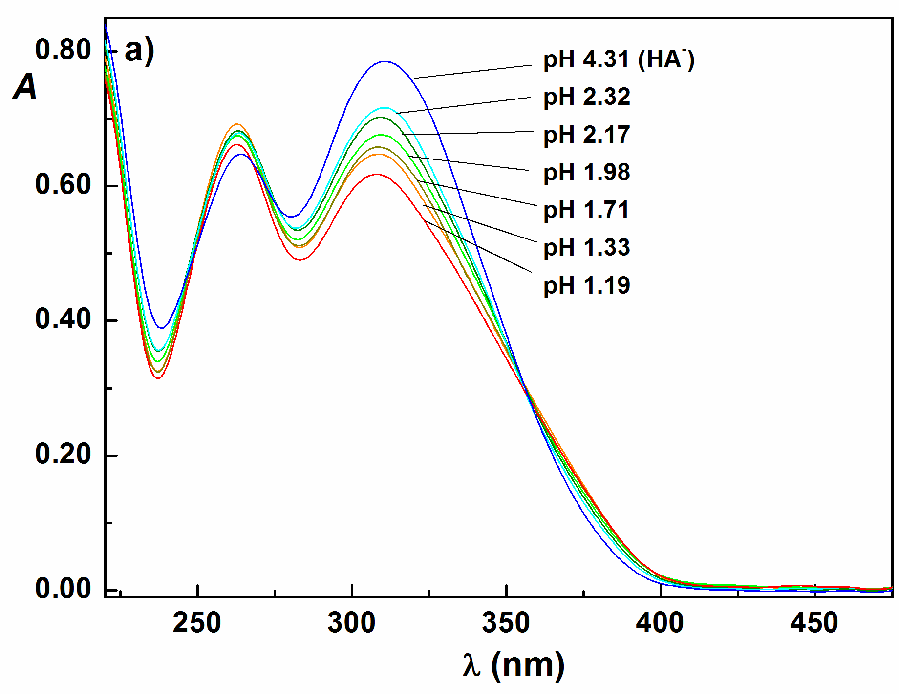 | 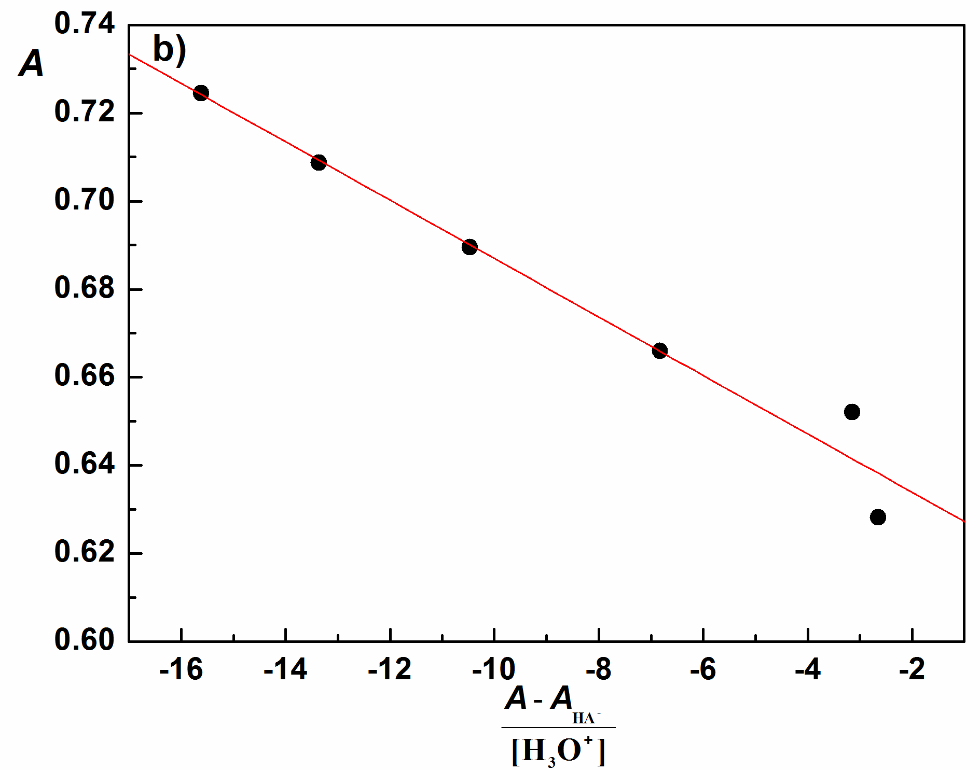
Fig. S18. Absorption spectra of compound 8 used for K_{a1} determination in solutions of different acidity, pH values are indicated; b) Spectrophotometric determination of K_{a1} according to Equation 1; c₈=5.904×10⁻⁵ М; λ=308.8 nm; t = 25 °C, I = 0.1 M (NaCl); scan speed 500 nm/min.

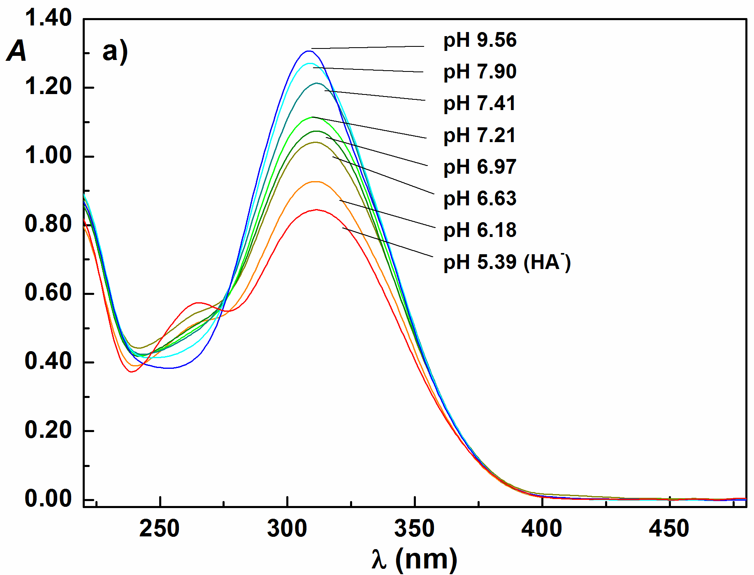 | 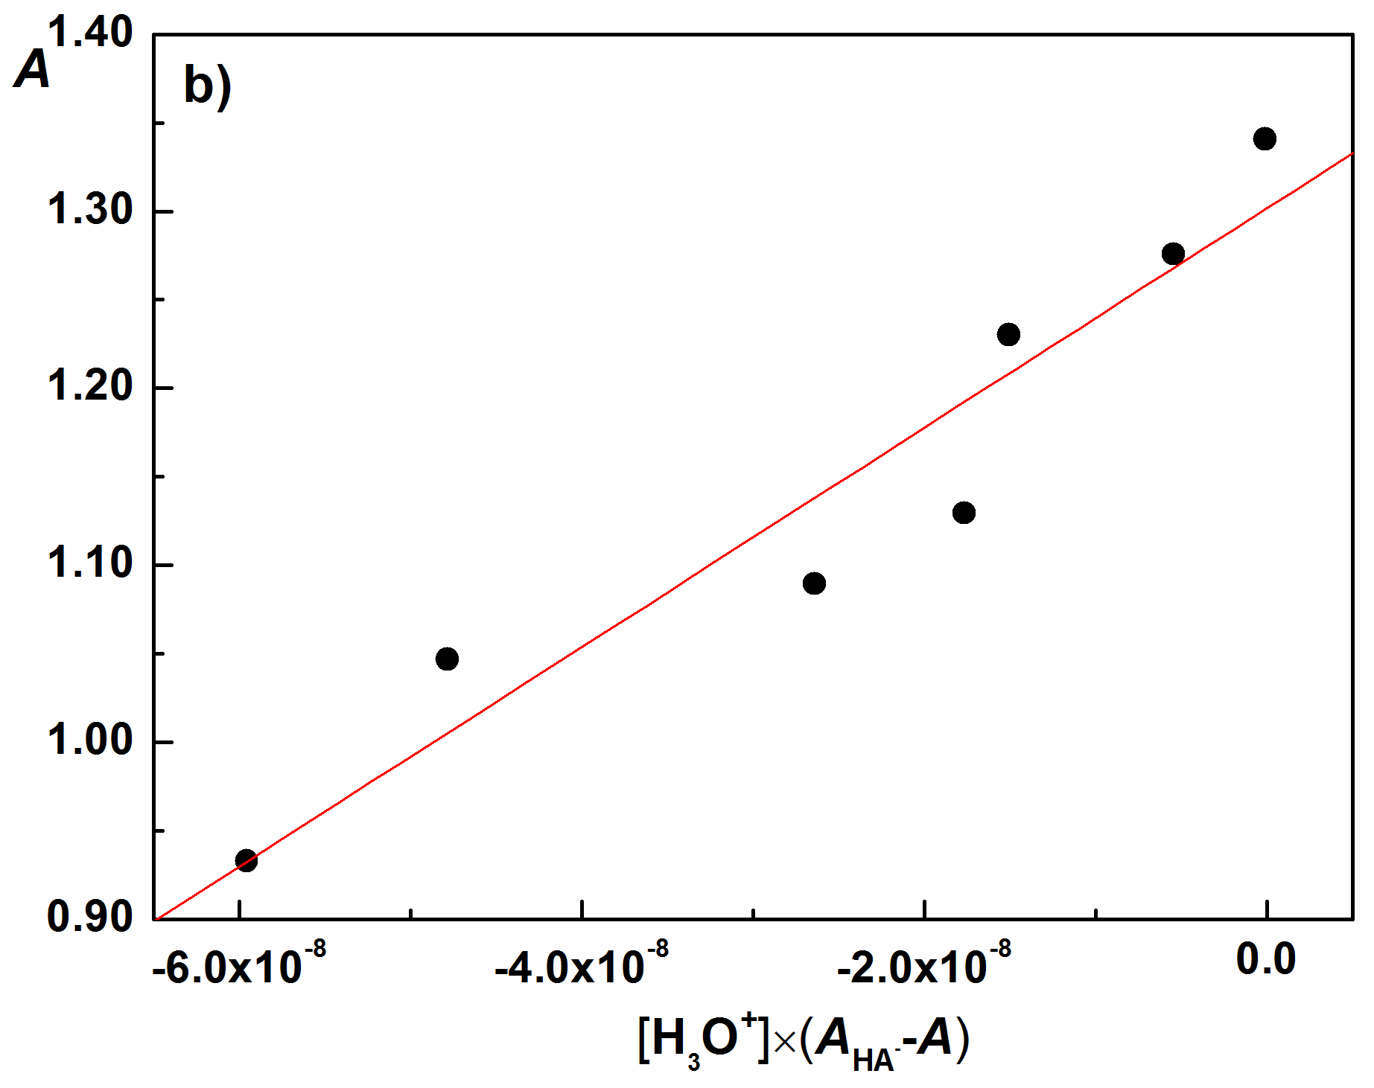
Fig. S19. Absorption spectra of compound 8 used for K_{a2} determination in solutions of different acidity, pH values are indicated; b) Spectrophotometric determination of K_{a2} according to Equation 2; c₈=5.904×10⁻⁵ М; λ=308.0 nm; t = 25 °C, I = 0.1 M (NaCl); scan speed 500 nm/min.

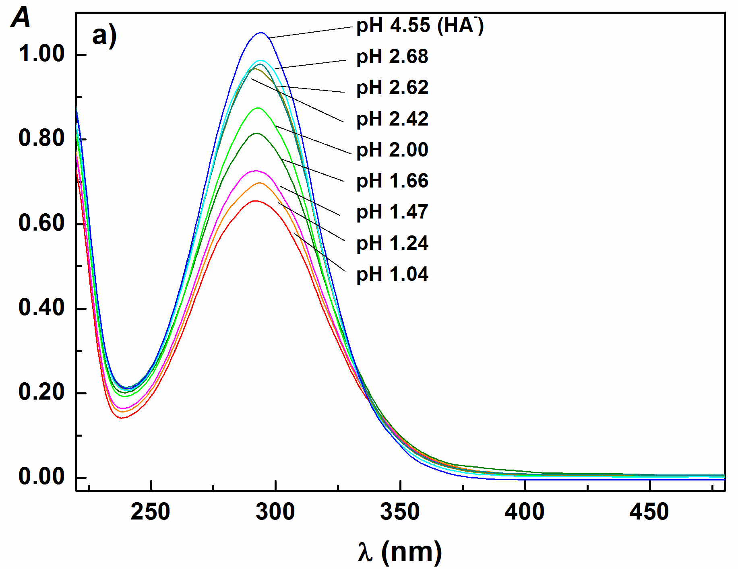 | 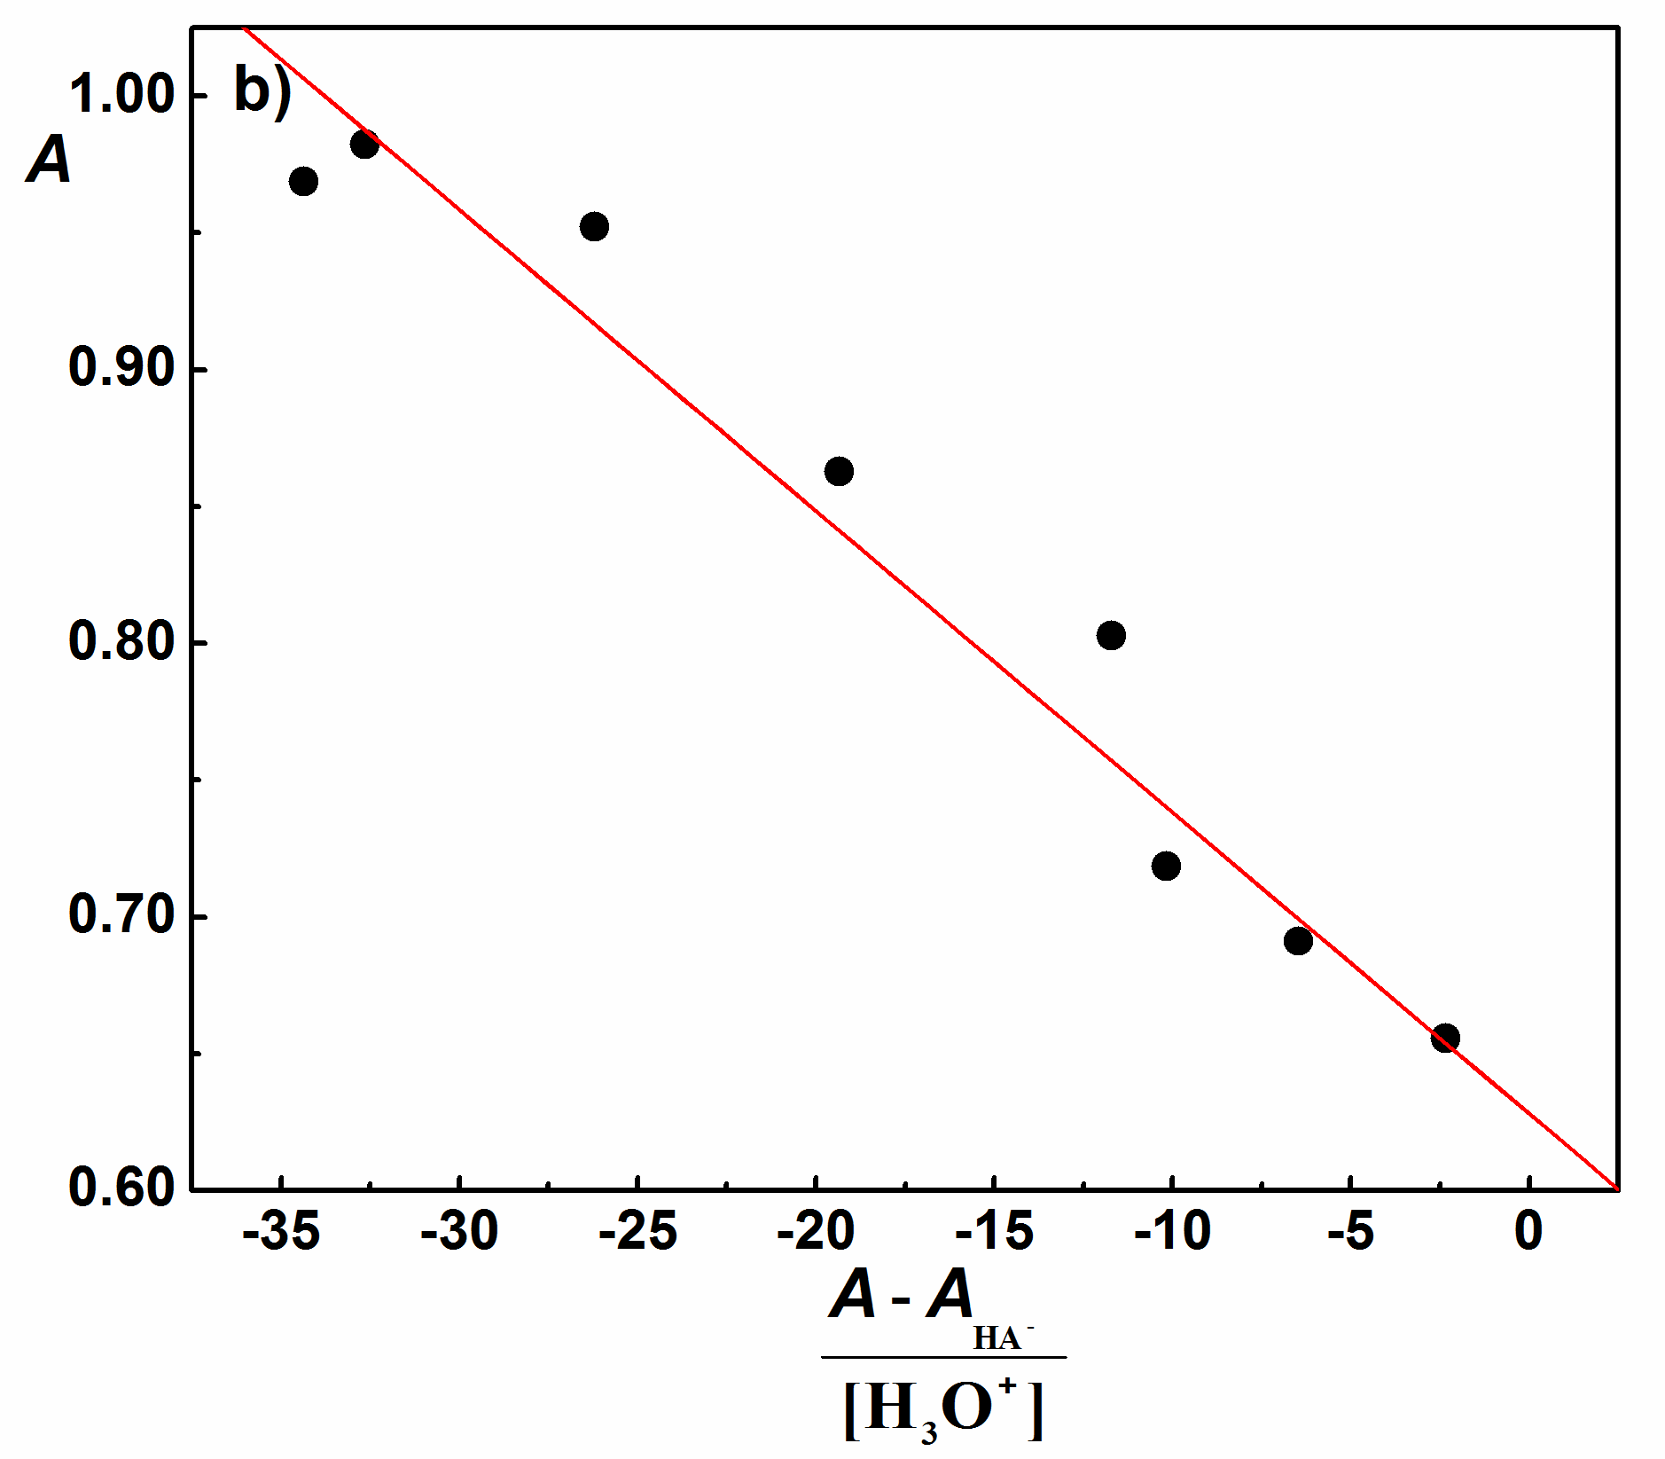
Fig. S20. Absorption spectra of compound 9 used for K_{a1} determination in solutions of different acidity, pH values are indicated; b) Spectrophotometric determination of K_{a1} according to Equation 1; c₉=6.066×10⁻⁵ M; λ=293.0 nm; t = 25 °C, I = 0.1 M (NaCl); scan speed 500 nm/min.

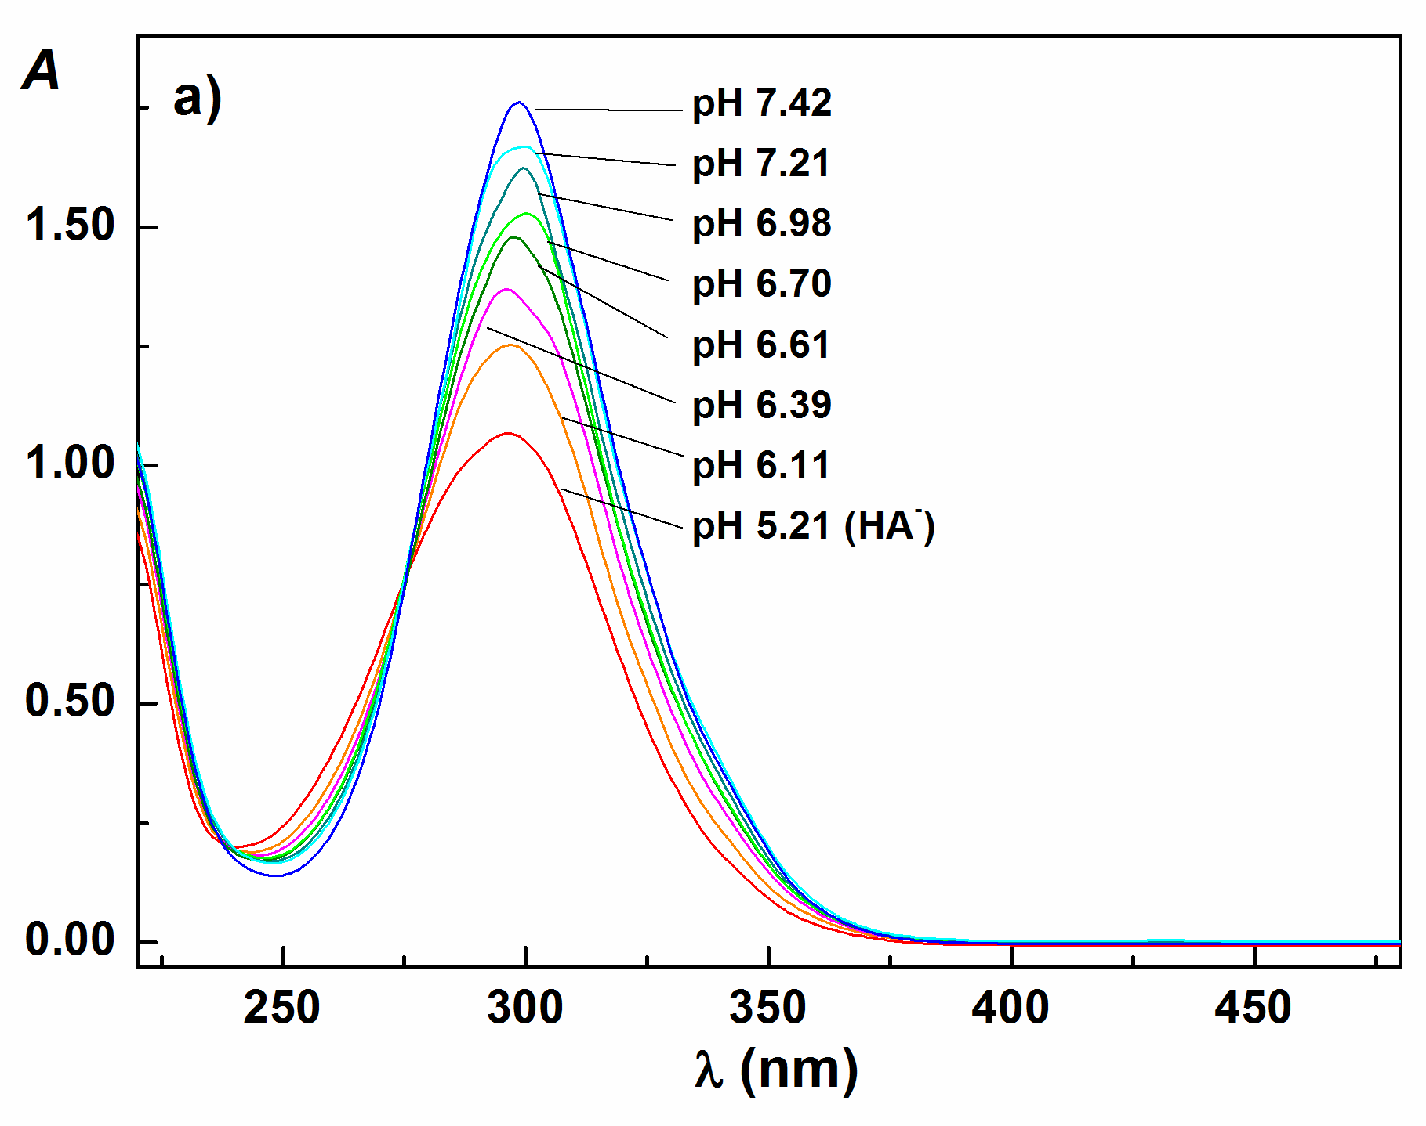 | 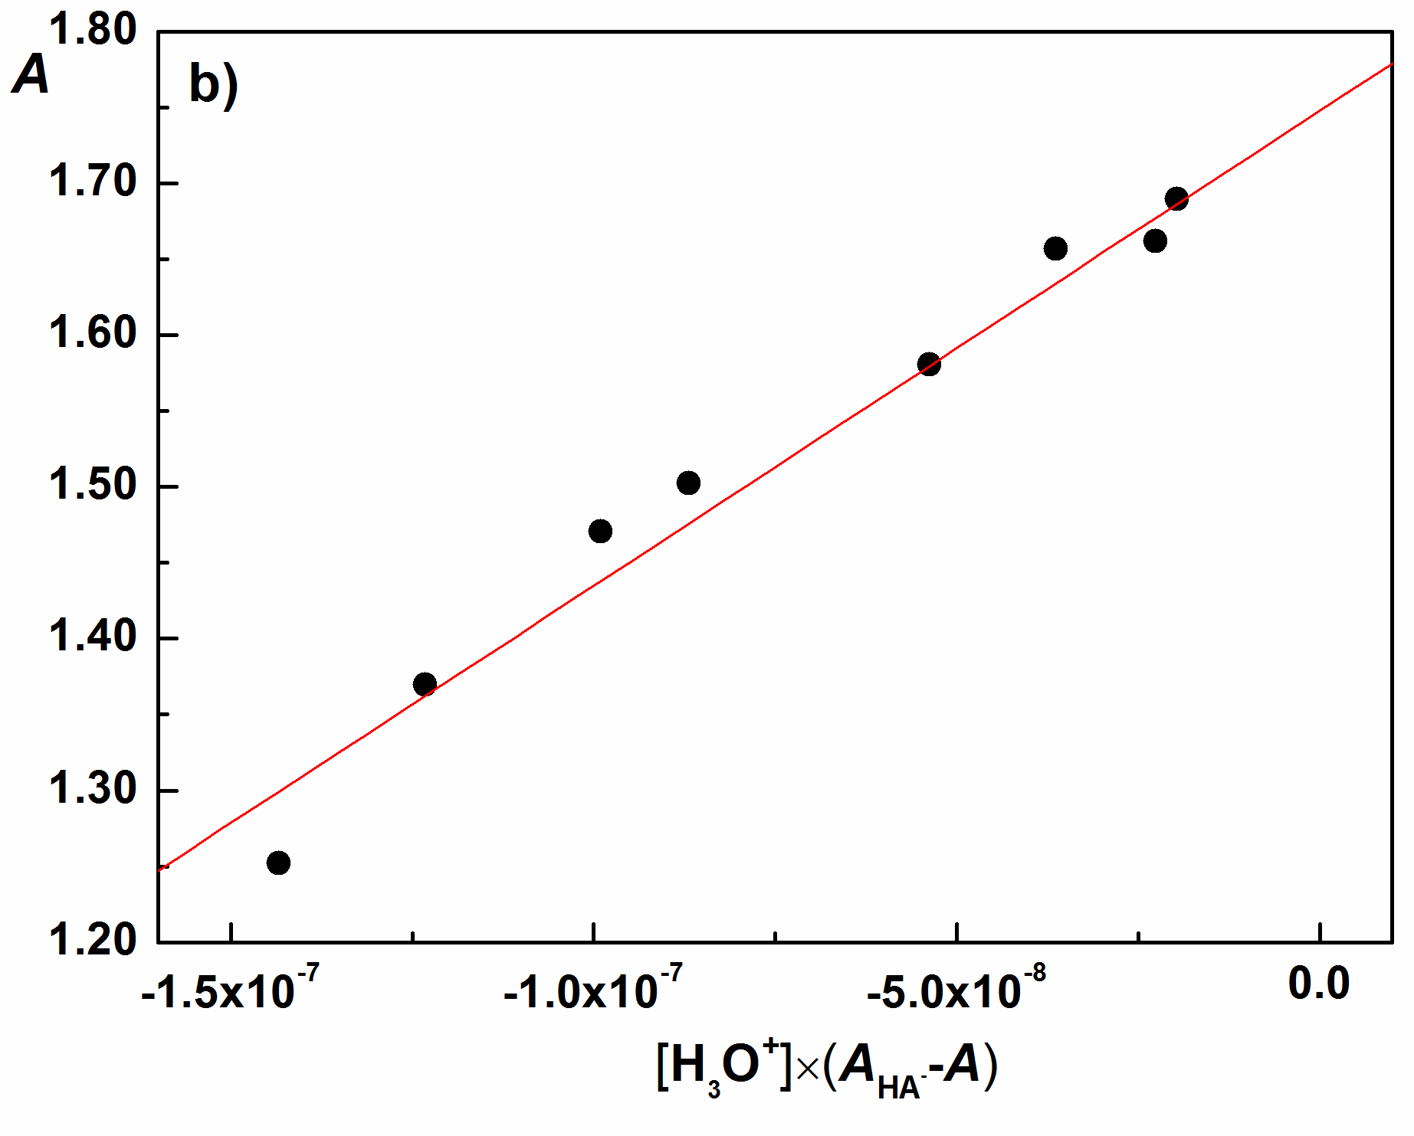
Fig. S21. Absorption spectra of compound 9 used for K_{a2} determination in solutions of different acidity, pH values are indicated; b) Spectrophotometric determination of K_{a2} according to Equation 2; c₉=6.066×10⁻⁵ M; λ=296.0 nm; t = 25 °C, I = 0.1 M (NaCl); scan speed 500 nm/min.

E_{MP2} (1) = – 684.84726595 a.u. | E_{MP2} (2) = –724.03224506 a.u. | E_{MP2} (3) = –724.03498687 a.u.
E_{MP2} (4) = –724.03499614 a.u. | E_{MP2} (5) = – 763.21997190 a.u. | E_{MP2} (6) = –763.21991834 a.u.
E_{MP2} (7) = –763.22322889 a.u. | E_{MP2} (8) = –802.40826292 a.u. | E_{MP2} (9) = –841.58953327 a.u.

Fig. S22. Optimized geometries and energies of 1-9 in their molecular (H₂A) form; MP2/6-31g (d,p) with PCM water solvation.

E_{MP2} (1) = –684.37315611a.u. | E_{MP2} (2) = –723.55802347 a.u. | E_{MP2} (3) = –723.56071545 a.u.
E_{MP2} (4) = –723.56057061 a.u. | E_{MP2} (5) = –762.74543555 a.u. | E_{MP2} (6) = –762.74547392 a.u.
E_{MP2} (7) = –762.74862068 a.u. | E_{MP2} (8) = –801.93348802 a.u. | E_{MP2} (9) = -841.11570354 a.u.

Fig. S23. Optimized geometries and energies of 1-9 in their monoanionic (HA–) form; MP2/6-31g (d,p) with PCM water solvation.

Fig. S24. Cyclic voltammograms of compounds 1-3 and 5-9 in Britton-Robinson buffer at pH 1, pH 5, and pH 10. a) 1, c₁= 5.46×10⁻⁵ M; b) 2, c₂ = 4.61×10⁻⁵ M; c) 3, c₃ = 6.54×10⁻⁵ M; d) 5, c₅ = 6.58×10⁻⁵ M; e) 6, c₆ = 4.09×10⁻⁵ M; f) 7, c₇ = 5.22×10⁻⁵ M; g) 8, c₈ = 4.06×10⁻⁵ M; h) 9, c₉ = 4.43×10⁻⁵ M; scan rate 100 mV/s, t=25±1 ºC.
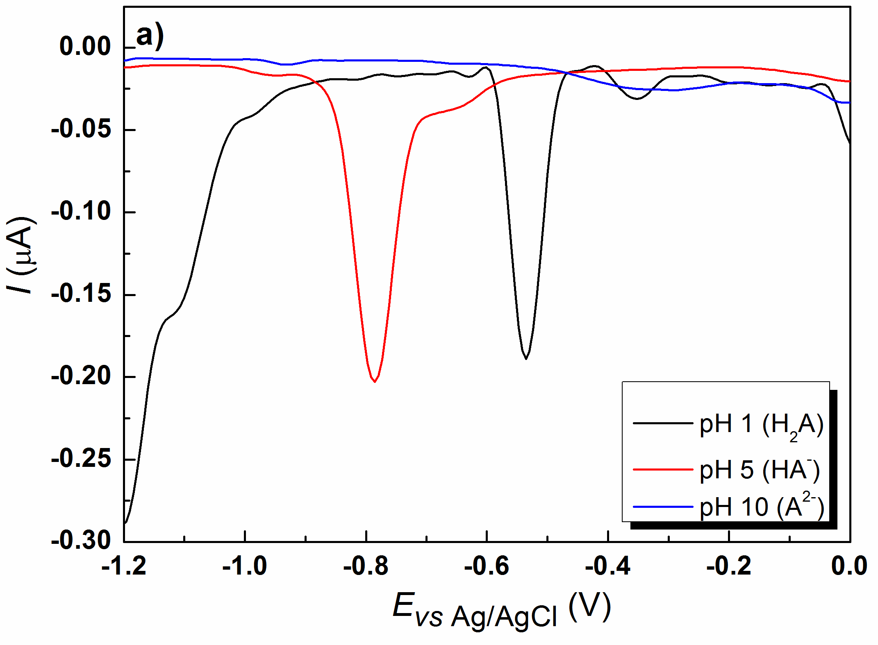 | 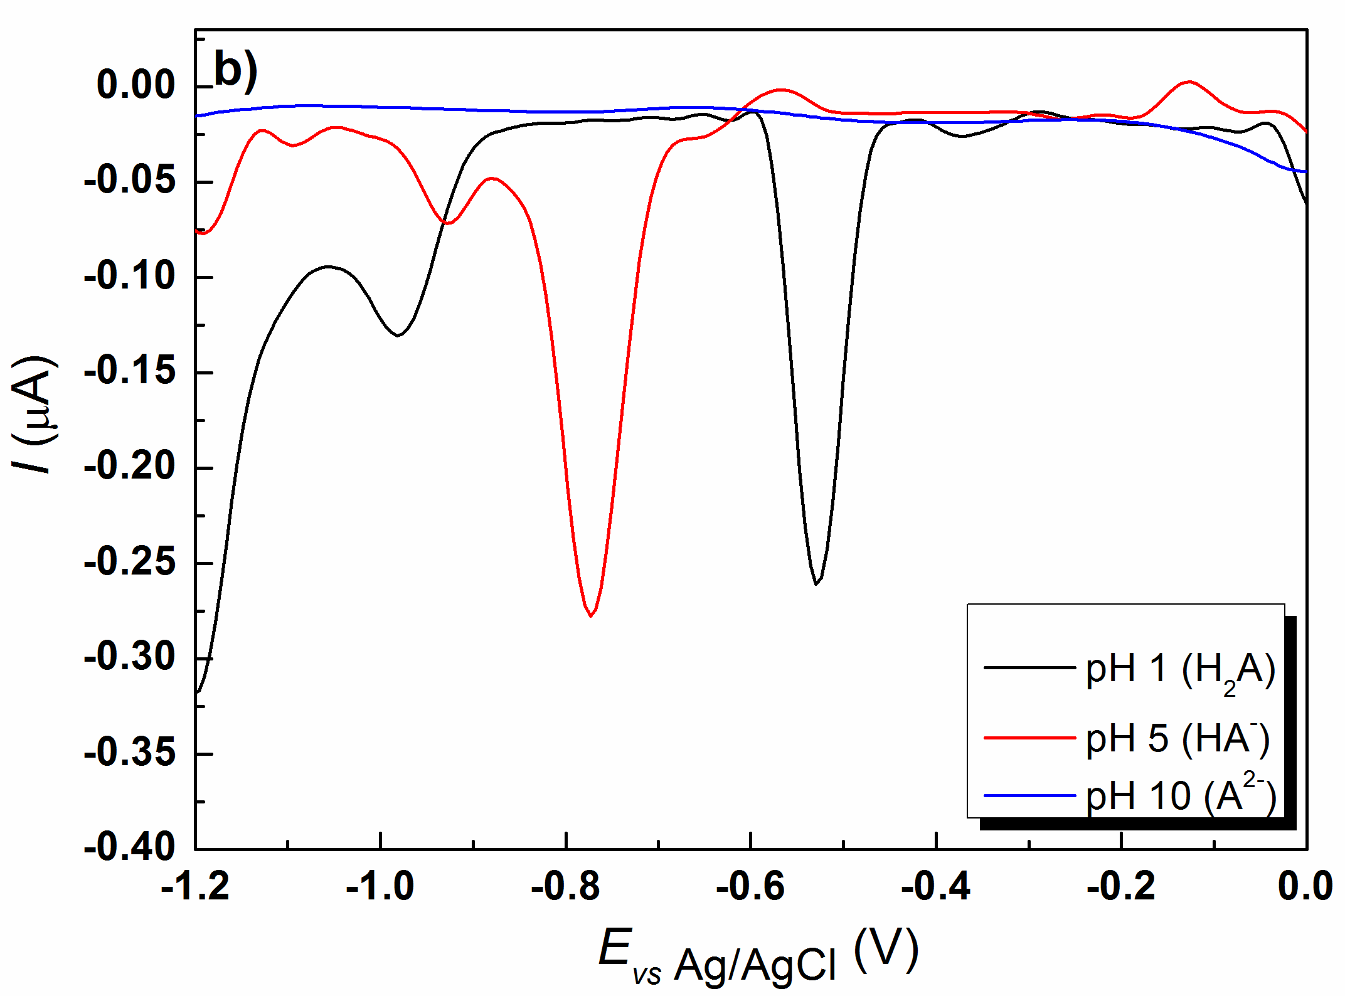
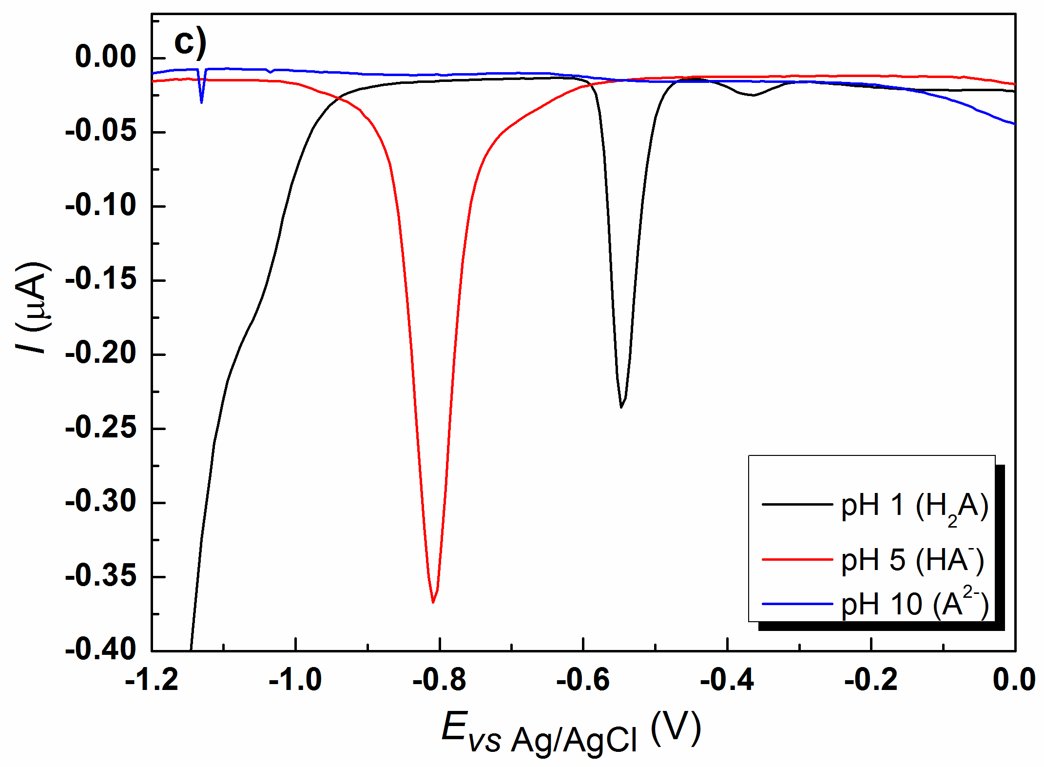 | 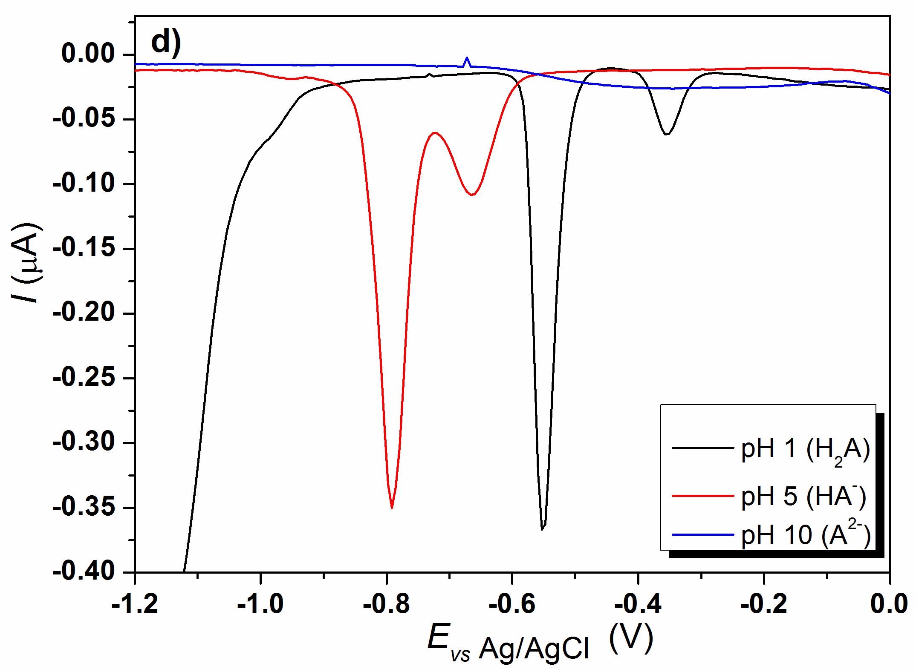
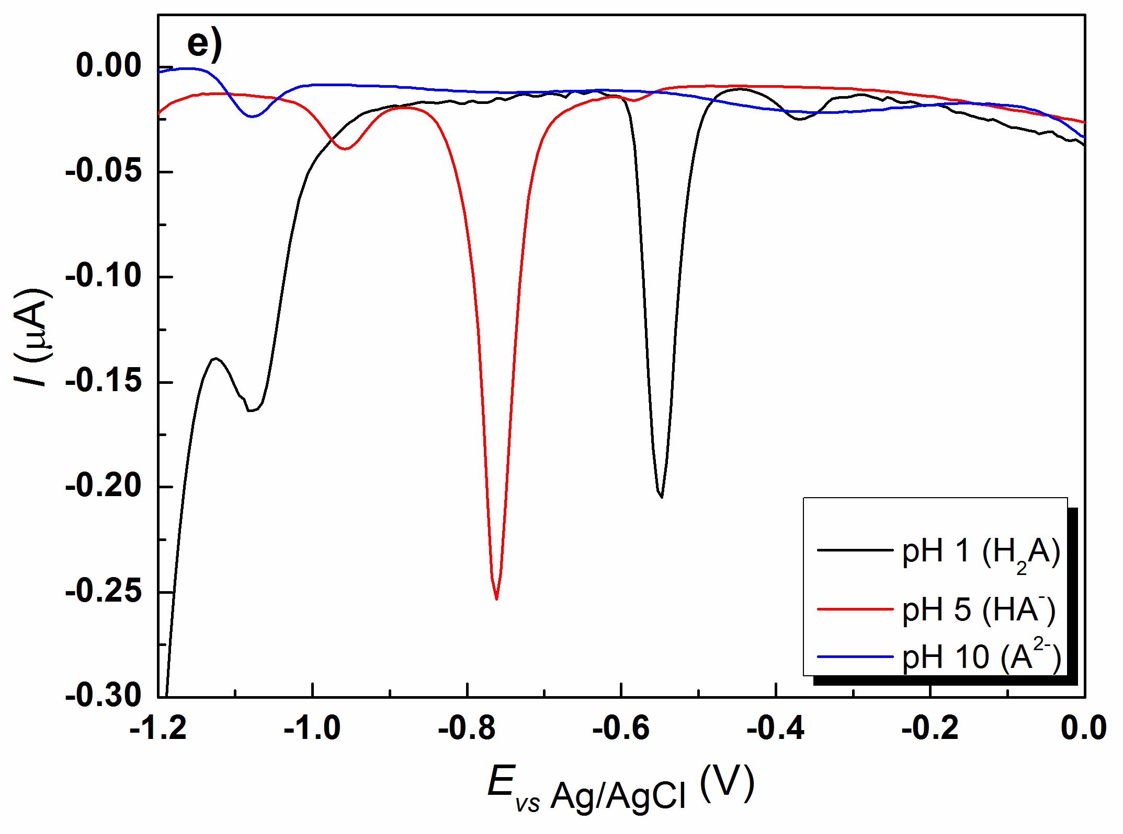 | 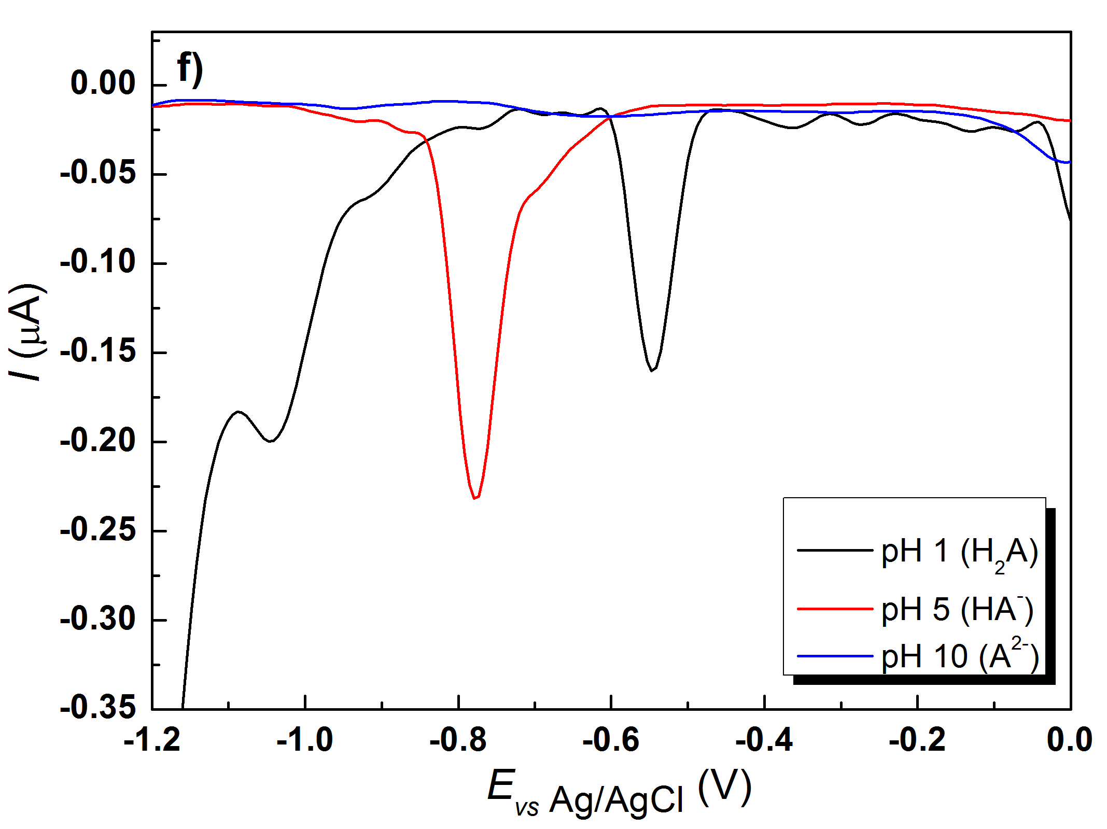
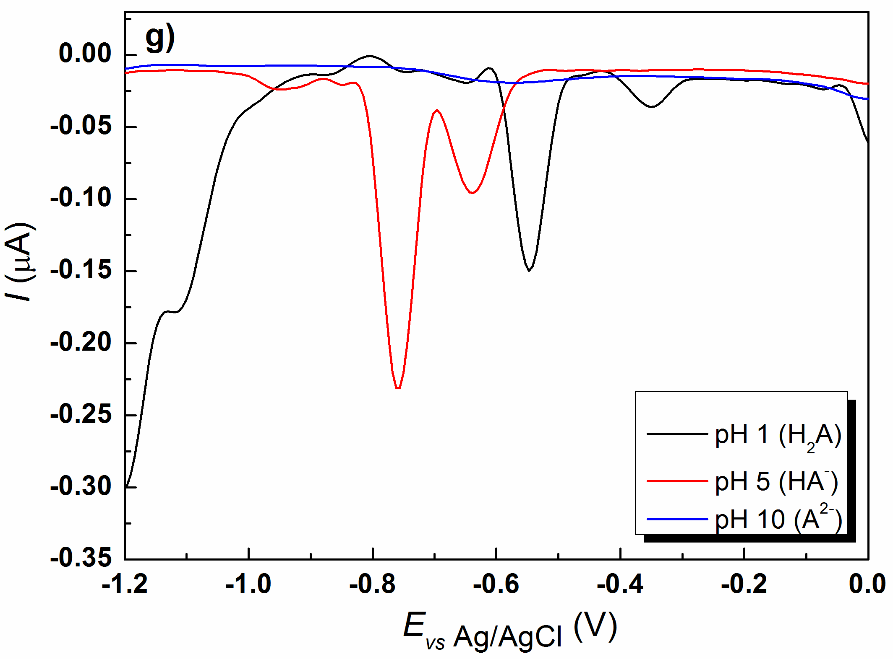 | 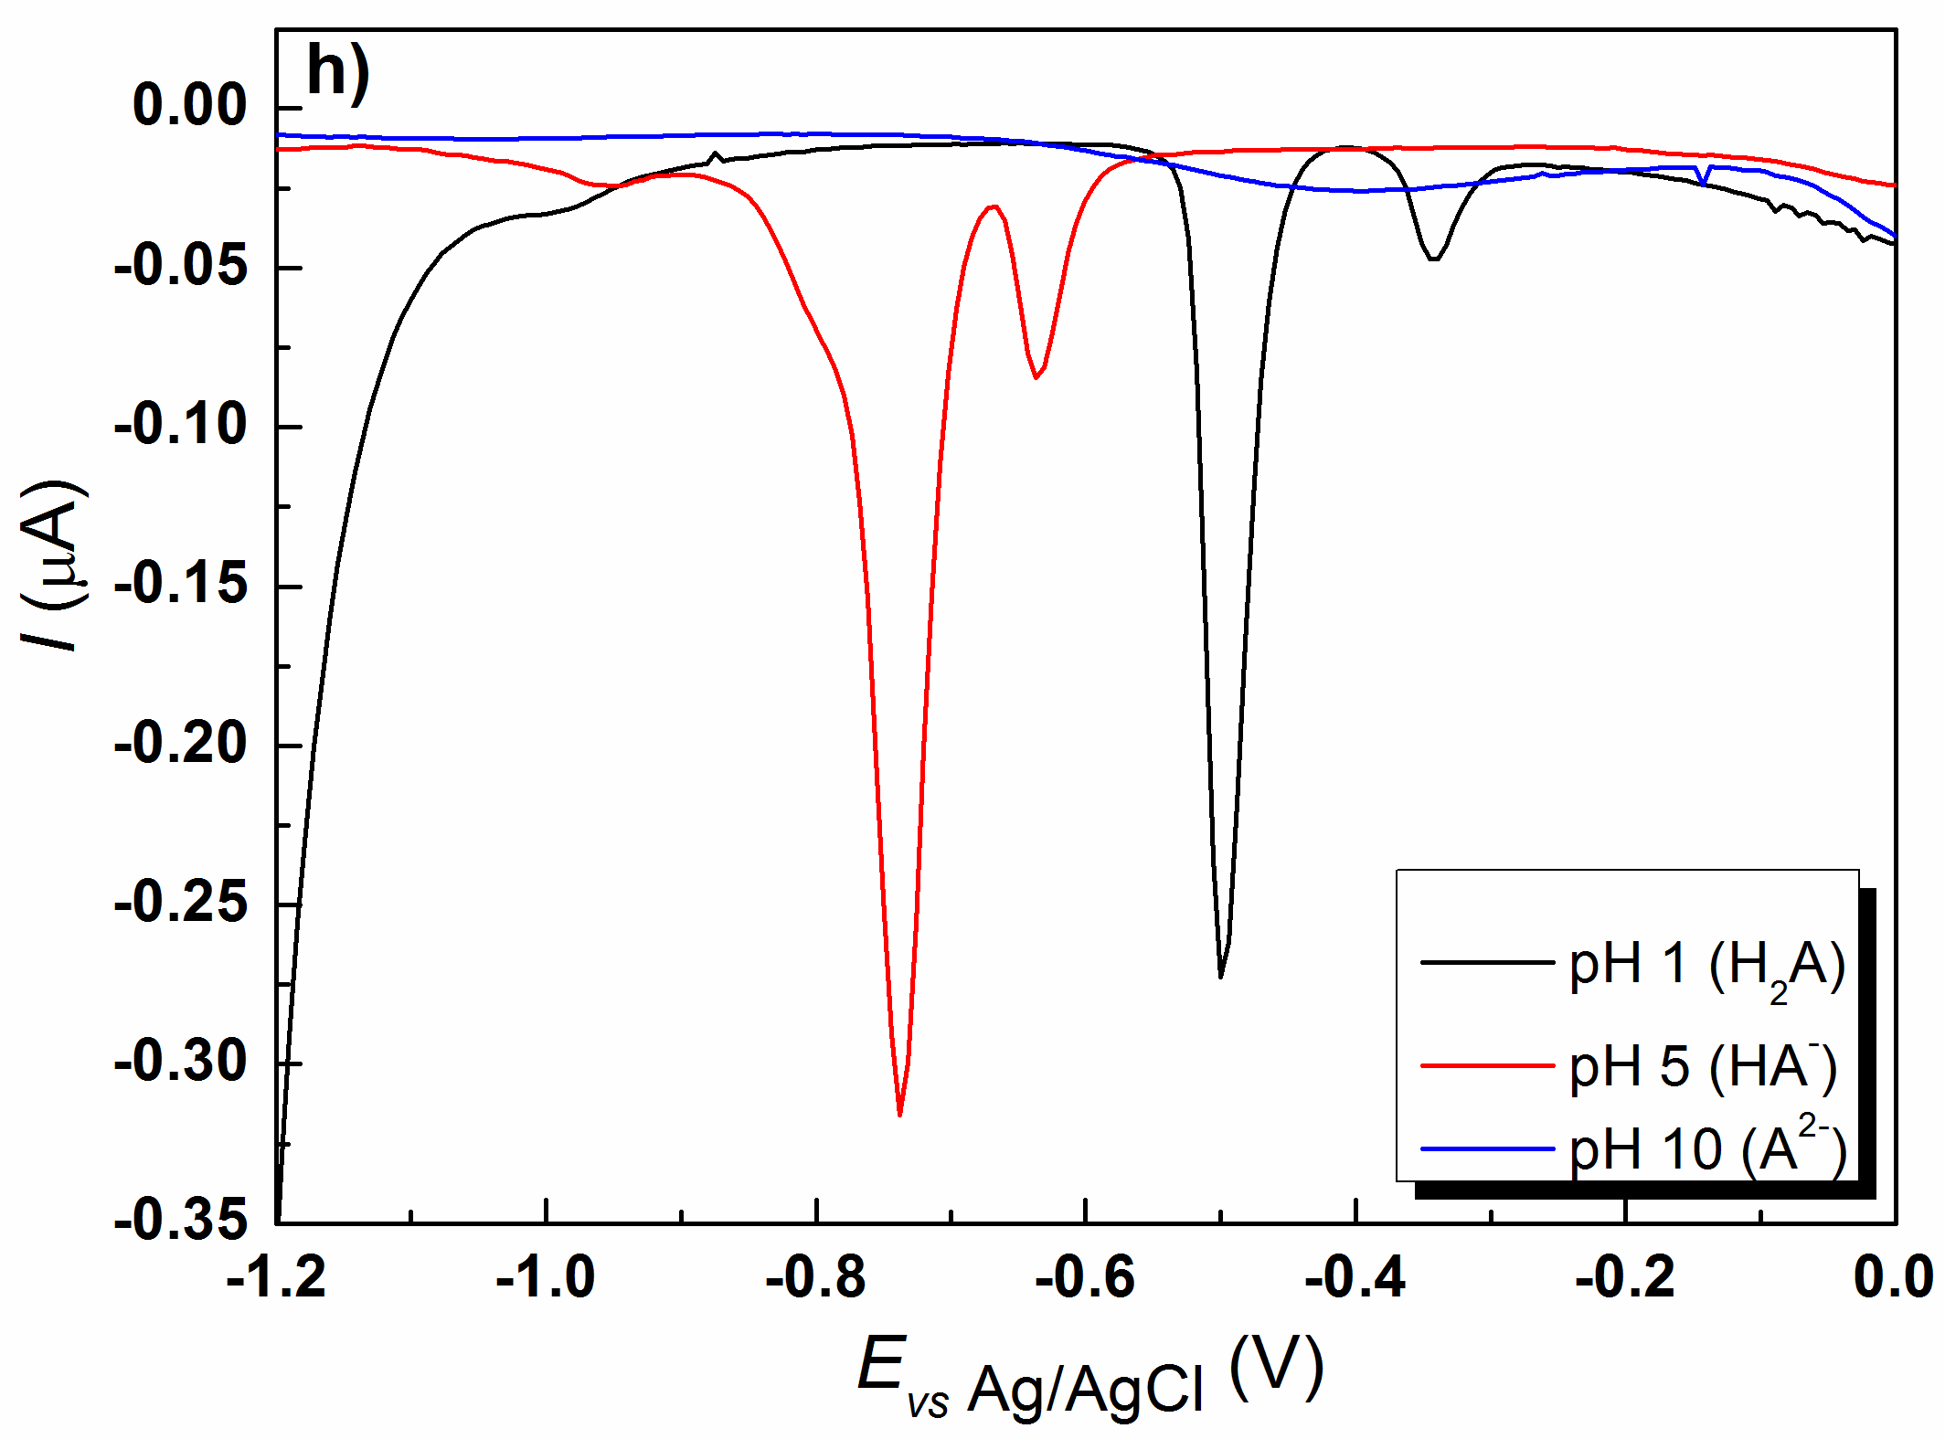
Fig. S25. Differential pulse polarograms of comp. 2-9 in Britton-Robinson buffer at pH 1, pH 5, and pH 10; a) 2, c₂ = 4.61×10⁻⁵ M; b) 3, c₃ = 6.54×10⁻⁵ M; c) 4, c₄ = 4.77×10⁻⁵ M d) 5, c₅ = 6.58×10⁻⁵ M; e) 6, c₆ = 4.09×10⁻⁵ M; f) 7, c₇ = 5.22×10⁻⁵ M; g) 8, c₈ = 4.06×10⁻⁵ M; h) 9, c₉ = 4.43×10⁻⁵ M; scan rate 13 mV/s, t=25±1 ºC.

Compound 4 | Compound 6 | Compound 9
Fig. S26. HOMO orbitals of H₂A form of compounds 4, 6 and 9 plotted on isocontour level 0.03.

Compound 4 | Compound 6 | Compound 9
Fig. S27. LUMO orbitals of H₂A form of compounds 4, 6 and 9 plotted on isocontour level 0.03.

Table SI. Energies of FMOs (given in Hartree), and dipoles (given in Debye) for molecular and monoanionic form of compounds 1-9.
 | Neutral (H₂A) |  |  |  | Anion (HA–)
Compound | HOMO | LUMO | HOMO-LUMO gap | Dipole | HOMO | LUMO | HOMO-LUMO gap | Dipole
1 | -0.3470 | 0.0367 | 0.3837 | 2.7040 | -0.3321 | 0.0625 | 0.3946 | 20.1289
2 | -0.3359 | 0.0406 | 0.3764 | 2.3366 | -0.3274 | 0.0670 | 0.3944 | 20.7147
3 | -0.3363 | 0.0377 | 0.3740 | 2.8168 | -0.3266 | 0.0625 | 0.3891 | 22.3967
4 | -0.3360 | 0.0394 | 0.3754 | 3.2365 | -0.3244 | 0.0641 | 0.3885 | 22.8528
5 | -0.3299 | 0.0417 | 0.3716 | 2.8786 | -0.3213 | 0.0683 | 0.3896 | 23.1538
6 | -0.3236 | 0.0401 | 0.3638 | 2.6851 | -0.3172 | 0.0670 | 0.3842 | 21.9031
7 | -0.3300 | 0.0403 | 0.3703 | 3.3452 | -0.3199 | 0.0641 | 0.3840 | 24.8252
8 | -0.3196 | 0.0425 | 0.3621 | 3.1584 | -0.3129 | 0.0687 | 0.3816 | 24.0766
9 | -0.3100 | 0.0448 | 0.3548 | 2.4134 | -0.3063 | 0.0778 | 0.3840 | 22.9021

Table SII. Energies of FMOs (given in Hartree), and dipole moments (given in Debye) for radical anion and radical cation derived from molecular form (H₂A) or monoanionic form (HA–) of compounds 1-9. Energies of αSOMO and αLUMO are shown.
 | Radical anion from H₂A |  |  |  | Radical cation from H₂A
Compound | SOMO | LUMO | SOMO-LUMO gap | Dipole | SOMO | LUMO | SOMO-LUMO gap | Dipole
1 | 0.0757 | 0.2471 | 0.1713 | 5.1253 | -0.3009 | -0.1600 | 0.1409 | 2.2888
2 | 0.0767 | 0.2475 | 0.1708 | 5.6837 | -0.2996 | -0.1579 | 0.1417 | 3.0584
3 | 0.0756 | 0.2459 | 0.1703 | 6.6132 | -0.2989 | -0.1576 | 0.1413 | 3.3480
4 | 0.0765 | 0.2458 | 0.1693 | 7.3901 | -0.2970 | -0.1551 | 0.1419 | 2.9073
5 | 0.0774 | 0.2465 | 0.1691 | 7.7582 | -0.2761 | -0.1313 | 0.1449 | 2.9050
6 | 0.0766 | 0.2443 | 0.1677 | 7.0045 | -0.2975 | -0.1555 | 0.1421 | 3.4272
7 | 0.0763 | 0.2452 | 0.1690 | 8.6434 | -0.2749 | -0.1306 | 0.1443 | 3.1645
8 | 0.0772 | 0.2461 | 0.1689 | 8.8467 | -0.2751 | -0.1316 | 0.1435 | 1.9357
9 | 0.0784 | 0.2537 | 0.1754 | 8.6062 | -0.2532 | -0.0821 | 0.1711 | 10.3233
 | Radical dianion from HA⁻
Compound | SOMO | LUMO | SOMO-LUMO gap | Dipole
1 | 0.1658 | 0.3866 | 0.2208 | 12.3478
2 | 0.1685 | 0.3824 | 0.2138 | 14.5640
3 | 0.1641 | 0.3836 | 0.2195 | 15.5722
4 | 0.1645 | 0.3812 | 0.2167 | 15.8690
5 | 0.1669 | 0.3779 | 0.2109 | 17.5080
6 | 0.1664 | 0.3836 | 0.2172 | 16.0213
7 | 0.1631 | 0.3817 | 0.2186 | 18.6586
8 | 0.1665 | 0.3795 | 0.2130 | 19.1801
9 | 0.1875 | 0.3529 | 0.1654 | 23.1287

Table SIII. Intercorrelation matrix (r values) between oxidation/reduction potentials at pH 1 and at pH 5 and descriptors extracted from QM calculations. Indicator variable (I) is also included. ‘Molecular’ refer to neutral form of compounds; ‘anion’ refer to anionic form of compounds (deprotonated carboxyl group); ‘RA’ refer to radical anion/dianion (derived from neutral/anionic form); ‘RC’ refer to radical cation derived from neutral form.
E_{ox}-pH_1 |  | E_{red}-pH_1
HOMO molecular | -0.6797 | HOMO molecular | 0.3250
LUMO molecular | -0.5739 | LUMO molecular | 0.2916
HOMO-LUMO gap/molecular | 0.6876 | HOMO-LUMO gap/molecular | -0.3233
Dipole molecular | 0.3642 | Dipole molecular | -0.6104
SOMO (RC) | -0.6565 | SOMO (RA) | 0.3298
LUMO (RC) | -0.7924 | LUMO (RA) | 0.8713
SOMO-LUMO gap/RC | -0.9352 | SOMO-LUMO gap/RA | 0.9361
Dipole RC | -0.9519 | Dipole RA | -0.0503
I | -0.7908 | I | 0.5906
E_{ox}-pH_5 |  | E_{red}-pH_5
HOMO molecular | -0.4092 | HOMO anion | 0.8213
LUMO molecular | -0.3958 | LUMO anion | 0.7433
HOMO-LUMO gap/molecular | 0.3999 | HOMO-LUMO gap/anion | -0.6495
Dipole molecular | 0.4117 | Dipole molecular | -0.3518
SOMO (RC) | -0.4353 | SOMO dianion (RA) | 0.6858
LUMO (RC) | -0.6048 | LUMO dianion (RA) | -0.6739
SOMO-LUMO gap/cation (RC) | -0.8283 | SOMO-LUMO gap/dianion (RA) | -0.6869
Dipole (RC) | -0.9067 | Dipole dianion (RA) | 0.7311
I | -0.5295 | I | 0.9533

*Corresponding author. E-mail: tatjanad@chem.bg.ac.rs
&We regret to inform that Branko Drakulić has passed away since completion of this work.

