Theoretical study on pegylation reaction mechanisms of IFN-α-2a, IFN-α-2b and IFN-β-1a

MOHAMMAD TAQAVIAN, DARYOUSH ABEDI, FATEMEH ZIGHEIMAT and LEILA ZEIDABADINEJAD

Biosun Pharmed, Co., Tehran, Iran

Abstract: Ab initio and DFT calculations have been carried out to study the reaction mechanism between IFN-α-2a, IFN-α-2b and IFN-β-1a and polyethylene glycol (PEG) group. The calculations show that the mechanisms are concerted in agreement with the results of experimental works. However, although it appears that there is one single transition state, the characteristics of its structure reveal a very synchronous reaction mechanism. The reactions are clearly exothermic and as well have feasible activation energies. Our computational study shows that the lowest transition state energies are related to Lys 134, His 34 and Met 1 of IFN-α-2a, IFN-α-2b and IFN-β-1a, respectively.

Keywords: IFN-α-2a; IFN-α-2b; IFN-β-1a; Pegylation; Transition state; DFT.

RUNNING TITLE: THEORETICAL INTERACTION BETWEEN INTERFERONS AND PEG GROUP

INTRODUCTION
Interferons (IFNs) are currently one of the classes of human proteins most widely used as therapeutic agents and approved to treat various types of cancer and viral diseases.¹⁻⁶ They are divided into type I (α and β IFNs) and type II (γ or immune interferon). Alpha interferons are used in the treatment of chronic hepatitis B and C infections in combination with antiviral drugs.⁷⁻¹¹ Beta interferon reduces the relapse rate in subgroups of patients with multiple sclerosis.⁷ The necessity of more effective and tolerable drugs caused to introduce some innovative methods such as drug delivery and carriers. One of the most effective methods is pegylation. This modification is a standard procedure to increment the solubility, stability, efficacy of a drug, and half-life, and is applied in several drugs.¹² As pegylation increases a protein’s half-life in the vascular circulation it reduces the dose of protein required for treatment and consequently reduces the drug’s side effects. Accordingly pegylation of IFNs has been used successfully to improve the pharmacokinetic properties and efficacy of the drug. PEGylated IFNs (PEG-IFNs) are the covalent conjugate of recombinant IFNs with a monomethoxy polyethylene glycol (PEG) in a 1:1 molar ratio^{13,14}, originally designed to improve pharmacokinetic profiles. PEG-IFN-α-2b (Pegintron / Sylatron) has been approved for the treatment of chronic hepatitis B and hepatitis C virus (HCV) infection¹⁵ and so PEG-IFN-α-2a (Pegasys / Peginterferon) is approved for the treatment of HCV, hairy cell leukemia, and chronic phase Philadelphia chromosome-positive chronic myelogenous leukemia.^{16,17} PEGylated IFN-β-1a (Plegridy) was developed by the attachment of a polyethylene glycol side chain to the parent interferon molecule and has been approved for treatment of relapsing multiple sclerosis in adult patients to slow the progression of disability and decrease the frequency of relapses.^{18,19}
In pegylation process the conjugation of PEG can occur conceivably at any of the numerous nucleophilic sites of the primary amino acids potentially available in protein structure. These sites generally include lysine (Lys), serine (Ser), tyrosine (Tyr), histidine (His), threonine (Thr), methionine (Met) and N-terminal cysteine (Cys) in different type of interferon.^{14,20-23}
The IFN-α-2a protein contains 11 lysine residues plus the N-terminus that theoretically are potential sites for pegylation.²⁴ It has been shown that not all 11 pegylation sites on IFN-α-2a are accessible for interaction with the PEG moiety and no pegylation was observed at the N-terminus.²⁵ In fact purified peginterferon (40PEG-IFN-α-2a) is composed of nine bioactive isomers contained around 95% to 99% monopegylated conjugates.^{26,27} There are 6 Lys (Lys 83, Lys 134, Lys 131, Lys 121, Lys 70 and Lys 31) in suitable positions for interaction with PEG group which overall, 94% of PEG attachment take place in Lys 134, Lys 131, Lys 121 and Lys 31 and the other lysine residues are in inner cavity of protein.²⁶
Theoretical pegylation sites in IFN-α-2b protein are numerous nucleophilic groups containing the ɛ-amino groups of the 10 lysines, the α-amino group at the N-terminal cysteine, the imidazolylnitrogens of the 3 histidines, and the hydroxyl groups at the 14 serines, 10 threonines, and 5 tyrosines. Cys 1-Cys 98, Cys 29-Cys138, His 7, His 57 and His 34 are positional of PEG Intron which His 7, His 57 and His 34 are major positional of PEG Intron.^{14,28}
The IFN-β-1a protein has numerous nucleophilic amino groups due to its constitutive amino acid residues. In Plegridy (20PEG-IFN-β-1a) the N-terminal α-amino group of methionine is modified.²⁹ Two important potential sites of IFN-β-1a contain Met 1 and Cys 17 were the objects of this investigation.
However, many fundamental issues remain unclear about reaction mechanism of formation PEG-IFNs. To the best of our knowledge, no theoretical studies have yet been reported for investigating reaction mechanism of PEG-IFNs. Therefore, in this paper, we carried out a detailed density functional theory (DFT) study aimed at gaining deeper insight into the mechanism of interaction between IFN-α-2a, IFN-α -2b and IFN-β-1a with PEG group. Based on computational studies in this work we proof that the major positions of IFN-α-2a, IFN-α-2b and IFN-β-1a are PEGylated at Lys 134, His 34 and Met 1, respectively.

METHODOLOGY
All calculations were performed with Gaussian 09,³⁰ geometries of the structures were
optimized without any symmetry constraints at B3LYP/6-31g(d,p) level theory.³¹ The structures were drawn in the Gaussview 5.0 software. Each optimized structure was confirmed by frequency analysis at the same level to confirm the stationary point as a true minimum (no imaginary frequency). Intrinsic reaction coordinates (IRC) calculations were performed to confirm that the transition states connect to the right starting materials and products. Stationary points located through IRC were then completely optimized. We present potential energy surfaces for the reactions and provide characterization of the transition states and intermediates involved.
In this study, we present theoretical study interaction between probable sites of IFN-α-2a, IFN-α-2b and IFN-β-1a with PEG group. The stability and electronic properties of the products have been unveiled by DFT calculation. This shall help to understand more thoroughly the origin of the interactions between residues in IFNs with PEG group. However, analyzing the nature of interactions provides a good basis for development and support of a chemical model. Accordingly, in the present work, the strength of the interactions between active sites of IFNs and PEG group has been unveiled. Within this work several a priori plausible mechanisms for PEG-IFNs have been tested.

RESULTS AND DISCUSSION
Geometries of IFN-α-2a, IFN-α-2b and IFN-β-1a
In the present study we selected B3LYP function to test suitability for the structures under consideration. The crystal structures of the IFN-α-2a, IFN-α-2b and IFN-β-1a with PDB codes: 1ITF, 1RH2 and 1AU1, respectively, were retrieved from the RCSB ProteinData Bank (http://www.rcsb.org), and water molecules were removed. The mechanisms for reactions between PEG group and IFN-α-2a, IFN-α-2b and IFN-β-1a have been calculated. According to obtained results of experimental studies,^{14,26,32} there are various sites of IFNs for pegylation which are shown in Fig. 1. In this work, we investigated reaction pathways and stability of mainly sites in pegylation of IFNs. At first, for each of the IFNs an active space is considered which optimizations were conducted without any constraint, and important bond lengths are shown in Fig. 2. The selected residues (Fig. 2) were truncated so that in principle only the side chains were kept in these models. To keep the optimized structures close to those obtained experimentally, the truncation of atoms except those residues which participate in reaction were fixed after optimization.
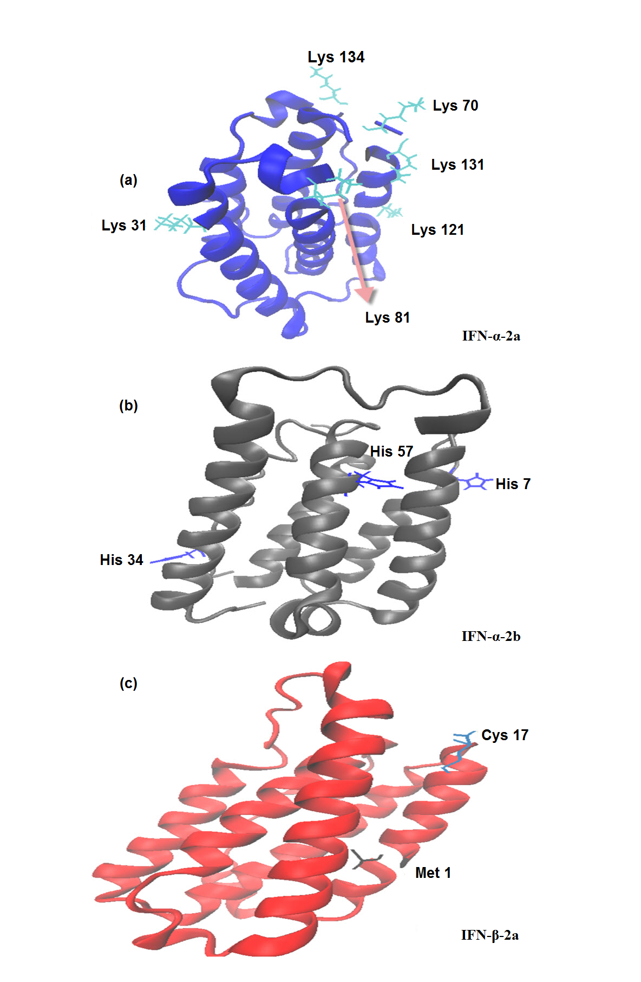
Fig.1. Positional assignment map for PEG isomers of (a) IFN-α-2a (b) IFN-α-2b and (c) IFN-β-2a
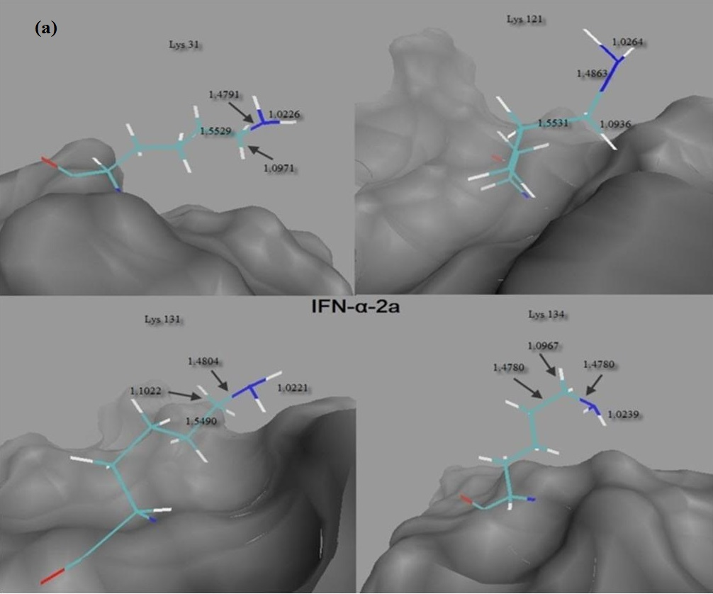
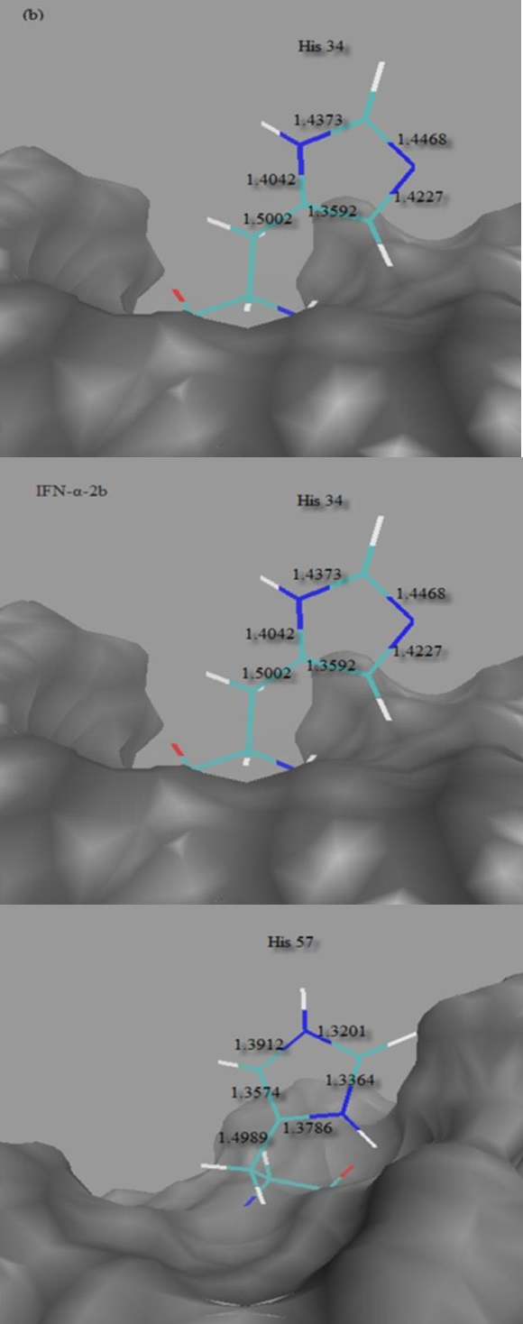
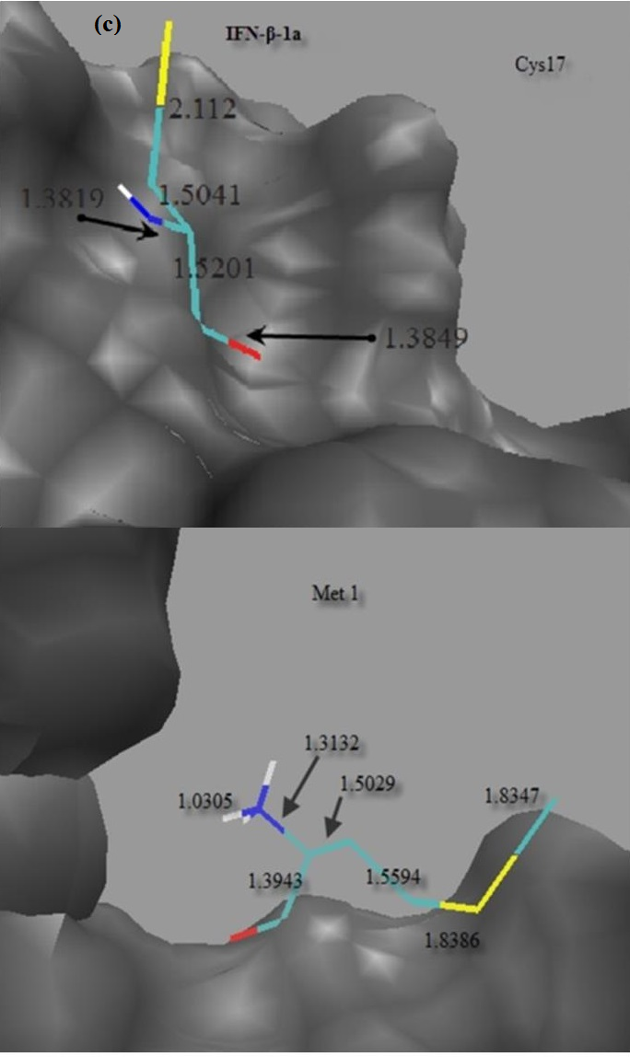
Fig. 2. Optimized structures for the (a) IFN-α-2a, (b) IFN-α-2b and (c) IFN-β-1a with PEG group, the bond distances are in angstroms.

Reaction mechanisms of the formation of PEG- IFN-α-2a
The calculating studies for investigation the energy of the transition state (TS) and reaction mechanism in the field of PEG-IFNs has not been done. Our study commenced with the proper choice of the computational models. Fig. 3 was employed as the models for the investigation of the reaction profile, when NH₂ of amine groups of IFNs participate at Pegylation reaction, reaction profile follows a mechanism. If the imidazolyl nitrogen of IFNs reacts with PEG group, reaction pathway follows b mechanism.
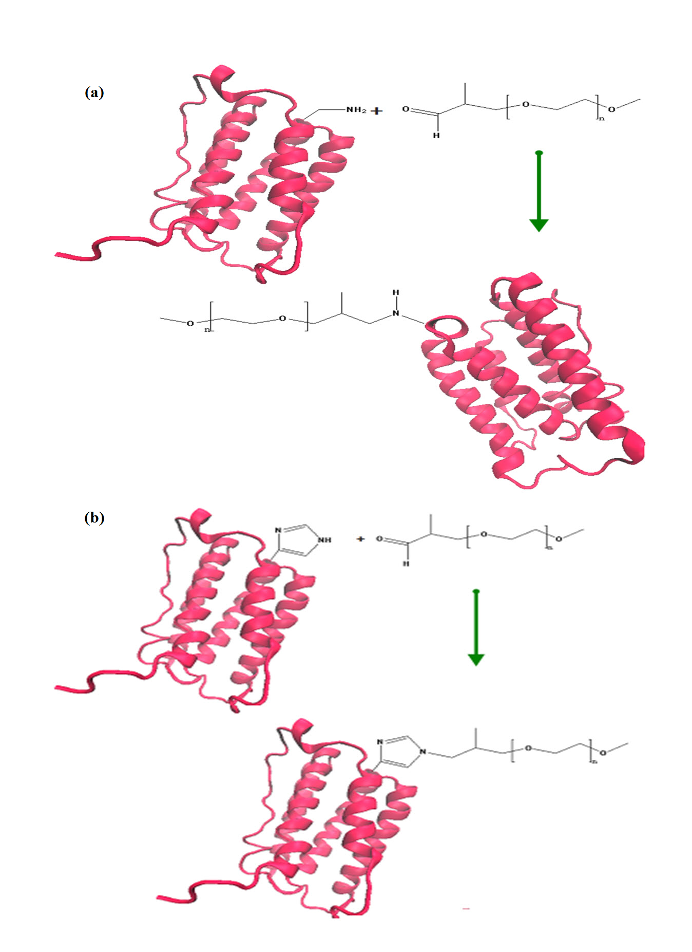
Fig.3 The suggested reaction paths for (a) NH₂-terminal group of amino acids and (b) NH group of imidazoleof IFNs with PEG

The transition states for the nucleophilic attack by the NH₂ of amine groups of Lys residues of IFN-α-2a on the PEG group were optimized and confirmed to be the first-order saddle point with only one imaginary frequency for Lys 31, Lys 121, Lys 131, Lys 134, Lys 83 and Lys 70 (104i, 100i, 120i, 83i, 118i and 101i cm⁻¹). The active sites of important residues (Fig. 2a) and PEG group were set as the zero-point of the potential energy surface. At TS, the key distances between NH₂ amine of Lys residues and the C atom which lie at the end of a carbon chain of PEG group are 2.23, 2.18, 2.30, 2.16, 2.38 and 2.41 Å. Calculating energetic barriers for these reactions reveals a feasible energy barrier. The calculated energetic barriers for these reactions are 15.7, 14.5, 19.2, 11.3, 66.1 and 57.2 kcal/mol (Fig. 4). According to reaction profile, activation barrier for Lys 31, Lys 121, Lys 131 and Lys 134 are lower than Lys 70 and Lys 83. Therefor it is interest to obtain larger quantity of PEG-IFN-α 2a that includes Lys 31, Lys 121, Lys 131 and Lys 134.
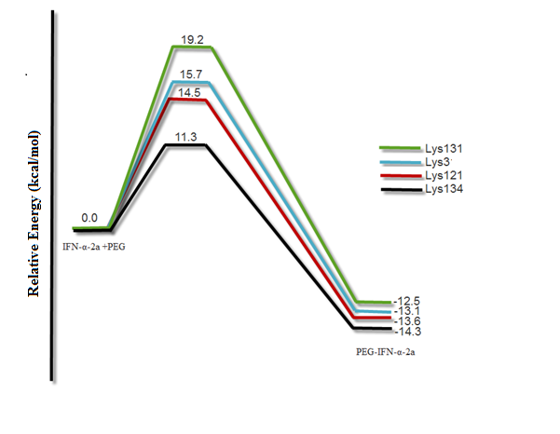Fig.4. The calculated energy profile along the suggested reaction path for PEG.IFN-α-2a

Reaction mechanisms of the formation of PEG- IFN-α-2b
In IFN-α-2, the lone pair of imidazolyl nitrogen of His has more nucleophilic strength than the CH of the ring. A useful aspect of the natural bond orbital (NBO) method is that it gives information about interactions in both filled and virtual orbital spaces that could enhance the analysis of intra and intermolecular interactions. The electron densities for this functional group have been analyzed using (NBO) reveals that the values of electron densities on C-H of the ring are 0.206, -0.0301 and -0.141, the value of electron density on NH is -0.542, so that NH group participate in pegylation. The transition states for the nucleophilic attack by the N of His on the PEG group were optimized and confirmed to be the first-order saddle point with only one imaginary frequency for His 7, His 34 and His 57 (98i, 32i and 86i cm⁻¹). The active sites of important residues (Fig. 2b) and PEG were set as the zero-point of the potential energy surface. At TS, the key distances between NH and the C atom which lie at end of a carbon chain of PEG are 2.54, 2.22 and 2.49 Å. The calculated energetic barriers are very feasible 34.4, 17.1 and 29.6 kcal/mol (Fig. 5). According to barrier activation, we expect more product contains PEG group connected to His 34.
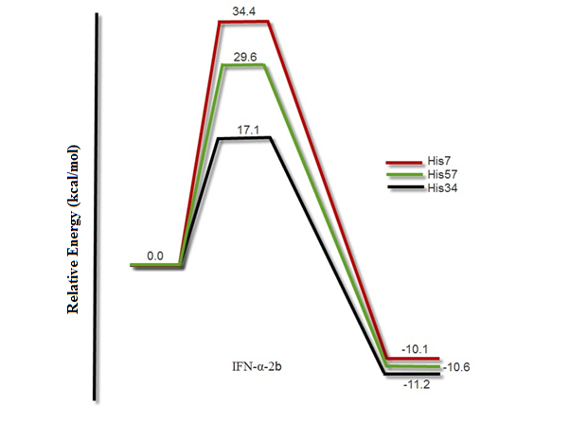
Fig.5 The calculated energy profile along the suggested reaction path for PEG.IFN-α-2b

Reaction mechanisms of the formation of PEG- IFN-β-1a
In IFN-β-1a, NH₂ of amine group attached to Met 1 and Cys 17 are nucleophile so they can attack to PEG group. The result of NBO analysis reveals the value of electron density on N atom of NH₂ of Met 1 and Cys 17 are -0.69 and -0.52, respectively. The transition states for the nucleophilic attacks on the PEG group were optimized and confirmed to be the first-order saddle point with only one imaginary frequency for Met 1and Met 36 (35i and 65i cm-1). The active sites of important residues (Fig. 2c) and PEG were set as the zero-point of the potential energy surface. At TS, the distances between corresponding N of Met 1 and Cys 17 with the C atom which lie at end of a carbon chain of PEG are 2.34 and 2.63 Å, respectively. The calculated energetic barriers are the very feasible 22.3 and 39.8 kcal/mol (Fig. 6). According to barrier activation, we expect more product contains PEG group connected to Met 1
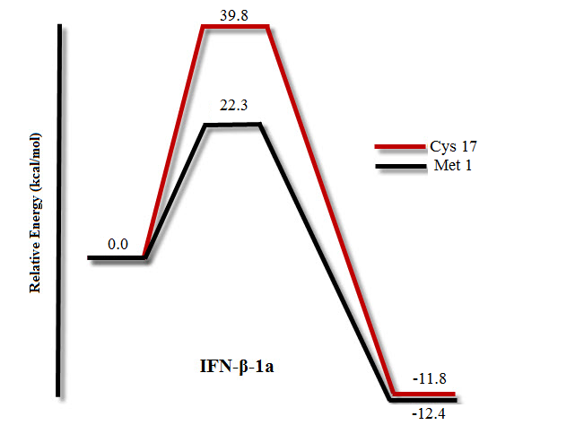
Fig.6 The calculated energy profile along the suggested reaction path for PEG.IFN-β-1a

CONCLUSIONS
N-Terminally PEGylated IFNs is useful for the treatment of certain cancers So that investigation of reaction mechanism of formation of PEGylated IFNs is important. The theoretical study of the Pegylation of the N-terminus of IFN-α-2a, IFN-α-2b IFN-β-2a has been carried out at B3lyp/6-31g(d,p) level theory. The most relevant aspect of this theoretical study concerns of achievement of valuable information on the reaction pathways of PEG-IFNs formation and on the transition state energy which would be important. We expect that our results provide new insight into interaction, reaction pathways and chemical properties between IFNs and PEG group for developing important performance theoretical calculation in suggesting sites in pegylation of IFNs. There are two possible mechanisms based on the nucleophilic attack of N-terminal residues. The major sites of IFN-α-2a, IFN-α-2b and IFN-β-1a which contribute at nucleophilic attacks to PEG group are Lys 134, His 34 and Met 1, respectively. The activation barriers in formation mechanism of PEG-IFNs are easily surpassed under the reaction conditions, therefore, plausible mechanism is used mechanism. The results of investigating TS shows that Lys 134, His 34 and Met 1 have the lowest energy to get transition state. Our calculated results have good agreement with experimental observations.

REFERENCES

1. G. Sen, P. Lengyel, J. Biol. Chem. 267 (1992) 5017
2. S.K. Tyring, Am. J. Obstet. Gynecol. 172 (1995) 1350
3. M. Peters, Hepatology. 23 (1996) 909
4. R.G. Tsanev, I. Ivanov, Immune interferon: properties and clinical applications, CRC Press 2001
5. B. Perussia, M. Kobayashi, M.E. Rossi, I. Anegon, G. Trinchieri, J. Immunol. 138 (1987) 765
6. K. Fantes, In Vitro Monogr. 3 (1974) 48
7. J. Parkin, B. Cohen, Lancet. 357 (2001) 1777
8. V. Gaberc-Porekar, I. Zore, B. Podobnik, V. Menart, Curr. Opin. Drug. Disc. Dev. 11 (2008) 242
9. T. Thomas, G. Foster, Int. J. Nanomedicine. 2 (2007) 19
10. J. Frey, R. Peck, W. Bollag, Cancer. Lett. 57 (1991) 223
11. S. Maher, A. Romero-Weaver, A. Scarzello, A.M. Gamero, Curr. Med. Chem. 14 (2007) 1279
12. P. Bailon, W. Berthold, J. Pharm. Sci. 1 (1998) 352
13. D. Baker, Rev Gastroenterol Disord. 3 (2002) 93
14. Y.-S. Wang, S. Youngster, J. Bausch, R. Zhang, C. McNemar, D.F. Wyss, Biochem. J. 39 (2000) 10634
15. H. Yano, S. Ogasawara, S. Momosaki, J. Akiba, S. Kojiro, S. Fukahori, H. Ishizaki, K. Kuratomi, Y. Basaki, S. Oie, Liver. Int. 26 (2006) 964
16. M. Talpaz, H. Kantarjian, R. Kurzrock, J.M. Trujillo, J.U. Gutterman, Ann. Intern. Med. 114 (1991) 532
17. H.M. Kantarjian, S. O'Brien, T.L. Smith, M.B. Rios, J. Cortes, M. Beran, C. Koller, F.J. Giles, M. Andreeff, S. Kornblau, J. Clin. Oncol. 17 (1999) 284
18. L.D. Jacobs, D.L. Cookfair, R.A. Rudick, R.M. Herndon, J.R. Richert, A.M. Salazar, J.S. Fischer, D.E. Goodkin, C.V. Granger, J.H. Simon, Ann. Neurol. 39 (1996) 285
19. R.A. Rudick, N. Simonian, J. Alam, M. Campion, J. Scaramucci, W. Jones, M. Coats, D. Goodkin, B. Weinstock-Guttman, R. Herndon, Neurology, 50 (1998) 1266

20. Y. Mitsui, T. Senda, T. Shimazu, S. Matsuda, J. Utsumi, Pharmacol. Ther. 58 (1993) 93
21. G. Uzé, G. Lutfalla, K.E. Mogensen, J. Interferon. Cytokine. Res. 15 (1995) 3
22. R. Camble, N. Petter, P. Trueman, C. Newton, F. Carr, R. Hockney, V. Moore, A. Greene, D. Holland, M. Edge, Biochem. Biophys. Res. Commun. 134 (1986) 1404
23. J.M. Harris, R.B. Chess, Nat. Rev. Drug Discov. 2 (2003) 214
24. S.P. Monkarsh, Y. Ma, A. Aglione, P. Bailon, D. Ciolek, B. Debarbieri, M.C. Graves, K. Hollfelder, H. Michel, A. Palleroni, Anal. Chem. 247 (1997) 434
25. K.R. Reddy, M.W. Modi, S. Pedder, Adv. Drug Deliv. Rev. 54 (2002) 571
26. P. Bailon, A. Palleroni, C.A. Schaffer, C.L. Spence, W.-J. Fung, J.E. Porter, G.K. Ehrlich, W. Pan, Z.-X. Xu, M.W. Modi, Bioconjugate Chem. 12 (2001) 195
27. C. Dhalluin, A. Ross, W. Huber, P. Gerber, D. Brugger, B. Gsell, H. Senn, Bioconjugate Chem. 16 (2005) 518
28. Y.-S. Wang, S. Youngster, M. Grace, J. Bausch, R. Bordens, D.F. Wyss, Adv. Drug Deliv. Rev. 54 (2002) 547
29. D.P. Baker, E.Y. Lin, K. Lin, M. Pellegrini, R.C. Petter, L.L. Chen, R.M. Arduini, M. Brickelmaier, D. Wen, D.M. Hess, Bioconjugate Chem. 17 (2006) 179
30. M. Frisch, G. Trucks, H.B. Schlegel, G. Scuseria, M. Robb, J. Cheeseman, G. Scalmani, V. Barone, B. Mennucci, G. Petersson, Gaussian 09, revision A. 02; Gaussian, Inc, Wallingford, CT, 19 (2009) 227
31. S. Huzinaga, Comput. Phys. Rep. 2 (1985) 281
32. M.M. van Beers, W. Jiskoot, H. Schellekens, J. Interf. Cytok. Res. 30 (2010) 767

Corresponding author. E-mail: lzeidabadi@yahoo.com

