SUPPLEMENTARY MATERIAL TO

**Design, synthesis and biological evaluation of organotin(IV) complexes of flumequine and cetirizine.**

Syed Hassan Iftikhara, Syeda Rubina Gilania, M. Babar Tajb, Ahmad Raheelb*, Imtiaz-ud-Din b Syed Ahmad Termizib, Mundher Al-Shakbanc, Hapipah Mohd Alid

*aDepartment of Chemistry, University of Engineering and Technology, Lahore-54890, Pakistan.*

*bDepartment of Chemistry, Quaid-i-Azam University, Islamabad 45320, Pakistan*

*cSchool of Chemistry, University of Manchester, M13 9PL, United Kingdom England*

*dDepartment of Chemistry, University of Malaya, Malaysia, Kuala Lumpu.50603,* *Malaysia.*

**\*** Corresponding author:

**Trimethylstannyl-9-Fluoro-6,7-dihydro-5-methyl-1-oxo-1H,5H-benzo[ij]-quinolizine-2-carboxylate**. **(1)**

Quantities used were 0.261 g (0.001mole) of **(HL1)** and 0.18 g (0.001mole) of trimethyl tin (IV) Hydroxide in toluene. Yield = 72%; mp = 107-110oC. Anal. Calc. for C17H20O3NFSn (MW = 424): C, 48.15; H,4.75; N,3.30; Sn, 27.99%; . Found: C,48.20; H,4.79; N,3.31; Sn, 27.90 %. IR (KBr disc, cm-1); νasym (COO) 1641, νsym (COO) 1464, ∆ν = 177, ν (Sn-C) 523, ν (Sn-O) 442. 1H-NMR (400 MHz,DMSO-d6 *δ* / ppm): 9.02 (s,1H,Ar-N-C**H**), 7.83-7.78 (d, 1H, **H**C-CF-Ar), 7.67 (s,2H , C**H**-CF-Ar), 4.99-4.91 (m,1H,-CH2-C**H**N-CH3), 3.14-3.08 (t,2H, ,F-Ar-C**H**2-CH2), 2.20-2.14 (t,2H,-C**H**2-CHN-CH3), 0.96-0.93 (d,3H,-CH2-CHN-C**H**3), 0.52 (s,9H, **H**3C-Sn). 13C-NMR (75.45 MHz, DMSO-d6 *δ* / ppm): 178.1 (Ar-**C**=O), 161.2 (**C**OO), 148.7, 146.0, 127.6, 127.4, 127.1, 126.9, 126.7(Ar-**C**), 122.2, 58.5, 26.4, 22.3, 20.7 (CH2-Flumequine), 15.03 (H3**C**-Sn). 119Sn NMR(129 MHz, DMSO-d6 *δ* / ppm): -142.6. (m/z) (M+1) peak [C17H20O3NFSn]+  (425).

**Tributylstannyl-9-Fluoro-6,7-dihydro-5-methyl-1-oxo-1H,5H-benzo[ij]-quinolizine-2-carboxylate. (2)**

Quantities used were 0.261 g (0.001mole) of **(HL1)** and 0.291 g (0.001mole) of tributyl tin (IV) Hydroxide in toluene. Yield = 66%; mp = 142-145oC. Anal. Calc. for C26H38O3NFSn (MW = 550): C,56.75; H,6.96; N,2.55; Sn, 21.57%; . Found: C, 56.71; H,6.99; N,2.59; Sn, 21.60 %. IR (KBr disc, cm-1); νasym (COO) 1648, νsym (COO) 1463, ∆ν = 185, ν (Sn-C) 521, ν (Sn-O) 449. 1H-NMR (400 MHz,DMSO-d6 *δ* / ppm): 9.01 (s,1H,Ar-N-C**H**), 7.77-7.72 (d,1H, **H**C-CF-Ar), 7.64 (s,2H , C**H**-CF-Ar), 4.91-4.87 (m,1H,-CH2-C**H**N-CH3), 3.10-3.06 (t,2H,F-Ar-C**H**2-CH2), 2.16-2.10 (t,2H,-C**H**2-CHN-CH3), 0.94-0.91 (d,3H,-CH2-CHN-C**H**3), 1.53-1.27 (m,18H,CH2,Bu), 0.72 (s,9H, **H**3C-Sn). 13C-NMR (75.45 MHz, DMSO-d6 *δ* / ppm): 176.5 (Ar-**C**=O), 163.7 (**C**OO), 148.2, 146.0, 127.3, 127.1, 126.8, 126.5, 126.3 (Ar-**C**), 122.1, 58.5, 46.4, 26.2, 25.3, 22.1, 20.3 (CH2-Flumequine and Bu), 16.23 (H3**C**-Sn). 119Sn NMR (129 MHz, DMSO-d6 *δ* / ppm): -119.6. (m/z) (M+1) peak [C26H38O3NFSn]+ (551).

**Triphenylstannyl-9-Fluoro-6,7-dihydro-5-methyl-1-oxo-1H,5H-benzo[ij]-quinolizine-2-carboxylate. (3)**

Quantities used were 0.261 g (0.001mole) of **(HL1)** and 0.367 g (0.001mole) of triphenyltin (IV) Hydroxide in toluene. Yield = 68%; mp = 161-163oC . Anal. Calc. for C32H26O3NFSn (MW = 611 ): C,62.98; H,4.29; N,2.30%; . Found: C, 62.94; H,4.29; N,2.31 %. IR (KBr disc, cm-1): νasym (COO) 1685, νsym (COO) 1432, ∆ν = 253, ν (Sn-C) 519, ν (Sn-O) 446. 1H-NMR (400 MHz,DMSO-d6 *δ* / ppm): 8.97 (s,1H,Ar-N-C**H**), 7.81-7.76 (d, 1H,**H**C-CF-Ar), 7.64 (s,2H,C**H**-CF-Ar), 7.59-7.32 (m,15H,Ph-Sn), 4.95-4.87 (m,1H,-CH2-C**H**N-CH3), 3.12-3.07 (t,2H, ,F-Ar-C**H**2-CH2), 2.14-2.08 (t,2H,-C**H**2-CHN-CH3), 0.97-0.93 (d,3H,-CH2-CHN-C**H**3). 13C-NMR (75.45 MHz, DMSO-d6 *δ* / ppm): 171.1 (Ar-**C**=O), 163.2 (**C**OO), 148.1, 145.7, 131.4, 133.8, 133.3, 132.9.132.2, 127.6, 127.4, 127.1, 126.9, 126.7 (Ar-C), 122.2, 58.0, 26.4, 22.3, 20.2 (CH2-Flumequine). 119Sn NMR(129 MHz, DMSO-d6 *δ* / ppm): -35.2. (m/z) (M+1) peak [C32H26O3NFSn]+ (612).

**Trimethylstannyl- 2-[2-[4-[(4-chlorophenyl)-phenylmethyl]piperazin-1-yl]ethoxy]acetate. (4)**

Quantities used were 0.461 g (0.001mole) of **(HL2)** and 0.18 g (0.001mole) of trimethyl tin (IV) Hydroxide in toluene. Yield = 65%; mp = 150-153oC. Anal. Calc. for C24H33O3N2ClSn (MW = 552): C,52.25; H,6.03; N,5.08; Cl,6.43 Sn, 21.52%; . Found: C,52.30; H,6.05; N,5.10; Cl, 6.40; Sn, 21.50 %. IR (KBr disc, cm-1); νasym (COO) 1642 , νsym (COO) 1466 , ∆ν = 176 , ν (Sn-C) 522 , ν (Sn-O) 447.1H-NMR (400 MHz,DMSO-d6 *δ* / ppm): 7.60-7.54 (m,4H,Cl-Ar), 7.48-7.40 (m,5H, Ar), 5.09 (s,1H,Ar(N)C**H**-CCl-Ar), 4.15 (s,2H,-O-**H**2C-COO), 3.82-3.76 (t,2H,O-C**H2-**CH2-N), 3.66-3.58 (t,2H,O-CH2**-**C**H**2-N), 3.47-3.41 (t,4H,N-C**H2**C**H2**-N), 3.37-3.31 (t,4H,N-C**H2**C**H2**-N), 0.52 (s,9**H**, H3C-Sn). 13C-NMR (75.45 MHz, DMSO-d6 *δ* / ppm): 173.8 (**C**OO), 134.9, 133.7, 132.8, 130.5.130.2, 129.9, 129.6, 128.0, 127.8, 127.6, 127.4, 127.2 (Ar-C), 74.5, 66.7, 63.5, 56.2, 48.4, 48.2, 47.9, 47.7, 13.5 (H3**C**-Sn). 119Sn NMR DMSO-d6 *δ* / ppm): *δ* -101.6. (m/z) (M+1) peak [C24H33O3N2ClSn]+ (553), (M+2) peak [C24H33O3N2ClSn]+ (554).

**Tributylstannyl- 2-[2-[4-[(4-chlorophenyl)-phenylmethyl]piperazin-1-yl]ethoxy]acetate. (5)**

Quantities used were 0.461 g (0.001mole) of **(HL2)** and 0.291 g (0.001mole) of tributyl tin (IV) Hydroxide in toluene. Yield = 68%; mp = 137-140oC. Anal. Calc. for C33H51O3N2ClSn (MW = 678): C,58.45; H,7.60; N,4.15; Cl,5.25 Sn, 17.50%; . Found: C, 58.50; H,7.56; N,4.17; Cl, 5.28; Sn, 17.55 %. IR (KBr disc, cm-1); νasym (COO) 1650 , νsym (COO)1457 , ∆ν = 193 , ν (Sn-C) 519 , ν (Sn-O) 443. 1H-NMR (400 MHz,DMSO-d6 *δ* / ppm): 7.64-7.58 (m,4H,Cl-Ar), 7.52-7.44 (m,5H, Ar), 5.12 (s,1H,Ar(N)C**H**-CCl-Ar), 4.19 (s,2H,-O-**H**2C-COO), 3.86-3.82 (t,2H,O-C**H2-**CH2-N), 3.68-3.60 (t,2H,O-CH2**-**C**H**2-N), 3.51-3.45 (t,4H,N-C**H2**C**H2**-N), 3.39-3.32 (t,4H,N-C**H2**C**H2**-N), 1.51-1.23 (m,18H,CH2,Bu), 0.81 (s,9**H**, H3C-Sn). 13C-NMR (75.45 MHz, DMSO-d6 *δ* / ppm): 173.8 (**C**OO), 134.9, 133.7, 132.8, 130.5.130.2, 129.9, 129.6, 128.0, 127.8, 127.6, 127.4, 127.2 (Ar-C), 74.5, 66.7, 63.5, 56.2, 48.4, 48.2, 47.9, 47.7, 42.23, 26.12, 21.05 (CH2,Bu), 15.53 (H3**C**-Sn). 119Sn NMR DMSO-d6 *δ* / ppm): -159.7. (m/z) (M+1) peak [C33H51O3N2ClSn]+ (679), (M+2) peak [C33H51O3N2ClSn]+ (680).

**Triphenylstannyl- 2-[2-[4-[(4-chlorophenyl)-phenylmethyl]piperazin-1-yl]ethoxy]acetate. (6)**

Quantities used were 0.461 g (0.001mole) of **(HL2)** and 0.367 g (0.001mole) of triphenyltin (IV) Hydroxide in toluene. Yield = 61%; mp = 168-170oC . Anal. Calc. for C39H39N2O3ClSn (MW = 737 ) : C,63.48; H,5.33; N,3.80; Cl, 4.80 Sn, 16.10%; . Found: C, 63.55; H, 5.35; N,3.82; Cl, 4.78; Sn, 16.15 %. IR (KBr disc, cm-1); νasym (COO) 1687, νsym (COO) 1436, ∆ν = 251, ν (Sn-C) 525 , ν (Sn-O) 452. 1H-NMR (400 MHz,DMSO-d6 *δ* / ppm): 7.74-7.66 (m,4H,Cl-Ar), 7.59-7.22 (m,20H,Ph+Ph-Sn), 5.13 (s,1H,Ar(N)C**H**-CCl-Ar), 4.14 (s,2H,-O-**H**2C-COO), 3.84-3.78 (t,2H,O-C**H2-**CH2-N), 3.72-3.66 (t,2H,O-CH2**-**C**H**2-N), 3.44-3.38 (t,4H,N-C**H2**C**H2**-N), 3.32-3.26 (t,4H,N-C**H2**C**H2**-N). 13C-NMR (75.45 MHz, DMSO-d6 *δ* / ppm): 173.8 (**C**OO), 134.9, 133.7, 132.8, 130.5.130.2, 129.9, 129.6, 128.0, 127.8, 127.6, 127.4, 127.2, 126.9, 126.4, 125.8, 125.3, 124.9 (Ar-C), 74.5, 66.7, 63.5, 56.2, 48.4, 48.2, 47.9, 47.7. 119Sn NMR DMSO-d6 *δ* / ppm): -21.8. (m/z) (M+1) peak [C39H39N2O3ClSn]+ ( 738), (M+2) [C39H39N2O3ClSn]+ peak (739).

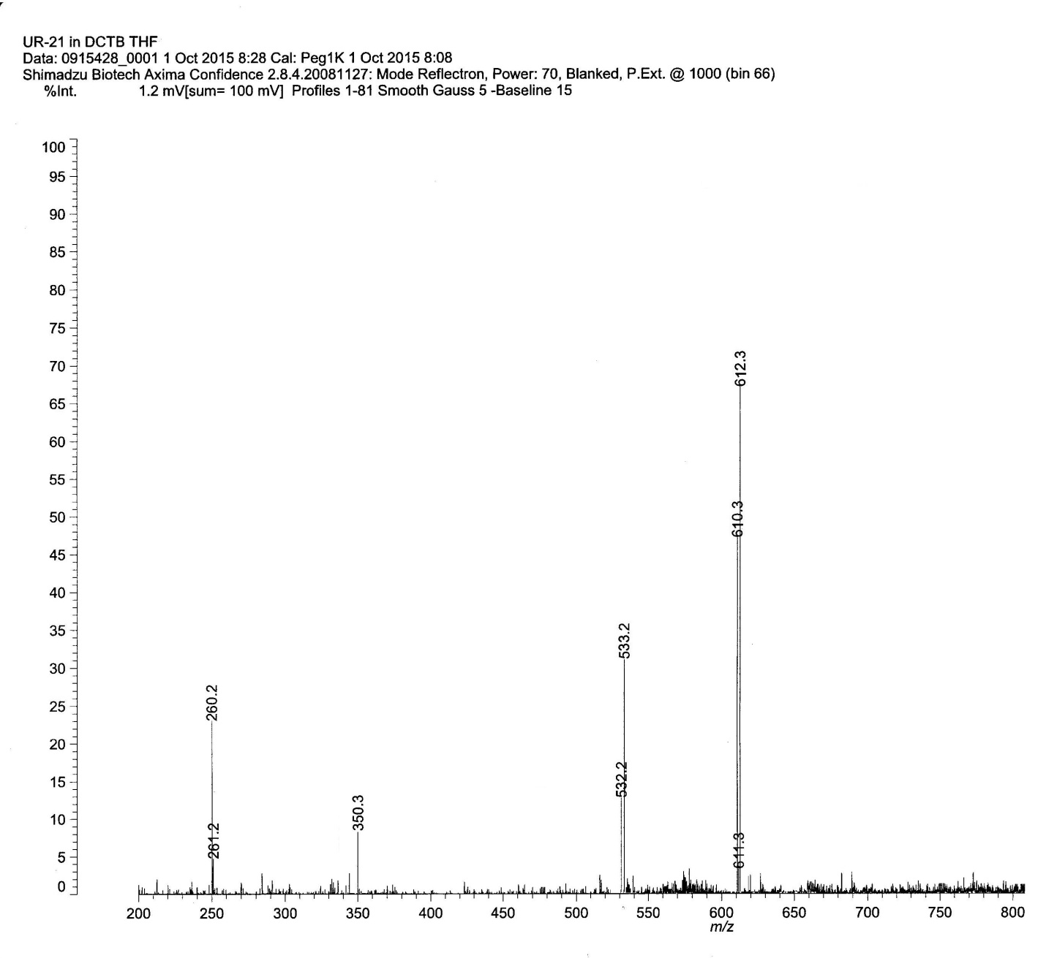

**Figure-1: Mass spectrum of Compound 3**

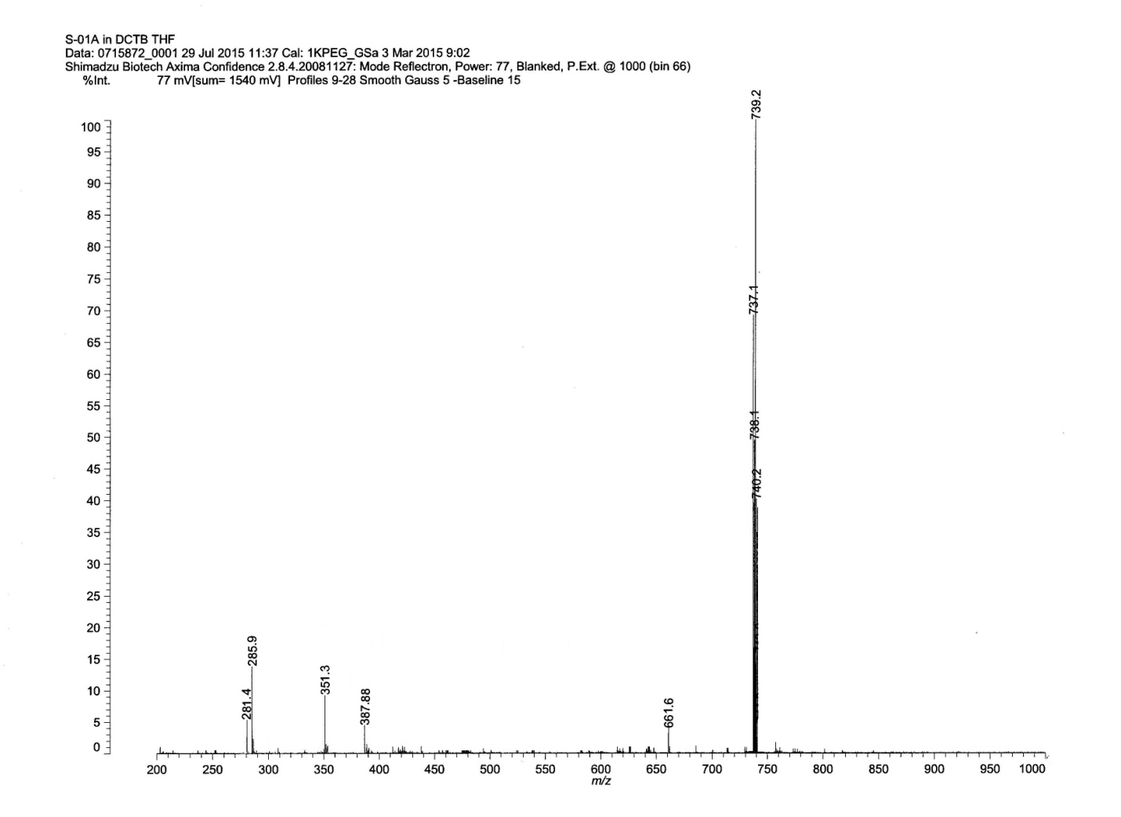

**Figure-2: Mass spectrum of Compound 6**

 

**M.W = 737 M.W = 661.6**



**M.W = 387.88**





**M.W = 285.8 M.W = 281.4**

**(B)**

**Figure 3:** Fragmentation pattern of triphenyltin(IV) (HL2) carboxylates. (Compound-6)

**Antioxidant**

**Table 1: Antioxidant Activity Data**

|  |  |  |
| --- | --- | --- |
| Compounds | Inhibition (%)* | IC50(μM) |
| (CH3)3Sn(HL1) (1) | 86.29 ± 2.0 | 19 ± 1 |
| (C4H9)3Sn(HL1) (2) | 60.30 ± 1.5 | 53 ± 2 |
| (C6H5)3Sn(HL1) (3) | 52.30 ± 1.0 | 55 ± 3 |
| (CH3)3Sn(HL2) (4) | 91.35 ± 2.1 | 20 ± 1 |
| (C4H9)3Sn(HL2) (5) | 59.35 ± 1.3 | 56 ± 3 |
| (C6H5)3Sn(HL2) (6) | 51.90 ± 1.0 | 59 ± 3 |
| Ligand (HL1) (7) | 58.50 ± 1.0 | 43 ± 1 |
| Ligand (HL2) (8) | 63.40 ± 1.2 | 48 ± 2 |
| Gallic acid (9) | 92.90 ± 1.0 | 14 ± 1 |

* 100 μL samples (5 mg/mL in DMSO)

**Table 2: Data of DNA binding studies by viscosity method.**

|  |  |  |  |  |  |  |  |  |  |  |  |
| --- | --- | --- | --- | --- | --- | --- | --- | --- | --- | --- | --- |
| Binding Ratio [Compound]/[SS-DNA] |  |  |  | | |  | | **(η/ηo)1/3** | | | |
| **(HL1)** | **(HL2)** | | **(1)** | **(2)** | | **(3)** | | **(4)** | **(5)** | **(6)** |
| 0.0 | 1.025 | 1.03 | | 1.025 | 1.025 | | 1.025 | | 1.03 | 1.03 | 1.03 |
| 0.25 | 1.026 | 1.03 | | 1.035 | 1.036 | | 1.038 | | 1.038 | 1.038 | 1.038 |
| 0.55 | 1.03 | 1.033 | | 1.043 | 1.045 | | 1.046 | | 1.046 | 1.046 | 1.046 |
| 0.80 | 1.05 | 1.055 | | 1.052 | 1.064 | | 1.067 | | 1.055 | 1.067 | 1.072 |
| 1.15 | 1.06 | 1.065 | | 1.072 | 1.073 | | 1.074 | | 1.076 | 1.076 | 1.076 |
| 1.40 | 1.075 | 1.076 | | 1.095 | 1.095 | | 1.095 | | 1.10 | 1.10 | 1.10 |

**Figure 4:** Antioxidant activity of Compounds, Ligands & Standard.

**Table 3: Antibacterial Activities of Ligands & Complexes.**

|  |  |  |  |  |  |
| --- | --- | --- | --- | --- | --- |
| Compounds | Zone of Inhibition (mm) | | | | |
| Escherichia coli | Bacillus subtilis | Staphylococcus aureus | Pseu-domonas aeruginosa | Micrococcus luteus |
| Ligand (HL1) | 10 | 08 | 09 | 10 | 11 |
| Ligand (HL2) | 11 | 10 | 11 | 11 | 11 |
| (CH3)3Sn(HL1) (1) | 13 | 11 | 14 | 15 | 14 |
| (C4H9)3Sn(HL1) (2) | 14 | 12 | 13 | 13 | 15 |
| (C6H5)3Sn(HL1) (3) | 15 | 13 | 13 | 14 | 13 |
| (CH3)3Sn(HL2) (4) | 13 | 14 | 12 | 15 | 14 |
| (C4H9)3Sn(HL2) (5) | 11 | 12 | 13 | 14 | 13 |
| (C6H5)3Sn(HL2) (6) | 12 | 15 | 12 | 12 | 15 |
| Cefixime | 22 | 21 | 19 | 20 | 23 |

Concentration: 1 mg/mL of DMSO. Reference drugs, Cefixime 1 mg/mL.

**Table 4: Antifungal activity data.**

|  |  |  |  |
| --- | --- | --- | --- |
| Compounds | Growth Inhibition (%) | | |
| trichophyton longiformis | candida albicans | aspergillus flavis |
| Ligand (HL1) | 07 | 10 | 15 |
| Ligand (HL2) | 10 | 09 | 16 |
| (CH3)3Sn(HL1) (1) | 12 | 10 | 18 |
| (C4H9)3Sn(HL1) (2) | 13 | 11 | 17 |
| (C6H5)3Sn(HL1) (3) | 13 | 10 | 18 |
| (CH3)3Sn(HL2) (4) | 14 | 13 | 17 |
| (C4H9)3Sn(HL2) (5) | 13 | 14 | 16 |
| (C6H5)3Sn(HL2) (6) | 12 | 13 | 19 |
| Terbinafine | 21 | 23 | 28 |

Agar tube dilution method, concentration: 200 mg/mL of DMSO

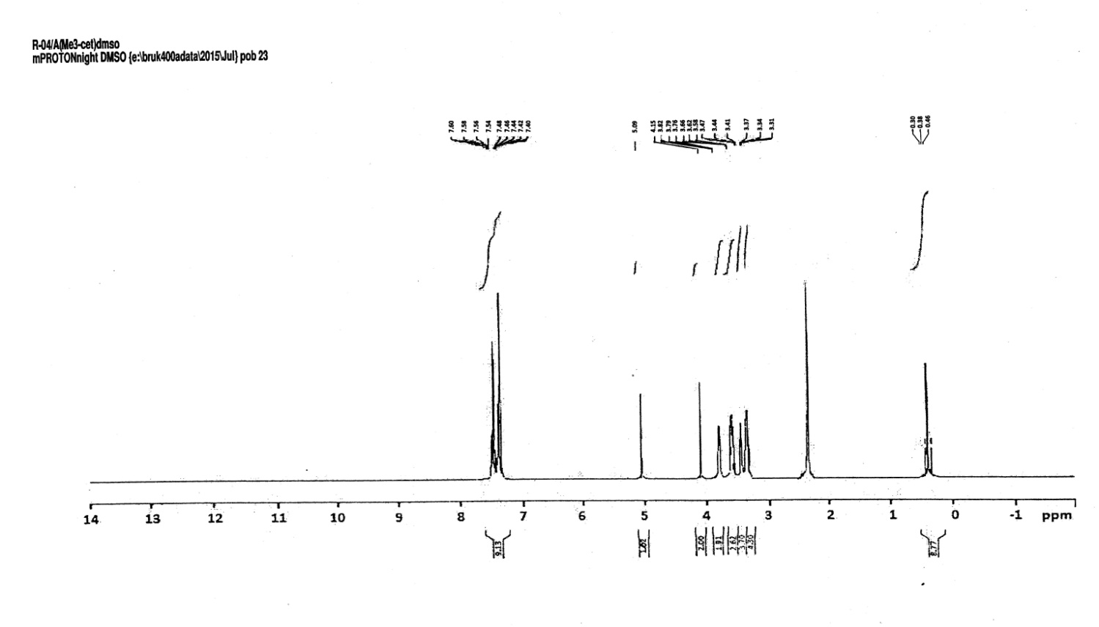

**Figure 5: 1**H NMR of complex 4.

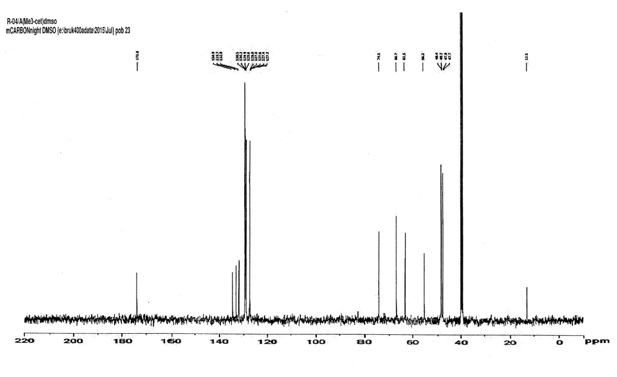

**Figure 6: 13**C NMR of complex 4.

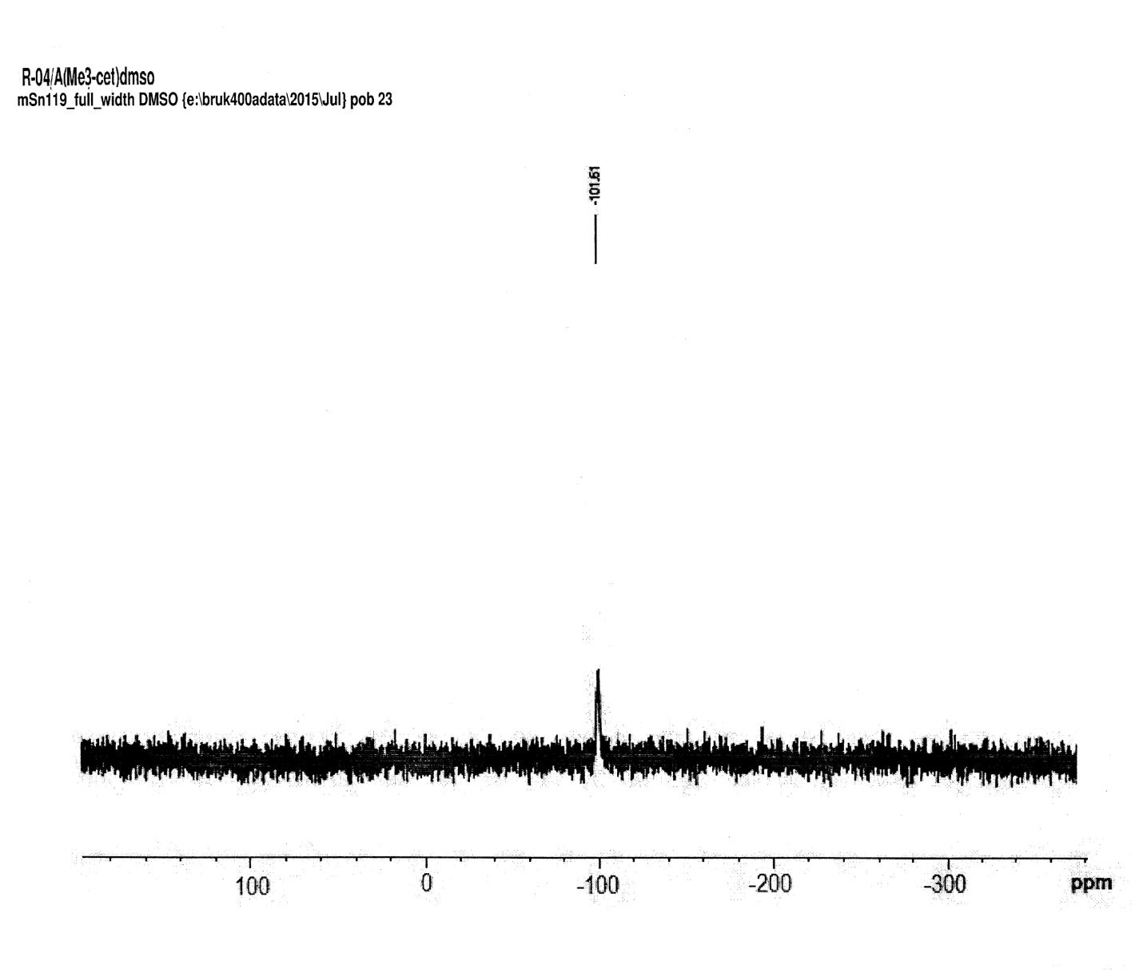

**Figure 7: 119Sn** NMR of complex 4.

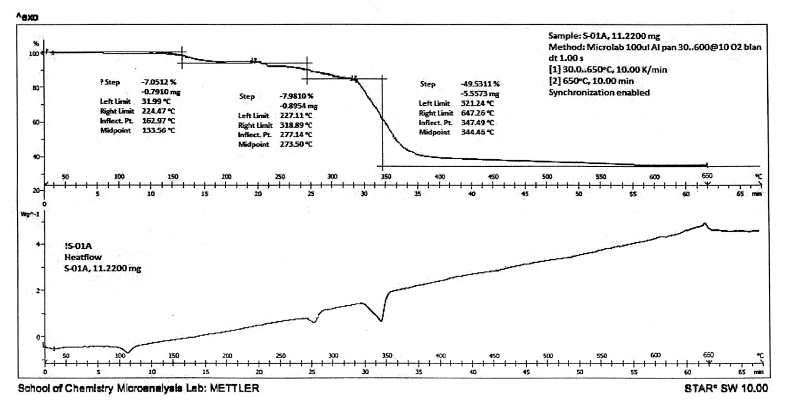

Figure 8: TGA-DSC graphof complex 1.