SUPLPLEMENTARY MATERIAL TO
Chemical composition and antioxidant activity of Astragalus monspessulanus L.
growing in semiarid areas of Algeria

SAWSEN BOUREZZANE¹, HAMADA HABA¹, CHRISTOPHE LONG²and
MOHAMMED BENKHALED^{1*}

¹Laboratory of Chemistry and EnvironmentalChemistry (L.C.C.E), Department of Chemistry, Faculty of Sciences, Batna-1University, Algeria
²USR 3388 CNRS-Pierre Fabre, 3 Avenue Hubert Curien BP 13562, 31035 Toulouse, France
ISOLATION OF THE FRACTIONS
The air-dried and powdered material of Astragalus monspessulanus L. (1000 g) was extracted three times with EtOH/H₂O (70/30, 10 Liters, each for 3 days) at room temperature. After filtration and evaporation, crude extract suspended in H₂O was partitioned successively with petroleum ether, ethyl acetate and n-butanol to give three different polar parts. The fractions were evaporated in vacuo to give the following extracts: petroleum ether (8.3 g), ethyl acetate (12.1 g), and n-butanol (15.33 g).
The n-butanol extract (7 g) was submitted to vacuum liquid chromatography VLC (50 mm × 50 mm; fractions of 100 ml) on RP-18 using H₂O/MeOH (80:20 to 0:100) to obtain 15 fractions (Fr₁–Fr₁₅). Fr₁ (5.53 g) was subjected to polyamide CC eluted with a gradient of H₂O/MeOH (100:0 to 0:100) to obtain 16 subfractions (Fr_{1.1}–Fr_{1.16}). Subfraction Fr_{1.12} (117 mg) was submitted to Sephadex LH-20 CC eluted with CHCl₃/MeOH (90:10) to get 4subfractions (Fr_{1.12.1}–Fr_{1.12.4}). Fr_{1.12.1} (32 mg) was purified by HPLC column to produce compounds 1 (3.8 mg) and 2 (2.4 mg). Fr_{1.5} (333 mg) was subjected to polyamide CC eluted with a gradient of Toluene/MeOH to get 12 subfractions (Fr_{1.5.1}–Fr_{1.5.12}). Fr_{1.5.8} (26 mg) was chromatographed over polyamide CC using a gradient of Toluene/MeOH (20:80 to 0:100) to yield four subfractions (Fr_{1.5.8.1}–Fr_{1.5.8.4}). Fr_{1.5.9} (32 mg) was also chromatographed over polyamide CC using a gradient of Toluene/MeOH (10:90 to 0:100) as eluent to yield five subfractions (Fr_{1.5.9.1}–Fr_{1.5.9.5}). The combined subfractions Fr_{1.5.8.2}, Fr_{1.5.9.3} and Fr_{1.5.9.4} (41.6 mg) were chromatographed over SiO₂ CC using CHCl₃/MeOH (5:95 to 0:100) as eluent, to obtain six subfractions (Fr_{1.5.9.A}–Fr_{1.5.9.F}). SubfractionFr_{1.5.9.E} (15 mg) was purified by HPLC to yield compounds 3 (4.2 mg) and 4 (2 mg).Purification of Fr_{1.5.11} (57 mg), by HPLC column, lead to compounds 5 (3.4 mg) and 6 (2 mg). Further purification of Fr_{1.5.4} (36.1 mg) by TLC (SiO₂) using CHCl₃/MeOH/H₂O (8:2:0.2) gave compound 7 (3.8 mg). The combined subfractions Fr_{1.7}, Fr_{1.8}, Fr_{1.9} and Fr_{1.10} (134.5 mg) were subjected to CC over silica gel eluting with CH₂Cl₂/acetone (100:0 to 0:100) to obtain 8subfractions (Fr_{1.7.1}–Fr_{1.7.8}). Fr_{1.7.5} was chromatographed on TLC (RP-18) using MeOH/H₂O (3:7) as eluent to give compound 8 (5 mg) as a mixture of 2α-OH and 2β-OH epimers in a ratio of 3:2 (estimated from the relative intensities of the H-5 and H-1'' ¹H-NMR signals). Compound 9 (15 mg) was obtained by precipitation of Fr₄ (60 mg) in MeOH. The residue of this fraction (Fr₄) was subjected to CC over silica gel and eluted with gradient system CHCl₃/MeOH (100/0 to 80/20), to give compound 10 (7 mg).
7 g of ethyl acetate extract were subjected to vacuum liquid chromatography VLC (50 mm × 50 mm; fractions of 100 ml) on RP-18 using a gradient system of H₂O/MeOH (80:20 to 0:100) to afford 9 fractions (Fr₁-Fr₉). Fraction Fr₉ (232 mg) was chromatographed on a silica gel CC eluting with petroleum ether/CHCl₃ (100:0 to 70:30) to yield 15 mg of pure compound 11. Fraction Fr₆ (695 mg) was further separated into 9subfractions (Fr_{6.1}-Fr_{6.9}) by chromatography over silica gel column with a gradient system of CHCl₃/MeOH (100:0 to 70:30). 10 mg of compound 12 were obtained by precipitation of Fr_{6.9} in MeOH. Fraction Fr₇ (780 mg) was subjected to CC over silica gel and eluted with petroleum ether/EtOAc (100:0 to 0:100) producing 10 subfractions (Fr_{7.1}-Fr₇.₁₀). Fr_{7.4} (39 mg) was chromatographed on a silica gel CC eluting with petroleum ether/CHCl₃ (100:0 to 15:85) to yield 4.3 mg of compound 13.

* Corresponding author. E-mail: mbenkhaled@yahoo.fr
CHARACTERIZATION DATA FOR COMPOUNDS 2, 4-10

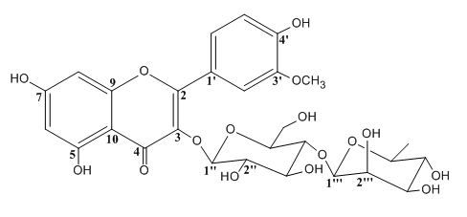

Isorhamnetin-3-O-(4-α-L-rhamnopyranosyl)-β-D-glucopyranoside (calendoside III) (2): ¹H NMR (500 MHz, MeOD, δ / ppm): 1.09 (3H, d, J= 6.2 Hz, H-6'''), 3.22 (1H, t, J= 9.8 Hz, H-4'''), 3.27 (1H, dd, J₁ = 9.3, J₂ = 7.3 Hz, H-4''), 3.40 (1H, t, J= 7.3 Hz, H-3''), 3.41 (1H, ddd, J₁= 9.3, J₂= 4.7, J₃ = 1.3 Hz, H-5''), 3.42 (1H, m, H-5'''), 3.46 (1H, t, J= 7.3 Hz, H-2''), 3,48 (1H, dd, J₁ = 9.8, J₂ = 3.4 Hz, H-3'''), 3.61 (1H, dd, J₁ = 3.4, J₂ =1.5 Hz, H-2'''), 3.80 (1H, dd, J₁ = 10.8, J₂ =1.3 Hz, H-6''a), 3.92 (1H, dd, J₁ = 10.8, J₂ = 4.7 Hz, H-6''b), 3.95 (3H, s, 3'-OMe), 4.52 (1H, d, J= 1.5 Hz, H-1'''), 5.25 (1H, d, J= 7.3 Hz, H-1''), 6.20 (1H, d, J= 2.1 Hz, H-6), 6.42 (1H, d, J= 2.1 Hz, H-8), 6.92 (1H, d, J= 8.6 Hz, H-5'), 7.64 (1H, dd, J₁ = 8.6, J₂ = 2.1 Hz, H-6'), 7.95 (1H, d, J= 2.1 Hz, H-2'); ¹³C NMR (125 MHz, MeOD, δ / ppm): 18.4 (CH₃, C-6'''), 57.3 (CH₃, 3'-OMe), 69.0 (CH₂, C-6''), 70.3 (CH, C-5'''), 72.2 (CH, C-4''), 72.6 (CH, C-3'''), 72.8 (CH, C-2'''), 74.3 (CH, C-4'''), 76.4 (CH, C-2''), 78.7 (CH, C-3''), 95.4 (CH, C-8), 100.5 (CH, C-6), 103.1 (CH, C-1'''), 104.9 (CH, C-1''), 105.6 (C, C-10), 115.1 (CH, C-2'), 116.7 (CH, C-5'), 123.0 (C, C-1'), 124.5 (C, C-6'), 135.6 (C, C-3), 145.9 (C, C-3'), 148.9 (C, C-4'), 158.5 (C, C-9), 159.0 (C, C-2), 163.0 (C, C-5), 166.1 (C, C-7), 179.5 (C, C-4). ESI-MS (m/z, (relative abundance, %)): 779 ((C₂₈H₃₂O₁₆+Na)⁺, 100).

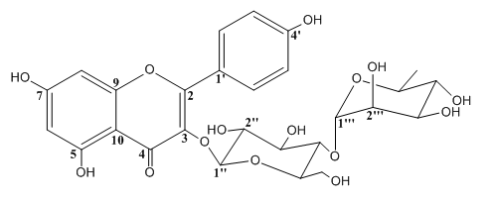

Kaempferol-3-O-(4-α-L-rhamnopyranosyl)-β-D-glucopyranoside (4): Yellow amorphous solid. ¹H NMR (500 MHz, MeOD, δ / ppm): 0.95 (3H, d, J= 6.4 Hz, H-6'''), 3.20 (1H, ddd, J₁ = 9.1, J₂ = 6.2, J₃ = 2.2 Hz, H-5''), 3.28 (1H, t, J= 9.1 Hz, H-4''), 3.33 (1H, t, J= 9.2 Hz, H-4'''), 3.50 (1H, dd, J₁ = 12.0, J₂ = 6.2 Hz, H-6''a), 3.55 (1H, t, J= 9.1 Hz, H-3''), 3.61 (1H, dd , J₁= 9.1, J₂ = 7.7 Hz, H-2''), 3.72 (1H, dd, J₁ = 12.0, J₂ = 2.2 Hz, H-6''b), 3.77 (1H, dd, J₁ = 9.2, J₂= 3.4 Hz, H-3'''), 3.99 (1H, dd, J₁ = 3.4, J₂ = 1.6 Hz, H-2'''), 4,02 (1H, dq, J₁ = 9.2, J₂ = 6.4 Hz, H-5'''), 5.23 (1H, d, J= 1.6 Hz, H-1'''), 5.73 (1H, d, J= 7.7 Hz, H-1''), 6.15 (1H, brs, H-6), 6.34 (1H, brs, H-8), 6.88 (2H, d, J= 9.1 Hz, H-3', H-5'), 8.04 (2H, d, J= 9.1 Hz, H-2', H-6'); ¹³C NMR (125 MHz, MeOD, δ / ppm): 17.7 (CH₃, C-6'''), 62.8 (CH₂, C-6''), 70.1 (CH, C-5'''), 71.9 (CH, C-4''), 72.4 (CH, C-3'''), 72.6 (CH, C-2'''), 74.2 (CH, C-4'''), 79.2 (CH, C-3''), 80.3 (CH, C-2''), 94.6 (CH, C-8), 100.3 (CH, C-1''), 101.0 (CH, C-6), 102.8 (CH, C-1'''), 105.9 (C, C-10), 116.3 (CH, C-3', C-5'), 123.1 (C, C-1'), 132.2 (CH, C-2', C-6'), 134.4 (C, C-3), 158.4 (C, C-9), 158.5 (C, C-2), 161.6 (C, C-4'), 163.2 (C, C-5), 165.6 (C, C-7), 179.4 (C, C-4). ESI-MS (m/z, (relative abundance, %)): 617 ((C₂₇H₃₀O₁₅+Na)⁺, 100).

Quercetin-3-O-(2,6-α-L-dirhamnopyranosyl-β-D-glucopyranoside (5):¹H NMR (500 MHz, MeOD, δ / ppm): 1.00 (3H, d, J= 5.6 Hz, H-6'''), 1.08 (3H, d, J= 5.9 Hz, H-6''''), 3.24 (1H, t, J= 9.4 Hz, H-4''''), 3.28 (1H, m, H-4''), 3.32 (1H, m, H-4'''), 3.33 (1H, m, H-5''), 3.38 (1H, m, H-6''a), 3.43 (1H, m, H-5'''), 3.50 (1H, dd, J₁ = 9.4, J₂ = 3.4 Hz, H-3''''), 3.54 (1H, t, J= 8.8 Hz, H-3''), 3.58 (1H, dd, J₁ = 3.4, J₂ =1.6 Hz, H-2''''), 3.63 (1H, dd, J₁ = 8.8, J₂ = 7.8 Hz, H-2''), 3.81 (1H, dd,J₁ = 9.8, J₂ = 3.8 Hz, H-3'''), 3.83 (1H, dd, J₁ = 11.5, J₂ = 1.6 Hz, H-6''b), 4,01 (1H, dd, J₁ = 3.8, J₂ = 1.6 Hz, H-2'''), 4.07 (1H, m, H-5''''), 4.50 (1H, d, J= 1.6 Hz, H-1''''), 5.22 (1H, d, J= 1.6 Hz, H-1'''), 5.59 (1H, d, J= 7.8 Hz, H-1''), 6.19 (1H, d, J= 2.1 Hz, H-6), 6.37 (1H, d, J= 2.1 Hz, H-8), 6.87 (1H, d, J= 8.1 Hz, H-5'), 7.60 (1H, dd, J₁= 8.1, J₂ = 2.1 Hz, H-6'), 7.62 (1H, d, J= 2.1 Hz, H-2');¹³C NMR (125 MHz, MeOD, δ / ppm): 17.6 (CH₃, C-6'''), 17.9 (CH3, C-6''''), 68.4 (CH2, C-6''), 69.9 (CH, C-5''''), 70.1 (CH, C-5'''), 72.0 (CH, C-4''), 72.3 (CH, C-3'''), 72.4 (CH, C-2''', C-3''''), 72.5 (CH, C-2''''), 74.0 (CH, C-4''''), 74.2 (CH, C-4'''), 77.3 (CH, C-5''), 79.1 (CH, C-3''), 80.2 (CH, C-2''), 94.8 (CH, C-8), 99.9 (CH, C-6), 100.6 (CH, C-1''), 102.4 (CH, C-1''''), 102.8 (CH, C-1'''), 106.1 (C, C-10), 116.2 (CH, C-5'), 117.5 (CH, C-2'), 123.6 (C, C-1'), 123.7 (C, C-7'), 134.6 (C, C-3), 146.1 (C, C-3'), 149.7 (C, C-4'), 158.6 (C, C-9), 159.1 (C, C-2), 163.3 (C, C-5),165.8 (C, C-7), 179.5 (C, C-4). ESI-MS (m/z, (relative abundance, %)): 779 ((C₃₃H₄₀O₂₀+Na)⁺, 100).

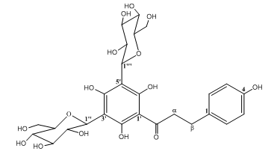
3',5'-di-C-β-D-glucopyranosylphloretin (6): Yellow amorphous powder. [α] _{D} = + 83.6 (c = 1.0 g mL⁻¹, MeOH). ¹H NMR (500 MHz, MeOD, δ / ppm): 2.86 (2H, m, H-β), 3.34 (2H, m, H-α), 3.42 (2H, m, H-5'', H-5'''), 3.51 (2H, t, J= 9.4 Hz, H-3'', H-3'''), 3.53 (2H, t, J= 9.4 Hz, H-4'', H-4'''), 3.62 (2H, t, J= 9.4 Hz, H-2'', H-2'''), 3.82 (2H, dd, J₁ = 12.5, J₂= 2.0 Hz, H-6''a, H-6'''a), 3.86 (2H, dd, J₁= 12.5, J₂ = 2.0 Hz, H-6''b, H-6'''b), 4.94 (2H, d, J= 9.4 Hz, H-1'', H-1'''), 6.67 (2H, d, J= 8.5 Hz, H-3, H-5), 7.04 (1H, d, J= 8.5 Hz, H-2, H-6);¹³C NMR (125 MHz, MeOD, δ / ppm): 31.3 (CH₂, C-β), 48.0 (CH₂, C-α), 62.1 (CH₂, C-6'', C-6'''), 71.2 (CH, C-4'', C-4'''), 74.3 (CH, C-2'', C-2'''), 76.9 (CH, C-1'', C-1'''), 79.3 (CH, C-3'', C-3'''), 82.9 (CH, C-5'', C-5'''), 104.6 (C, C-3', C-5'), 106.2 (C, C-1'), 116.3 (CH, C-3, C-5), 130.6 (CH, C-2, C-6), 134.1 (C, C-1), 156.6 (C, C-4), 162.2 (C, C-2', C-6'), 163.1 (C, C-4'), 207.2 (C, C=O). ESI-MS (m/z, (relative abundance, %)): 597 ((C₂₇H₃₄O₁₅-H)⁻, 100).
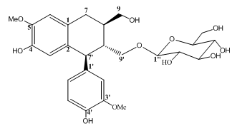

Isolariciresinol 9'-O-β-D-glucopyranoside (7): White amorphous powder. [α] _{D} = + 16 (c = 0.9 g mL⁻¹, MeOH /CH₂Cl₂ (1/0.5)). ¹H NMR (500 MHz, DMSO-d₆, δ / ppm): 1.72 (1H, m, H-8'), 1,91 (1H, m, H-8), 2.72 (2H, d, J= 8.0 Hz, H-7), 2.96 (1H, m, Ha-9'), 2.97 (1H, t, J= 7.8 Hz, H-2''), 3.01 (1H, ddd, J₁= 9.3, J₂ = 4.7, J₃ = 2.6 Hz, H-5''), 3.03 (1H, dd, J₁ = 9.3, J₂ = 7.8 Hz, H-4''), 3.13 (1H, t, J = 7.8 Hz, H-3''), 3.41 (1H, dd, J₁= 11.7,J₂ = 2.6 Hz, H-6''a), 3.45 (1H, m, H-9a); 3.57 (1H, m, H-9b), 3.63 (1H, dd, J₁ = 11.7,J₂ = 4.7 Hz, H-6''b), 3.71 (6H, s, 5-OMe/3'-OMe), 3.90 (1H, dd, J₁ = 9.8, J₂ = 1.9 Hz, H-9'b), 3.95 (1H, d, J= 7.8 Hz, H-1''), 4.03 (1H, d, J = 10.7 Hz, H-7'), 6.08 (1H, brs, H-3), 6.50 (1H, dd, J₁= 8.2, J₂ = 1.8 Hz, H-6'), 6.61 (1H, brs, H-6 ), 6.68 (1H, d, J = 8.2 Hz, H-5'), 6.80 (1H, d, J = 1.8 Hz, H-2'); ¹³C NMR (125 MHz, DMSO-d₆, δ / ppm): 32.5 (CH₂, C-7), 37.5 (CH, C-8), 44.1 (CH, C-8'), 45.5 (CH, C-7'), 55.5 (5-OMe), 55.6 (3'-OMe), 61.0 (CH₂, C-6''), 62.8 (CH₂, C-9), 67.6 (CH₂, C-9'), 70.0 (CH, C-4''), 73.3 (CH, C-2''), 76.7 (CH, C-5''), 76.8 (CH, C-3''),104.1 (CH, C-1''), 111.8 (CH, C-6), 113.9 (CH, C-2'),115.5 (CH, C-5'), 116.2 (CH, C-3),121.1 (CH, C-6'), 127.0 (C, C-1), 132.7 (C, C-2), 136.9 (C, C-1'), 144.0 (C, C-4), 144.5 (C, C-5, C-4'), 147.1 (C, C-3'). ESI-MS (m/z, (relative abundance, %)): 545 ((C₂₆H₃₄O₁₁+Na)⁺, 100).

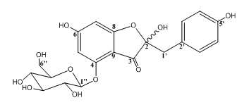
Hovetrichoside C (8): Amorphous powder. [α]²⁵_{D} = -54.1 (c = 1.9 g mL⁻¹, MeOH). (Major): ¹H NMR (500 MHz, DMSO-d₆, δ / ppm): 2.90 (2H, m, H-1'), 3.17 (1H, m, H-4''), 3.19 (1H, m, H-3''), 3.24 (1H, m, H-2''), 3.25 (1H, m, H-5''), 3.47 (1H, m, H-6''a), 3.61 (1H, m, H-6''b), 4.90 (1H, d, J= 8.2 Hz, H-1''), 5.93 (1H, d, J= 1.8 Hz, H-7), 6.00 (1H, d, J= 1.8 Hz, H-5), 6.55 (2H, d, J= 7.1 Hz, H-4', H-6'), 6.92 (2H, d, J= 7.1 Hz, H-3', H-7');¹³C NMR (125 MHz, DMSO-d₆, δ / ppm): 40.4 (CH₂, C-1'), 60.4 (CH₂, C-6''), 69.3 (CH, C-4''), 72.9 (CH, C-2''), 76.7 (CH, C-3''), 77.2 (CH, C-5''), 91.5 (CH, C-7), 95.2 (CH, C-5), 99.4 (CH, C-1''), 101.9 (C, C-9), 105.5 (C, C-2), 114.7 (CH, C-4', C-6'), 124.1 (C, C-2'), 131.3 (CH, C-3', C-7'), 155.9 (C, C-5'), 156.7 (C, C-4), 168.4 (C, C-6), 171.9 (C, C-8), 192.4 (C, C-3). ESI-MS (m/z, (relative abundance, %)): 449 ((C₂₁H₂₂O₁₁-H)⁻, 100).

(Minor): ¹H NMR (500 MHz, DMSO-d₆, δ / ppm): 2.90 (2H, m, H-1'), 3.17 (1H, m, H-4''), 3.19 (1H, m, H-3''), 3.24 (1H, m, H-2''), 3.25 (1H, m, H-5''), 3.47 (1H, m, H-6''a), 3.61 (1H, m, H-6''b), 4.98 (1H, d, J= 8.2 Hz, H-1''), 5.93 (1H, d, J= 1.8 Hz, H-7), 6.05 (1H, d, J= 1.8 Hz, H-5), 6.55 (2H, d, J= 7.1 Hz, H-4', H-6'), 6.92 (2H, d, J= 7.1 Hz, H-3', H-7');¹³C NMR (125 MHz, DMSO-d₆, δ / ppm): 40.4 (CH₂, C-1'), 60.3 (CH₂, C-6''), 69.2 (CH, C-4''), 73.0 (CH, C-2''), 76.7 (CH, C-3''), 77.1 (CH, C-5''), 91.7 (CH, C-7), 95.7 (CH, C-5), 99.2 (CH, C-1''), 101.9 (C, C-9), 105.5 (C, C-2), 114.7 (CH, C-4', C-6'), 124.1 (C, C-2'), 131.3 (CH, C-3', C-7'), 155.9 (C, C-5'), 156.7 (C, C-4), 168.4 (C, C-6), 171.9 (C, C-8), 192.7 (C, C-3).
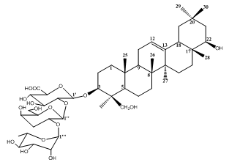

Soyasaponin I (9): White amorphous solid. [α]²⁰ _{D} = - 12 (c = 0.9 g mL⁻¹, MeOH). ¹H NMR (500 MHz, DMSO-d₆, δ / ppm): 0.83 (3H, s, H-28), 0.92 (3H, s, H-30), 0.93 (1H, m, H-5), 0.95 (1H, m, H-19a), 0.98 (3H, s, H-26), 1.01 (1H, m, H-1a), 1.03 (3H, s, H-29), 1.04 (2H, m, H-2a), 1.13 (3H, s, H-27), 1.24 (3H, s, H-23), 1.27 (3H, d, J= 8.6 Hz, H-6'''), 1.29 (2H, m, H-16a, H-16b), 1.32 (1H, m, H-21b), 1.36 (2H, m, H-6a), 1.44 (1H, m, H-21a), 1.42 (1H, m, H-7a), 1.54 (1H, m, H-7b), 1.57 (1H, m, H-9), 1.63 (2H, m, H-6b), 1.65 (1H, m, H-1b), 1.76 (2H, m, H-2b), 1.75 (1H, m, H-19b), 1.86 (2H, m, H-15a, H-15b), 1.87 (2H, m, H-11a, H-11b), 2.07 (1H, d, J = 14.7 Hz, H-18), 3.22 (1H, d, J = 11.3 Hz, H-24a), 3.37 (1H, dd, J₁= 5.1, J₂ = 3.5 Hz, H-22), 3.40 (1H, dd, J₁ = 10.3, J₂ = 3.5 Hz, H-3), 3.42 (1H, t, J = 9.6 Hz, H-4'''), 3.46 (1H, t, J = 9.4 Hz, H-4'), 3.48 (1H, m, H-5''), 3.54 (1H, dd, J₁ = 9.5,J₂ = 3.1 Hz, H-3''), 3.61 (1H, d, J = 7.9 Hz, H-5'), 3.62 (1H, dd, J₁ = 9.5; J₂ = 7.5 Hz, H-2''), 3.64 (1H, dd, J₁ = 9.4, J₂ = 7.9 Hz, H-3'), 3.72 (1H, dd, J₁= 9.6, J₂ = 3.5 Hz, H-3'''), 3.72 (1H, m, H-6''a/H-6''b), 3.74 (1H, dl, J = 3.1 Hz, H-4''), 3.76 (1H, d, J = 7.9 Hz, H-2'), 3.92 (1H, dd, J₁= 3.5; J₂ = 1.9 Hz, H-2'''), 4.12 (1H, m, H-5'''), 4.13 (1H, d, J = 11.3 Hz, H-24b), 4.45 (1H, d, J = 7.9 Hz, H-1'), 4.87 (1H, d, J = 7.5 Hz, H-1''), 5.14 (1H, d, J= 1.9 Hz, H-1'''), 5.25 (2H, t, J = 3.3 Hz, H-12); ¹³C NMR (125 MHz, DMSO-d₆, δ / ppm): 16.6 (CH₃, C-25), 17.7 (CH₃, C-26), 18.5 (CH₃, C-6'''), 19.5 (CH₂, C-6), 20.6 (CH₃, C-28), 23.6 (CH₃, C-23), 25.0 (CH₂, C-11), 25.6 (CH₃, C-27), 27.0 (CH₂, C-2), 27.3 (CH₂, C-15), 29.2 (CH₃, C-29), 30.0 (CH₂, C-16), 31.5 (C, C-20), 32.7 (CH₃, C-30), 34.5 (CH₂, C-7), 37.6 (C, C-10), 38.7 (C, C-17), 39.8 (CH₂, C-1), 40.9 (C, C-8), 42.3 (CH₂, C-21), 43.5 (C, C-14),44.9 (C, C-4), 46.9 (CH, C-18), 47.6 (CH₂, C-19), 47.9 (CH, C-9), 57.5(CH, C-5), 62.3 (CH₂, C-6''), 64.5 (CH₂, C-24), 69.6 (CH, C-5'''), 71.7 (CH, C-3'''), 72.3 (CH, C-4'', C-2'''), 74.3 (CH, C-4'), 74.4 (CH, C-4'''), 76.4 (CH, C-3''), 76.5 (CH, C-5''), 77.1 (CH, C-22), 77.3 (CH, C-2', C-5'), 78.2 (CH, C-3'), 78.5 (CH, C2''), 92.7 (CH, C-3), 102.4 (CH, C-1''), 102.5 (CH, C-1'''), 105.7 (CH, C-1'), 123.8 (CH, C-12), 145.4 (C, C13), 175.6 (C, COOH). ESI-MS (m/z, (relative abundance, %)): 965 ((C₄₈H₇₈O₁₈+Na)⁺, 100).

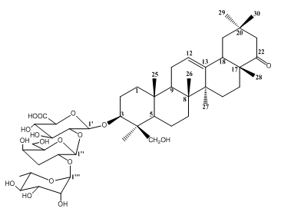
Dehydrosoyasaponin I (10): White amorphous solid. [α] _{D} = -15.2 (c = 0.23 g mL⁻¹, MeOH). ¹H NMR (600 MHz, CD₃OD, δ / ppm): 0.87 (3H, s, H-30), 0.92 (3H, s, H-25), 0.96 (1H, m, H-5), 1.00 (3H, s, H-26), 1.01 (3H, s, H-28), 1.03-1.66 (1H, m, H-1), 1.03 (3H, s, H-29), 1.12-2.17 (2H, m, H-16), 1.29 (3H, s, H-23), 1.30 (3H, s, H-27), 1.30 (3H, d, J= 8.6 Hz, H-6'''), 1.33-1.85 (2H, m, H-15), 1.34 (1H, m, H-19_{a}), 1.39-1.66 (2H, m, H-6), 1.40-1.68 (1H, m, H-7), 1.64 (1H, m, H-9), 1.8-1.13 (2H, m, H-2), 1.92 (2H, m, H-11a, H-11b), 1.99-2.59 (1H, m, H-21), 2.23 (1H, t, J = 13,8 Hz, H-19b), 2.37 (1H, dd, J₁= 13.8, J₂ = 3.8 Hz, H-18), 3.23 (1H, d, J = 11.5 Hz, H-24a), 3.42 (1H, dd, J₁ = 10.3, J₂ = 4.5 Hz, H-3), 3.42 (1H, t, J= 9.6 Hz, H-4'''), 3.46 (1H, t, J= 9.2 Hz, H-4'), 3.51 (1H, m, H-5''), 3.56 (1H, dd, J₁ = 9.6; J₂ = 3.5 Hz, H-3''), 3.61 (1H, d, J = 9.2 Hz, H-5'), 3.62 (1H, dd, J₁ = 9.2, J₂ = 8.3 Hz, H-3'), 3.66 (1H, dd, J₁ = 9.6,J₂ = 7.5 Hz, H-2''), 3.72 (1H, m, H-6''b), 3.73 (1H, nd, H-3'''), 3.74 (1H, nd, H-4''), 3.76 (1H, m, H-6''a), 3.78 (1H, d, J= 8.3 Hz, H-2'), 3.94 (1H, dd, J₁ = 3.3; J₂ = 1.6 Hz, H-2'''), 4.12 (1H, m, H-5'''), 4.16 (1H, d, J= 11.5 Hz, H-24b), 4.48 (1H, d, J= 8.3 Hz, H-1'), 4.90 (1H, d, J= 7.5 Hz, H-1''), 5.15 (1H, d, J= 1.6 Hz, H-1'''), 5.35 (2H, t, J= 3.5 Hz, H-12);¹³C NMR (150 MHz, CD₃OD, δ / ppm): 14.9 (CH₃, C-25), 15.9 (CH₃, C-26), 16.9 (CH₃, C-27, C-6'''), 18.0 (CH₂, C-6), 19.7 (CH₃, C-28), 22.0 (CH₃, C-23), 23.5 (CH₂, C-11), 24.2 (CH₃, C-30), 24.8 (CH₂, C-2), 25.7 (CH₂, C-15), 27.0 (CH₂, C-16), 30.8 (CH₃, C-29), 32.6 (CH₂, C-7), 33.7 (C, C-20), 36.1 (C, C-10), 38.3 (CH₂, C-1), 39.4 (C, C-8), 41.6 (C, C-14), 43.3 (C, C-4), 46.2 (CH₂, C-19), 47.6 (CH, C-18), 47.3 (CH, C-9), 48.0 (C, C-17), 50.3 (CH₂, C-21), 55.9 (CH, C-5), 60.8 (CH₂, C-6''), 62.9 (CH₂, C-24), 68.1 (CH, C-5'''), 70.3 (CH, C-3'''), 70.8 (CH, C-4'', C-2'''), 72.8 (CH, C-4', C-4'''), 74.9 (CH, C-3''), 75.7 (CH, C-5''), 75.8 (CH, C-2', C-5'), 76.9 (CH, C-3'), 77.8 (CH, C2''), 91.0 (CH, C-3), 100.7 (CH, C-1''), 100.9 (CH, C-1'''), 104.1 (CH, C-1'), 123.7 (CH, C-12), 141.4 (C, C13), 175.6 (C, COOH), 218.3 (CH, C-22). ESI-MS (m/z, (relative abundance, %)): 963 ((C₄₈H₇₆O₁₈+Na)⁺, 100).

SPECTRUM DATA FOR COMPOUNDS 6 AND 8
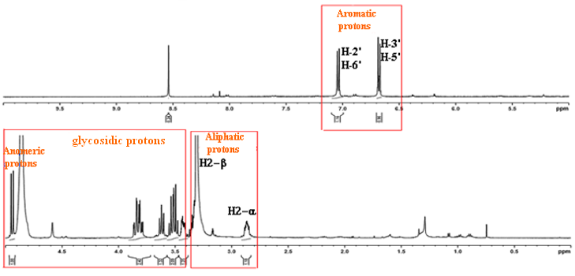

Fig. S1. ¹H-NMR for compound 6

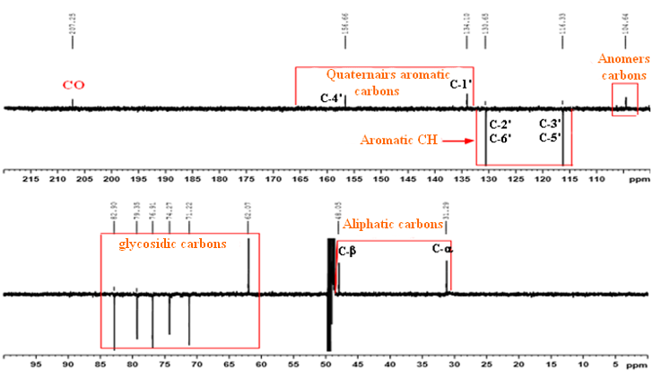

Fig. S2. ¹³C-NMR for compound 6
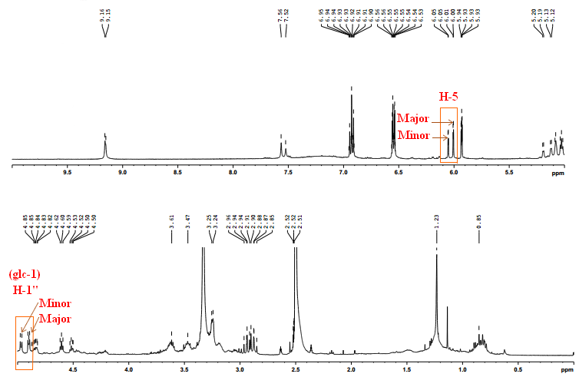
Fig. S3. ¹H-NMR for compound 8

DPPH RADICAL SCAVENGING ASSAY

The free radical scavenging activity of n-butanol extract of Astragalus monspessulanus L. was measured in vitro by 1,1-Diphenyl-2-picrylhydrazyl (DPPH) according to the procedure described by (Saeed et al. 2012).¹The stocksolutionwaspreparedby dissolving 2.5 mg DPPH with 100 ml methanol and stored at 20°C until required. The working solution was obtained by diluting DPPH solution with methanol to attain an absorbance of about 0.98±0.02 at 517 nm using the spectrophotometer. A 3 ml aliquot of this solution was mixed with 100 μl of the sample at various concentrations. The reaction mixture was shaken well and incubated in the dark for 30 min at room temperature. Then the absorbance was taken at 517 nm. Ascorbic acid was used as reference compound. The scavenging activity was estimated based on the percentage of DPPH radical scavenged as the following equation:

(1)

The antiradical activity of tested extract is expressed as a relative or absolute decrease of concentration of DPPH or as IC₅₀ (concentration of extract decreasing the absorbance of the DPPH solution by 50 %).
FERROUS IRON-CHELATING ASSAY

The ferrous iron-chelating (FIC) activityof n-butanol extract of Astragalus monspessulanus L. was performed to determine the inhibition of the formation of iron(II)–ferrozine complex after treatment of test material with Fe²⁺, according to the procedure described by (Decker and Welch, 1990).²The reaction mixture(1.50 ml) contained 500 μl test material (n-butanol extract(0–35 mg) or Na₂EDTA. 2H₂O (0–25 μg)), 100 μl FeCl₂(0.6 mM in water) and 900 μl methanol. The control contained all the reaction reagents except the extract and EDTA. The mixture was incubated at room temperature for 5 min. Next, one hundred microliters of ferrozine (5 mM in methanol) was added, mixed thoroughly and left in the dark for another 10 min tocomplex the residual Fe²⁺ ion. The absorbance of the solution was measured spectrophotometrically at λ_{562 nm} against amethanol blank. The percentage inhibition of ferrozine-Fe²⁺ formations was calculated, using the equation (2).

(2)

The EC₅₀ value (µg/mL), which is the concentration of the extract/standard that chelates 50% of the ferrous ion, was calculated through linear interpolation between valuesabove and below 50% activity.

REFERENCES

- N. Saeed,M. R. Khan, M. Shabbir, The official Journal of the International Society for Complementary Medicine Research (ISCMR).12 (2012) 221

- E. A.Decker, B.Welch, Journal of Agricultural and Food Chemistry. 36 (1990) 674

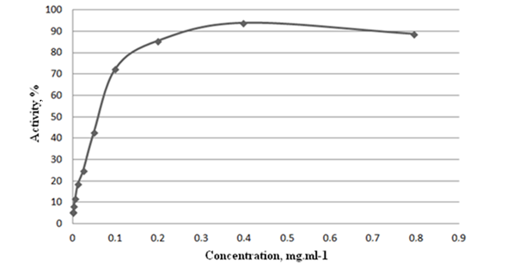
Fig. S4. DPPH radical scavenging activity of Astragalus monspessulanus n-BuOH extract. The Data was represented as Mean (n=3)
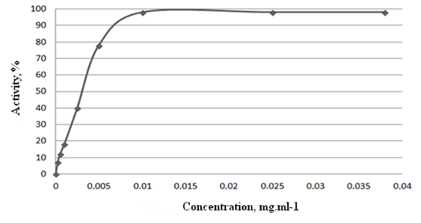
Fig. S5. DPPH radical scavenging activity of ascorbic acid

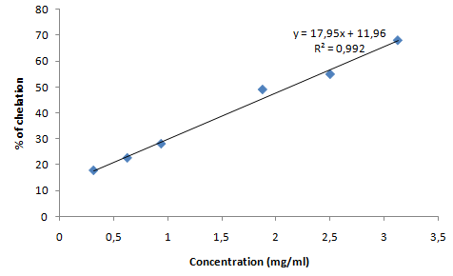
Fig. S6. Ferrous iron-chelating activity of Astragalus monspessulanus n-BuOH extract.The Data was represented as Mean (n=3)
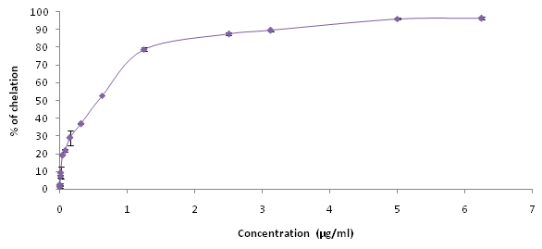
Fig. S7. Ferrous iron-chelating activity of EDTA
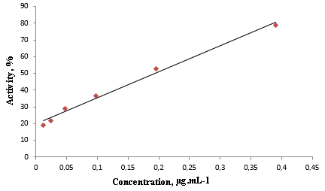
Fig. S8. Ferrous iron-chelating activity of EDTA - linear part

