Structural and electronic effects of cation binding (Li⁺, Na⁺, K⁺, Mg²⁺ & Ca²⁺) to π system of ƞ⁶-benzene-Cr(CO)₃ complex: A theoretical study
A. KALPANA¹, L. AKILANDESWARI*²
^{1,2}Department of Chemistry, Sri Sarada College for Women, Salem 636 016, TamilNadu, India.

Supplementary Material
SM TABLE I. Computed λ_{max} (maximum absorption wavelength), f (oscillator strength), TDM (transition dipole moments),
Root mean square value (μ_{0n}) (RMS) between the ground and n^{th} excited state of all the system under study.
Systems | MB |  |  |  |  |  |  | MBC
 | State  transition | λ (nm) | f | Transition dipolemoment |  |  | RMS  (μ_{0n})  (e-bohr) | State  transition | λ (nm) | f | Transition dipolemoment |  |  | RMS  (μ_{0n})  (e-bohr)
 |  |  |  | x | y | z |  |  |  |  | x | y | z
BC | S₀→S₃ | 168.03 | 0.5587 | -0.1278 | -0.4628 | 0 | 0.480 | S₀→S₂ | 361.16 | 0.0004 | -0.0011 | -0.0122 | 0.0661 | 0.067
 | S₀→S₄ | 168.03 | 0.5588 | -0.4629 | 0.1278 | 0 | 0.480 | S₀→S₃ | 361.10 | 0.0004 | -0.0006 | 0.0657 | 0.0121 | 0.067
 | S₀→S₈ | 155.08 | 0.0056 | 0 | 0 | -0.0087 | 0.009 | S₀→S₄ | 346.01 | 0.0002 | 0.0323 | 0.0405 | -0.0043 | 0.052
 |  |  |  |  |  |  |  | S₀→S₅ | 345.91 | 0.0010 | -0.0093 | 0.0202 | -0.1022 | 0.105
 |  |  |  |  |  |  |  | S₀→S₆ | 345.80 | 0.0009 | -0.0117 | 0.0954 | 0.0238 | 0.099
 |  |  |  |  |  |  |  | S₀→S₇ | 344.98 | 0.0005 | 0.0720 | 0.0005 | -0.0060 | 0.072
 |  |  |  |  |  |  |  | S₀→S₈ | 328.93 | 0.0016 | -0.0002 | -0.1242 | -0.0418 | 0.131
 |  |  |  |  |  |  |  | S₀→S₉ | 328.89 | 0.0016 | 0.0008 | -0.0419 | 0.1247 | 0.132
 |  |  |  |  |  |  |  | S₀→S₁₀ | 308.11 | 0.0001 | 0.0006 | -0.0353 | -0.0010 | 0.035
Li⁺-BC | S₀→S₂ | 193.2 | 0.0202 | 0.0085 | 0.0635 | 0 | 0.064 | S₀→S₄ | 390.76 | 0.0006 | -0.0051 | -0.0323 | 0.0820 | 0.088
 | S₀→S₃ | 193.19 | 0.0202 | -0.0636 | 0.0084 | 0 | 0.064 | S₀→S₅ | 390.42 | 0.0006 | 0.0013 | -0.0824 | -0.0336 | 0.089
 | S₀→S₆ | 165.65 | 0.5223 | -0.1315 | 0.4292 | 0 | 0.449 | S₀→S₆ | 352.21 | 0.0025 | 0.1700 | 0.0058 | 0.0026 | 0.170
 | S₀→S₇ | 165.65 | 0.5222 | -0.4292 | -0.1315 | 0 | 0.449 | S₀→S₇ | 349.04 | 0.0013 | 0.0925 | -0.0814 | 0.0041 | 0.123
 | S₀→S₁₀ | 163.62 | 0.0066 | 0 | 0.0001 | -0.0277 | 0.028 | S₀→S₈ | 348.72 | 0.0012 | -0.0476 | -0.0692 | -0.0820 | 0.117
 |  |  |  |  |  |  |  | S₀→S₉ | 348.49 | 0.0013 | 0.0531 | 0.0593 | -0.0911 | 0.121
 |  |  |  |  |  |  |  | S₀→S₁₀ | 322.44 | 0.0006 | 0.0060 | 0.0061 | -0.0785 | 0.079
Na⁺-BC | S₀→S₁ | 230.59 | 0.0111 | -0.0067 | 0.0494 | 0.0001 | 0.050 | S₀→S₂ | 398.04 | 0.0006 | 0.0000 | -0.0337 | 0.0837 | 0.090
 | S₀→S₂ | 230.57 | 0.0111 | 0.0495 | 0.0069 | 0.0001 | 0.050 | S₀→S₃ | 397.86 | 0.0006 | 0.0018 | 0.0831 | 0.0338 | 0.090
 | S₀→S₅ | 168.36 | 0.5276 | -0.0938 | 0.444 | 0.0009 | 0.454 | S₀→S₄ | 391.39 | 0.0001 | -0.0007 | -0.0035 | 0.0404 | 0.041
 | S₀→S₆ | 168.35 | 0.5276 | 0.4441 | 0.0938 | 0.001 | 0.454 | S₀→S₅ | 391.27 | 0.0001 | 0.0007 | 0.0414 | 0.0036 | 0.042
 |  |  |  |  |  |  |  | S₀→S₈ | 367.94 | 0.0012 | -0.1217 | -0.0008 | -0.0002 | 0.122
 |  |  |  |  |  |  |  | S₀→S₉ | 351.84 | 0.0015 | 0.0012 | -0.1334 | 0.0118 | 0.134
 |  |  |  |  |  |  |  | S₀→S₁₀ | 351.64 | 0.0015 | 0.0001 | -0.0119 | -0.1333 | 0.134
K⁺-BC | S₀→S₁ | 230.94 | 0.0085 | 0 | 0.0002 | -0.0395 | 0.040 | S₀→S₄ | 379.73 | 0.0007 | 0.0019 | 0.0929 | 0.0145 | 0.094
 | S₀→S₂ | 230.93 | 0.0085 | 0 | -0.0395 | -0.0002 | 0.040 | S₀→S₅ | 379.42 | 0.0007 | -0.0026 | -0.0143 | 0.0924 | 0.094
 | S₀→S₅ | 172.58 | 0.0001 | -0.0055 | 0 | 0.0001 | 0.006 | S₀→S₆ | 377.77 | 0.0001 | -0.0001 | 0.0292 | -0.0173 | 0.034
 | S₀→S₇ | 171.21 | 0.1136 | 0.1767 | -0.0001 | 0 | 0.177 | S₀→S₇ | 377.69 | 0.0001 | -0.0002 | -0.0152 | -0.0304 | 0.034
 | S₀→S₉ | 169.78 | 0.3383 | 0 | -0.2698 | 0.2307 | 0.355 | S₀→S₉ | 341.11 | 0.0001 | -0.0332 | -0.0051 | -0.0049 | 0.034
 | S₀→S₁₀ | 169.76 | 0.3436 | -0.0001 | 0.233 | 0.2718 | 0.358 | S₀→S₁₀ | 339.76 | 0.0013 | -0.0026 | -0.0183 | 0.1175 | 0.119
Mg²⁺-BC | S₀→S₁ | 334.30 | 0.0014 | 0.0098 | 0.0108 | 0 | 0.015 | S₀→S₁ | 1096.59 | 0.0002 | 0.0018 | 0.0651 | 0.0407 | 0.077
 | S₀→S₂ | 334.28 | 0.0014 | -0.0107 | 0.0098 | -0.0001 | 0.015 | S₀→S₂ | 1095.48 | 0.0002 | 0.0018 | 0.0401 | -0.0655 | 0.077
 | S₀→S₈ | 174.03 | 0.0109 | 0 | 0 | -0.0519 | 0.052 | S₀→S₃ | 792.33 | 0.0484 | -1.1238 | -0.0011 | 0.0001 | 1.124
 |  |  |  |  |  |  |  | S₀→S₅ | 402.55 | 0.0001 | 0.0020 | -0.0285 | -0.0024 | 0.029
 |  |  |  |  |  |  |  | S₀→S₆ | 402.43 | 0.0001 | -0.0014 | 0.0018 | -0.0282 | 0.028
 |  |  |  |  |  |  |  | S₀→S₇ | 395.43 | 0.0001 | -0.0007 | 0.0356 | 0.0053 | 0.036
 |  |  |  |  |  |  |  | S₀→S₈ | 395.14 | 0.0001 | 0.0001 | -0.0057 | 0.0363 | 0.037
 |  |  |  |  |  |  |  | S₀→S₉ | 374.08 | 0.0016 | 0.0000 | 0.1391 | -0.0113 | 0.140
 |  |  |  |  |  |  |  | S₀→S₁₀ | 373.93 | 0.0016 | 0.0010 | 0.0112 | 0.1395 | 0.140
Ca²⁺-BC | S₀→S₁ | 296.74 | 0.0027 | 0 | 0 | 0.0157 | 0.016 | S₀→S₁ | 744.07 | 0.0003 | 0.0002 | 0.0394 | -0.0834 | 0.092
 | S₀→S₂ | 296.72 | 0.0027 | 0 | 0.0157 | 0 | 0.016 | S₀→S₂ | 743.49 | 0.0003 | 0.0013 | 0.0835 | 0.0395 | 0.092
 | S₀→S₁₀ | 173.55 | 0.0069 | 0.0335 | -0.0001 | 0 | 0.034 | S₀→S₃ | 667.06 | 0.0174 | -0.6181 | 0.0001 | -0.0001 | 0.618
 |  |  |  |  |  |  |  | S₀→S₅ | 430.26 | 0.0001 | 0.0008 | -0.0075 | -0.0359 | 0.037
 |  |  |  |  |  |  |  | S₀→S₆ | 430.18 | 0.0001 | -0.0001 | 0.0359 | -0.0077 | 0.037
 |  |  |  |  |  |  |  | S₀→S₉ | 374.44 | 0.0009 | 0.0003 | -0.0892 | 0.0523 | 0.103
 |  |  |  |  |  |  |  | S₀→S₁₀ | 374.36 | 0.0009 | 0.0003 | -0.0518 | -0.0892 | 0.103
Data corresponding to the maximum absorption wavelength are in bold letters.

SM TABLE II . NTO pictures and MO transitions corresponding to λ_{max} of MB systems under study.
Systems | λmax  &  f | NTO |  |  | MO transition
 |  | % contribution | Hole | Particle
B | 168.035  (0.559) | 50% |  |  | HOMO-1 → LUMO  HOMO → LUMO+1  HOMO-1 → LUMO+1  HOMO → LUMO | 0.69  -0.69  -0.16  -0.16 | (47%)  (47%)  (2%)  (2%)
 |  | 50%
Li⁺-B | 165.649  (0.522) | 49% |  | 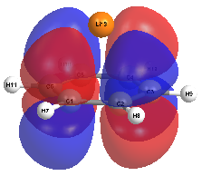 | HOMO-1 → LUMO  HOMO → LUMO+1  HOMO-1 → LUMO+1  HOMO → LUMO | 0.62  -0.62  0.33  0.33 | (38%)  (38%)  (11%)  (11%)
 |  | 49%
Na⁺-B | 168.357  (0.528) | 49% |  |  | HOMO-1 → LUMO+2  HOMO → LUMO+1 | 0.70  -0.70 | (49%)  (49%)
 |  | 49%
K⁺-B | 169.766  (0.344) | 63% |  | 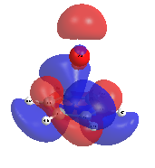 | HOMO-1 → LUMO+3  HOMO → LUMO+1  HOMO → LUMO+5  HOMO-1→LUMO+5  HOMO-1→LUMO+1 | 0.57  0.57  0.46  0.28  0.15 | (32%)  (32%)  (21%)  (8%)  (2%)
 |  | 34%
Mg²⁺-B | 174.029  (0.011) | 53% |  |  | HOMO-2 → LUMO+1  HOMO-3 → LUMO+2 | 0.73  0.67 | (53%)  (45%)
 |  | 45%
Ca²⁺-B | 173.551  (0.007) | 49% |  |  | HOMO-3 → LUMO+2  HOMO-2 → LUMO+1 | 0.70  0.70 | (49%)  (48%)
 |  | 48% |  | 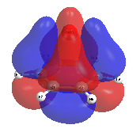

SM TABLE III. NTO pictures and MO transitions corresponding to λ_{max} of MBC systems under study.
Systems | λmax  &  f | NTO |  |  | MO transition
 |  | % contribution | Hole | Particle
BC | 328.925  (0.002) | 71% |  |  | HOMO-2 →LUMO+1  HOMO-2 → LUMO+2  HOMO-1 → LUMO+3  HOMO → LUMO+2  HOMO-2 → LUMO+13  HOMO-1 → LUMO+12 | 0.71  -0.37  0.28  -0.27  -0.18  0.15 | (51%)  (14%)  (8%)  (7%)  (3%)  (2%)
 |  | 10% |  | 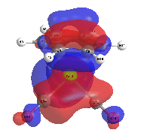
Li⁺-BC | 352.210  (0.003) | 49% | 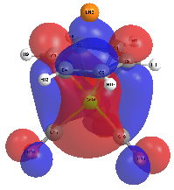 | 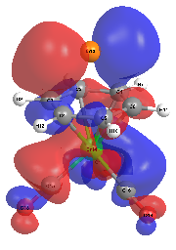 | HOMO → LUMO+5  HOMO → LUMO+4  HOMO-1 → LUMO+4 HOMO-1 → LUMO+5  HOMO → LUMO+12  HOMO-1 → LUMO+11 | 0.45  -0.45  -0.44  -0.41  -0.22  -0.20 | (21%)  (20%)  (19%)  (17%)  (5%)  (4%)
 |  | 43% | 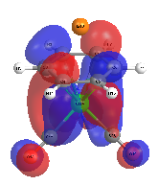 | 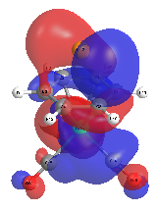
Na⁺-BC | 351.840  (0.002) | 77% | 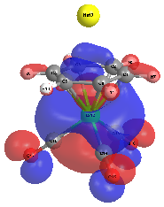 | 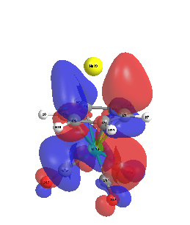 | HOMO-2 → LUMO+3  HOMO-2 → LUMO+11  HOMO-2 → LUMO+1  HOMO-2 → LUMO+6  HOMO → LUMO+4  HOMO-1 → LUMO+3 | 0.66  -0.31  -0.27  0.27  -0.23  0.23 | (43%)  (10%)  (7%)  (7%)  (5%)  (5%)
K⁺-BC | 339.759  (0.001) | 70% | 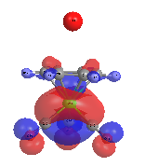 | 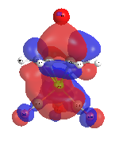 | HOMO-3 → LUMO+2  HOMO-3 → LUMO+1  HOMO-3→LUMO+5  HOMO-3→LUMO+14  HOMO-2→LUMO+3  HOMO-2→LUMO+2 | 0.56  0.39  0.39  0.21  -0.20  0.17 | (31%)  (15%)  (15%)  (4%)  (4%)  (3%)
Mg²⁺-BC | 792.337  (0.048) | 98% | 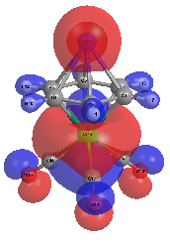 | 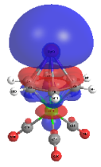 | HOMO-2 → LUMO | 0.99 | (98%)
Ca²⁺-BC | 667.052  (0.017) | 99% |  | 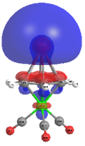 | HOMO-2 → LUMO | 1.00 | (99%)

