Low-temperature-synthesized RuO₂ from acidic chloride solution for the electrode coating applications
Gavrilo Šekularac^{1,**}, Sanja Eraković¹, Dušan Mijin², Vesna Pavelkić^{1,3}, Jasmina Stevanović¹, Vladimir Panić^{1,}*
¹Institute of Chemistry, Technology and Metallurgy, Department of Electrochemistry, University of Belgrade, Belgrade, Serbia
²Faculty of Technology and Metallurgy, University of Belgrade, Belgrade, Serbia
³The Railway College of Vocational Studies, Zdravka Čelara 14, Belgrade, Serbia

Abstract
For the preparation of RuO₂ coatings on Ti substrate, the RuO₂ was synthesized in acidic aqueous medium by simple one-step low temperature-controlled microwave (MW) irradiation. The physical composition of synthesized solid phase was analysed through particle size distribution (PSD), whereas the coating was investigated for its capacitive response and activity in oxygen evolution reaction (OER). The oxide phase is found highly polydisperse, with overlapped fractions within rather narrow particle size range and clear tendency toward agglomeration. The smallest particles and their best resolved fractions were synthesized at the temperature just above the boiling point of the reaction medium, and quite below the chloride-to-oxide conversion temperature. Consequently, the highest OER activity was registered for RuO₂/Ti anodes prepared from this sample, with strong indication of different oxide structure with respect to the electrodes prepared from samples synthesized at higher temperatures. However, the coatings from high temperature samples have considerably higher capacitance than those synthesized at lower temperatures. These findings can be correlated rather to MW temperature-dependent oxide structure than to different morphology analysed through PSD.
Keywords: electrocatalytic oxide materials; hydrothermal synthesis; microwave synthesis; electrochemical impedance spectroscopy; pseudocapacitance.
Introduction
Electrochemically active noble metal oxides found their application as coatings for industrial electrodes,¹⁻⁵ due to the great electrocatalytic activity for chlorine evolution reaction (CER) and oxygen evolution reaction (OER),⁶⁻⁹ but also for many other electrochemical reactions.¹⁰⁻¹² These oxides show also the excellent supercapacitive performances.¹⁵⁻¹⁹ The main electrocatalytic coating component is RuO₂.^{6,20–27} Typical procedure for the preparation of electrode oxide coatings on Ti substrate is by thermal decomposition of chloride salts.^{6,27–30} In order to increase the oxide electrocatalytic activity, selectivity and operational stability, variety of methods, based on separation of oxide synthesis and coating formation, have been applied. The aim was to establish defined coating structure, which should be as much as possible independent from coating formation procedure itself.^{31–39} Different types of hydrothermal oxide synthesis have been studied intensively, which promoted the sol-gel process due to improved coating stability in comparison to typical thermally prepared coatings.³⁵ However, hydrothermal procedures appear rather complex and long-lasting for the application in practice. The time required for complete conversions of chlorides to oxides of define structure is rather long since the temperature/pressure conditions are far from those required for controlled conversion.³⁵
Microwave (MW)-assisted synthesis was proven to enhance many kinds of different processes, from organic synthesis⁴⁰ to extraction procedures.⁴¹ It was shown³⁹ that suitable conditions for extremely short hydrothermal synthesis of RuO₂ can be reached by highly controllable MW-assisted synthesis of the oxide from aqueous chloride solution. The corresponding coatings, prepared from the oxide synthesized at high pressures and MW temperatures above 200 °C, were found to be of high pseudocapacitance and activity for chlorine and oxygen evolution reaction. However, the applied MW conditions are rather extreme. The aim of this work is to investigate the physical properties of RuO₂ synthesized at moderate MW conditions (low temperatures/pressure around boiling point of reaction medium) and consequently their influence on electrochemical behaviour of corresponding RuO₂/Ti electrodes. The results of particle size distribution of the oxide in synthesized medium, the corresponding changes in MW synthesis conditions, the activity of RuO₂/Ti in oxygen evolution reaction and its capacitive performance gained by cyclic voltammetry and electrochemical impedance spectroscopy are reported and discussed. The data are compared to those obtained in the investigation of MW-synthesized RuO₂ at higher temperatures.³⁹

Experimental
Low temperature MW synthesis of RuO₂
The precursor for the preparation of RuO₂ coatings on Ti, the RuO₂ colloidal dispersion, was synthesized by simple one-step temperature-controlled microwave (MW) irradiation, starting from aqueous RuCl₃ solution as described in previous work.³⁹ The reaction mixture (6 ml) was continuously mechanically stirred at 600 rpm inside a closed reactor (10 ml) and irradiated isothermally to 80, 120 and 150 °C in a MW oven (Monowave 300, Anton Paar, Ashland, VA, USA). The initial heating speed was set to “as fast as possible” and the temperature was maintained constant for 5 min. The reaction mixture was cooled to 60 °C in the reactor and afterwards to ambient temperature. The obtained dispersions are denoted as MW_{t80}, MW_{t120} and MW_{t150}. As a result of MW irradiation, initially brown precursor solution turned black with visible appearance of a solid phase.
Physical characterization
The reaction medium was subjected to dynamic light scattering (DLS) after the synthesis in order to analyse the solid phase presence. Laser-based particle size analyser Zetasizer Nano ZS (Malvern Instruments, UK), operating at λ = 633 nm (produced by a He–Ne laser at scattering angle 173°) at 25 ± 0.1 °C was employed. All samples were diluted with DI-water in volume ratio 1:100 and ultra-sonicated for 10 min before measurements.
Coating preparation
The reaction mediums, after MW irradiation at different temperatures, were used for the formation of a RuO₂ coating on Ti. Sand-blasted titanium rods (commercially pure, Krupp AG, Essen, Germany), 3 mm in diameter, were thoroughly etched in hot aqueous 18 % HCl solution for 20 min, rinsed by water, and dried at 100 °C. Before the application of reaction medium onto Ti rods up to the height of 1 cm, the medium has been ultra-sonicated for 15 min. After deposition, the rod was dried at 120 °C for 30 min. These two steps were repeated and finally the coating was formed during the thermal treatment at 300 °C for 2 h. In the order to avoid possible detachment, the coating was deposited as rather thin layer in an amount of 0.11 mg cm⁻². Thus prepared RuO₂/Ti served as working electrodes in electrochemical testing.
Electrochemical measurements
The electrochemical experiments were carried out on 0.5 cm² working surface area in a three-electrode cell, with Pt gauze electrode and saturated calomel electrode (SCE; all potentials are expressed vs. SCE) as counter and reference electrodes, respectively. Cyclic voltammetry (CV) at 50 mV/s, quasi-steady-state polarization at 5 mV/s and electrochemical impedance spectroscopy (EIS) measurements (at open circuit potential) in 1 M H₂SO₄ were performed with a Biologic SP-200 potentiostat/galvanostat (Bio-Logic SAS, Claix, France) at room temperature. Polarization measurements were performed in the potential range 0.90–1.32 V vs. SCE with preceding anode potentiostatic conditioning at 0.90 V for 10 min. EIS data were recorded with ac potential amplitude of 10 mV (root mean square, rms) around open circuit potential in a multi-sine mode, within frequency range of 100 kHz–5 mHz with 10 points per decade. The fitting of EIS data was performed in ZView® software (Scribner Associates Inc., Southern Pine, NC, USA) with data-modulus type of data weighting in maximum 100 iterations. The fitting is assumed acceptable if the chi-squared and weighted sum of squares were of the orders of 10⁻⁵ and 10⁻³, respectively. With these fitting criteria, the relative error of the all equivalent circuit parameter values were below 10 % (the only exceptions was the value of R2 resistor for MW_{t150} sample, for which the fitting returned the error of 13 %).

Results and discussion
The changes in parameters, temperature (t_{MW}), MW power (P) and heating rate ((dt/dτ)_{τ}), of MW reactor in the early stages of synthesis are shown in Fig. 1. The data are analysed during the time required to reach the desired isothermal condition, i.e., during the early stages of MW irradiation. Around 1 min was required to reach the temperature plateau upon characteristic heating conditions, which depend on pre-set isothermal requirements. The MW power is delivered continuously during ca. 6 s with no significant changes temperatures. When the power maxima, which considerably depend on required temperature (200, 400 and 650 W for 80, 120 and 150 °C, respectively), is reached after additional 5-6 s, the temperature starts to increase with different rate at different pre-set temperatures. As in the case of power maxima, the peak heating rate is reached faster if the required temperature is higher. In addition, the lower reaction temperature requires finer power and heating rate tuning: there are two heating rate plateaus at 80 °C around 30 s and 45 s, while the single one is seen at 120 °C around 30 s. No plateaus after heating rate peak can be observed at 150 °C. As a consequence, there is minute overthrow of pre-set temperature of 80 °C, as an indication of hardly controllable heating conditions at temperatures below boiling point of the reaction medium. It should be noted that reactor pressure above standard conditions was registered only at the heating to 150 °C, which reached the steady-state value of 5.5 bar.
The considered changes in heating parameters which precede the conditions required to maintain the steady-state heating indicate that synthesized solid phase should be of different physical properties since the heating is expected to affect the particle nuclei formation and subsequent particle growth. This is checked by investigation of particle size distribution (PSD) by dynamic light scattering (DLS) as presented in following section.

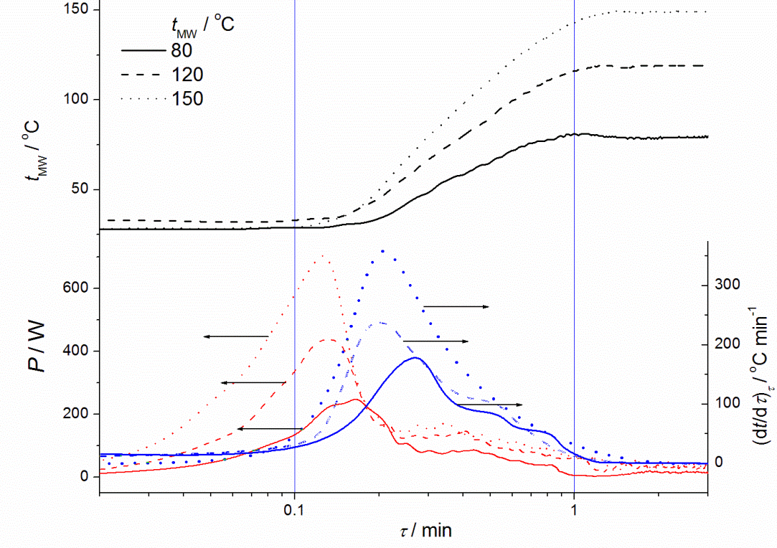
Fig. 1. The changes in MW reactor parameters: temperature (t_{MW}), MW power (P) and heating rate ((dt/dτ)_{τ}), in the early stages of synthesis.
PSD of synthesized RuO₂ solid phase
The PSDs by DLS in reaction media for RuO₂ synthesized by MW irradiation at 80, 120 and 150 °C are shown in Fig. 2. The distribution is analysed during the ten consecutive runs of light irradiation in order to check the PSD stability. All samples appear highly polydisperse, with distinct appearance of the grains within the diameter fractions between 20 nm and 1 µm. The agglomerates of diameter above 3 µm are present in all samples, but their size distribution is becoming more pronounced upon increase in pre-set temperature. The grains of smallest diameter are obtained at 120 °C grouped within well resolved fractions around 30 and 150 nm (Fig. 2B). The separation of the fractions is considerably less pronounced at lower and higher temperature (Fig. 2A and C). The initially registered peaks at higher MW temperatures (Run 1, Fig. 2B and C) are becoming better distinguished during the consecutive runs, which indicates the merging of the grains into larger ones. Consequently, in steady state Run 10 there are well resolved peaks around 50 and 300 nm for the sample synthesized at 120 °C (Fig. 2B) and around 100 and 500 nm if the synthesis temperature is increased to 150 °C (Fig. 2C). This effect is very weak, or even opposite at 80 °C (Fig. 2A). The sample at 80 °C contains the µm-sized agglomerates, stable during the runs, of extremely narrow PSD in comparison to other two samples.
These considerations of DLS data indicate that pre-set temperature below the boiling point favours the particle growth formation and generates the grains of low tendency to join into agglomerates of different size. On the other hand, the intensification of the heating condition induces the nucleation and subsequent generation of the grains tending to form defined grouped structures and agglomerates of different sizes between 3 and 5 µm. This tendency of grains is reflected into the fraction of agglomerates themselves too, since they appeared joined between first and tenth run (Fig. 2B and C) into distinct size similar to those present in sample synthesised at 80 °C (Fig. 2A). Further increase in temperature up to 220 °C did not affect the main grain fracture around 300 nm,³⁹ but the fractions of smaller grains (below 100 nm) was found transferred to the regions of lower diameter. These findings are strong confirmation of nuclei formation favoured over particle growth. Exclusively, the PSD of the sample synthesized at 200 °C did not show any presence of the agglomerates.³⁹ However, the particles appear to be of high surface energy since they form stable grains and agglomerates.

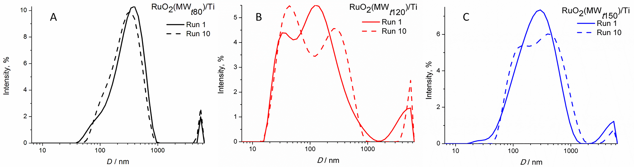
Fig. 2. Particle size distribution by intensity for RuO₂ suspension synthetized at: (A) 80; (B) 120 and (C) 150 °C in an MW reactor. The run relates to the number of successively repeated DLS measurement.

The electrochemical properties of the MW-synthesized RuO₂/Ti electrodes
Electrochemical properties of RuO₂/Ti electrodes prepared from MW_{t80}, MW_{t120}, and MW_{t150} samples were investigated by cyclic voltammetry (CV), polarization measurement and electrochemical impedance spectroscopy (EIS). The CV curves (as specific currents per mass of the coating) are shown in Fig. 3.
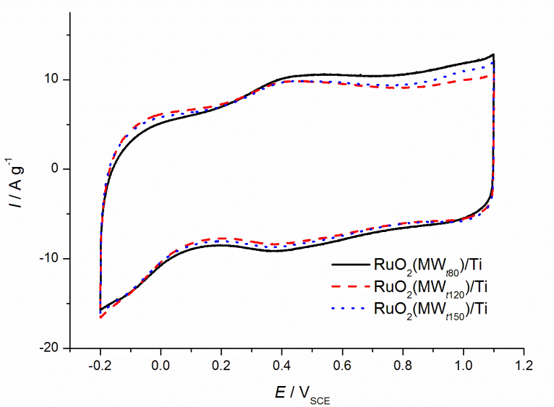
Fig. 3. The Cyclic voltammograms of RuO₂/Ti electrodes prepared from the oxide synthesized at the different temperatures. Sweep rate: 50 mV/s; electrolyte: 1 M H₂SO₄.
Cyclic voltammograms has usual shape for RuO₂/Ti electrodes obtained by different synthesis procedures.³⁵ In the most of CV potential region of CV anodic branch, the highest currents were registered for RuO₂(MW_{t80})/Ti and the lowest for RuO₂(MW_{t120})/Ti electrode, although the currents are quite similar for all samples. This indicates their almost equal capacitive ability. It should be noted that the order of currents is opposite right at the beginning of charging (-0.2 to 0.1 V). This part of the anodic charging branch follows the completion of the proton insertion into the hydrous structure of the oxide in the same potential region of the cathodic branch. It appears that the oxide synthesized at higher temperatures is able to respond more efficiently to redox transitions involving the lower oxidation states of Ru.⁴² Similarly, the transitions related to higher Ru oxidation states are improved when the synthesis temperature is below the boiling point of the reaction (RuO₂(MW_{t80})/Ti). These findings indicate that increasing temperature of MW synthesis to 120 and 150 °C produce more polycrystalline particles that creates more accessible coatings with more defects sites (kink sites, defect sites, edges, etc.), which can be readily oxidized to higher oxidation states.
Total capacitance of anodes was calculated by integration of CV curves. A bit higher value was obtained for RuO₂(MW_{t80})/Ti, 108 F g⁻¹, in comparison to RuO₂(MW_{t120})/Ti and RuO₂(MW_{t150})/Ti, 101 and 107 F g⁻¹, respectively. In addition to small differences commented in previous paragraph, these small differences in CV capacitance could originate also from a bit more compact structure of the RuO₂(MW_{t120})/Ti and RuO₂(MW_{t150})/Ti coatings, for which more pronounced presence of a fraction of smaller particles was registered (Fig. 2).
The synthesis temperatures above 150 °C, which is assumed as optimal for good capacitive response of RuO₂,⁴³ caused considerable increase in CV currents.³⁹
In order to investigate further coating structure-related pseudo-capacitive characteristics of synthesized RuO₂ coatings, electrochemical impedance spectroscopy (EIS) measurements at open circuit potential (OCP) were carried out. If one assumes that OCP value corresponds to the fastest and the most convenient redox transition, the EIS analysis is expected to give more details related to the differences in different potential regions indicated by CV curves (Fig. 3). Experimental and fitted EIS data are presented in form of complex plane and Bode plots, along with the model of applied equivalent electrical circuit (EEC), are shown in Fig. 4. The registered EIS response and the EEC structures are typical for DSAs with a well-developed TiO₂-rich interlayer.⁴⁴ The semicircle-like dependence is seen in high frequency range down to 400 Hz (Fig. 4B), which precedes capacitive-like response in intermediate frequency range, down to 0.5 Hz. The semicircle is assignable to TiO₂-rich in the coating/Ti substrate interphase, created during annealing of the electrode as the product of the substrate oxidation. Its parameters found the equivalence in CPE1 and R2 EEC elements in parallel (Fig. 4A). The capacitive-like response is distributed through a transmission line generated by the elements C1-C4 and R3-R5 and is well developed as a capacitive loop, Fig. 4C. In low frequency range, there is an indication of finite diffusion limitations to the pseudo-capacitive response, taken into account by the element CPE2. The mean values (± abs. error) of EEC parameters are shown in Fig. 5. EIS response which describes the properties of TiO₂-rich interlayer appears similar for three samples (Fig. 4A), with corresponding resistance and capacitance around 0.6 Ω and 2,5 F g⁻¹, respectively. These findings indicate that corresponding TiO₂-rich interlayer is of similar structure since the coatings should be of similar texture³⁹ created from the particles of similar size distribution around 200 nm (Fig. 2). Owing to more narrower and more stable particle distribution in case of MW_{t80}, the least compact coating structure is expected, and hence the most compact TiO₂ interlayer could be formed. This appears indicated by larger interlayer capacitance for MW_{t80} in comparison to MW_{t120} and MW_{t150} (Fig. 4A, branch No. 1, CPE1). However, the interlayer thickness is similar for all samples and seems to be considerably thinner than the coating, since the corresponding resistance (0.6 Ω) is negligible in comparison to coating pore resistance around 100 Ω.
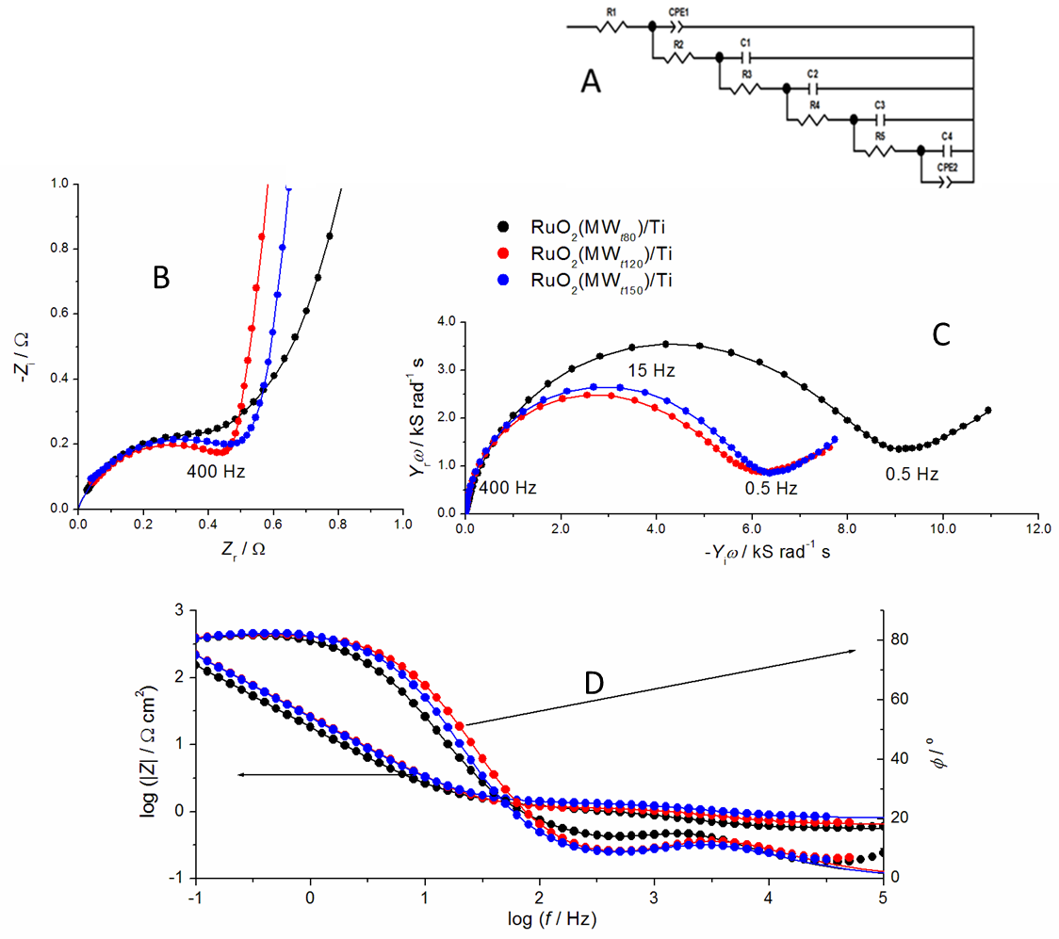
Fig. 4. The results of the fitting of measured EIS data to equivalent electrical circuit (EEC, A) presented as impedance (B) and capacitance (C) complex plane, and Bode (D) plots of the RuO₂/Ti electrodes synthetized at: 80; 120 and 150 °C in an MW reactor at OCP; symbols: measured data, lines: EEC data.

The capacitance complex plane plots show the difference in EIS behaviour between investigated RuO₂ coatings (Fig. 4C). Capacitive loop for RuO₂(MW_{t80})/Ti is larger than those obtained for RuO₂(MW_{t120})/Ti and RuO₂(MW_{t150})/Ti coatings. The fitting of EIS response with EEC model (Fig. 4A) showed that RuO₂(MW_{t80})/Ti is of higher total capacitance of around 96,6 F g⁻¹ in comparison to RuO₂(MW_{t120})/Ti and RuO₂(MW_{t150})/Ti coatings, which show similar total capacitance of around 71,3 F g⁻¹. This presents more pronounced difference between RuO₂(MW_{t80})/Ti and other two samples, while the values are lower, with respect to CV data. This means that MW_{t80} has better pseudo-capacitive characteristics in comparison with RuO₂(MW_{t120})/Ti and RuO₂(MW_{t150})/Ti. Results obtained by fitting of experimental data are presented like capacitance and resistance through the branches of EEC, Fig. 5A and B, respectively. The more pronounced difference between samples appears to be much higher pore resistances of RuO₂(MW_{t120})/Ti and RuO₂(MW_{t150})/Ti due to more compact coating structure, which consequently show the lower capacitance value in the EEC branches 3-5. As can be seen the capacitance values in the second branch, associated to the most outer part of the coating, are quite similar with even small opposite trend with respect to branches 3-5. These branches, according to transmission line model,⁴⁵ relates to coating inner structure. Accordingly, higher pore resistance values are obtained for the branches 3-5. On the other hand, branch 2 presents the negligible resistance difference between samples, apparently related to the interspace of a fraction of large particles of similar size of around 200 nm for all samples. Bearing in mind that the CV data where registered with rather fast input perturbance by a potential sweep rate in comparison to EIS measurements, it could be noticed that registered CV data reflect fairly well the findings related to second EEC branches of the lower order.
A 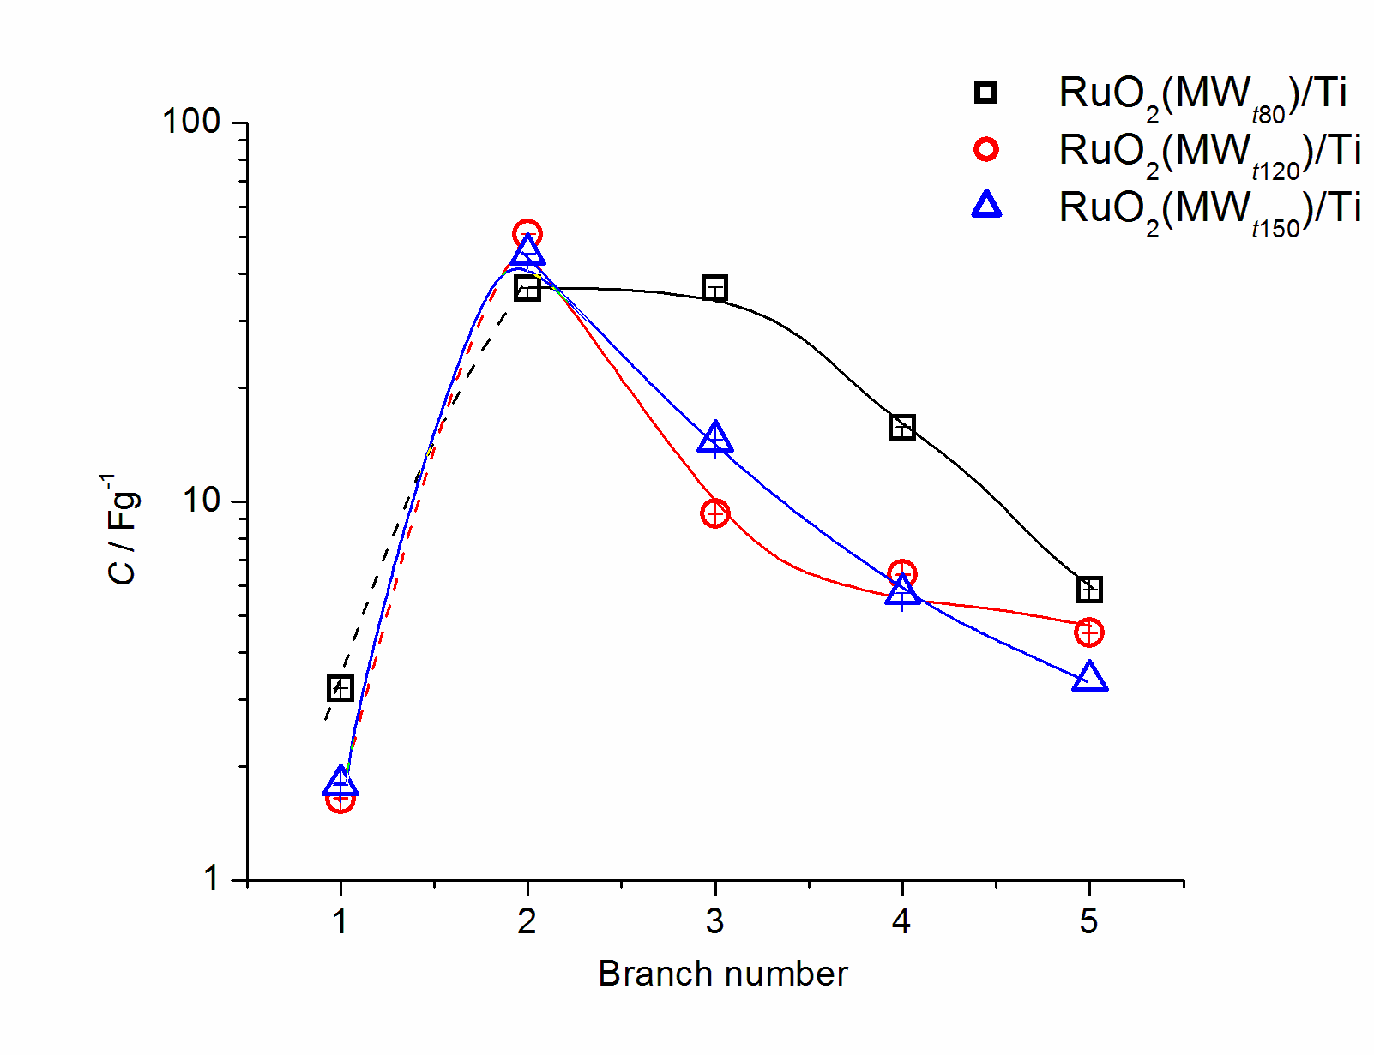 | B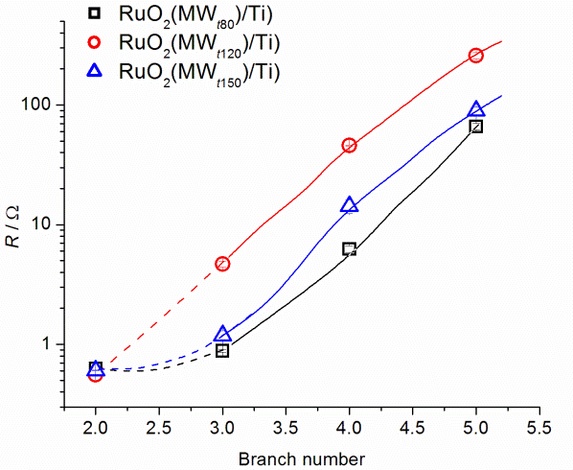
Fig. 5. (A) Capacitance and (B) resistance through the branches of the equivalent electrical circuit used for the fitting the impedance spectra of the RuO₂/Ti electrodes prepared from MW_{t80}, MW_{t120}, and MW_{t150} samples.

It appears that pseudo-capacitive response is sensitive to charging/discharging potential limits, with wider limits improving the capacitance performance (1.3 V in CV and only 10 mV rms amplitude in EIS), since the CV conditions double the values of those obtained by EIS. This sensitivity is less pronounced for RuO₂(MW_{t80})/Ti (55 % of CV capacitance is seen by EIS) than for other two samples (45 %). This indicates that more defined structure is formed at higher synthesis temperatures, with the ability to promote electrocatalytic activity (Fig. 3).
Fig. 6 represents the total capacitance and total pore resistance for the samples synthesized at different MW temperatures. RuO₂(MW_{t120})/Ti is of largest resistance because of the compact structure created by the particles belonging to PSD fractions of the smallest diameter in comparison to other samples (Fig. 2B). Consequently the total capacitance is small, as indicated by Fig. 6. Similarly, RuO₂(MW_{t80})/Ti and RuO₂(MW_{t150})/Ti are of lower resistance with corresponding higher values of total capacitance, owing to the structure created by larger particles (Figs. 2A and C). The increase in MW temperature to 200 °C bring the compromise between pore resistance and coating capacitance, which resulted in highest capacitance for moderate pore resistance, but also to more defined crystalline structure as shown in previous work.³⁹ PSD of RuO₂(MW_{t200})/Ti³⁹ is consisted of similar small particle from fractions as PSDs for RuO₂(MW_{t150})/Ti and RuO₂(MW_{t80})/Ti, but with the appearance of huge agglomerates for these two samples. The intrinsic values of capacitance and resistance of RuO₂(MW_{t200})/Ti can also be assigned to more uniform coating texture due to absence of the agglomerates.
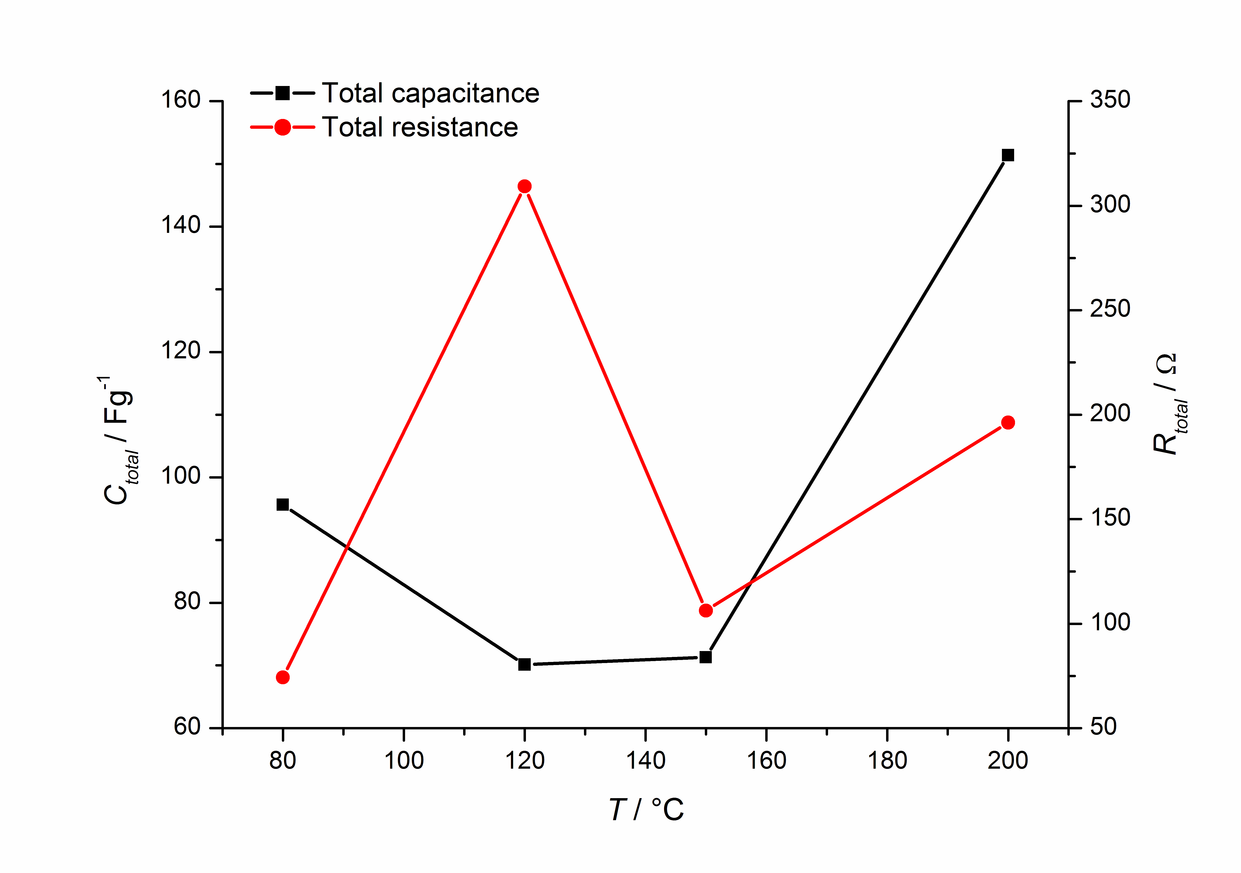
Fig. 6. Total capacitance and resistance of the RuO₂/Ti electrodes as a function of MW synthesis temperature.
Electrocatalytic properties of prepared RuO₂/Ti electrodes in oxygen evolution reaction (OER) are demonstrated by polarization curves shown in Fig. 7. Recorded polarization curves showed typical OER behaviour of RuO₂/Ti;^{39,45} all of the curves show regions of the two Tafel slopes: around 40 mV below 1.23 V, and larger ones above this potential value. The region of lower Tafel slopes is typical for polycrystalline, thermally prepared RuO₂/Ti, assignable to the mechanism with indirect water oxidation over simultaneous OH/O transition as rate-determining step, mostly on (110) RuO₂. The data from previous work³⁹ show that the synthesis temperature just above 150 °C makes the oxide less active in this potential region (the data for 200 °C show the increase of a slope to around 55 mV and consequent decrease in currents, Fig. 8A and B, respectively). Further increase in temperature to 220 °C recovers the slope (the electrocatalytic features of surface active sites) and only partially the currents with respect to low-temperature samples. This indicates that considerable changes oxide structure take place at and above 150 °C as reported in literature.⁴³ Similarly, the discontinuity in synthesis temperature-dependent electroctalytic behaviour is registered in the region of larger Tafel slopes which is supposed to correspond to OER mechanism with a step of direct water splitting on oxygen terminals at the oxide sites.⁴⁴ However, in this case the temperature of catalytic discontinuity is 120 °C, at which the considerable promotion of electroctalytic activity is registered. The slope is considerably lower (Fig. 8A) and corresponding currents are the highest (Fig. 8B). It follows that substantial changes in the oxide structure during the nuclei growth are initiated at the synthesis temperature above the boiling point of reaction mixture. It appears that MW temperature of 120 °C is able to generate a plenty of active sites at the surface of oxide particles, which is well preserved during the coating preparation and maintained as RuO₂(MW_{t120})/Ti unique electro-catalytic feature. It even appears that mechanism is not changed in the whole investigated potential region for RuO₂(MW_{t120})/Ti, and corresponds much to consecutive OER over OH/O transition of surface active sites.
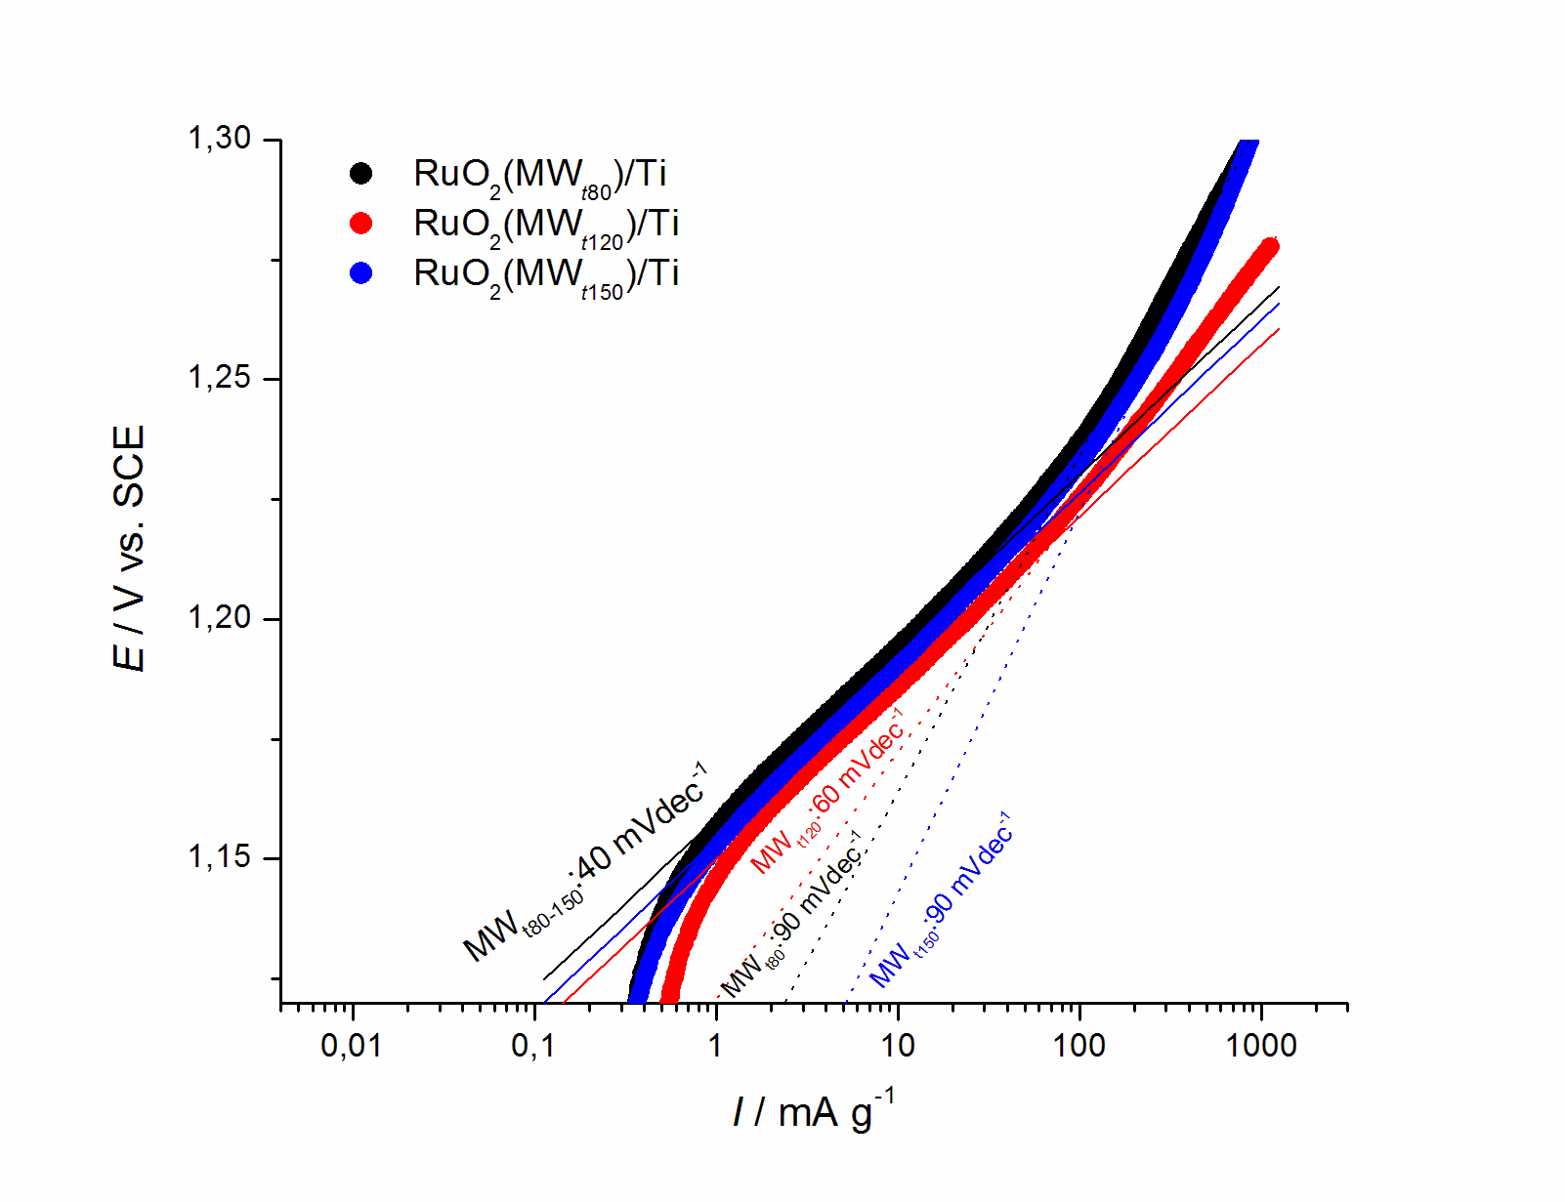
Fig. 7. Quasi-steady-state polarization curves (5 mV s⁻¹) for O₂ evolution in 1 M H₂SO₄ at room temperature on the RuO₂/Ti electrodes prepared from MW_{t80}, MW_{t120}, and MW_{t150} samples.

A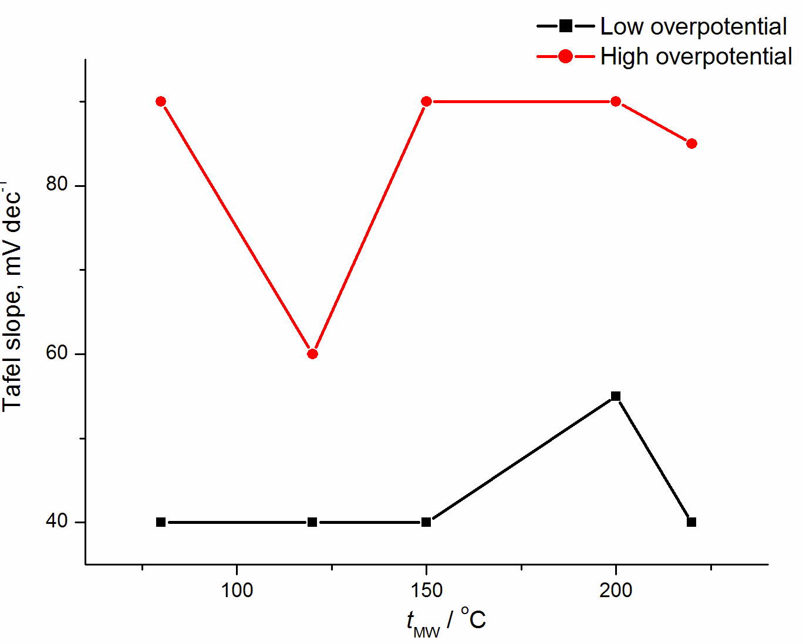 | B 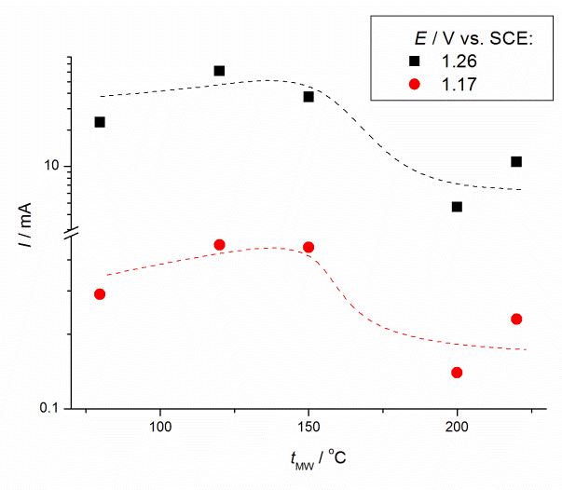
Fig. 8. (A) Tafel slopes in the regions of lower and higher potentials and (B) corresponding current densities at 1.26 and 1.17 V (Fig. 7) for the RuO₂/Ti electrodes as a function of RuO₂ synthesis temperature.

Conclusions
RuO₂ coatings on Ti were prepared by thermal treatment of the oxide solid phase synthesized from RuCl₃ aqueous solution by low temperature-controlled microwave (MW) heating. The minor difference in capacitance between coatings prepared from oxides synthesized in temperature range of 80-150 °C is registered from voltammetric responses. The difference can be associated to more compact structure of the oxide synthesized at the temperature of 120 °C in comparison to other samples. The more compact structure was correlated to the presence of the fractions of smallest particles. The distribution of capacitance and pore resistance as a result of impedance measurements showed more pronounced difference between samples due to the same cause related to coating structure. The considerable differences capacitance and pore resistance were found in inner parts of a coating, while similar behaviour was restricted only to the outer parts, as found by voltammetric measurements.
The electrocatalytic activity of the coatings in oxygen evolution reaction (OER) was found considerably different and promoted the coatings prepared from the oxide synthesized at lower temperatures as more active. These differences are correlated to different oxide structure with characteristic structure transitions at the intrinsic temperatures just above the boiling point of reaction mixture and above the temperature recognized as crucial for optimum proton/electron oxide conductivity.
Although low synthesis temperatures were found beneficial for OER, the synthesis temperatures above 150 °C promoted the coating capacitance. This opposite finding was supposed to be due to differences in the structure of oxide surface active sites, which appears to be generated during the MW synthesis and preserved during the formation of the coating.

Acknowledgment:
Financial support for the reported investigation from the Ministry of Education, Science and Technological Development of the Republic of Serbia is acknowledged. The authors thank to Dr. Ivana Drvenica for DLS measurements.
Ниско температурна синтеза RuO₂ из киселог хлоридног раствора за припрему eлектродне превлаке
Гаврило Шекуларац¹, Сања Ераковић¹, Душан Мијин², Весна Павелкић¹, Јасмина Стевановић¹, Владимир Панић¹
¹Институт за хемију, технологију и металургију, Центар за електрохемију, Универзитет у Београду, Београд
² Технолошко-металуршки факултет, Универзитет у Београду, Београд

Извод
RuO₂ је синтетисан у киселом воденом раствору једноставним микроталасним (MW) поступком у једном кораку на контролисаним ниским температурама и затим коришћен за припрему RuO₂ превлаке на подлози од титана. Синтетисана чврста фаза је окарактерисана анализом расподеле величине честица (PSD), док су капацитивност превлаке и њена активност у реакцији издвајања кисеоника (OER) испитане електрохемијским техникама. Нађено је да је оксидна фаза изражено полидисперзна, са преклопљеним фракцијама величине честица у уском опсегу са јасном тенденцијом ка укрупњавању. Најситније честице и најјасније раздвојене фракције синтетисане су на температурама блиским температури кључања реакционе смеше, знатно испод температуре конверзије хлорида у оксид. У овом случају је последично регистрована највећа активност RuO₂/Ti аноде за OER, са јасном назнаком различите структуре оксида у односу на узорке припремљене на вишим температурама. Међутим, нађено је да превлаке формиране од оксида синтетисаног на вишим температурама имају већу кпацитивност од оних синтетисаних на нижим темпераутрама. Овакви резултати пре су последица температурно-зависне структуре оксида током МW синтезе него различите морфологије регистроване PSD анализом.

References:
1. S. Trasatti, W. O’Grady, in: H. Gerisher, C.W. Tobias (Eds.), Advances in Electrochemistry and Electrochemical Engineering, Wiley, New York, 1981, p. 177.
2. A. Cornell, F. Herlitz, in: Proceedings of the Fourth Kurt Schwabe Corrosion Symposium, Helsinki, Finland, 2004, p. 326.
3. S. Trasatti and W.E. O’ Grady in H. Gerischer and P. Delahay (Eds.), Advances in Electrochemistry and Electrochemical Engineering, Vol. 13, Interscience, New York, 1980, p. 177.
4. S. Horacek and S. Puschaver, Chem. Eng. Progress. 67 (1971) 71.
5. A. Nidola in S. Trasatti (Eds.), Electrodes of Conductive Metallic Oxides, Part B,
Elsevier, Amsterdam, 1981, p. 627.
6. S. Trasatti (1999) In: Wieckowski A (ed) Interfacial electrochemistry—theory, experiment and applications. Marcel Dekker Inc., New York, p. 769
7. De Nora elettrodi network (2009) http://www.lidaproducts.com. Accessed May 2009
8. B.Ž. Nikolić, V.V. Panić (2014) In: Kreysa G., Ota K-I, Savinell R.F. (eds) Encyclopedia of applied electrochemistry. Springer, New York, p. 411
9. F. Herlitz, B. Hakansson, in: Proceedings of the Fourth Kurt Schwabe Corrosion Symposium, Helsinki, Finland, 2004, p. 32
10. K. Darowicki, S. Janicki, Corr. Sci. 41 (1999) 1165
11. S.M.A. Shibli, V.S. Gireesh, S. George, Corr. Sci. 46 (2004) 819.
12. E. O’Sullivan, J. White, J. Electrochem. Soc. 136 (1989) 2576
13. C.L.P.S. Zanta, A.R. De Andrade, J.F.C. Boodts, Electrochim. Acta 44 (1999) 3333.
14. V.V. Panić, A.B. Dekanski, T.R. Vidaković, V.B. Mišković-Stanković, B.Ž. Jovanović, B.Ž. Nikolić, J. Solid State Electrochem. 9 (2005) 43
15. S. Trasatti and P. Kurzweil, Platinum Metals Rev. 38 (1994) 46.
16. B.E. Conway, Electrochemical Supercapacitors: Scientific Fundamentals and Technological Applications, Kluwer Academic / Plenum Publishers, New York, 1999, p. 211
17. T. Jow, J. Zheng, J. Electrochem. Soc. 145 (1998) 49.
18. V. Panić, T. Vidaković, S. Gojković , A. Dekanski, B. Nikolić, Electrochim. Acta 48 (2003) 3805.
19. I.-H. Kim, J.-H. Kim, K.-B. Kim, Electrochem. Solid State Lett. 8 (2005) A369.
20. J.M. Hu, J.Q. Zhang, C.N. Cao, Int. J. Hydrog Energy 29 (2000) 791
21. M.H.P. Santana, L.A. De Faria, J.F.C. Boodts, Electrochim. Acta 49 (2004) 1925
22. C. Comninellis, P.G.J. Vercesi, Appl. Electrochem. 21 (1991) 335
23. M. Yagi, E. Tomita, T.J. Kuwabara, Electroanal. Chem. 579 (2005) 83
24. Y.W. Jung, J. Lee, Y. Tak, Electrochem. Solid State Lett. 7 (2004) H5
25. P.S. Patil, R.W. Kawar, S.B. Sadale, Electrochim. Acta. 50 (2005) 2527
26. V. Jovanović, A. Dekanski, P. Despotov, B. Nikolić, R.J. Atanasoski, Electroanal. Chem. 339 (1992) 147
27. S. Ardizzone, S. Trasatti, Adv. Colloid Interf. Sci. 64 (1996) 173
28. N. Yoshinaga, W. Sugimoto, Y. Takasu, Electrochim. Acta. 54 (2008) 566
29. A.A.F. Grupioni, E. Arashiro, T.A.F. Lassali, Electrochim. Acta 48 (2002) 407
30. R.K. Karlsson, A. Cornell, Chem. Rev. 116 (2016) 2982–3028
31. A. Marshall, B. Borresen, G. Hagen, M. Tsypkin, R. Tunold, Mater. Chem. Phys. 94 (2005) 226
32. A. De Oliveira-Sousa, M.A.S. Da Silva, S.A.S. Machado, L.A. Avaca, P. De Lima-Neto, Electrochim. Acta 45 (2000) 4467
33. P.S. Patil, R.K. Kawar, S.B. Sadale, Appl. Surf. Sci. 249 (2005) 367
34. M.X. Xia, C.B. Wang, Y.S. Gong, Q. Shen, L.M. Zhang, Rare Met. Mater. Eng. 35 (2006) 820
35. V.V. Panić, B.Ž. Nikolić, J. Serb. Chem. Soc. 73 (2008) 1083
36. L. Massot, P. Palau, A. Savall, P. Taxil, J. New Mater. Electrochem. Sys. 10 (2007) 123
37. L. Xu, Y. Xin, J. Wang, Electrochim. Acta 54 (2009) 1820
38. J.R. Osman, J.A. Crayston, A. Pratt, D.T. Richens, J. Sol-Gel Sci. Technol. 46 (2008) 126
39. G. Šekularac , M. Košević, I. Drvenica, A. Dekanski, V. Panić, B. Nikolić, J. Solid State Electrochem. 20 (11) (2016) 3115
40. N. Božinović, B. A. Šolaja, I. M. Opsenica, J. Serb. Chem. Soc. 81 (11) (2016) 1225
41. A.M. Tasić, I.D. Sredović Ignjatović, Lj.M. Ignjatović, I.B. Anđelković, M.P. Antić, Lj.V. Rajaković, J. Serb. Chem. Soc. 81 (4) (2016) 403
42. I. Povar, O. Spinu, J. Electrochem. Sci. Eng. 6(1) (2016) 123
43. J. P. Zheng, P. J. Cygan, T. R. Jow, J. Electrochem. Soc. 142(8) (1995) 2699
44. V. Panić , A. Dekanski, V.B. Mišković-Stanković, S. Milonjić, B. Nikolić, J. Electroanal. Chem. 579(1) (2005) 67
45. Y.-H. Fang, Z.-P. Liu, J. Am. Chem. Soc. 132 (2010) 18214

* Corresponding author: panic@ihtm.bg.ac.rs, tel. /fax: +381 11 3370390 ** Present address: Jožef Stefan Institute, Department of Physical and Organic Chemistry, Jamova cesta 39, Ljubljana, Slovenia

