**Electrochemical characterization of novel screen‑printed carbon paste electrodes for voltammetric measurements**

MILAN SÝS1, ELMORSY KHALED2, RADOVAN METELKA1 and KAREL VYTŘAS1[1]*

*1Department of Analytical Chemistry, Faculty of Chemical Technology, University of Pardubice, Studentská 573, 532 10 Pardubice, Czech Republic*

*2Microanalysis Laboratory, National Research Centre,*

*33 El Bohouth St., Dokki, Giza, 12622 Egypt.*

*Abstract:* This work is focused on homemade screen‑printed carbon paste electrode containing basically graphite powder (or glassy carbon powder), polyvinylchloride (PVC) and paraffin oil. It compares the electrochemical properties of conventional carbon‑based electrodes and proposed screen‑printed carbon paste electrodes towards [Fe(CN)6]3‑/[Fe(CN)6]4‑ and quinone/hydroquinone redox couples. Significant attention was paid to the development of corresponding carbon inks, printing and surface characterisation of resulting electrodes by scanning electron microscopy. An optimization consisted in selection of organic solvent, optimum content of used polymer with chosen paste binder, propose appropriate isolation of electric contact etc. Very similar properties of prepared screen-printed electrodes containing only corresponding carbon powder and 3% PVC with their conventional carbon paste electrode and glassy carbon-based electrodes were observed during their characterisation. Screen‑printed electrodes with the pasting liquid presence usually provided satisfied analytical data. Moreover, they can be used in flow injection analysis and could undoubtedly replace the carbon paste grooved electrodes. It can be assumed that certain progress in the development of electrode materials was carried out by this research.

*Keywords:* carbon paste; carbon ink; screen printed electrodes; redox couples; cyclic voltammetry

INTRODUCTION

At least since the eighties of the last century, all scientific community is well informed on carbon paste electrodes (CPEs).1-3 CPEs can be defined as a heterogeneous mixture of a conductive carbon powder and a liquid binder which is pressed into the cavity of the electrode holder with an electric contact. The most distinct advantage of CPE is possibility of bulk modification and renewing surface by simple pushing out of carbon paste and polishing at wet filter paper. Carbon paste has usually different physical properties than solid electrode materials due to lipophilic character of the liquid binder which links together individual carbon particles.4‑5 Moreover, hydrophobic character of carbon paste can be useful for accumulation of many significant analytes which exhibit lipophilic properties.6‑7

Unmodified CPEs only differ based on types of used carbon powder and lipophilic binder. These CPEs can simply be modified by mixing of corresponding carbon paste with some specific components such as carbon nanomaterials,8‑9 surfactants,10 metal oxide powders,11‑12 organic dyes,13 biomolecules and tissues etc.14‑15 Electrochemical measurements at CPEs are usually realized in common batch configuration.

An application of CPEs in flow injection analysis (FIA) is more complicated than for compatible screen‑printed carbon electrodes (SPCEs) due to bulky electrodes holders and small flow cell.16 To the best of our knowledge, this problem was resolved by development of groove electrodes (GrEs) as a new type of CPEs.17 Unfortunately, the restoration of GrE surface is lengthier than simple replacement by another SPCE because the operation of the GrE includes many necessary steps such as careful removing old paste from electrode, addition of new carbon paste, tamping into the groove, rubbing of excess paste on a clean filter paper and polishing of the electrode surface.

This contribution is tasked with preparing the CPE in the planar arrangement and could be applied in FIA. For this reason, it was necessary to find a way of immobilization of carbon paste on ceramic platform. An idea is based on previous knowledge of preparation of home‑made carbon inks18‑19 when an organic solvent is evaporated at room temperature and resulting carbon paste is deposited onto the ceramic platform by low content of binding polymer.

The optimization of the screen‑printed electrodes preparation is described in detail. As a comparison with conventional variants of CPEs, the electrodes presented here are characterized by ohmic resistance,20 scanning electron microscopy (SEM) and cyclic voltammetry of [Fe(CN)6]3‑/[Fe(CN)6]4‑ and quinone/hydroquinone redox couples.

EXPERIMENTAL

*Apparatus*

All electrochemical measurements were performed using conventional three electrode system consisting of screen-printed and carbon paste electrodes (working), Ag/AgCl/3.0 mol dm‑3 KCl (reference) and platinum wire (counter electrode), immersed into the voltammetric glass cell and connected to the modular electrochemical system Metrohm AUTOLAB (Utrecht, The Netherlands). Scanning electron microscopy (SEM) for characterization of developed SPCPE was done at VEGA3 SB (TESCAN, Czech Republic). The freshly printed electrodes were dried in dryer Memmert (Schwabach, Germany). The printing of carbon ink on ceramic platform (10 × 40 mm) using screen-printer machine (UL 1505 A, Tesla, Czech Republic).

*Reagents and Chemicals*

Polyvinyl chloride (PVC) as polymer substance was form Sigma Aldrich. Different kinds of lipophilic binders, such as paraffin wax (PW; Sigma Aldrich) vaseline (VA; Sigma Aldrich), silicone oil (SO; Sigma Aldrich), paraffin oil (PO; Merck, Germany) and polypropylene (PP; Spolana Neratovice, Czech Republic), were tested as eventually suitable pasting liquids for preparation carbon ink and carbon pastes. Two types of carbon powders were used for preparation of carbon inks and also for corresponding conventional carbon pastes which are presented in the upcoming chapters.

Hydroquinone and K4[Fe(CN)6] of p.a. grade were purchased from Sigma Aldrich, Austria. Potassium chloride and hydrochloric acid (35%) were provided by Lach‑Ner, Czech Republic. Ultrapure water with electric resistivity ~18.3 MΩ cm (Milli-Q system, Millipore) was used to prepare supporting electrolyte solutions as well as a stock solution of ferrocyanide. All other chemicals were used with analytical grade purity.

*Preparation of screen‑printed electrodes*

Screen‑printed electrodes were prepared as described in the previous paper dealing with potentiometric sensors.18 Principally, carbon‑based ink was printed onto a ceramic substrate and then, an organic solvent was evaporated either at laboratory conditions during whole day or in an oven at 60 °C for two hours. Resulting carbon paste was kept on ceramic platform by low content of sticky polymer. Corresponding home‑made carbon inks were prepared by mixing of 3 g spectroscopic graphite powder (8 g glassy carbon powder) with 5 g polyvinylchloride (PVC) solution (3% w/w) in pure cyclohexanone and paraffin oil (PO) (10% w/w; relative to the portion of used powder). The compositions of these carbon inks was optimized as explained in following paragraphs.

*Commercial working electrodes*

For comparison, two types of completely different commercial carbon‑based electrodes were also used, namely a SPCE type 150 from DropSens (Spain), a SPCE based on commercial carbon ink (type C10903P14) from Gwent Group (United Kingdom) and a solid glassy carbon electrode (GCE; Metrohm, Czech Republic). Before each measurement, the last commercial GCE had to be polished using wet Al2O3 powder of particles size 1.0 µm and washed by water redistilled.The other ones were for single use only.

*Preparation of conventional carbon paste electrodes*

CPE and GCPE21‑22 were prepared by through mixing of 0.450 g spectroscopic graphite powder CR‑2 type (Maziva, Týn nad Vltavou, Czech Republic) or 0.045 g of glassy carbon (GC) powder Sigradur‑G type (HTW Meitingen, Germany) with 0.05 g of PO in ceramic mortar for 15 min. Homogenous carbon pastes were pushed into the individual Teflon piston holders with conductive electric wires for electric contact with potentiostat. The surfaces of carbon paste electrodes was polished using wet filter paper.

*Procedure*

All electrochemical experiments were performed at room temperature using 0.01 mol dm‑3 HCl and 0.1 mol dm‑3 KCl (pH 2.05) as supporting electrolyte. Electrochemical characterization of screen‑printed electrodes ̶ compared with conventional carbon‑based electrodes ̶ was realized by cyclic voltammetry (CV) of 1×10−3 mol dm–3 K4[Fe(CN)6] and 5×10−4 mol dm–3 hydroquinone under following conditions: potential range from –0.5 to +1.0 V, potential step 5.0 mV and scan rate (*ν*) 50 mV s–1.

RESULTS AND DISCUSSION

*Selection of suitable organic solvent*

Tetrahydrofuran (THF), a traditional solvent commonly used when handmade membranes are prepared, evaporates rapidly and thus, it cannot be used for screen‑printing. The result is that viscosity of the ink rapidly changes during the printing process which causes inhomogeneity of the ink composition. Several solvents exhibiting relatively high boiling point (e.g. cyclohexanone, cyclohexanone–acetone mixtures or commercial thinner) were used to substitute THF. Purely cyclohexanone was found as the most suitable solvent.

Although many commercial carbon ink formulations are commonly used for printing the working electrodes, these formulations are rather unknown and may contain different additives which may interfere in the potentiometric measurements. Therefore, we decided to develop our own homemade carbon‑based ink which is composed of graphite powder and a suitable binder dissolved in a proper organic solvent.

Different binding materials are usually used for the preparation of organic solvents‑based inks including, cellulose triacetate (CTA), PVC, polyacrylic and epoxy resin.23 In the present work, different inks containing the aforementioned binding polymers were used for printing of the working electrodes. While the printed electrodes containing CTA as a binding material showed the lowest electrical resistance (210, 700, 2200 and 1800 Ω for CTA, PVC, polyacrylic and epoxy resin, respectively), the application of such electrodes in the potentiometric measurements suffers from serious interference from metal ions, probably caused by the complexation of these ions with CTA. On the other hand, PVC is known to be inert and usually used for fabrication of PVC membrane electrodes, so SPEs prepared using this type of binder will not suffer from such interferences.

*Effects of used carbon powders*

Two types of carbon powders were used for preparation of carbon inks. Both of them (CR‑2 and Sigradur‑G) were identical for preparation of conventional CPE and GCPE. Prepared carbon ink based on dissolved PVC in pure cyclohexanone containing glassy carbon powder is more sensitive for drying than its analogue with graphite powder due to its different shape and size. Unfortunately, the sedimentation of used carbon powders was found during the storing of prepared carbon inks at laboratory conditions. Due to this negative phenomenon, carbon inks had to be mixed before each printing.

*Effect of PVC amount in carbon ink*

For satisfied immobilization of carbon‑based layer on some solid platforms (ceramic, glass or Teflon plates) is not possible without using any polymer which makes a carbon ink sufficiently sticky and mechanically stable after evaporating of used organic solvent. In potentiometry, favoured PVC was frequently used for preparation of ion selective electrodes. Although electrically nonconducting, its high ohmic resistance (*R*) is principally accepted.24

In contrast, in the voltammetric arrangement, the high ohmic resistance of working electrode is usually a cause of very high background current response of polarization curves and so, electrochemical properties of final sensors are dramatically worsen.

As apparent from Fig. 1, conductivity of sensors exponentially decreases with increasing amount of PVC in the carbon ink. For example, the values of ohmic resistance attained about 2.0 kΩ for SPCE and 3.0 kΩ for SPGCE with 8% PVC content, but values little bit higher than 200 Ω were observed for electrodes with 3% content of PVC in graphite powder-based electrodes. It was found, that PVC content cannot be lower than 3% (*w/w*) because the dried carbon layer did not hold on ceramic plate. This phenomenon is more evident when glassy carbon powder is used (due to its geometric shape ̶ beads). Thus, the value 3% PVC content was chosen as optimum.

An explanation can be found just in different structure of used carbon powders; balls of glassy carbon (spherical particles with a distribution of 5‑20 μm) and sheets of spectroscopic graphite powder type CR‑2 (diameter of particle size less than 2 µm). Homogenous distribution of PVC is much better in combination with bigger carbon particles of glassy carbon. Therefore, beads of glassy carbon are whole covered by thin layer of PVC if its 8% content is used. Otherwise, this amount of PVC is not sufficient to cover every smaller particle of graphite powder. For that reason, ohmic resistance of SPCEs was lower than that of SPGCEs with the same content of nonconducting PVC.

Fig. 1. Dependence of the ohmic resistance on different amount of PVC in SPCE (a) and SPGCE (b).

As a reference, the value (arithmetic mean) of ohmic resistance about 400 Ω was found for five samples of commercially available screen‑printed carbon electrodes marketed by DropSens. According to such observations, SPCEs or SPGCEs with 3% PVC content can be modified by some amount of a pasting liquid. This is important for development of CPEs in planar arrangement (utilizing ceramic platforms) looking like conventional SPCEs because in voltammetric measurements, small increase of ohmic resistance caused by the presence of pasting liquid can still be tolerated.

*Selection of suitable pasting liquid*

Based on different solubility of used binders in cyclohexanone, preparation of carbon inks based on PVC is much more complicated than mixing of carbon paste in ceramic mortal. Carbon graphite or glassy carbon powders are covered by thin film of cyclohexanone with dissolved PVC in corresponding carbon inks, therefore it is impossible to link the individual particles together by a binder as it is in the case of conventional paste electrodes. Due to low boiling point of cyclohexanone, it is evident that only paste liquids soluble in this solvent can be used at laboratory conditions.

Compare with PW and PO, which are totally soluble in cyclohexanone, pasting liquids like VA, PP and SO create unspecific emulsions. It was observed that PW dissolves more slowly than PO. It should be mentioned that when CPEs are prepared, PO is more often used than PW. It turned out that PO is the best choice because it is totally soluble in cyclohexanone and the resulting carbon ink does not dry out too quickly during mechanical printing unlike the bare carbon ink containing only the organic solvent and PVC.

*Effect of paraffin oil content*

Possibility of characterization of CPEs using the ohmic resistance measurements was already studied by our group in 2009. As reported,20 CPEs are suitable for electrochemical measurements if they contain less than 30% PO, because higher amount of the binder causes an extreme increase of ohmic resistance. In opposite situations, very low amount of the binder usually causes negative disintegration of carbon paste from an electrode holder. Nevertheless, in our case, screen‑printed carbon layer is still stable thanks the presence of PVC.

Several carbon inks containing different amounts of PO were printed onto ceramic platforms. After drying, their ohmic resistances were measured and the cyclic voltammetric measurements of 0.1 mmol dm‑3 K4[Fe(CN)6] at each electrode were realized. Carbon inks containing more than 20% PO usually looked like black liquids than like viscous inks. Therefore, the printing of these kinds of carbon inks was difficult. Moreover, freshly printed carbon inks did not hold the desired shape. This negative effect was more evident for carbon inks based on glassy carbon powder. Values of ohmic resistance less than 500 Ω were found for screen‑printed electrodes with 10% PO. Higher content of used pasting liquid dramatically increased the ohmic resistance; values higher than 2.0 kΩ were measured at screen‑printed glassy carbon paste electrodes (SPGCPEs) with 20% of PO. According to observed facts, it can be assumed that these kinds of screen printed electrodes must not contain more than 10% PO (w/w).

*Selection of suitable isolation*

At the beginning of printing, it was necessary to paste a copper plate on one end of ceramic platform with conductive glue to protect the carbon layer damage caused by repeating of electric connection. Only then, the carbon ink could be printed and dried, where the part of printed carbon ink had to cover partly also the copper plate.

The place between electrode active site and copper plate had to be electrically isolated. This could be done by several ways, e.g., to use hot wax, solution of PVC in tetrahydrofuran (2 mg cm–3), commercial nail polish and universal polyester resin (Lamit 109, Czech Republic) were tried.

Searching of suitable electrical insulation of electric contact realized by identical electrode material is complicated due to physical properties of the participating components. Negative infiltration of dissolved PVC in tetrahydrofuran, nail polish and resin was observed during covering of carbon layer by small brash. It caused an increase of ohmic resistance up to 1.0 kΩ. When very thin layers of these isolations were applied, the values of ohmic resistance were lower (about 400 - 600 Ω). Because of rapid evaporation of organic solvents, the optimum is when the surface of electrode material is covered by very thin layers of insulator repeatedly.

Fortunately, no increase of ohmic resistance was observed when hot wax was deposited. However, it should be mentioned that the SPCPE covered by thin film of PW cannot be used for extractions of lipophilic compounds into PO which is a part of the sensor because such compounds could be extracted into PW as well.

*Effect of carbon layer thickness*

Manually prepared SPGCEs without any content of PO provides usually lower ohmic resistance (~250 Ω) than electrodes printed mechanically at a machine (~800 Ω). This phenomenon was also observed for SPCEs. An explanation can be found in differences of carbon layer thickness - with increasing thickness, values of ohmic resistance decrease. Unlike electrodes printed by the machine having the thickness of carbon layer 100 µm, the size of the carbon layer thickness was about 250 µm in case of the handmade electrodes.

It is assumed, that an evaporation of cyclohexanone can cause the creation of small gaps between particles of carbon powder, therefore conductivity of carbon paste layer decreases. These gaps are probably filled with an indefinable amount of PVC and PO, both characterized by extremely low electric conductivity. For that reason, electrodes without PVC or PO are more conductive than SPCPEs because there is greater probability of contact between conductive carbon particles.

*Structures of screen‑printed electrodes*

In contrast with SPCEs based on PVC, structures of conventional CPEs are already known.24 Carbon particles occupy the closest arrangement, where individual particle is entirely surrounded by the others. Structures of SPCPE surfaces are very close to their analogues of conventional CPEs but individual carbon particles are arranged in thin layers. The confirmation is demonstrated in Fig. 2. The different structure is evident from SEM of GCPE (A) in comparison with SPGCE (B).

Spherical arrangement of glassy carbon beads provides better conductivity than planar configuration. Moreover, dielectric constants (*εr*) differ also significantly (2.1 for PO, 4.5 for PVC). It results in an increase of ohmic resistance from ca. 10 Ω of conventional GCPE to ca. 250 Ω of SPGCE containing 3% PVC (w/w).

Fig. 2. SEM image of GCPE (A) and SPGCE (B) surface structure.

*Physicochemical properties of electrodes*

The SPCEs based on carbon powder and PVC are mechanically very stable and the carbon layer cannot simply be removed from ceramic platform by manual wiping. It must be appreciated especially form the viewpoint of their practical application in flow systems. Thanks of specific properties of PVC, they are also chemically resistant.25

Unfortunately, electrodes containing PO are usually susceptible to damage when touching their surfaces similarly to conventional CPEs. On the other hand, SPCEs created from commercial inks may also easily be scratched. Because PW is more viscous than PO, electrodes containing PW as a pasting liquid are more stable than electrodes mentioned above. However, it is important to remark that electrochemical properties of PW-based SPEs were not satisfactory.

It was confirmed that all of the SPCEs are suitable for electrochemical measurements in common aqueous electrolytes such as buffers, solutions of salts, strong inorganic acids or bases. Moreover, electrodes based on glassy carbon powder are resistant to aggressive aqueous‑organic mixtures; when tested by immersion in immersed into 60% acetone for 2 hours, no differences in their behaviour were observed.

*Voltammetric studies*

Generally, polarization capability of working electrode is defined by their practical application in faradaic measurements. Thus, polarization study can be seen as an initial step of developed SPCEs characterisation. The resulting potential ranges are determined by limit values of cathodic (*E*c,lim) and anodic potential (*E*a,lim) which are totally different depending on the supporting electrolyte used, especially on its pH value.

Various supporting electrolytes were selected at the same concentrations (0.1 mol dm‑3) to cover the whole pH range and linear sweep voltammetric (LSV) measurements at SPGCPE in common buffers were realized. In addition, these measurements were carried out also in solutions of strong inorganic acids and bases (see Fig. 3).

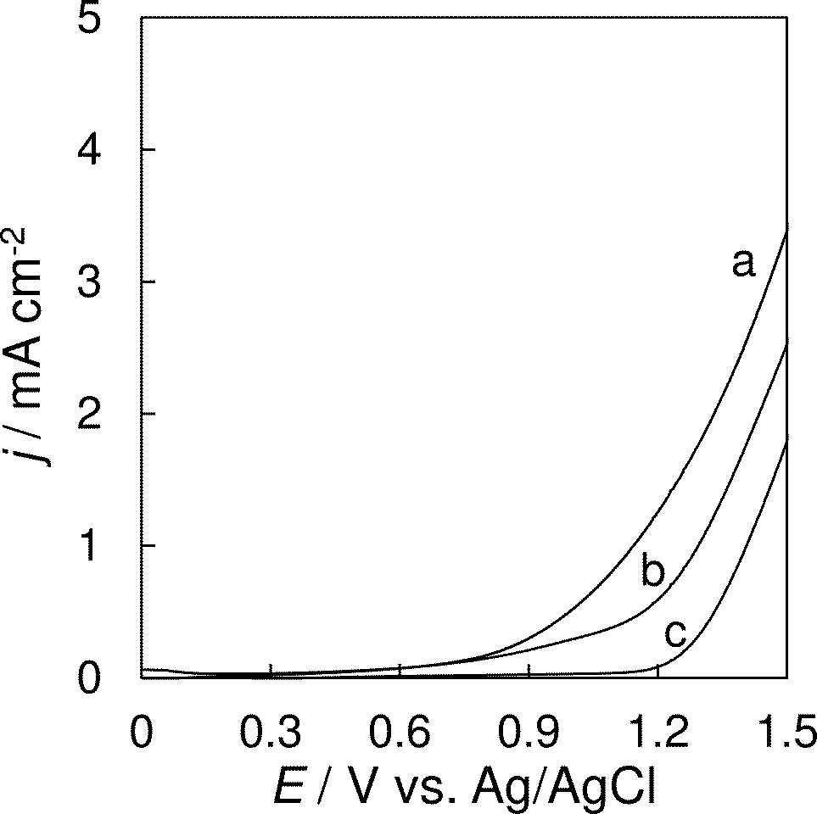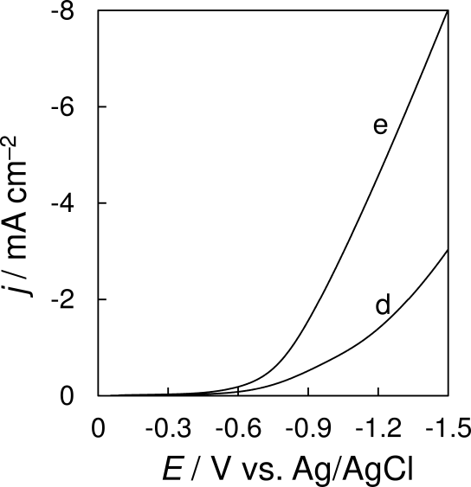

Fig. 3. LSV at SPGCPE in 0.1 mol dm–3 NaOH (pH 12.5; *a*), ammonia buffer (pH 9.2; *b*), HCl (pH 1.1; *c*) acetate buffer (pH 4.5; *d*) and HNO3 (pH 1.05; *e*); scan rate 50 mV s‑1.

Fundamentally, the value of *E*c,lim decreases with increasing pH values of supporting electrolytes. For example, values of *E*c,lim about –0.4 V for HNO3 solution (pH 1.05) and  
–1.4 V for NaOH solution (pH 12.5) were observed. Otherwise, the values of *E*a,lim are typically higher for acidic solutions (+1.3 V; HCl) than for the alkaline ones (+0.6; NaOH). The SPCPE provides similar results (not shown) which are typical for carbon-based working electrodes.25

Voltammetric behaviour of a conventional CPEs and their screen‑printed analogues described here was examined with [Fe(CN)6]3‑/ [Fe(CN)6]2‑ and quinone/hydroquinone redox systems. Corresponding SPEs were always compared with their conventional analogues in which identical carbon powders were used. Because the above sensors differed in surface sizes, current responses obtained during voltammetric measurements are presented as current density (*j*).

As shown in Fig. 4, the comparison of SCPEs with corresponding conventional paste electrodes is documented by representative cyclic voltammograms (CVs) of K4[Fe(CN)6] obtained at these sensors based on graphite powder (*a*) and glassy carbon (*b*).

Resulting shapes of presented cyclic voltammograms obtained at SPEs (thin lines) are very similar to them recorded with their analogues of the conventional CPE and GCPE types (thick lines). Any content of PO in the carbon ink causes the peak broadening (dashed lines).

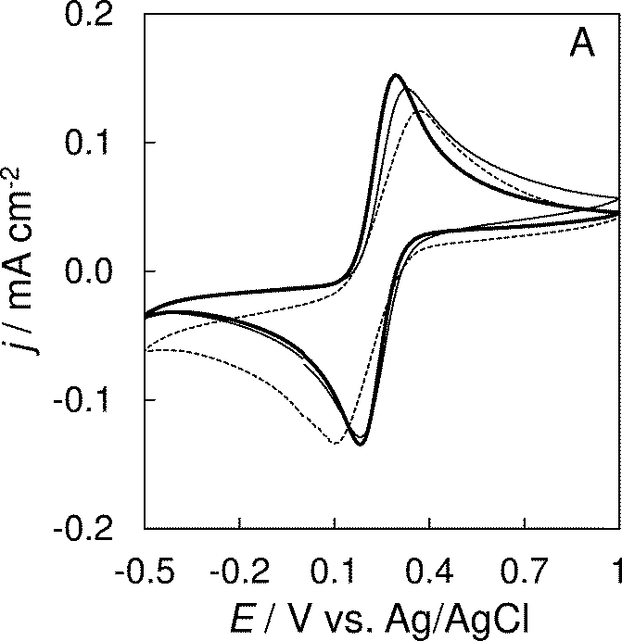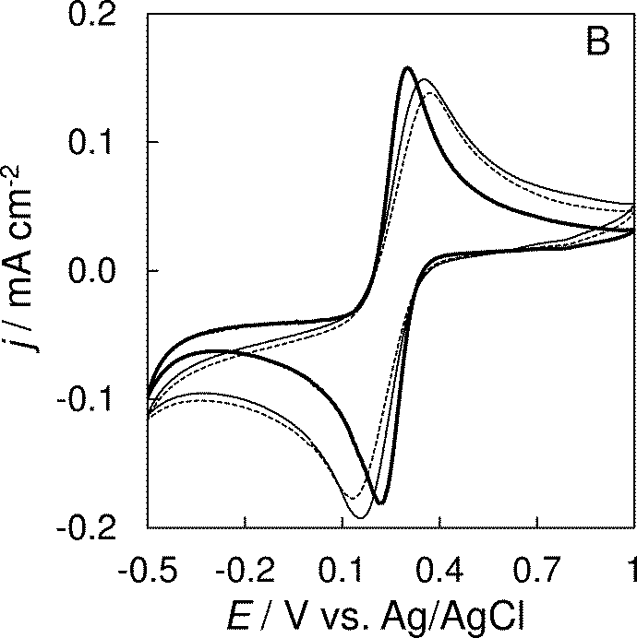

Fig. 4. CVs of 1×10−3 mol dm–3 K4[Fe(CN)6] at conventional GCPE (thick), SPGCE (thin) and SPGCPE (dashed line) A, and conventional CPE (thick), SPCE (thin) and SPCPE (dashed line) B. Measured in 0.1 mol dm–3 KCl and 0.01 mol dm–3 HCl at scan rate 50 mV s‑1.

To compare electrochemical behavior of the developed screen‑printed CPEs with their conventional analogues, measurements in [Fe(CN)6]3‑/[Fe(CN)6]4‑ were preferred.27 It is evident that conventional paste-based sensors (both CPE and GCPE) provide better analytical data than their screen‑printed analogues. In Table I, the values of peak separation potential (Δ*E*p) are presented. These values of all working electrodes were higher than 59 mV expected for Nernstian one electron transfer. It should be stated that the results obtained are typical for heterogeneous electrode materials. It is caused by slower kinetics of partial electrode reactions due to presence of hydrophobic PO. Fortunately, the ratio of cathodic/anodic peak current responses |*I*red/ *I*ox| was always close to 1.

Table I. Comparison of various carbon electrodes at [Fe(CN)6]4‑/ Fe(CN)6]3‑ redox couple

|  |  |  |  |
| --- | --- | --- | --- |
| Electrodes | Compositions | Δ*E*p / mV | |*I*red/ *I*ox| |
| CPE | CR‑2; 10% PO | 110 | 1.06 |
| SPCE | CR‑2; 3% PVC | 190 | 1.24 |
| SPCPE | CR‑2; 10% PO; 3% PVC | 240 | 1.28 |
| GCE | solid glassy carbon | 140 | 1.15 |
| GCPE | GC; 10% PO | 130 | 0.90 |
| SPGCE | GC; 3% PVC | 160 | 0.92 |
| SPGCPE | GC; 10% PO; 3% PVC | 280 | 1.08 |

A scan rate study of each prepared SPCE was done for closer characterisation. Scan rate varied from 20 mV s‑1 to 300 V s‑1 and cyclic voltammograms were recorded and compared mutually (SPCE with SPCPE and SPGCE with SPGPCE). Corresponding cyclic voltammograms obtained at SPCEs based on glassy carbon powder are shown in Fig. 5. A linear relationship between the peak current density (both anodic and cathodic) and the square root of the scan rate demonstrated that the process is controlled by diffusion. Parameters of individual equations of the linear regressions (*k*; slope and *q*, intercept) with corresponding correlation coefficients (*R*2) are presented in Table II.

As evident form the data obtained experimentally, polarisation of all prepared screen‑printed electrodes is slower than for conventional paste ones. A little bit higher sensitivity towards K4[Fe(CN)6] was observed in case of electrodes prepared from the spectroscopic graphite powder than in case of glassy carbon‑based electrodes.

It is important to note that no dramatically different values of calculated slops were found. Moreover, values of intercept were very low. These facts indicate good electrochemical properties of developed electrodes which are comparable with conventional CPEs. In measurements with all electrodes, observed values of background current responses were not usually higher than 1.0 µA. Generally, developed SPCEs fortified by 10% PO (w/w) provided worse analytical data than their conventional analogues. Anyway, they are still beneficial in case of their application for measurements in flow systems where they can replace GrEs.17



Fig. 5. Cyclic voltammograms for 1×10−3 mol dm–3 K4[Fe(CN)6] in 0.1 mol dm–3 KCl and 0.01 mol dm–3 HCl, at conventional GCPE (A),SPGCE (B) and SPGCPE (C). Scan rates 20, 40, 60, 80, 100, 150, 200, 250 and 300 mV s–1.

Table II. Parameters of equations obtained at various carbon electrodes under scan rate study

|  |  |  |  |  |  |  |  |
| --- | --- | --- | --- | --- | --- | --- | --- |
|  | *j* (anodic) | | |  | *j* (cathodic) | | |
| Sensor | *k*  mA cm‑2 (mV s-1)-1/2 | *q*  mA cm‑2 | *R*2 |  | *k*  mA cm‑2 (mV s-1)-1/2 | *q*  mA cm‑2 | *R*2 |
| CPE | 0.477 | 0.020 | 0.9999 |  | –0.434 | –0.015 | 0.9988 |
| SPCE | 0.404 | –0.013 | 0.9996 |  | –0.410 | 0.021 | 0.9994 |
| SPCPE | 0.372 | –0.022 | 0.9970 |  | –0.348 | –0.021 | 0.9997 |
| GCPE | 0.376 | 0.016 | 0.9980 |  | –0.345 | –0.012 | 0.9989 |
| SPGCE | 0.338 | 0.012 | 0.9999 |  | –0.346 | –0.002 | 0.9999 |
| SPGCPE | 0.325 | 0.003 | 0.9990 |  | –0.357 | –0.020 | 0.9990 |

Using repetitive cyclic voltammetry of the K4[Fe(CN)6], the satisfactory repeatability of peak current responses at all kinds of prepared SPCEs was observed for five repetitions which was comparable with corresponding conventional CPEs. The highest value of standard relative deviation (RSD) was calculated for SPCPE (about 0.8 %).

It was also necessary to check if it is possible to prepare for example five identical screen‑printed carbon electrodes containing 3% PVC and 10% PO (optimum composition). From a total amount of seven pieces prepared, two SPCPEs failed. Towards 1.0 mmol dm–3 K4[Fe(CN)6] measured in 0.1 mol dm–3 KCl and 0.01 mol dm–3 HCl, the remaining five electrodes provides nearly constant anodic current response of average value about 22.26 ± 0.75 µA (± 3.4%).

In addition, behaviour of developed SPEs was compared with their commercial variants as well (see Fig. 6 and 7). This comparison was carried out using cyclic voltammetry of quinone/hydroquinone redox couple. Solid glassy carbon electrode (GCE) from Metrohm and also conventional GCPE were chosen for comparison with SPGCE (Sigradur‑G powder with 3% PVC). Similarly, SPCE based on commercial carbon ink (type C10903P14) from Gwent Group (United Kingdom) and conventional CPE were used for comparison with developed SPCE (CR-2 graphite powder with 3% PVC content).





Fig. 6. Repetitive cyclic voltammetry of   
5×10‑4 mol dm‑3 hydroquinone at SPGCE (solid line; A). Its comparison with conventional GCPE (dashed line; B) and commercial solid GCE (dotted line; C). All shown measurements were performed in 0.1 mol dm‑3 KCl and 0.01 mol dm‑3 HCl at 50 mV s‑1.

Very satisfactory repeatability of peak current responses was obtained at both kinds of PVC electrodes (see voltammograms A in Fig. 6 and 7) using repetitive cyclic voltammetry (*n* = 5). Unfortunately, SPCEs based on PVC provided worse electrochemical properties than conventional paste electrodes in most cases. This fact is documented by voltammograms B in Fig. 6 and 7 (for example, values of Δ*E*p were usually observed higher than 200 mV at PVC electrodes). In comparison with commercial carbon electrodes, they provided higher peak current responses (voltammograms C in Fig. 6 and 7) due to larger electrode surfaces. This increase is probably caused by paste character of these PVC electrodes.



Fig. 7. Repetitive cyclic voltammetry of 5×10−4 mol dm–3 hydroquinone at SPCE (solid line; A). Its comparison with conventional CPE (dashed line; B) and commercial SPE (dotted line; C). All shown measurements were performed in 0.1 mol dm‑3 KCl and 0.01 mol dm–3 HCl at 50 mV s‑1.

CONCLUSION

The electrochemical experiments carried out in the present study showed that the both types of screen‑printed electrodes containing only corresponding carbon powder and PVC can successfully be applied in voltammetric measurements because they provide nearly identical electrochemical properties as their conventional analogues.

Their surfaces cannot be simply restored like in case of conventional carbon paste electrodes but they could undoubtedly replace the carbon paste “groove electrodes” mentioned in the introduction. It is also important to mention that screen‑printed CPEs or GCPEs can be used for accumulation of many important chemical substances, such as surfactants, lipophilic vitamins, some alkaloids, steroid hormones, etc., thanks of the presence of lipophilic pasting liquids. It is also evident that the screen‑printed electrode composited from glassy carbon powder and PVC only can doubtlessly replace the commercial solid GCE because the SPGCE is very mechanically and chemically stable and their ohmic resistance is low.

It can be assumed, that SPCEs fortified by some content of PO up to 10% (w/w) can be used as largely as conventional CPEs due to similar electrochemical properties. Similar memory effects known at conventional CPE and GCPE were observed also at SPEs containing only 3% PVC and CR‑2 or Sigradur powders. However, SPCEs with low content of PO provided a little bit higher memory effect, fortunately not higher than 1.5% hydroquinone oxidation peak current response.

Preparation of carbon inks at laboratory conditions brings many benefits, from which the known composition of mixtures is the largest one. This is a way how to develop more sophisticated sensors of the screen-printed type for various classes of compounds. This will be target of the further research.

И З В О Д

НАСЛОВ РАДА

ПРВИ А. АУТОР, ДРУГИ Б. АУТОР1 и ТРЕЋИ В. АУТОР2

*Афилијација првог аутора*

*1Афилијација другог аутора*

*2Афилијација трећег аутора*

(Домаћи аутори морају доставити Извод (укључујући имена аутора и афилијацију) на српском језику, исписане ћирилицом, иза Захвалнице, а пре списка референци.) For authors outside Serbia, the Editorial Board will provide a Serbian translation of their English abstract.

REFERENCES

1. I. Švancara, K. Kalcher, A, Walcarius, K. Vytřas, *Electroanalysis with Carbon Paste Electrodes.* CRC Press, Taylor & Francis Group, Boca Raton, 2012
2. K. Vytřas, I. Švancara, R. Metelka, *J. Serb. Chem. Soc.* **74** (2009) 1021
3. I. Švancara, K. Vytřas, J. Barek, J. Zima, *Crit. Rev. Anal. Chem.* **31** (2001) 311
4. J. Lindquist, *J. Electroanal. Chem.* **18** (1968) 204
5. I. Švancara, K. Vytřas, K. Kalcher, A. Walcarius, J. Wang, *Electroanalysis* **21** (2009)7
6. C. A. H. Chambers, J. K. Lee, *J. Electroanal. Chem. Interfacial. Electrochem.* **14** (1967)309
7. J. Wang, B. A. Freiha, *Anal. Chem.* **56** (1984) 849
8. I. Noviandri, R. Rakhmana, *Int. J. Electrochem. Sci.* **7** (2012) 4479
9. T. Ch. Huang, L. Ch. Yeh, H. Y. Huang, Z. Y. Nian, Y. Ch. Yeh, Y. Ch. Chou, J. M. Yeh, M. H. Tsaic, *Polym. Chem.* **5** (2014)630
10. I. Švancara, P. Foret, K. Vytřas, *Talanta* **64** (2004) 844
11. L. G. Shaidarova, S. A. Ziganshina, G. K. Budnikov, *J. Anal. Chem.* **58** (2003)577
12. J. Labuda, A. Meister, P. Gläser, G. Werner, *Fresenius J. Anal. Chem.* **360** (1998)654
13. M. Portaccio, D. D. Tuoro, F. Arduini, M. Lepore, D. G. Mita, N. Diano, L. Mita, D. Moscone, *Biosens. Bioelectron.* **25** (2010) 2003
14. L. Gorton, [*Electroanal.*](http://www.researchgate.net/journal/1521-4109_Electroanalysis) **7** (1995) 23
15. J. K. Yang, K. S. Ha, H. S. Baek, S. S. Lee, M. L. Seo, *Bull. Korean Chem. Soc.* **25** (2004)1499
16. P. Fanjul‑Bolado, David Hernández‑Santos, P. J. Lamas‑Ardisana, A. Martín‑Pernía,   
    A. Costa‑García, *Electrochim. Acta* **53**(2008) 3635
17. I. Švancara, P. Kotzian, M. Bartoš, K. Vytřas, *Electrochem. Commun.* **7** **(2005)** 657
18. E. Khaled, H. N. A. Hassan, I. H. I. Habib, R. Metelka, *Int. J. Electrochem. Sci.* **5** (2010)158
19. E. Khaled, G. G. Mohamed, T. Awad, *Sens. Actuator B‑Chem.* **135** (2008) 74
20. T. Mikysek, I. Švancara, K. Kalcher, M. Bartoš, K. Vytřas, J. Ludvík, *Anal. Chem.* **81** (2009)6327
21. I. Švancara, M. Hvízdalová, K. Vytřas, K. Kalcher, R. Novotný, *Electroanal.* **8** (1996)61
22. J. Wang, Ü. A. Kirgöz, J. W. Mo, J. Lu, A. N. Kawde, A. Muck, *Electrochem. Commun.* **3** (2001) 203
23. E. Khaled, H. N. A. Hassan, A. Girgis, R. Metelka, *Talanta* **77** (2008) 737
24. K. Vytřas, V. Dvořáková, I. Zeman, *Analyst* **114** (1989)1435
25. H. A. Yasser, M. H. Al‑Maamori, A. I. Al‑Mosawi, *Res. J. Recent. Sci.* **3** (2014)209
26. I. Švancara, M. Fairouz, Kh. Ismail, R. Metelka, K. Vytřas, *Sci. Pap. Univ. Pardubice, Ser. A*   
    **9** (2003) 31
27. J. P. Metters, R. O. Kadara, C. E. Banks, *Analyst* **136** (2011) 1067

1. *Corresponding author. E‑mail: karel.vytras@upce.cz