Dear Dr. Nikolić and Dr. Opsenica,

The authors thank the reviewers for their stimulating comments which, we believe will further contribute to the quality of this manuscript.

Please find below point-by-point responses to both Editorial and Reviewer comments.

We believe that addressing the Editorial and Reviewer comments has improved the quality of the manuscript, and hope that the revision will be suitable for acceptance in the Journal of the Serbian Chemical Society.

We thank you for your consideration and for the opportunity to submit a revision of the manuscript.

Kind Regards,
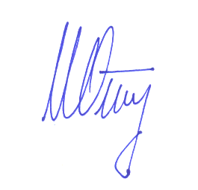
Igor Opsenica
Corresponding author

RESPONSES TO REVIEWER COMMENTS

Reviewer 1
Comments:
1. "Stereochemical descriptor E should be italic for compounds 19-27 (also in Supplementary)."
Author Response: We thank reviewer for his/her remark. The suggested change has been included, in the corrected manuscript.

2. "Give 13C NMR chemical shifts to two digits after the decimal point for compound 10."
Author Response: Done.

Reviewer 2
Comments:
1. "RESULTS AND DISCUSSION
Line 105: While the names of other microorganisms e.g. Staphylococcus aureus ATCC 25923 and Micrococcus luteus ATCC 379, contain evidential number from the appropriate strain collection, Pseudomonas aeruginosa PAO1 is listed without it. This should be corrected."
Author Response: We thank reviewer for his/her remark. The suggested change has been included, in the corrected manuscript.

2. "EXPERIMENTAL
Line 275: cfu mL-1 should be corrected to cfu/mL according to other standard unit abbreviations (e.g. line 270: 500 μg/mL)."
Author Response: Done.

