Journal of the Serbian Chemical Society
Professor Branislav Ž. Nikolić
Serbian Chemical Society – JSCS
4 Karnegijeva Street, 11120 Belgrade, SERBIA

Belgrade, 13 February 2017

Dear Prof. Nikolić,
Enclosed please find our manuscript Antibacterial and antifungal properties of guanylhydrazones, intended to be published as an Original scientific paper. The electronically submitted manuscript consists of the abstract, body of the text, Experimental section, schemes, tables, and Supporting material.
Explanation of manuscript’s significance:
A series of novel guanylhydrazones were designed, synthesized and characterized. All the compounds were screened for their antibacterial and antifungal activity. Compounds 26 and 27 showed excellent antibacterial activities against Staphylococcus aureus ATCC 25923 and Micrococcus luteus ATCC 379 with minimal inhibitory concentrations of 4 µg/mL, and good antifungal activity against Candida parapsilosis ATCC 22019. These results suggested that selected guanylhydrazones could serve as promising leads for the improved antimicrobial development.

The manuscript submitted to the Journal of the Serbian Chemical Society for review is original, has been written by the stated authors and has not been published elsewhere; is currently not being considered for publication by any other journal and will not be submitted for such a review while under review by the Journal of the Serbian Chemical Society; the manuscript contains no libelous or other unlawful statements and does not contain any materials that violate any personal or proprietary rights of any other person or entity.

Reviewers:
- Dr. Marina Pekmezovic, Microbial Pathogenicity Mechanisms, OPATHY, marina.pekmezovic@leibniz-hki.de
- Dr. Milos Petkovic, Assistant professor, petkovicmilos1@yahoo.com; milosp@pharmacy.bg.ac.rs
- Dr. Bogdan Šolaja, Faculty of Chemistry, bsolaja@chem.bg.ac.rs

I hope that this manuscript will be acceptable to the Journal of the Serbian Chemical Society, and we thank you for your consideration.

Sincerely yours,
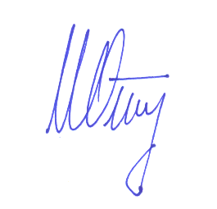
Igor Opsenica
Corresponding author

