Adsorption kinetics

Adsorption of heavy metal ions (Cd²⁺, Zn²⁺ and Pb²⁺) onto hemp-fibers based biocarbon is presented in Figure S1, as a dependence of adsorption capacity (q, mg g⁻¹) and time of adsorption (t, min). It can be observed that adsorption capacity, for all tested biocarbons, increases with the adsorption time, until it reaches equilibrium value after 120 minutes.

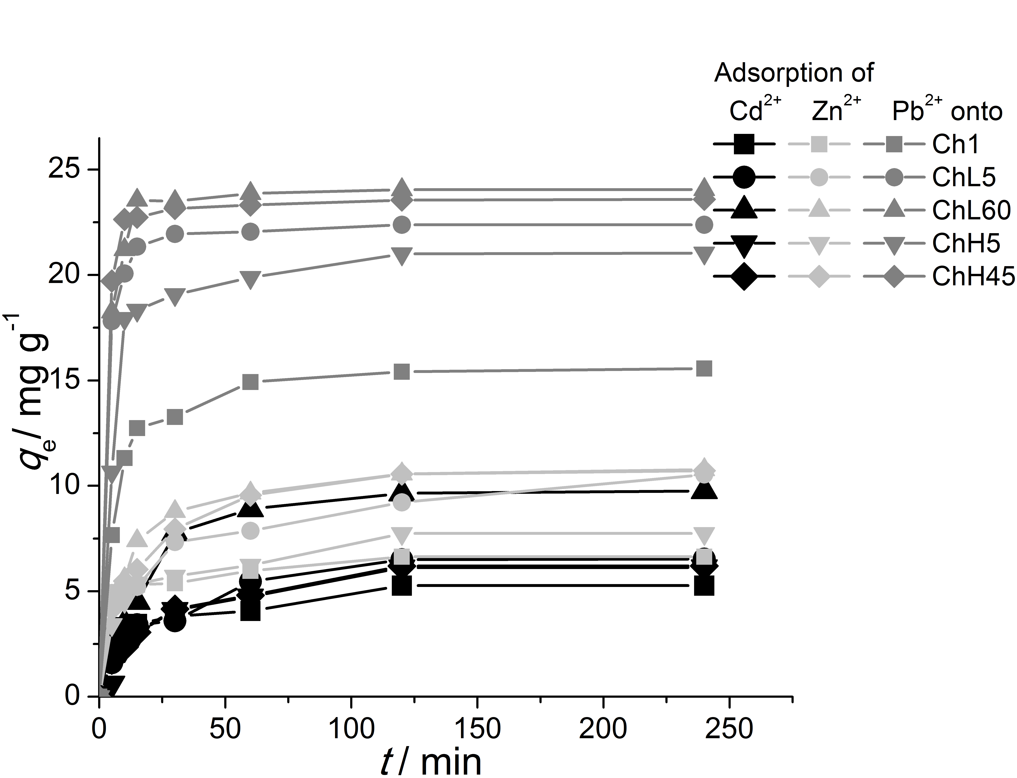

Figure S1. Adsorption of heavy metal ions (Cd²⁺, Zn²⁺ and Pb²⁺) onto hemp-fibers based biocarbon samples (initial ion concentration c₀=50mg dm⁻³)

