Synthesis of substituted allyl acetates from heterocyclic dienes
by Pd-promoted arylation-acetoxylation cascade

- Supplementary material -

MILENA R. SIMIĆ, MILOŠ R. PETKOVIĆ, PREDRAG M. JOVANOVIĆ,
GORDANA D. TASIĆ and VLADIMIR M. SAVIĆ

University of Belgrade, Faculty of Pharmacy, Department of Organic Chemistry,
Vojvode Stepe 450, 11221 Belgrade, Serbia

Table of contents

Copies of NMR spectra.........................................................................................2

[2-(4-Methoxy-benzyl)-1,6,7,11b-tetrahydro-4H-pyrido[2,1-a]isoquinolin-3-yl]-methyl acetate (5)
¹H NMR
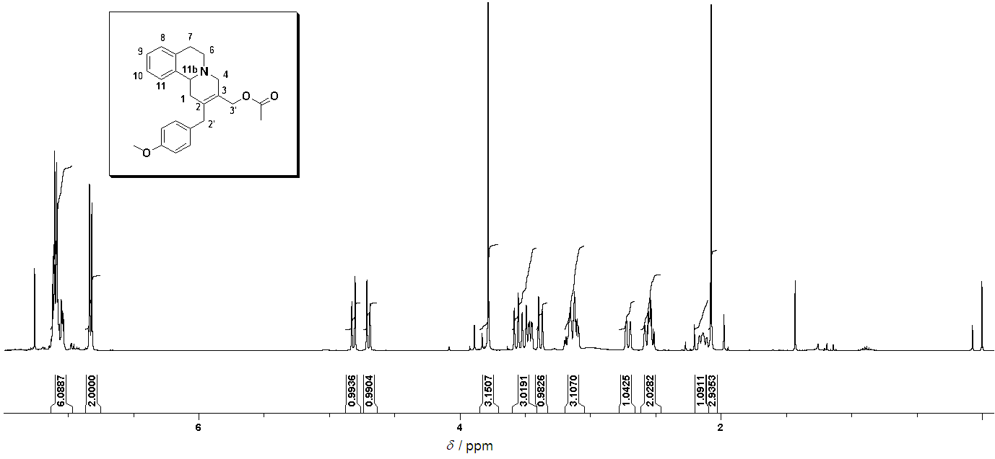
¹³C NMR
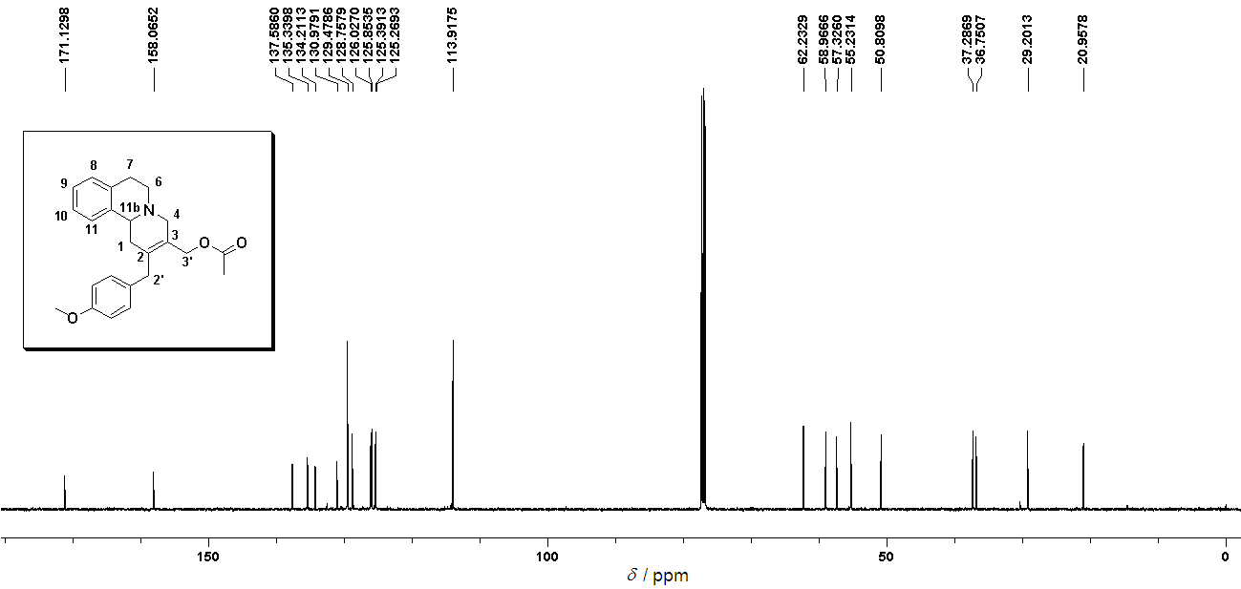
NOESY
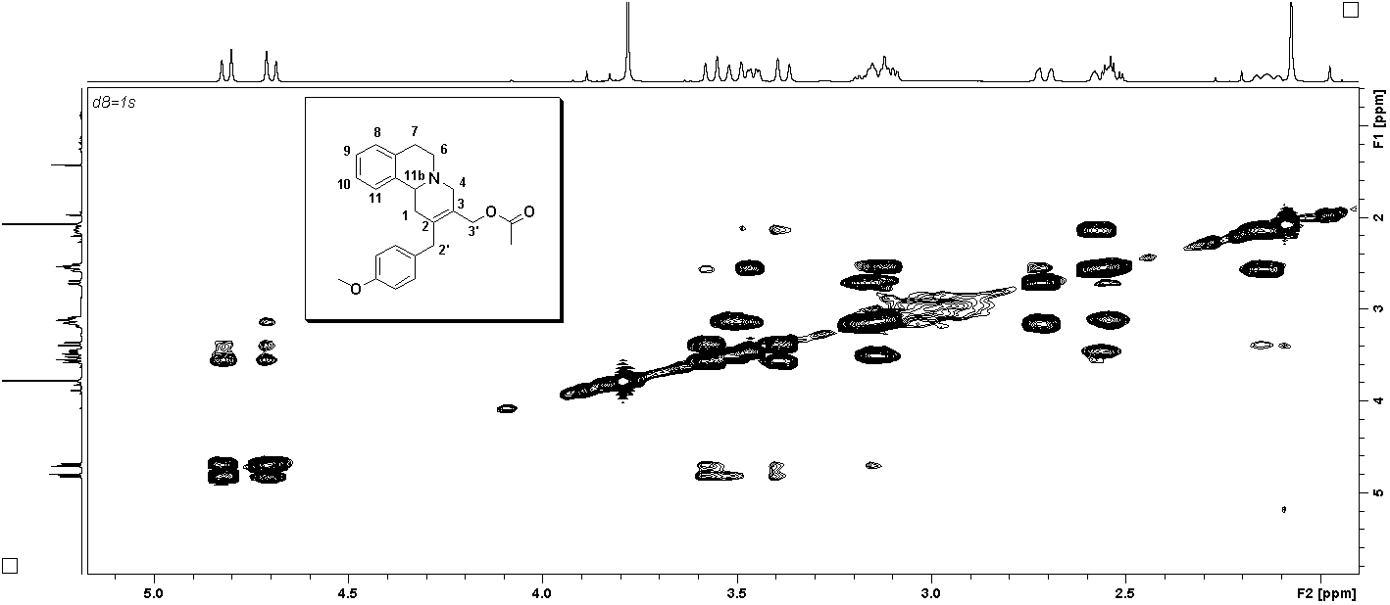
HMBC
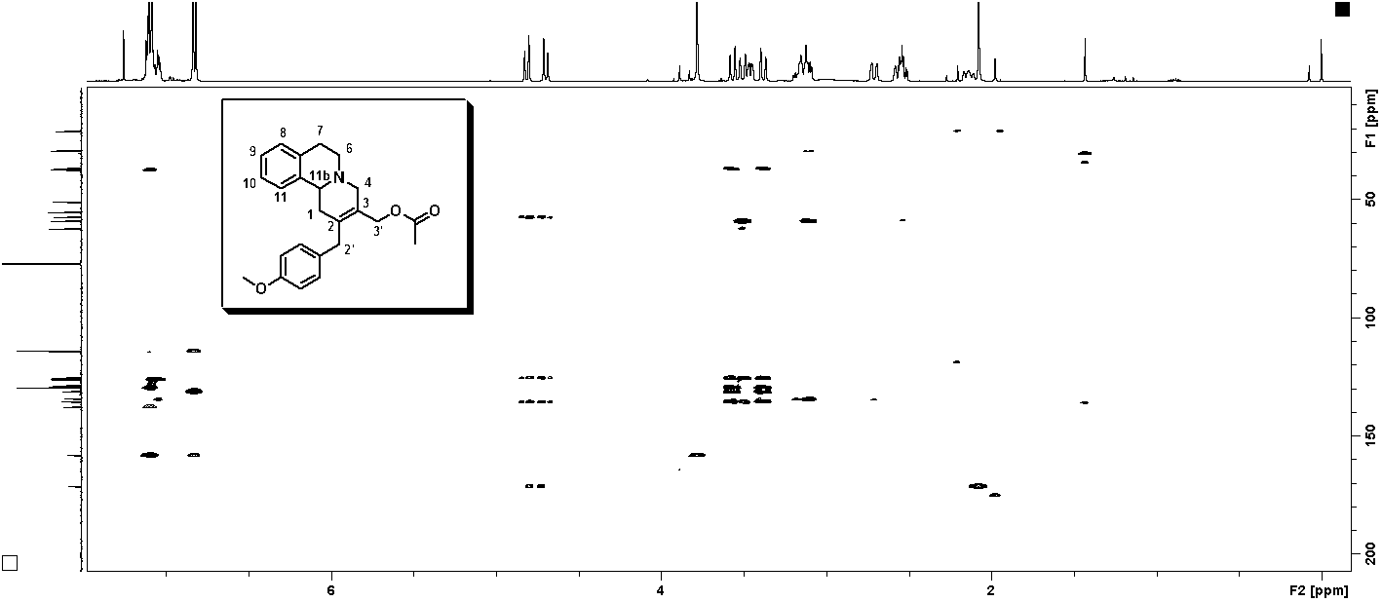

[2-(3,4-Dimethyl-benzyl)-1,6,7,11b-tetrahydro-4H-pyrido[2,1-a]isoquinolin-3-yl]-methyl acetate (7a)
¹H NMR
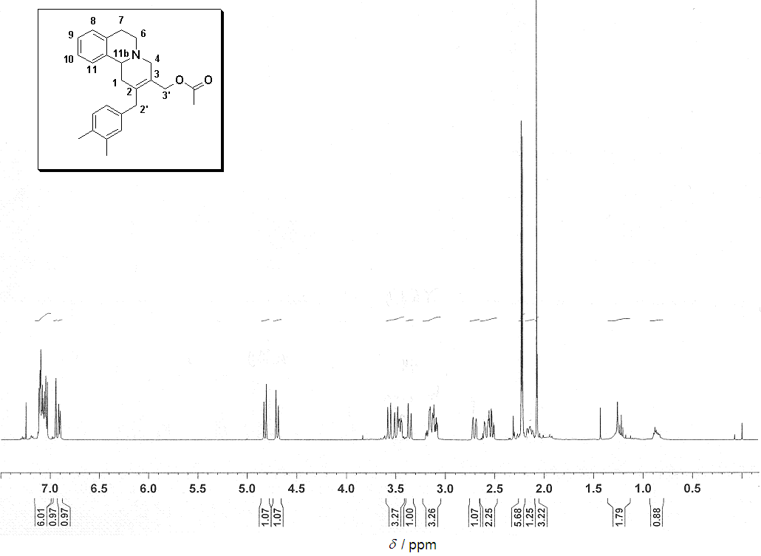

¹³C NMR

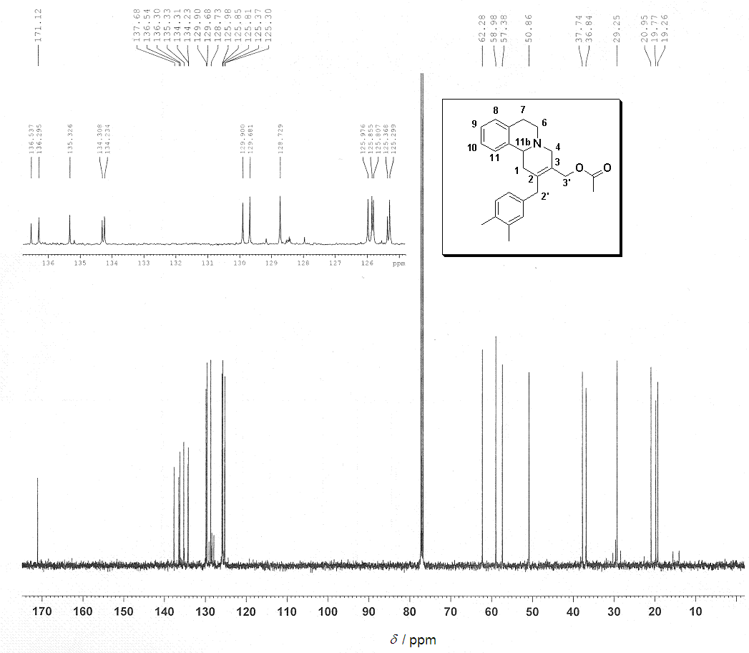
NOESY
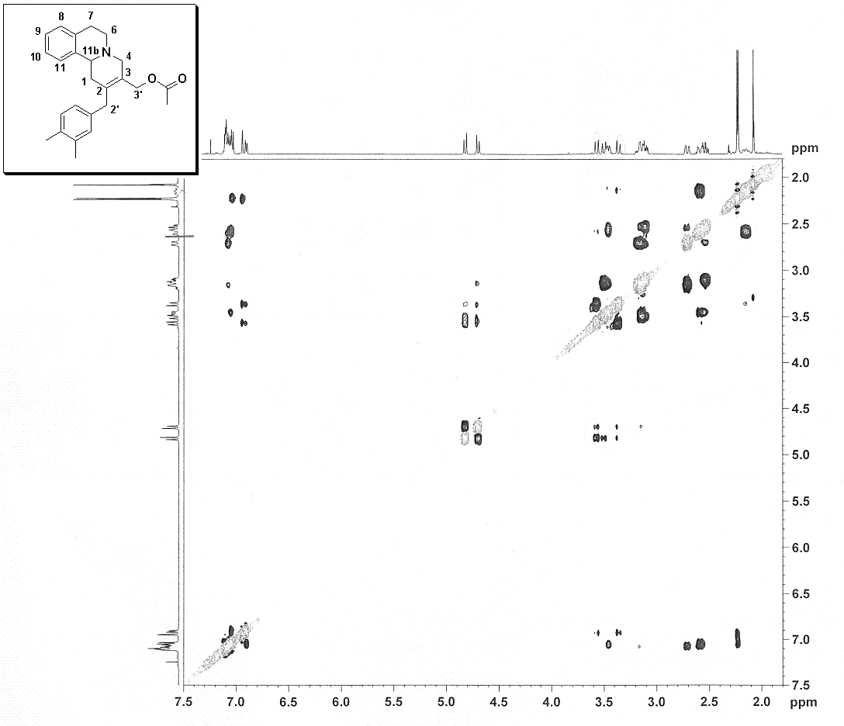

[2-(4-Methyl-benzyl)-1,6,7,11b-tetrahydro-4H-pyrido[2,1-a]isoquinolin-3-yl]-methyl acetate (7b)
¹H NMR
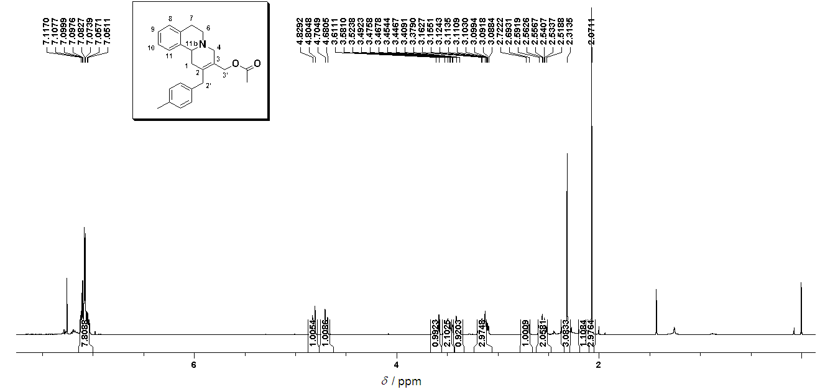

¹³C NMR
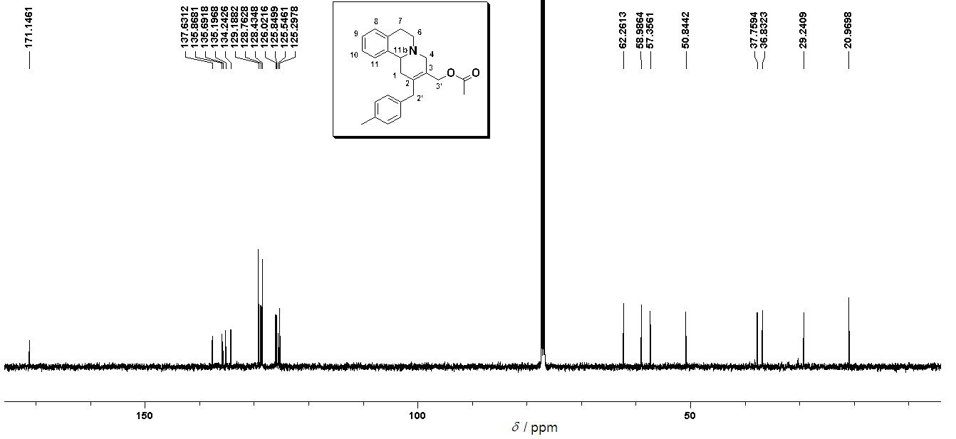
NOESY
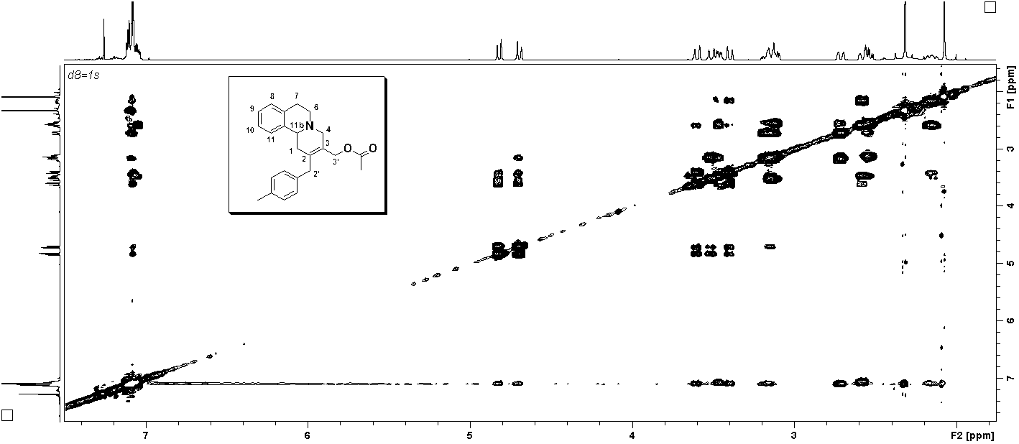

(2-Naphthalen-1-ylmethyl-1,6,7,11b-tetrahydro-4H-pyrido[2,1-a]isoquinolin-3-yl)-methyl acetate (7c)

¹H NMR
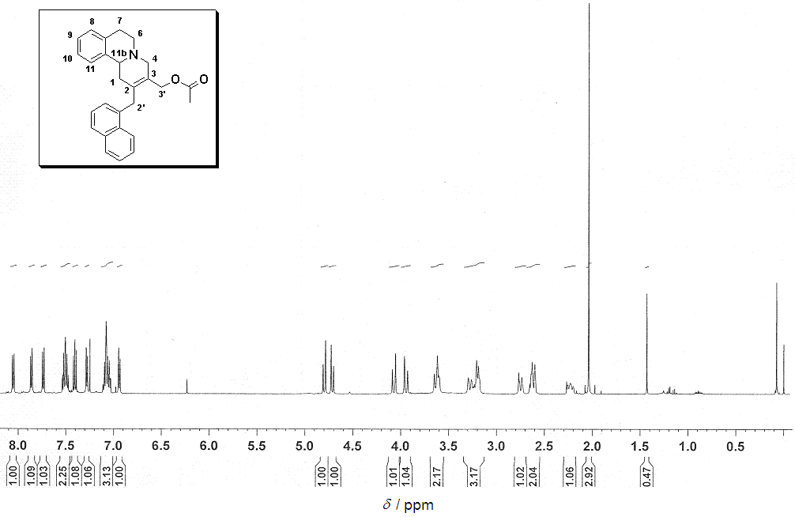
¹³ C NMR
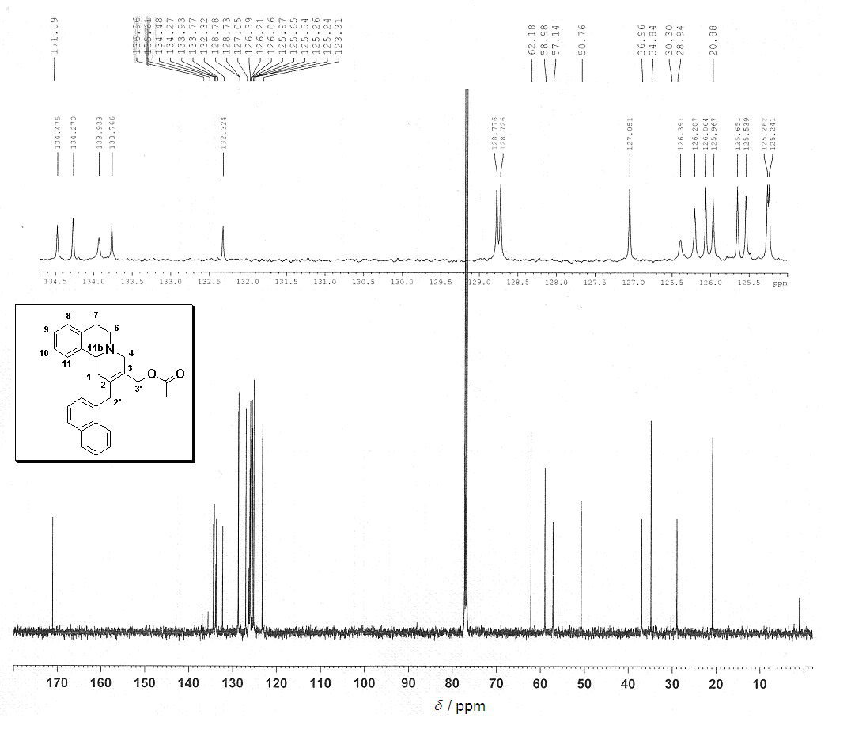

NOESY
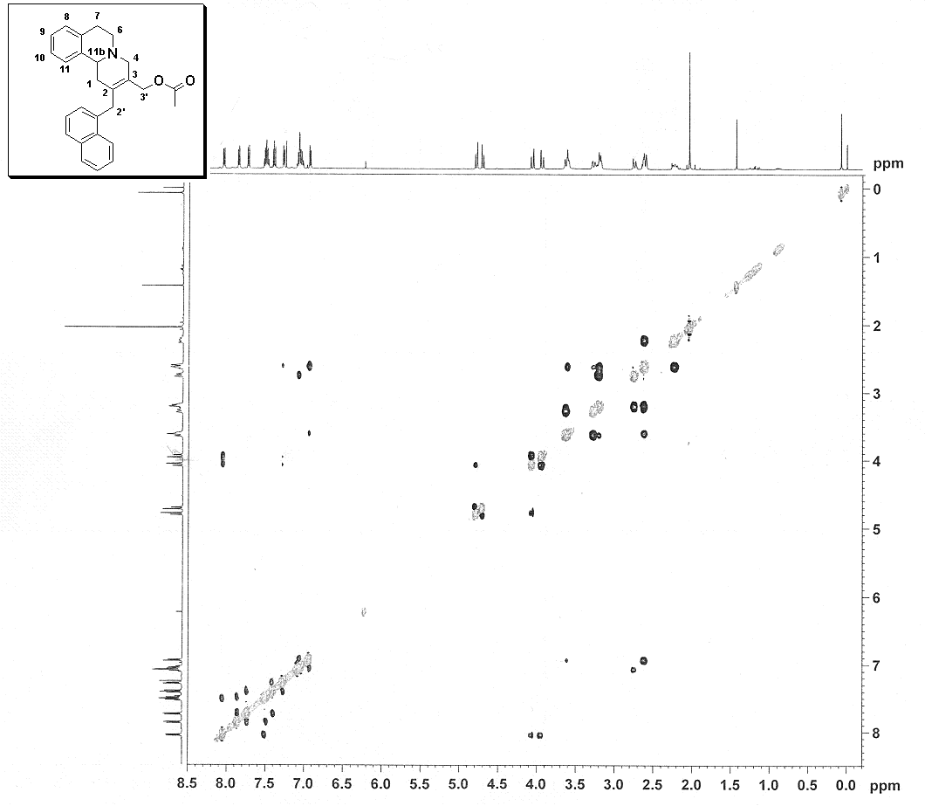

[2-(4-Methyl-benzyl)-1,4,6,7,12,12b-hexahydro-indolo[2,3-a]quinolizin-3-yl]-methyl acetate (9)
¹H NMR
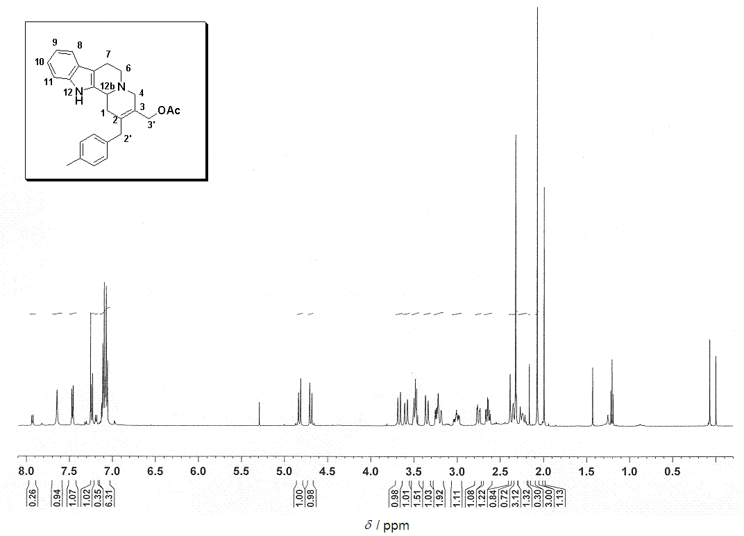
¹³C NMR
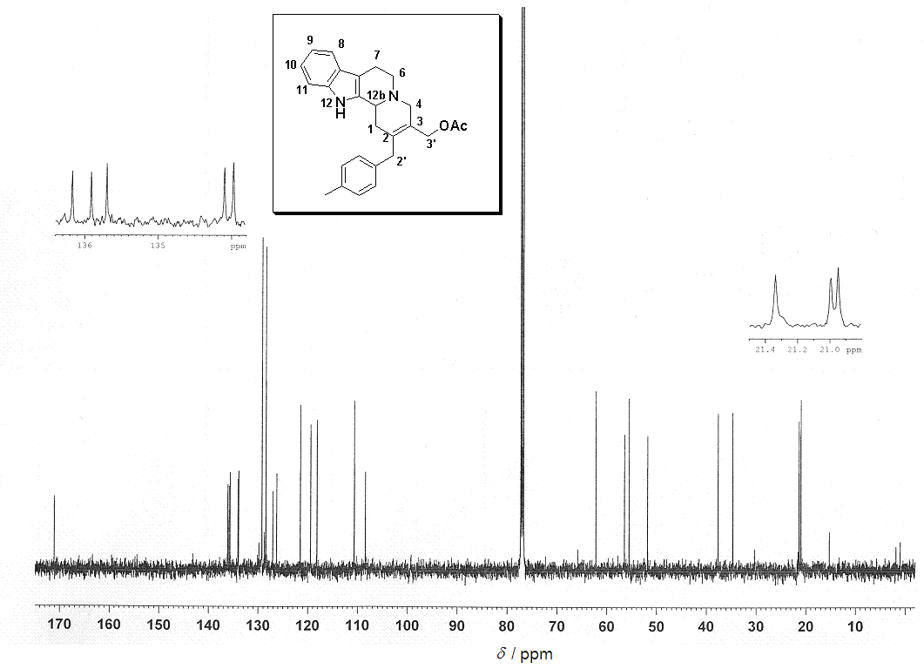

NOESY

