SUPPLEMENTARY MATERIAL

Synthesis, structures and electronic properties of Co(III) complexes with
2-quinolinecarboxaldehyde thio- and selenosemicarbazone: a combined experimental and theoretical study
IVANA S. DJORDJEVIĆ¹**, JELENA VUKAŠINOVIĆ², TAMARA R. TODOROVIĆ^{3#}, NENAD R. FILIPOVIĆ^{4#}, MARKO V. RODIĆ⁵, ALEKANDAR LOLIĆ³, GUSTAVO PORTALONE⁶, MARIO ZLATOVIĆ^{3#} and SONJA GRUBIŠIĆ¹*
¹ Institute of Chemistry, Technology and Metallurgy, University of Belgrade,
Njegoševa 12, 11001 Belgrade, Serbia
²Institute for multidisciplinary research, University of Belgrade, Volgina 15, 11060 Belgrade, Serbia
³Faculty of Chemistry, University of Belgrade, Studentski trg 12–16, 11001 Belgrade, Serbia
⁴Faculty of Agriculture, University of Belgrade, Nemanjina 6, Belgrade, Serbia
⁵ Department of Chemistry, Faculty of Sciences, University of Novi Sad, Trg Dositeja Obradovića 4, Novi Sad, Serbia
⁶ Department of Chemistry, Sapienza University of Rome, P.le Aldo Moro 5, 00185
Rome, Italy

TABLE S-I. Crystal data and structure refinement for complexes 1 and 2.
Complex | 1 | 2
Empirical formula | C₂₂H₁₈CoN₈S₂⁺×ClO₄⁻×OH₂ | C₂₂H₁₈CoN₈Se₂⁺×ClO₄⁻×OH₂
Formula weight | 634.96 | 726.74
Temperature, K | 293(2) | 293(2)
Wavelength , Å | 0.71073 | 0.71073
Crystal system | Triclinic | Triclinic
Space group | P –1 | P –1
Unit cell dimensions
a / Å | 9.4673(4) | 9.5870(5)
b / Å | 10.9731(3) | 11.2021(6)
c / Å | 13.9826(4) | 13.9356(6)
α / ° | 70.668(3) | 71.128(4)
β / ° | 87.653(3) | 87.977(4)
γ / ° | 72.439(3) | 72.076(5)
Volume, Å³ | 1304.01(8) | 1343.99(13)
Z | 2 | 2
Density (calculated), Mg m^{–3} | 1.617 | 1.801
Absorption coefficient, mm^{–1} | 0.97 | 3.50
F(000) | 648 | 720
Theta range for data collection, ° | 2.6 to 29.1 | 2.5 to 29.0
Reflections collected | 28698 | 20644
Independent reflections | 6312 [R(int) = 0.0250] | 6379 [R(int) = 0.0243]
Completeness to theta = 26.320° | 99.9 % | 99.9 %
Refinement method | Full-matrix least-squares on F²
Data / restraints / parameters | 6312 / 4 / 364 | 6379 / 4 / 366
Goodness-of-fit on F² | 1.05 | 1.007
Final R indices [I > 2sigma(I)] | R₁ = 0.0359, wR₂ = 0.0916 | R₁ = 0.0370, wR₂ = 0.0976
R indices (all data) | R₁ = 0.0430, wR₂ = 0.0963 | R₁ = 0.0475, wR₂ = 0.1037
Largest diff. peak and hole, e Å^{–3} | 0.48 and –0.41 | 0.91 and –0.51

TABLE S–II. Hydrogen bond (Å) and π–π stacking interaction parameters (angle, ° and distance, Å) in the crystal structure of complexes 1 and 2.
H–bond parameters
D‒H···A | D‒H / Å | H···A / Å | D···A / Å | D‒H···A / ° | symmetry operation on A
complex 1
N4A‒H41A···N3A | 0.845(17) | 2.357(18) | 3.166(2) | 161(2) | 1 ‒ x, 1 ‒ y, 1 ‒ z
N4A‒H42A···N3B | 0.857(17) | 2.441(19) | 3.252(3) | 158(2) | 1 ‒ x, ‒ y, 1 ‒ z
N4B‒H41B···O5 | 0.862(17) | 2.28(2) | 3.054(4) | 150(3) | 1 ‒ x, ‒ y, 1 ‒ z
N4B‒H42B···O4 | 0.872(18) | 2.302(19) | 3.158(4) | 167(3) | 2 ‒ x, ‒ y, 1 ‒ z
complex 2
N4A‒H41A···N3A | 0.849(19) | 2.32(2) | 3.122(4) | 157(4) | 1 ‒ x, 1 ‒ y, 1 ‒ z
N4A‒H42A···N3B | 0.860(18) | 2.59(2) | 3.408(4) | 158(4) | 1 ‒ x, ‒ y, 1 ‒ z
N4B‒H41B···O5 | 0.871(19) | 2.23(3) | 3.041(6) | 154(4) | 1 ‒ x, ‒ y, 1 ‒ z
N4B‒H42B···O4 | 0.870(19) | 2.35(2) | 3.212(8) | 169(4) | 2 ‒ x, ‒ y, 1 ‒ z
π–π interaction parameters
Cg(I),Cg(J)ª  Cg–Cg^{b} / Å | α^{c} / ° | β ^{d} / ° | γ ^{e} / ° | slippage ^{f} /Å | symmetry operation on J
complex 1
Cg1, Cg1  4.184(16) | 0.00(13) | 21.9 | 21.9 | 1.560 | 1 ‒ x, 1 ‒ y, ‒ z
Cg2, Cg2  3.7319(17) | 0.02(14) | 17.9 | 17.9 | 1.150 | ‒ x, 1 ‒ y, ‒ z
Cg3, Cg3  3.6062(14) | 0.03(11) | 18.3 | 18.3 | 1.132 | ‒ x, 1 ‒ y, 1 ‒ z
complex 2
Cg1, Cg1  4.506(3) | 0.0(2) | 21.8 | 21.8 | 1.673 | 1 ‒ x, 1 ‒ y, ‒ z
Cg2, Cg2  3.759(3) | 0.0(2) | 20.0 | 20.0 | 1.285 | ‒ x, 1 ‒ y, ‒ z
Cg3, Cg3  3.630(2) | 0.03(17) | 19.9 | 19.9 | 1.233 | ‒ x, 1 ‒ y, 1 ‒ z
ª Planes of the rings I/J: ring (1) = N(1A),C(3A),C(4A),C(5A),C(6A),C(7A); ring (2) = C(6A),C(7A),C(8A),C(9A),C(10A),C(11A); ring (3) = C(6B),C(7B),C(8B),C(9B),C(10B),C(11B); ^{b} Cg–Cg = distance between ring centroids (Å); ^{c} α = dihedral angle between planes I and J (°); ^{d} β = angle between Cg(I),Cg(J) vector and normal to plane I (°); ^{e} γ = angle between Cg(I), Cg(J) vector and normal to plane J (°); ^{f} Slippage = distance between Cg(I) and perpendicular projection of Cg(J) on ring I (Å).

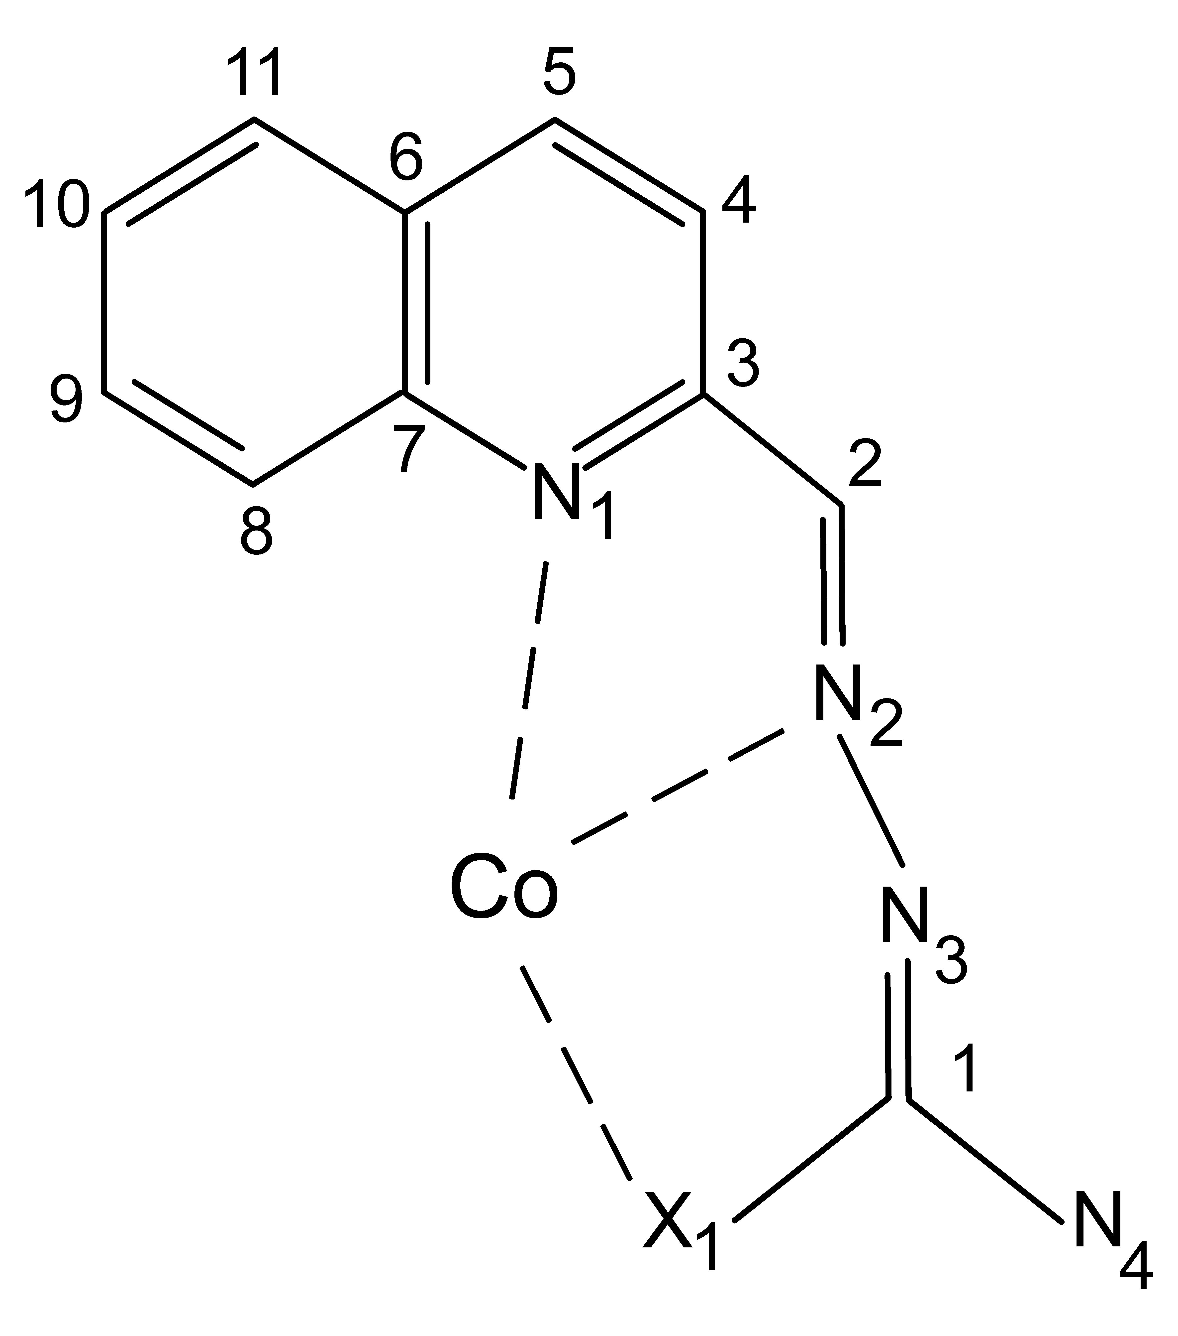
Fig. S-1. Atomic numbering for investigated molecules (X=S for 1 and X=Se for 2).

TABLE S-III. Comparison of average values of the theoretically calculated Co–N and Co-Se bond lengths (Å) obtained for the complex 2, using two DFT/B3LYP with two basis sets and experimental measured values.
Basis sets / Bond | Co–N₂ | Co–N₁ | Co–Se₁
6-311g(d,p)ª | 1.925 | 2.099 | 2.380
cc-pVTZ / 6-311g(d)^{b} | 1.940 | 2.120 | 2.398
Measured^{c} | 1.913 | 2.056 | 2.335
ª B3LYP functional with 6-311g(d,p) on all atoms; ^{b}B3LYP functional with cc–pVTZ on Co and 6-311g(d) on all others atoms; ^{c} Experimental measured bond lengths

TABLE S-IV. Comparison of average values of the experimental and the theoretical calculated Co-N, Co-S and Co-Se bond lengths (Å) obtained for the complexes 1 and 2.
Compound / Bond, Å |  | Co–N₂ |  |  |  | Co–N₁ |  |  |  |  | Co–S₁
1 | 1.901ª |  | 1.914^{b} |  | 2.058ª |  | 2.081^{b} |  |  | 2.224ª |  | 2.267^{b}
 |  | Co–N₂ |  |  |  | Co–N₁ |  |  |  |  | Co–Se₁
2 | 1.913ª |  | 1.925^{b} |  | 2.056ª |  | 2.099^{b} |  |  | 2.335ª |  | 2.380^{b}
ª Crystal structure data obtained by XRD in the present work; ^{b} Optimized geometries parameters obtained by the use of DFT/B3LYP/6-311G(d,p)

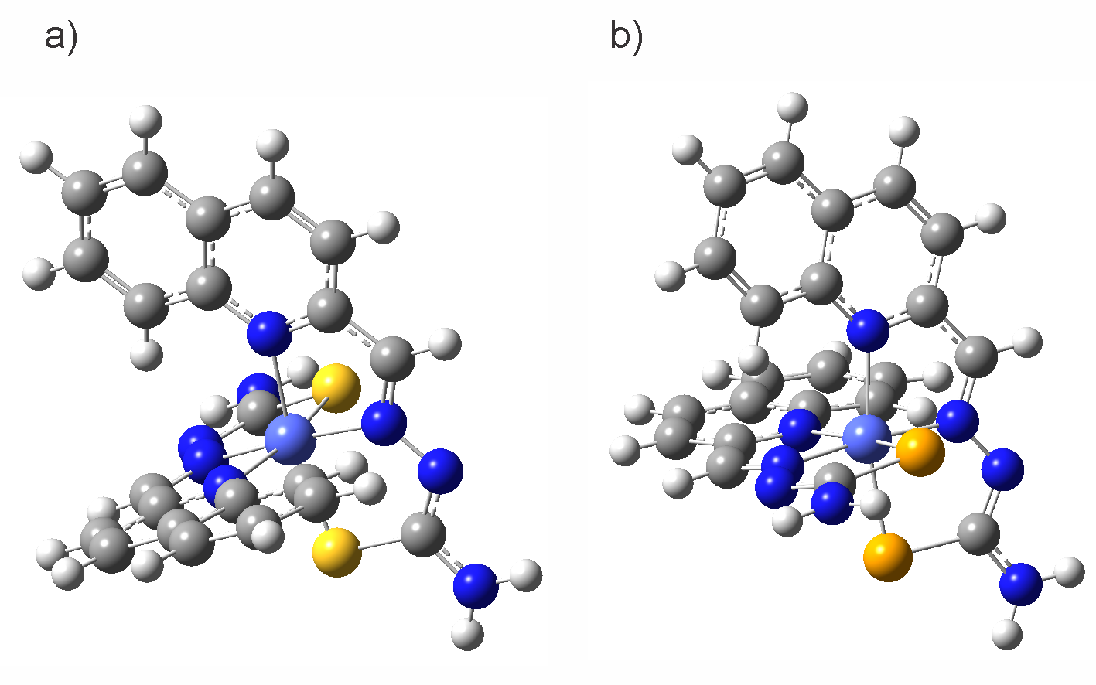
Fig. S-2. The ground state geometries of a) complex 1 and b) complex 2.

TABLE S-V. TD–DFT electronic transitions (absorption maxima, nm), oscillator strengths (f) and major MO contributors in percent of complexes 1 in DMSO.
Complex | No. | λ / nm | f | MO major contributors, %
1 |  |  |  | Transition | % | Transition | % | Transition | %
 | 1 | 715 | 0.0004 | H–1→L+2 | 33 | H–5→L+2 | 25 | H–13→L+2 | 14
 | 2 | 526 | 0.0017 | HOMO→L+2 | 46 | HOMO→L+1 | 28
 | 3 | 507 | 0.0000 | H–1→L+3 | 32 | HOMO→L+1 | 13 | H–1→LUMO | 11
 | 4 | 500 | 0.0318 | HOMO→LUMO | 91 | H–1→L+1 | 3
 | 5 | 493 | 0.0081 | H–12→L+3 | 23 | HOMO→L+3 | 12 | H–11→L+2 | 11
 | 6 | 476 | 0.0008 | HOMO→L+1 | 39 | HOMO→L+2 | 30 | H–1→LUMO | 21
 | 7 | 453 | 0.1186 | H–1→LUMO | 45 | HOMO→L+1 | 16
 | 8 | 444 | 0.1238 | H–1→L+1 | 73 | H–1→L+2 | 12
 | 9 | 439 | 0.0250 | HOMO→L+3 | 52 | H–1→L+1 | 13 | H–1→L+2 | 11
 | 10 | 438 | 0.0416 | H–1→L+3 | 23 | H–1→LUMO | 13 | H–5→L+3 | 11
 | 11 | 411 | 0.0003 | H–1→L+2 | 28 | HOMO→L+3 | 27 | H–12→L+3 | 12
 | 12 | 394 | 0.0153 | H–2→L+2 | 48 | H–2→L+1 | 24 | H–5→LUMO | 6
 | 13 | 390 | 0.0523 | H–2→LUMO | 87 | H–5→L+1 | 4
 | 14 | 381 | 0.0488 | H–2→L+2 | 23 | H–3→LUMO | 17 | H–5→LUMO | 12
 | 15 | 379 | 0.0128 | H–2→L+1 | 34 | H–3→LUMO | 26 | H–2→L+2 | 19
 | 16 | 376 | 0.0167 | H–3→L+1 | 52 | H–3→L+2 | 11 | H–5→L+2 | 10
 | 17 | 371 | 0.0008 | H–3→LUMO | 54 | H–2→L+1 | 14 | H–11→L+3 | 6
 | 18 | 368 | 0.0695 | H–4→LUMO | 82 | H–3→L+1 | 6
 | 19 | 360 | 0.0038 | H–3→L+1 | 31 | H–5→L+1 | 18 | H–4→LUMO | 12
 | 20 | 359 | 0.1652 | H–5→LUMO | 53 | H–2→L+1 | 22 | H–2→L+2 | 5
 | 21 | 357 | 0.0339 | H–4→L+1 | 88 | H–6→L+2 | 2
 | 22 | 354 | 0.1253 | H–5→L+1 | 48 | H–3→L+2 | 11 | H–13→L+2 | 9
 | 23 | 349 | 0.0493 | H–3→L+2 | 41 | H–2→L+3 | 26 | H–5→L+1 | 10
 | 24 | 346 | 0.0312 | H–5→L+3 | 42 | H–1→L+3 | 30 | H–13→L+3 | 10
 | 25 | 343 | 0.0403 | H–2→L+3 | 68 | H–3→L+2 | 20 | H–5→L+1 | 3
 | 26 | 337 | 0.0067 | H–4→L+2 | 84 | H–6→L+1 | 5 | H–6→L+2 | 3
 | 27 | 330 | 0.0028 | H–6→LUMO | 86 | H–7→L+1 | 3
 | 28 | 324 | 0.0008 | H–6→L+1 | 58 | H–7→LUMO | 20 | H–9→LUMO | 5
 | 29 | 316 | 0.0012 | H–3→L+3 | 72 | HOMO→L+4 | 6 | H–13→L+3 | 5
 | 30 | 312 | 0.0176 | HOMO→L+5 | 66 | H–7→L+1 | 9 | H–13→L+2 | 7
 | 31 | 312 | 0.0445 | HOMO→L+4 | 50 | H–7→LUMO | 17 | H–7→LUMO+3 | 14
 | 32 | 309 | 0.1095 | HOMO→L+5 | 26 | H–13→L+2 | 20 | H–5→L+2 | 18
 | 33 | 308 | 0.0204 | H–7→LUMO | 38 | HOMO→L+4 | 29 | H–6→L+1 | 13
 | 34 | 303 | 0.0020 | H–4→L+3 | 81 | H–7→L+1 | 6 | H–12→L+3 | 4
 | 35 | 301 | 0.0403 | H–6→L+2 | 56 | H–10→L+2 | 16 | H–12→L+2 | 6
 | 36 | 298 | 0.0994 | H–1→L+4 | 89
 | 37 | 296 | 0.1203 | H–1→L+5 | 84 | H–7→LUMO | 4 | HOMO→L+4 | 4

TABLE S-VI. TD–DFT electronic transitions (absorption maxima, nm), oscillator strengths (f) and major MO contributors in percent of complexes 2 in DMSO.
Complex | No. | λ / nm | f | MO major contributors, %
2 |  |  |  | Transition | % | Transition | % | Transition | %
 | 1 | 748 | 0.0003 | H–1→L+2 | 39 | H–13→L+2 | 13 | H–4→L+2 | 10
 | 2 | 590 | 0.0008 | HOMO→L+1 | 54 | HOMO→L+2 | 44
 | 3 | 570 | 0.0189 | HOMO→LUMO | 97
 | 4 | 535 | 0.0001 | H–1→L+3 | 24 | H–1→LUMO | 19 | H–13→L+3 | 15
 | 5 | 530 | 0.0089 | HOMO→L+2 | 39 | HOMO→L+1 | 29 | H–1→L+3 | 16
 | 6 | 513 | 0.0053 | H–12→L+3 | 33 | HOMO→L+3 | 20 | H–14→L+2 | 7
 | 7 | 482 | 0.0609 | H–1→LUMO | 60 | H–14→L+3 | 5
 | 8 | 478 | 0.0005 | HOMO→L+3 | 71 | H–14→L+2 | 3 | H–11→L+2 | 4
 | 9 | 466 | 0.0914 | H–1→L+1 | 80 | H–1→L+2 | 10
 | 10 | 460 | 0.0302 | H–1→L+3 | 28 | H–1→LUMO | 14 | H–12→L+2 | 11
 | 11 | 429 | 0.0010 | H–1→L+2 | 26 | H–12→L+3 | 18 | H–4→L+2 | 6
 | 12 | 417 | 0.0082 | H–2→L+2 | 38 | H–2→L+1 | 32
 | 13 | 408 | 0.0790 | H–2→LUMO | 84 | H–3→L+2 | 4 | H–3→L+1 | 3
 | 14 | 396 | 0.0083 | H–2→L+2 | 37 | H–2→L+1 | 34 | H–3→LUMO | 24
 | 15 | 389 | 0.0588 | H–12→L+2 | 17 | H–4→LUMO | 14 | H–2→L+2 | 12
 | 16 | 386 | 0.0147 | H–3→L+1 | 50 | H–3→L+2 | 24 | H–4→L+1 | 10
 | 17 | 376 | 0.0448 | H–3→LUMO | 48 | H–4→LUMO | 31 | H–2→L+1 | 14
 | 18 | 371 | 0.1849 | H–3→LUMO | 48 | H–4→LUMO | 18
 | 19 | 370 | 0.0440 | H–5→LUMO | 59 | H–13→L+2 | 9 | H–4→L+1 | 8
 | 20 | 367 | 0.1496 | H–4→L+1 | 44 | H–3→L+1 | 24 | H–4→L+2 | 8
 | 21 | 366 | 0.0180 | H–5→LUMO | 31 | H–13→L+2 | 16 | H–2→L+3 | 14
 | 22 | 360 | 0.0370 | H–5→L+1 | 88 | HOMO→L+4 | 3
 | 23 | 359 | 0.0431 | H–2→L+3 | 35 | H–3→L+2 | 21 | H–4→L+1 | 13
 | 24 | 352 | 0.0630 | H–2→L+3 | 42 | H–3→L+ | 24 | H–4→L+2 | 12
 | 25 | 348 | 0.0175 | H–3→L+3 | 38 | H–1→L+3 | 24 | H–13→L+3 | 15
 | 26 | 339 | 0.0115 | H–6→LUMO | 81
 | 27 | 339 | 0.0006 | H–5→L+2 | 61 | H–6→L+1 | 19
 | 28 | 335 | 0.0252 | HOMO→L+4 | 62 | H–6→L+1 | 13 | H–7→LUMO | 12
 | 29 | 335 | 0.0296 | HOMO→L+5 | 92
 | 30 | 331 | 0.0372 | H–6→L+1 | 33 | H–5→L+2 | 27 | HOMO→L+4 | 15
 | 31 | 325 | 0.0038 | H–3→L+3 | 42 | H–4→L+3 | 28 | H–13→L+3 | 13
 | 32 | 324 | 0.0501 | H–4→L+2 | 38 | H–7→L+1 | 18 | H–13→L+2 | 18
 | 33 | 320 | 0.0019 | H–7→LUMO | 65 | H–6→L+1 | 20
 | 34 | 313 | 0.0033 | H–7→L+1 | 62
 | 35 | 311 | 0.0020 | H–5→L+3 | 28 | H–6→L+3 | 25 | H–12→L+3 | 22
 | 36 | 309 | 0.0574 | H–6→L+2 | 57 | H–12→L+1 | 9 | H–12→L+2 | 9
 | 37 | 306 | 0.0543 | H–1→L+4 | 92

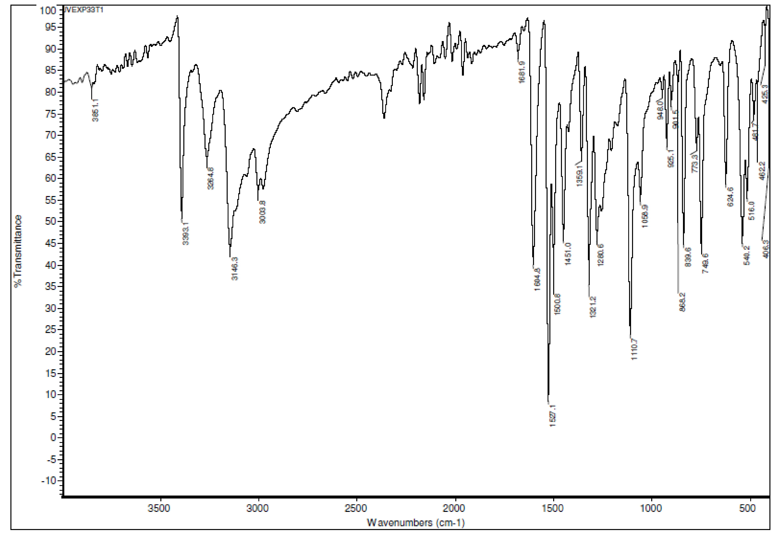
Fig.S-3. IR spectrum of H2qatsc.

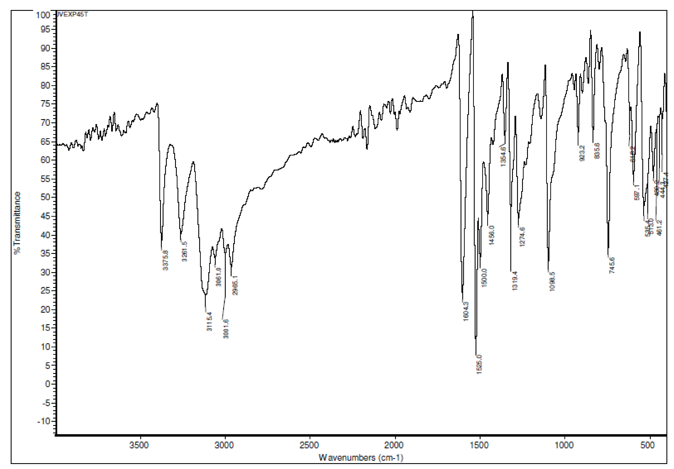
Fig.S-4. IR spectrum of H2qasesc.

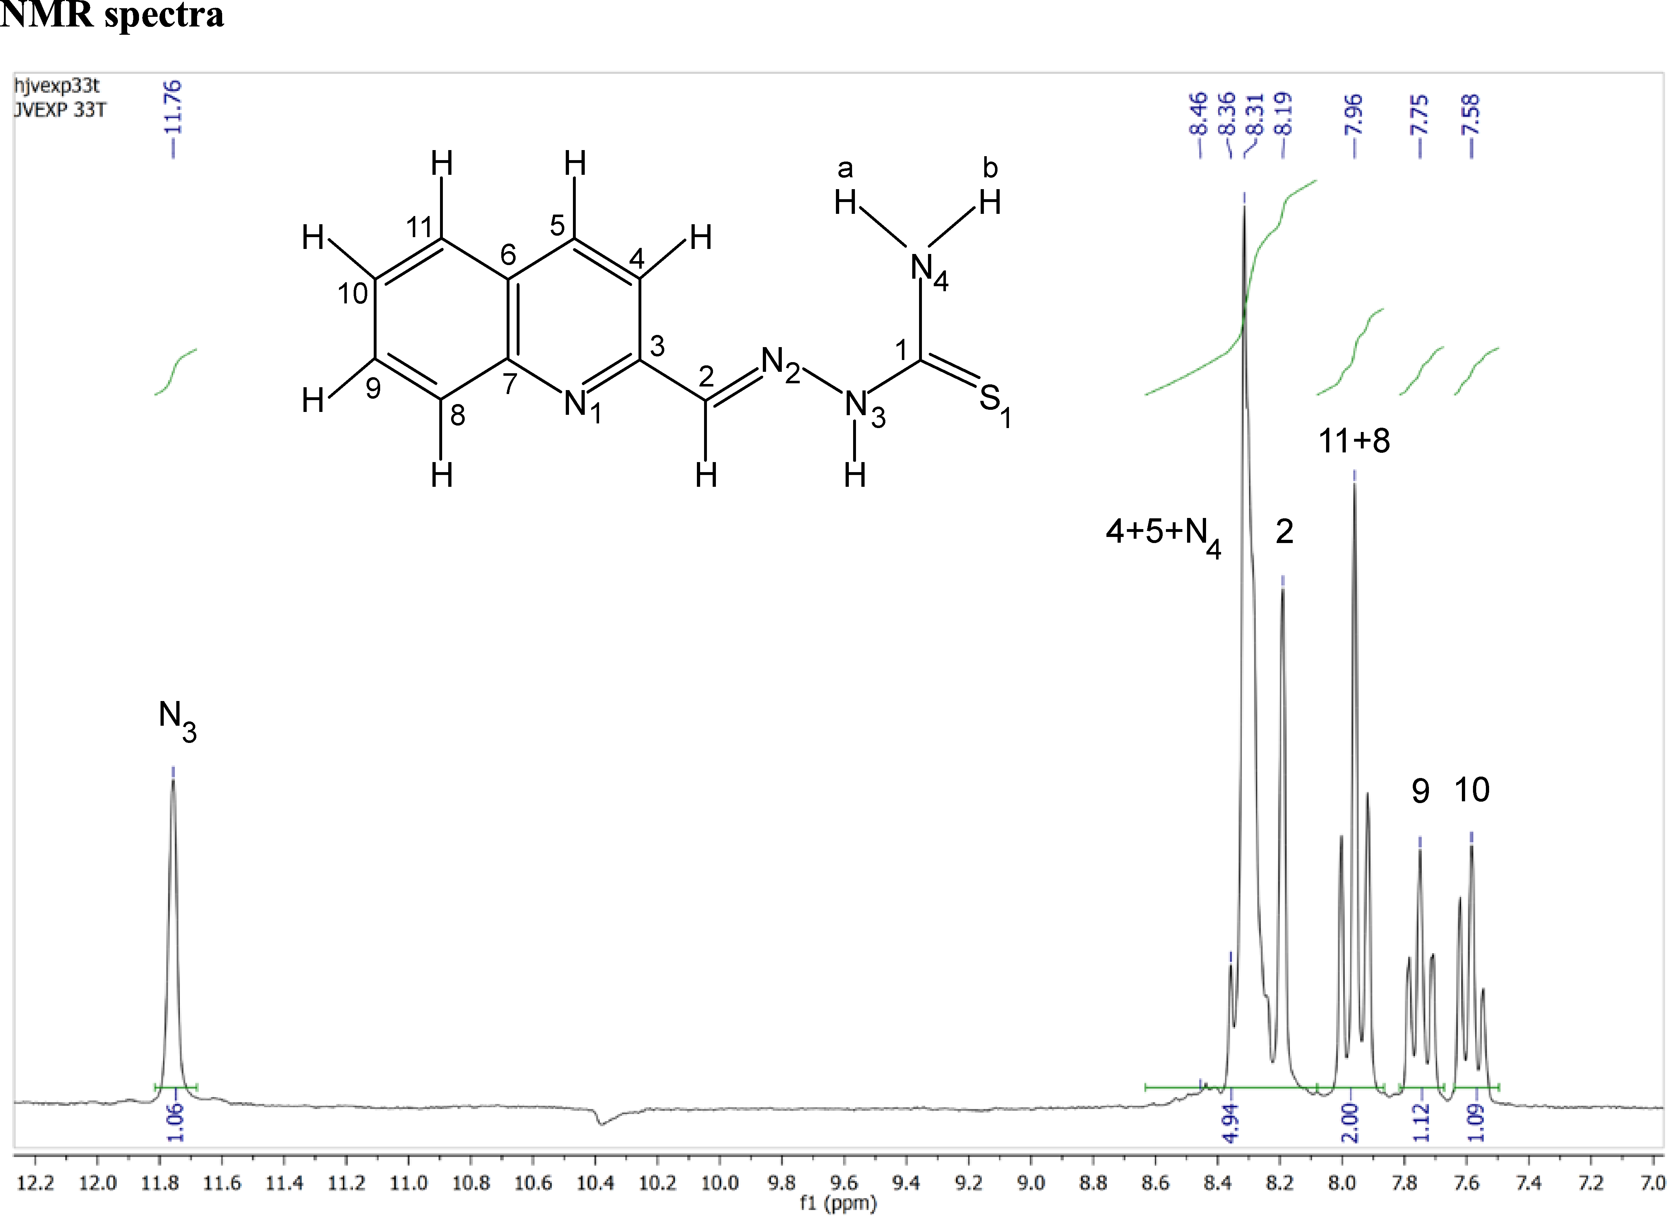
Fig. S-5. ¹H NMR spectrum of H2qatsc in DMSO-d₆.

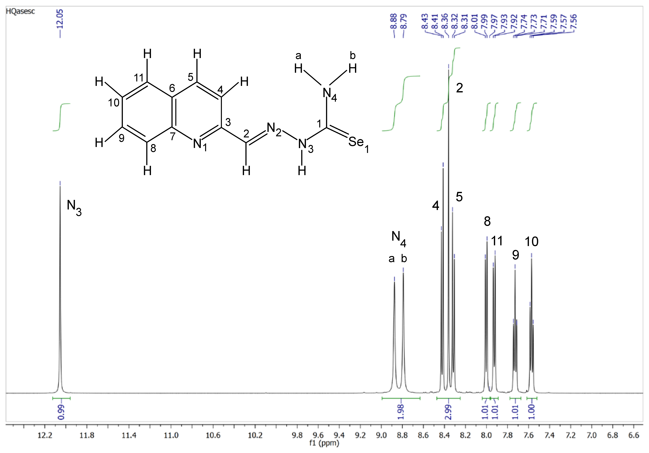
Fig. S-6.¹H NMR spectrum of H2qasesc in DMSO-d₆.

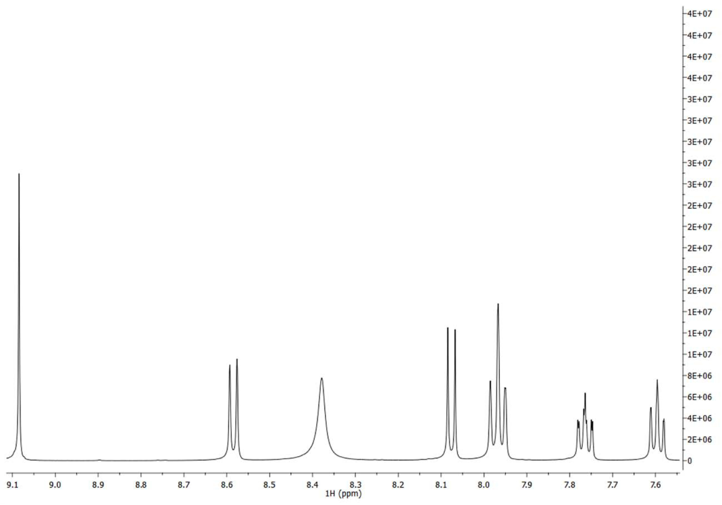
Fig. S-7. ¹H NMR spectrum of 1 in DMSO-d₆.

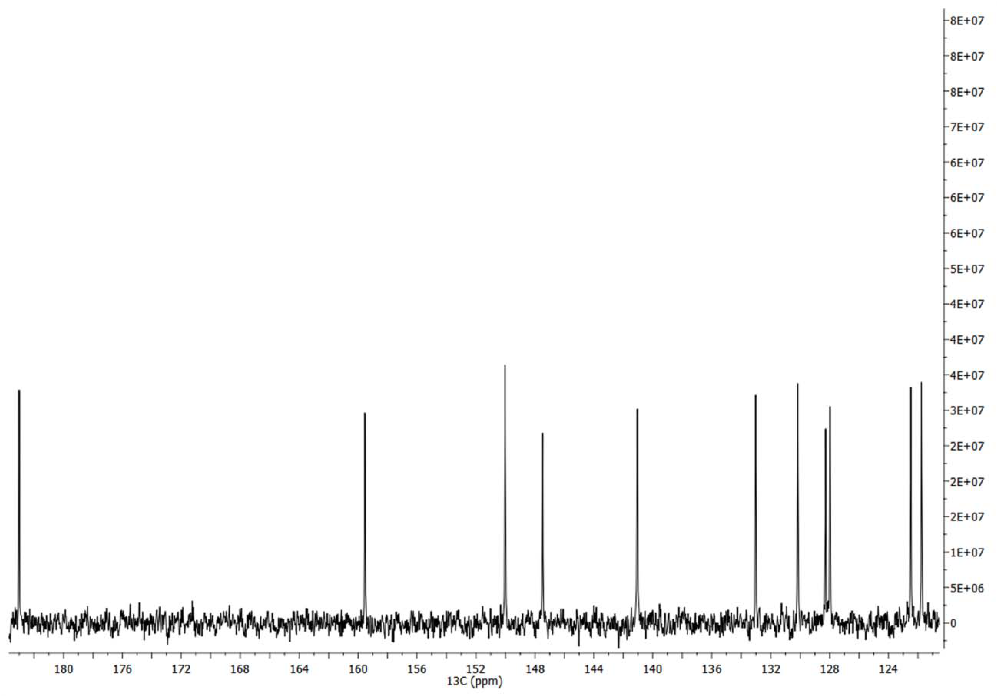
Fig. S-8. ¹³C NMR spectrum of 1 in DMSO-d₆.

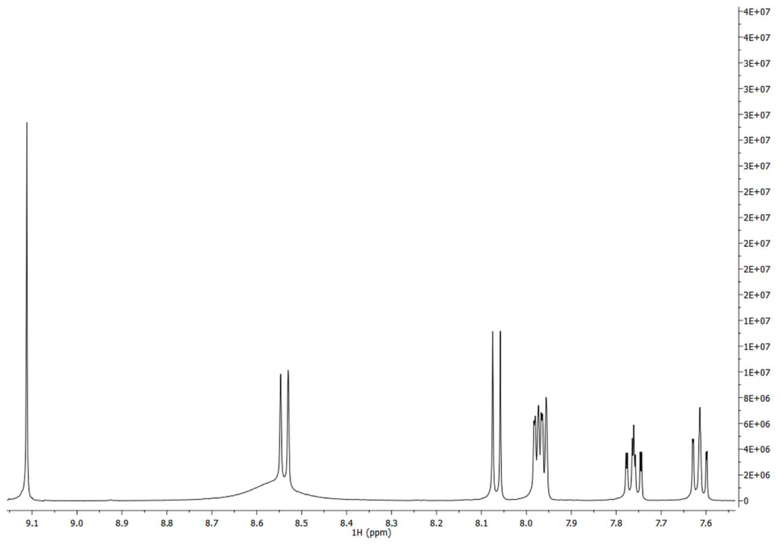
Fig. S-9. ¹H NMR spectrum of 2 in DMSO-d₆.

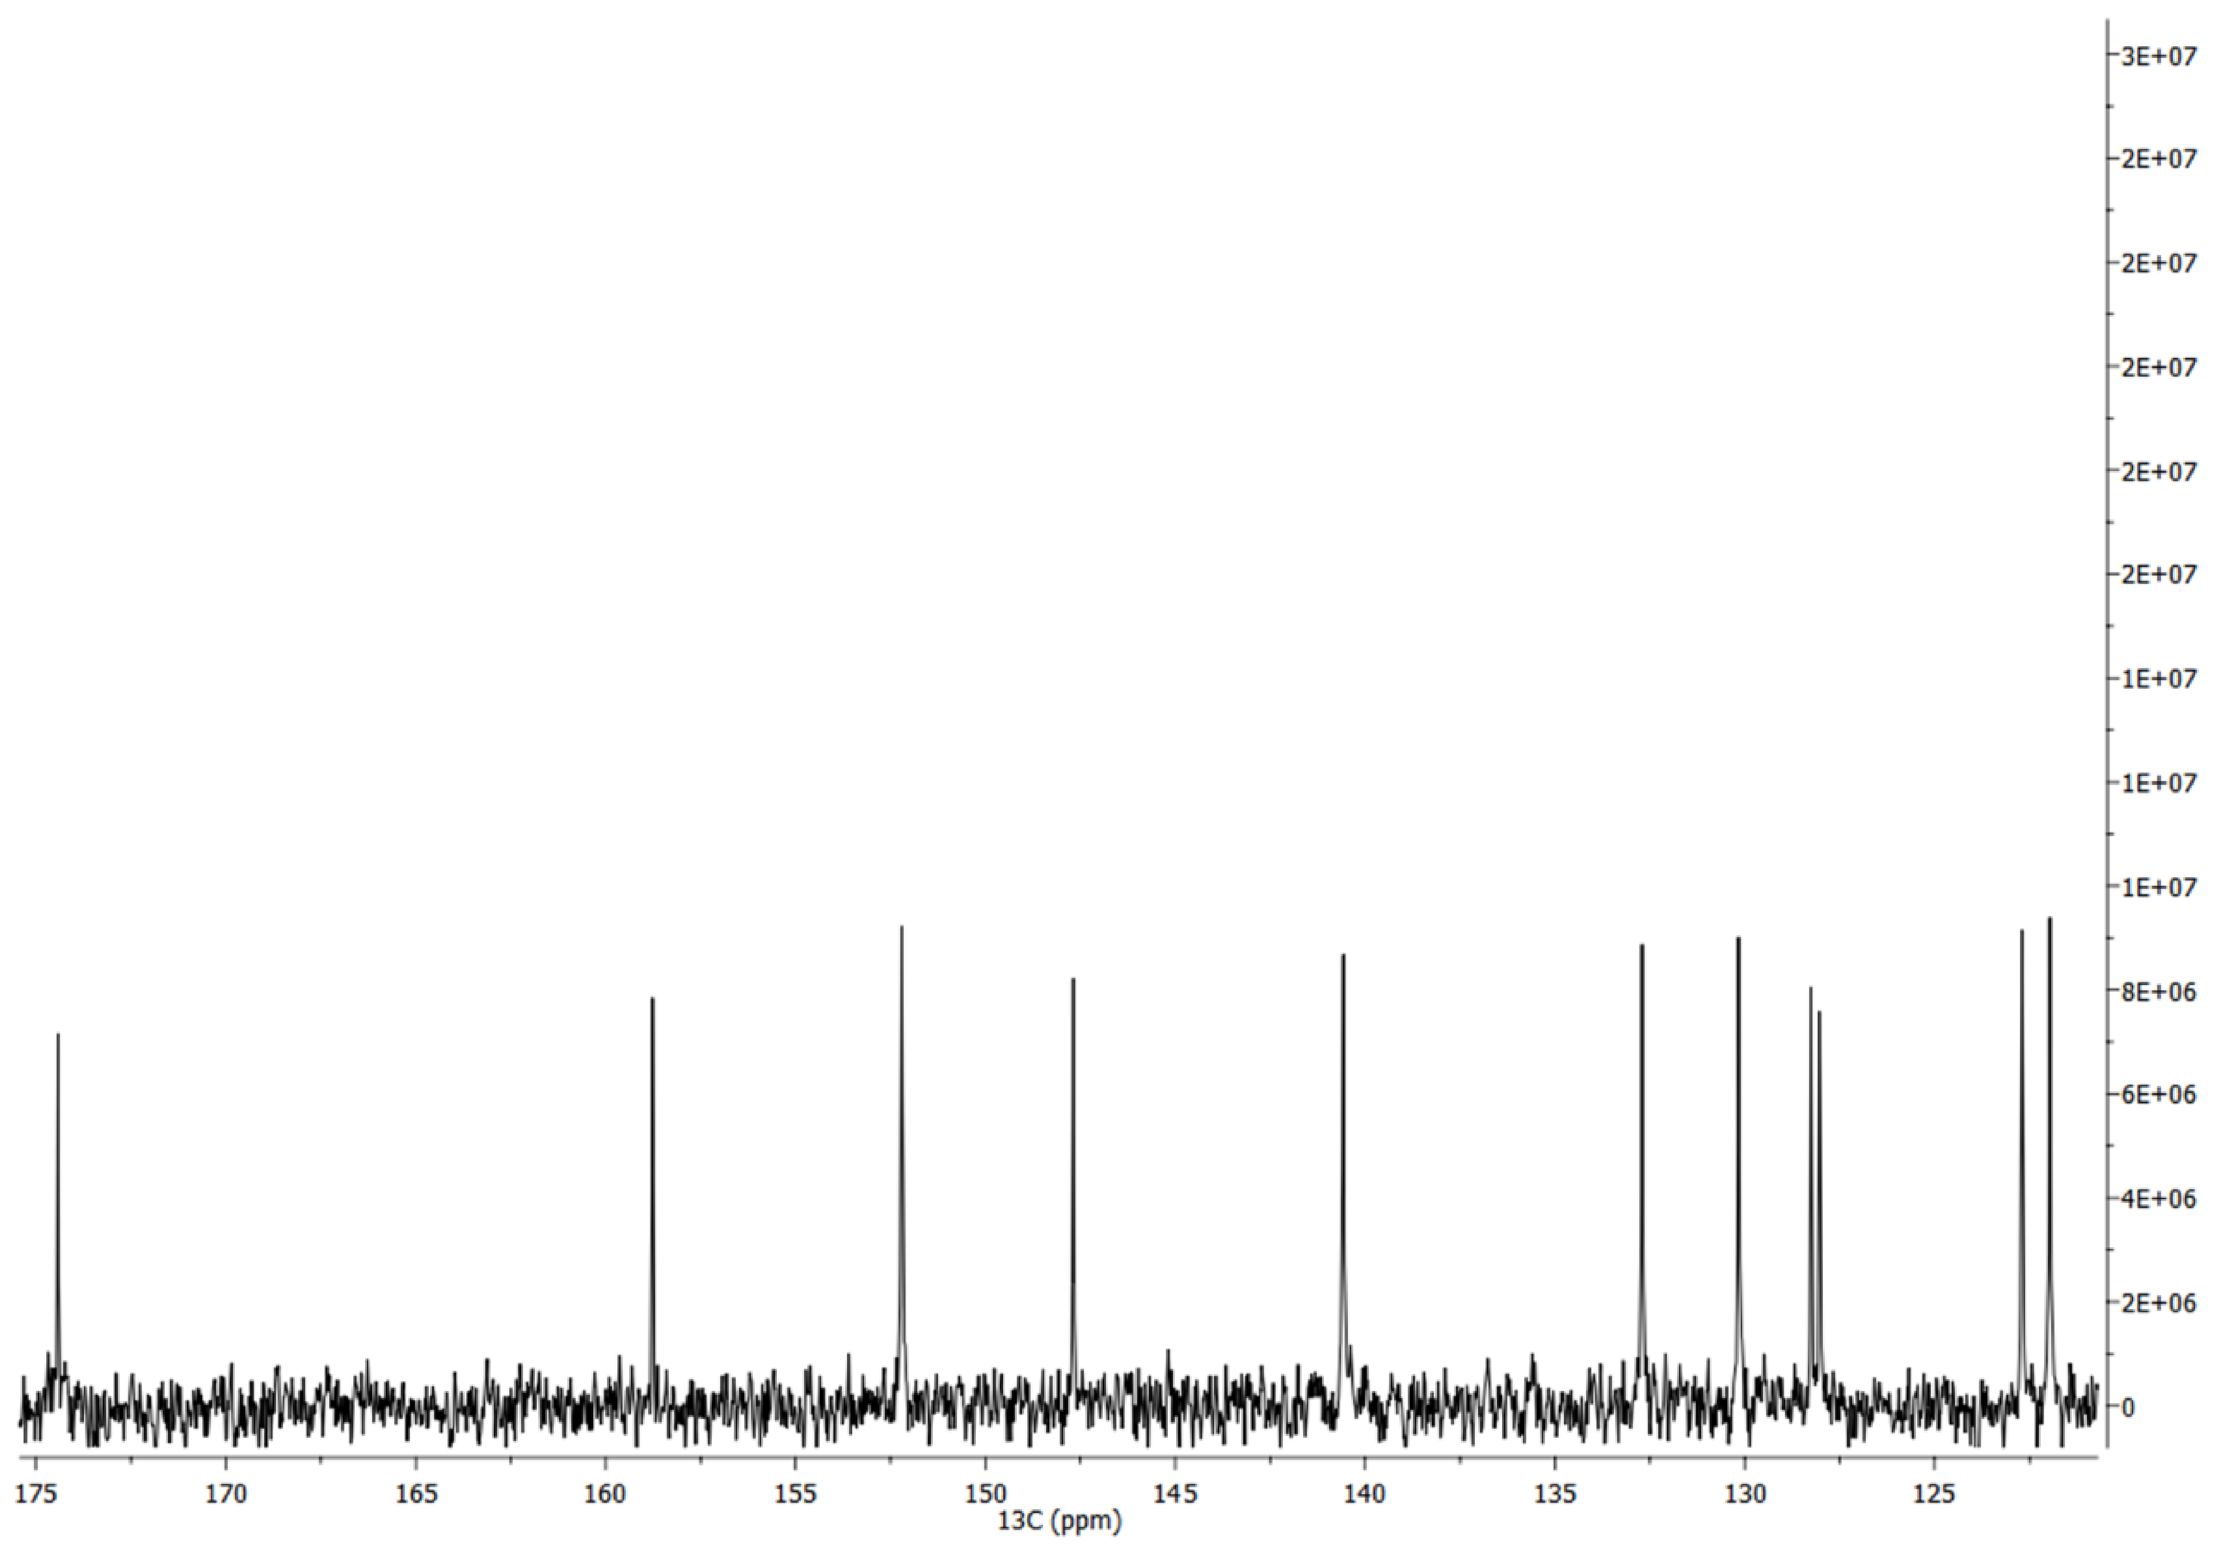
Fig. S-10. ¹³C NMR spectrum of 2 in DMSO-d₆.

*,**Corresponding authors. E-mail: (*)grubisic@chem.bg.ac.rs; (**)ivana.djordjevic@chem.bg.ac.rs # Serbian Chemical Society member.
*
*

