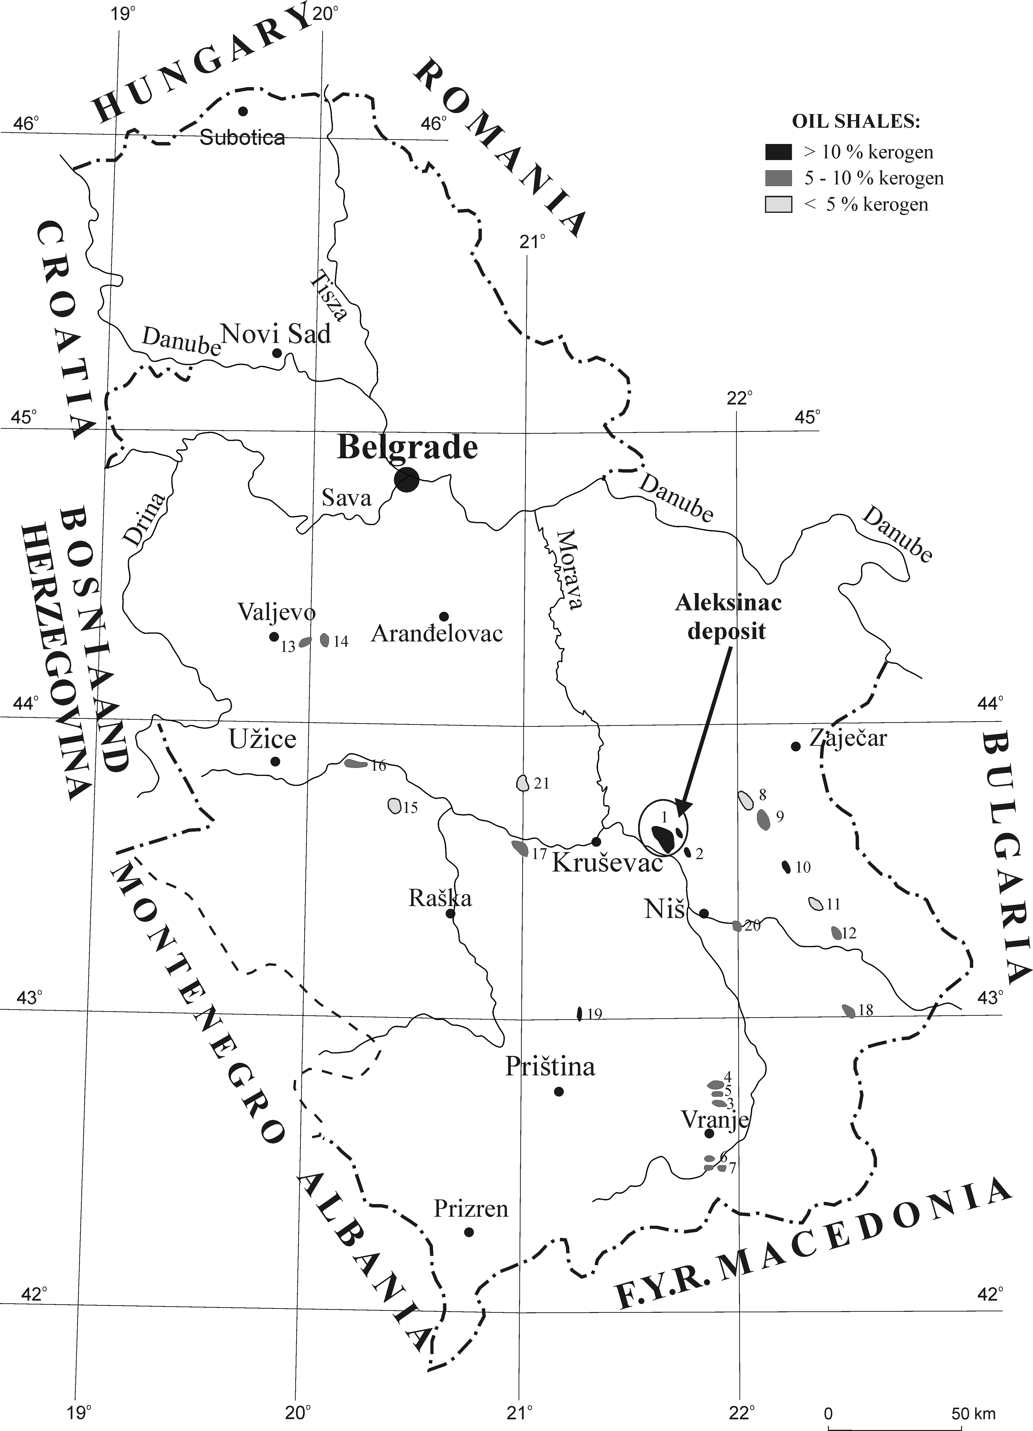

Fig. S-1. Location of the Aleksinac deposit and oil shale discoveries in Serbia (modified after Jelenković et al.¹).
1 – Aleksinac deposit; 2 – Bovan-Prugovac; 3 – Goč-Devotin deposit; 4 – Vlase-G.Selo; 5 – Stance; 6 – Buštranje; 7 – Klenike; 8 – Vlaško polje-Rujište; 9 – Vina-Zubetinac; 10 – Podvis-G. Karaula; 11 – Manojlica-Okolište; 12 – Miranovac-Orlja; 13 – Šušeoke-Klašnić; 14 – Radobićka strana-Svetlak; 15 – Pekčanica-Lazac; 16 – Parmenac-Lazac; 17 – Odžaci; 18 – Raljin; 19 – Rača; 20 – Paljina; 21 – Komarane-Kaludra.

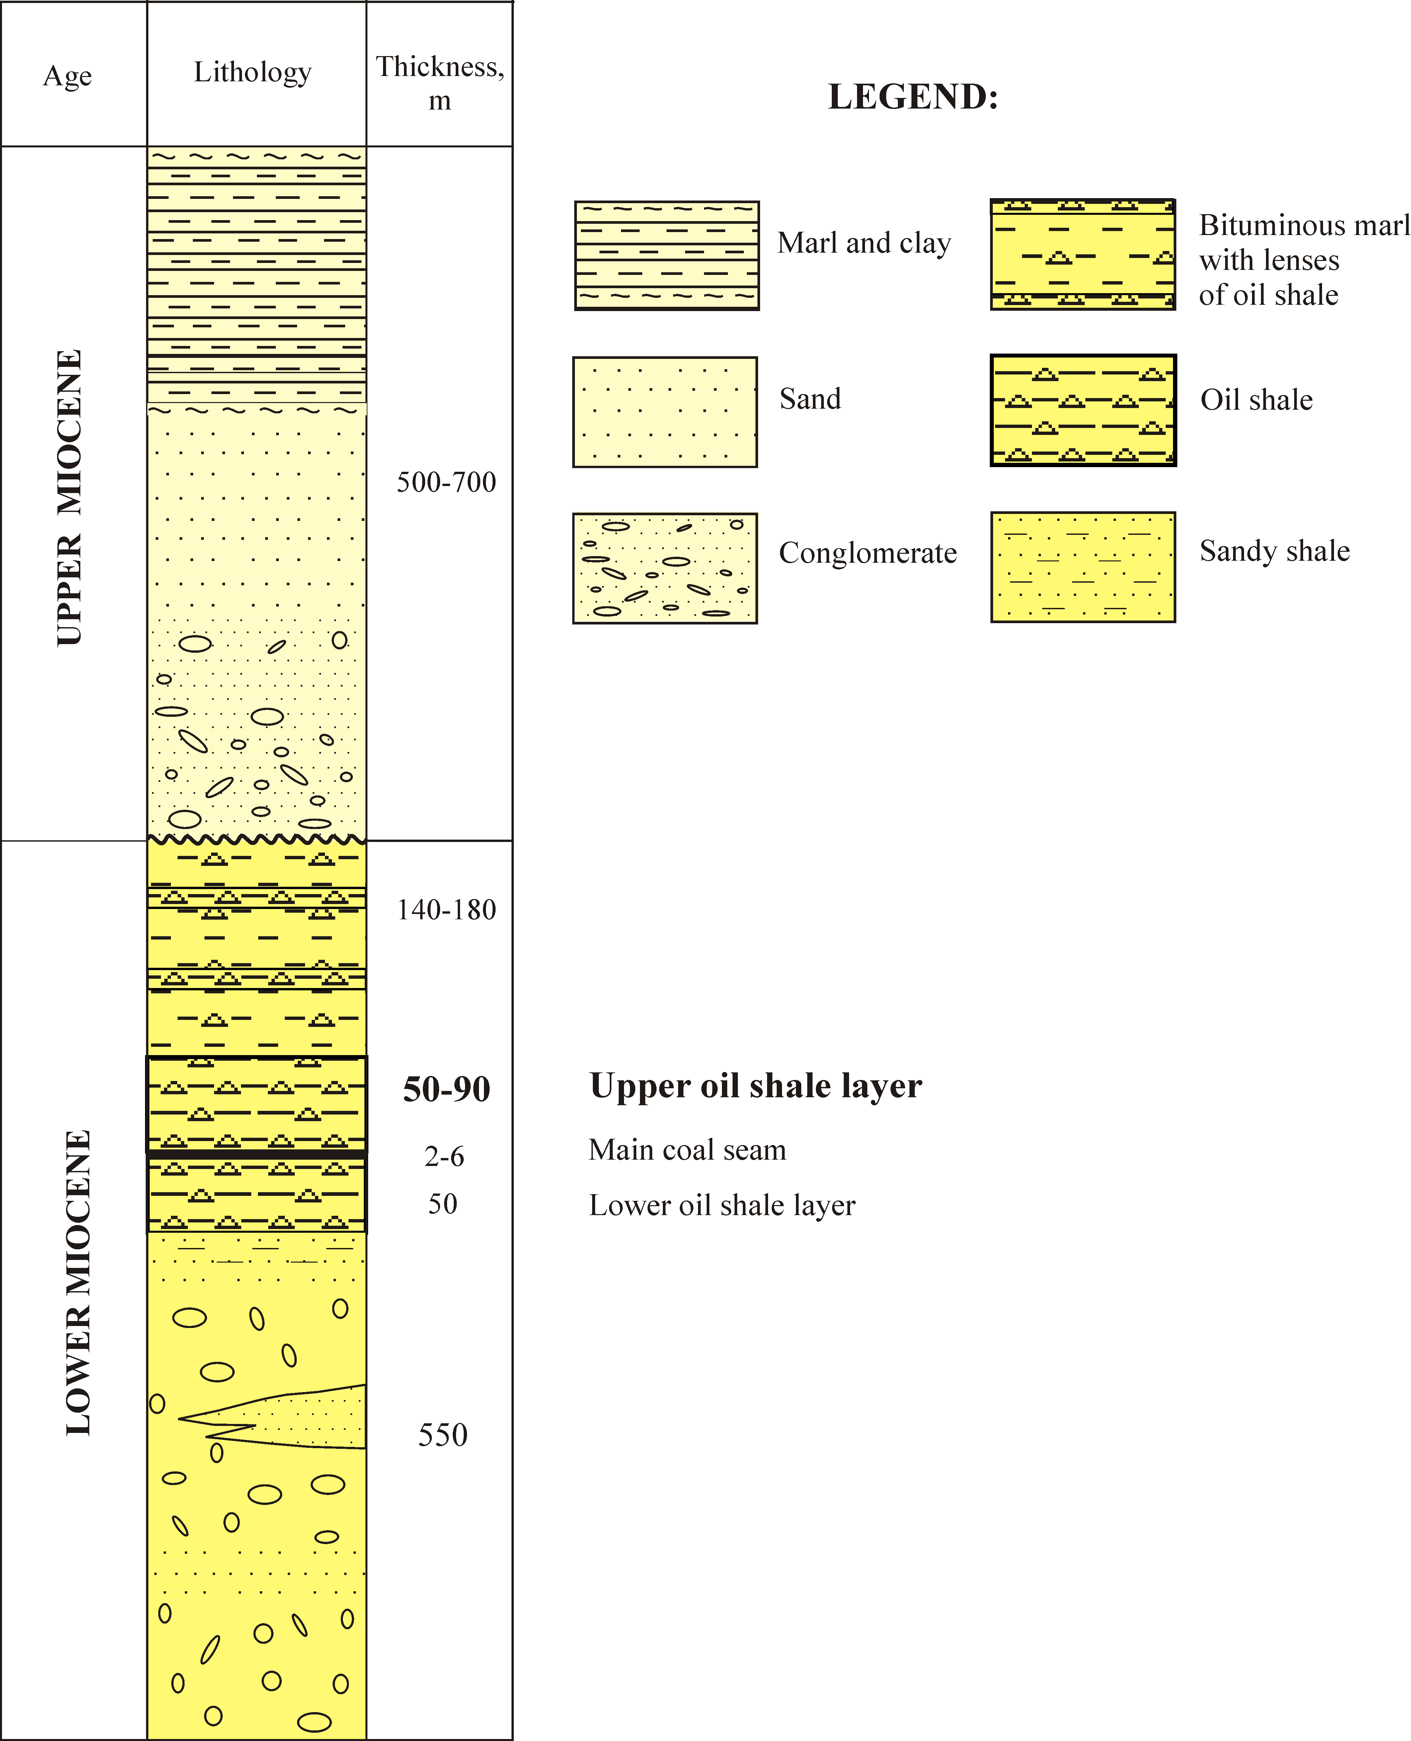

Fig. S-2. Schematic lithostratigraphic column of the Miocene from the Aleksinac oil shale deposit.

REFERENCES

- R. Jelenković, A. Kostić, D. Životić, M. Ercegovac, Geol. Carpath. 59 (2008) 345.

