Influence of the aerosol flow and exposure time on the structural changes in the filtering half masks material

Negovan IvankoviC*, DuSan RajiC², Radovan KarkaliC¹, DuSan JankoviC¹,
Zeljko RadovanoviC², Stevan Stupar³ and Darko JankoviC¹
¹University of Defence, Military Academy, Pavla Jurisica Sturma 33, 11000 Belgrade, Serbia, ²University of Belgrade, Innovation Center Faculty of Technology and Metallurgy, Karnegijeva 4, 11120 Belgrade, Serbia and
³University of Belgrade, Faculty of Technology and Metallurgy, Karnegijeva 4, 11120 Belgrade, Serbia

Abstract:
The flow of air and aerosol particles through the filtering half masks material depends on the structure porosity. It is very difficult to determine the behavior of the filtering material during the process of extraction and retention of aerosols. The samples of five filtering half mask models were used in this investigation. Dynamics of aerosol filtration through the filtering materials was tested using a method for testing the leakage of aerosol particles through the filtering material and a method for testing the inhalation resistance of filtering material, both specified in the SRPS EN 149:2013. Recording of the structural changes in the samples of the tested materials was carried out by a technique of scanning electron microscopy. Experiments showed a deviation of the results in relation to the theory of filtration the finely dispersed submicron sized particles. It was concluded that the aerosol leakage through the filtering half masks and their resistance to aerosol flow change depend on the aerosol flow rates and the filtration process duration, as a direct consequence of the newly-made changes in the structure of the filtering material and due to reversibility effect between the filtration process and the changes in the filtering material.
Keywords: filtration dynamics, structure porosity, fiber properties, scanning electronic microscopy.

Running title: half masks material structural changes
INTRODUCTION
Filtering half masks are personal means of respiratory organs protection, which are used in addition to other preventive measures to protect human health in case of epidemics and pandemics, in accordance with the recommendations of the World Health Organization (WHO). ^{1, 2} These are designed to be used primarily for the following purposes:
- to limit the spread of infectious respiratory secretions of infected people,
- to prevent accidental contamination of patients' wounds from microorganisms normally present in mucus and saliva of health care personnel,
- to protect health care personnel against splash of blood or body fluids of patients. ^{3, 4, 5}
With the scientific knowledge spread in the second half of the 20th century the progress in the development of respiratory protection means also flowed, primarily in the direction of increasing in order to make flawless filtering half mask.⁶ Ideality always reflects the maximum use of the existing resources within a system, both external as well as internal, thereby increasing the use value of the product, ie. product's purpose. ⁷
Recent advances in the technology of nanofibers allow their usage for the filtering purposes. ^{8, 9, 10, 11} This is especially featured for synthetic nanomaterial fibers with a diameter of 10 to 200 nm, which can be used for making a pleated filtering medium of high density, a small pore size and a large adsorption surface area. Even though all of the above mentioned is a fact, there still is more room for exploring, since the flow of the air and aerosol particles through a filter material represents a complex, dynamic system with a large number of small currents passing through the channels between the fibers. ¹²
Direction and shape of the currents are changing during the filtration process, depending on the irregularities of fibers distribution in the filtering material, provided that the aerosol dimensions do not exceed the size of the channels between the fibers. Precisely this kind of fiber distribution causes the structure porosity with different distances between the fibers. ¹³ Since the flow of the air which carries the aerosol particles has a laminar character in inter-fiber channels, such filtering material actually represents a system of the inter-fiber capillaries. ¹⁴ Due to many time-varying factors of a complex and dynamic nature, in such a system there are forces of internal friction expressed by: the resistance required for their overcoming, and the resistance coming from the precipitated particles. Therefore, it is very difficult to determine the behavior of the filtering material. ¹⁵
In order to determine the above mentioned, numerous tests of the filtering materials were conducted - regarding their resistance and aerosol particles permeability, caused by different aerodynamic particle diameters at different speeds and different humidity levels. ^{16, 17, 18, 19} All of them show that a large number of submicron-sized particles easily penetrate the filter at higher flow rates, yet, contribute very little to the total mass of the penetrating particles. Number of bio-aerosol particles that penetrate the filter is crucial for assessing the occurrence of health problems, while the impact of the non-biological aerosols usually depends on the total mass of the particles.
However, there is no data in the literature on how the filtering material structure changes depending on the flow of aerosols and the duration of the filtration process and how the resulting changes impact the filtration process in a cause and effect manner.
The aim of this study is to assess the impact of the aerosols flow and exposure time on the structural changes in the filtering material, in order to assess the behavior of filtering material during extended periods of exploitation.
EXPERIMENTAL
Materials
The nine samples of all five filtering half mask models were used in this investigation: epidemiological masks antimicrobial (EM1), epidemiological masks with "nano" filter (EM2) and surgical masks (HM1, HM2 and HM3). Models marked EM1, EM2 and HM1 are products of "9th September", Republic of Serbia; model marked HM2 is a product of the "Sänger", Federal Republic of Germany, and the model HM3 a product of the "Van Oostveen Medical B. V. - Romed", Netherlands.
Methods
Dynamics of aerosol filtration through the filtering materials was tested in a specific testing atmosphere, using the method for testing the leakage (permeability) (P) of aerosol particles through the filtering material and the method for testing the inhalation resistance, both specified in the SRPS EN 149:2013. ¹⁹
The test method of leakage through the filtering material is based on the principle of leakage of NaCl aerosol through a filtering medium, whereby the concentration of this aerosol is measured before and after the test sample by the flame photometry method. Precise leakage determination (P) is possible in the area of penetration from 0.0001% to 100%.
Leakage of particles through the filtering material P [%] is calculated by the equation
$$P=\frac{C_{2}}{C_{1}}×\text{100}$$
where:
C₁ – the concentration of NaCl aerosol in front of the test sample [mg/m³],
C₂ – the concentration of NaCl aerosol behind the test sample [mg/m³].
Since the testing device is connected to a computer, the software calculates the value of testing, and the test result is read from the display.
The method of testing the inhalation resistance of the filtering medium is based on the principle of leaking the air of a certain flow through the medium, horizontally, in the direction of inhaling, and measuring the pressure differences in front of and behind the filtering medium. The results are read directly from the manometer and then recorded.
Testing was conducted through the following steps. A sample of filtering half mask was hermetically connected to the filtering medium disposition (shown in Fig. 1). Then the sampling probe for leaked aerosol was attached. After that, the inlet for the test aerosol to the test chamber was turned on. Using nebulizer Type Collison (manufacturer BGI, USA), a polydispersion solid aerosol of concentration C₀ = 8 mg/m³ was produced from 1% aqueous NaCl solution (characteristics of the polydispersion solid aerosol : particle diameter dp = 0.02 - 2.0 μm, median particles per mass MMD = 0.60 μm, median particle by NMD = 0.03 μm, geometric deviation σ_{g} = 2.53; the geometric particle distribution was determined by an electrical particle analyzer EAA-3030 (manufacturer of TSI, USA)). The desired flow of the test aerosol (30 or 95 dm³/min) was adjusted using the flow meter, so that the test aerosol could continuously flow through the protective device. Concentration of the aerosol is measured in front of and behind the test sample by a flame photometer Type 1100 (manufactured by Moores (Wallisdown) LTD, UK). It was measured for 30 minutes, every 5 minutes from the beginning of the test.
Simultaneously, the filtering medium resistance to the applied aerosol flow was measured. It was done by a manometer which was connected to the testing apparatus. Once a constant value was reached, the resistance result was recorded.
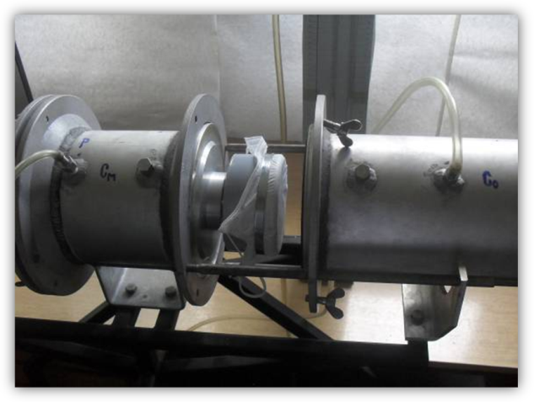
Fig. 1. Testing chamber with a sample of a filtering half mask
Upon the tests completion, samples of the tested materials were scanned using the scanning electron microscopy (SEM) technique to determine the changes in the structure of the filtering materials caused by different flow rates of the aerosol and duration of the filtering process. Characterization was performed using the scanning electron microscope model JSM-5800 (manufactured by the JEOL company, Japan).
Results and discussion
The results obtained by the experimental tests of aerosol leakage (P) and inhalation resistance (p), are all shown at Fig. 2 and Fig. 3. Presented results are the average values of nine parallel measurements, with variation less than 30%.
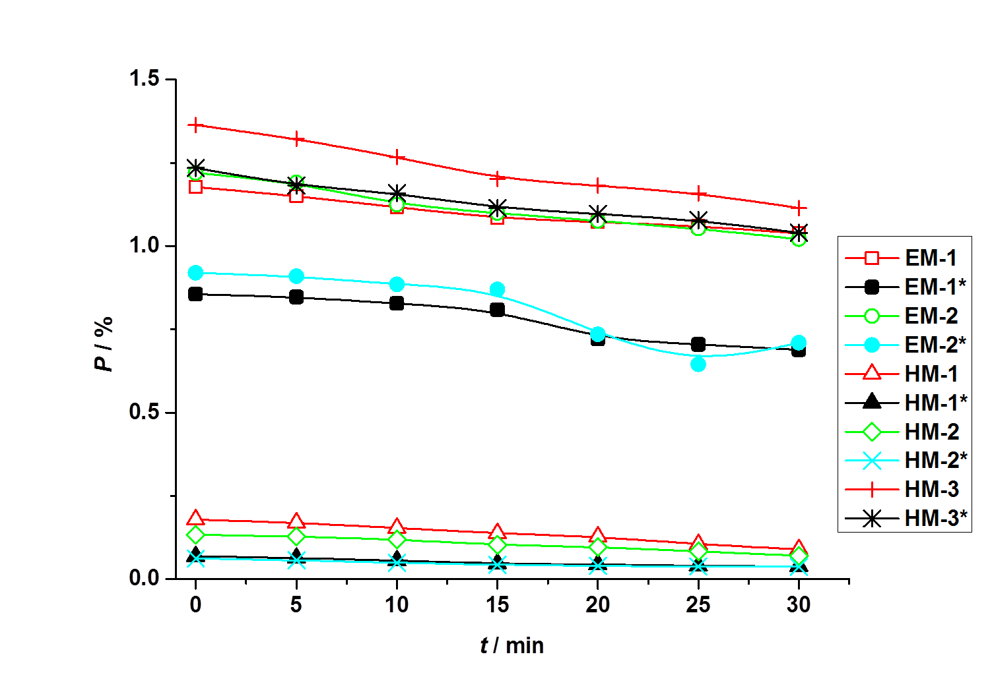
Fig 2. The leakage values of the filtering material samples depending on the time, at the test aerosol flow of 30 and 95 dm³ / min (indicated by an asterisk)

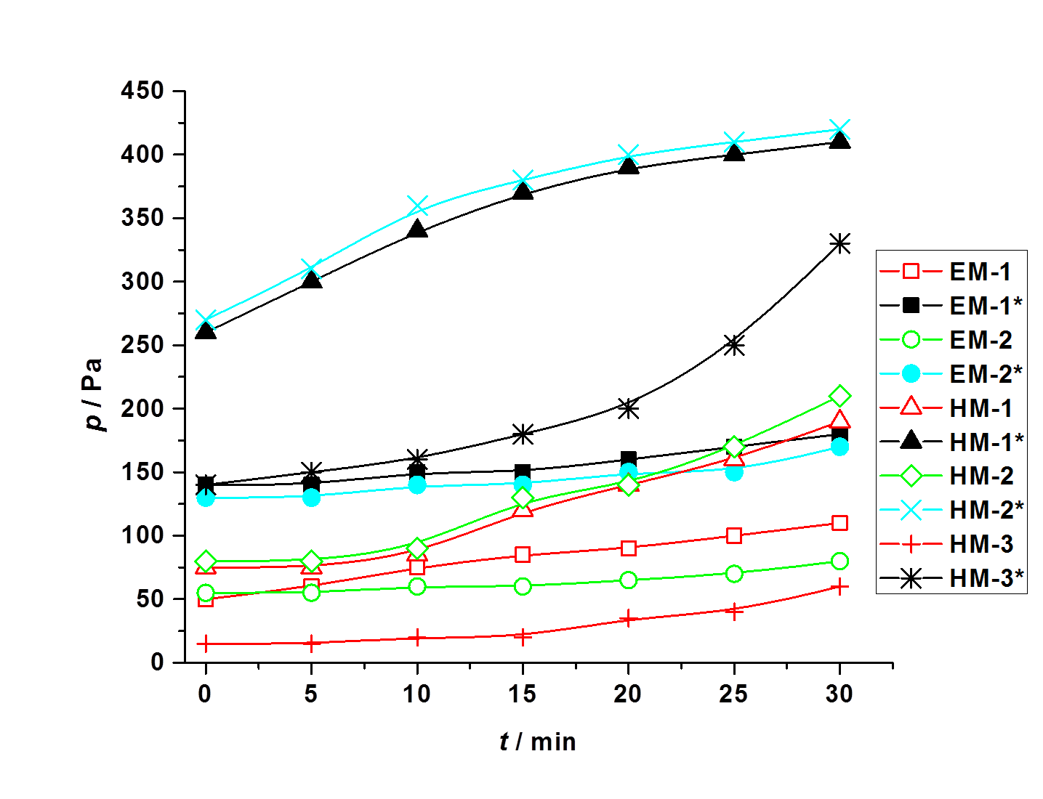
Fig. 3. The resistance values of filtering material samples depending on the time, at the test aerosol flow of 30 and 95 dm³ / min (indicated by an asterisk)
As opposed to the theory of filtration of finely dispersed submicron-sized particles, ^{12, 13} the results of leakage at various flow rates in all investigated models of filtering half masks are considerably lower at a higher flow rate, indicating that the inward leakage through the filtering half masks decreases with the increase of the volumetric aerosol flow rate. This phenomenon can be explained as a result of two parallel processes:
- at higher aerosol flow rates, for the same time, a homogeneous layer of the particles is formed faster, due to the particles accumulation by the inertia mechanism on the filtering material fibers, thus increasing the obstacle thickness,
- at higher aerosol flow through the relatively small filtering area of the filtering half masks, the higher sub-pressure occurs due to the flow, due to which the filtering material fibers get compacted.
The above mentioned processes reduce porosity of the filtering material (pore size between the fibers) and increase the active filtration area of the filtering material in relation to the volume of air flowing through it. These structural changes result in decrease of the inward leakage of filtering medium with a certain resistance increase.
The longer a filtering process timewise, the more homogeneous layer of particles is being formed, which depending on the size, produces a higher or smaller resistance increase to the aerosol flow. SEM images of the filtering material samples (Fig. 2-6) were made before and after testing. They show changes in the structure of the material based on which can be drawn conclusions about the mentioned processes.
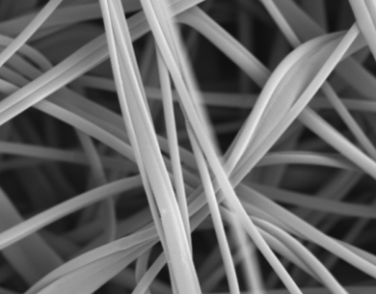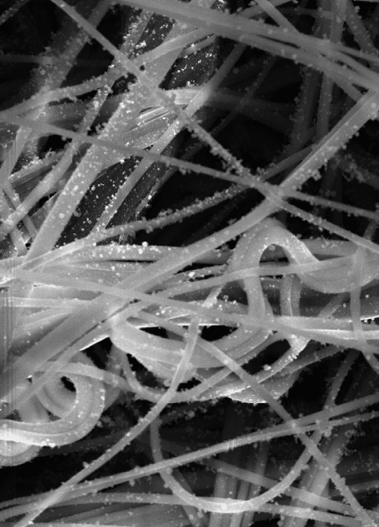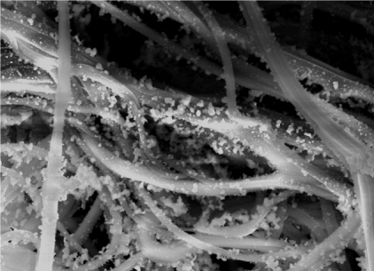
а) b) c)
Fig. 4. SEM image of the filtering material in the model EM1 (enlarged 1000x): a) the pure filtering material, b) after testing (aerosol flow 30 dm³ / min), and c) after testing (aerosol flow 95 dm³ / min).

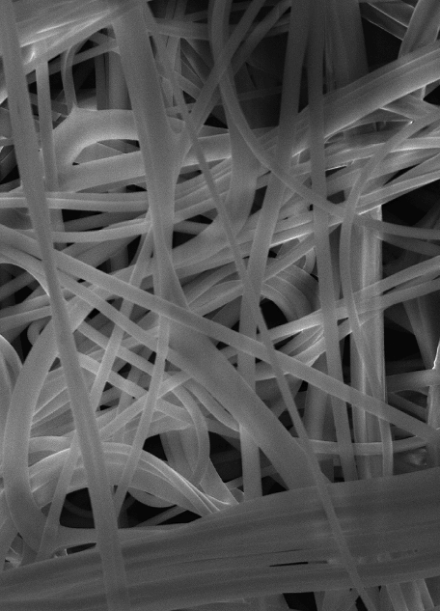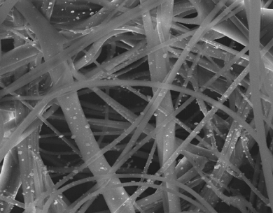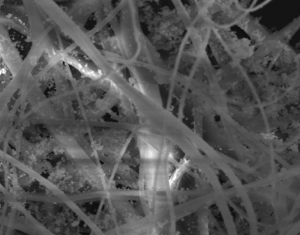
а) b) c)
Fig. 5. SEM image of the filtering material in the model EM2 (enlarged 1000x): a) the pure filtering material, b) after testing (aerosol flow 30 dm³ / min), and c) after testing (aerosol flow 95 dm³ / min).

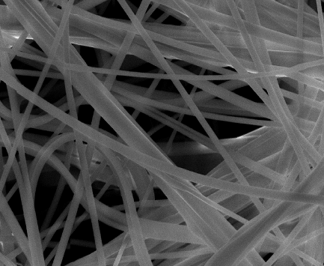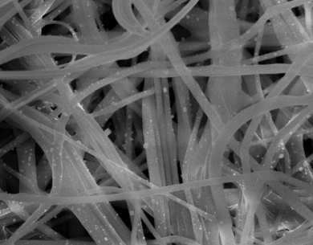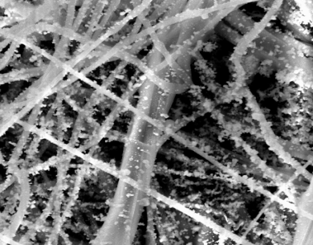
а) b) c)
Fig. 6. SEM image of the filtering material in the model HM1 (enlarged 1000x): a) the pure filtering material, b) after testing (aerosol flow 30 dm³ / min), and c) after testing (aerosol flow 95 dm³ / min).

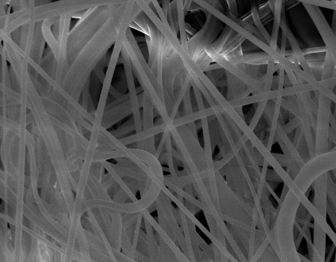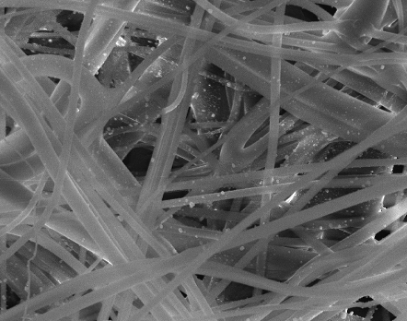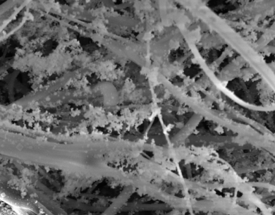
а) b) c)
Fig. 7. SEM image of the filtering material in the model HM2 (enlarged 1000x): a) the pure filtering material, b) after testing (aerosol flow 30 dm³ / min), and c) after testing (aerosol flow 95 dm³ / min).

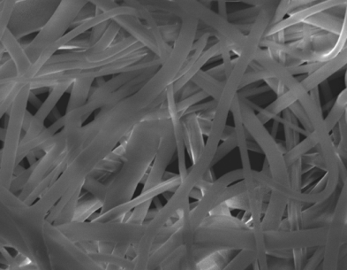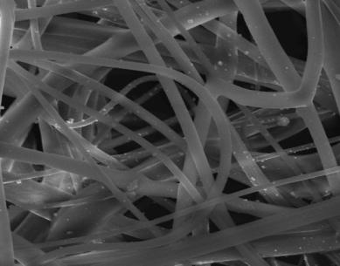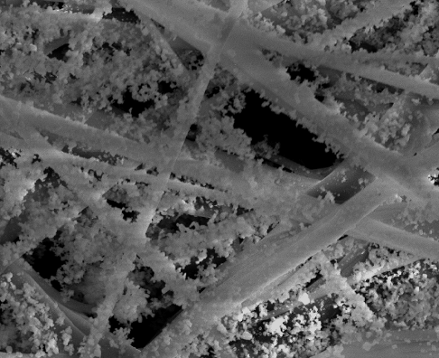
а) b) c)
Fig. 8. SEM image of the filtering material in the model HM3 (enlarged 1000x): a) the pure filtering material, b) after testing (aerosol flow 30 dm³ / min), and c) after testing (aerosol flow 95 dm³ / min).

The test results and SEM images of the tested samples indicate significant differences between filtering half mask models when it comes to the changes in leakage and resistance depending on the test aerosol flow and test duration. The similarity of the filtering structure behavior for the EM1 and EM2 models may be noticed, as well as for the HM1 and HM2 models. Of all the tested half masks, the HM1 and HM2 models show the minimum initial leak and the greatest difference in the value of leakage at different flow rates, as well as the highest increase in resistance during continuous testing time. Considering all, the half mask samples marked as HM1 and HM2 showed the best characteristics for usage.
SEM images show a direct effect of the mutual coupling of the duration time and flow rate of the aerosol filtering on the structure changes of the filtering material, whereby it can be observed that the structural changes are more pronounced at higher flow rates of the testing aerosol - at lower flow rates the changes in the structure happen more uniformly. From a practical point of view this means that for a detailed examination of the qualitative characteristics of any kind of the filtering mediums, it is necessary to test simultaneously the filtering material on inward leakage and resistance changes, in relation to the filtration duration at different flow rates of the testing aerosol.
CONCLUSION
It has been concluded that the leakage is considerably lower at a higher aerosol flow in all tested models of filtering half masks, contrary to the filtration theory of finely dispersed submicron-sized particles.
This can be explained by the changes in the structure of the filtering material - decrease of porosity and increase of the active filtration area, due to the formation of a homogeneous layer of particles during their accumulation on the fibers (due to inertia mechanism) and fiber compaction (due to higher negative pressure at higher aerosol flow rates).
SEM analysis of the filtering material samples has shown that structural changes are more pronounced at higher aerosol flow rates, i.e. that the changes in the structure take place more uniformly at lower aerosol flow rates.
According to all presented, it can be concluded that the aerosol leakage through the filtering material of the filtering half masks and their resistance to aerosol flow are changing in relation to the aerosol flow rates and the filtration process duration. The above is a direct consequence of the changes in the structure of the filtering material, because the created changes have reversible influence on the filtration process itself.
Acknowledgement: Ministry of Education, Science and Technological Development of the Republic of Serbia support this work, Grant № TR34034 (2011-2017) and Grant № III45019 (2011 - 2017).
ИЗВОД
УТИЦАЈ ПРОТОKА АЕРОСОЛА И ВРЕМЕНА ЕKСПОЗИЦИЈЕ НА СТРУKТУРНЕ ПРОМЕНЕ У МАТЕРИЈАЛУ ФИЛТРИРАЈУЋИХ ПОЛУМАСKИ
Негован Иванковић¹, Душан Рајић², Радован Kаркалић¹, Душан Јанковић¹, Жељко Радовановић², Стеван Ступар³
¹Универзитет Одбране у Београду, Војна акдемија, Павла Јуришића Штурма 33, 11000 Београд, ²Универзитет у Београду, Иновациони центар Технолошко-металуршког факултета, Карнегијева 4, 11000 Београд и ³Универзитет у Београду, Технолошко-металуршки факултет, Карнегијева 4, 11000 Београд
Струјање ваздуха и аеросолних честица кроз материјал филтрирајућих полумаски условљено је порозношћу структуре. Током процеса издвајања и задржавања честица аеросола, веома је тешко одредити понашање филтрирајућег материјала. У испитивању су коришћени узорци пет модела филтрирајуће полумаске. Динамика филтрирања аеросола у филтрирајућим материјалима је испитивана коришћењем методе за испитивање пропуштања кроз филтрирајући материјал и методе за испитивање отпора при удисању, прописаним у СРПС ЕН 149:2013. Снимање структурних промена у узорцима испитиваних материјала је извршено техником скенирања електронском микроскопијом. Испитивања су показала одступање резултата у односу на теорију филтрирања фино дисперзних субмикронских честица. Утврђено је да се пропуштање аеросола кроз филтрирајући материјал филтрирајућих полумаски и отпор протицању аеросола филтрирајућих полумаски мења у зависности од протока аеросола и трајања процеса филтрације, као директна последица насталих промена у структури филтрирајућих материјала, услед реверзибилности односа процеса филтрације и промена у филтрирајућем материјалу.

References
- D. Bell, A. Nicoll, K. Fukuda, Emerg. Infect. Dis. 12 (2006) 88
- World Health Organization. WHO global influenza preparedness plan: the role of WHO and recommendations for national measures before and during pandemics (2005). Annex 1. Recommendations for nonpharmaceutical public health interventions.
- Center for Disease Control and Prevention. Guidelines for Preventing the Transmission of Mycobacterium tuberculosis in Health-Care Settings, 2005. MMWR 2005; 54 (No. RR-17): [inclusive page numbers].
- L. Y. Pei, Z. C. Gao, Z. Yang, D. G. Wei, S. X. Wang, J. M. Ji, B. G. Jiang, Beijing Da Xue Xue Bao. 38 (2006) 271
- D. Rajic, Z. Kamberovic, B. Zakula, Creative Engineering, Innovation Centre of the Faculty of Technology and Metallurgy, Belgrade, 2016
- D. Rajic, Creative Ecology, Copyright edition, Belgrade, 2016
- A. Frenot, I. S. Chronakis, Curr. Opin. Colloid. Interface. Sci. 8 (2003) 64
- K. Kosmider, J. Scott, Filtr. Sep. 39 (2002) 20
- R.S. Barhate, S. Ramakrishna, J. Membr. Sci. 296 (2007) 1
- А. Podgorski, А. Balazy, L. Gradon, Chem. Eng. Sci. 61 (2006) 6804
- T. Sparks, G. Chase, Filters and Filtration Handbook, 6th ed., Butterworth-Heinemann, Oxford, 2016
- T. D. Show, Fundamentals of Aeroсol Science, John Wiley and Sons, New York, 1978
- R. C. Brown, Air filtration, an integrated approach to the theory and application of fibrous filters, Pergamon Press, Oxford–New York–Seoul, Tokyo, 1993
- W. C. Hinds, Aerosol Technology. Properties, Behavior, and Measurement of Airborne Particles, John Wiley and Sons, Toronto, 1982
- C. C. Chen, M. Lehtimaki, K. Willeke, Am. Indust. Hyg. Assoc. J. 53 (1992) 566
- L. Janssen, Occup. Health. Saf. 72 (2003) 73
- L. M. Brosseau, N. V. McCullough, D. Vesley, Appl. Occup. Environ. Hyg. 12 (1997) 435
- N. V. McCullough, L. M. Brosseau, D. Vesley, Ann. Occup. Hyg. 41 (1997) 677
- SRPS EN 149: Respiratory protective devices - Filtering half masks to protect against particles - Requirements, testing, marking (2013)

*Corresponding author. E-mail: negovan.ivankovic@gmail.com

