Supplementary material

PPCPs analysis
A 2 μL sample was injected into GC (splitless mode 0.1 min, purge flow 60 mL min⁻¹, at 250 °C). The GC oven was programmed as follows: an initial temperature of 60 °C, held for 3 min, and then was ramped at 5 °C/min to 300 °C, held for 10 min. Samples were analyzed using an GC/MS (Agilent Technologies 7890B, with 5977A MSD). Separation was achieved using a HP-5 MS 30 m×0.25 mm×0.25 μm (Agilent J&W, CA, USA) capillary column with helium as the carrier gas.

Toxicity tests
Daphnia magna acute toxicity test
Less than 24 h-old daphnias (neonates) were used in tests. Neonates were transferred into 50-mL glass vessels containing 25 mL of test solution and controls – standard M4 medium,³⁰ and the filtered river Danube sample, in four replicates (5 animals per test vessel) each. Immobilisation of the neonates was recorded after 24 and 48 h, and the results were compared to the controls. Test acceptability criterion for D. magna acute toxicity tests is ≥ 90 % survival rate in the control. Dissolved oxygen concentration (mg L⁻¹) was measured prior to D. magna toxicity tests, in control / test solutions. Measured values were in the range 4.45-6.19 mg L⁻¹, and did not change considerably over D. magna toxicity test.

Vibrio fischeri luminescence inhibition test
V. fischeri culture (strain NRRL B-11177), supplied by Macherey-Nagel GmbH&Co. KG, Duren, Germany as freeze-dried bacteria (BioFix®Lumi), was reconstituted, prior to testing, using the commercial reactivation solution from the same manufacturer. Initial luminescence (I₀) was measured in reactivated bacterial suspension after 15 min long adjustment period at 15 °C. To achieve a minimum required quantity of bacteria for accurate luminescence measurement,³¹ 0.2 mL of the bacterial test suspension was added into 0.8 mL of test solution / control. The final luminescence (I₃₀) was measured after 30 min exposure of the bacterial suspension to the test solutions / controls. Tests were carried out in triplicates. The results were calculated as the percentage of luminescence inhibition (H₃₀) in test solutions relative to the corresponding controls (standard 2 % NaCl solution / filtered river Danube sample (FD) with addition of 2 % NaCl for salinity adjustment).
The correction factor (fk₃₀) was calculated as follows:
(1)
where:
Ik₃₀ stands for the bioluminescence in control after 30 min;
I₀ stands for the initial bioluminescence.
The corrected values of I₀ were calculated as follows:
Ic_{t} = I₀ fk₃₀ (2)
The inhibition in each test solution was calculated as follows:
(3)
where:
H₃₀ stands for the inhibition of bioluminescence after 30 min, %;
I₃ stands for the bioluminescence after 30 min.

Table SI. List of PPCPs studied and their properties
Name | Abbreviation | Molecular weight (g mol⁻¹) | Octanol / water partition coefficient
Benzophenone¹ | BP | 182.222 | 3.18
Benzophenone-3² | BP-3 | 228.247 | 3.79
Carbamazepine³ | CBZ | 236.274 | 2.45
Caffeine⁴ | CF | 194.194 | -0.07
¹;²⁵
²;²⁶
³;²⁷
⁴;²⁸

Table SII. List of target ions (m / z) of compounds used for analysis
Analyte | Target  Ion, m / z
BP | 105
BP-3 | 151
CBZ | 193
CF | 194

Table SIII. Parameters for river water during phase of biofilm development
Parameters | I cycle |  | II cycle |  | III cycle |  | IV cycle
 | I day | VII day | I day | VII day | I day | VII day | I day | VII day
pH | 8.1 | 8.2 | 8.3 | 7.5 | 8.02 | 8.1 | 8.1 | 8.02
Conductivity, µS cm⁻¹ | 390 | 396 | 394 | 392 | 377 | 393 | 351 | 342
Temperature, °C | 17 | 23 | 26.3 | 24.2 | 23.5 | 26 | 19 | 26
KMnO₄ consumption , mg L⁻¹ | 5.8 | 2.5 | 9 | 6.3 | 14 | 12.6 | 11.4 | 10

Table SIV. Results of weathering tests in glass beakers
Phase of experiment | BP |  | BP-3 |  | CF |  | CBZ
Removal, % | Night-day circle | Dark | Night-day circle | Dark | Night-day circle | Dark | Night-day circle | Dark
B1 | 83 | 25 | 15 | 54 | 54 | 47 | Not calculated | Not calculated
B2 | 90 | 29 | 7 | 53 | 54 | 51 | 0 | 0

Figure S1. Biologically test filter set-up
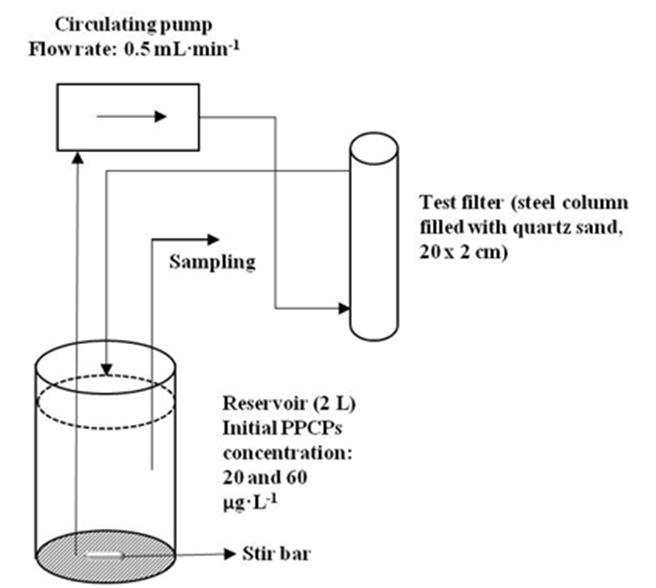

Figure S2. Images of stained samples showing bacteria (coccal and rod forms) and diatoms

Figure S3. Images of native samples showing diatoms present in the biofilm
a) Synedra sp.
b) Cyclotella sp.
c) Melosira sp.

d) Asterionella sp.
e) Nitzschia sp.

