Supplementary material

Table SI. List of PPCPs studied and their properties
Name | Abbreviation | Molecular weight (g⋅mol⁻¹) | Octanol / water partition coefficient
Benzophenone¹ | BP | 182.222 | 3.18
Benzophenone-3² | BP-3 | 228.247 | 3.79
Carbamazepine³ | CBZ | 236.274 | 2.45
Caffeine⁴ | CF | 194.194 | -0.07
¹;²⁵
²;²⁶
³;²⁷
⁴;²⁸

Table SII. List of target ions (m / z) of compounds used for analysis
Analyte | Target  Ion, m / z
BP | 105
BP-3 | 151
CBZ | 193
CF | 194

Table SIII. Parameters for river water during phase of biofilm development
Parameters | I cycle |  | II cycle |  | III cycle |  | IV cycle
 | I day | VII day | I day | VII day | I day | VII day | I day | VII day
pH | 8.1 | 8.2 | 8.3 | 7.5 | 8.02 | 8.1 | 8.1 | 8.02
Conductivity, µS⋅cm⁻¹ | 390 | 396 | 394 | 392 | 377 | 393 | 351 | 342
Temperature, °C | 17 | 23 | 26.3 | 24.2 | 23.5 | 26 | 19 | 26
KMnO₄ consumption , mg⋅L⁻¹ | 5.8 | 2.5 | 9 | 6.3 | 14 | 12.6 | 11.4 | 10

Table SIV. Results of weathering tests in glass beakers
Phase of experiment | BP |  | BP-3 |  | CF |  | CBZ
Removal, % | Night-day circle | Dark | Night-day circle | Dark | Night-day circle | Dark | Night-day circle | Dark
B1 | 83 | 25 | 15 | 54 | 54 | 47 | Not calculated | Not calculated
B2 | 90 | 29 | 7 | 53 | 54 | 51 | 0 | 0

Figure S1. Biologically test filter set-up
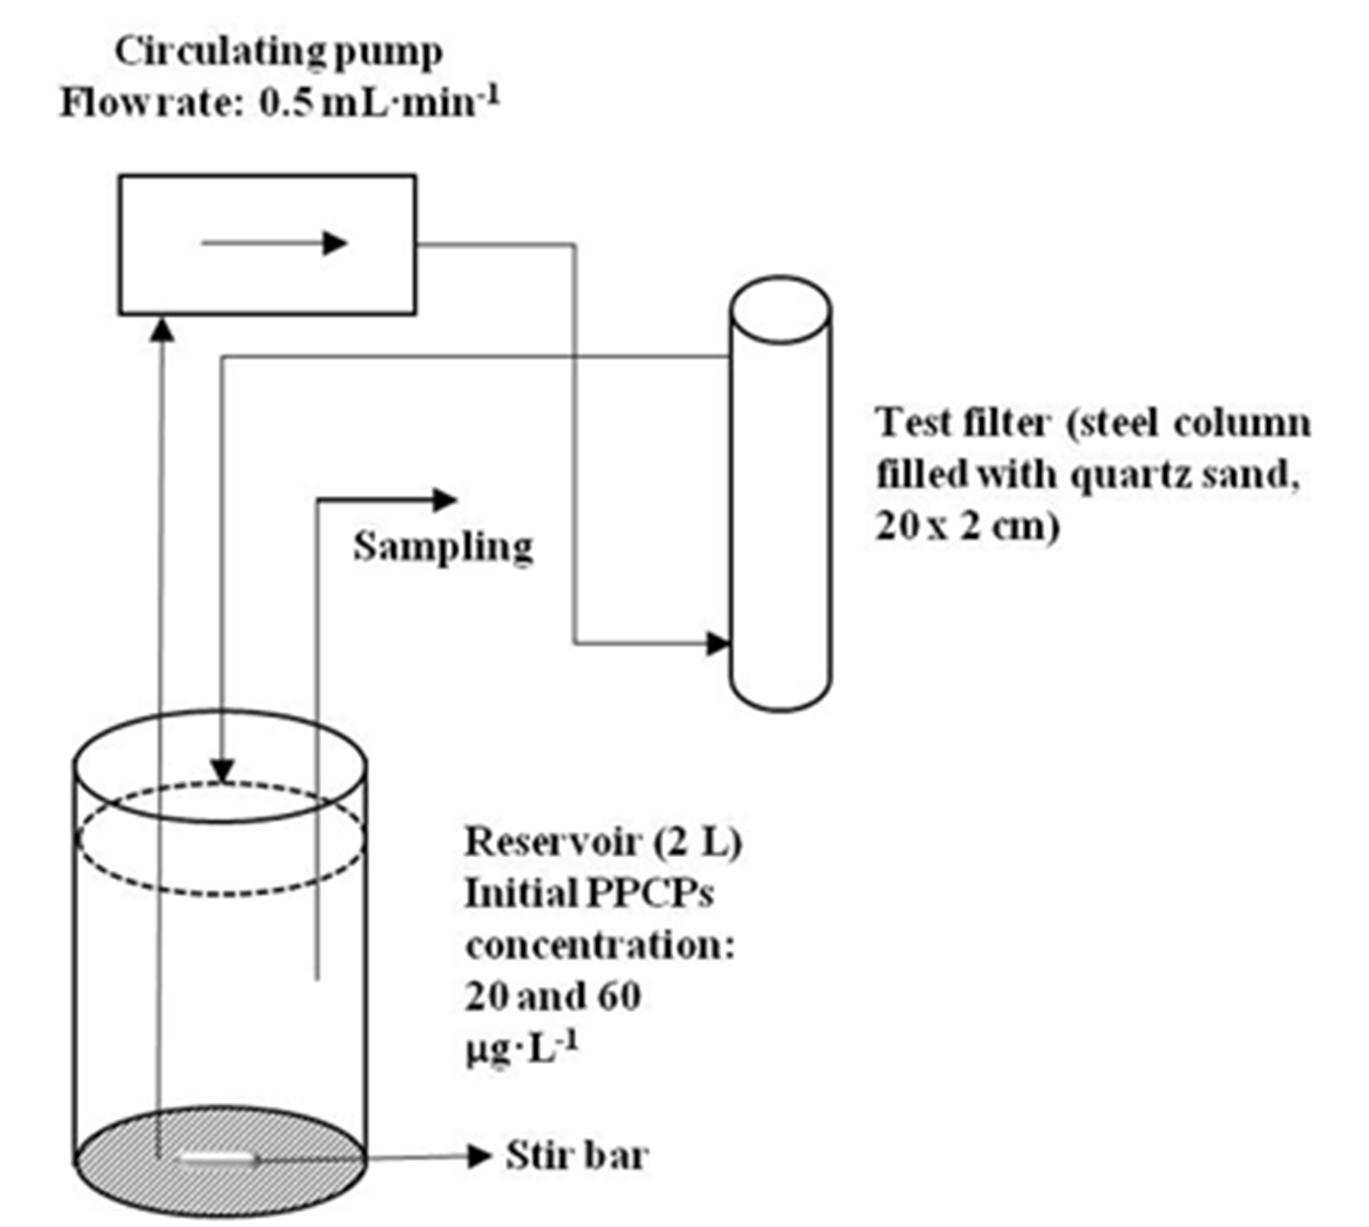

Figure S2. Images of stained samples showing bacteria (coccal and rod forms) and diatoms

Figure S3. Images of native samples showing diatoms present in the biofilm
a) Synedra sp.
b) Cyclotella sp.
c) Melosira sp.

d) Asterionella sp.
e) Nitzschia sp.

