Tribute to Professor Bojan Djordjevic - in honour of his 80th birthday

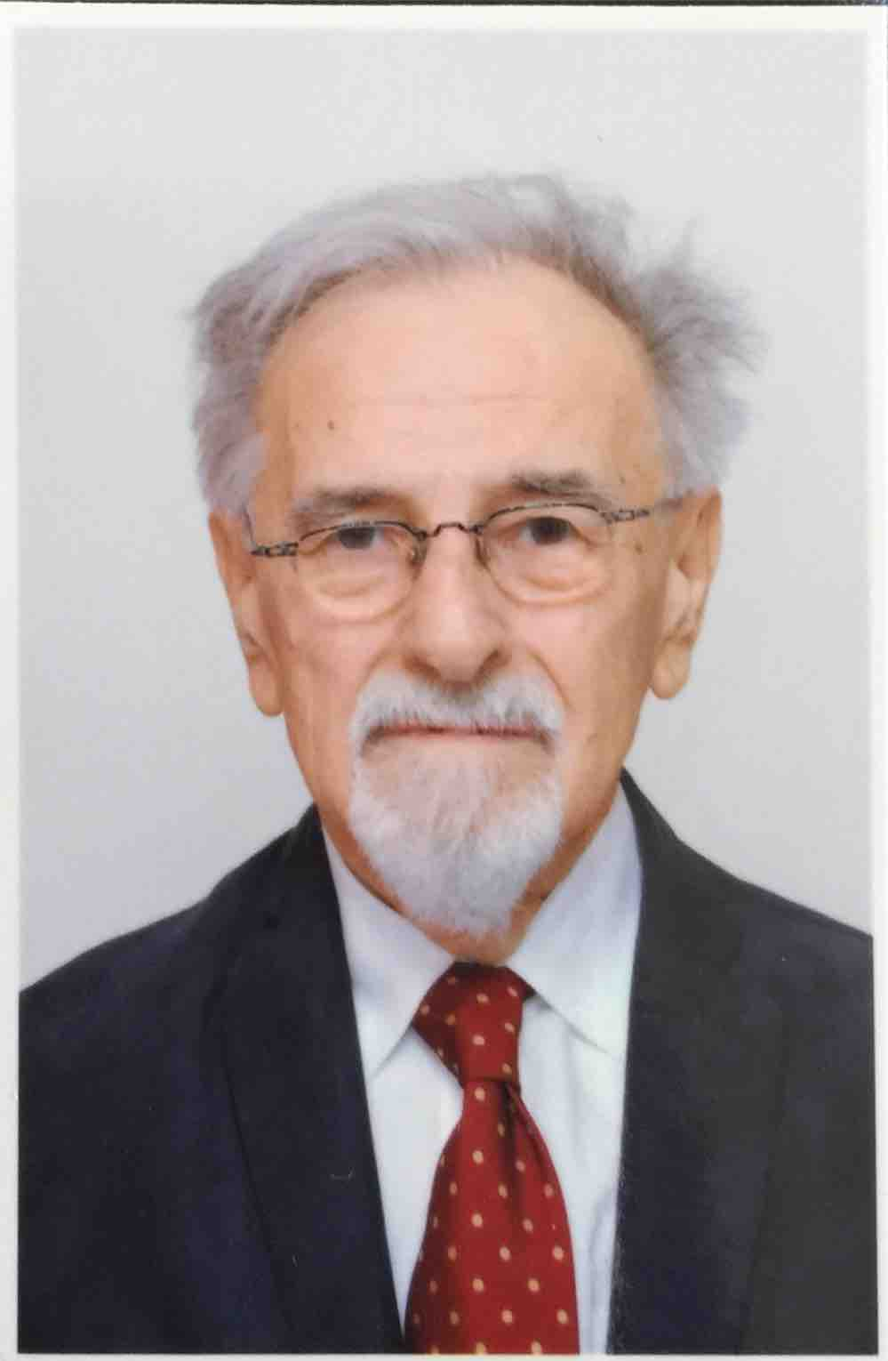

In this issue, Journal of the Serbian Chemical Society wishes to draw attention to Professors Djordjević' reach legacy and superior contribution to the field of thermodynamics in general and to our Journal in particular.
Professor Djordjević has made an exceptional contribution to the field of thermodynamics throughout his career, and has also been graciously involved in supporting the Journal of the Serbian Chemical Society. It is therefore our great pleasure to honour him in this tribute, on the celebration of his 80th birthday.
Prof. Dr. Bojan D. Djordjević was born in 1937 in Belgrade where he graduated from the Faculty of Technology, University of Belgrade in 1961 and commenced his career as Researcher in IHTM, Belgrade. He stayed in IHTM in period from 1961 to 1964. He received his Ph.D. in 1970 from Institute of Nuclear Sciences “Vinča“ and the Faculty of Technology where, in 1971, he was promoted to be an assistant professor and in 1976 to the position of the associate professor.
Since 1982 he had been full professor at the Faculty of Technology and Metallurgy where he had been extensively involved in curricula development and teaching of various subjects of thermodynamics including but not limited to chemical engineering thermodynamics, energy of process industry, and molecular thermodynamics. During his fruitful carrier he also mentored hundreds of graduate students supporting them selflessly to commence their own academic paths. Further, Professor Djordjević lectured different subjects of thermodynamics at many other university centers (Novi Sad; Podgorica; Priština; The Military-Technical Academy, Belgrade; Higher Technical School, Kosovska Mitrovica etc) He is an author of 27 text-books and monographs including Thermodynamics and Thermotechnics, Thermodynamics of Fluids, Chemical Engineering Thermodynamics, and Heat Transfer.
Professor Djordjević was a foundational member of the Laboratory for chemical engineering parameters. In two terms he was the Head of Fundamental Technical Science Department and, also, led a national research projects and sub-projects. He contributed to over 50 technical studies and projects, many of which have been applied in chemical industry (Mineloprema, Pančevo; Oil Refinery, Beograd; Oil Refinery, Pančevo; HIP, Pančevo; Miloje Zakić, Kruševac, Železara, Smederevo etc) and he also established cooperation with Imperial Chemical Industries, United Kingdom and University of Berkley, USA. His research has encompassed a wide range of fundamental areas, with a focus on equations of state, vapour-liquid equilibria, excess properties of solution and thermo-hydraulic design of heat equipment. Professor Djordjevic has also been very active in the Yugoslav Association of Chemists and Technologists. He is a member of Serbian Scientific Society, Serbian Chemical Society and American Chemical Society. He received a number of national and international acknowledgments, awards, plaques and certificates (Men of Achievement for Distinguished Achievement, Cambridge, England, 1982.; 5.000 Personalities of the Word, American Biographical Institute; The International Who’ S Who of Intellectuals, Cambridge, England, 1983.; Certificate of Merit for Distinguished Service To The Community, Cambridge, England, 1984.; Who’s Who in the World 1980/1981; Who’ s Who in the World 1982/1983; Medal for outstanding and long-lasting contribution for development of chemical engineering thermodynamics, Serbian Chemical Society, 2000; Honorary diploma on the 25th anniversary of the Faculty of Technology, University of Novi Sad, for a significant contribution to the work and development of the Faculty of Technology, University of Novi Sad, 1984; Ccertificate as a sign of acknowledgment and gratitude for the great contribution to the work and development of the Serbian Chemical Society on the 100th anniversary of its existence, 1997).
Professor Djordjević authored and contributed to over 100 scientific articles, and to more than hounded scientific papers presented on international and national congresses and symposia, over 30 professional papers and more than 100 articles which were published in international journals, such as: Journal of Chemical Thermodynamic, Fluid Phase Equilibria, Journal of Chemical Engineering Data, Chemical Engineering Science, AIChE Journal, Canadian Journal of Chemical Engineering, Industrial & Engineering Chemistry Process Design and Development, Industrial & Engineering Chemistry Research, Thermochimica Acta, Physics and Chemistry of Liquids, Chemie Ingenieur Technik, Korean Journal of Chemical Engineering., Journal of Applied Polymer Science, Hungarian Journal of Industrial Chemistry, Chemische Technik, Journal of Chemical Education etc.
Being internationally recognized and respected, Professor Djordjević was cited over 500 times in the international journals, university textbooks and monographs. He was a referee in the leading international and national journals and congresses and was a member of editorial boards of the Journal of the Serbian Chemical Society and Chemical Industry.
Finally, by being a member of Editorial Board of the Journal of the Serbian Chemical Society for more than 30 years and publishing more than 40 scientific papers in this journal, professor Djordjević provided an outstanding contribution to Journal of the Serbian Chemical Society development and reputation as well.
We join in wishing him well in the future and thanking him for all the work and the high standards he set for all of us.
Professor Mirjana Kijevčanin,
Faculty of Technology and Metallurgy, University of Belgrade
Associate Professor Ivona Radović,
Faculty of Technology and Metallurgy, University of Belgrade
Professor Slobodan Šerbanović,
Faculty of Technology and Metallurgy, University of Belgrade

