SUPPLEMENTARY MATERIAL TO
Microwave assisted synthesis of 1H-tetrazole based flavonoid derivatives and their antimicrobial activity
DONGAMANTI ASHOK *, NALAPARAJU NAGARAJU¹, MADDERLA SARASIJA² and
B.VIJAYA LAKSHMI¹.
¹Green and Medicinal Chemistry Laboratory, Department of Chemistry, Osmania University, Hyderabad, 500007, Telangana, India; ²Department of Chemistry, Satavahana University, Karimnagar, Telangana 505001.

¹H NMR, ¹³C NMR, MASS AND IR OF COMPOUNDS
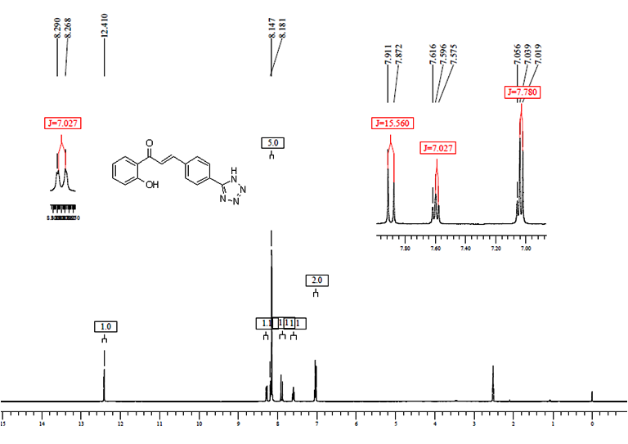
Figure S1: ¹H-NMR (400 MHz, DMSO-d₆) of Compound 4a
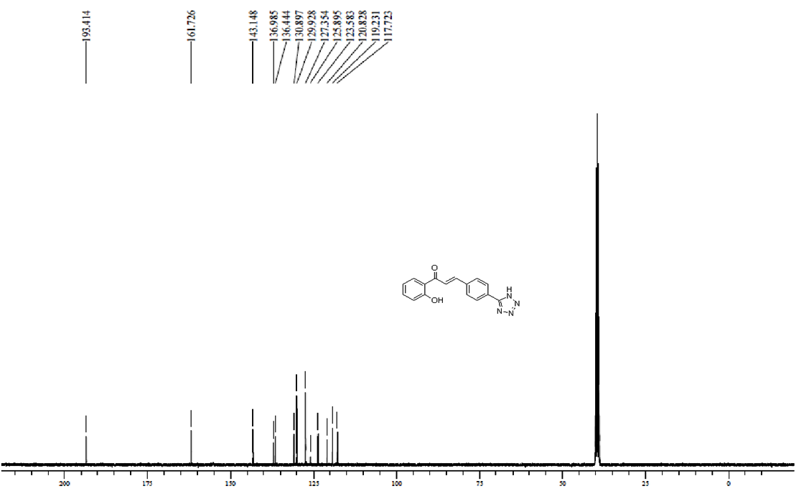Figure S2: ¹³C-NMR (100 MHz, DMSO-d₆) of Compound 4a

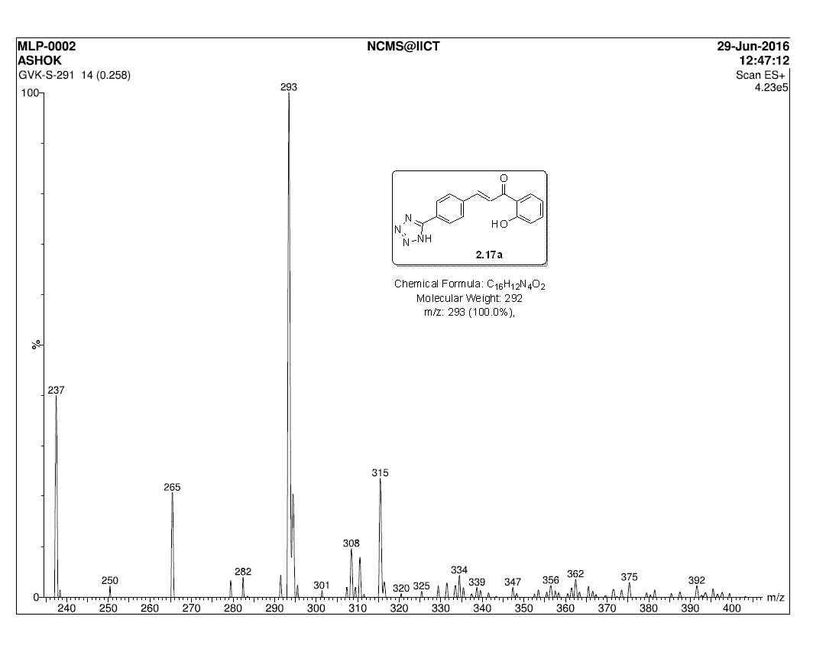Figure S3: Mass spectrum of Compound 4a

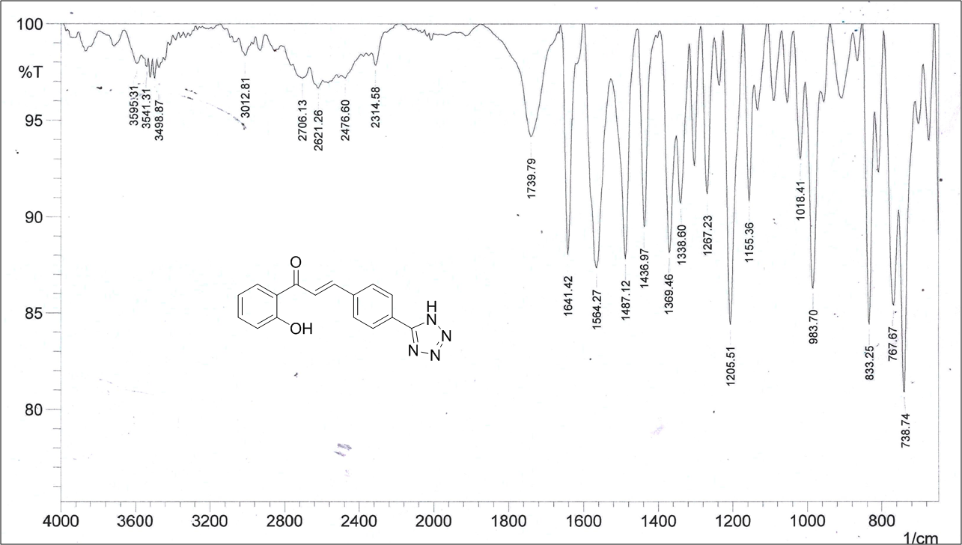Figure S4: IR spectrum of Compound 4a

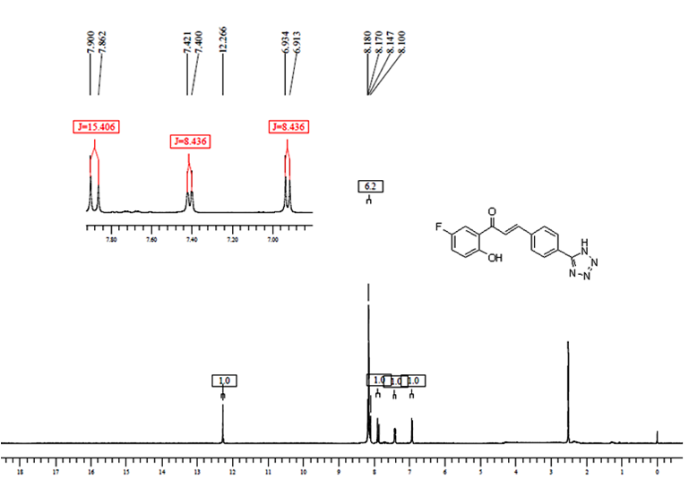Figure S5: ¹H-NMR of Compound 4b

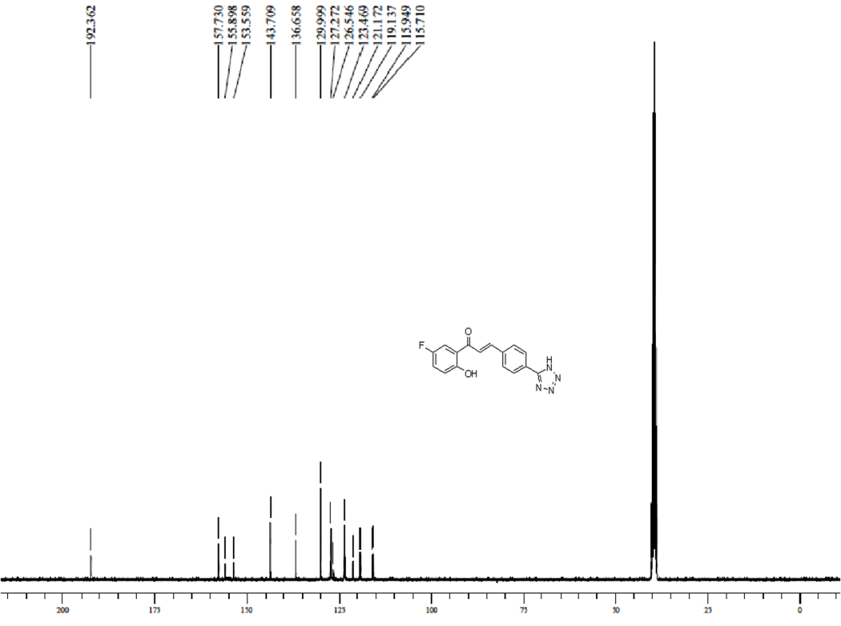
Figure S6: ¹³C-NMR of Compound 4b

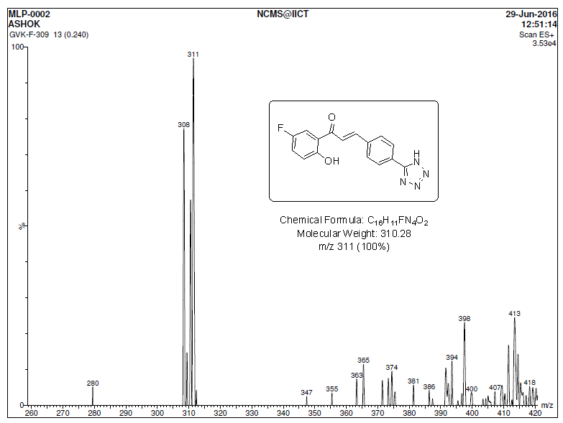
Figure S7: Mass spectrum of Compound 4b

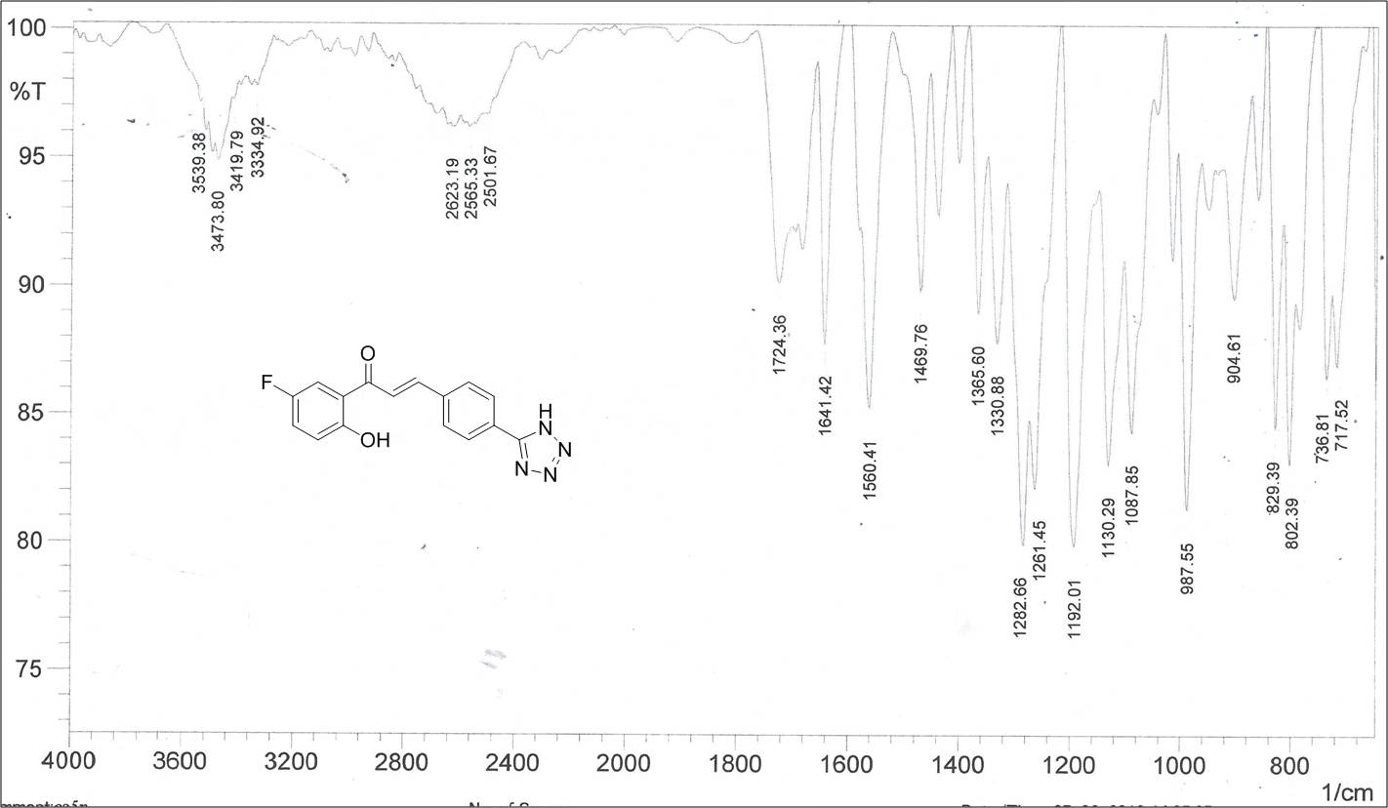
Figure S8: IR spectrum of Compound 4b

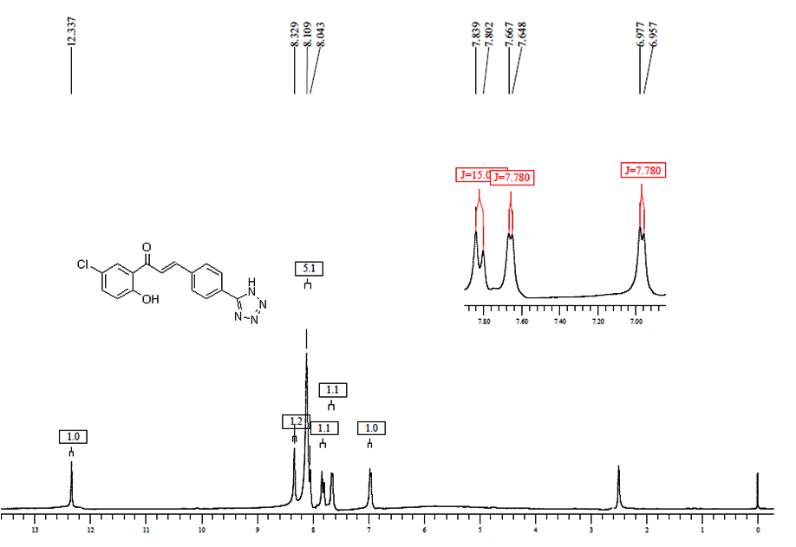Figure S9: ¹H-NMR of Compound 4c

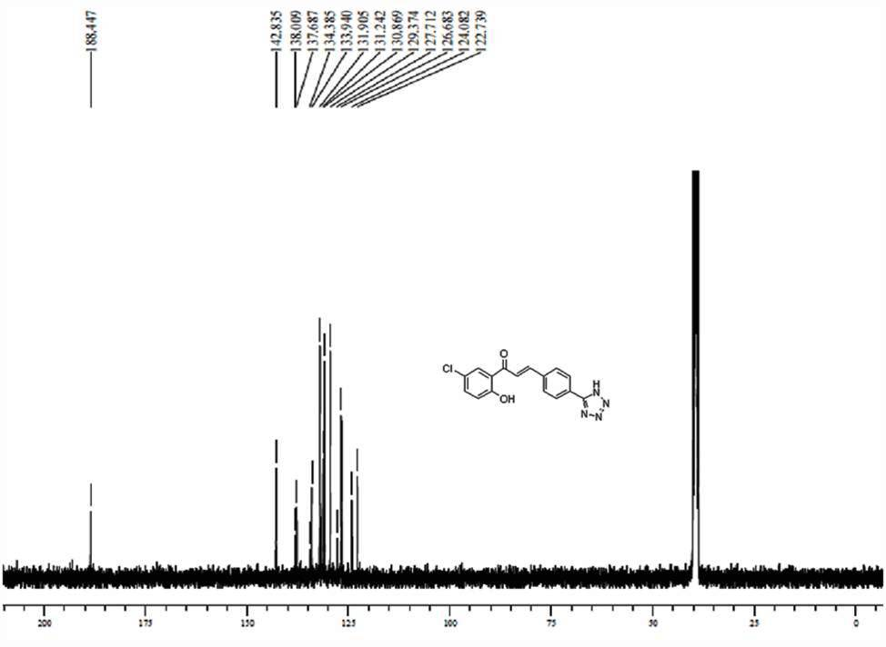
Figure S10: ¹³C-NMR of Compound 4c

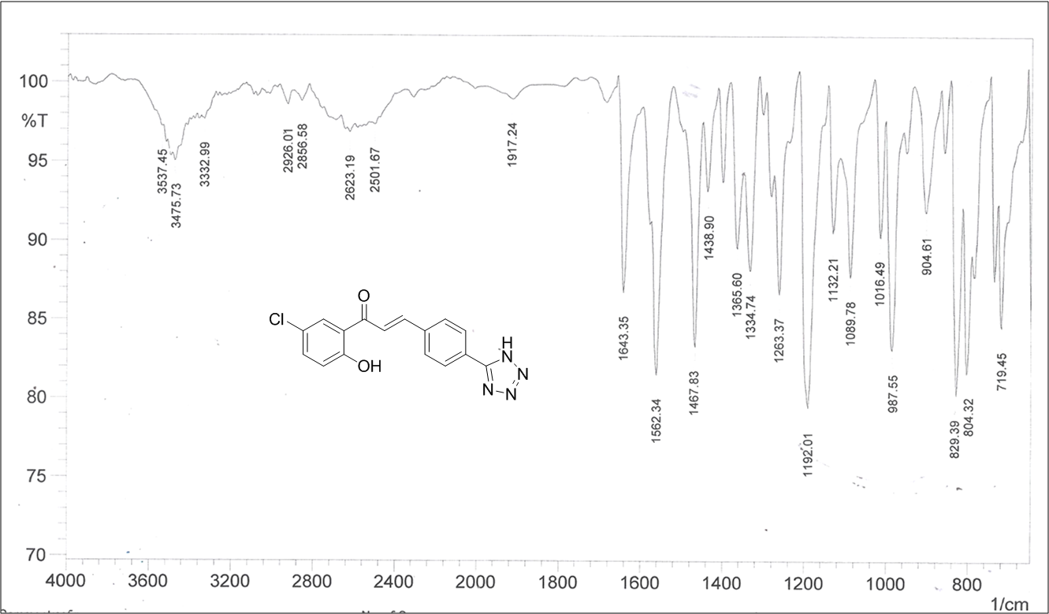
Figure S11: IR spectrum of Compound 4c

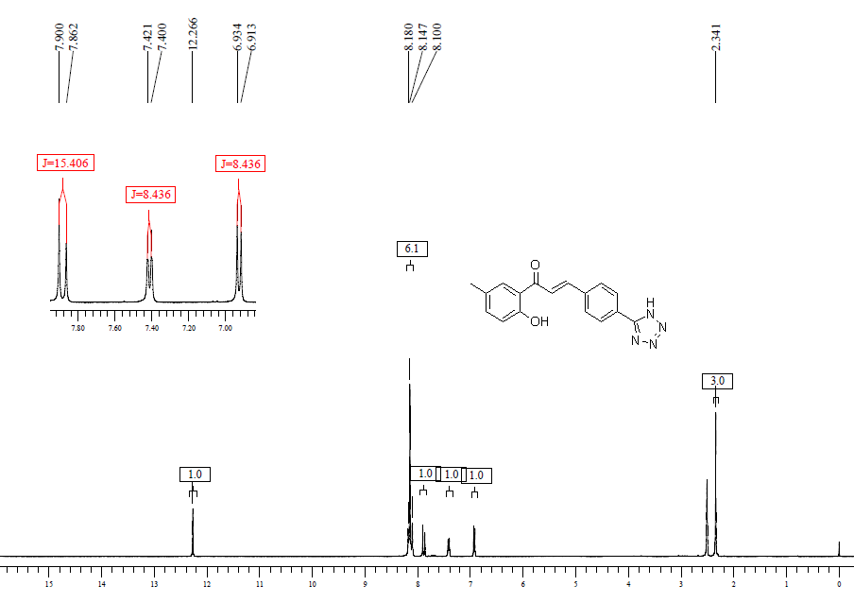Figure S12: ¹H-NMR spectrum of Compound 4d

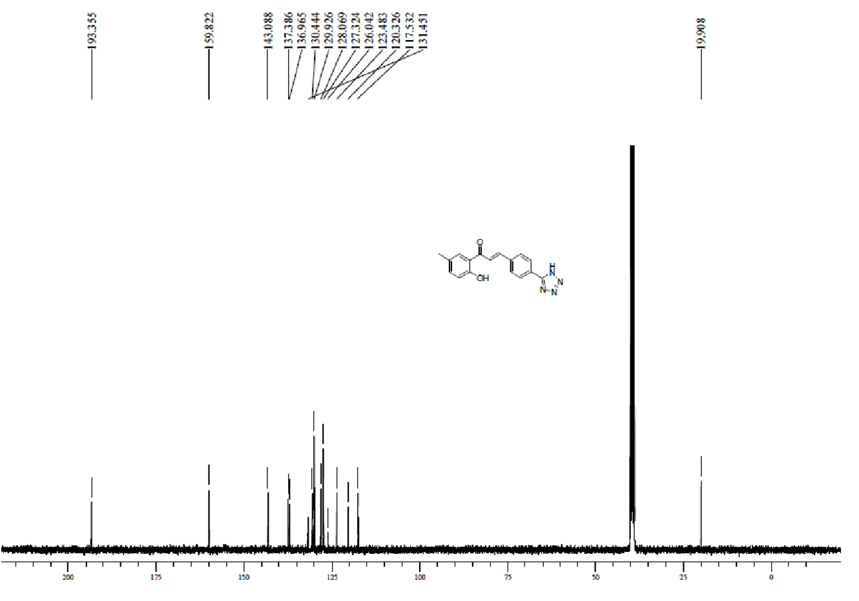Figure S13: ¹³C-NMR spectrum of Compound 4d

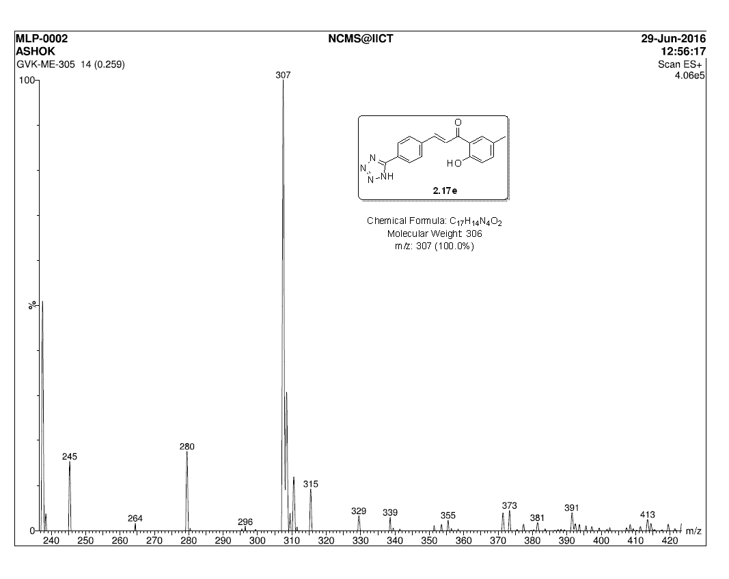
Figure S14: Mass spectrum of Compound 4d

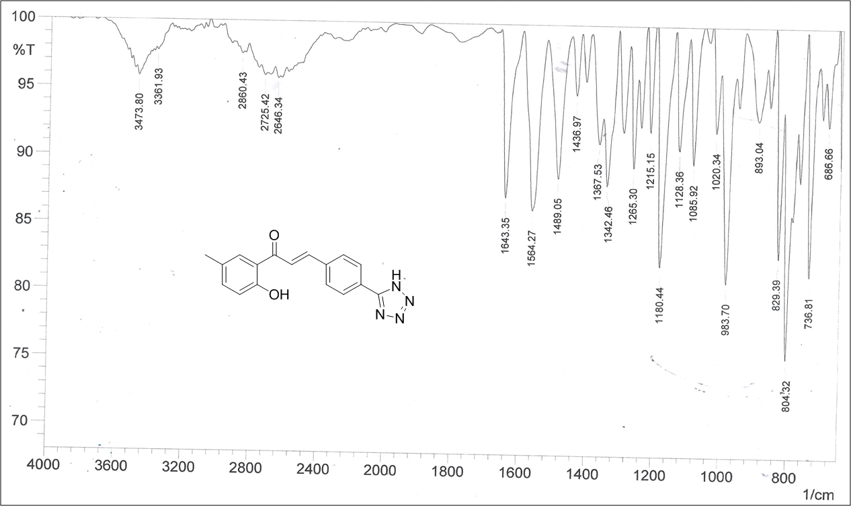
Figure S15: IR spectrum of Compound 4d

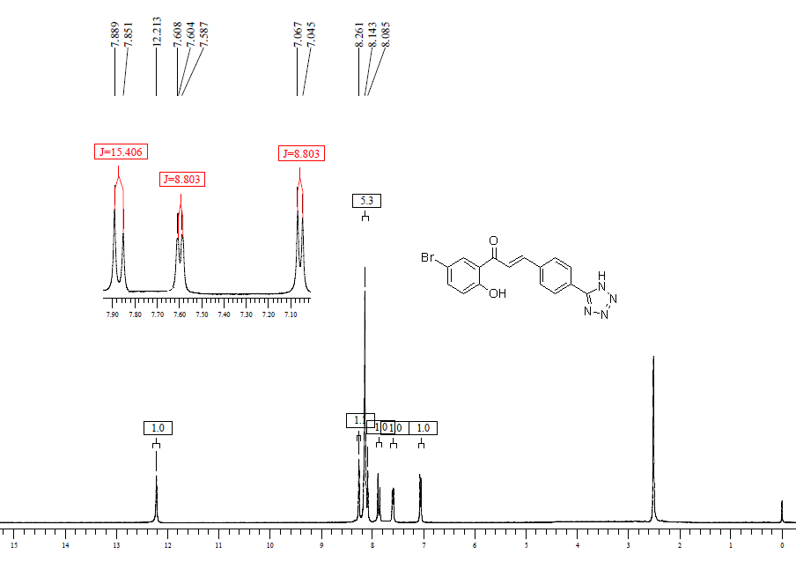
Figure S16: ¹H-NMR spectrum of Compound 4e

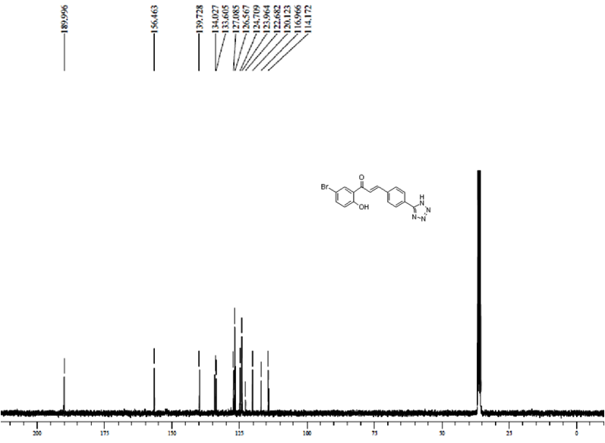
Figure S17: ¹³C-NMR spectrum of Compound 4e

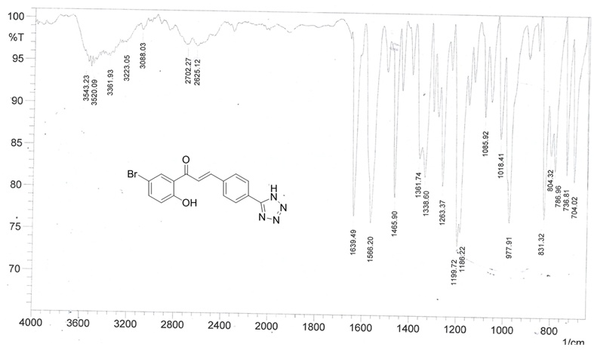
Figure S18: IR spectrum of Compound 4e

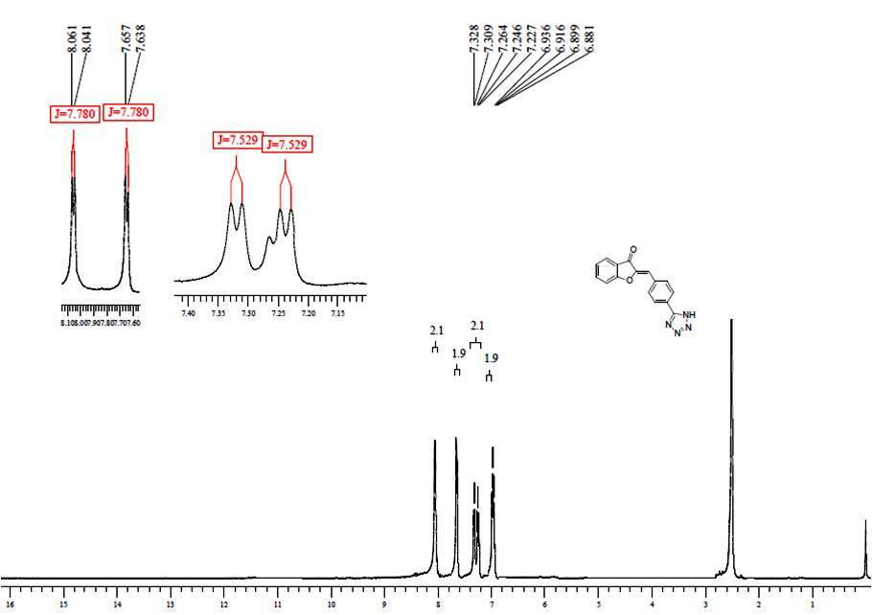
Figure S19: ¹H-NMR spectrum of Compound 5a

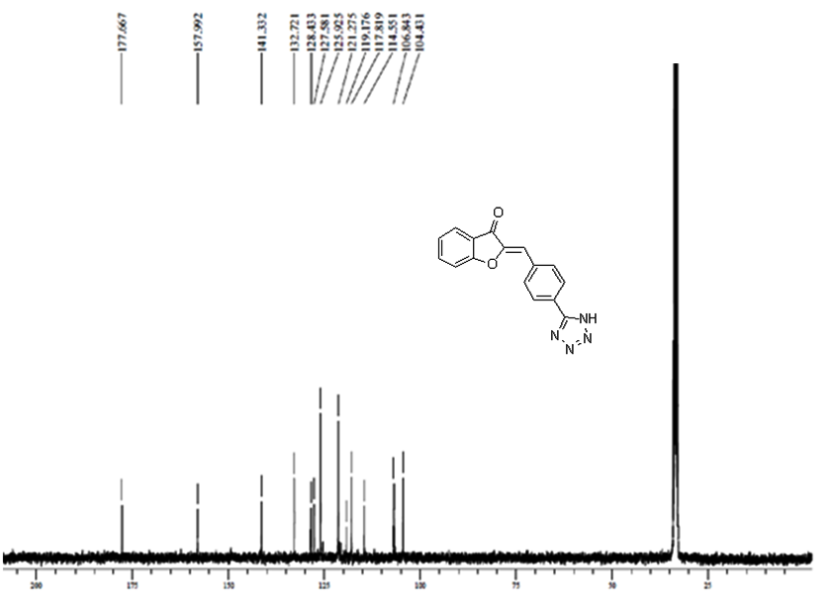
Figure S20: ¹³C-NMR spectrum of Compound 5a

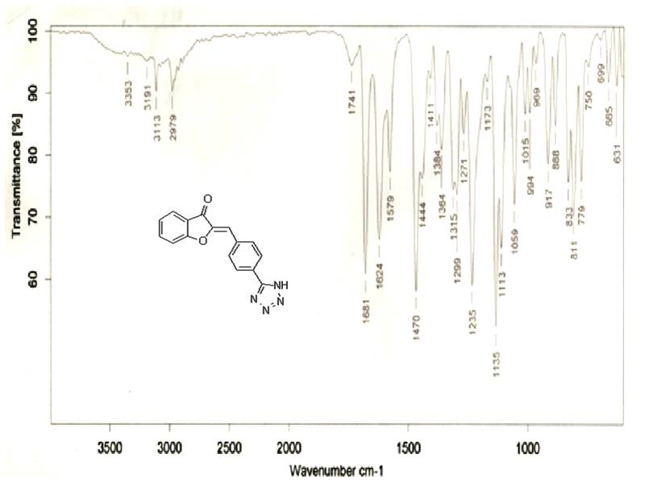
Figure S21: IR spectrum of Compound 5a
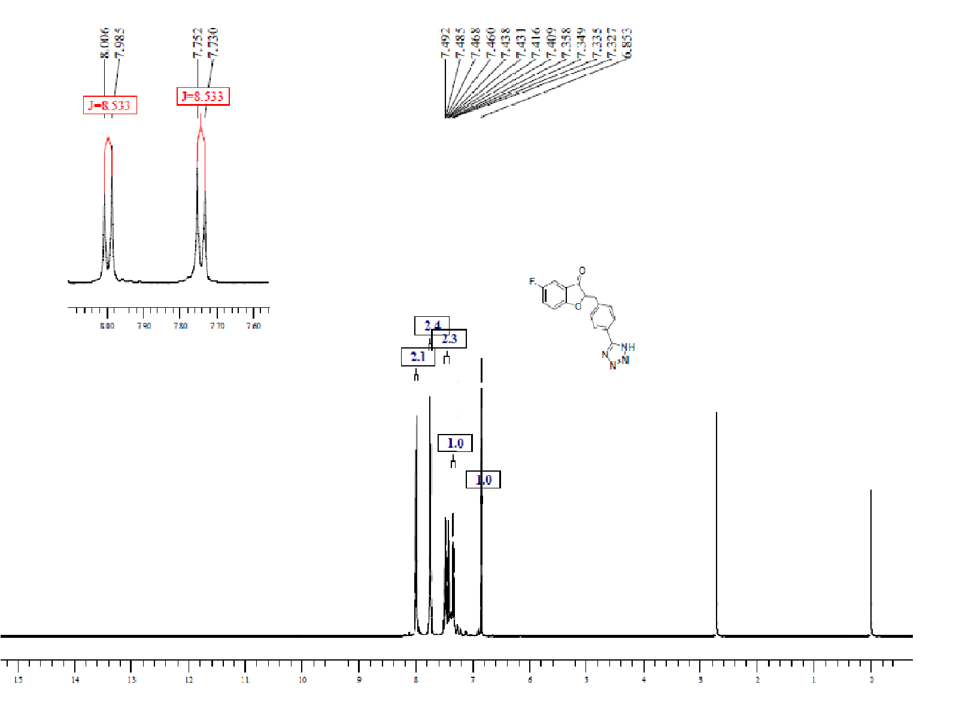
Figure S22: ¹H-NMR spectrum of Compound 5b

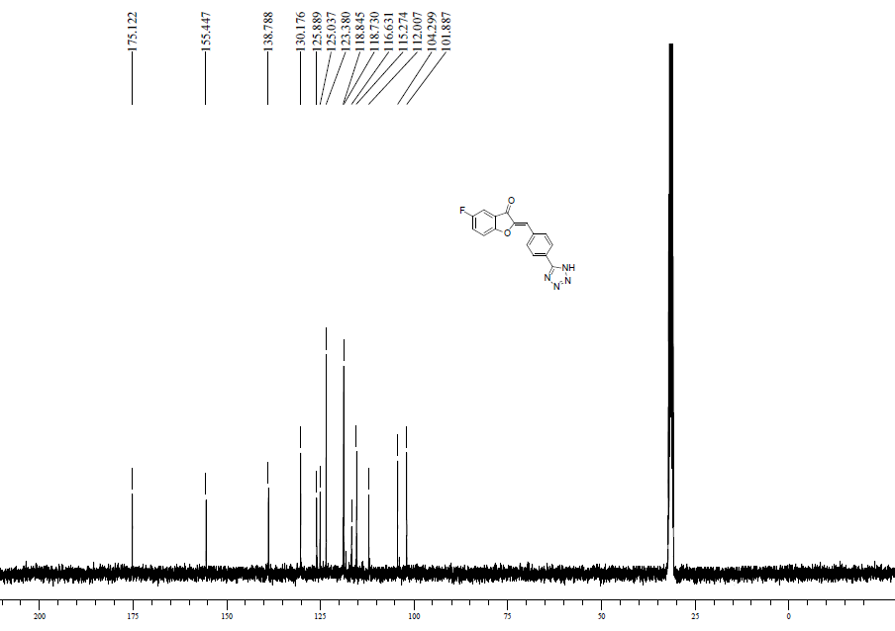
Figure S23: ¹³C-NMR spectrum of Compound 5b

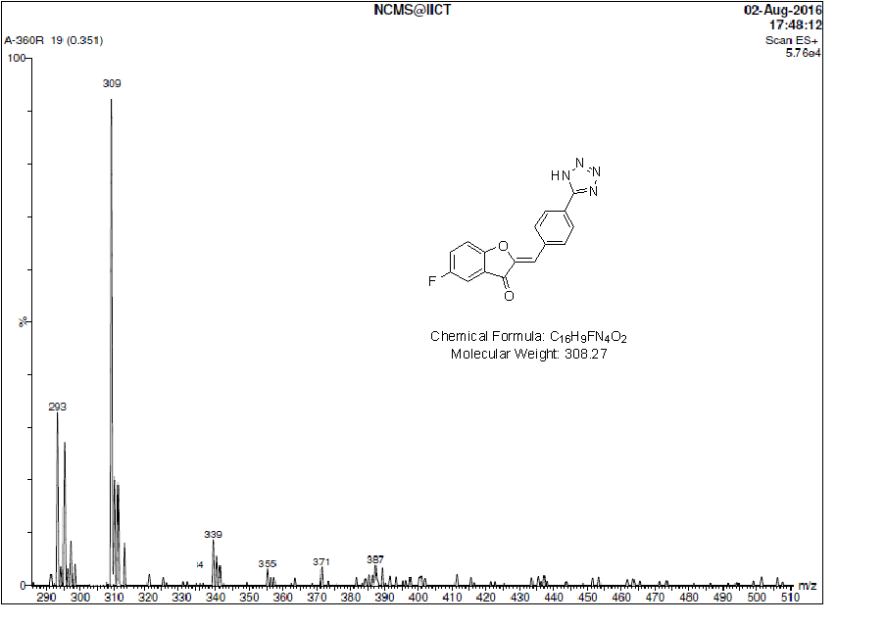
Figure S24: Mass spectrum of Compound 5b

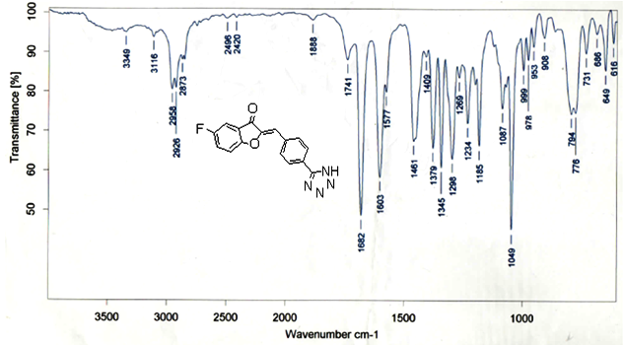
Figure S25: IR spectrum of Compound 5b
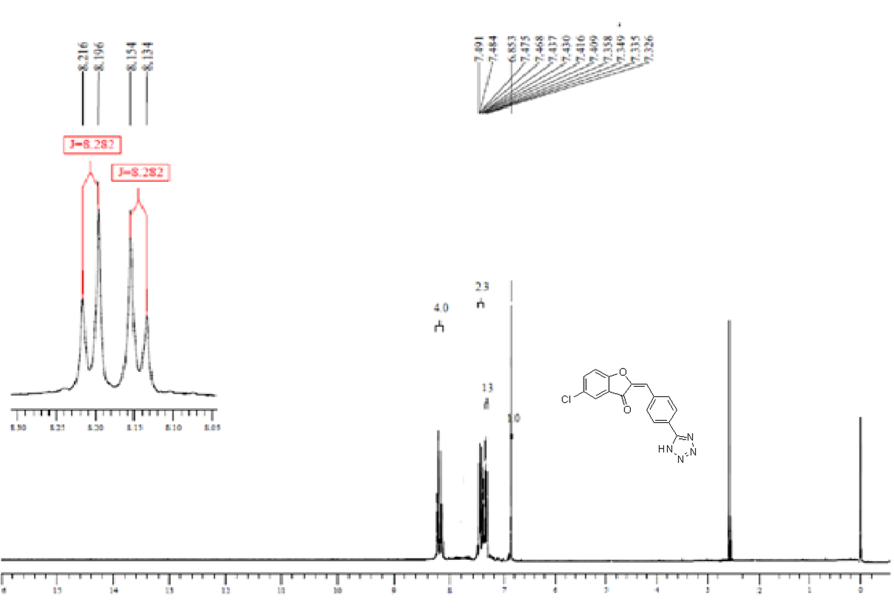
Figure S26: ¹H-NMR spectrum of Compound 5c

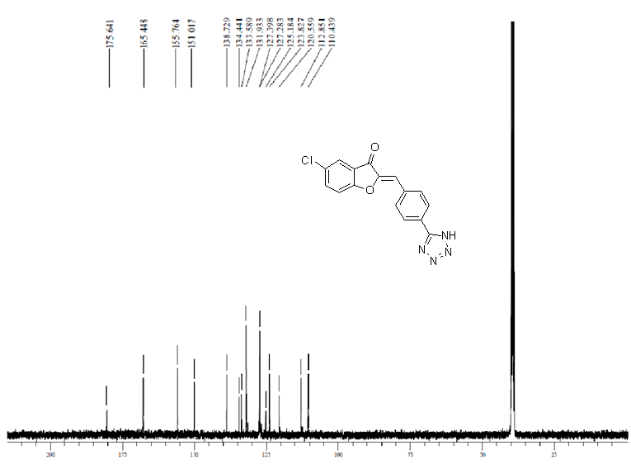Figure S27: ¹³C-NMR spectrum of Compound 5c

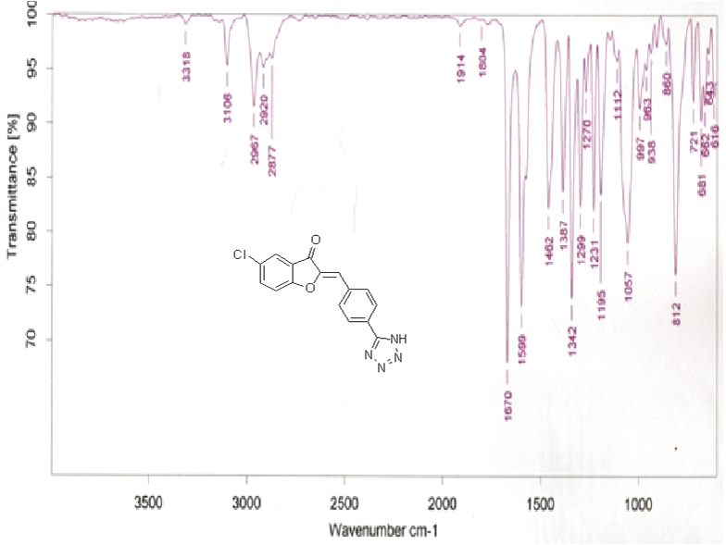
Figure S28: IR spectrum of Compound 5c

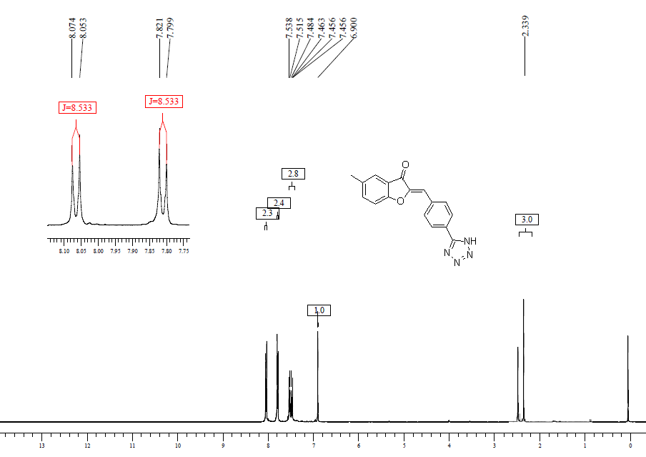
Figure S29: ¹H-NMR spectrum of Compound 5d

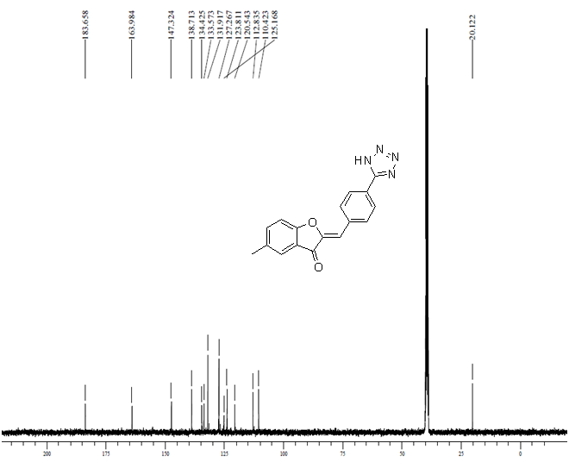
Figure S30: ¹³C-NMR spectrum of Compound 5d

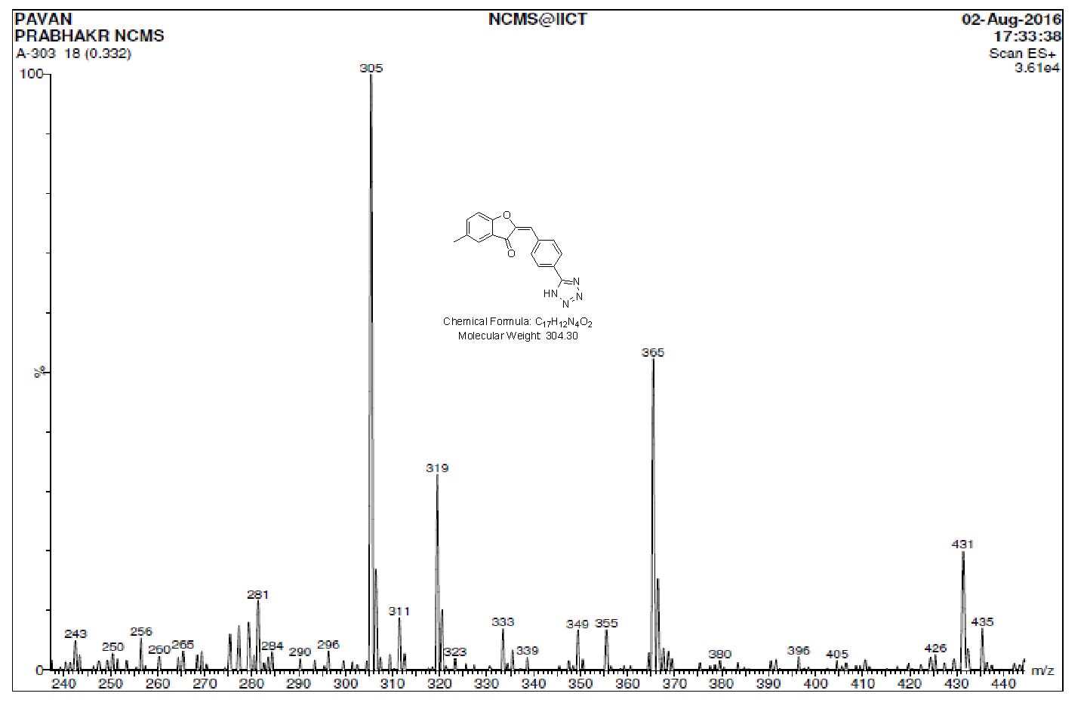
Figure S31: Mass spectrum of Compound 5d
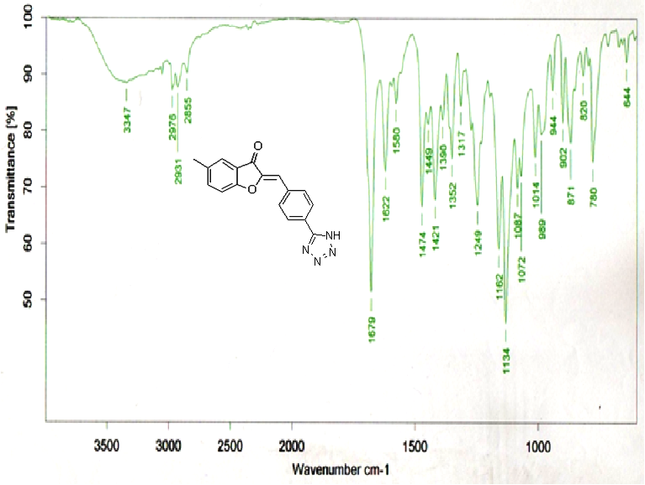
Figure S32: IR spectrum of of Compound 5d

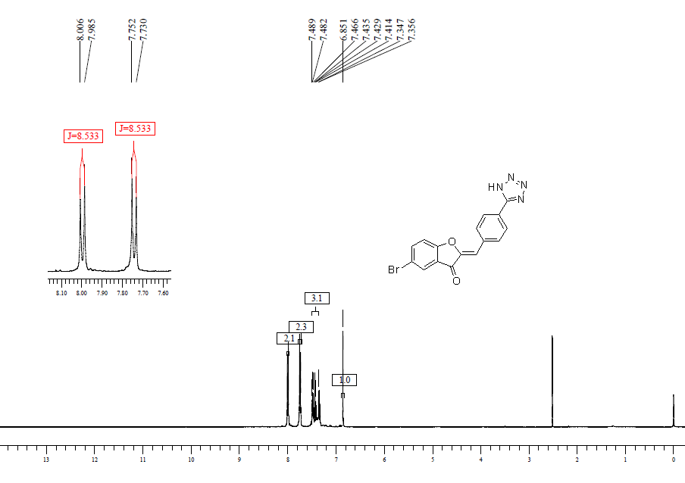
Figure S33: ¹H-NMR spectrum of Compound 5e
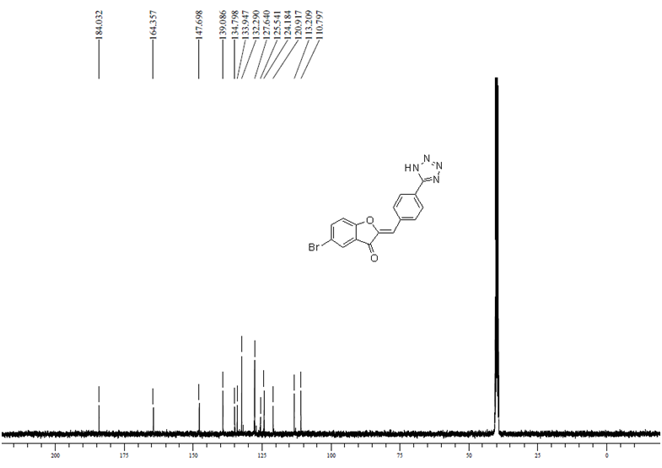
Figure S34: ¹³C-NMR spectrum of Compound 5e

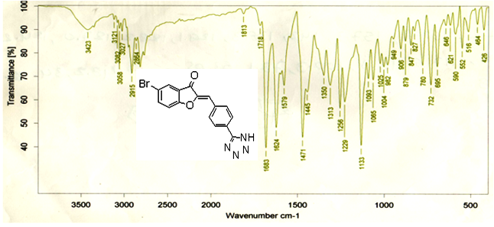
Figure S35: IR spectrum of Compound 5e

* Corresponding author. E-mail: ashokdou@gmail.com

