Supplementary Material
Nitrogen-modified nanoporous activated carbon from eucalyptus leaves for ultrasound-assisted removal of basic dyes using derivative spectrophotometric method

AISAN KHALIGH ^{1*}, HASSAN ZAVVAR MOUSAVI¹, ALIMORAD RASHIDI² and HAMID SHIRKHANLOO³

¹ Department of Chemistry, Semnan University, Semnan 35131-1911, Iran.
² Nanotechnology Research Center, Research Institute of Petroleum Industry (RIPI), West Entrance Blvd., Olympic Village, Tehran 14857-33111, Iran.
³ Research Institute of Petroleum Industry (RIPI), West Entrance Blvd., Olympic Village, Tehran 14857-33111, Iran

*Corresponding author: A. Khaligh; Tel: +98 23 3366194; Fax: +98 23 3354110.
E-mail address: akhalighv@gmail.com

FT-IR analysis of the pristine and modified AC samples
FT-IR spectra of modified AC samples were shown in Figs. S-1(a)-(b). For oxidized AC (Fig. S-1a), the peak at 3430 cm⁻¹ is attributed to O–H stretching vibrations of the absorbed water molecules and structural OH groups (phenol, alcohol, and carboxylic acid). The peak at 1725 cm⁻¹ is related to C=O stretching in ketones and carboxylic acids and the peak at 1705 cm-1 is associated to C=O stretching in lactones. The broad peak at 1100 cm⁻¹ is corresponded to C-O stretching vibrations. The two bands at 2850–2950 cm⁻¹ and the peak at 1628 cm⁻¹ are assigned to C–H and C=C stretching vibrations, respectively. As shown in Fig. S-1b, for nitrogen-modified AC, the -NH₂ and –OH groups were indicated by the peaks at 3330 cm⁻¹ and 3444 cm⁻¹, respectively. The peaks at 1150 cm⁻¹ and 1220 cm⁻¹ were attributed to -C-N (aliphatic and aromatic) stretching vibration. As can be seen from this Figure, most of the carboxylic acid groups were eliminated from the surface of OAC by urea treatment of this sample; this is reflected by disappearance of the 1725 cm⁻¹ band in the spectrum of NOAC sample, which exists in the spectra of the oxidized AC sample.
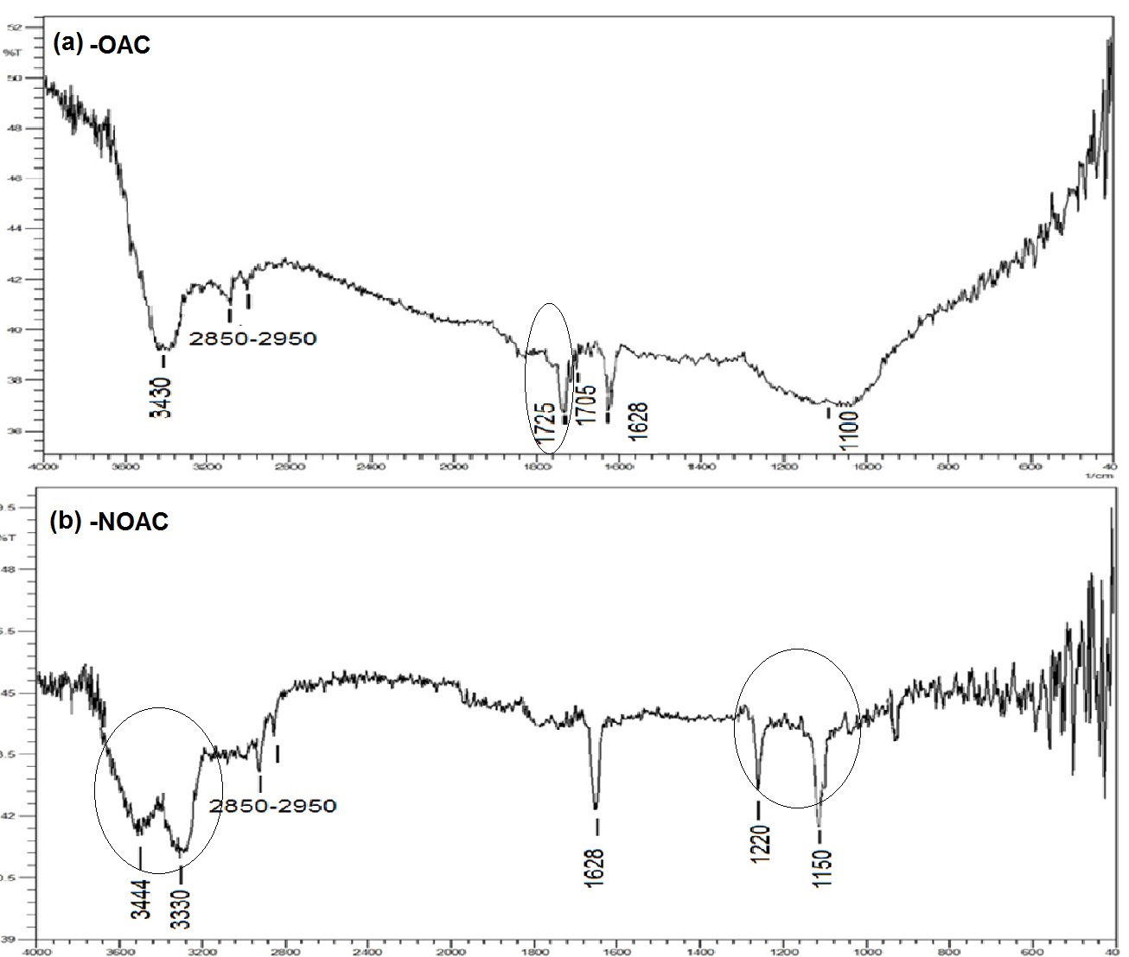
Fig. S-1. FTIR spectra of (a) oxidized AC and (b) nitrogen-modified AC.

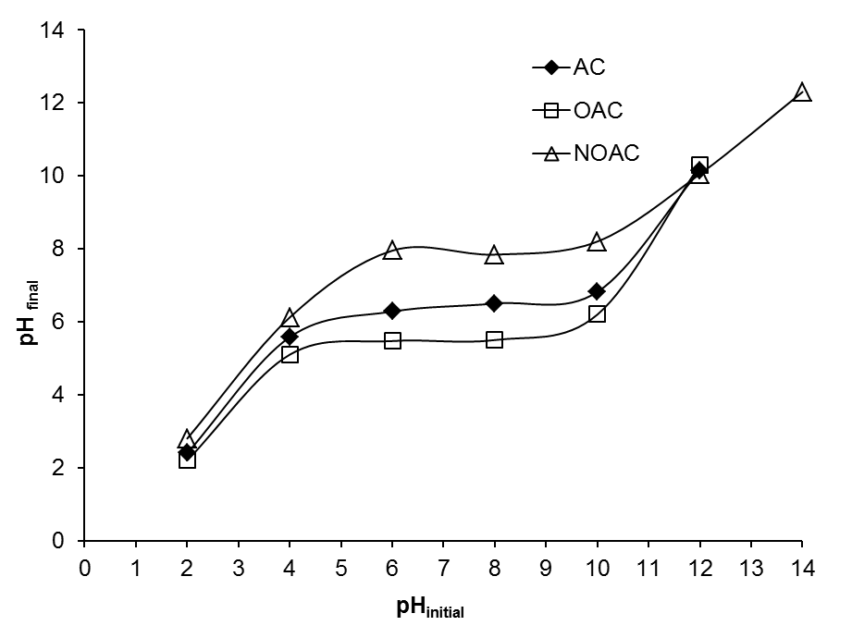
Fig. S-2. Final pH versus initial pH plots for pristine, oxidized and nitrogen modified AC samples.

Fig. S-3. First order derivative spectra of BR46 and BY13 in binary solutions in the range of 5–20 mg L⁻¹ of each two dyes concentration.

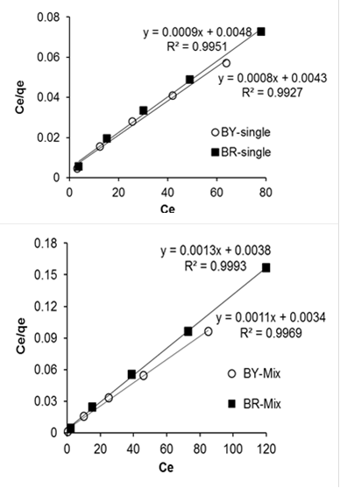
Fig. S-4. Langmuir plots for the adsorption of BY13 and BR46 dyes onto NOAC in single and binary dye solutions (V_{solution}=100 mL, C_{single}=200=400 mg L⁻¹, C_{mix}=150-300 mg L⁻¹, pH=9, m=30 mg, t= 8 min, T=25 ºC).

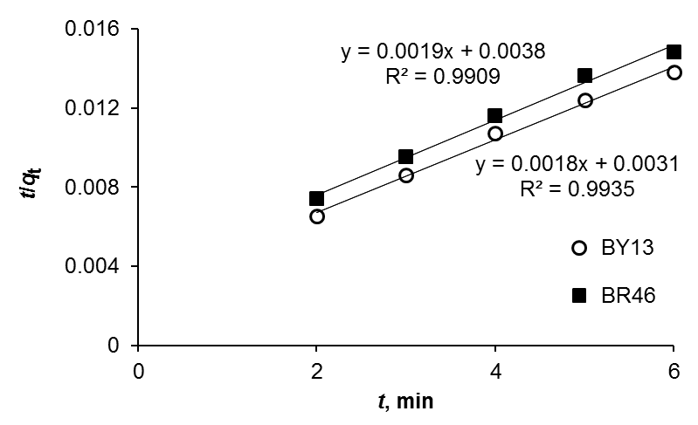
Fig. S-5. Pseudo-second order kinetic plots for the adsorption of BY13 and BR46 dyes onto NOAC in binary dye solution (100 mL of 150 mg L⁻¹ dyes solution, pH=9, m=30 mg, t= 2-6 min, T=25 ºC).

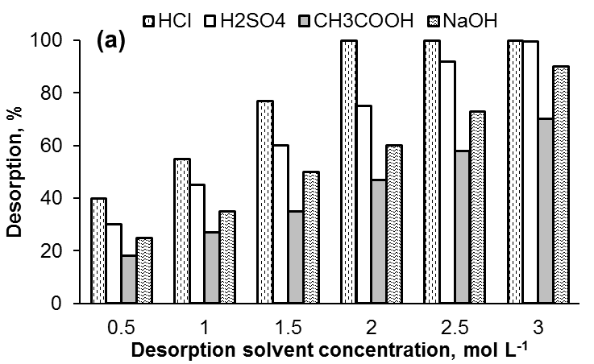

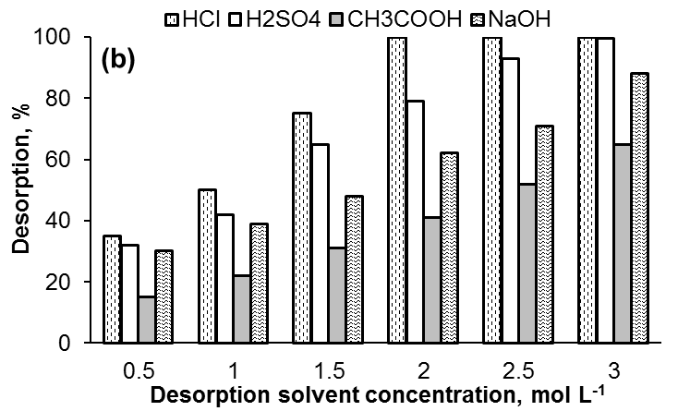

Fig. S-6. Effect of solvent type and concentration on the desorption of (a) BY13 and (b) BR46 dyes from loaded NAC (desorption solvent volume 100 mL, spent NOAC=30 mg, t=8 min, T=25 ºC).

TABLE S-1. Chemical structure and properties of basic dyes used in this study.
Chemical structure | Commercial name | C. I. number | λ_{max} | Molecular weigth, g mol⁻¹
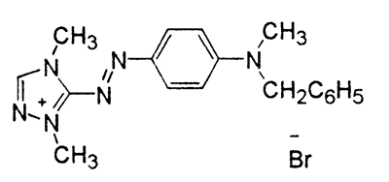 | Basic Red 46 | 110825 | 530 | 401.3
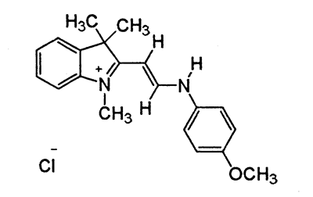 | Basic Yellow 13 | 48056 | 411 | 342.86

TABLE S-2. Initial dye concentrations in single and binary systems.
Single system |  |  | Binary System (1) |  |  | Binary System (2)
C₀, _{BR46} /  mg L⁻¹ | C₀, _{BY13} /  mg L⁻¹ |  | C₀, _{BR46} /  mg L⁻¹ | C₀, _{BY13} /  mg L⁻¹ |  | C₀, _{BR46} /  mg L⁻¹ | C₀, _{BY13} /  mg L⁻¹
200-400 | 200-400 |  | - 150-350  - 150 | - 150  - 150-350 |  | 150-350 | 150-350

TABLE S-III. Determination of percentage recovery and error values for BR46 and BY13 in binary mixture by zero and first order derivative spectra methods.
Error, % |  |  | Recovery, % |  |  | C_{m} / mg L⁻¹ |  |  | C_{t} / mg L⁻¹
C_{BR} | C_{BY} |  | C_{BR} | C_{BY} |  | C_{BR} | C_{BY} |  | C_{BR} | C_{BY}
+1.20 | -3.40 |  | 101.20 | 96.60 |  | 5.06 | 4.83 |  | 5 | 5
+2.5 | -2.75 |  | 102.50 | 97.25 |  | 8.20 | 7.78 |  | 8 | 8
-3.50 | +2.00 |  | 96.50 | 102.00 |  | 9.65 | 10.20 |  | 10 | 10
-2.00 | -1.20 |  | 98.00 | 101.20 |  | 14.70 | 15.18 |  | 15 | 15
-3.33 | -4.22 |  | 96.67 | 95.78 |  | 17.40 | 17.24 |  | 18 | 18
+1.90 | +1.25 |  | 101.90 | 101.25 |  | 20.38 | 20.25 |  | 20 | 20

TABLE S-IV. R_{L} values for BY13 and BR46 dyes in single and binary solutions.
C₀ / mg L⁻¹ | R_{L} of BY13 |  | R_{L} of BR46
 | Single | Binary | Single | Binary
150 | ----- | 0.020 | ----- | 0.020
200 | 0.026 | 0.015 | 0.026 | 0.014
250 | 0.021 | 0.012 | 0.020 | 0.011
300 | 0.018 | 0.010 | 0.017 | 0.009
350 | 0.015 | 0.008 | 0.015 | 0.008
400 | 0.013 | ----- | 0.013 | -----

