**Response to Reviewers Question**

Reviewers questions are given in black color, responses to the reviewers question are given in the red color and the changes in the manuscript are given in blue color.

**Referee 1**

**Major issue:**

**Question 1:** Figures 4, 5 and 6 miss SD. What was the number of experiments performed?

**Response:** Thanks for the comment. We repeated the experiments three times, and the average value along with the standard deviation is reported in the revised manuscript. As we have included the SEM image as Fig. 1, Fig. 4, 5 and 6 is numbered as Fig. 5, 6 and 7 in the revised manuscript. Also, we have included the SD in Fig. 8 and 9 in the revised manuscript.

**Changes in the manuscript:** We have included the SD in Figures 4, 5, 6, 7 and 8 in the revised manuscript.

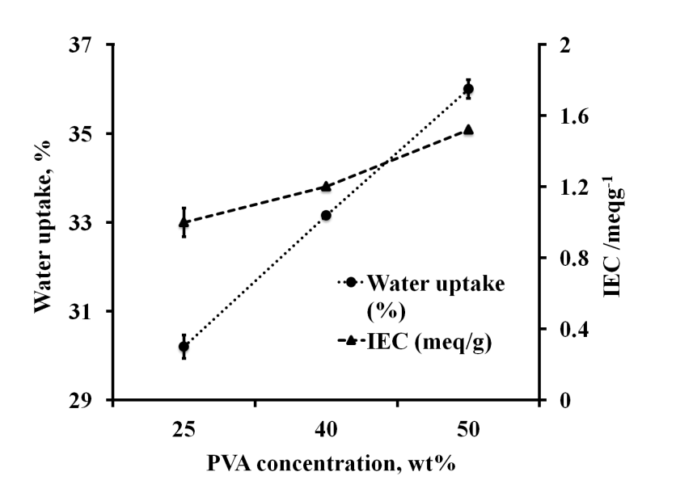

Fig 4. Water uptake (%) and IEC (meq/g) vs. % PVA concentration (wt %) of membranes.

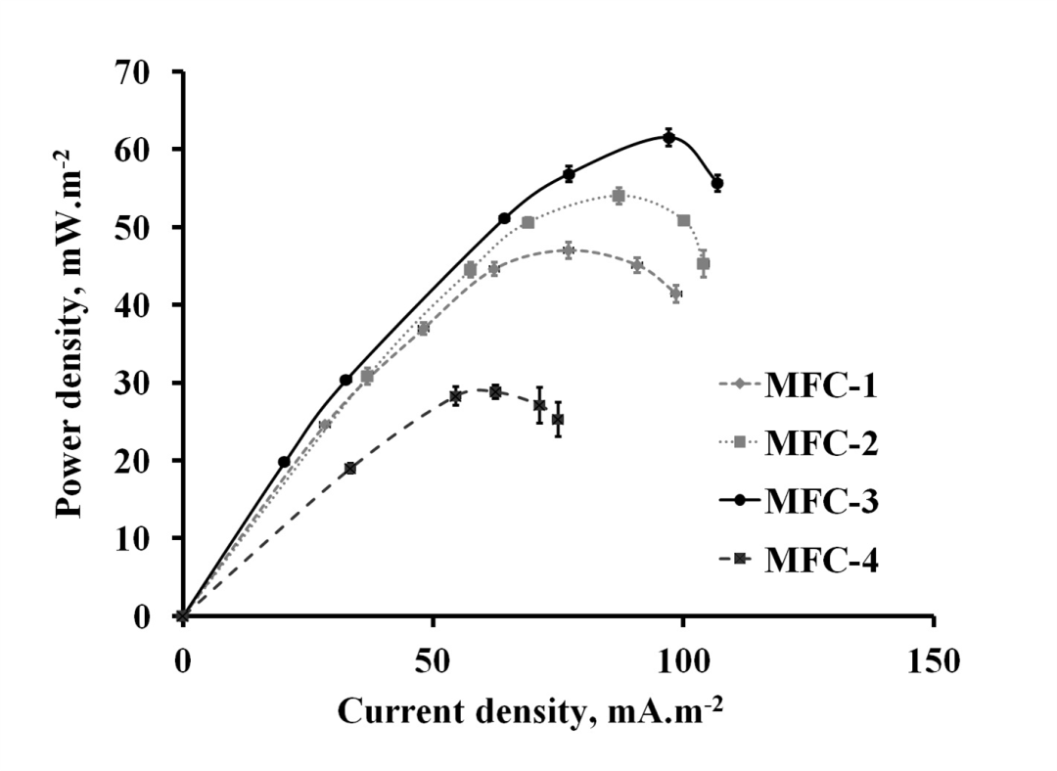

Fig. 5. Power density curves of synthesized membranes and Nafion 117 membrane in MFCs setups.

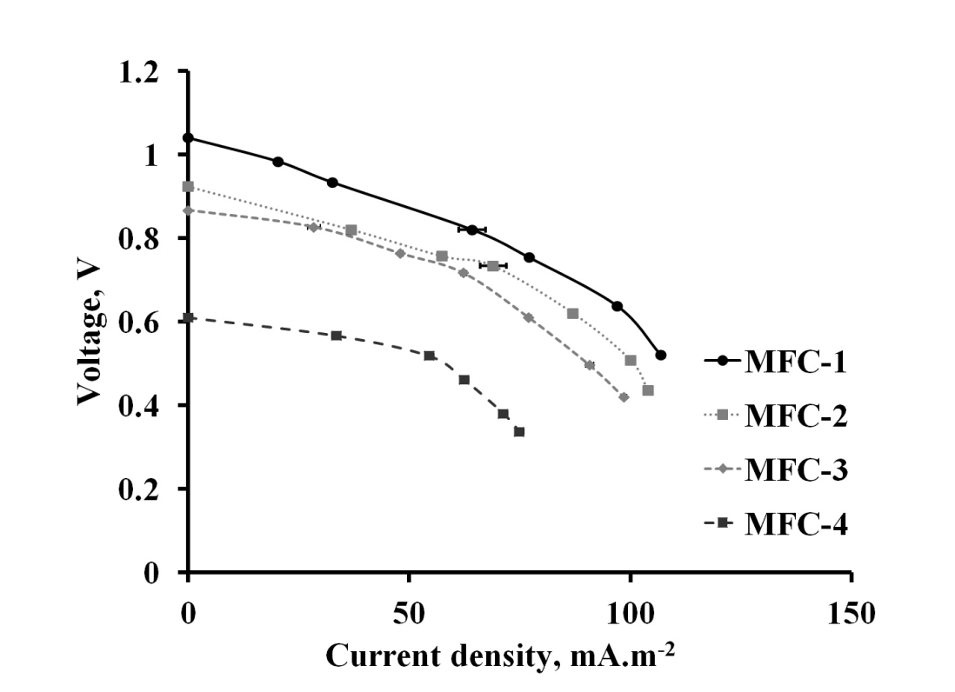

Fig. 6. Polarization curves of synthesized membranes and Nafion 117 membrane in MFCs setups.

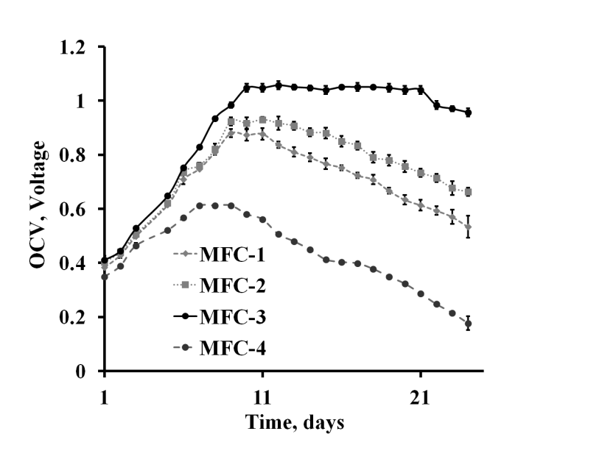

Fig. 7. OCV of various synthesized membrane in MFCs vs. time.

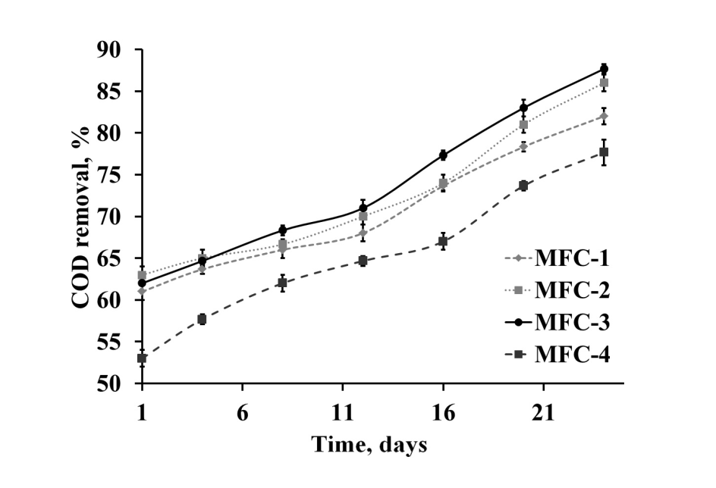

Fig. 8. COD removal of wastewater in anodic compartment of MFCs vs. time.

**Question 2:** Line 186, please write numbers in reverse order (500 and 4000 cm-1).

Response: Thanks for the suggestion. We have written the numbers in the reverse order.

**Changes in the manuscript:**

Spectra were obtained with resolution between 4000 and 500 cm-1.

**Question 3:** Table I was not necessary to be presented. Consider excluding it.

Response: Thanks for the suggestion. We have removed the Table I from revised manuscript.

**Minor issue:  
Question 1**: Please find some types and minor changes within the corrected pdf document.

Response: Thanks for the suggestion. We have thoroughly checked the manuscript and the typo errors were corrected in the revised manuscript.

**Referee 2**

**Question 1:** In the line 187, for the water uptake procedure authors should give some explanations.

* Did they use distilled or deionized water?
* Are the membranes dried at vacuum?
* Are the membranes weighed in a microbalance?
* Whether the authors can show dimensional changes of the membranes, such as the changes of thickness and diameter of the membrane?

**Response:** Thanks for the suggestion. We have included more explanation in the revised manuscript.

* We used deionized water for water uptake experiments.
* No, the membranes are not dried at vacuum. We dried the membrane using hot air oven with closed conditions.
* No, we did not use microbalance for weighing of the membranes. We used Sartorius (BSA 2245-CW) analytical balance with a readability of 0.0001 g.
* We monitored the dimensional changes of the membrane during the water uptake experiments and found that the swelling ratio (dimensional change) was found to be lesser than 5%, which is reasonable as reported in the literature [35].

Changes in the manuscript:

*Water Uptake*

The membranes were dried using a hot air oven with closed condition at 50°C for 15 min to remove the moisture content. Membranes were weighed using an analytical balance (Sartorius, BSA 2245-CW) with a readability of 0.0001 g. Weight of the dried membrane (*Wd*) was noted down. Dried membranes were soaked in deionized water for 24 h. Membrane surfaces were wiped out with tissue paper and then weighed the wet membrane (*Ww*). Water uptake of the synthesized membranes was calculated using Eq. (1).



where, *Wd* is the weight of the dried membrane and *Ww* is the weight of the wet membrane.25,27 Swelling ratio was found to be lesser than 5%, which is reasonable as reported in the literature.35

**Reference**

1. M.S. Boroglu, S.Cavus, I. Boz, A. Ata, *Polym. Lett.***5** (2011) 470.35.
2. W. Li, C. Gao, J. Guo, Y. Ren, X. Deng, Y. Liu, *Solid State Ion.* **278**(2015) 254.

**Question 6:** The authors must give more detailed explanation about Ion Exchange Capacity measuring procedure.

**Response:** Thanks for the suggestion. We have included a paragraph about the ion exchange capacity (IEC) measuring procedure.

**Changes in the manuscript:**

The IEC of the synthesized membrane was measured using the standard procedure reported in the literature.28,29 Synthesized membrane was immersed in 1 N HCl for 24 h and washed with distilled water to remove excess acid. Subsequently, the membrane was soaked in 1 N NaCl solution for 24 h. NaCl solution was titrated with 0.01 N NaOH to determine the concentration of the exchanged protons with phenolphthalein as an indicator.

**References**

1. M.A. Masuelli, M. Grasselli, J. Marchese, N.A. Ochoa, *J. Membr. Sci.* **389** (2012) 91.
2. A. Taeger A, C. Vogel, D. Lehmann, D. Jehnichen, H. Komber, J. Meier-Haack, N.A. Ochoa, S.P. Nunes, K. Peinemann, *React. Funct. Polym.* **57** (2003) 77.

**Question 7:** It would be very useful to have TEM or SEM micrographs of membrane (or other microscopic techniques) in order to have information about morphology of membrane with different content of PVA.

**Response:** Thanks for the comment. We have included the SEM micrographs of all three synthesized membranes with different content of PVA for morphological analysis in the revised manuscript.

Changes in the manuscript: We have included SEM images in the revised manuscript as Fig. 1.

*Scanning Electron Microscopy (SEM)*

Morphological analysis of the synthesized membrane surface was carried out using SEM (JEOL 6380A). Synthesized membranes were cut into small portion and were kept in sample bags prior to SEM analysis.

*Scanning Electron Microscopy (SEM)*



Fig. 1. SEM images of PEMs synthesized using various recipes (a) M-1 (b) M-2 and (c) M-3.

Fig. 1 (a-c) shows the SEM surface image of three membranes (M-1, M-2 and M-3) synthesized using various recipes. Surface morphology shows that all constituents of the membranes are homogeneously distributed throughout the membranes without causing any major migration and phase segregation.35 SEM images confirm that the pores are not significant in the synthesized membranes.

**References:**

1. W. Li, C. Gao, J. Guo, Y. Ren, X. Deng, Y. Liu, *Solid State Ion.* **278**(2015) 254.

**Question 8:** Authors should compare the performance (power density) of MFC-3 setup with M-3 membrane with similarly synthesized membranes found in the literature.

Response: Thanks for the suggestion. We compared the performance (power density) of MFC-3 setup with M-3 membrane with similarly synthesized membranes reported in the literature. Maximum power density of MFC-3 setup with M-3 membrane was found to be 63.3 mW.m-2, which is higher than the power density of similarly synthesized membranes found in the literature [a,b].

**References:**

1. W. Li, C. Gao, J. Guo, Y. Ren, X. Deng, Y. Liu, *Solid State Ion.* **278**(2015) 254.
2. S. Angioni, L. Millia, G. Bruni, D. Ravelli, P. Mustarelli, E. Quartarone, *J Power Sources,* **348** (2017) 57.