Supplementary material
Overlaid TIC chromatograms of each cultivar analyzed in this paper (cultivars from Table 3), separated according to the corresponding cereal/pseudocereal species, i.e. botanical origin.
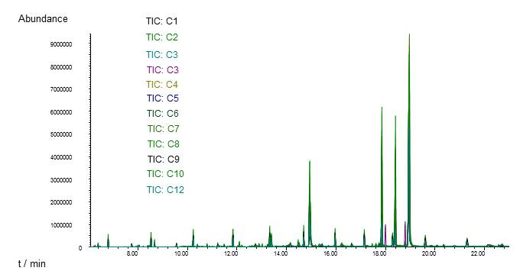
Fig. 1 Overlaid TIC chromatograms of the corn cultivars analyzed in this paper
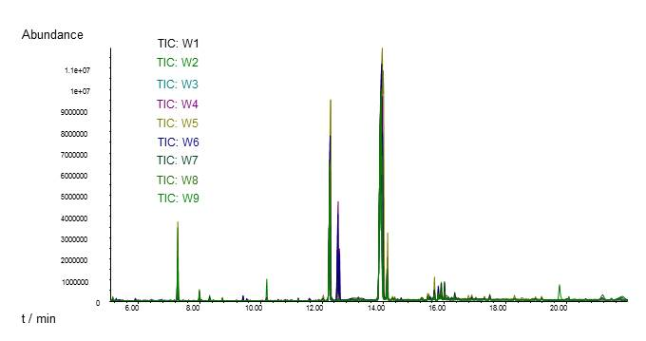
Fig. 2 Overlaid TIC chromatograms of the wheat cultivars analyzed in this paper
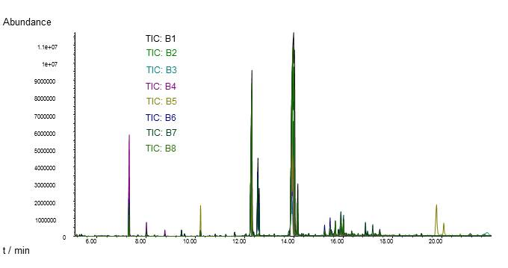
Fig. 3 Overlaid TIC chromatograms of the barley cultivars analyzed in this paper
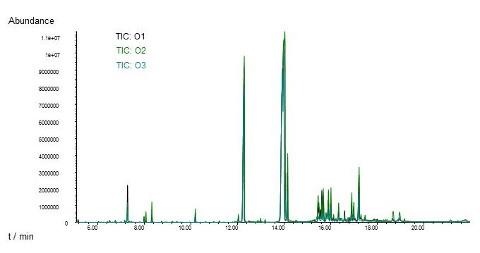
Fig. 4 Overlaid TIC chromatograms of the oat cultivars analyzed in this paper

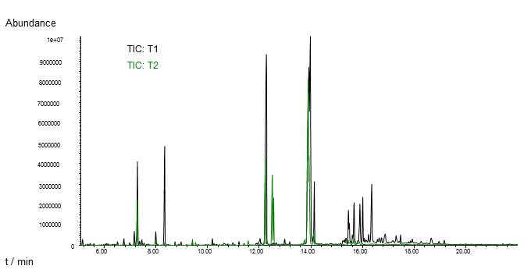
Fig. 5 Overlaid TIC chromatograms of the triticale cultivars analyzed in this paper

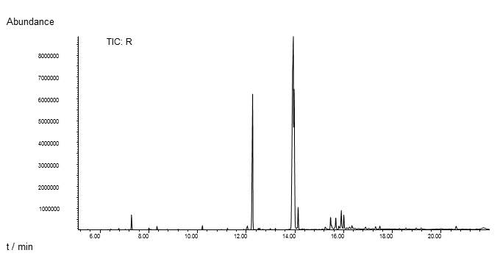
Fig. 6 Overlaid TIC chromatograms of a rye cultivar analyzed in this paper
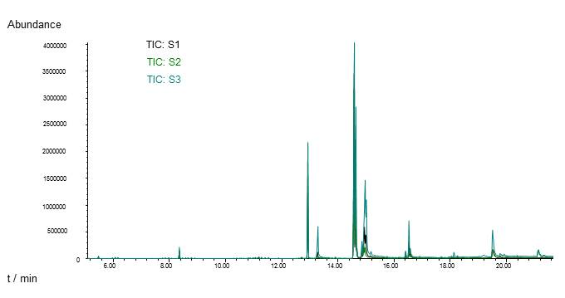
Fig. 7 Overlaid TIC chromatograms of the spelt cultivars analyzed in this paper

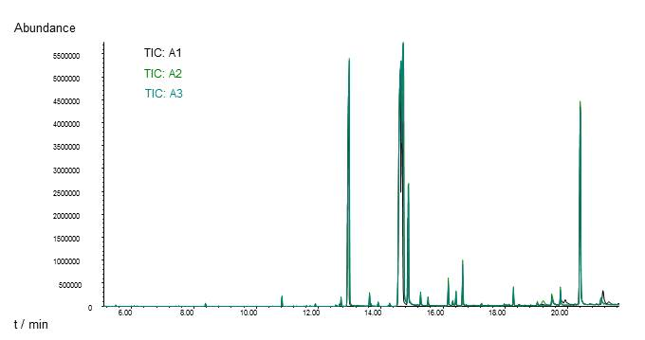
Fig. 8 Overlaid TIC chromatograms of the amaranth cultivars analyzed in this paper
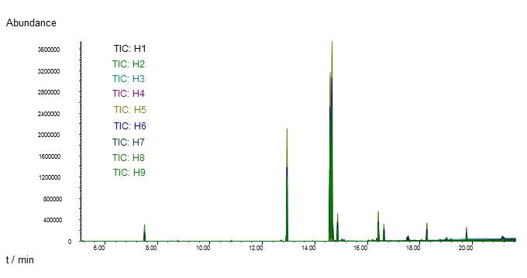
Fig. 9 Overlaid TIC chromatograms of the buckwheat cultivars analyzed in this paper

