**A DFT study of the chemical reactivity of thiobencarb and its oxidized derivatives in aqueous phase.**

LUIS HUMBERTO MENDOZA-HUIZAR[1]*

*Universidad Autónoma del Estado de Hidalgo. Academic Area of Chemistry. Carretera Pachuca-Tulancingo Km. 4.5 Mineral de la Reforma, Hgo, México*

*Abstract:* In the present work, the global and local reactivity of S-4-chlorobenzyl *N*, *N*-diethylthiocarbamate (TB) and its oxidized derivatives (sulfone (TBSu) and sulfoxide (TBS) was analyzed. Also, the chemical reactivity of the dechlorinated forms of TB (DTB), TBSu (DTBSu) and TBs (DTBs) was studied. The calculations were performed at the wB97XD/6-311++G(2d,2p) level of theory in the aqueous phase. The condensed Fukui functions indicate that for TB and DTB the most preferred sites for donating electron in a reaction are located in the S and N atoms, while the most reactive sites for accepting electrons are associated with the aromatic ring (AR). For TBS and DTBS, the more reactive sites are located on AR, S and AR for nucleophilic, electrophilic and free radical attacks, respectively. In the case of TBSu and DTBSu, the AR result to be the more reactive zone for the three kind of attacks. Last results suggest that the cleavage of the C–S bond in TB, TBS and their dechlorinated forms is favored by electrophilic attacks. Additionally, our results suggest that in TB is plausible the cleavage of the C-N favored by electrophiles attacking on this molecule.

*Keywords:* thiobencarb; Fukui function; dual descriptor; DFT.

RUNNING TITLE: CHEMICAL REACTIVITY OF THIOBENCARB HERBICIDE

INTRODUCTION

Rice is one of the most important crops in the world,1 and one of the staple food for more than half of the world's population.2 Therefore, different methods have been developed to increase its production. In this sense, rice crop production is higher when herbicide treatments are used in comparison with non-treated crops.2 The herbicide thiobencarb (S-4-chlorobenzyl *N*, *N*-diethylthiocarbamate), also called benthiocarb, see Figure 1a, has been widely applied in rice paddy fields in Japan and other Asian countries to control various weeds, especially barnyard grass.3 Thiobencarb (TB) is considered safe for rice plants when used at recommended rates. TB does not inhibit the germination of seeds, but potently inhibits the shoot elongation of germinated seeds,4 this resultant syndrome is called delayed phytotoxicity syndrome.3,5 Additionally, when TB is used on paddy, its residues in standing water may harm beneficial flora and fauna.6,7 Also, TB is toxic for tadpoles for concentrations found in waters where rice is cultivated.8 Here, it is interesting to mention that TB is naturally transformed to dechlorinated thiobencarb (DTB) in certain field soils in Japan and the United States, but DTB, is highly toxic to rice crops.8 Additionally, in aqueous phase TB can be easily oxidized to thiobencarb sulfoxide (TBS) and thiobencarb sulfone (TBSu) under environmental and biological conditions,9-11 since, these oxidized forms are the active forms of TB.4 Although, thiobencarb is considered as photostable,12 TB degradation in natural water may occur abiotically through photooxidation,13 and indirect photolysis via hydroxyl radicals.12,13 If a laser flash photolysis is employed the TB degradation involves the photocleavage of the C–S bond.11 Also, it has been reported that during chlorination of drinking water, thiobencarb has shown to be quickly degraded, producing chlorobenzyl alcohol, chlorotoluene, chlorobenzyl chloride, chlorobenzoic acid and chlorobenzyl aldehyde as chlorination by-products.14 Nevertheless, it has been recently reported that the pollution levels of thiobencarb are increasing at the drainage canals close to the irrigation systems of the rice fields.15 Moreover, TB has shown to be persistent in water,16 by which there is an accelerated increase in the concentration of TB and its oxidized metabolites in surface-water,16 which would constitute a potential risk for drinking water contamination.17 Moreover, this pollution is a great risk to animals inhabiting to freshwater bodies nearby fields of application.18 Despite its potential risk as an emerging water contaminant, literature data concerning the chemical behavior of TB and their oxidized derivatives in aqueous phase is very scarce. Thus, a detailed study of the chemical reactivity exhibited by TB, TBS and TBSu and their dechlorinated forms at the molecular level may become fundamental to understand its degradation mechanism in aqueous phase. In this sense, the value of the frontier orbitals (HOMO and LUMO) of thiobencarb have been determined and employed to predict its genotoxicity by artificial neural network simulation.19 Also, Quantitative Structure Activity Relationship study were carried out to evaluate the toxicity of TB employing its molecular structure.20 However, to the best of our knowledge, there is not any report in the literature, which analyze the chemical reactivity of TB and its oxidized derivatives employing the global and local reactivity descriptors derived from the Density Functional Theory (DFT). Here, it is important to mention that this kind of study may become useful to propose new o alternative degradation mechanisms of this herbicide. Therefore, we consider that this kind of study will contribute to get a better understanding of the chemical behavior, in the aqueous phase, of this herbicide and its derivatives.

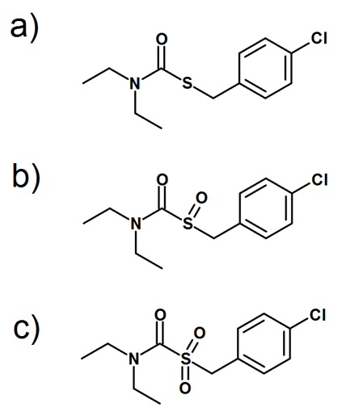

Figure 1. Chemical structures of thiobencarb derivatives a) thiobencarb, b) thiobencarb sulfoxide and c) thiobencarb sulfone.

*Theory*

Within the framework of the DFT, it is possible to define global reactivity parameters, which give us information about the general chemical behavior of a molecule. These parameters are the electronic chemical potential (), the electronegativity () and hardness ( ), which are defined as:21-27

  (1)

 (2)

  (3)

In these equations, , , and  are the energy, number of electrons and the external potential of the system, respectively. The chemical potential measures the escaping tendency of an electron and is minus the Mulliken electronegativity of molecules, 28 while *η* is related to the polarizability.29, 30 Additional to *µ*,  and *η*, the global electrophilicity index *ω* was defined by Parr and can be calculated using *μ* and *η*, equation (4):31

 (4)

According to this definition, *ω* measures the susceptibility of chemical species to accept electrons. Thus, low values of *ω* suggest a good nucleophile while higher values indicate the presence of a good electrophile. From this reactivity index it is possible to define the electrodonating (**-) and electroaccepting (**+) powers as:32

 (5)

 (6)

where

 (7)

and,

 (8)

Additional to the global reactivity parameters, it is possible to define local reactivity parameters, which allow us to analyze the reactivity on different sites within a molecule. In this sense, the Hard and Soft Acids and Base principle (HSAB) has been useful to predict the reactivity of chemical systems.33-35 Thus, from HSAB principle in combination with the DFT, it has been possible to identify many useful and important reactivity concepts such as the Fukui Function ().33-34 The Fukui function (FF) is defined as:33-34

 (9)

where  is the electronic density. FF can be evaluated by using a finite difference approximation. However, due to the discontinuity of the electron density with respect to the number of electrons (N), this approximation leads to three types of FF for a molecular system, namely, , , and  for electrophilic, nucleophilic, and free radical attacks respectively, which can be evaluated as:29

 (10)

 (11)

 (12)

On the other hand, it has been reported that the dual descriptor is a more accurate tool than nucleophilic and electrophilic Fukui functions.36 This dual descriptor is able to unambiguously expose truly nucleophilic and electrophilic regions, and can be written as:

 (13)

The dual descriptor allows one to obtain simultaneously the preferably sites for nucleophilic attacks ( *>* 0) and the preferably sites for electrophilic attacks ( *<* 0) over the system at point **r.**

COMPUTATIONAL

The optimal conformations of TB, TBS and TBSu were subjected to full geometry optimization in the gas phase employing the hybrid functional wB97XD and the basis set 6-311++G(2d,2p). 37-38 The optimized molecules in the gas phase were further reoptimized in the aqueous solvent employing the wB97XD/6-311++G(2d,2p) level. Solvent phase optimization has been carried out using the polarizable continuum model (PCM) developed by Tomasi and coworkers.39-40 The vibrational frequencies were computed to make sure that the stationary points were minima in the potential energy surface (not shown). All the calculations here reported were performed with the package Gaussian 09,41 and visualized with the GaussView V. 2.0842

RESULTS AND DISCUSSION

Figure 2 depicts the optimized structures of TB, TBS and TBSu and their dechlorinated forms DTB, DTBS and DTBSu, respectively, at the wB97XD/6-311++G(2d,2p) level of theory and in the aqueous phase; the xyz coordinates of these molecules are reported in Tables IS-VIS in supplementary material. The total electronic energy calculated for TB, TBS and TBSu are ̶1455.319899, ̶ 1530.503507, and ̶ 1605.726321 hartrees, while the electronic energies of DTB, DTBS and DTBSu are ̶ 995.7099588, ̶ 1070.893676 and ̶ 1146.116732 hartrees, respectively. Note that the bond lengths and angle values are similar in the chlorinated and dechlorinated forms, see Figures 2, 3 and 4, suggesting a similar molecular structure.

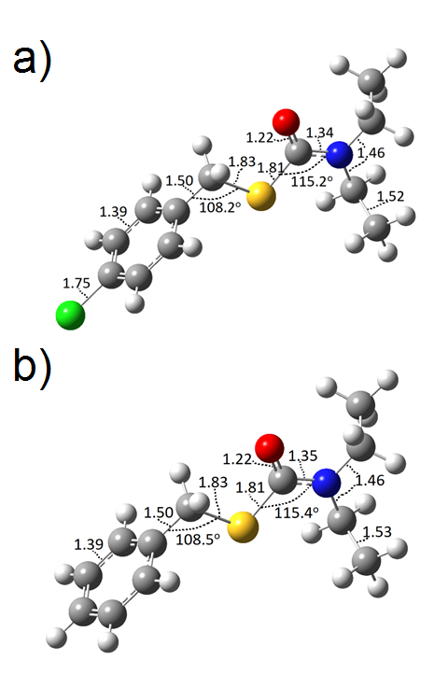

Figure 2. Chemical structures of a) thiobencarb and b) dechlorinated thiobecarb, optimized at the wB97XD/6-311++G(2d,2p) level of theory in the aqueous phase employing the PCM solvation model.

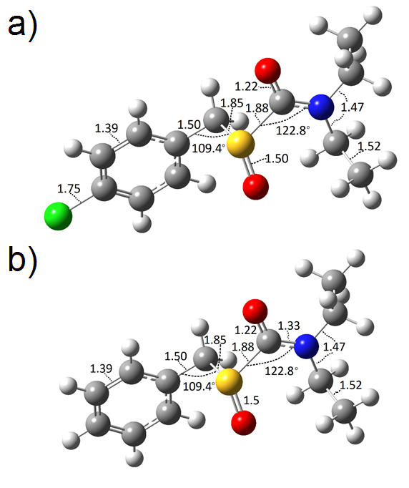

Figure 3. Chemical structures of a) thiobencarb sulfoxide and b) dechlorinated thiobencarb sulfoxide, optimized at the wB97XD/6-311++G(2d,2p) level of theory in the aqueous phase employing the PCM solvation model.

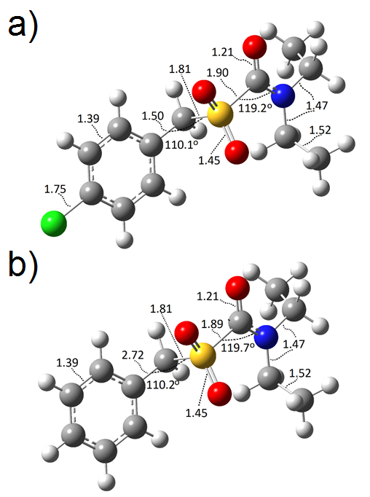

Figure 4. Chemical structures of a) thiobencarb sulfone and b) dechlorinated thiobencarb sulfone, optimized at the wB97XD/6-311++G(2d,2p) level of theory in the aqueous phase employing the PCM solvation model.

The global chemical reactivity descriptors (η, ** and ω) for TB and its derivatives are evaluated employing the equations (1), (3) and (4). In these equations the value of the vertical affinity energy is calculated as A = E(N) - E(N + 1), where E(N) and E(N + 1) are the total ground-state energies in the neutral N and singly charged (N + 1) configurations, while the ionization potential was calculated as I = E(N - 1) - E(N), where E(N - 1) corresponds to the energy of the cationic configuration. The values of,η, ** and ω of chlorinated and dechlorinated forms are reported in Table I. Observe that in all cases de hardness values are similar for the chlorinated and dechlorinated forms, which suggest a similar chemical stability of TB and its derivatives. If one compares the values of ** and ω of the six molecules studied in the present work, similar results are observed. Last result suggests an equivalent global chemical behavior of the chlorinated and dechlorinated forms of TB.

Table I. Global reactivity descriptors evaluated for TB and its dechlorinated forms at the wB97XD/6-311++G(2d,2p) level of theory in the aqueous phase, employing the PCM solvation model, according to the equations (1), (3) and (4).

|  |  |  |  |  |  |  |  |
| --- | --- | --- | --- | --- | --- | --- | --- |
|  | **  /eV | **  /eV | **  /eV |  | **  /eV | **  /eV | **  /eV |
| TB | 0.22 | -0.15 | 0.05 | DTB | 0.22 | -0.14 | 0.04 |
| TBS | 0.22 | -0.15 | 0.05 | DTBS | 0.22 | -0.15 | 0.05 |
| TBSu | 0.22 | -0.15 | 0.05 | DTBSu | 0.24 | -0.15 | 0.05 |

Here, it is interesting to mention that the origin of toxicity is supposed to be governed by the possible charge transfer between a toxin and a biosystem,43 for example electrophilic substances can form covalent bonds to proteins and DNA, resulting in reactive toxicity and according diseases such as dermal or respiratory sensitization and mutagenicity.44 In this sense, the origin of the toxicity may be attributed to the electron accepting nature,43 which may be evaluated through equation (6).45 In Table II are reported the values of **+ for the compounds analyzed in the present work. Observe that DTB exhibit a lower value of **+ in comparison to TB suggesting a major toxicity by DBT. Indeed this result is coincident with the reported experimentally because DBT is more toxic than TB.8 Also, note that the **+ value of DTBSu is lower than the obtained for TBSu, suggesting that the first one is more toxic than the second one. In the case of DTBS and TBS, these compounds show similar **+ values, indicating a similar toxicity. According to the last results, the more toxic thiobencarb derivatives are DTB and DTBSu.

Table II. Electroaccepting (**+) powers evaluated at the wB97XD/6-311++G(2d,2p) level of theory in the aqueous phase, employing the PCM solvation model, according to the equation (6).

|  |  |  |  |  |
| --- | --- | --- | --- | --- |
|  | **  / eV |  |  | **  / eV |
| TB | 0.0195 |  | DTB | 0.0158 |
| TBS | 0.0201 |  | DTBS | 0.0202 |
| TBSu | 0.0204 |  | DTBSu | 0.0167 |

**Local reactivity descriptors**

In order to determine the pin point distribution of the active sites of TB and its derivatives; we employed the equations (10), (11) and (12) to calculate the distribution of FF on the respective molecule. Table III depicts the FF isosurfaces for TB and DTB obtained when equations (10-12) are applied. In the case of TB the more susceptible sites to nucleophilic and free radical attacks are located in the aromatic ring (AR), while that for electrophilic attacks the more reactive sites are on the S and N atoms, see Figure 2. For the case of DTB the more reactive sites to electrophilic and free radical attacks are on N and S, while the more nucleophilic actives sites are on AR. Thus, note that the dechlorination process is not modifying the positions of the more reactive sites to nucleophilic and electrophilic attacks observed on TB, TBS and TBSu. Free radical attacks on DTB are expected on AR and S atom. Also, electrophilic and free radical attacks on S may start the degradation process on DTB by cleaving the C-S bond.

Table III. Isosurfaces of the Fukui Functions for nucleophilic (), electrophilic () and free radical attacks () on TB and DTB according to equations (10), (11) and (12) at the wB97XD/6-311++G(2d,2p) level of theory, employing the PCM solvation model. In all cases the isosurfaces were obtained at 0.01 e/u.a.3

|  |  |  |
| --- | --- | --- |
|  | **TB** | **DTB** |
|  | f+.tif | f+.tif |
|  | f-.tif | f-.tif |
|  | f+.tif | f0.tif |

Table IV shows the FF isosurfaces for TBS and its dechlorinated form. For this molecule, the more nucleophilic reactive sites are located in AR, for electrophilic case the more reactive sites are on N and S, while that free radical attacks are in AR, and on the N and S atoms. Interestingly, the dechlorination process is not modifying the reactivity distribution because DTBS exhibits the same chemical behavior than TBS. From these results, it is possible to suggest that the fragmentation of both molecules is possible if the S atom is attacked by either electrophiles or free radicals, favoring the cleavage of the C-S bond as experimentally observed for TB.11

Table IV. Isosurfaces of the Fukui Functions for nucleophilic (), electrophilic () and free radical attacks () on TBS and DTBS according to equations (10), (11) and (12) at the wB97XD/6-311++G(2d,2p) level of theory employing the PCM solvation model. In all cases the isosurfaces were obtained at 0.01 e/u.a.3

|  |  |  |
| --- | --- | --- |
|  | **TBS** | **DTBS** |
|  | f+.tif | f+.tif |
|  | f-.tif | f-.tif |
|  | f0.tif |  |

Table V shows the FF isosurfaces for TBSu and DTBSu, note that in all cases AR is the more susceptible site to the three kind of attacks, which suggests aromatic substitutions instead a direct degradation of these molecules.

Table V. Isosurfaces of the Fukui Functions for nucleophilic (), electrophilic () and free radical attacks () on TBSu and DTBSu according to equations (10), (11) and (12) at the wB97XD/6-311++G(2d,2p) level of theory employing the PCM solvation model. In all cases the isosurfaces were obtained at 0.01 e/u.a.3

|  |  |  |
| --- | --- | --- |
|  | **TBSu** | **DTBSu** |
|  | f+.tif | f+.tif |
|  | f-.tif | f-.tif |
|  | f0.tif | f0.tif |

In Table VI are summarized the more reactives sites for each molecule, note that in all cases the nucleophilic attacks are favoring aromatic substitutions on AR.

Table VI. More reactive sites according to condensed Fukui functions determinated at the wB97XD/6-311++G(2d,2p) level of theory employing the PCM solvation model.

|  |  |  |  |  |  |  |  |
| --- | --- | --- | --- | --- | --- | --- | --- |
|  |  |  |  |  |  |  |  |
| TB | AR | S,N | AR | DTB | AR | S,N | S,N |
| TBS | AR | S | AR,S | DTBS | AR | S | AR,S |
| TBSu | AR | AR | AR | DTBSu | AR | AR | AR |

Also, we analyze the local chemical reactivity of TB and its derivatives by mean the dual descriptor, equation (13). This descriptor allow us to obtain simultaneously the preferably sites for nucleophilic and electrophilic attacks on the system at point **r**. In Table VII is reported the distribution of the dual descriptor for thiobencarb derivatives. The more reactive sites for TB and TBS are found in AR, and on S atom for nucleophilic and electrophilic attacks, respectively. For TBSu the more reactive sites are in AR. In the case of the dechlorinated molecules, the nucleophilic attacks are in AR for DTB, DTBS and DTBSu, while the electrophilic attacks are located on AR, S and AR for DTB, DTBS and DTBSu respectively. A summary of the more reactive sites is reported in Table VIII. These results are coincident with those obtained from equations (10), (11) and (12). Last results suggest that the cleavage of the C-S bond, experimentally observed during the TB degradation,11, 46 may be obtained by electrophiles attacking TB, TBS and their dechlorinated forms. Moreover, our results indicate that this electrophilic attack might cause the cleavage of the C-N bond in TB and DTB.

Table VII. Dual descriptors evaluated at the wB97XD/6-311++G(2d,2p) level of theory employing the PCM solvation model according to equation (13). In all cases the isosurfaces were obtained at 0.01 e/u.a.3

|  |  |  |
| --- | --- | --- |
|  | **-chloro** | **-without chloro** |
| **TB** |  |  |
| **TBS** |  |  |
| **TBSu** |  |  |

Table VIII. Summary of the more reactive sites according to the dual descriptor at the wB97XD/6-311++G(2d,2p) level of theory employing the PCM solvation model according to equation (13).

|  |  |  |  |  |  |
| --- | --- | --- | --- | --- | --- |
|  | **Nucleophilic** | **Electrophilic** |  | **Nucleophilic** | **Electrophilic** |
| **TB** | AR | S,N | DTB | AR | S,N |
| **TBS** | AR | S | DTBS | AR | AR |
| **TBSu** | AR | AR | DTBSu | AR | AR |

Additional to the global and local reactivity descriptors we analyzed the reactivity of TB, TBS, and TBSu and their dechlorinated forms through maps of the electrostatic potential. This kind of maps may provide insight on reactivity.47 In these maps a reactive site is a particularly charged region of a molecule that has an affinity for interacting with charged particles. Thus, a region of very low potential energy would have a very strong influence on positively charged particles or regions of particles nearby. In Figure 1S (see supplementary material), areas of low potential (red color), are characterized by an abundance of electrons while areas of high potential, (blue color), are characterized by a relative lack of electrons. Note that the oxygen atoms have the lowest values of potential in comparison to the other atoms; consequently have a higher electron density around them.

CONCLUSIONS

In the present work, we have analyzed the chemical reactivity of chlorinated and dechlorinated S-4-chlorobenzyl *N*, *N*-diethylthiocarbamate and its oxidized derivatives, in the aqueous phase. The results suggest that the six molecules studied have a similar global chemical behavior. However, Fukui functions isosurfaces revealed that AR is the more susceptible zone to nucleophilic attacks in all cases. Only TB and TBS and their dechlorinated forms show a main susceptibility to electrophilic attacks on N and S atoms. These results suggests that the photocleavage of the C–S bond is favored in the aqueous media by electrophiles. In addition, except DTB, the free radical attacks are favored in the aromatic ring for the other chemical species analyzed.

*Acknowledgements:* LHMH gratefully acknowledges financial support from CONACYT (project CB2015-257823) and to the Universidad Autónoma del Estado de Hidalgo. Guanajuato National Laboratory (CONACyT 123732) is acknowledged for supercomputing resources. LHMH acknowledges to the SNI for the distinction of their membership and the stipend received.

REFERENCES

1. J. L. Maclean, D. C. Dawe, B. Hardy, G. P. Hettel, *Rice Almanac: Source Book for the Most Important* *Economic Activity of Earth*, CABI Publishing, Wallingford, UK, 2002.

2. V. Singh, M. L. Jat, Z. A. Ganie, B. S. Chauhan, R. K. Gupta, *Crop Prot.* **81** (2016) 168

3. Y. H. Moon, S. Kuwatsuka, *J. Pesticide Sci.* **9** (1984) 745

4. Y. Tanetani, K. Kaku, M. Ikeda, T. Shimizu, *J. Pestic. Sci.* **38(1)** (2013) 39

5. S. A. Mabury, J. S. Cox, D. G. Crosby. *Rev. Environ. Contam. Toxicol.* **147** (1996) 71

6. E. Sancho, M. Sánchez, M.D. Ferrando, E. Andreu-Moliner, *J. Environ. Sci. Heal. B* **36** (2001) 55

7. K. Ishikawa, J. Pest. Sci. **5(2)** (1980) 287.

8. M. Saka, *Ecotox. Environ. Saf.* **73** (2010) 1165

9. X. Huang, J. He, X. Yan, Q. Hong, K. Chen, Q. He, L. Zhang, X. Liu, S. Chuang, S Li, J Jiang, *Pestic. Biochem. Physiol.* doi: 10.1016/j.pestbp.2016.11.010

10. S. Kodama, A. Yamamoto, A. Matsunaga, *J. Agric. Food Chem.* **45** (1997) 990

11. H.D. Burrows, M. Canle, J.A. Santaballa, S. Steenken, *J. Photoch. Photobio. B* **67** (2002) 71

12. D. Vialaton, C. Richard, *J. Photoch. Photobio. A* **136** (2000) 169

13. W.M. Draper, D.G. Crosby, *J. Agr. Food Chem.* **32** (1984) 231

14. Y. Magara, T. Aizawa, N. Matumoto, F. Souna, *Water Sci. Technol.* **30(7)** (1994) 119

15. P. Sapari, B.S. Ismail, Environ Monit Assess. **184(10)** (2012) 6347

16. I. A. Mahzabin, M. R. Rahman, *Fundam. Appl. Agric.* **2(2)** (2017) 277

17. W. C. Quayle, D. P. Oliver, S. Zrna, *J. Agr. Food Chem.* **54(19)** (2006) 7213

18. C. Fernández-Vega, [E. Sancho](http://www.sciencedirect.com/science/article/pii/S0045653515002428), M. D. Ferrando, *Chemosphere* **135** (2015) 94

19. R. Shoji, M. Kawakami, *Mol. Diver.* **10** (2006) 101

20. M. Cassotti, *QSAR study of aquatic toxicity by chemometrics methods in the framework of REACH regulation*. U

niversity of Milano, Italy, Bicocca, 2015

21. J. L. Gázquez, *J. Mex. Chem. Soc.* **52** (2008) 3

22. P. Geerlings, F. De Proft, W. Langenaeker, *Chem. Rev.* **103** (2003) 1793

23. H. Chermette, *J. Comput. Chem.* **20** (1999) 129

24. P. W. Ayers, J. S. M. Anderson, L. J. Bartolotti, *Int. J. Quantum Chem.* **101** (2005) 520

25. P. K. Chattaraj, U. Sarkar, D.R. Roy, *Chem. Rev.* **106** (2006) 2065

26. P. A. Johnson, L. J. P. Bartolotti, W. Ayers, T. Fievez, P. Geerlings, *Modern Charge Density Analysis*, ed(s) Gatti C and Macchi P Springer New York: 2012.

27. S. B. Liu, *Acta Phys. Chim. Sin.* **25** (2009) 590.

28. R. G. Parr, R. A. Donnelly, M. Levy, W. E. Palke, *J. Chem. Phys.* **68** (1978) 3801

29. R. G. Parr, R. G. Pearson, *J. Am. Chem. Soc.* **105** (1983) 7512

30. R. G. Pearson, *J. Chem. Educ.* **64** (1987) 561

31. R.G. Parr, L. Szentpaly, S. Liu, *J. Am. Chem. Soc.* **121** (1999) 1922

32. J. L. Gázquez, A. Cedillo, A. Vela, *J. Phys. Chem. A* **111** (2007) 1966

33. R. G. Parr, W. Yang, *J. Am. Chem. Soc.* **106** (1984) 4048

34. R. G. Parr,; W. Yang, *Functional Theory of Atoms and Molecules, 1st ed.*, Oxford University Press: New York, 1989

35. S. B. Liu, In Chemical reactivity theory: A density functional view; Chattaraj, P. K., ed.; Taylor and Francis: Boca Raton, 2009.

36. C. Morell, A. Grand, A. Toro-Labbe, *J. Phys. Chem. A* **109** (2005) 205

37. R. Krishnan, J. S. Binkley, R. Seeger, J. A. Pople, **72** (1980) 650

38. A. D. McLean, G. S. Chandler, *J. Chem. Phys.* **72** (1980) 5639

39. S. Miertus, J. Tomasi, *J. Chem. Phys.* **65** (1982) 239

40. S. Miertus, E. Scrocco, J. Tomasi, *J. Chem. Phys.* **55** (1981) 117.

41. Gaussian 09, Revision A.01, M. J. Frisch, G. W. Trucks, H. B. Schlegel, G. E. Scuseria, M. A. Robb, J. R. Cheeseman, G. Scalmani, V. Barone, G. A. Petersson, H. Nakatsuji, X. Li, M. Caricato, A. Marenich, J. Bloino, B. G. Janesko, R. Gomperts, B. Mennucci, H. P. Hratchian, J. V. Ortiz, A. F. Izmaylov, J. L. Sonnenberg, D. Williams-Young, F. Ding, F. Lipparini, F. Egidi, J. Goings, B. Peng, A. Petrone, T. Henderson, D. Ranasinghe, V. G. Zakrzewski, J. Gao, N. Rega, G. Zheng, W. Liang, M. Hada, M. Ehara, K. Toyota, R. Fukuda, J. Hasegawa, M. Ishida, T. Nakajima, Y. Honda, O. Kitao, H. Nakai, T. Vreven, K. Throssell, J. A. Montgomery, Jr., J. E. Peralta, F. Ogliaro, M. Bearpark, J. J. Heyd, E. Brothers, K. N. Kudin, V. N. Staroverov, T. Keith, R. Kobayashi, J. Normand, K. Raghavachari, A. Rendell, J. C. Burant, S. S. Iyengar, J. Tomasi, M. Cossi, J. M. Millam, M. Klene, C. Adamo, R. Cammi, J. W. Ochterski, R. L. Martin, K. Morokuma, O. Farkas, J. B. Foresman, and D. J. Fox, Gaussian, Inc., Wallingford CT, 2009.

42. Gaussview Rev. 3.09, Windows version. Gaussian Inc., Pittsburgh

43. A. Poland, D. Palen, E. Glover, *Nature* **300** (1982) 271

44 D. Wondrousch, A. Böhme, D. Thaens, N. Ost, G. Schüürmann, *J. Phys. Chem. Lett.* **1(10)** (2010) 1605

45. A. U. Orozco-Valencia, A. Vela, *J. Mex. Chem. Soc.* **56(3)** (2012) 294

46. L. O. Ruzo, J.E. Casida, *J. Agric. Food Chem.* **33** (1985) 272

47. L. Senthilkumar, P. Umadevi, K.N. Nithya, P. Kolandaivel, *J. Mol. Model.* **19(8)** (2013) 3411.

1. *Corresponding author. E-mail: hhuizar@uaeh.edu.mx