SOIL ORGANIC CARBON STOCK VARIATION WITH CLIMATE AND LAND USE IN SHALE DERIVED SOILS
AYAZ MEHMOOD^{1*}, MOHAMMAD S. AKHTAR², SHAH RUKH², MUHAMMAD IMRAN², ASMA HASSAN², KASHIF S. ABBASI³, ABDUL QAYYUM¹, TALAT MAHMOOD¹, WASEEM AHMED¹, KHURAM SHAHAZAD¹, AYUB KHAN¹, ZAHOOR AHMAD¹
¹Department of Agricultural Sciences, University of Haripur, Haripur, Pakistan;
²Department of Soil Science, PMAS-Arid Agriculture University Rawalpindi, Rawalpindi, Pakistan;
³Department of Food Technology, PMAS-Arid Agriculture University Rawalpindi, Rawalpindi, Pakistan.
Email address: ayaz.gill@uoh.edu.pk
Abstract: Anthropogenic activities, urbanization and industrialization cause an increase in atmospheric carbon dioxide. Current focus of soil scientists and environmentalists is to quantify carbon stocks and its flow in agroecological system which is one of the main culprits of global warming and climate change. The information on distribution of soil organic carbon (SOC) stocks along the soil profiles in relation with changing climate is scant. Objective of this study was to quantify the effect of climate and land use on equilibrium of SOC stocks in soil profiles with development. Murree soil series (Typic Hapludolls) in humid climate and was under coniferous forest, and Tirnul soil series (Typic Haplustepts) in semiarid climate was under cultivation, were selected. Triplicate soil profiles were selected for each of the soils and sampled at genetic horizons level. Cumulative SOC stocks in Typic Hapludolls soil profiles (95 Mg ha⁻¹) were significantly greater than Typic Haplustepts (30 Mg ha⁻¹). The Typic Hapludolls had significantly greater SOC stock at each horizon level under humid climate. This research concludes that soils under forest and humid climate had higher SOC stocks as compared to the soils under semiarid climate and cultivation.
Keywords: Soil genesis, cultivation, climate, land use, carbon stocks.
Corresponding author (ayaz.gill@uoh.edu.pk)
RUNING TITLE: VARIATION IN SOIL ORGANIC CARBON WITH CLIMATE CHANGE

INTRODUCTION
The global emission of soil carbon dioxide is well recognized as one of the largest contributor to worldwide carbon fluxes. Atmospheric carbon dioxide concentration significantly affected by slight change in the rate of soil respiration ¹. Atmospheric carbon dioxide is one of the largest anthropogenic source which enhance green house effect ² and its significance to the climate increased interest in global carbon cycle research in terrestrial ecosystem. Reliable estimates of C stocks are required under the Kyoto Protocol by the United Nations Framework Convention on Climate Change thought to be the major factor in global warming ³. Balance between biomass debris and decomposition driven by various parameters of natural and human origin controls the quantity of organic matter and soil carbon stock ^{4, 5,} ⁶. Organic matter reduction in top soils severely affects the water holding capacity, structure stability, nutrient storage and supply as well as soil microbes i.e. mycorrhizas and nitrogen-fixing bacteria ⁷.
Estimated soil carbon contents in 100 cm soil profile depth are around 1500 Pg. Soil carbon is an important component of the global carbon cycle, exchange with the atmosphere through soil respiration is approximately 80 Pg C yr⁻¹ ⁸. It is well known that SOC pools have distinct residence times. The most soil carbon occur as resistant material that cannot be altered by recent land uses and thus it is a low cycling carbon ^{9,10,11}. Whereas recalcitrant material has rapid response to recent land use changes and considered as much faster carbon cycling pool ^{9,10,11, 12, 13}. Consequently, it is important for humans to store carbon by managing soils or controlling high losses of it with tillage practices ¹⁴. Stratification of SOC act as quality indicator to mitigates greenhouse gas emissions. Additional research is needed to identify stratification ratio in soil horizon with change in climosequences in the future ¹⁵.

Rainfall intensity has a positive effect while rising temperature has inverse effect on soil organic carbon levels ¹⁶. Soil carbon stocks may vary with change in climatic conditions and land use practices. Land use and climosequence frequently influence on dynamics of organic carbon stocks. However, changes in total SOC stocks in response to land use and climosequence may be difficult to quanify because of the natural soil inconsistency. However, dissolved organic carbon (DOC), is much more sensitive than SOC stocks ¹⁷. In current study, two soils from shale parent material were selected varying in development from different rainfall zones and different land use. . Triplicate soil profiles in each soil were selected and sampled at genetic horizon level. Objective of the study was to quantify the effect of climate on cumulative SOC stocks as well as carbon stock of each layer in soil profiles with climate change and land use.
EXPERIMENTAL
SOIL DESCRIPTION AND SAMPLING
Typic Hapludolls (Murree soil series) is developed in Murree’s shale of Miocene Epoch in humid climate and under coniferous forest. Soil is noncalcareous due to high rainfall (1440 mm per annum and annual temperature 12.7 °C). Typic Haplustepts (Tirnul soil series) is developed in Murree’s shale in semiarid climate (< 500 mm per annum and annual temperature 21.7 °C) and was under cultivation. The dominant coniferous tree is Pinus in Murree while main crops grown in Tirnul soil are maize, wheat and groundnut. The Murree soil series occurs on the mountain tops, the Tirnul at the bottom of troughs within the mountain ridges. Triplicate soil profiles were identified dug and described. Soil samples from each genetic horizon for both soils were taken.
Soil characterization
Soil texture was determined by dispersing soil in 1 % sodium hexametaphosphate followed by sonication and density of the suspension was recorded at specific time intervals by hydrometer ¹⁸ and soil pH was measured using pH meter after preparing saturated soil paste ¹⁹. Dithionite extractable iron and aluminum from soil were extracted in 0.3 M C₆H₅Na₃O₄.2H₂O solution, 1 M NaHCO₃ solution by adding 1 g Na₂S₂O₄ and heating at 80 °C ¹⁷. Iron and aluminum were analyzed using Atomic Absorption Spectrometer (AAS) in the extract. Amorphous iron was extracted by 0.2 M acidified (NH₄)₂C₂O₄.H₂O solution. The Fe concentration in the extract was determined by AAS ²⁰. Calcium carbonate was determined by CH₃COOH consumption method ²¹. Soil organic carbon was measured by wet digestion²². Soil bulk density (ρb) was measured by taking 5 cm high core with 5 cm inner diameter from the center of each horizon. The soil sample taken with fixed volume of core was oven dried until constant weight at 105 °C ²³.
SOIL CARBON STOCK AND STRATIFICATION RATIO CALCULATION
Total SOC stock of each genetic horizon was quantified by the following formula
C Stock = SOC × ρ × H × 10
Where SOC is the quantity of soil organic carbon (g kg⁻¹), ρ is the bulk density (g cm⁻³) and H is the depth of respective soil layers. The stratification ratio (SR) of organic carbon (OC) stocks and DOC were calculated by dividing the concentration of OC stocks and DOC with other layers ¹⁵.
The variance in the soil organic carbon content and stock at the horizon level was analyzed using multivariate analysis of variance (MANOVA) in GLM procedure of SAS version 9.0 ²⁴. Class variable was ‘soil’ and the measurements at various depths were multiple dependent variables.

RESULTS AND DISCUSSION
The basic soil characteristics important for estimating the degree of soil development viz. soil pH, texture, and dithionite and oxalate extractable iron are presented first followed by distribution of total organic carbon (TOC), cumulative carbon stock and carbon stock of each soil horizon.
SOIL CHARACTERISTICS
The selected soil Typic Haplustepts is at early stage of development with weak to moderate horizon differentiation and the Typic Hapludolls is relatively at weathered stage of development compared to Typic Haplustepts ²⁵. The basic properties of the soils are given in Figure 1. The Typic Haplustepts were calcareous with no distinct zone of lime accumulation while the Typic Hapludolls were decalcified to a variable depth, and had a distinct zone of lime accumulation. Similarly, Typic Hapludolls had greater dithionite extractable iron and clay content than Typic Haplustepts, dithionite extractale iron and clay content increased with soil depth in Typic Hapludolls due to weathering processes while Typic Haplustepts had uniform distribution indicating greater development in the Typic Hapludolls than Typic Haplustepts.
SOIL ORGANIC CARBON DISTRIBUTION
Accumulation of SOC in agricultural fields depends on time, parent material, climate, organisms and relief ²⁶. Parent material variation causes differences in soil texture or clay content. Soil organic carbon ranged between 0.35 to 24 g kg⁻¹ in the data set. Soil organic carbon content was high at Ap/A and Bw/BA horizons. The extent of SOC and plant biomass production changes with degree of soil development ²⁷. Soil organic carbon significantly correlated with DOC (r 0.89, p ≤ 0.001). Soil organic carbon decreased with soil depth in both soils. Typic Hapludolls had greater SOC content than Typic Haplustepts at all soil depths (Figure 2). As Typic Hapludolls occurred under humid climate leading towards high organic carbon content. High SOC content also relates with Mollisols ²⁸. Soil organic carbon decreased with increase in bulk density (r -0.77, p ≤ 0.001). Reduction in bulk density, increase in aggregate stability, porosity and water holding capacity are important long-term functions of applied organic matter ²⁹. The concentration of SOC correlated significantly with dithionite extractable aluminum (r 0.51, p ≤ 0.01) as aluminum is associated with organic matter’s exposed edges in calcareous system ³⁰. In some studies, SOC is better correlated with factors other than clay such as extractable aluminum, allophane content or specific surface area ³¹.
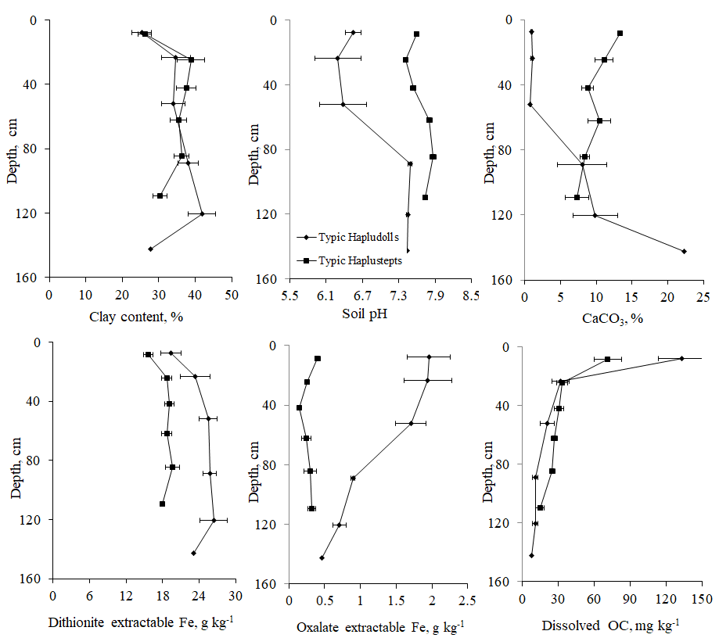
Fig 1. Basic characteristics (clay, pH, CaCO₃, dithionite extractable Fe, oxalate extractable Fe and DOC content) of Typic Hapludolls and Typic Haplustepts, and Each number is mean of 3 and error bars show standard errors.
SOIL ORGANIC CARBON STOCK DISTRIBUTION
Soil organic carbon stock was calculated using TOC, soil bulk density and depth of each soil horizon. Soil organic carbon stock raged between 1.5 to 46.3 Mg ha⁻¹ in the data set. Soil carbon stock had the similar trend as the SOC increased towards the surface in both soils. Typic Hapludolls had greater carbon stocks as compared to Typic Haplustepts at all horizon levels (Figure 2). Soil organic carbon stock negatively correlated with soil pH (r -0.38 p ≤ 0.05) and calcium carbonates (r -0.45, p ≤ 0.01). Relationship of SOC stock with soil properties is given in figure 3. Soil organic carbon stock positively correlated with DOC, oxalate extractable iron and dithionite extractable aluminum as organic carbon contents are associated with amorphous iron and crystalline aluminum oxides. Soil organic carbon stock negatively correlated with soil bulk density and clay content. Cumulative organic carbon stock was estimated by addition of all horizons of a soil profile. Cumulative organic carbon stock for Typic Hapludolls was 95 Mg ha⁻¹ while 30 Mg ha⁻¹ for the Typic Haplustepts.
Fig 2. Distribution of soil carbon stock and soil organic carbon in soil profiles. Each number is mean of 3 and error bars show standard errors.
Typic Hapludolls located in high rainfall area under coniferous forest which result in accumulation of high organic carbon whereas Typic Haplustepts located in semiarid area under continuous cultivation which result in depletion of carbon from soil. Land use and management practices influence distribution of organic carbon content ³². Accumulation potential of organic carbon in arid and semi-arid climate is more than humid regions ³³. As a result of high temperature and atmospheric carbon dioxide concentration increase calcium carbonate and soil pH. Which reduce organic carbon quantity in soil by increase in rate of mineralization. As rate of mineralization increase plants utilize carbon more effectively for biomass production. Negative correlation between OC and clay content and bulk density due to reduce contact with surface layer. With depth micro porosity increase and bulk density also cause lower carbon stocks. However macro porosity increases with increase in carbon stocks and provided positive correlations ^{34.}
Fig 3. Relationship of soil organic carbon stock with selected soil properties.

STRATIFICATION RATIO OF TOTAL AND DISSOLVED ORGANIC CARBON
Overall SR of TOC and DOC in Typic Haplustepts more relative to Typic Hapludolls (Table. 1). Stratification ratio of TOC in first three layers in Typic Hapludolls D1: D2, D1: D3 and D1:D4 were 0.25, 0.22 and 0.014 respectively. However, in Typic Haplustepts pronounced effect observed in first two layer D1: D2 and D1: D3 SR were 0.46 and 0.38. Stratification ratio of DOC in Typic Hapludolls and Typic Haplustepts were more in D1:D2 both series 0.21 and 0.43 respectively (Table 1). Although the soils under arid or semiarid climate are vulnerable to degradation but work in favor of carbon stratification in soil profile as the residence time of carbon in dry lands soils is long, sometimes even longer than in humid soils ^{35.}
Table 1. Stratification ratio of total and dissolved organic carbon in selected soils
Soil | Depth | Total organic carbon | Dissolved organic carbon
Typic Hapludolls | D1:D2 | 0.25 a | 0.21 a
 | D1:D3 | 0.22 ab | 0.13 ab
 | D1:D4 | 0.14 bc | 0.08 b
 | D1:D5 | 0.10 c | 0.08 b
Typic Haplustepts | D1:D2 | 0.46 a | 0.57 a
 | D1:D3 | 0.38 a | 0.52 ab
 | D1:D4 | 0.28 b | 0.48 bc
 | D1:D5 | 0.18 c | 0.43 c

CONCLUSION
It is concluded from the current study that soil organic carbon content and SOC stock varied with climate, land use and soil development. Soil developed in humid climate under forest had higher cumulative soil carbon stock as compared to soil develop in semiarid climate and under cultivation. Soil organic carbon stock decreased with soil depth in the profiles of both soils and was greater at all soil depths in soil under forest than the soil under cultivation. Stratification ratio of TOC and DOC was more on the surface layer and Typic Haplustepts. Soil organic carbon content as well as SOC stock was controlled by dithionite extractable aluminum, oxalate extractable iron, bulk density and DOC rather than clay content and dithionite extractable iron.

REFERENCES
- P. Schlesinger, J. P. Winkler. Soils and the global carbon cycle. In: T. M. L. Wigley and D. S. Schimel (ed.). The Carbon Cycle. Cambridge University Press, Cambridge. (2000). p. 93
- IPCC, 2007. Climate Change: Synthesis Report. Contribution of Working Groups I, II and III to the Fourth Assessment Report of the Intergovernmental Panel on Climate Change. IPCC, Geneva, Switzerland.
- R. Lal, Geoderma, 123 (2004) 1
- 4. Schlesinger, P. and J. P. Winkler. 2000. Soils and the global carbon cycle. In: T. M. L. Wigley, D. S. Schimel (ed.). The Carbon Cycle. Cambridge University Press, Cambridge. p. 93
5. W. J. Palmer, R. S. Cherry, W. H. Schlesinger, Soil Biol. Biochem. 28 (1996) 1067
6. R. Amundson, Rev. Earth Pl. Sc. 29 (2001) 535
7. W. Sombroek, F. O. Nachtergaele, A. Hebel, Ambio, 22 (1993) 417
8. J. W. Raich, C. S. Potter. Global Biogeochem. Cycl. 9 (1995) 23
9. S. Chen, Y. Huang, J. Zou, Y. Shi. Glob. Planet Change. 100 (2013) 99
10. C. C. Lisboa, R. T. Conant, M. L. Haddix, C. E. P. Cerri, C. C. Cerri. Ecosys., 12 (2009) 1212
11. R. P. Eclesia, E. G. Jobbagy, R. B. Jackson, F. Biganzoli G. Pineiro, Glob. Change Biol. 18 (2012) 3237
12. Y. L. Zinn, R. Lal, D. V. S. Resck. Soil Till. Res. 84 (2005) 28
13. S. E. Trumbore, E. A. Davidson, P. B. Camargo, D. C. Nepstad , L. A. Martinelli, Global Biogeochem. Cycl. 9 (1995) 515
14. R. Lal, Crop Sci. 50 (2010) 120
15. A. Hassan, S. S. Ijaz, R. Lal, S. Ali, Q. Hussain, M. Ansar, R. H. Khattak and M. S. Baloch. 2016. Land Degrad Develop, 27 (2016) 1175
16. P. E. Rasmussen, H. P. Collins. Adv. Agron. 45 (1991) 93
17. O. P. Mehra, M. L. Jackson. Clay Mineral, 7 (1960) 317
18. G. W. Gee, J. W. Bauder. Particle size analysis. In: Klute. A. (ed.). Methods of Soil Analysis Part 1.ASA. monograph. No. 9. Medison, Wisconsin, USA. (1986) 383
19. E. O. Mclean, Soil pH and lime requirement. In: A. L. Page (ed.). Methods of Soil Analysis. Part II, Chemical and microbiological properties. Am. Soc. Agron. Madison, Wisconsin, USA. No. 9 (1982) 199
20. M. L. Jackson, C. H. Lim, L. W. Zelazny. Oxides, hydroxides and aluminosilicates. In: A. Klute (ed.) Methods of Soil Analysis. Part 1. ASA No.9. Madison, Wisconsin, (1986) p. 101.
21. R. H. Leoppert, C. T. Hallmark, M. M. Koshy. Soil Sci. Soc. Am. J. 48 (1984) 1030
22. Walkley, A. I. A. Black. Soil Sci. 37 (1934) 29
23. G. R. Black, K. H. Hartge. 1986. Bulk density. In Page, A. L., R. H. Miller, and D. R. Keeney (ed.), Methods of Soil Analysis part I: Physical and Mineralogical Methods. Agronomy Monograph no.9 (2nd Edition). Am. Soc. Agron.. Medison WI. USA. p. 363
24. SAS Institute Inc. 2003. SAS Version 9. Cary (NC): SAS Institute Inc.
25. A. Mehmood, M.S. Akhtar, M. Imran, S. Rukh. Geoderma. 310 (2018) 218
26. H. Jenny, 1941. Factors of Soil Formation - a System of Quantitative Pedology. McGraw-Hill, New York, p. 241.
27. A. J. Jones , L. N. Mielke, C. A. Bartles, and C. A. Miller. J. Soil Water Cons. 44 (1989) 328

28. R. Lal, J. M. Kimble, E. Levine, B. A. Stewart. Soils and Global Change. Adv. Soil Sci. CRC Press. (1995) p 440
29. P. Schjonning, B. T. Christensen. 1994. Eur. J. Soil Sci. 45 (1994) 257

30. T. Larssen, R. D. Vogt, H. M. Seip, G. Furuberg, B. Liao, J. Xiao, J. Xiong. Geoderma. 91(1999) 65
31. H. J. Percival, R. L. Parfitt and N. A. Scott. Soil Sci. Soc. Am. J. 64 (2000) 1623
32. Z. Tan, R. Lal, L. Owens, R. C. Izaurralde. Soil Till. Res. 92 (2007) 53
33. J. D. Patil, N. D. Patil. Plant and Soil. 60 (1981) 295
34. G. M. Hugar, V.S. Soraganvi, Intl. Res. J. of Environ. Sci. 3 (2014) 48
35. H. E. Dregne, Arid Land Res. Man. 16 (2002) 99.

