Sample AgPd1

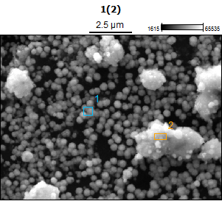
Image Name: 1(2)
Image Resolution: 512 by 384
Image Pixel Size: 0.03 µm
Acc. Voltage: 20.0 kV
Magnification: 10000
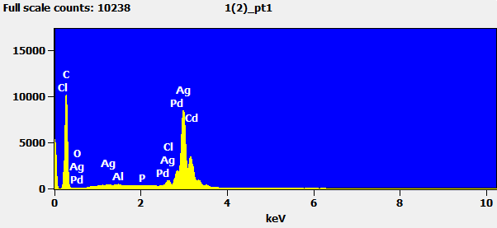
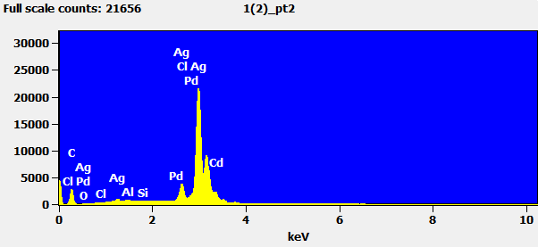
Weight %
 | C-K | O-K | Al-K | Si-K | P-K | Cl-K | Pd-L | Ag-L | Cd-L
1(2)_pt1 | 46.65 | 0.00 | 0.24 |  | 0.09 | 0.72 | 8.86 | 43.44 | 0.00
1(2)_pt2 | 12.86 | 0.00 | 0.30 | 0.10 |  | 3.27 | 2.01 | 81.46 | 0.00

Atom %
 | C-K | O-K | Al-K | Si-K | P-K | Cl-K | Pd-L | Ag-L | Cd-L
1(2)_pt1 | 88.23 | 0.00 | 0.20 |  | 0.07 | 0.46 | 1.89 | 9.15 | 0.00
1(2)_pt2 | 54.87 | 0.00 | 0.58 | 0.18 |  | 4.72 | 0.97 | 38.69 | 0.00

Sample AgPd2

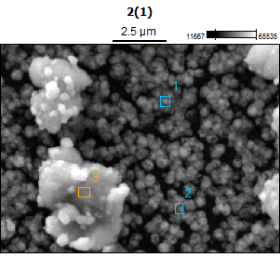
Image Name: 2(1)
Image Resolution: 512 by 384
Image Pixel Size: 0.03 µm
Acc. Voltage: 20.0 kV
Magnification: 10000
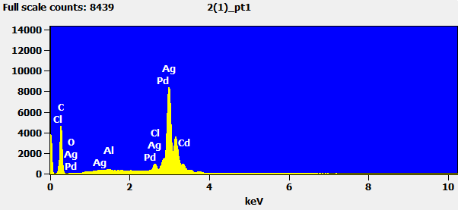
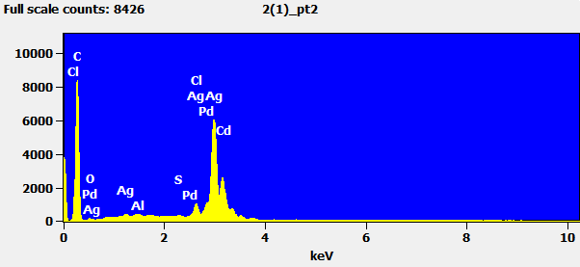
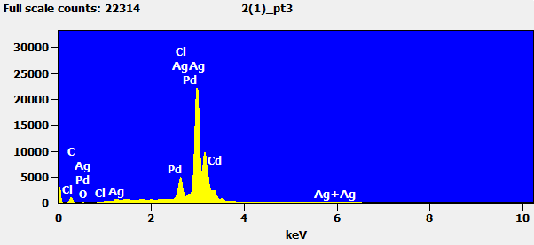
Weight %
 | C-K | O-K | Al-K | S-K | Cl-K | Pd-L | Ag-L | Cd-L
2(1)_pt1 | 30.83 | 1.40 | 0.37 |  | 1.13 | 6.59 | 59.69 | 0.00
2(1)_pt2 | 52.32 | 0.00 | 0.20 | 0.08 | 1.33 | 4.20 | 41.86 | 0.00
2(1)_pt3 | 4.38 | 2.19 |  |  | 4.42 | 1.01 | 87.96 | 0.06

Atom %
 | C-K | O-K | Al-K | S-K | Cl-K | Pd-L | Ag-L | Cd-L
2(1)_pt1 | 77.42 | 2.65 | 0.42 |  | 0.96 | 1.87 | 16.69 | 0.00
2(1)_pt2 | 90.17 | 0.00 | 0.16 | 0.05 | 0.78 | 0.82 | 8.03 | 0.00
2(1)_pt3 | 25.12 | 9.41 |  |  | 8.58 | 0.65 | 56.19 | 0.03

Sample AgPd3

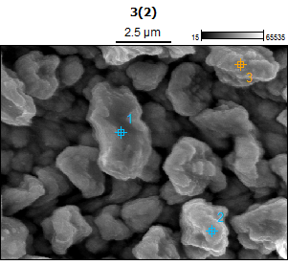
Image Name: 3(2)
Image Resolution: 512 by 384
Image Pixel Size: 0.03 µm
Acc. Voltage: 20.0 kV
Magnification: 10000
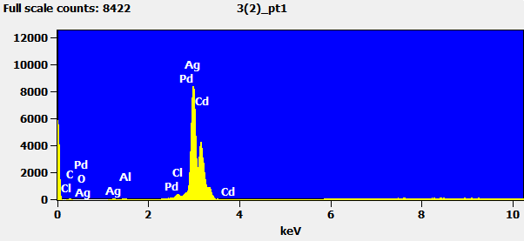
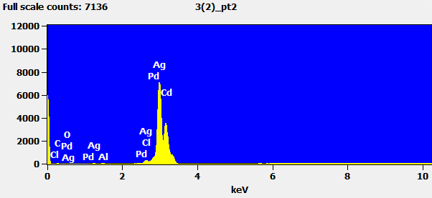
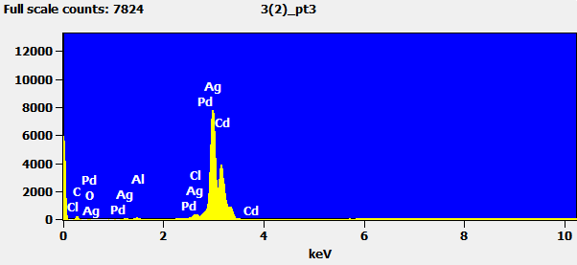
Weight %
 | C-K | O-K | Al-K | Cl-K | Pd-L | Ag-L | Cd-L
3(2)_pt1 | 1.08 | 0.38 | 0.66 | 0.00 | 1.44 | 86.33 | 10.11
3(2)_pt2 | 1.13 | 0.52 | 0.61 | 0.00 | 3.14 | 83.40 | 11.19
3(2)_pt3 | 2.29 | 0.56 | 0.83 | 0.00 | 3.48 | 82.56 | 10.29

Atom %
 | C-K | O-K | Al-K | Cl-K | Pd-L | Ag-L | Cd-L
3(2)_pt1 | 8.66 | 2.30 | 2.33 | 0.00 | 1.30 | 76.78 | 8.63
3(2)_pt2 | 8.98 | 3.09 | 2.15 | 0.00 | 2.81 | 73.50 | 9.47
3(2)_pt3 | 16.62 | 3.07 | 2.68 | 0.00 | 2.85 | 66.79 | 7.99

