SUPPLEMENTARY MATERIAL TO
Multicomponent synthesis of the new bispyranpyrazole and their antimicrobial-antioxidant evaluations
MOHAMAD YUSUF* and SALONI THAKUR
Department of Chemistry, Punjabi University, Patiala-147002, Punjab, India.
email: yusuf_sah04@yahoo.co.in

ANALYTICAL AND SPECTRAL DATA FOR SYNTHESISED COMPOUNDS
Synthesis of 4,4’-[{biphenyl-4,4’-diylbbis(methylene)}bis(oxy)bis(4,1-phenylene)-)bis(6-amino-3-methyl-1,4-dihydropyrano[2,3-c]pyrazole-5-carbonitrile)(3a). Brown solid; Yield: 69%; m.p.: 209-211⁰C; IR (KBr) cm⁻¹ 3323, 3150 (N-H), 2974, 2828 (methylene C-H), 2189 (C≡N), 1638 (C=N) & 1233, 1172 (C-O); ¹H-NMR (400 MHz, CDCl₃): δ 12.0 (2H, bs, 1-NH), 7.41 (4H, d, J_{o}=8.1 Hz, H-2’’,6’’), 7.09 (4H, d, J_{o}=8.0 Hz, H-3’’,5’’), 6.89 (4H, dt, J=8.0, 10.0 Hz, 2’, 6’), 6.57 (4H, J_{o}=10.0 Hz, H-3’,5’), 6.04 (4H, bs, NH₂), 5.35 (4H, s, OCH₂), 4.50 (2H, s, H-4), 1.80 (6H, s, CH₃); ¹³C-NMR (CDCl₃): δ 160.56 (C-6), 154.70 (C-3), 131.52 (C-4’), 128.70 (C-7a), 128.32 (C-4’’), 128.16 (C-1’’), 128.03 (C-2’,6’), 127.97 (C-3’’,5’’), 127.83 (C-2’’,6’’), 120.70 (C-1’), 113.21 (C≡N), 110.51 (C-3’,5’), 97.56 (C-3a), 67.10 (OCH₂), 57.89 (C-5), 35.59 (C-4), 9.69 (CH₃); ESI-MS: m/z 716 (M+2), 715 (M+1), 358, 357, 274, 267, 175; Anal. Calc. For C₄₂H₃₄N₈O₄: C, 70.58; H, 4.79; N, 15.68; found C, 70.30; H, 4.78; N, 15.62%.
Synthesis of 4,4’-[{but-2-yne-1,4-diylbis(oxy)} bis(4,1-phenylene)bis(6-amino-3-methyl-1,4-dihydropyrano[2,3-c]pyrazole-5-carbonitrile) (3b). Light yellow solid; Yield: 58%; m.p.: 98-100⁰C; IR (KBr) cm⁻¹ 3471, 3263 (N-H), 2971, 2880 (methylene C-H), 2190 (C≡N), 1600 (C=N) & 1220, 1054 (C-O); ¹H-NMR (400 MHz, DMSO-d₆): δ 12.0 (2H, bs, 1-NH), 7.09 (4H, d, J_{o}=7.2 Hz, H-2’,6’), 6.89 (4H, d, J_{o}=7.5 Hz, H-3’,5’), 6.75 (4H, bs, NH₂), 4.81 (4H, s, OCH₂ ) 4.53 (2H, s, H-4), 1.79 (6H, s, CH₃); ¹³C-NMR ( DMSO-d₆): δ 160.68 (C-6), 155.93 (C-3), 137.15 (C-4’), 135.41(C-7a), 128.40 (C-2’,6’), 124.68 (C-1’), 120.41 (C-3’, 5’), 114.48 (C≡N), 97.68 (C-3a), 82.38 (C≡C), 57.51 (OCH₂), 55.44 (C-5), 35.51 (C-4), 9.74 (CH₃); ESI-MS: m/z 609 (M+Na), 588 (M+2), 587 (M+1), 586 (M), 371, 320, 253, 252; Anal. Calc. For C₃₂H₂₆N₈O₄: C, 65.52; H, 4.47; N, 19.10; found C, 65.26; H, 4.46; N, 19.03%.
Synthesis of 4,4’-[{1,2-phenylenebis (methylene)}bis(oxy)bis(4,1-phenylene)]bis(6-amino-3-methyl-1,4-dihydropyrano[2,3-c]pyrazole-5-carbonitrile) (3c) Grey solid; Yield: 67%; m.p.: 158-160⁰C; IR (KBr) cm⁻¹ 3314-3184 (N-H), 2922, 2871 (methylene C-H), 2190 (C≡N), 1599 (C=N) & 1266, 1037 (C-O); ¹H-NMR (400 MHz, DMSO-d₆): δ 11.80 (2H, bs, 1-NH), 7.53 (2H, t, J=3.2, 5.4 Hz, H-5’’), 7.36 (2H, dd, J=2.1, 3.2 Hz, H-6’’), 7.10 (4H, dd, J_{m,o}=2.0, 8.3 Hz, H-2’,6’), 6.91 (4H, d, J_{o}=7.0 Hz, H-3’,5’), 6.38 (4H, bs, NH₂), 5.15 (4H, s, OCH₂), 4.57 (2H, s, H-4), 1.80 (6H, s, CH₃); ¹³C-NMR (DMSO-d₆): δ 160.49 (C-6), 156.98 (C-3), 154.73 (C-4’), 136.37 (C-7a), 135.53 (C-1’’), 134.90 (C-6’’), 128.34 (C-5’’), 127.84 (C-2’, 6’), 120.68 (C-1’), 118.30 (C≡N), 114.31 (C-3’, 5’), 97.45 (C-3a), 7.30 (OCH₂), 58.25 (C-5), 35.62 (C-4), 9.72 (CH₃); ESI-MS: m/z 661 (M+Na), 638 (M), 463, 387, 281, 252, 251, 102; Anal. Calc. For C₃₆H₃₀N₈O₄: C, 67.70; H, 4.73; N, 17.54; found C, 67.43; H, 4.72; N, 17.47%.

Synthesis of 4,4’-[{1,4-phenylenebis (methylene)}bis(oxy)bis(4,1-phenylene)]bis(6-amino-3-methyl-1,4-dihydropyrano[2,3-c]pyrazole-5-carbonitrile) (3d). Light brown solid; Yield: 64%; m.p.: 178-180⁰ C; IR (KBr) cm⁻¹ 3392, 3156 (N-H), 2956, 2880 (methylene C-H), 2189 (C≡N), 1598 (C=N) & 1256, 1018 (C-O); ¹H-NMR (400 MHz,CDCl₃): δ 12.0 (2H, bs, 1-NH), 7.49 (4H, d, J=4.1 Hz, H-2’’, 6’’), 6.86 (4H, dd, J_{o}=7.1, J_{m}=1.1 Hz, H-2’,6’), 6.78 (4H, d, J_{o}=7.0 Hz, H-3’,5’), 6.65 (4H, bs, NH₂), 4.98 (4H, s, OCH₂), 4.52 (2H, s, H-4), 1.78 (6H, s, CH₃); ¹³C-NMR (CDCl₃): δ 160.85 (C-6), 154.76 (C-3), 145.82 (C-4’), 129.30 (C-7a), 127.58 (C-1’’), 121.47 (C-2’, 6’), 120.73 (C-1’), 119.98 (C-2’’, 6’’), 114.11 (C≡N), 112.69 (C-3’, 5’), 97.21 (C-3a), 68.95 (OCH₂), 57.41 (C-5), 36.39 (C-4), 9.73 (CH₃); ESI-MS: m/z 662 (M+Na+1), 661 (M+Na), 638 (M), 559, 477, 281; Anal. Calc. For C₃₆H₃₀N₈O₄: C, 67.70; H, 4.73; N, 17.54; found C, 67.41; H, 4.70; N, 17.45%.
Synthesis of 4,4’-[{1,3-phenylenebis (methylene)}bis(oxy)bis(4,1-phenylene)]bis(6-amino-3-methyl-1,4-dihydropyrano[2,3-c]pyrazole-5-carbonitrile) (3e). Light yellow solid; Yield: 70%; m.p.: 128-130⁰ C; IR (KBr) cm⁻¹ 3392, 3210-3156 (N-H), 2956, 2888 (methylene C-H), 2169 (C≡N), 1592 (C=N) & 1256, 1018 (C-O); ¹H-NMR (400 MHz, DMSO-d₆): δ 11.74 (2H, bs, 1-NH), 7.38 (1H, dt, J=4.1, 5.4 Hz, H-5’’), 7.09 (2H, dd, J=1.6, 6.4 Hz, H-4’’,6’’), 6.92 (1H, d, J_{m}=1.8 Hz, H-2’’), 6.83 (4H, dd, J= 4.3, 6.8 Hz, H-2’, 6’), 6.67 (4H, d, J= 2.0, 3.6 Hz, H-3’, 5’), 6.42 (4H, bs, NH₂), 4.72 (4H, s, OCH₂ ), 4.51 (2H, s, H-4),), 1.81 (6H, s, CH₃); ¹³C-NMR (DMSO-d₆): δ 160.53 (C-6), 154.73 (C-3), 129.49 (C-4’), 128.35 (C-7a), 128.13 (C-5’’), 127.02 (C-4’’, 6’’), 126.76 (C-2’, 6’), 120.71 (C-1’’, 3’’), 114.59 (C-1’), 114.29 (C-2’’), 114.11 (C≡N), 113.76 (C- 3’, 5’), 97.47 (C-3a), 58.16 (C-5), 69.14 (OCH₂), 35.64 (C-4), 9.72 (CH₃); ESI-MS: m/z 640 (M+2), 639 (M+1), 638 (M), 583, 357, 281, 251; Anal. Calc. For C₃₆H₃₀N₈O₄: C, 67.70; H, 4.73; N, 17.54; found C, 67.44; H, 4.71; N, 17.49%.
Synthesis of 4,4’-[{but-2-ene-1,4-diylbis} bis(oxy)bis(4,1-phenylene)]bis(6-amino-3-methyl-1,4-dihydropyrano[2,3-c]pyrazole-5-carbonitrile) (3f) Brown solid; Yield: 67%; m.p.: 235-237⁰ C; IR (KBr) cm⁻¹ 3335-3191 (N-H), 2961, 2925 (methylene C-H), 2189 (C≡N), 1607 (C=N) & 1221, 1015 (C-O); ¹H-NMR (400 Mz, DMSO-d₆): δ 12.00 (2H, bs, 1-NH), 7.08 (4H, dt, J=2.0, 6.8 Hz, H-2’, 6’), 6.89 (4H, d, J_{o}=8.6 Hz, H-3’, 5’), 6.76 (4H, bs, NH₂), 6.12 (2H, t, J_{vic}=6.1 Hz, OCH₂CH=), 4.81 (4H, J_{vic}=6.1 Hz, s, OCH₂), 4.52 (2H, s, H-4), 1.79 (6H, s, CH₃); ¹³C-NMR (DMSO-d₆): δ 160.68 (C-6), 155.94 (C-3), 137.16 (C-4’), 135.42 (C-7a), 128.40 (C-2’, 6’), 126.78 (OCH₂CH=), 120.79 (C-1’), 117.67 (C≡N), 114.48 (C-3’, 5’), 97.67 (C-3a), 57.50 (OCH₂), 55.45 (C-5), 35.50 (C-4), 9.74 (CH₃); ESI-MS: m/z 589 (M+1, 15%), 588 (M), 321, 261; Anal. Calc. For C₃₂H₂₈N₈O₄: C, 65.30; H, 4.79; N, 19.04; found C, 65.03; H, 4.77; N, 18.96%.

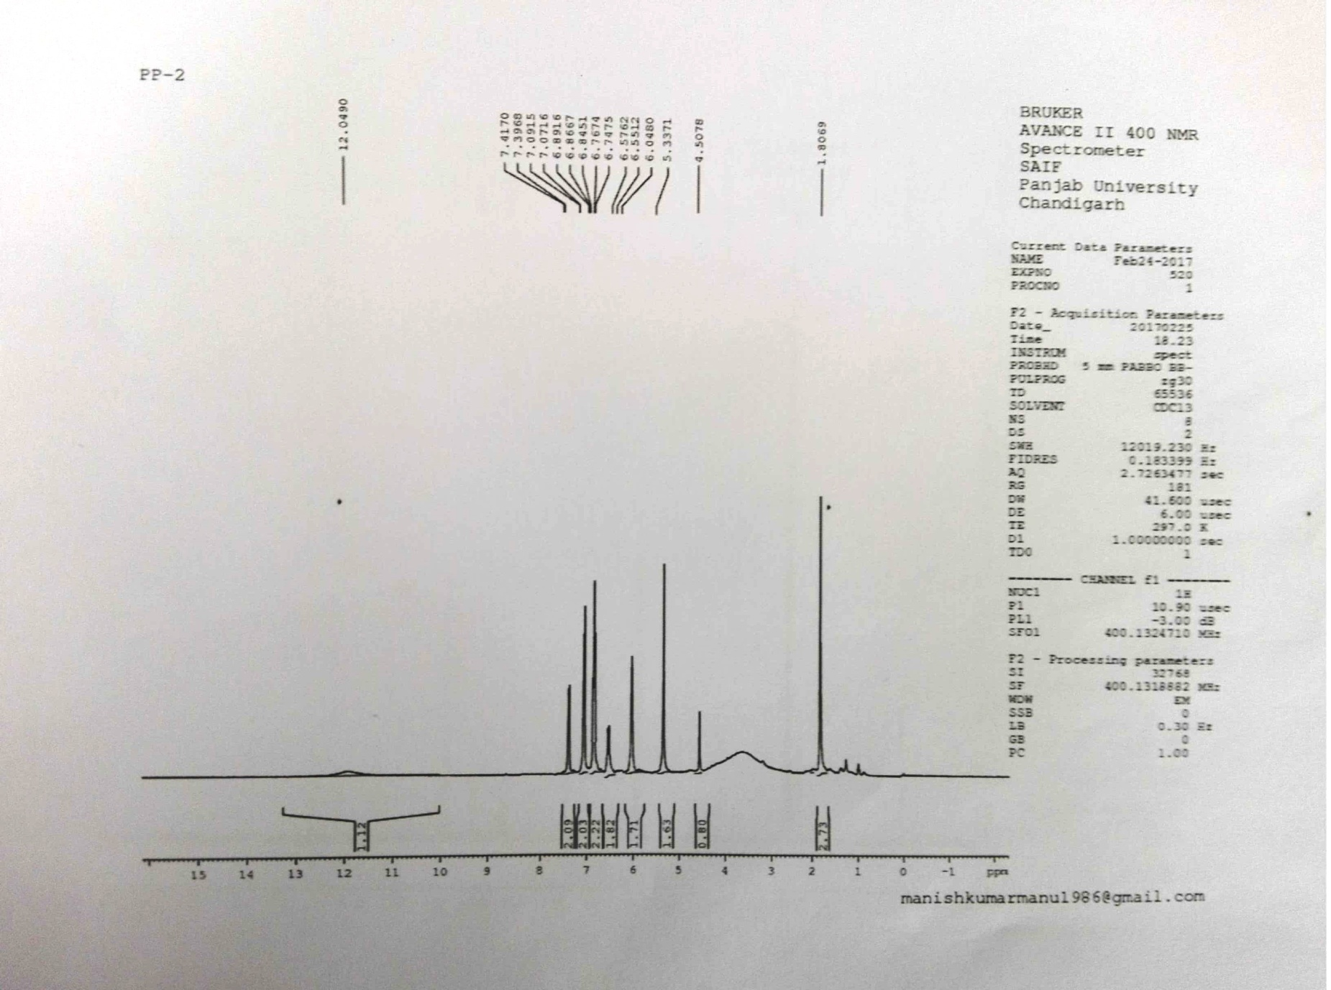
¹H-NMR of bispyranopyrazole (3a)
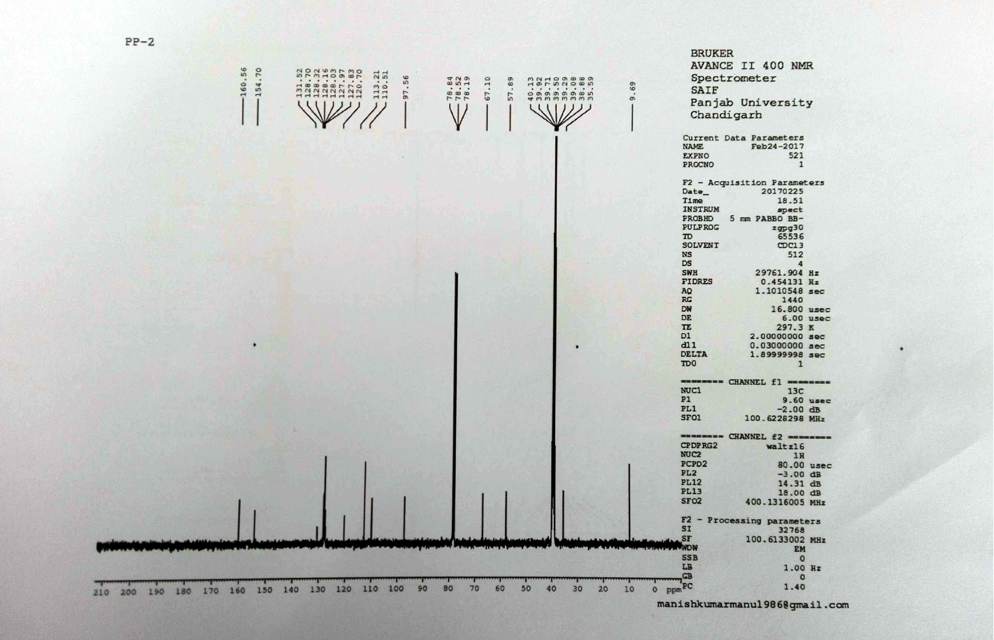
¹³C-NMR of bispyranopyrazole (3a)
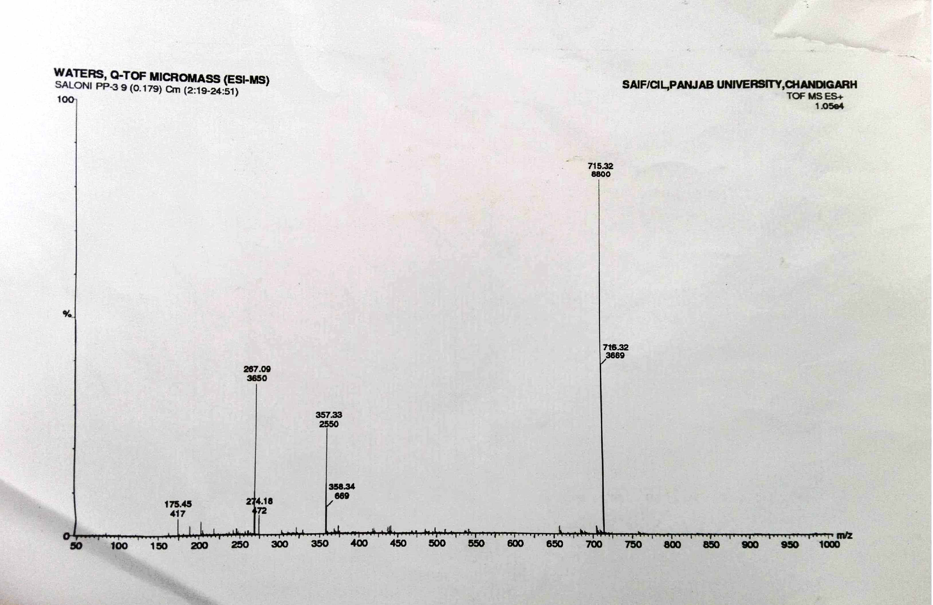
ESI-MS of bispyranopyrazole (3a)

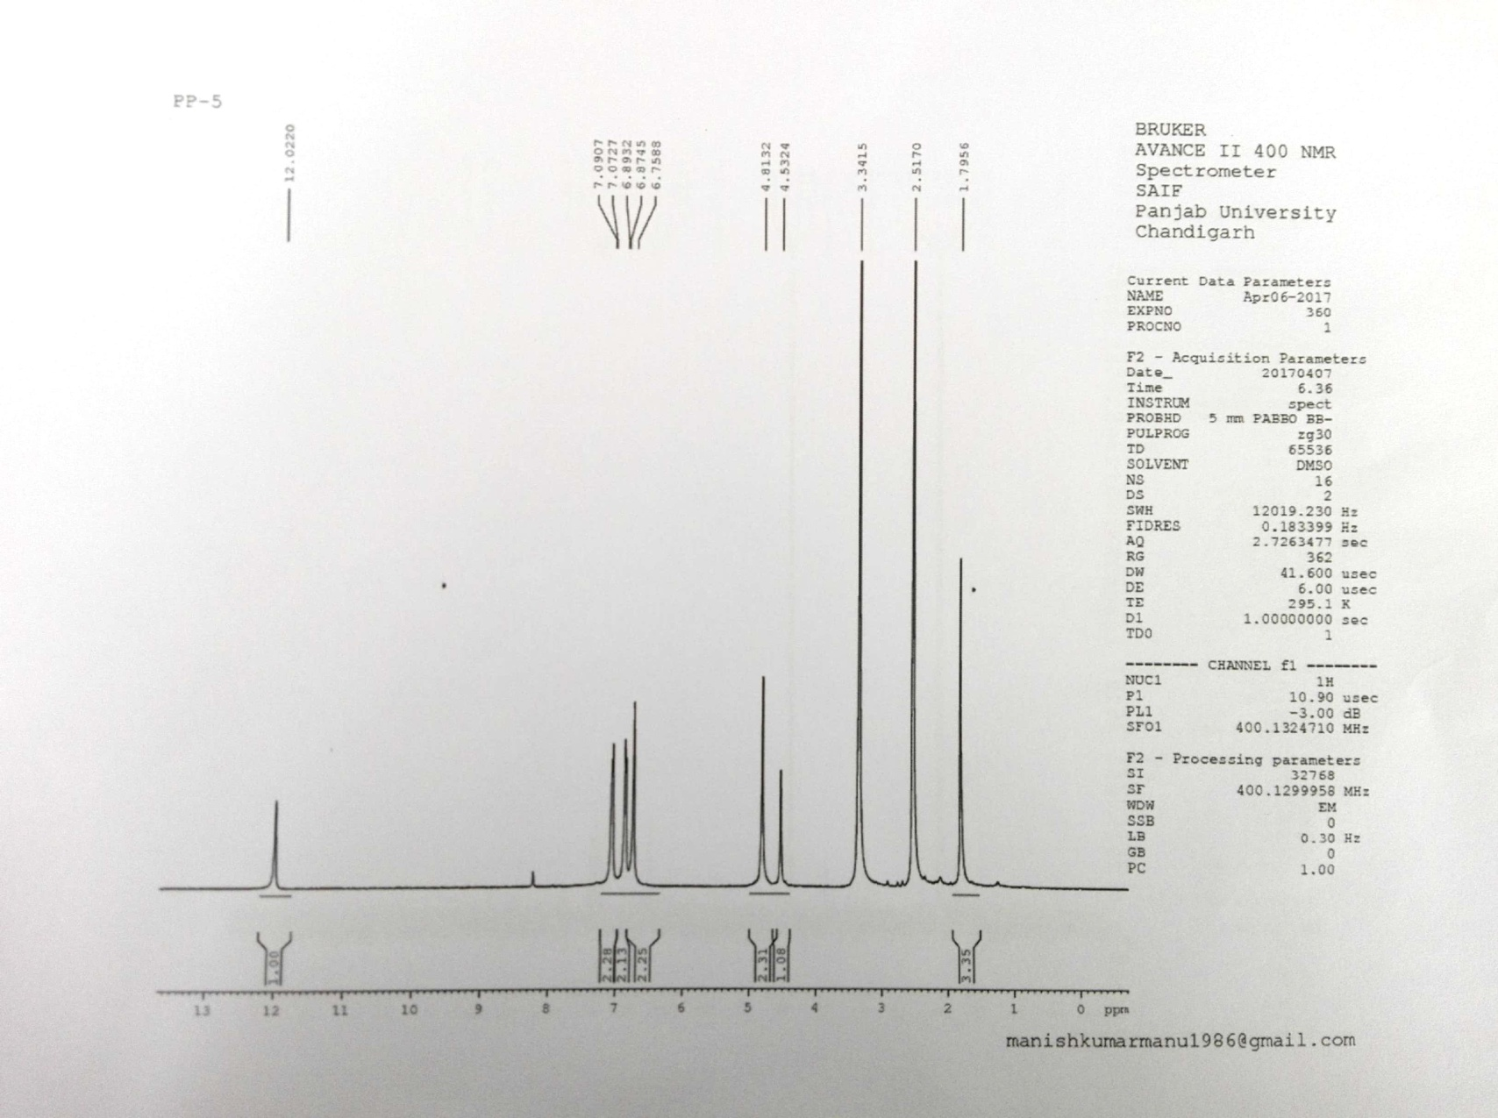
¹H-NMR of bispyranopyrazole (3b)

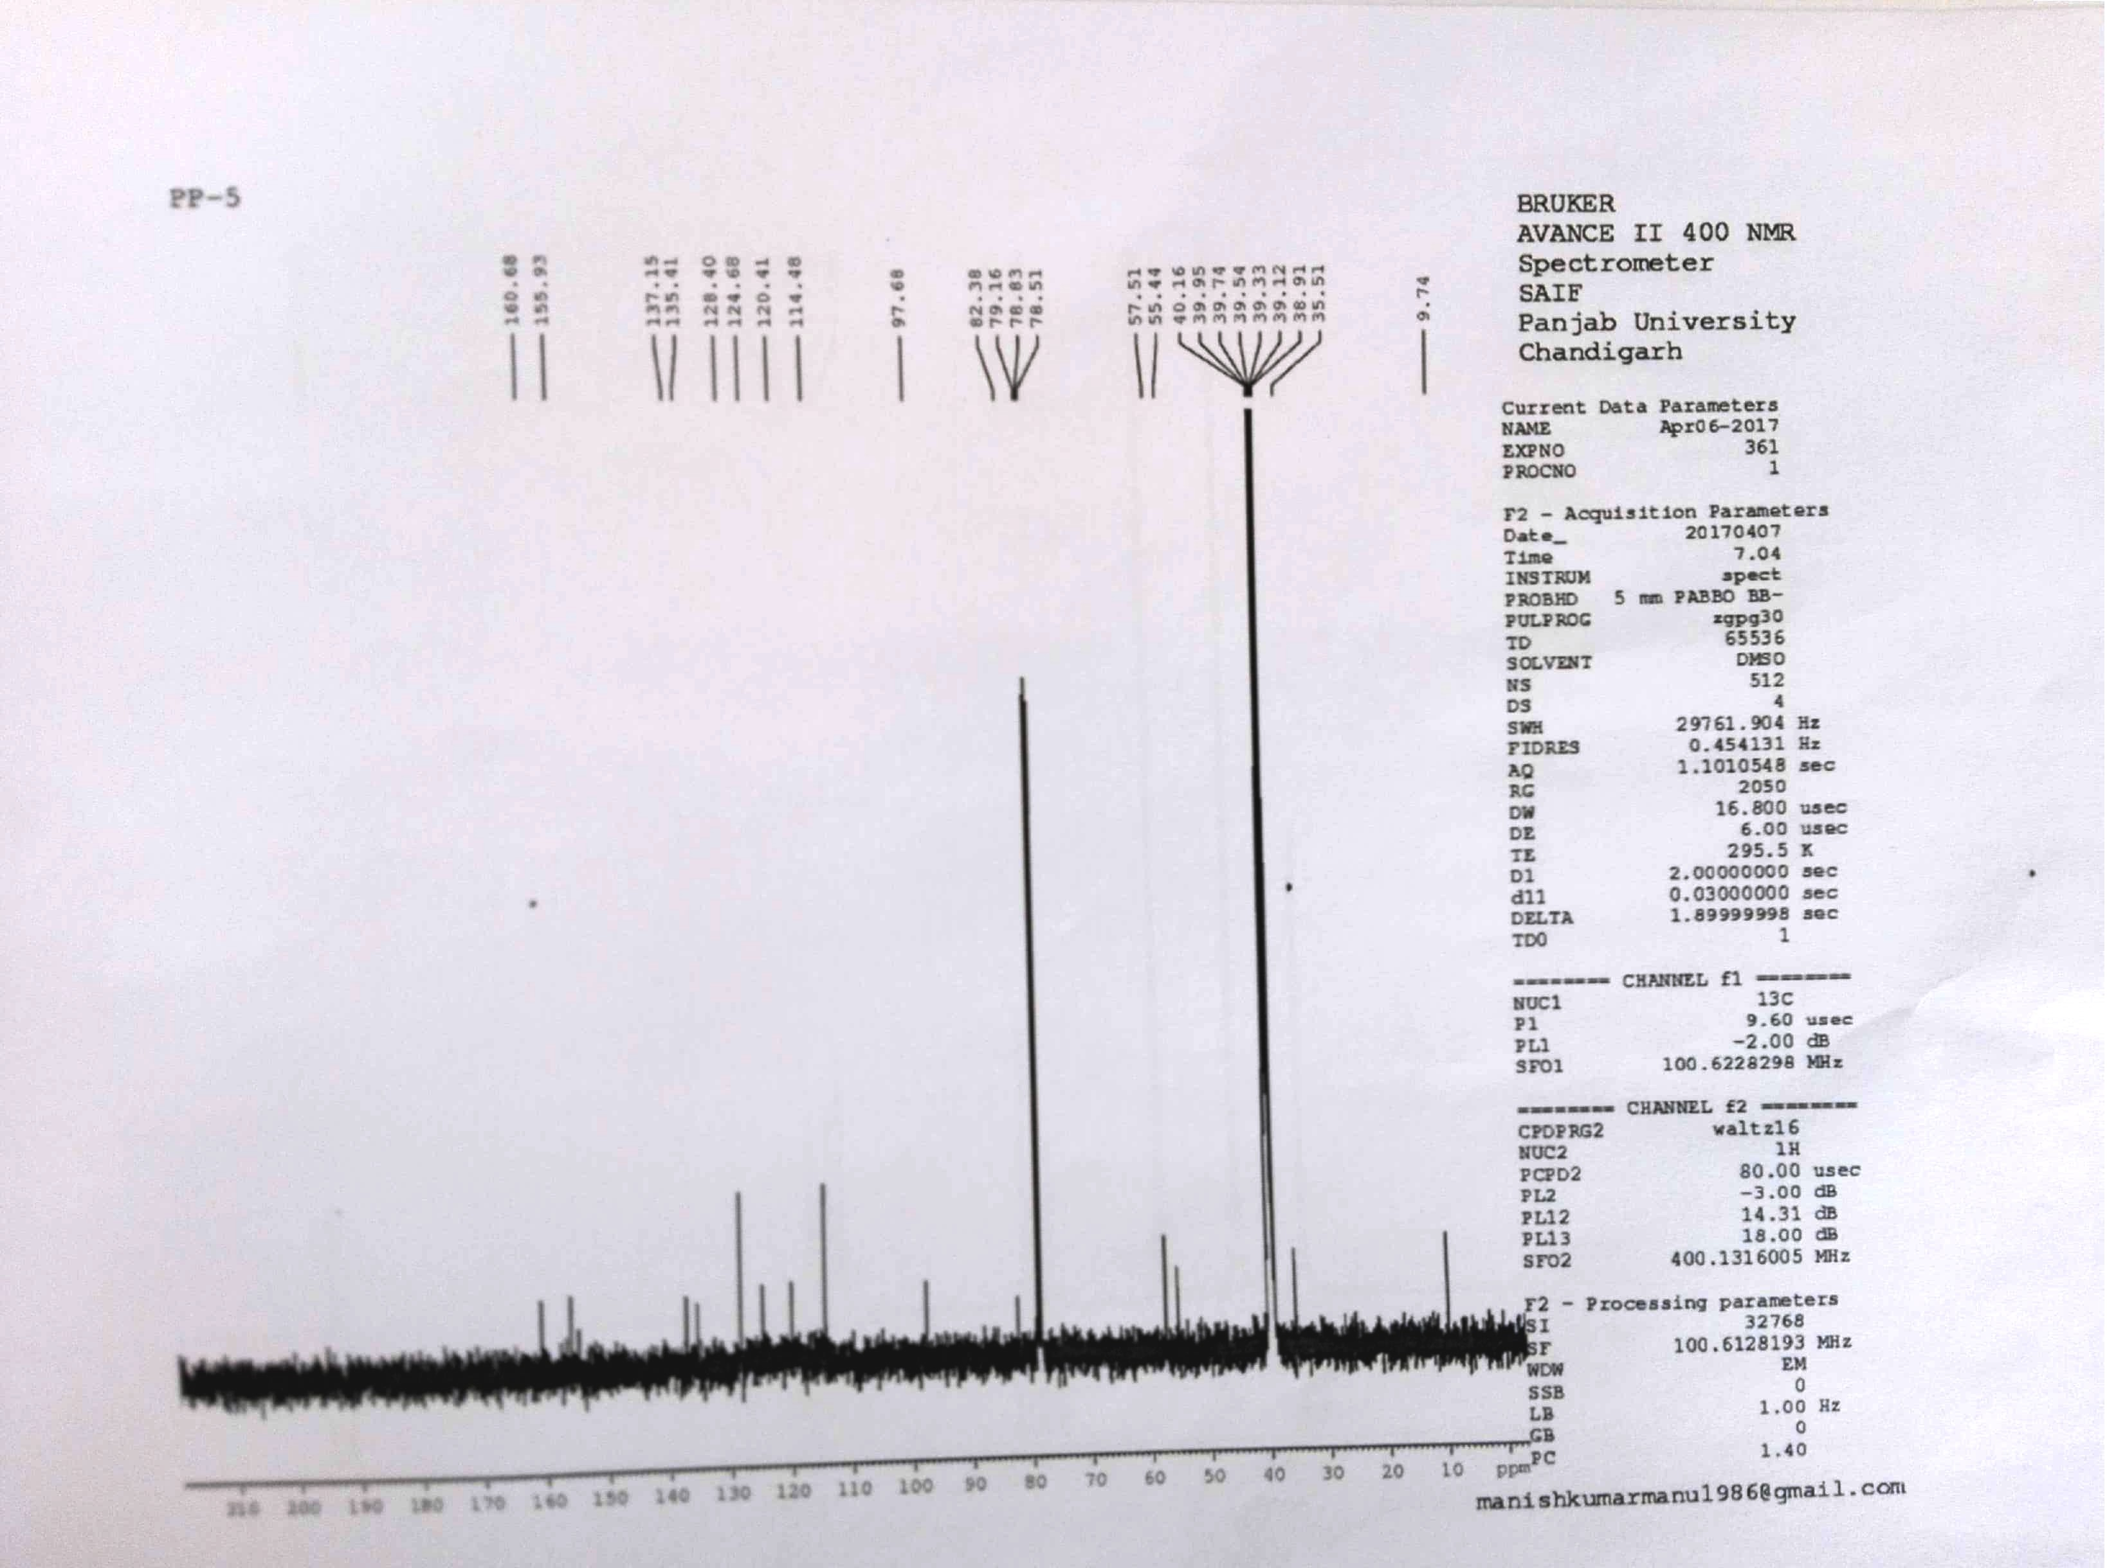
¹³C-NMR of bispyranopyrazole (3b)
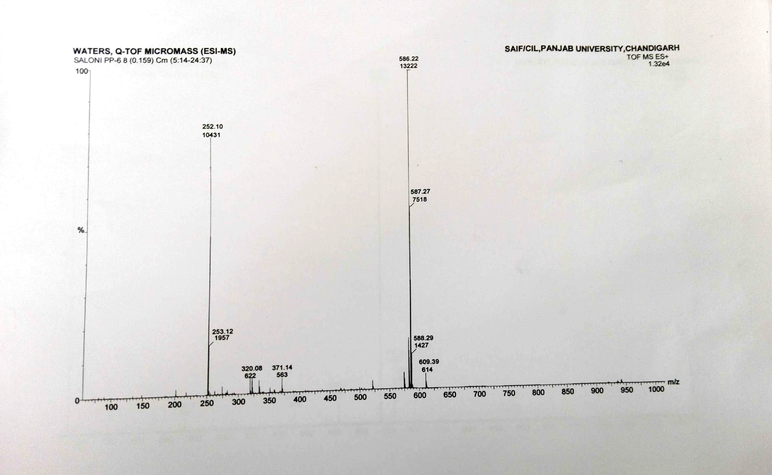
ESI-MS of bispyranopyrazole (3b)

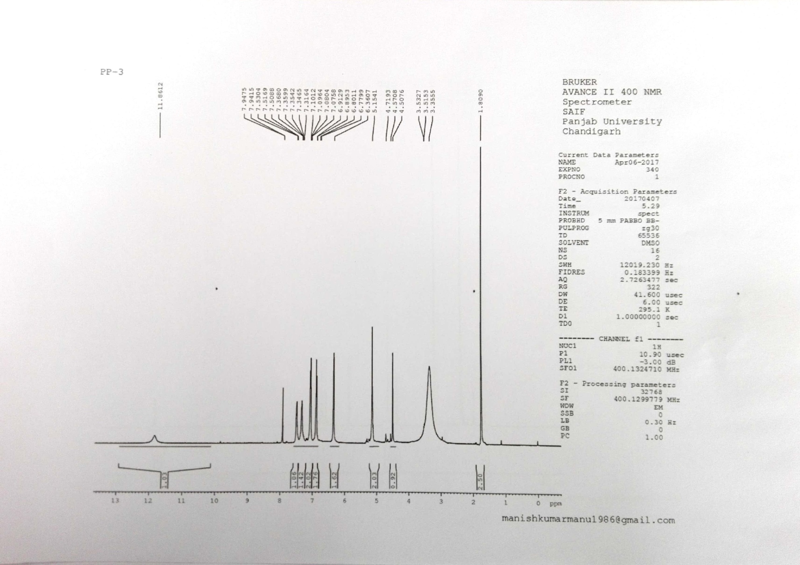
¹H-NMR of bispyranopyrazole (3c)
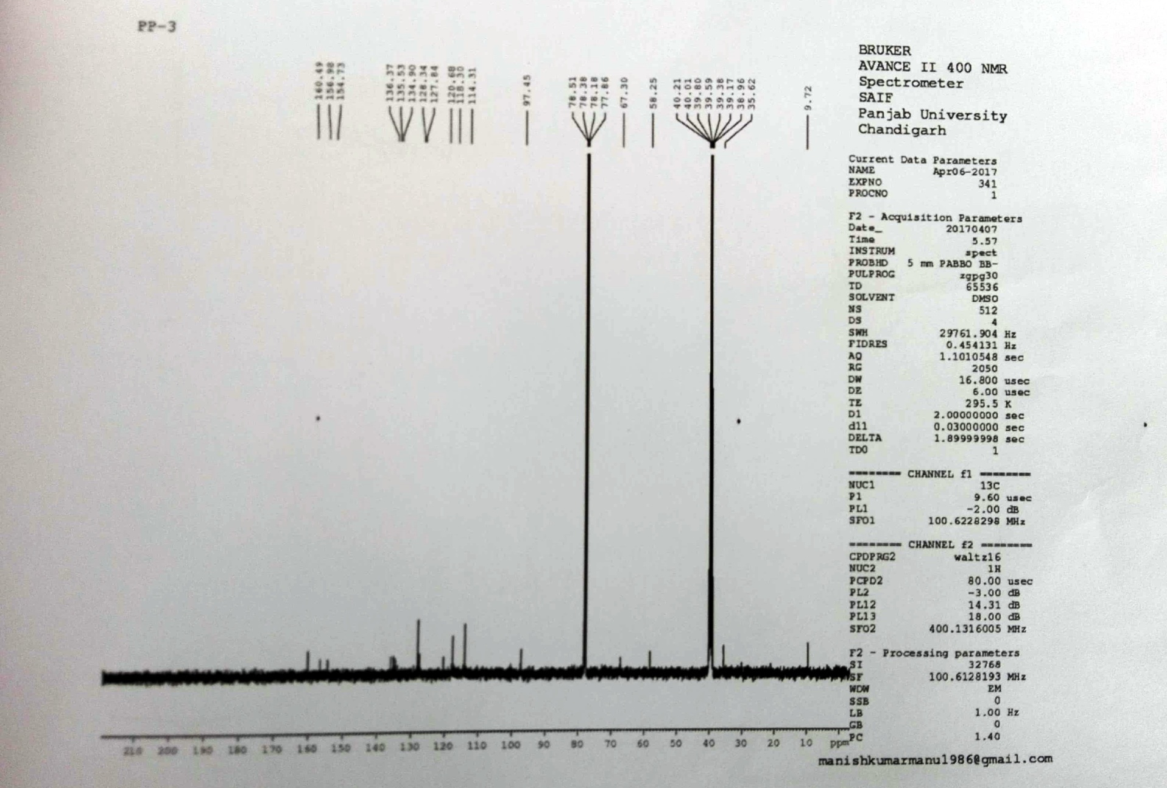
¹³C-NMR of bispyranopyrazole (3c)
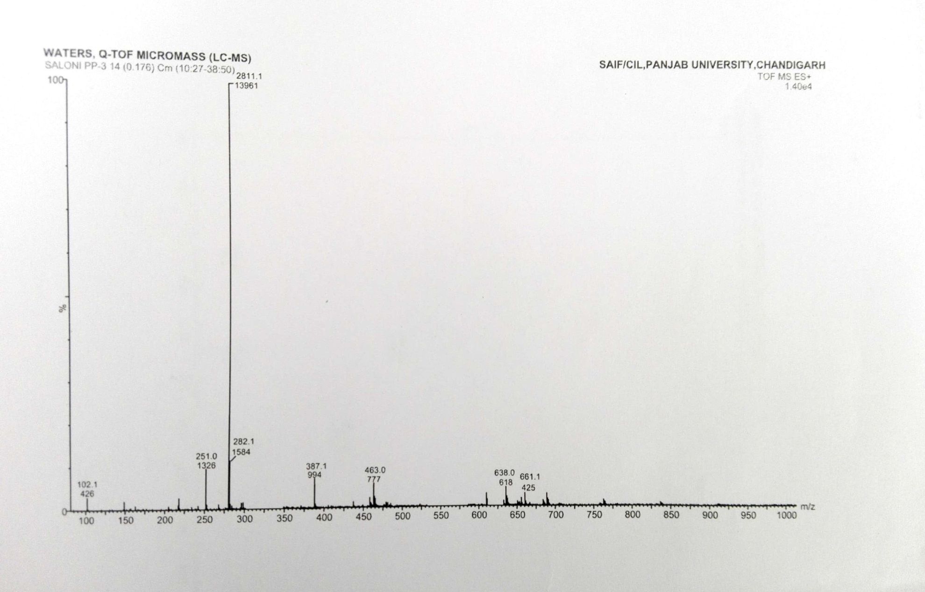
ESI-MS of bispyranopyrazole (3c)

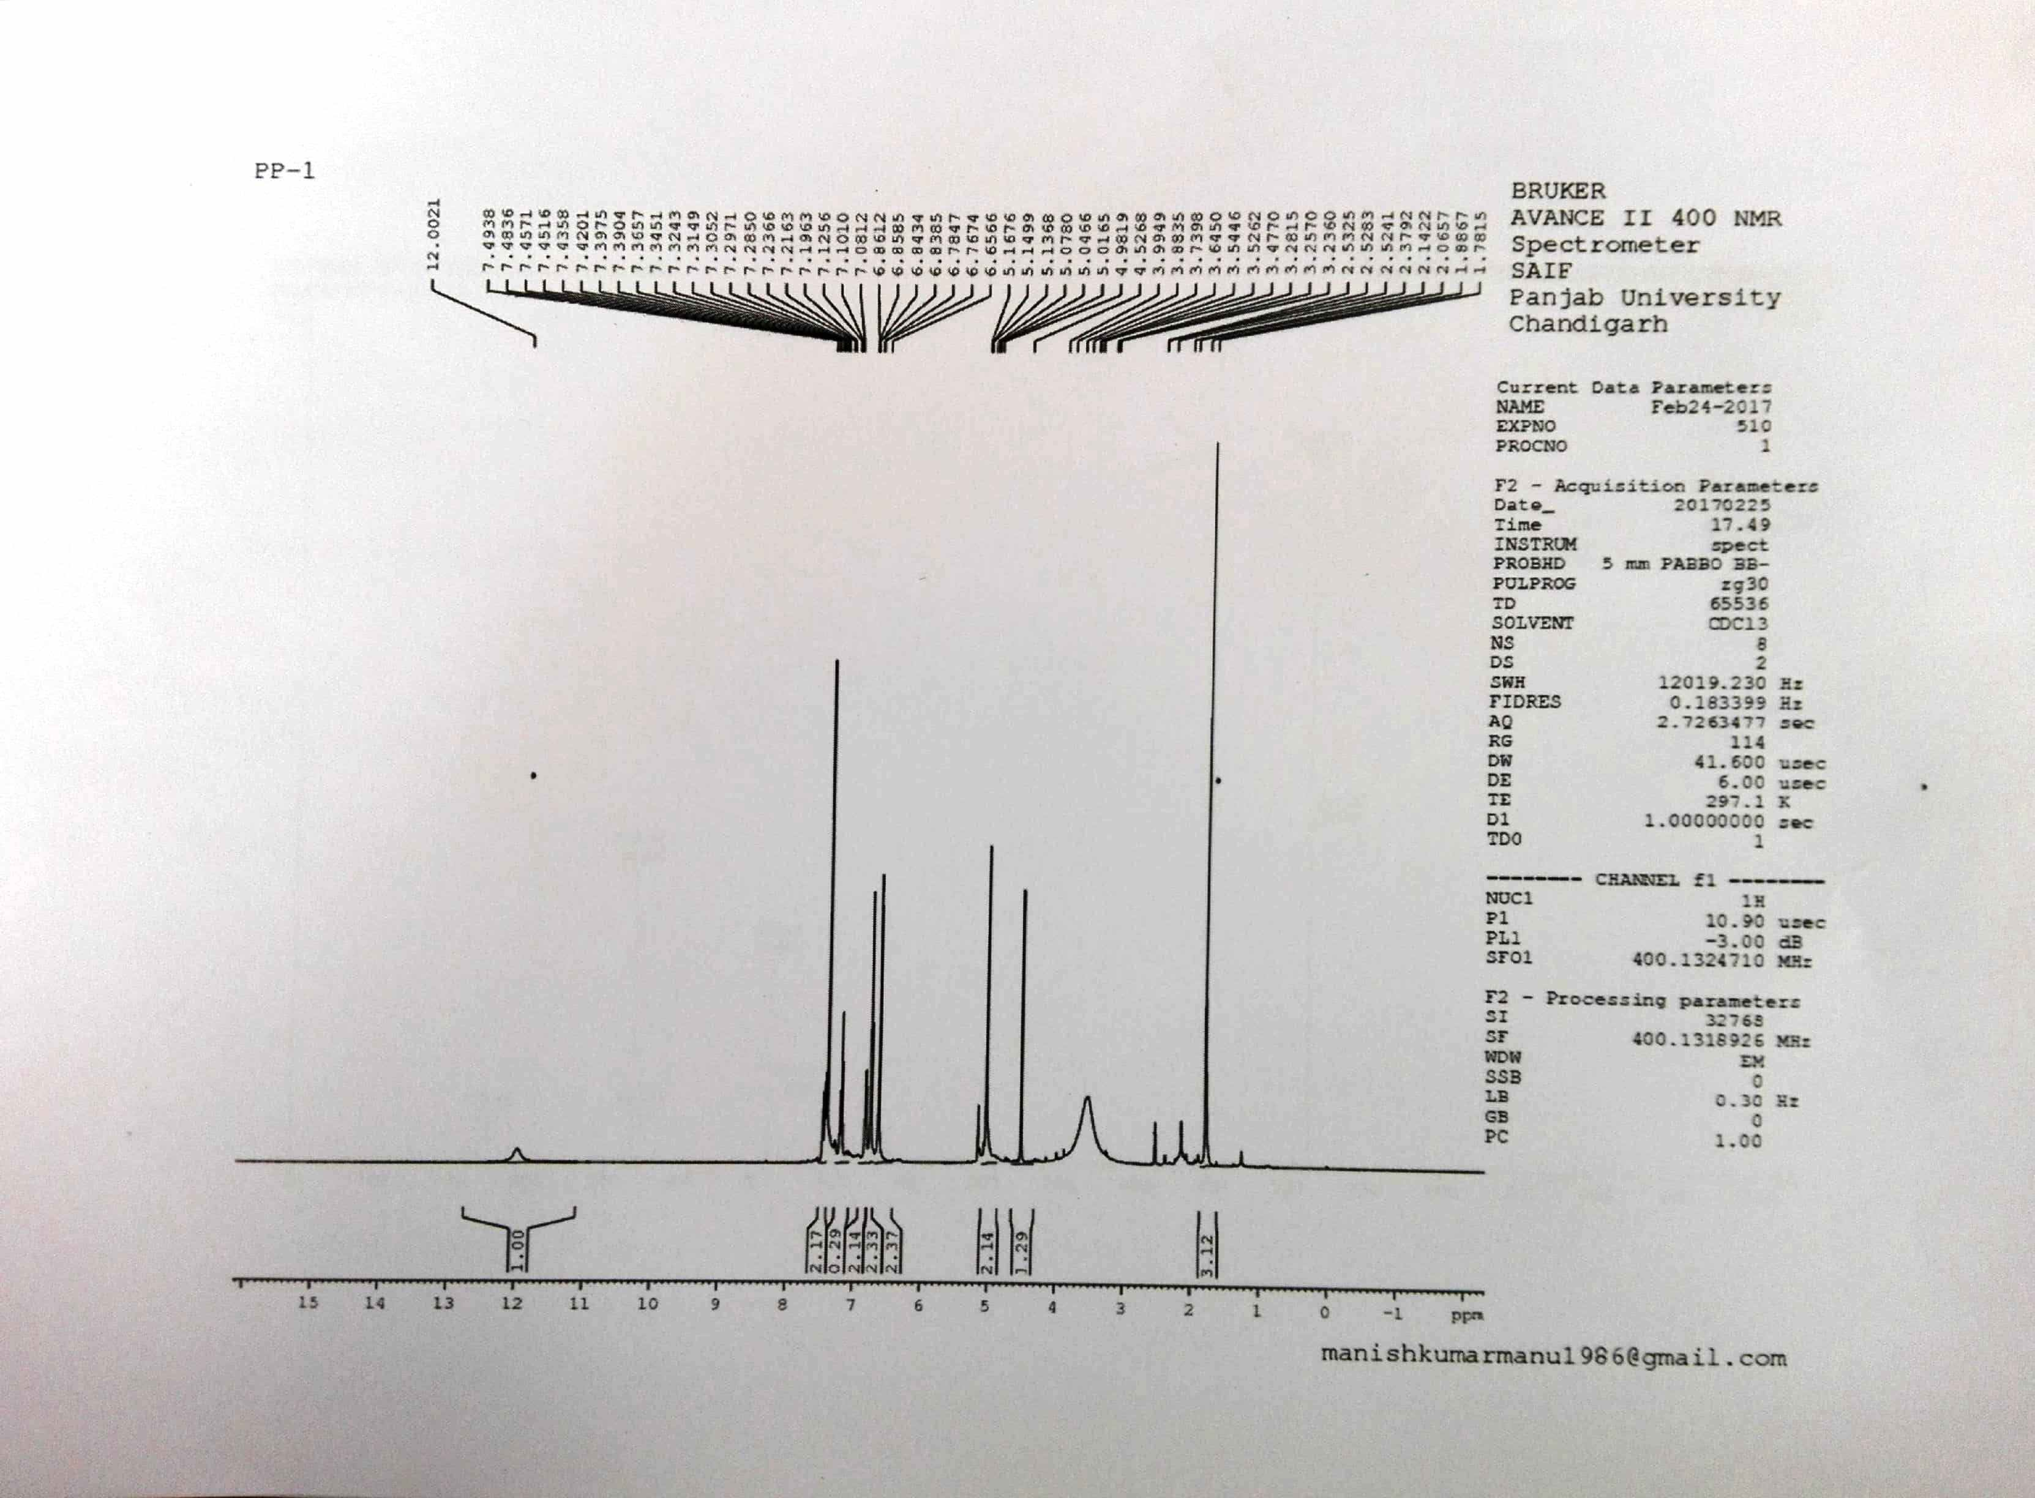
¹H-NMR of bispyranopyrazole (3d)
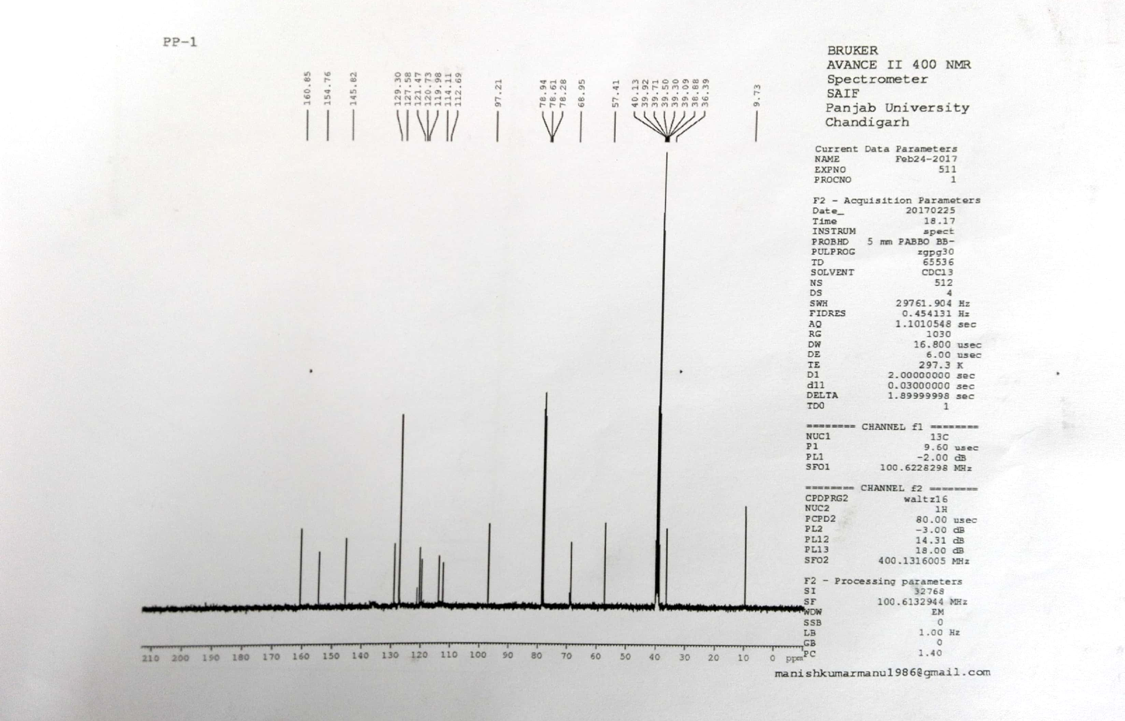
¹³C-NMR of bispyranopyrazole (3d)

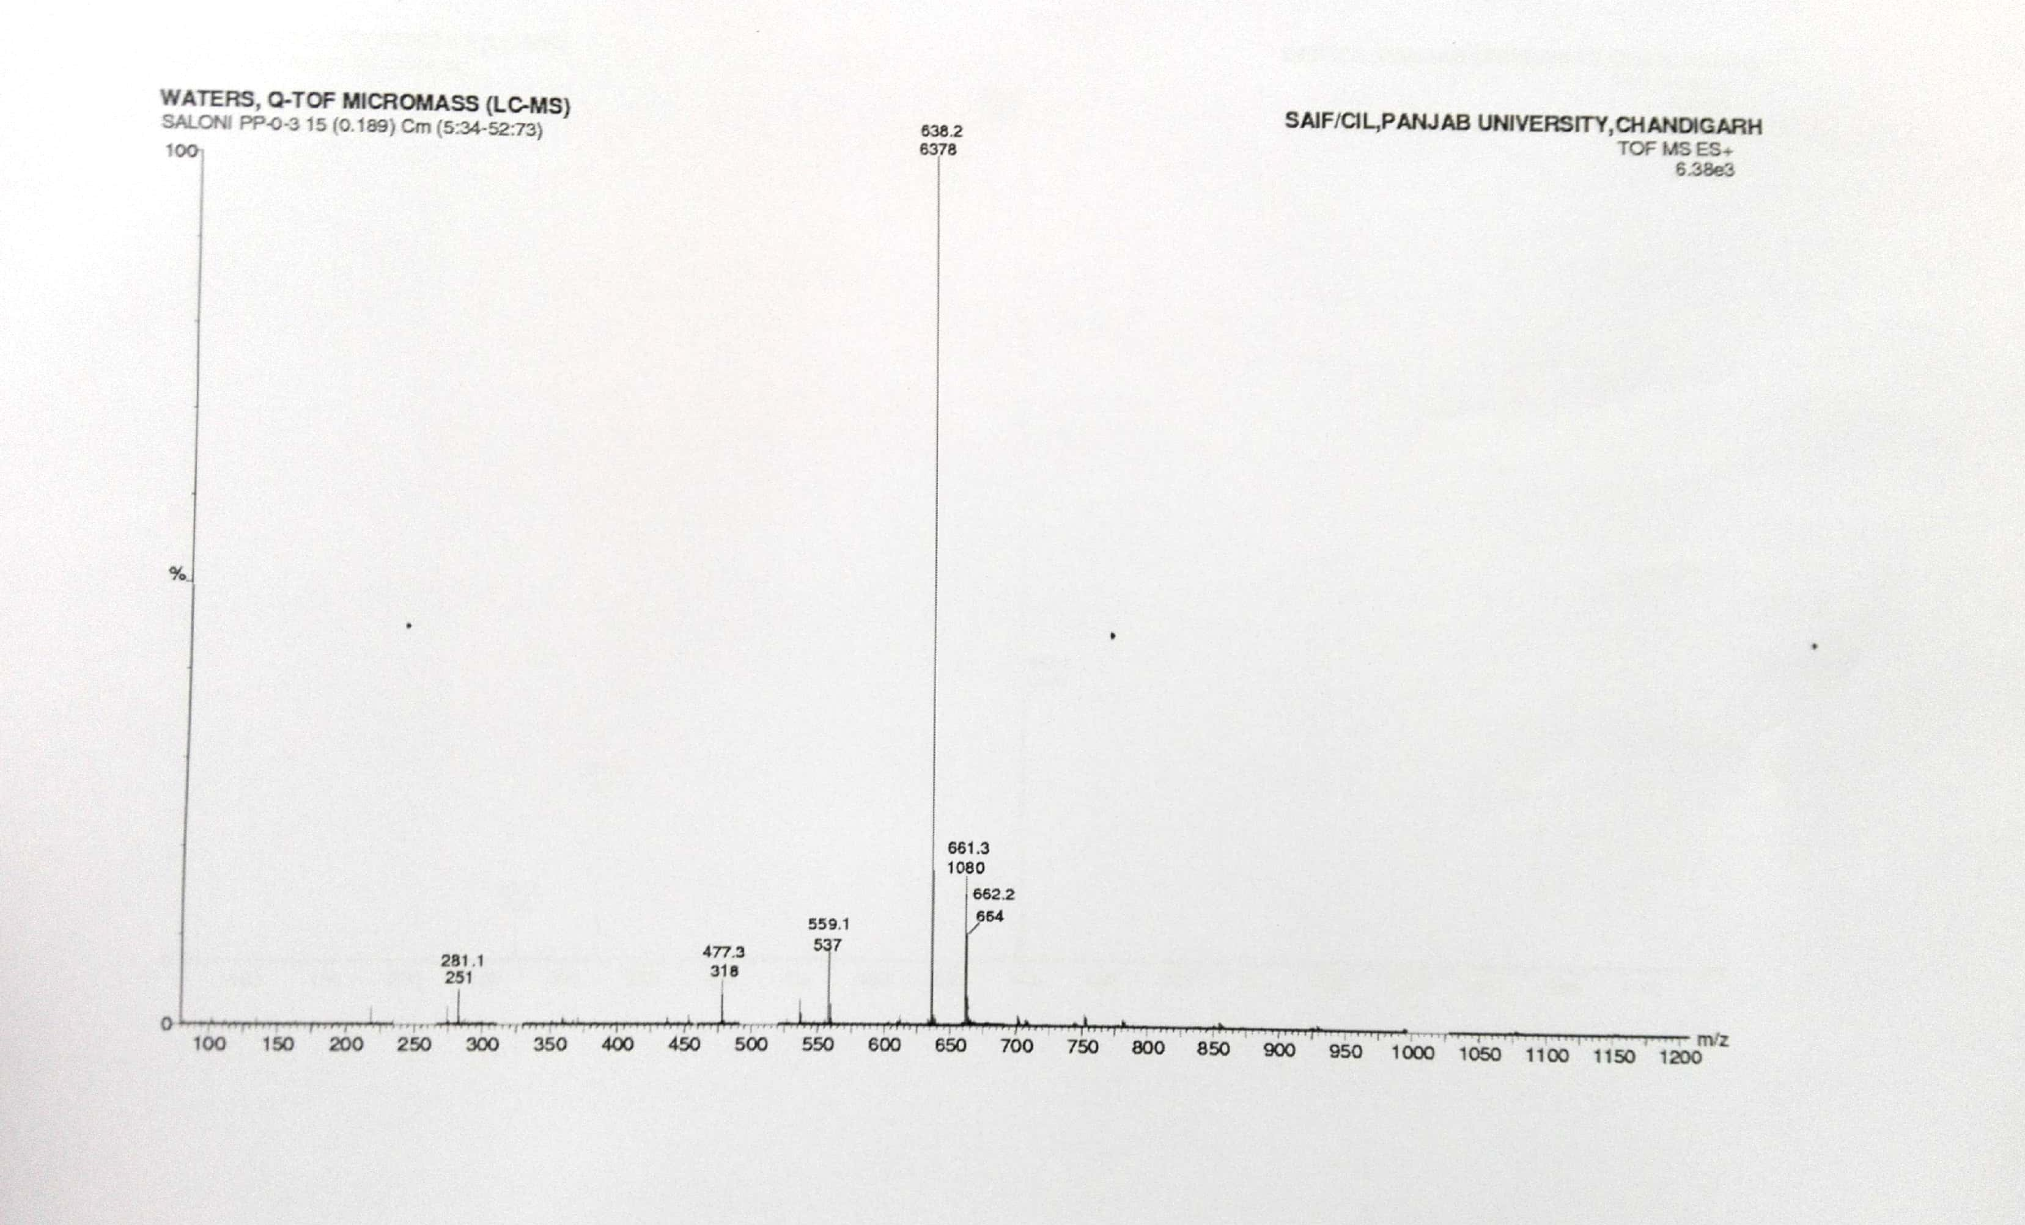
ESI-MS of bispyranopyrazole (3d)
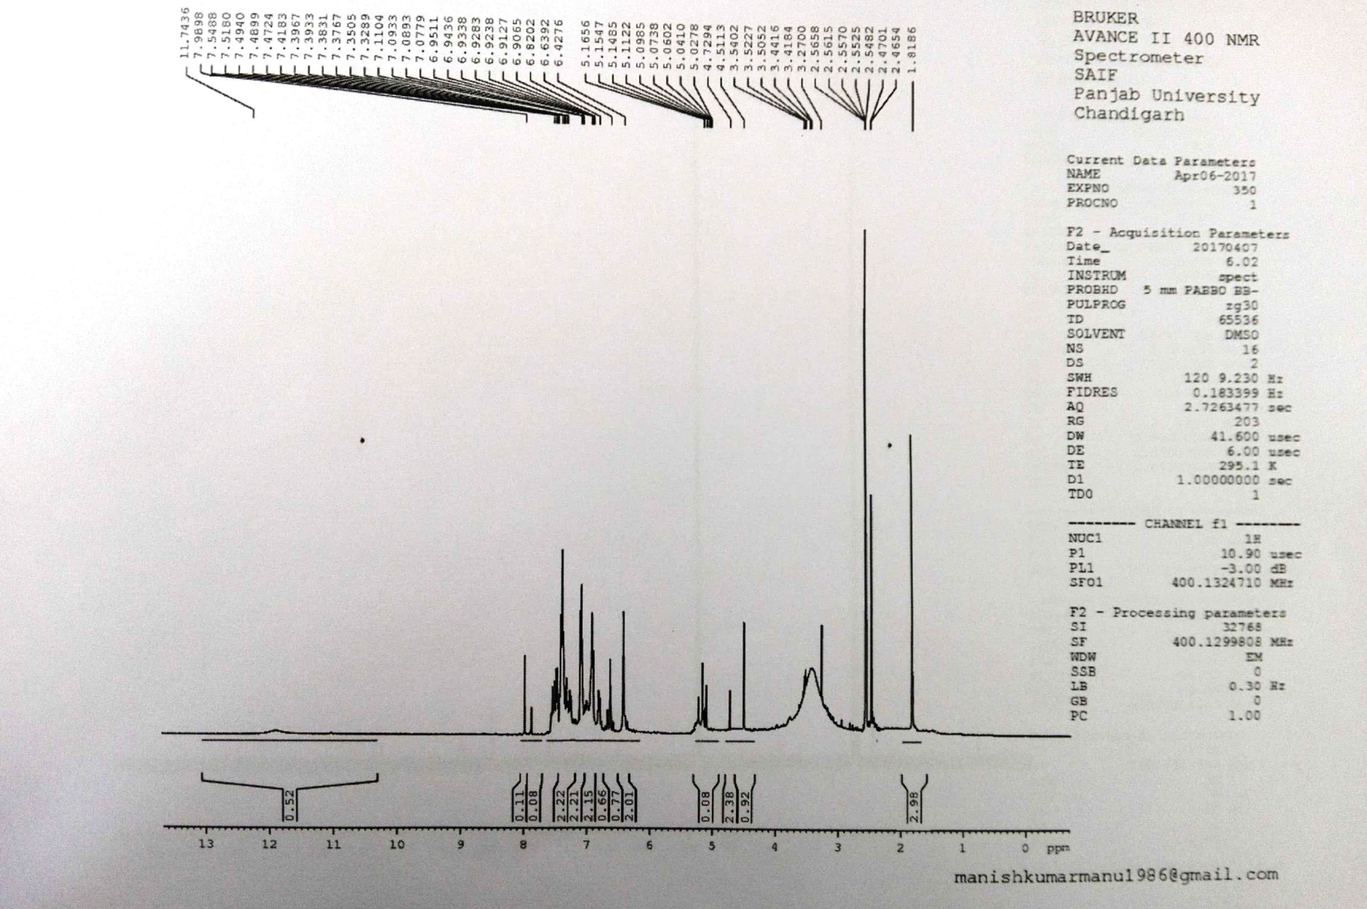
¹H-NMR of bispyranopyrazole (3e)

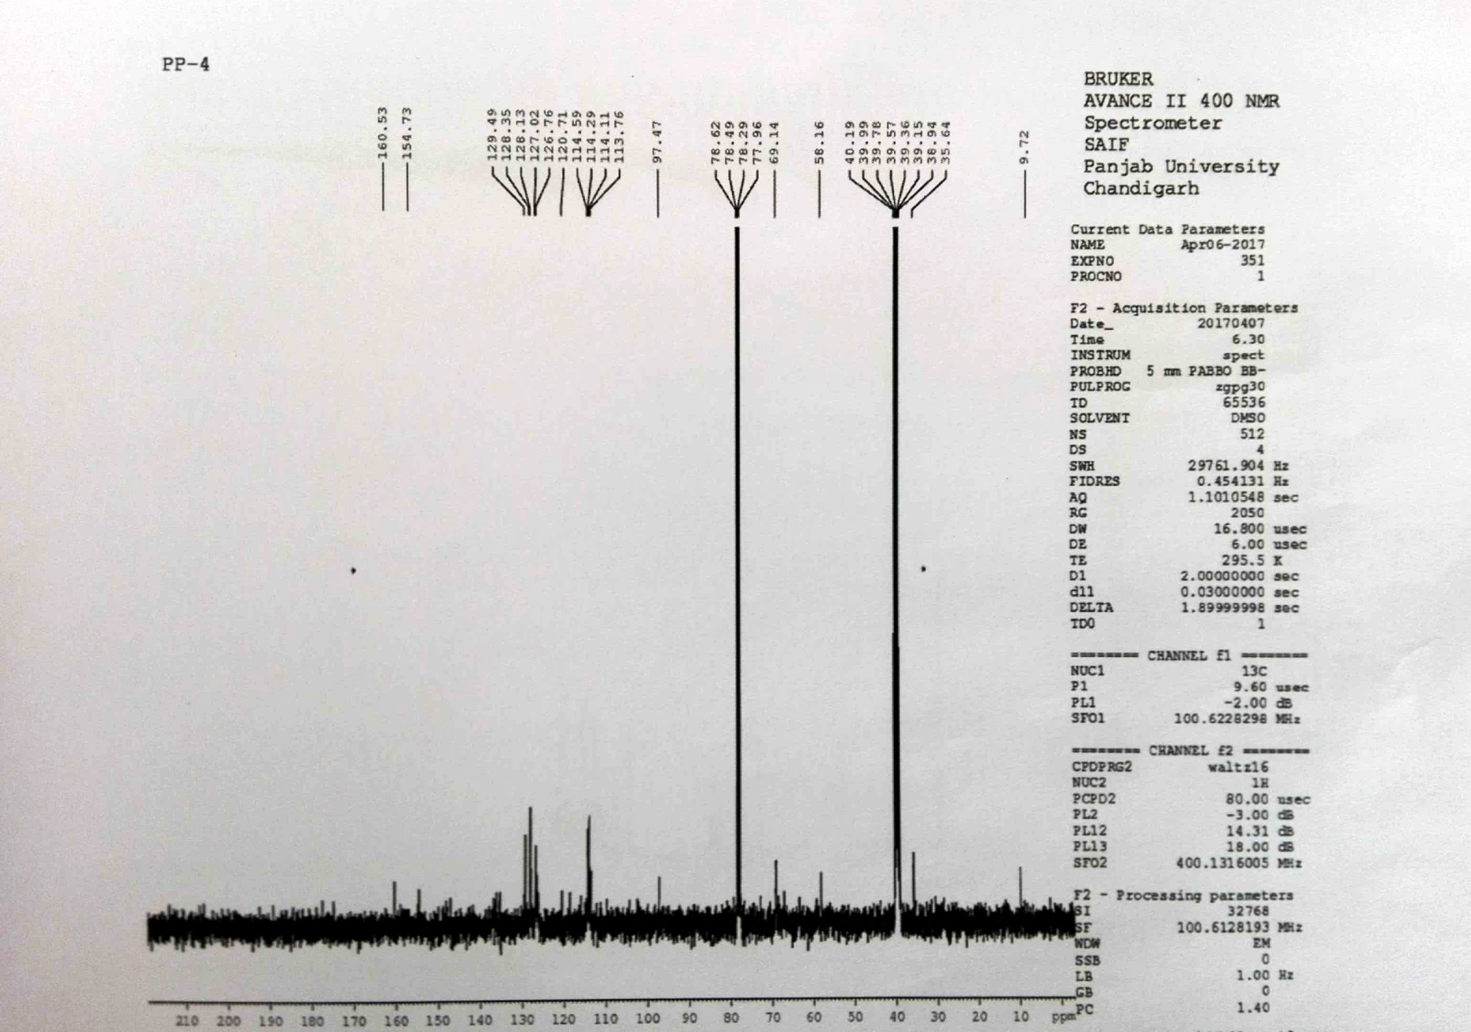
¹³C-NMR of bispyranopyrazole (3e)
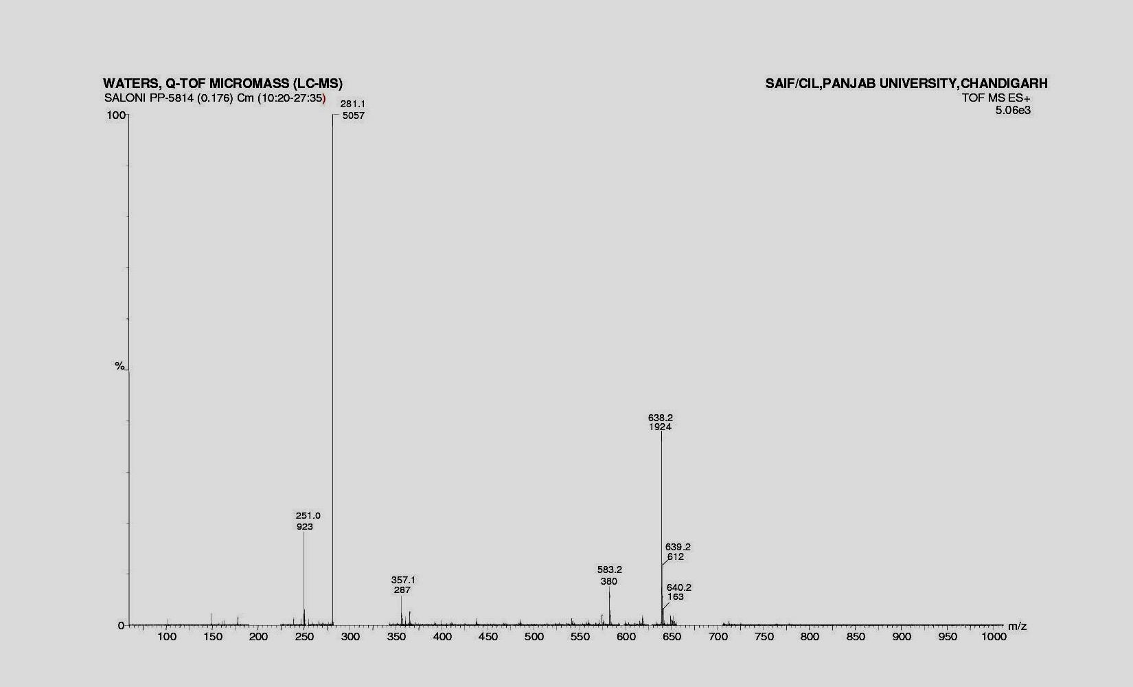
ESI-MS of bispyranopyrazole (3e)

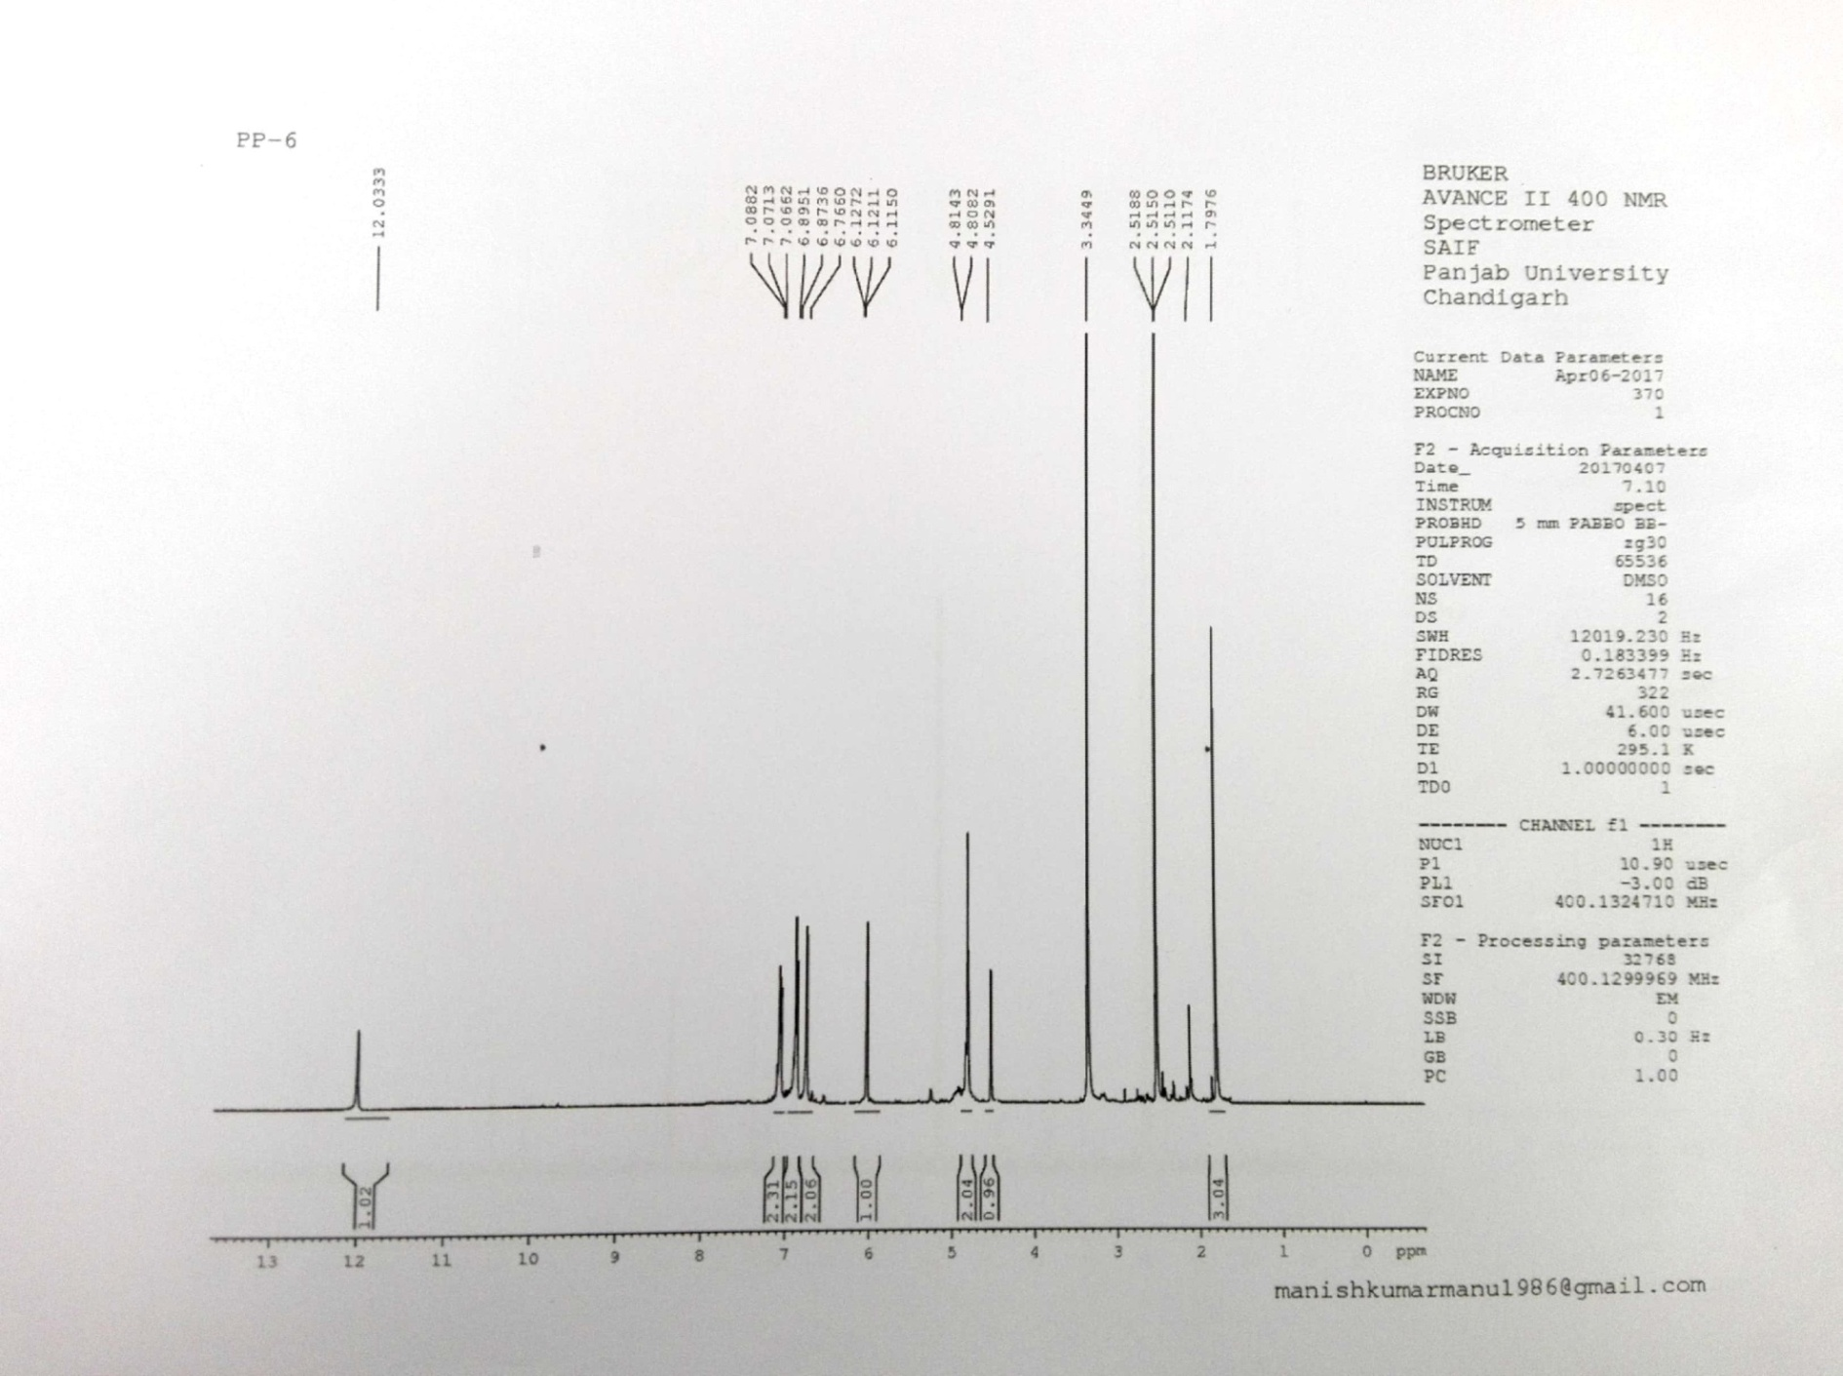
¹H-NMR of bispyranopyrazole (3f)
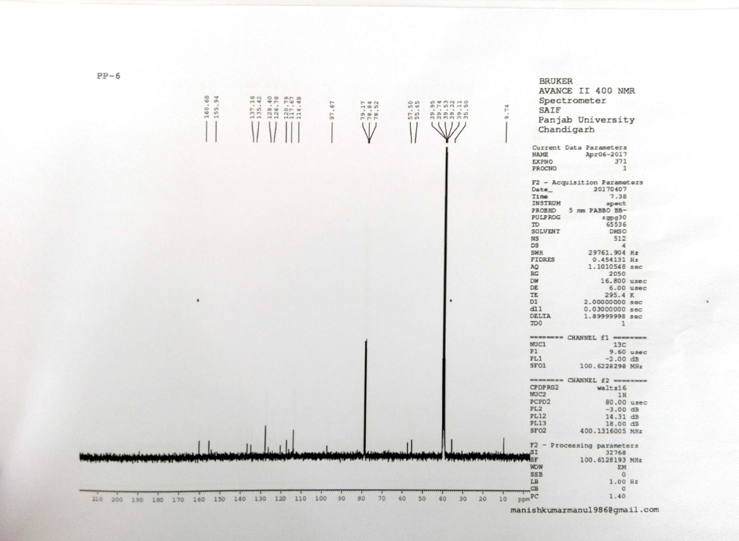
¹³C-NMR of bispyranopyrazole (3f)

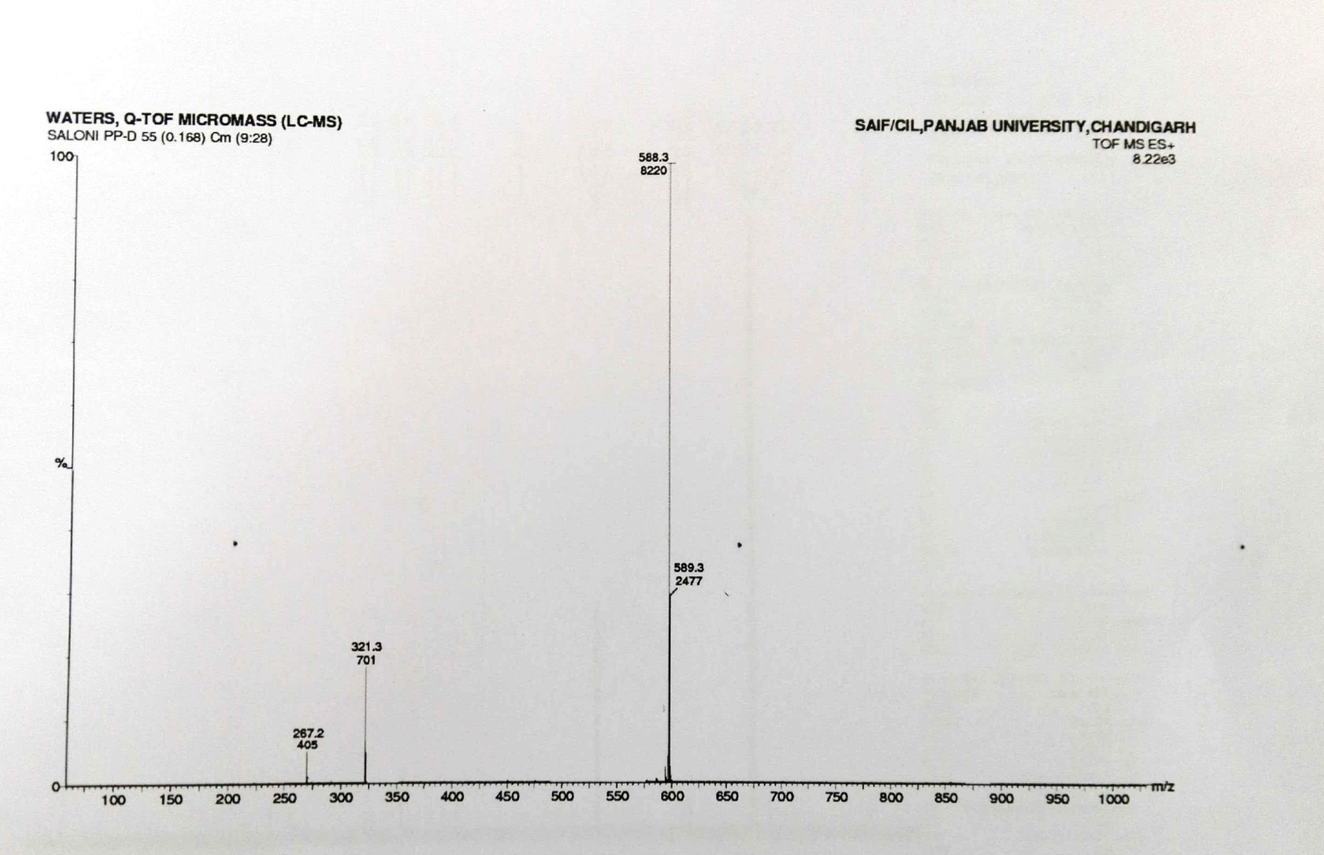
ESI-MS of bispyranopyrazole (3f)

*Corresponding author. e-mail: yusuf_sah04@yahoo.co.in

