Highly thermal resistance hydrophobic poly(vinyl alcohol)-silica hybrid nanofibers
Mustafa Hulusi Ugur, Burcu Oktay, Atilla Gungor and Nilhan Kayaman-Apohan*
Marmara University, Faculty of Arts and Sciences, Department of Chemistry, 34722, Istanbul, Turkey

*Corresponding author’s Tel. number: +90 532 5737610
E-mail address: napohan@marmara.edu.tr

RUNNING TITLE: HIGHLY THERMAL RESISTANCE NANOFIBERS

Abstract: In this study, we report the preparation of hydrophobic and crosslinked poly(vinyl alcohol)/silica organic-inorganic hybrid nanofibers via sol-gel electrospinning method. Silica was produced through acetic acid catalyzed reaction of a silica precursor consists of dimethyl dimethoxysilane (DMDMS), methyl trimethoxysilane (MTMS), tridecafluoro-1,1,2,2-tetrahydrooctyl triethoxysilane (FAS; Dynasylan®F8261) and phenyl trimethoxysilane (PTMS; Dynasylan®9165) in isopropyl alcohol–water mixture. Hybrid nanofibers were realized with electrospinning of the silica precursor and PVA aqueous solution. Chemical, structural, thermal and surface analyses have been conducted by Fourier-transform infrared spectroscopy (FTIR), thermogravimetric analysis (TGA), scanning electron microscopy-energy-dispersive X-ray (SEM/EDX) and water contact angle (WCA) methods, respectively. The obtained hybrid nanofibers are insoluble in aqueous solution. SEM images displayed that highly cross-linked and porous structures were obtained and the average fiber diameter of poly(vinyl alcohol) (PVA)/silica nanocomposite were around 70 nm. A nanofiber surface with 130° water contanct angle was achieved.

Keywords: Poly (vinyl alcohol); Electrospinning; Sol-Gel; Hybrid Nanofibers

INTRODUCTION
Electrospinning has become recognized method within last decade and it is primarily concern with the preparation of electrospun materials from synthetic and natural polymers. The electrospun materials show different architectures in large diameter range^{1,2}. Electrospinning equipment comprises a pump, a collector and a high voltage supply, which generates between 1–40 kV voltage that orients the polymer solution to the collector. In the electrospinning process, a high voltage is applied to surface of a polymer solution. As charged solution overcome its surface tension, jet travels towards to a collector^{3,4}.
In particular, nanofibers are prefered due to their large surface area/volume ratio⁵. Moreover they show high porosity with controllable pore structure and tailorable thickness⁶. Nanofibers have huge potential for the application in tissue scaffolds, drug release, protective clothing, sensors and affinite membranes⁷. In particular, nanofiber matrices have been highly desired for fabricating scaffolds in tissue engineering because of their porous structure, high elastic modulus and cell-surface interactions^{8,9}. Z. Tang et al prepared a novel cyclodextrin-functionalized PVA/SiO₂ fibrous membrane by electrospinning with combined sol-gel method. Adsorption capacity of the membranes was tested for indigo carmine dye¹⁰. In another study, Wang et al used electrospinning for the preparation of lipase immobilized poly(vinyl alcohol) nanoﬁbrous membranes. Activity of lipase immobilized bicomponent ﬁber was tested and also its stability over time expore to humidity and temperatures was evaluated¹¹. Guo et al was used electrospinning, calcination and surface modification techniques for preparation of composite nanofibrous mats. The surface properties of the amphiphilic electrospun nanoﬁbrous PVA mats was changed to amphiphobic by grafting of ﬂuoroalkyl silane. The ﬂuorinated mat displayed higher water contact angle (WCA)¹². In another study, fluoroalkyl silane modified super-hydrophobic electropun membranes were fabricated. Cellulose acetate nanofiber were prepared by electrospinning. TiO₂ nanoparticles were deposited on the cellulose acetate nanofibrous membranes. Finally, the surface of the mats was modified by fluoroalkyl silane¹³. Electrospinning usually achieves polycrystalline fibers, which may lower down the mobility of charge carriers in devices. This technique get some of the advantage such as, wet chemical methods are lower cost, less hazardous, higher reproducibility, easier controllability in comparison of the above methods^{14,15}.
In this study, the primary goal is to prepare and develop a porous and highly thermal resistance hydrophobic PVA/silica hybrid nanofiber mats. The crosslinked PVA/silica nanofibers were synthesized via the sol-gel electrospinning technique. The effect of sol-gel concentration on the morphology and thermal resistance, including FTIR, contact angle and physical properties were investigated.

EXPERIMENTAL
Apparatus and Reagents
Methyltrimethoxysilane (Dynasylan®MTMS), phenyltrimethoxysilane (PTMS; Dynasylan® 9165), tridecafluoro-1,1,2,2-tetrahydrooctyl triethoxysilane (FAS; Dynasylan® F8261) were kindly supplied by EVONIK. Dimethyldimethoxysilane (DMDMS), Poly(vinyl alcohol) (PVA; Mw 67,000 g/mol; 86.7–88.7 mol% hydrolysis) and isopropyl alcohol (IPA; (CH₃)₂CH(O)H) was purchased from Aldrich–Sigma. Deionized water of 18.2 MΩ cm resistivity (Millipore, Anamed–Turkey) was used. All chemicals were used to as received without further purification.
Preparation of PVA/silica electrospinning solution
Firstly, PVA solution (7 wt.%) were prepared in deionized water. PVA granules were stirred in deionized water for 30 min at room temperature (RT). Then, the temperature of the mixture was raised to 60 °C and constantly stirred for 3 h to obtain a clear solution. This solution was kept in refrigerate overnight.
The silica precursor was prepared by using MTMS (11.76 g, 0.0864 mol), DMDMS (5.04 g, 0.042 mol), PTMS (0.72 g, 0.00363mol) and FAS (1.2 g, 0.00234 mol). The mixture of alkoxysilanes were magnetically stirred for about 1 h at RT. Then, MTMS/DMDMS/PTMS/FAS mixture were dissolved in isopropyl alcohol (35 mL) and deionized water (65 mL). The molar ratios of ingredients were as 37:160:1000 alkoxysilanes:isopropanol:water. As can be seen in Table 1, the silica precursor ranging from 0.5 to 40 wt.% were added into the PVA solutions by stirring at 60 °C for 2 h to homogenize the PVA/MTMS/DMDMS/PTMS/FAS. Upon adding the acetic acid as a catalyst into the prepared solutions, the solutions were electrospun immediately.

Table I. Amounts of silica precursor in aqueous PVA solution.
Nanofiber Formulations | Silica precursor,  wt.% | 7wt.% aq PVA,  mL | Nanofiber diameter,  nm
M1 | 0.5 | 99.5 | 45-75
M2 | 1 | 99 | 48-60
M3 | 5 | 95 | 25-52
M4 | 10 | 90 | 50-100
M5 | 20 | 80 | 15-40
M6 | 30 | 70 | 20-60
M7 | 40 | 60 | 25-100

Totally, seven electrospun solutions were prepared containing various amounts of silica precursor. These clear solutions were loaded in a 10 mL stainless steel syringe. The distance between the aluminum foil coated the collecting drum and the capillary was fixed as 16 cm. The electric filed of 33 kV was applied to spin solution and at flow rate was kept at 1 mL/h. Then, the nanofibers cured at 100 °C during 1 hour to obtain crosslinked material. Schematic illustration of resulting PVA/silica nanofibers is shown in Fig. 1.

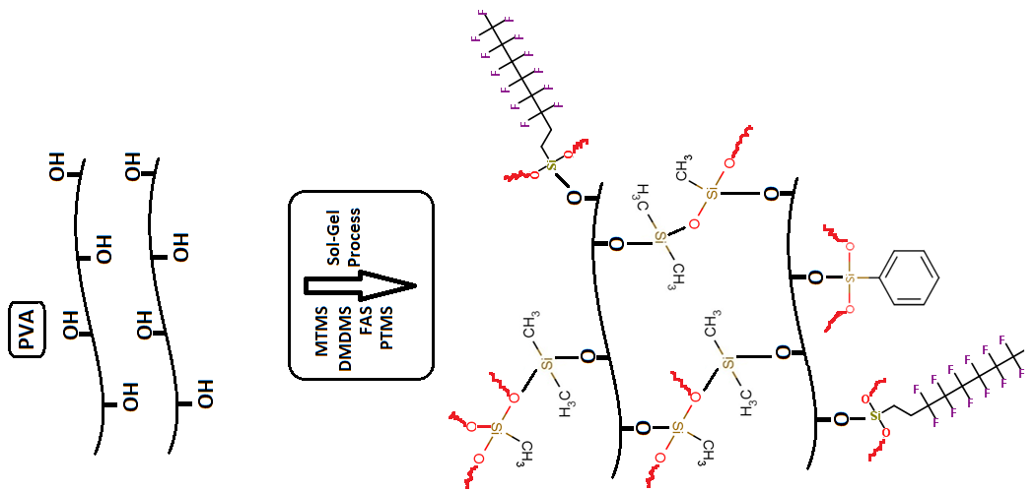
Fig. 1. Schematic illustration of PVA/silica nanofiber mats.
Characterization
The FTIR spectra of PVA/silica nanofibers was recorded in range of 4000–600 cm^{–1}. FTIR spectrum was recorded on PerkinElmer Spectrum 100 ATR-FTIR spectrophotometer.
The termal stability of the samples was tested in the temperature range of 30–600°C by Pyris 1 TGA model using a PerkinElmer STA 6000 instrument under nitrogen flux at a heating rate of 10°C/min.
The synthesized pure electrospun PVA/silica nanofibers were characterized by SEM imaging of the films were performed on Philips XL30 ESEM-FEG/EDAX. The specimens were prepared for SEM by freeze fracturing in liquid nitrogen and applying a gold coating.
The wettability characteristics of nanofiber coatings were performed on a Kruss (Easy Drop DSA-2) tensiometer. The contact angles (θ) were measured by means of sessile drop test method in which drops were created by using a syringe. Measurements were made using 3–5 µL drops of distilled water. For each sample, at least five measurements were made, and the average was taken. The surface energy of the coatings was calculated. For the calculation of the surface energy, three test liquids were considered: water and ethylene glycol as polar solvents and diiodomethane as a disperse solvent.

RESULTS AND DISCUSSION
The FTIR spectrum of electrospun PVA based nanofibers are collected (see Fig. 2). As can be seen in Fig. 2, in the neat PVA spectrum a large broad band of hydroxyl (OH) stretching appears at 3300 cm⁻¹. It is observed that the band obtained 2850–2950 cm^{–1} related to CH₂ stretching. The peak observed at 1100 cm^{–1} indicated the terminal polyvinyl groups¹⁶⁻¹⁹. The bands at the 1335 and 1418 cm⁻¹ related to the CH bending and CH₂ deformation vibrations, respectively²⁰ and an accompanying C–O stretching exists at 1150–1250 cm⁻¹.
In the FTIR spectra of M1 and M3, the Si–O–C and Si–O–Si asymmetric stretchings observed at 956 and 1135 cm^{–1} respectively, and they display a broad absorption because of hydrogen bonded silanols. Si–O–Si group comprises of reaction between Si–OH and the Si–O–C groups. In this study, the Si–O–Si groups occured from reaction the between Si–OH groups of hydrolyzed MTMS–DMDMS–PTMS–FAS and hydroxyl groups of PVA. The presence of the peaks at 956 and 1135 cm^{–1} demonstared covalent linkage of PVA and MTMS–DMDMS–PTMS–FAS. FT-IR results proved that the cross–linking network were formed by between organic and inorganic components^{19,21}. The absorption at 1725 cm⁻¹ arises due to the C=O stretching in the partially hydrolyzed PVA²².
In comparison of the FTIR spectra of neat PVA, the absorption peak 3300 cm⁻¹ of O–H lost in PVA/Silica, which can be attributed that there were not uncondensed Si–OH and/or unreacted –OH groups of the PVA. Thus, the relative decrease in the intensity of the –OH stretching at 3300 cm⁻¹ for PVA/Silica based nanofibers is consistent with the decrease in PVA content in the precursor mixture due to the cross–linking between the hydroxyl groups of PVA and the silica sol.
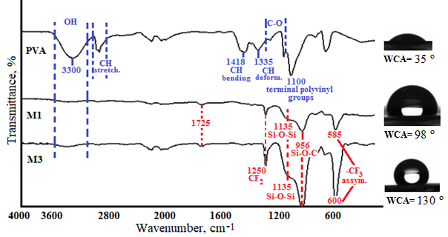

Fig. 2. FTIR spectra of neat PVA and M1 and M3 nanofibers.

The thermal behaviour of PVA/Silica nanofibers was performed using TGA. Fig. 3 and 4 show TGA and DTG curves of PVA based nanofibers containing different silica precursor content, respectively. The results for the thermal analysis are presented in Table I. It is clear from this table that the decomposition temperature of PVA/silica fiber is extremely higher than that of neat PVA fiber²³. TGA curves show that the first weight lost temperatures increased with increasing sol-gel ratio for M2 to M7. Also as the inorganic content increased in the nanofibers char yields were increased. We must also note that exceptional char yields were obtained which could be ascribed to the high thermal stability of the silica precursor used and even with only addition of 0.5 wt.% silica precursor, the char yield of M1 was calculated as 86%. The thermal properties of the resulting PVA/Silica nanofibers are better than most of similar studies^{19,23-26}. The high thermal stability of the silica precursor in this work can be attributed to the existence of C-F bonds and rigid aromatic units. This result also shows that the organic and inorganic matrices were fully crosslinked at the molecular level as supported previously by the FTIR results. The enhancement of rupture energy of the composites due to the high cross-link density, increased the thermal stability of the hybrid nanofiber mats²³.
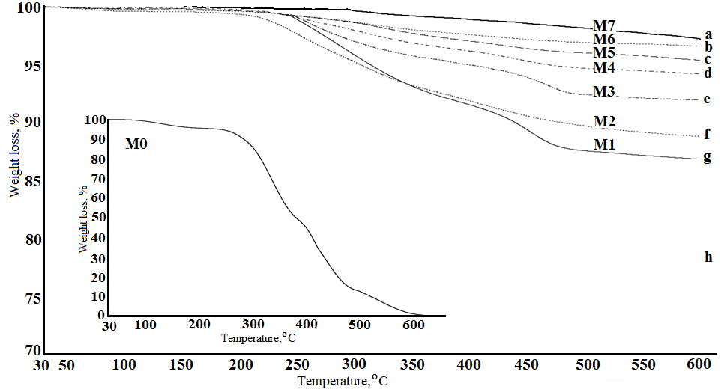
Fig. 3. TGA curves of (a-g) PVA/silica hybrid nanofibers and (h) pure PVA nanofiber

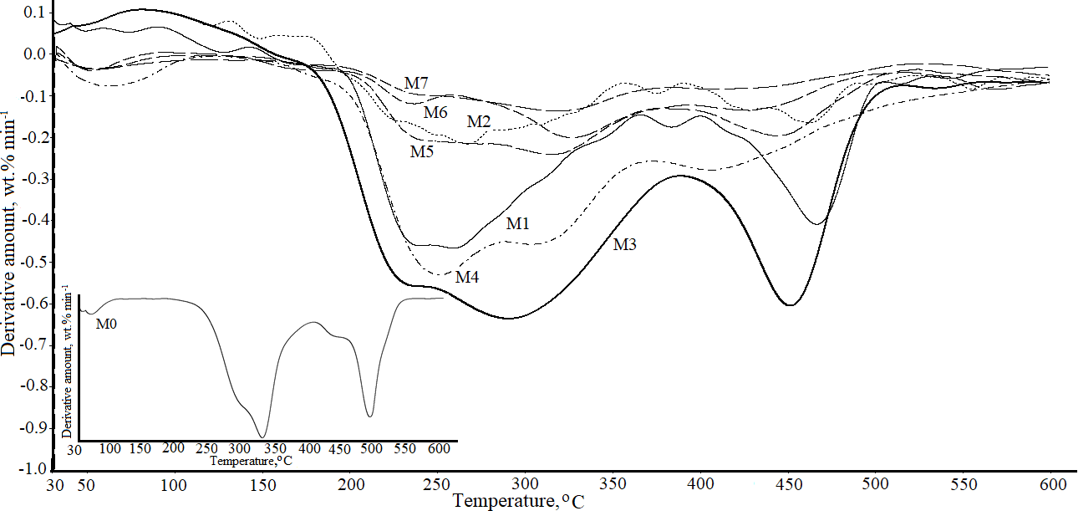
Fig. 4. DTG curves of PVA/silica hybrid nanofibers and pure PVA nanofiber.

The surface properties of the PVA/Silica nanofiber mats were examined by SEM analysis and water contact angle method. All of the micrographs showing different fibrous structures after post-cure at 100 °C for 4 h. SEM image of pure PVA nanofiber was given in Fig. 5. Fig. 6 and 8 show SEM micrographs of nanofiber obtained with electrospinning of PVA solutions containing silica precursor. Fig. 6 shows the SEM images, obtained with a 40000× and 5000× magnifications. Fig. 6 (M1) – (M4) represent the PVA/Silica for the average fiber diameters of the obtained hybrid nanofibers through M1 to M4, were found to be 57, 54, 38 and 73 nm, respectively. SEM images displayed evidence that highly cross-linked and beaded nanofibers and the average fiber diameter of PVA/Silica composite in range of 40 and 75 nm. However, the more regular, uniform and less beads formed in comparison of M5 – M7 hybrid membranes.

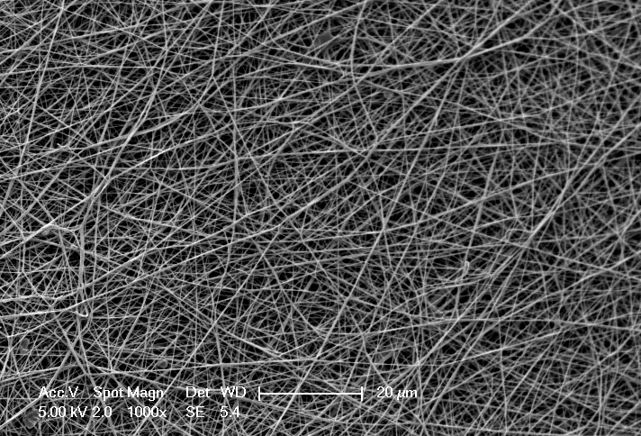

Fig. 5. SEM image of pure PVA nanofiber.
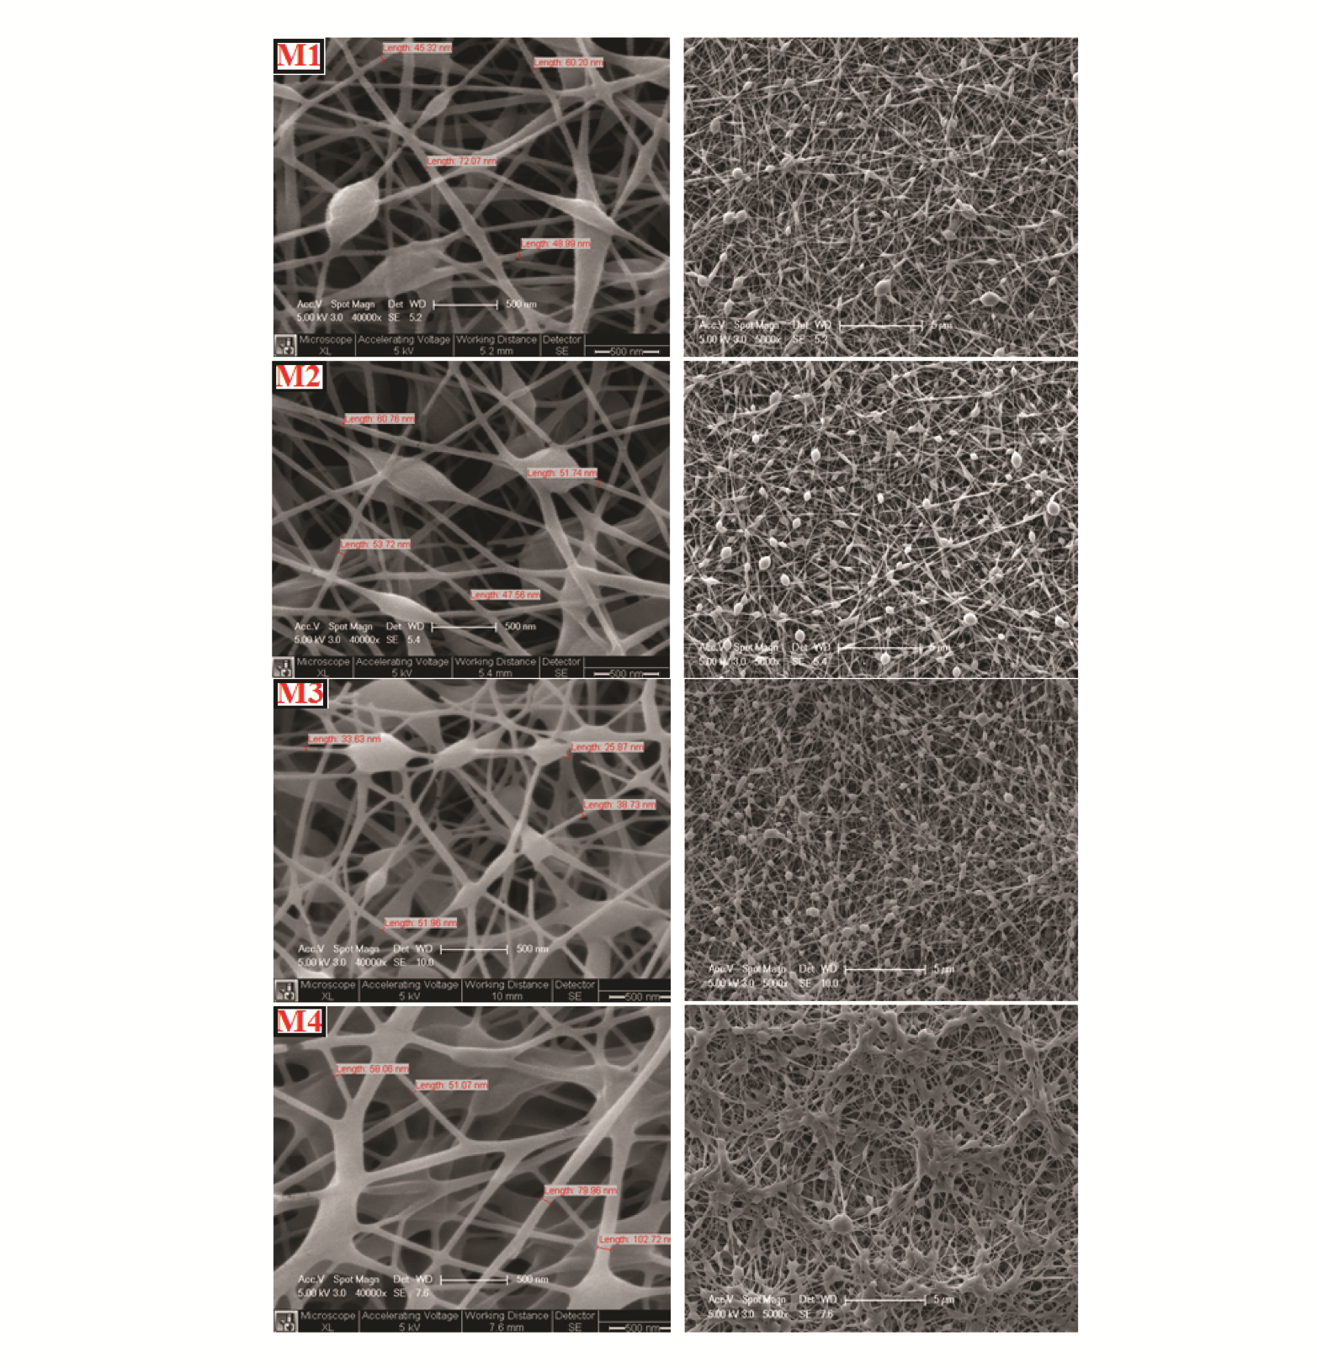
Fig. 6. SEM images of PVA/silica nanofiber mats, M1, M2, M3 and M4, at 40000× and 5000× magnifications (500 nm and 5 µm, from left to right).
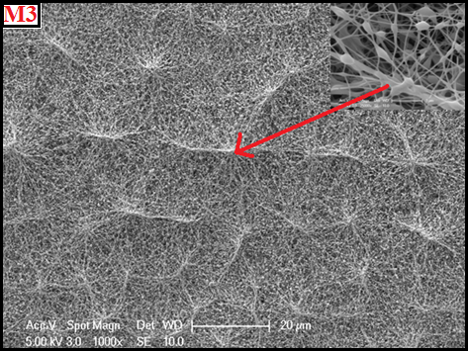

Fig. 7. SEM images of PVA/silica nanofiber mats, M3 at 1000× magnifications (20 µm).

The elements distribution on surface of the PVA/silica nanofiber coated aluminum foil (before and after immersing in water) was examined by SEM-EDX analysis (kV 30, 1000×) and results are given in Table II. The selected region part of the micrographs mainly contains C, O and Si elements coming from PVA/silica hybrid nanofiber. However, Pt element come from coating process before the analysis.

Table II. EDS results of PVA/silica composite nanofibers (M1 – M4).

M1 | Composition before immersing |  | Composition after immersing
Element | wt.% | at.% | wt.% | at.%
C K | 8.72 | 35.64 | 8.71 | 35.89
O K | 5.36 | 16.45 | 5.15 | 15.92
Al K | 0.2 | 0.36 | 0.27 | 0.49
Si K | 17.37 | 30.35 | 17.18 | 30.27
Pt K | 68.34 | 17.19 | 68.69 | 17.42
Totals | 100 | 100 | 100 | 100

M2 | Composition before immersing |  | Composition after immersing
Element | wt.% | at.% | wt.% | at.%
C K | 5.31 | 21.60 | 5.31 | 22.17
O K | 4.62 | 14.11 | 4.77 | 14.95
Al K | 0.58 | 1.05 | 0.46 | 0.85
Si K | 27.43 | 47.70 | 25.53 | 45.59
Pt K | 62.05 | 15.53 | 63.94 | 16.44
Totals | 100 | 100 | 100 | 100

M3 | Composition before immersing |  | Composition after immersing
Element | wt.% | at.% | wt.% | at.%
C K | 5.10 | 19.78 | 4.84 | 19.31
O K | 5.07 | 14.76 | 4.84 | 14.50
Al K | 0.61 | 1.06 | 0.53 | 0.94
Si K | 30.38 | 50.36 | 29.58 | 50.46
Pt K | 58.83 | 14.04 | 60.21 | 14.79
Totals | 100 | 100 | 100 | 100

M4 | Composition before immersing |  | Composition after immersing
Element | wt.% | at.% | wt.% | at.%
C K | 5.46 | 21.86 | 4.88 | 19.73
O K | 5.50 | 16.54 | 5.27 | 15.99
Al K | 1.30 | 2.32 | 1.01 | 1.82
Si K | 25.66 | 43.97 | 27.27 | 47.14
Pt K | 62.08 | 15.31 | 61.57 | 15.32
Totals | 100 | 100 | 100 | 100

Fig. 8 (M5) – (M7) represent the PVA/silica for the obtained hybrid nanofibers through M5 to M7, were found to be pop-corn like bead models. As shown in Fig. 6 (M5) to (M7), when increasing the amount of sol-gel ratio from 20 to 40% (sol volume fraction), the structure resembles almost fully bead morphology.

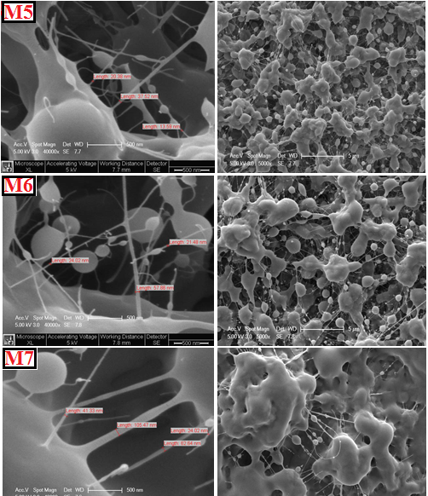

Fig. 8. SEM images of PVA/silica nanofiber mats, M5, M6 and M7, at 40000× and 5000×
magnifications (500 nm and 5 µm, from left to right).

Fig. 9 shows the SEM micrographs of the M3 and M4 (after immersing in water; M3-W and M4-W) obtained with a 40000× and 5000× magnifications. Fig. 9 (M3-W) – (M4-W) represent the PVA/Silica for the average fiber diameters of the obtained hybrid nanofibers through M3-W to M4-W, were found to be 50 and 59 nm, respectively.When immersed overnight in water, the organic-inorganic nanofibers remain intact, basically maintaining their morphology, even though PVA has a hydrophilic character. On the other hand, the concentration of inorganic and organic parts are very important and their values should exceed a critical value to maintain a uniform morphology²⁷. As can be seen Fig. 9 both of membrane showed very uniform pores.

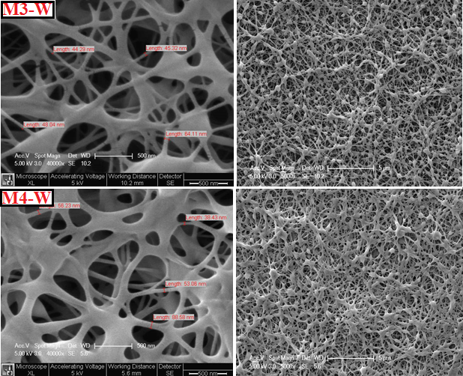

Fig. 9. SEM images of PVA/silica nanofiber mats after soaked overnight in water, M3-W and
M4-W, at 40000× and 5000× magnifications (500 nm and 5 µm, from left to right).

Fig. 10 represents the SEM image of PVA/Silica electrospun nanofiber after soaked overnight in water scanned at 1 µm magnification. Fig. 10 (M4-W) show that the formations of pores are widely observed and found to be between 100 and 700 nm. SEM image proved that the PVA/silica hybrid membrane (after immersing in water, M4-W) showed very uniform pores. The distribution of pore is very important for filtration, seperation and gas permeability applications.

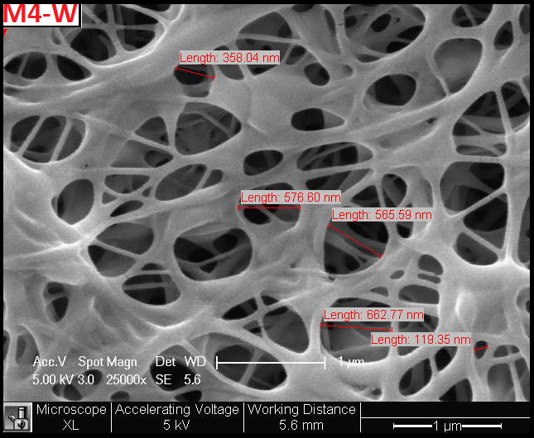

Fig. 10. SEM images of PVA/silica nanofiber mats after soaked overnight in water, M4-W at
25000× magnifications (1 µm).

Water contact angles (WCAs) are very sensitive to the surface composition changes. The surface properties of the PVA and PVA/Silica nanofibers determined with contact angle measurements. Each contact angle value given represents an average of at least 5 readings. The surface energy and WCA values of the hybrid nanofibers can be seen in Table III. From WCA measurements it was found that with the addition of silica precursor hybrid fibers gained hydrophobic character. While neat PVA fibers were highly hydrophilic, hybrid nanofibers displayed contact angle values at around 94–130°. Related WCA images were shown in FTIR section. There was a slight enhancement in the contact angle as the inorganic content of the coating increased orderly from M1 to M3. The WCA values increased for M1, M2 and M3 by adding of inorganic content. The WCA results also show that the surface energy decreased by adding of silica precursor due to the increase in its surface roughness. The nanoscale roughness influences for high WCA values, in which WCA value does not depend on compounds of lower surface energy, such as those with –CH₃ groups and/or fluoro containing compounds, but on the hierarchical nanoscale roughness^{28,29}. As can be seen in Figures 6, 8, 9 and 10, these data suggest that the markedly contribution to the large WCA is the nanofiber with reticulate nodes structure¹⁵. In our case, while the minimum surface energy was measured to be 32 mN/m, the corresponding WCA value was 130°, a finding which can be attributed to low surface energy and the highly roughened surface of the hybrid nanofibers. Conversely, WCA values of nanofibers begin to decrease as of M3 formulation. The increase in the hydrophilicity of the hybrid nanofibers is an indicative with the increase polarity in the precursor mixture which can be attributed that there was uncondensed Si–OH and/or unreacted –OH groups of the PVA. Thus, polar character decreases the surface energy of the hybrid nanofibers from M3 to M7 formulations.
The hydrophobic surfaces have the low free surface energy, which are also quite useful for a variety of properties such as release, water-repelling properties, biocompatibility, lubricity, and durability of materials³⁰.

Table III. Thermal and surface morphology properties of PVA/silica composite nanofibers.
Sample Codes | Silica precursor ratio,  wt.% | First weight loss temperature,  °C | Char yield, % | Water contact angle,  ° | Surface energy, mN/m
M1 | 0.5 | 245 | 86 | 98 | 46.6
M2 | 1 | 210 | 89 | 110 | 39.4
M3 | 5 | 244 | 92 | 130 | 32
M4 | 10 | 255 | 94 | 103 | 43
M5 | 20 | 258 | 95.5 | 97 | 51
M6 | 30 | 277 | 97 | 96 | 60.8
M7 | 40 | 300 | 98 | 94 | 66

Finally, in comparison with neat PVA nanofibers in the literature, the resulting PVA/Silica nanofiber mats provide considerable superiority such as improved thermal resistance, fiber quality and hydrophobicity³¹. The morphology of neat PVA nanofiber and crosslinked PVA/silica nanofibers is quite different due to the strong interaction between the inorganic and the organic phases. The fact that silica particles were buried in the fibrous structure indicates the compatibility of the both phases.

CONCLUSIONS
We successfully obtained cross-linked PVA/Silica electrospun mat which have reticulated structure by varying the percentage of precursor sol comprising MTMS/DMDMS/PTMS/FAS via electrospinning technique. The crosslinking between PVA chains and the silica network was proved via Si−O−C−O−Si bridges, which were evident in FTIR spectra of nanofibers. The average fiber diameter was less than 100 nm. SEM images also displayed that the average pore diameter of PVA/silica nanofiber was in range of 100–700 nm. SEM-EDX results showed that when the nanofiber mat was immersed overnight in water, the elemental structure did not change and the fiber remained intact. The 5 wt.% precursor sol containing nanofiber mat has a 130° water contanct angle. The resultant highly thermal resistance hydrophobic PVA/silica hybrid nanofibers with their improved stability in aqueous media could find applications in areas such as filtration, separation, gas permeability and tissue engineering.

Acknowledgements: This study is a part of my PhD dissertation at the University of Marmara.

REFERENCES
1. S. Agarwala, A. Greinera and J. H. Wendorff, Prog. Poly. Sci. 38 (2013) 963
2. B. Oktay, E. Baştürk, N. Kayaman-Apohan and M. V. Kahraman, Polym. Compos. 34 (2013) 1321
3. Y. Doshi and D. H. Reneker, J. Electrostatics 35 (1995) 151
4. K. Garg and G. L. Bowlin, Biomicrofluidics 5 (2011) 13403
5. Z. M. Huang, Y. Z. Zhang, M. Kotaki and S. Ramakrishna, Compos. Sci. Technol. 63 (2003) 2223
6. C. Feng, K. C. Khulbe, T. Matsuur, S. Tabe and A. F. Ismail, Sep. Purif. Technol. 102 (2013) 118
7. K. S. Yang, D. D. Edie, D. Y. Lim, Y. M. Kim and Y. O. Choi, Carbon 41 (2003) 2039
8. R. Vasita and D. S. Katti, Int. J. Nanomedicine 1 (2006) 15
9. S. Y. Lee, D. H. Jang, Y. O. Kang, O. B. Kim, L. Jeong, H. K. Kang, S. J. Lee, C.-H Lee, W. H. Park
and B.-M. Min, Appl. Surf. Sci. 258 (2012) 6914
10. M. Teng, F. Li, B. Zhang and A. A.Taha, Colloids Surf. A: Physicochem. Eng. 385 (2011) 229
11. Y. Wang and Y.-L. Hsieh, J. Memb. Sci. 309 (2008) 73
12. M. Guo, B. Ding, X. Li, X. Wang, J. Yu and M. Wang, J. Phys. Chem. C. 114 (2010) 916
13. T. Ogawa, B. Ding, Y. Sone and S. Shiratori, Nanotechnology 18 (2007) 165607
14. M. Gong, X. Xu, Z. Yang, Y. Liu, H. Lv and L. Lv, Nanotechnology 20 (2009) 165602
15. M. G. Gong, Y. Z. Long, X. L. Xu, H. D. Zhang and B. Sun, Synthesis, Superhydrophobicity,
Enhanced Photoluminescence and Gas Sensing Properties of ZnO Nanowires, Nanowires – Recent
Advances, Prof. Xihong Peng (Ed.), InTech, Rijeka, Crotia, 2012, Chapter 5, p. 77
16. A. Bandyopadhyay, M. D. Sarkar and A. K. Bhowmick, J. Mater. Sci. 41 (2006) 5981
17. A. Hozumi and O. Takai, App. Surf. Sci. 103 (1996) 431
18. J.-D. Brassard, D. K. Sarkar and J. Perron, Appl. Sci. 2 (2012) 453
19. T. Pirzada, S. A. Arvidson, C. D. Saquing, S. S. Shah and S. A. Khan, Langmuir 28 (2012) 5834
20. S. Tang, P. Zou, H. Xiong and H. Tang, Carbohydr. Polym. 72 (2008) 521
21. R. Guo, X. Ma, C. Hu and Z. Jiang, Polymer 48 (2007) 2939
22. J. P. Jeun, Y. K. Jeon, Y. C. Nho and P. H. Kang, J. Ind. Eng. Chem. 15 (2009) 430
23. H. Ma, T. Shi and Q. Song, Fibers 2 (2014) 275
24. F.-Y. Quan, L.-L. Chen, Y.-Z. Xia and Q. Ji, Polym. Polym. Compos. 17 (2009)
25. B. Zeytuncu, S. Akman, O. Yucel and M. V. Kahraman, Mat. Res. 17 (2014) 565
26. J. M. Dodda, P. Belsky, J. Chmelar, T. Remis, K. Smolna, M. Tomas, L. Kullova and J. Kadlec, J.
Mater. Sci. 19 (2015)
27. K.-L. Ou, C.-S. Chen, L.-H. Lin, J.-C. Lu, Y.-C. Shu, W.-C. Tseng, J.-C. Yang, S.-Y. Lee and C.-C. Chen, Eur. Polym. J., 47 (2011) 882-892
28. M. Ma and R. M. Hill, Curr. Opin. Colloid Interface Sci. 11 (2006) 193
29. Y. Mülazim, E. Çakmakçı and M. V. Kahraman, J. Vinyl Addit. Technol. 19 (2013) 31
30. T. Nishino, M. Meguro, K. Nakamae, M. Matsushita and Y. Ueda, Langmuir 15 (1999) 4321
31. Z. Peng, L. X. Kong and S. D. Li, Polymer 46 (2005) 1949

Table Captions
Table I. Amounts of silica precursor in aqueous PVA solution.
Table II. EDS results of PVA/Silica composite nanofibers (M1 – M4).
Table III. Thermal and surface morphology properties of PVA/Silica composite nanofibers.

Figure Captions
Fig. 1. Schematic illustration of PVA/silica nanofiber mats.
Fig. 2. FTIR spectra of neat PVA and M1 and M3 nanofibers.
Fig. 3. TGA curves of (a-g) PVA/Silica hybrid nanofibers and (h) pure PVA nanofiber.
Fig. 4. DTG curves of PVA/Silica hybrid nanofibers and pure PVA nanofiber.
Fig. 5. SEM image of pure PVA nanofiber.
Fig. 6. SEM images of PVA/Silica nanofiber mats, M1, M2, M3 and M4, at 40000× and 5000× magnifications (500 nm and 5 µm, from left to right).
Fig. 7. SEM images of PVA/Silica nanofiber mats, M3 at 1000× magnifications (20 µm).
Fig. 8. SEM images of PVA/Silica nanofiber mats, M5, M6 and M7, at 40000× and 5000×
magnifications (500 nm and 5 µm, from left to right).
Fig. 9. SEM images of PVA/Silica nanofiber mats after soaked overnight in water, M3-W and
M4-W, at 40000× and 5000× magnifications (500 nm and 5 µm, from left to right).
Fig. 10. SEM images of PVA/Silica nanofiber mats after soaked overnight in water, M4-W at
25000× magnifications (1 µm).

