SUPPORTING DATA
Microwave-assisted synthesis and antimicrobial evaluation of 6-(3'-(aryl)-1'-phenyl-3,4-dihydro-1'H,2H-[3,4'-bipyrazol]-5-yl)-2H-chromen-5-ols
DONGAMANTI ASHOK*^{,1}, RANGU KAVITHA¹, SRINIVAS GUNDU¹, MADDERLA SARASIJA²
¹Green and Medicinal Chemistry Laboratory, Department of Chemistry, Osmania University, Hyderabad- 500 007, India
²Department of Chemistry, Satavahana University, Karimnagar- 505001, India
e-mail: ashokdou@gmail.com

¹H, ¹³C NMR & Mass Spectra of compounds (6a-j):
¹H, ¹³C NMR & Mass Spectra of 6-(1',3'-Diphenyl-3,4-dihydro-1'H,2H-[3,4'-bipyrazol]-5-yl)-2H-chromen-5- ol (6a):
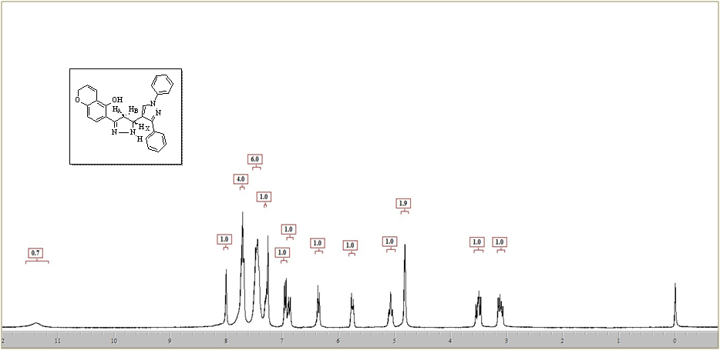
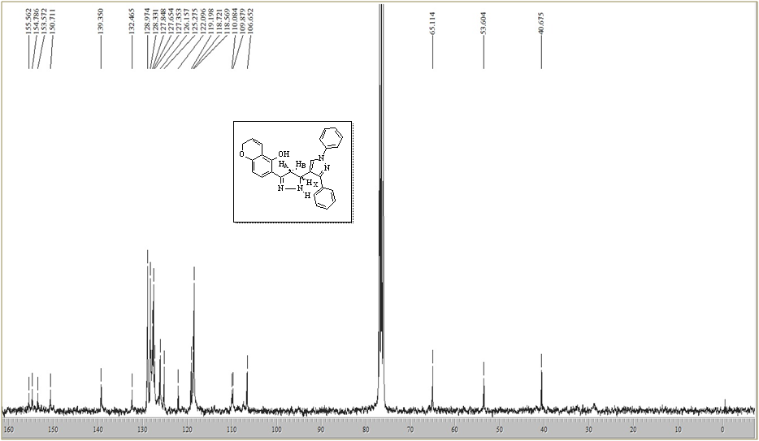

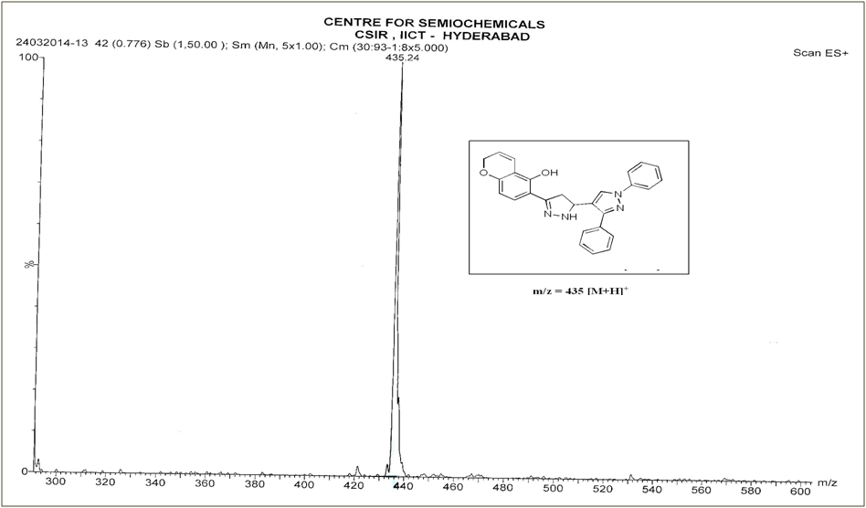

¹H, ¹³C NMR & Mass Spectra of 6-(3'-(4-Bromophenyl)-1'-phenyl-3,4-dihydro-1'H,2H-[3,4'-bipyrazol]-5-yl)-2H-chromen-5-ol (6b):
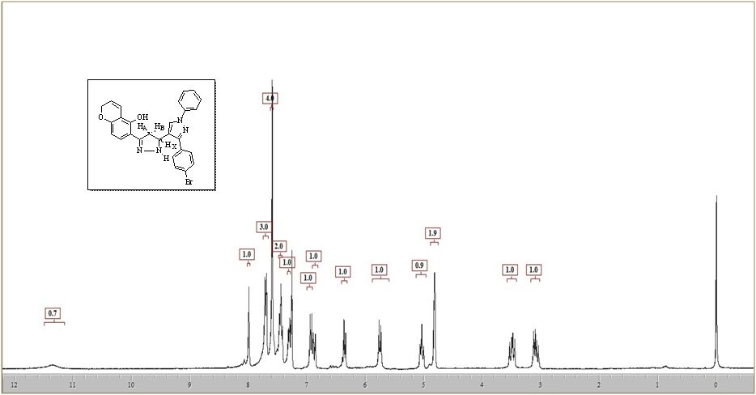
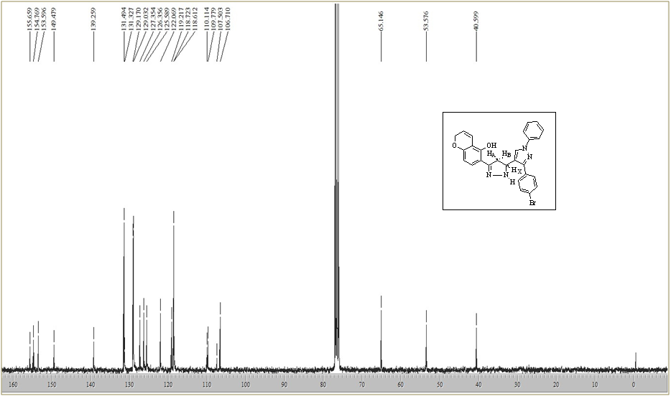

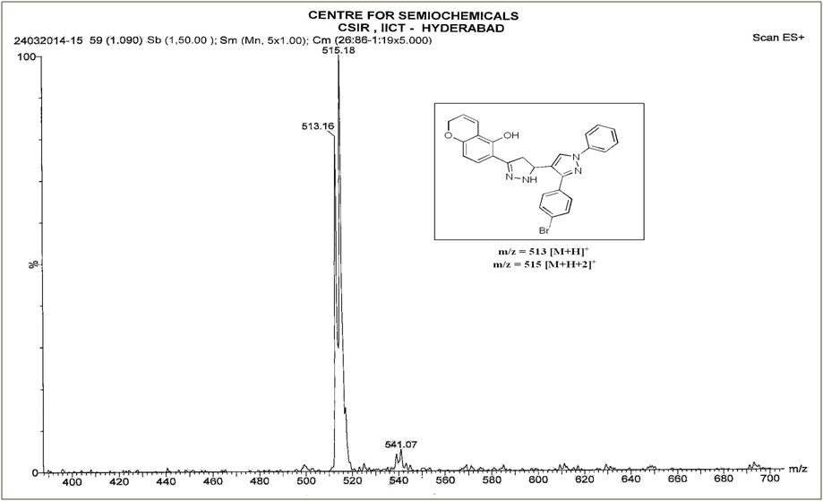

¹H, ¹³C NMR & Mass Spectra of 6-(3'-(4-Chlorophenyl)-1'-phenyl-3,4-dihydro-1'H,2H-[3,4'-bipyrazol]-5-yl)-2H-chromen-5-ol (6c):
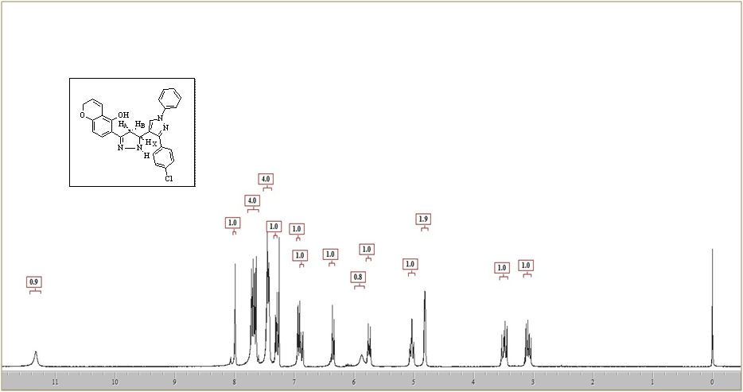

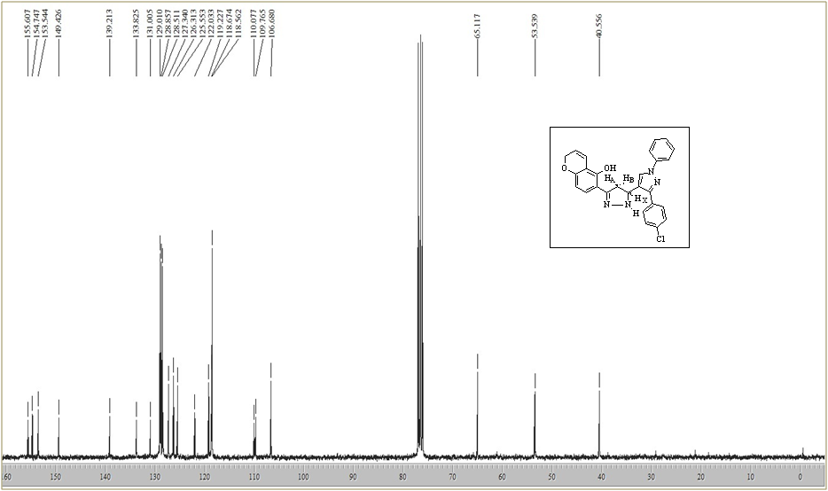

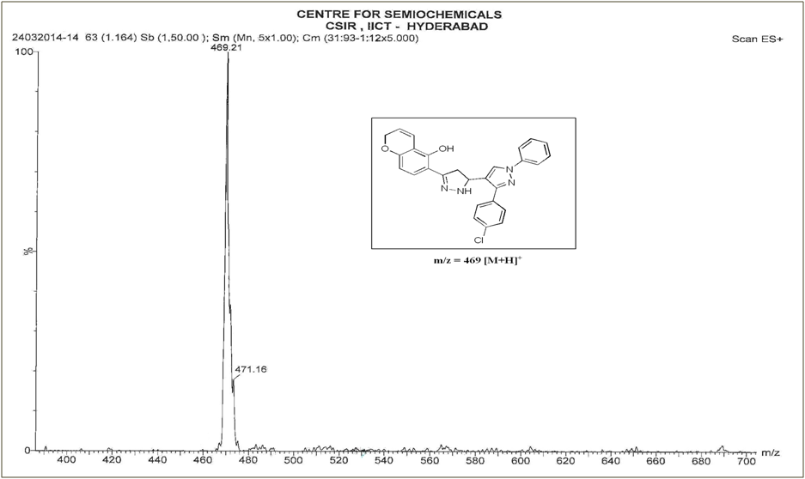

¹H, ¹³C NMR & Mass Spectra of 6-(1'-Phenyl-3'-(p-tolyl)-3,4-dihydro-1'H,2H-[3,4'-bipyrazol]-5-yl)-2H-chromen-5-ol (6d):
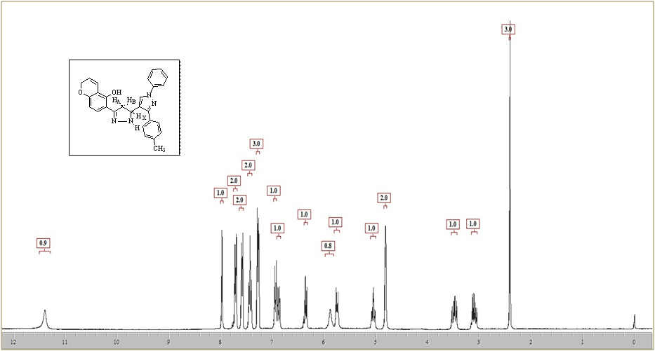

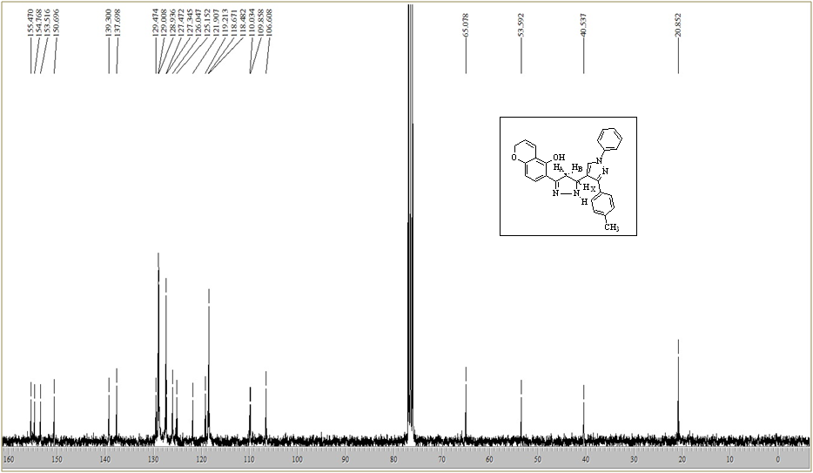
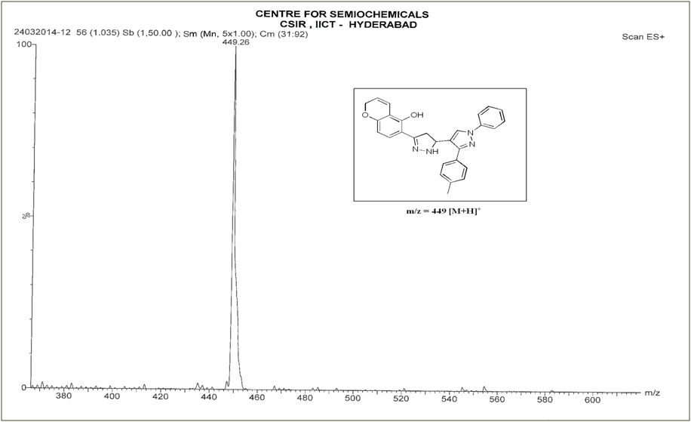

¹H & ¹³C NMR Spectra of 6-(3'-(4-Hydroxyphenyl)-1'-phenyl-3,4-dihydro-1'H,2H-[3,4'-bipyrazol]-5-yl)-2H-chromen-5-ol (6e):
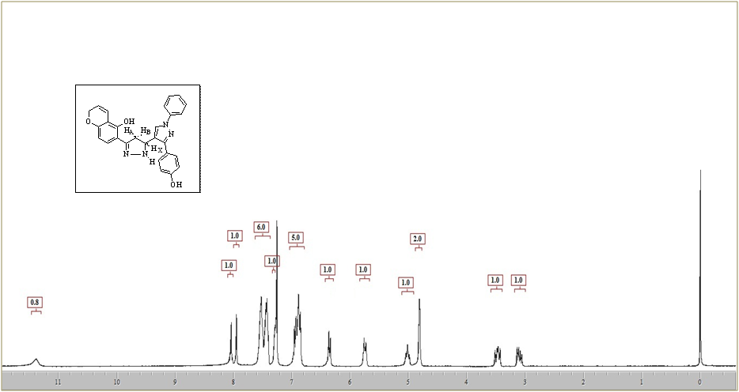

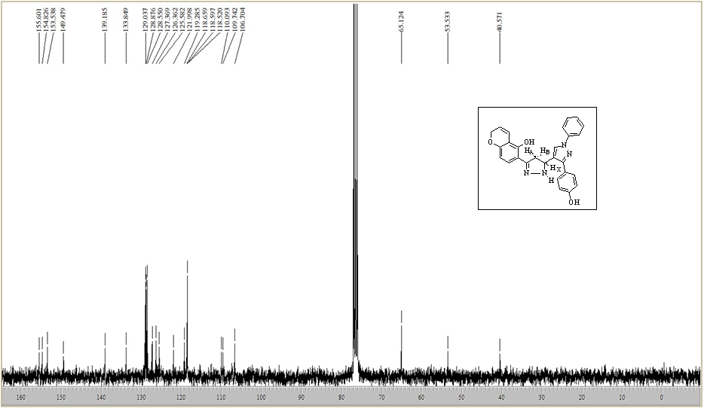
¹H, ¹³C NMR Spectra of 6-(3'-(4-Methoxyphenyl)-1'-phenyl-3,4-dihydro-1'H,2H-[3,4'-bipyrazol]-5-yl)-2H-chromen-5-ol (6f):
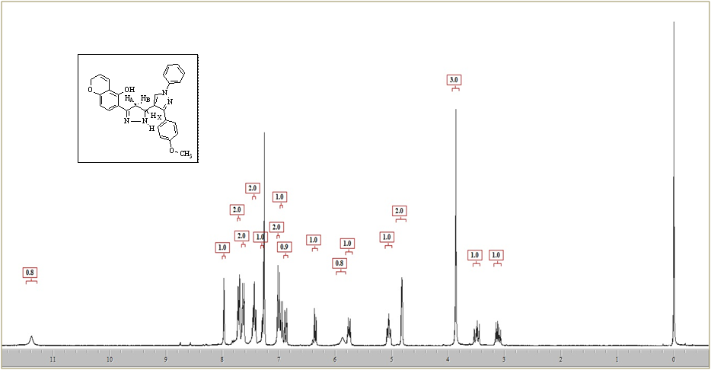

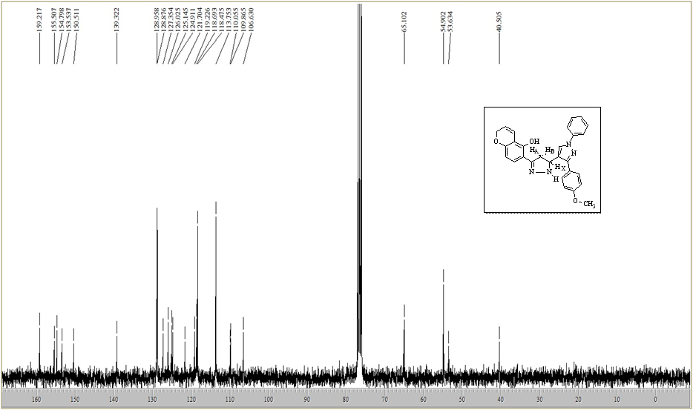

¹H, ¹³C NMR & Mass Spectra of 6-(3'-(4-Ethoxyphenyl)-1'-phenyl-3,4-dihydro-1'H,2H-[3,4'-bipyrazol]-5-yl)-2H-chromen-5-ol (6g):
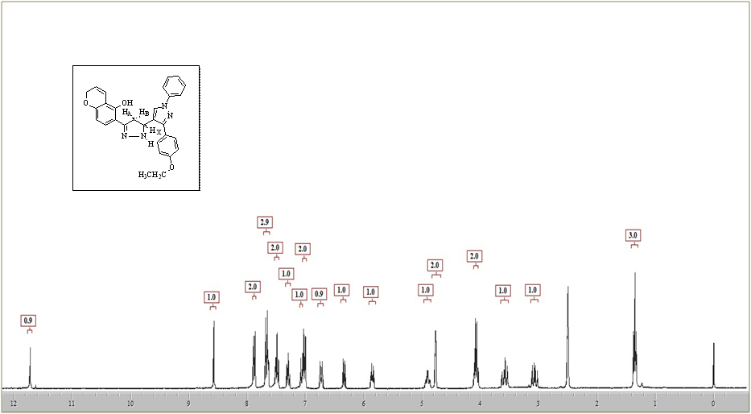
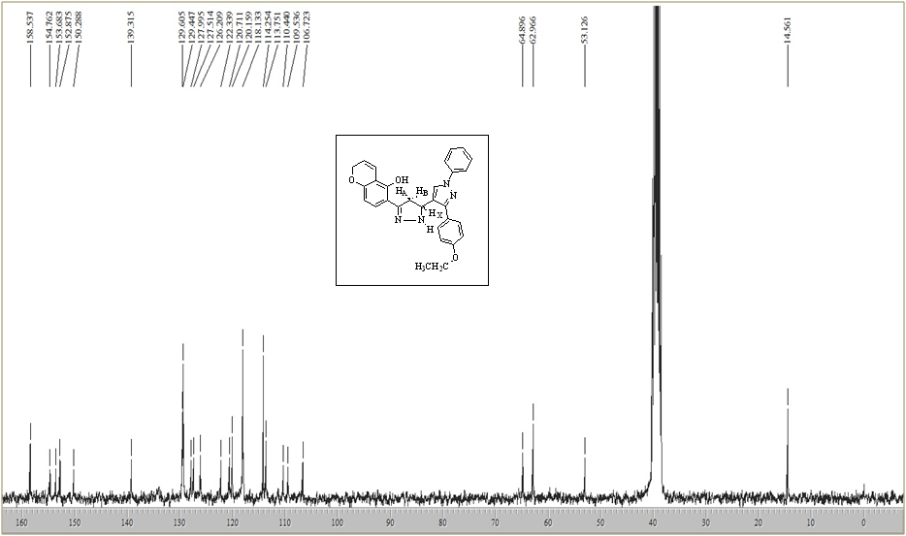

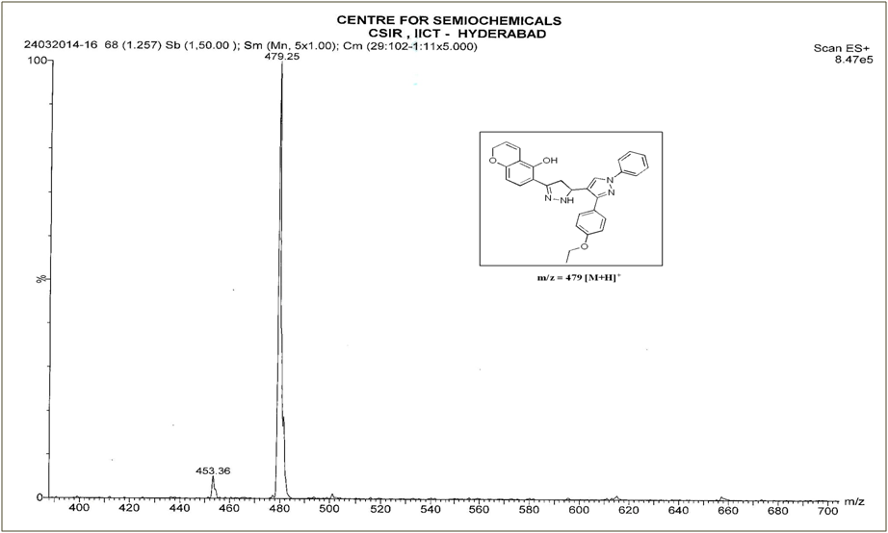

¹H, ¹³C NMR & Mass Spectra of 6-(3'-(3-Ethoxyphenyl)-1'-phenyl-3,4-dihydro-1'H,2H-[3,4'-bipyrazol]-5-yl)-2H-chromen-5-ol (6h):
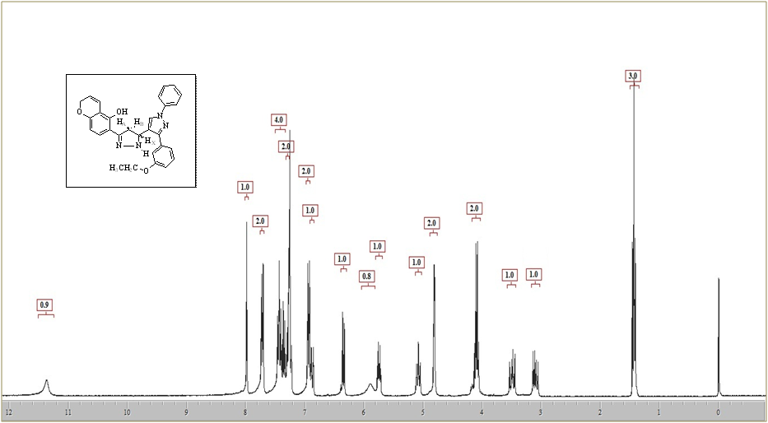

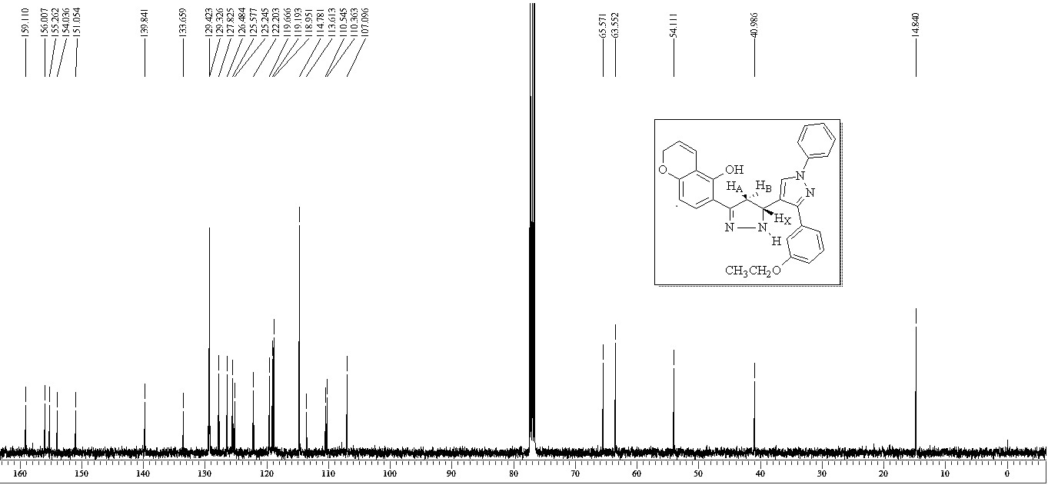

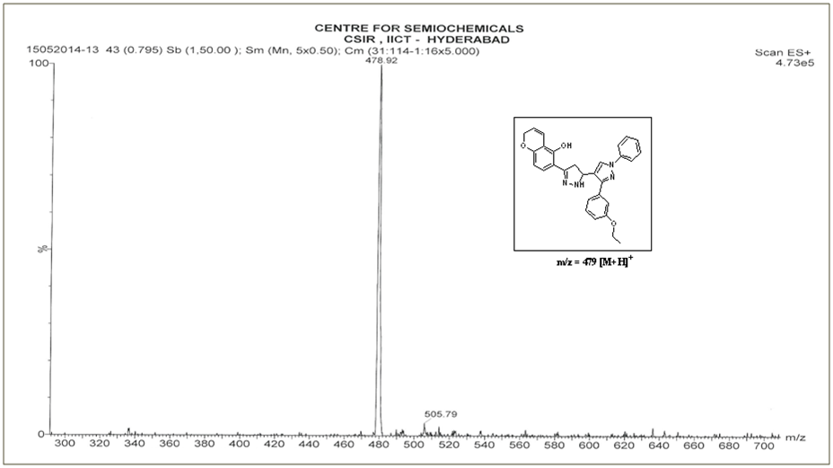

¹H, ¹³C NMR & Mass Spectra of 6-(3'-(3,4-Dimethoxyphenyl)-1'-phenyl-3,4-dihydro-1'H,2H-[3,4'-bipyrazol]-5-yl)-2H-chromen-5-ol (6i):
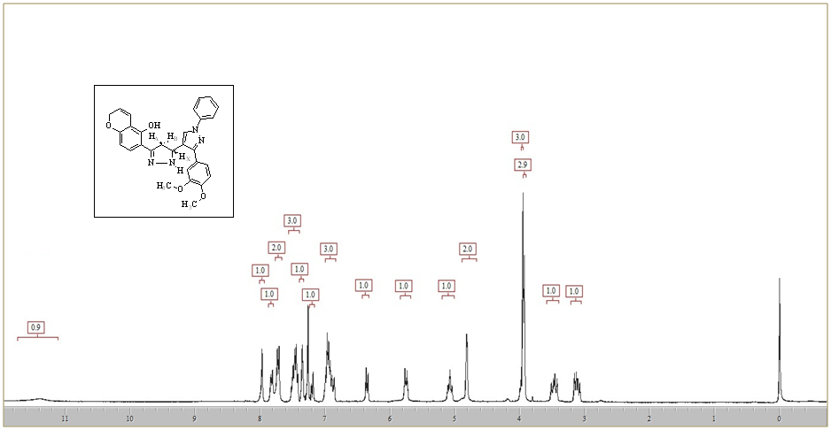

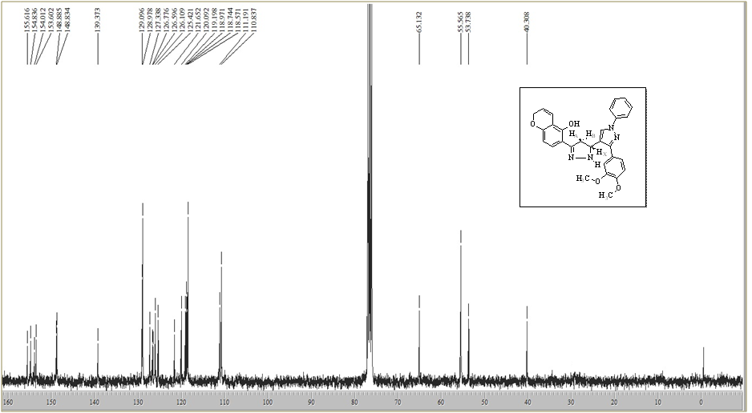

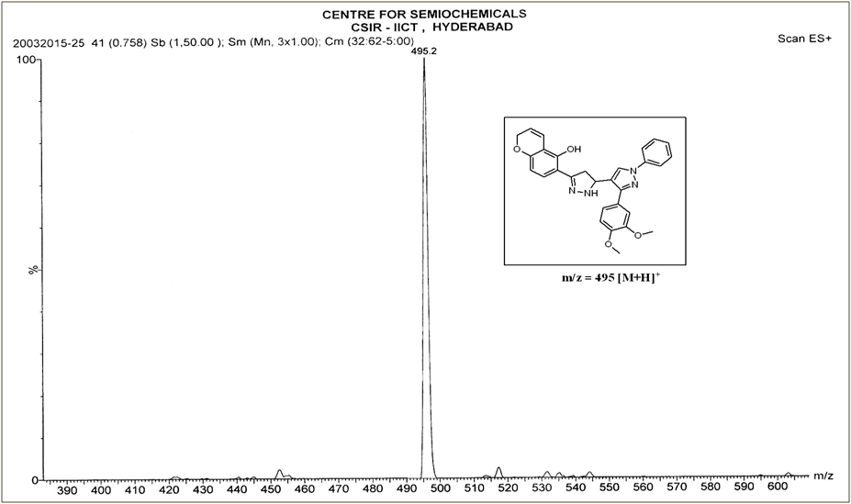

¹H, ¹³C NMR Spectra of 6-(3'-(naphthalen-1-yl)-1'-phenyl-3,4-dihydro-1'H,2H-[3,4'-bipyrazol]-5-yl)-2H-chromen-5-ol (6j):
