1. NMR and mass spectrum of **1-10.**





Fig. 1A EI-MS of quercetin-3-*O*-β-D-glucopyranoside (**1**)

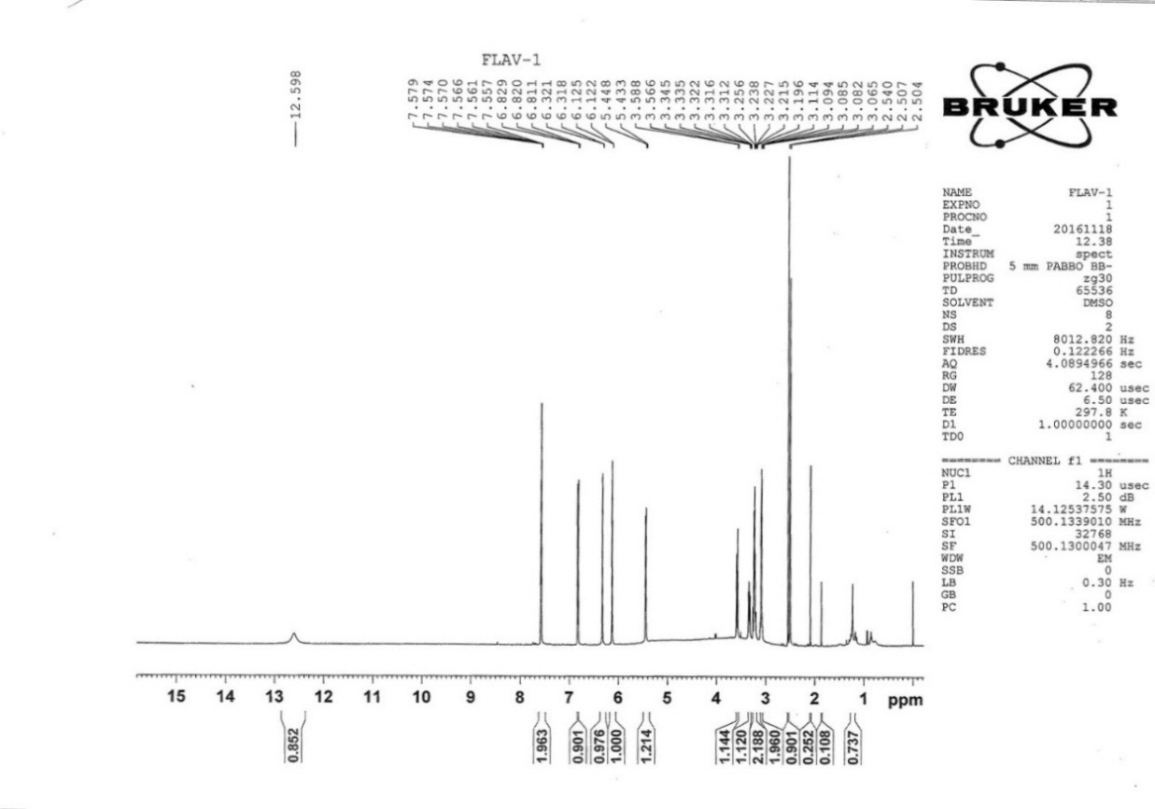

Fig. 1B 1H-NMR spectrum of quercetin-3-*O*-β-D-glucopyranoside (**1**)

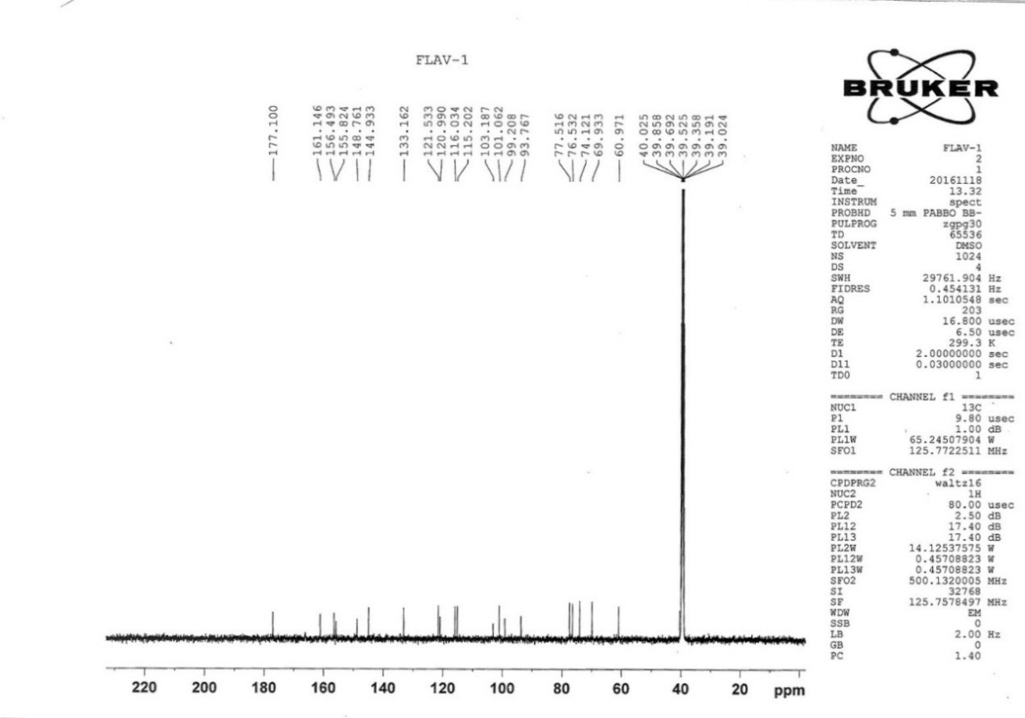

Fig. 1C 13C-NMR spectrum of quercetin-3-*O*-β-D-glucopyranoside (**1**)

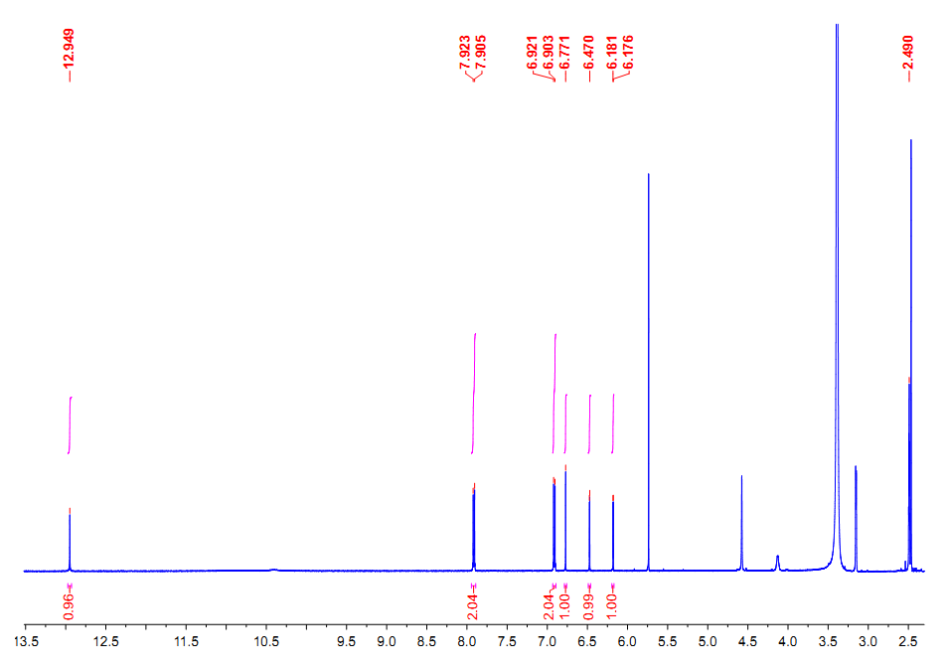

Fig. 2A 1H-NMR spectrum of apigenin (**2**)

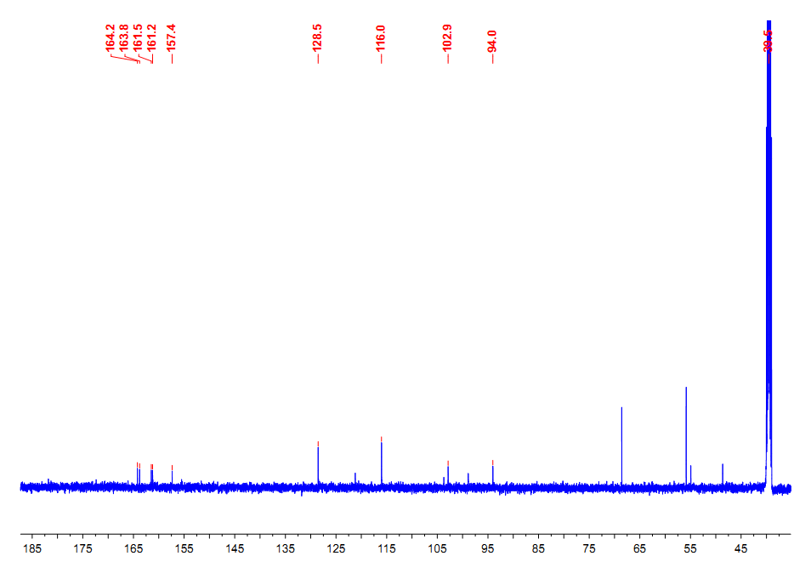

Fig. 2B 13C-NMR spectrum of apigenin (**2**)

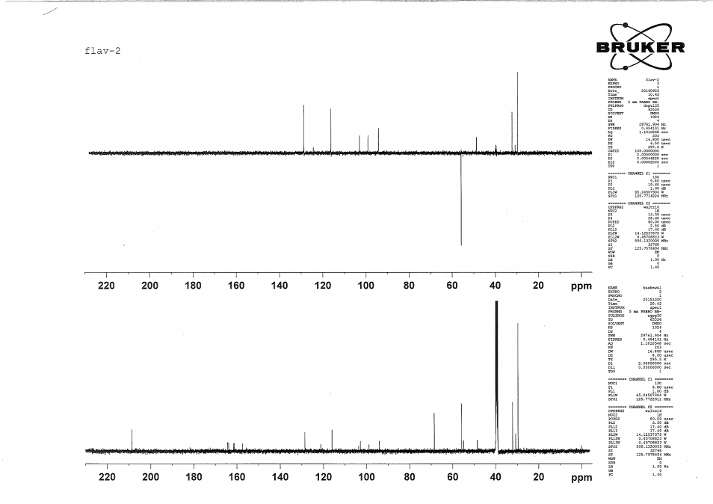

Fig. 2C DEPT spectrum of apigenin (**2**)

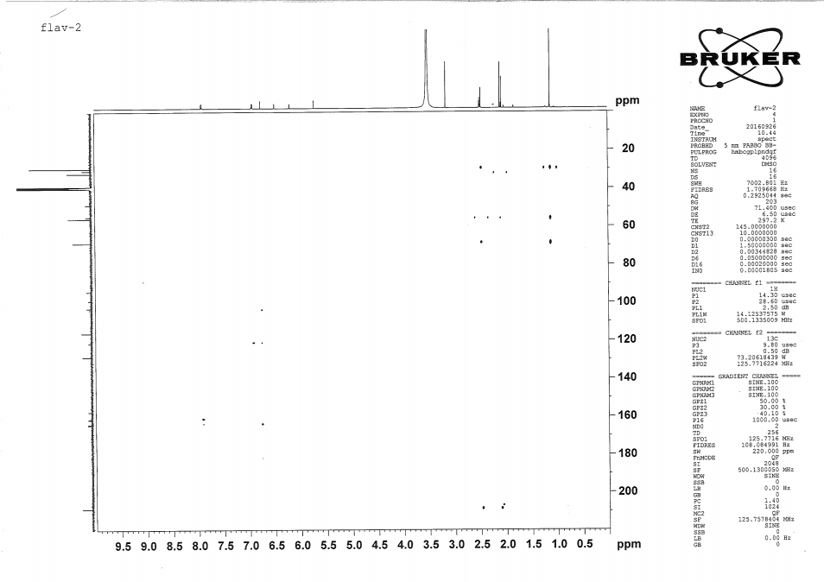

Fig. 2D HMBC spectrum of apigenin (**2**)





Fig. 3A EI-MS spectrum of methyl wogonin (**3**)

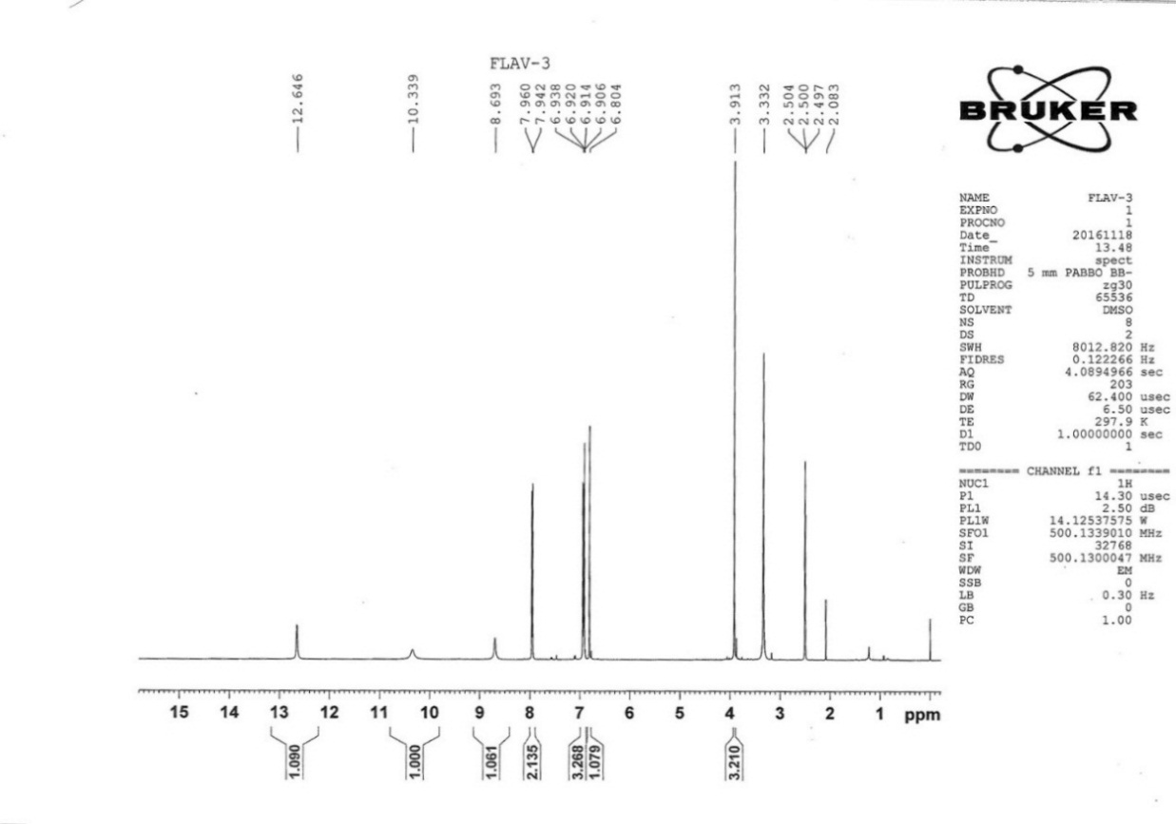

Fig. 3B 1H-NMR spectrum of methyl wogonin (**3**)

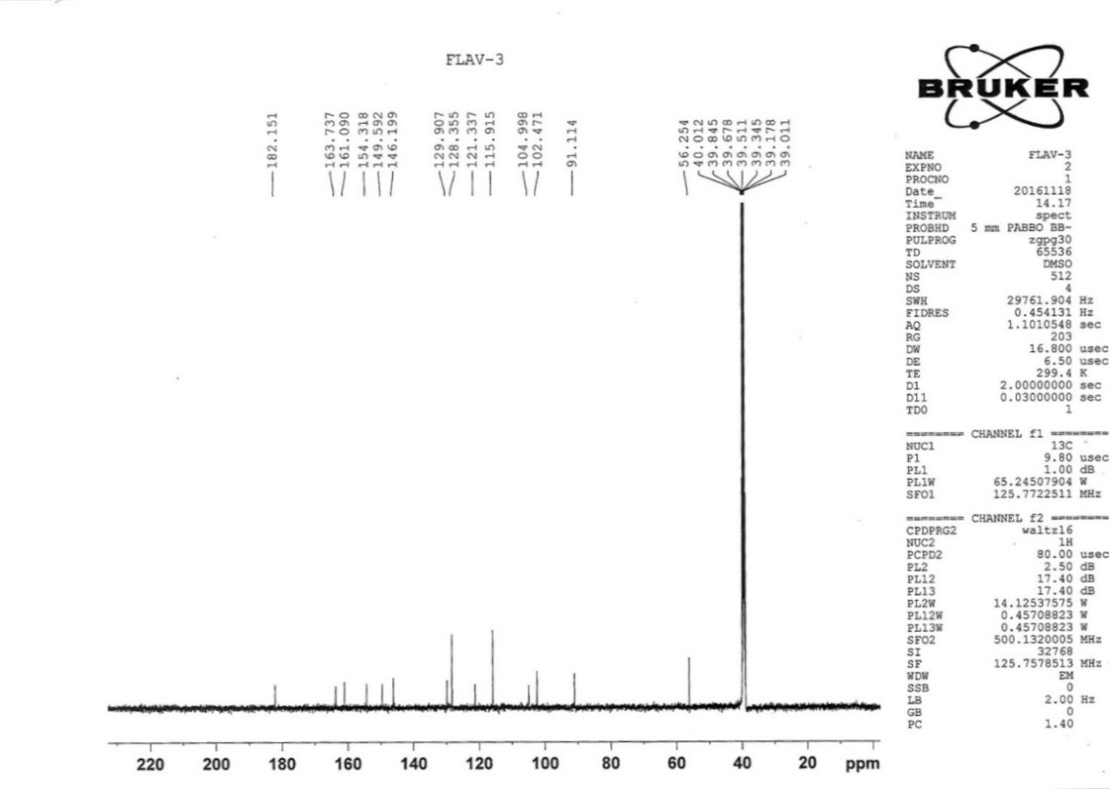

Fig. 3C 13 C-NMR spectrum of methyl wogonin (**3**)

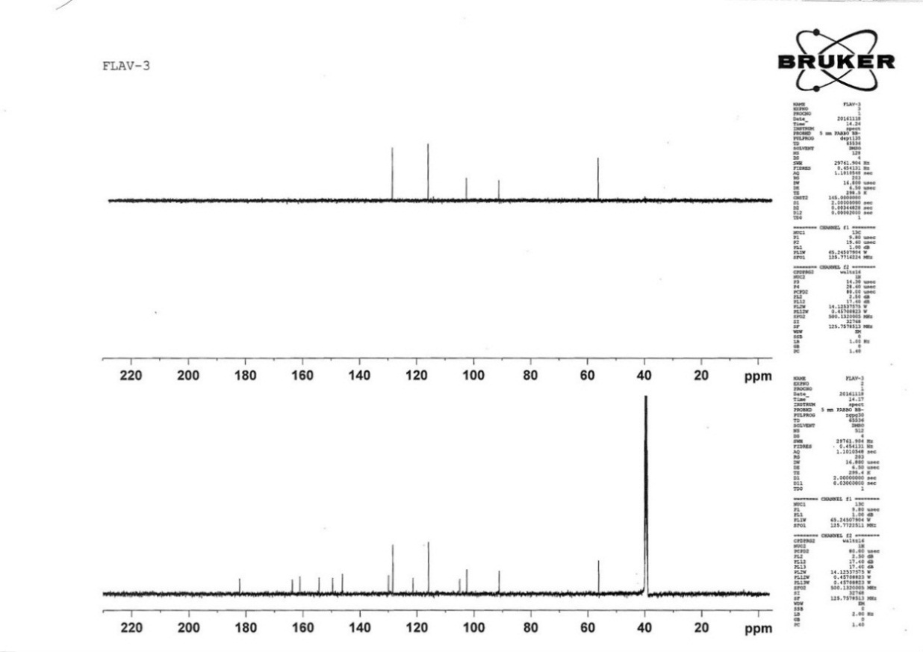

Fig. 3D DEPT spectrum of methyl wogonin (**3**)





Fig. 4A EI-MS spectrum of quercetin (**4**)

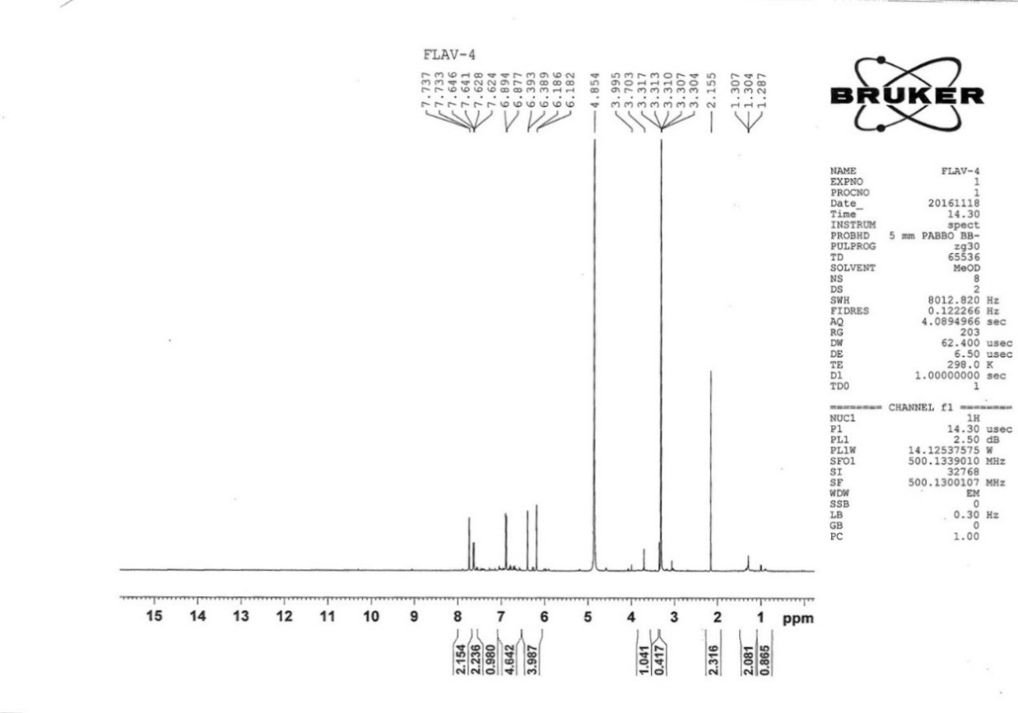

Fig. 4B 1H-NMR spectrum of quercetin (**4**)

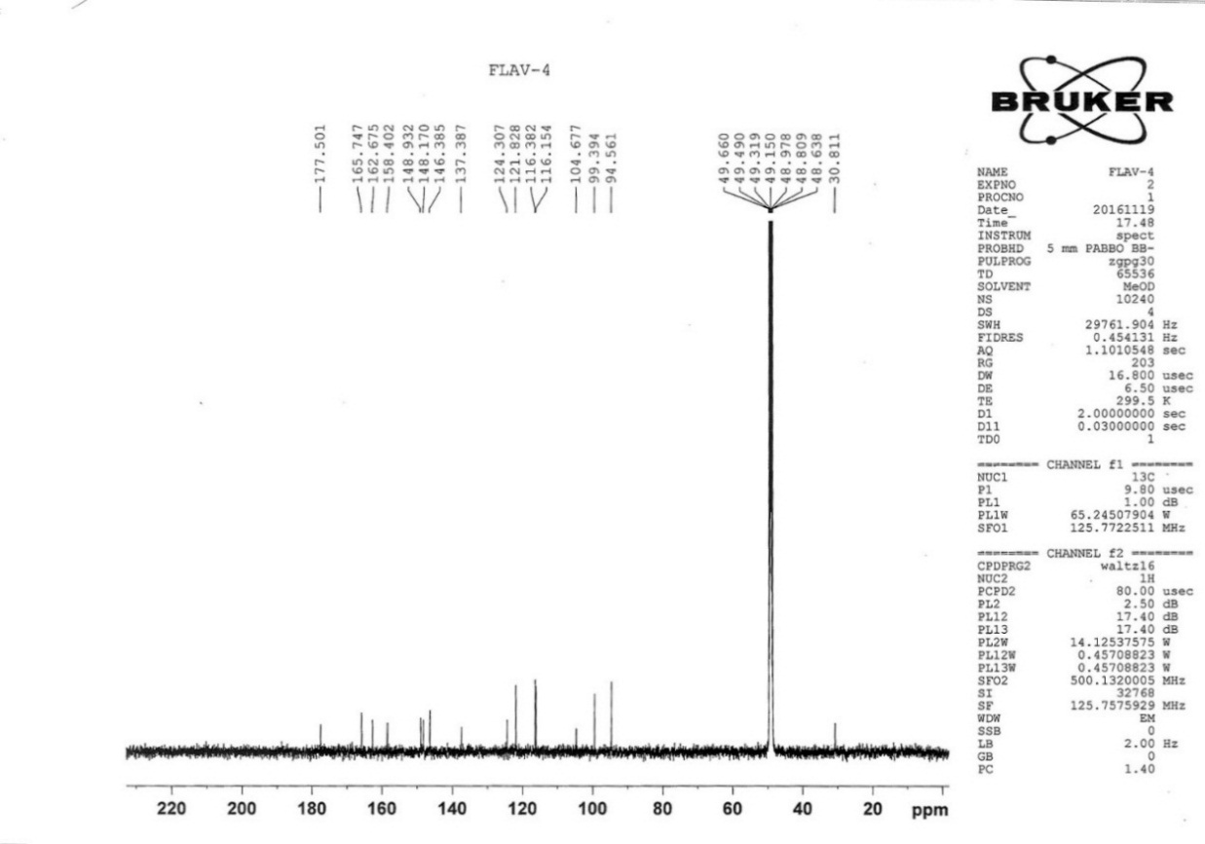

Fig. 4C 13C-NMR spectrum of quercetin (**4**)

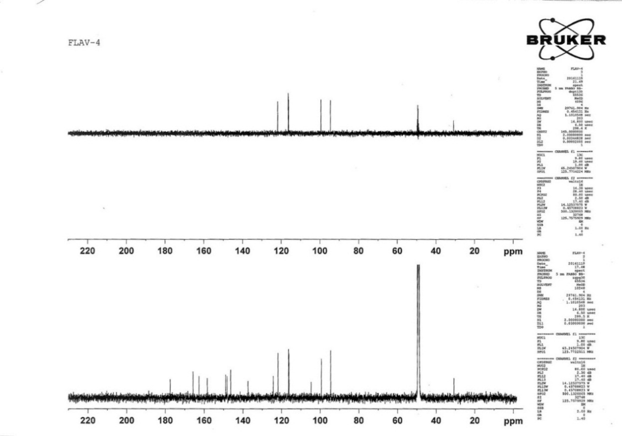

Fig. 4D DEPT spectrum of quercetin (**4**)





Fig. 5A EI-MS spectrum of kaempferol (**5**)

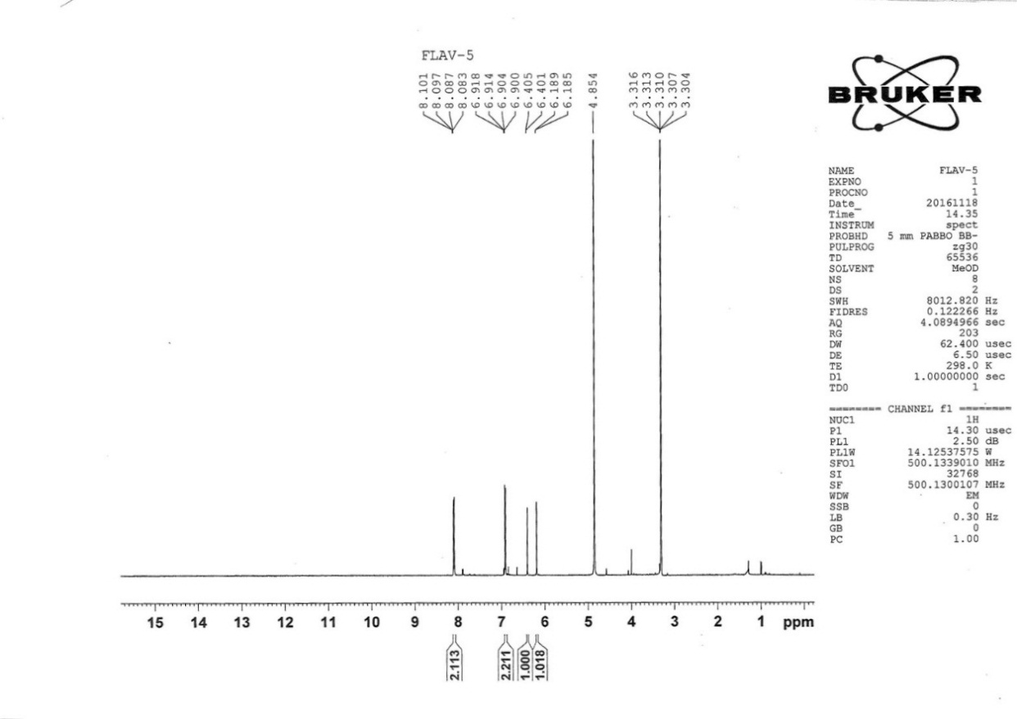

Fig. 5B 1H-NMR spectrum of kaempferol (**5**)

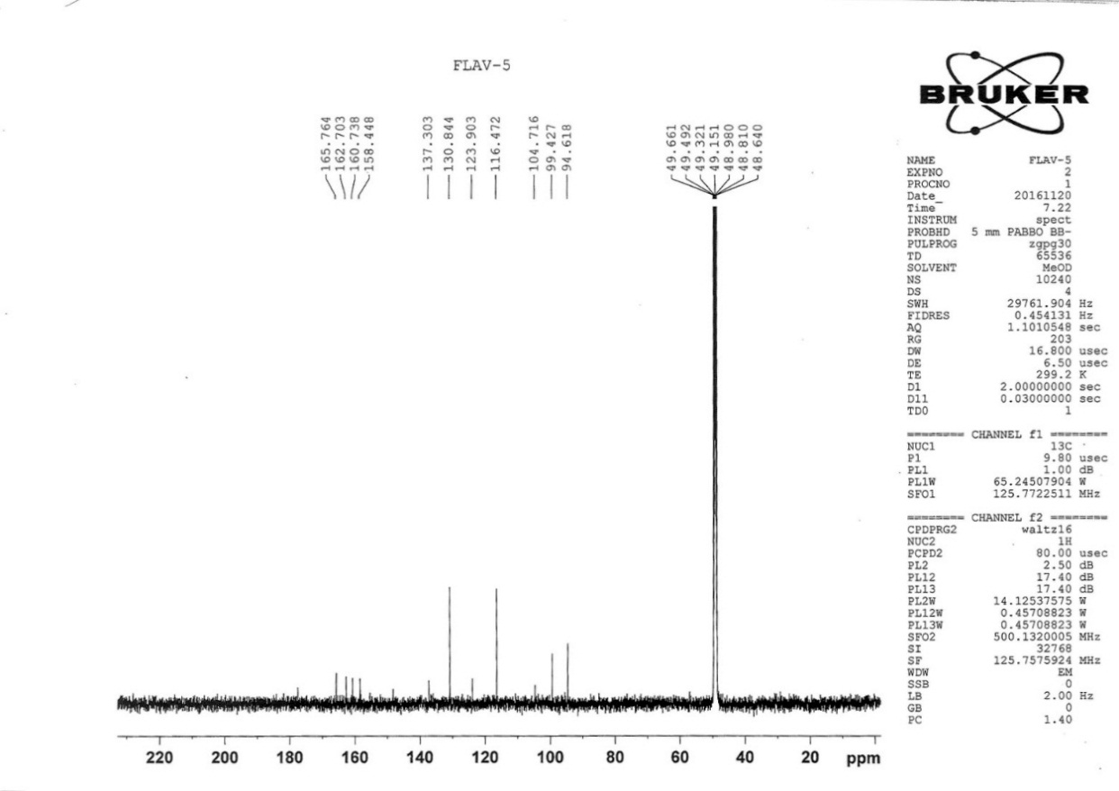

Fig. 5C 13C-NMR spectrum of kaempferol (**5**)





Fig. 6A EI-MS spectrum of genkwanin (**6**)

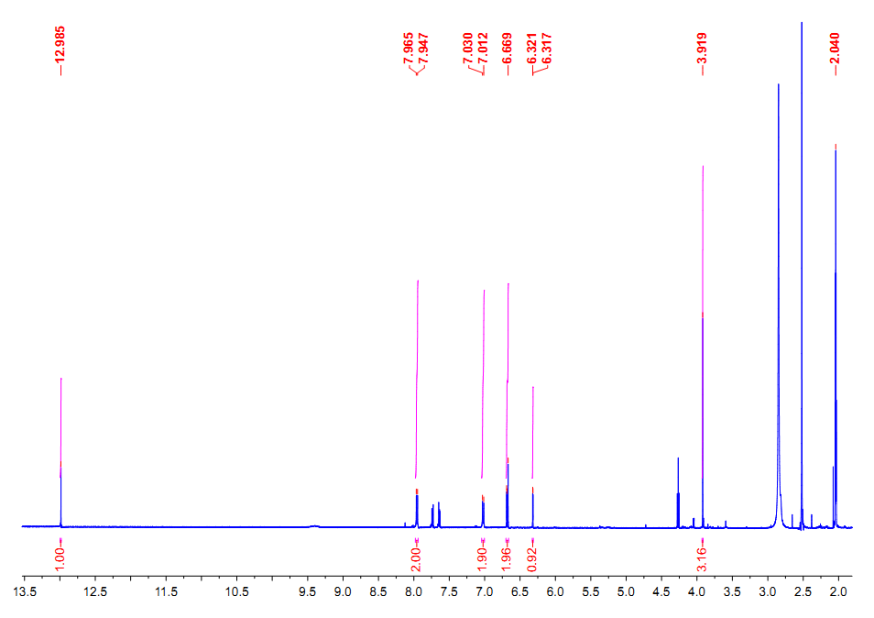

Fig. 6B 1H-NMR spectrum of genkwanin (**6**)

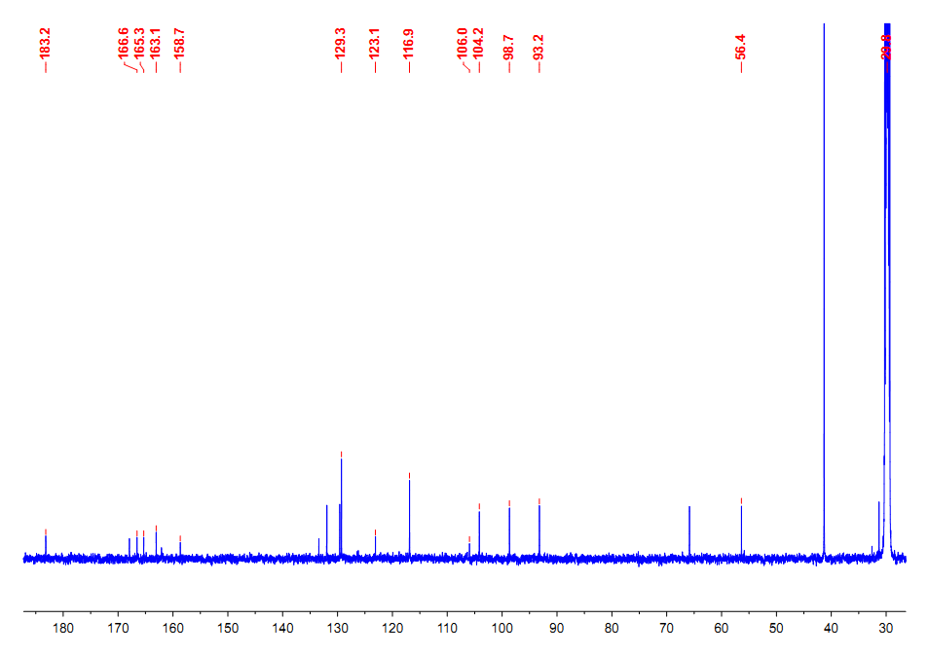

Fig. 6C 13C-NMR spectrum of genkwanin (**6**)





Fig. 7A EI-MS spectrum of rosmarinic acid (**7**)

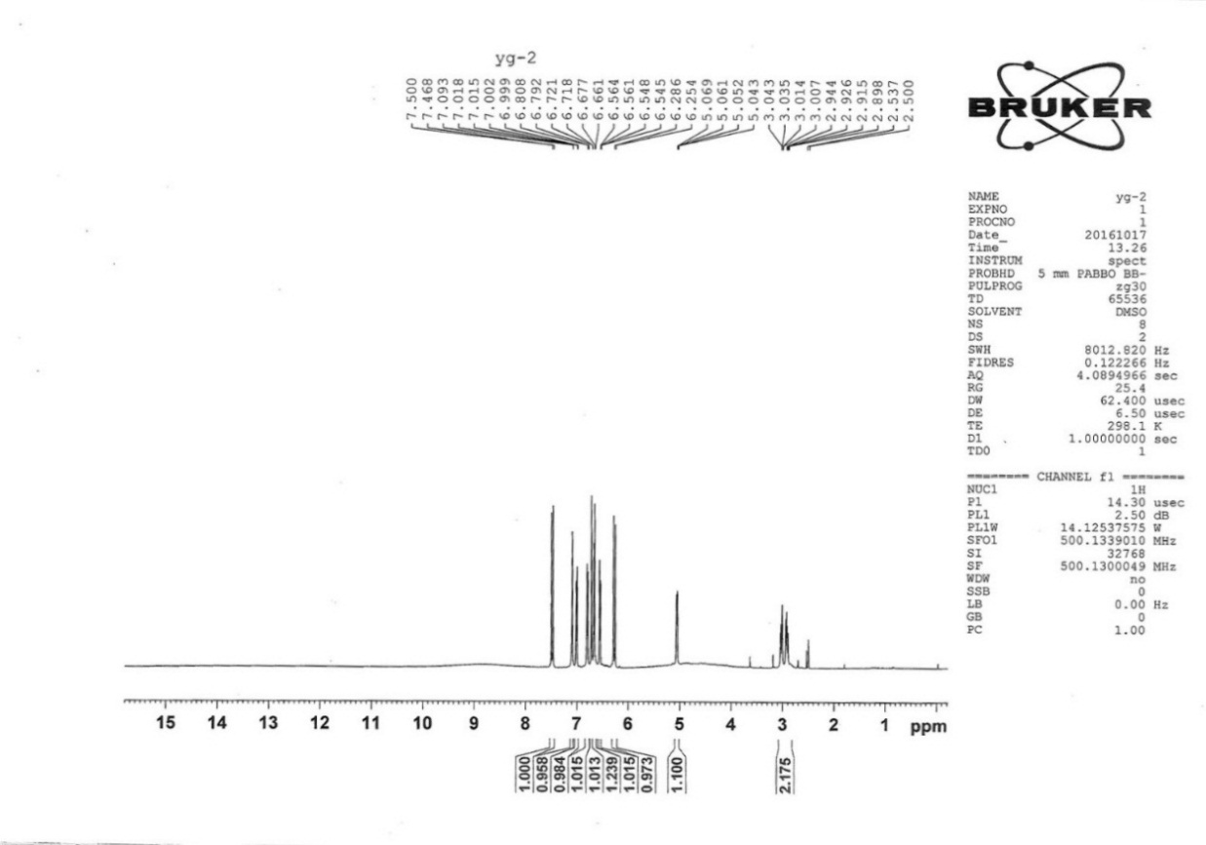

Fig. 7B 1H NMR of rosmarinic acid (**7**)

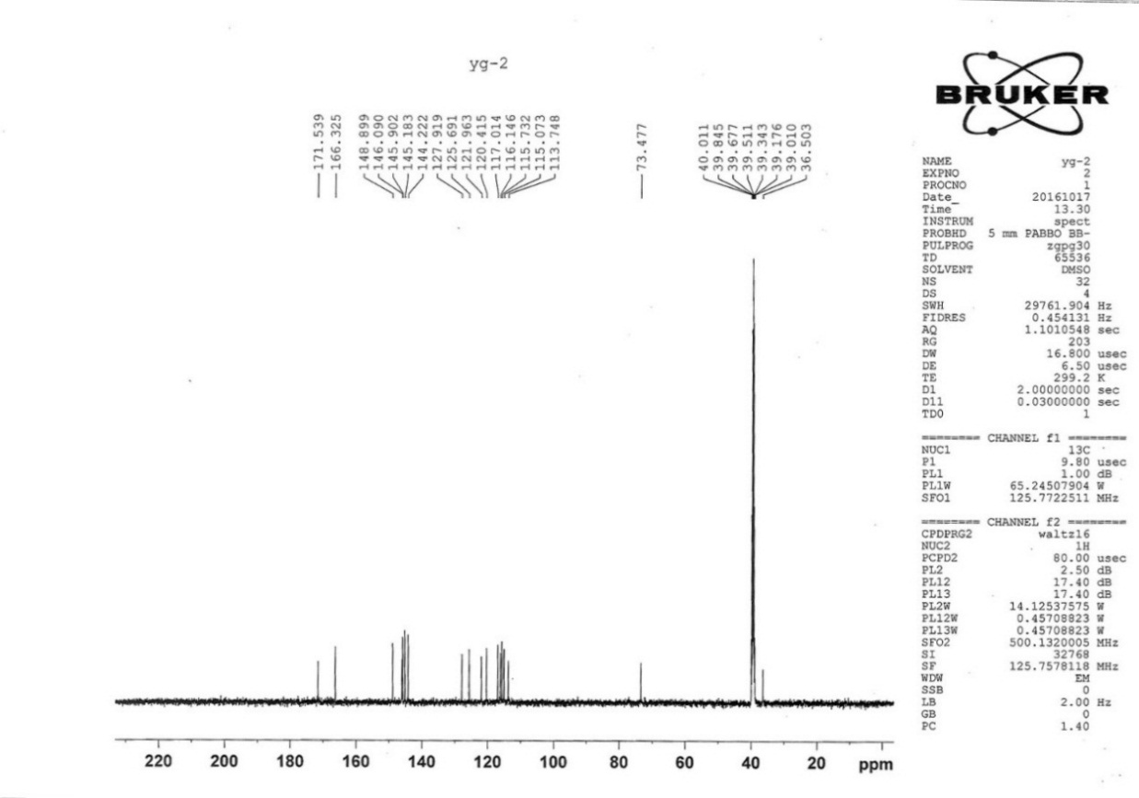

Fig. 7C 13C NMR of rosmarinic acid (**7**)

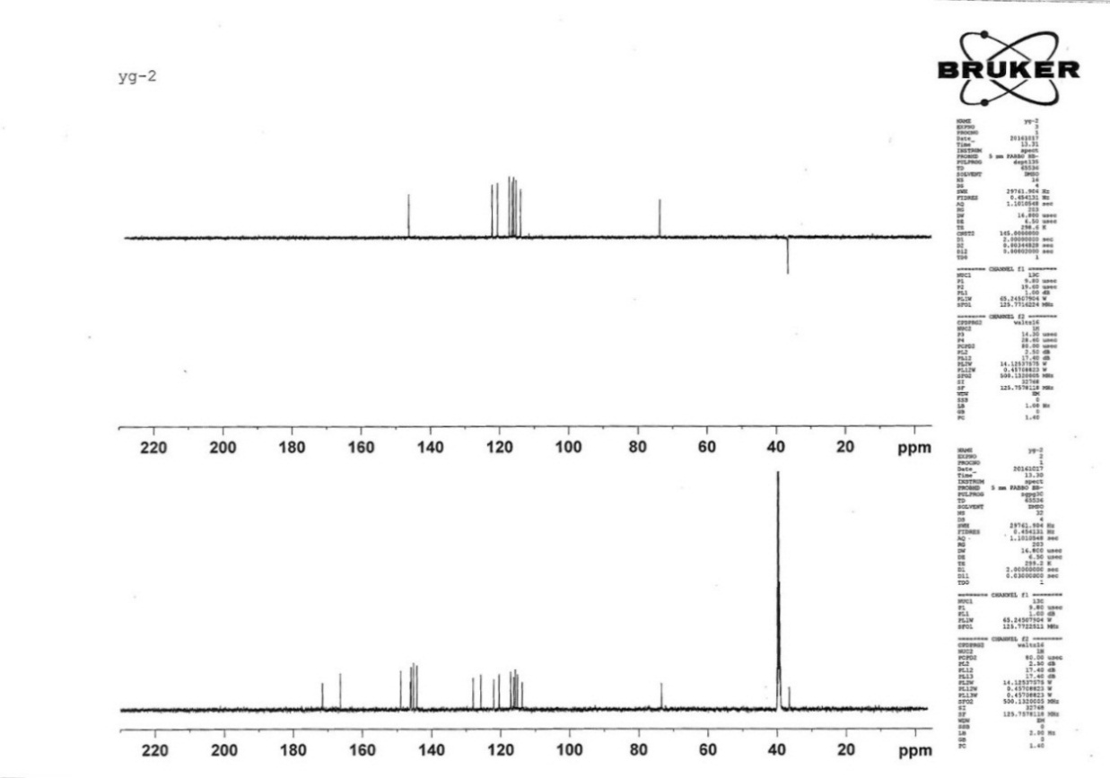

Fig. 7D DEPT of rosmarinic acid (**7**)





Fig. 8A EI-MS spectrum of methylrosmarinate (**8**)

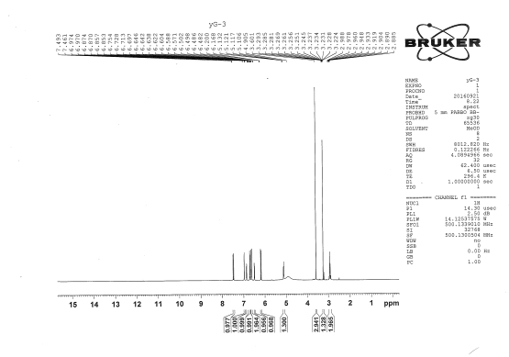

Fig. 8B 1H NMR of methylrosmarinate (**8**)

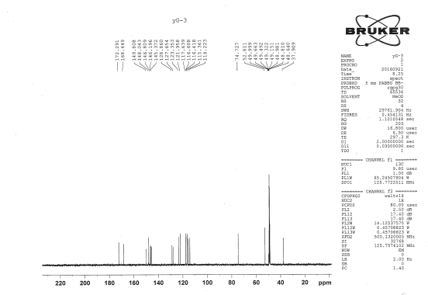

Fig. 8C 13C NMR of methylrosmarinate (**8**)

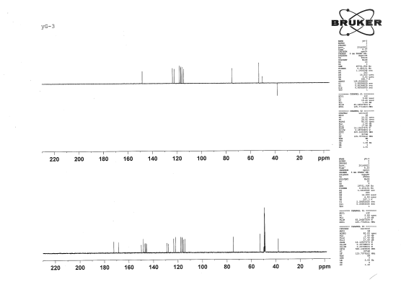

Fig. 8D DEPT of methylrosmarinate (**8**)

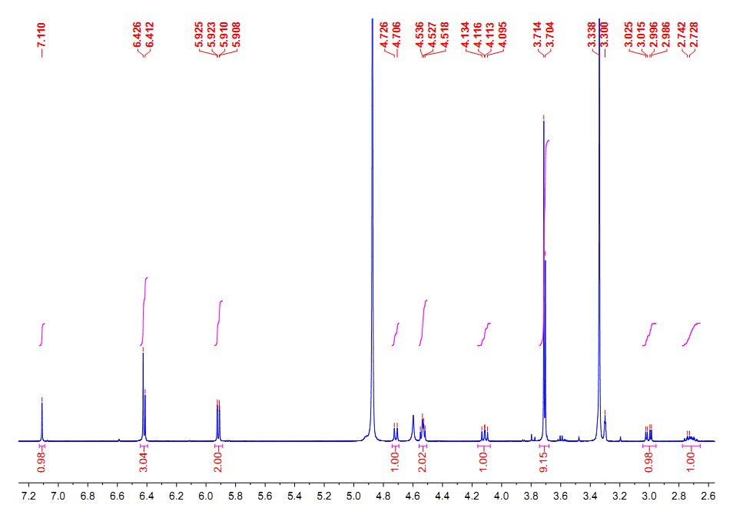

Fig. 9A 1H NMR of podophyllotoxin (**9**)

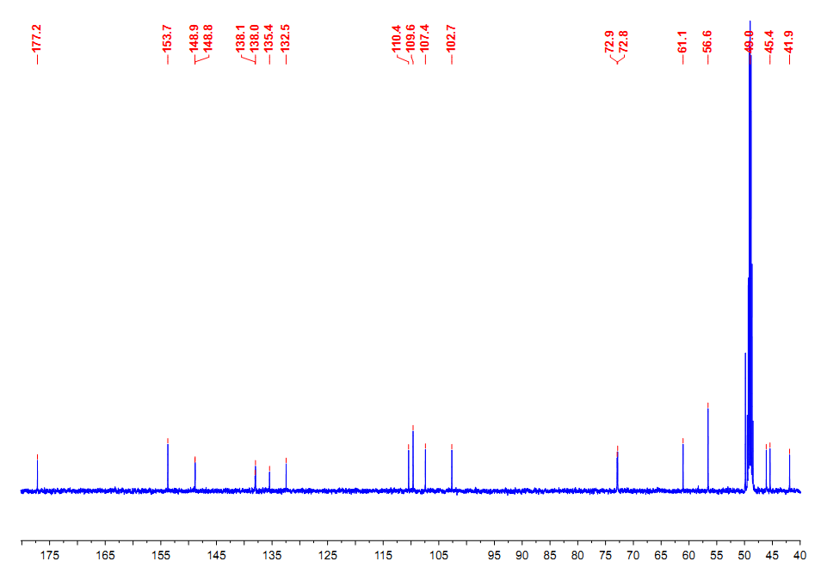

Fig. 9B 13C NMR of podophyllotoxin (**9**)

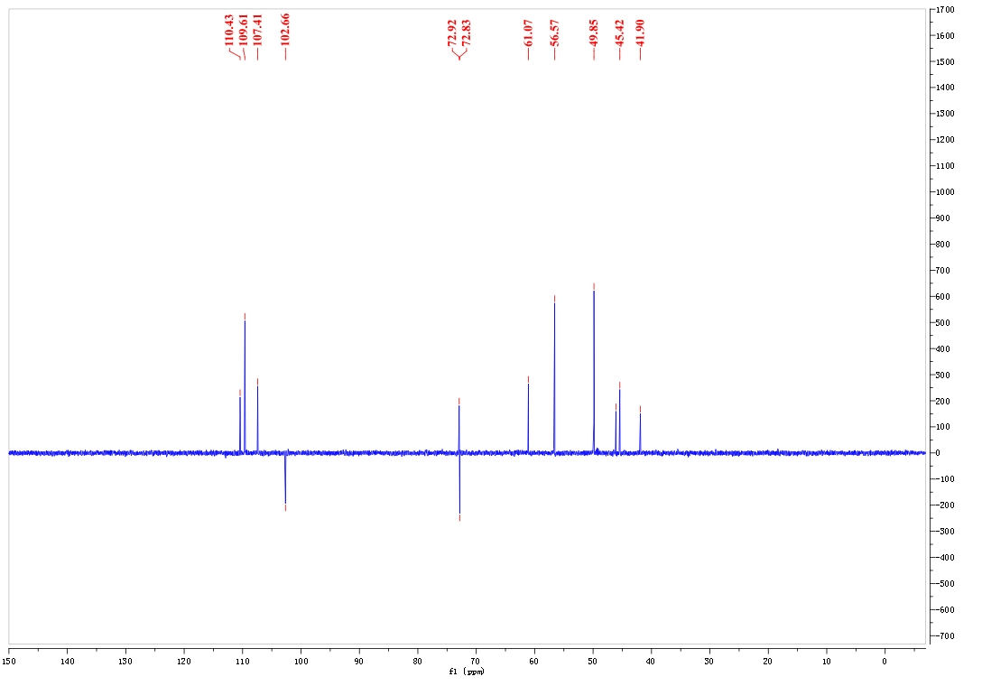

Fig. 9C DEPT of podophyllotoxin (**9**)

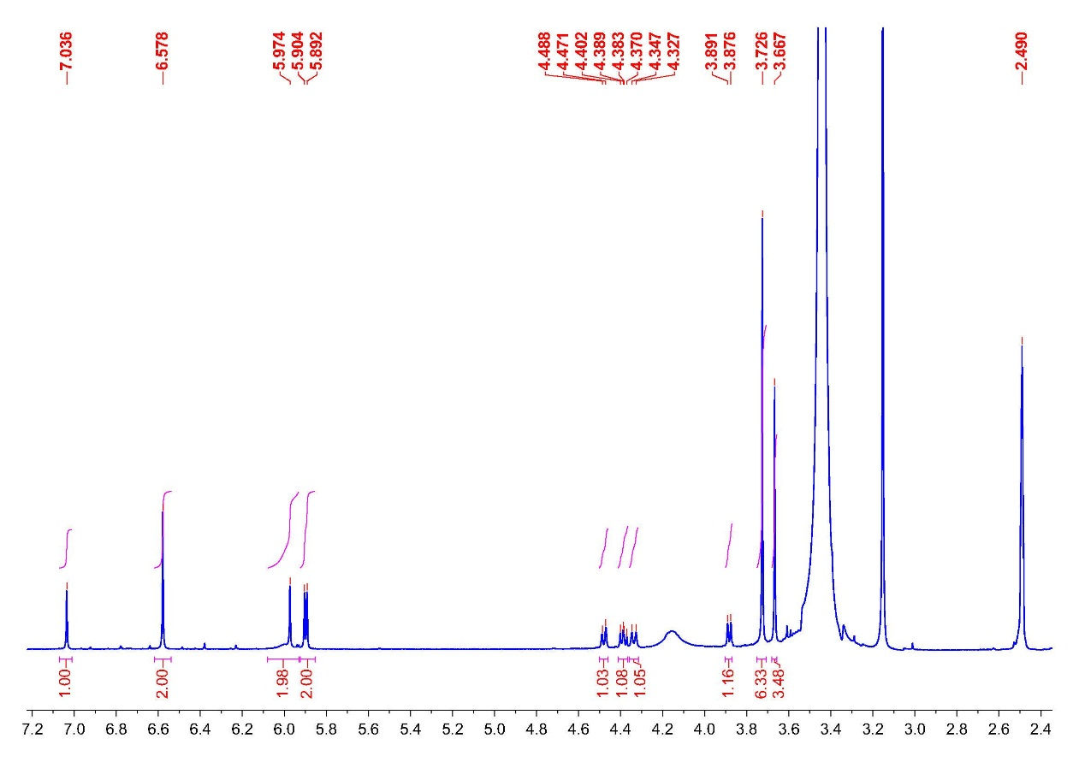

Fig. 10A 1H NMR of picropodophyllotoxin (**10**)

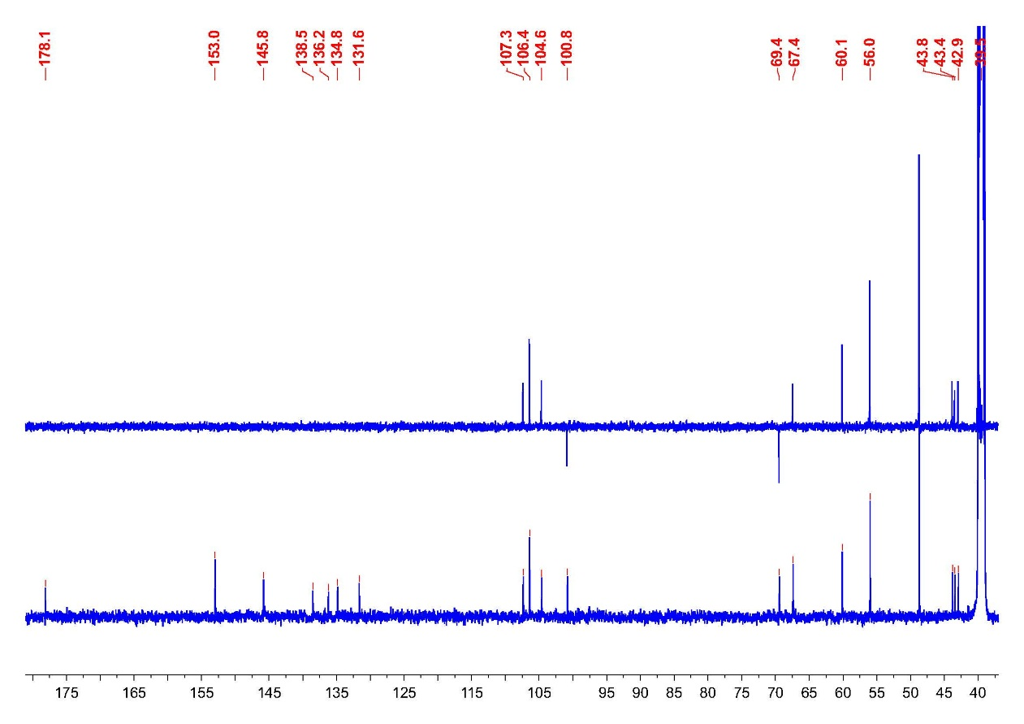

Fig. 10B 13C NMR and DEPT of picropodophyllotoxin (**10**)

1. LC chromatogram of **1, 3, 4** and **7-10**. (LC chromatogram of **2, 5** and **6** were not done.)

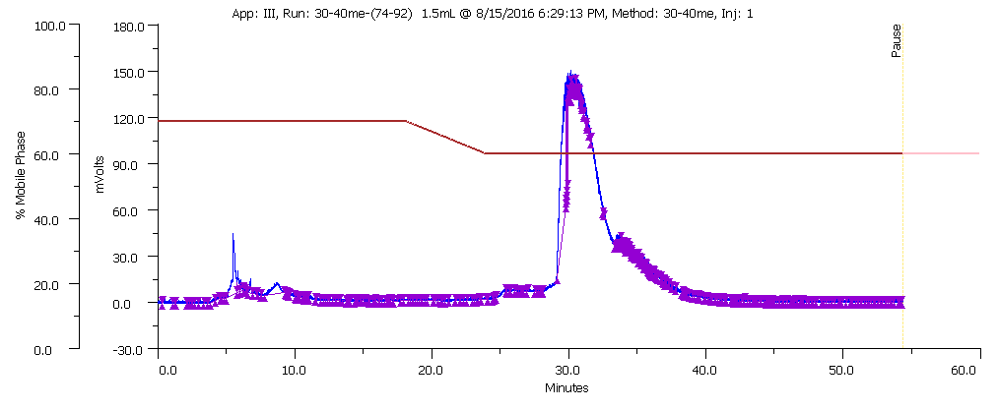

Fig. 11 Preparation of liquid chromatograms of quercetin-3-*O*-β-D-glucopyranoside (**1**)

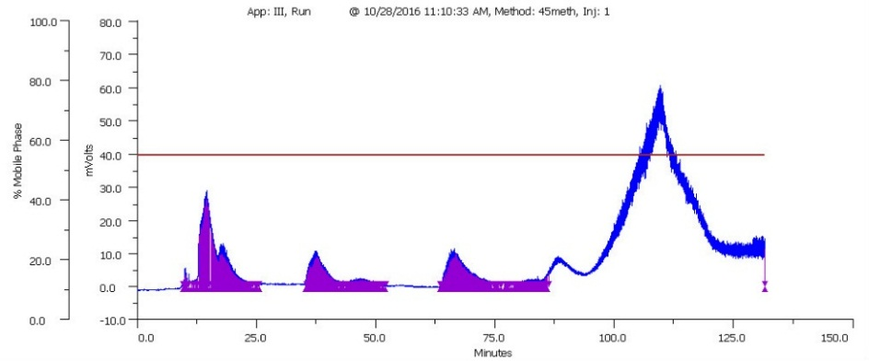

Fig. 12 Preparation of liquid chromatograms of methyl wogonin (**3**)

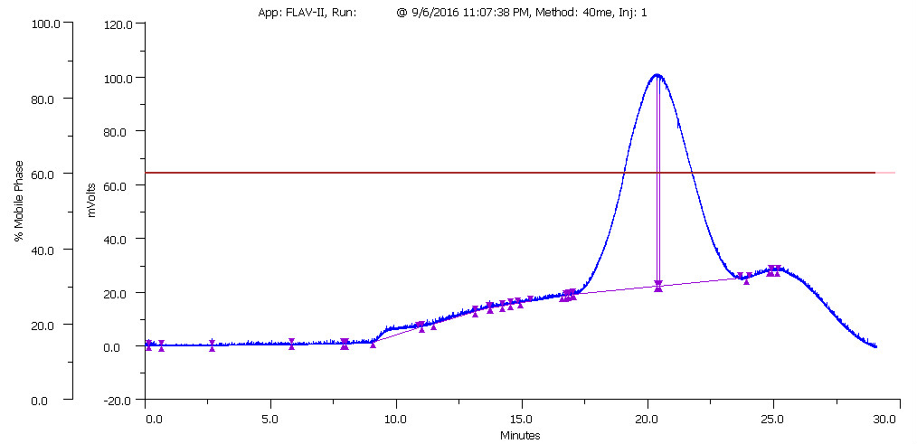

Fig. 13 Preparation of liquid chromatograms of quercetin (**4**)

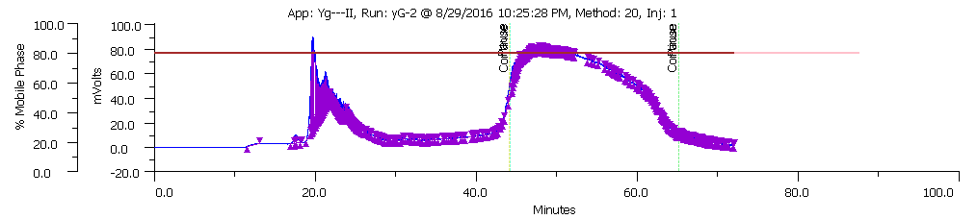

Fig. 14 Preparation of liquid chromatograms of rosmarinic acid (**7**)

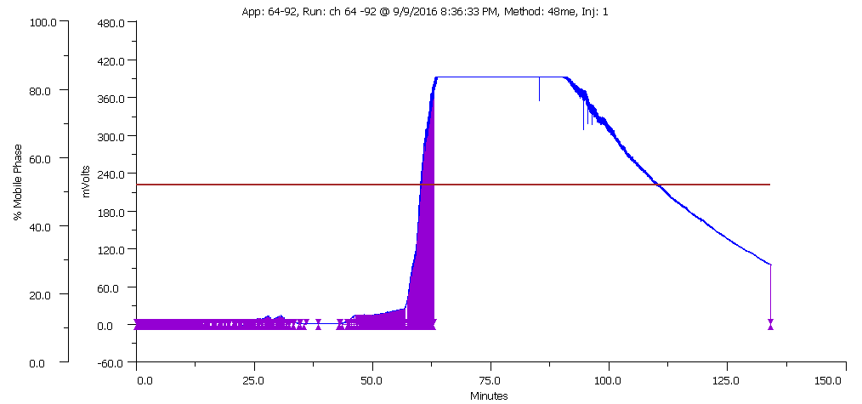

Fig. 15 Preparation of liquid chromatograms of methylrosmarinate (**8**)

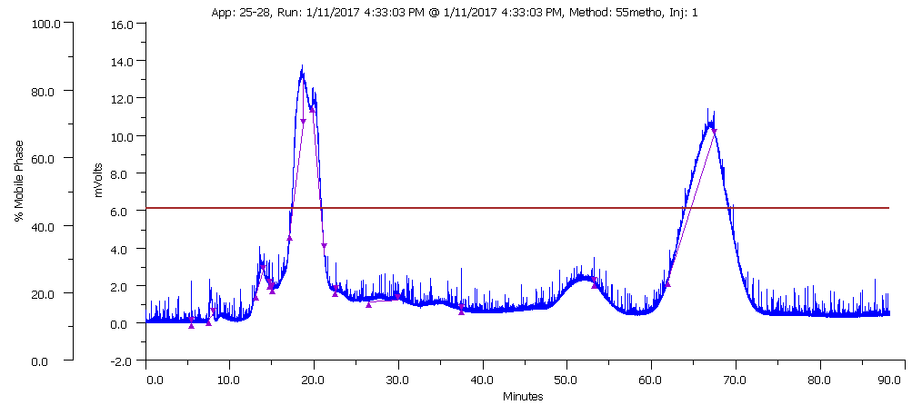

Fig. 16 Preparation of liquid chromatograms of podophyllotoxin (**9**)

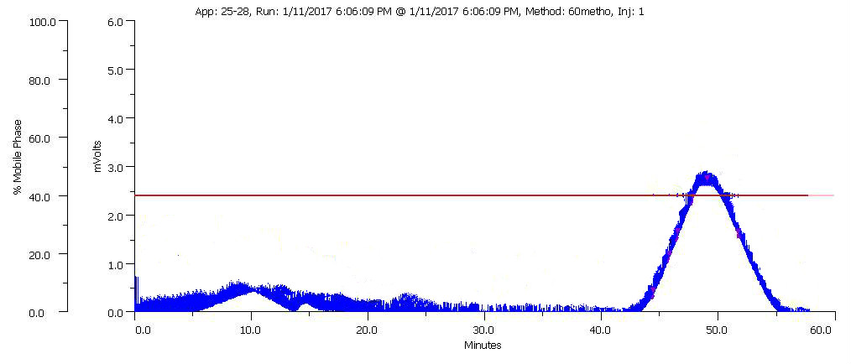

Fig. 17 Preparation of liquid chromatograms of picropodophyllotoxin (**10**)