Supplementary Material to

Study of pyrolysis of high density polyethylene in the open system and estimation of its capability for co-pyrolysis with lignite

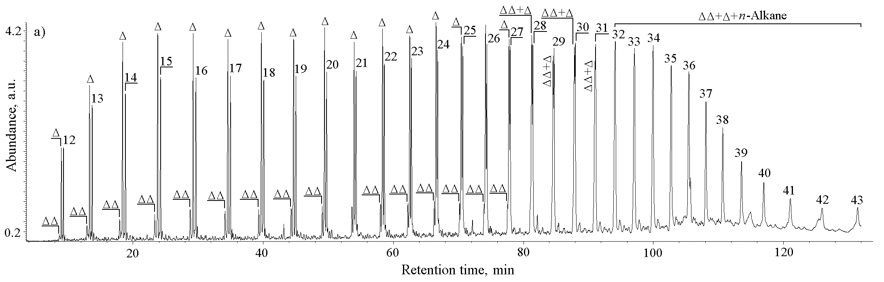
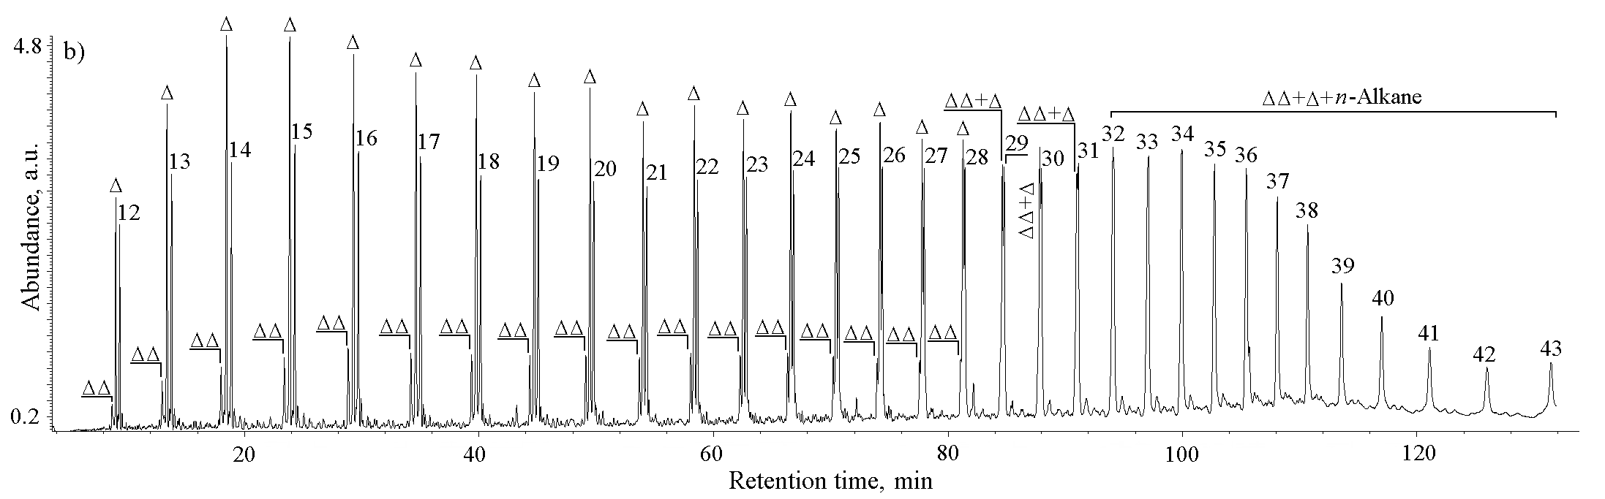
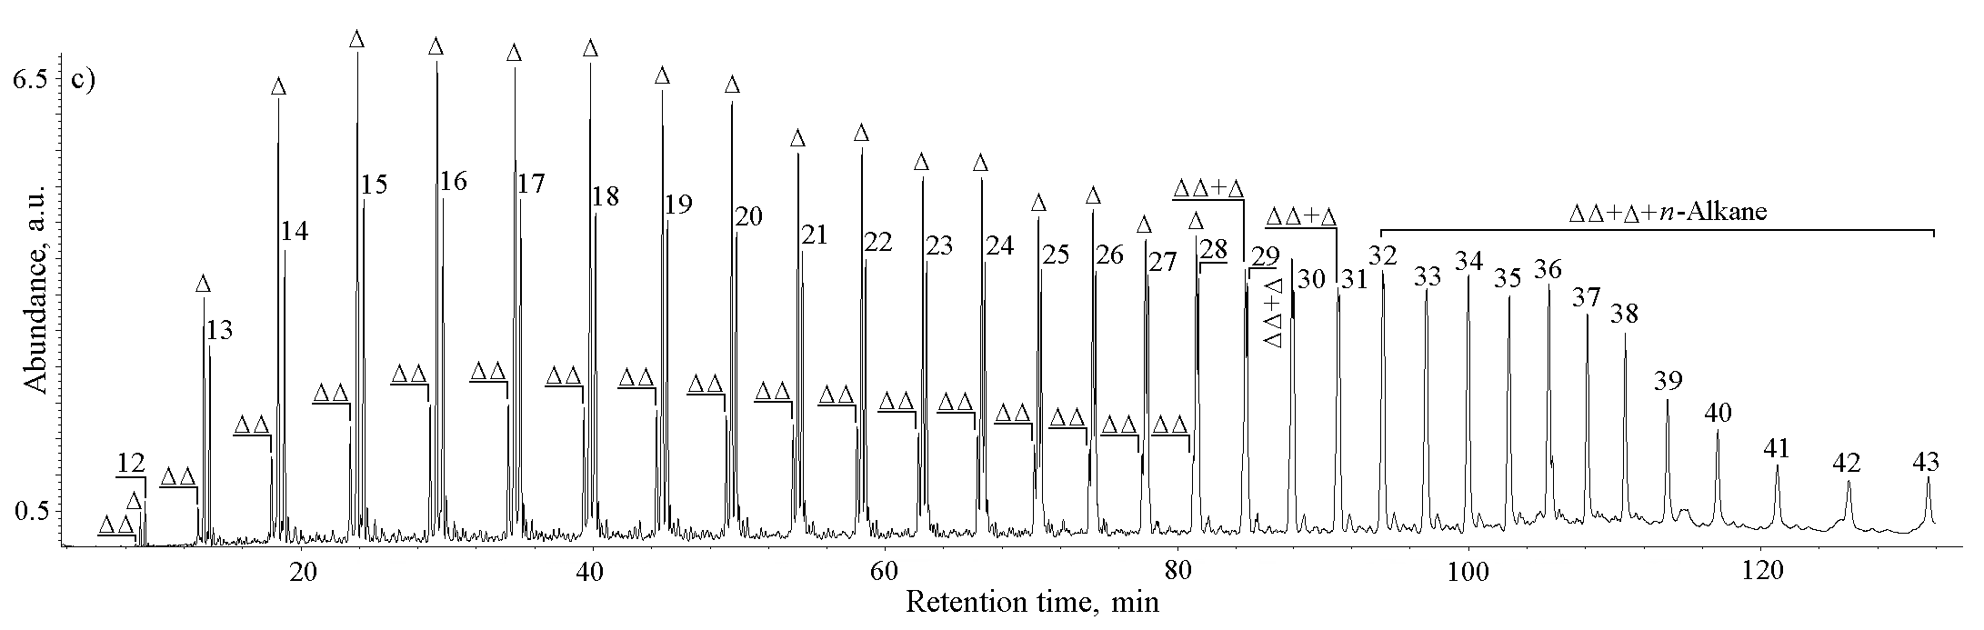

Fig. S-1. TIC (Total Ion Current) of liquid pyrolysates obtained at 400 ºC (a), 450 ºC (b) and 500 ºC (c).
n-Alkanes are labelled according to their carbon number; Δ – 1-n-Alkenes with same number of carbon atoms as n-alkanes; ΔΔ – Terminal dienes with same number of carbon atoms as n-alkanes.

