Supplementary Material to

Study of pyrolysis of high density polyethylene in the open system and estimation of its capability for co-pyrolysis with lignite

INTRODUCTION

Seo et al. (2003)¹ reported similar or even higher yield of liquid product obtained by thermal cracking than thermo-catalytic cracking (ZSM-5 and Zeolite Y) of HDPE at 450 ºC. However, composition of liquid products was quite different. Liquid product obtained by non-catalytic cracking contained 56 % of light hydrocarbons (C₆-C₁₂), whereas liquid products from thermo-catalytic cracking comprised more than 90 % of light hydrocarbons. Miskolczi et al. (2004)² studied thermal and thermo-catalytic cracking behaviour of a commercial HDPE waste in the temperature range of 400-450 ºC. Fluid catalytic cracking catalyst (FCC), HZSM-5 and a clinoptilolite containing rhyolite tuff were used as catalysts. The yield of gases increased in the following order: non-thermo-catalytic cracking < clinoptilolite < FCC < HZSM-5 catalysed cracking, while the yields of liquid products increased in the sequence of non-thermo-catalytic cracking < clinoptilolite < HZSM-5 < FCC catalysed cracking. Barbarias et al. (2015)³ used spent FCC catalysts regenerated with air at 550 °C for 1 h and then agglomerated by wet extrusion with bentonite (50 wt%) in the two-step system (flash pyrolysis at 500 ºC and catalytic cracking in the temperature range from 450 ºC to 550 ºC). It was observed that an increase in catalytic cracking temperature from 450 °C to 550 °C resulted in significant increase of the yield of light olefins (from 12 to 28 wt%) and non-aromatic C₅-C₁₁ compounds (from 34 to 52 wt%). Almustapha and Andresen (2011)⁴ used two sulphate modified zirconium catalysts (CAT) in catalytic degradation of HDPE. Heating of HDPE with catalysts to 400 ºC at heating rate of approximately 20 ºC min⁻¹ resulted in extremely high conversion of HDPE (about 99.8%) into gaseous and liquid products. García et al (2005)⁵ demonstrated advantage of utilisation of hybrid zeolitic-mesoporous material (ZSM-5/MCM-41) for the catalytic degradation of HDPE. By heating of HDPE:catalyst mixture (mass ratio, 100:1) at 380 ºC for 2 hours, conversion of HDPE of about 70 % was achieved. Light hydrocarbons (C₂-C₆) rich in olefins were the main degradation products, while the production of heavy fractions was negligible.

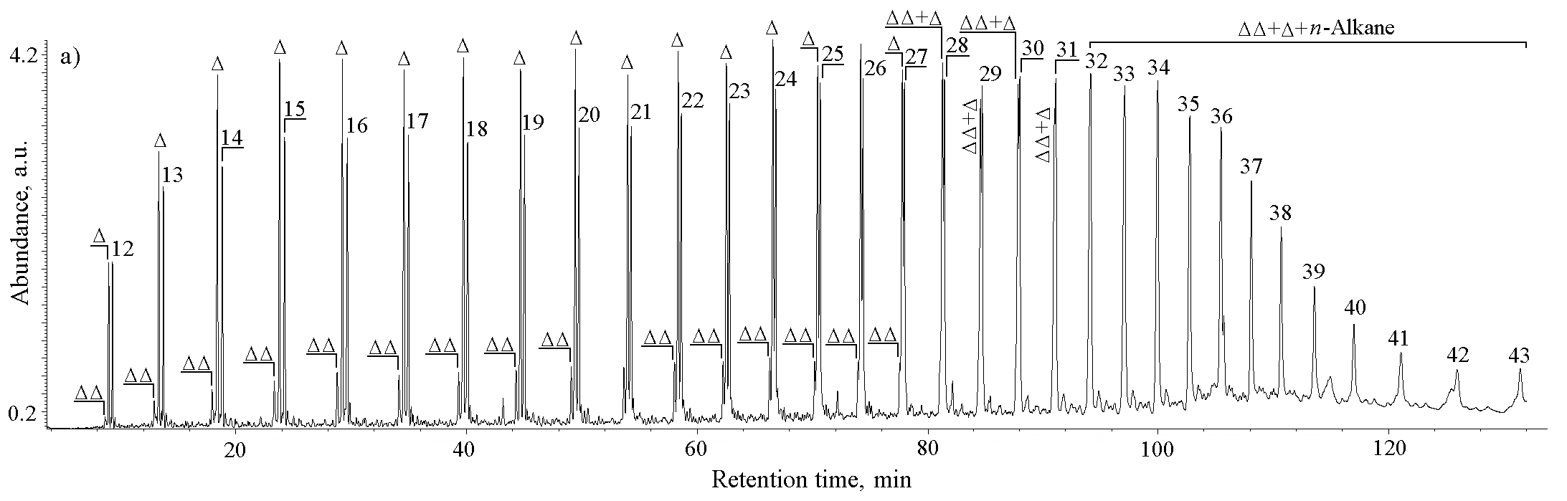
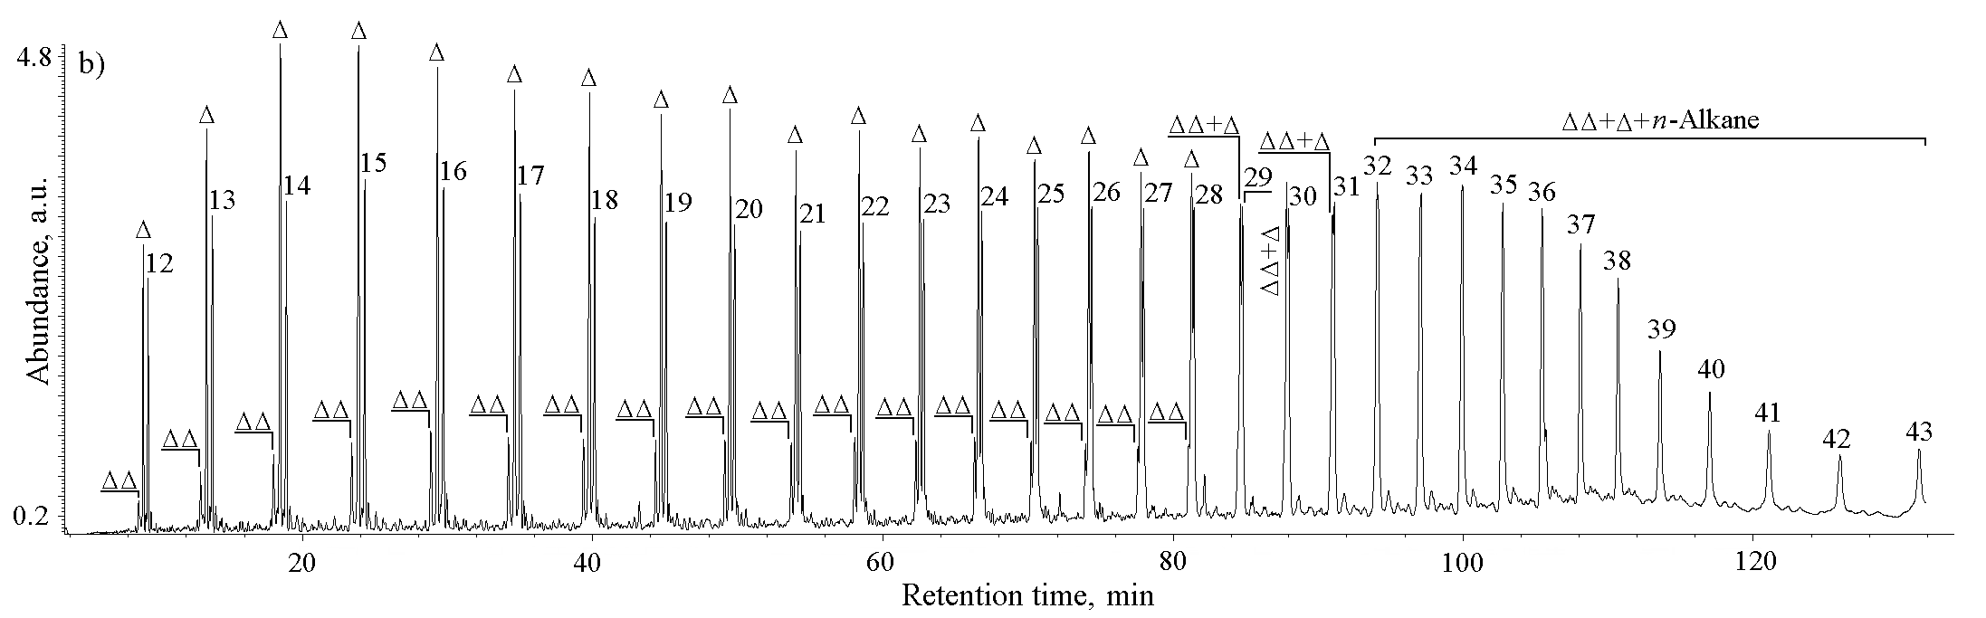
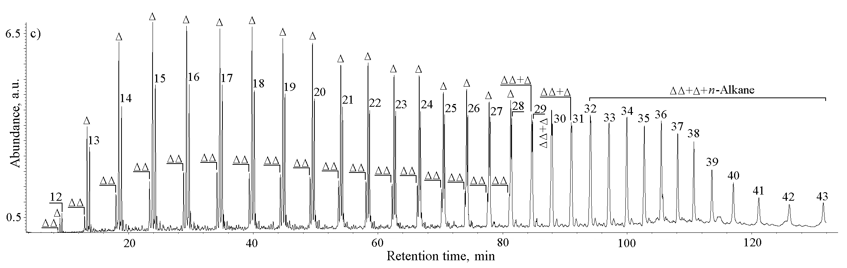

Fig. S-1. TIC (Total Ion Current) of liquid pyrolysates obtained at 400 ºC (a), 450 ºC (b) and 500 ºC (c).
n-Alkanes are labelled according to their carbon number; Δ – 1-n-Alkenes with same number of carbon atoms as n-alkanes; ΔΔ – Terminal dienes with same number of carbon atoms as n-alkanes.

REFERENCES
- Y.-H. Seo, K.-H. Lee, D.-H. Shin, J. Anal. Appl. Pyrolysis 70 (2003) 383
- N. Miskolczi, L. Bartha, G. Deák, B. Jóver, D. Kalló, J. Anal. Appl. Pyrolysis 72 (2004) 235
- I. Barbarias, M. Artetxe, A. Arregi, J. Alvarez, G. Lopez, M. Amutio, M. Olazar, Chem. Eng. Trans. 43 (2015) 2029
- M.N. Almustapha, J.M. Andresen, Int. Proc. Chem. Biol. Environ. Eng. 26 (2011) 21
- R.A. García, D.P. Serrano, D. Otero, J. Anal. Appl. Pyrolysis 74 (2005) 379.

