SUPPLEMNTARY MATERIAL TO
Synthesis of Novel Phthalimido Oxime Esters and Evaluation of Their Cytotoxicity
ASMA MEHREZ¹, IBTISSEM CHAKROUN², DALILA MTAT¹, HÉDI BEN MANSOUR³, RIDHA TOUATI*¹

1. Laboratory of Asymmetric Organic Synthesis and Homogeneous Catalysis (UR11ES56), Faculty of Sciences of Monastir, Avenue of the Environment, 5019 Monastir, Tunisia.
2. Laboratory for analysis, treatment and recovery of environmental pollutants and products, Faculty of Pharmacy, Avicenne Street, 5000 Monastir, Tunisia.
3. Research Unit Analyzes and Processes Applied to the Environment (UR17ES32), Higher Institute of Applied Sciences and Technology of Mahdia, 5111 Mahdia, Tunisia.

(S)-2-(1,3-dioxoisoindolin-2-yl)propanoic acid (4a). Product was isolated upon column chromatography (SiO₂, eluent EA/ Hex gradient 8/2). Yield 95%, white powder, mp 138±2 °C, [α]_{D}²⁵ = -43.2 (c= 1×10⁻³g/mL, CHCl₃), ¹H NMR (CDCl₃, 300 MHz, 27°C): δ= 11.26 (sl, COOH) 7.80-7.76 (m, 2H, H₆, H_{6’}), 7.68-7.63 (m, 2H, H₇, H_{7’}), 5.00 (q, J_{2,3}=7.5Hz, 1H, H₂), 1.65 (d, J_{3,2}= 7.2Hz, 3H, H₃). ¹³C NMR (CDCl₃, 75MHz, 27°C): δ= 174.9 (C₁), 166.8 (C₄), 133.7 (C₇), 131.3 (C₅), 123.0 (C₆), 46.7 (C₂), 14.4 (C₃). IR (KBr): ν= 2931 (CH), 1721 (C＝O), 1345 (C-N) cm⁻¹. Anal..Calcd. for C₁₁H₉NO₄ requires: C, 60.27; H, 4.10; N, 6.39; O, 29.22; found: C, 60.34; H, 4.12; N, 6.28; O, 29.26.

(S)-4-methyl-2-(1,3-dioxoisoindolin-2-yl)pentanoic acid (4b). Product was isolated upon column chromatography (SiO₂, eluent EA/ Hex gradient 8/2). Yield 89%, white powder, mp 123±2 °C , [α]_{D}²⁵ = -35 (c= 1×10⁻³g/mL, CHCl₃), ¹H NMR (CDCl₃, 300 MHz, 27°C): δ= 10.20 (sl, COOH) 7.87-7.83 (m, 2H, H₆, H_{6’}), 7.75-7.70 (m, 2H, H₇, H_{7’}), 4.97 (dd, J_{2,3}=11.1, J_{2,3’}=4.5Hz, 1H, H₂), 2.40-2.30 (m, 1H, H₄), 2.03-1.94 (m, 1H, H₃), 1.56-1.51 (m, 1H, H₃), 0.97 (dd, J_{5,4}=J_{5’,4}=6.6Hz, 6H, H₅, H_{5’}). ¹³C NMR (CDCl₃, 75MHz, 27°C): δ= 174 (C₁), 167 (C₄), 133.5 (C₇), 131.3 (C₅), 123 (C₆), 49.9 (C₂), 36.6 (C₃), 24.6 (C₅), 20.5 (C₄). IR (KBr): ν= 1708 (C＝O), 1465 (CH₂), 1328 (C-N) cm⁻¹. Anal..Calcd. for C₁₄H₁₅NO₄ requires: C, 64.36; H, 5.74; N, 5.36; O, 24.52; found: C, 64.42; H, 5.70; N, 5.37; O, 24.51.

(2S,3R)-3-methyl-2-(1,3-dioxoisoindolin-2-yl)pentanoic acid (4c). Product was isolated upon column chromatography (SiO₂, eluent EA/ Hex gradient 8/2). Yield 85%, white cristals, mp 134±2 °C , [α]_{D}²⁵ = -19.7 (c= 1×10⁻³g/mL, CHCl₃), ¹H NMR (CDCl₃, 300 MHz, 27°C): δ= 8.84 (sl, COOH) 7.87-7.83 (m, 2H, H₆, H_{6’}), 7.75-7.70 (m, 2H, H₇, H_{7’}), 4.73 (d, J_{2,3}= 9Hz, 1H, H₂), 2.61-2.54 (m, 1H, H₃), 1.56-1.43 (m, 1H, H₄), 1.18 (d, J_{3’,3}= 8.1Hz, 3H, H_{3’}), 0.89 (t, J_{5,4}=7.5Hz, 3H, H₅). ¹³C NMR (CDCl₃, 75MHz, 27s°C): δ= 172.8 (C₁), 167.2 (C₄), 133.6 (C₇), 131.2 (C₅), 123 (C₆), 56.6 (C₂), 33.9 (C₃), 25.3 (C₄), 16.1 (C_{3’}), 10.2 (C₅). IR (KBr): ν= 1718 (C＝O), 1460 (CH₂), 1320 (C-N) cm⁻¹. Anal..Calcd. for C₁₄H₁₅NO₄ requires: C, 64.36; H, 5.74; N, 5.36; O, 24.52; found: C, 64.39; H, 5.71; N, 5.38; O, 24.52.

(S)-3-(3,4-dihydroxyphenyl)-2-(1.3-dioxoisoindoline-2-yl)propanoic acid (4d). Product was isolated upon column chromatography (SiO₂, eluent EA/ Hex gradient 8/2). Yield 76%, white powder, 185±2 °C, [α]_{D}²³ = -45.6 (c= 1×10⁻³g/mL, DMSO), ¹H NMR (DMSO-d₆, 300 MHz, 27°C): δ= 13.13 (sl, COOH), 8.54 (sl ,2Η, 2(OH)), 7.83-7.62 (m, 4H, H₆, H_{6’,} H₇, H_{7’}), 6.52 (d, 1H, J_{9,8}= 5.7 Hz, H₉ ), 6.48 (s, 1H, H₅), 6.33 (d, 1H, J_{8,9}= 7.8 Hz, H₈), 4.97 (d.d, 1H, J_{2,3}=11.4, J_{2,3’}=5.1 Hz, H₂), 3.32-3.14 (m, 2H, H₃). ¹³C NMR (75MHz, DMSO-d₆, 27°C): δ= 170 (C₁), 167 (C₄), 144.9 (C₆), 143.7 (C₇), 134.7 (C₄), 130.8 (C₁₃), 128.0 (C₁₁), 123.2 (C₆), 119.3 (C₉), 116 (C₈), 115.5 (C₅), 53.3 (C₂), 33.2 (C₃). IR (KBr): ν= 3290 (ΟΗ),1721 (C＝O), 1460 (CH₂), 1332 (C-N) cm⁻¹. Anal..Calcd. for C₁₇H₁₃NO₆ requires: C, 62.29; H, 3.97; N, 4.28; O, 29.35; found: C, 62.39; H, 3.91; N, 4.27; O, 29.43.
(S)-1-p-tolylethanoneoximyl-2-(1,3-dioxoisoindolin-2-yl)propanoate (5a). Product was isolated upon column chromatography (SiO₂, eluent Hex/EA gradient 8/2). Yield 63%, yellow oil , [α]_{D}²⁵ = -78.2 (c= 1×10⁻³g/mL, CHCl₃), 1H NMR (CDCl₃, 300 MHz, 27°C): δ= 7.82-7.80 (m, 2H, H₆, H_{6’}), 7.71-7.66 (m, 2H, H₇, H_{7’}), 7.56 (d, J_{11,12}=7.8Hz, 2H, H₁₁, H_{11’}), 7.13 (d, J_{12,11}=7.8Hz, 2H, H₁₂, H_{12’}), 5.19 (q, J_{2,3}=7.2Hz, 1H, H₂), 2.28 (s, 3H, H₁₄), 2.16 (s, 3H, H₈), 1.81 (d, J_{3,2}= 7.2Hz, 3H, H₃). ¹³C NMR (CDCl₃, 75MHz, 27°C): δ= 166.7 (C₁), 166.3 (C₄), 163.6 (C₉), 140.5 (C₁₃), 133.8 (C₁₀), 133.5 (C₇), 128.9 (C₁₁), 126.4 (C₁₂), 122.8 (C₆), 46.6 (C₂), 20.7 (C₁₄), 14.8 (C₈), 13.7 (C₃). IR (KBr): ν= 1770 (C＝O), 1595 (C＝N), 1088 (O＝CON), 985 (N-O) cm⁻¹. Anal..Calcd. for C₂₀H₁₈N₂O₄ requires: C, 68.57; H, 5.14; N, 8.00; O, 18.28; found: C, 68.54; H, 5.19; N, 8.01; O, 18.26.

(S)-1-(4-methoxyphenyl)ethanoneoximyl-2-(1,3-dioxoisoindolin-2-yl)propanoate (5b). Product was isolated upon column chromatography (SiO₂, eluent Hex/EA gradient 8/2). Yield 52%, white powder, mp 150±2 °C, [α]_{D}²² = -40.2 (c= 1×10⁻³g/mL, CHCl₃), ¹H NMR (CDCl₃, 300 MHz, 27°C): δ= 7.88-7.87 (m, 2H, H₆, H_{6’}), 7.75-7.72 (m, 2H, H₇, H_{7’}), 7.70 (d, J_{11,12}= 8.4Hz, 2H, H₁₁, H_{11’}), 7.04 (d, J_{12,11}= 8.4Hz, 2H, H₁₂, H_{12’}), 5.21 (q, J_{2,3}=7.2Hz, 1H, H₂), 3.80 (s, OCH₃), 2.20 (s, 3H, H₈), 1.82 (d, J_{3,2}= 7.2Hz, 3H, H₃).¹³C NMR (CDCl₃, 75MHz, 27°C): δ= 166.7 (C₁), 166.2 (C₄), 163.0 (C₁₃), 141.8 (C₉), 133.6 (C₇), 131.4 (C₅), 128.1(C₁₁), 126.2 (C₆), 122.9 (C₁₀), 113.4 (C₁₂), 54.7 (OCH₃), 46.6 (C₂), 14.8 (C₈), 13.9 (C₃). IR (KBr): ν= 2938 (OCH₃), 1751 (C＝O), 1592 (C＝N), 1051 (O＝CON), 987 (N-O) cm⁻¹. Anal..Calcd. for C₂₀H₁₈N₂O₅ requires: C, 65.57; H, 4.95; N, 7.65; O, 21.84; found: C, 65.76; H, 4.82; N, 7.61; O, 21.81.

(S)-1-(4-fluorophenyl)ethanoneoximyl-2-(1,3-dioxoisoindolin-2-yl)propanoate (5c). Product was isolated upon column chromatography (SiO₂, eluent Hex/EA gradient 8/2). Yield 60%, white crystals, mp 166±2 °C, [α]_{D}²³ = -60.1 (c= 1×10⁻³g/mL, CHCl₃), ¹H NMR (CDCl₃, 300 MHz, 27°C): δ= 7.86-7.85 (m, 2H, H₆, H_{6’}), 7.75-7.73 (m, 2H, H₇, H_{7’}), 7.66 (d, J_{11,12}= 8.4Hz, 2H, H₁₁, H_{11’}), 6.78 (d, J_{12,11}= 8.4Hz, 2H, H₁₂, H_{12’}), 5.24 (q, J_{2,3}=7.2Hz, 1H, H₂), 2.21 (s, 3H, H₈), 1.84 (d, J_{3,2}= 7.2Hz, 3H, H₃). ¹³C NMR (CDCl₃, 75MHz, 27°C): δ= 166.7 (C₁), 166.0 (C₄), 162.5 (C₁₃), 139.8 (C₉), 133.7 (C₇), 131.4 (C₅), 128.7 (C₁₁), 128.6 (C₁₀), 123.0 (C₆), 115.1 (C₁₂), 46.5 (C₂), 14.6 (C₈), 13.9 (C₃). IR (KBr): ν= 1737 (C＝O), 1589 (C＝N), 1062 (O＝CON), 1001 (N-O) cm⁻¹. Anal..Calcd. for C₁₉H₁₅N₂O₄F requires: C, 64.40; H, 4.23; N, 7.90; O, 18.07; F, 5.36; found: C, 64.38; H, 4.32; N, 7.94; O, 18.04; F, 5.32.

(S)-1-(4-chlorophenyl)ethanoneoximyl-2-(1,3-dioxoisoindolin-2-yl)propanoate (5d). Product was isolated upon column chromatography (SiO₂, eluent Hex/EA gradient 8/2). Yield 76%, white powder, mp 140±2 °C, [α]_{D}²⁵ = -28.6 (c= 1×10⁻³g/mL, CHCl₃), ¹H NMR (CDCl₃, 300 MHz, 27°C): δ= 7.84-7.83 (m, 2H, H₆, H_{6’}), 7.75-7.74 (m, 2H, H₇, H_{7’}), 7.45 (d, J_{11,12}= 8.2Hz, 2H, H₁₁, H_{11’}), 7.25 (d, J_{12,11}= 8.2Hz, 2H, H₁₂, H_{12’}), 5.09 (q, J_{2,3}=7.2Hz, 1H, H₂), 2.60 (s, 3H, H₈), 1.81 (d, J_{3,2}=7.2Hz, 3H, H₃). ¹³C NMR (CDCl₃, 75MHz, 27°C): δ= 167.9 (C₁), 167.4 C 162.5 (C₄), 140.7 (C₉), 136.0 (C₁₃), 134.4 (C₇), 131.7 (C₅), 129.7 (C₁₀), 128.9 (C₁₁), 123.6 (C₁₂), 121.4 (C₆), 50.9 (C₂), 15.3(C₈), 13.5 (C₃). IR (KBr): ν= 1739 (C＝O), 1516 (C＝N), 1068 (O＝CON), 963 (N-O) cm⁻¹. Anal..Calcd. for C₁₉H₁₅N₂O₄Cl requires: C, 61.53; H, 4.04; N, 7.55; O, 17.27; Cl, 9.58; found: C, 61.57; H, 4.07; N, 7.48; O, 17.34; Cl, 8.91.

4(S)-1-(4-bromophenyl)ethanoneoximyl-2-(1,3-dioxoisoindolin-2-yl)propanoate (5e). Product was isolated upon column chromatography (SiO₂, eluent Hex/EA gradient 8/2). Yield 75%, white powder, mp 96±2 °C, [α]_{D}²² = -38.3 (c= 1×10⁻³g/mL, CHCl₃), ¹H NMR (CDCl₃, 300 MHz, 27°C): δ= 7.89-7.88 (m, 2H, H₆, H_{6’}), 7.88-7.85 (m, 2H, H₇, H_{7’}), 7.76 (d, J_{11,12}= 8.2Hz, 2H, H₁₁, H_{11’}), 7.57 (d, J_{12,11}= 8.2Hz, 2H, H₁₂, H_{12’}), 5.24 (q, J_{2,3}= 7.2Hz, 1H, H₂), 2.20 (s, 3H, H₈), 1.84 (d, J_{3,2}= 7.2Hz, 3H, H₃).¹³C NMR (CDCl₃, 75MHz, 27°C): δ= 166.6 (C₁), 166.0 (C₄), 162.5 (C₉), 141.6 (C₁₀), 133.7 (C₇), 132.8 (C₅), 131.4 (C₁₂), 131.3 (C₁₁), 128.0 (C₆), 124.8 (C₁₃), 46.6 (C₂), 14.7 (C₈), 13.5 (C₃). IR (KBr): ν= 1757 (C＝O), 1591 (C＝N), 1074 (O＝CON), 999 (N-O) cm⁻¹. Anal..Calcd. for C₁₉H₁₅N₂O₄Br requires: C, 54.95; H, 3.61; N, 6.74; O, 15.42; Br, 19.25; found: C, 54.88; H, 3.64; N, 6.78; O, 15.47; Br, 19.32.

(S)-4-methyl-1-tolylethanoneoximyl-2-(1,3-dioxoisoindolin-2-yl)pentanoate (5f). Product was isolated upon column chromatography (SiO₂, eluent Hex/EA gradient 9,5/0,5). Yield 61%, white oil , [α]_{D}²⁶ = -42.7 (c= 1×10⁻³g/mL, CHCl₃), ¹H NMR (CDCl₃, 300 MHz, 27°C): δ= 7.89-7.16 (m, 8H, Ar-H), 5.19 (dd, 1H, J_{2,3}= 10.8, J_{2,3’}= 4.5Hz, H₂), 2.51-2.40 (m, 1H, H₃), 2.35 (s, 3H, H₁₆), 2.19 (s, 3H, H₁₀), 2.11-2.09 (m, 1H, CH₂), 1.61-1.53 (m, 1H, H₄), 1.01 (d, 3H, J_{5,4}= 6.9Hz, H₅), 0.98 (d, 3H, J_{5’,4}= 6.9Hz, H_{5’}). ¹³C NMR (75MHz, CDCl₃, 27°C): δ= 167.0 (C₁), 166.2 (C₆), 163.4 (C₁₁), 140.5 (C₁₅), 134.1 (C₉), 133.7 (C₇), 131.1 (C₁₂), 128.7 (C₁₄), 126.4 (C₁₃), 122.9 (C₈), 50.4 (C₂), 37.3 (C₃), 25.1 (C₁₆), 22.9 (C₅), 21.2 (C₄), 14.2 (C₁₀). IR (KBr): ν= 1762 (C＝O), 1595 (C＝N), 1460 (CH₂), 1084 (O＝CON), 989 (N-O) cm⁻¹. Anal..Calcd. for C₂₃H₂₄N₂O₄ requires: C, 70.40; H, 6.12; N, 7.14; O, 16.32; found: C, 70.42; H, 6.18; N, 7.12; O, 16.28.

(S)-1-(4-chlorophenyl)ethanoneoximyl-4-methyl-2-(1,3-dioxoisoindolin-2-yl)pentanoate (5g). Product was isolated upon column chromatography (SiO₂, eluent Hex/EA gradient 9,5/0,5). Yield 69%, white powder, mp 116±2 °C, [α]_{D}²⁵ = -40.5 (c= 1×10⁻³g/mL, CHCl₃), ¹H NMR (CDCl₃, 300 MHz, 27°C): δ= 7.87-7.29 (m, 8H, Ar-H), 5.18 (dd, 1H, J_{2,3}= 11.1, J_{2,3’}= 4.8Hz, H₂), 2.49-2.34 (m, 1H, H₄), 2.17 (s, 3H, H₁₀), 2.08-1.99 (m, 1H, H₃), 1.61-1.54 (m, 1H, H₃), 0.99 (d, 3H, J_{5,4}= 7.2Hz, H₅), 0.97 (d, 3H, J_{5’,4}=7.2Hz, H_{5’}). ¹³C NMR (75MHz, CDCl₃, 27°C): δ= 166.5 (C₁), 166.0 (C₆), 162.4 (C₁₁), 136.5 (C₁₅), 133.7 (C₉), 131.2 (C₇), 130.9 (C₁₂), 128.4 (C₁₃), 126.7 (C₁₄), 122.9 (C₈), 49.1 (C₂), 36.6 (C₃), 24.3 (C₅), 22.6 (C₄), 13.6 (C₁₀). IR (KBr): ν= 1751 (C＝O), 1595 (C＝N), 1462 (CH₂), 1080 (O＝CON), 991 (N-O) cm⁻¹. Anal..Calcd. for C₂₂H₂₄N₂O₄Cl requires: C, 64.00; H, 5.09; N, 6.78; O, 15.51; Cl, 8.60; found: C, 64.08; H, 5.12; N, 6.64; O, 15.54; Cl, 8.62.

(2S,3R)-1-(4-methylphenyl)ethanoneoximyl-3-methyl-2-(1,3-dioxoisoindolin-2-yl) pentanoate (5h). Product was isolated upon column chromatography (SiO₂, eluent Hex/EA gradient 9,5/0,5). Yield 62%, white crystals, mp 92±2 °C, [α]_{D}²⁵ = -23.2 (c= 1×10⁻³g/mL, CHCl₃), ¹H NMR (CDCl₃, 300 MHz, 27°C): δ= 7.85-7.11 (m, 8H, Ar-H), 4.82 (d, 1H, J_{2,3}=9 Hz, H₂), 2.76-258 (m, 1H, H₃), 2.30 (s, 3H, H₁₆), 2.15 (s, 3H, H₁₀), 1.591-35 (m, 1H, H₄), 1.19 (d, 3H, J_{3’,3}=6.9Hz, H_{3’}), 1.11-1.06 (m, 1H, H₄), 1.04 (t, 3H, J_{5,4}=6.9Hz, H₅).¹³C NMR (75MHz, CDCl₃, 27°C): δ= 168.0 (C₁), 167.0 (C₆), 165.4 (C₁₁), 140.4 (C₁₅), 134.2 (C₉), 133.9 (C₇), 131.1 (C₁₂), 129.2 (C₁₄), 128.5 (C₁₃), 123.4 (C₈), 55.5 (C₂), 34.8 (C₄), 25.7 (C₃), 16.7 (C₁₆), 15.7 (C₁₀), 14.2 (C_{3’}), 10.6 (C₅). IR (KBr): ν= 1759 (C＝O), 1595 (C＝N), 1464 (CH₂), 1074 (O＝CON), 993 (N-O) cm⁻¹. Anal..Calcd. for C₂₃H₂₄N₂O₄ requires: C, 70.40; H, 6.12; N, 7.14; O, 16.32; found: C, 70.43; H, 6.15; N, 7.15; O, 16.31.

(S)-3-(3,4-dihydroxyphenyl)-1-phenylethanoneoximyl-2-(1,3-dioxoisoindolin-2-yl) propanoate (5i). Product was isolated upon column chromatography (SiO₂, eluent Hex/EA gradient 9/1). Yield 53%, white crystals, mp 166±2 °C, [α]_{D}²³ = -42.7 (c= 1×10⁻³g/mL, CHCl₃), ¹H NMR (CDCl₃, 300 MHz, 27°C): δ= 8.14 (2s ,2Η, 2(OH)), 7.80-7.26 (m, 12H, Ar-H), 5.37 (d.d, 1H, J_{2,3}=9.6, J_{2,3’}= 6.9 Hz, H₂), 3.59-3.55 (m, 2H, H₃), 2.28 (s, 3H, H₁₄). ¹³C NMR (75MHz, CDCl₃, 27°C): δ= 166.9 (C₁), 165.7 (C₁₀), 164.0 (C₁₅), 142.7 (C₆), 133.8 (C₇), 133.7 (C₁₆), 131.7 (C₄), 130.3 (C₁₃), 128.5 (C₁₁), 128.6 (C₁₉), 126.4 (C₁₇), 123.5 (C₁₈), 120.5 (C₁₂), 118.2 (C₉), 115.9 (C₈), 114.3 (C₅), 52.1 (C₂), 33.5 (C₃), 13.7 (C₁₄). IR (KBr): ν= 3373 (ΟΗ), 1743 (C＝O), 1593 (C＝N), 1424 (CH₂), 1080 (O＝CON), 986 (N-O) cm⁻¹. Anal..Calcd. for C₂₅H₂₀N₂O₆ requires: C, 67.56; H, 4.50; N, 6.30; O, 21.62; found: C, 67.52; H, 4.54; N, 6.30; O, 21.64.

(S)-3-(3,4-dihydroxyphenyl)-1-(4-methoxyphenyl)ethanoneoximyl-2-(1,3-dioxoisoindolin-2-yl)propanoate (5j). Product was isolated upon column chromatography (SiO₂, eluent Hex/EA gradient 9/1). Yield 73%, white crystals, mp 180±2 °C, [α]_{D}²⁵ = -57.2 (c= 1×10⁻³g/mL, CHCl₃), ¹H NMR (CDCl₃, 300 MHz, 27°C): δ= 8.54 (2s ,2Η, 2(OH)), 7.84-7.67 (m, 11H, Ar-H), 5.35 (d.d, 1H, J_{2,3}=9.3, J_{2,3’}= 7.2 Hz, H₂), 3.84 (s, 3H, OCH₃), 3.68-3.59 (m, 2H, H₃), 2.18 (s, 3H, H₁₄). ¹³C NMR (75MHz, CDCl₃, 27°C): δ= 167.4 (C₁), 166.1 (C₁₀), 161.8 (C₁₉), 142.7 (C₁₅), 134.1 (C₆), 131.6 (C₇), 129.3 (C₄), 128.6 (C₁₃), 126.6 (C₁₁), 123.4 (C₁₇), 122.7 (C₁₂), 121.5 (C₁₆), 116.5 (C₉), 115.0 (C₈), 114.3 (C₅), 114.2 (C₁₈), 53.5 (OCH₃), 53.1 (C₂), 34.8 (C₃), 15.7 (CH₃). IR (KBr): ν= 3370 (ΟΗ), 2948 (OCH₃), 1758 (C＝O), 1548 (C＝N), 1416 (CH₂), 1076 (O＝CON), 983 (N-O) cm⁻¹. Anal..Calcd. for C₂₆H₂₃N₂O₇ requires: C, 65.68; H, 4.84; N, 5.89; O, 23.57; found: C, 65.74; H, 4.79; N, 5.87; O, 23.60.

(S)-3-(3,4-dihydroxyphenyl)-1-(4-chlorophenyl)ethanoneoximyl-2-(1,3-dioxoisoindolin-2-yl)propanoate (5k). Product was isolated upon column chromatography (SiO₂, eluent Hex/EA gradient 9/1). Yield 67%, white oil, [α]_{D}²⁰ = -48.9 (c= 1×10⁻³g/mL, CHCl₃), ¹H NMR (CDCl₃, 300 MHz, 27°C): δ= 8.65 (2s ,2Η, 2(OH)), 7.82-7.26 (m, 11H, Ar-H), 5.33 (d.d, 1H, J_{2,3}=9.3, J_{2,3’}= 6.9 Hz, H₂), 3.59-3.46 (m, 2H, H₃), 2.27 (s, 3H, CH₃). ¹³C NMR (75MHz, CDCl₃, 27°C): δ= 168.9 (C₁), 165.7 (C₁₀), 163.0 (C₁₅), 142.7 (C₆), 137.8 (C₇), 134.7 (C₁₉), 132.0 (C₄), 131.0 (C₁₃), 129.5 (C₁₁), 128.6 (C₁₆), 126.8 (C₁₇), 123.5 (C₁₈), 121.2 (C₁₂), 116.0 (C₉), 115.3 (C₈), 114.5 (C₅), 53.1 (C₂), 34.5 (C₃), 14.7 (C₁₄). IR (KBr): ν= 3368 (ΟΗ), 1741 (C＝O), 1584 (C＝N), 1462 (CH₂), 1076 (O＝CON), 991 (N-O) cm⁻¹. Anal..Calcd. for C₂₅H₁₉N₂O₆Cl requires: C, 62.69; H, 3.97; N, 5.85; O, 20.06; Cl, 7.41; found: C, 62.72; H, 4.01; N, 5.77; O, 20.04; Cl, 7.46.

(S)-1-p-tolylethanoneoximyl-2-(1,3-dioxoisoindolin-2-yl)propanoate (5a).
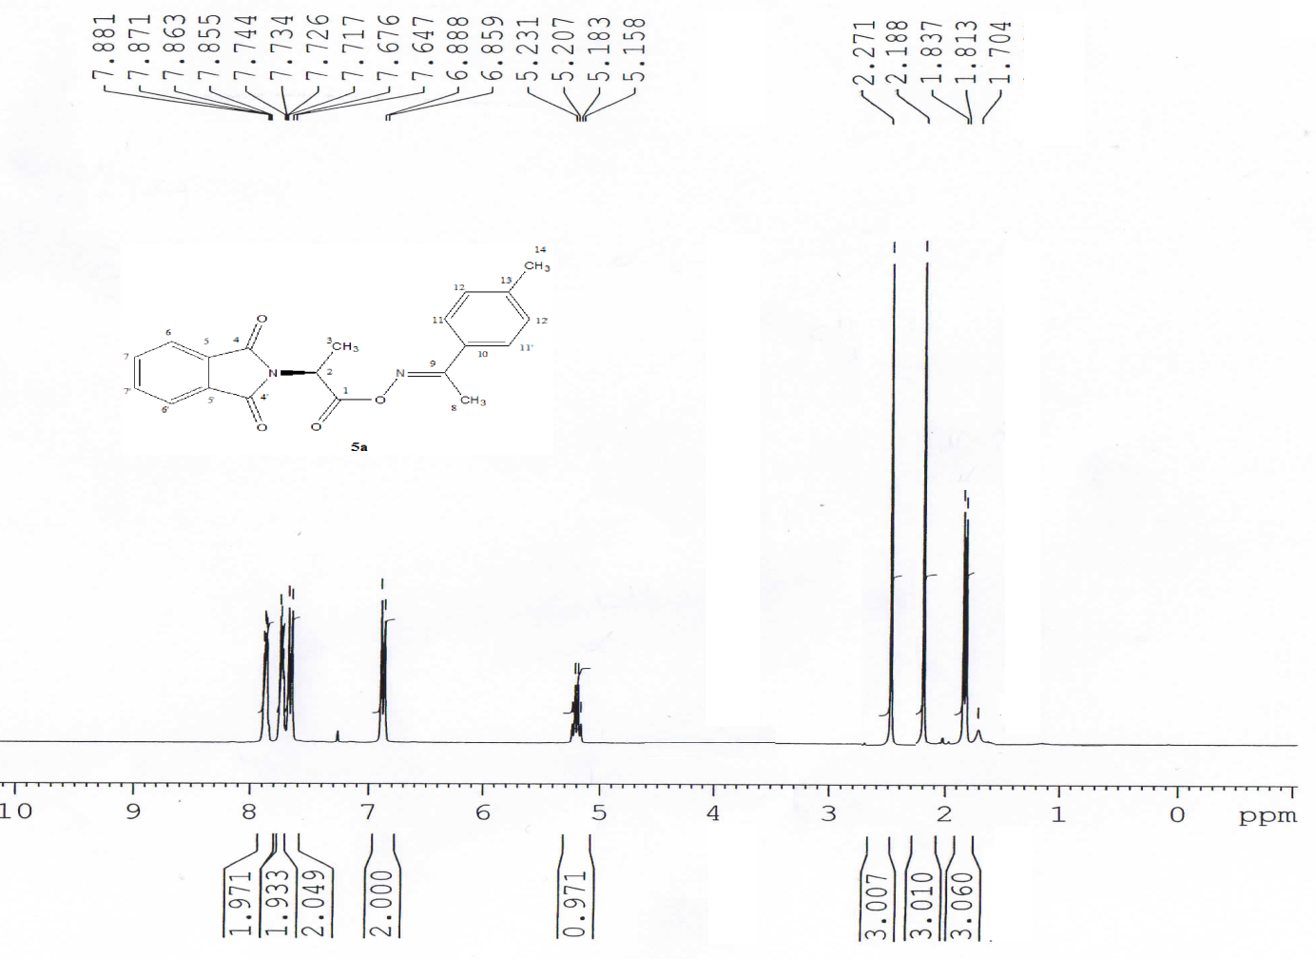
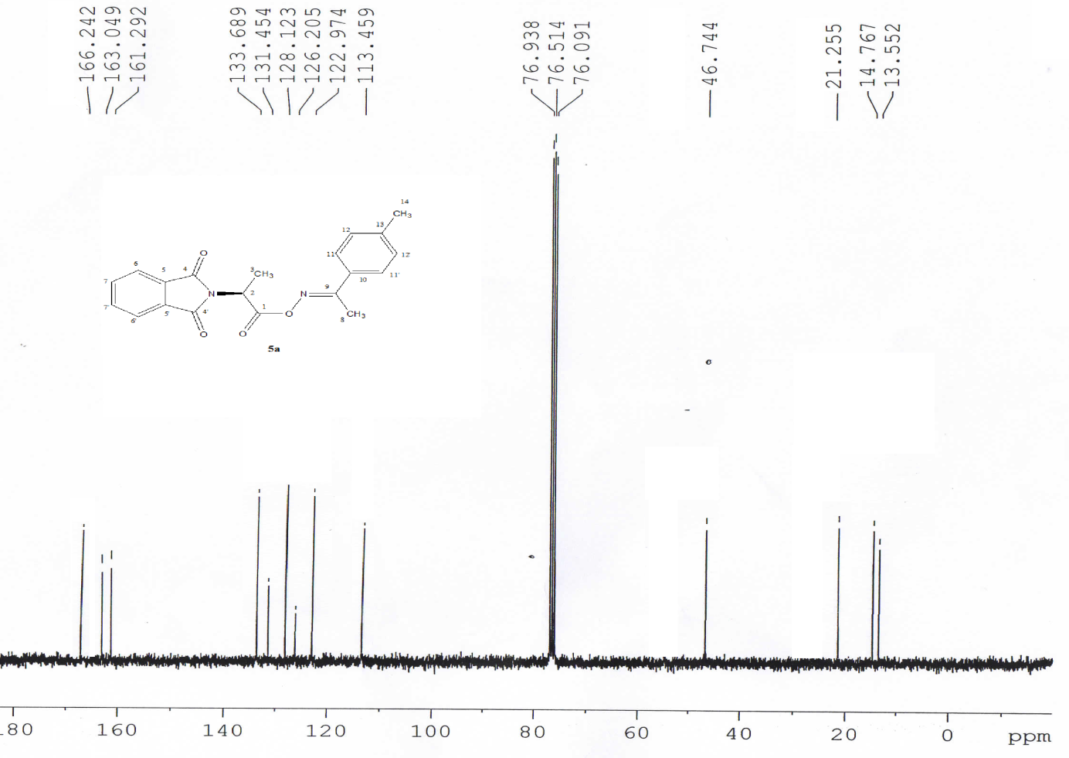

(S)-1-(4-methoxyphenyl)ethanoneoximyl-2-(1,3-dioxoisoindolin-2-yl)propanoate (5b).
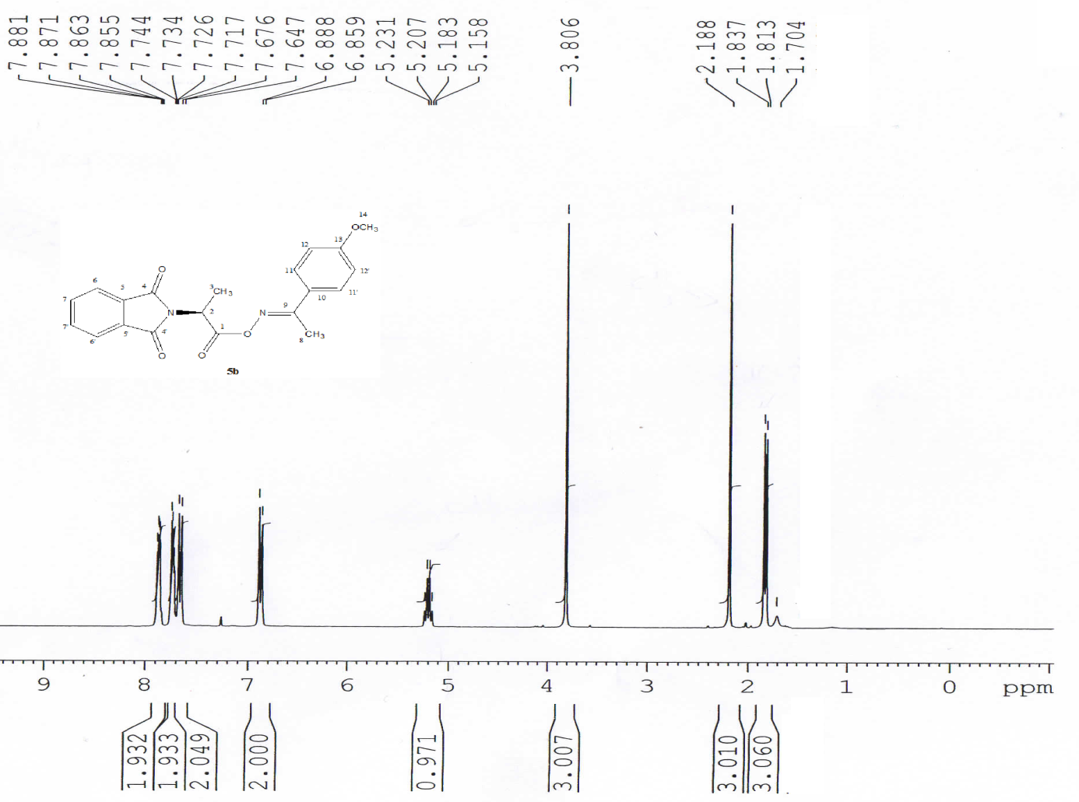
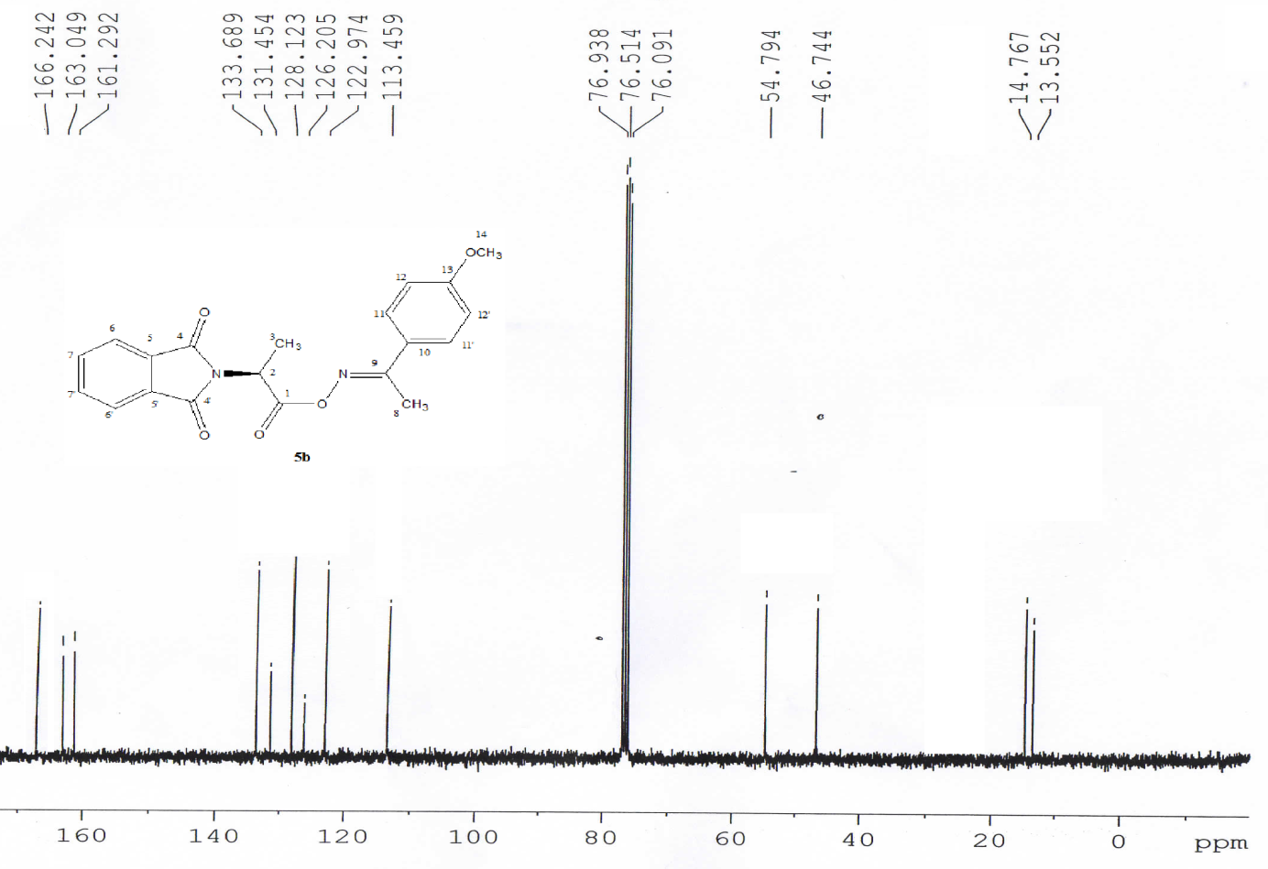

(S)-1-(4-fluorophenyl)ethanoneoximyl-2-(1,3-dioxoisoindolin-2-yl)propanoate (5c)
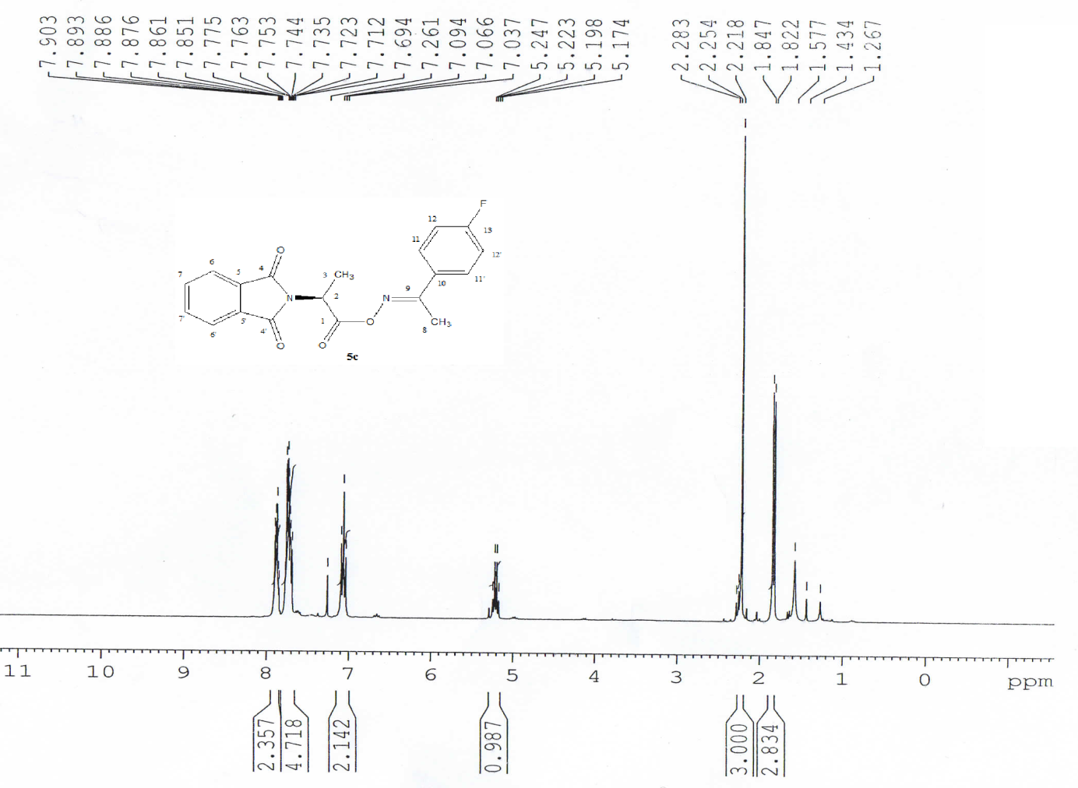

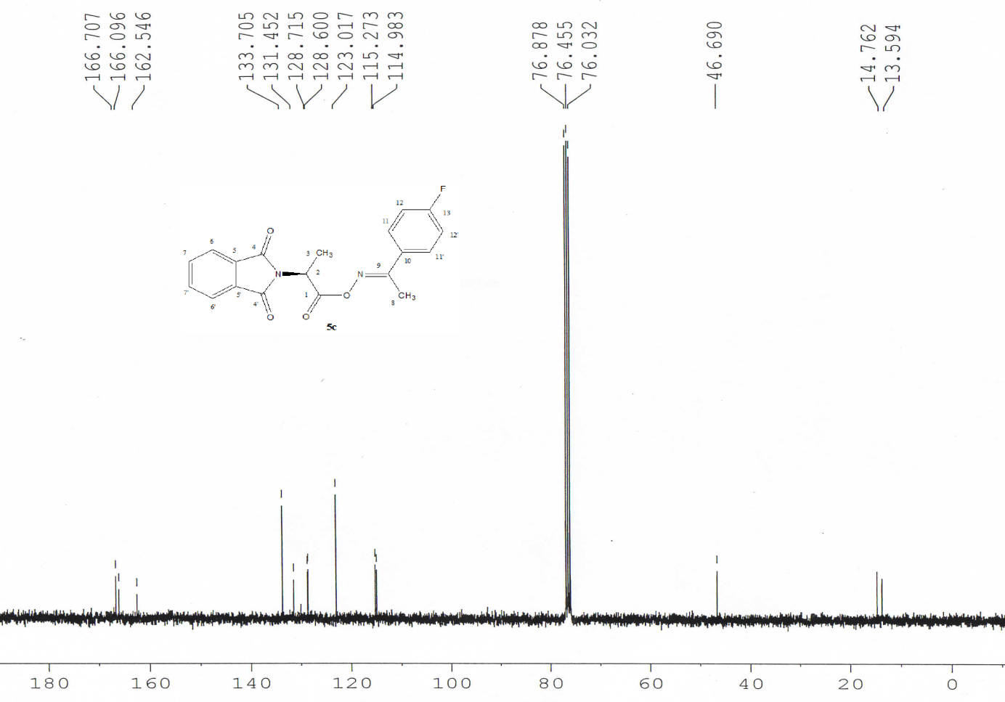
(S)-1-(4-chlorophenyl)ethanoneoximyl-2-(1,3-dioxoisoindolin-2-yl)propanoate (5d).
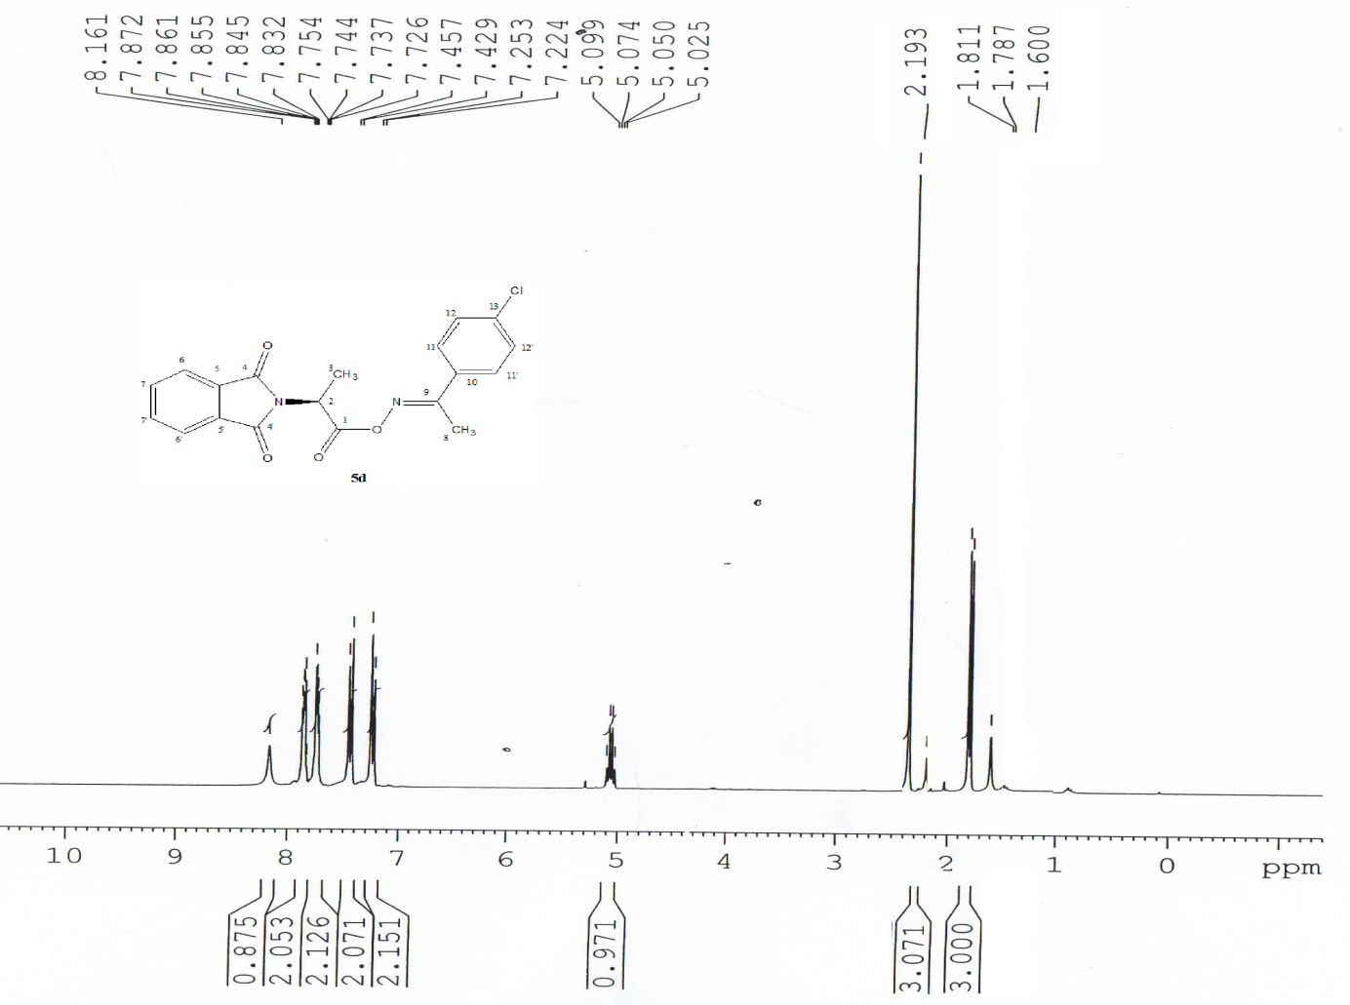
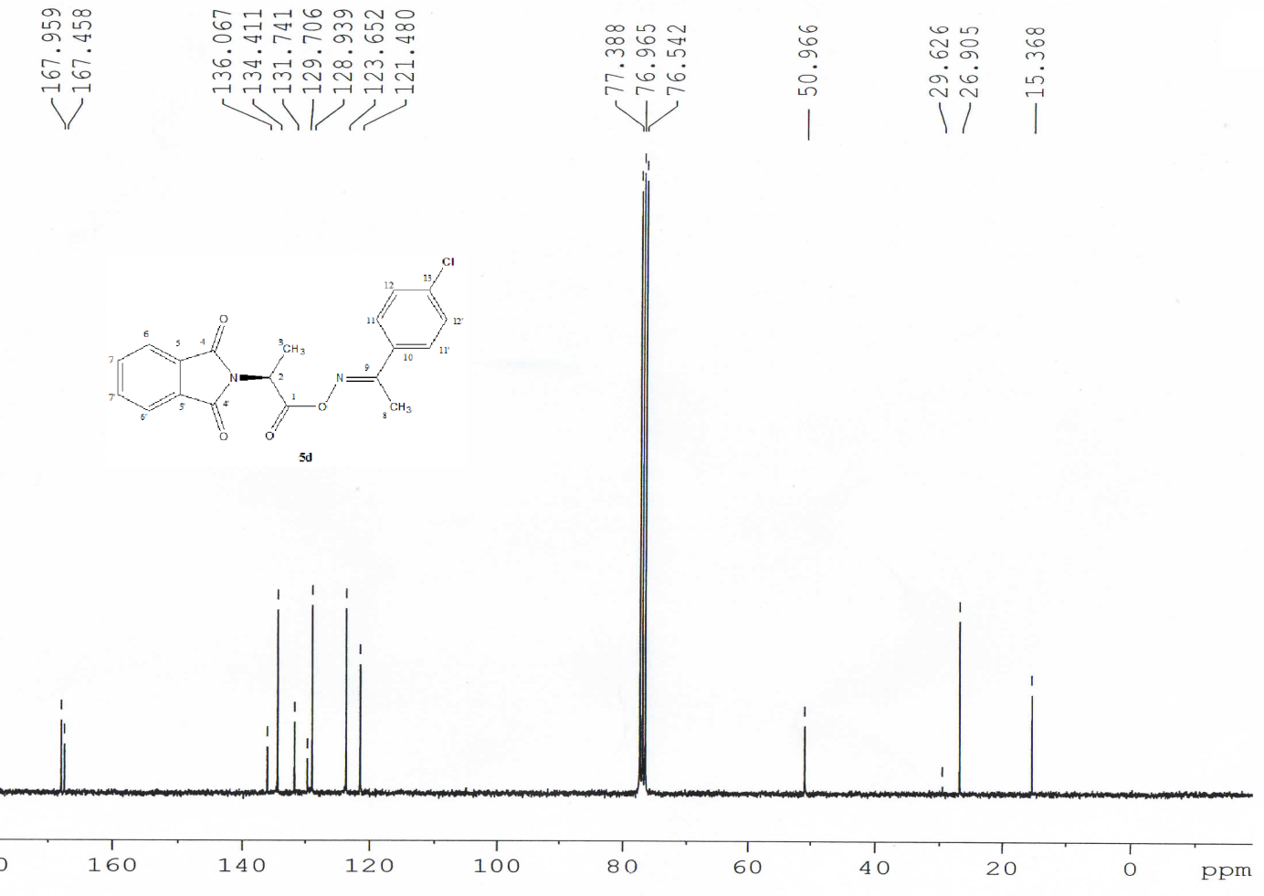

4(S)-1-(4-bromophenyl)ethanoneoximyl-2-(1,3-dioxoisoindolin-2-yl)propanoate (5e).
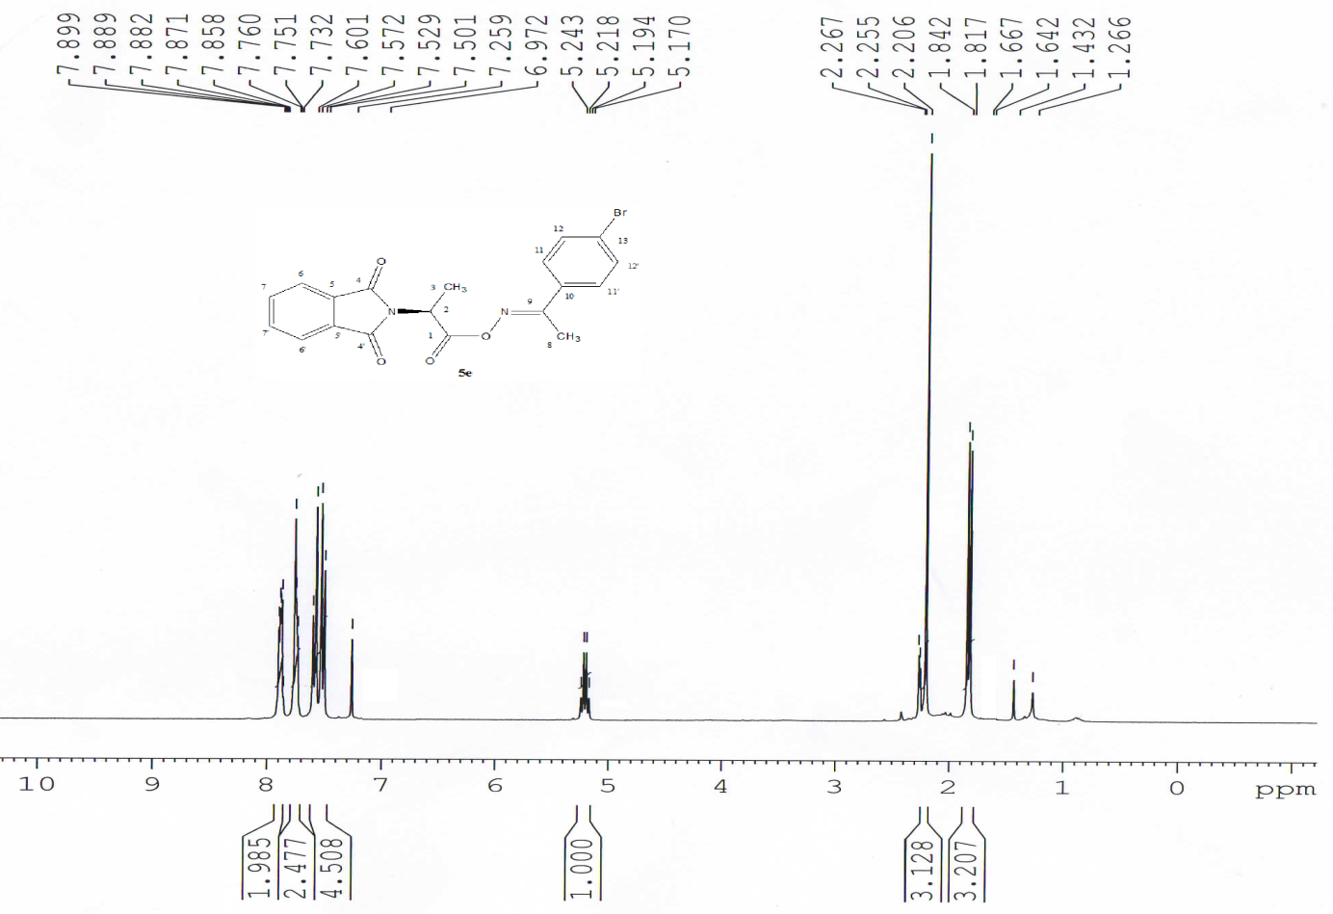

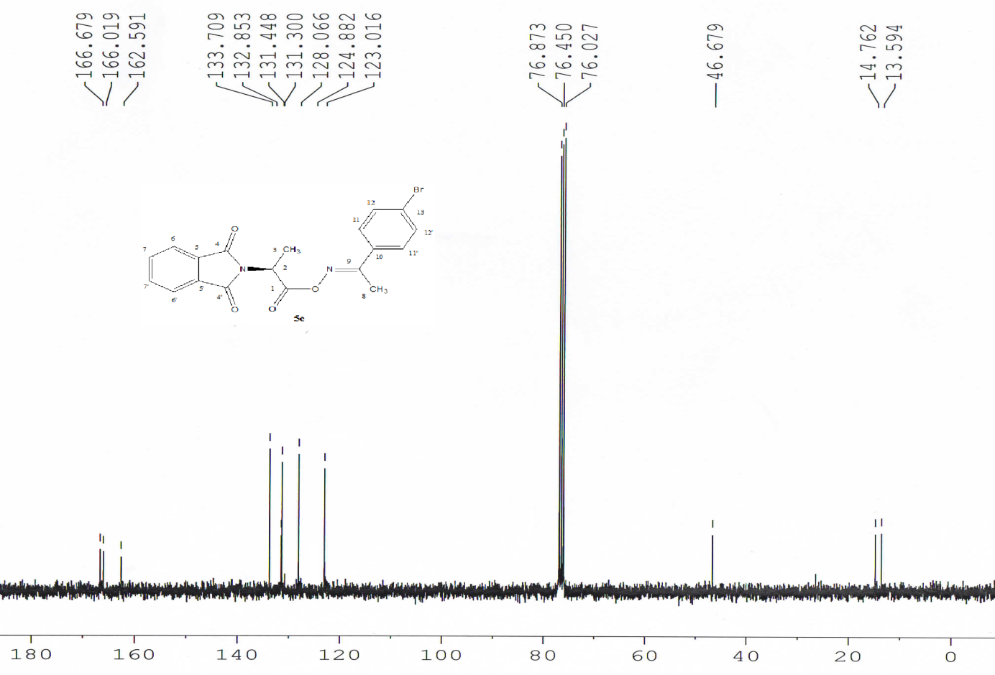

(S)-4-methyl-1-tolylethanoneoximyl-2-(1,3-dioxoisoindolin-2-yl)pentanoate (5f).
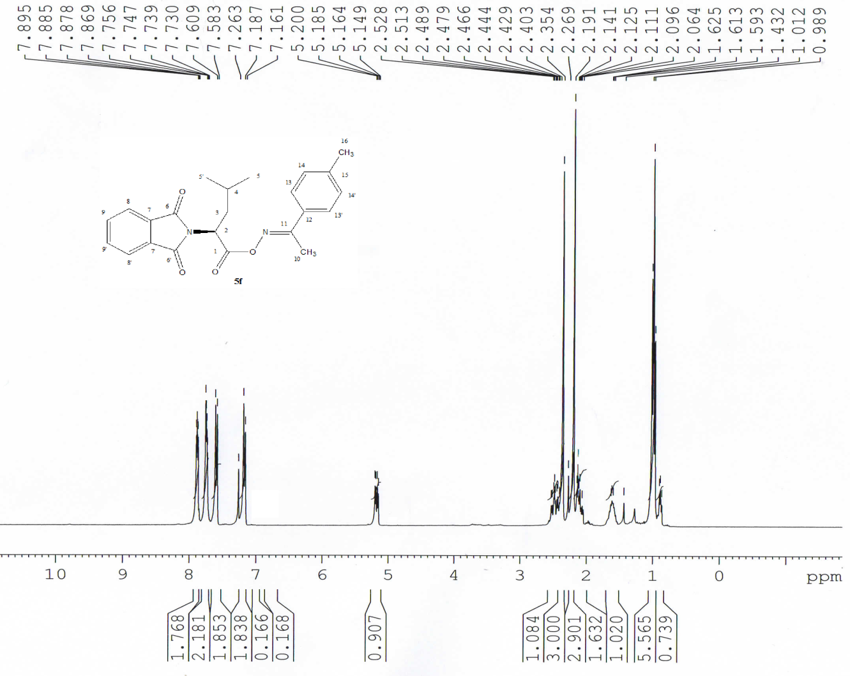

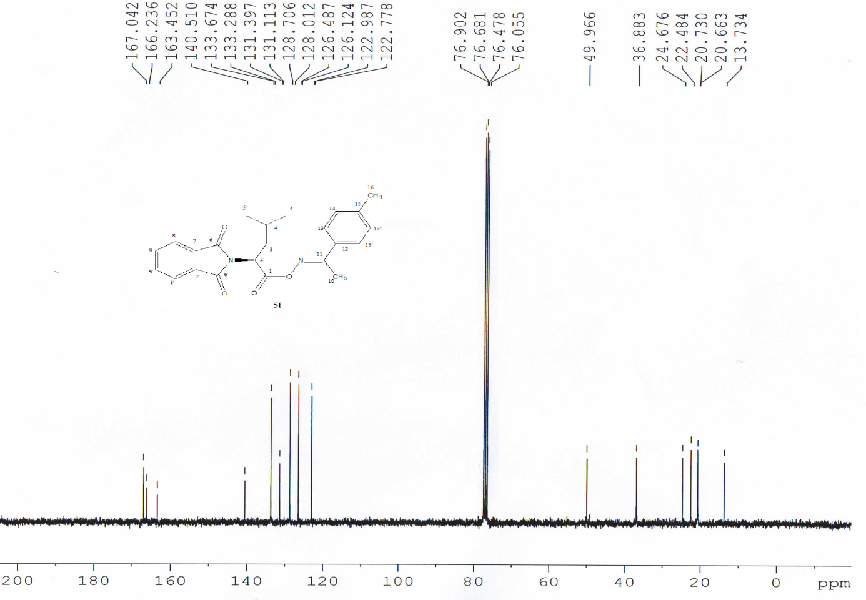
(S)-1-(4-chlorophenyl)ethanoneoximyl-4-methyl-2-(1,3-dioxoisoindolin-2-yl)pentanoate (5g).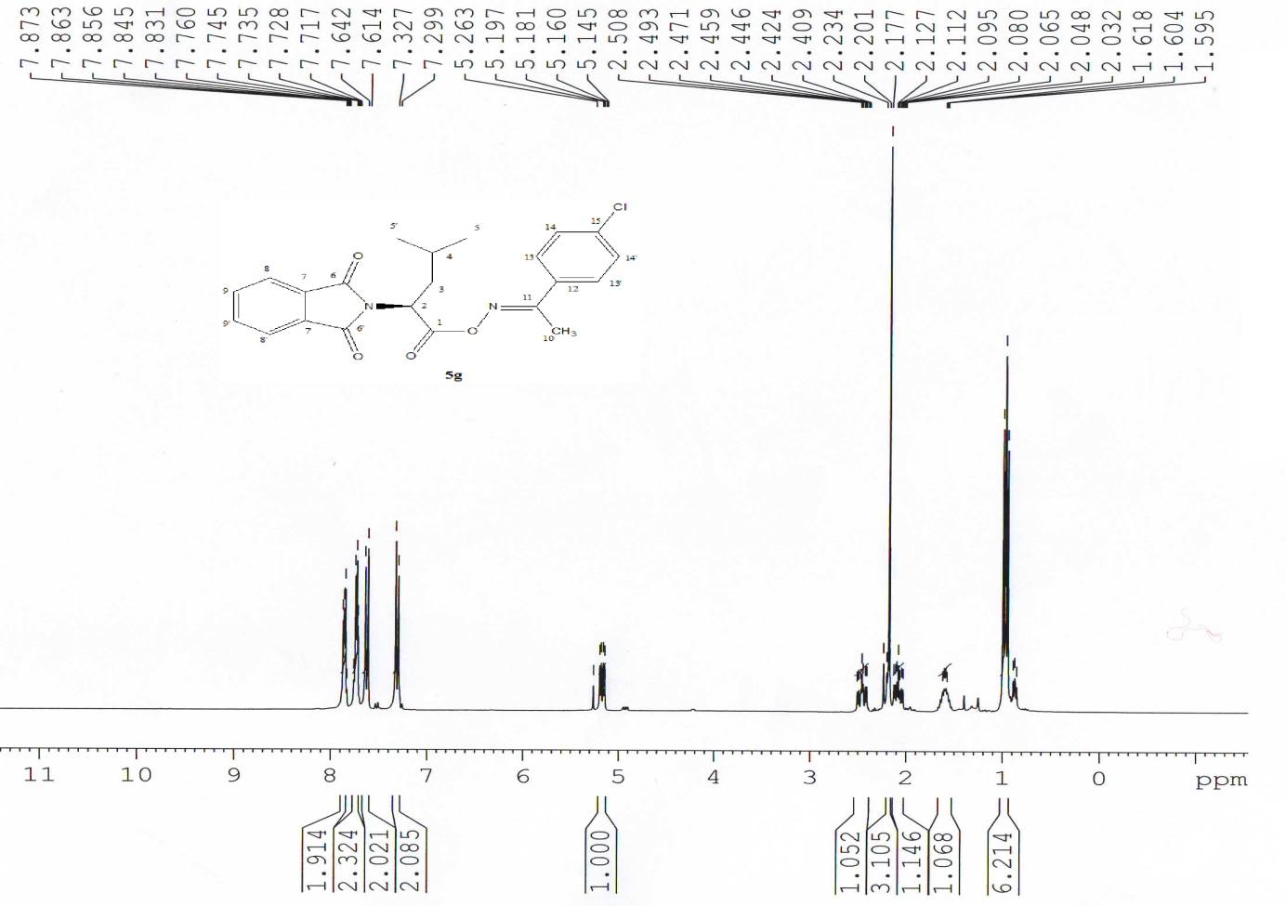

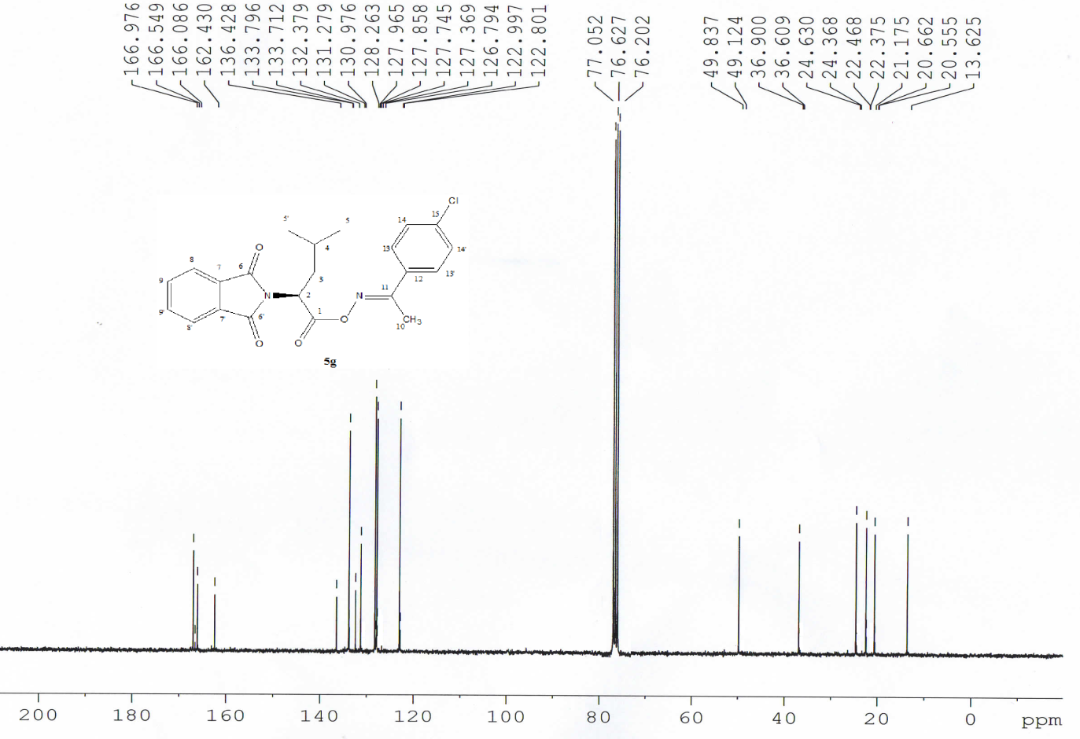

(2S,3R)-1-(4-methylphenyl)ethanoneoximyl-3-methyl-2-(1,3-dioxoisoindolin-2-yl)pentanoate (5h). 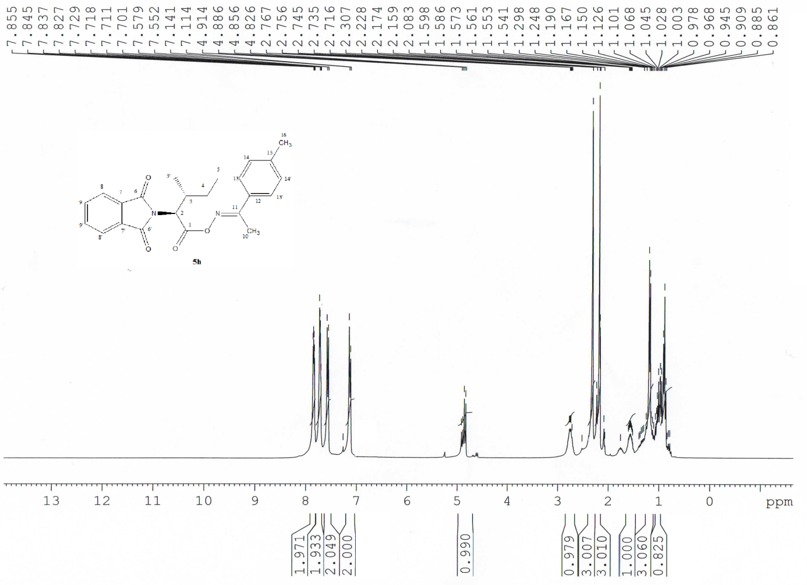

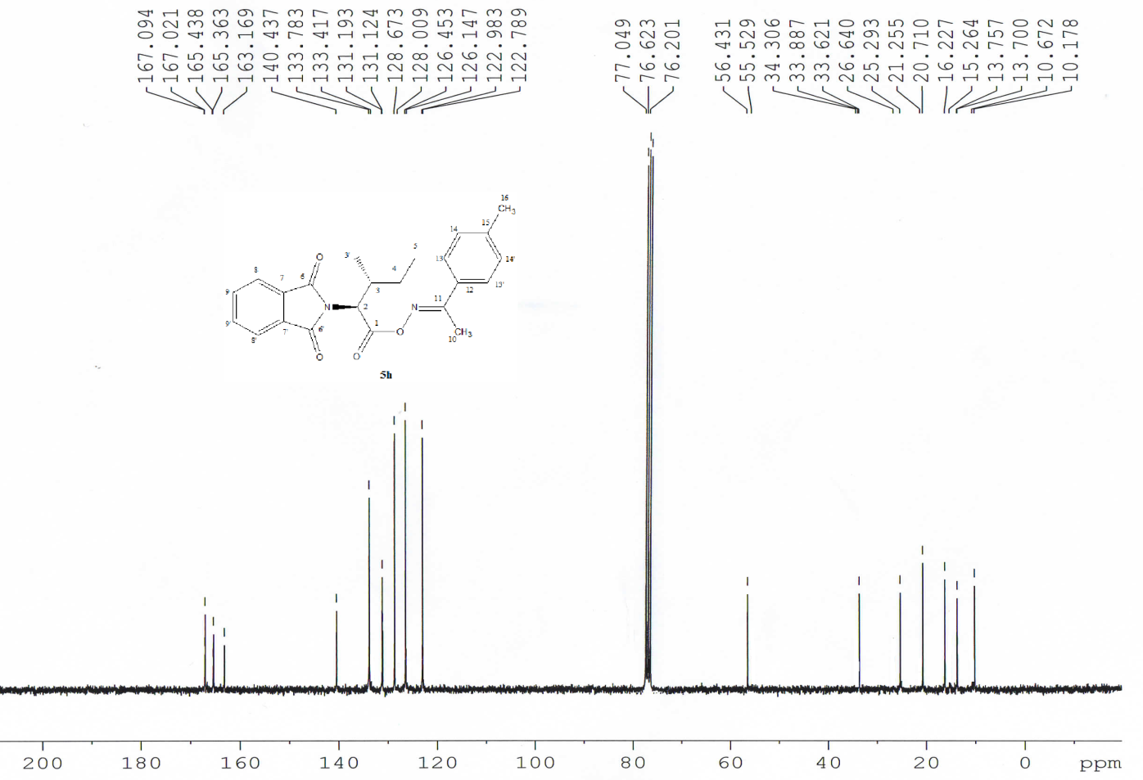

(S)-3-(3,4-dihydroxyphenyl)-1-phenylethanoneoximyl-2-(1,3-dioxoisoindolin-2-yl) propanoate (5i).

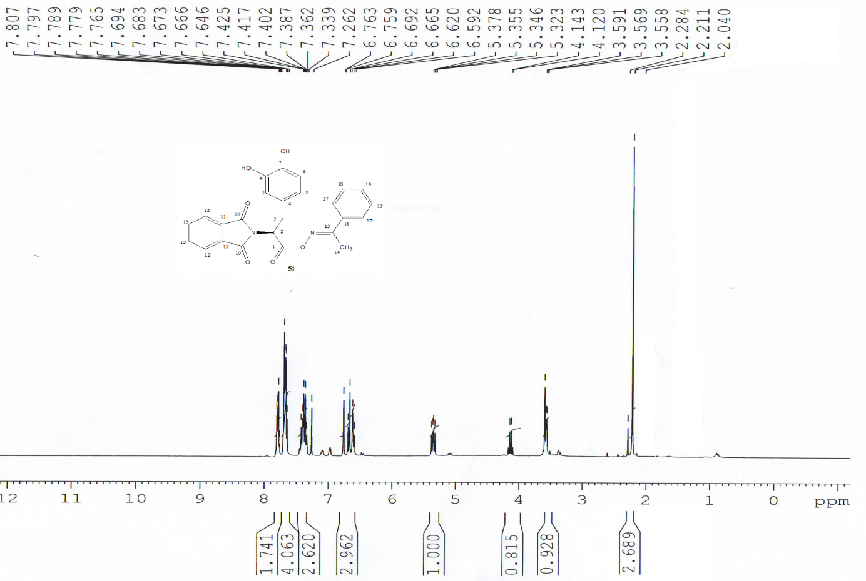

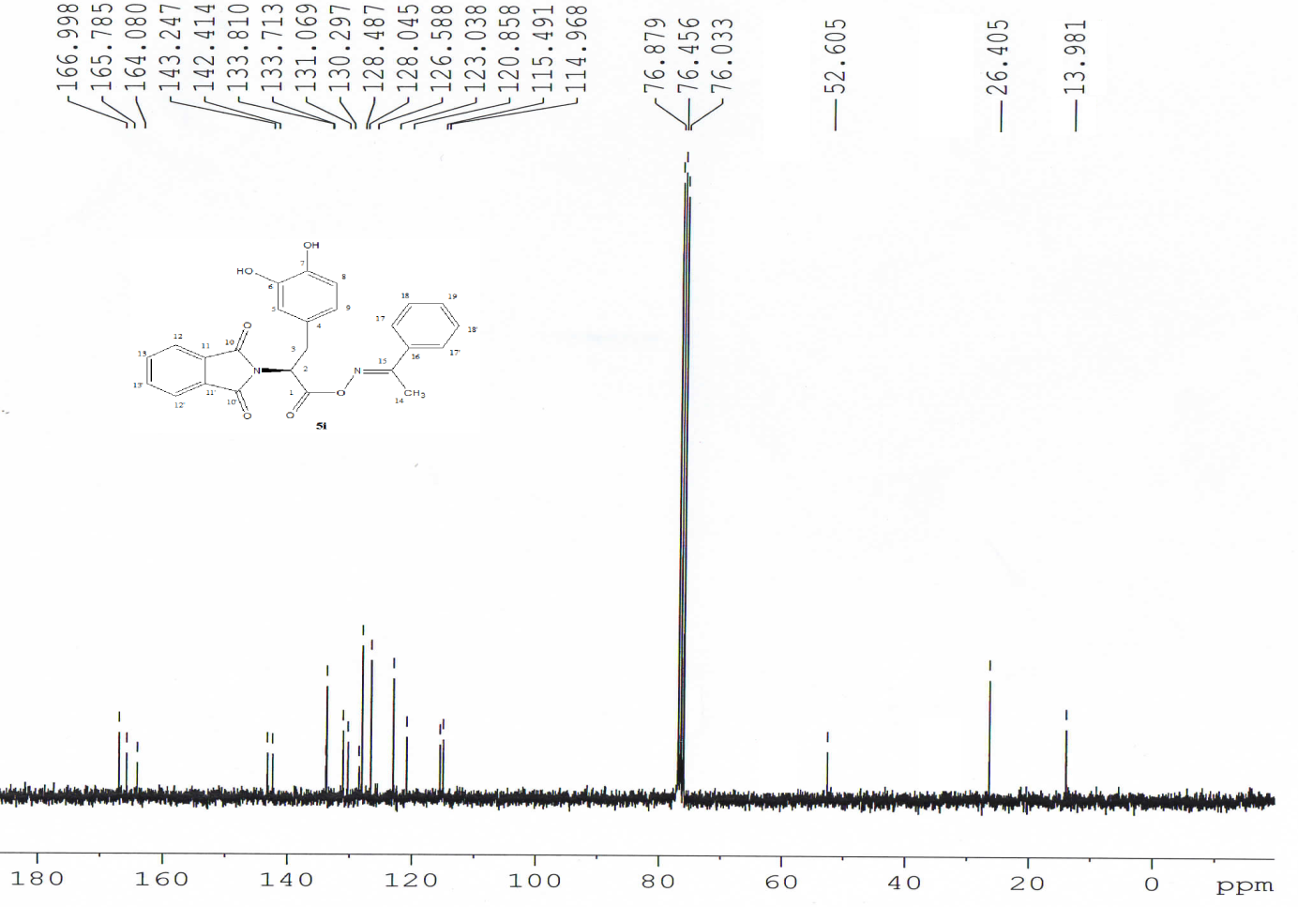

(S)-3-(3,4-dihydroxyphenyl)-1-(4-methoxyphenyl)ethanoneoximyl-2-(1,3-dioxoisoindolin-2-yl)propanoate (5j).

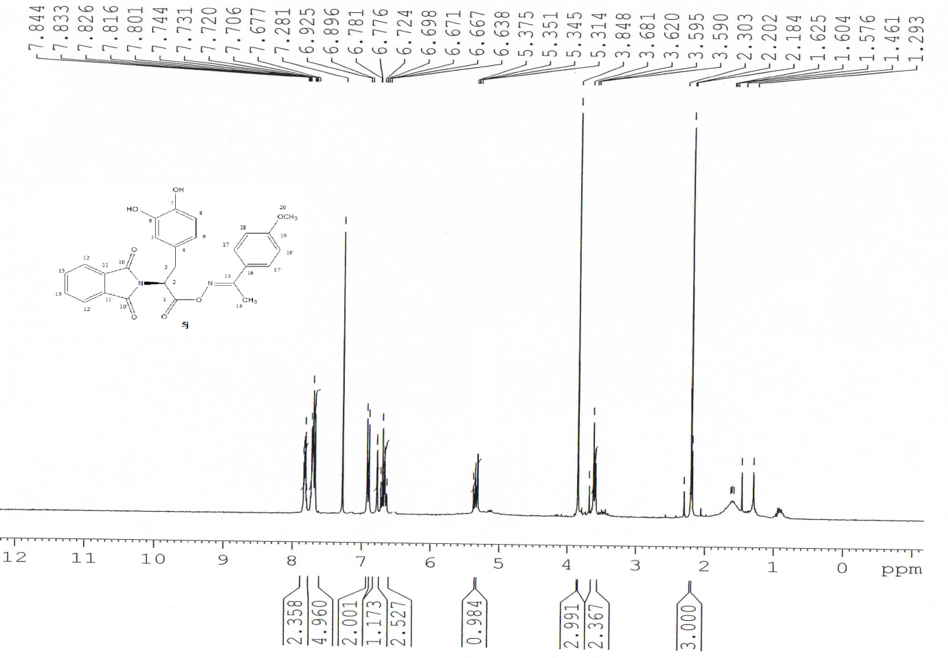

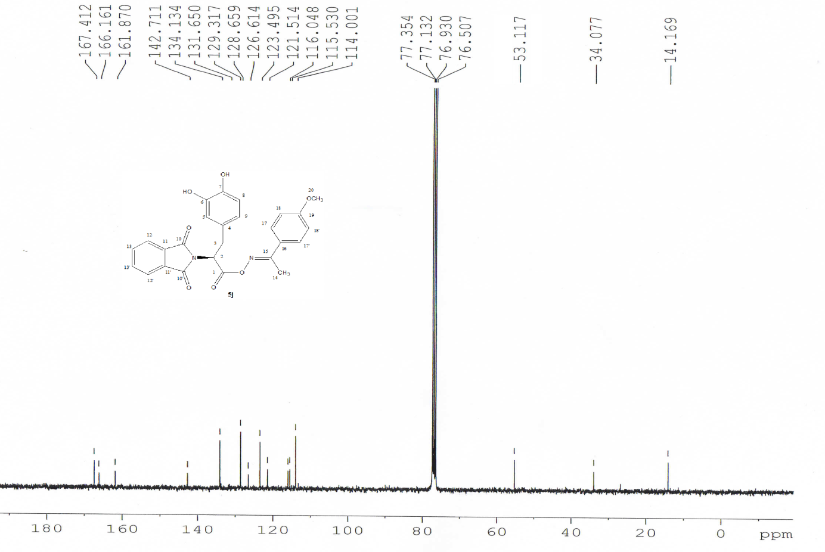

(S)-3-(3,4-dihydroxyphenyl)-1-(4-chlorophenyl)ethanoneoximyl-2-(1,3-dioxoisoindolin-2-yl)propanoate (5k).

